
Our regulatory approach
August 2024


Introduction
It is our job to make sure all electoral participants follow the laws in the Electoral Act 2002 (Vic) (Electoral Act). We monitor compliance, investigate and take enforcement action to respond to unlawful conduct. In doing so, we deter future misconduct, improve standards and behaviours, and reduce the risk of harm to all electoral participants.
We aim to make sure everyone plays by the rules to protect Victoria’s democracy, safeguard free and fair elections, and ensure compliance and transparency in electoral systems and political finance.
We are the regulator for all participants in state electoral processes, including:
- voters
- candidates and elected members
- registered political parties, their office holders, and party members
- anyone who gives or receives political donations
- anyone who campaigns or fundraises for a political party or candidate
- anyone who publishes or distributes electoral material.
We assess and investigate compliance with the Electoral Act and may take action on offences we identify in relation to state electoral processes.
We regulate compliance with the rules for:
- enrolment and voting
- electoral materials
- conduct during election periods
- political funding, donation disclosure and reporting
- political party registration.
Our regulatory role in local government elections is limited to enforcing compulsory voting. The Local Government Inspectorate assesses and investigates other offences under the Local Government Act 2020 (Local Government Act), including electoral offences. We work with the Local Government Inspectorate to assess and escalate complaints and we assist and support their investigations.
Other integrity agencies investigate complaints in specific areas. We may refer a matter to another agency if it is not part of our responsibilities:
- Australian Electoral Commission monitors compliance with federal electoral laws and works with federal and local law enforcement agencies.
- Local Government Inspectorate monitors and investigates offences against the Local Government Act, including the electoral laws that apply at local council elections.
- Victorian Ombudsman investigates complaints about councils, Victorian Government departments and organisations.
- Independent Broad-based Anti-Corruption Commission (IBAC) takes complaints about suspected public sector corruption and misconduct, including taking or offering bribes, committing fraud or theft and misusing information.
- Office of the Victorian Information Commissioner investigates complaints about the handling of personal information by Victorian public sector organisations.
- Victoria Police investigates criminal conduct. We may refer a matter to Victoria Police where we believe a crime has been committed.
- Fines Victoria manages the administration and enforcement of infringement fines and court fines across Victoria. We may refer infringement fines to Fines Victoria for them to enforce on our behalf.

Our constructive compliance approach
We use a constructive compliance approach to engage and educate electoral participants about their obligations. Providing information is an important first step in making sure participants have the information they need to meet their obligations.
Where education doesn’t address non-compliance with the Electoral Act, or when we suspect an offence may have been committed, we may investigate and take action in proportion with the level of harm.
Criminal prosecution is only used when no other compliance action is appropriate or other steps have been exhausted.
This approach is consistent with:
- our vision of all Victorians actively participating in their democracy
- our purpose to deliver high quality, accessible electoral services with innovation, integrity and independence
- our obligations under the Charter of Human Rights and Responsibilities Act 2006 (Vic).

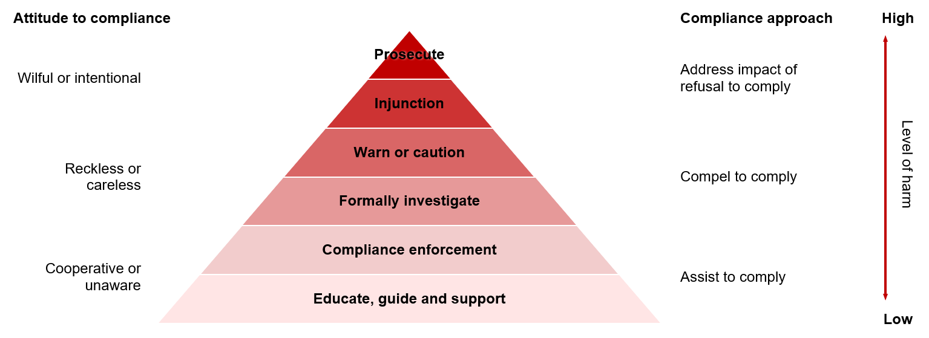
Figure 1. The VEC’s constructive compliance approach (Source: Adapted from Ayres and Braithwaite, 1992).

Educate, guide and support
We educate and guide by providing relevant information to all participants in Victoria’s democracy. We engage directly with more targeted audiences when this support is needed.
We also provide assistance through our subject matter experts and systems like VEC Disclosures, a portal for those who give or receive political donations.
We may provide education and guidance in writing to inform a participant that their behaviour may be placing them at risk of further compliance action. We may try to identify solutions to help them rectify the issue.
Compliance enforcement
The Electoral Act sets out clear obligations for those who participate in Victoria’s electoral processes. These obligations range from the requirement for all enrolled Victorians to vote in state elections, to regular reporting requirements for registered political parties and others to detail certain financial transactions.
If we identify unintentional non-compliance, we will seek to resolve the matter in a supportive manner. The participant may be contacted by phone or email to remind them of their obligations. If this resolves the issue, and no significant harm has occurred, we will likely decide that no further action is necessary.

We also have powers under the Electoral Act to require certain individuals or entities to provide documents, materials and other things, or to answer questions. These powers are used in accordance with our values: independence, accountability, innovation, respect and collaboration.
Where appropriate, we may partner with or refer matters to state and federal enforcement or integrity agencies.
Formally investigate
Where efforts to address non-compliance are unsuccessful or there is a breach of the Electoral Act associated with a greater level of harm, we may commence an investigation. Matters involving careless, reckless or intentional non-compliance may progress directly to investigation.
We will always be considered in our communications about investigations, including with the media.
Our commitment to openness means we may name entities in public statements and reports when it is appropriate to do so. This is important for transparency and public education, so there are no surprises and electoral participants know what may happen if they break the rules.
We will weigh any potential impact on those involved against our responsibility to promote proper conduct under the Electoral Act before we decide if we will name individuals or groups.
Warn or caution
If an investigation finds an offence against the Electoral Act, we may issue a warning or caution. These are appropriate for when the non-compliance identified is less harmful. Warnings and cautions are restorative and seek to prevent future non-compliance.
Injunction
An injunction is a court order requiring a person to do, not to do, or to stop doing something. Failing to comply with the requirements of an injunction has serious consequences.
We may apply for an injunction when an individual or entity’s behaviour or conduct poses a significant risk to the electoral process, and the behaviour or conduct needs to be stopped immediately. We may also seek an injunction where we need to stop someone from causing harm to an election. During an election, the Electoral Act also allows other electoral participants to seek an injunction in certain circumstances.
Where we seek an injunction, we may do this alongside other compliance actions. We will communicate the reason for seeking the injunction to those involved and may also make a public statement about why we applied for the injunction.
Prosecute
Prosecuting a person for an offence against the Electoral Act is the final option for non-compliance. Before deciding to prosecute an offence, we consider any other appropriate compliance action and the success of actions already taken.
We acknowledge the important role the justice system has in regulating democracy, and the independence of the courts in making decisions.
We have policies to inform our decision to prosecute and also refer to other policies, including those of the Director of Public Prosecutions.
Our values
We value independence, accountability, innovation, respect, and collaboration in our work. Our regulatory approach also needs to be consistent, transparent and align with the principles of natural justice and procedural fairness.
We report annually in relation to our regulatory activity, including our use of any powers provided by the Electoral Act.
Feedback on our regulatory approach
We are committed to continuous improvement and welcome feedback on our regulatory approach.
If you have feedback, contact us through the feedback and complaints forms available at vec.vic.gov.au

