Local council electoral structure review

## About the review

Under Victoria’s *Local Government Act 2020*, Brimbank City Council must now have a single-councillor ward electoral structure.

The Minister for Local Government has appointed an electoral representation advisory panel to review the electoral structure of Brimbank City Council and advise on the most appropriate single-councillor ward structure.

The panel is looking at:

* the appropriate number of councillors and wards
* the location of ward boundaries
* appropriate ward names.

Electoral structure reviews are an important part of democracy and your input is valuable. As a local, you know your council area better than anyone. This is your chance to tell the panel your thoughts about the single-councillor ward structure you believe would best provide representation for your community.

You can have your say:

1. in a response submission to the preliminary report
2. at an online public hearing, if you ask to speak in your response submission.

About Brimbank City Council

The Traditional Custodians of the land in Brimbank City Council are the Wurundjeri and the Bunurong peoples.

Brimbank City Council is about 20 km west of central Melbourne. Covering an area of   
123 km2 it is home to 194,618 people. As the most populated of Victoria’s metropolitan councils, it is forecast to grow to nearly 230,000 people by 2040.

The council area is heavily urbanised and residential, industrial and commercial areas account for about 85% of all land use. It comprises 25 suburbs, which the council has organised into 5 local districts: St Albans, Sunshine, Deer Park, Sydenham and Keilor. Each district has its own identity, culture, and heritage.

Pre- and post-war homes characterise the established suburbs of Sunshine, St Albans and Deer Park. The more recently developed suburbs of Cairnlea, Sydenham, Hillside, and Derrimut feature more contemporary housing.

Growth is expected to occur through medium and higher density housing development in Brimbank, Deer Park, Keilor Downs,   
St Albans, Sunshine, and Sydenham.

Brimbank is culturally diverse. At the 2021 Census, about 70% of residents had both parents born overseas and people with Vietnamese ancestry accounted for about 17% of the population. Other large cultural groups include people with Chinese, Italian and Maltese ancestry.

## Current structure

Brimbank City Council is divided into 4 wards with a total of 11 councillors:

* one ward with 2 councillors
* 3 wards with 3 councillors each

## Last review

The VEC conducted an electoral representation review of Brimbank City Council in 2011.

Visit the VEC website at [vec.vic.gov.au](https://www.vec.vic.gov.au/) to access a copy of the 2011 review final report.

Review process

Monday 16 and Tuesday 17 October

### Information sessions

Session 1: 12 noon, Monday 16 October

Session 2: 6 pm, Tuesday 17 October

These sessions will give you more information about the review process. You will be able to register for a session on the VEC website.

Wednesday 18 October

### Preliminary report

The panel will release a preliminary report with one or more options for the electoral structure on Wednesday 18 October.

**You can make a response submission from this date.**

Wednesday 8 November

### Response submission close

The panel must receive all submissions by   
5 pm on Wednesday 8 November.

The panel will not accept late submissions.

Wednesday 15 November

### Public hearing

The panel will hold an online public hearing if anyone asks to speak about their response submission at 10 am Wednesday 15 November.

The public hearing will not be held if no one asks to speak.

Wednesday 13 December

### Final report

The panel will submit a final report to the Minister for Local Government including its advice for the electoral structure on Wednesday 13 December.

The minister will consider the panel’s advice before recommending a change to the electoral structure. Any change is expected to apply at the next local council general election.

## Submission guide

You can download a submission guide from the VEC website at [vec.vic.gov.au](http://vec.vic.gov.au/)

## How to make a submission Untitled-1

On the VEC website at [vec.vic.gov.au](http://vec.vic.gov.au/)

By email to:

[Brimbank.ERAPSubmissions@ vec.vic.gov.au](mailto:Brimbank.ERAPSubmissions@vec.vic.gov.au)

LetterBy post to:

Electoral representation advisory panel  
c/o Victorian Electoral Commission  
Level 11, 530 Collins St  
Melbourne VIC 3000

Submissions must include your:

* full name
* contact phone number or email address
* residential or postal address.

Your submission will be published on the VEC website, including your name and suburb or town but not your full address or contact details. See the submission guide or VEC website at [vec.vic.gov.au/privacy](https://www.vec.vic.gov.au/privacy) for privacy information.

## One vote, one value

The ‘one vote, one value’ democratic principle is enshrined in the *Local Government Act 2020*. This means every person’s vote counts equally.

When a local council is subdivided into wards, the number of voters each councillor represents in each ward must be plus-or-minus 10% of the average number of voters per councillor for all wards.

The map below includes the current number of voters in each ward and the ward’s current deviation from the average. The panel will consider likely population and voter changes to ensure the structure remains equitable.

If you make a submission online, you can use a mapping tool to build your preferred electoral structure. The tool uses current voter numbers to tell you the deviations of the wards you make. This will help you propose a structure that meets the requirements of the Act.

Current electoral structure

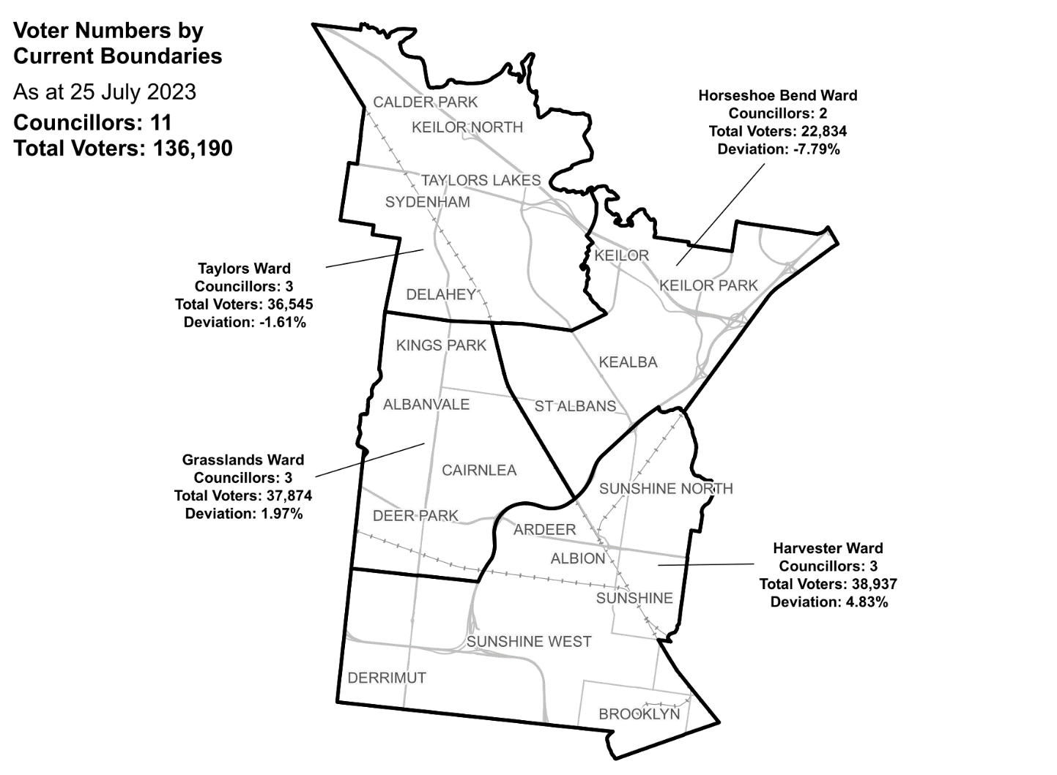

|  |  |  |  |
| --- | --- | --- | --- |
| Ward | Councillors | Voters | Deviation |
| Grasslands Ward | 3 | 37,874 | +1.97% |
| Harvester Ward | 3 | 38,937 | +4.83% |
| Horseshoe Bend Ward | 2 | 22,834 | -7.79% |
| Taylors Ward | 3 | 36,545 | -1.61% |

## Statistics

Area (km2) 123

Voters

### Voter density (per square km)

1,107

### Average voters per councillor

12,380

Population

### Current population

194,618

### Forecast population growth

0.3 % p.a.

More Census statistics available at [abs.gov.au](https://www.abs.gov.au/census/find-census-data/search-by-area)

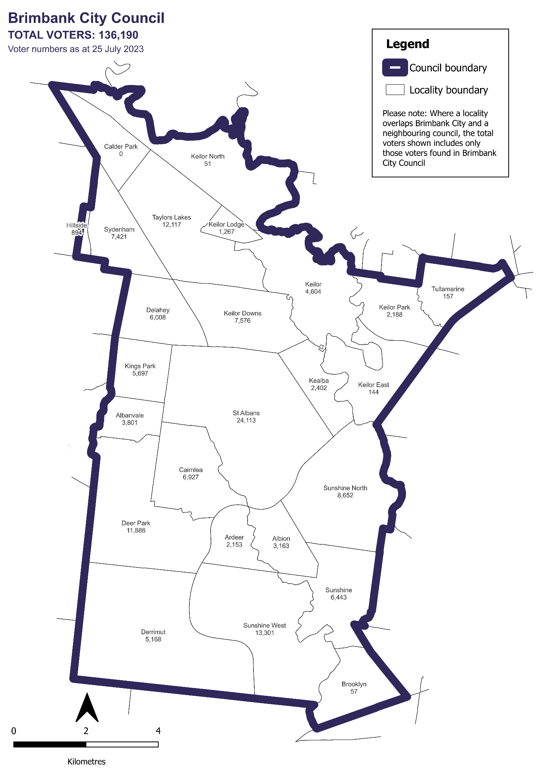Voter numbers by locality (map)

Voter numbers by locality (table)

## Brimbank City Council voter numbers at 25 July 2023

|  |  |
| --- | --- |
| Locality | Voters |
| Albanvale | 3,801 |
| Albion | 3,163 |
| Ardeer | 2,153 |
| Brooklyn | 57 |
| Cairnlea | 6,927 |
| Calder Park | 0 |
| Deer Park | 11,886 |
| Delahey | 6,008 |
| Derrimut | 5,168 |
| Hillside | 894 |
| Kealba | 2,402 |
| Keilor | 4,604 |
| Keilor Downs | 7,576 |
| Keilor East | 144 |
| Keilor Lodge | 1,267 |
| Keilor North | 51 |
| Keilor Park | 2,188 |
| Kings Park | 5,697 |
| St Albans | 24,113 |
| Sunshine | 6,443 |
| Sunshine North | 8,652 |
| Sunshine West | 13,301 |
| Sydenham | 7,421 |
| Taylors Lakes | 12,117 |
| Tullamarine | 157 |