Local council electoral structure review

## About the review

Under Victoria’s *Local Government Act 2020*, Frankston City Council must now have a single-councillor ward electoral structure.

The Minister for Local Government has appointed an electoral representation advisory panel to conduct an electoral structure review of the council. The panel will advise the Minister on the most appropriate single-councillor ward structure for Frankston City Council.

The panel is looking at:

* the appropriate number of councillors and wards
* the location of ward boundaries
* appropriate ward names.

Electoral structure reviews are an important part of democracy, and your input is valuable. As a local, you know your local council area better than anyone. This is your chance to let the panel know your thoughts about the single-councillor ward electoral structure that you believe would best provide representation for your community.

There are 2 opportunities for you to have your say on the electoral structure of the council:

1. in a response submission to the preliminary report
2. in an online public hearing, if you request to speak in your response submission.

About Frankston City Council

The formally recognised Traditional Custodians of the land in Frankston City Council are the Bunurong people.

Frankston City Council is on the eastern shore of Port Phillip Bay, approximately 40 kms south of Melbourne. The council area covers 130 km2. The western boundary of the city is the Port Phillip Bay coastline. The council area is also bordered by Mornington Peninsula Shire Council to the south, Casey City Council to the east, and Greater Dandenong and Kingston city councils to the north.

The total residential population of Frankston City Council was 139,281 people at the 2021 Census. This was an increase of about 30,000 since 2001. The population is forecast to grow by about 22,000 people by 2041 to over 161,000 people.

The council area includes the suburbs of Carrum Downs, Frankston, Frankston North, Frankston South, Langwarrin, Langwarrin South, Sandhurst, Seaford, and Skye.

In addition to residential and retail land use, there are large industrial areas in the south of Seaford, and in the west of Carrum Downs. Frankston City Council also has large green-wedge areas in its north, east and south-east. Natural features include about 9.5 km of the Port Phillip Bay coastline, and the Seaford Wetlands, which are internationally significant and the largest natural wetlands in the Port Phillip and Western Port basins.

The median age is 39, and Australia is the country of birth for about 73% of the population, compared to 65% for Victoria overall. The main industries of employment are health care and social assistance, construction, and retail trade.

## Current structure

Frankston City Council is divided into 3 wards with a total of 9 councillors:

* 3 wards with 3 councillors each.

## Last review

The VEC conducted an electoral representation review of Frankston City Council in 2011.

Visit the VEC website at [vec.vic.gov.au](https://www.vec.vic.gov.au/) to access a copy of the 2011 review final report.

Review process

Monday 10 and Tuesday 11 July

### Information sessions

Session 1: 12 noon, Monday 10 July

Session 2: 6 pm, Tuesday 11 July

Information sessions are for anyone wanting to find out more about the review process. Links to register for an information session will be available on the VEC website.

Wednesday 12 July

### Preliminary report

The panel will release a preliminary report including one or more options for the electoral structure on Wednesday 12 July.

**Response submissions open from this date.**

Wednesday 2 August

### Response submission close

The panel must receive all submissions by 5 pm on Wednesday 2 August.

Late submissions will not be accepted.

Wednesday 9 August

### Public hearing

The panel will hold an online public hearing if anyone requests to speak about their response submission at 2 pm on Wednesday   
9 August.

The public hearing will not be held if there are no requests to speak.

Wednesday 6 September

### Final report

The panel will submit a final report to the Minister for Local Government including its advice on the electoral structure on Wednesday 6 September.

The Minister will then consider the panel’s advice before recommending a change to the electoral structure. Any change to the electoral structure of the council following the review is expected to apply at the next local council elections.

## Untitled-1How to make a submission

On the VEC website at [vec.vic.gov.au](http://vec.vic.gov.au/)

By email to

[Frankston.ERAPSubmissions  
@vec.vic.gov.au](mailto:Frankston.ERAPSubmissions@vec.vic.gov.au)

LetterBy post to

Electoral representation advisory panel  
c/o Victorian Electoral Commission  
Level 11, 530 Collins Street  
Melbourne VIC 3000

Submissions must include your:

* full name
* contact phone number or email address
* residential or postal address.

All submissions will be published on the VEC website. Your name and locality (suburb or town) will be published, but your full address and contact details will be removed. See the submission guide and VEC website at [vec.vic.gov.au/privacy](https://www.vec.vic.gov.au/privacy) for privacy information.

## Submission guide

Download the submission guide from the VEC website at [vec.vic.gov.au](http://vec.vic.gov.au/) for more information on the review process and making a submission.

## One vote, one value

The ‘one vote, one value’ democratic principle is enshrined in the *Local Government Act 2020*. This means that every person’s vote counts equally.

When a local council area is subdivided into wards, the number of voters each councillor represents in each ward must be within plus-or-minus 10% of the of the average number of voters per councillor for all the wards.

The map below includes the current number of voters in each ward and the ward’s current deviation from the average. The panel will consider likely population and voter changes to ensure the structure remains equitable.

If you make a submission online, you can use a mapping tool to build your preferred electoral structure. The tool uses current voter numbers to tell you the deviations of the wards you make. This will help you propose a structure that meets the requirements of the Act.

Current electoral structure

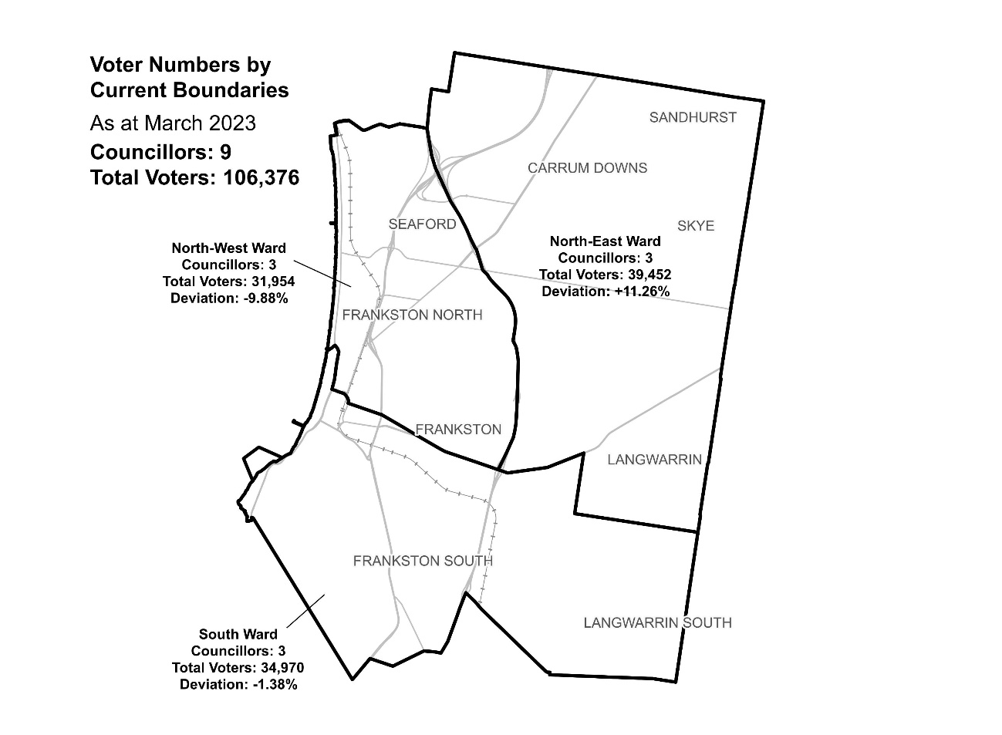

|  |  |  |  |
| --- | --- | --- | --- |
| Ward | Councillors | Voters | Deviation |
| North-East | 3 | 39,452 | +11.26% |
| North-West | 3 | 31,954 | -9.88% |
| South | 3 | 34,970 | -1.38% |

## Statistics

Area (km2) 130

Voters

### Voters per square km

818

### Average voters per councillor

11,819

Population

### Current population

139,281

### Forecast population growth

0.9 % p.a.

Further census statistics available at [abs.gov.au](http://www.abs.gov.au)

Voter numbers by locality (map)

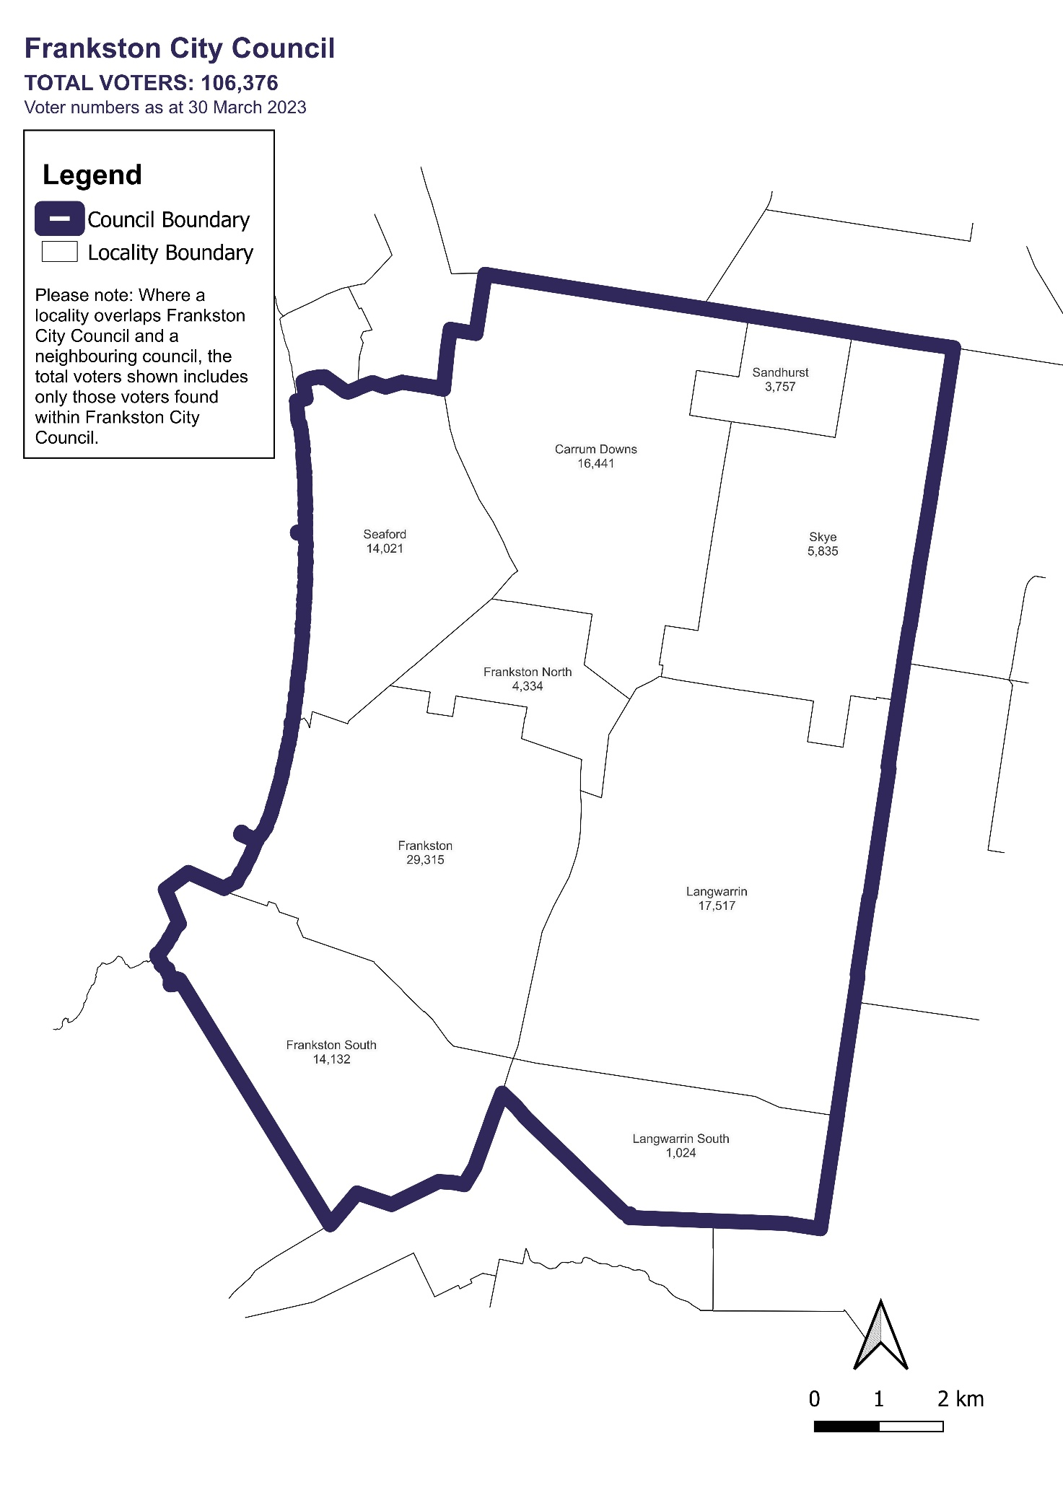

Voter numbers by locality (table)

## Frankston City Council voter numbers at 30 March 2023

|  |  |
| --- | --- |
| Locality | Voters |
| Carrum Downs | 16,441 |
| Frankston | 29,315 |
| Frankston North | 4,334 |
| Frankston South | 14,132 |
| Langwarrin | 17,517 |
| Langwarrin South | 1,024 |
| Sandhurst | 3,757 |
| Seaford | 14,021 |
| Skye | 5,835 |