ELECTORAL REPRESENTATION REVIEW
Frankston City Council
Final Report


3 November 2011

Contents
Recommendation 3
Background 4
Legislative basis 4
The VEC and electoral representation reviews 4
Profile of Frankston City Council 5
Current electoral structure 5
The electoral representation review process 5
VEC research 6
Public involvement 6
Preliminary report 9
Preliminary submissions 9
Preliminary options 9
Public response 14
Response submissions 14
Analysis of submissions 14
Public hearing 15
Findings and Recommendation 16
Recommendation 19
Appendix 1: List of submitters 20
Appendix 2: Map 22

Recommendation
The Victorian Electoral Commission (VEC) recommends that Frankston City Council consists of nine councillors, to be elected from three three-councillor wards, with changes to the current ward boundaries and changing the name of the current South-West Ward to South Ward.

Background

Legislative basis
The Local Government Act 1989 (the Act) requires the VEC to conduct an Electoral Representation Review of each municipality in Victoria at least every 12 years. The Act specifies that the purpose of a representation review is to recommend to the Minister for Local Government the number of councillors and the electoral structure for a municipality, which will provide ‘fair and equitable representation for the persons who are entitled to vote at a general election of the Council’.
The Act requires the VEC, as part of an Electoral Representation Review, to consider:
- the number of councillors in a municipality;
- whether a municipality should be unsubdivided or subdivided;
- if it should be subdivided, whether ward boundaries:
  - provide for fair and equitable division of the municipality;
  - ensure equality of representation through the number of voters being represented by each councillor being within 10 per cent of the average number of voters represented by all councillors; and,
- if it should be subdivided, the number of councillors that should be elected for each ward.

The VEC and Electoral Representation Reviews
The VEC has conducted Electoral Representation Reviews since 2004 on appointment by local councils. The Act was changed in 2010 to define the VEC as the only agency authorised to undertake the reviews.
The VEC drew on its experience in mapping and boundary modelling and also engaged consultants with experience in local government to provide advice on specific local representation issues during the review.

Profile of Frankston City Council
The City of Frankston was formed in 1994 by the amalgamation of parts of the former Cities of Frankston, Springvale and Cranbourne. The City includes the suburbs of Carrum Downs, Frankston, Frankston North, Frankston South, Langwarrin, Langwarrin South, Sandhurst, Seaford and Skye.
At the 2006 census, the City recorded a population of 117,802. Over the next ten years, the population is projected to grow by 13.26 per cent.

Current electoral structure
The last electoral representation review for Frankston City Council took place in 2004. Following the review, the Minister for Local Government determined that the structure of Frankston City Council would be:
- nine councillors;
- divided into three wards — East Ward, North-West Ward and South-West Ward;
- with three councillors for each ward.
Before the 2004 representation review, the Council comprised seven single-councillor wards. The VEC considered that the size of the City of Frankston, its projected growth, and its diversity justified an increase to nine councillors. The VEC recommended a change to three three-councillor wards because this structure complied better with broad communities of interest (with the East Ward covering the growth areas of Carrum Downs and Langwarrin, the North-West Ward including Frankston North and Seaford, and the South-West Ward including the CBD and Frankston South), because this structure was less vulnerable to population shifts, and because it offered scope for the representation of non-geographic communities of interest.

The electoral representation review process
The VEC proceeded on the basis of three main principles:
- Ensuring the number of voters represented by each councillor is within 10 per cent of the average number of voters per councillor for that municipality.
Populations are continually changing. Over time these changes can lead to some wards having larger or smaller numbers of voters. As part of the review, the VEC corrected any imbalances and also took into account likely population changes to ensure these boundaries provide equitable representation until the next review.
- Taking a consistent, State-wide approach to the total number of councillors.
The VEC was guided by its comparisons of municipalities of a similar size and category to the council under review. The VEC also considered any special circumstances that may warrant the municipality to have more or fewer councillors than similar municipalities.
- Ensuring communities of interest are as fairly represented as possible.
Each municipality contains a number of communities of interest and, where practicable, the electoral structure should be designed to take these into account. This allows elected councillors to be more effective representatives of the people in their particular municipality or ward.
The recommendation is based on:
- internal research specifically relating to the municipality under review;
- VEC experience from its work with other municipalities and in similar reviews for State elections;
- VEC expertise in mapping, demography and local government;
- careful consideration of all public input in the form of written and verbal submissions received during the review; and,
- advice received from consultants with wide experience in local government.
Public submissions were an important part of the process, but were not the only consideration during the review. The VEC seeks to combine the information gathered through public submissions with its own research and analysis of other factors, such as the need to give representation to communities of interest. The recommendation is not based on a ‘straw poll’ of the number of submissions supporting a particular option.

VEC research
In addition to the information provided in submissions, the VEC created a profile of the municipality based on population trends, development projections and demographic indicators. The VEC used the Australian Bureau of Statistics 2006 census community profiles, the Department of Planning and Community Development projections and voter statistics from the Victorian electoral roll. The VEC also undertook field work to view current and possible boundaries for each of the options presented in the preliminary report to evaluate their effectiveness.

Public involvement
The VEC values the local knowledge and perspectives presented by the public in written submissions. The public were given two opportunities to provide submissions during the review. Their input was considered by the panel in forming the options in the preliminary report and they were also invited to respond to these options. In addition, a public hearing was held to enable people to speak in support of their submissions and supplement it with information.
To ensure transparency in the process, all written submissions were published on the VEC website and all verbal submissions were heard in a public environment.
To raise awareness of the review and encourage the public to engage with the process, a full public information campaign was undertaken.

Advertising
In accordance with sections 219F(4) and 219F(7) of the Act, the VEC ensured public notices were placed in local newspapers.
Notification of the review appeared in the Frankston Leader on 18 July 2011. The notice detailed the process for the review and called for public submissions. A general notice covering several reviews was printed in The Age and the Herald Sun on 5 July 2011.
Notification of the release of the preliminary report appeared in the Frankston Leader on 5 September 2011. The notice detailed the options contained in the preliminary report, including a map of each option, instructions on how to access a copy of the preliminary report and how to make a submission in response to the report.

Media releases
The VEC distributed two media releases for this review to supplement the advertising. The first release provided information on the review and overall process. A second release detailed the options in the preliminary report and how to make a submission in response to the report.

Public information session
The VEC held a public information session for people interested in the review process on 2 August 2011 at the Samuel Sherlock Reserve Hall, Quality Street, Frankston.

Information brochure and poster
An information brochure was provided to the Council to be distributed to residents through the Council’s network, such as in libraries and service centres. A poster was provided to the Council to be displayed in public spaces.

Helpline
A dedicated helpline was established to assist with public enquiries concerning the review process.

VEC website
The VEC website delivered up-to-date information to provide transparency during the preliminary and response stages of the review process. All submissions were posted on the website and an online submission tool was created to facilitate the submission process. The preliminary report was available for electronic download on the website.

Guide for Submissions
A guide for submissions was developed and distributed to those interested in making submissions. Copies of the guide for submissions were available on the VEC website, in hardcopy on request, and were provided to the Council.

Preliminary report
In accordance with the Act, the VEC produced a preliminary report outlining its proposed options for Frankston City Council. The report was released on
5 September 2011.

Preliminary submissions
By the close of preliminary submissions at 5.00pm on Monday, 15 August 2011, the VEC received two submissions.
Both submitters supported a multi-councillor ward structure. While the Proportional Representation Society accepted the status quo of nine councillors, Ms Samantha Leonard’s submission proposed expanding the Council to 11 councillors.
A list of submitters, by name, is available in Appendix One. Copies of the submissions can be viewed on the VEC website vec.vic.gov.au.

Preliminary options
The VEC considers that similar types of municipality of a similar size should have the same number of councillors, unless special circumstances justify a variation. The City of Frankston fits in the middle of the nine-councillor band of metropolitan municipalities.
Ms Samantha Leonard’s submission supported raising the number of councillors to 11 in light of the projected growth for the municipality over the coming 12 years. Frankston is growing quite rapidly, with a projected increase of 13.26 per cent in population by 2021. Development is concentrated in the east of the municipality, where the tasks of planning and service provision would be substantial. On the other hand, Frankston’s projected growth rate is less than the median for metropolitan municipalities of 16.78 per cent.
The City of Frankston is socio-economically diverse, with areas of disadvantage. On the SEIFA Index of Relative Socio-Economic Disadvantage, Frankston is the eighth-most disadvantaged municipality in the Melbourne Statistical Division. A high proportion of residents who speak a language other than English can increase the challenges of representation, but Frankston has a markedly low proportion of such residents, with only 3.7 per cent of residents not proficient in English (compared to 13.9 per cent for the Melbourne Statistical Division as a whole), and 8.6 per cent speaking a language other than English at home (compared to the Melbourne Statistical Division’s 26.5 per cent).
Significant growth and a degree of social disadvantage would increase the councillors’ workload. However, the VEC does not believe that these factors are strong enough in Frankston’s case to justify raising the number of councillors.
The VEC examined a range of possible electoral structures for a nine-councillor Council. It is important to understand the geographical context for these structures.
Frankston’s population is expected to grow fastest in the east, where the forecast is for 18.5 per cent growth by 2021. Expected developments are particularly concentrated around Carrum Downs in the north-east. Growth in the west of the municipality is 9.8 per cent, and some areas, such as Frankston North and Karingal, are currently declining slightly. Any ward boundaries need to allow for these expected differential growth patterns.
There are nine suburbs within the City of Frankston. The Community Profile on the Council website includes profiles of 11 small areas shown on the map below, which are related to but not exactly the same as the suburbs. The suburban and small area boundaries provide a guide to communities of interest.
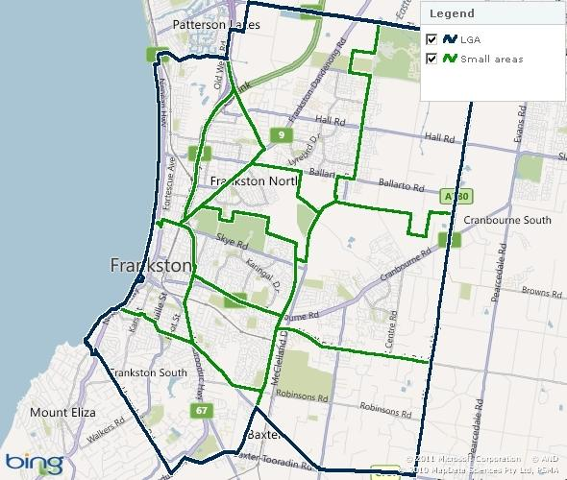

Map: Small areas within the City of Frankston
The VEC first considered an unsubdivided structure, under which all the voters would vote for all the candidates for Council, and the councillors would directly represent the entire municipality instead of a specific ward. Commonly cited advantages of this structure are that it gives voters a wide choice of candidates and councillors, and it encourages councillors to take a municipality-wide view of issues.
The main obstacle to an unsubdivided structure for Frankston is related to the width of choice for voters. The Local Government Act requires voters to number every square on the ballot paper. It can be a difficult task to number all the squares correctly on a long ballot paper. A VEC study of the 2008 local government elections revealed that the more candidates there are, the higher the informal vote tends to be, and that this effect is particularly marked where there are more than 15 candidates.
The number of candidates under Frankston’s current structure has averaged around ten per ward, and informal voting rate has been only slightly above the overall rate for elections conducted by post. Even so, there has been a strong positive correlation (.735201158) between the number of candidates for a ward and the informal vote. If voters had to vote for 30 candidates for the entire municipality, the informal voting rate could be much worse. A structure that would inflate the informal vote would not be compatible with fair and equitable representation. As well, the necessity to campaign across such a wide area could be seen as unfair to candidates with limited resources. The VEC therefore did not recommend an unsubdivided structure for Frankston City Council.
Frankston City Council’s previous electoral structure comprised single-councillor wards. However, there was no call for a return to single-councillor wards. Because of the varying sizes of suburbs, the ward boundaries would probably cut across communities of interest. Enrolments for the wards would be vulnerable to deviating beyond the 10 per cent tolerance, which would require a subdivision review before the next scheduled electoral representation review was due. The VEC did not put forward a single-councillor ward option.
Both submissions strongly supported multi-councillor wards on grounds of equity, parity, diversity of representation and representation of communities of interest. The current wards have very clear boundaries, and group the broad communities of interest within the municipality. However, these boundaries are no longer viable. Growth in the east has put enrolments for two of the three wards outside the 10 per cent tolerance. On the current boundaries, enrolment for the East Ward is forecast to blow out to more than 24 per cent above the average by 2021, while enrolments for the South-West Ward would shrink to more than 15 per cent below the average. Major changes are required to achieve a ward structure that will meet legislative provisions now and into the future. The VEC put forward three options.
A different configuration of wards
The outstanding feature of the VEC’s preferred option was the creation of a Coastal Ward, stretching the length of the City’s coastline from Seaford to Frankston South. Coastal issues are common to the whole of the ward. Highways, a freeway and a railway tied the ward together, and it had clear boundaries. The ward coincided almost exactly with the Council’s small areas of Frankston Central, Frankston North and Seaford (West).
The rest of the City would be taken up by the North-East and South-East Wards, created by splitting the current East Ward, and joining the two halves with adjacent parts of the current North-West and South-West Wards. This configuration can be justified on community of interest grounds. Although the current East Ward has the common element that it is growing, there is a substantial gap between Langwarrin in the south and Skye and Carrum Downs in the north, with only a couple of roads linking the two areas. In the north, Carrum Downs has strong connections with Frankston North and the eastern part of Seaford, along the Frankston-Dandenong Road. Similarly, in the south, there are links between the eastern part of the suburb of Frankston and Langwarrin along Cranbourne-Frankston and Robinsons Roads. There was a readily identifiable boundary between the two eastern wards, in most places coinciding with suburb boundaries.
Changes to the current boundaries
Option B was based on the current boundaries, with no change to the North-West Ward. The current South-West Ward was expanded to the east to include Langwarrin South and part of Langwarrin, and renamed the South Ward. This was a minimal change option, and the new boundary (along Cranbourne-Frankston, Warrandyte and North Roads) was clear. However, this option split the suburb of Langwarrin, and there was some risk that the North-East Ward would grow beyond the 10 per cent threshold before the next review.
A four-ward model
Under Option C, the municipality would be divided into quadrants. The North-West Ward would retain three councillors, and would take in Frankston’s central business district, while the other wards would have two councillors each. In a very general sense, this option was based on the current model while recognising the distinction between the south and the north of the current East Ward. There were two difficulties with this model. Firstly, the ward boundaries in the suburb of Frankston largely followed residential streets, splitting communities of interest. Secondly, two-councillor wards may not provide as much scope for diversity of representation as three-councillor wards.

Option A (Preferred Option)
That Frankston City Council consist of nine councillors, to be elected from three three-councillor wards, with a different configuration of wards from the current boundaries.

Option B (Alternative Option)
That Frankston City Council consist of nine councillors, to be elected from three three-councillor wards, with changes to the current ward boundaries.

Option C (Alternative Option)
That Frankston City Council consist of nine councillors, to be elected from one three-councillor ward and three two-councillor wards.

Public response

Response submissions
Response submissions on the Electoral Representation Review of Frankston City Council opened on 5 September 2011 and closed at 5.00pm on Monday,
3 October 2011. Twenty response submissions were received. Table 1 shows the levels of support for each option based on the preferences expressed in each response submission.
Table 1: Preferences expressed in response submissions for each option

Option A | Option B | Option C | Other
5 | 11 | 5 | 1
Note: The Council submission favoured both Options B and C, and the Proportional Representation Society’s submission favoured both Options B and C. These submissions have been counted twice in the table.

Analysis of submissions
Eleven of the 20 submissions came from Frankston, five from Frankston South, and one each from Carrum downs, Frankston North, Seaford and Beaumaris. Four of the submissions were by councillors (including the Council’s submission, signed by the Mayor), four were lodged on behalf of organisations, and the remainder were by members of the public.
All the submissions accepted that Frankston should have nine councillors, and all but one thought that there should be multi-councillor wards.
Although five submissions supported Option A, only one (by Cr Colin Hampton) went into any detail. Cr Hampton considered that Option A best addressed communities of interest. He stated that Carrum Downs and Seaford (east of the freeway) in the proposed North-East Ward had strong ties in schools, recreation and commerce, and the proposed South-East Ward consolidated Langwarrin with an area of Frankston that had a community of interest with it. In his opinion, the proposed Coastal Ward was ideal as it consolidated the coastal areas into one ward, which would give the councillors of that ward a focus on the problems associated with climate change.
This was the very reason why many submissions opposed Option A. They argued that the three councillors of the Coastal Ward, covering Frankston’s Central Activities Area (CAA) and entire coastline, would have to deal with the biggest issues of the municipality, and garner support on these issues from the other six councillors. The Coastal Ward councillors would be overburdened, and decision making and representation would suffer. As well, submissions contended that the Coastal Ward would group three communities (Seaford, the CAA and Frankston South) which were very different from each other in socio-economic terms and would be incompatible. Cr Aitken’s submission also pointed out that Option A would split the community of Seaford.
Eleven submissions favoured Option B, though some suggested modifications. The main reason given was that, under this option, six councillors would be directly concerned with the CAA and the coastline. As well, Option B was a minimal change option.
Five submissions preferred Option C, mainly on the ground that the four-ward model would best fit community of interests. Cr Aitken opposed Option B because it split Langwarrin, while Cr Richards thought that under Option B the South Ward councillors would be overloaded trying to represent a ward almost doubled in size. The Proportional Representation Society opposed Option C because in the Society’s view it would create three ‘stalemate’ wards, in which a majority of votes would not be reflected in the election results.
Several submitters suggested modifications connected with Frankston’s CAA, to maximise the number of councillors representing central Frankston. Some submitters suggested changes to ward boundaries within the CAA, while the Long Island Residents Group suggested that CAA voters be given the option of voting for either North or South Ward councillors.
Mr Warwick Exton rejected all the options in the Preliminary Report, putting forward instead a model of a North, a Central and a South Ward.
A list of submitters, by name, is available in Appendix 1. Copies of the submissions can be viewed on the VEC website at vec.vic.gov.au.

Public hearing
A public hearing was held at 6.30 pm on Tuesday, 11 October 2011 at the Council Chambers, Frankston Civic Centre, 30 Davey Street, Frankston. Everyone who made a submission in response to the report was invited to speak to their submissions and eight individuals accepted. Members of the public were invited to attend and 13 people, including the speakers, were present.
Speakers expressed a wide variety of views. They generally expanded on their submission, and also provided valuable information about communities and issues in the City of Frankston.

Findings and Recommendation
All submitters and speakers accepted that Frankston should have nine councillors, and nearly all supported a multi-councillor ward structure. Mr Peter Anscombe at the public hearing praised the 2004 change from seven single-councillor wards to three three-councillor wards, and felt that the current electoral structure was working well. Ms Hilary Poad, who spoke for the Long Island Residents Group, recalled that in the past when there were single-councillor wards, there could be situations of only one or two councillors versus the rest, whereas now the Council was more representative.
One submitter, Mr John Killian, expressed a preference for single-councillor wards. He stated that rural landowners were an ignored minority, and had no chance of electing a representative under the three-councillor ward model. The current structure did not provide fair and equitable representation to rural landowners nor represent their community of interest. He felt that a single-ward councillor would provide a better service to the rural zone and accept the ownership of the landowners’ needs.
It should be noted that the total number of voters in the rural areas of Frankston is 819. This is less than 8 per cent of the number of voters in a single-councillor ward. Rural landowners would be a small minority under any electoral structure, and there is no evidence that they would be better represented with single-councillor wards.
Mr Warwick Exton proposed a different model comprising three-councillor North, Central and South wards, and suggested boundaries for these wards. The VEC tested this model and discovered that it was unworkable because enrolments for two of the three wards were well outside the acceptable 10 per cent deviation from the average.
The three options put forward in the Preliminary Report all have the capacity to provide fair and equitable representation for the voters of Frankston, and all received a degree of support in submissions and the public hearing. Each option complies with the legislative requirement that the number of voters represented by each councillor must be within 10 per cent of the average for the municipality. This numbers requirement overrides the principle of representing communities of interest, and in each option a community of interest is unavoidably split. Public responses to the review revealed that there are different ways of construing communities of interest, all of which are valid to a degree.
One of the key matters considered in the review is how to deal with Frankston’s Central Activities Area (CAA). Although it is small in area and only 180 voters are enrolled there, the CAA is the heart of the municipality. The CAA is the centre of commerce, of transport, of governance and of education for the whole of the City of Frankston. Important redevelopment is taking place in the CAA, where, as the Council submission stated, ‘There is also a significant number of dilapidated buildings and vacant buildings ... which is of increasing concern to Council and to our community’. Many submitters and speakers stated that all councillors were keenly interested and involved in the CAA, regardless of their ward. Currently the CAA is in the South-West Ward, though the North-West Ward begins at the northern edge of the CAA. The Long Island Residents Group proposed that voters in the CAA should be able to choose whether to vote for the North Ward or the South Ward, which is impossible under current legislation. A couple of submitters suggested that the CAA be split between wards. However, all of the VEC’s options allocated the CAA to a single ward. The VEC considers that an arbitrary splitting of the CAA would be confusing for residents and businesses.
The VEC’s Option A was a complete reconfiguration of the wards, with every voter placed in a different ward from at present. Attention focused on the proposed Coastal Ward. Cr Colin Hampton (East Ward), the longest serving councillor, believed that the great virtue of this option was its simplicity. In his view, the option kept most communities of interest together; the only split community was Seaford, and he contended that there the Frankston Freeway was a clear divider, with the part of Seaford east of the freeway and in the proposed North-East Ward looking toward Carrum Downs. Cr Hampton thought it was sensible to have the entire coastline in one Coastal Ward, because the councillors for the ward would be able to focus on climate change issues.
Most submitters opposed Option A because the Coastal Ward contained too much. Representatives of coastal groups argued that coastal matters were diverse and urgent enough to need the attention of the councillors from two wards. In the north, the Seaford foreshore had a State Significance rating, the Seaford Wetlands were listed on the Register of the National Estate, and Kananook Creek needed to be restored; in the centre there was a proposed marina and other possible developments of the Frankston foreshore, and in south there were issues of collapsing cliffs and protection of coastal remnant vegetation. Along the whole coastline there was the threat of storm surges and flooding associated with climate change. Ms Gillian Collins was concerned that under Option A, the two inland wards would be disengaged from the coast even though they had a vital stake in what happened there. The Coastal Ward would also be socially disparate, comprising lower income areas in Seaford, the CAA and all its challenges, and the most affluent part of the municipality in Frankston South. Submitters feared that the three councillors of Coastal Ward would be so overloaded in dealing with the issues of their ward and discussing them with the other six councillors that their ability to represent their constituents would suffer.
Of course, all councillors are required to act in the best interests of the people of the municipality as a whole. Nevertheless, councillors will inevitably be more familiar with the issues and people of their own ward. The variety and scale of the issues to be covered by the proposed Coastal Ward suggested that this is not the best model of representation for the voters of Frankston.
In contrast to Option A, Option B was a minimal change option. The only substantial change was to extend the South-West Ward to the eastern boundary of the municipality and to rename it the South Ward. Under this option, only 4,325 voters (4.5 per cent of the total) would be transferred from one ward to another.
Cr Christine Richards of the South-West Ward had concerns that Option B would almost double the area of her ward, and that the increase in the councillors’ workload would lower the standards of representation they could offer to residents. In fact, the number of voters in the new South Ward would be similar to that in the other wards. Still, the addition of new communities would be likely to increase the demands on councillors.
The main difficulty with Option B is the fact that it splits Langwarrin, with part in the new South Ward and the majority remaining in the North-East Ward. Cr Glen Aitken at the public hearing stated that Langwarrin had a strong sense of community, but had always felt on the edge – first of the Shire of Cranbourne and now of the City of Frankston. Ms Hilary Poad of the Long Island Residents Group felt that dividing the area might double its representation. However, the risk is that Langwarrin would be a minority in both wards, and that residents would be confused about which ward they belonged to.
Under Option C, the current East Ward would be divided into the North-East Ward based on Carrum Downs and the South-East Ward based on Langwarrin, while the boundary between the North-West and South-West Wards would be modified. A total of 44,040 voters would be placed in different wards under this option. Don and Denise Tremills were pleased that under Option C two councillors would be able to focus their attention on the particular needs of Frankston South. Cr Aitken considered that Option C was:
certainly the better option in that it keeps the various communities throughout our city more cohesive. Langwarrin is clearly represented in a ward of its own which the people of Langwarrin would welcome. Carrum Downs and Skye are clearly identified as communities of interest, ... the North West Ward keeps Seaford, Karingal and the Pines together whilst it also embraces part of Frankston town centre and South West Ward retains largely its identity and also shares the remainder of Frankston town centre.
On the other hand, Option C splits the suburb of Frankston, with ward boundaries running along residential streets and the edge of a golf club in a puzzling way. Moreover, Option C changes a model of representation that appears to have worked well. Instead of three equally sized wards, there would be three smaller wards and one larger ward. Voters in the two-councillor wards would not have the same opportunity for diverse representation as they do now, and there could be a perception of inequality between the smaller and larger wards.
Thus each of the options broadly complies with communities of interest, while each divides a community – Seaford in Option A, Langwarrin in Option B, and Frankston in Option C. The VEC considers that on balance Option B is the best available. Despite the splitting of Langwarrin, Option B generally follows communities of interest, and maintains an electoral structure that appears to have worked well and under which all voters are in the same position. Option A completely reconfigures the wards, and creates a Coastal Ward that is arguably too disparate and overloaded with issues for good representation. Option C changes the electoral structure to end equality among wards, for insufficient reason.

Recommendation
The Victorian Electoral Commission (VEC) recommends that Frankston City Council consists of nine councillors, to be elected from three three-councillor wards, with changes to the current ward boundaries and changing the name of the current South-West Ward to South Ward.
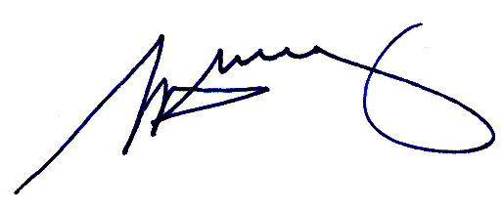
S. H. Tully
Electoral Commissioner

Appendix 1: List of submitters
Preliminary submissions were received from:
Name
Leonard, Samantha
Proportional Representation Society of Australia (Victoria-Tasmania) Inc.

Response submissions were received from:
Name
Aitken, Glen*
Anscombe, Peter*
Collins, Gillian*
Cross, David (for Frankston Environmental Friends Network)*
Exton, Warwick
Frankston Beach Association Inc.
Frankston City Council
Hampton, Colin*
Hassell, George and Kathleen
Hattingh, Jennifer
Killian, John
Leonard, Samantha
Long Island Residents Group Inc.*
Noonan, Mary
Proportional Representation Society of Australia (Victoria-Tasmania) Inc.
Richards, Christine*
Rogers, Dave
Tiller, Simon*
Tremills, Don and Denise
Welsh, Joyce and Simon
* indicates those submitters who spoke in support of their submission at the public hearing.

Appendix 2: Map

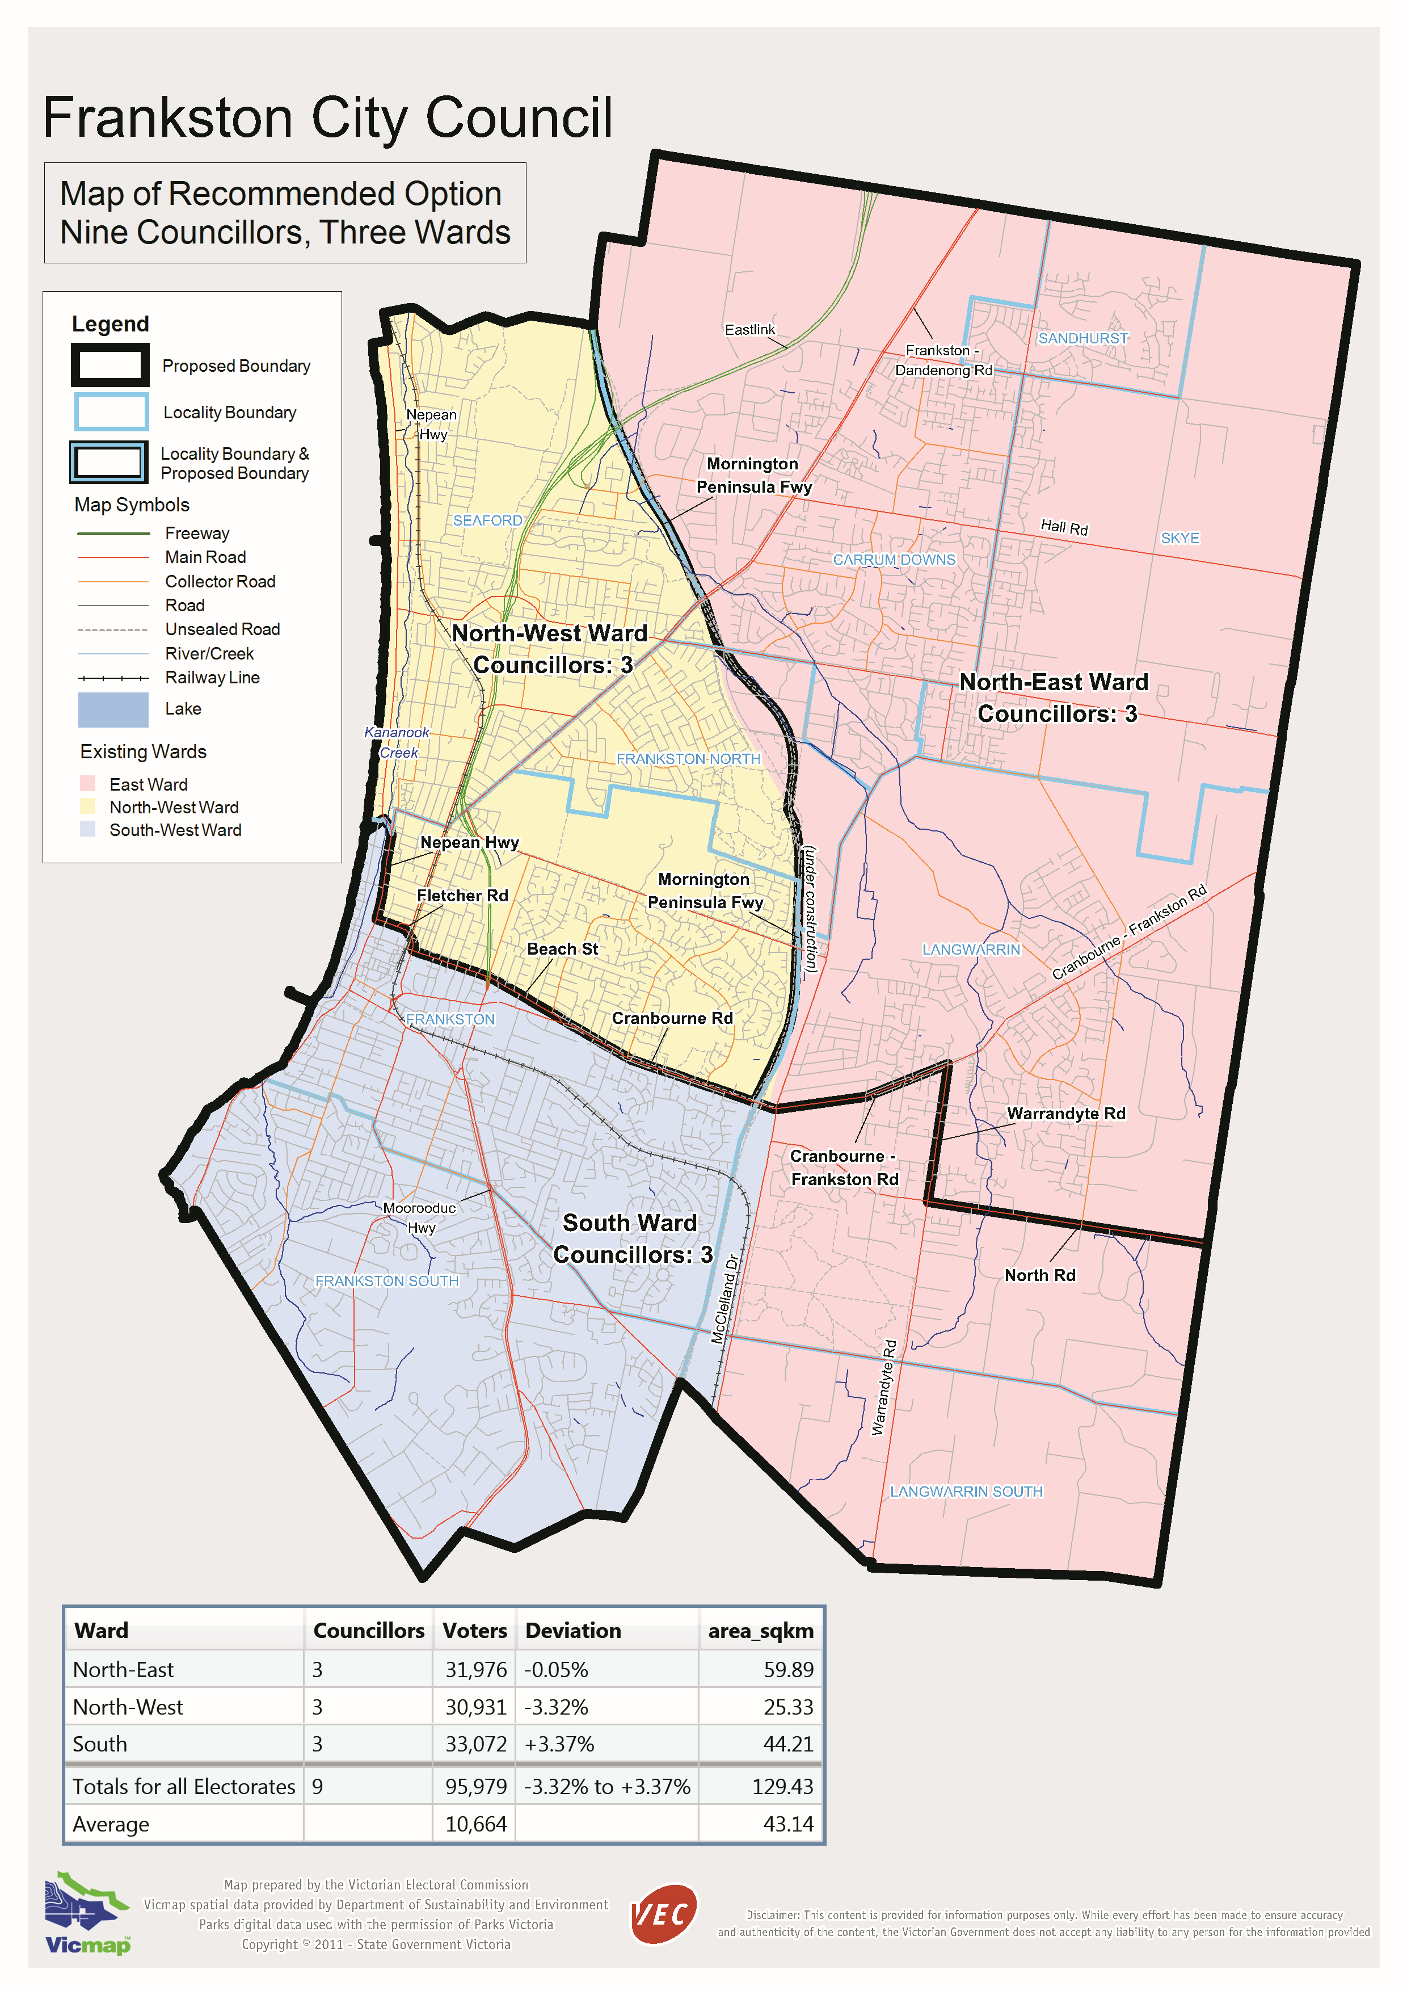

Victorian Electoral Commission
Level 11, 530 Collins Street
Melbourne, Vic 3000

131 VEC (131 832)
frankston.review@vec.vic.gov.au
vec.vic.gov.au

Section 219D of the Local Government Act 1989.
An electoral subdivision review, which can only look at adjusting ward boundaries, was conducted by the VEC in 2008. The subdivision review recommended no changes to the boundaries.
Frankston Community Profile, downloaded from Frankston City Council website, 31 August 2011.
Victorian Electoral Commission: Report of local government electoral activity 2008-09, Part 1, Report of the conduct of the 2008 local government elections, pp. 41-42.
The boundary between the North-West and the North-East Wards was slightly adjusted to follow the Mornington Peninsula Freeway reservation, but this did not involve any voters.

