Local council electoral structure review

## About the review

Under Victoria’s *Local Government Act 2020*, Wodonga City Council must now have a single-councillor ward electoral structure.

The Minister for Local Government has appointed an electoral representation advisory panel to conduct an electoral structure review of the council. The panel will advise the Minister on the most appropriate single-councillor ward structure for Wodonga City Council.

The panel is looking at:

* the appropriate number of councillors and wards
* the location of ward boundaries
* appropriate ward names.

Electoral structure reviews are an important part of democracy, and your input is valuable. As a local, you know your local council area better than anyone. This is your chance to let the panel know your thoughts about the single-councillor ward electoral structure that you believe would best provide representation for your community.

There are 2 opportunities for you to have your say on the electoral structure of the council:

1. in a response submission to the preliminary report
2. in an online public hearing, if you request to speak in your response submission.

About Wodonga City Council

While there are no formally recognised Traditional Custodian groups for the land in Wodonga City Council, the council recognises the connection Aboriginal peoples have to the land and engages with Aboriginal communities.

Wodonga City Council is in north-eastern Victoria on the New South Wales border, about 300 km from Melbourne. The Murray River and Lake Hume form the northern and western boundaries of the council. Covering about 433 km², the council area includes the main population centre of Wodonga and significant rural hinterland.

Agriculture, including grazing and dairy farming, are the main rural land uses. Health care, public administration, and retail trade are the top employment sectors in the council, accounting for almost 40% of jobs.

At the 2021 Census, Wodonga City Council had a population of 43,253, having grown by an average of 2.2% each year since 2011. The median age of the population was 38 years, lower than the median of 43 years for rural and regional Victoria overall.

People born in Australia made up 83.6% of the population, compared to 81% of regional Victoria. 88.1% of residents spoke only English at home, compared to 86% in rural & regional Victoria.

The weekly median household income in Wodonga City Council was $1,498 in 2021, above the regional Victoria median of $1,386.

## Current structure

Wodonga City Council is unsubdivided with a total of 7 councillors.

## Last review

The VEC conducted an electoral representation review of Wodonga City Council in 2015.

Visit the VEC website at [vec.vic.gov.au](https://www.vec.vic.gov.au/electoral-boundaries/local-councils/wodonga-city-council) to access a copy of the 2015 review final report.

Review process

Monday 3 and Tuesday 4 July

### Information sessions

Session 1: 12 noon, Monday 3 July

Session 2: 6 pm, Tuesday 4 July

Information sessions are for anyone wanting to find out more about the review process. Links to register for an information session will be available on the VEC website.

Wednesday 5 July

### Preliminary report

The panel will release a preliminary report including one or more options for the electoral structure on Wednesday 5 July.

**Response submissions open from this date.**

Wednesday 26 July

### Response submission close

The panel must receive all submissions by   
5 pm on Wednesday 26 July.

Late submissions will not be accepted.

Wednesday 2 August

### Public hearing

The panel will hold an online public hearing if anyone requests to speak about their response submission at 2 pm on Wednesday   
2 August.

The public hearing will not be held if there are no requests to speak.

Wednesday 30 August

### Final report

The review panel will submit a final report to the Minister for Local Government, including its advice on the electoral structure, on Wednesday 30 August.

The Minister will then consider the panel’s advice before recommending a change to the electoral structure. Any change to the electoral structure of the council following the review is expected to apply at the next local council elections.

## Untitled-1How to make a submission

On the VEC website at [vec.vic.gov.au](http://vec.vic.gov.au/)

By email to

[Wodonga.ERAPSubmissions  
@vec.vic.gov.au](mailto:Wodonga.ERAPSubmissions@vec.vic.gov.au)

LetterBy post to

Electoral representation advisory panel  
c/o Victorian Electoral Commission  
Level 11, 530 Collins Street  
Melbourne VIC 3000

Submissions must include your:

* full name
* contact phone number or email address
* residential or postal address.

All submissions will be published on the VEC website. Your name and locality (suburb or town) will be published, but your full address and contact details will be removed. See the submission guide and VEC website at [vec.vic.gov.au/privacy](https://www.vec.vic.gov.au/privacy) for privacy information.

## Submission guide

Download the submission guide from the VEC website at [vec.vic.gov.au](http://vec.vic.gov.au/) for more information on the review process and making a submission.

## One vote, one value

The ‘one vote, one value’ democratic principle is enshrined in the *Local Government Act 2020*. This means that every person’s vote counts equally.

When a local council area is subdivided into wards, the number of voters each councillor represents in each ward must be within plus-or-minus 10% of the of the average number of voters per councillor for all the wards.

The map below includes the current number of voters in each ward and the ward’s current deviation from the average. The panel will consider likely population and voter changes to ensure the structure remains equitable.

If you make a submission online, you can use a mapping tool to build your preferred electoral structure. The tool uses current voter numbers to tell you the deviations of the wards you make. This will help you propose a structure that meets the requirements of the Act.

Current electoral structure

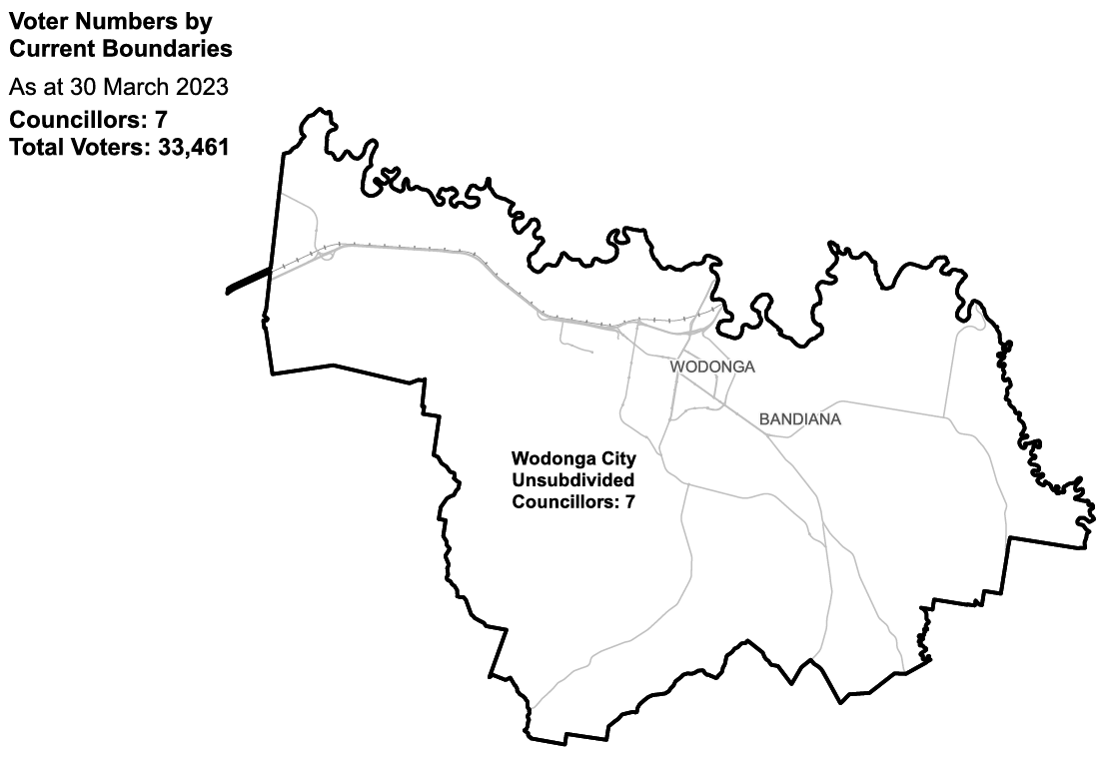

|  |  |  |  |
| --- | --- | --- | --- |
| Ward | Councillors | Voters | Deviation |
| Unsubdivided | 7 | 33,461 | n/a |

## Statistics

Area (km2) 433

Voters

### Voters per square km

77.3

### Average voters per councillor

4,780

Population

### Current population

43,253

### Forecast population growth

1.7% p.a.

Further census statistics available at [abs.gov.au](http://abs.gov.au)

Voter numbers by locality (map)

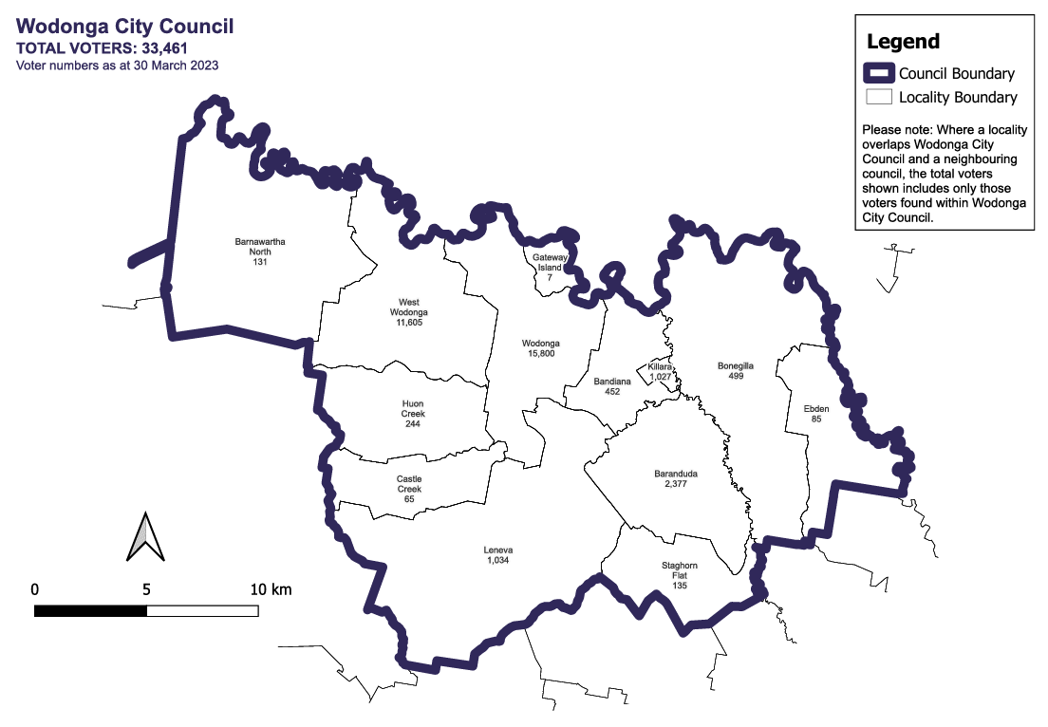

Voter numbers by locality (table)

## Wodonga City Council voter numbers at 30 March 2023

|  |  |
| --- | --- |
| Locality | Voters |
| Bandiana | 452 |
| Baranduda | 2,377 |
| Barnawartha North | 131 |
| Bonegilla | 499 |
| Castle Creek | 65 |
| Ebden | 85 |
| Gateway Island | 7 |
| Huon Creek | 244 |
| Killara | 1,027 |
| Leneva | 1,034 |
| Staghorn Flat | 135 |
| West Wodonga | 11,605 |
| Wodonga | 15,800 |