Local council electoral structure review

## About the review

Under Victoria’s *Local Government Act 2020*, Merri-bek City Council must now have a single-councillor ward electoral structure.

The Minister for Local Government has appointed an electoral representation advisory panel to review the electoral structure of   
Merri-bek City Council and advise on the most appropriate single-councillor ward structure.

The panel is looking at:

* the appropriate number of councillors and wards
* the location of ward boundaries
* appropriate ward names.

Electoral structure reviews are an important part of democracy and your input is valuable. As a local, you know your council area better than anyone. This is your chance to tell the panel your thoughts about the single-councillor ward structure you believe would best provide representation for your community.

You can have your say:

1. in a response submission to the preliminary report
2. at an online public hearing, if you ask to speak in your response submission.

About Merri-bek City Council

The Traditional Custodians of the land in Merri-bek City Council are the Wurundjeri people.

Merri-bek City Council is about 4 km north of the Melbourne CBD. It covers an area of   
51 km2 and in 2021 was home to 171,357 people. The population will likely exceed 250,000 by 2036, with over half of this growth expected in Brunswick, Brunswick East and Coburg, driven by higher density living. It is expected that over 50% of new households will have 2 or fewer occupants.

Significant and recent housing developments have occurred in and around the Pentridge Prison site and there will be continued growth along major transport corridors, such as Lygon Street in Brunswick and parts of Sydney Road.

The council area is heavily urbanised, with most land zoned for residential, industrial, and commercial use. About 15% of the land is open space. The Merri and Moonee Ponds creeks are significant waterways, marking the east and west boundaries respectively.

Merri-bek is culturally diverse. About 33% of residents were born outside of Australia, and 31% of households used a language other than English at home in 2021.

In 2022 the council changed its name from Moreland to Merri-bek.

## Current structure

Merri-bek City Council is divided into 3 wards with a total of 11 councillors:

* 2 wards with 4 councillors each
* one ward with 3 councillors.

## Last review

The VEC conducted an electoral representation review of Merri-bek City Council in 2011.

Visit the VEC website at [vec.vic.gov.au](https://www.vec.vic.gov.au/) to access a copy of the 2011 review final report.

Review process

Monday 16 and Tuesday 17 October

### Information sessions

Session 1: 12 noon, Monday 16 October

Session 2: 6 pm, Tuesday 17 October

These sessions will give you more information about the review process. You will be able to register for a session on the VEC website.

Wednesday 18 October

### Preliminary report

The panel will release a preliminary report with one or more options for the electoral structure on Wednesday 18 October.

**You can make a response submission from this date.**

Wednesday 8 November

### Response submissions

The panel must receive your submission by   
5 pm on Wednesday 8 November.

The panel will not accept late submissions.

Tuesday 14 November

### Public hearing

The panel will hold an online public hearing if anyone asks to speak about their response submission at 10 am on Tuesday 14 November.

The public hearing will not be held if no one asks to speak.

Wednesday 13 December

### Final report

The panel will submit a final report to the Minister for Local Government including its advice for the electoral structure on Wednesday 13 December.

The minister will consider the panel’s advice before recommending a change to the electoral structure. Any change is expected to apply at the next local council general election.

## Submission guide

You can download a submission guide from the VEC website at [vec.vic.gov.au](http://vec.vic.gov.au/)

## How to make a submission Untitled-1

On the VEC website at [vec.vic.gov.au](http://vec.vic.gov.au/)

By email to:

[Merri-bek.ERAPSubmissions@ vec.vic.gov.au](mailto:Merri-bek.ERAPSubmissions@vec.vic.gov.au)

LetterBy post to:

Electoral representation advisory panel  
c/o Victorian Electoral Commission  
Level 11, 530 Collins St  
Melbourne VIC 3000

Submissions must include your:

* full name
* contact phone number or email address
* residential or postal address.

Your submission will be published on the VEC website, including your name and suburb or town but not your full address or contact details. See the submission guide or VEC website at [vec.vic.gov.au/privacy](https://www.vec.vic.gov.au/privacy) for privacy information.

## One vote, one value

The ‘one vote, one value’ democratic principle is enshrined in the *Local Government Act 2020*. This means every person’s vote counts equally.

When a local council is subdivided into wards, the number of voters each councillor represents in each ward must be plus-or-minus 10% of the average number of voters per councillor for all wards.

The map below includes the current number of voters in each ward and the ward’s current deviation from the average. The panel will consider likely population and voter changes to ensure the structure remains equitable.

If you make a submission online, you can use a mapping tool to build your preferred electoral structure. The tool uses current voter numbers to tell you the deviations of the wards you make. This will help you propose a structure that meets the requirements of the Act.

Current electoral structure

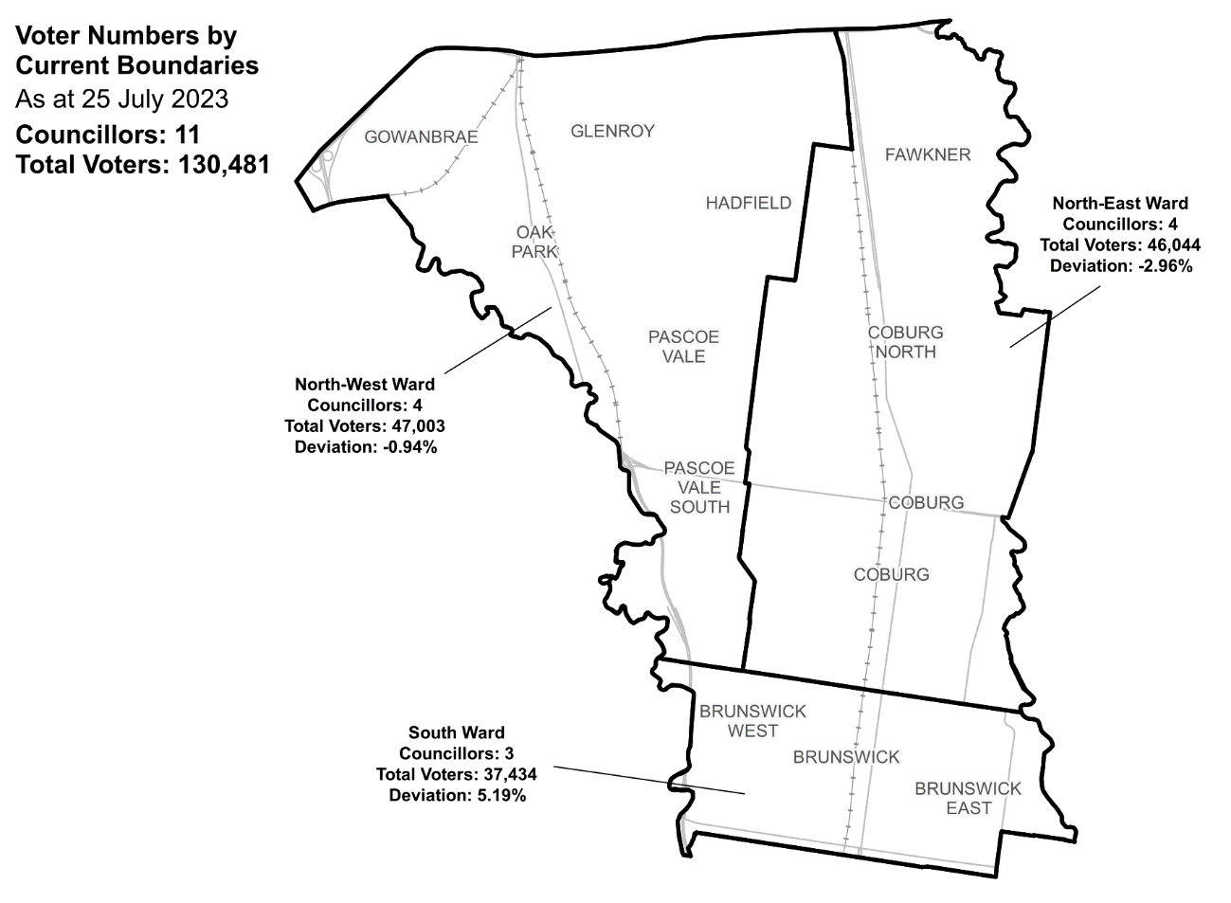

|  |  |  |  |
| --- | --- | --- | --- |
| Ward | Councillors | Voters | Deviation |
| North-East Ward | 4 | 46,044 | -2.96% |
| North-West Ward | 4 | 47,003 | -0.94% |
| South Ward | 3 | 37,434 | +5.19% |

## Statistics

Area (km2) 51

Voters

### Voters per square km

2,559

### Average voters per councillor

11,861

Population

### Current population

171,357

### Forecast population growth

1.4% p.a.

More Census statistics available at [abs.gov.au](https://www.abs.gov.au/census/find-census-data/search-by-area)

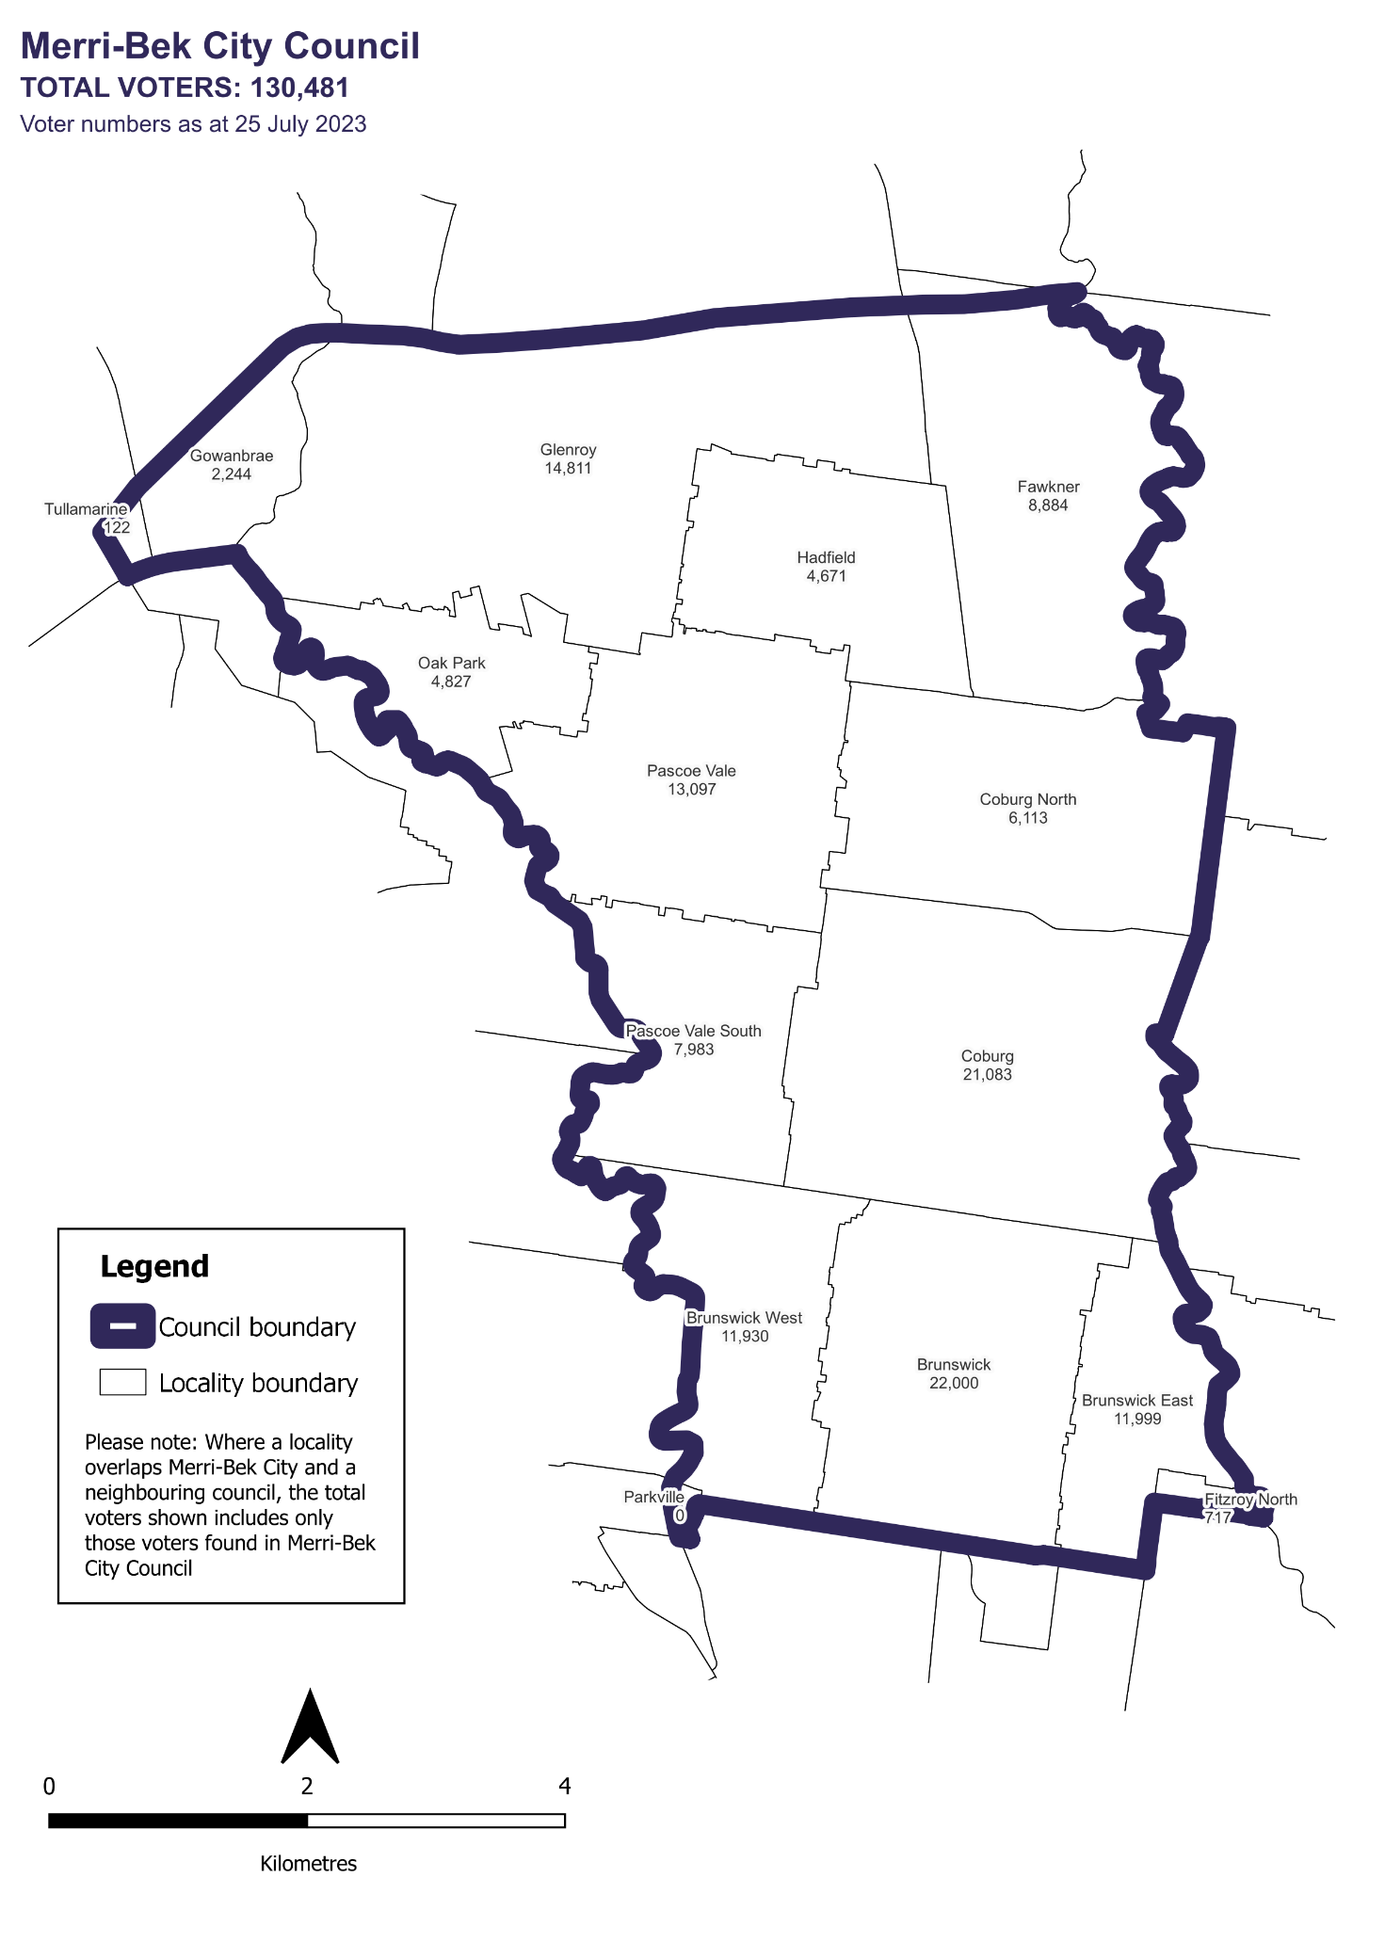Voter numbers by locality (map)

## Voter numbers by locality (table)

|  |  |
| --- | --- |
| Locality | Voters |
| Brunswick | 22,000 |
| Brunswick East | 11,999 |
| Brunswick West | 11,930 |
| Coburg | 21,083 |
| Coburg North | 6,113 |
| Fawkner | 8,884 |
| Fitzroy North | 717 |
| Glenroy | 14,811 |
| Gowanbrae | 2,244 |
| Hadfield | 4,671 |
| Oak Park | 4,827 |
| Parkville | 0 |
| Pascoe Vale | 13,097 |
| Pascoe Vale South | 7,983 |
| Tullamarine | 122 |

## Merri-bek City Council voter numbers at 25 July 2023