Local council electoral structure review

March 2023

Central Goldfields Shire Council

Preliminary   
Report

Acknowledgement of Country

The electoral representation advisory panel acknowledges the Dja Dja Wurrung people as the Traditional Custodians of the lands and waters on which it is holding this review and pays respects to ancestors and Elders past, present and emerging. The panel acknowledges their custodianship for many thousands of years and their continuing living culture.

Document history and version control

|  |  |  |  |
| --- | --- | --- | --- |
| **Version** | **Date approved** | **Approved for publication by** | **Brief description** |
| 1 | 27 March 2023 | Electoral Commissioner | Final version |

# Contents

Executive summary 4

Developing electoral structure models 4

Preliminary submissions 4

Electoral structure options 4

Next steps 4

Background 5

About the 2023–24 electoral structure reviews 5

The electoral representation advisory panel 5

Public engagement 6

Developing recommendations 6

About Central Goldfields Shire Council 9

Profile 9

Current number of councillors and electoral structure 10

Last electoral structure review 10

Preliminary submissions 11

Number of councillors 11

Electoral structure 12

Preliminary findings and options 14

Number of councillors 14

Electoral structure 15

Models for public feedback 18

Next steps 19

Response submissions 19

Public hearing 20

Final report 20

References 21

Appendix 1: Model maps 22

Appendix 2: List of preliminary submitters 26

# Executive summary

An independent electoral structure review panel appointed by the Minister for Local Government has reviewed the structure of Central Goldfields Shire Council.

The panel looked at:

* + whether the council had an appropriate number of councillors
  + whether it should be unsubdivided or subdivided.

This report outlines the preliminary models that the panel is presenting for the proposed new electoral structure of Central Goldfields Shire Council to meet the requirements of Victoria’s *Local Government Act 2020* (the Act). More information about the background to the reviews is available on page 5.

## Developing electoral structure models

The panel considered a range of factors when deciding on the models in this report, including:

* + research and analysis
  + voter growth or decline over time
  + public submissions (see below).

More information on the way the panel decided on the models is available on page 6.

## Preliminary submissions

The panel received 3 preliminary submissions. Of these, 1 submission included a map. A full analysis of submissions received can be found on page 11.

## Electoral structure options

After considering submissions and research, the panel is presenting the following electoral structure models for further public consultation:

* Model 1: an unsubdivided electoral structure with 7 councillors.
* Model 2: a subdivided electoral structure with a total of 6 councillors – 3 wards and 2 councillors per ward.
* Model 3: a subdivided electoral structure with a total of 7 councillors – 7 wards and one councillor per ward.

Details on these models, including maps, are available in Appendix 1.

## Next steps

The panel is now seeking feedback on the electoral structure models. You can make a response submission to these models until 5 pm on Wednesday 19 April 2023.If any response submitters wish to speak at a public hearing, the panel will hold an online public hearing on Wednesday 26 April 2023. Following this, it will present its final recommendation to the minister by 24 May 2023. More information about the review process is available on the Victorian Electoral Commission (VEC) website at [vec.vic.gov.au](https://www.vec.vic.gov.au/)

# Background

## About the 2023–24 electoral structure reviews

In October 2022, the Minister for Local Government formed 2 electoral representation advisory panels to review the electoral structures of 39 local councils, under section 16 of the *Local Government Act 2020* (the Act). If the minister accepts the electoral structures the panels recommend, they will take effect at the October 2024 elections.

The Act introduced several changes to local government representation, including the types of electoral structures local councils may have. Large and small rural shire councils (including Central Goldfields) can have one of 3 electoral structures:

* unsubdivided (entire council area with no wards)
* single-councillor wards
* multi-councillor wards with the same number of councillors per ward.

For Central Goldfields Shire Council, the electoral representation advisory panel is examining:

* the number of councillors
* whether the council should be subdivided into wards or unsubdivided.

For subdivided structures, it is also examining:

* the number of wards
* where the ward boundaries should be
* the name of each ward
* how many councillors should be elected for each ward.

The Act requires electoral structures to provide fair and equitable representation and facilitate good governance. For subdivided structures, each ward must have an approximately equal number of voters per councillor (within +/-10% of the average).

## The electoral representation advisory panel

The panel conducting the electoral structure review of Central Goldfields Shire Council has 3 members:

* Ms Julie Eisenbise (Chairperson)
* Mr Tim Presnell
* Deputy Electoral Commissioner Ms Dana Fleming (Electoral Commissioner delegate).

The panel is independent of councils and the State government.

Under the Act, the VEC is not responsible for reviewing council electoral structures but must provide administrative and technical support to the panel. The Electoral Commissioner (or their delegate) must be a member of each panel.

## Public engagement

### Public information program

To educate and inform the public about the Central Goldfields Shire Council electoral structure review, the VEC began a public information program in mid-December 2022. The VEC:

* printed public notices in state-wide newspapers
* held public information sessions to outline the review process and respond to questions from the community
* sent out media releases to announce the start of the review
* published information on its social media channels
* provided updated website content on [vec.vic.gov.au](http://www.vec.vic.gov.au/), including:
  + information on the review process
  + submission guides and fact sheets for each council under review with background information
  + preliminary submissions from the public.

The VEC will continue to promote the review during the response submissions stage via media releases, the VEC’s social media channels and updated content on the VEC website.

### Public consultation

The panel encouraged public input to the review of Central Goldfields Shire Council via preliminary submissions at the start of the review. The panel now invites further input via:

* response submissions to this preliminary report
* an online public hearing to provide anyone who makes a response submission the opportunity to expand on their submission.

Public submissions are an important part of the review process but the panel also considers other factors during a review. These are outlined below.

## Developing recommendations

The panel’s electoral structure models presented in this preliminary report comply with the Act and were developed through careful consideration of:

* research and analysis conducted by the VEC support team, including geospatial and demographic factors
* rates or patterns of population and voter growth or decline over time, and relevant forecasts of growth or decline based on forecast information provided by .id (informed decisions, a company specialising in demographics and forecasting)
* input received from the public in written submissions during the preliminary submissions phase.

### Deciding on the number of councillors

The Act allows local councils to have between 5 and 12 councillors, but neither the Act nor the Local Government (Electoral) Regulations 2020 specify how to determine the number of councillors a council needs. Therefore, the models put forward by the panel in this report are guided by the Act’s intention for fairness and equity in voter representation.

In examining the number of councillors Central Goldfields Shire Council should have, the panel considered these factors:

* the population and number of voters in the council area, compared to other councils with a similar population size and number of voters in the same category (for example, metropolitan, interface, regional city, large rural shire, small rural shire)
* patterns of population change and voter growth or decline in the council area over time
* the current and past numbers of councillors
* the representation needs of the communities of interest in the council area
* if a particular type of electoral structure best suits the council (see ‘Deciding the electoral structure’ below)
* any matter raised in public submissions not already listed above.

Generally, local councils with a larger number of voters will have a higher number of councillors. Large populations are often more likely to have greater diversity, both in the type and number of communities of interest and issues relating to representation. However, the ideal number of councillors can also be influenced by the particular circumstances of a council, such as the:

* nature and complexity of services the council provides
* geographic size and topography of the area
* forecast population and voter growth or decline
* social diversity.

### Deciding the electoral structure

The electoral structure of large and small rural shire councils can be:

* unsubdivided (entire council area with no wards)
* made up of single-councillor wards

or

* made up of multi-councillor wards with the same number of councillors per ward.

When developing electoral structure models for Central Goldfields Shire Council, the panel considered these main criteria:

* whether the structure would comply with section 15(2) of the Act (see below), and for how long it would likely comply
* the appropriate number of councillors, as outlined above
* whether meaningful and effective ward boundaries can be established and whether these would be easily identifiable to local communities
* representation of communities of interest
* the voter distribution and physical features of the area, and the impact these may have on the shape and size of any wards
* past elections for the council, including:
* numbers of candidates nominating
* incidences of uncontested elections
* rates of informal voting.
* other matters raised in public submissions not already listed above.

Under section 15(2) of the Act, subdivided structures must aim for an approximately equal number of voters per councillor in each ward. This means the number of voters represented by each councillor in a ward should be within +/-10% of the average number of voters per councillor for all wards.

The panel recommends structures that will comply with section 15(2) at the October 2024 local council elections and uses current voter numbers and forecasts of population and voter change to assess this with as much accuracy as possible. In some cases, population changes and other factors mean it is not possible for a subdivided electoral structure to comply with section 15(2) based on current voter numbers. If this occurs, compliance at the 2024 local government elections will be the priority to ensure each vote has approximately equal value.

# About Central Goldfields Shire Council

## Profile

Central Goldfields Shire is located about 120 km north-west of Melbourne and is about one hour’s drive from the regional centres of Ballarat and Bendigo. The shire covers an area of 1,533 km2 and shares its borders with Loddon Shire Council to the north, Northern Grampians Shire Council to the northwest, Pyrenees Shire Council to the west, Hepburn Shire Council to the south and Mount Alexander Shire Council to the east.

The Traditional Custodians of the land in Central Goldfields Shire are the Dja Dja Wurrung people.

### Landscape

Within the shire there are large areas of land designated for conservation (Department of Transport and Planning, 2022), including Paddys Ranges State Park and several other large nature reserves. Ecologically significant Box-Ironbark forests surround Maryborough and cover large areas in the shire’s north and south. Other important features of the natural landscape are Mt Bealiba Range, Moolort Plains and Talbot’s volcanic rises.

Several creeks flow through the shire, including the Bet Bet, Tullaroop and McCallums Creeks. The Tullaroop and Cairn Curran Reservoirs are in the southeast, and the Avoca River forms part of the shire’s western boundary. These waterways traverse extensive farmland covering much of the rural area of the shire. This agricultural land is used mainly for cropping and beef and sheep raising (Department of Transport and Planning, 2022).

The shire has a population of 13,483 people (ABS, 2021a). Its largest town, Maryborough, is home to 7,769 people or almost 60% of the population (ABS, 2021a). It is the shire’s major business, health and administrative centre. Other major towns include nearby Carisbrook, Dunolly to the north and Talbot to the south. Approximately 27% of the population live in smaller communities and rural areas across the shire (ABS, 2021a).

The Pyrenees Highway runs east to west through Maryborough, located at the centre of the shire. Railway lines pass north-south and east-west through the shire carrying freight trains, as well as passenger trains from Melbourne to Talbot and Maryborough.

### Community

The shire has an older age profile compared to regional Victoria. The median age in Central Goldfields Shire is 52 (ABS, 2021a), higher than the regional Victorian median age of 43 (ABS, 2021b) and more than half of the population (53.6%) is aged over 50 years (ABS, 2021a). The population is forecast to grow at a rate of 0.7% annually from 2022 to 2028.

Of the population, 82.3% were born in Australia and 89.7% speak only English at home (ABS, 2021a). Aboriginal and Torres Strait Islander people represent 2.3% of the population (ABS, 2021a).

Manufacturing is the main industry in the shire, employing 12.2% of workers and accounting for 20.5% of economic output (REMPLAN, 2023). This includes sectors such as printing, publishing and food processing. Other major industries by employment include health care and social assistance (21.2% of workers), retail (12.4%), education and training (9.4%), accommodation and food services (7.5%) and agriculture (7%) (ABS, 2021a; REMPLAN, 2023).

In 2021, unemployment in the shire was 5.9%, higher than the average rate for regional Victoria (4.1%). Nearly half (49%) of population are not in the labour force, which is also above that for regional Victoria at 36.8%.

The median weekly household income is $904, lower than the regional Victorian median of $1,386 (ABS, 2021a; ABS, 2021b). At 46.8%, rates of home ownership in shire are higher than the rate of 39.3% for the rest of regional Victoria (ABS, 2021a; ABS, 2021b).

## Current number of councillors and electoral structure

Central Goldfields Shire Council is currently divided into 4 wards with a total of 7 councillors:

* one ward with 4 councillors (Maryborough Ward)
* 3 wards with one councillor each (Flynn, Paddys Ranges and Tullaroop).

There are approximately 11,329 voters in Central Goldfields Shire Council, with a ratio of 1,618 voters per councillor.

Visit the VEC website at [vec.vic.gov.au](http://www.vec.vic.gov.au/) for more information on Central Goldfields Shire Council.

## Last electoral structure review

The VEC conducted an electoral representation review of Central Goldfields Shire Council in 2011. This review complied with the *Local Government Act 1989*, which was replaced by the *Local Government Act 2020*.

After conducting the review, the VEC recommended that Central Goldfields Shire Council continue to consist of 7 councillors elected from four wards:

* one ward with 4 councillors
* 3 wards with one councillor each.

The VEC recommended that the boundaries of four wards be slightly adjusted.

Visit the VEC website at [vec.vic.gov.au](http://www.vec.vic.gov.au/) to access a copy of the 2011 representation review final report.

Before the 2011 review, the VEC held a representation review of Central Goldfields Shire Council in 2005. This resulted in the current electoral structure being implemented. Before the 2005 representation review, Central Goldfields Shire Council comprised five single-councillor wards.

# Preliminary submissions

The panel received 3 preliminary submissions from the public by the deadline of 5 pm on Wednesday 1 March 2023. You can view these submissions on the VEC website at [vec.vic.gov.au](https://www.vec.vic.gov.au/) and find a list of people or organisations who made a submission in Appendix 2.

The table below provides an overview of preferences in the preliminary submissions. You can read an analysis of submissions below this table.

|  |  |  |  |  |  |
| --- | --- | --- | --- | --- | --- |
|  | Unsubdivided structure | Single-councillor wards | Multi-councillor wards | Subdivided structure (unspecified) | No comment on structure |
| Fewer councillors | - | 1 | - | - | - |
| Maintain current councillor number | - | 1 | - | - | - |
| More councillors | - | - | 1 | - | - |
| No comment on number of councillors | - | - | - | - | - |

## Number of councillors

There was one submission in favour of maintaining 7 councillors, one that preferred decreasing the number of councillors to 5 and another proposing to increase the number to 8.

**Maintaining 7 councillors**

Central Goldfields Shire Council argued that 7 is an appropriate number of councillors in comparison to similar rural shires, particularly when considering the number of voters per councillor. The council stated that 7 councillors better facilitates ‘sustainable representation’ of the shire’s diverse and growing communities, all of which have different needs and socio-economic circumstances. The council’s submission identified these communities as urban Maryborough and the shire’s smaller rural townships and farming communities.

### Decreasing to 5 councillors

In a submission arguing against multi-councillor wards, Anne Doran suggested that the number of councillors should be reduced to 5 to facilitate a single-councillor ward structure similar in some ways to the current electoral structure.

**Increasing to 8 councillors**

In support of increasing councillor numbers, John Moyle argued that 8 councillors would allow for 4 councillors to represent Maryborough and 4 councillors to represent the rest of the shire. It was suggested that this would provide equal representation for these areas in that every voter would be able to elect the same number of councillors for their respective communities

The submission also suggested that having an equal number of councillors for Maryborough and for the rest of the shire was the fairest approach the best way to address community concerns of the shire’s rural areas having less of a say on the council than Maryborough.

## Electoral structure

Each of the 3 preliminary submissions received favoured a subdivided electoral structure. One of these supported a structure of 2 wards with four councillors in each ward, another was for 7 single-councillor wards, while the third did not outline a specific subdivided electoral structure. No submissions advocated for an unsubdivided electoral structure.

### Unsubdivided

Of submissions received, 2 argued against an unsubdivided structure for the following reasons. In an unsubdivided electoral structure, candidates and councillors from Maryborough would likely outnumber those from smaller towns and rural areas due to its large population and number of voters. Consequently, many felt issues specific to urban Maryborough might dominate council business, and relatedly councillor based in Maryborough would possibly dominate voting at council meetings. As such, one submitter suggested an unsubdivided structure was likely be very unpopular with voters outside Maryborough.

Central Goldfields Shire Council suggested in its submission that ballot papers would be larger in an unsubdivided structure due to more candidates standing for election, and this may confuse voters and increase informal voting rates.

### Multi-councillor wards

Moyle argued that an electoral structure consisting of 2 four-councillor wards would ensure fair representation for both urban Maryborough and for smaller townships and rural areas, as it would allow every voter in each ward the opportunity to vote for the same number of councillors to represent their interests.

### Single-councillor wards

Central Goldfields Shire Council put forward an electoral structure consisting of 7 single-councillor wards in its submission and argued this would facilitate strong representation of the shire’s different communities, in particular the smaller towns and communities of interest outside of Maryborough. The shire also stated that this structure could facilitate a stronger connection between community and council through local representation.

Doran proposed an electoral structure consisting of 5 single-councillor wards. The submission called for the creation of a new ward to capture Carisbrook and surrounds, and named ‘Tilly Aston Ward’, after an important local historical figure Matilda Aston. Doran felt each ward should have the same number of councillors elected in each, preferably one councillor per ward. It was argued that this structure may make representation and council decision-making fairer, as those elected to represent Maryborough would no longer outnumber the councillors elected to represent the shire’s rural wards.

Moyle opposed moving to a 7 single-councillor ward structure, on the grounds that it would hinder representation by allowing voters to only elect one councillor and thus have no say in the composition of the council as a whole. The submission also suggested that low candidate numbers and continued uncontested elections would be more likely under this structure.

# Preliminary findings and options

## Number of councillors

After taking into consideration the requirements of the Act, public submissions and the agreed criteria, the panel found either 6 or 7 councillors to be an appropriate number for Central Goldfields Shire Council.

The panel considered the characteristics of Central Goldfields Shire Council in relation to similar rural shire councils, including its size and geography, population and the number and distribution of voters across the shire.

|  |  |  |  |  |  |  |
| --- | --- | --- | --- | --- | --- | --- |
| Similar rural shire councils to Central Goldfields Shire Council | | | | | | |
| Local council | Area (km2) | Number of voters at 2020 election | Population (2021 Census) | Current total estimate of voters | Number of councillors | Number of voters per councillor |
| Corangamite Shire* | 4,407 | 13,283 | 16,115 | 13,826 | 7 | 1,975 |
| Southern Grampians Shire | 6,654 | 13,058 | 16,588 | 13,151 | 7 | 1,879 |
| Benalla Rural City | 2,353 | 11,755 | 14,528 | 12,022 | 7 | 1,717 |
| Alpine Shire | 4,788 | 11,169 | 13,235 | 11,566 | 7 | 1,652 |
| Central Goldfields Shire | 1,533 | 11,169 | 13,483 | 11,329 | 7 | 1,618 |
| Strathbogie Shire* | 3,303 | 9,806 | 11,455 | 10,963 | 7 | 1,566 |
| Mansfield Shire | 3,844 | 10,205 | 10,178 | 10,910 | 5 | 2,182 |
| Northern Grampians Shire* | 5,730 | 10,424 | 11,948 | 10,172 | 7 | 1,453 |
| Gannawarra Shire* | 3,738 | 9,129 | 10,683 | 9,449 | 7 | 1,350 |

*This local council is undergoing an electoral structure review during 2023–24.

### Maintaining 7 councillors

Taking into consideration the modest forecast population growth, the area of the shire and its various communities of interest, maintaining 7 councillors was found to be appropriate. This was also supported in public submissions.

### Decreasing to 6 councillors

Decreasing councillor numbers was also considered appropriate if it enabled a favourable multi-councillor ward structure for the shire. The Act stipulates that an electoral structure with multi-councillor wards must have an equal number of councillors in each ward, which is not possible with 7 councillors. As such, 6 councillors was considered to be an appropriate number as it allowed for a subdivided structure consisting of 3 wards and 2 councillors per ward.

Neighbouring Pyrenees Shire Council and Loddon Shire Council are similar rural shires with 5 councillors. Although these shires have smaller populations, they cover much larger areas and have a comparable number of voters per councillor.

It was considered that any drawbacks of the decrease in councillor numbers may be balanced by the potential benefits of retaining a subdivided electoral structure.

## Electoral structure

To identify the most appropriate electoral structure, various factors were considered. This included the requirements of the Act, the communities of interest in Central Goldfields Shire Council, public submissions, the appropriateness of ward boundaries and which models best offered fair and equitable representation.

In developing the preliminary models presented in this report, a range of models were considered. The strongest 3 models have been put forward for further public comment.

The panel proposes 3 models for the consideration of the Central Goldfields Shire Council community:

* an unsubdivided electoral structure (Model 1)
* a subdivided electoral structure of with 6 councillors, 3 wards, with 2 councillors per ward (Model 2)
* a subdivided electoral structure of 7 single-councillor wards (Model 3).

Diagrams of the preliminary models are included in Appendix 1.

### Unsubdivided structure (Model 1)

Under this model, Central Goldfields Shire Council would adopt an unsubdivided electoral structure, represented by 7 councillors.

Although this model was not supported in public submissions, it would allow the council to retain 7 councillors.

The panel considered potential drawbacks of this model. Given the concentration of voters in Maryborough, there is the potential for the main town to gain a greater number of local representatives compared to the towns and communities outside Maryborough with lower populations and numbers of voters. However, it was also noted that retaining a subdivided structure would not necessarily guarantee locally-based representatives, given that the councillor elected for Flynn Ward in the 2020 local government election did not reside within it and that candidates are not required to reside in the ward in which they might nominate.

The panel considered that an unsubdivided electoral structure would likely provide voters increased choice of candidates at an election and possibly reduce the risk of uncontested elections. An unsubdivided structure would not divide geographic communities or communities of interest into different wards. Additionally, this model may also foster a shire-wide approach to representation and to council business.

Model 1 was also considered of benefit as it would accommodate any unequal population growth in the shire, particularly as forecast for Maryborough and Carisbrook. This would eliminate any need for future boundary adjustments to account for such change.

### Multi-councillor ward structure (Model 2)

Under this model, Central Goldfields Shire Council would adopt a 3-ward structure. Each ward would be represented by 2 councillors, in line with the requirement of the Act for there to be the same number of councillors per ward.

The southern boundary of current Flynn Ward has been moved south to encompass localities including Simson, Alma and Wareek. This boundary follows the Castlemaine-Ararat railway line, major roads and some minor roads. Model 2 combines much of the current Paddys Ranges and Tullaroop wards into a single new Tullaroop Ward represented by 2 councillors. The new Flynn and Tullaroop wards cover areas currently contained within Maryborough Ward. The central Maryborough ward covers a smaller area of the main town than under the current structure. Represented by two councillors, the boundary of this ward follows a mix of major and minor roads.

Despite a reduction in the number of councillors, the panel considered Model 2 to be reasonably consistent with the current structure and may be supported by those who support the current ward structure.

This model broadly captures geographic communities of interest in the shire. Most of Maryborough is captured within the central Maryborough Ward. The main town of Dunolly and connected towns such as Bet Bet, Havelock and Bealiba, continue to be captured within Flynn Ward. In the south, Carisbrook and Talbot are included along with connected towns such as Moolort, Majorca and Mount Glasgow.

This model provides for fair and equitable representation for the separate geographic communities and communities of interest in the shire with the same number of councillors representing each of the three wards.

Model 3 also reflects the principle of equal representation for the shire’s urban and rural communities, as outlined by some submitters, where each ward has an equal number of councillors so that all voters the same number of councillors to represent them.

The main drawbacks considered of this model were a reduction in councillor numbers, and potentially a reduction in the number of councillors representing Maryborough alone from 4 to 2. These potential drawbacks may be balanced by the continuation of a subdivided model with similarities to the current structure and local representation for communities outside of Maryborough.

### Single-councillor ward structure (Model 3)

Under this model, Central Goldfields Shire Council would adopt a 7-ward structure. Each ward would be represented by 1 councillor, in line with the requirement of the Act for there to be the same number of councillors per ward.

Model 3 largely retains the boundaries of the current Flynn, Paddys Ranges and Tullaroop wards. Minor adjustments have been made to the Tullaroop Ward boundary to encompass the entire locality of Flagstaff and to accommodate anticipated population growth. The current Maryborough Ward has been divided into 4 new wards each represented by 1 councillor. These ward boundaries follow railway lines and major and minor roads. The business and administrative heart of Maryborough is captured within the Maryborough Central Ward. Maryborough North, East and West Wards surround Maryborough Central Ward capturing most of the area of the main town. Maryborough North Ward extends north beyond the current Maryborough Ward boundary to capture areas of expected urban growth.

Central Goldfields Shire Council’s proposal to retain the existing ward names for the rural wards and to use cardinal directions for the 4 new wards covering the Maryborough township was adopted.

Model 3 had support in public submissions and would allow the shire to retain the current number of 7 councillors. With Flynn, Paddys Ranges and Tullaroop Wards left largely untouched, this model is similar to the current structure. This provides for continuity of representation for people living in the towns and rural communities outside the main population centre of Maryborough. The number of voters represented by each councillor in each ward also falls comfortably within the required +/-10% tolerance well into the future.

Model 3 has some potential drawbacks, including the division of Maryborough across four wards, which would almost certainly divide a community of interest to a significant degree. Additionally, recent uncontested elections and patterns of low candidate numbers in some wards may continue under Model 3.

The panel considered the drawbacks of Model 3 may be balanced by continuation of a subdivided model similar to the current structure.

**Models considered but not put forward**

Although a range of possible electoral structures for Central Goldfields Shire Council were investigated during geospatial modelling, no other viable models were identified for further consideration by the panel.

## Models for public feedback

The panel considers all models outlined below to offer fair and equitable representation for voters in Central Goldfields Shire Council. Please see Appendix 1 for detailed maps of these models.

### Model 1

Central Goldfields Shire Council has an unsubdivided electoral structure with 7 councillors.

### Model 2

Central Goldfields Shire Council has 6 councillors and is divided into 3 wards with 2 councillors per ward.

### Model 3

Central Goldfields Shire Council has 7 councillors and is divided into 7 wards with one councillor per ward.

### Ward names

The panel has suggested ward names to identify the wards in Model 2 and Model 3 and invites comments from the community on these names as part of submissions responding to the preliminary report.

# Next steps

## Response submissions

Any person or group, including the local council under review, can make a response submission to the electoral representation advisory panel. In your submission, you should address the models proposed by the panel in this preliminary report.

You can make a submission:

|  |  |
| --- | --- |
|  | **Online** Visit [vec.vic.gov.au](http://vec.vic.gov.au/" \o "To vec website) to make a submission online.  You will need to make an account to use the online Public Submission Tool and can save a draft submission to finish later. |
|  | **By email** [CentralGoldfields.ERAPSubmissions@vec.vic.gov.au](mailto:CentralGoldfields.ERAPSubmissions@vec.vic.gov.au) |
|  | **By post**  Electoral Representation Advisory Panel c/o Victorian Electoral Commission Level 11, 530 Collins St Melbourne VIC 3000 |

The panel must receive all response submissions before 5 pm on Wednesday 19 April 2023. If you post your submission, make sure it has enough time to reach the panel before the deadline. Late submissions will not be accepted.

### Required information

For your submission to be considered, you must include your:

* full name
* contact phone number or email address
* postal or residential address.

The panel will not consider submissions without this information. If you are submitting as a group or organisation, you must include the name of a nominated contact person who is authorised to submit on behalf of your group.

The VEC will handle information provided by submitters in accordance with the privacy policy available at [vec.vic.gov.au/privacy](http://vec.vic.gov.au/privacy)

### Public access to submissions

To ensure transparency in the electoral structure review process, your submission will be published on the VEC website at [vec.vic.gov.au](http://www.vec.vic.gov.au/) The VEC will remove your signature and contact details, including residential and postal addresses, from all public copies but must publish your full name (or group name) and locality (suburb or town).

## Public hearing

If you make a response submission, you can also ask to speak at an online public hearing to support your submission and expand on your views.

The online public hearing is scheduled for:

Time: 2 pm

Date: Wednesday 26 April 2023

The panel encourages participation in the public hearing. If you wish to speak at the public hearing, you **must** indicate this in your response submission. The public hearing will not be held if there are no requests to speak.

Anyone can attend a public hearing, but you will only be able to speak if you asked to in your response submission. If you ask to speak, the VEC will contact you to arrange a time for you at the hearing. You will have 10 minutes to address the public hearing panel, which will include at least 2 of the review panel members. The members of the public hearing panel may ask you questions.

Visit the VEC website at [vec.vic.gov.au](http://vec.vic.gov.au/) for more information on public hearings.

## Final report

Following the public hearing, the review panel will consider all evidence gathered and publish a final report for the Minister for Local Government containing a recommendation for the number of councillors and the electoral structure for the local council.

The final report is scheduled to be published on Wednesday 24 May 2023. If the recommendation is accepted, any changes will apply at the October 2024 local council elections.

The final report will be available on the VEC website at [vec.vic.gov.au](http://vec.vic.gov.au/) or you can request a printed copy by calling 131 832.

# References

Australian Bureau of Statistics. (2021a). *2021 Census All persons QuickStats, Central Goldfields.* <https://abs.gov.au/census/find-census-data/quickstats/2021/LGA21670> accessed 14 March 2023.

Australian Bureau of Statistics. (2021b). *2021 Census All persons QuickStats, Rest of Vic.* <https://abs.gov.au/census/find-census-data/quickstats/2021/2RVIC> accessed 14 March 2023.

Department of Transport and Planning*.* (2022). *Planning Scheme, Central Goldfields.* <https://planning-schemes.app.planning.vic.gov.au/Central%20Goldfields/ordinance> accessed 13 March 2023.

*Local Government Act 1989* (Vic)

*Local Government Act 2020* (Vic)

Local Government (Electoral) Regulations 2020 (Vic)

REMPLAN, 2023. *Economy, Jobs and Business Insights, Central Goldfields*. <https://app.remplan.com.au/centralgoldfields/economy/industries/employment?state=yXjGF9!PDqGHlkAoIP9WNaTB92GMs8sgfovbt6RQRoikpPpzIrfQZTnfwhyyJ7F7PX> accessed 14 March 2023.

# Appendix 1: Model maps

The following maps are included in this report:

|  |  |
| --- | --- |
| Map | Page |
| Model 1 – an unsubdivided electoral structure with 7 councillors | 23 |
| Model 2 – a multi-councillor ward structure with 6 councillors, 3 wards and 2 councillors per ward | 24 |
| Model 3 – a single-councillor ward structure with 7 councillors, 7 wards and one councillor per ward. | 25 |

Forecast information in the text of this report is based on forecasts prepared by .id – informed decisions [id.com.au](http://id.com.au/) .id and its licensors are the sole and exclusive owners of all rights, title and interest subsisting in that part of the report content where .id are identified. Some of .id content is a derivative of ABS Data, which can be accessed from the website of the Australian Bureau of Statistics at [abs.gov.au](http://abs.gov.au/), and licensed on terms published on the ABS website.

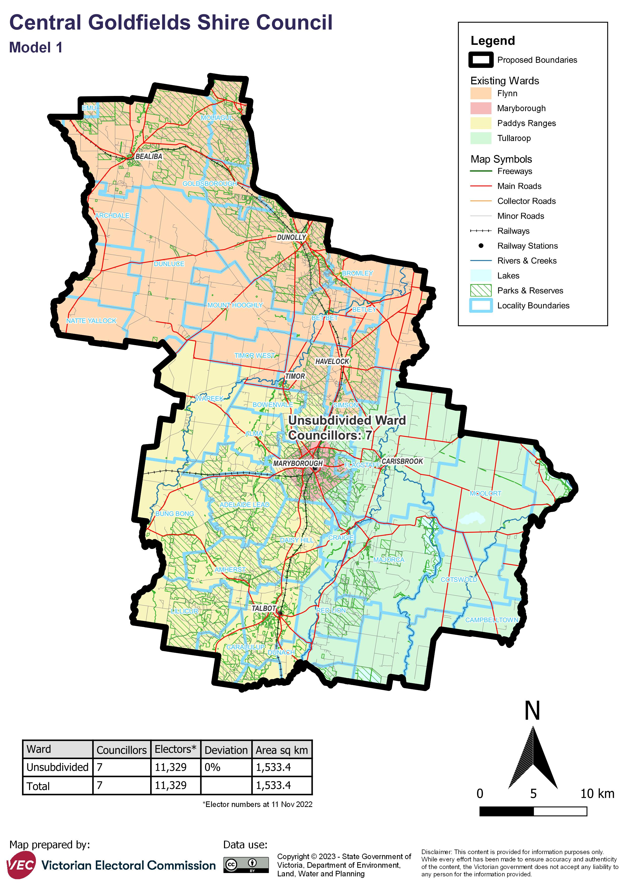

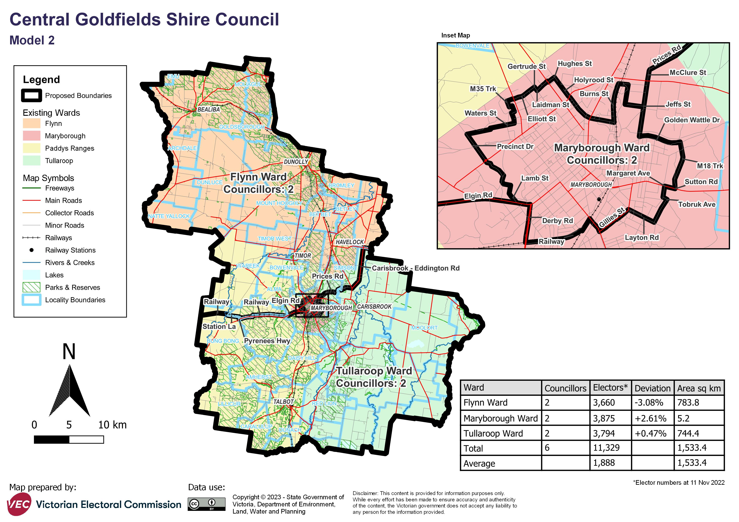

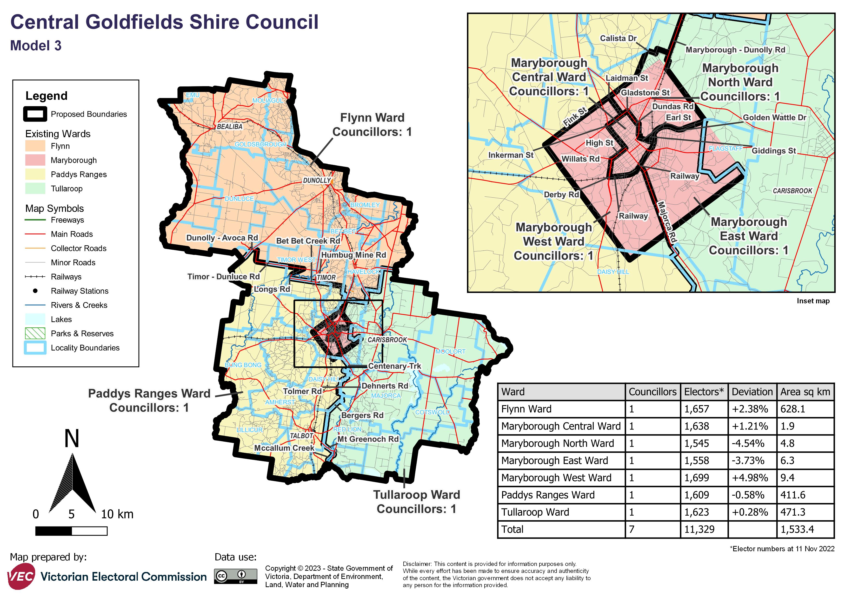

# Appendix 2: List of preliminary submitters

The review received 3 preliminary submissions.

Preliminary submissions were made by:

Central Goldfields Shire Council

Doran, Anne

Moyle, John