July 2023

Yarra City Council

Local council electoral structure review

Preliminary   
Report

Acknowledgement of Country

The electoral representation advisory panel acknowledges the Wurundjeri Woi Wurrung peoples as the Traditional Custodians of the lands and waters for which it is holding this review and pays respects to ancestors and Elders past, present and emerging. The panel acknowledges their custodianship for many thousands of years and their continuing living culture.

Document history and version control

|  |  |  |  |
| --- | --- | --- | --- |
| **Version** | **Date approved** | **Submission approved by** | **Brief description** |
| 1 | 7 July 2023 | Acting Electoral Commissioner | Final version for publication |

Contents

Executive summary 4

Developing electoral structure models 4

Electoral structure models 4

Next steps 4

Background 5

About the 2023–24 electoral structure reviews 5

The electoral representation advisory panel 5

Public engagement 5

Developing recommendations 6

About Yarra City Council 10

Profile 10

Current number of councillors and electoral structure 12

Last electoral structure review 12

Preliminary findings and models 13

Number of councillors 13

Electoral structure 14

Models for public feedback 16

Ward names 16

Next steps 17

Response submissions 17

Public hearing 18

Final report 18

References 19

Appendix 1: Model map 20

# Executive summary

An independent electoral structure review panel appointed by the Minister for Local Government is reviewing the electoral structure of Yarra City Council.

The purpose of the review is to advise the Minister on the appropriate number of councillors and electoral structure, including ward names, for the council.

Under Victoria’s *Local Government Act 2020* (the Act), Yarra City Council must now have a single-councillor ward electoral structure.

The panel is looking at:

* + the appropriate number of councillors and wards for the council
  + the location of ward boundaries
  + appropriate ward names.

This report outlines the preliminary models the panel is presenting for public consultation, for the proposed new electoral structure of Yarra City Council to meet the requirements of the Act.

More information about the background to the review is available on page 5.

## Developing electoral structure models

The panel considered a range of factors when deciding on the models in this report, including:

* + research and analysis
  + voter growth or decline over time.

More information on the way the panel decided on the models is available on page 6.

## Electoral structure models

After considering research and the requirements of the Act, the panel is presenting the following electoral structure model for public consultation:

* Model 1: a subdivided electoral structure with a total of 9 councillors – 9 wards with one councillor per ward.

Details of this model, including a map, are available in Appendix 1.

## Next steps

The panel is now seeking feedback on the preliminary electoral structure model. You can make a response submission to the preliminary models until 5 pm Wednesday 2 August. If any response submitters wish to speak at a public hearing, the panel will hold an online public hearing on Wednesday 9 August 2023. Following this, the panel will present its final recommendation to the Minister on Wednesday 6 September 2023.

More information about the review process is available on the Victorian Electoral Commission (VEC) website at [vec.vic.gov.au](https://www.vec.vic.gov.au/)

# Background

## About the 2023–24 electoral structure reviews

In October 2022, the Minister for Local Government formed 2 electoral representation advisory panels to review and provide advice on the electoral structures of 39 local councils, under section 16 of the Act. If the Minister accepts the electoral structure recommended by the panel, any changes will take effect at the October 2024 local council elections.

The Act introduced several changes to local government representation, including the types of electoral structures local councils may have. All metropolitan, interface and regional city councils (including Yarra City Council) must now have single-councillor ward electoral structures.

For Yarra City Council, the electoral representation advisory panel is examining:

* the number of councillors and wards
  + where the ward boundaries should be
  + the name of each ward.

The Act requires electoral structures to provide fair and equitable representation and facilitate good governance. Each ward must have an approximately equal number of voters per councillor (within +/-10% of the average). While conducting the review, the panel also notes the role of a councillor as specified under section 28 of the Act.

## The electoral representation advisory panel

The panel conducting the electoral structure review of Yarra City Council has 3 members:

* The Honourable Frank Vincent AO KC (Chairperson)
* Ms Liz Williams PSM
* Acting Deputy Electoral Commissioner Ms Máiréad Doyle.

The purpose of the review is to advise the Minister on the appropriate number of councillors and electoral structure, including ward names, for the council. The panel is independent of councils and the Victorian State government.

Under the Act, the VEC is not responsible for reviewing council electoral structures but must provide administrative and technical support to the panel. The Electoral Commissioner (or their delegate) must be a member of each panel.

## Public engagement

### Public information program

On behalf of the panel, the VEC has conducted a public information and awareness program to inform the public about the Yarra City Council electoral structure review. This has included:

* + printed public notices in state-wide newspapers
  + public information sessions to outline the review process and respond to questions from the community
  + media releases to announce the start of the review
  + information on social media channels
  + updated website content on [vec.vic.gov.au](https://www.vec.vic.gov.au/), including:
    - current information on the review process
    - submission guide and fact sheets for each council under review with background information.

The VEC will continue to promote the review on behalf of the panel during the response submission stage via media releases, the VEC’s social media channels and the VEC website.

### Public consultation

The panel now invites input to the electoral structure review of Yarra City Council via:

* + response submissions to this preliminary report
  + an online public hearing for anyone who makes a response submission to speak to the panel and expand on their submission.

Public submissions are an important part of the review process and are considered alongside other factors addressed during the review. These are outlined below.

## Developing recommendations

The electoral structure models the panel is presenting in this preliminary report comply with the Act and were developed through careful consideration of:

* + research and analysis conducted by the VEC support team, including geospatial and demographic data
  + rates or patterns of population and voter change over time, and relevant forecasts of growth or decline based on forecast information provided by .id (informed decisions, a company specialising in demographics and forecasting).

### Deciding on the number of councillors

The Act allows local councils to have between 5 and 12 councillors, but neither the Act nor the Local Government (Electoral) Regulations 2020 specify how the number of councillors is to be determined. Therefore, the models put forward by the panel in this report are guided by the Act’s intention for fairness and equity in voter representation.

In examining the appropriate number of councillors for Yarra City Council, the panel considered the following criteria:

* + the population and number of voters in the council area, compared to other councils with a similar population size and number of voters in the same category (for example, other comparable metropolitan, interface or regional city councils)
  + patterns of population change and voter growth or decline in the council area over time
  + the current and past numbers of councillors
  + the representation needs of the communities of interest in the council area.

The panel’s final recommendation will also consider any matters raised in public response submissions not already listed above.

Local councils with a larger number of voters will often have more councillors. Large populations generally have greater diversity, both in the type and number of communities of interest and issues relating to representation. However, the ideal number of councillors can also be influenced by the circumstances of each council, such as the:

* + nature and complexity of services the council provides
  + geographic size and topography of the area
  + forecast population and voter growth or decline
  + social diversity.

### Deciding the electoral structure

Under the Act, regional city, metropolitan and interface councils must now have single-councillor ward electoral structures.

When developing single-councillor ward models for Yarra City Council, the panel considered these criteria:

* + whether the structure would comply with section 15(2) of the Act (see below), and for how long it would likely comply
  + the appropriate number of councillors, as outlined above
  + whether meaningful and effective ward boundaries could be established and whether these would be easily identifiable to local communities
  + the representation of communities of interest
  + the voter distribution and physical features of the area, and the impact these may have on the shape and size of wards
  + past elections for the council, including:
    - numbers of candidates nominating
    - incidences of uncontested elections
    - rates of informal voting.

The panel’s final recommendation will also consider any matters raised in public response submissions not already listed above.

Under section 15(2) of the Act, subdivided structures must aim for an approximately equal number of voters per councillor in each ward. This means the number of voters represented by each councillor in a ward should be within +/-10% of the average number of voters per councillor for all wards.

During this review, the panel aims to recommend a structure that will comply with section 15(2) at the time of the 2024 local council elections and, if possible, also comply based on voter numbers at the time the review is conducted. The panel uses forecasts of population and voter change to assess compliance at the 2024 elections with as much accuracy as possible. In some cases, population change and other factors impacting voter numbers mean it is not possible to create compliant subdivided structures based both on voter numbers that were current at the time of the review and forecast voter numbers. In these instances, the panel prioritises compliance at the 2024 local government elections to ensure each vote will have approximately equal value at the 2024 election.

One of the factors that may impact compliance with section 15(2) is the number of current and forecast voters with ratepayer-based voting entitlements, also known as council-enrolled electors. Voters’ rolls include both state-enrolled electors (the majority of the roll) and a smaller number of council-enrolled electors. The Act introduced changes to ratepayer-based entitlement categories, which come into full effect at the 2024 local council elections. The panel will take this change to the makeup of voters’ rolls, and therefore compliance with section 15(2) of the Act, into consideration during this review.

### Deciding on ward names

The panel has taken the following approach to naming wards.

1. Retaining existing ward names if these are still relevant to the area covered by the ward.
2. When a new name is required, the panel bases this on features such as:
   * + places (registered under the *Geographic Place Names Act 1998*) in the ward
     + compass directions
     + native flora or fauna.

### Use of Aboriginal language

The panel recognises that there should first be meaningful consultation with local Aboriginal communities and groups before a ward is named using Aboriginal language. Meaningful consultation is a significant process that the panel is not able to undertake within the timeframes of the current review program.

The panel also recognises that many of the place names in current use across Victoria are based on Aboriginal language. As such, the panel may put forward new ward names using Aboriginal language if:

* it is the name of a place within a ward
* it is currently in common use

and

* the name is registered under the *Geographic Place Names Act 1998*.

Unregistered names using Aboriginal language have not been put forward by the panel as new ward names. While the panel supports the adoption of names based on Aboriginal language, this requires appropriate consultation.

Accordingly, for the panel to consider an Aboriginal language ward name that is suggested in a public submission to the review, the name submitted needs to comply with the above guidelines.

# About Yarra City Council

## Profile

Yarra City Council covers an area of 20 km2 and is in inner metropolitan Melbourne, approximately 5 km north-west of the city centre. It is bounded by Darebin, Merri-Bek and Banyule councils in the north, the City of Boroondara in the east, the City of Stonnington in the south, and the City of Melbourne in the west. The Traditional Custodians of the Yarra City Council area are the Wurundjeri Woi Wurrung peoples.

### Landscape

Yarra City Council includes the relatively affluent suburbs of Carlton North, Clifton Hill and Princes Hill in the north, and parts of Alphington and Fairfield in the east. The formerly industrial suburbs of Fitzroy, Collingwood, and Abbottsford make up the council’s centre, while the council’s southern suburbs include Burnley, Richmond, and Cremorne.

The Yarra River forms most of the council’s eastern boundary, while the Merri Creek forms part of the northern boundary. Major parks within the council’s boundaries include Edinburgh Gardens, Darling Gardens, Yarra Bend Park, and Burnley Park.

The council area is well connected to public transport, with connections to the major northern and eastern train lines as well as numerous tram and bus services. The Eastern Freeway ends at Clifton Hill and becomes Alexandra Parade, connecting traffic with the city’s northern and western suburbs. The major arterial road of Hoddle Street runs north-south through the centre of the council, while the City Link toll road runs through Cremorne and Burnley near the council’s southern boundary connecting the freeway system east and west of Melbourne.

### Community

At the 2021 census, Yarra City Council’s population was 90,114 (ABS 2022a), an increase from 86,657 in 2016, and 74,090 in 2011 (ABS 2011, 2016). From 2022, the council’s population is projected to increase by 2.2% per year to be about 102,800 by 2028. The median age of the council’s population is 34, less than the median of 37 found in Greater Melbourne (ABS 2022a, 2022b).

Of the population, 66.2% were born in Australia, and 74.8% speak only English at home, compared to 59.9% and 61.1% respectively for Greater Melbourne (ABS 2022a, ABS 2022b). Despite appearing less diverse than metropolitan Melbourne overall, some areas have significantly high proportions of the population born overseas and speaking a language other than English. The suburb of Richmond, for example, is home to a very large Vietnamese community (ABS 2022b, ABS 2022d). The number of Aboriginal and Torres Strait islander people at the 2021 census was 0.6%, slightly less than the 0.7% across Greater Melbourne (ABS 2022a, ABS 2022b).

Home ownership, at 44.1% of all households (inclusive of property owned outright and with a mortgage), is significantly lower than the Greater Melbourne rate of 66.8%. More than half (53.4%) of all households are renting, which is far greater than the Greater Melbourne average of 30.2% (ABS 2022a, ABS 2022b). The council has one of the highest proportions of people living in public housing at 10%, which is over 3 times the metropolitan average (Yarra City Council 2023), most of which is located in the suburbs of Richmond and Fitzroy.

The weekly median income is $2,270, more than the Greater Melbourne median of $1,901 (ABS 2022a, ABS 2022b). However, the council contains heavily gentrified areas, such as Carlton North and parts of Fitzroy where median house prices are well above the metropolitan average. The most common employment categories for residents of the council are professionals and managers. These factors underpin the higher than median incomes of the population.

## Current number of councillors and electoral structure

Yarra City Council is currently divided into 3 wards with a total of 9 councillors:

* 3 wards with 3 councillors each (Nicholls Ward, Langridge Ward, Melba Ward).

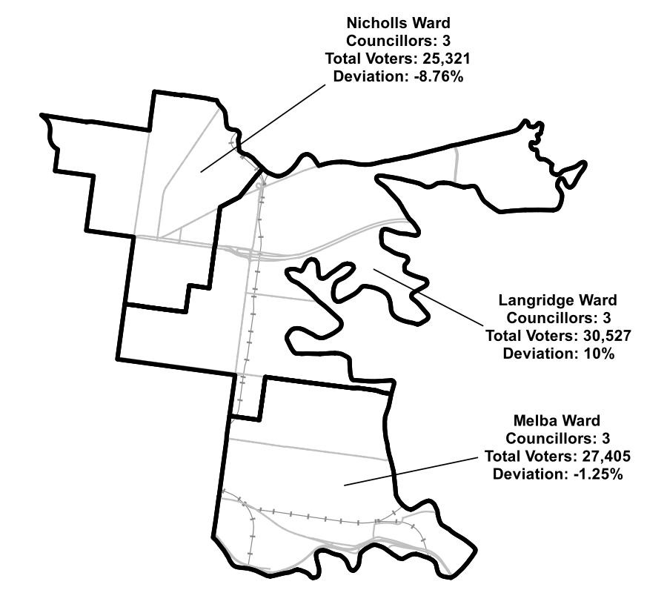

**Figure 1:** Diagram of current electoral structure of Yarra City Council.

There are approximately 83,253 voters in Yarra City Council, with an approximate ratio of 9,250 voters per councillor.

Visit the VEC website at [vec.vic.gov.au](https://www.vec.vic.gov.au/electoral-boundaries/local-councils/yarra-city-council) for more information on Yarra City Council.

## Last electoral structure review

The VEC conducted an electoral representation review of Yarra City Council in 2011. This review was carried out under the *Local Government Act 1989* (Vic), which was replaced by the *Local Government Act 2020* (Vic).

After conducting the review, the VEC recommended that Yarra City Council continue to consist of 9 councillors elected from 3 wards with 3 councillors in each.

Visit the VEC website at [vec.vic.gov.au](https://www.vec.vic.gov.au/electoral-boundaries/local-councils/yarra-city-council) to access a copy of the 2011 representation review final report.

# Preliminary findings and models

## Number of councillors

After taking into consideration the requirements of the Act and the agreed criteria, the panel found 9 councillors to be an appropriate number for Yarra City Council.

The panel considered the characteristics of Yarra City Council in relation to similar councils, including its population, the number and distribution of voters, and the size and geography of the council.

|  |  |  |  |  |  |  |
| --- | --- | --- | --- | --- | --- | --- |
| Similar metropolitan councils to Yarra City Council | | | | | | |
| Local council | Area (km2) | Number of voters at 2020 election | Population (2021 Census) | Current total estimate of voters | Number of councillors | Number of voters per councillor |
| Moonee Valley City* | 43 | 93,923 | 121,851 | 93,530 | 9 | 10,392 |
| Manningham City | 113 | 87,255 | 124,700 | 87,278 | 9 | 9,698 |
| Stonnington City* | 26 | 89,600 | 104,703 | 86,821 | 9 | 9,646 |
| Maroondah City | 61 | 85,275 | 115,043 | 85,033 | 9 | 9,448 |
| Yarra City* | 20 | 78,793 | 90,114 | 83,253 | 9 | 9,250 |
| Bayside City | 37 | 76,020 | 101,306 | 76,043 | 7 | 10,863 |
| Hobsons Bay City | 64 | 68,321 | 91,322 | 67,693 | 7 | 9,670 |
| Maribyrnong City* | 31 | 63,456 | 85,209 | 64,361 | 7 | 9,194 |

*This local council is undergoing an electoral structure review during 2023–24.

### Maintaining 9 councillors

Yarra City Council currently has 83,253 voters represented by 9 councillors and covers an area of 20 km2. Other metropolitan councils with a similar number of voters usually also have either 7 or 9 councillors. While Yarra City Council has the lowest number of voters of all 9-councillor metropolitan councils, forecasts indicate relatively high rates of growth and population change will continue throughout the council area.

Additionally, there are special circumstances that Yarra City Council faces, creating conditions that may increase councillor workloads and demand for council services. These include the largest public housing population in Victoria, significant and expanding commercial activities, a high growth profile – which likely requires the council to manage local opposition and community expectations – and a section of the population considered to be highly mobile.

These special circumstances warrant Yarra City Council having 9 councillors and have not changed since the last council electoral structure review. For these reasons, the panel considers it appropriate for the total number of councillors to remain unchanged at 9.

## Electoral structure

To identify the most appropriate electoral structure, various factors were considered. This included the requirements of the Act, the communities of interest in Yarra City Council, the appropriateness of ward boundaries and which models best offered fair and equitable representation and consequently facilitate good governance.

In developing the preliminary model presented in this report, the panel considered a range of models. The strongest model has been put forward for further public comment.

The panel proposes one model for the consideration of the Yarra City Council community:

* a subdivided electoral structure of 9 single-councillor wards (Model 1).

A diagram of the preliminary model is included in Appendix 1.

### A single-councillor ward structure with 9 councillors (Model 1)

Under this model, Yarra City Council would adopt a 9-ward structure. Each ward would be represented by one councillor, in line with the requirements of the Act.

Despite being presented with various models, the panel chose this sole model as it best represents the community, while also complying with the strictures of the Act. Creating legislatively compliant and sensibly bordered single-councillor ward structures is a considerable challenge for geospatial modellers. The unique shape of the council area, including a narrow passage of land extending east along the Yarra River around Alphington, was an important consideration in determining appropriate ward divisions. As such, these geographic features, as well as the pattern and distribution of the population throughout the council area, limit the ways the council can reasonably be divided. In acknowledging these challenges, the panel also noted that this model represents the culmination of various attempts and revisions at achieving compliance with the Act (particularly the +/-10% requirement) and was considered to be significantly stronger than other draft models.

The panel noted the distinct social and cultural identities throughout the council area, which tend to materialise in the form of strong connections to suburbs. From the diverse Richmond area in the south, the formerly industrial and gentrifying areas of Fitzroy, Collingwood and Abbotsford in the centre, and the quieter northern suburbs like Carlton North, Fitzroy North and Clifton Hill, each area of the council has a history and identity that makes it distinct. Each area also faces particular challenges and pressures related to population growth and housing development. As such, the key design principle for this model was an attempt to keep these distinct localities sensibly grouped together, while using recognisable features for boundaries. This model also attempts to follow similar boundaries as the current electoral structure, achieving this aim in numerous places, such as along Victoria Street in Richmond.

Model 1 structures Yarra City Council in the following ways:

* Carlton North and Fitzroy North Wards capture the northern and quieter suburbs of Princes Hill, Carlton North and Fitzroy North, using well known features for boundaries such as Merri Creek, Nicholson Street, and the northern part of Brunswick Street.
* Abbotsford, Collingwood, and Fitzroy Wards capture the formerly industrial suburbs in the centre of the council. They provide representation for the significant cultural and commercial precincts found in and around Smith Street, Brunswick Street, Gertrude Street, and Johnson Street, as well as the public housing units located around Gertrude Street and Hoddle Street.
* The southern area of the council is divided into three wards: Cremorne Ward, Burnley Ward, and Richmond Ward. These wards provide representation for the large Richmond area, and the commercial and cultural precincts of Bridge Road, Swan Street, Victoria Street and Church Street, as well as the large number of public housing units found around Lennox Street.
* Yarra Bend Ward takes in the localities of Clifton Hill, Fairfield, Alphington, and a small part of Fitzroy North adjacent to the Yarra River and Merri Creek. Strong boundaries in the Eastern Freeway, Alexandra and Queens parades are used to separate it from neighbouring wards.

Every effort was made in this model to capture sensible communities of interest while considering the special circumstances facing the council, including areas of disadvantage and diversity. Bearing in mind the constraints of the Act, the panel is now interested in public feedback regarding this model and welcomes any suggestions for improvement.

### Summary

In summary, introducing single-councillor wards represents a large electoral change for Yarra City Council. Achieving models that divide communities into appropriate wards while also accounting for population growth and ensuring they comply with the +/-10% requirement proved to be challenging. Division of the council into 9 wards was also difficult due to the geography of the council area and the distribution of its population. However, the presence of distinct suburb-based communities and strong features for possible ward boundaries allowed a reasonable single-councillor ward structure to be developed. For the most part each ward of the current structure was able to be divided evenly to form 9 wards. Of the various options considered during this process no other model was able to be developed which captured the council’s communities using sound features for ward boundaries as well as Model 1.

## Models for public feedback

The panel considers the model outlined below to be the single-councillor ward electoral structure with the best potential to offer fair and equitable representation for voters in Yarra City Council and consequently facilitate good governance. Please see Appendix 1 for a detailed map of this model.

### Model 1

Yarra City Council has 9 councillors and is divided into 9 wards with one councillor per ward.

Ward names: Abbotsford Ward, Burnley Ward, Carlton Ward, Cremorne Ward, Collingwood Ward, Fitzroy Ward, Fitzroy North Ward, Richmond Ward, Yarra Bend Ward.

## Ward names

The panel has suggested ward names to identify the wards in the model and invites comments from the community on these names as part of submissions responding to the preliminary report. The basis of the ward name recommendations for the model are described below.

### Model 1

All ward names are new and are based on natural features or localities found within each ward.

The panel will review ward name suggestions received during the response submission stage when forming the final advice to the Minister for Local Government on the electoral structure of the council. Suggested ward names should comply with the panel’s approach to naming wards (see Deciding on ward names and Use of Aboriginal language). All ward name suggestions received during the response submission stage will be provided to the Minister for consideration at the conclusion of the electoral structure review.

# Next steps

## Response submissions

Any person or group, including the local council under review, can make a response submission to the electoral representation advisory panel. In your submission you should address the models proposed by the panel in this preliminary report.

You can make a submission:

|  |  |
| --- | --- |
|  | **Online** Visit [vec.vic.gov.au](http://vec.vic.gov.au/" \o "VEC homepage) to make a submission online.  You will need to make an account to use the online Public Submission Tool and can save a draft submission to finish later. |
|  | **By email** [Yarra.ERAPSubmissions@vec.vic.gov.au](mailto:Yarra.ERAPSubmissions@vec.vic.gov.au) |
|  | **By post**  Electoral Representation Advisory Panel c/o Victorian Electoral Commission Level 11, 530 Collins St Melbourne VIC 3000 |

The panel must receive all response submissions before 5 pm on Wednesday 2 August 2023. If you post your submission, make sure it has enough time to reach the panel before the deadline. Late submissions will not be accepted.

### Required information

For your submission to be considered, you must include your:

* full name
* contact phone number or email address
* postal or residential address.

To protect the integrity and transparency of the review process, the panel will not consider submissions without this information. If you are submitting as a group or organisation, you must include the name of a nominated contact person who is authorised to submit on behalf of your group.

On behalf of the panel, the VEC will handle information provided by submitters in accordance with the privacy policy available at [vec.vic.gov.au/privacy](http://vec.vic.gov.au/privacy)

### Public access to submissions

To ensure transparency in the electoral structure review process, your submission will be published on the VEC website at [vec.vic.gov.au](http://www.vec.vic.gov.au/). The VEC will remove your signature and contact details, including residential and postal addresses, from all public copies but must publish your full name (or group name) and locality (suburb or town).

Please note that any submission content that is potentially defamatory, offensive, obscene or that includes the personal information of people or organisations who are not a party to the submission may also be redacted before publication.

## Public hearing

If you make a response submission, you can also ask to speak at an online public hearing to support your submission and expand on your views.

The online public hearing is scheduled for:

Time: 10 am

Date: Wednesday 9 August 2023

The panel encourages participation in the public hearing. If you wish to speak at the public hearing, you **must** indicate this in your response submission. The public hearing will not be held if there are no requests to speak.

Anyone can attend a public hearing, but you will only be able to speak if you asked to in your response submission. If you ask to speak, the VEC will contact you to arrange a time for you to speak at the hearing. You will have 10 minutes to address the public hearing panel, which will include at least 2 of the review panel members. The members of the public hearing panel may ask you questions.

Visit the VEC website at [vec.vic.gov.au](http://vec.vic.gov.au/) for more information on public hearings.

## Final report

Following the public hearing, the review panel will consider all evidence gathered and prepare a final report for the Minister for Local Government containing a recommendation for the number of councillors and the electoral structure for the local council.

The final report is scheduled to be provided to the Minister on Wednesday 6 September 2023. The Minister will consider the final reports, including any determination to make the reports publicly available. Any change to the electoral structure of Yarra City Council following on from this review is expected to apply at the October 2024 local council elections. Under the Act, the final council electoral structure will be set by an Order in Council published in the Victoria Government Gazette.

# References

.id (2023a) [*City of Yarra, Industry sector of employment*](https://profile.id.com.au/yarra/industries), .id website, accessed 8 June 2023.

ABS (Australian Bureau of Statistics) (2022a) [*2021 Census All Person Quickstats, Yarra*](https://abs.gov.au/census/find-census-data/quickstats/2021/LGA27350) ABS website, accessed 7 June 2023.

—— (2022b) [*2021 Census All Person Quickstats, Greater Melbourne*](https://abs.gov.au/census/find-census-data/quickstats/2021/2GMEL)*,* ABS website, accessed 7 June 2023.

—— (2022c) [*2021 Census All Person Quickstats, Victoria*](https://www.abs.gov.au/census/find-census-data/quickstats/2021/2RVIC)*,* ABS website, accessed 22 June 2023.

—— (2022d) [*2021 Census All Person Quickstats, Richmond*](——%20(2022c)%202021%20Census%20All%20Person%20Quickstats,%20Victoria,%20ABS%20website,%20accessed%2022%20June%202023.)*,* ABS website, accessed 28 June 2023.

—— (2016) [*2016 Census All Person Quickstats, Yarra*](https://abs.gov.au/census/find-census-data/quickstats/2016/LGA27350)*,* ABS website, accessed 7 June 2023.  
—— (2011) [*2011 Census All Person Quickstats, Yarra*](https://abs.gov.au/census/find-census-data/quickstats/2011/LGA27350)*,* ABS website, accessed 7 June 2023.

Yarra City Council (2023) [*Council Plan 2021-2025*](https://reports.yarracity.vic.gov.au/council-plan?_gl=1*14qarrx*_ga*OTY3MDc1NDc4LjE2ODQzNjUxMDA.*_ga_JNSPEYNQ3T*MTY4NzkwMzE3MC4xMi4wLjE2ODc5MDMxNzAuMC4wLjA.), Yarra City Council website, accessed 28 June 2023.

Geographic Place Names Act 1998 (Vic)

Local Government Act 1989 (Vic)

Local Government Act 2020 (Vic)

Local Government (Electoral) Regulations 2020 (Vic)

# Appendix 1: Model map

The following map is included in this report:

|  |  |
| --- | --- |
| Map | Page |
| Model 1 – a single-councillor ward structure with 9 councillors – 9 wards with one councillor per ward. | 21 |

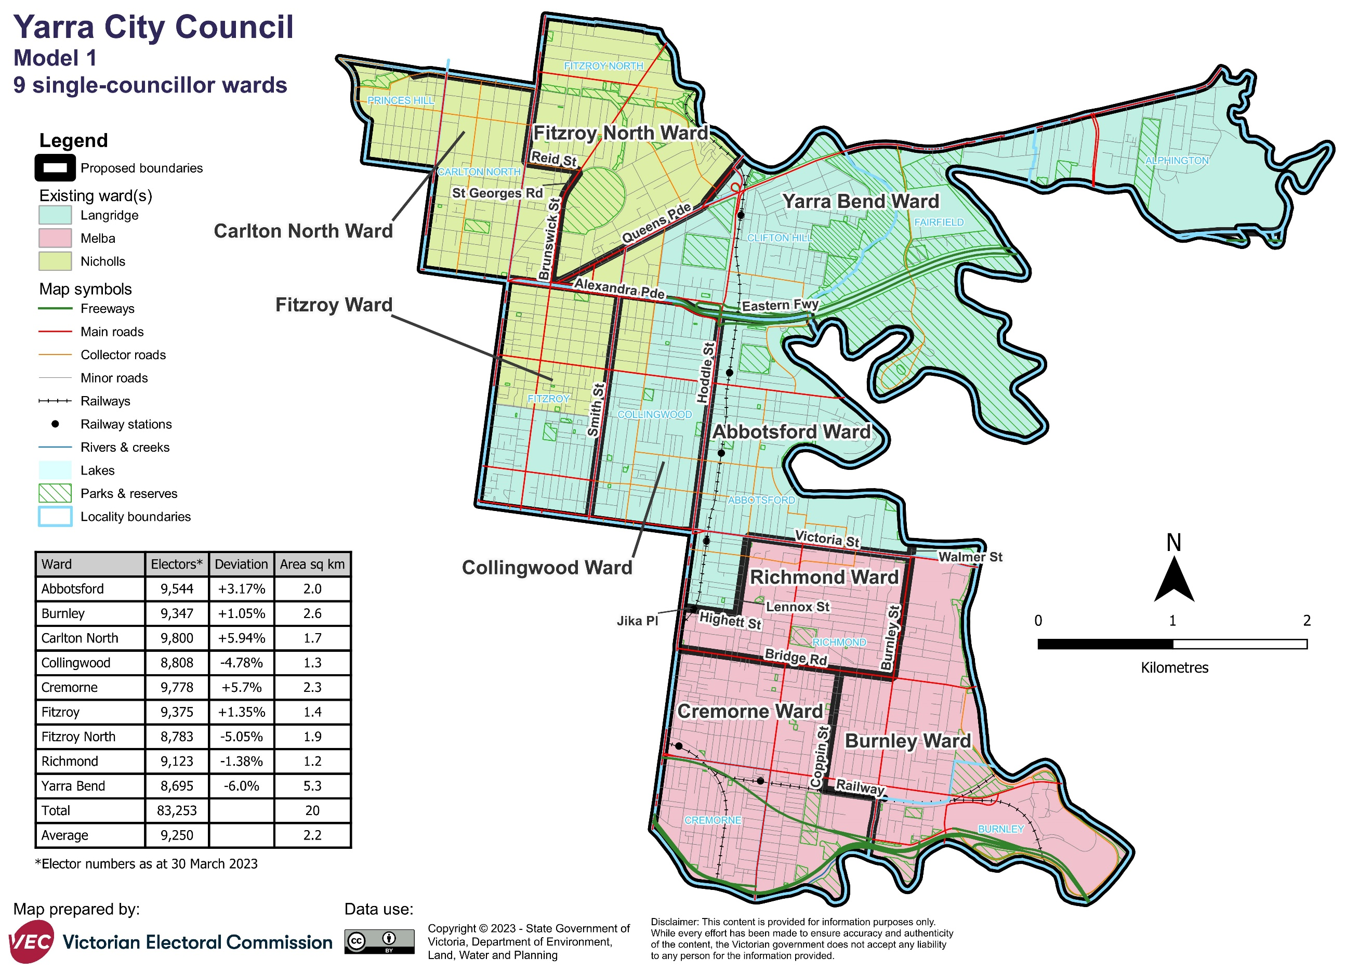

Forecast information referred to in the text of this report is based on forecasts prepared by .id – informed decisions [id.com.au](http://id.com.au/) .id and its licensors are the sole and exclusive owners of all rights, title and interest subsisting in that part of the report content where .id are identified. Some of .id content is a derivative of ABS Data, which can be accessed from the website of the Australian Bureau of Statistics at [abs.gov.au](http://abs.gov.au/), and licensed on terms published on the ABS website.