ELECTORAL REPRESENTATION REVIEW
Mornington Peninsula Shire Council
Final Report

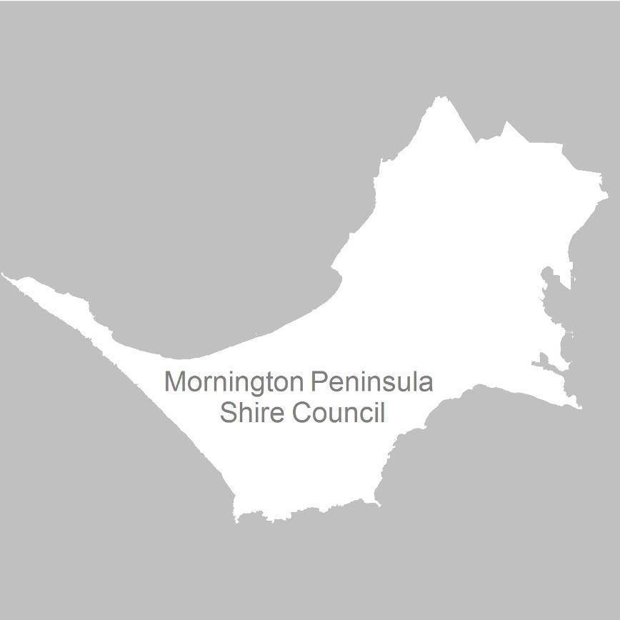

11 January 2012

Contents
Recommendation 4
Background 5
Legislative basis 5
The VEC and electoral representation reviews 5
The electoral representation review process 6
Profile of Mornington Peninsula Shire Council 7
Current electoral structure 7
Chronology of the review 7
VEC research 8
Public involvement 8
Preliminary report 10
Preliminary submissions 10
Preliminary options 11
Public response 14
Response submissions 14
Analysis of submissions 14
Public hearing 15
Correspondence from Mornington Peninsula Shire Council legal representatives 17
Addendum report 18
Explanation of Option B 18
Comments on the Addendum Report 19
Findings and Recommendation 23
Number of councillors 23
Electoral structure 23
Recommendation 29
Appendix 1: List of submitters 30
Appendix 2: Map 36
Appendix 3: Correspondence between council legal representatives
and the VEC 37
APPENDIX 4: Article referenced in correspondence from Mornington
Peninsula Shire Council legal representatives 42

Recommendation
The Victorian Electoral Commission (VEC) recommends that Mornington Peninsula Shire Council consist of 11 councillors elected from six wards with two three-councillor wards, one two-councillor ward, and three single-councillor wards.

Background

Legislative basis
The Local Government Act 1989 (the Act) requires the VEC to conduct an electoral representation review of each municipality in Victoria at least every 12 years. In 2010, legislation extended the review period from two terms to three terms. As part of the transition, the Minister for Local Government determined that Mornington Peninsula Shire Council would be in the first group of councils to be reviewed under the new schedule, even though it had been only six years since its last representation review.
The Act specifies that the purpose of a representation review is to recommend to the Minister for Local Government the number of councillors and the electoral structure for a municipality, which will provide ‘fair and equitable representation for the persons who are entitled to vote at a general election of the Council’.
The Act requires the VEC, as part of an electoral representation review, to consider:
- the number of councillors in a municipality;
- whether a municipality should be unsubdivided or subdivided;
- if it should be subdivided, whether ward boundaries:
  - provide for fair and equitable division of the municipality;
  - ensure equality of representation through the number of voters being represented by each councillor being within 10 per cent of the average number of voters represented by all councillors; and,
- if it should be subdivided, the number of councillors that should be elected for each ward.

The VEC and electoral representation reviews
The VEC has conducted electoral representation reviews since 2004 on appointment by local councils. The Act was changed in 2010 to define the VEC as the only agency authorised to undertake the reviews.
The VEC drew on its experience in mapping and boundary modelling and also engaged consultants with experience in local government to provide advice on specific local representation issues during the review.

The electoral representation review process
The VEC proceeded on the basis of three main principles:
- Ensuring the number of voters represented by each councillor is within 10 per cent of the average number of voters per councillor for that municipality.
Populations are continually changing. Over time these changes can lead to some wards having larger or smaller numbers of voters. As part of the review, the VEC corrected any imbalances and also took into account likely population changes to ensure these boundaries provide equitable representation until the next review.
- Taking a consistent, State-wide approach to the total number of councillors.
The VEC was guided by its comparisons of municipalities of a similar size and category to the council under review. The VEC also considered any special circumstances that may warrant the municipality to have more or fewer councillors than similar municipalities.
- Ensuring communities of interest are as fairly represented as possible.
Each municipality contains a number of communities of interest and, where practicable, the electoral structure should be designed to take these into account. This allows elected councillors to be more effective representatives of the people in their particular municipality or ward.
The VEC’s recommendation is based on:
- internal research specifically relating to the municipality under review;
- VEC experience from its work with other municipalities and in similar reviews for State elections;
- VEC expertise in mapping, demography and local government;
- careful consideration of all public input in the form of written and verbal submissions received during the review; and,
- advice received from consultants with wide experience in local government.
Public submissions were an important part of the process, but were not the only consideration during the review. The VEC seeks to combine the information gathered through public submissions with its own research and analysis of other factors, such as the need to give representation to communities of interest. The recommendation is not based on a ‘straw poll’ of the number of submissions supporting a particular option. All suggestions for structures were modelled using sophisticated mapping software and those that fit the +/- per cent tolerance were included as options at the preliminary stage. Those that do not comply are included in diagram form, indicating why they do not work.

Profile of Mornington Peninsula Shire Council
Mornington Peninsula Shire was formed in 1994 by the amalgamation of the Shires of Flinders, Hastings, and Mornington. The Shire includes Arthurs Seat, Balnarring, Baxter, Bittern, Blairgowrie, Crib Point, Dromana, Flinders, Hastings, McCrae, Moorooduc, Mornington, Mount Eliza, Mount Martha, Portsea, Red Hill, Rosebud, Rosebud West, Rye, Safety Beach, Somerville, Sorrento, Tootgarook and Tyabb.
At the 2006 census, the Shire recorded a population of 136,482 people. Over the next 10 years, the population is projected to grow by 8.8 per cent, though the Department of Planning and Community Development notes that growth in the Shire is difficult to predict due to the high number of holiday dwellings.

Current electoral structure
The last electoral representation review for Mornington Peninsula Shire Council took place in 2005. Following the review, the Minister for Local Government determined that the structure of Mornington Peninsula Shire Council would be:
- 11 councillors;
- divided into 11 wards — Balcombe Ward, Cerberus Ward, Kangerong Ward, Mornington Ward, Mount Eliza Ward, Nepean Ward, Red Hill Ward, Rosebud Ward, Rye Ward, Truemans Ward, and Watson Ward;
- with one councillor for each ward.

Chronology of the review
The electoral representation review of Mornington Peninsula Shire Council followed the below timeline:
- Wednesday, 3 August: Public information sessions.
- Wednesday, 17 August at 5.00pm: Deadline for preliminary submissions.
- Monday, 5 September: Release of preliminary report.
- Wednesday, 5 October at 5.00pm: Deadline for response submissions.
- Wednesday, 12 October: Public hearing in support of response submissions.
- Thursday, 3 November: Release of addendum report.
- Wednesday, 7 December: Deadline for comment on the addendum report.
- Wednesday, 11 January: Release of final report.

VEC research
In addition to the information provided in submissions, the VEC created a profile of the municipality based on population trends, development projections and demographic indicators. The VEC used the Australian Bureau of Statistics 2006 census community profiles, the Department of Planning and Community Development projections and voter statistics from the Victorian electoral roll. The VEC also undertook field work to view current and possible boundaries for each of the options presented in the preliminary report to evaluate their effectiveness.

Public involvement
The VEC values the local knowledge and perspectives presented by the public in written submissions. The public were given four opportunities to provide submissions during the review. Their input was considered by the panel in forming the options in the preliminary report and they were also invited to respond to these options. In addition, a public hearing was held to enable people to speak in support of their submissions and supplement it with information. The VEC released an addendum report on Thursday, 3 November, and invited the public to lodge further submissions in response to this report.
To ensure transparency in the process, all written submissions were published on the VEC website and all verbal submissions were heard at a public hearing.
To raise awareness of the review and encourage the public to engage with the process, a full public information campaign was undertaken.

Advertising
In accordance with sections 219F(4) and 219F(7) of the Act, the VEC ensured public notices were placed in local newspapers.
A notification of the review appeared in local newspapers — Frankston Leader on Monday, 18 July, Frankston Weekly and Mornington Peninsula Leader on Tuesday,
19 July, and Peninsula Weekly on Wednesday, 20 July. A general notice covering several reviews was printed in The Age and Herald Sun on Tuesday, 5 July.
A notification of the release of the preliminary report appeared in — Frankston Leader on Monday, 5 September, Frankston Weekly and Mornington Peninsula Leader on Tuesday, 6 September, and Peninsula Weekly on Wednesday, 7 September.
A notification of the release of the addendum report appeared in — Frankston Leader on Monday, 7 November, Frankston Weekly and Mornington Peninsula Leader on Tuesday, 8 November, and Peninsula Weekly on Wednesday, 9 November.

Media releases
The VEC produced three media releases for this review and distributed these to the local media. These releases corresponded with the notice of review on Monday,
18 July, the notice of release of the preliminary report on Monday, 5 September and notification of the release of the addendum report on Thursday, 3 November.

Public information session
The VEC held three public information sessions for people interested in the review process on Wednesday, 3 August in Rosebud, Mornington, and Hastings.

Information brochure and poster
An information brochure was provided to the Council to be distributed to residents through the Council’s network, such as in libraries and service centres. A poster was provided to the Council to be displayed in public spaces.

Helpline
A dedicated helpline was established to assist with public enquiries concerning the review process.

VEC website
The VEC website delivered up-to-date information to provide transparency during all stages of the review process. All submissions were posted on the website and an online submission tool was created to facilitate the submission process. VEC reports were available for electronic download on the website.

Guide for submissions
A guide for submissions was developed and distributed to those interested in making submissions. Copies of the guide for submissions were available on the VEC website, in hardcopy on request, and were provided to the Council.

Preliminary report
In accordance with the Act, the VEC produced a preliminary report outlining its proposed options for Mornington Peninsula Shire Council. The report was released on Monday, 5 September.

Preliminary submissions
The deadline for preliminary submissions was 5.00pm on Wednesday, 17 August. Of the 42 submissions that were received, 13 were in favour of retaining the existing single-councillor ward structure. Only one submitter specified they wished to retain
11 councillors; while the other 12 preferred single-councillor wards, they did not discuss the number of councillors. The arguments made in support for single-councillor wards for Mornington Peninsula Shire included that:
- historically, multi-councillor wards have been less effective in the Shire;
- competition between candidates at council elections would likely create adversarial relationships during the ensuing term of Council under a multi-councillor ward structure;
- increased accountability of councillors to their individual constituencies exists under a single-councillor ward structure;
- there is duplication in work by councillors in multi-councillor wards;
- a number of small towns in the Shire may be under-represented in a multi-councillor situation; and,
- single-councillor wards provide responsive and accessible local representatives.
The remaining 29 submissions were in favour of an unsubdivided municipality
or a configuration of multi-councillor wards. The majority of submitters
who mentioned an unsubdivided municipality were in favour of multi-councillor wards as an alternative. The arguments in favour of multi-councillor ward and unsubdivided structures included that:
- these structures provide that an alternative representative is available to constituents where an individual councillor is unable or unavailable to take up their concerns;
- having a range of councillors can provide representation across a wider range of issues and communities of interest;
- there is the opportunity for increased competition and co-operation between councillors;
- multi-councillor structures are likely to encourage new individuals to stand as candidates at Council elections;
- these structures reduce the likelihood of candidates standing unopposed at Council elections;
- councillors would be in a better position to share their workload; and,
- residents would not be left unrepresented when a councillor is on leave, is ill, or during the period between a councillor leaving office mid-term and the consequential by-election.
A list of submitters, by name, is available in Appendix 1. Copies of the submissions can be viewed on the VEC website vec.vic.gov.au.

Preliminary options
The VEC assessed a range of electoral representation models that might suit Mornington Peninsula Shire Council. The VEC considered the projected population change, the desire to maintain communities of interest, the number of voters and number of councillors compared with other municipalities, and the electoral history of the Council. The VEC developed a number of models, finally selecting four options for consideration.
Since the Council’s last electoral representation review in 2005, there has been significant population growth in the north-west of the Shire. The Act requires all wards within a ward structure to deviate from the average number of voters per councillor across the municipality by no more than +/- 10 per cent. The VEC conducted an electoral subdivision review in 2008 to correct an imbalance that had occurred since the 2005 review, where Balcombe Ward, at +12.96 per cent, had exceeded the tolerance. Being single-councillor wards, the electoral structure for Mornington Peninsula Shire is more vulnerable to falling outside tolerance and more likely to require remedial measures in the intervening years between electoral representation reviews. In fact, changing population has led to another imbalance in the wards, with Balcombe Ward, at +11.53 per cent, already falling outside the tolerance level, and Truemans Ward, at -8.25 per cent, also projected to fall outside tolerance in the
near future.
The VEC provided a single-councillor ward model as its preferred option (Option A). This option reflected the outcome of the 2005 representation review, where the VEC recognised strong community support for localised representation. However, the VEC was concerned that some communities of interest would be split and that ongoing population changes would continue to create imbalances because of the model’s vulnerability to localised population shifts.
In considering suitable options, the VEC took into account how each option would provide for fair and equitable representation. The VEC noted that six of the 11 wards were uncontested at the 2008 local council elections. A number of submitters who mentioned this issue were concerned that electors were denied the choice of
candidates and could not be fairly represented. The VEC noted that all electoral combinations, including multi-councillor wards, single-councillor wards, and a mixture of multi- and single-councillor wards, have generally worked effectively across each of the four categories of municipalities in Victoria — Metropolitan, Metropolitan/Rural Fringe, Regional Urban Areas and Rural.
Another issue raised in submissions was the unique situation in the Shire of having a highly developed metropolitan area immediately adjacent to a sparsely populated rural area. Therefore, it is difficult to capture rural and urban communities separately without adjusting councillor numbers or mixing different zones together. The VEC recognised that the agricultural community in Mornington Peninsula Shire has different issues from the urban communities and, consequently, most of the options the VEC put forward did not mix the urban and rural communities. Option D did combine the current Red Hill Ward with bayside suburbs in a three-councillor ward. This model responded to a desire for multi-councillor wards throughout the Shire, elected through proportion representation. The proposed Two Bays Ward comprised a large enough rural component to facilitate representation of rural interests.
While multi-councillor wards, which use a proportional vote counting method, can provide fair representation to both urban and rural dwellers, the VEC found that in this instance it was possible to create wards that accommodated communities of interest without ignoring the different needs of the rural and urban communities.
Options B, C and D presented different configurations of multi-councillor wards, but have the sparsely populated agricultural area generally contained within one ward so that this community is more likely to be represented on Council. This meant that, as with the current Red Hill Ward, the rural ward was much larger in area than the more urban wards in each of the models.
Despite the arguments about what model is most appropriate for the Shire, it was clear from submissions that the structure must acknowledge the diversity between, and within, communities across the Mornington Peninsula. The VEC tries to develop sustainable boundaries that provide voters with recognisable wards. In addition, the VEC looks for electoral structures that are likely to provide effective representation for the next election and for future elections, and, as much as possible, avoid the dislocations and costs involved with subdivision reviews.

The preliminary report detailed four options that were under consideration by
the VEC:
- Option A (Preferred Option) that Mornington Peninsula Shire Council consist of 11 single-councillor wards, using modified boundaries from the existing structure.
- Option B (Alternative Option) that Mornington Peninsula Shire Council consist of 11 councillors elected from six wards with two three-councillor wards, one two-councillor ward, and three single-councillor wards. For this option, the proposed ward name for Briars Ward was derived from geographic features in the area.
- Option C (Alternative Option) that Mornington Peninsula Shire Council consist of 11 councillors elected from five wards with one four-councillor ward, three two-councillor wards, and one single-councillor ward. For this option, the proposed ward name for Briars Ward was derived from geographic features in the area.
- Option D (Alternative Option) that Mornington Peninsula Shire Council consist of 11 councillors elected from four wards with three three-councillor wards and one two-councillor ward. For this option, the proposed ward names for Briars Ward and Two Bays Ward were derived from geographic features in the area.

Public response

Response submissions
Response submissions on the electoral representation review of Mornington Peninsula Shire Council opened on Monday, 5 September and closed at 5.00pm on Wednesday, 5 October. The VEC received 78 response submissions. Table 1 shows the levels of support for each option based on the preferences expressed in each response submission.
Table 1: Preferences expressed in response submissions for each option
Option A  (Preferred Option) | Option B  (Alternative Option) | Option C  (Alternative Option) | Option D  (Alternative Option) | Multi-member ward structure  (non-specific) | Other
30 | — | 3 | 35 | 8 | 2

Analysis of submissions
The VEC received 30 submissions that directly supported Option A (Preferred Option), which proposed an 11 single-councillor structure using modified boundaries to the existing structure. Submitters argued that the existing structure has served the community well and offered accountability, transparency and more localised representation. Some submitters suggested that the boundaries in Option A reflected the historical and geographic communities of interest that exist within the Shire.
Several submitters in support of Option A expressed dissatisfaction with the proposed boundary changes and suggested that these boundaries did not retain established communities of interest. Arguments raised included that:
- the community of Mount Martha is quite distinct from Mornington and is, therefore, best served by being placed in its entirety within Balcombe Ward;
- the proposed boundary change between Kangerong Ward and Red Hill Ward is not suitable as it moves residents of Dromana into Red Hill Ward; and
- using the Mornington Peninsula Freeway/Moorooduc Hwy as a boundary of Cerberus Ward would not best reflect communities of interest of that area.
A submission by the Mornington Peninsula Shire Council argued that a single-councillor ward structure was the only workable option, given the size and social, economic and environmental diversity of the Shire. The Council also suggested that the smaller wards under the current model reflected the Shire’s 40 distinct towns
and villages, each with very strong communities of interest, and argued that single-councillor wards make councillor workloads manageable and simplify councillor/
organisational relationships.
The VEC received 35 submissions that supported Option D (Alternative Option). In support of Option D, submitters suggested that the ward boundaries captured the key communities of interest, particularly in Red Hill Ward, and would provide effective representation for these communities through a multi-councillor ward structure.
Submitters also felt that having more than one councillor to contact with their issues or concerns could strengthen the relationships between the residents and their ward councillors, improve the diversity of representation for the community’s varied and changing population, and still ensure representation of local issues. Many also argued that the proportional representation vote counting system used in multi-councillor wards and unsubdivided structures was fairer.
Three submissions were in direct support of Option C (Alternative Option), which proposed an electoral structure consisting of 11 councillors to be elected from five wards with one four-councillor ward, three two-councillor wards, and one single-councillor ward. While the reasons submitters noted for supporting this option were similar to those who supported Option D, some submitters also argued that Option C offered more sustainable boundaries.
Ten further submissions did not directly support a particular option put forward by the VEC. Eight of the submissions, however, stated a preference for a multiple-councillor ward structure. The majority of these submissions argued that multiple-councillor ward structures would ensure effective representation of local interests. The remaining two submissions were in favour of an unsubdivided structure or a configuration of multiple-councillor and single-councillor wards. One of the submitters suggested a change of ward names for the proposed Nepean and Briars Wards in Options B, C and D, to Collins and Balcombe Wards, respectively, suggesting these names could be tied to the area historically or geographically.
The VEC received no submission directly supporting Option B (Alternative Option), which proposed an electoral structure consisting of 11 councillors to be elected from six wards with two three-councillor wards, one two-councillor ward, and three single-councillor wards.
A list of submitters, by name, is available in Appendix 1. Copies of the submissions can be viewed on the VEC website at vec.vic.gov.au.

Public hearing
A public hearing was held at the Mornington Peninsula Shire Council Chamber in Rosebud at 6.00 pm on Wednesday, 12 October. Everyone who made a submission in response to the report was invited to speak, and 20 speakers were heard. Seven people spoke on behalf of organisations, including the Mornington Peninsula Shire Council. Members of the public were invited to attend and 32 people, including the speakers, were present.
There were nine speakers in favour of Option A, which retained the existing structure of 11 single-councillor wards, with modified boundaries. Most argued that the current single-councillor ward structure has served the community well and that the Council has been consistently providing effective representation under this model. The Mayor, Cr Graham Pittock, maintained that the current structure offered the only workable option for the Shire given its geographic, economic and social diversity.
Many speakers in favour of Option A argued that a single-councillor ward structure offered more transparency and allowed Councillors to be individually accountable to the electorate for their performance. In their view, this option provided residents with more localised representation and allowed Councillors to be responsive to the needs and priorities of their community. Speakers also suggested that the larger wards under a multi-councillor ward structure would require an increased level of localised knowledge and larger geographical distances to be travelled, which could result in heavier workloads for councillors. Some speakers were also concerned that there are higher costs in canvassing larger multi-councillor wards with more voters which might deter many from running as a candidate. As well, speakers were concerned that the proportional representation vote counting system would encourage party politics in the Shire, reiterating a point made in written submissions.
Nine speakers favoured Option D, which proposed 11 councillors to be elected from four wards, with three three-councillor wards and one two-councillor ward. However, three of these speakers supported Option D in lieu of a more suitable option. Most speakers in favour of Option D believed that a change to a multi-councillor ward structure would provide the most effective representation for the Shire. Many speakers highlighted the disadvantages of single-councillor wards, and spoke about varied experiences with particular councillors. They believed that multi-councillor wards would allow councillors to be more accessible to respond to residents’ concerns.
Many speakers in favour of Option D argued that a multi-councillor ward structure would provide better representation of local issues and effective decision-making and would improve accountability and transparency of councillors. Some submitters felt that the current structure did not effectively represent the community’s diversity and changing population, and argued that Option D provided the most progressive option by giving residents greater choice and support through the most number of councillors for each ward of all of the options put forward by the VEC. Some submitters also argued that multi-councillor wards discourage parochialism and ward-centric decision making, and encourage co-operation between councillors and consideration of broader issues.
Many speakers also noted the relatively high number of uncontested seats (six of the 11 wards) at the 2008 local council election. Some speakers discussed how under a single-councillor ward system incumbents can become entrenched, making it difficult for potential candidates to stand. Many felt that a multi-councillor ward system would encourage more people to stand in an election and allow more views to be represented on the Council.

Correspondence from Mornington Peninsula Shire Council legal representatives
On 26 October, some 12 days after deciding to issue an addendum report to extend the consultation period, the VEC received a letter from solicitors on behalf of Mornington Peninsula Shire Council, which was delivered by hand. The letter raised certain concerns about the conduct of the public hearing and the review as a whole. Council would not have known about the addendum report at the time. The VEC replied on 26 October, received a letter in response from the Council, and replied
in turn.
The documents speak for themselves and can be interpreted by readers.
The VEC accepts that on occasion it will receive accusations of bias in the conduct of representation reviews. For example, in the current round of reviews, allegations have been made (and cited in final reports) during public hearings for Strathbogie and Moorabool Shires. Coincidentally, on all occasions the VEC’s final recommendations have been the same as was supported by those making the allegations of bias. The VEC has also been accused of bias by proponents of multi-member ward structures who have viewed the Mornington Peninsula Shire Council preliminary report as giving in to the Council position.
The VEC is not and should not be immune to criticism, justified or not, and must be robust and tolerant of passion that is often involved with debate on electoral matters. Accordingly, the VEC is not disposed to do anything other than follow the law and the complementary principles it has developed over the past decade regarding issues of fair and equitable representation.
The aforementioned correspondence and a copy of the associated Southern Peninsula News article are available in Appendices 3 and 4 of this report.

Addendum report
The VEC released an addendum report on Thursday, 3 November to extend the consultation period and call for further public feedback on one of its options. The decision to release an addendum report was made in light of the public reaction to the preliminary report. Opinions were polarised between a single-councillor and multi-councillor ward options. It was, however, notable that many submissions wanted a change from the current structure because of operational issues involving the current Council. While such issues are outside the scope of this review, the VEC considered that these concerns may have distracted submitters from fully considering the impact of each of the options proposed in its preliminary report.
In view of this, and in recognition of the need to provide fair and equitable representation for both the rural and urban communities within the Shire, the VEC considered that further consultation was required to test the preliminary alternative model Option B. The VEC considered that this model could respond to the genuine concerns expressed by many submitters on both sides of the debate and meet the requirements for an electoral structure that provides fair and equitable representation for all voters for the next 12 years.
People and organisations were invited to provide written comments on this particular model, but it also should be noted that all options were under active consideration during this period.

Explanation of Option B
Option B proposed that Mornington Peninsula Shire Council consist of 11 councillors from six wards with two three-councillor wards, one two-councillor ward, and three single-councillor wards. The boundaries used in this option generally followed existing boundaries; however, similar communities were merged to create three multi-councillor wards to cover the urban population along the Port Phillip Bay coast.
This model provided for multi-councillor wards in the urban areas where there is a strong case for localities to be grouped. The VEC noted that five of the six current wards in the proposed multi-councillor wards were uncontested in 2008. It can be argued that proportional representation could provide those areas with a diversity of representation and a real choice in candidates. Single-councillor wards, covering the rural part of the peninsula, could provide effective localised representation that reflects the particular needs of those areas. Option B also minimised splitting existing wards to keep voter deviations within the required +/- 10 per cent tolerance.
Briars Ward combined the largely urban localities of Mornington, Mount Eliza, and Mount Martha, and proposed three councillors for this ward. This option also, to some extent, resolved the concerns about splitting the locality of Mount Martha, which was necessary under Option A in the VEC’s preliminary report to ensure the
+/- 10 per cent tolerance could be met.
Seawinds Ward is the southern bay region extending from Safety Beach to Tootgarook, along the Port Phillip Bay coast, and included McCrae, Rosebud, and Rosebud West, and parts of Arthurs Seat and Dromana. In addition to the geographic similarities of most of these areas, the localities also experience a huge influx of holiday makers during the summertime peak.
Nepean Ward combined the current Rye and Nepean Wards to create one ward with two councillors. The VEC considered that these areas are geographically connected at the tip of the Peninsula and many live a lifestyle dominated by the sea.
Red Hill, Cerberus, and Watson Wards generally followed existing boundaries with minor modifications to align more closely with locality boundaries, and each ward retained a single councillor. There were many commonalities found in the localities grouped by each of these wards. Watson Ward, which contained the localities of Baxter, Moorooduc, Somerville and Tyabb, consists of rural communities that are within a commuting distance of Melbourne. Cerberus Ward is based on the industrial town of Hastings and includes the naval base at Crib Point. Red Hill Ward contains small beachside communities along the Western Port coastline and the hilly inland
of the Peninsula, largely devoted to vineyards, and is by far the most sparsely
populated ward.

Comments on the Addendum Report
Comments on the addendum report opened on Thursday, 3 November and closed at 5.00pm on Wednesday, 7 December. The VEC received 126 submissions in response to the report. Table 2 shows the levels of support for each option based on the preferences expressed in each submission.
Table 2: Preferences expressed in submissions for each option.
Option A (Preferred Option) | Option B (Alternative Option) | Option C (Alternative Option) | Option D (Alternative Option) | Multi-member (non-specific) | Option B with changes | Option A with changes
65 | 40 | — | 14 | 4 | 2 | 1

As at both the preliminary and response stages, views were divided between
support for a single-councillor ward structure and a structure that includes multi-councillor wards, though at this stage marginally more submitters favoured single-councillor wards.
The VEC received 40 submissions that directly supported Option B, which proposed an 11-councillor structure with two three-councillor wards, one two-councillor ward, and three single-councillor wards. A further two submissions supported Option B, but recommended changes to boundaries. Many submitters mentioned their shift in preference from Option D, which proposed a structure of three-three councillor wards and one two-councillor ward, arguing that Option B also offered a model through which effective representation could be achieved for their community. Many favoured the proposed model as it offered a structure with minimal changes to ward boundaries as these generally followed the existing structure, and supported communities of interest of a broader nature.
One submitter suggested Option B reflected broad geographic and historical communities of interest in the Shire, suggesting it recognised both commuter areas to the north, rural areas to the east and the distinct area of the southern part of the Shire that contains a very high number of non-resident electors. Arguments raised in support for the proposed boundaries of Option B included that the structure:
- retained communities of interest, provided diversity in representation, and allowed for an increased in population in the urban wards;
- offered boundaries for Watson and Cerberus Wards that are likely to offset growth resulting from the development of the Port of Hastings and associated infrastructure, which is anticipated to occur in the next 13 years; and
- provided wards that would be more apt in reflecting the new services, functions and demographics likely to emerge over time in the Shire.
Several submissions also noted that communities of interest exist within and between the localities in the proposed Nepean Ward. The submitters suggested that, in addition to the geographical similarities of these areas, many residents used the shopping and recreational facilities at various localities in the proposed ward. One submitter in favour of this option, argued that grouping these localities would provide some of the more disadvantaged areas of the Shire with the attention needed for improvement.
Several submitters supported Option B because it used the proportional representation voting system for three of the six proposed wards. Some submitters noted that this would widen the selection of candidates for urban wards, which encompassed most of the uncontested seats at the 2008 local council elections.

Some of the general arguments made in favour of Option B were that the
electoral structure:
- improved accountability and transparency of councillors, discouraged parochialism and ward-centric decision making, and encouraged co-operation between councillors; and
- provided better ratepayer representation and improved accessibility of councillors.
The VEC received 14 submissions with a preference for Option D. Eight of these submissions also stated their support for Option B. In support for Option D, one submitter suggested the major flaws of Option B were that no consideration was given for the major developments occurring around Hastings and that it used a combination of the preferential and proportional representation voting systems. Another submitter suggested that Option A did not provide representation for the full range of political opinion on matters that are the responsibility of local government.
Four further submissions did not directly support a particular option put forward by the VEC, but stated a preference for a multi-councillor ward structure. One submitter suggested a multi-councillor ward structure would increase the opportunity for collaboration within a region with close social links.
The VEC received 65 submissions that directly supported Option A, which proposed retaining the existing structure of 11 single-councillor wards, with minimal change to ward boundaries. One further submitter supported Option A, but suggested changes to boundaries.
Submitters who supported Option A argued that:
- a multi-councillor ward structure had not worked in the past for the Shire;
- a multi-councillor ward structure would result in resident confusion over who to contact regarding matters of concern;
- a multi-councillor ward structure would result in increased workloads for councillors; and
- a single-councillor ward structure would ensure councillor accountability and transparency.
Several submissions made in favour of the current structure were opposed to the proposed grouping of localities of multi-councillor wards, particularly Nepean Ward. Many argued that grouping localities with stark socio-economic differences would decrease the level of effective representation for these communities.
Furthermore, many submitters also opposed the grouping of Mount Eliza, Mount Martha and Mornington in the proposed Briars Ward. Submitters suggested that Option B could potentially place the ‘voting control’ of the Council into the hands of councillors in two wards (Seawinds and Briars Wards), disenfranchising much of the voter base.
One submitter suggested the +/- 10 per cent tolerance requirement under the Act was an administration benefit and not a sufficient reason to change the system of representation. The submitter, however, suggested a number of modifications to the boundaries of Mount Eliza Ward, Mornington Ward and Balcombe Wards to allow for further population increases.
Several submitters from both sides of the argument also put forward opinions that were outside the scope of the review.
A list of submitters, by name, is available in Appendix 1. Copies of the submissions can be viewed on the VEC website at vec.vic.gov.au.

Findings and Recommendation
The VEC published a preliminary report outlining a preferred and three alternative options for the electoral structure of Mornington Peninsula Shire Council on Monday,
5 September. The VEC subsequently released an addendum report on Thursday,
3 November to call for further public consultation and comment on Option B, one of the alternative options presented in its preliminary report. After careful analysis and consideration of the arguments raised during the consultation process, the VEC now provides its findings for recommendation to the Minister.

Number of councillors
The VEC is guided by its comparisons with Victorian municipalities of similar size and category in the State in determining the appropriate number of councillors for a council. The Act allows municipalities to have between five and 12 councillors.
The VEC recommended an increase from nine to 11 councillors following the Shire’s last electoral representation review in 2005 in recognition of its size, seasonal peak demands and seasonal population fluctuations. The VEC considers that the Shire’s growing population, planned developments and number of non-resident electors justify the retention of 11 councillors.

Electoral structure
The VEC received a strong public response for the electoral representation review for Mornington Peninsula Shire Council. More than twice as many submissions were received at the preliminary and response stages of the review process than for any other review conducted in 2011, and a further 126 submissions were made in response to the addendum report. The VEC values all submissions, and considers this as a reasonable cross-section of opinion of the residents interested in this review. Although the VEC’s final recommendation is not based on a ‘straw poll’ of the number of submissions supporting a particular option, the trend and substance of submissions is important. The VEC considers the submissions received in support for an alternative to the current structure, notwithstanding the Council’s efforts to encourage local organisations and residents to write in support of the status quo, do show there may be an appetite for change that was not present to the same extent during the previous review in 2005.
The VEC considers that all of the options put forward in its preliminary report have the capacity to achieve fair and equitable representation. The critical point is which option is the most appropriate option for Mornington Peninsula Shire Council at this time.

Submissions from the Council were based on its ‘Ten Tests of Effective Local Government’, which are:
- Maximises local accountability
- Smallest ward size
- One vote/one value/one councillor
- Avoids voting blocs/facilitates consensus approach within Council
- Makes candidacy affordable
- Makes councillor workloads manageable
- Simplifies councillor/organisational relationships
- Proven successful for the Mornington Peninsula
- Has the strong support of the community
- Same electoral system for all councillors
Implicit in the ten tests is the assumption that single-councillor wards are superior. Application of the ten tests would have a predetermined result in favour of single-councillor wards. The VEC does not regard the ten tests as an impartial method of assessing electoral structures.
The Act does not support the notion that one model of representation has a clear advantage over another. The criteria outlined in the legislation and the complementary principles applied by the VEC in the context of a particular municipality and its features are decisive in discriminating between options and determining the recommended structure.
Indeed, the VEC has recommended all four types of structures (unsubdivided or comprising of single-councillor wards, multi-councillor wards, or a mixed structure). For example, in the most recent electoral representation reviews, the VEC recommended single-councillor wards for the Shires of Loddon and Pyrenees, and mostly single-councillor wards for Strathbogie and Moorabool Shires, and the VEC recommended a change from a mixed structure to single-councillor wards for Loddon Shire Council.
It should be noted that multi-councillor ward structures are not uncommon in Victoria. Prior to the 1990s, every Council in Victoria consisted of multi-councillor wards. Research also shows that unsubdivided municipalities and multi-councillor wards are the predominant electoral structures for councils across Australia, as shown in Table 3.

State/Territory | Unsubdivided | Multi-councillor wards | Mixed | Single-councillor wards | Unknown/  Not Applicable
Victoria | 23 | 29 | 13 | 14 | —
New South Wales | 88 | 64 | — | — | —
Queensland | 46 | — | — | 22 | 1
Western Australia | 74 | 66 | — | — | 4
South Australia | 32 | 29 | 6 | — | —
Tasmania | 29 | — | — | — | —
Northern Territory | 5 | 8 | 2 | 1 | —
TOTAL | 297 | 196 | 21 | 37 | 5
Table 3: Comparison of electoral structures in Australia in 2011
Source: VEC research based on local government and electoral commission websites. Victorian data include structures approved as of 30/12/2011.
The VEC’s experience with other councils has been that often where there was strong opposition against a move away from single-councillor wards at earlier reviews, once in place there is very little support for a change back. Wyndham City Council is one such council. In 2005, the Council’s submission argued strongly against a multi-councillor structure, suggesting that single-councillor wards were beneficial for councillors to have different communities of interest within their ward so that councillors can understand the different factors affecting the municipality. In contrast, the Council’s submission as part of the 2011 representation review stated:
... multi-member wards are seen by Council to represent a much more effective system than single member wards and better serve both the community and the aim of equitable representation. They permit the sharing of workload amongst Councillors and allow continued representation of a ward when individual Councillors are indisposed or on leave.
Similarly, the electoral representation reviews of the Frankston, Moreland and Monash City Councils showed minimal support for a return to single-councillor wards.
Submissions argued that a multi-councillor ward structure had not worked well for Mornington Peninsula Shire in the past. However, there was a different vote counting system in place at that time. The proportional representation system that applies now could lead to different outcomes.
In determining the most appropriate structure for Mornington Peninsula Shire Council, one of the VEC’s key concerns was the number of uncontested wards at the Council’s general election in 2008 and its effect on fair and equitable representation for voters. While unopposed elections are not exclusive to single-councillor ward structures, this structure does make up the majority of uncontested wards in Victoria. At the 2008 Council elections, 45 of the 50 uncontested wards across the State were single-councillor wards.
The VEC received submissions that suggested uncontested seats reflected the community’s satisfaction with the incumbent or the level of disinterest in potential candidates due to the increase in length of term from three to four years, and the relatively low remuneration. While there are a number of factors that may influence candidacy, including, but not limited to, an established incumbent with no willing opponent, or the expense of a political campaign, the VEC is concerned by the dramatic increase in the number of uncontested wards compared to the Council’s previous general elections. Six of the 11 wards were uncontested at the last election, compared to only one uncontested ward in 2005, with more than half of the electors in the Shire not having the opportunity to vote for their chosen representative. It is the VEC’s view, and past elections show, that multi-councillor wards are likely to provide a wider choice of candidates and limit the possibility of uncontested elections. Some submitters argued that the cost of campaigning across larger wards would deter candidates, but evidence from the 2008 local council elections indicates that this is not a serious concern. There was an average of 3.5 candidates for each of the 166 single-councillor wards across the State, 6.1 candidates for the two-councillor wards, and 10.7 candidates for the three-councillor wards.
Another consideration raised in submissions was the level of localised knowledge required by councillors and the difficulty in maintaining this under a multi-councillor ward structure. The VEC, however, notes that the current Red Hill Ward encompasses some 21 localities comprising a land area of 340.96 square kilometres. Under
Option B, each of the multi-councillor wards is less than quarter of the size of the
Red Hill Ward and have no more than seven localities. Although these wards are larger than the current single-councillor wards, it is possible for councillors to gain effective local knowledge.
Many of the submissions received argued on the lines of accountability, suggesting that with single-councillor wards there was more transparency in councillors’ responsibilities. Many also suggested there would be a duplication of efforts in multi-councillor wards. Although this may be the case, the VEC views this occurrence as largely depending on the individual councillors rather than the arrangement of wards. In practice, councillors in many multi-councillor wards seem to work together satisfactorily, as has been indicated in Wyndham City Council’s submission. The VEC considers that multi-councillor ward structures would have the advantage of offering constituents a number of councillors to contact, particularly where one councillor
is unavailable.
The VEC also noted concerns expressed in submissions that suggested that two of the multi-councillor wards combined would make up the majority of the council, potentially leaving other wards disadvantaged. It is the VEC’s experience that councillors from multi-councillor wards generally work in the wider interests of their ward and more broadly for the interests of the municipality as a whole through Council decision making. The VEC Report of Local Government Electoral Activity 2008–09 showed that councillors from selected two-councillor wards vote differently on 37.8% of divisions.
The VEC considers communities of interest as an important guiding principle in determining the most appropriate structure for a municipality. The arguments made in support of separate and distinct communities of interest presented by Mornington Peninsula Shire Council in 2005, and consistent with Council’s and other submitters’ current view, were taken into consideration when modelling single-councillor ward boundaries for Option A. The Council’s submissions argued a single-councillor ward structure was the only workable option, given the size and social, economic and environmental diversity of the Shire and that smaller wards under the current model reflected the Shire’s 40 distinct towns and villages. The VEC strongly supports the guiding principles of communities of interest and recognises that individual communities have their own identity. However, the number of councillors allowable and the +/- 10 per cent tolerance requirement under the Act creates challenges in modelling ward boundaries that reflect the variety of communities of interest present in each ward.
Option A was the VEC’s best endeavour at modelling single-councillor ward boundaries best fitting the communities of interest that exist within the Shire to maintain the existing electoral structure. However, the VEC’s attempt to bring Truemans and Balcombe Wards within tolerance inevitably meant that adjusted boundaries cut across communities. Given that under any model communities can be either grouped or split, it was important for the VEC to consider the best grouping of communities. Localities grouped in the larger wards can vary considerably in terms of communities of interest. For instance, the varying localities of Somers and Red Hill in the current Red Hill Ward provides an example of where localities are grouped as a broader community of interest, belonging to the rural part of the peninsula. Similarly, under Option A, Truemans Ward combines the urban area of Rosebud West with the thinly populated Cape Schanck on the other side of the Peninsula.
Option B offers a structure whereby broader geographic communities of interest are grouped to reduce the number of split communities. The structure consists of boundaries that generally follow existing ward boundaries, but reduces the number of wards by merging similar communities to create three multi-councillor wards covering the urban population along the Port Phillip Bay coast.
The Council’s submission has criticised the proposed Nepean Ward under Option B, because it combines Sorrento and Portsea with Rye despite marked socio-economic differences between the localities. Although the VEC does take into account the socio-economic nature of areas, this does not necessarily determine where boundaries are placed. The VEC views the pattern of living — where people go for their shopping, education, recreation and government services — as more important considerations in determining boundaries. The VEC also considers the area within Nepean Ward, under Option B, as being geographically connected at the tip of the Peninsula and with many within this ward living a lifestyle dominated by the sea. Further, one submitter suggested that Truemans Ward is a unique area with no major shopping, transport or industry to support its community. This indicates that in fact the centre of the community is outside the ward in Rosebud.
The VEC also views the communities on the Western Port Bay side as being more distinct than those along the Port Phillip Bay coast and, accordingly, sought to ensure effective representation for the rural part of the Peninsula, each area with its particular characteristics. Watson Ward, which contains the localities of Baxter, Moorooduc, Somerville and Tyabb, consists of rural communities that are within a commuting distance of Melbourne. Cerberus Ward is based on the industrial town of Hastings and includes the naval base at Crib Point. Red Hill Ward contains small beachside communities along the Western Port coastline and the hilly inland of the Peninsula, largely devoted to vineyards, and is by far the most sparsely populated ward.
The VEC believes Option B provides the most effective electoral structure for the residents of Mornington Peninsula Shire. This option addresses many of the concerns expressed by submitters, as it retains existing communities of interest, but also adapts to the sprawling residential development along the Port Phillip Bay coast and provides diversity of representation for the urban areas. The historical communities of interest are preserved within the proposed wards and single-councillor wards are retained in the less populated Western Port Bay side of the Shire, where population change is
less dramatic.
For this option, the proposed ward names for Briars Ward and Seawinds Ward were derived from geographic features in the area. The option uses the existing ward names for the remaining four wards as they largely correspond with the option’s proposed boundaries.
Furthermore, the VEC modelled all specific changes to ward boundaries suggested in submissions to assess the viability of the changed boundaries. The VEC found that some modifications to boundaries were more successful than others in meeting the
-/+ 10 per cent voter tolerance requirement of the Act.
While Councillor Gibb did not support Option B, he did make valuable suggestions, which improved the way that boundaries reflected communities of interest while affecting a minimal number of electors (22). Councillor Gibb suggested shifting the boundaries to have BlueScope Steel as part of Cerberus Ward and using Denham Road as a boundary. The VEC was able to successfully model this change and considers this as an improvement, having BlueScope Steel now within a largely industrial ward. This change means that the whole industrial area of Hastings is included within one ward. Councillor Gibb also recommended continuing the eastern boundary between Briars and Cerberus Wards along Moorooduc Highway (as in Option A). The VEC considers this as another valuable change that will better reflect communities of interest by including more of Mount Martha within Briars Ward and will offer a clearer boundary.
The VEC believes that Option B can respond to the genuine concerns expressed by many submitters on both sides of the debate and meets the requirements for an electoral structure that provides fair and equitable representation for all voters for the next 12 years.

Recommendation
The Victorian Electoral Commission (VEC) recommends that Mornington Peninsula Shire Council consist of 11 councillors elected from six wards with two three-councillor wards, one two-councillor ward, and three single-councillor wards:
- Briars Ward (three-councillor ward, including the localities of Mornington, Mount Eliza and Mount Martha);
- Seawinds Ward (three-councillor ward, including the localities of Safety Beach, McCrae, Rosebud, Rosebud West and Tootgarook, and parts of Arthurs Seat and Dromana);
- Nepean Ward (two-councillor ward, combining the current Rye and Nepean Wards to include Rye, Blairgowie, Sorrento and Portsea);
- Watson Ward (single-councillor ward, uniting the locality of Tyabb and using similar ward boundaries to the current ward);
- Cerberus Ward (single-councillor ward, including BlueScope Steel and using similar ward boundaries to the current ward); and
- Red Hill Ward (single-councillor ward, using the current ward boundaries).
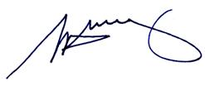

S. H. Tully
Electoral Commissioner

Appendix 1: List of submitters
Preliminary submissions were received from:
Blairgowrie Yacht Squadron Inc.  P. Brown  M. and D. Campbell  M. Chatterton  I. Cowden  J. Dwyer  L. G. and N. J. Evans  D. Gibb  D. Harrison  J. Hocking  C. Holden  G. Howard  I. Hundley  A. Kotzman  R. E. B. Lambert  J. Lenzo  D. Lines  A. Lorkin  A. McInnes  Mornington Environment Association Inc.  Mornington Peninsula Croquet Club  Mornington Peninsula Ratepayers and Residents Association Inc. | Mornington Peninsula Shire Council  D. Morris  A. and N. Nelsen  Nepean Ratepayers Association  Nepean Conservation Group Inc.  Nepean Historical Society Inc.  J. Oliver  Proportional Representation Society  of Australia (Victoria–Tasmania) Inc.  B. Robinson  M. Rush  L. Smith  Somers Residents Association Inc.  J. Spittle  M. Spittle  St. Andrews Habitat Improvement Preservation and Protection Society  D. Trunfull  Tyabb and District Ratepayers Group  Victorian Farmers’ Federation  M. Wilson

Response submissions were received from:
1066 Hasting Day Club  L. Allan  R. and E. Auhl  Balnarring Beach Ratepayers Association Inc.*  Balnarring Pony Club  R. Barnard Brown  P. Borzymowski  S. Borzymowski  P. Brown*  N. Buck*  G. Bull  H. Bull  A. Burke  K. Burnstein  P. Carlsen  A. Celi  T. Code*  B. Colomb*  B.D. and J.L. Davidson  A. and S. Drebing  K. Dyer  L. Eustace*  Flinders Community Association*  D. Gibb*  Greek Senior Citizens Club  Growing Our Community Incorporated  G. Nelmes  A.A. and N.J Nelsen  Nepean Historical Society Inc.  J. Oliver  M. Orwin  Peninsula Aero Club  Proportional Representation Society of Australia  N. Quick  D. Renouf  B. and D. Robinson  Rosebud Chamber of Commerce  M. Rush  Rye RSL  Rye Historical Society Inc. | J. Hill  J. Hocking  G. Howard  I. Hundley*  Dr M. K. Kennedy*  A. Kotzman  L. Lambert  R. Lambert*  J. Lenzo*  R. Lewis  R. Ljubicic*  S. Luntz  R. J. Matthews  McCrae Homestead Coastal Group Inc.  S. McLean  W. McLoughlin  Moorooduc Progress Association  Mornington Civic Bowls and Social Club  Mornington Peninsula Ratepayers and Residents Association Inc.*  Mornington Peninsula Shire Council*  MornPenCouncilWatch*  B. Morris  Mount Eliza Community Alliance 2011*  Mount Martha Senior Citizens Club  National Trust of Australia Mornington Peninsula Branch  R. Smith  Somerville Tennis Club  Southern Peninsula Players  J. Spittle  M. Spittle  St Andrews Habitat Improvement Preservation and Protection Society*  B. L. Stahl*  R. Steiner  Tyabb and District Ratepayers Business and Environment Group  P. Uri*  War Widows' Guild of Australia Southern  J. Warfe  M. Wilson
* Indicates those submitters who spoke in support of their submission at the public hearing on Wednesday, 12 October.

Comments on addendum report were received from:
W. Agnew  L. Allan  N. Allen  K. Anderson  P. Avery  S. Berson  M. Bottari  L. Bowden  R. Bowden  M. Breidahl  P. Brown  R. Brown  N. Buck  G. Bull  K. Burnstein  K.A. and S. Burrows  E. Cain  J. Cain  D. Campbell  M. Campbell  D. Capper  P. Carlsen  A. Carlyon  N. Carlyon  C. Cayless  A. Celi  D. and K. Chalke  J. ClarkeJ  G. Howard  S. Howard  I. Hundley  D. Jarman  P. Johns  S. Johnson  E. Judd  R. Kenery  R. Kilkenny  A. Kotzman  L. Lambert  R. Lambert  J. Lenzo  M. Lewis  R. Lewis  D. Lines  J. Lines  R. Ljubicic  S. Lowther  F. Martin  R. Martin  H. Mason  A. McInnes  R. Miller  J. Moore  Mornington Peninsula Shire Council  MornPenCouncilWatch  Mt Eliza Community Alliance 2011  Mt Eliza Woodland Residents  Association  R. Steiner  E. Sutton  C. Thompson  B. Thornell  J. Trantino  Truemans Road Recreation Reserve  Section 86 Committee  D. Trunfull | M. Coates  J. Coleman  B. Colomb  N. Cornish  N. Cowles and T. Hill  A.S. Crowe  P. Davis  I. and D. Dick  K. Dyer  L. Eustace  L. G. Evans  N. J. Evans  P. Fitton  P. Fitzgerald  R. Fitzgerald  B. Foster  P. Galante  P. and N. Galante  D. Gibb  B. Goodrem  G. Gordon  B. and C. Gray  P. Greer  D. Harrison  P. and P. Harvey  C. Haydon  M. Hibbert  K. Hopcroft  G. Nelmes  A. and N. Nelsen  Nepean Historical Society  Nepean Ratepayers Association  J. Oliver  B. Parry  C. Paterson  Peninsula Aero Club  G. Powell  P. Powell  B. Preston  Proportional Representation Society  of Australia  D. Renouf  M. and M. Ringham  B. Robinson  M. Rush  E. Sage  A. Shaw  K. Sheaves  R. Smith  Reade Smith  Sorrento Portsea Chamber of Commerce  R. and L. Spaull  J. Spittle  M. Spittle  St Andrews Habitat Improvement Protection and Preservation Society  B. L Stahl  B. Turner  P. Uri  L. Wagner  J. Warfe  L. Warfe  J. Wilson  M. Wilson

Appendix 2: Map

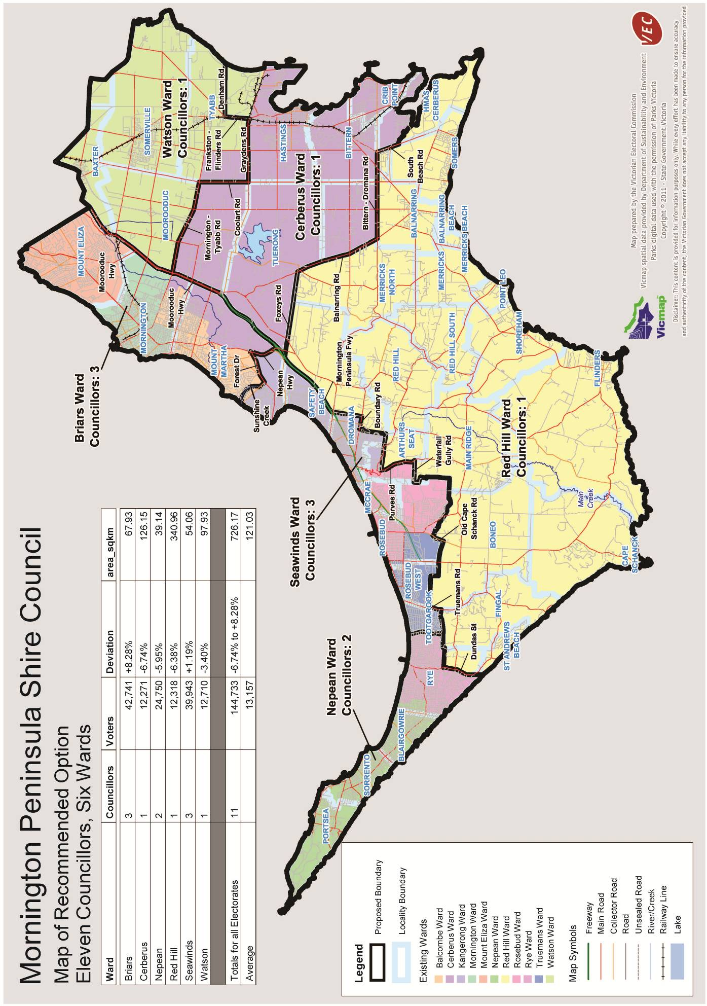

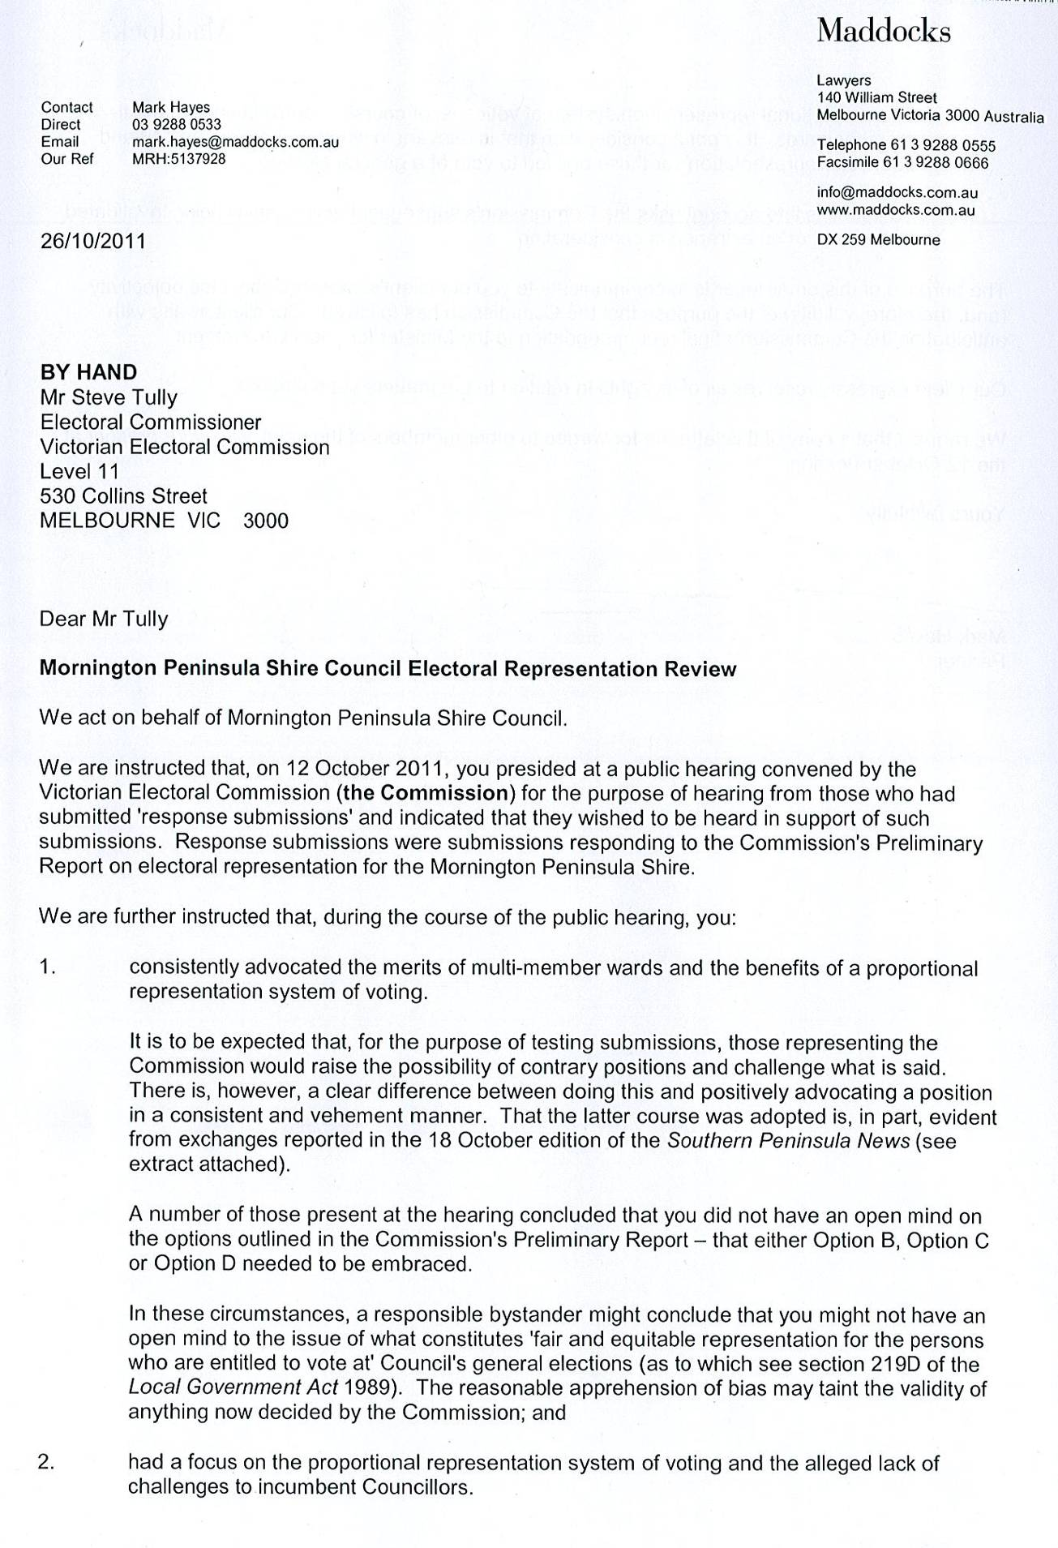
Appendix 3: Correspondence between Council legal representatives and the VEC
Continued next page
Continued next page
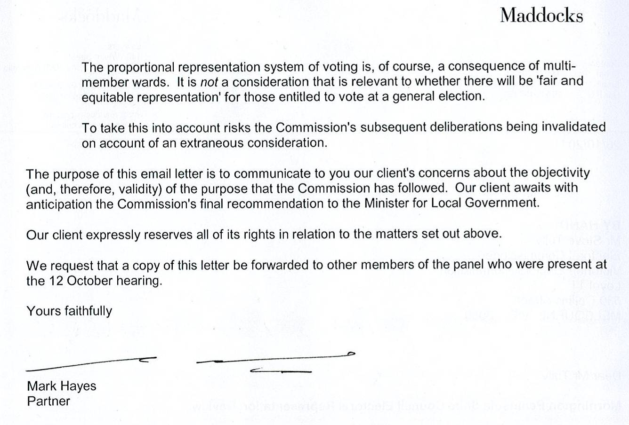
Continued from previous page

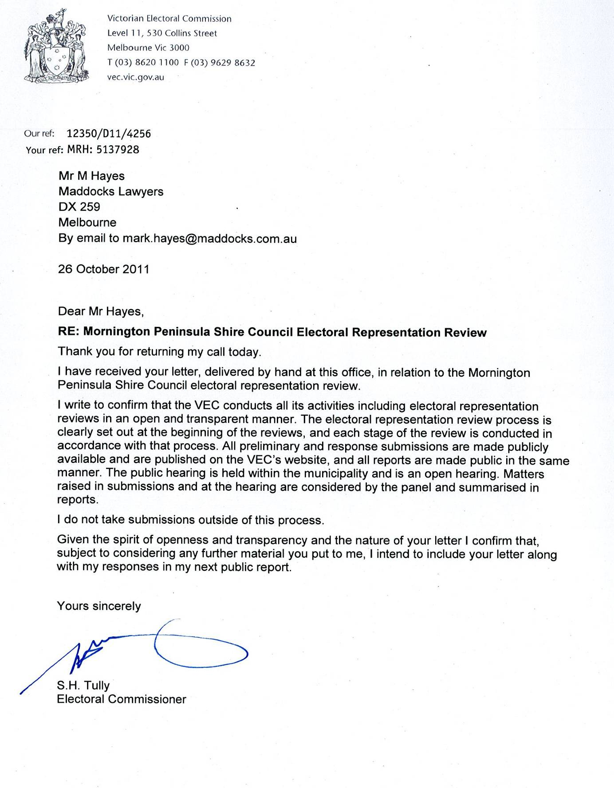

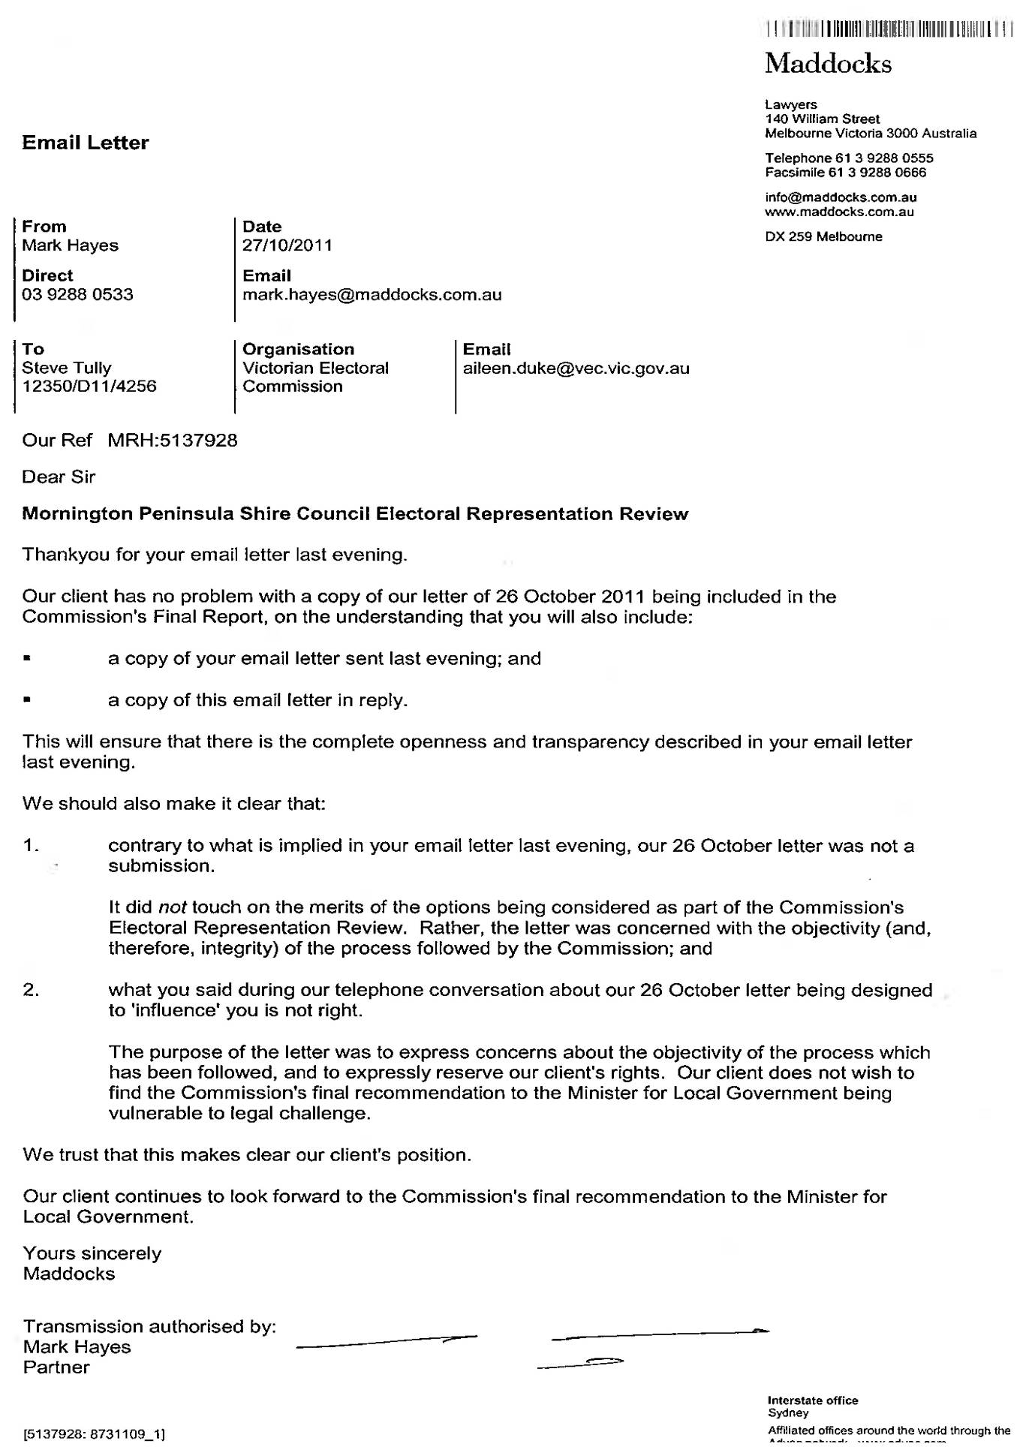
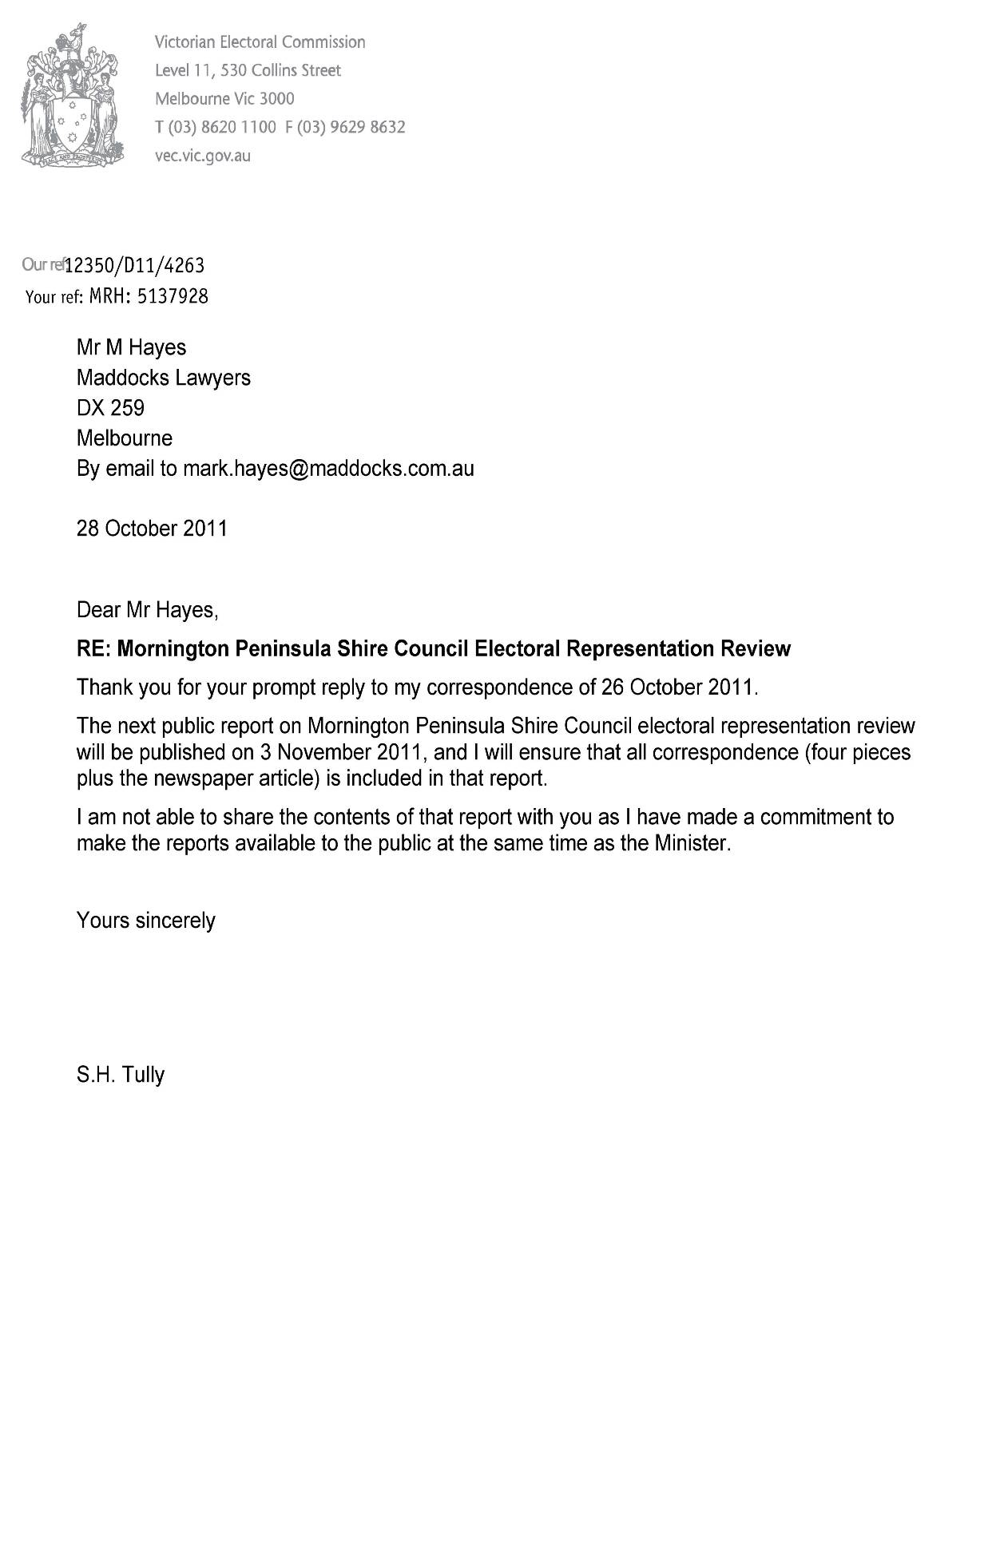
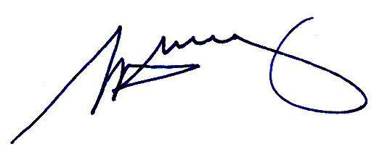

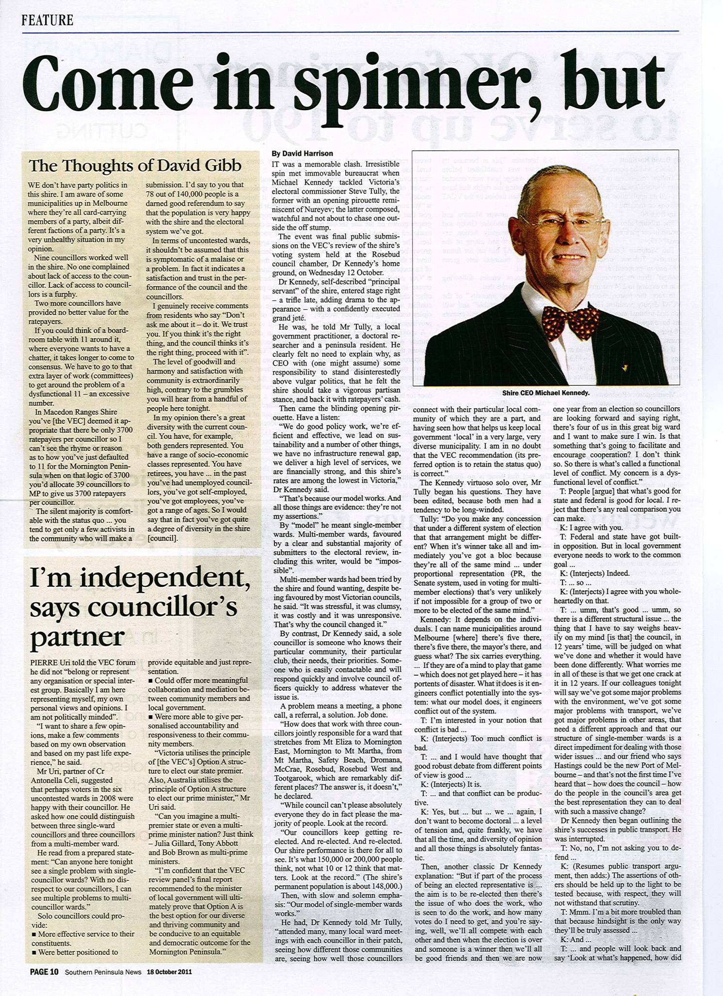

Appendix 4: Article referenced in correspondence from Mornington Peninsula Shire Council legal representatives

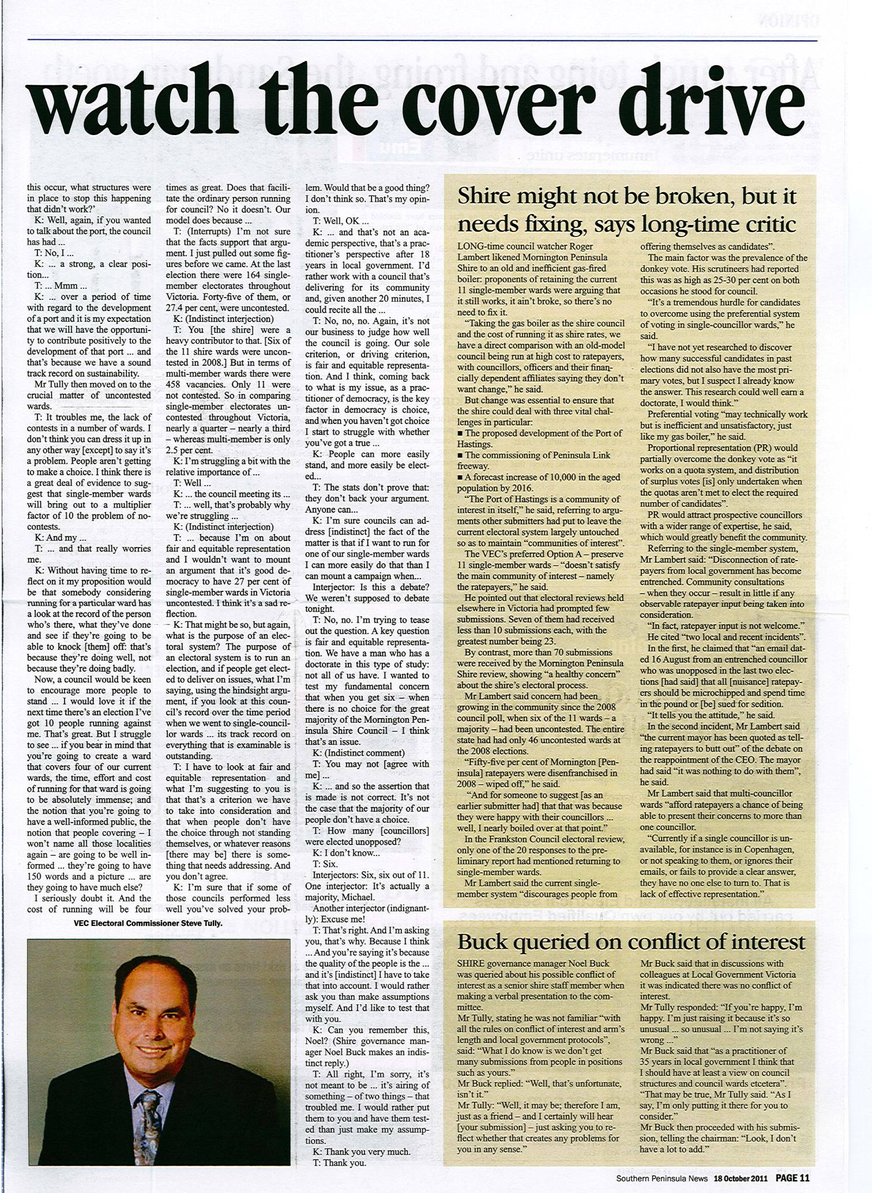

26.

Victorian Electoral Commission
Level 11, 530 Collins Street
Melbourne, Vic 3000

131 VEC (131 832)
review.morningtonpeninsula@vec.vic.gov.au
vec.vic.gov.au

Section 219D of the Local Government Act 1989.
Department of Planning and Community Development, Victoria in Future 2nd Release (2008).
An electoral subdivision review, which can only look at adjusting ward boundaries, was conducted by the VEC in 2008. The subdivision review recommended (and resulted in) changes to the boundaries of Balcombe Ward, Cerberus Ward, and Red Hill Ward.
Document referenced in the Mornington Peninsula Shire Council’s Preliminary and Response submissions.
Victorian Electoral Commission. Report of local government electoral activity 2008–09. Part III. Report of local government electoral representation reviews conducted by the VEC between 2004 and 2008. 2009: 78–80 & Appendix 8.
L. G. and N. J. Evans submitted twice to the review — a personal written submission and they were included in the count of form submissions.

