Local council electoral structure review

## About the review

Under Victoria’s *Local Government Act 2020*, Latrobe City Council must now have a single-councillor ward electoral structure.

The Minister for Local Government has appointed an electoral representation advisory panel to conduct an electoral structure review of the council. The panel will advise the Minister on the most appropriate single-councillor ward structure for Latrobe City Council.

The panel is looking at:

* the appropriate number of councillors and wards
* the location of ward boundaries
* appropriate ward names.

Electoral structure reviews are an important part of democracy, and your input is valuable. As a local, you know your local council area better than anyone. This is your chance to let the panel know your thoughts about the single-councillor ward electoral structure that you believe would best provide representation for your community.

There are 2 opportunities for you to have your say on the electoral structure of the council:

1. in a response submission to the preliminary report
2. in an online public hearing, if you request to speak in your response submission.

About Latrobe City Council

The Traditional Custodians of the land in Latrobe City Council are the Braiakaulung people.

Latrobe City Council is in the Gippsland region of Victoria, approximately 150 kms east of Melbourne.

Covering an area of 1,426 km², Latrobe City Council has 4 central towns – Churchill, Moe-Newborough, Morwell and Traralgon. It is recognised as the hub of Victoria’s electricity industry.

The major transport routes and services are the Princess Freeway (M1) and the V/Line, which runs an hourly service between Melbourne and Traralgon.

Accounting for over 37% of jobs in the 2021 Census, the top employment sectors are health care, retail, and construction. The main occupations are technicians, trade workers and professionals. Unemployment, at 6.6%, was higher in 2021 than for regional Victoria overall (4.1%).

Between 2016 and 2021, the population in Latrobe City Council has grown by 5.5% to 77,318, with the Traralgon urban centre accounting for over 52% of this growth. The median age of the population was 42 years in 2021, marginally lower than the median age for regional Victoria overall (43 years).

People born in Australia made up 79.4% of the population in the council area (compared to 81% for regional Victoria overall). In 2021, 86% of residents spoke only English at home, mirroring regional Victoria overall.

The weekly median household income in Latrobe City Council in 2021 was $1,260, which was below the regional Victorian median of $1,386.

## Current structure

Latrobe City Council is divided into 4 wards with a total of 9 councillors:

* 2 wards with 2 councillors each
* one ward with 4 councillors
* one single-councillor ward.

## Last review

The VEC conducted an electoral representation review of Latrobe City Council in 2012.

Visit the VEC website at [vec.vic.gov.au](https://www.vec.vic.gov.au/electoral-boundaries/local-councils/latrobe-city-council) to access a copy of the 2012 review final report.

Review process

Monday 10 and Tuesday 11 July

### Information sessions

Session 1: 12 noon, Monday 10 July

Session 2: 6 pm, Tuesday 11 July

Information sessions are for anyone wanting to find out more about the review process. Links to register for an information session will be available on the VEC website.

Wednesday 12 July

### Preliminary report

The panel will release a preliminary report including one or more options for the electoral structure on Wednesday 12 July.

**Response submissions open from this date.**

Wednesday 2 August

### Response submission close

The panel must receive all submissions by 5 pm on Wednesday 2 August.

Late submissions will not be accepted.

Tuesday 8 August

### Public hearing

The panel will hold an online public hearing if anyone requests to speak about their response submission at 2 pm on Tuesday   
8 August.

The public hearing will not be held if there are no requests to speak.

Wednesday 6 September

### Final report

The panel will submit a final report to the Minister for Local Government including its advice on the electoral structure on Wednesday 6 September.

The Minister will then consider the panel’s advice before recommending a change to the electoral structure. Any change to the electoral structure of the council following the review is expected to apply at the next local council elections.

## Untitled-1How to make a submission

On the VEC website at [vec.vic.gov.au](http://vec.vic.gov.au/)

By email to

[Latrobe.ERAPSubmissions  
@vec.vic.gov.au](mailto:Latrobe.ERAPSubmissions@vec.vic.gov.au)

LetterElectoral representation advisory panel  
c/o Victorian Electoral Commission  
Level 11, 530 Collins Street  
Melbourne VIC 3000

Submissions must include your:

* full name
* contact phone number or email address
* residential or postal address.

All submissions will be published on the VEC website. Your name and locality (suburb or town) will be published, but your full address and contact details will be removed. See the submission guide and VEC website at [vec.vic.gov.au/privacy](https://www.vec.vic.gov.au/privacy) for privacy information.

## Submission guide

Download the submission guide from the VEC website at [vec.vic.gov.au](http://vec.vic.gov.au/) for more information on the review process and making a submission.

## One vote, one value

The ‘one vote, one value’ democratic principle is enshrined in the *Local Government Act 2020*. This means that every person’s vote counts equally.

When a local council area is subdivided into wards, the number of voters each councillor represents in each ward must be within plus-or-minus 10% of the of the average number of voters per councillor for all the wards.

The map below includes the current number of voters in each ward and the ward’s current deviation from the average. The panel will consider likely population and voter changes to ensure the structure remains equitable.

If you make a submission online, you can use a mapping tool to build your preferred electoral structure. The tool uses current voter numbers to tell you the deviations of the wards you make. This will help you propose a structure that meets the requirements of the Act.

Current electoral structure

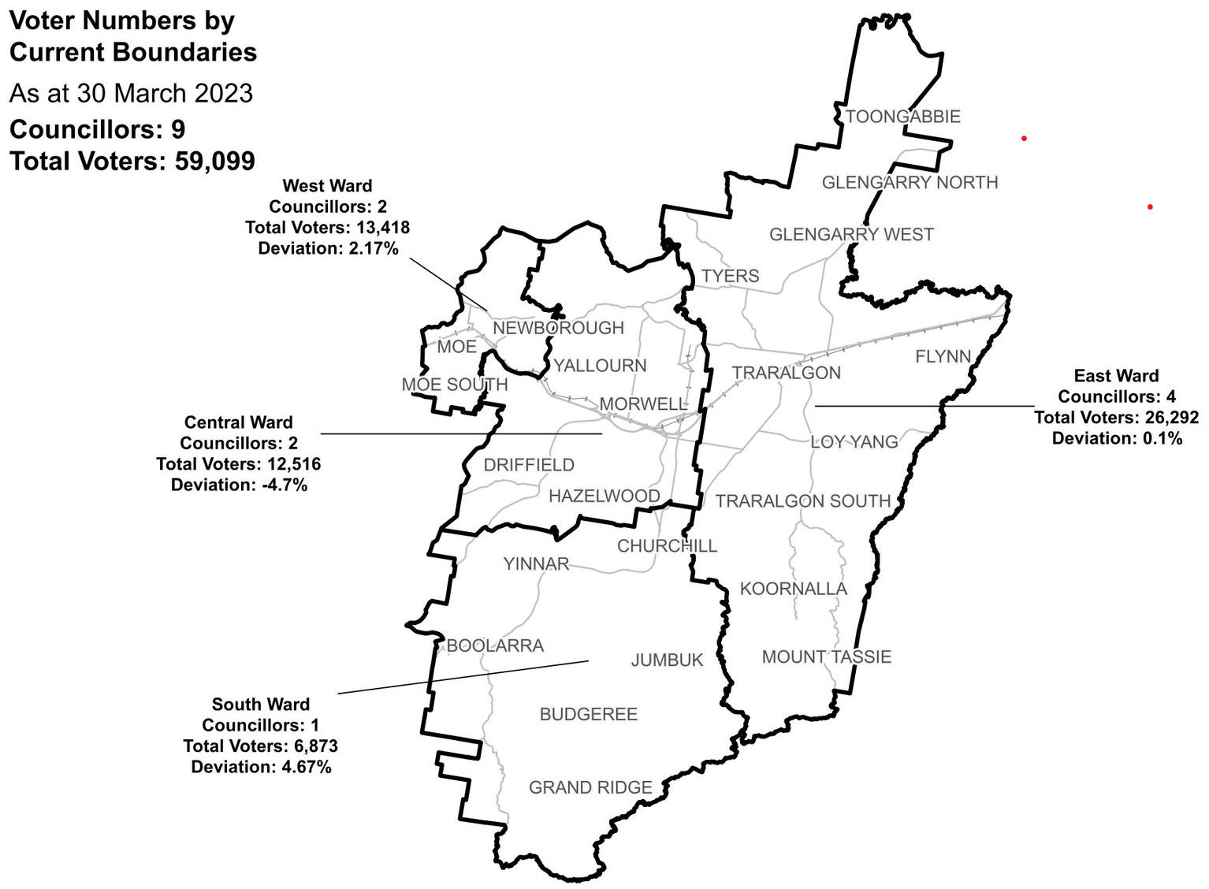

|  |  |  |  |
| --- | --- | --- | --- |
| Ward | Councillors | Voters | Deviation |
| Central Ward | 2 | 12,516 | -4.70% |
| East Ward | 4 | 26,292 | +0.10% |
| South Ward | 1 | 6,873 | +4.67% |
| West Ward | 2 | 13,418 | +2.17% |

## Statistics

Area (km2) 1,426

Voters

### Voters per square km

41.4

### Average voters per councillor

6,566

Population

### Current population

77,318

### Forecast population growth

1.3% p.a.

Further census statistics available at [abs.gov.au](http://www.abs.gov.au/)

Voter numbers by locality (map)

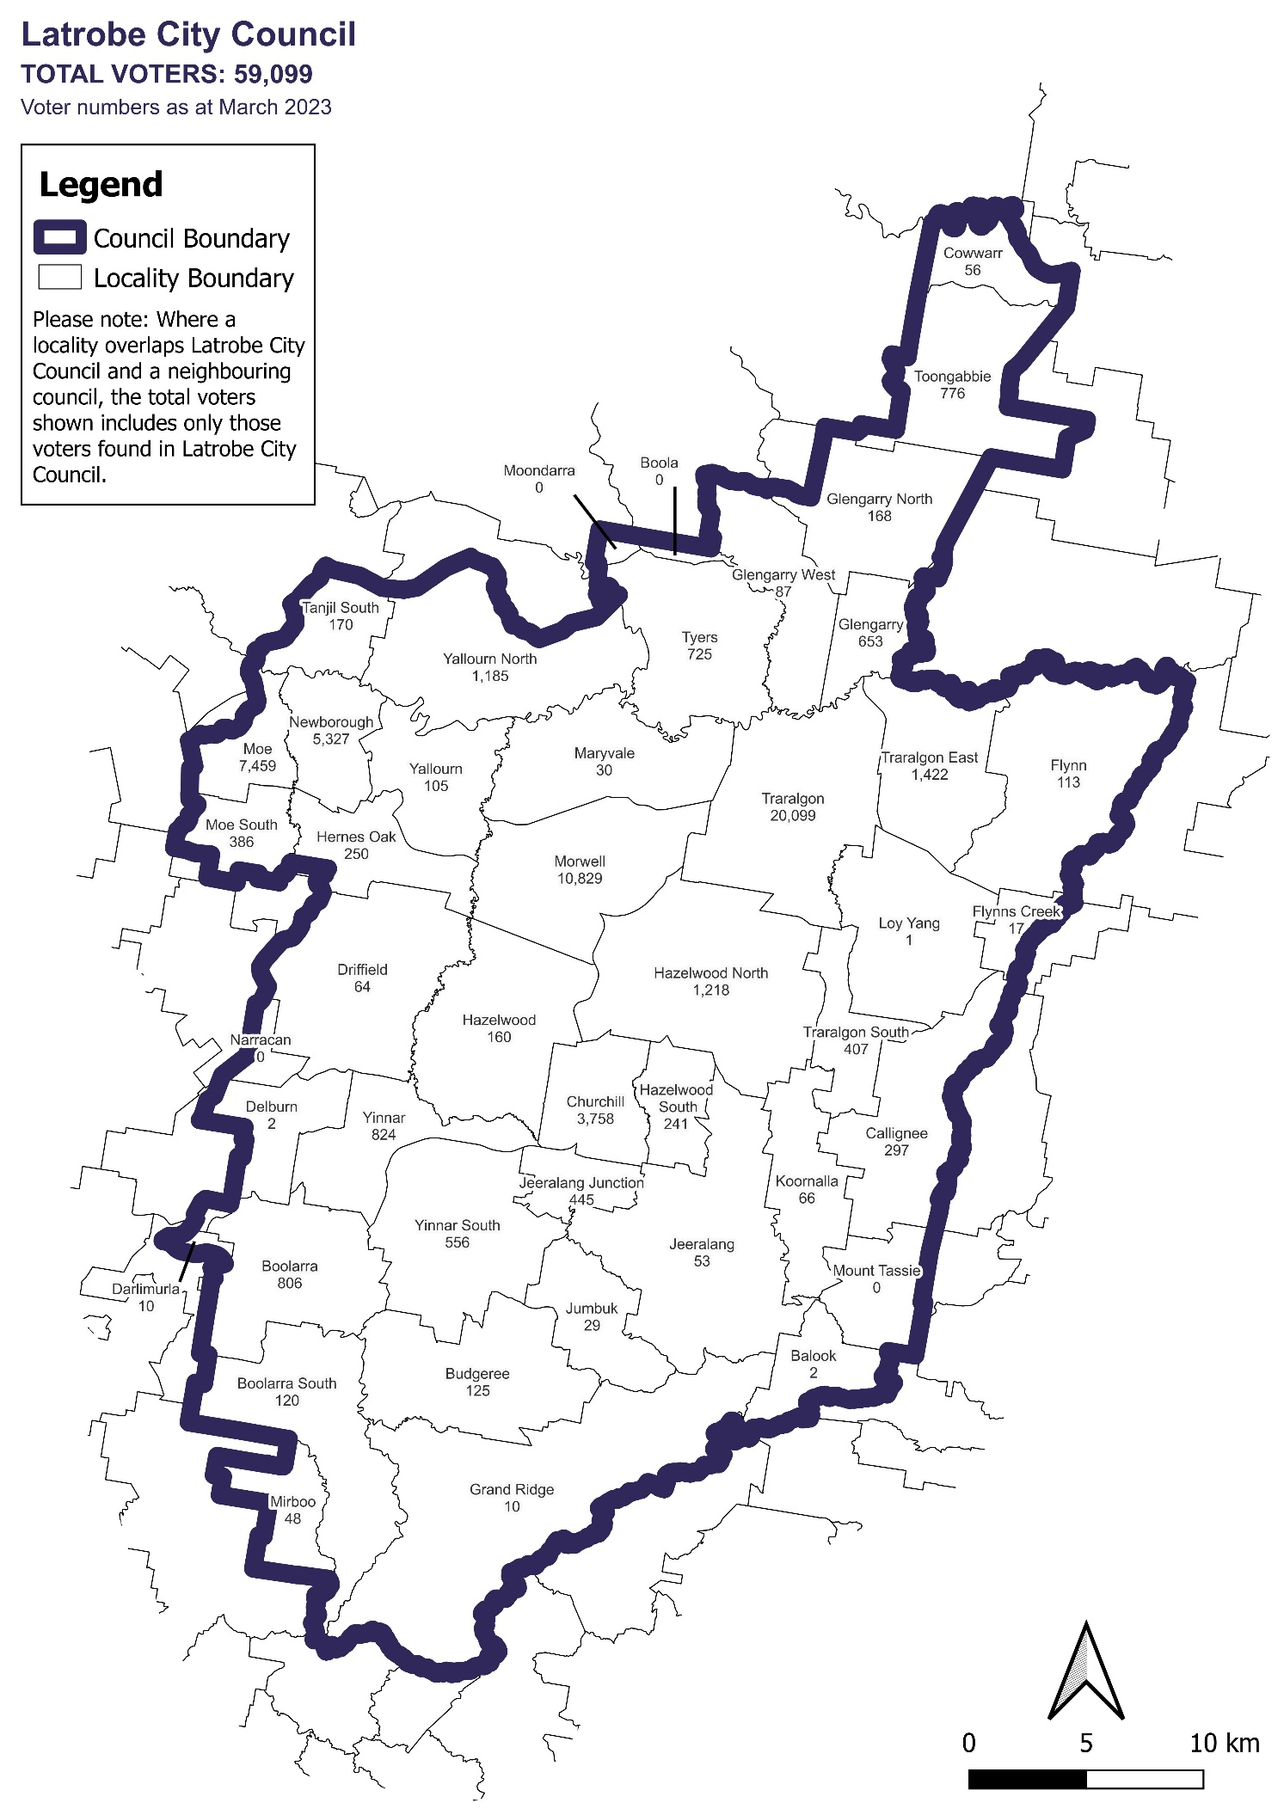

Voter numbers by locality (table)

## Latrobe City Council voter numbers at 30 March 2023

|  |  |
| --- | --- |
| Locality | Voters |
| Balook | 2 |
| Boola | 0 |
| Boolarra | 806 |
| Boolarra South | 120 |
| Budgeree | 125 |
| Callignee | 297 |
| Churchill | 3,758 |
| Cowwarr | 56 |
| Darlimurla | 10 |
| Delburn | 2 |
| Driffield | 64 |
| Flynn | 113 |
| Flynns Creek | 17 |
| Glengarry | 653 |
| Glengarry North | 168 |
| Glengarry West | 87 |
| Grand Ridge | 10 |
| Hazelwood | 160 |
| Hazelwood North | 1,218 |
| Hazelwood South | 241 |
| Hernes Oak | 250 |
| Jeeralang | 53 |
| Jeeralang Junction | 445 |

|  |  |
| --- | --- |
| Locality | Voters |
| Jumbuk | 29 |
| Koornalla | 66 |
| Loy Yang | 1 |
| Maryvale | 30 |
| Mirboo | 48 |
| Moe | 7,459 |
| Moe South | 386 |
| Moondarra | 0 |
| Morwell | 10,829 |
| Mount Tassie | 0 |
| Narracan | 0 |
| Newborough | 5,327 |
| Tanjil South | 170 |
| Toongabbie | 776 |
| Traralgon | 20,099 |
| Traralgon East | 1,422 |
| Traralgon South | 407 |
| Tyers | 725 |
| Yallourn | 105 |
| Yallourn North | 1,185 |
| Yinnar | 824 |
| Yinnar South | 556 |