Local council electoral structure review

March 2023

Moorabool Shire Council

Preliminary   
Report

Acknowledgement of Country

The electoral representation advisory panel acknowledges the Wadawurrung, Wurundjeri and Dja Dja Wurrung peoples as the Traditional Custodians of the lands and waters on which it is holding this review and pays respects to ancestors and Elders past, present and emerging. The panel acknowledges their custodianship for many thousands of years and their continuing living culture.

Document history and version control

|  |  |  |  |
| --- | --- | --- | --- |
| **Version** | **Date approved** | **Approved for publication by** | **Brief description** |
| 1 | 27 March 2023 | Electoral Commissioner | Final version |

Contents

Executive summary 4

Developing electoral structure models 4

Preliminary submissions 4

Electoral structure models 4

Next steps 4

Background 5

About the 2023–24 electoral structure reviews 5

The electoral representation advisory panel 5

Public engagement 6

Developing recommendations 6

About Moorabool Shire Council 9

Profile 9

Current number of councillors and electoral structure 10

Last electoral structure review 10

Preliminary submissions 12

Number of councillors 12

Electoral structure 13

Preliminary findings and models 14

Number of councillors 14

Electoral structure 15

Models for public feedback 18

Next steps 19

Response submissions 19

Public hearing 20

Final report 20

References 21

Appendix 1: Model maps 22

Appendix 2: Additional models considered 25

Appendix 3: List of preliminary submitters 26

# Executive summary

An independent electoral structure review panel appointed by the Minister for Local Government has reviewed the structure of Moorabool Shire Council.

The panel looked at:

* + whether the council had an appropriate number of councillors
  + whether it should be unsubdivided or subdivided.

This report outlines the preliminary models that the panel is presenting for the proposed new electoral structure of Moorabool Shire Council to meet the requirements of the *Local Government Act 2020* (the Act).

More information about the background to the reviews is available on page 5.

## Developing electoral structure models

The panel considered a range of factors when deciding on the models in this report, including:

* + research and analysis
  + voter growth or decline over time
  + public submissions (see below).

More information on the way the panel decided on the models is available on page 6.

## Preliminary submissions

The panel received 4 preliminary submissions. Of these, no submissions included maps.

A full analysis of submissions received can be found on page 12.

## Electoral structure models

After considering submissions and research, the panel is presenting the following electoral structure models for further public consultation:

* + Model 1: an unsubdivided electoral structure with 9 councillors.
  + Model 2: a subdivided electoral structure with a total of 9 councillors, 3 wards and 3 councillors per ward.

Details on these models, including maps, are available in Appendix 1.

## Next steps

The panel is now seeking feedback on the electoral structure models. You can make a response submission to these models until Wednesday 19 April 2023. If any response submitters wish to speak at a public hearing, the panel will hold an online public hearing on Thursday 27 April 2023. Following this, it will present its final recommendation to the Minister by Wednesday 24 May 2023.

More information about the review process is available on the Victorian Electoral Commission (VEC) website at [vec.vic.gov.au](https://www.vec.vic.gov.au/)

# Background

## About the 2023–24 electoral structure reviews

In October 2022, the Minister for Local Government formed 2 electoral representation advisory panels to review the electoral structures of 39 local councils, under section 16 of the *Local Government Act 2020* (the Act). If the Minister accepts the electoral structures the panels recommend, they will take effect at the October 2024 elections.

The Act introduced several changes to local government representation, including the types of electoral structures local councils may have. Large and small rural shire councils (including Moorabool Shire Council) can have one of 3 electoral structures:

* + unsubdivided (entire council area with no wards)
  + single-councillor wards
  + multi-councillor wards with the same number of councillors per ward.

For Moorabool Shire Council, the electoral representation advisory panel is examining:

* the number of councillors
* whether the council should be subdivided into wards or unsubdivided.

For subdivided structures, it is also examining:

* + the number of wards
  + where the ward boundaries should be
  + the name of each ward
  + how many councillors should be elected for each ward.

The Act requires electoral structures to provide fair and equitable representation and facilitate good governance. For subdivided structures, each ward must have an approximately equal number of voters per councillor (within +/-10% of the average).

## The electoral representation advisory panel

The panel conducting the electoral structure review of Moorabool Shire Council has 3 members:

* The Honourable Frank Vincent AO KC (Chairperson)
* Ms Liz Williams PSM
* Electoral Commissioner Mr Warwick Gately AM.

The panel is independent of councils and the State government.

Under the Act, the VEC is not responsible for reviewing council electoral structures but must provide administrative and technical support to the panel. The Electoral Commissioner (or their delegate) must be a member of each panel.

## Public engagement

### Public information program

To educate and inform the public about the Moorabool Shire Council electoral structure review, the VEC began a public information program in mid-December 2022. The VEC:

* + printed public notices in state-wide, and some local, newspapers
  + held public information sessions to outline the review process and respond to questions from the community
  + sent out media releases to announce the start of the review
  + published information on its social media channels
  + provided updated website content on [vec.vic.gov.au](https://www.vec.vic.gov.au/), including:
    - information on the review process
    - submission guides and fact sheets for each council under review with background information
    - preliminary submissions from the public.

The VEC will continue to promote the review during the response submissions stage via media releases, the VEC’s social media channels and updated content on the VEC website.

### Public consultation

The panel encouraged public input to the review of Moorabool Shire Council via preliminary submissions at the start of the review. The panel now invites further input via:

* + response submissions to this preliminary report
  + an online public hearing to provide anyone who makes a response submission the opportunity to expand on their submission.

Public submissions are an important part of the review process but the panel also considers other factors during a review. These are outlined below.

## Developing recommendations

The panel’s electoral structure models presented in this preliminary report comply with the Act and were developed through careful consideration of:

* + research and analysis conducted by the VEC support team, including geospatial and demographic factors
  + rates or patterns of population and voter growth or decline over time, and relevant forecasts of growth or decline based on forecast information provided by .id (informed decisions, a company specialising in demographics and forecasting)
  + input received from the public in written submissions during the preliminary submissions phase.

### Deciding on the number of councillors

The Act allows local councils to have between 5 and 12 councillors, but neither the Act nor the Local Government (Electoral) Regulations 2020 specify how to determine the number of councillors a council needs. Therefore, the models put forward by the panel in this report are guided by the Act’s intention for fairness and equity in voter representation.

In examining the number of councillors Moorabool Shire Council should have, the panel considered these factors:

* + the population and number of voters in the council area, compared to other councils with a similar population size and number of voters in the same category (for example, metropolitan, interface, regional city, large rural shire, small rural shire)
  + patterns of population change and voter growth or decline in the council area over time
  + the current and past numbers of councillors
  + the representation needs of the communities of interest in the council area
  + if a particular type of electoral structure best suits the council (see ‘Deciding the electoral structure’ below)
  + any matter raised in public submissions not already listed above.

Generally, local councils with a larger number of voters will have a higher number of councillors. Large populations are often more likely to have greater diversity, both in the type and number of communities of interest and issues relating to representation. However, the ideal number of councillors can also be influenced by the particular circumstances of a council, such as the:

* + nature and complexity of services the council provides
  + geographic size and topography of the area
  + forecast population and voter growth or decline
  + social diversity.

### Deciding the electoral structure

The electoral structure of large and small rural shire councils can be:

* + unsubdivided (entire council area with no wards)
  + made up of single-councillor wards

or

* + made up of multi-councillor wards with the same number of councillors per ward.

When developing electoral structure models for Moorabool Shire Council, the panel considered these main criteria:

* + whether the structure would comply with section 15(2) of the Act (see below), and for how long it would likely comply
  + the appropriate number of councillors, as outlined above
  + whether meaningful and effective ward boundaries can be established and whether these would be easily identifiable to local communities
  + representation of communities of interest
  + the voter distribution and physical features of the area, and the impact these may have on the shape and size of any wards
  + past elections for the council, including:
    - numbers of candidates nominating
    - incidences of uncontested elections
    - rates of informal voting.
  + other matters raised in public submissions not already listed above.

Under section 15(2) of the Act, subdivided structures must aim for an approximately equal number of voters per councillor in each ward. This means the number of voters represented by each councillor in a ward should be within +/-10% of the average number of voters per councillor for all wards.

The panel recommends structures that will comply with section 15(2) at the October 2024 local government elections and uses current voter numbers and population forecasts to assess this with as much accuracy as possible. In some cases, population changes and other factors mean it is not possible for a subdivided electoral structure to comply with section 15(2) based on current voter numbers. If this occurs, compliance at the 2024 local government elections will be the priority to ensure each vote has approximately equal value.

# About Moorabool Shire Council

## Profile

Moorabool Shire Council is a large rural council located in south-west Victoria, about 80 kms from Melbourne’s central business district. It is surrounded by 7 council areas: Hepburn Shire, Macedon Ranges Shire, Golden Plains Shire, Melton City, Wyndham City, Greater Geelong City, and Ballarat City. The shire is mostly rural in character but has a large, fast-growing population in its east around the Bacchus Marsh area.

The Traditional Custodians of the lands in Moorabool Shire Council are the Wurundjeri, Wadawurrung and Dja Dja Wurrung peoples (Moorabool Shire Council, 2023).

### Landscape

The shire covers an area of about 2,110 km2, from Bacchus Marsh, Hopetoun and Long Forest in the east to the outskirts of Ballarat in the west. The shire has high value environmental assets including the Wombat and Lerderderg forests which cover a large part of the shire’s north, and in the south a large section of the Brisbane Ranges National Park. The Lerderderg, Moorabool and Werribee rivers, and the Korjamnunnip, Korkuperrimul and Pyrites creeks are also of cultural and environmental significance.

Primary production accounts for about 65% of land use in the shire. The main primary industries are sheep and beef grazing, and high value horticultural production is found in the Bacchus Marsh area (DJSIR, 2022).

At the 2021 census the shire had a total population of 37,632 people (ABS 2021). In 2023, the estimated populations of the main centres were Darley (9,250 people), Bacchus Marsh (8,725), Maddingley (5,683), Ballan (2,922), and Merrimu and Hopetoun Park (2,157). In 2023, the estimated populations of the rural east and the rural west were 4,103 and 6,622 people respectively.

The Western Freeway runs through the centre of the shire from east to west connecting Melbourne to Ballarat. The Midland Highway passes through the southwest corner of the shire. Likewise, rail services follow the general route of the Western Freeway and the Midland Highway through the shire.

### Community

Moorabool Shire Council has the third fastest rate of population growth of all of Victoria’s regional councils and is forecast to have a population of over 65,500 people by 2041, an increase of about 27,000 people from the current population. The main growth area is in the east of the shire around Bacchus Marsh. By 2041, the population of Merrimu and Hopetoun Park is forecast to increase by over 10,000 people and Parwan Station by 5,500 people. Ballan, in the centre of the shire, is also forecast to more than double in population by 2041, to about 6,700 people. By contrast the rural areas in the shire are not forecast to have any significant population change over the same period.

Moorabool Shire Council has a younger age profile compared to regional Victoria, but similar to all of Victoria, mostly due to the high percentage of people in the 0-14 age range (ABS, 2021).

At the 2021 Census, Moorabool Shire Council had 63.7% of people aged 15 and over in the labour force, which was above the Victorian percentage of 62.4%. The median weekly incomes are much the same as the median for Victoria (ABS, 2021).

Of those people in the labour force, 58.4% work full-time and 30.5% work part-time. Professionals (3,128 people) were the largest group in terms of occupation, followed by technicians and trades workers (3,124), clerical and administrative workers (2,541), managers (2,330), and community and personal service workers (2,167) (ABS, 2021).

The main industries of employment in Moorabool Shire Council are construction which accounts for 7.3% of employed people, health care and social assistance 5.53%, education and training 4.72%, retail trade 3.88%, public administration and safety 3.78% and transport, postal and warehousing 3.51% (ABS, 2022).

Over 87% of residents reported as speaking English only. Most of the population (80%) was born in Australia with the other main countries of birth being England (3.2%), India (1.9%), New Zealand (1.4%), Scotland (0.6%) and Malta (0.6%) (ABS, 2021).

Aboriginal and Torres Strait Islander people account for 1.5% of the total shire population (558 people) and they have a median age of 24 (ABS, 2021).

In Moorabool Shire Council, 32.1% of the occupied private dwellings are owned outright (similar to the Victorian average of 32.2%), 47.3% are mortgaged (significantly higher than the Victorian average of 36.1%) and 17.2% are rented (lower than the Victorian average of 28.5%) (ABS, 2021).

## Current number of councillors and electoral structure

Moorabool Shire Council is currently divided into 4 wards with a total of 7 councillors:

* + one ward with 4 councillors (East Moorabool Ward)
  + 3 wards with one councillor each (Central Moorabool Ward, West Moorabool Ward, Woodlands Ward).

There are approximately 28,815 voters in Moorabool Shire Council, with a ratio of 4,116 voters per councillor.

Visit the VEC website at [vec.vic.gov.au](https://www.vec.vic.gov.au/electoral-boundaries/local-councils/moorabool-shire-council) for more information on Moorabool Shire Council.

## Last electoral structure review

The VEC conducted an electoral representation review of Moorabool Shire Council in 2011. This review was carried out under the *Local Government Act 1989*. After conducting the 2011 review, the VEC recommended that Moorabool Shire Council continue to consist of 7 councillors elected from 4 wards (one ward with 4 councillors and 3 wards with one councillor each).

Before the 2011 review, a representation review of Moorabool Shire Council was completed in 2004. This resulted in the current electoral structure being implemented (7 councillors elected from 4 wards: one 4-councillor ward and 3 one-councillor wards). Before the 2004 representation review, Moorabool Shire Council comprised 5 ridings and a total of 7 councillors:

* + one riding with 3 councillors
  + 4 ridings with one councillor each.

### Subdivision review

Since the 2011 representation review, the VEC also conducted a subdivision review of Moorabool Shire Council in 2020.

Subdivision reviews conducted under the *Local Government Act 1989* adjusted the internal ward boundaries of a council but did not change the electoral structure or number of councillors. Subdivision reviews were conducted in situations where the voter-to-councillor ratios in one or more wards of a council were forecast to move outside the legislated +/-10% tolerance before the council’s next election, and aimed to ensure voter-to-councillor ratios for all wards were within tolerance at the election.

The 2020 review of Moorabool Shire Council aimed to return the West Moorabool Ward and Woodlands Ward to within the permitted +/-10% tolerance before the 2020 local government elections. Visit the Moorabool Shire Council profile on the VEC website at [vec.vic.gov.au](https://www.vec.vic.gov.au/electoral-boundaries/local-councils/moorabool-shire-council) to access a copy of the 2020 subdivision review final report.

# Preliminary submissions

The panel received 4 preliminary submissions from the public by the deadline of 5 pm on Wednesday 1 March 2023. You can view these submissions on the VEC website at [vec.vic.gov.au](https://www.vec.vic.gov.au/electoral-boundaries/council-reviews/electoral-structure-reviews/moorabool/preliminary-submissions) and find a list of people or organisations who made a submission in Appendix 3.

The table below provides an overview of preferences in the preliminary submissions. You can read an analysis of submissions below this table.

|  |  |  |  |  |  |
| --- | --- | --- | --- | --- | --- |
|  | Unsubdivided structure | Single-councillor wards | Multi-councillor wards | Subdivided structure (unspecified) | No comment on structure |
| Fewer councillors | - | - | - | - | - |
| Maintain current councillor number | 2 | - | - | - | - |
| More councillors | 1 | - | - | - | - |
| No comment on number of councillors | - | 1 | - | - | - |

## Number of councillors

Of the 4 submitters, 2 recommended maintaining the current number of 7 councillors, one recommended more than 7 councillors, and one made no comment about the number of councillors. Only 2 submissions gave reasons for their preferred number of councillors.

### Maintaining 7 councillors

Two submissions supported the current number of councillors. Robert Reid from Hopetoun Park believed the bulk of residents’ concerns are addressed by council officers and did not feel increasing councillor numbers would result in material change for residents. In its submission, the Proportional Representation Society of Australia (Victoria-Tasmania) Inc. supported 7 councillors but did not provide reasons why that was the best number of councillors for the shire.

### Reducing councillor numbers

No submissions wanted to see a decrease in councillor numbers.

### Increasing councillor numbers

One submitter proposed increasing councillors. John Kowarsky from Ballan believed an increase in councillor numbers was required due to councillors often being absent from council meetings. Kowarsky argued this reduced the diversity of voices in council meetings and limited the quality of decision-making. They also felt having more councillors could reduce and more effectively distribute councillor workloads, allowing for travel and meaningful engagement across all parts of the shire.

## Electoral structure

An unsubdivided structure was the preferred option of 3 submitters, while one submitter preferred a structure of 7 wards with one councillor each.

### Unsubdivided

All 3 submitters seeking an unsubdivided structure believed this would result in councillors acting in the interests of the entire shire. The Proportional Representation Society of Australia (Victoria-Tasmania) Inc. argued that the distortions associated with single-councillor wards cannot happen with unsubdivided structures. John Kowarsky reasoned that councillors must act in the overall interest of the shire, and that an unsubdivided structure was the strongest way to promote this responsibility. Robert Reid also argued that one large undivided area may result in better outcomes.

### Single-councillor wards

One submitter preferred a single-councillor ward structure. Michael Lombardi of Bacchus Marsh asserted that councillors did not visit their estate, and consequently their unique local issues were not understood by councillors. They believed a single-councillor ward structure would result in better representation for their local area. However, John Kowarsky also argued that single-councillor ward structures were problematic because sizable minorities in each ward were represented by councillors they did not vote for. Kowarsky also pointed out that uncontested elections are more likely under a single-councillor ward structure.

# Preliminary findings and models

The panel is recommending an increase in the number of councillors for Moorabool Shire Council from the current 7 councillors to 9 councillors. Population growth in the shire is the key factor influencing this recommendation.

## Number of councillors

After taking into consideration the requirements of the Act, public submissions and the agreed criteria, the panel found 9 councillors to be an appropriate number for Moorabool Shire Council.

The panel considered the characteristics of Moorabool Shire Council in relation to similar rural shire councils, including its size and geography, population and the number and distribution of voters across the shire.

|  |  |  |  |  |  |  |
| --- | --- | --- | --- | --- | --- | --- |
| Similar rural shire councils to Moorabool Shire Council | | | | | | |
| Local council | Area (km2) | Number of voters at 2020 election | Population (2021 Census) | Current total estimate of voters | Number of councillors | Number of voters per councillor |
| Macedon Ranges Shire | 1,748 | 38,068 | 51,458 | 39,622 | 9 | 4,402 |
| Mitchell Shire | 2,862 | 34,595 | 49,460 | 36,928 | 9 | 4,103 |
| Surf Coast Shire* | 1,553 | 33,644 | 37,694 | 35,330 | 9 | 3,926 |
| Campaspe Shire* | 4,519 | 30,493 | 38,735 | 31,046 | 9 | 3,450 |
| **Moorabool Shire\*** | **2,111** | **27,947** | **37,632** | **28,815** | **7** | **4,116** |
| South Gippsland Shire | 3,296 | n/a | 30,577 | 27,964 | 9 | 3,107 |
| Moira Shire | 4,046 | 24,290 | 30,522 | 24,974 | 9 | 2,775 |
| Colac Otway Shire | 3,438 | 19,697 | 22,423 | 20,060 | 7 | 2,866 |
| Golden Plains Shire | 2,703 | 18,643 | 24,985 | 19,702 | 7 | 2,815 |

*This local council is undergoing an electoral structure review during 2023–24.

### Changing councillor numbers

With 7 councillors, Moorabool Shire Council is no longer in line with the number of councillors of other comparable councils. At the time of the last representation review in 2011, the shire’s population was about 28,000 people and 7 councillors was considered an appropriate number. However, since 2011 the population has increased rapidly, and the shire now has voter numbers comparable with a 9-councillor shire.

The current number of voters per councillor is 4,116, which is high compared to most other similar councils. An increase to 9 councillors will reduce the number of voters per councillor to about 3,200, making it consistent with other similar councils. Increasing councillor numbers will ensure the number of voters per councillor does not become unusually high over time because population growth is forecast to continue rising at a rapid rate.

Increasing the number of councillors to 8 was not considered suitable given the shire’s current and forecast rate of growth.

## Electoral structure

To identify the most appropriate electoral structure, various factors were considered. This included the requirements of the Act, the communities of interest in Moorabool Shire Council, public submissions, the appropriateness of ward boundaries and which models best offered fair and equitable representation.

In developing the preliminary models presented in this report, a range of models were considered. The strongest 2 models have been put forward for further public comment.

The panel proposes 2 models for the consideration of the Moorabool Shire Council community:

* an unsubdivided electoral structure, with 9 councillors (Model 1)
* a subdivided electoral structure of 3 wards, with 3 councillors per ward (Model 2).

Diagrams of the preliminary models are included in Appendix 1.

### Unsubdivided structure (Model 1)

Under this model, Moorabool Shire Council would adopt an unsubdivided electoral structure, represented by 9 councillors.

The panel considered the advantages of an unsubdivided structure, particularly as an effective structure for accommodating changes in population. The Moorabool Shire Council population is forecast to continue growing rapidly for the next 20 to 30 years. Under a ward-based structure the shire would likely need to undergo frequent ward boundary reviews in response to such growth. This would not occur in an unsubdivided structure.

Another advantage considered was the fostering of a shire-wide focus amongst councillors elected from voters across the entire council. However, it was noted that with an unsubdivided structure there may be concerns in the community that most councillors may come from the main urban areas, rather than rural and regional areas.

However, unsubdivided structures use the proportional voting system which can enable sizeable minority groups an opportunity to gain representation, in turn increasing the diversity of councillors.

Uncontested elections are generally rare in unsubdivided structures, particularly where there is a large population or voter base as is the case in Moorabool Shire Council. However, there is a potential for large numbers of candidates appearing on the ballot paper at election time, which may lead to increased levels of informal voting. This is not considered a major concern due to the average number of candidates at previous elections for Moorabool Shire Council.

Noting that public submissions were largely supportive of an unsubdivided structure the panel seeks further community feedback on this model.

### Multi-councillor ward structure (Model 2)

Under this model, Moorabool Shire Council would adopt a 3-ward structure. Each ward would be represented by 3 councillors, in line with the requirement of the *Local Government Act 2020* (Vic) for there to be the same number of councillors per ward.

To ensure the wards have a similar number of voters per councillor, the 3 wards are very different in size. The rural Bungal Ward would cover most of the shire. The 3 councillors representing this ward would need to travel long distances to carry out their duties and to connect with voters across the large area. It would include the townships of Blackwood and Dales Creek in the north, Gordon, Ballan and Mount Egerton in the central area, and Elaine, Ingliston, Rowsley and Parwan in the south of the ward. The northeast Lerderderg Ward would include the majority of Darley, Long Forest and Hopetoun Park, and a Bacchus Marsh Ward would cover Bacchus Marsh and Maddingley. Overall, the boundaries were considered strong and easily identifiable, following creeks from the north until meeting the Western Highway.

As mentioned above, an important disadvantage of a ward-based structure for Moorabool Shire Council is the real risk of voter numbers becoming unbalanced across wards over time due to forecasts of rapid and uneven population growth across the shire. Nonetheless, multi-councillor wards are generally better than single-councillor wards at absorbing population changes, as the model presented here demonstrates. The calculated deviations of all wards in this model are forecast to be within the permissible +/-10% tolerance at the 2024 election.

Finally, the model broadly captures the communities of interest. Bungal Ward effectively covers most of the shire’s rural areas, Lerderderg Ward an appropriate mix of rural and urban properties, including larger properties in the semi-rural section, and Bacchus Marsh Ward covers the shire’s main urban area. Noting that the public submissions were largely supportive of an unsubdivided structure, the panel seeks community feedback on this model.

### Models considered but not put forward

#### A single-councillor ward model

The panel considered variations on a single-councillor ward model. Although there was support for a 9 single-councillor ward model in public submissions, developing meaningful and effective wards and boundaries proved difficult. For instance, to ensure the proportion of voters to councillors was balanced across wards, the northernmost ward had to stretch around to include residents in Hopetoun Park, Long Forest and towns like Barrys Reef and Blackwood. It was also necessary to divide communities in the Bacchus Marsh area. Of the 9 wards, 3 were forecast to be close to the +/-10% threshold by 2024 and risked being outside the permitted tolerance at the 2024 election.

There were also concerns related to uncontested and failed elections in a single-councillor ward structure. Moorabool Shire Council has a history of uncontested elections in the West Moorabool and Woodlands wards and a single-councillor ward structure may increase the risk of uncontested elections recurring. As such, a single-councillor ward model has not been put forward for further consideration. See Appendix 2 for a diagram of this model.

## Models for public feedback

The panel considers all models outlined below to offer fair and equitable representation for voters in Moorabool Shire Council. Please see Appendix 1 for detailed maps of these models.

### Model 1

Moorabool Shire Council has an unsubdivided electoral structure with 9 councillors.

### Model 2

Moorabool Shire Council has 9 councillors and is divided into 3 wards with 3 councillors per ward.

### Ward names

The panel has suggested ward names to identify the wards in Model 2 and invites comments from the community on these names as part of submissions responding to this preliminary report.

# Next steps

## Response submissions

Any person or group, including the local council under review, can make a response submission to the electoral representation advisory panel. In your submission, you should address the models proposed by the panel in this preliminary report.

You can make a submission:

|  |  |
| --- | --- |
|  | **Online** Visit [vec.vic.gov.au](http://vec.vic.gov.au/) to make a submission online.  You will need to make an account to use the online Public Submission Tool and can save a draft submission to finish later. |
|  | **By email** [Moorabool.ERAPSubmissions@vec.vic.gov.au](mailto:Moorabool.ERAPSubmissions@vec.vic.gov.au) |
|  | **By post**  Electoral Representation Advisory Panel c/o Victorian Electoral Commission Level 11, 530 Collins St Melbourne VIC 3000 |

The panel must receive all response submissions before 5 pm on Wednesday 19 April 2023. If you post your submission, make sure it has enough time to reach the panel before the deadline. Late submissions will not be accepted.

### Required information

For your submission to be considered, you must include your:

* full name
* contact phone number or email address
* postal or residential address.

The panel will not consider submissions without this information. If you are submitting as a group or organisation, you must include the name of a nominated contact person who is authorised to submit on behalf of your group.

The VEC will handle information provided by submitters in accordance with the privacy policy available at [vec.vic.gov.au/privacy](http://vec.vic.gov.au/privacy).

### Public access to submissions

To ensure transparency in the electoral structure review process, your submission will be published on the VEC website at [vec.vic.gov.au](http://www.vec.vic.gov.au/). The VEC will remove your signature and contact details, including residential and postal addresses, from all public copies but must publish your full name (or group name) and locality (suburb or town).

## Public hearing

If you make a response submission, you can also ask to speak at an online public hearing to support your submission and expand on your views.

The online public hearing is scheduled for:

Time: 10 am

Date: Thursday 27 April 2023

The panel encourages participation in the public hearing. If you wish to speak at the public hearing, you **must** indicate this in your response submission. The public hearing will not be held if there are no requests to speak.

Anyone can attend a public hearing, but you will only be able to speak if you asked to in your response submission. If you ask to speak, the VEC will contact you to arrange a time for you at the hearing. You will have 10 minutes to address the public hearing panel, which will include at least 2 of the review panel members. The members of the public hearing panel may ask you questions.

Visit the VEC website at [vec.vic.gov.au](http://vec.vic.gov.au/) for more information on public hearings.

## Final report

Following the public hearing, the review panel will consider all evidence gathered and publish a final report for the Minister for Local Government containing a recommendation for the number of councillors and the electoral structure for the local council.

The final report is scheduled to be published on Wednesday 24 May 2023. If the recommendation is accepted, any changes will apply at the October 2024 local council elections.

The final report will be available on the VEC website at [vec.vic.gov.au](http://vec.vic.gov.au/) or you can request a printed copy by calling 131 832.

# References

ABS (Australian Bureau of Statistics) (2021) *Moorabool 2021 Census All persons QuickStats*, ABS website, <https://abs.gov.au/census/find-census-data/quickstats/2021/LGA25150> accessed Friday 24 February 2023.

ABS (Australian Bureau of Statistics) (2022) *ABS Census 2021 TableBuilder pro datasets*, ABS website, <https://www.abs.gov.au/statistics/microdata-tablebuilder/tablebuilder> accessed Tuesday 10 January 2023.

DJSIR (Department of Jobs, Skills, Industry and Regions) (2022) *Central Highlands interactive data dashboard*, DJSIR website, <https://app.powerbi.com/view?r=eyJrIjoiMzc2NmVhNTItMzdjNy00NmNiLWJiZDItZTU4YTVhYmRmZTU2IiwidCI6IjcyMmVhMGJlLTNlMWMtNGIxMS1hZDZmLTk0MDFkNjg1NmUyNCJ9> accessed Friday 24 February 2023.

*Local Government Act 1989* (Vic)

*Local Government Act 2020* (Vic)

Local Government (Electoral) Regulations 2020 (Vic)

Moorabool Shire Council (2023) *Moorabool Shire Council home page*, <https://www.moorabool.vic.gov.au/Home> accessed Friday 3 March 2023.

# Appendix 1: Model maps

The following maps are included in this report:

|  |  |
| --- | --- |
| Map | Page |
| Model 1 – an unsubdivided electoral structure with 9 councillors | 23 |
| Model 2 – a multi-councillor ward structure with 9 councillors, 3 wards and 3 councillors per ward | 24 |

Forecast information in the text of this report is based on forecasts prepared by .id – informed decisions [id.com.au](http://id.com.au), .id and its licensors are the sole and exclusive owners of all rights, title and interest subsisting in that part of the report content where .id are identified. Some of .id content is a derivative of ABS Data, which can be accessed from the website of the Australian Bureau of Statistics at [abs.gov.au](http://abs.gov.au), and licensed on terms published on the ABS website.

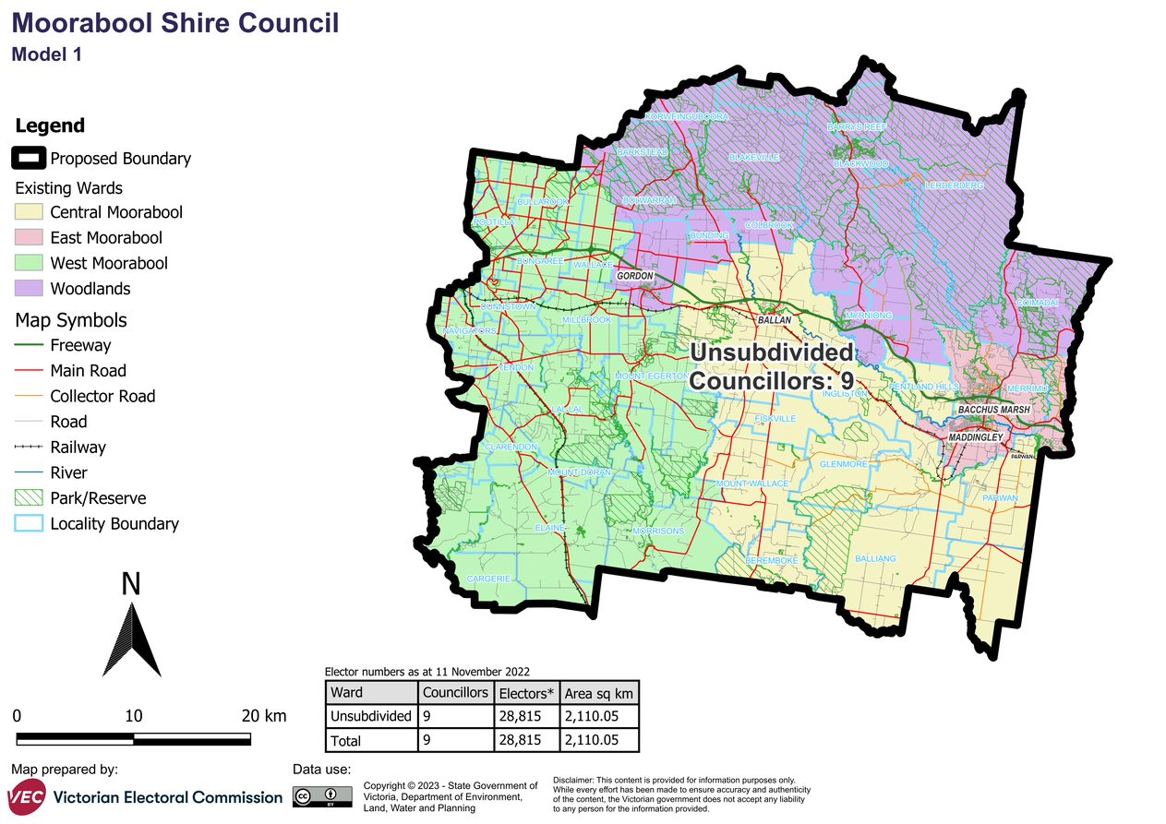

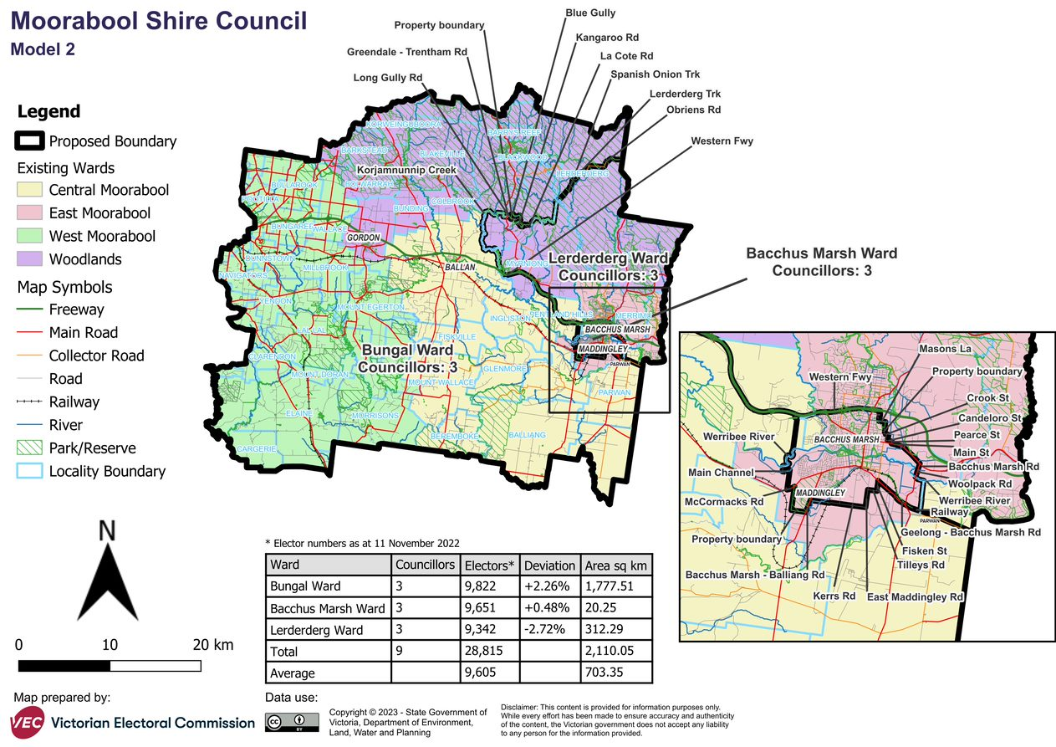

# Appendix 2: Additional models considered

The following models were closely considered by the panel but are not being put forward for further public consultation. See Models considered but not put forward for further information.

#### A single-councillor ward model with 9 councillors

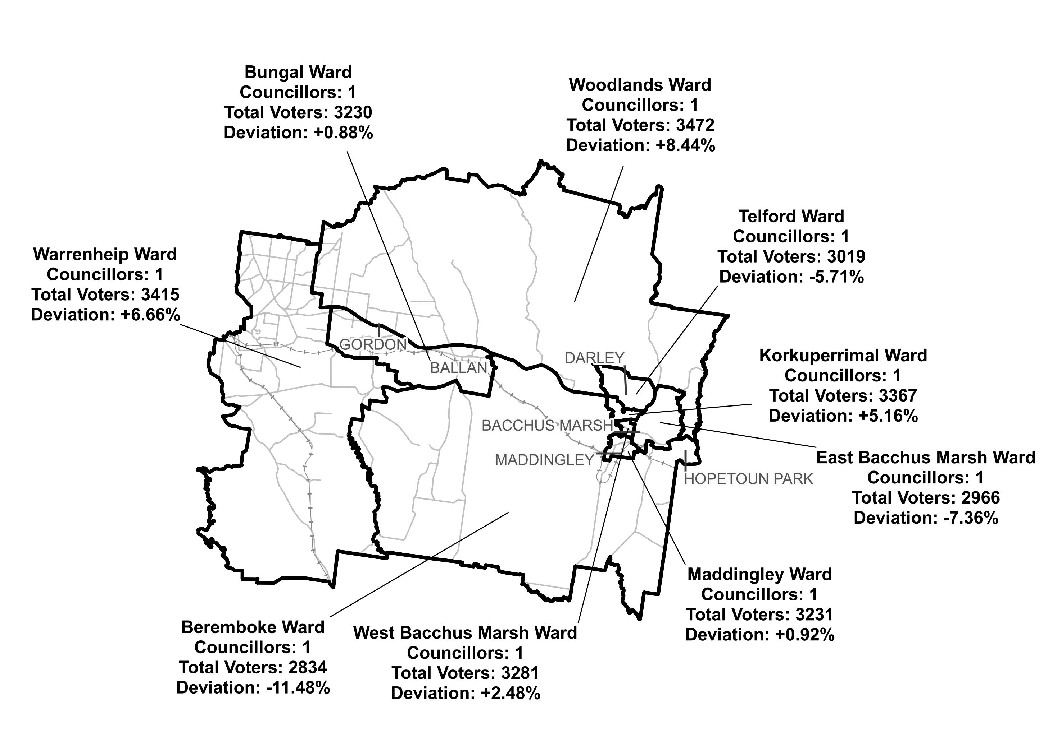

# Appendix 3: List of preliminary submitters

The review received 4 preliminary submissions.

Preliminary submissions were made by:

Kowarsky, John

Lombardi, Michael

Proportional Representation Society of Australia (Victoria-Tasmania) Inc.

Reid, Robert