ELECTORAL REPRESENTATION REVIEW
Glen Eira City Council
Final Report
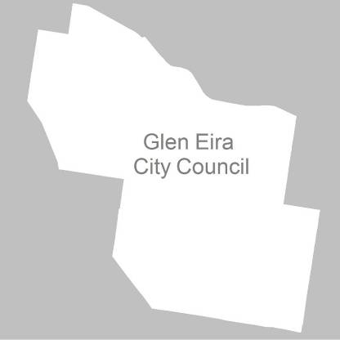

17 May 2011

Contents
Recommendation 3
Background 4
Legislative basis 4
The VEC and Electoral Representation Reviews 4
Profile of Glen Eira City Council 5
Current electoral structure 5
The electoral representation review process 6
VEC research 7
Public involvement 7
Preliminary report 9
Preliminary submissions 9
Preliminary options 9
Public response 10
Response submissions 10
Analysis of submissions 10
Public hearing 11
Findings and Recommendation 12
Recommendation 16
Appendix 1: List of submitters 17
Appendix 2: Map 18

Recommendation
The Victorian Electoral Commission (VEC) recommends that
Glen Eira City Council consists of three wards and nine councillors, with three councillors representing each ward.
Minimal changes should be made to the existing ward boundaries to ensure the entire suburb of Caulfield is included in Camden Ward, using Glen Huntly Road as a boundary.

The recommended ward boundaries are illustrated in the map at the back of this report.

Background

Legislative basis
The Local Government Act 1989 (the Act) requires the VEC to conduct an Electoral Representation Review of each municipality in Victoria at least every 12 years. The Act specifies that the purpose of a representation review is to recommend to the Minister for Local Government the number of councillors and the electoral structure for a municipality, which will provide ‘fair and equitable representation for the persons who are entitled to vote at a general election of the Council’.
The Act requires the VEC, as part of an Electoral Representation Review, to consider:
- the number of councillors in a municipality;
- whether a municipality should be unsubdivided or subdivided;
- if it should be subdivided, whether ward boundaries:
  - provide for fair and equitable division of the municipality;
  - ensure equality of representation through the number of voters being represented by each councillor being within 10 per cent of the average number of voters represented by all councillors; and,
- if it should be subdivided, the number of councillors that should be elected for each ward.

The VEC and Electoral Representation Reviews
The VEC has conducted Electoral Representation Reviews since 2004 on appointment by local councils. The Act was changed in 2010 to define the VEC as the only agency authorised to undertake the reviews.
The VEC drew on its experience in mapping and boundary modelling and also engaged consultants with experience in local government to provide advice on specific local representation issues during the review.

Profile of Glen Eira City Council
The City of Glen Eira was formed in 1995 by the amalgamation of the City of Caulfield with parts of the City of Moorabbin. The City includes the suburbs of Gardenvale, McKinnon, Caulfield, Caulfield North, Caulfield South, Ormond, Carnegie, Bentleigh, Bentleigh East, Murrumbeena and parts of St Kilda East and Elsternwick.
Glen Eira is a culturally diverse City Council with 32 % of the population born overseas, of whom 24% come from China, India, South Africa, Greece and Poland.
Glen Eira also has a large Jewish community, concentrated in the north-west corner in the suburbs of Caulfield North, Elsternwick and St Kilda East.
A large percentage of the population is aged between 70 and 84 years old and there are fewer younger people than in Melbourne as a whole. Individual income levels are generally higher and there is a low unemployment rate in comparison with other councils in Melbourne.
Glen Eira has an area of 38.7 square kilometres with a population of 124,084. Over the next 10 years the population is projected to grow by 4.9%.

Current electoral structure
The City of Glen Eira is currently divided into three wards with nine councillors. Three councillors represent each ward.
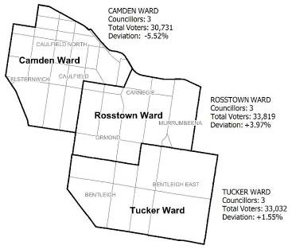
The last electoral representation review for Glen Eira City Council took place between 2004 and 2005. Previously, the City comprised three wards, divided vertically into western, central and eastern wards, with three councillors representing each ward.

The electoral representation review process
The VEC proceeded on the basis of three main principles:
- Ensuring the number of voters represented by each councillor is within 10 per cent of the average number of voters per councillor for that municipality.
Populations are continually changing. Over time these changes can lead to some wards having larger or smaller numbers of voters. As part of the review, the VEC corrected any imbalances and also took into account likely population changes to ensure these boundaries provide equitable representation until the next review.
- Taking a consistent, State-wide approach to the total number of councillors.
The VEC was guided by its comparisons of municipalities of a similar size and category to the council under review. The VEC also considered any special circumstances that may warrant the municipality to have more or fewer councillors than similar municipalities.
- Ensuring communities of interest are as fairly represented as possible.
Each municipality contains a number of communities of interest and, where practicable, the electoral structure should be designed to take these into account. This allows elected councillors to be more effective representatives of the people in their particular municipality or ward.
The recommendation is based on:
- internal research specifically relating to the municipality under review;
- VEC experience from its work with other municipalities and in similar reviews for State elections;
- VEC expertise in mapping, demography and local government;
- careful consideration of all public input in the form of written and verbal submissions received during the review; and,
- advice received from consultants with wide experience in local government.
Public submissions were an important part of the process, but were not the only consideration during the review. The VEC seeks to combine the information gathered through public submissions with its own research and analysis of other factors, such as the need to give representation to communities of interest. The recommendation is not based on a ‘straw poll’ of the number of submissions supporting a particular option.

VEC research
In addition to the information provided in submissions, the VEC created a profile of the municipality based on population trends, development projections and demographic indicators. The VEC used the Australian Bureau of Statistics 2006 census community profiles, the Department of Planning and Community Development projections and voter statistics from the Victorian electoral roll. The VEC also undertook field work to view current and possible boundaries for each of the options presented in the preliminary report to evaluate their effectiveness.

Public involvement
The VEC values the local knowledge and perspectives presented by the public in written submissions. The public were given two opportunities to provide submissions during the review. Their input was considered by the panel in forming the options in the preliminary report and they were also invited to respond to these options. In addition, a public hearing was held to enable people to speak in support of their submissions and supplement it with information.
To ensure transparency in the process, all written submissions were published on the VEC website and all verbal submissions were heard in a public environment.
To raise awareness of the review and encourage the public to engage with the process, a full public information campaign was undertaken.

Advertising
In accordance with section 219F (4) and 219 (7) of the Act, the VEC ensured public notices were placed in local newspapers. The notices detailed the process for the review and called for public submissions. They appeared in the Moorabbin Leader on Wednesday, 26 January 2011 and the Caulfield Leader on Tuesday, 1 February 2011.
A general notice covering several reviews was printed in The Age and Herald Sun on Tuesday, 1 February 2011.
The notice of the release of the Preliminary Report appeared in Caulfield Leader on Tuesday, 22 March 2011 and in Moorabbin Leader on Wednesday, 23 March 2011. The notice detailed the options contained in the preliminary report, including a map of each option, instructions on how to receive a copy of the preliminary report and how to make a submission in response to the report.

Media releases
Two media releases were also distributed to relevant media outlets to complement the advertising campaign.

Public information session
The VEC held a public information session on Monday, 14 February 2011 at Glen Eira Town Hall for people interested in the review process.

Information brochure and poster
An information brochure was provided to the council to be sent to residents through the council network and made available in service centres and libraries. A poster was also provided to Council as an extra publicity tool.

Glen Eira City Council website
Information about the reviews is highlighted on the front page of the Glen Eira City Council website (gleneira.vic.gov.au) with a link to further details about the review process, a copy of the Guide for Submissions and a hyperlink to the VEC website.

Glen Eira City Council newsletter
An article about the review featured in Glen Eira news in February 2011, outlining the process and how the public could get involved. The newsletter was delivered to all houses and business in Glen Eira.

Helpline
A dedicated helpline was established to assist with public enquiries concerning the review process.

VEC website
The VEC website (vec.vic.gov.au) delivered up-to-date information and provided transparency during the review process. An online submission tool was created to facilitate the submissions process and all preliminary submissions were published online. The preliminary report was available for download on the website too.

Guide for Submissions
Copies of the Guide for Submissions are available on the VEC website. They can also be obtained by calling the dedicated helpline. They were provided to the Council and handed out at the information sessions.

Preliminary report
In accordance with the Act, the VEC produced a preliminary report outlining its proposed options for Glen Eira City Council. The report was released on Tuesday, 22 March 2011.

Preliminary submissions
By the close of preliminary submissions at 5.00pm on Tuesday, 1 March, the VEC had received four preliminary submissions.
Two of the submissions supported the current three-ward structure, stating that it works well and should be retained. One of these submissions favoured a return to the ward boundaries of 1996, arguing that the people of the former City of Moorabbin felt isolated and there was a perception that council is only concerned with residents north of North Road.
On an initial reading, another submitter seemed to favour seven wards and seven councillors, with one councillor to represent each ward. The submitter drew comparisons with the City of Banyule. However, this submitter later wrote to the VEC to clarify the submission and confirm support for an unsubdivided structure with fewer councillors and no wards.
The fourth submission recommended a five-ward structure with 11 councillors, suggesting it would better serve the diversity of Glen Eira and give a wider perspective.
A list of all submitters, by name, is available in Appendix 1. Copies of the submissions can be viewed on the VEC website at vec.vic.gov.au.

Preliminary options
After careful consideration of the submissions, two preliminary options were drawn up:

Option A (Preferred Option)
Glen Eira City Council should remain with three wards and nine councillors, with three councillors representing each ward. Minimal changes should be made to the ward boundaries.

Option B (Alternative Option)
Glen Eira City Council should remain with three wards and nine councillors, with three councillors representing each ward. The ward boundaries of Tucker and Rosstown Ward should be redrawn to run vertically and the two wards should revert to their previous ward names of Jasper Ward and Mackie Ward.

Public response

Response submissions
Response submissions on the Electoral Representation Review of Glen Eira City Council opened on Tuesday, 22 March and closed at 5.00pm on Wednesday,
20 April. Seven response submissions were received. The table below shows the levels of support for each option based on the preferences expressed in each response submission.
Option A | Option B | Both Options | Other
2 | 2 | 1 | 2

Analysis of submissions
Two submitters argued in favour of Option A, the status quo with a minor modification. They pointed to the geographic communities of interest and stated that the north-south orientation, as proposed in Option B, is more elongated and residents at one end are less likely to feel an association with residents at the other end. They also felt the current structure reflected the communities of interest well and ‘aligned with the patterns of public transport and services linkages’.
Two submitters favoured option B, both citing the fact that the current structure is based on an ‘Old City of Moorabbin’ and two ‘Old City of Caulfield’ wards, which leads to a feeling of isolation for the people living in the ‘Old City of Moorabbin’ and a perception that Council is biased towards residents who live north of North Road.
The Proportional Representation Society of Australia supported each of the options on the grounds they both ensure elections are conducted according to the proportional representation counting method.
The last two submitters did not express a preference for either option and reiterated their previous arguments (one for an unsubdivided municipality with fewer councillors, the other for five wards and 11 councillors).
A list of submitters, by name, is available in Appendix 1. Copies of the submissions can be viewed on the VEC website at vec.vic.gov.au.

Public hearing
A public hearing was held at Glen Eira Town Hall on Monday, 2 May at 6.30pm. Everyone who made a submission in response to the report was invited to speak to their submissions and two individuals accepted. Members of the public were invited to attend, but none chose to do so on this occasion.
The speakers were given the opportunity to amplify their submissions and the panel were able to ask questions and clarify information. Further details about the arguments presented at the public hearing are included in the following section.

Findings and Recommendation

Number of councillors
The VEC stated in its Preliminary Report that nine is an appropriate number of councillors for Glen Eira City Council. This figure was reached by comparing other municipalities of a similar size and diversity to take a reasoned State-wide approach. Only one submitter put forward the case for more councillors on the grounds that it would ‘enable a greater opportunity for the full range of different communities of interest to be fairly represented on Council’.
The VEC recognises that the City of Glen Eira is one of the larger Councils with a culturally diverse population and understands that the varying communities of interest will have particular demands from their councillors. However, as many of these communities can be defined geographically, the demands on councillors should be more manageable than in municipalities with disparate and numerous minority groups.
In addition, the population across Glen Eira is only projected to grow by 4.9% over the next ten years. For these reasons the VEC does not believe there is a justification for a change in the number of councillors.

Electoral Structure

Unsubdivided
As outlined in the Preliminary Report, the VEC considers that an unsubdivided municipality would be impracticable for Glen Eira. In the past a high number of candidates have nominated (61 in 2008), and in an unsubdivided municipality this would necessitate a very large ballot paper and require voters to number every box.
One response submitter to the Preliminary Report repeated the argument for an unsubdivided municipality, stating that voters would only have to number the boxes from one to nine in their order of preference if there were nine vacancies. This is not the case; local council elections follow the full preferential voting method and legislation requires all boxes to be filled in for a vote to be counted as formal.
In this scenario, with such a high possibility that voters could misnumber the boxes, the VEC is not confident that fair representation would be achieved.
The City of Glen Eira also contains communities of interest that can be defined geographically, and therefore a ward structure that captures these communities neatly will offer the best model for fair and equitable representation.

Option A (Preferred Option)
Glen Eira City Council should remain with three wards and nine councillors, with three councillors representing each ward. Minimal changes should be made to the ward boundaries.

The existing structure is likely to absorb the projected future population growth and the VEC is satisfied that it will be sustainable until the next scheduled Electoral Representation Review in 12 years’ time.
The boundaries are based on straight roads resulting in solid boundaries that neatly follow the outlines of the suburbs. The VEC considers that this model reflects the current communities of interest, and this view was shared by one of the speakers at the public hearing who felt that Bentleigh East and Bentleigh would relate to each other better than Bentleigh East and Murrumbeena. The speaker also highlighted that the City of Glen Eira had a high turnover of residents by detailing figures from the 2001–2006 census revealing that a third of people had moved from the area. In his opinion, the perception that Glen Eira City Council was comprised of ‘an Old City of Moorabbin and two old City of Caulfield’ wards would therefore diminish over time.
The speaker also drew attention to the distribution of the local newspapers, which follow the patterns of the existing ward structure and suggested that the newspapers also have different editorial coverage based on the existing ward structure.
The view that the existing ward structures were established, and working well, was also shared by the Bayside Glen Eira Greens who stated that the boundaries neatly follow the ‘transport and service patterns’.

Option B (Alternative Option)
Glen Eira City Council should remain with three wards and nine councillors, with three councillors representing each ward. The ward boundaries of Tucker and Rosstown Ward should be redrawn to run vertically and the two wards should revert to their previous ward names of Jasper Ward and Mackie Ward.

Option B was favoured by three of the City of Glen Eira’s nine councillors and a submitter who has lived in the area for 30 years. Option B also uses main roads for its boundaries and offers a clear and logical structure. One submitter (a councillor from Tucker Ward), spoke at the public hearing and explained that Option A furthers the perception that Glen Eira is comprised of an ‘Old City of Moorabbin’ and two ‘Old City of Caulfield’ wards.
The councillor explained that this leads to a perception of bias, with residents feeling that councillors are only interested in issues to the north of the North Road boundary, a view that he hears expressed ‘all the time’. He also explained that while the newspapers have different distributions, the Council will always advertise all council business in both papers and indicated that the newspapers would probably change their editorial content according to the new structure.
The Councillor also highlighted that in Option B, no neighbourhood areas would be split up by the ward boundaries while, in Option A, the McKinnon shopping strip is divided between Rosstown and Tucker Wards. The Councillor explained how this can lead to confusion over responsibility for the shopping strip.
The Councillor finished his presentation by drawing the panel’s attention to a new housing development of 1200 dwellings adjacent to the Caulfield campus of Monash University that had just been given planning permission and could affect voter numbers. The VEC re-checked this and can confirm it had already been taken into account.

Conclusion
The VEC took into consideration all written submissions and was pleased to be able to gain more information from the two speakers that generously gave their time at the public hearing.
The VEC undertook some further investigation into the small McKinnon shopping strip and, while it understands that this area will be split as it currently is under the existing structure, the boundaries still reflect the current communities of interest. The majority of the shopping is contained in Rosstown Ward on the north side of McKinnon Road with just a few shops contained on the south side in Tucker Ward.
Although the VEC acknowledges the Councillor’s difficulties of working in a ward that is perceived to be neglected, it has to consider the disruption that changing the ward boundaries would entail. By reverting to the old ward boundaries, 66,165 voters would be affected, which equates to approximately two-thirds of the voters in the municipality. In contrast, the minor change to the boundaries in Option A would only affect 686 voters.
There would need to be very clear evidence that the structure is not working for the VEC to consider reverting to the previous structure. On the contrary, the evidence shows that the existing structure is working and seems to be well established in the community. The distribution of the newspapers in the municipality is also a compelling argument and would mean further disruption if the ward boundaries were changed.
As indicated earlier, Option A will absorb the projected future population growth and neatly encapsulates the communities of interest, indeed, better reflecting these communities by keeping similar suburbs together.
The VEC is also confident that, over time, the perception that the City of Glen Eira is formed of an amalgamation of two parts of former cities will diminish.
For these reasons the VEC recommends Option A.

Recommendation
The Victorian Electoral Commission (VEC) recommends that
Glen Eira City Council consists of three wards and nine councillors, with three councillors representing each ward.
Minimal changes should be made to the existing ward boundaries to ensure the entire suburb of Caulfield is included in Camden Ward, using Glen Huntly Road as a boundary.

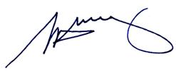

S. H. Tully
Electoral Commissioner

Appendix 1: List of submitters
Preliminary submissions were received from:
Name
Cramphorn, M.
Dowd, K.
Hyams, J and Magee, J. and Lipshutz, M.
Proportional Representation Society of Australia

Response submissions were received from:
Name
Bayside Glen Eira Greens
Bunn, A.*
Callinan, P.
Cramphorn, M. and B.
Dowd, K.L. and V.
Hyams, J*and Magee, J. and Lipshutz, M.
Proportional Representation Society of Australia
* Those submitters who spoke to their submission at the Public Hearing on
2 May 2011

Appendix 2: Map
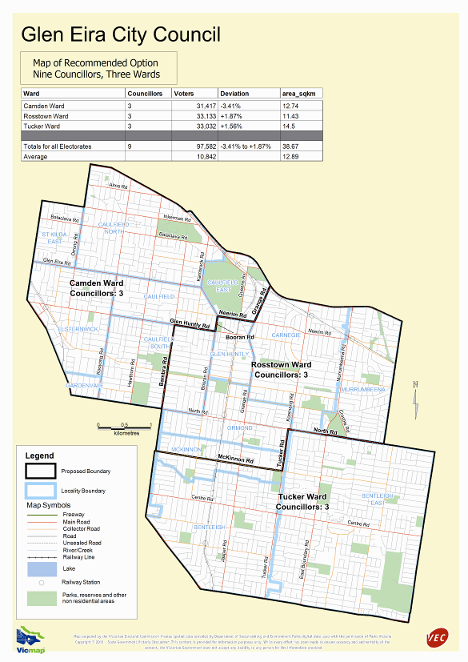

Victorian Electoral Commission
Level 8, 505 Little Collins Street
Melbourne, Vic 3000

131 VEC (131 832)
info@vec.vic.gov.au
vec.vic.gov.au

Section 219D of the Local Government Act 1989.
Census of Population and Housing 2006, Australian Bureau of Statistics.
Victoria in Future, Department of Planning and Community Development.
Victoria in Future, Department of Planning and Community Development
The Preliminary Report erroneously stated that part of the former City of Moorabbin would be contained in a single ward in Option B.

