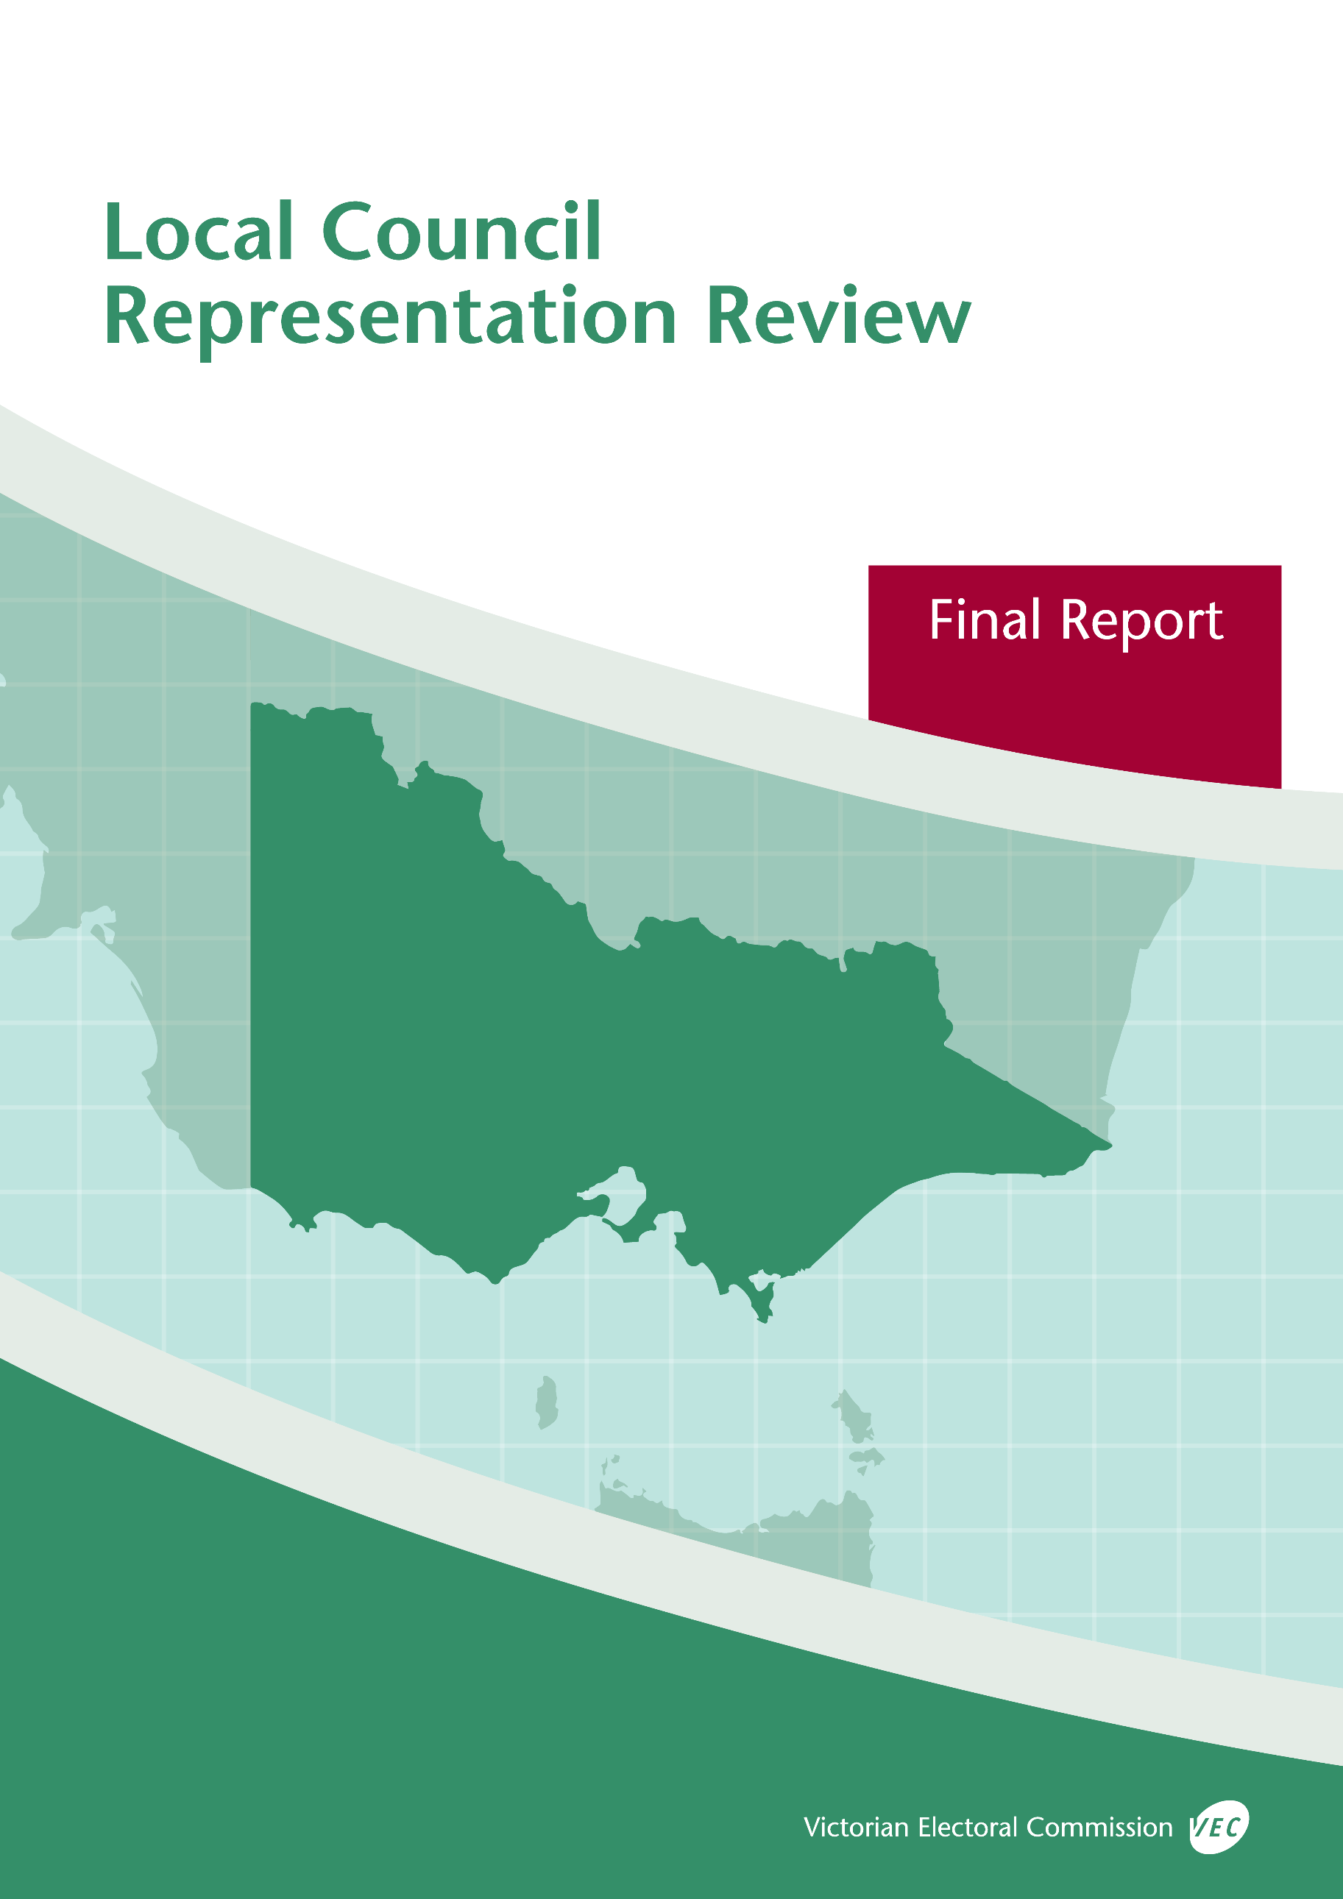



**October 2019**

**Buloke Shire Council**

**DOCUMENT HISTORY AND VERSION CONTROL**

|  |  |  |  |
| --- | --- | --- | --- |
| **Version** | **Date approved** | **Approved by** | **Brief description** |
| 1.0 | 1 October 2019 | Electoral Commissioner | Published on 2 October 2019. |
| 1.1 | 2 October 2019 | Electoral Commissioner | Name of submitter Daryl Warren corrected. |

© State of Victoria (Victorian Electoral Commission)   
Wednesday 2 October 2019

Version 1.1  
  
cid:image001.png@01D4D431.F774F3F0

This work, Local Council Representation Review Final Report – Buloke Shire Council, is licensed under a Creative Commons Attribution 4.0 licence [<http://creativecommons.org/licenses/by/4.0/>]. You are free to share this work under that licence, on the condition that you do not change any content and you credit the State of Victoria (Victorian Electoral Commission) as author and comply with the other licence terms. The licence does not apply to any branding, including Government logos.

Contents

Contents 3

Recommendation 1

Executive summary 2

Background 4

Legislative basis 4

Public engagement 4

The VEC’s principles 5

Developing recommendations 6

Buloke Shire Council representation review 8

Profile of Buloke Shire Council 8

Current electoral structure 9

Preliminary submissions 9

Preliminary report 10

Public response 14

Response submissions 14

Public hearing 15

Findings and recommendation 17

The VEC’s findings 17

The VEC’s recommendation 20

Appendix 1: Public involvement 21

Appendix 2: Map 22

Appendix 3: Public information program 24

Recommendation

The Victorian Electoral Commission recommends that Buloke Shire Council continue to consist of seven councillors elected from three wards (two two-councillor wards and one three-councillor ward).

This recommendation is submitted to the Minister for Local Government as required by the *Local Government Act 1989*.

Please see Appendix 2 for a detailed map of this recommended structure.

Executive summary

The *Local Government Act 1989* (the Act) requires the Victorian Electoral Commission (VEC) to conduct an electoral representation review of each municipality in Victoria before every third council general election.

The purpose of an electoral representation review is to recommend an electoral structure that provides ‘fair and equitable representation for the persons who are entitled to vote at a general election of the Council.’[1] The matters considered by a review are:

* the number of councillors
* the electoral structure of the council (whether the council should be unsubdivided or divided into wards and, if subdivided, the details of the ward boundaries and the number of councillors per ward).

The VEC conducts all reviews based on three main principles:

1. taking a consistent, State-wide approach to the total number of councillors
2. if subdivided, ensuring the number of voters represented by each councillor is within   
   plus-or-minus 10% of the average number of voters per councillor for that local   
   council
3. ensuring communities of interest are as fairly represented as possible.

Current electoral structure

Buloke Shire Council currently comprises seven councillors elected from three wards (two two‑councillor wards and one three-councillor ward). More information on Buloke Shire Council and the current electoral structure is available in the council fact sheet on the VEC website at [vec.vic.gov.au](http://vec.vic.gov.au).

Prior to the last representation review in 2007, Buloke Shire Council was comprised of nine councillors elected from three three-councillor wards. Visit the VEC website at [vec.vic.gov.au](http://www.vec.vic.gov.au/) to access a copy of the 2007 review final report.

Preliminary submissions

Preliminary submissions opened at the commencement of the current review on Wednesday   
12 June 2019. The VEC received six preliminary submissions for the representation review of Buloke Shire Council by the deadline at 5.00 pm on Wednesday 10 July 2019.

Preliminary report

A preliminary report was released on Wednesday 7 August 2019 with the following options for consideration:

* Option A (preferred option)  
  **Buloke Shire Council consist of seven councillors elected from three wards (two two-councillor wards and one three-councillor ward).**
* Option B (alternative option)  
  **Buloke Shire Council consist of seven councillors elected from an unsubdivided electoral structure.**

Response submissions

The VEC received five submissions responding to the preliminary report by the deadline at   
5.00 pm on Wednesday 4 September 2019.

Public hearing

The VEC conducted a public hearing for those wishing to speak about their response submission at 5.00 pm on Thursday 12 September 2019. Two people spoke at the hearing, both of whom spoke on behalf of Buloke Shire Council.

Recommendation

**The Victorian Electoral Commission recommends that Buloke Shire Council continue to consist of seven councillors elected from three wards (two two-councillor wards and one three-councillor ward).**

This electoral structure was designated as Option A in the preliminary report. Please see Appendix 2 for a detailed map of this recommended structure.

Background

Legislative basis

The Act requires the VEC to conduct a representation review of each local council in Victoria before every third general council election, or earlier if gazetted by the Minister for Local Government.

The Act states that the purpose of a representation review is to recommend the number of councillors and the electoral structure that provides ‘fair and equitable representation for the persons who are entitled to vote at a general election of the Council.’[2]

The Act requires the VEC to consider:

* the number of councillors in a local council
* whether a local council should be unsubdivided or subdivided.

If a local council is subdivided, the VEC must ensure that the number of voters represented by each councillor is within plus-or-minus 10% of the average number of voters per councillor for that local council.[3] On this basis, the review must consider the:

* number of wards
* ward boundaries
* number of councillors that should be elected for each ward.

Public engagement

### Public information program

The VEC conducted a public information program to inform the community of the representation review, including:

* public notices printed in local and State-wide papers
* public information sessions to outline the review process and respond to questions from the community
* media releases announcing the commencement of the review and the release of the preliminary report
* a submission guide to explain the review process and provide background information on the scope of the review
* an information email campaign targeted at known community groups and communities of interest in the local council area
* sponsored social media advertising geo-targeted to users within the local council   
  area
* ongoing information updates and publication of submissions on the VEC website.

More information on the VEC’s public information program for the representation review of Buloke Shire Council can be found at Appendix 3.

### Public consultation

Public input was accepted by the VEC via:

* preliminary submissions at the start of the review
* response submissions to the preliminary report
* a public hearing that provided an opportunity for people who had made a response submission to expand on their submission.

Public submissions are an important part of the review process but are not the only consideration. The VEC ensures its recommendations comply with the Act and are formed through careful consideration of public submissions, independent research, and analysis of all relevant factors.

The VEC’s principles

Three main principles underlie all the VEC’s work on representation reviews:

1. **Taking a consistent, State-wide approach to the total number of councillors.**

The VEC is guided by its comparisons of local councils of a similar size and category to the council under review. The VEC also considers any special circumstances that may warrant the local council having more or fewer councillors than similar local councils.

1. **If subdivided, ensuring** **the number of voters represented by each councillor is within plus-or-minus 10% of the average number of voters per councillor for that local council.**

This is the principle of ‘one vote, one value’, which is enshrined in the Act. This means that every person’s vote counts equally.

1. **Ensuring communities of interest are as fairly represented as possible.**

Each local council contains a number of communities of interest. Where practicable, the electoral structure should be designed to ensure they are fairly represented, and that geographic communities of interest are not split by ward boundaries. This allows elected councillors to be more effective representatives of the people and interests in their particular local council or ward.

Developing recommendations

The VEC bases its recommendations for particular electoral structures on the following information:

* internal research specifically relating to the local council under review, including data from the Australian Bureau of Statistics and .id[4]; voter statistics from the Victorian electoral roll; and other State and local government data sets
* small area forecasts provided by .id for relevant local council areas
* the VEC’s experience conducting previous electoral representation reviews of local councils and similar reviews for State elections
* the VEC’s expertise in mapping, demography and local government
* careful consideration of all input from the public in written submissions received during the review and via oral submissions at the public hearing
* advice from consultants with extensive experience in local government.

### Deciding on the number of councillors

The Act allows for a local council to have between five and 12 councillors but does not specify how to decide the appropriate number.[5] In considering the number of councillors for a local council, the VEC is guided by the Victorian Parliament’s intention for fairness and equity in the local representation of voters under the Act.

The starting point in deciding the appropriate number of councillors for a local council is comparing the local council under review to other local councils of a similar size and type (Principle 1). Generally, local councils that have a larger number of voters will have a higher number of councillors. Often large populations are more likely to be diverse, both in the nature and number of their communities of interest and the issues of representation.

However, the VEC also considers the particular circumstances of each local council which could justify fewer or more councillors, such as:

* the nature and complexity of services provided by the Council
* geographic size and topography
* population growth or decline
* the social diversity of the local council.

### Deciding the electoral structure

The Act allows for a local council ward structure to be unsubdivided—with all councillors elected ‘at-large’ by all voters—or subdivided into a number of wards.

If the local council is to be subdivided into wards, there are three options available:

1. single-councillor wards
2. multi-councillor wards
3. a combination of single-councillor and multi-councillor wards.

A subdivided electoral structure must be developed with internal ward boundaries that provide for a fair and equitable division of the local council.

The Act allows for wards with different numbers of councillors, as long as the number of voters represented by each councillor is within plus-or-minus 10% of the average number of voters per councillor for that local council (Principle 2). For example, a local council may have one   
three-councillor ward with 15,000 voters and two single-councillor wards each with 5,000 voters. In this case, the average number of voters per councillor would be 5,000.

Over time, population changes can lead to some wards in subdivided local councils having larger or smaller numbers of voters. As part of the review, the VEC corrects any imbalances and considers likely population changes to ensure ward boundaries provide equitable representation for as long as possible.

In considering which electoral structure is most appropriate, the VEC considers the following matters:

* the VEC’s recommendation at the previous representation review and the reasons for that recommendation
* the longevity of the structure, with the aim of keeping voter numbers per councillor within the 10% tolerance for as long as possible (Principle 2)
* communities of interest, consisting of people who share a range of common concerns, such as geographic, economic or cultural associations (Principle 3)
* the number of candidates in previous elections, as outcomes from previous elections indicate that large numbers of candidates can lead to an increase in the number of informal (invalid) votes
* geographic factors, such as size and topography
* clear ward boundaries.

Buloke Shire Council representation review

Profile of Buloke Shire Council

Buloke Shire Council is located in the Mallee region of Victoria and is approximately 300 kilometres north-west of Melbourne and 180 kilometres south-east of Mildura. The Shire occupies a large geographical area of about 8,000 square kilometres, and is mostly farming land dedicated to broadacre, dry land cropping. The Shire is often confronted with significant environmental challenges, such as drought, erosion and flooding.[6]

The size of the Shire measures approximately 200 km from north to south and includes an extensive road network. The Council represents the Shire and residents across a network of local and regional bodies and committees on issues such as economic development, tourism, environmental and land management, transport and road maintenance.

The population is dispersed throughout most of the Shire on farms and in various townships. Donald and Charlton, both in the south of the Shire, are the largest towns with populations of 1,395 and 961, respectively. There is no single town within the Shire that all residents relate to. Instead, residents tend to connect with larger towns outside of the Shire, such as Swan Hill, Horsham and Bendigo, though there are strong local communities based around the Shire’s townships.

The population is largely homogenous in terms of birthplace, cultural background and language spoken at home.[7] While there are some indications of social disadvantage and poor health outcomes on a number of measures, the Shire reports positive social and community wellbeing outcomes, such as high rates of volunteering and low rates of crime and housing stress.[8] A high proportion of residents are home-owners, which partially offsets the lower than average incomes earned by individuals and households.[9]

The local economy is based heavily on agriculture. The gross value of agricultural production in the 2015-16 period was approximately $161 million, over half of which was derived from cropping.[10] Agriculture employs about 30% of the Shire’s population and while this has declined slightly since the last review, farming remains central to the social and economic life of the local community.[11]

Population change and decline presents significant challenges to the Shire, its services and elected representatives. The population of Buloke Shire is expected to decline in future years, from 6,193 in 2016 to 5,392 in 2031.[12] It will also continue to age, partly as a result of the out-migration of younger age groups.[13]

Current electoral structure

Buloke Shire Council currently comprises seven councillors elected from three wards (two two‑councillor wards and one three-councillor ward).

Preliminary submissions

At the close of submissions on Wednesday 10 July 2019, the VEC had received six preliminary submissions for the representation review of Buloke Shire Council. A list of people who made a preliminary submission can be found in Appendix 1.

### Number of councillors

All submitters were in favour of retaining the current number of councillors and argued that seven councillors were appropriate for fair and equitable representation and to effectively manage councillor workloads. Submitters considered seven councillors necessary to represent all the communities distributed throughout the Shire, in particular the smaller, more remote communities, and to enable councillors to attend activities and events in at least 10 townships.

Submitters also felt that seven councillors were needed to manage councillor workloads, which some suggested had increased since the last review in 2007. Councillor workloads were impacted by the long travel distances and the various committees and regional bodies councillors were expected to represent the Shire on. Some submitters, including Buloke Shire Council, argued that heavy councillor workloads discouraged potential candidates from standing for election and that this factor could result in uncontested elections. Similarly, other submitters felt heavy councillor workloads contributed to councillor burnout.

The Proportional Representation Society of Australia (Victoria-Tasmania) Inc. (PRSA) proposed seven councillors in preference for an odd number of councillors.

### Electoral structure

**Unsubdivided**

Only one submitter, the PRSA, proposed an unsubdivided electoral structure, mainly to maximise the value of individual votes and to address the lack of parity between the wards under the current electoral structure. The PRSA suggested that an unsubdivided electoral structure was the only way to ensure a majority of the councillors would be elected by the majority of voters across the whole local council area. It also argued that under an unsubdivided electoral structure there would be no need for boundary adjustments, councillors would be compelled to understand all areas of the Shire, there would be less likelihood of uncontested elections, and voters would have more choice at elections and would not be confused about which ward they were in.

**Multi-councillor wards**

Most submitters believed the current multi-councillor ward electoral structure had served the Shire well, was supported by the community and had provided fair and equitable representation for different parts of the Shire. Some suggested that changing to an unsubdivided electoral structure would adversely affect community cohesion, skew representation towards the more populated areas and promote parochial interests.

Other submitters argued that it was preferable to have voters represented by a locally elected councillor due to the large area of the Shire. They suggested that under the current structure, councillors were able to develop a comprehensive understanding of issues in their ward and share workloads more effectively.

Some submitters mentioned the community expectation that councillors maintain regular contact with their constituents through attendance at meetings and community events. Others suggested the preference for some groups, such as older adults, to have face-to-face contact with their councillors. In both cases it was argued that the current multi-councillor ward structure best met these expectations.

Finally, preliminary submitters pointed out that under the current electoral structure the number of voters represented by each councillor was within plus-or-minus 10% of the average number of voters per councillor for the Shire as is required by the Act.

Preliminary report

A preliminary report was released on Wednesday 7 August 2019. The VEC considered public submissions and research findings when formulating the options presented in the preliminary report.

### Number of councillors

When considering the appropriate number of councillors for Buloke Shire Council, the VEC assessed population data and any other factor that might warrant an increase or decrease in the number of councillors, such as population change or special circumstances relating to communities of interest.

Demographic data for Buloke Shire Council projected a slight decline in population numbers in coming years and the VEC noted the Shire’s already low voter-to-councillor ratio, the lowest of all seven-councillor Country Victorian local councils. However, these considerations were balanced with the special circumstances faced by the Shire.

Submissions and the VEC’s own research identified various challenges faced by Buloke Shire Council, including flooding, drought and erosion, councillor travel times to attend meetings and community events, representation on different regional committees and an ageing population. It was considered that all of these factors were likely to put pressure on councillor workloads and the Shire’s services, policy and planning capabilities. Given these circumstances, the VEC found that seven councillors would be appropriate for fair and equitable representation.

While the VEC was aware that Buloke Shire Council had a low voter-to-councillor ratio and declining population, it determined that the special circumstances of the Shire warranted retaining seven councillors. The VEC also considered that a structure of seven councillors was consistent with recommendations made in previous reviews of similar local councils and with the VEC’s principles for conducting representation reviews.

### Electoral structure

The VEC presented two viable seven-councillor electoral structure options for the Buloke Shire community to consider: the current structure of three wards (two two-councillor wards and one three-councillor ward); and an unsubdivided electoral structure.

The VEC identified that in all wards of the current electoral structure, the number of voters represented by each councillor was within plus-or-minus 10% of the average number of voters per councillor. The VEC was confident this would continue to be the case until the next scheduled representation review and determined that the ward boundaries of the current structure did not split communities of interest.

The VEC considered the merits of local representation provided by a subdivided electoral structure. Buloke Shire Council covers a large geographical area and it was suggested in submissions that voters in one part of the Shire would likely have limited knowledge of issues faced by those in other parts. It was identified that voters in different parts of the Shire valued the ability to choose candidates more aware of local or ward-based issues. On the basis of these views, it was concluded that under a subdivided electoral structure, voters would be likely to know of or have a connection with their local ward representatives. From its analysis of the preliminary submissions, the VEC also revealed that the Shire’s community expects regular contact and, in some cases, has a preference for face-to-face contact with elected councillors, and this was identified as an important issue for voters.

The VEC was made aware of councillor travel times and considered the benefits of the current subdivided structure in relation to sharing workloads, particularly in light of a population dispersed across a large geographical area. It also determined that the three multi-councillor wards, ranging from two to three councillors in each, would provide voters with a level of choice at election time and the option for them to connect with the most suitable councillor regarding a specific issue.

However, a principal concern of the VEC with Buloke Shire Council’s current electoral structure was the historically low number of candidates at elections and repeated instances of uncontested elections for Mallee Ward at the 2008 and 2012 general elections. In response, the VEC also presented the option of an unsubdivided electoral structure.

The VEC determined that the ability for voters to elect candidates from across the Shire would provide them with a greater degree of choice and reduce the risk of uncontested elections. It also considered that through proportional vote-counting, whereby councillors would be elected if they received a certain quota, smaller communities and non‑geographic communities of interest would have a reasonable chance of achieving representation on the Council. With an unsubdivided electoral structure, all candidates would be subject to the same quota to be elected and there would be no need for ward boundaries or the impact of population change on those boundaries.

Given the challenges faced by the Shire, such as road maintenance, environmental concerns and an ageing demographic, the VEC considered that a whole-of-council approach would be beneficial to voters. However, the large geographic area covered by the Shire could result in voters having difficulties choosing from candidates located in different parts of the Shire, particularly where candidates campaign on very local issues.

The VEC noted the concern among submitters that an unsubdivided electoral structure could result in candidates from the south of the Shire dominating elections because of the higher concentration of voters there. The VEC also considered that in an unsubdivided electoral structure, candidates from the north of the Shire might face greater challenges connecting with voters and campaigning compared to candidates from the more populated areas in the south.

Finally, the VEC considered that the risk of uncontested elections could not be completely ruled out if the numbers of candidates at elections continued to be low. This would be the case under any electoral structure if as suggested by submitters councillor workloads deter prospective candidates from standing for election to the Council.

In summary, the VEC found that the current electoral structure of two two-councillor wards and one three-councillor ward would provide a good chance for communities of interest from across Buloke Shire to be represented, would enable councillor workloads to be shared equitably and would likely meet community expectations regarding fair and equitable representation. The VEC also considered that under an unsubdivided electoral structure there would be less chance of uncontested elections and voters would have more choice at election time.

### Options

After careful consideration, the VEC put forward the following options:

* Option A (preferred option)  
  **Buloke Shire Council consist of seven councillors elected from three wards (two two-councillor wards and one three-councillor ward).**
* Option B (alternative option)  
  **Buloke Shire Council consist of seven councillors elected from an unsubdivided electoral structure.**

Public response

Response submissions

The VEC accepted submissions responding to the preliminary report from Wednesday 7 August 2019 until 5.00 pm on Wednesday 4 September 2019. The VEC received five response submissions. A list of people who made a response submission can be found in Appendix 1.

Four response submitters supported Option A, the current electoral structure, and one supported Option B, an unsubdivided electoral structure.

### Number of councillors

All submitters supported seven councillors as appropriate for fair and equitable representation for the Shire. In its submission, Buloke Shire Council argued seven councillors was appropriate for the particular social, economic and environmental circumstances of the Shire, provided good representation for the community and enabled councillors to better manage workloads. Harold Flett, a former councillor of Buloke Shire Council, preferred an odd number of councillors to avoid tied Council votes over contentious issues. Adam Newman submitted that, because the Shire was not expected to experience population growth, seven councillors was appropriate for representing the Shire’s interests.

### Electoral structure

In its submission, Buloke Shire Council contended that Option A from the preliminary report would continue to provide local representation to the Shire’s various communities and provide sufficient scope for diversity of representation. Mr Newman felt that the proposed wards in   
Option A were suitable, as they combined communities of interest appropriately and were not too large to prevent voters having access to their elected councillors. Mr Flett argued that the ward structure of Option A corresponded with the distribution of the Shire’s population and its farming lands. Buloke Shire Council submitted that the current ward structure suited the geographic needs of the Council and its residents, including the connections they have with regional cities outside the Shire, such as Swan Hill, Bendigo and Horsham.

Both Mr Newman and Mr Flett each submitted that all current wards were within plus-or-minus 10% of the average number of voters per councillor for the Shire, and therefore saw no reason to adjust the ward boundaries.

Some submitters also presented arguments against Option B. Mr Flett suggested that an unsubdivided electoral structure could result in one area having a majority of councillors elected and being over-represented at the expense of other areas, and that this would prevent equitable representation. Buloke Shire Council made the same point and added that an unsubdivided electoral structure would result in a travel burden for councillors, particularly if all councillors were from one part of the Shire. It also presented arguments against the points raised in the PRSA’s preliminary submission, arguing that:

* councillors have consistently looked beyond local ward matters to council-wide issues
* it would be unlikely for voters to be confused about what ward they were in or who their councillors were
* given projections of voter numbers, concerns about future ward boundary changes were unfounded.

Buloke Shire Council also submitted that in cases where elected councillors were mainly from the one area, voters or residents may lack a connection with their elected representatives.

Mr Newman proposed changes to the current ward names, suggesting that:

* Mallee Ward be renamed Tyrell Ward after Lake Tyrell and Tyrell Creek
* Lower Avoca Ward be renamed Charlton Ward after the community of Charlton
* Mount Jeffcott Ward retain its current name.

The PRSA argued in favour of Option B as it felt an unsubdivided electoral structure was the only way proportional representation could be applied to a seven-councillor structure in a fair way. The PRSA suggested an unsubdivided electoral structure would ensure a majority of councillors would be elected by an absolute majority of voters from across the whole Shire. It opposed Option A because, in its view, the two two-councillor wards were ‘stalemate’ wards and would not reflect majority opinion as they would require 67% of voters to elect a majority of councillors. The PRSA argued this could potentially make the three-councillor ward the ‘kingmaker’, assuming support from one councillor in each of the two-councillor wards. The PRSA reiterated the points made in its preliminary submission in support of an unsubdivided electoral structure.

Public hearing

The VEC conducted a public hearing for those wishing to speak about their response submission at 5.00 pm on Thursday 12 September 2019 in Buloke Shire Council Wycheproof District Office (Supper Room), 367 Broadway, Wycheproof. There was one request to speak from Buloke Shire Council. The Council was represented at the public hearing by two speakers, the Deputy Mayor, Councillor Daryl Warren, and Chief Executive Officer, Anthony Judd.

Cr Warren restated the points made in the Shire’s preliminary and response submissions in support of the current three-ward electoral structure. He argued that Buloke Shire Council had operated successfully under a three-ward electoral structure since amalgamation and that   
Option A accommodated the specific demographic, economic, social and geographical factors of the Shire. Cr Warren emphasised the geographical size of the Shire and the distribution of the population throughout most parts of the council area, to suggest that Option A enabled all areas to have local representation. He noted that the Shire operates depots and service centres in several locations through the council area and also holds regular council briefing meetings in most of the ten townships on a rotating basis.

Cr Warren felt the community valued access to their locally elected councillors and expected their attendance at community events; he argued these expectations were best facilitated under the current ward structure. Mr Judd argued that the performance of the Shire, which was difficult to administer due to its size and dispersed population, was contingent on a geographical spread of councillors. The Shire and its staff, he pointed out, relied heavily on councillors engaging with their local communities and feeding information about local issues back to the Council.

Councillor workloads and travel times were critical considerations and both Cr Warren and   
Mr Judd felt these were best managed under a subdivided electoral structure. The current structure, they argued, had enabled councillors to work together to share workloads, particularly with travel and attendance at community events and councillor delegations on regional committees beyond the Shire’s boundaries. Mr Judd argued that councillor representation on such committees was organised to correspond with the three-ward structure, so that councillors tended to engage with the regional town or body closest or most relevant to their ward.

Both speakers strongly suggested that the current electoral structure had fostered a collegiate and whole-of-council approach amongst councillors. They argued that councillors elected from one ward did not compete with those from other wards and were not parochial in their approach to council matters. Indeed, both feared councillor collegiality and a whole-of-council approach would be lost under an unsubdivided electoral structure.

The speakers raised other concerns about an unsubdivided structure, including the potential for voting blocs to emerge, and a high possibility that the more populated areas of the Shire would dominate elections. Both speakers agreed that councillor workloads would be more difficult to manage under Option B, and Mr Judd suggested individuals would be reluctant to stand for election if they thought councillor workloads were unmanageable or not shared equitably. He added that this could increase the chance of uncontested elections.

Both Cr Warren and Mr Judd asserted that the current electoral structure was understood by the different communities of the Shire, and that arguments in support of Option B did not consider the specifics of the council or the lived experience of its residents and councillors.

With reference to the ward name changes proposed in Mr Newman’s response submission,   
Mr Judd believed there would be little support from councillors or the broader community for this. In particular, he noted that the proposal to change Lower Avoca Ward to Charlton Ward would not be representative of the community as the town of Wycheproof was also located in this ward.

Findings and recommendation

The VEC’s findings

The VEC considered a range of views expressed in submissions and conducted its own internal research to inform its final recommendations regarding the appropriate number of councillors and electoral structure for Buloke Shire Council. The VEC also considered the special circumstances of the Shire, including the geography of the council area and councillor travel times, when making these recommendations.

### Number of councillors

The VEC put forward two options in its preliminary report, both of which consisted of seven councillors, and acknowledged the unanimous support in public submissions for maintaining a seven-councillor electoral structure.

The VEC found no justification for either increasing or decreasing the number of councillors for Buloke Shire Council. Increasing the number of councillors would not be warranted due to the Shire’s relatively small population, low voter‑to‑councillor ratio and projected decline in population, whereas any reduction would likely increase councillor workloads, which the VEC considered was already high due to the special circumstances of the Shire.

For these reasons and considering the support for retaining the current number of councillors in submissions, the VEC recommends seven councillors as appropriate for fair and equitable representation for the voters of Buloke Shire Council.

### Electoral structure

The VEC proposed two electoral structures in its preliminary report, both of which were considered to provide fair and equitable representation. Of the five response submissions, all but one supported Option A (the current subdivided electoral structure) over Option B (an unsubdivided electoral structure).

The key concern among submitters was the best structure to provide local representation for different parts of the Shire. The VEC considered the view that voters valued councillors who were accessible and knowledgeable of local issues. Given the distribution of the population across the Shire and the strong identities attached to its townships, having councillors elected from a local ward was considered to be the best option for representing the Shire’s communities of interest. The VEC also considered the view that, due to the size and geography of the Shire, voters in one part would likely have limited knowledge of issues in another. As such, while   
Option B would provide voters with more choice at election time, they would likely experience difficulties choosing candidates from outside their local area, especially where candidates campaigned on more local issues.

The VEC considered that both Option A and Option B would support the election of candidates based on local issues and therefore both options had the potential to represent a reasonable spread of councillors from across the Shire. However, the VEC balanced this consideration with the main argument against Option B as presented by submitters: that an unsubdivided electoral structure could leave the less populated parts of the Shire without a local representative. It was also considered that under Option B candidates in some parts of the Shire might find it difficult to campaign or connect with voters from across the whole council area.

The VEC found that the Shire faces various council-wide challenges, such as drought, flooding, and a population that is ageing and gradually declining, and that Option B could potentially promote a whole-of-council approach to such matters. However, given that there is no central town that all residents relate to, and that residents tend to have strong connections with major towns outside the council area, an unsubdivided electoral structure would not necessarily improve representation on council-wide issues. Indeed, the VEC was presented with the view that the current electoral structure already supports a whole-of-council approach and has encouraged positive, collaborative working relations amongst its elected councillors. A number of submitters feared that changing from a three-ward structure (which has been in place for over twenty years) to an unsubdivided electoral structure would compromise these positive features and undermine community confidence in Buloke Shire Council.

The VEC was presented with evidence that under the current three-ward electoral structure councillor workloads were being shared fairly and effectively. Buloke Shire Council claimed that its commitment to maintain a presence in the various townships of the council area and effectively represent the Shire’s communities of interest relied heavily on the equitable distribution of councillor workloads and travel times. This, the Council suggested, was best provided for under the current electoral structure whereby councillors represented a particular geographical area. (The Council also pointed out that since 1997 only one councillor had lived outside the ward from which they were elected). Accordingly, Option A would enable councillors to continue to respond to local issues and resident concerns without necessarily having to travel too far. It was also identified that councillor representation on regional committees corresponded with the current three-ward structure, so that councillors tend to represent the Shire on committees that are closest or most relevant to their local ward.

The VEC considered some of the concerns raised by the PRSA in opposition to Option A, in particular, the lack of parity between the wards in the current three-ward structure. The VEC determined that the practical benefits of Option A, such as local representation, community support for the current structure and the sharing of councillor workloads, outweighed these concerns. Moreover, the VEC found no evidence to support the assertions that the two-councillor wards currently behaved as ‘stalemate’ wards and the three-councillor ward behaved as a ‘kingmaker’ ward.

### Summary

Overall, the VEC found the advantages of Option A outweigh the potential benefits of an unsubdivided electoral structure and that this structure better accommodates the special circumstances of the Shire. The VEC also considered that Option A provides the best chance for the different parts of the Shire to have local representation, adequately represents its various communities of interest and better assists in the fair and effective distribution of councillor workloads. Therefore, the VEC recommends retaining the current electoral structure of two two‑councillor wards and one three-councillor ward.

The VEC’s recommendation

**The Victorian Electoral Commission recommends that Buloke Shire Council continue to consist of seven councillors elected from three wards (two two-councillor wards and one three-councillor ward).**

This recommendation is submitted to the Minister for Local Government as required by the *Local Government Act 1989*. The model was designated as Option A in the VEC’s preliminary report for this review.

Please see Appendix 2 for a detailed map of this recommended structure.

# Appendix 1: Public involvement

Preliminary submissions

Preliminary submissions were made by:

Birchip Community Forum

Buloke Shire Council

Getley, Alan

Milne, Graeme (Councillor)

Proportional Representation Society of Australia (Victoria-Tasmania) Inc.

Warren, Daryl (Councillor)

Response submissions

Response submissions were made by:

Buloke Shire Council

Flett, Harold

Newman, Adam

Proportional Representation Society of Australia (Victoria-Tasmania) Inc.

Warren, Daryl (Councillor)

Public hearing

The following individuals spoke at the public hearing:

Judd, Anthony (Chief Executive Officer, Buloke Shire Council)

Warren, Daryl (Deputy Mayor Councillor, Buloke Shire Council)

# Appendix 2: Map

The map is provided on the next page

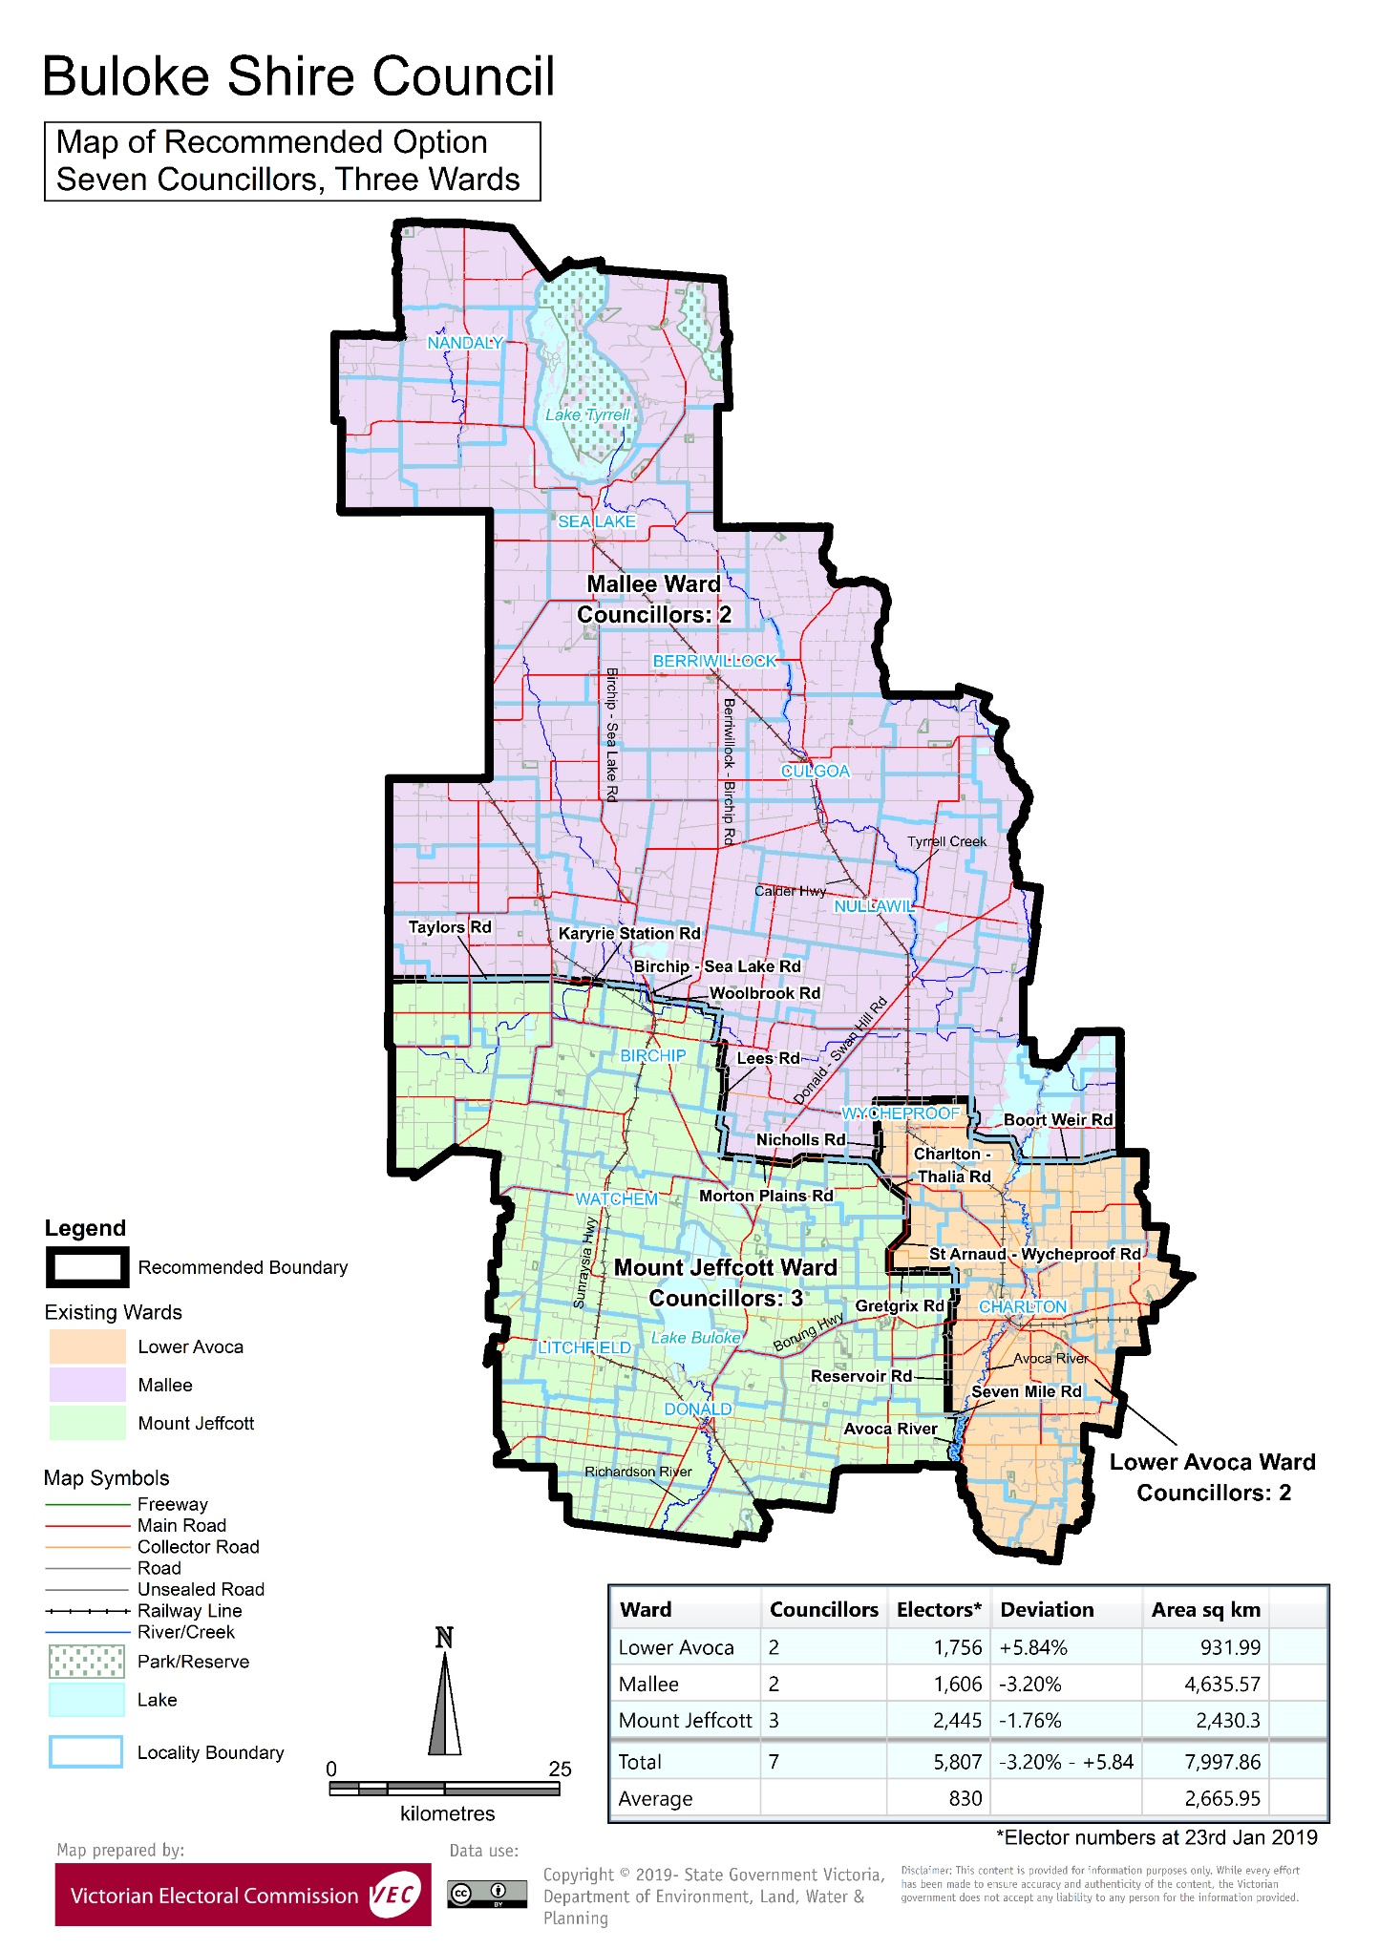

# Appendix 3: Public information program

Advertising

In accordance with the Act, public notices of the review and the release of the preliminary report were placed in the following newspapers:

|  |  |  |
| --- | --- | --- |
| **Newspaper** | **Notice of review** | **Notice of preliminary report** |
| *Herald Sun* | Thursday 6 June | Wednesday 7 August |
| *St Arnaud North Central News* | Wednesday 5 June | Wednesday 7 August |
| *Sea Lake Wycheproof Times* | Thursday 6 June | Thursday 1 August |
| *Donald Buloke Times* | Friday 7 June | Tuesday 6 August |

Media releases

A media release was prepared and distributed to local media to promote the commencement of the review on Thursday 6 June 2019. A further release was distributed with the publication of the preliminary report on Wednesday 7 August 2019. A final media advisory was circulated on the publication date of this final report.

Public information sessions

Public information sessions for people interested in the review process were held on:

* Tuesday 11 June 2019 in the Sea Lake Senior Citizens Club Rooms, Sutcliff Street, Sea Lake
* Tuesday 11 June 2019 in the Supper Room, Donald Soldiers Memorial Hall, Cnr Houston and McCulloch Streets, Donald.

Submission guide

A submission guide was developed and made available on the VEC website, or in hardcopy on request, throughout the review timeline. The submission guide provided information about the review, the review timeline and how to make submissions to the review.

Online submission tool

An online submission tool was developed and made available during the submission periods of the review. The tool allowed people to make a submission from the VEC website. During the preliminary submission stage, users also had the opportunity to map out their preferred subdivisions through the online submission tool using Boundary Builder. Boundary Builder included real elector numbers so that users could see if their preferred structures and numbers of councillors met the plus-or-minus 10% rule.

VEC website

The VEC website delivered up-to-date information to provide transparency and facilitate public participation during the review process. All public submissions were published on the website.

Email and social media engagement

The VEC delivered an information email campaign targeted at known community groups and communities of interest in the local council area. This included a reminder email at each milestone of the representation review process.

The VEC also published sponsored social media advertising that was geo-targeted to users within the local council area. This included advertising at both the preliminary submission and response submission stages. The total reach of these posts was 2,372 during the preliminary submission stage and 2,521 during the response submission stage.

Council communication resources

The VEC provided the Council with a communication pack that included information on the review in various formats. While the council is encouraged to distribute this information and raise awareness about the review, the VEC is an independent reviewer and all communications resources include reference and links to the VEC website and core materials.

This page has been left intentionally blank

This page has been left intentionally blank



1. Section 219D of the *Local Government Act* *1989.*
2. Section 219D of the *Local Government Act* *1989.*
3. Ibid.
4. .id is a consulting company specialising in population and demographic analysis and prediction information products in most jurisdictions in Australia and New Zealand.
5. Section 5B(1) of the *Local Government Act 1989.*
6. Department of Environment, Land, Water and Planning (DELWP), Planning Schemes Online, Buloke Planning Scheme, <http://planning-schemes.delwp.vic.gov.au/schemes/buloke>, accessed 20 August 2019.
7. ABS, ‘2016 Quickstats: Buloke (S)’, <https://quickstats.censusdata.abs.gov.au/census_services/getproduct/census/2016/quickstat/LGA21270>, accessed 20 August 2019.
8. ABS, *Census of Population and Housing: Socio-Economic Indexes for Areas (SEIFA), Australia, 2016*, 2033.0.55.001. Socio-Economic Indexes for Areas (SEIFA) is developed by the Australian Bureau of Statistics (ABS) to rank areas in Australia according to relative socio-economic advantage and disadvantage. The rankings use variables, such as income, education, employment, occupation and housing, derived from Census data to indicate relative socio-economic advantage and disadvantage for particular areas, including Local Government Areas, <https://www.abs.gov.au/ausstats/abs@.nsf/mf/2033.0.55.001>, accessed 20 August 2019. See also Victorian Department of Health and Human Services, *2015 Local Government Area Profiles,* <https://discover.data.vic.gov.au/dataset/2015-local-government-area-profiles>, accessed 20 August 2019.
9. ABS, ‘2016 Quickstats: Buloke (S)’, <https://quickstats.censusdata.abs.gov.au/census_services/getproduct/census/2016/quickstat/LGA21270>, accessed 20 August 2019.
10. Australian Bureau of Statistics (ABS), *Value of Agricultural Commodities Produced, Australia, 2015-16*, 7503.0, 2017.
11. ABS, *Census of population and housing: time series profile, Australia, 2016,* 2003.0, 2017. See also Buloke Shire Council, *Economic Development and Tourism Strategy, 2018-2021.* 
12. DELWP, *Victoria in Future 2019,* 2019. Available at <https://www.planning.vic.gov.au/land-use-and-population-research/victoria-in-future>, accessed 20 August 2019.
13. Ibid. See also Aither Pty Ltd. *Mallee Regional Profile,* A report prepared for Infrastructure Victoria, March 2019.