ELECTORAL REPRESENTATION REVIEW
Mount Alexander Shire Council
Final Report
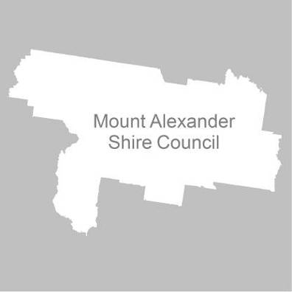

24 May 2011

Contents
Recommendation 3
Background 4
Legislative basis 4
The VEC and Electoral Representation Reviews 4
Profile of Mount Alexander Shire 4
Current electoral structure 5
The electoral representation review process 5
VEC research 6
Public involvement 6
Preliminary report 8
Preliminary submissions 8
Preliminary options 9
Public response 12
Response submissions 12
Analysis of submissions 12
Public hearing 13
Findings and Recommendation 14
Recommendation 16
Appendix 1: List of submitters 17
Appendix 2: Map 18

Recommendation
The Victorian Electoral Commission (VEC) recommends that the Mount Alexander Shire Council consist of seven councillors, to be elected from one three-councillor ward and four single-councillor wards, with unchanged ward boundaries.

Background

Legislative basis
The Local Government Act 1989 (the Act) requires the VEC to conduct an Electoral Representation Review of each municipality in Victoria at least every 12 years. The Act specifies that the purpose of a representation review is to recommend to the Minister for Local Government the number of councillors and the electoral structure for a municipality, which will provide ‘fair and equitable representation for the persons who are entitled to vote at a general election of the Council’.
The Act requires the VEC, as part of an Electoral Representation Review, to consider:
- the number of councillors in a municipality;
- whether a municipality should be unsubdivided or subdivided;
- if it should be subdivided, whether ward boundaries:
  - provide for fair and equitable division of the municipality;
  - ensure equality of representation through the number of voters being represented by each councillor being within 10 per cent of the average number of voters represented by all councillors; and,
- if it should be subdivided, the number of councillors that should be elected for each ward.

The VEC and Electoral Representation Reviews
The VEC has conducted Electoral Representation Reviews since 2004 on appointment by local councils. The Act was changed in 2010 to define the VEC as the only agency authorised to undertake the reviews.
The VEC drew on its experience in mapping and boundary modelling and also engaged consultants with experience in local government to provide advice on specific local representation issues during the review.

Profile of Mount Alexander Shire
Mount Alexander Shire was formed in 1995 by the amalgamation of the City of Castlemaine, the Shire of Newstead and parts of the Shires of Maldon and Metcalfe.
At the 2006 census, the Shire recorded a population of 17,067 people. According to the Department of Planning and Community Development’s Victoria in Future projections, the population of Mount Alexander Shire will grow by 13.56% by 2020. This growth will be fairly even across the Shire.

Current electoral structure
The previous Electoral Representation Review for Mount Alexander Shire Council took place in 2004–2005. Following the review, the Minister for Local Government determined that the structure of Mount Alexander Shire Council would be:
- seven councillors;
- divided into five wards — Calder Ward, Castlemaine Ward, Coliban Ward, Loddon Ward and Tarrengower Ward;
- with three councillors from the Castlemaine Ward and one councillor from each of the remaining wards.
Previously, the Shire comprised seven single-councillor wards, with the urban area of Castlemaine divided into three wards. The VEC recommended creating a three-councillor Castlemaine Ward to represent that community, while retaining single-councillor wards for the local communities outside Castlemaine.

The electoral representation review process
The VEC proceeded on the basis of three main principles:
- Ensuring the number of voters represented by each councillor is within 10 per cent of the average number of voters per councillor for that municipality.
Populations are continually changing. Over time these changes can lead to some wards having larger or smaller numbers of voters. As part of the review, the VEC corrected any imbalances and also took into account likely population changes to ensure these boundaries provide equitable representation until the next review.
- Taking a consistent, State-wide approach to the total number of councillors.
The VEC was guided by its comparisons of municipalities of a similar size and category to the council under review. The VEC also considered any special circumstances that may warrant the municipality to have more or fewer councillors than similar municipalities.
- Ensuring communities of interest are as fairly represented as possible.
Each municipality contains a number of communities of interest and, where practicable, the electoral structure should be designed to take these into account. This allows elected councillors to be more effective representatives of the people in their particular municipality or ward.
The recommendation is based on:
- internal research specifically relating to the municipality under review;
- VEC experience from its work with other municipalities and in similar reviews for State elections;
- VEC expertise in mapping, demography and local government;
- careful consideration of all public input in the form of written and verbal submissions received during the review; and,
- advice received from consultants with wide experience in local government.
Public submissions were an important part of the process, but were not the only consideration during the review. The VEC seeks to combine the information gathered through public submissions with its own research and analysis of other factors, such as the need to give representation to communities of interest. The recommendation is not based on a ‘straw poll’ of the number of submissions supporting a particular option.

VEC research
In addition to the information provided in submissions, the VEC created a profile of the municipality based on population trends, development projections and demographic indicators. The VEC used the Australian Bureau of Statistics 2006 census community profiles, the Department of Planning and Community Development projections and voter statistics from the Victorian electoral roll. The VEC also undertook field work to view current and possible boundaries for each of the options presented in the preliminary report to evaluate their effectiveness.

Public involvement
The VEC values the local knowledge and perspectives presented by the public in written submissions. The public were given two opportunities to provide submissions during the review. Their input was considered by the panel in forming the options in the preliminary report and they were also invited to respond to these options. In addition, a public hearing was held to enable people to speak in support of their submissions and supplement it with information.
To ensure transparency in the process, all written submissions were published on the VEC website and all verbal submissions were heard in a public environment.
To raise awareness of the review and encourage the public to engage with the process, a full public information campaign was undertaken.

Advertising
In accordance with sections 219F(4) and 219F(7) of the Act, the VEC ensured public notices were placed in local newspapers.
Notification of the review appeared in the Castlemaine Mail and the Maldon Tarrangower Times on 4 February 2011 and the Kyneton Midland Express on
8 February 2011. The notice detailed the process for the review and called for public submissions. A general notice covering several reviews was printed in The Age and the Herald Sun on 1 February 2011.
Notification of the release of the preliminary report appeared in the Kyneton Midland Express on 29 March 2011 and in the Castlemaine Mail and the Maldon Tarrangower Times on 1 April 2011. The notice detailed the options contained in the preliminary report, including a map of each option, instructions on how to access a copy of the preliminary report and how to make a submission in response to the report.

Media releases
The VEC produced two media releases for this review. The first release, distributed to local media through the Council, provided information on the review and overall process. A second release, distributed to local media by the VEC, detailed the options in the preliminary report and how to make a submission in response to the report.

Information brochure and poster
An information brochure was provided to the Council to be distributed to residents through the Council’s network, such as in libraries and service centres. A poster was provided to the Council to be displayed in public spaces.

Helpline
A dedicated helpline was established to assist with public enquiries concerning the review process.

VEC website
The VEC website delivered up-to-date information to provide transparency during the preliminary and response stages of the review process. All submissions were posted on the website and an online submission tool was created to facilitate the submission process. The preliminary report was available for electronic download on the website.

Guide for submissions
A guide for submissions was developed and distributed to those interested in making submissions. Copies of the guide for submissions were available on the VEC website, in hardcopy on request, and were provided to the Council.

Preliminary report
In accordance with the Act, the VEC produced a preliminary report outlining its proposed options for Mount Alexander Shire Council. The report was released on 29 March 2011.

Preliminary submissions
By the close of preliminary submissions at 5.00pm on 8 March 2011, the VEC received four submissions.
The only common element among the four submissions is that all preferred to retain the current number of councillors (though the Proportional Representation Society suggested an alternative of nine councillors). Most submissions took the number of councillors for granted, but the Council argued that the current number is appropriate because the ratio of voters to councillor is comparable to similar-sized municipalities, the current number adequately represents voters’ needs, and the odd number of councillors prevents tied votes.
There was more diversity on the electoral structure, with two submissions advocating an unsubdivided council, one wanting single-councillor wards, and one supporting the status quo. The Proportional Representation Society argued in terms of the principles of proportional representation, maintaining that the current structure means that there are unequal quotas for election and that more votes are wasted in single-councillor wards. Mr K Roberts, a resident of the municipality, believed that the three councillors for Castlemaine Ward gave this ward an advantage over the others, and that councillors are elected to represent the whole of the Shire and so all voters should vote for all councillors. Castlemaine Action Inc. wanted single-councillor wards on the ground that proportional representation had been abused by candidates fielding multiple ‘running mates’. The Council supported the current structure because it reflected geographic communities of interest and enabled smaller communities to take up concerns with their ward councillor.
Only the Council submission mentioned ward boundaries. The Council considered that there was no need to change ward boundaries, as enrolments for all wards were within the 10% tolerance and they were not likely to go out of balance in the next 12 years.
A list of submitters, by name, is available in Appendix One. Copies of the submissions can be viewed on the VEC website at vec.vic.gov.au.

Preliminary options
The VEC considers that similar types of municipalities of a similar size should have the same number of councillors, unless special circumstances justify a variation. Mount Alexander Shire fits in the middle of the seven-councillor rural municipality band. The number of voters per councillor (2,200) is slightly above the median for seven-councillor rural municipalities (1,906).
There are no particular factors pointing towards an increase in the number of councillors. The Shire is not large geographically (1,529 square kilometres compared to a median for rural municipalities of 3,880), and there are no major topographical barriers to travel. The Shire’s population is growing evenly and gradually across the municipality, without large-scale developments. With 95% of the population speaking English only, there are no significant numbers of residents who are not proficient in English.
Therefore the VEC considered that Mount Alexander Shire Council should continue to have seven councillors.
On this basis, the VEC believed that there were two practical options for the Shire’s electoral structure:
- the current structure, of one three-councillor ward and four single-councillor wards; and
- an unsubdivided municipality.
In the 2004–2005 electoral representation review, the VEC recommended combining the three wards covering the urban area of Castlemaine, while retaining single-councillor wards for the more rural parts of the Shire. This recommendation was based on communities of interest, with Castlemaine constituting one community and the other wards each being based on one or two townships (Calder Ward on Harcourt, Coliban Ward on Taradale and Chewton, Loddon Ward on Newstead and Guildford, and Tarrengower Ward on Maldon).
The Council submission stated that there is a community view that the geographic area that separates each ward provides a strong sense of place and community. Ward councillors are seen as representative of their wards and are often charged with taking up local causes on behalf of residents or community groups. The Council argued that ‘Single-Councillor Wards provide smaller communities with an avenue to have their concerns heard and local issues supported, which may not be possible in larger multi-member Wards’.
The submission by Castlemaine Action Inc. advocated dividing the Castlemaine Ward into three single-councillor wards, so that all councillors would be elected under the same system. The submission maintained that ‘Examination of past elections in Castlemaine Ward prove that the Proportional Voting system has been abused by candidates fielding multiple “running mates” in order to get elected’.
There is nothing inherent in proportional representation to encourage the proliferation of running mates. The VEC’s experience across Victoria is that running mates or ‘dummy candidates’, who nominate not to get elected but just to transfer preferences to ‘real’ candidates, are allegedly more of an issue in single-councillor wards.
The large number of candidates (15) for Castlemaine Ward in 2005 (the first election under the new structure) suggests that there may have been an issue with running mates at that election. However, at the 2008 election there were only nine candidates for three vacancies.
One of the potential problems with single-councillor wards, especially in the country, is that voters may be deprived of a wide choice. A popular councillor may gain such a hold that he or she is repeatedly unopposed, which means that voters have no choice at all. This does not appear to have been the case in the rural wards of Mount Alexander Shire, where there have been no unopposed elections since 2000.
As the current structure represents communities of interest and offers a wide choice to voters, the VEC considered that this structure provides fair and equitable representation for the voters of Mount Alexander Shire.
Enrolments for all of Mount Alexander Shire’s wards are within the 10% tolerance permitted by legislation. Because population growth is fairly uniform across the Shire, adjustment of ward boundaries does not appear to be necessary.
The Shire’s rural wards are named after prominent geographical features: Coliban and Loddon Wards after the rivers that flow through the wards, Calder Ward after the highway, and Tarrengower Ward after the mountain that overlooks Maldon. The VEC believes it is undesirable to duplicate names used by other councils or levels of government. The name ‘Loddon Ward’ could be confused with the neighbouring Loddon Shire. Accordingly, the VEC suggested renaming this ward Strangways Ward, after the old goldmining locality between Guildford and Newstead.
An alternative electoral structure is an unsubdivided municipality. Two of the main perceived advantages of an unsubdivided structure are:
- all voters can vote for all of the candidates, giving voters a wide choice; and,
- councillors will be encouraged to take a shire-wide view of issues.
In a shire the size of Mount Alexander, it should be possible for candidates and councillors to cover the entire municipality. It can also be noted that all candidates would require the same level of support to be elected, which is not the case under the current hybrid structure of one multi-councillor and four single-councillor wards.

The preliminary report recommended two options:
Option A (Preferred Option): That the Mount Alexander Shire Council consist of seven councillors, to be elected from one three-councillor ward and four single-councillor wards, with unchanged ward boundaries.
Option B (Alternative Option): That the Mount Alexander Shire Council consist of seven councillors, to be elected from an unsubdivided municipality.

Public response

Response submissions
Response submissions on the Electoral Representation Review of Mount Alexander Shire Council opened on 29 March 2011 and closed at 5.00pm on
29 April 2011. Five response submissions were received. Table 1 shows the levels of support for each option based on the preferences expressed in each response submission.
Table 1: Preferences expressed in response submissions for each option
Option A  (Preferred Option) | Option B  (Alternative Option) | Suggestions about ward names
1 | 4 | 1

Analysis of submissions
Four of the five submissions supported an unsubdivided municipality (Option B), with the Council’s submission supporting the current structure (Option A). The non-council submissions argued that all voters should be represented by all councillors, which would eliminate parochialism and encourage councillors to participate fully in decision making about all parts of the Shire. Mr Hans Paas pointed out that Mount Alexander Shire is relatively compact geographically and in population, and so does not need to be divided into wards. Ms Lisa Minchin supported an unsubdivided municipality on similar grounds, as well as suggesting that ‘Continuing to divide the Shire into wards will perpetuate inequities with different wards growing at different rates’. The Proportional Representation Society based its views on the principles of proportional representation. Mr Roberts felt that the current structure advantages Castlemaine Ward, and that a ward structure means that individual ward councillors are powerless as they can be outvoted by the councillors from other wards.
The Council’s submission in support of the status quo largely reprised its preliminary submission. It based its case on community of interest, maintaining that the smaller communities have a strong sense of community which is reflected in the ward structure, and that the ward councillors act as advocates for their communities.
The Council wanted to retain the name of Loddon Ward, arguing that the Loddon River is a significant geographical feature in the ward and that no other names are appropriate.
A list of submitters, by name, is available in Appendix 1. Copies of the submissions can be viewed on the VEC website at vec.vic.gov.au.

Public hearing
A public hearing was held at the Castlemaine Phee Broadway Theatre, Castlemaine on 5 May 2011. Everyone who made a submission in response to the report was invited to speak to their submissions and one individual accepted.
Mr Roberts, of Maldon, contended that ward councillors can be outvoted by councillors from other wards, and that councillors for single-councillor wards were more vulnerable in this regard. The panel asked if Mr Roberts had observed instances of this occurring with the Council. Mr Roberts responded that he had not, but that there was potential for it to occur. Mr Roberts submitted that by electing councillors across the whole municipality, they are accountable to the whole Shire. Asked whether he thought Maldon should have its own representative, Mr Roberts replied that there was no guarantee of local representation under the current structure, as a ward councillor did not have to live in that ward. In response to a proposition that this
could also be possible in an unsubdivided structure, Mr Roberts acknowledged that
it could occur.

Findings and Recommendation
The VEC regards both the options in its Preliminary Report as viable and democratic electoral structures. The question for the VEC to consider is which option would be more effective in achieving fair and equitable representation for the voters of Mount Alexander Shire.
Four of the response submissions advocated a change to an unsubdivided structure. It is correct as argued that in an unsubdivided municipality, all of the voters for the municipality would be able to vote for all of their councillors, voters would have a wider choice of candidates than under a ward structure, and more voters would be likely to gain the election of their preferred candidates (under the operation of proportional representation, all candidates gaining a significant share of votes would be elected). An unsubdivided structure could also mean that the councillors would reflect the diversity of the community, including groups that are not geographically based. With all councillors representing the entire Shire, it can be argued that there is less chance of parochialism affecting decision making. The compact size of the Shire should enable candidates to conduct municipality-wide campaigns.
However, some of the arguments for an unsubdivided structure are less persuasive. The Proportional Representation Society observed that, under the current hybrid system, the number of votes required to reach a quota would be greater in the three-councillor Castlemaine Ward than in the single-councillor wards. The Society argued that this represented a significant distortion, and was unfair from the perspective of voters in Castlemaine. The Society’s point is mathematically undeniable. However, the number of voters represented by each councillor is approximately equal in Castlemaine Ward and in the single-councillor wards. Proportional representation means that voters in Castlemaine Ward are represented according to their votes even if the quota in Castlemaine Ward is higher than in other wards. Mr Roberts maintained that the three councillors for Castlemaine Ward gave voters in that ward an advantage over the other wards, but in fact Castlemaine Ward has three times more voters than each of the other wards, and the number of voters per councillor is approximately equal across the Shire.
A number of the arguments for an unsubdivided municipality are founded on what might happen rather than what is happening. For example, the Proportional Representation Society postulated a scenario under which majority opinion would end up in a minority on Council thanks to the current hybrid electoral structure. Such a situation might occur, but there is no sign of it occurring. It would depend on voters voting for two clearly defined groups, and on votes being distributed as the Society hypothesised. Mr Roberts maintained that any ward’s councillor(s) are outnumbered by the councillors from the other wards, and that this can lead to a ward being governed by ‘remote control’, with the councillors from the other wards imposing their will on the first ward. Again, this situation appears to be theoretical rather than actual. In general, the argument that a ward structure leads to decision making becoming excessively parochial does not seem to be based on current experience.
While some will perceive an imbalance in the current structure, it is the Council that formally decides matters on behalf of the community, not individual councillors. This applies equally to an unsubdivided structure.
The current electoral structure is based on geographic communities of interest. Both the Council submissions stress that the ward boundaries reflect communities, and that residents have a strong sense of place, which through its own observations, is a view shared by the VEC. Maldon, for instance, has a very strong sense of identity, with its own newspaper. Proclaimed by the National Trust as Australia’s first Notable Town, with the best preserved nineteenth-century streetscape in the nation, it is a former gold mining town that now relies largely on tourism. Chewton, Newstead, Guildford and Taradale are also old gold towns with their own individual features, while Harcourt is famous for apples and wine. Under the model of representation adopted at Mount Alexander Shire, the rural ward councillors act as advocates for their communities, including bringing the concerns of smaller communities to the Council’s attention.
Statistics from council elections this century indicate that voters in the rural wards generally have a wide choice of candidates. There has been an average of 2.7 candidates for each rural ward in the elections since 2000. Indeed, the number of candidates overall counts against an unsubdivided structure. Since 2000, the number of candidates for Mount Alexander Shire Council has ranged between 14 and 28, with an average of 22.25. With such large fields of candidates on the ballot paper for an unsubdivided shire, there would be a risk of an increased informal vote.
Because of the strength of community of interest in Mount Alexander Shire and because the case for an unsubdivided municipality is largely based on what might happen rather than what is happening, the VEC considers that it is preferable to retain the current electoral structure.

Ward names
In the Preliminary Report, the VEC suggested renaming Loddon Ward ‘Strangways Ward’, after an old goldmining locality, to avoid duplication with the Loddon Shire. The Council submitted that the original name be retained, arguing that it was not appropriate to use the name of a single community. The Council submission discussed possible alternatives, but concluded that the original name should be kept as the river is a significant geographical feature and the Council did not believe that the name had been a source of confusion for the community.
The VEC agrees that the Loddon River is the major geographic feature of the ward. It flows the length of the ward, past the two main towns of Guildford and Newstead. Accordingly, the VEC recommends that the name of the ward should be retained, but modified slightly to be ‘Loddon River Ward’.

Recommendation
The Victorian Electoral Commission (VEC) recommends that the Mount Alexander Shire Council consist of seven councillors, to be elected from one three-councillor ward and four single-councillor wards, with unchanged ward boundaries.
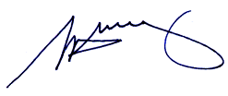

S. H. Tully
Electoral Commissioner

Appendix 1: List of submitters
Preliminary submissions were received from:
Name
Castlemaine Action Inc.
Mount Alexander Shire Council
Proportional Representation Society of Australia (Victoria-Tasmania) Inc.
Keith Roberts

Response submissions were received from:
Name
Lisa Minchin
Mount Alexander Shire Council
Hans Paas
Proportional Representation Society of Australia (Victoria-Tasmania) Inc.
Keith Roberts*
* indicates the submitter who spoke at the public hearing on Thursday,
5 May 2011.

Appendix 2: Map
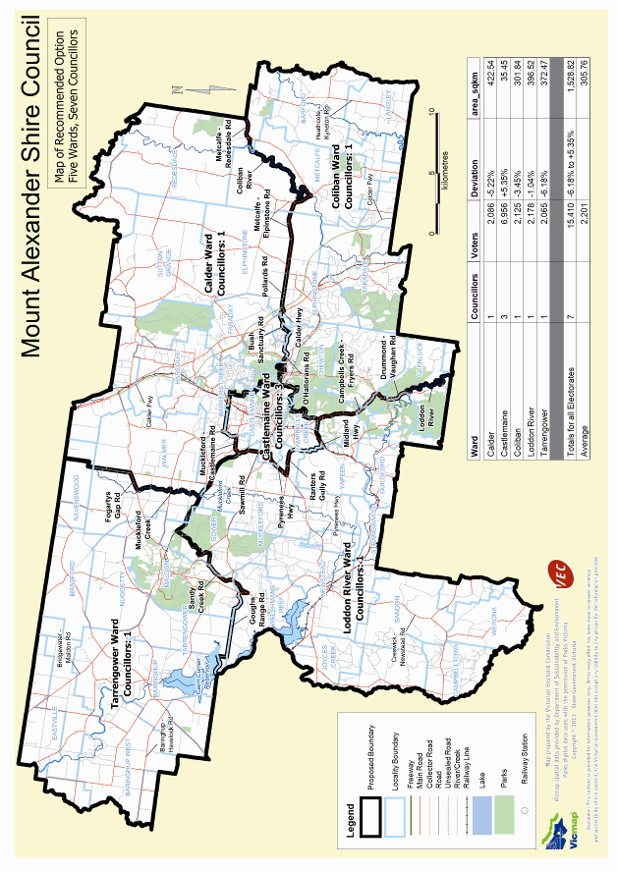

Victorian Electoral Commission
Level 8, 505 Little Collins Street
Melbourne, Vic 3000

131 VEC (131 832)
info@vec.vic.gov.au
vec.vic.gov.au

Section 219D of the Local Government Act 1989.
See maldon.org.au, maldonvictoria.org, maldoncastlemaine.com.au, chewton.net, newstead.vic.au.
In the 2008 elections, the informal voting rate in postal elections ranged from 2.05% where there were 2-5 candidates to 6.28% where there were more than 15 candidates. See the VEC’s Report of local government electoral activity 2008-09, Part 1: Report of the conduct of the 2008 local government elections, p. 42.

