Local council electoral structure review

March 2023

Surf Coast Shire Council

Preliminary   
Report

Acknowledgement of Country

The electoral representation advisory panel acknowledges the Wadawurrung, the Gulidjan and the Gadubanud peoples as the Traditional Custodians of the lands and waters on which it is holding this review and pays respects to ancestors and Elders past, present and emerging. The panel acknowledges their custodianship for many thousands of years and their continuing living culture.

Document history and version control

|  |  |  |  |
| --- | --- | --- | --- |
| **Version** | **Date approved** | **Approved by** | **Brief description** |
| 1 | 21 March 2023 | Electoral Commissioner | Final version |

Contents

Executive summary 4

Developing electoral structure models 4

Preliminary submissions 4

Electoral structure models 4

Next steps 4

Background 5

About the 2023–24 electoral structure reviews 5

The electoral representation advisory panel 5

Public engagement 6

Developing recommendations 6

About Surf Coast Shire Council 9

Profile 9

Current number of councillors and electoral structure 10

Last electoral structure review 10

Preliminary submissions 12

Number of councillors 12

Electoral structure 13

Preliminary findings and models 16

Number of councillors 16

Electoral structure 17

Models for public feedback 20

Next steps 21

Response submissions 21

Public hearing 22

Final report 22

References 23

Appendix 1: Model maps 24

Appendix 2: Additional models considered 28

Appendix 3: List of preliminary submitters 29

# Executive summary

An independent electoral structure review panel appointed by the Minister for Local Government has reviewed the structure of Surf Coast Shire Council.

The panel looked at:

* whether the council had an appropriate number of councillors
* whether it should be unsubdivided or subdivided.

This report outlines the preliminary models that the panel is presenting for the proposed new electoral structure of Surf Coast Shire Council to meet the requirements of Victoria’s *Local Government Act 2020* (the Act).

More information about the background to the reviews is available on page 5.

## Developing electoral structure models

The panel considered a range of factors when deciding on the models in this report, including:

* research and analysis
* voter growth or decline over time
* public submissions (see below).

More information on the way the panel decided on the models is available on page 6.

## Preliminary submissions

The panel received 62 preliminary submissions. Of these, 9 submissions included maps.

A full analysis of submissions received can be found on page 12.

## Electoral structure models

After considering submissions and research, the panel is presenting the following electoral structure models for further public consultation:

Model 1: an unsubdivided electoral structure with 9 councillors.

Model 2: a subdivided electoral structure with a total of 8 councillors, 2 wards and 4 councillors per ward.

Model 3: a subdivided electoral structure with a total of 9 councillors, 3 wards and 3 councillors per ward.

Details on these models, including maps, are available in Appendix 1.

## Next steps

The panel is now seeking feedback on the electoral structure models. You can make a response submission to these models until Wednesday 12 April 2023. If any response submitters wish to speak at a public hearing, the panel will hold an online public hearing on Wednesday 19 April 2023. Following this, it will present its final recommendation to the Minister by Wednesday 17 May 2023.

More information about the review process is available on the Victorian Electoral Commission (VEC) website at [vec.vic.gov.au](https://www.vec.vic.gov.au/electoral-boundaries/council-reviews/electoral-structure-reviews)

# Background

## About the 2023–24 electoral structure reviews

In October 2022, the Minister for Local Government formed 2 electoral representation advisory panels to review the electoral structures of 39 local councils, under section 16 of the *Local Government Act 2020* (the Act). If the Minister accepts the electoral structures the panels recommend, they will take effect at the October 2024 local council elections.

The Act introduced several changes to local government representation, including the types of electoral structures local councils may have. Large and small rural shire councils (including Surf Coast Shire Council) can have one of 3 electoral structures:

* + unsubdivided (entire council area with no wards)
  + single-councillor wards
  + multi-councillor wards with the same number of councillors per ward.

For Surf Coast Shire Council, the electoral representation advisory panel is examining:

* the number of councillors
* whether the council should be subdivided into wards or unsubdivided.

For subdivided structures, it is also examining:

* + the number of wards
  + where the ward boundaries should be
  + the name of each ward
  + how many councillors should be elected for each ward.

The Act requires electoral structures to provide fair and equitable representation and facilitate good governance. For subdivided structures, each ward must have an approximately equal number of voters per councillor (within +/-10% of the average).

## The electoral representation advisory panel

The panel conducting the electoral structure review of Surf Coast Shire Council has 3 members:

**Panel 2**

* Ms Julie Eisenbise (Chairperson)
* Mr Tim Presnell
* Deputy Electoral Commissioner Ms Dana Fleming (Electoral Commissioner delegate).

The panel is independent of councils and the State government.

Under the Act, the VEC is not responsible for reviewing council electoral structures but must provide administrative and technical support to the panel. The Electoral Commissioner (or their delegate) must be a member of each panel.

## Public engagement

### Public information program

To educate and inform the public about the Surf Coast Shire Council electoral structure review, the VEC began a public information program in mid-December 2022. The VEC:

* + printed public notices in state-wide newspapers
  + held public information sessions to outline the review process and respond to questions from the community
  + sent out media releases to announce the start of the review
  + published information on its social media channels
  + provided updated website content on [vec.vic.gov.au](https://www.vec.vic.gov.au/), including:
    - information on the review process
    - submission guides and fact sheets for each council under review with background information
    - preliminary submissions from the public.

The VEC will continue to promote the review during the response submissions stage via media releases, the VEC’s social media channels and updated content on the VEC website.

### Public consultation

The panel encouraged public input to the review of Surf Coast Shire Council via preliminary submissions at the start of the review. The panel now invites further input via:

* + response submissions to this preliminary report
  + an online public hearing to provide anyone who makes a response submission the opportunity to expand on their submission.

Public submissions are an important part of the review process but the panel also considers other factors during a review. These are outlined below.

## Developing recommendations

The panel’s electoral structure models presented in this preliminary report comply with the Act and were developed through careful consideration of:

* + research and analysis conducted by the VEC support team, including geospatial and demographic factors
  + rates or patterns of population and voter growth or decline over time, and relevant forecasts of growth or decline based on forecast information provided by .id (informed decisions, a company specialising in demographics and forecasting)
  + input received from the public in written submissions during the preliminary submissions phase.

### Deciding on the number of councillors

The Act allows local councils to have between 5 and 12 councillors, but neither the Act nor the Local Government (Electoral) Regulations 2020 specify how to determine the number of councillors a council needs. Therefore, the models put forward by the panel in this report are guided by the Act’s intention for fairness and equity in voter representation.

In examining the number of councillors Surf Coast Shire Council should have, the panel considered these factors:

* + the population and number of voters in the council area, compared to other councils with a similar population size and number of voters in the same category (for example, metropolitan, interface, regional city, large rural shire, small rural shire)
  + patterns of population change and voter growth or decline in the council area over time
  + the current and past numbers of councillors
  + the representation needs of the communities of interest in the council area
  + if a particular type of electoral structure best suits the council (see ‘Deciding the electoral structure’ below)
  + any matter raised in public submissions not already listed above.

Generally, local councils with a larger number of voters will have a higher number of councillors. Large populations are often more likely to have greater diversity, both in the type and number of communities of interest and issues relating to representation. However, the ideal number of councillors can also be influenced by the particular circumstances of a council, such as the:

* + nature and complexity of services the council provides
  + geographic size and topography of the area
  + forecast population and voter growth or decline
  + social diversity.

### Deciding the electoral structure

The electoral structure of large and small rural shire councils can be:

* + unsubdivided (entire council area with no wards)
  + made up of single-councillor wards

or

* + made up of multi-councillor wards with the same number of councillors per ward.

When developing electoral structure models for Surf Coast Shire Council, the panel considered these main criteria:

* + whether the structure would comply with section 15(2) of the Act (see below), and for how long it would likely comply
  + the appropriate number of councillors, as outlined above
  + whether meaningful and effective ward boundaries can be established and whether these would be easily identifiable to local communities
  + representation of communities of interest
  + the voter distribution and physical features of the area, and the impact these may have on the shape and size of any wards
  + past elections for the council, including:
    - numbers of candidates nominating
    - incidences of uncontested elections
    - rates of informal voting.
  + other matters raised in public submissions not already listed above.

Under section 15(2) of the Act, subdivided structures must aim for an approximately equal number of voters per councillor in each ward. This means the number of voters represented by each councillor in a ward should be within +/-10% of the average number of voters per councillor for all wards.

The panel recommends structures that will comply with section 15(2) at the October 2024 local council elections and uses current voter numbers and forecasts of population and voter change to assess this with as much accuracy as possible. In some cases, population changes and other factors mean it is not possible for a subdivided electoral structure to comply with section 15(2) based on current voter numbers. If this occurs, compliance at the 2024 local government elections will be the priority to ensure each vote has approximately equal value.

# About Surf Coast Shire Council

## Profile

Surf Coast Shire Council is in the Barwon South West region of Victoria, about 100 km from Melbourne. It borders Colac Otway Shire Council to the west and Golden Plains Shire and Greater Geelong City councils to the north.

The Traditional Custodians of the land within Surf Coast Shire are the Wadawurrung, the Gulidjan and the Gadubanud peoples.

### Landscape

The shire covers an area of 1,553 km² and includes an iconic stretch of coastline, part of the Otway Ranges and a large rural hinterland. The shire is a major tourist destination, registering over 2.4 million visitors each year. Attractions include the Great Ocean Road, Great Otway National Park, Erskine Falls and the world-famous Bells Beach. It is a popular holiday destination for those living in Melbourne and surrounds.

The shire’s current population is 37,694. Torquay, 21 km south of Geelong, is the shire’s largest town, with just under half of the total population. Along the Great Ocean Road, Anglesea, Aireys Inlet and Lorne are the most populous coastal towns. Winchelsea, situated on the Barwon River, is the largest inland town and is an important service base for the surrounding rural communities (Remplan 2022).

The main transport corridor is the Princes Highway, which passes through the northern towns of Mount Moriac and Winchelsea. The Surf Coast Highway connects the city of Geelong with Torquay. The Great Ocean Road extends along the entire coast of the shire, linking the urban centre of the Torquay-Jan Juc region with coastal towns as far south as Lorne.

### Community

The population of the shire has increased rapidly over the past decade, at a rate significantly higher than other rural Victorian councils. From 2011 to 2021 the population grew by over 10,000 people (from 26,666 to 37,694). This pattern is expected to continue at a rate of 2.2% each year to reach around 43,100 by 2026. Most of the growth has and will continue to occur in the urban centres of Torquay and Jan Juc. Torquay alone is forecast to grow by more than 3,900 people by 2026 and account for over 70% of total population growth during this period (ABS 2021; Remplan 2022).

At the 2021 Census, around 32% of all homes in the shire were unoccupied, with significantly higher vacancy rates recorded for Lorne (68.6%), Aireys Inlet (59.5%) and Anglesea (55.5%%). These coastal towns swell in population significantly during the peak summer holiday period (ABS 2021).

At 42 years, the median age of the population has remained unchanged from the 2016 Census, though this varies across different areas of the shire. Torquay has a median age of 39 years, while Winchelsea and Lorne have median ages of 41 years and 56 years respectively (ABS 2021).

People born in Australia make up 82.9% of the population, and 90.7% speak only English at home. Both rates are above the regional Victoria averages (ABS 2021). People of Aboriginal or Torres Strait Islander heritage make up 0.6% of the shire’s population, below the regional Victoria average of 2.0% (ABS 2021).

The unemployment rate across the shire sits at 2.8%, which is lower than the regional Victoria average. Almost 64% of the population participates in the labour force, mostly as professionals (27.6%), followed by managers (18.1%) and technicians and trade workers (13.7%). In contrast, the main employment sectors throughout the shire are construction (15.0%), accommodation and food services (14.4%) and retail trade (12.8%) (ABS 2021; Remplan 2022).

Across the shire the median weekly household income is $2,088, higher than the regional Victoria average. Home ownership is widespread, with 78.2% of homes owned outright or owned with a mortgage, while fewer people rent (18.1%) than in regional and rural Victoria overall (23.6%). Both the median weekly rent ($461) and median monthly mortgage repayment ($2,145) are well above the averages for regional Victoria (ABS 2021).

## Current number of councillors and electoral structure

Surf Coast Shire Council is currently divided into 4 wards with a total of 9 councillors:

* + one ward with 4 councillors (Torquay)
  + 2 wards with 2 councillors each (Anglesea and Winchelsea)
  + one single-councillor ward (Lorne).

There are approximately 35,330 voters in Surf Coast Shire, with a ratio of 3,926 voters per councillor.

Visit the VEC website at [vec.vic.gov.au](https://www.vec.vic.gov.au/electoral-boundaries/local-councils/surf-coast-shire-council) for more information on Surf Coast Shire Council.

## Last electoral structure review

The VEC conducted an electoral representation review of Surf Coast Shire Council in 2012. This review was carried out under the *Local Government Act 1989*, which was replaced by the *Local Government Act 2020*.

After conducting the review, the VEC recommended that the Surf Coast Shire Council consist of 9 councillors elected from 4 wards (1 ward with 4 councillors, 1 ward with 1 councillor and 2 wards with 2 councillors).

Before the 2012 review, Surf Coast Shire Council had 9 councillors in an unsubdivided electoral structure. Before a representation review in 2003, Surf Coast Shire Council was divided into 5 wards with a total of 9 councillors:

* + 2 wards with 3 councillors each
  + 3 wards with one councillor each.

### Subdivision review

Since the 2012 representation review, the VEC also conducted a subdivision review of Surf Coast Shire Council in 2020.

Subdivision reviews conducted under the *Local Government Act 1989* adjusted the internal ward boundaries of a council but did not change the electoral structure or number of councillors. Subdivision reviews were conducted in situations where the voter-to-councillor ratios in one or more wards of a council were forecast to move outside the legislated +/-10% tolerance before the council’s next election and aimed to ensure voter-to-councillor ratios for all wards were within tolerance at the election.

The 2020 review of Surf Coast Shire Council aimed to return the Anglesea and Lorne Wards to within the permitted +/-10% tolerance before the 2020 local government elections. Visit the [Surf Coast Shire Council profile](https://www.vec.vic.gov.au/electoral-boundaries/local-councils/surf-coast-shire-council) on the VEC website to access a copy of the 2020 subdivision review final report.

# Preliminary submissions

The panel received 62 preliminary submissions from the public by the deadline of 5 pm on Wednesday 22 February 2023. You can view these submissions on the VEC website at [vec.vic.gov.au](https://www.vec.vic.gov.au/electoral-boundaries/council-reviews/electoral-structure-reviews/surf-coast/preliminary-submissions) and find a list of people or organisations who made a submission in Appendix 3.

The table below provides an overview of preferences in the preliminary submissions. You can read an analysis of submissions below this table.

|  |  |  |  |  |  |
| --- | --- | --- | --- | --- | --- |
|  | Unsubdivided structure | Single-councillor wards | Multi-councillor wards | Subdivided structure (unspecified) | No comment on structure |
| Fewer councillors | - | - | 9 | - | - |
| Maintain current councillor number | 9 | 17 | 5 | - | 2 |
| More councillors | - | - | 12 | - | - |
| No comment on number of councillors | 5 | 1 | 5 | 3 | 6 |

Note: 12 submitters supported more than one electoral structure/option for the total number of councillors.

## Number of councillors

More than half of all submissions (33) supported keeping 9 councillors. Two submissions proposed reducing to 8 councillors while 5 submissions favoured an increase to 12 councillors. An additional 7 submissions supported electoral structures with either 8 or 12 councillors.

### Maintaining 9 councillors

Most submissions felt the current number of councillors was appropriate.

Mat Hines proposed keeping 9 councillors based on other rural councils with similar size and distribution of population to Surf Coast Shire.

Cr Rose Hodges reasoned that given the high rate of population growth within the shire, 9 councillors was an appropriate number. Likewise, Cr Adrian Schonfelder supported keeping 9 councillors as it maintained the status quo.

### Reducing to 8 councillors

The Aireys Inlet and District Association (AIDA) proposed either 8 or 12 councillors to enable a 4-ward electoral structure. This approach was also supported by 5 other submissions, including the Surf Coast Positive Aging Advisory Committee.

### Increasing to 12 councillors

Barbara Hammond and Chris Ryan each submitted that 12 councillors would be ‘workable’ for the preferred ward structures they proposed. However, one submitter (Mat Hines) did not support this increase. Hines pointed out that no councils in Victoria have 12 councillors, and those with 11 councillors have a much higher voter-to-councillor ratio than Surf Coast Shire.

## Electoral structure

Of the 62 submissions received, 14 supported an unsubdivided electoral structure, while the remaining submissions generally supported keeping a subdivided ward model. Nine submissions included a map to detail their preferred electoral structure. These maps were created using the VEC’s public submission tool.

### Unsubdivided electoral structure

Beth Davidson proposed an unsubdivided structure, arguing that given the requirements of the Act, there was no equitable way of dividing the population of Surf Coast Shire into wards.

Adrian Kennelly felt subdividing the shire into wards encouraged local biases and preferred an unsubdivided structure as the best way to ensure councillors were elected based on a platform of community representation. Gisela Gardener also argued that an unsubdivided electoral structure would encourage a shire-wide approach to issues and the election of councillors based on their commitment to the whole shire.

Mat Hines suggested an unsubdivided electoral structure would better guarantee representation for the shire’s diverse communities of interest. It would also avoid the need to redraw ward boundaries in the future to re-balance voter numbers across wards. Similarly, Judy Cameron suggested that for such a fast-growing shire, the need to consistently adjust ward boundaries would complicate council elections.

Cr Rose Hodge presented the view that, considering the 3 types of electoral structures allowed under the Act, an unsubdivided electoral structure was the best choice overall for the shire.

Several submitters presented opposing arguments to the benefits of an unsubdivided electoral structure. For example, multiple Lorne-based submitters argued that an unsubdivided electoral structure had in the past encouraged the council to take a Torquay-centric approach, to the disadvantage of smaller coastal and rural communities. They felt that the shire’s various communities of interest would be better served by having local councillors elected under a subdivided structure.

### 3 wards with 3 councillors per ward

A common theme in these submissions was the understanding of the 3 distinct communities of interest that make up the shire: the urban area of Torquay, the communities located along the coastline from Anglesea to Lorne and the rural hinterland. Most submitters argued that each was unique in character and had distinct needs.

Mat Hines provided a mapped submission that supported (as one of 2 options) a 3-ward electoral structure with the wards defined as urban, peri-urban and rural. In each ward was:

* Urban ward –Torquay region including Torquay North
* Peri-urban ward – Jan Juc to Anglesea, and inland to Bellbrae and Coombes Road
* Rural ward – current Winchelsea ward as well as Lorne, Fairhaven and Aireys Inlet.

### 4 wards with either 2 or 3 councillors per ward

Fourteen submissions proposed a 4-ward electoral structure, 7 of which supported having either 2 or 3 councillors per ward. In support of the 4-ward structure, many submitters referred to the shire’s 3 main communities of interest. Barbara Hammond proposed a 4-ward structure as a good way to provide social, economic and environmental benefits to all of these communities.

The mapped submission from the Aireys Inlet and District Association (AIDA) proposed:

* a Torquay North Ward
* a Torquay South Ward, encompassing Jan Juc and Bells Beach
* a West Coast Ward encompassing Anglesea, Aireys Inlet, Fairhaven, Moggs Creek, Eastern View, Pennyroyal and Lorne
* a ward covering the shire’s rural hinterland, capturing the area of the current Winchelsea Ward as well as Deans Marsh, Bambra, and Wensleydale.

### 9 single-councillor wards

Seventeen submitters including 14 from Lorne, proposed a structure of 9 single-councillor wards. Of these, 5 had maps detailing proposed ward boundaries. Supporting this structure, John Agar argued that because the shire’s 3 main communities all have diverging interests, a single-councillor ward structure would better allow councillors to focus on distinct and specific community interests. Many submitters supported Agar’s proposal, while similar proposals were put forward by Lorne Community Connect Inc, Clive Goldsworthy, and the Committee for Lorne. These submissions broadly proposed:

* 4 single-councillor wards to capture the town and suburbs of Torquay, from Ghazeepore Road to the coastline and south to the Torquay side of the Great Ocean Road and to Torquay Golf Club
* separate single-councillor wards that each cover the coastal communities of Jan-Juc, Bellbrae, Anglesea, Aireys Inlet and Lorne. In building these 4 wards, most submitters found it necessary to group the communities of Anglesea, Bellbrae, Freshwater Creek, and Paraparap in a single ‘Bellbrae’ ward, with the proposed ‘Lorne’ ward extending north as far as Wensleydale and Winchelsea South.
* one ward capturing Winchelsea and surrounding rural areas.

The mapped submission from Andrew Phelps proposed that Torquay be split into 5 wards (including Jan Juc and Bells Beach), with Lorne in a ‘west’ ward that extended in a corridor along the western shire boundary through to the north of the shire.

# Preliminary findings and models

## Number of councillors

After taking into consideration the requirements of the Act, public submissions and the agreed criteria, the panel found 8 or 9 councillors to be an appropriate number for Surf Coast Shire Council.

The panel considered the characteristics of Surf Coast Shire in relation to similar rural shire councils, including its size and geography, population and the number and distribution of voters across the shire.

|  |  |  |  |  |  |  |
| --- | --- | --- | --- | --- | --- | --- |
| Similar rural shire councils to Surf Coast Shire Council | | | | | | |
| Local council | Area (km2) | Number of voters at 2020 election | Population (2021 Census) | Current total estimate of voters | Number of councillors | Number of voters per councillor |
| East Gippsland Shire | 20,940 | 41,335 | 48,715 | 42,842 | 9 | 4,760 |
| Wellington Shire | 10,817 | 40,220 | 45,639 | 41,338 | 9 | 4,593 |
| Macedon Ranges Shire | 1,748 | 38,068 | 51,458 | 39,622 | 9 | 4,402 |
| Mitchell Shire | 2,862 | 34,595 | 49,460 | 36,928 | 9 | 4,103 |
| **Surf Coast Shire** | **1,553** | **33,644** | **37,694** | **35,330** | **9** | **3,926** |
| Campaspe Shire* | 4,519 | 30,493 | 38,735 | 31,046 | 9 | 3,450 |
| Moorabool Shire* | 2,111 | 27,947 | 37,632 | 28,815 | 7 | 4,116 |
| South Gippsland Shire | 3,296 | N/A | 30,577 | 27,964 | 9 | 3,107 |
| Moira Shire | 4,046 | 24,290 | 30,522 | 24,974 | 9 | 2,775 |

*This local council is undergoing an electoral structure review during 2023–24

### Maintaining 9 councillors

The panel believed that maintaining 9 councillors was appropriate for the shire. Maintaining a total of 9 councillors would keep the shire’s councillor numbers and voter-to-councillor ratio in line with other similarly sized rural councils, and this option would also involve the least amount of change for the shire. It was also noted that there was significant support in public submissions for maintaining the number at 9 councillors.

### Increasing councillor numbers

The panel noted that there was support in some submissions for an increase in councillor numbers. After assessing population and voter data in comparison with other similar Victorian local councils and considering factors such as communities of interest and special circumstances in the shire, the panel concluded that increasing the number of councillors was not justified at this point in time.

### Reducing to 8 councillors

The Act requires any multi-councillor electoral structure to have an equal number of councillors elected to each ward. The panel considered reducing councillor numbers if this enabled a favourable multi-councillor ward structure to be created. It believed that reducing the number of councillors to 8 may be justified if such a favourable structure could be identified. However, increased councillor workloads was considered one of the possible drawbacks of reducing councillor numbers to 8. These workloads would need to be balanced against any potential benefits of a multi-councillor ward electoral structure.

## Electoral structure

To identify the most appropriate electoral structure, various factors were considered. This included the requirements of the Act, the communities of interest in Surf Coast Shire council, public submissions, the appropriateness of ward boundaries, and which models offered the most fair and equitable representation.

In developing the preliminary models presented in this report, a range of models were considered. The strongest 3 models have been put forward for further public comment.

The panel proposes 3 models for the consideration of the Surf Coast Shire Council community:

* an unsubdivided electoral structure with 9 councillors (Model 1)
* a subdivided electoral structure of 2 wards, with 4 councillors per ward (Model 2)
* a subdivided electoral structure of 3 wards, with 3 councillors per ward (Model 3)

Diagrams of the preliminary models are included in Appendix 1.

### Unsubdivided structure (Model 1)

Under this model, Surf Coast Shire Council would adopt an unsubdivided electoral structure with 9 councillors.

The panel found that this model had a reasonable level of support in public submissions from across the shire and enabled the current number of councillors to be maintained. It also removes any need for future boundary adjustments to account for changes in population and is equitable for candidates as all future candidates would need the same quota of votes to be elected. Candidates will also be able to appeal to voters from across the whole shire.

While in some cases unsubdivided structures can lead to an increase in informal voting (due to the larger numbers of candidates appearing on the ballot paper), Surf Coast Shire Council has a history of low informal voting rates in past elections.

The panel noted, however, that in previous representation reviews there was significant opposition to an unsubdivided electoral structure. This was mainly due to concerns that candidates from the larger areas of the shire would dominate elections such that some of the smaller communities in the shire would not be represented. However, balanced against this was the ability to promote a shire-wide perspective and that historically, there has been a good spread of candidates and councillors from across all areas of the shire. Candidate quotas to be elected would also be lower, giving any candidate with a moderate level of support from a local community a better chance of being elected.

### Multi-councillor ward structure: 2 wards, with 4 councillors per ward (Model 2)

Under this model, Surf Coast Shire Council would adopt a 2-ward structure. Each ward would be represented by 4 councillors, in line with the requirement of the *Local Government Act 2020* for there to be the same number of councillors per ward.

The panel considered this model in response to the large number of submissions supporting multi-councillor wards.

The proposed Torquay ward maintains the current ward boundaries and contains most of Torquay and surrounding suburbs. The shire’s other communities are combined into one very large ward. A potential drawback of this structure is that it may encourage a division between the greater Torquay community and the rest of the shire. The larger ward also contains various communities of interest who may have concerns about losing local representation under such a structure. However, proportional representation may afford these communities a chance of gaining representation.

While this model involved a reduction to 8 councillors, the panel determined it to be the most stable of the multi-councillor ward electoral structures, as it is best able to accommodate future growth and change.

### Multi-councillor ward structure: 3 wards, with 3 councillors per ward (Model 3)

Under this model, Surf Coast Shire Council would adopt a 3-ward structure. Each ward would be represented by 3 councillors, in line with the requirement of the *Local Government Act 2020* for there to be the same number of councillors per ward.

The panel considered this electoral structure to be well-balanced and a good response to the community support for a subdivided electoral structure.

There are many potential benefits to this model. It responds to the views put forward in many public submissions that a subdivided model is the best option for the shire. It captures the shire’s 3 major communities of interest - urban Torquay, coastal towns, and the rural hinterland. The model broadly maintains Torquay in one ward with similar ward boundaries to the current Torquay Ward, while grouping the coastal communities together and maintaining Lorne’s connection north with Deans Marsh. It also maintains much of the current Winchelsea ward.

While not as stable as other multi-councillor ward structures modelled, all wards are forecast to be within the +/-10% tolerance at the October 2024 local council elections.

### Models considered but not put forward

#### A multi-councillor ward model of 4 wards with 2 councillors per ward

An electoral structure of 4 multi-councillor wards with 2 councillors each was also considered (see Appendix 2). This structure was proposed in several submissions and thought to have potential benefits for community representation. Although the number of voters across all wards in this model were within the +/-10 tolerance based on current enrolments, voter projections indicated that a number of wards were likely to move outside this tolerance by the time of the October 2024 local council elections. This is due to the uneven distribution and growth of the population across the council area. As a result, this structure was not put forward for public consultation.

#### A single-councillor ward model with 9 councillors

The panel considered an electoral structure of 9 single-councillor wards (see Appendix 2). This was due to the support for this model in public submissions and its potential to provide representation for the shire’s various communities of interest. All mapped proposals of this electoral structure were assessed against current and projected voter numbers to ensure ward enrolments would be with the +/-10% tolerance at the October 2024 local council elections. Adjustments were made to improve the viability of these structures where possible. However, due to the uneven population distribution and growth across the shire, wards within any single-councillor ward model were forecast to rapidly move outside the +/-10% tolerance. As such, a single-councillor ward model was not put forward for consideration.

## Models for public feedback

The panel considers all models outlined below to offer fair and equitable representation for voters in Surf Coast Shire Council. Please see Appendix 1 for detailed maps of these models.

### Model 1

Surf Coast Shire Council has an unsubdivided electoral structure with 9 councillors.

### Model 2

Surf Coast Shire Council has 8 councillors and is divided into 2 wards with 4 councillors per ward.

### Model 3

Surf Coast Shire Council has 9 councillors and is divided into 3 wards with 3 councillors per ward.

### Ward names

The panel has suggested ward names to identify the wards in Model 2 and Model 3 and invites comments from the community on these names as part of submissions responding to the preliminary report.

# Next steps

## Response submissions

Any person or group, including the local council under review, can make a response submission to the electoral representation advisory panel. In your submission you should address the models proposed by the panel in this preliminary report.

You can make a submission:

|  |  |
| --- | --- |
|  | **Online** Visit [vec.vic.gov.au](http://vec.vic.gov.au/" \o "VEC website home page) to make a submission online.  You will need to make an account to use the online Public Submission Tool and can save a draft submission to finish later. |
|  | **By email** [SurfCoast.ERAPSubmissions@vec.vic.gov.au](mailto:SurfCoast.ERAPSubmissions@vec.vic.gov.au) |
|  | **By post**  Electoral Representation Advisory Panel c/o Victorian Electoral Commission Level 11, 530 Collins St Melbourne VIC 3000 |

The panel must receive all response submissions before 5 pm on Wednesday 12 April 2023. If you post your submission, make sure it has enough time to reach the panel before the deadline. Late submissions will not be accepted.

### Required information

For your submission to be considered you must include your:

* full name
* contact phone number or email address
* postal or residential address.

The panel will not consider submissions without this information. If you are submitting as a group or organisation you must include the name of a nominated contact person who is authorised to submit on behalf of your group.

The VEC will handle information provided by submitters in accordance with the privacy policy available at [vec.vic.gov.au/privacy](http://www.vec.vic.gov.au/privacy).

### Public access to submissions

To ensure transparency in the electoral structure review process, your submission will be published on the VEC website at [vec.vic.gov.au](http://www.vec.vic.gov.au/). The VEC will remove your signature and contact details, including residential and postal addresses, from all public copies but must publish your full name (or group name) and locality (suburb or town).

## Public hearing

If you make a response submission you can also ask to speak at an online public hearing to support your submission and expand on your views.

The online public hearing is scheduled for:

Time: 2 pm

Date: Wednesday 19 April 2023.

The panel encourages participation in the public hearing. If you wish to speak at the public hearing, you **must** indicate this in your response submission. The public hearing will not be held if there are no requests to speak.

Anyone can attend a public hearing, but you will only be able to speak if you asked to in your response submission. If you ask to speak, the VEC will contact you to arrange a time for you at the hearing. You will have 10 minutes to address the public hearing panel, which will include at least 2 of the review panel members. The members of the public hearing panel may ask you questions.

Visit the VEC website at [vec.vic.gov.au](http://vec.vic.gov.au/) for more information on public hearings.

## Final report

Following the public hearing, the review panel will consider all evidence gathered and publish a final report for the Minister for Local Government containing a recommendation for the number of councillors and the electoral structure for the local council.

The final report is scheduled to be published on Wednesday 17 May 2023. If the recommendation is accepted, any changes will apply at the October 2024 local council elections.

The final report will be available on the VEC website at [vec.vic.gov.au](http://vec.vic.gov.au/) or you can request a printed copy by calling 131 832.

# References

Australian Bureau of Statistics. (2021). *Census 2021 All persons QuickStats, Surf Coast*<https://www.abs.gov.au/census/find-census-data/quickstats/2021/LGA26490> accessed 30 January 2023.

Australian Bureau of Statistics. (2021). *Census 2021 All persons QuickStats, Torquay*.  
<https://www.abs.gov.au/census/find-census-data/quickstats/2021/SAL22551> accessed on 16 February 2023.

Australian Bureau of Statistics. (2021). *Census 2021 All persons QuickStats, Anglesea*.  
<https://www.abs.gov.au/census/find-census-data/quickstats/2021/SAL20046> accessed on 16 February 2023.

Australian Bureau of Statistics. (2021). *Census 2021 All persons QuickStats, Lorne*.  
<https://www.abs.gov.au/census/find-census-data/quickstats/2021/SAL21542> accessed on 16 February 2023.

Australian Bureau of Statistics. (2021). *Census 2021 All persons QuickStats, Aireys Inlet*.  
<https://www.abs.gov.au/census/find-census-data/quickstats/2021/SAL20013> accessed on 16 February 2023.

Australian Bureau of Statistics. (2021). *Census 2021 All persons QuickStats, Winchelsea*.  
<https://www.abs.gov.au/census/find-census-data/quickstats/2021/SAL22802> accessed on 16 February 2023.

*Local Government Act 1989* (Vic)

*Local Government Act 2020* (Vic)

*Local Government (Electoral) Regulations 2020* (Vic)

Surf Coast Shire Council. (2023). *About the Shire.*  
<https://www.surfcoast.vic.gov.au/About-us/About-the-Shire> accessed 31 January 2023

Surf Coast Shire Council. (2023): *Surf Coast Planning Scheme.*  
<https://planning-schemes.app.planning.vic.gov.au/Surf%20Coast/ordinance> accessed 13 February 2023.

Remplan. (2022). *Surf Coast Shire. Economy, Jobs and Business Insights*.  
<https://app.remplan.com.au/surfcoast/economy/summary?state=xrjVFNzPQUKOkQvCOo2gaQFpIoIpe0> accessed 10 February 2023.

Remplan. (2022). *Surf Coast Shire. Our Place - Our Community*.  
<https://app.remplan.com.au/surfcoast/community/summary?state=Q68riymlRF1rJ9BUQpE8yLs8tvtaPZ> accessed 10 February 2023

Remplan. (2022). *Surf Coast Shire. Population, Households and Dwellings Forecasts to 2041*.<https://app.remplan.com.au/surfcoast/forecast/summary?state=D8emTrMLnIbZ4ebc4mndOyhRt2t2Bz> accessed 13 February 2023.

# Appendix 1: Model maps

The following maps are included in this report:

|  |  |
| --- | --- |
| Map | Page |
| Model 1 – an unsubdivided electoral structure with 9 councillors | 25 |
| Model 2 – a multi-councillor ward structure with 8 councillors, 2 wards and 4 councillors per ward | 26 |
| Model 3 – a multi-councillor ward structure with 9 councillors, 3 wards and 3 councillors per ward | 27 |

Forecast information in the text of this report is based on forecasts prepared by .id – informed decisions [id.com.au](http://www.id.com.au/) .id and its licensors are the sole and exclusive owners of all rights, title and interest subsisting in that part of the report content where .id are identified. Some of .id content is a derivative of ABS Data, which can be accessed from the website of the Australian Bureau of Statistics at [abs.gov.au](http://www.abs.gov.au/), and licensed on terms published on the ABS website.

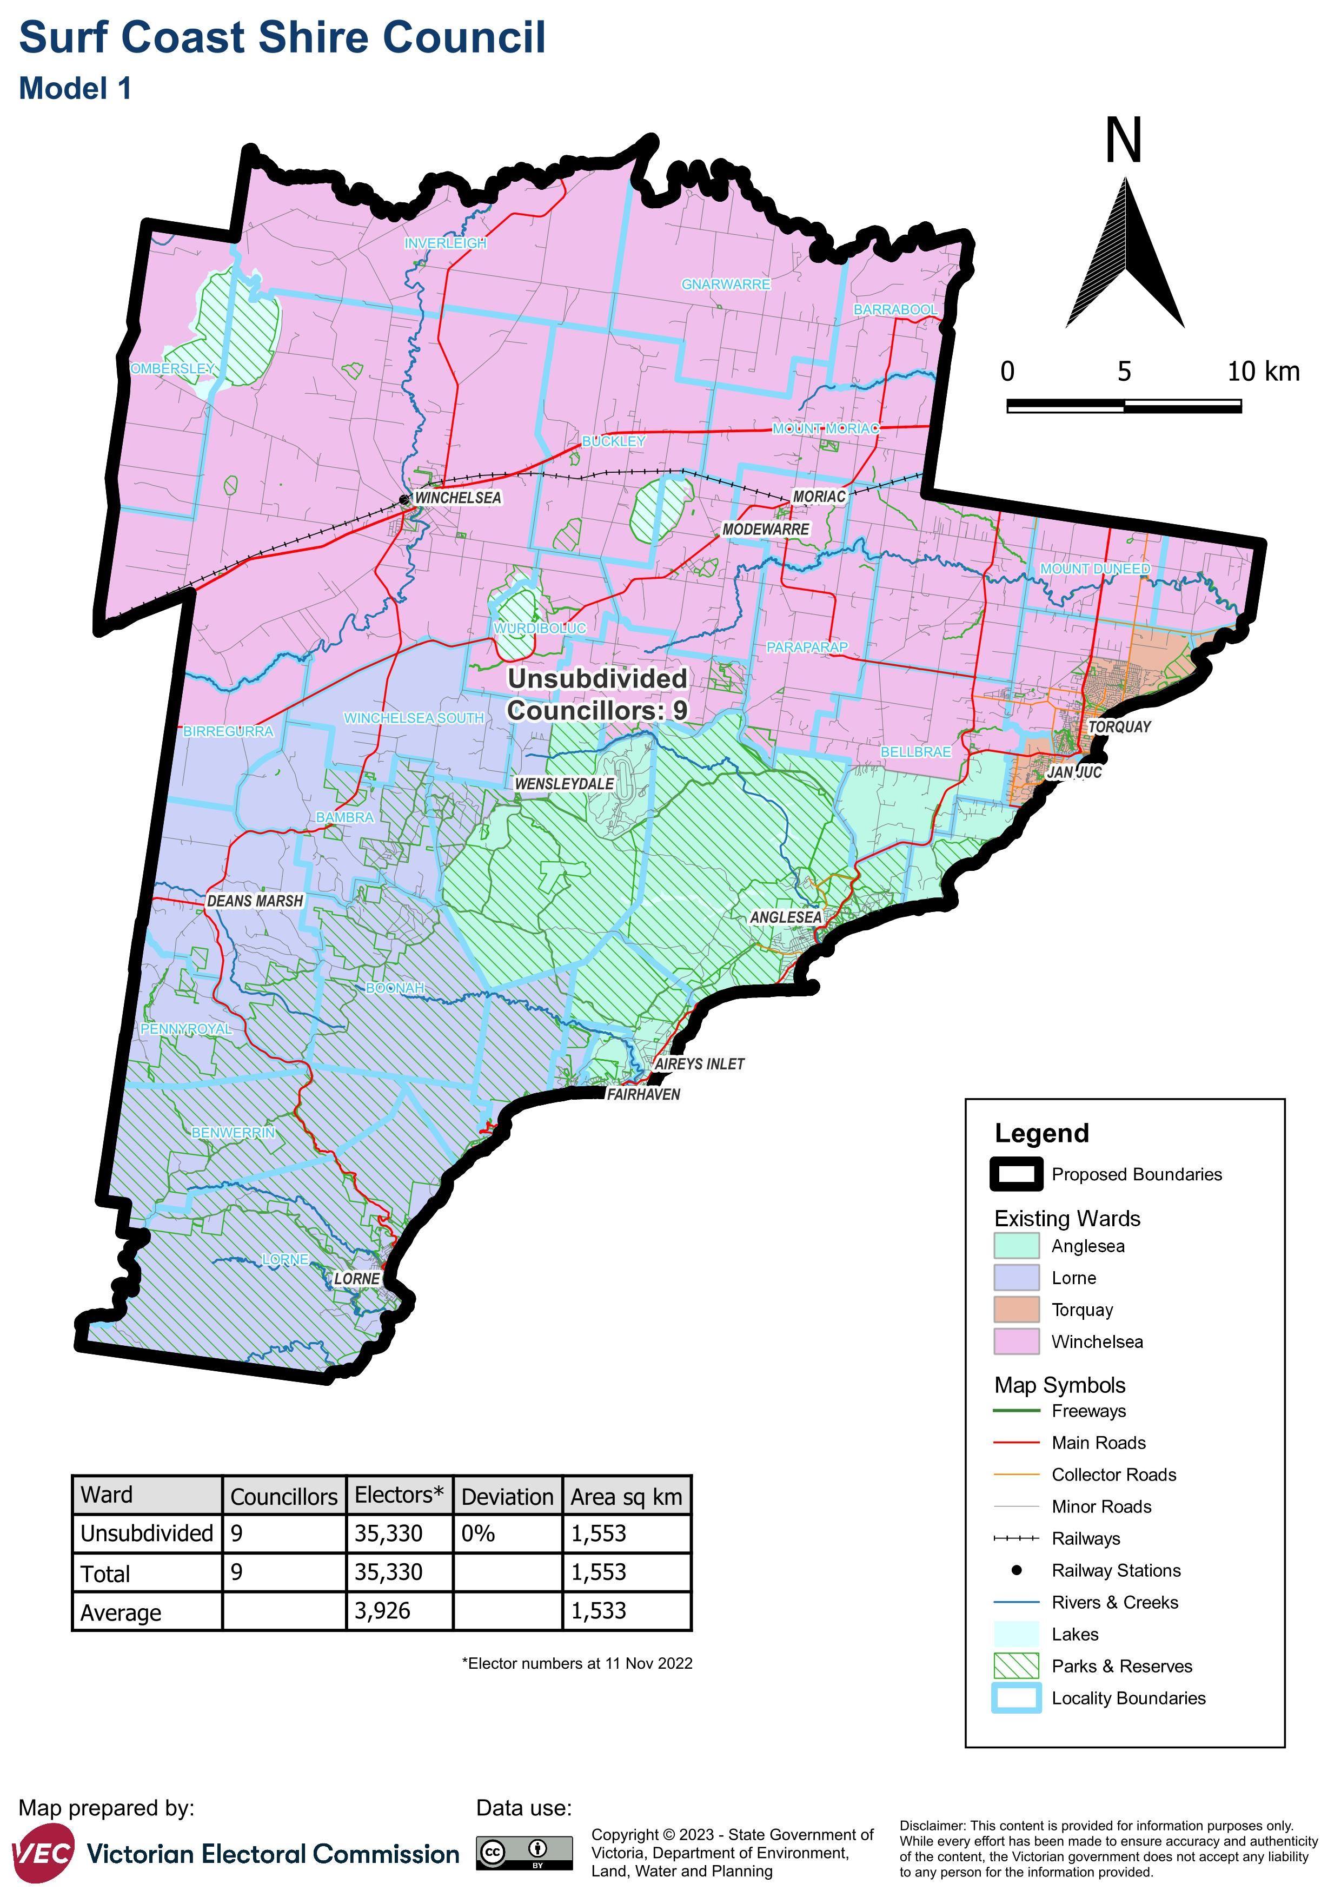

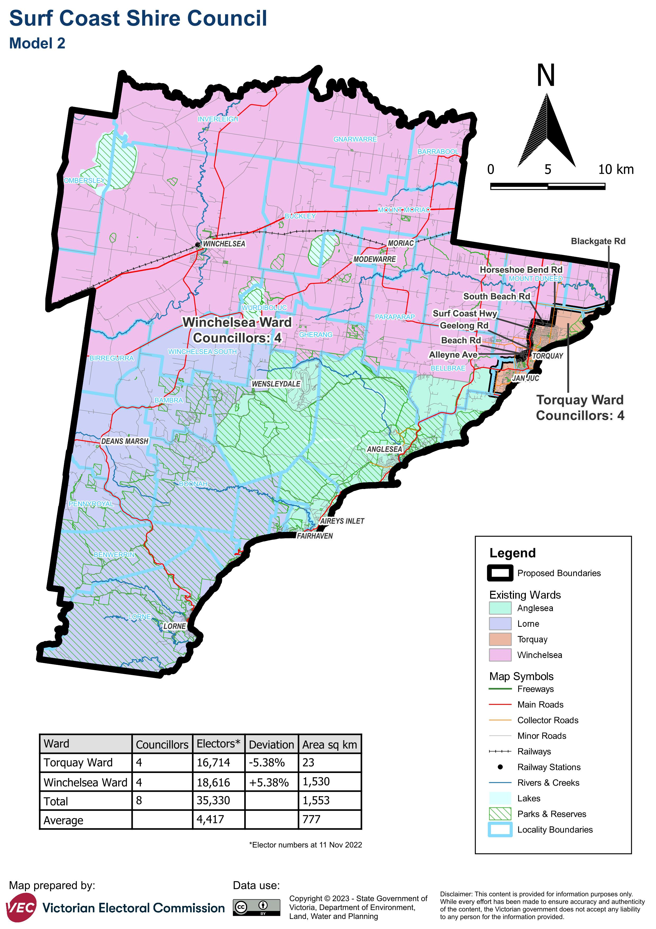

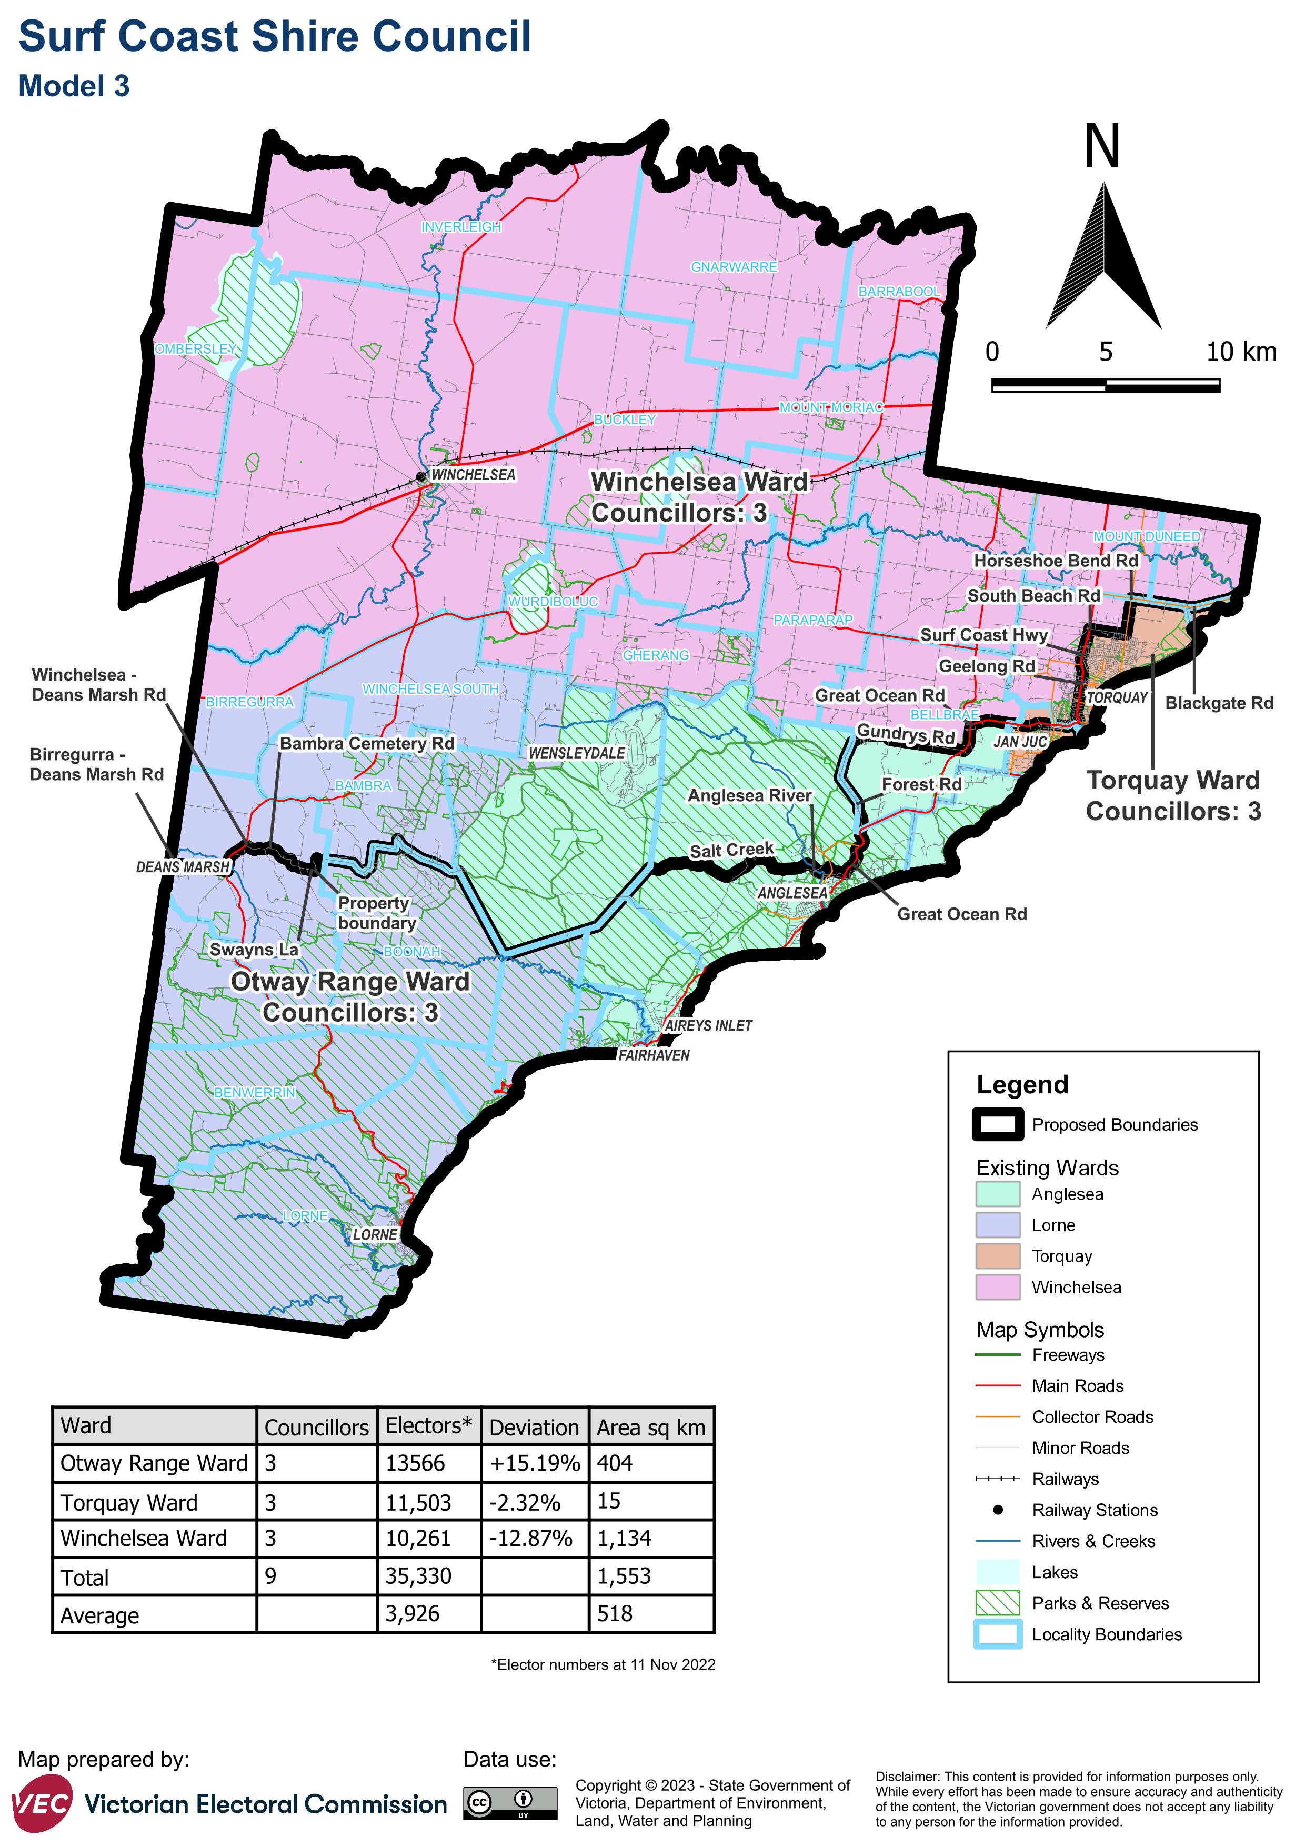

# Appendix 2: Additional models considered

The following models were closely considered by the panel but are not being put forward for further public consultation. See Models considered but not put forward for further information.

#### A single-councillor ward model with 9 councillors

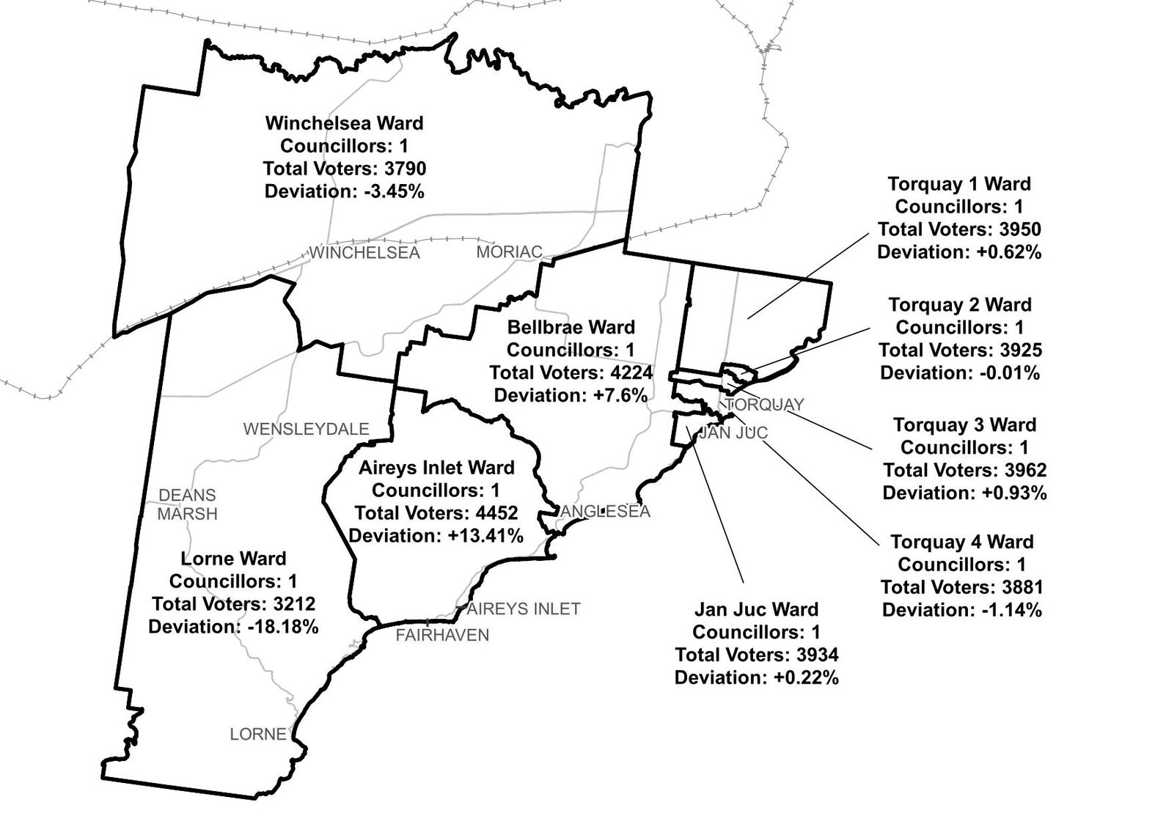

#### A multi-councillor ward model of 4 wards with 2 councillors each

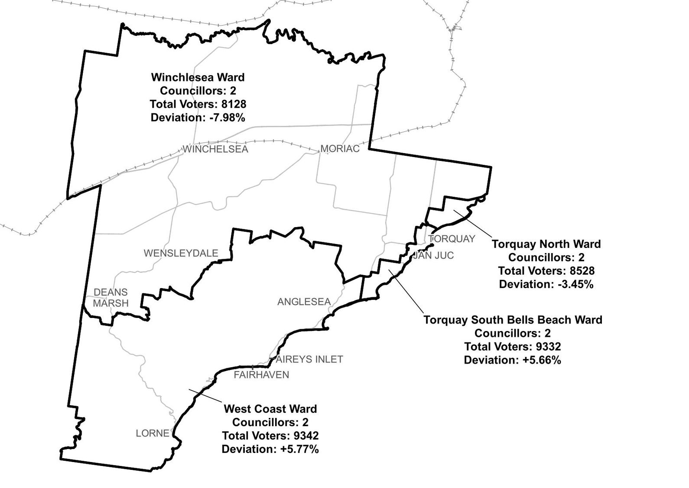

# Appendix 3: List of preliminary submitters

The review received 62 preliminary submissions.

Preliminary submissions were made by:

Agar, John

Aireys Inlet and District Association

Allen, Gary (Councillor)

Baldwin, Don

Barber, John

Bloomfield, Ellison

Bodsworth, Mike (Councillor)

Breen, Kevin

Burns, Angela

Butler, Jeanette

Cameron, Judy and Webb, Graeme

Clements, Helen

Cole, Susan

Collins, Michael

Committee for Lorne

Cope, Kim

Cotter, Mary

Davidson, Beth (OAM)

Einsiedel, Emma

Falk, James

Friends of Lorne

Gaffney, David

Gardener, Gisela

Goldsworthy, Clive (first submission)

Goldsworthy, Clive (second submission)

Greater Torquay Alliance Inc and 3228 Residents Association Inc

Hammond, Barbara

Hines, Mat

Hodge, Rose (Councillor)

Jarvis, Lisa

Jelbart, Meredith

Kennelly, Adrian

Laird, Andrew

Lamont, Gretel

Lawson, Heather

Lorne & District Men’s Shed

Lorne Community Connect Inc

MacDonald, Robert

Mathison, Jenny & Stewart

McDonald, Ken

Mitchell, Eathorne

Mitchell-Taverner, Amanda

Phelps, Anthony

Pitt, Karen

Positive Aging Advisory Committee

Rice, Heather

Robertson, Douglas

Rosson, Stuart

Ryan, Chris

Schonfelder, Adrian (Councillor)

Shaw, Simone

Smith, Margery and Trevor

Smith, Rodney

Stapleton, Elizabeth (Councillor)

Stribling, David

Tehan, Maureen

Tucker, Rod

Tutt, James

Walls, Allan

Wilson, Joh Cunningham

Wood, Liz

Youl, Eva Janice