Local council ward boundary review

February 2024

Loddon Shire Council

Preliminary   
Report



© State of Victoria   
(Victorian Electoral Commission)   
February 2024

This work, Local council ward boundary review – Preliminary report – Loddon Shire Council, is licensed under a Creative Commons Attribution 4.0 licence [<http://creativecommons.org/licenses/by/4.0/>]. You are free to share this work under that licence, on the condition that you do not change any content and you credit the State of Victoria (Victorian Electoral Commission) as author and comply with the other licence terms. The licence does not apply to any branding, including Government logos.



Level 11, 530 Collins Street

Melbourne Victoria 3000

T 131 832

info@vec.vic.gov.au

vec.vic.gov.au

**Content approval**

|  |  |  |
| --- | --- | --- |
| Version | Date approved | Approved by |
| 1 | 14 February 2024 | Executive chairperson |
| 1 | 14 February 2024 | Program sponsor |

**Release approval**

|  |  |  |  |
| --- | --- | --- | --- |
| Version | Date approved | Approved by | Brief description |
| 1 | 16 February 2024 | Program sponsor | Final proofread and confirmed for publication |

**Acknowledgement of Country**

The Victorian Electoral Commission (VEC) acknowledges the Dja Dja Wurrung and Yorta Yorta peoples as the Traditional Custodians of the lands and waters for which it is holding this review and pays respects to ancestors and Elders past, present and emerging. The VEC acknowledges their custodianship for many thousands of years and their continuing living culture.

Contents

Executive summary 5

Ward boundary model 5

Next steps 5

Background 6

About the 2024 ward boundary reviews 6

The ward boundary review panel 6

Public engagement 7

Considerations in developing models 7

About Loddon Shire Council 9

Profile 9

Current electoral structure 11

Last electoral structure review 12

Preliminary findings and model 13

Ward boundary model for public feedback 13

Next steps 14

Response submissions 14

Public hearing 15

Final report 15

References 16

Appendix 1: Model map 17

# Executive summary

Under section 17 of the *Local Government Act 2020* (Vic) (the Act), the Minister for Local Government has asked the Victorian Electoral Commission (VEC) to conduct ward boundary reviews for 10 local council areas prior to the next general local council elections in October 2024.

For these 10 councils, the number of voters per councillor is forecast to be out of balance by October 2024, with the number of voters per councillor in one or more wards forecast to vary from the average number of voters per councillor for all of the wards by more than 10 per cent.

Loddon Shire Council is one of the 10 local council areas under review. The purpose of this review is to correct this forecast imbalance for the October 2024 local council election.

In its review, the VEC is looking at:

* + the number of currently enrolled voters in each ward
  + the forecast number of enrolled voters at the next election
  + adjustments to the locations of existing ward boundaries.

At the end of the review, the VEC will recommend ward boundary changes to the minister, with the aim of all wards in Loddon Shire Council being within the legislated +/-10% tolerance at the time of the 2024 local council election.

This preliminary report presents proposed ward boundary adjustments for Loddon Shire Council.

More information about the background to the review is available on page 6.

## Ward boundary model

After considering research and the requirements of the Act, the VEC is presenting a single model for public consultation, outlining the proposed ward boundary changes to Loddon Shire Council.

Details on this model, including a map, are available in Appendix 1.

## Next steps

The VEC is now seeking feedback on its preliminary ward boundary model. You can make a response submission to the preliminary model until 5 pm on Wednesday 13 March 2024. If any submitters ask to speak at a public hearing, the VEC will hold this online on Tuesday 19 March 2024. Following the hearing, the VEC will present its final recommendation to the minister on Wednesday 17 April 2024.

More information about the review process is available on the VEC website at [vec.vic.gov.au](https://www.vec.vic.gov.au)

# Background

## About the 2024 ward boundary reviews

Under section 15(2) of the *Local Government Act 2020* (Vic), for a council that is divided into wards:

* 1. each ward should have an approximately equal number of voters per councillor; and
  2. the number of voters per councillor in a ward should not vary from the average number of voters per councillor for all of the wards by more than 10 per cent.

On 22 February 2023, the VEC provided advice to the Minister for Local Government on councils that were projected to have at least one ward with the number of voters per councillor outside this +/-10% range at the time of the October 2024 local council elections.

This advice was based on:

* current enrolment and enrolment trends
* future population projections
* legislated changes to council entitlements for council-enrolled voters.

On 20 April 2023, in response to this advice and under section 17 of the Act, the minister asked the VEC to conduct ward boundary reviews for 10 local council areas before the October 2024 local council elections. These reviews aim to balance the number of voters per councillor for the wards of these 10 councils in time for the 2024 elections.

Loddon Shire Council is one of the 10 local council areas under review.

In its review, the VEC is looking at:

* + the number of currently enrolled voters in each ward
  + the forecast number of enrolled voters at the next election
  + adjustments to the locations of existing ward boundaries.

A ward boundary review does not change a council’s electoral structure, number of councillors, or ward names. A ward boundary review also cannot change the external boundaries of a local council, divide local councils, or amalgamate local councils.

At the end of the review, the VEC will recommend ward boundary adjustments to the minister, with the aim of all wards in Loddon Shire Council being within the legislated +/-10% tolerance at the time of the 2024 local council election.

## The ward boundary review panel

Leading the VEC’s review is a ward boundary review panel, which has 2 members:

* the executive chairperson
* the program sponsor.

Administrative and technical support for the panel is provided by the VEC’s team of electoral structure and boundary review experts as well as specialists from across the VEC.

## Public engagement

### Public information program

The VEC is conducting a public information and awareness program about the Loddon Shire Council ward boundary review. This includes:

* + printed public notices in state-wide newspapers
  + public information sessions to outline the review process and respond to questions from the community
  + a media release to announce the start of the review
  + information on social media channels
  + website content on [vec.vic.gov.au](https://www.vec.vic.gov.au/), including:
    - current information on the review process
    - fact sheets for each council under review and a submission guide.

Loddon Shire Council was also offered but did not take up 2 optional methods to promote the reviews:

* + printed public notices in local newspapers
  + targeted social media advertisements for the council area

### Public consultation

The VEC now invites input to the ward boundary review of Loddon Shire Council via:

* + response submissions to this preliminary report
  + an online public hearing for anyone who makes a response submission and wishes to speak to the ward boundary review panel and expand on their submission.

Public submissions are an important part of the review process and the VEC will consider them alongside other factors during the review. These factors are outlined below.

## Considerations in developing models

The model in this preliminary report complies with the Act and was developed through careful consideration of:

* + research and analysis conducted by the VEC, including geospatial, electoral and demographic data
  + rates or patterns of population and voter change over time, and relevant forecasts of growth or decline based on forecast information provided by .id (informed decisions, a company specialising in demographics and forecasting).

When developing the preliminary model for Loddon Shire Council, the VEC considered:

* + whether the adjusted wards would comply with section 15(2) of the Act (see below), and how long they are likely to comply
  + whether meaningful and effective ward boundaries could be established and whether these would be easily identifiable to local communities
  + the representation of communities of interest
  + the voter distribution and physical features of the area, and the impact these may have on the shape and size of wards
  + the scale of ward boundary changes, aiming for minimal change (where possible).

In addition to the above, the VEC’s final recommendation will also consider matters raised in public response submissions.

Under section 15(2) of the Act, subdivided structures must aim for an approximately equal number of voters per councillor across all wards. This means the number of voters represented by each councillor in a ward should be within +/-10% of the average number of voters per councillor for all wards of that council.

During this review, the VEC aims to recommend ward boundary adjustments that help ensure a council’s wards comply with section 15(2) at the time of the 2024 local council elections and, if possible, also comply based on voter numbers at the time the review is conducted. The VEC uses forecasts of population and voter change to assess compliance at the 2024 elections with as much accuracy as possible.

In some cases, population change and other factors impacting voter numbers mean it is not possible to adjust the ward boundaries of a council so that both ‘current’ (at the time of the review) and ‘forecast’ (at October 2024) voter numbers are within the legislated +/-10% tolerance. Where this happens, the VEC prioritises compliance at the October 2024 elections to ensure each vote will have approximately equal value at the 2024 elections. In some cases, the VEC’s recommended model may set the current ward deviations outside the +/-10% tolerance. This is because the ward deviations are forecast to change over a short period of time and move within the +/-10% tolerance by the time of the 2024 local council elections.

One of the factors that may impact compliance with section 15(2) is the number of current and forecast voters with ratepayer-based voting entitlements, also known as council-enrolled electors. Voters’ rolls include both state-enrolled electors (the majority of the roll) and a smaller number of council-enrolled electors. The Act introduced changes to ratepayer-based entitlement categories, which come into full effect at the 2024 local council elections. The VEC will take this change to the makeup of voters’ rolls, and therefore compliance with section 15(2) of the Act, into consideration during this review.

# About Loddon Shire Council

## Profile

Loddon Shire Council is in north central Victoria, about 175 km from central Melbourne. Covering almost 6,700 km2 it is one of Victoria’s largest councils by area. With a population of 7,759 it is also one of Victoria’s least populated council areas (ABS 2022c). Loddon Shire Council is surrounded by Gannawarra Shire Council to the north, Campaspe Shire Council and Greater Bendigo City Council to the east, Mount Alexander and Central Goldfields shire councils to the south, and to the west, Northern Grampians and Buloke shire councils.

The Traditional Custodians of most of the land in the Loddon Shire Council are the Dja Dja Wurrung People. The Yorta Yorta People are the Traditional Custodians of a small area in the northeast on the fringe of Kow Swamp. There are no formally recognised Traditional Custodians for a northern portion of the council (VAHC 2023).

### Landscape

The council is located to the north of the Great Dividing Range. It sits within the Murray-Darling Basin and includes a section of the Riverine Plain of northern Victoria (AV 2020). The Loddon River is a major watercourse flowing northward through the centre of the council area and to its east the Bullock Creek follows a similar course. The Waranga Western Channel, a major irrigation carrier channel, cuts through the council flowing east from Kamrooka North to its northwest corner. The council contains remnants of forest and native grasslands, with the Terrick Terrick National Park of particular importance. Other state forests and parks stretch between Logan and Inglewood and are also located around Wedderburn and Tarnagulla.

Loddon Shire Council is predominantly rural, with large areas dedicated to farming. It has nearly 100 localities and many small centres serving the surrounding rural areas. The council has no dominant population centre and farming activities are supported by small townships, the main ones being Boort, Bridgewater on Loddon, Inglewood, Pyramid Hill and Wedderburn. Other important localities are Bridgewater, Dingee, Eddington, Korong Vale, Laanecoorie, Mitiamo, Newbridge, Serpentine and Tarnagulla. These small settlements provide important social services and are a residential and community focus within their respective districts (DTP 2023).

Agriculture accounts for about 84% of land use, which in the south is dominated by dryland cropping as well as grazing sheep and beef on modified pastures. More intensive land uses exist in the north, especially irrigated farming, and dairy farming which can be found in a north-south band between the Loddon River and Bullock Creek. In addition, areas of horticultural production exist around Terrappee and Serpentine. The council is a major national tomato producer (by volume) and a major national olive producer. It is also in the top 10 local government areas nationally by gross value for pig, poultry, sheep and lambs, and barley production (ABARES 2022; AV 2018; DAFF 2021).

Three major roads pass through the council, fanning out from Bendigo in the southeast. The Wimmera Highway runs in an east-west direction towards St Arnaud, the Calder Highway travels through Inglewood and Wedderburn in a northwest direction, and the Loddon Valley Highway travels directly north, following the path of the Loddon River.

Two railway lines run in a north-south direction through the council. One from Bendigo travels through Pyramid Hill. The other travels north to Inglewood, and splits at Korong Vale, west towards Charlton and also north through Boort. Rail is important for transporting agricultural commodities to Melbourne ports (DTP 2023).

### Community

Since 2001 the population has decreased by about 400 people (ABS 2001, ABS 2022c) and is forecast to continue to slowly decline.

Overall, about 5,000 people live in largely rural settings and residents typically have an affinity to and identify strongly with their localities. Small urban populations are in Boort (808 people), Inglewood (779), Pyramid Hill (475) and Wedderburn (650) (ABS 2022a, ABS 2022b, ABS 2022c, ABS 2022d, ABS 2022f). Proximity to Bendigo makes the south of the council an attractive lifestyle option and significant areas of rural residential living exist around Inglewood, Bridgewater, Wedderburn, and Newbridge (DPT 2023).

The median age in the council is 52, which is far higher than the median of 43 for regional Victoria. Like regional Victoria, the council has low levels of cultural diversity. Australia is the country of birth for just under 80% of people, similar to regional Victoria (81%). English is the only language used in 86% of households, the same as for regional Victoria. (ABS 2022c, ABS 2022e).

Close to 50% of adults are in the work force, which is low compared to over 57% for regional Victoria. The top 5 occupations are grain-sheep or grain-beef cattle farming, sheep farming, other grain growing, hospitals (except psychiatric hospitals), and dairy cattle farming. Personal, family and household median weekly incomes are $554, $1,394, and $1,039 respectively, well below the $713, $1,808, and $1,386 for regional Victoria (ABS 2022c, ABS 2022e).

At 95%, nearly all dwellings are separate houses, which is high even for regional Victoria (90%). The occupancy rate in private dwellings of about 78% is low, compared to 86% for regional Victoria. Family households account for about 64% of households, 4 percentage points below that of regional Victoria. Mortgage rates are low with just over 55% of houses owned outright, about 15 percentage points higher than for regional Victoria. Nearly 52% of families are couples without children, about 6 percentage points higher than regional Victoria. Whereas the percentage of couple families with children is low at 34% relative to regional Victoria at over 38%. The proportion of one parent families at 12.6% is also low compared to 16% for regional Victoria (ABS 2022c, ABS 2022e).

Loddon has localities that are amongst the most disadvantaged in Victoria. Korong Vale is Victoria’s second most disadvantaged, and of the more populated localities, Wedderburn, Pyramid Hill, and Inglewood all have scores on the SEIFA Index of 1, which is the lowest score (ABS 2023).

## Current electoral structure

Loddon Shire Council has a total of 5 councillors and is divided into 5 single-councillor wards (Boort, Inglewood, Tarnagulla, Terrick, and Wedderburn wards).

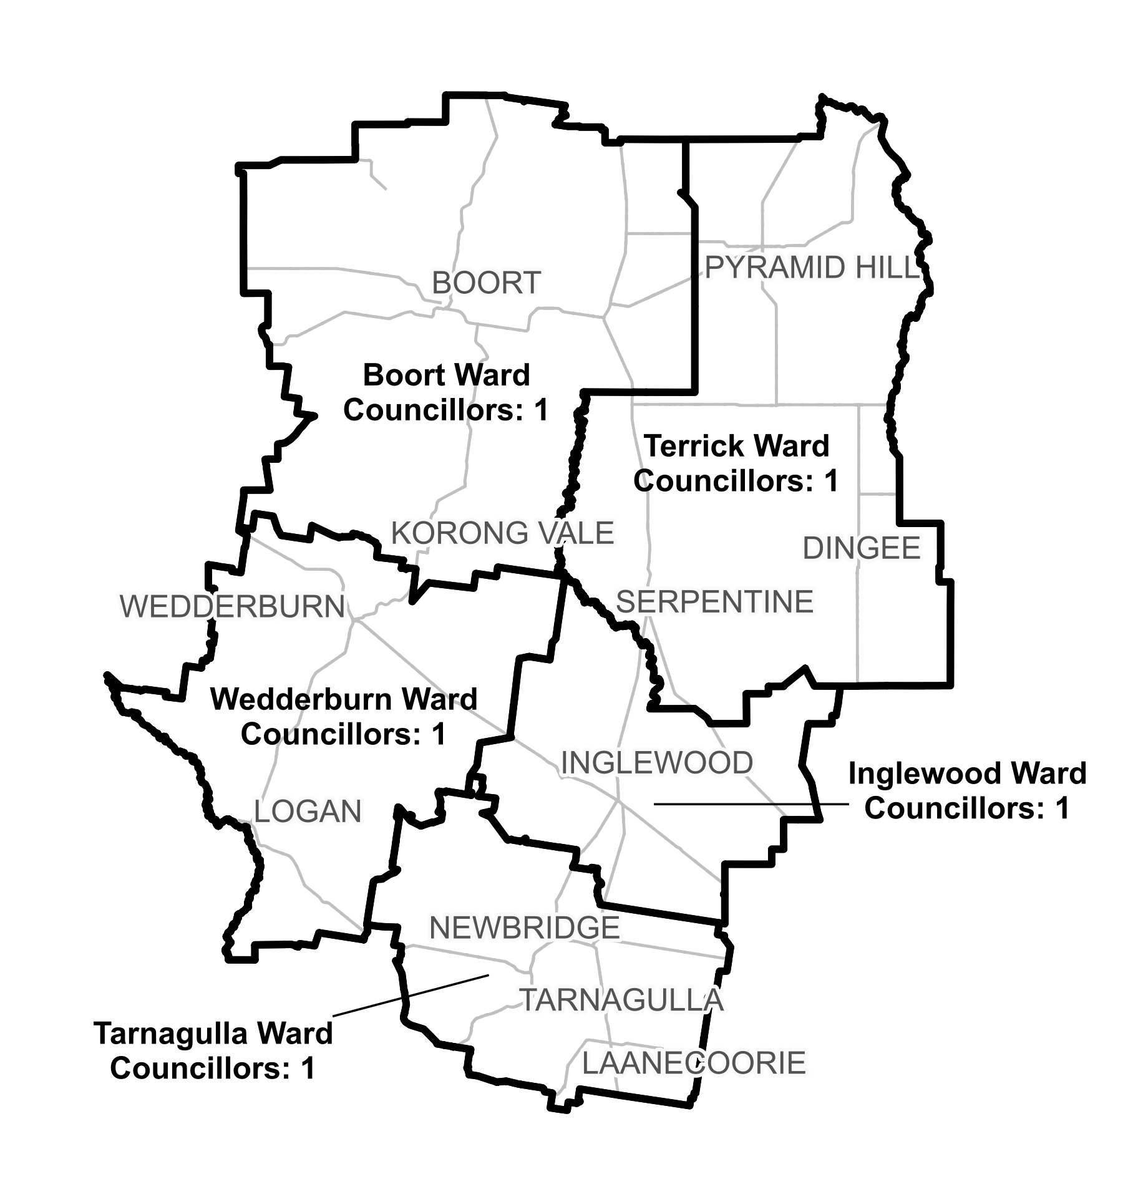

***Figure 1:*** *Diagram of current electoral structure of Loddon Shire Council.*

There are an estimated 6,978 voters in Loddon Shire Council, with an estimated ratio of 1,396 voters per councillor.

By October 2024, the voter-to-councillor ratio of Inglewood Ward is forecast to be outside of +10%, and the voter-to-councillor ratio of Tarnagulla Ward is forecast to be outside of -10%.

Visit the VEC website at [vec.vic.gov.au](https://www.vec.vic.gov.au/electoral-boundaries/local-councils/loddon-shire-council) for more information on Loddon Shire Council.

## Last electoral structure review

The VEC conducted an electoral representation review of Loddon Shire Council in 2011. That review was carried out under the *Local Government Act 1989* (Vic), which was replaced by the *Local Government Act 2020* (Vic).

After conducting the review, the VEC recommended that Loddon Shire Council adopt a structure of 5 councillors elected from 5 wards (5 single-councillor wards).

Visit the VEC website at [vec.vic.gov.au](https://www.vec.vic.gov.au/electoral-boundaries/local-councils/loddon-shire-council) to access a copy of the 2011 representation review final report.

# Preliminary findings and model

## Ward boundary model for public feedback

The VEC considered a range of ward boundary adjustments for Loddon Shire Council and chose the strongest model for public consultation.

The following model is presented for community consideration:

* Preliminary model, which proposes changes to the boundaries of Inglewood and Tarnagulla wards.

A map of the preliminary model is included in Appendix 1.

### Preliminary model

Forecast voter numbers indicate that the deviations of Inglewood and Tarnagulla wards are on track to be outside of the legislated +/-10% range at the 2024 local council elections. A minor adjustment will bring deviations into the required +/-10% range. To do this, the preliminary model reduces the size of the existing Inglewood Ward, transferring about 110 voters south into Tarnagulla Ward. No other boundaries are changed.

The proposed adjustments shift the boundary between Tarnagulla and Inglewood wards north, to run along minor roads and property and locality boundaries. In general, the boundary moves north from Yorkshire Road, Black Bridge Road and several other minor roads to bring areas south of Sloans Road and Duggans Road into Tarnagulla Ward. This results in most of Derby, Leichardt, and part of Inglewood and Bridgewater transferring to Tarnagulla Ward.

The panel felt this was an appropriate ward boundary adjustment for several reasons. As the council population is relatively stable, there was no reason for large or disruptive changes to the existing structure. Further, as the 2 wards forecast to be outside of the +/-10% deviation range at the 2024 elections are adjacent, it was possible to make a neat transfer of voters from one ward to another without making changes to other wards. The panel believed the proposed change would minimise impacts to communities of interest, and affected voters were likely to have connections with Inglewood and Tarnagulla wards.

The panel identified one potential drawback of the preliminary model. The adjusted ward boundary would run through the locality of Bridgewater, about 2 km to the south of Bridgewater on Loddon. This may result in some voters with connections to Bridgewater on Loddon and Inglewood being included in a different ward to those townships. However, many of these residents may travel outside of the council area to Bendigo for many goods and services, and this division may have minimal impacts for those voters.

By making these minor adjustments to the ward boundaries, the electoral structure is likely to be within the required +/-10% deviation range at the October 2024 election and is also likely to be within that range in 2028. The panel is interested to hear from the community whether there are other factors that could be considered or whether the structure is considered an appropriate modification for Loddon.

# Next steps

## Response submissions

Any person or group, including the local council under review, can make a response submission to the VEC. Your submission should address the model or models proposed in this preliminary report.

You can make a submission:

|  |  |
| --- | --- |
|  | **Online** Visit [vec.vic.gov.au](http://vec.vic.gov.au/) and make an account to use the online Public Submission Tool. You may save a draft submission to finish later. |
|  | **By email** [Loddon.WardReview@vec.vic.gov.au](mailto:Loddon.WardReview@vec.vic.gov.au) |
|  | **By post**  Ward boundary review panel Victorian Electoral Commission Level 11, 530 Collins St Melbourne VIC 3000 |

The panel must receive all response submissions before 5 pm on Wednesday 13 March 2024. If you post your submission, it must reach the VEC before the deadline. Late submissions will not be accepted.

### Required information

To be considered, your submission must include your:

* full name
* contact phone number or email address
* postal or residential address.

To protect the integrity and transparency of the review process, the VEC will not consider submissions without this information. If you are submitting as a group or organisation, you must include a nominated contact person authorised to submit on behalf of your group.

The VEC will handle information provided by submitters in accordance with its privacy policy at [vec.vic.gov.au/privacy](http://vec.vic.gov.au/privacy)

### Public access to submissions

To ensure transparency in the ward boundary review process, your submission will be published on the VEC website at [vec.vic.gov.au](http://www.vec.vic.gov.au/). The VEC will remove your signature and contact details, including residential and postal addresses, from all public copies but must publish your full name (or group name) and locality (suburb or town).

Please note that any submission content that is potentially defamatory, offensive, obscene or that includes the personal information of people or organisations who are not a party to the submission may also be redacted before publication.

## Public hearing

If you make a response submission, you can also ask to speak at an online public hearing to support your submission and expand on your views.

The online public hearing is scheduled for:

Time: 2 pm

Date: Tuesday 19 March 2024

The VEC encourages participation in the public hearing. If you wish to speak at the public hearing, you **must** indicate this in your response submission. The public hearing will not be held if there are no requests to speak.

Anyone can attend a public hearing, but you will only be able to speak if you expressly asked to speak in your response submission. If you ask to speak, the VEC will contact you to arrange a time for you to speak at the hearing. You will have 10 minutes to address the public hearing panel. The members of the public hearing panel may ask you questions.

Visit the VEC website at [vec.vic.gov.au](http://vec.vic.gov.au/) for more information on public hearings.

## Final report

Following the public hearing, the VEC will consider all evidence and prepare a final report for the Minister for Local Government containing recommended ward boundary adjustments for the local council.

The final report is scheduled to be provided to the minister on Wednesday 17 April 2024. The minister will consider the final reports, including any determination to make the reports publicly available. Any change to the ward boundaries of Loddon Shire Council following this review is expected to apply at the October 2024 local council elections. Under the Act, the final council electoral structure will be set by an Order in Council published in the Victoria Government Gazette.

# References

ABARES (Australian Bureau of Agricultural and Resource Economics and Sciences) (2022) [*Agricultural commodities 2020-21 by local government area*](https://public.tableau.com/app/profile/australian.bureau.of.agricultural.and.resource.economics.and.sci/viz/AgCensus_LGA_2020-21/StoryLGA), ABARES, accessed 21 December 2023.

ABS (Australian Bureau of Statistics) (2001) [*2001 Census All Persons QuickStats, Loddon (LGA)*](https://abs.gov.au/census/find-census-data/quickstats/2001/LGA23940), ABS, accessed 21 December 2023.

—(2022a) [*2021 Census All Persons QuickStats, Boort (L)*](https://abs.gov.au/census/find-census-data/quickstats/2021/UCL221008), ABS, accessed 20 December 2023.

—(2022b) [*2021 Census All Persons QuickStats, Inglewood (L)*](https://abs.gov.au/census/find-census-data/quickstats/2021/UCL221035), ABS, accessed 20 December 2023.

—(2022c) [*2021 Census All Persons QuickStats, Loddon (LGA)*](https://abs.gov.au/census/find-census-data/quickstats/2021/LGA23940), ABS, accessed 20 December 2023.

—(2022d) [*2021 Census All Persons QuickStats, Pyramid Hill (L)*](https://abs.gov.au/census/find-census-data/quickstats/2021/UCL222076), ABS, accessed 20 December 2023.

—(2022e) [*2021 Census All Persons QuickStats, Rest of Vic. (greater capital city statistical areas)*](https://www.abs.gov.au/census/find-census-data/quickstats/2021/2RVIC), ABS, accessed 20 December 2023.

—(2022f) [*2021 Census All Persons QuickStats, Wedderburn (L)*](https://abs.gov.au/census/find-census-data/quickstats/2021/UCL221079), ABS, accessed 20 December 2023.

—(2023) [*Socio-Economic Indexes for Areas (SEIFA), Australia, Suburbs and Localities, Indexes, SEIFA 2021*](https://www.abs.gov.au/statistics/people/people-and-communities/socio-economic-indexes-areas-seifa-australia/latest-release#data-downloads), ABS, accessed 22 December 2023.

AV (Agriculture Victoria) (2018) [*Interactive resource map*](https://invest.agriculture.vic.gov.au/#/map?lat=144.13561721849936&lon=-36.31876506946396&z=9.7565406642571&bm=bm3&l=mb1:y:100,ag01:y:100,mb0:y:57,fp3:n:100,mb2:n:100), AV, accessed 21 December 2023.

—(2020) [*Victorian Resources Online: Northern Riverine Plain (RP)*](https://vro.agriculture.vic.gov.au/dpi/vro/vrosite.nsf/pages/landform_geomorphological_framework_4), AV, accessed 16 January 2024.

DAFF (Department of Agriculture, Fisheries and Forestry) (2021*)* [*Catchment scale land use profile dashboard – local government areas*](https://www.agriculture.gov.au/abares/aclump/land-use/catchment-scale-land-use-profile-lga), DAFF, accessed 22 December 2023.

DTP (Department of Transport and Planning) (2023) [*Loddon planning scheme*](https://planning-schemes.app.planning.vic.gov.au/Loddon/ordinance?f.Scheme%7CplanningSchemeName=), DTP, accessed 19 December 2023.

Local Government Act 1989 (Vic)

Local Government Act 2020 (Vic)

Local Government (Electoral) Regulations 2020 (Vic)

VAHC (Victorian Aboriginal Heritage Council) (2021) [*Registered Aboriginal Parties in Victoria*](https://achris.vic.gov.au/weave/wca.html), Aboriginal Victoria, accessed 19 December 2023.

# Appendix 1: Model map

The following map is included in this report:

|  |  |
| --- | --- |
| Map | Page |
| Preliminary model – with proposed changes to the boundaries of Inglewood and Tarnagulla wards. | 18-19 |

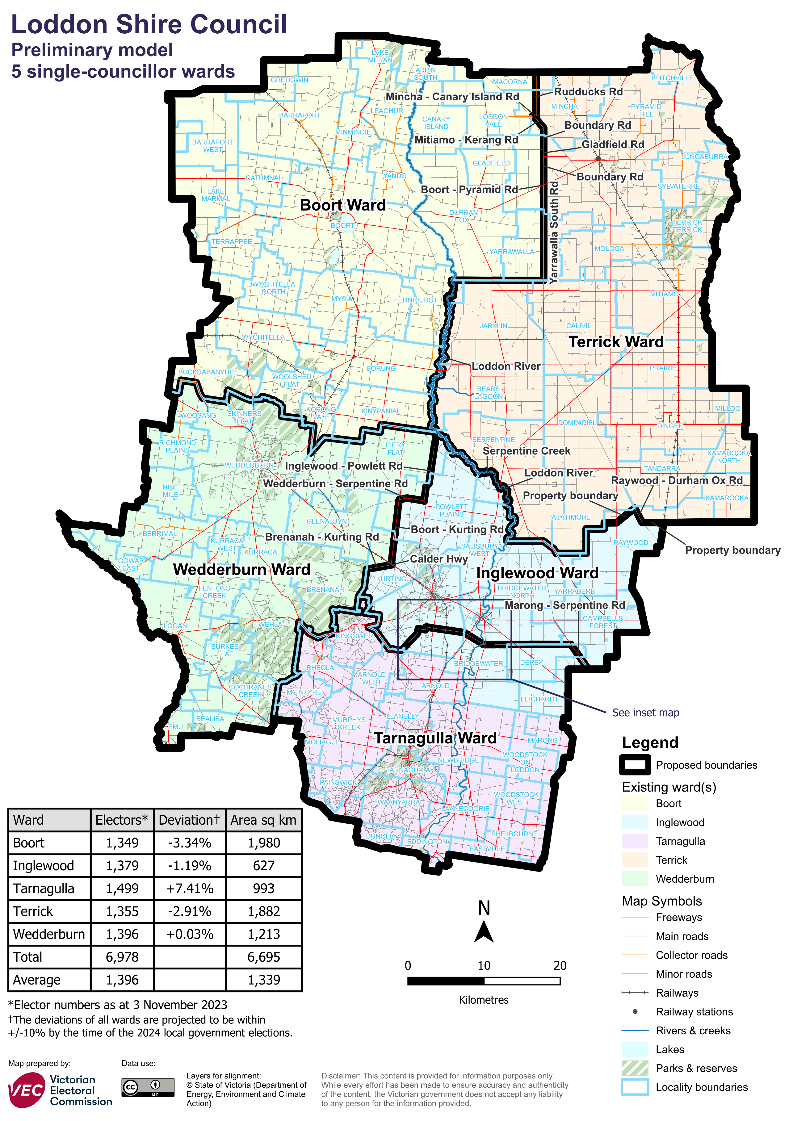

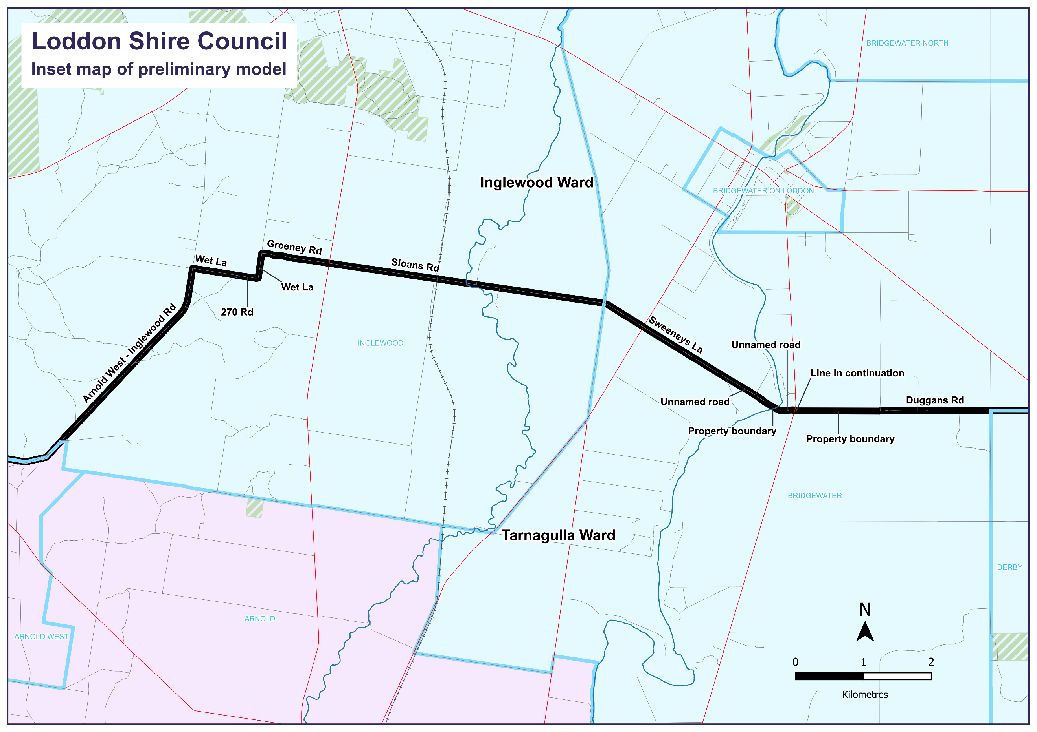

### Data for preliminary model

|  |  |  |  |
| --- | --- | --- | --- |
| Ward | Electors* | Deviation† | Area# (square km) |
| Boort Ward | 1,349 | -3.34% | 1,980 |
| Inglewood Ward | 1,490 | +6.76% | 627 |
| Tarnagulla Ward | 1,388 | -0.54% | 993 |
| Terrick Ward | 1,355 | -2.91% | 1,882 |
| Wedderburn Ward | 1,396 | +0.03% | 1,213 |
| **Total** | **6,978** | **n/a** | **6,695** |
| **Average** | **1,396** | **n/a** | **1,339** |

* Elector numbers at 3 November 2023

† The deviations of all wards are forecast to be within +/-10% by the time of the 2024 local council elections. The current deviation of some wards may be set outside +/-10% at the time of the review to offset forecast change between the review and the 2024 election.

# Ward area (square km) and total council area is measured at level of accuracy required for electoral boundaries. This may vary slightly from other data sources (for example, the ABS).

Forecast information referred to in the text of this report is based on forecasts prepared by .id – informed decisions [id.com.au](http://id.com.au). .id and its licensors are the sole and exclusive owners of all rights, title and interest subsisting in that part of the report content where .id are identified. Some of .id content is a derivative of ABS Data, which can be accessed from the website of the Australian Bureau of Statistics at [abs.gov.au](http://abs.gov.au), and licensed on terms published on the ABS website.

