Local council electoral structure review

March 2023

Yarriambiack Shire Council

Preliminary   
Report

Acknowledgement of Country

The electoral representation advisory panel acknowledges the Wotjobaluk, Jaadwa, Jadawadjali, Wergaia and Jupagulk people as the Traditional Custodians of the lands and waters on which it is holding this review and pays respects to ancestors and Elders past, present and emerging. The panel acknowledges their custodianship for many thousands of years and their continuing living culture.

Document history and version control

|  |  |  |  |
| --- | --- | --- | --- |
| **Version** | **Date approved** | **Approved by** | **Brief description** |
| 1 | 14 March 2023 | Electoral Commissioner | Final version |

# Contents

Contents 3

Executive summary 4

Developing electoral structure models 4

Preliminary submissions 4

Electoral structure models for public feedback 4

Next steps 4

Background 5

About the 2023–24 electoral structure reviews 5

The electoral representation advisory panel 5

Public engagement 6

Developing recommendations 6

About Yarriambiack Shire Council 9

Profile 9

Current number of councillors and electoral structure 10

Last electoral structure review 10

Preliminary submissions 11

Number of councillors 11

Electoral structure 12

Preliminary findings and models 14

Number of councillors 14

Electoral structure 15

Models for public feedback 19

Next steps 20

Response submissions 20

Public hearing 21

Final report 21

References 22

Appendix 1: Model maps 23

Appendix 2: Additional models considered 27

Appendix 3: List of preliminary submitters 28

# Executive summary

An independent electoral structure review panel appointed by the Minister for Local Government has reviewed the structure of Yarriambiack Shire Council.

The panel looked at:

* whether the council had an appropriate number of councillors
* whether it should be unsubdivided or subdivided.

This report outlines the preliminary models that the panel is presenting for the proposed new electoral structure of Yarriambiack Shire Council in order to meet the requirements of the *Local Government Act 2020*.

More information about the background to the reviews is available on page 5.

## Developing electoral structure models

The panel considered a range of factors when deciding on the models in this report, including:

* research and analysis
* voter growth or decline over time
* public submissions (see below).

More information on the way the panel decided on the models is available on page 6.

## Preliminary submissions

The panel received 5 preliminary submissions. Of these, 2 submissions included maps.

A full analysis of submissions received can be found on page 11.

## Electoral structure models for public feedback

After considering submissions and research, the panel is presenting the following electoral structure models for further public consultation:

Model 1: an unsubdivided electoral structure with 7 councillors

Model 2: a subdivided electoral structure with 6 councillors, 3 wards and 2 councillors per ward

Model 3: a subdivided electoral structure with 7 councillors, 7 wards and one councillor per ward.

Details on these models, including maps, are available in Appendix 1.

## Next steps

The panel is now seeking feedback on the electoral structure models. You can make a response submission to these models until Wednesday 5 April 2023. If any response submitters wish to speak at a public hearing, the panel will hold an online public hearing on Thursday 13 April 2023. Following this, it will present its final recommendation to the Minister by Wednesday 10 May 2023. More information about the review process is available on the Victorian Electoral Commission (VEC) website at [vec.vic.gov.au](https://www.vec.vic.gov.au/electoral-boundaries/council-reviews).

# Background

## About the 2023–24 electoral structure reviews

In October 2022, the Minister for Local Government formed 2 electoral representation advisory panels to review the electoral structures of 39 local councils, under section 16 of the *Local Government Act 2020* (the Act). If the Minister accepts the electoral structures the panels recommend, they will take effect at the October 2024 elections.

The Act introduced several changes to local government representation, including the types of electoral structures local councils may have. Large and small rural shire councils (including Yarriambiack Shire Council) can have one of 3 electoral structures:

* + unsubdivided (entire council area with no wards)
  + single-councillor wards
  + multi-councillor wards with the same number of councillors per ward.

For Yarriambiack Shire Council, the electoral representation advisory panel is examining:

* the number of councillors
* whether the council should be subdivided into wards or unsubdivided.

For subdivided structures, it is also examining:

* + the number of wards
  + where the ward boundaries should be
  + the name of each ward
  + how many councillors should be elected for each ward.

The Act requires electoral structures to provide fair and equitable representation and facilitate good governance. For subdivided structures, each ward must have an approximately equal number of voters per councillor (within +/-10% of the average).

## The electoral representation advisory panel

The panel conducting the electoral structure review of Yarriambiack Shire Council has   
3 members:

* Ms Julie Eisenbise (Chairperson)
* Mr Tim Presnell
* Deputy Electoral Commissioner Ms Dana Fleming (Electoral Commissioner delegate).

The panel is independent of councils and the State government.

Under the Act, the VEC is not responsible for reviewing council electoral structures but must provide administrative and technical support to the panel. The Electoral Commissioner (or their delegate) must be a member of each panel.

## Public engagement

### Public information program

To educate and inform the public about the Yarriambiack Shire Council electoral structure review, the VEC began a public information program in mid-December 2022. The VEC:

* + printed public notices in state-wide, and some local, newspapers
  + held public information sessions to outline the review process and respond to questions from the community
  + sent out media releases to announce the start of the review
  + published information on its social media channels
  + ran social media advertisements targeted to the council area
  + notified voters in the council area who are subscribed to the VEC’s [VoterAlert](https://vec.vic.gov.au/voteralert) service of the start of the review
  + provided updated website content on [vec.vic.gov.au](https://vec.vic.gov.au/yarriambiack), including:
    - information on the review process
    - submission guides and fact sheets for each council under review with background information
    - preliminary submissions from the public.

The VEC will continue to promote the review during the response submissions stage via media releases, the VEC’s social media channels and updated content on the VEC website.

### Public consultation

The panel encouraged public input to the review of Yarriambiack Shire Council via preliminary submissions at the start of the review. The panel now invites further input via:

* + response submissions to this preliminary report
  + an online public hearing to provide anyone who makes a response submission the opportunity to expand on their submission.

Public submissions are an important part of the review process but the panel also considers other factors during a review. These are outlined below.

## Developing recommendations

The panel’s electoral structure models presented in this preliminary report comply with the Act and were developed through careful consideration of:

* + research and analysis conducted by the VEC support team, including geospatial and demographic factors
  + rates or patterns of population and voter growth or decline over time, and relevant forecasts of growth or decline based on forecast information provided by .id (informed decisions, a company specialising in demographics and forecasting)
  + input received from the public in written submissions during the preliminary submissions phase.

### Deciding on the number of councillors

The Act allows local councils to have between 5 and 12 councillors, but neither the Act nor the Local Government (Electoral) Regulations 2020 specify how to determine the number of councillors a council needs. Therefore, the models put forward by the panel in this report are guided by the Act’s intention for fairness and equity in voter representation.

In examining the number of councillors Yarriambiack Shire Council should have, the panel considered these factors:

* + the population and number of voters in the council area, compared to other councils with a similar population size and number of voters in the same category (for example, metropolitan, interface, regional city, large rural shire, small rural shire)
  + patterns of population change and voter growth or decline in the council area over time
  + current and past numbers of councillors
  + the representation needs of the communities of interest in the council area
  + if a particular type of electoral structure best suits the council (see ‘Deciding the electoral structure’ below)
  + any matter raised in public submissions not already listed above.

Generally, local councils with a larger number of voters will have a higher number of councillors. Large populations are often more likely to have greater diversity, both in the type and number of communities of interest and issues relating to representation. However, the ideal number of councillors can also be influenced by the particular circumstances of a council, such as the:

* + nature and complexity of services the council provides
  + geographic size and topography of the area
  + forecast population and voter growth or decline
  + social diversity.

### Deciding the electoral structure

The electoral structure of large and small rural shire councils can be:

* + unsubdivided (entire council area with no wards)
  + made up of single-councillor wards

or

* + made up of multi-councillor wards with the same number of councillors per ward.

When developing electoral structure models for Yarriambiack Shire Council, the panel considered these main criteria:

* + whether the structure would comply with section 15(2) of the Act (see below), and for how long it would likely comply
  + the appropriate number of councillors, as outlined above
  + whether meaningful and effective ward boundaries can be established and whether these would be easily identifiable to local communities
  + representation of communities of interest
  + the voter distribution and physical features of the area, and the impact these may have on the shape and size of any wards
  + past elections for the council, including:
    - numbers of candidates nominating
    - incidences of uncontested elections
    - rates of informal voting.
  + other matters raised in public submissions not already listed above.

Under section 15(2) of the Act, subdivided structures must aim for an approximately equal number of voters per councillor in each ward. This means the number of voters represented by each councillor in a ward should be within +/-10% of the average number of voters per councillor for all wards.

The panel recommends structures that will comply with section 15(2) at the October 2024 local government elections and uses current voter numbers and forecasts of population and voter change to assess this with as much accuracy as possible. In some cases, population changes and other factors mean it is not possible for a subdivided electoral structure to comply with section 15(2) based on current voter numbers. If this occurs, compliance at the 2024 local government elections will be the priority to ensure each vote has approximately equal value.

# About Yarriambiack Shire Council

## Profile

Yarriambiack Shire Council is in north-western Victoria, 300 km north-west of Melbourne. The shire is between the Wimmera River and the Grampians mountain range and covers an area of 7,326 km2. It shares its borders with Mildura Rural City Council to the north, Buloke Shire Council to the east, Northern Grampians and Horsham Shire Councils to the south and Hindmarsh Shire Council to the west.

The Traditional Custodians of the Yarriambiack area are the Wotjobaluk, Jaadwa, Jadawadjali, Wergaia and Jupagulk peoples.

### Landscape

Located in the Wimmera Southern Mallee region of Victoria, Yarriambiack Shire Council is home to significant areas of mallee parks and mallee ecosystems in Australia as well as some of the largest areas of semi-arid wilderness. Wyperfeld National Park, Paradise Flora and Fauna Reserve, Outlet Creek, Wathe Flora and Fauna Reserve and Albacutya Reserve are areas of cultural, historical and conservation value (Department of Transport and Planning, 2021).

At the 2021 Census, the shire’s population was 6,556. Almost two-thirds of the population live in 5 of the shire’s main urban centres – Warracknabeal, Murtoa, Hopetoun, Minyip, and Rupanyup.

Warracknabeal (population 2,227) (ABS, 2021e) is home to 34% of the shire’s population. It is the major service and commercial centre, supporting the shire’s grain and agricultural industries.

Murtoa, the shire’s second largest town (population 780) (ABS, 2021c), is a major hub for grain handling and home to Victoria’s largest inland grain storage point (Yarriambiack Shire Council, 2023a). Hopetoun (population 509) (ABS, 2021a) is a town servicing the north of the shire and is known for its landscape of rolling sand hills and grassy plains. Located in the south of the shire, Minyip (429) (ABS, 2021b) and Rupanyup (353) (ABS, 2021d) make up the remaining urban populations.

There are 4 major highways (Borung, Henty, Sunraysia and Wimmera) connecting major towns in the shire and service centres in other councils. Yarriambiack also has a freight rail network servicing agricultural and grain transport industries.

### Community

The shire is known as the heartland of grain production and handling for the Mallee and Wimmera regions (Yarriambiack Shire Council, 2023a). Agriculture is the main industry and employs almost half of the population’s workforce. The shire produces around one quarter of Victoria’s wheat and barley (Yarriambiack Shire Council, 2023a).

Over the last 20 years, the shire’s population declined from 7,739 in 2001 (ABS, 2001) to 6,556 in 2021 (ABS, 2021f). This trend is expected to continue with an estimated annual growth rate of -0.3% and a decrease of more than 1000 residents by 2036 (Department of Transport and Planning, 2021).

The profile of the shire is somewhat older than the overall state and regional populations, with around 53% aged 50 or older. The median age is 52, higher than the regional Victorian median of 43 (ABS, 2021f).

Almost 85% of the shire are born in Australia and 1.7% identify as Aboriginal or Torres Strait Islander (ABS, 2021f).English is the most common language spoken with 89.7% speaking only English at home (ABS, 2021f).

Most of the shire own their home either outright or with a mortgage (70%), and the median weekly household income is $1,102 (ABS, 2021f).

## Current number of councillors and electoral structure

Yarriambiack Shire Council is currently divided into 3 wards with a total of 7 councillors:

* + one ward with 3 councillors (Warracknabeal)
  + 2 wards with 2 councillors each (Dunmunkle and Hopetoun).

There are approximately 5,594 voters in Yarriambiack, with a ratio of 799 voters per councillor.

Visit the VEC for [more information on Yarriambiack Shire Council](https://www.vec.vic.gov.au/electoral-boundaries/local-councils/yarriambiack-shire-council).

## Last electoral structure review

The VEC conducted an electoral representation review of Yarriambiack Shire Council in 2015. This review was carried out under the *Local Government Act 1989*, which was replaced by the *Local Government Act 2020*.

After conducting the review, the VEC recommended that Yarriambiack Shire Council continue to consist of 7 councillors elected from 3 wards (2 wards with 2 councillors and 1 ward with 3 councillors).

Visit the [Yarriambiack Shire Council profile](https://www.vec.vic.gov.au/electoral-boundaries/local-councils/yarriambiack-shire-council) [on the VEC website](https://www.vec.vic.gov.au/electoral-boundaries/local-councils/yarriambiack-shire-council) to access a copy of the 2015 representation review final report.

Before the 2015 review, a representation review of Yarriambiack Shire Council was completed in 2005 and resulted in the current electoral structure being implemented.

Before the 2005 representation review, Yarriambiack Shire Council comprised of 5 wards with a total of 9 councillors:

* + 3 wards with one councillor each
  + 2 wards with 3 councillors each.

# Preliminary submissions

The panel received 5 preliminary submissions from the public by the deadline of 5 pm on Wednesday 15 February 2023. You can view these submissions on the VEC website at [vec.vic.gov.au/yarriambiack](https://www.vec.vic.gov.au/electoral-boundaries/council-reviews/electoral-structure-reviews/yarriambiack) and find a list of people or organisations who made a submission in Appendix 3.

The table below provides an overview of preferences in the preliminary submissions. You can read an analysis of submissions below this table.

|  |  |  |  |  |  |
| --- | --- | --- | --- | --- | --- |
|  | Unsubdivided structure | Single-councillor wards | Multi-councillor wards | Subdivided structure (unspecified) | No comment on structure |
| Decreased number of councillors | - | - | 1 | - | - |
| Maintain current councillor number | 1 | - | 1 | - | - |
| Increased number of councillors | - | 1 | - | - | - |
| No comment on number of councillors | - | - | 1 | 2 | - |

Note: 2 submitters supported more than one electoral structure/option for the total number of councillors

## Number of councillors

Most submissions **wanted to keep the current number of councillors.**

### Maintaining 7 councillors

Yarriambiack Shire Council stated 7 councillors were needed to provide proactive representation across all areas of the shire. It outlined the negative impacts of reducing councillor numbers, including an increase to councillor workloads, which it suggested would deter people from nominating as candidates in the future.

Diane Connolly identified the value of the current electoral structure and suggested any changes to the number of councillors would have a negative impact.

### Reducing to 6 councillors

Jo Burke suggested 6 councillors would better suit the shire’s different communities of interest and represent the geographic diversity of the area.

## Electoral structure

A common theme throughout submissions was the need for a subdivided electoral structure, which most argued would best support the diversity of the shire.

Some submissions offered alternative models if their preference for a subdivided structure was not achievable.

### Unsubdivided

Yarriambiack Shire Council acknowledged the challenges of complying with the new requirements of a subdivided ward structure, especially given the uneven distribution of the population. It pointed out that the population of Warracknabeal presented major difficulties to maintaining a subdivided ward structure. As such, it suggested an unsubdivided structure with 7 councillors as an alternative model if wards were not possible.

Vicki South suggested an unsubdivided structure could negatively impact smaller communities. This structure could result in most or all councillors coming from towns with larger voter populations, leaving smaller communities and rural areas underrepresented.

South also identified that in an unsubdivided structure councillors would need to travel long distances to connect with voters and communities.

### Multi-councillor wards

Jo Bourke stated a preference for a subdivided multi-councillor structure with 3 wards and 2 councillors per ward as better suited to representing the range of communities of interest of the shire and their varying needs. Bourke also highlighted the fact that both upper and lower house state electoral boundaries cut across parts of the shire and that at a council level, these divisions should be reflected through the ward structure.

Vicki South reasoned that retention of the current multi-councillor ward structure with a similar number of councillors best served the large area of the shire and its diverse rural area. Noting the size of the shire, including sparsely populated rural areas, South argued that all areas of the shire would not be served well by the majority of councillors who, in an unsubdivided electoral structure, may live a great distance from small communities.

Carmel Healy also commented on the size of the shire and travel times and suggested geographic differences, availability of services and population would be best represented in a multi-councillor structure.

Diane Connolly similarly supported the current structure, and highlighted the representation needs of those residing in small towns and villages, and the potential for larger towns to dominate.

Yarriambiack Shire Council supported a ward structure, pointing out that retaining wards provided the best outcome for the shire and its services and would better meet the needs of the shire’s various communities. It outlined the importance of ‘representation from across the shire’ to ‘ensure the diverse landscape, interests, and issues are expressed and represented at a local level’.

### Single-councillor wards

Vicki South expressed an alternative preference for single-councillor wards noting the need to ensure there are sufficient councillors to support the shire’s communities.

Diane Connolly did not support such a structure, noting it may lead to loss of representation for smaller towns and communities.

# Preliminary findings and models

## Number of councillors

After taking into consideration the requirements of the Act, public submissions and the agreed criteria, the panel found either 6 or 7 councillors to be an appropriate number for Yarriambiack Shire Council.

The panel considered the characteristics of the shire in relation to similar rural shire councils, including its size and geography, population and the number and distribution of voters across the shire.

|  |  |  |  |  |  |  |
| --- | --- | --- | --- | --- | --- | --- |
| Similar rural shire councils to Yarriambiack Shire Council | | | | | | |
| Local council | Area (km2) | Number of voters at 2020 election | Population (2021 Census) | Current total estimate of voters | Number of councillors | Number of voters per councillor |
| Gannawarra Shire* | 3,738 | 9,129 | 10,683 | 9,449 | 7 | 1,350 |
| Ararat Rural City | 4,211 | 8,955 | 11,880 | 9,002 | 7 | 1,286 |
| Pyrenees Shire | 3,435 | 7,063 | 7,671 | 7,233 | 5 | 1,447 |
| Loddon Shire | 6,696 | 7,072 | 7,759 | 7,146 | 5 | 1,429 |
| **Yarriambiack Shire\*** | **7,326** | **5,703** | **6,556** | **5,594** | **7** | **799** |
| Towong Shire | 6,675 | 5,264 | 6,223 | 5,305 | 5 | 1,061 |
| Buloke Shire* | 7,998 | 5,404 | 6,178 | 5,249 | 7 | 750 |
| Hindmarsh Shire | 7,524 | 4,695 | 5,698 | 4,673 | 6 | 779 |
| Queenscliffe Borough | 9 | 4,143 | 3,276 | 4,337 | 5 | 867 |

*This local council is undergoing an electoral structure review during 2023–24.

### Maintaining 7 councillors

The shire has similar features and special circumstances to other rural shires with 7 councillors. Neighbouring Buloke Shire also has 7 councillors and is similar in terms of its area, population, voter numbers and voters per councillor. It also shares many of the same special circumstances as Yarriambiack Shire, which previous representation reviews have found justified 7 as an appropriate number of councillors.

The panel agreed that retaining 7 councillors was advantageous due to the geographic size of the shire and distances councillors would be required to travel. Most submissions also supported keeping the current number of councillors.

### Reducing to 6 councillors

Although recognising the limited support to change the current number of councillors, the panel proposed reducing councillor numbers to 6. This would only be possible if a suitable subdivided electoral structure could be identified and presented to the public.

An even number of councillors was not viewed as problematic for the operation of the council, as an even number of councillors would likely be needed to create multi-councillor ward structures for other councils under the new legislative requirements.

The shire’s voter-to-councillor ratio compared with other rural councils was also considered by the panel and it agreed such a reduction could be justified. Hindmarsh Shire Council operates with 6 councillors and has a voter-to-councillor ratio of 779. Towong Shire Council operates with 5 councillors and has a voter-to-councillor ratio of 1,061.

### Reducing to 5 councillors

Given the voter-to-councillor ratio and various needs of the shire’s population, reducing the number of councillors to 5 was not supported. The 5-councillor electoral structure were not found to provide better representation of communities than the 6 and 7 councillor models. Additionally, no public submissions supported such a reduction in councillor numbers.

**Increasing councillors**

The population of Yarriambiack and the estimated rate of decline per year (-0.3%) compared to other rural councils were considered by the panel. It viewed an increase in councillor numbers was not necessary based on an already low voter-to-councillor ratio of 799, which would further decrease to 699 with 8 councillors.

## Electoral structure

To identify the most appropriate electoral structure, various factors were considered. This included the requirements of the Act, the communities of interest in Yarriambiack Shire Council, public submissions, the appropriateness of ward boundaries and which models best offered fair and equitable representation.

In developing the preliminary models presented in this report, a range of models were considered. The strongest 3 models have been put forward for further public comment.

The panel proposes 3 models for the consideration of the Yarriambiack Shire community:

* an unsubdivided electoral structure (Model 1)
* a subdivided electoral structure of 3 wards, with 2 councillors per ward (Model 2)
* a subdivided electoral structure of 7 wards with 1 councillor per ward (Model 3).

Diagrams of the preliminary models are included in Appendix 1.

### Unsubdivided structure (Model 1)

Under this model, Yarriambiack Shire Council would adopt an unsubdivided electoral structure, represented by 7 councillors.

Reflecting on the feedback in public submissions, the suitability of an unsubdivided structure was considered by the panel. While there was little support for this structure in public submissions, Yarriambiack Shire Council identified that this structure would enable 7 councillors to be maintained. The council thought that if a subdivided electoral structure was not possible, then keeping 7 councillors in an unsubdivided structure would be a reasonable compromise.

The desire for local representation in public submissions was acknowledged by the panel but it felt that such representation would not necessarily be compromised or reduced in an unsubdivided electoral structure. At past elections there has been a varied spread of elected candidates from across the whole shire, not just from the most populous town (Warracknabeal). This indicates interest in standing as a candidate from most parts of the shire. As such, it was not viewed that an unsubdivided structure would reduce local representation and that voters across all areas of the shire would have a reasonable chance and choice to elect a candidate to represent them.

The positive aspects of an unsubdivided structure were considered, most notably no artificial division of towns and communities. No ward boundaries also means no need for future ward boundary changes to balance population change across wards.

A potential drawback to an unsubdivided structure was the long and narrow shape of the shire. The distance between Tempy in the north and Lubeck in the south is over 150 km straight-line distance (the shortest distance between 2 points). Thought was given to travel needs and the ability of councillors to connect with all the shire’s communities, including those spread across large areas. However, because of the reasonable spread of candidates and councillors from across most areas of the shire and the location of council services in many of the towns, the large expanse of the shire was not considered a major drawback for an unsubdivided model.

On balance, Model 1:

* + enables the existing number of councillors to be maintained
  + is a viable model with good longevity, as there is no need to balance voter numbers or future population changes across wards
  + does not create arbitrary boundaries that could combine or divide towns and communities unnecessarily.

### Multi-councillor ward structure (Model 2)

Under this model, Yarriambiack Shire Council would maintain its current 3-ward structure. Each ward would be represented by 2 councillors, in line with the requirement of the *Local Government Act 2020* (Vic) for there to be the same number of councillors per ward.

It was observed by the panel that submitters expressed a clear preference for a subdivided ward structure. The panel noted the shire’s current structure did not comply with the Act.

When modelling electoral structures, the VEC attempted to maintain the existing ward boundaries by reducing the Warracknabeal ward from 3 councillors to 2. However, this was not viable as the resulting ward deviations for the Warracknabeal ward were well outside the permitted +/- 10% tolerance.

Consideration was given to the strength of the ward boundaries proposed by this model. Warracknabeal and surrounds are established as an urban ward, and the Borung Highway makes a clear division between north and south. Each ward in this model contains main towns, however, to balance the population and meet the +/-10% requirement, significant change to the existing boundaries was required. The urban boundary around Warracknabeal extends to Sheep Hills – Bangerang Road in the east and Averys Road in the west. The boundary follows Bangerang Road in the north, and along Melis Road and part of Yarriambiack Creek in the south.

A possible drawback to this model was the linking of the northern town Hopetoun with more southerly towns of Brim, Lah and Crymelon through to the Borung highway. It was considered as possibly grouping communities artificially by the panel, and quite different to the current ward boundary dividing the Mallee and Wimmera parts of the shire.

On balance, Model 2:

* + provides a structure closest to the existing multi-councillor ward structure
  + is viable, with predicted longevity and compliance with the +/- 10% tolerance to the October 2024 local government elections
  + uses strong boundaries to create an urban ward around Warracknabeal and 2 rural wards, one in the north and one in the south, to capture communities of interest.

### Single-councillor ward structure (Model 3)

Under this model, Yarriambiack Shire Council would adopt a 7-ward structure. Each ward would be represented by 1 councillor, in line with the requirement of the *Local Government Act 2020* (Vic) for there to be the same number of councillors per ward.

In determining the suitability of this model, proposals in public submissions were considered by the panel. Primarily, submissions expressed a need for wards in the shire and reasoned that a single-councillor ward structure was one way to satisfy this.

Many submissions expressed support for wards to maintain local representation and ensure towns with larger voting populations did not dominate the council.

It should be noted that a ward-based structure does not guarantee a locally based representative will be elected. There is no requirement under the Act for a councillor to live in the ward they represent. However, the panel noted that a single-councillor ward structure could assist to reduce councillor workloads, such as the distance they may be required to travel across the shire. It observed the ward boundaries of this model roughly maintained the existing Mallee/Wimmera divide, but also introduced an east-west divide through the length of the shire.

Consideration was also given to the potential drawbacks of these ward boundaries. A 3-way split through the Warracknabeal town centre could cause concern to residents. However, the boundaries of the proposed 7 single-councillor wards might offer extra benefits from a local perspective. This model has been submitted for public feedback to obtain that perspective.

On balance, Model 3:

* + provides a way to keep the existing number of councillors
  + is viable, with predicted longevity and compliance with the +/- 10% rule through to the October 2024 local government elections
  + approximately retains the existing north/south divide
  + has potential to facilitate local representation.

### Models considered but not put forward

#### Single-councillor ward structure with 6 councillors

Reducing councillor numbers to 6 was viewed as not appropriate in a single councillor ward structure. Consideration to the boundaries was given and although meeting the +/- 10 % rule, the 6 wards were not viewed to best support communities of interest. To balance voter numbers across wards it was necessary to split Warracknabeal through the town centre. There was also concern about how future growth of the urban centre would impact boundary longevity. For these reasons the model was viewed as being less favourable by the panel. See Appendix 2 for a diagram of this model.

#### Single-councillor ward structure with 5 councillors

Also explored was reducing councillor numbers to 5 to allow communities of interest to be better captured by ward boundaries. A single-councillor ward model with 5 councillors would split Warracknabeal across 3 wards and result in potentially unfavourable groupings of towns and communities. For these reasons a single-councillor ward model with 5 councillors was viewed by the panel to be unsuitable for Yarriambiack Shire Council. See Appendix 2 for a diagram of this model.

## Models for public feedback

The panel believes that all models outlined below offer fair and equitable representation for voters in Yarriambiack Shire Council. Please see Appendix 1 for detailed maps of these models.

### Model 1

Yarriambiack Shire Council has an unsubdivided electoral structure with 7 councillors.

### Model 2

Yarriambiack Shire Council has 6 councillors and is divided into 3 wards with 2 councillors per ward.

### Model 3

Yarriambiack Shire Council has 7 councillors and is divided into 7 wards with one councillor per ward.

### Ward names

The panel has suggested ward names to identify the wards in Model 2 and Model 3 and invites comments from the community on these names as part of submissions responding to the preliminary report.

# Next steps

## Response submissions

Any person or group, including the local council under review, can make a response submission to the electoral representation advisory panel. In your submission you should address the models proposed by the panel in this preliminary report.

You can make a submission:

|  |  |
| --- | --- |
|  | **Online** Visit [vec.vic.gov.au](http://vec.vic.gov.au/) to make a submission online.  You will need to make an account to use the online public submission tool. You can save a draft submission to finish later. |
|  | **By email** [Yarriambiack.ERAPSubmissions@vec.vic.gov.au](mailto:Yarriambiack.ERAPSubmissions@vec.vic.gov.au) |
|  | **By post**  Electoral Representation Advisory Panel c/o Victorian Electoral Commission Level 11, 530 Collins St Melbourne VIC 3000 |

The panel must receive all response submissions before 5 pm on Wednesday 5 April 2023. If you post your submission make sure it has enough time to reach the panel before the deadline. Late submissions will not be accepted.

### Required information

For your submission to be considered, you must include your:

* full name
* contact phone number or email address
* postal or residential address.

The panel will not consider submissions without this information. If you are submitting as a group or organisation, you must include the name of a nominated contact person who is authorised to submit on behalf of your group.

The VEC will handle information provided by submitters in accordance with the privacy policy available at [vec.vic.gov.au/privacy](http://www.vec.vic.gov.au/privacy).

### Public access to submissions

To ensure transparency in the electoral structure review process, your submission will be published on the VEC website at [vec.vic.gov.au](http://www.vec.vic.gov.au/). The VEC will remove your signature and contact details, including residential and postal addresses, from all public copies but must publish your full name (or group name) and locality (suburb or town).

## Public hearing

If you make a response submission you can also ask to speak at an online public hearing to support your submission and expand on your views.

The online public hearing is scheduled for:

Time: 2 pm

Date: Thursday 13 April 2023

The panel encourages participation in the public hearing. If you wish to speak at the public hearing, you **must** indicate this in your response submission. The public hearing will not be held if there are no requests to speak.

Anyone can attend a public hearing, but you will only be able to speak if you asked to in your response submission. If you ask to speak, the VEC will contact you to arrange a time for you at the hearing. You will have 10 minutes to address the public hearing panel, which will include at least 2 of the review panel members. The members of the public hearing panel may ask you questions.

Visit the VEC website at [vec.vic.gov.au](http://vec.vic.gov.au/) for more information on public hearings.

## Final report

Following the public hearing, the review panel will consider all evidence gathered and publish a final report for the Minister for Local Government. This report will contain a recommendation for the number of councillors and the electoral structure for the local council.

The final report is scheduled to be published on Wednesday 10 May 2023. If the recommendation is accepted, any changes will apply at the October 2024 local government elections.

The final report will be available on the VEC website at [vec.vic.gov.au](http://vec.vic.gov.au/) or you can request a printed copy by calling [131 832](tel:131832).

# References

Australian Bureau of Statistics. (2021a). *Census 2021 All persons QuickStats, Hopetoun*. <https://www.abs.gov.au/census/find-census-data/quickstats/2021/UCL221033> accessed 7 February 2023.

Australian Bureau of Statistics. (2021b). *Census 2021 All persons QuickStats, Minyip*. <https://www.abs.gov.au/census/find-census-data/quickstats/2021/UCL222055> accessed 7 February 2023.

Australian Bureau of Statistics. (2021c). *Census 2021 All persons QuickStats, Murtoa*. [https://www.abs.gov.au/census/find-census-data/quickstats/2021/UCL221051 accessed 7 February 2023](https://www.abs.gov.au/census/find-census-data/quickstats/2021/UCL221051%20accessed%207%20February%202023).

Australian Bureau of Statistics. (2021d). *Census 2021 All persons QuickStats, Rupanyup*. <https://www.abs.gov.au/census/find-census-data/quickstats/2021/UCL222080> accessed 7 February 2023.

Australian Bureau of Statistics. (2021e). *Census 2021 All persons QuickStats, Warracknabeal*. [https://www.abs.gov.au/census/find-census-data/quickstats/2021/UCL215089 accessed 7 February 2023](https://www.abs.gov.au/census/find-census-data/quickstats/2021/UCL215089%20accessed%207%20February%202023).

Australian Bureau of Statistics. (2021f). *Census 2021 All persons QuickStats, Yarriambiack*. <https://www.abs.gov.au/census/find-census-data/quickstats/2021/LGA27630> accessed 30 January 2023.

Australian Bureau of Statistics. (2001). *Census 2001 All persons QuickStats, Yarriambiack*. <https://www.abs.gov.au/census/find-census-data/quickstats/2001/LGA27630> accessed 7 February 2023

Department of Transport and Planning. (2021). *Yarriambiack Planning Scheme, ordinance 02.01*. <https://planning-schemes.app.planning.vic.gov.au/Yarriambiack/ordinance/02.01> accessed 29 January 2023

*Local Government Act 1989* (Vic)

*Local Government Act 2020* (Vic)

*Local Government (Electoral) Regulations 2020* (Vic)

Yarriambiack Shire Council. (2023a). *Murtoa*. <https://www.yarriambiack.vic.gov.au/Engage-With-Us/Discover-Yarriambiack/Townships-To-Visit/Murtoa> accessed 30 January 2023.

Yarriambiack Shire Council. (2023b). *Our Region.* [https://www.yarriambiack.vic.gov.au/Engage-With-Us/Discover-Yarriambiack/Our-Region accessed 30 January 2023](https://www.yarriambiack.vic.gov.au/Engage-With-Us/Discover-Yarriambiack/Our-Region%20accessed%2030%20January%202023).

# Appendix 1: Model maps

The following maps are included in this report:

|  |  |
| --- | --- |
| Map | Page |
| Model 1 - an unsubdivided electoral structure with 7 councillors | 24 |
| Model 2 – a multi-councillor ward structure with 6 councillors, 3 wards and 2 councillors per ward | 25 |
| Model 3 – a single-councillor ward structure with 7 councillors | 26 |

Forecast information in the text of this report is based on forecasts prepared by .id – informed decisions [id.com.au](http://www.id.com.au/) .id and its licensors are the sole and exclusive owners of all rights, title and interest subsisting in that part of the report content where .id are identified. Some of .id content is a derivative of ABS Data, which can be accessed from the website of the Australian Bureau of Statistics at [abs.gov.au](http://www.abs.gov.au/), and licensed on terms published on the ABS website.

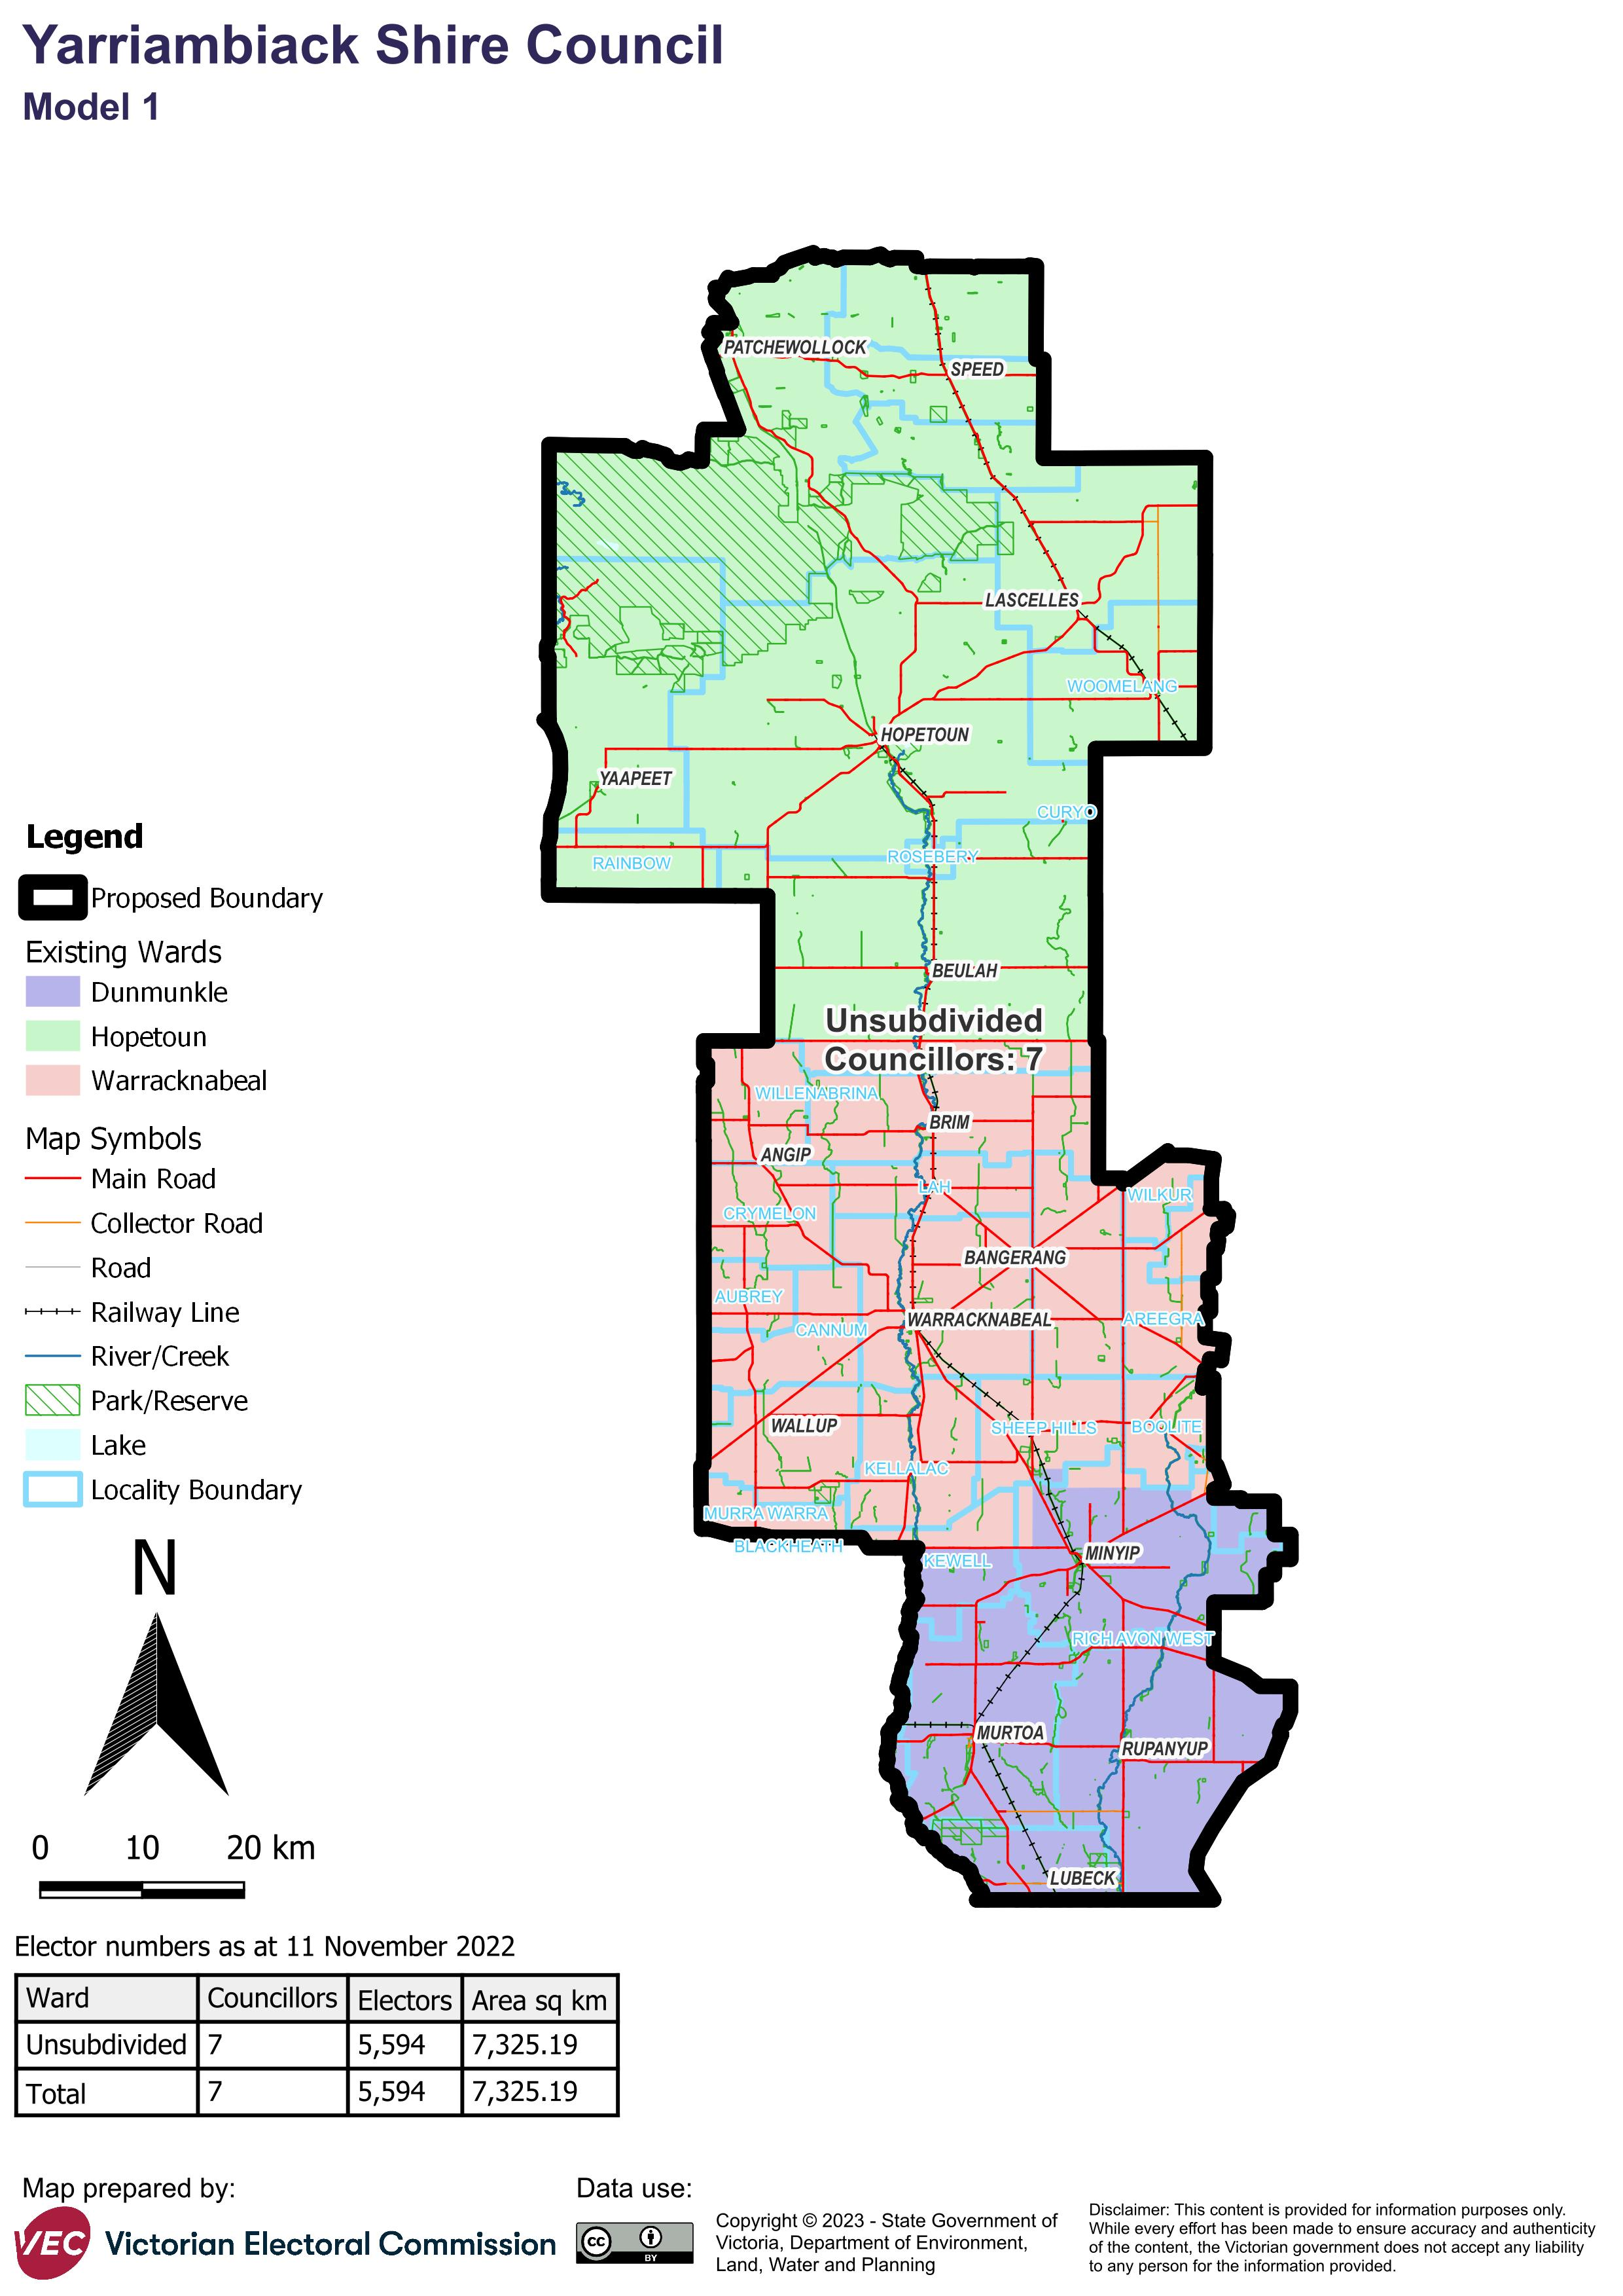

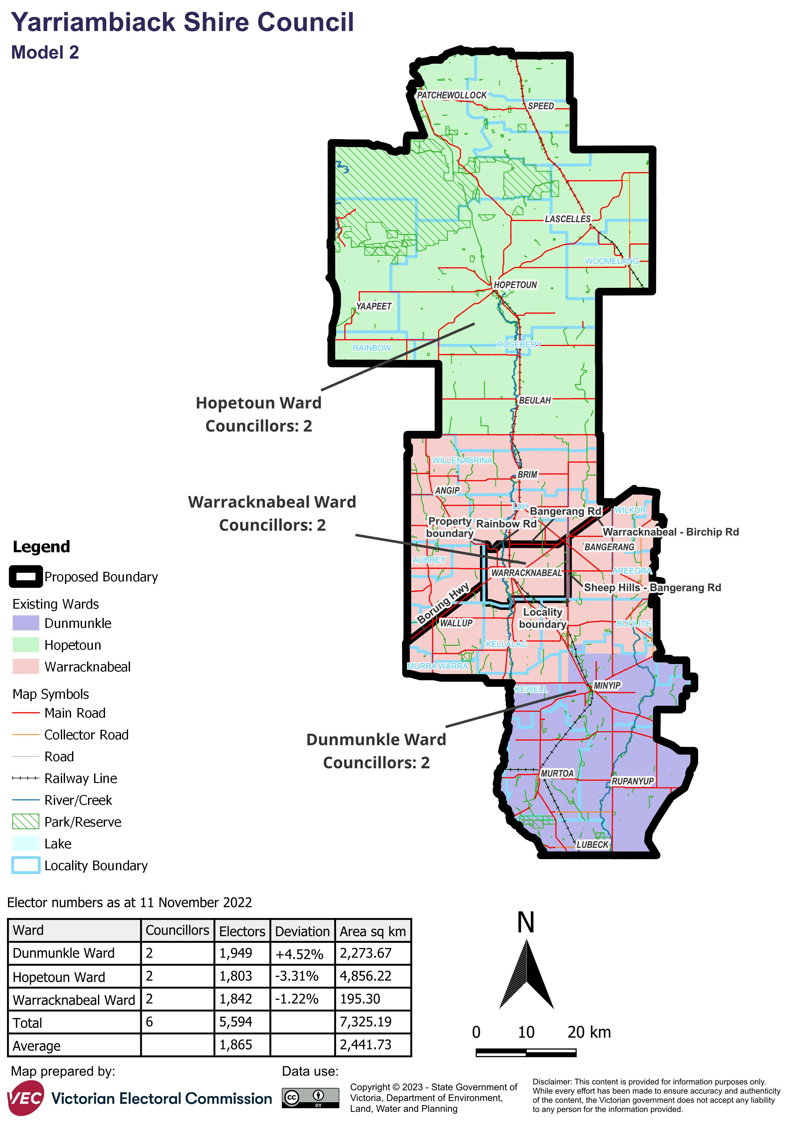

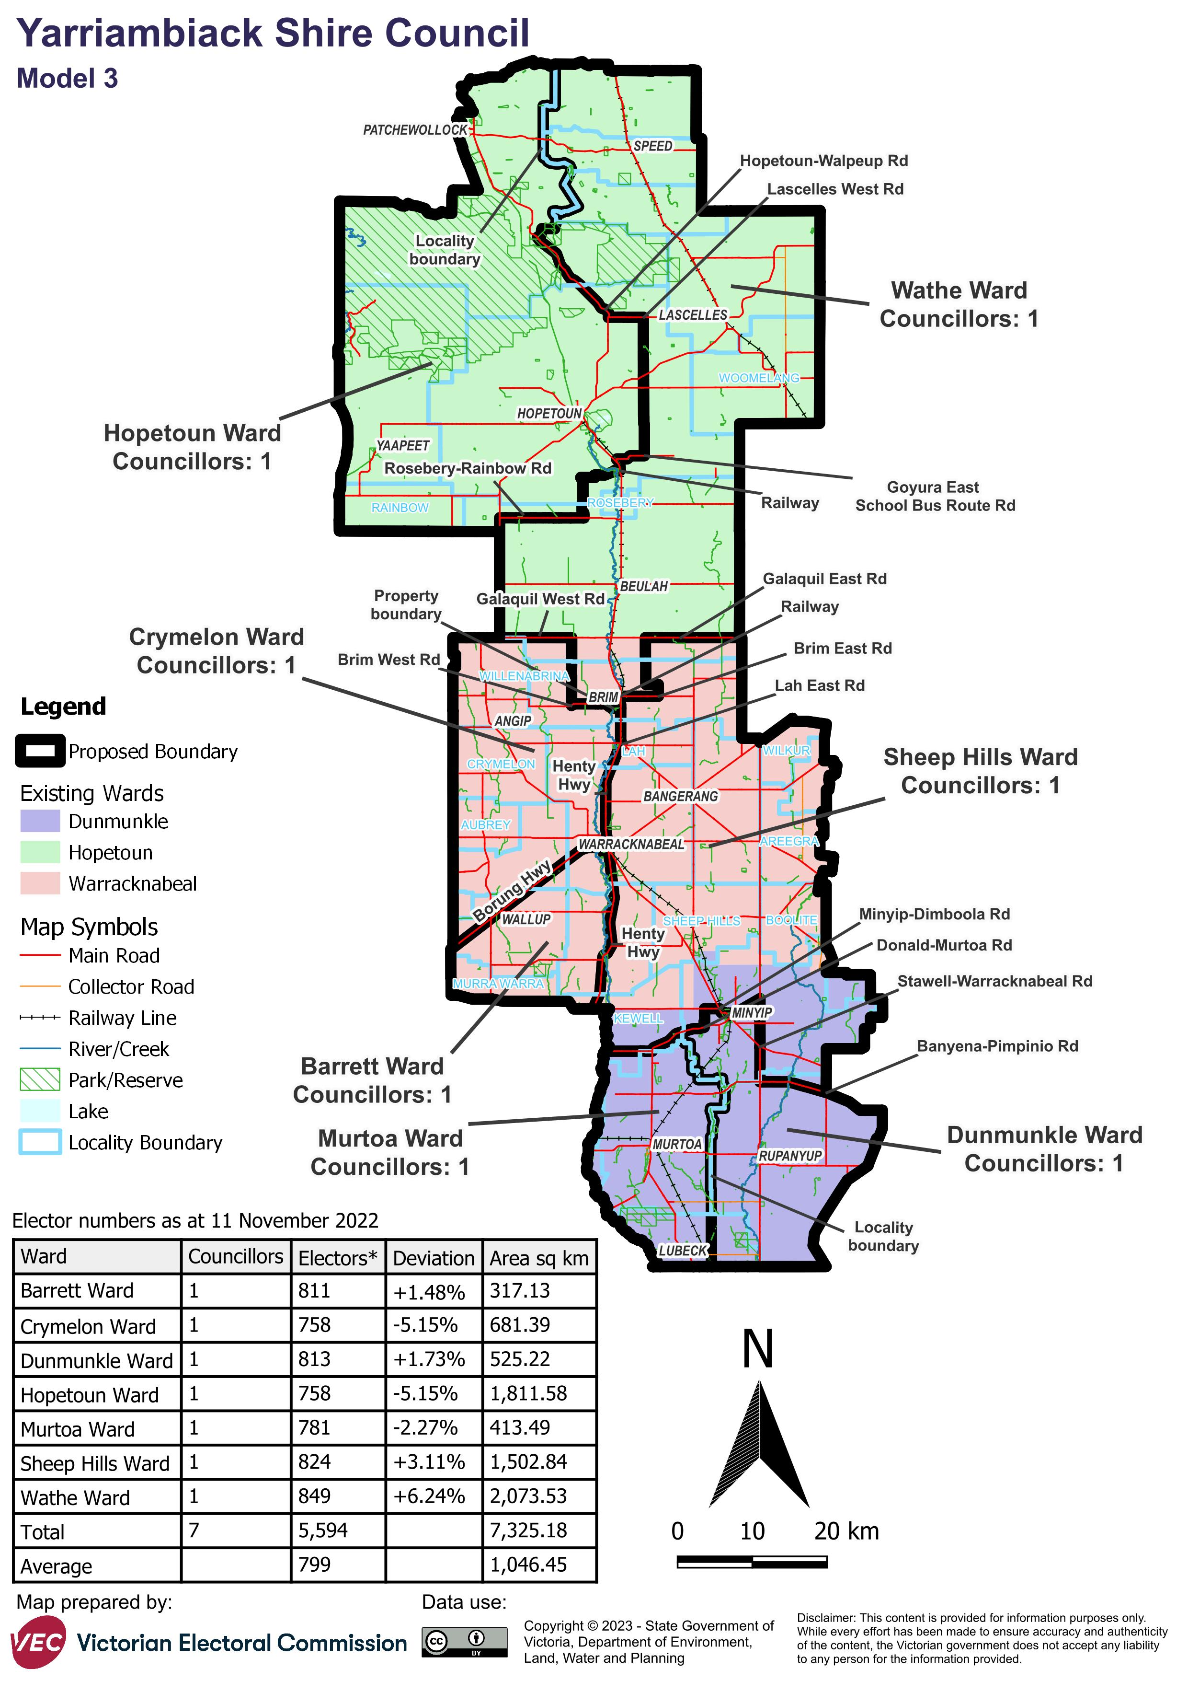

# Appendix 2: Additional models considered

The following models were closely considered by the panel but are not being put forward for further public consultation. See Models considered but not put forward for further information.

#### Single-councillor ward structure with 6 councillors

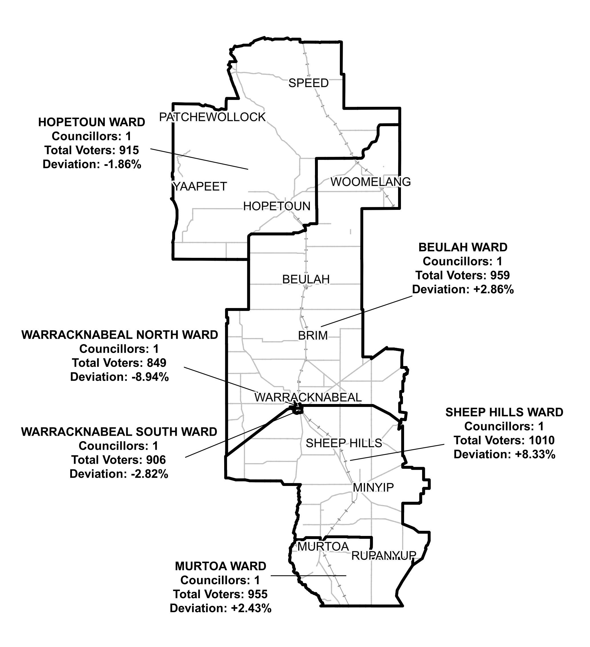

#### Single-councillor ward structure with 5 councillors

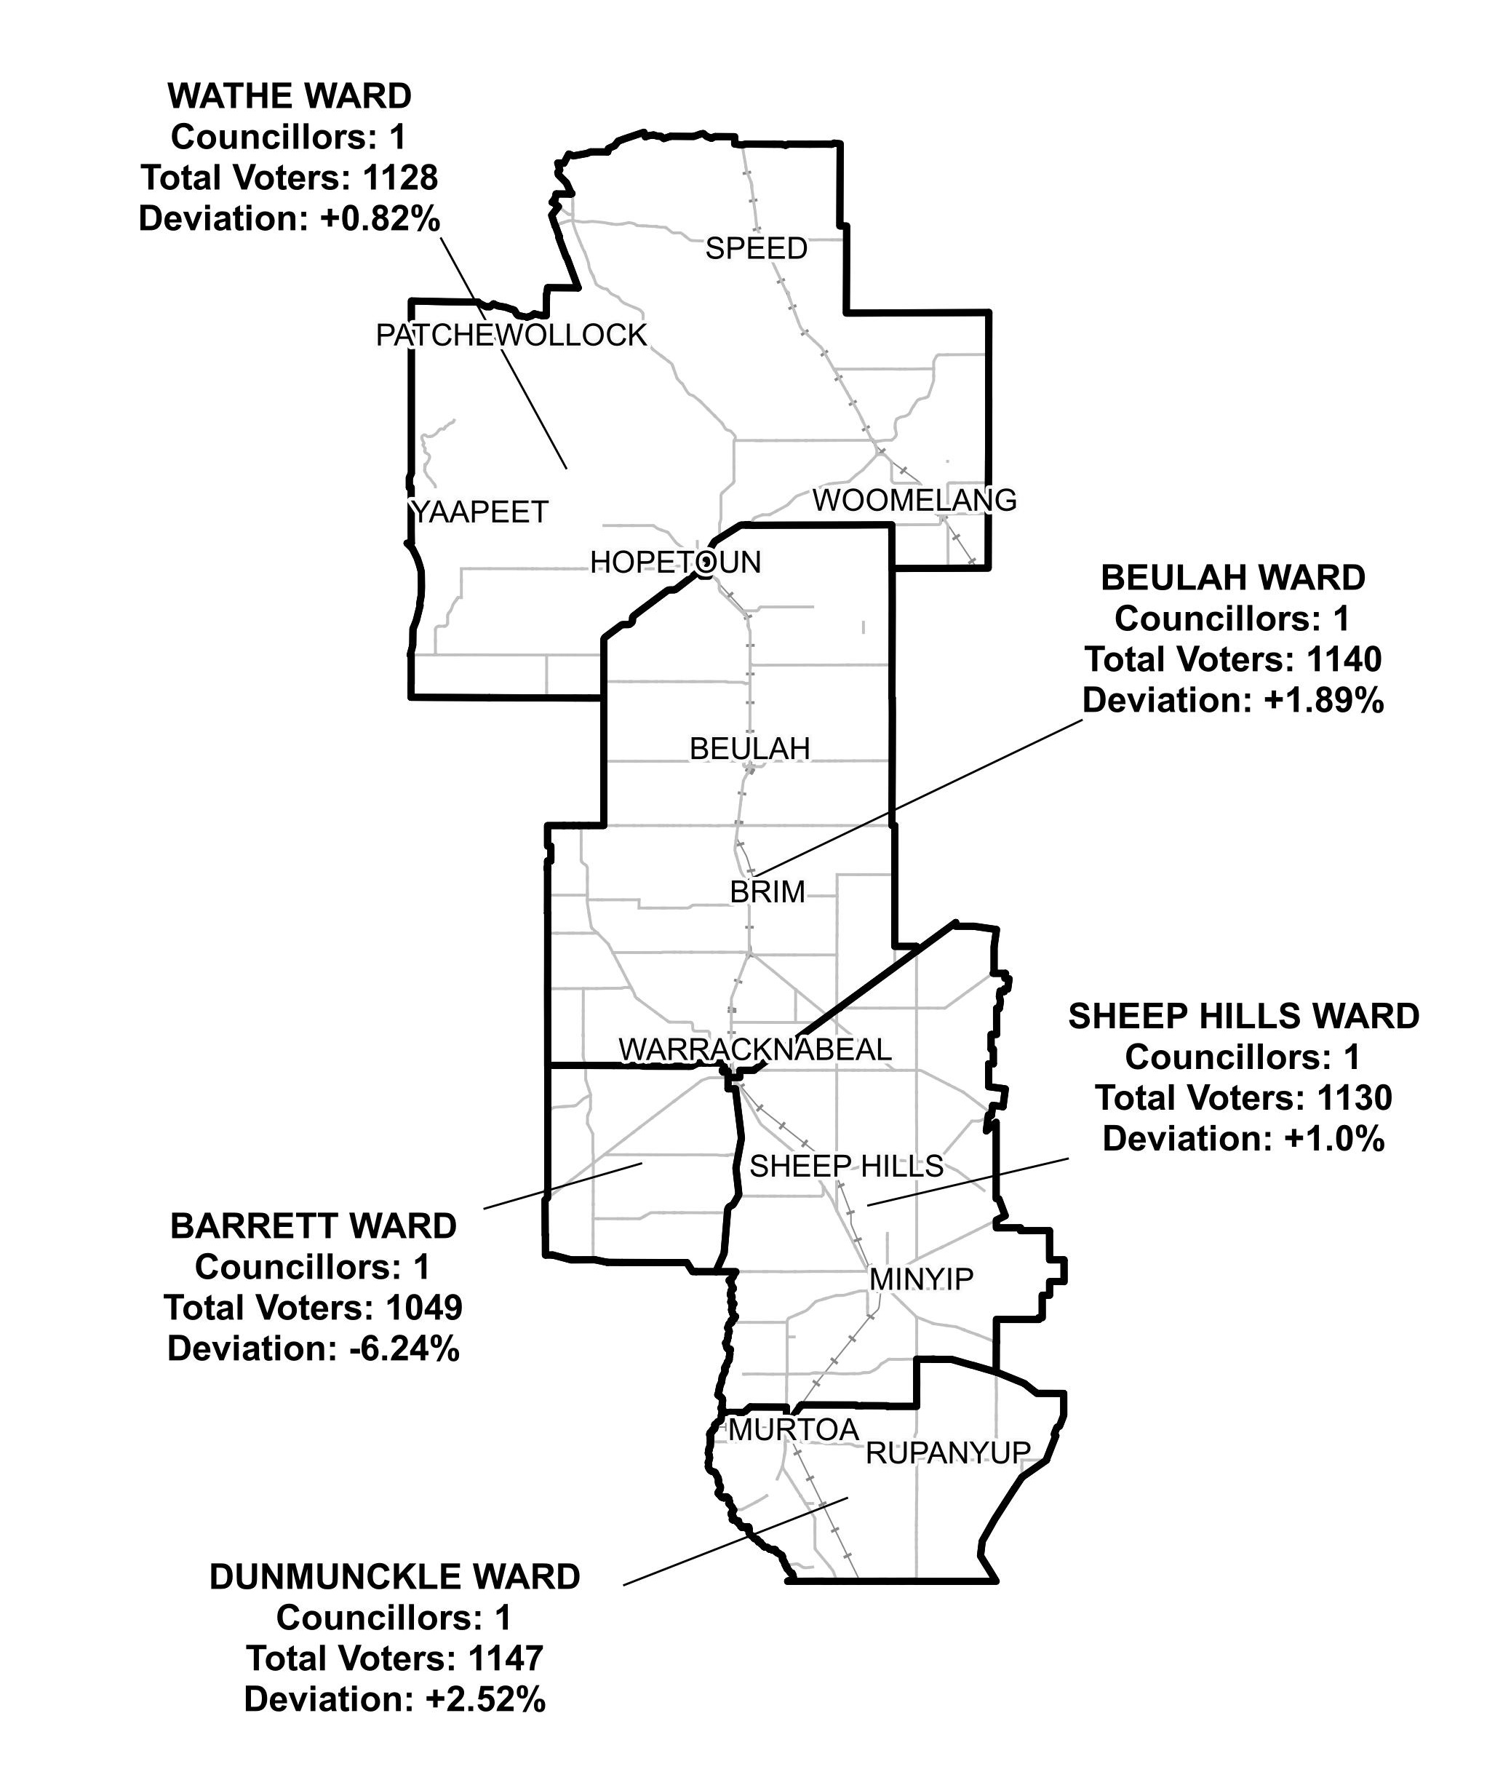

# Appendix 3: List of preliminary submitters

The review received 5 preliminary submissions.

Preliminary submissions were made by:

Bourke, Jo

Connolly, Diane

Healy, Carmel

South, Vicki

Yarriambiack Shire Council