Local council electoral structure review

## About the review

Under Victoria’s *Local Government Act 2020*, Mornington Peninsula Shire Council must now have a single-councillor ward electoral structure.

The Minister for Local Government has appointed an electoral representation advisory panel to review the electoral structure of Mornington Peninsula Shire Council and advise on the most appropriate single-councillor ward structure.

The panel is looking at:

* the appropriate number of councillors and wards
* the location of ward boundaries
* appropriate ward names.

Electoral structure reviews are an important part of democracy and your input is valuable. As a local, you know your council area better than anyone. This is your chance to let the panel know your thoughts about the single-councillor ward structure you believe would best provide representation for your community.

You can have your say:

1. in a response submission to the preliminary report
2. at an online public hearing, if you ask to speak in your response submission.

About Mornington Peninsula Shire Council

The Traditional Custodians of the land in the Mornington Peninsula Shire Council area are the Bunurong people.

Mornington Peninsula is an interface council located about 50 kms south of the Melbourne CBD. It covers an area of 724 km2 bounded mostly by coastline, extending south from   
Mt Eliza to Point Nepean, east to Cape Schanck and north along Western Port Bay to take in Hastings and Tyabb. In 2021 the population was 168,948.

Most of the council area is covered by green wedge planning provisions, which prevents development encroaching on areas of environmental or scenic value. The large hinterland also supports important agricultural activities, such as vineyards and livestock.

Urban living accounts for the remaining land use, with most residents living on the Port Phillip Bay side of the council area. This area also supports a high concentration of holiday homes.

The population of the council area is estimated to grow by over 6% by 2036, most of which will be accommodated in Mornington and Rosebud along the bay and Hastings in the east.

The council area is a key tourist destination and the population surges during the holiday months. The local economy also includes construction, health care, manufacturing, and business services.

## Current structure

Mornington Peninsula Shire Council is divided into 6 wards with a total of 11 councillors:

* one ward with 2 councillors
* 2 wards with 3 councillors each
* 3 wards with one councillor each.

## Last review

The VEC conducted an electoral representation review of Mornington Peninsula Shire Council in 2012.

Visit the VEC website at [vec.vic.gov.au](https://www.vec.vic.gov.au/) to access a copy of the 2012 review final report.

Review process

Monday 23 and Tuesday 24 October

### Information sessions

Session 1: 12 noon, Monday 23 October

Session 2: 6 pm, Tuesday 24 October

These sessions will give you more information about the review process. You will be able to register for a session on the VEC website.

Wednesday 25 October

### Preliminary report

The panel will release a preliminary report with one or more options for the electoral structure on Wednesday 25 October.

**You can make a response submission from this date.**

Wednesday 15 November

### Response submissions

The panel must receive your submission by   
5 pm on Wednesday 15 November.

The panel will not accept late submissions.

Wednesday 22 November

### Public hearing

The panel will hold an online public hearing if anyone asks to speak about their response submission at 2 pm Wednesday 22 November.

The public hearing will not be held if no one asks to speak.

Wednesday 20 December

### Final report

The panel will submit a final report to the Minister for Local Government including its advice for the electoral structure on Wednesday 20 December.

The minister will consider the panel’s advice before recommending a change to the electoral structure. Any change is expected to apply at the next local council general election.

## Submission guide

You can download a submission guide from the VEC website at [vec.vic.gov.au](http://vec.vic.gov.au/)

## Untitled-1How to make a submission

On the VEC website at [vec.vic.gov.au](Link%20to%20the%20Victorian%20Electoral%20Commission%20website%20home%20page)

By email to:

[MorningtonPeninsula.ERAPSubmissions@vec.vic.gov.au](mailto:MorningtonPeninsula.ERAPSubmissions@vec.vic.gov.au)

LetterBy post to:

Electoral representation advisory panel  
c/o Victorian Electoral Commission  
Level 11, 530 Collins Street  
Melbourne VIC 3000

Submissions must include your:

* full name
* contact phone number or email address
* residential or postal address.

Your submission will be published on the VEC website, including your name and suburb or town but not your full address or contact details. See the submission guide or VEC website at [vec.vic.gov.au/privacy](https://www.vec.vic.gov.au/privacy) for privacy information.

## One vote, one value

The ‘one vote, one value’ democratic principle is enshrined in the *Local Government Act 2020*. This means that every person’s vote counts equally.

When a local council area is subdivided into wards, the number of voters each councillor represents in each ward must be plus-or-minus 10% of the of the average number of voters per councillor for all the wards.

The map below includes the current number of voters in each ward and the ward’s current deviation from the average. The panel will consider likely population and voter changes to ensure the structure remains equitable.

If you make a submission online, you can use a mapping tool to build your preferred electoral structure. The tool uses current voter numbers to tell you the deviations of the wards you make. This will help you propose a structure that meets the requirements of the Act.

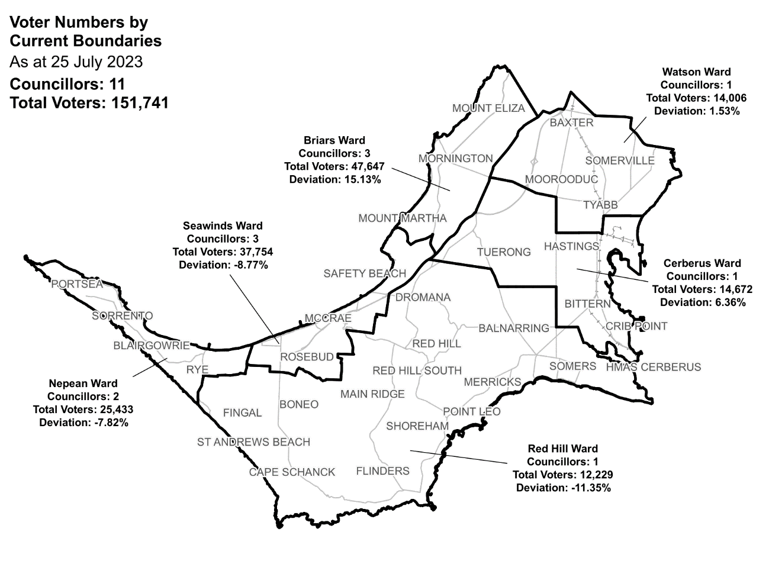Current electoral structure

|  |  |  |  |
| --- | --- | --- | --- |
| Ward | Councillors | Voters | Deviation |
| Briars Ward | 3 | 47,647 | 15.13% |
| Cerberus Ward | 1 | 14,672 | 6.36% |
| Nepean Ward | 2 | 25,433 | -7.82% |
| Red Hill Ward | 1 | 12,229 | -11.35% |
| Seawinds Ward | 3 | 37,754 | -8.77% |
| Watson Ward | 1 | 14,006 | 1.53% |

## Statistics

Area (km2) 727

Voters

### Voter density (per square km)

209

### Average voters per councillor

13,794

Population

### Current population

168,948

### Forecast population growth

1.1% p.a.

More Census statistics available at [abs.gov.au](https://www.abs.gov.au/census/find-census-data/search-by-area)

Voter numbers by locality (map)

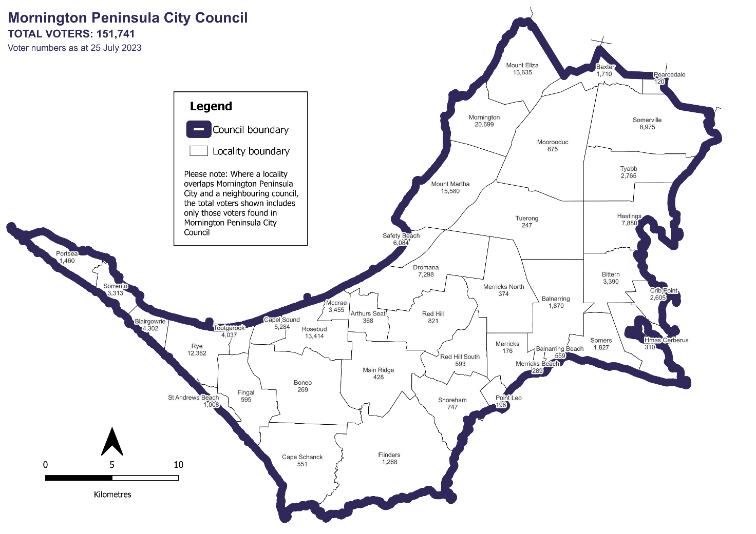

Voter numbers by locality (table)

## Mornington Peninsula Shire Council voter numbers at 25 July 2023

|  |  |
| --- | --- |
| Locality | Voters |
| Arthurs Seat | 368 |
| Balnarring | 1,870 |
| Balnarring Beach | 559 |
| Baxter | 1,710 |
| Bittern | 3,390 |
| Blairgowrie | 4,302 |
| Boneo | 269 |
| Cape Schanck | 551 |
| Capel Sound | 5,284 |
| Crib Point | 2,605 |
| Dromana | 7,298 |
| Fingal | 595 |
| Flinders | 1,268 |
| Hastings | 7,880 |
| HMAS Cerberus | 310 |
| Langwarrin South | 0 |
| Main Ridge | 428 |
| McCrae | 3,455 |
| Merricks | 176 |
| Merricks Beach | 289 |
| Merricks North | 374 |
| Moorooduc | 875 |

|  |  |
| --- | --- |
| Locality | Voters |
| Mornington | 20,699 |
| Mount Eliza | 13,635 |
| Mount Martha | 15,580 |
| Pearcedale | 120 |
| Point Leo | 198 |
| Portsea | 1,460 |
| Red Hill | 821 |
| Red Hill South | 593 |
| Rosebud | 13,414 |
| Rye | 12,362 |
| Safety Beach | 6084 |
| Shoreham | 747 |
| Somers | 1,827 |
| Somerville | 8,975 |
| Sorrento | 3,313 |
| St Andrews Beach | 1,008 |
| Tootgarook | 4,037 |
| Tuerong | 247 |
| Tyabb | 2,765 |