Local council electoral structure review

## About the review

Under Victoria’s *Local Government Act 2020*, Wangaratta Rural City Council must now have a single-councillor ward electoral structure.

The Minister for Local Government has appointed an electoral representation advisory panel to conduct an electoral structure review of the council. The panel will advise the Minister on the most appropriate single-councillor ward structure for Wangaratta Rural City Council.

The panel is looking at:

* the appropriate number of councillors and wards
* the location of ward boundaries
* appropriate ward names.

Electoral structure reviews are an important part of democracy, and your input is valuable. As a local, you know your local council area better than anyone. This is your chance to let the panel know your thoughts about the single-councillor ward electoral structure that you believe would best provide representation for your community.

There are 2 opportunities for you to have your say on the electoral structure of the council:

1. in a response submission to the preliminary report
2. in an online public hearing, if you request to speak in your response submission.

About Wangaratta Rural City Council

The Traditional Custodians of the land in Wangaratta Rural City Council are the Yorta Yorta, Taungurung and Bpangerang peoples.

The Rural City of Wangaratta is located approximately 250 km north-east of Melbourne in the Ovens Murray region of Victoria.

The council covers an area of 3,646 km2, of which approximately 40% is conservation and natural environment. This includes sections the Alpine National Park in the south, the Warby-Ovens National Park in the north-west, and the Chiltern-Mt Pilot National Park in the north-east. The Ovens and King rivers flow through the council area.

The population was 29,808 in 2021, with approximately 66% concentrated in Wangaratta. Other main townships in the council include Glenrowan, Oxley, Milawa, Moyhu and Eldorado.

The Hume Freeway runs through the north of the municipality between Melbourne and Sydney. Passenger and freight services operate on the railway line that passes through Wangaratta in the north.

Health care, agriculture, manufacturing, and construction are major industries in the municipality, both in terms of employment and economic output.

The population grew steadily at an annual rate of approximately 1% from 2011 to 2021. The population is forecast to grow between 2022 and 2028 at an annual rate of 0.8%, largely concentrated in Wangaratta. The median age of the population was 45 years in 2021, higher than the median for rural and regional Victoria overall (43 years).

## Current structure

Wangaratta Rural City Council is divided into 4 wards with a total of 7 councillors:

* One ward with 4 councillors
* 3 wards with one councillor each

## Last review

The VEC conducted an electoral representation review of Wangaratta Rural City Council in 2015.

Visit the VEC website at [vec.vic.gov.au](https://www.vec.vic.gov.au/electoral-boundaries/local-councils/wangaratta-rural-city-council) to access a copy of the 2015 review final report.

Review process

Monday 10 and Tuesday 11 July

### Information sessions

Session 1: 12 noon, Monday 10 July

Session 2: 6 pm, Tuesday 11 July

Information sessions are for anyone wanting to find out more about the review process. Links to register for an information session will be available on the VEC website.

Wednesday 12 July

### Preliminary report

The panel will release a preliminary report including one or more options for the electoral structure on Wednesday 12 July.

**Response submissions open from this date.**

Wednesday 2 August

### Response submission close

The panel must receive all submissions by 5 pm on Wednesday 2 August.

Late submissions will not be accepted.

Tuesday 8 August

### Public hearing

The panel will hold an online public hearing if anyone requests to speak about their response submission at 10 am on Tuesday   
8 August.

The public hearing will not be held if there are no requests to speak.

Wednesday 6 September

### Final report

The panel will submit a final report to the Minister for Local Government including its advice on the electoral structure on Wednesday 6 September.

The Minister will then consider the panel’s advice before recommending a change to the electoral structure. Any change to the electoral structure of the council following the review is expected to apply at the next local council elections.

## Untitled-1How to make a submission

On the VEC website at [vec.vic.gov.au](https://www.vec.vic.gov.au/electoral-boundaries/council-reviews/electoral-structure-reviews)

By email to

[Wangarratta.ERAPSubmissions  
@vec.vic.gov.au](mailto:Wangarratta.ERAPSubmissions@vec.vic.gov.au)

LetterBy post to

Electoral representation advisory panel  
c/o Victorian Electoral Commission  
Level 11, 530 Collins Street  
Melbourne VIC 3000

Submissions must include your:

* full name
* contact phone number or email address
* residential or postal address.

All submissions will be published on the VEC website. Your name and locality (suburb or town) will be published, but your full address and contact details will be removed. See the submission guide and VEC website at [vec.vic.gov.au/privacy](https://www.vec.vic.gov.au/privacy) for privacy information.

## Submission guide

Download the submission guide from the VEC website at [vec.vic.gov.au](http://vec.vic.gov.au/) for more information on the review process and making a submission.

## One vote, one value

The ‘one vote, one value’ democratic principle is enshrined in the *Local Government Act 2020*. This means that every person’s vote counts equally.

When a local council area is subdivided into wards, the number of voters each councillor represents in each ward must be within plus-or-minus 10% of the of the average number of voters per councillor for all the wards.

The map below includes the current number of voters in each ward and the ward’s current deviation from the average. The panel will consider likely population and voter changes to ensure the structure remains equitable.

If you make a submission online, you can use a mapping tool to build your preferred electoral structure. The tool uses current voter numbers to tell you the deviations of the wards you make. This will help you propose a structure that meets the requirements of the Act.

Current electoral structure

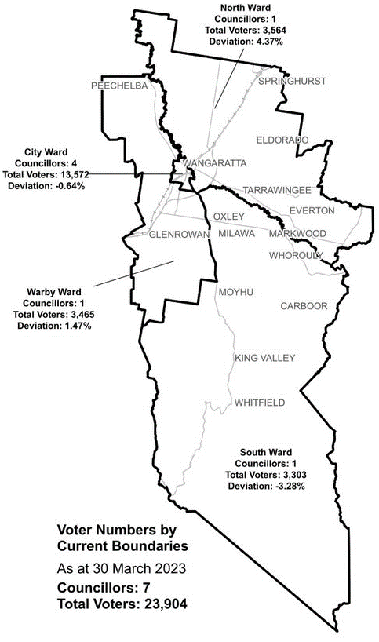

|  |  |  |  |
| --- | --- | --- | --- |
| Ward | Councillors | Voters | Deviation |
| City Ward | 4 | 13,572 | -0.64% |
| North Ward | 1 | 3,564 | 4.37% |
| South Ward | 1 | 3,303 | -3.28% |
| Warby Ward | 1 | 3,465 | 1.47% |

## Statistics

Area (km2) 3,645 km2

Voters

### Voters per square km

6.6

### Average voters per councillor

3,414

Population

### Current population

29,808

### Forecast population growth

0.8% p.a.

Further census statistics available at: abs.gov.au

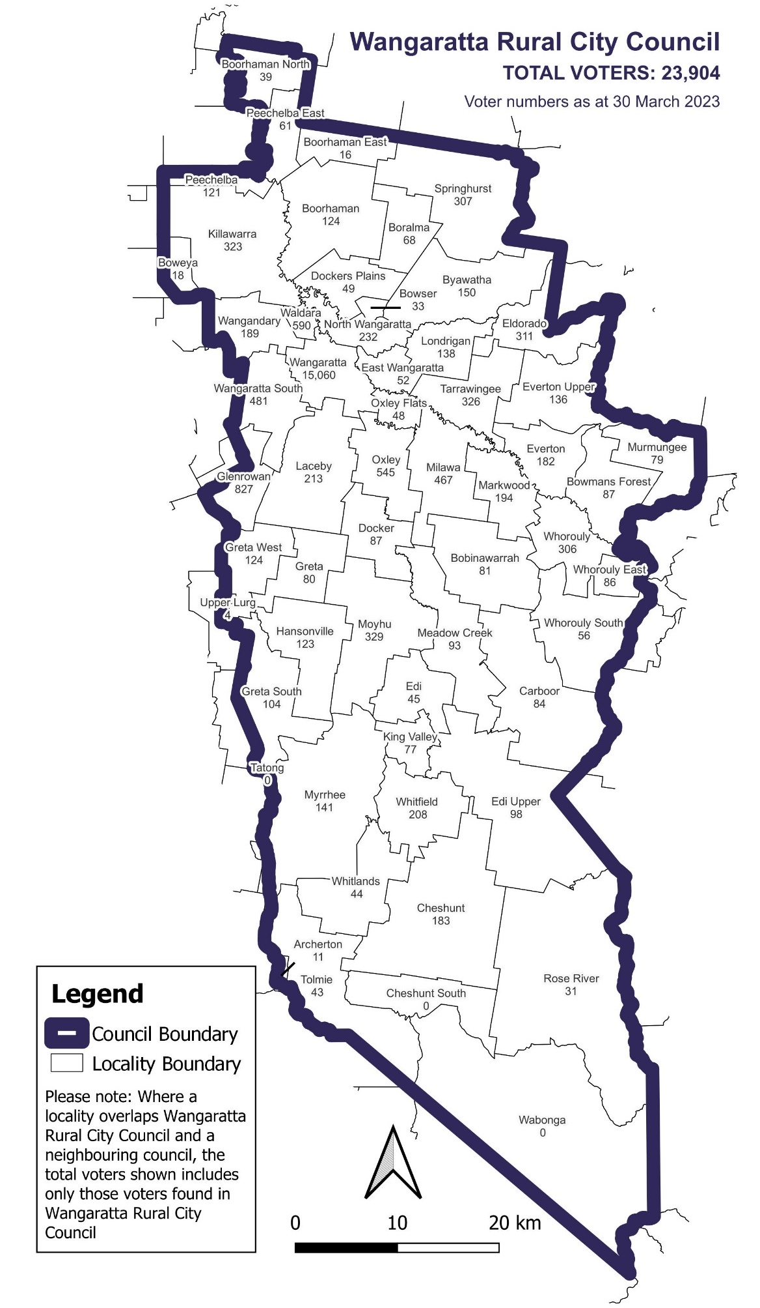Voter numbers by locality (map)

Voter numbers by locality (table)

## Wangaratta Rural City Council voter numbers at 30 March 2023

|  |  |
| --- | --- |
| Locality | Voters |
| Archerton | 11 |
| Bobinawarrah | 81 |
| Boorhaman | 124 |
| Boorhaman East | 16 |
| Boorhaman North | 39 |
| Boralma | 68 |
| Boweya | 18 |
| Bowmans Forest | 87 |
| Bowser | 33 |
| Byawatha | 150 |
| Carboor | 84 |
| Cheshunt | 183 |
| Cheshunt South | 0 |
| Docker | 87 |
| Dockers Plains | 49 |
| East Wangaratta | 52 |
| Edi | 45 |
| Edi Upper | 98 |
| Eldorado | 311 |
| Everton | 182 |
| Everton Upper | 136 |
| Glenrowan | 827 |

|  |  |
| --- | --- |
| Locality | Voters |
| Greta | 80 |
| Greta South | 104 |
| Greta West | 124 |
| Hansonville | 123 |
| Killawarra | 323 |
| King Valley | 77 |
| Laceby | 213 |
| Londrigan | 138 |
| Markwood | 194 |
| Meadow Creek | 93 |
| Milawa | 467 |
| Moyhu | 329 |
| Murmungee | 79 |
| Myrrhee | 141 |
| North Wangaratta | 232 |
| Oxley | 545 |
| Oxley Flats | 48 |
| Peechelba | 121 |
| Peechelba East | 61 |
| Rose River | 31 |
| Springhurst | 307 |
| Tarrawingee | 326 |

|  |  |
| --- | --- |
| Locality | Voters |
| Tolmie | 43 |
| Upper Lurg | 4 |
| Wabonga | 0 |
| Waldara | 590 |
| Wangandary | 189 |
| Wangaratta | 15,060 |
| Wangaratta South | 481 |
| Whitfield | 208 |
| Whitlands | 44 |
| Whorouly | 306 |
| Whorouly East | 86 |
| Whorouly South | 56 |