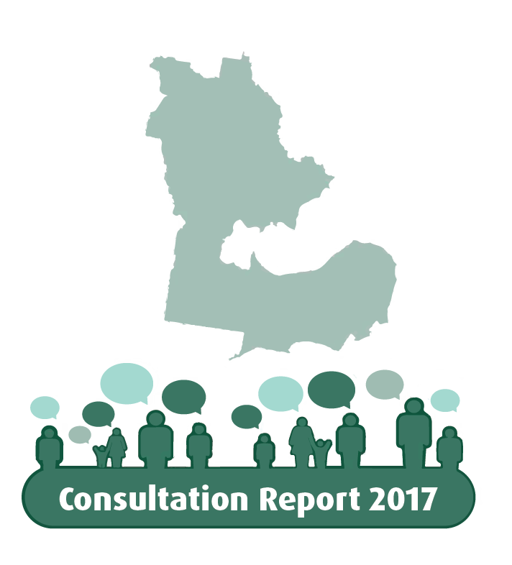
Greater Geelong City Council’s Electoral Structure
Consultation Report

9 June 2017

contents
The consultation 4
Background 4
The two models 5
The consultation process 7
Submissions 8
Public hearing 11
Conclusion 12
Model maps 13

THE consultation
In April 2017, the Minister for Local Government, the Hon. Natalie Hutchins MP, asked the Victorian Electoral Commission (VEC) to consult with the Geelong community on a new electoral structure for the Greater Geelong City Council. This report describes the consultation process and its outcome.

background
At the October 2012 council general election, the voters of the City of Greater Geelong elected 12 councillors and, for the first time, a directly elected Mayor. Each councillor was elected to represent one single-councillor ward.
This was a transitional arrangement. In addition to providing for the direct election of the Mayor, the City of Greater Geelong Act 1993 (CoGG Act), which governs the structure of the Council, specified that there had to be an electoral representation review before the next council election, and that there could be no more than 11 councillors, excluding the Mayor.
In 2015-2016, the VEC conducted electoral representation reviews of 24 local councils in accordance with the requirements of the Local Government Act 1989 (LG Act). These reviews were required to be completed at least six months before the 2016 council elections. As a particular requirement of the CoGG Act, Greater Geelong City Council was one of the councils reviewed during this program.
As with any review, the review of Greater Geelong considered the number of councillors and the electoral structure of the City. The CoGG Act meant that the review did not consider the position and method of election of the Mayor. The review included two rounds of consultation with the Greater Geelong community. On 16 March 2016, the VEC’s final report was lodged with the Minister for Local Government and recommended that Greater Geelong City Council consist of 11 councillors (excluding the Mayor), elected from three three-councillor wards and one two-councillor ward. The two-councillor ward was located in the northern suburbs and northern rural area of Greater Geelong.
In April 2016, shortly after the VEC’s final report was released, the Victorian Parliament dismissed Greater Geelong City Council. A Commissioner and then three Administrators were appointed to run the Council until the next council elections, which were put back to October 2017.
In July 2016, the State Government appointed a Citizens’ Jury to recommend the best future design of the City of Greater Geelong, including its electoral structure. The Citizens’ Jury’s final report, released in January 2017, stated:
The citizens jury agreed as a ‘super majority’ on a four ward structure, comprising of 11 councillors in total. We suggest these wards be divided into rough geographical areas, dependent on the electoral population of the areas. The proposed wards would encompass the Bellarine coastal region, the Northern region, suburban Geelong and central Geelong. The preferred distribution of councillors would be three in each ward, except for central Geelong, which would have two. This distribution would be dependent on the number of electoral voters in each ward as per current electoral legislation. It is worthwhile noting that this proposal received more than 90% of jury support.
The Citizens’ Jury reported that this structure would “provide multiple local voices in each ward to represent the diversity of local needs and interests in each area. We decided on the odd number of councillors to avoid deadlocks when voting on issues. In addition, we agreed the greater region needed to be broken up into wards, but fewer wards with multiple members to encourage collaboration, increase broader representation and greater accessibility for voters to councillors.”
The State Government supported this recommendation by the Citizens’ Jury, commenting that the Government had approved the preparation of a Bill to give effect to it. The Government stated that information about the 2017 council elections, including ward boundaries, would be provided by the VEC.
In January 2017, Local Government Victoria wrote to the Electoral Commissioner requesting the VEC to prepare one or more options for a ward structure having regard to the Jury’s recommendation. The VEC developed two models that both had regard to the recommendation and complied with the requirements of the LG Act. The VEC provided these models to Local Government Victoria in March 2017. The Minister for Local Government then requested the VEC to conduct a public consultation process on the models.

the two models
Both models followed the Jury’s recommendation of three three-councillor wards and one two-councillor ward, with the two-councillor ward covering central Geelong. The ward names were identical for both models, and were drawn directly from the ward descriptions provided by the Jury’s report. Both models also complied with the equality provision of the LG Act, which requires that the number of voters represented by each councillor must not vary by more than ±10% from the average number of voters per councillor for the council overall. Voter numbers in the models were based on a voters’ roll compiled on 17 February 2017. In preparing the ward boundaries, the VEC allowed for likely population changes to maximise the longevity of the boundaries as much as possible. In both models, enrolment projections indicated that all wards would stay within the ±10% tolerance up to the 2024 council elections. Borrowing from its principles for electoral representation reviews, the VEC also took account of geographic communities of interest and, wherever possible, used clear, logical features as ward boundaries, as these assist effective representation and the easy identification of wards.
There were two main difficulties in translating the Jury’s recommendation into ward boundaries. First, it was not possible to create a ‘suburban Geelong’ ward that included all of Geelong’s suburbs and still complied with the equality requirement of the LG Act. In both models, the Geelong urban area was distributed across multiple wards. Second, the distribution of voters meant that the central Geelong ward necessarily extended beyond the central business district into adjoining suburbs. Again, this was in order for the ward to comply with the equality requirement established by the LG Act.
In Model 1, the wards were more compact and well-defined. The Barwon River and Coppards Road were clear ward boundaries. The Bellarine Coastal Region Ward captured the Bellarine Peninsula well, though it also included Moolap, which might fit better in a suburban Geelong ward. The Suburban Geelong Ward comprised the part of Geelong south of the Barwon River. The Northern Region Ward included the northern rural area and most of the northern suburbs. The boundary between the Northern Region Ward and the Central Geelong Ward followed the major thoroughfares of Melbourne Road and Church Street, but also followed more minor roads in some areas. The boundary followed existing locality boundaries, so it did not divide suburbs, but it might be considered that the suburb of Herne Hill (in Northern Region Ward) has much in common with Manifold Heights (in Central Geelong Ward), and that it would be undesirable to place them in different wards.
Model 2 provided a more literal interpretation of the Jury’s recommendation to create a suburban Geelong ward. The Suburban Geelong Ward in this model wrapped around the Central Geelong Ward and included most of the southern suburbs and parts of the eastern and inner western suburbs of Geelong. The Bellarine Coastal Region Ward covered the Bellarine Peninsula—without Moolap in this model. The Central Geelong Ward did not include Moolap, St Albans Park and Newtown, and so the ward extended further into the northern suburbs than it did in Model 1. The Northern Region Ward retained the northern rural area and the northern suburbs of Norlane, Corio and Bell Park.
The main drawback of Model 2 was that the attempt to create a suburban Geelong ward damaged the coherence of three of the wards. The Northern Region Ward extended around the western and southern sides of Greater Geelong to include Armstrong Creek, Mount Duneed, Waurn Ponds and Ceres. It could be argued that these localities have little direct connection and little in common with those on the northern side of Greater Geelong. Similarly, the Suburban Geelong Ward comprised three disparate areas (the southern suburbs, Newtown and St Albans Park/Moolap) that are separated by the Barwon River. The Central Geelong Ward did not include Newtown, immediately to the west of the CBD, but did include suburbs further to the west. The ward boundaries in general were less clear than in Model 1.

the consultation process
The VEC modelled the consultation process on that prescribed by the LG Act for electoral representation reviews. First, the VEC invited feedback from the public, allowing a month (to 11.59 pm on Sunday 28 May) for receipt of submissions. Submissions could be made via email, post, fax or using the online submission form on the VEC’s website. All submissions received were published on the VEC website, with submitters’ personal details (signatures, telephone numbers, email and street addresses) removed. Following the close of submissions, the VEC arranged a public hearing on 1 June. The views and information provided in submissions and at the public hearing form the basis of the current report.
A consultation paper provided guidance for those interested in making a submission. The paper stressed the restricted scope of the consultation: it simply sought feedback from the public on two models of an electoral structure recommended by the Citizens’ Jury. The consultation did not cover the position of the Mayor, as the question of how the Mayor was to be elected would need to be decided by the Parliament. As well, the consultation could not consider proposals for different electoral structures or numbers of councillors from those in the two models. On the other hand, the VEC welcomed ideas for modifications that might improve ward boundaries in either model, and also welcomed suggestions for ward names.
The VEC’s website prominently displayed information about the Greater Geelong consultation throughout the consultation period, including the time and location of the public hearing. The VEC placed advertisements in the Geelong Advertiser on 29 April and in local weekly newspapers over the following week. In the week before the deadline for public submissions, the VEC further advertised the submission process by placing additional advertisements on Facebook and on Geelong radio stations (K Rock and Bay FM).
The scale of advertising was somewhat larger than the VEC’s normal publicity for electoral representation reviews. A number of stories in the Geelong media covered the consultation: for example, former Mayor Keith Fagg discussed the two models in the Geelong Advertiser of 22 May, and the Geelong Advertiser of 31 May outlined split public opinion, and some general negative opinion, about the proposed ward boundaries.

submissions
The VEC received a total of 29 submissions – a number comparable to many electoral representation reviews. The great majority of submissions were by individuals, with three submissions from local community organisations (the Barwon Heads Association, the Ocean Grove Community Association Inc. and the Portarlington Community Association) and one from a State-wide group (the Proportional Representation Society of Australia (Victoria-Tasmania) Inc.).
As Table 1 shows, submissions came from all parts of the municipality, with the northern area somewhat under-represented. Table 2 shows the number of submissions favouring each model.
 | Inner | Bellarine | North | South | Outside Greater Geelong
Number of submissions | 9 | 9 | 3 | 7 | 1
Table 1: Location of people making submissions

 | Model 1 | Model 2 | Neither
Number of submissions | 19 | 9 | 1
Table 2: Submissions favouring each model
A strong majority of submissions supported Model 1, while about one-third preferred Model 2. One submission had nothing to do with electoral matters. Many submissions were brief and simply declared support for a model, but others included substantial reasons for their preference.
In some submissions, support for a model was unwilling or partial. For example, David White considered Model 1 to be the better model being less complicated, but argued that both models failed the “fairness test” because of the smaller representation of Central Ward, which disenfranchised the voters of that ward and infringed the principle of one-vote one-value. The Barwon Heads Association supported the Bellarine Coastal Region boundary in Model 2, but believed that both models were flawed and unsatisfactory and should be reconsidered.
Submissions favouring Model 1 tended to see it as embodying the traditional or natural grouping of wards. For Elaine Carbines, “Model 1 represents a logical division of communities of interest across our municipality. This is fundamental in ensuring appropriate representation of the four wards at the Council level”. Sarah Gofton thought that Model 1 “is definitely more accurate in reflecting what the citizen’s jury was driving at in terms of subdividing the Geelong area into representative geographic regions”.
As well as having positive reasons for favouring Model 1, submissions rejected the boundaries in Model 2, particularly those of the Northern Region Ward. As Rosemary Nugent wrote, this ward “extends from Balliang to Armstrong Creek, which I think is quite ridiculous”. As far as submitters were concerned, the ward’s boundaries were tortuous, it was geographically far too large (comprising well over half of the area of the local council area), and, most importantly, it included areas to the south of Geelong such as Armstrong Creek and Waurn Ponds which had little in common with the north. Submitters argued that these characteristics in Model 2 would create an unfair workload on the councillors for the ward.
Some of the nine submissions favouring Model 2 supported that model in general. Matt Hrkac, for instance, reasoned that it made sense to group the rural areas outside the Bellarine Peninsula into a single ward (Northern Region Ward); it made sense to group Newtown with suburbs of similar demographics such as Highton and Belmont (in Suburban Geelong Ward); and enrolment numbers in Model 2 were more likely to remain comparatively stable. Justin Teague supported Model 2 because the ward boundaries would work to encourage collaboration between socially disparate suburbs and areas.
Most submissions supporting Model 2 had a more restricted focus. These submitters, who were residents of the Bellarine Peninsula, judged the models according to where they placed Moolap. Moolap is a thinly populated outer suburban area including Point Henry (the site of the former Alcoa smelter), located between the Geelong urban area and the Bellarine township of Leopold. Submissions favouring Model 2 rejected Model 1 because it included Moolap in the Bellarine Coastal Region Ward, and supported Model 2 because it excluded Moolap from the Bellarine ward. In the view of these submitters, industrial and suburban Moolap did not align with the special coastal and rural nature of the Bellarine Peninsula, and so should not be in the same ward.
The VEC’s consultation paper invited suggestions about ward names. The names used in the two models were based directly on those used in the Citizens’ Jury’s report. Table 3 shows submitters’ suggested alternative names for each ward:

Submitter | Bellarine Coastal Region | Central Geelong | Northern Region | Suburban Geelong
George Ballas OAM | Cheetham-Buckley | Kardinia-Austin | Cowie-Brownbill | Kildare-Deakin
Elaine Carbines | No suggestion | No suggestion | No suggestion | Southern Geelong Region
Rosemary Kiss | Bellarine | Bayside | You Yangs | Barwon
Bruce McDonald | Eastern or Bellarine | Central | Northern or Corio | Southern or Barwon
Ocean Grove Community Association Inc. | Bellarine | Central | Northern | Southern
David White | Bellarine | Central | North | South
Table 3: Suggested alternative ward names
For George Ballas OAM, it was vital to preserve Geelong’s heritage. The wards under the former structure used the names of distinguished former residents of Geelong. Mr Ballas proposed that each ward be named after a pair of former residents who were associated with that part of the municipality.
Most other submissions suggested straightforward directional names. There was near universal support for a Bellarine ward, as the Bellarine Peninsula is such a distinctive area. Rosemary Kiss put forward names that were evocative of each area, such as You Yangs Ward for the Northern Region Ward, named after the range that dominates the northern part of the municipality, and Barwon Ward for the Suburban Geelong Ward, named after the river that forms the boundary of the ward.

public hearing
A public hearing was held at 6.00 pm on 1 June 2017 in the Kardinia Room at Rydges Geelong. The hearing was an opportunity for those who had made submissions to speak to their submissions. A panel, comprising Warwick Gately AM (Electoral Commissioner), Liz Williams (Deputy Electoral Commissioner), Michael Ulbrick (a consultant with experience in local government) and Paul Thornton-Smith (an information and research officer at the VEC) listened to and asked questions of the three speakers.
Mr Ballas reiterated the points in his submission supporting Model 1 (with modified boundaries) and advocating that ward names recognise Geelong’s heritage. He argued that the ward boundaries in Model 2 lumped the north and south of the local council area together, and that people in Lara had different needs from those in Armstrong Creek. When asked whether Drumcondra and Rippleside would fit better in Central Geelong Ward (as in Model 1) or in Northern Region Ward (as suggested by Mr Ballas), Mr Ballas replied that he could not speak for the residents, but that Drumcondra had a north Geelong postcode (3215), and that it made sense for the suburb to be in the north. When asked whether he thought if Moolap should be in the Bellarine ward, Mr Ballas replied that Moolap was beyond the long-term city limits; at one stage it was classified as rural, and it still had large allotments.
Ms Kiss said that there needed to be perspective on ward boundaries; they were not the “Berlin Wall” and they would not have a profound effect on the democratic process. Both models maintained equality of numbers and were likely to last until the next review. Ms Kiss thought that Model 1’s boundaries were acceptable, while in Model 2 the northern ward, including both northern and southern areas, would be difficult to manage. Ms Kiss explained her suggested ward names. When asked about the best ward for Rippleside and Drumcondra, Ms Kiss replied that the two suburbs had a close connection with each other, and that waterfront development was increasingly linking them to the central city. In relation to the appropriate ward for Moolap, Ms Kiss said that its inclusion in the Bellarine ward was acceptable, as Moolap was geographically connected with the Bellarine Peninsula and residents would have links with Leopold. Ms Kiss thought that the forthcoming Point Henry developments would make Moolap a valuable component of whatever ward it was in.
Mary Budd, who advised she had been a member of the Citizens’ Jury, said that Model 1 offered the best prospect of local accessibility to councillors. Ms Budd observed that some parts of Moolap were still rural, while Drumcondra had close links with the city centre.

conclusION
The VEC’s consultation paper invited the public to put forward any ideas for modification of the boundaries in either of the models, including the reasons for the suggested changes. Two possible amendments to Model 1’s boundaries arose in the course of the consultation.
Mr Ballas suggested amending the boundary between the Central Geelong and Northern Region wards, replacing Model 1’s zig-zag boundary with a straight line along Glenleith Avenue and Church Street to the Princes Freeway, which he considered would be more identifiable for voters. Bruce McDonald also proposed a Church Street boundary, so that the suburb of Herne Hill would be located in the Central Geelong Ward, fitting its community of interest.
Although these are reasonable points, a Church Street boundary would put the Central Geelong Ward’s current enrolment 12.89% above the average ratio of voters per councillor. This would not comply with the equality requirements of the LG Act, and so cannot be considered.
In response to calls in submissions for Moolap not to be included in the Bellarine Coastal Region Ward, the VEC modelled a modification of Model 1, with Moolap included in the Central Geelong Ward and Drumcondra and Rippleside being transferred from the Central Geelong Ward to the Northern Region Ward. Such an amendment would work well as far as voter numbers are concerned, and would have clear boundaries. However, information gained during the consultation indicates that this modification would not fit communities of interest as well as Model 1. Drumcondra and Rippleside have close links with the city centre, which is only 2.6 kilometres away. By contrast, Moolap is 7.9 kilometres from the city centre, and is a semi-rural area that has much less in common with central Geelong than Drumcondra or Rippleside both do. Despite objections in some submissions, there is no compelling reason against Moolap being included in the Bellarine Coastal Region Ward. Consequently, the VEC considers that this modification is inferior to Model 1’s boundaries.
In summary, the consultation has revealed much stronger support for Model 1 than for Model 2. Much of the support for Model 2 related to the single issue of the location of Moolap, and the VEC considers that Moolap could reasonably be included in the Bellarine Coastal Region Ward. There were a number of suggestions for ward names put forward through submissions, with geographical names being the most popular. Ward names may be considered by the State Government, or by the elected Council.

MODEL MAPS
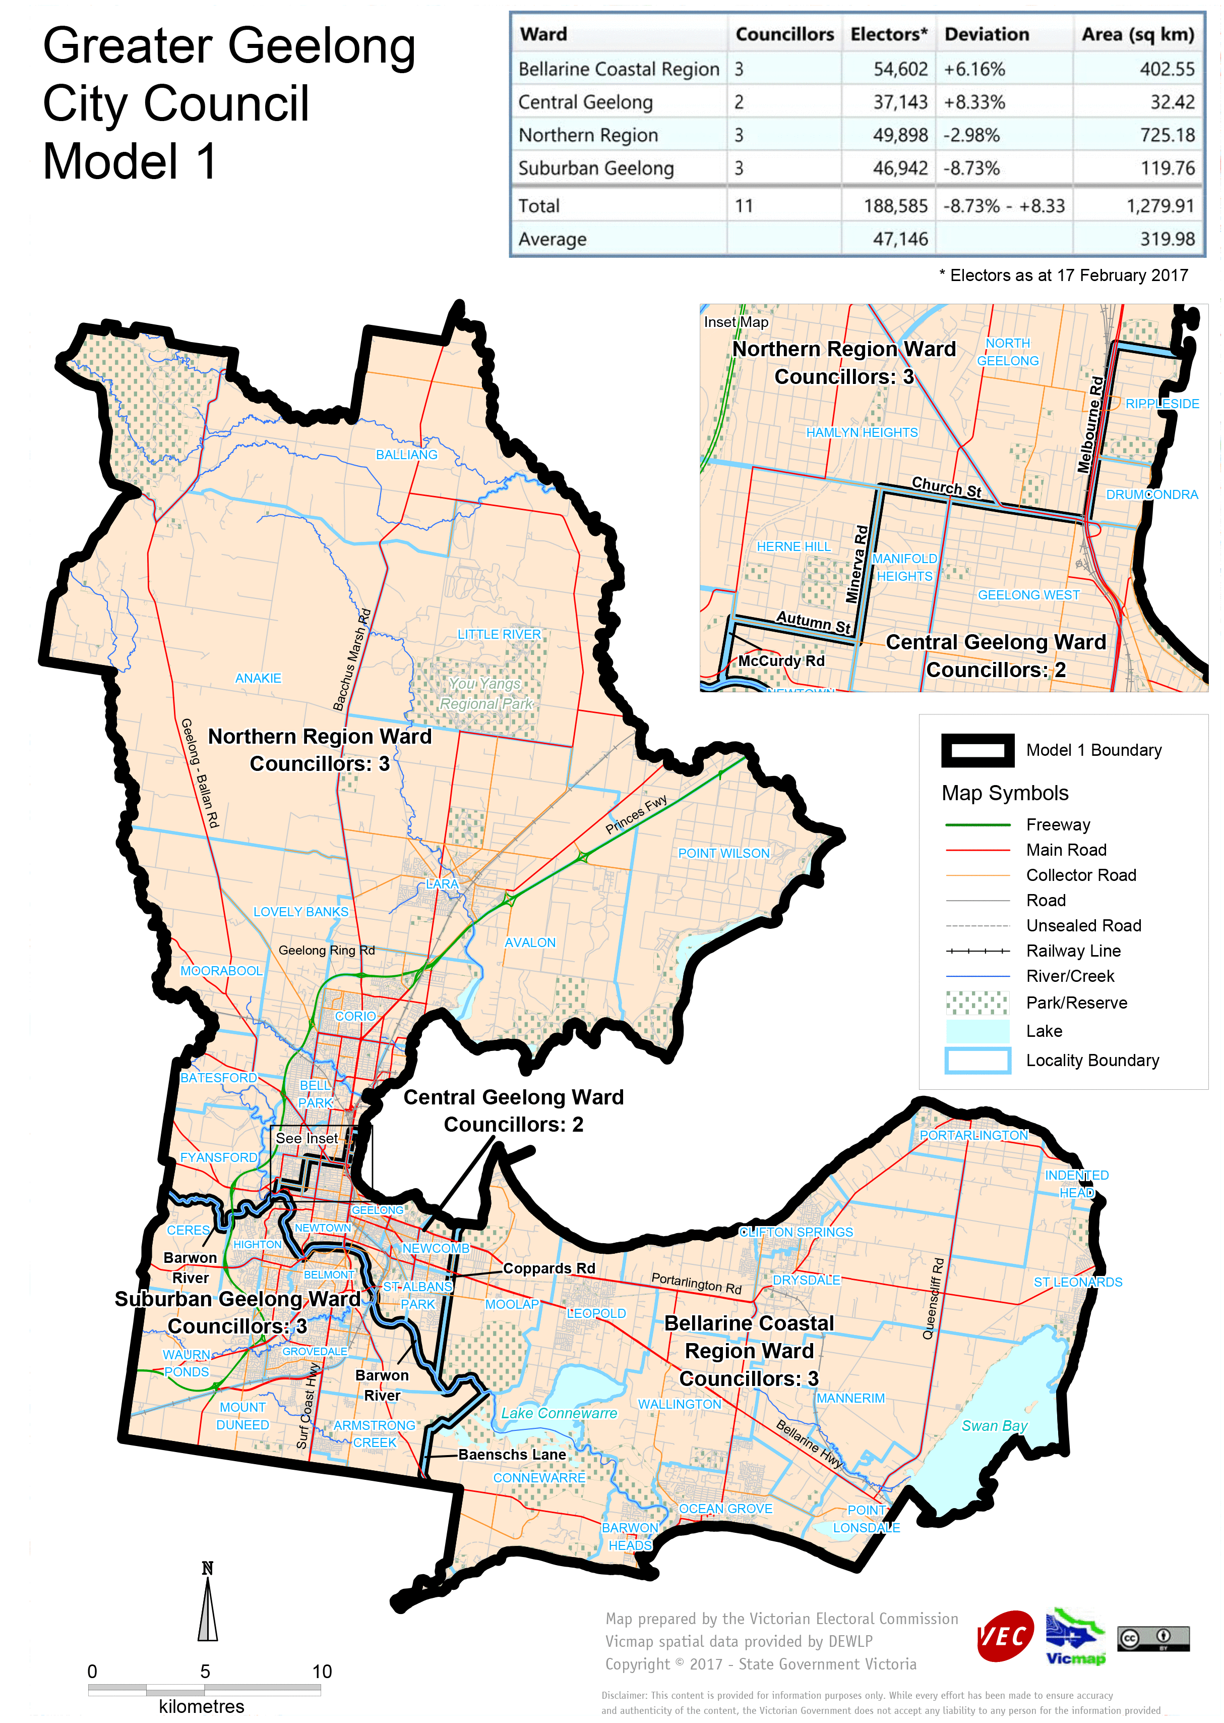
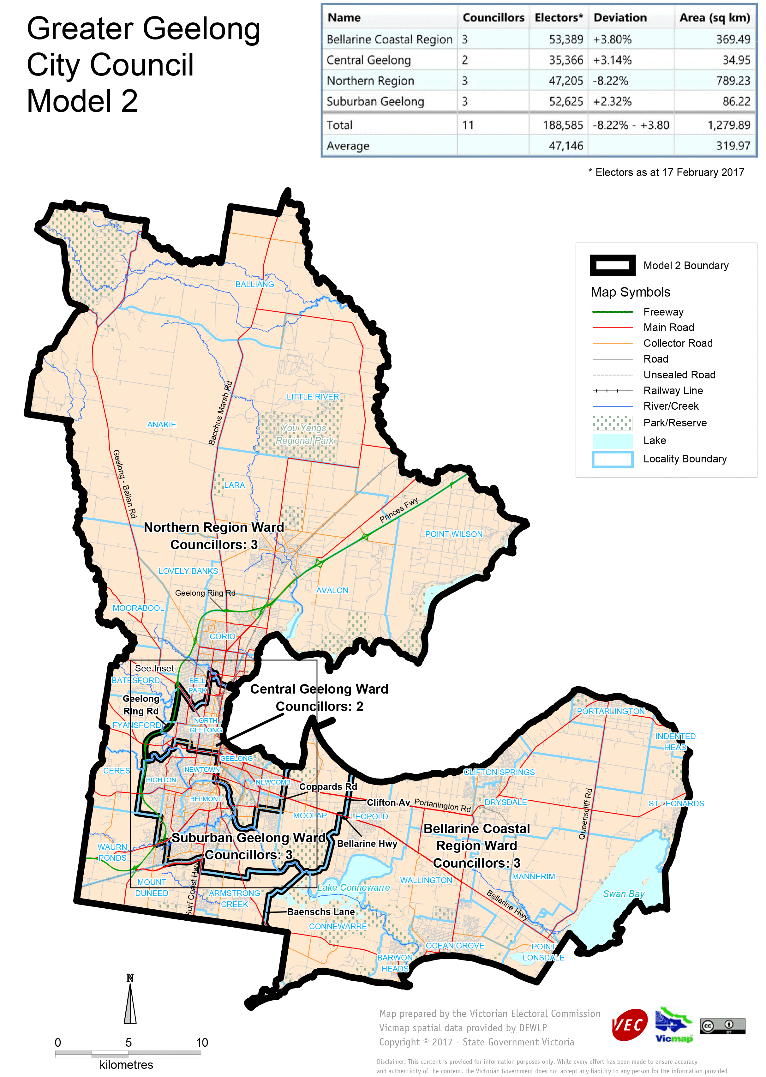

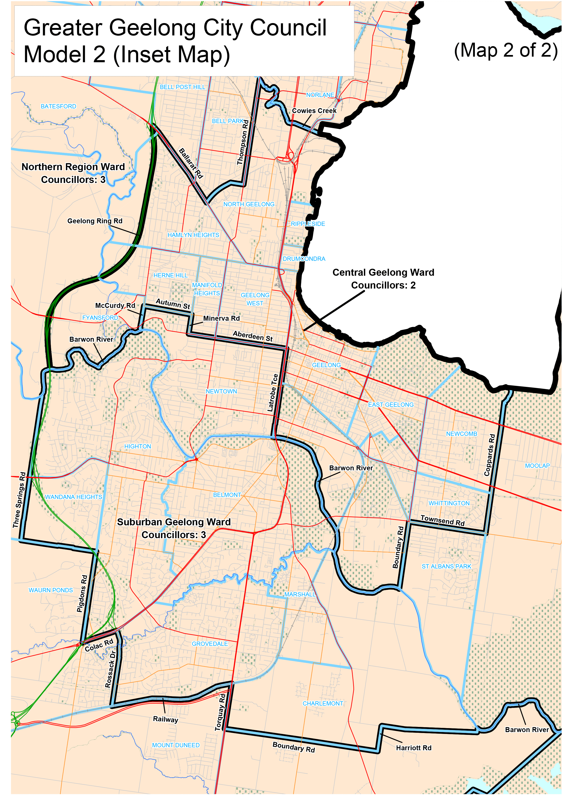
Victorian Electoral Commission
Level 11, 530 Collins Street
Melbourne VIC 3000
131 832
greatergeelong.review@vec.vic.gov.au

© State of Victoria (Victorian Electoral Commission) 2017.
This work is licensed under a Creative Commons Attribution Non-Derivatives 4.0 licence (http://creativecommons.org/licenses/by-nd/4.0/).
You are free to share this work under that licence, on the condition that you do not change any content and you credit the State of Victoria (Victorian Electoral Commission) as author and comply with the other licence terms. The licence does not apply to any branding, including Government logos or the Easy English icon.

Geelong Citizens’ Jury Final Report, January 2017, p. 4.
Victorian Government Response to the Geelong Citizens’ Jury, pp. 9, 18, 33.
The Echo, Geelong Independent, Ocean Grove Voice and Bellarine, Surf Coast and Armstrong Creek Times.

