
Victorian Electoral Commission
2021-2022 Annual Report
Department of Health

Sharpening our focus.

Victorian Electoral Commission
Level 11, 530 Collins Street
Melbourne VIC 3000
Telephone: 03 8620 1100
Website: vec.vic.gov.au
Email: info@vec.vic.gov.au
Office hours:
8.30 am to 5 pm
Monday to Friday

Letter of transmittal
The Hon. Danny Pearson MP
Assistant Treasurer
Minister for Regulatory Reform
Minister for Government Services
Minister for Housing
1 Treasury Place
Melbourne VIC 3002

Dear Minister
In accordance with the requirements of the Financial Management Act 1994, I am pleased to submit the Annual Report of the Victorian Electoral Commission for the year ending 30 June 2022 for presentation to Parliament. Also included is the Report of the Electoral Boundaries Commission 2021–22 for the year ending 30 June 2022.
Yours sincerely

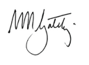

Warwick Gately AM
Electoral Commissioner

The Victorian Electoral Commission (VEC) pays respect to Victoria’s Traditional Owners and their elders past, present and emerging, who have been custodians of this country for many thousands of years. Their living culture and their role in the life of Victoria is acknowledged by the VEC.

Contents
Abbreviations and acronyms 7
About the VEC 10
About this report 12
Our highlights 14
Our challenges 14
Our year 15
Finance at a glance 20
Our strategic plan 24
Our commission 32
Governance 33
Organisational structure 34
The Office of the Electoral Commissioner 35
The Executive Management Group 38
Internal committees and groups 46
External advisory groups 50
Governing legislation and tribunals 53
Accountability and transparency 54
Disclosures 58
Information Technology 64
Warehouse 66
Our core business 69
Electoral activity 70
Enforcement of compulsory voting 79
Electoral structure and boundary reviews 82
Register of electors 84
Communication services 94
Research and development 96
Funding and disclosure 98
Our stakeholders 104
Inclusion and participation 107
Services to political parties 121
Interaction with electoral bodies 124
Our people 128
Inspired people 129
Staff profile 133
Occupational health and safety 135
Financial statements 144
Financial report 145
Declaration in the financial statements 149
Comprehensive operating statement 150
Balance sheet 151
Statement of changes in equity 152
Cash flow statement 153
Notes to the financial statements 154
Auditor–General’s report 192
Appendices 194
Glossary 209
Index 213

Abbreviations and acronyms
AEC | Australian Electoral Commission
AEM | Assistant Election Manager
AIP | Aboriginal Inclusion Plan
BDM | Births, Deaths and Marriages Victoria
CALD | Culturally and Linguistically Diverse
CCYP | Commission for Children and Young People
COAG | Council of Australian Governments
COVID-19 | Coronavirus
DA | Democracy Ambassador
DAIP | Disability Access and Inclusion Plan
DoT | Department of Transport
DPC | Department of Premier and Cabinet
DTF | Department of Treasury and Finance
DWG | Designated Work Groups
EAAG | Electoral Access Advisory Group
EAP | Employee Assistance Program
EBC | Electoral Boundaries Commission
EBC Act | Electoral Boundaries Commission Act 1982
ECANZ | Electoral Council of Australia and New Zealand
Electoral Act | Electoral Act 2002
EM | Election Manager
EMC | Electoral Matters Committee
EMG | Executive Management Group
EMS | Election Management System
EO | Election Official
ERRN | Electoral Regulation Research Network
FMCF | Financial Management Compliance Framework
FOI Act | Freedom of Information Act 1982
FRD | Financial Reporting Directions
FTE | Full time equivalent
HSR | Health and Safety Representative
HSW | Health, Safety and Wellbeing
IPAA | Institute of Public Administration Australia
IRP | Issue Resolution Procedures
JRMB | Joint Roll Management Board
JRMC | Joint Roll Management Committee
KMP | Key Management Personnel
LGA 1989 | Local Government Act 1989
LGA 2020 | Local Government Act 2020
LGI | Local Government Inspectorate
LSL | Long service leave
LTI | Lost time injury
MIP | Multicultural Inclusion Plan
MOU | Memorandum of Understanding
OHS | Occupational Health and Safety
OHSC | Occupational Health and Safety Committee
OHSMS | Occupational Health and Safety Management System
OVIC | Office of the Victorian Information Commissioner
PG | Planning Group
PID Act | Public Interest Disclosures Act 2012
PMC | Prime Minister and Cabinet
PMO | Project Management Office
PMS | People Matter Survey
PROV | Public Record Office of Victoria
PTD | Passport to Democracy
RMS | Roll Management System
RoU | Right of Use
RSC | Resource Smart Committee
RTW | Return to work
SEO | Senior Election Official
SLG | Senior Leadership Group
VCAA | Victorian Curriculum and Assessment Authority
VEC | Victorian Electoral Commission
VicSRC | Victorian Student Representative Council
VIPP | Victorian Industry Participation Policy
VPS | Victorian Public Sector
VPSC | Victorian Public Sector Commission

About the VEC

Our history and functions
Elections for the Victorian Parliament began when Victoria achieved independence from New South Wales in 1851. In 1910, Victoria’s first Chief Electoral Inspector was appointed to head the new State Electoral Office.
The State Electoral Office existed as part of a public service department for 70 years. However, it became increasingly clear that it was inappropriate for the conduct of elections to be subject to ministerial direction. On 1 January 1989, legislation established the independent statutory office of Electoral Commissioner, who was to report to Parliament instead of a Minister. In 1995, the State Electoral Office was renamed the VEC.
The VEC’s functions and operations are governed by six main pieces of legislation:
The Electoral Act 2002 (Electoral Act) establishes the VEC as an independent statutory authority, sets out its functions and powers and prescribes processes for State elections.
The Constitution Act 1975 sets out who is entitled to enrol as an elector, who is entitled to be elected to Parliament, and the size and term of Parliament.
The Financial Management Act 1994 governs the way the VEC manages finances and financial reporting.
The Electoral Boundaries Commission Act 1982 (EBC Act) governs the determination of State electoral boundaries. Under this legislation, the Electoral Commissioner is nominated as a member of the Electoral Boundaries Commission (EBC).
The Local Government Act 2020 (LGA 2020) provides for the conduct of local government elections. The LGA 2020 received Royal Assent on 24 March 2020 and replaced the Local Government Act 1989 (LGA 1989).
The Infringements Act 2006 provides for stages two and three of compulsory voting enforcement.
Subject to these Acts, the VEC:
maintains the electoral enrolment register
conducts State elections, local government elections, statutory elections and polls, and fee-for-service elections
conducts electoral boundary reviews
administers political funding and donation disclosure laws.
The VEC also has a mandated role to conduct electoral research, provide communication and education services, and inform and engage Victorians in the democratic process.
A complete list of legislation and regulations governing the VEC is included in Appendix B.

Our people and partners
Creating and sustaining a work environment that supports, nurtures and inspires our people is core to the VEC’s operating model. The VEC ensures through practice that its people are engaged, capable and equipped to support democracy in Victoria.
The VEC achieves this by prioritising staff capability development to meet service delivery; recruiting for ability and attitude; encouraging and supporting innovation and new ways of working; fostering concrete learning and reflective practices.
The VEC focuses on its core workforce of dedicated people, as well as the election officials and contractors fundamental to complementing the work of its core staff. Valued partnerships with suppliers also contribute greatly to the VEC’s achievements.
A fundamental principle at the VEC is that our organisation is safe, diverse and inclusive and that it reflects the community we serve. The VEC achieves this through the breadth of staff engaged and by working closely with advisory and community groups. The VEC continues to strive to ensure all people are included in the electoral process. These groups comprise members of under-represented communities, including:
Aboriginal and Torres Strait Islander communities
young people
people experiencing homelessness or in prison
people living with disabilities
culturally and linguistically diverse communities.
The VEC acknowledges and is appreciative of the engagement from all advisory and community group members and their organisations for their contributions during 2021–22. The VEC thanks them for their continuing and constructive partnership.

Our purpose
To deliver high-quality, accessible electoral services with innovation, integrity and independence.

Our values
Independence: acting with impartiality and integrity.
Accountability: transparent reporting and effective stewardship of resources.
Innovation: shaping our future through creativity and leadership.
Respect: consideration of self, others and the environment.
Collaboration: working as a team with partners and communities.

Our vision
All Victorians actively participating in their democracy.

About this report

This report provides a summary of the activities, programs and initiatives undertaken by the VEC in delivering on its responsibilities and the key objectives of Strategy 2023.

This report has been published in accordance with Financial Reporting Direction (FRD) 30C. As part of the VEC’s environmental sustainability activity, only the required number of reports were printed, and environmentally friendly paper and printing processes were used.

Our year
In this section, the Electoral Commissioner, Warwick Gately AM, provides a summary of key activities, achievements for 2021–22 and the outlook for 2022–23. The summary covers the VEC’s operational activity; preparations for the 2022 State election; the VEC’s progress in implementing Strategy 2023; and commentary on how the VEC has engaged with its community and key contacts through the contribution of its people. Also discussed is how the VEC met its general compliance, reporting and accountability responsibilities.
Chief Financial Officer, Binh Le, provides an overview of the VEC’s financial performance. This section includes a summary of the VEC’s achievements against its strategic initiatives.

Our commission
Good corporate governance and transparent reporting help ensure continued public confidence in the VEC and its processes.
This section provides detail of the VEC’s regulatory environment, its governance and organisational structures, key people and staff profiles, disclosure requirements, and the corporate systems that enable the VEC to deliver its core business and operate effectively and efficiently on a day-to-day basis.
Accountability to the Victorian public and Parliament is critical, and the VEC’s good corporate citizenship is evidenced by its performance in areas such as diversity, inclusion, accessibility, sustainability, information management and reporting.
Information relating to internal and external advisory groups is also detailed in this section. These advisory groups play an important role for the VEC.

Our core business
This section includes information about the VEC’s core business, which includes the conduct of elections, maintenance of the register of electors, ensuring fair and equitable representation for voters at State and local government levels, and administering Victoria’s political funding and donation disclosure laws.
Part of the VEC’s core business is also focused on building communication capability to increase the awareness of, and engagement with, electoral events and matters.
This financial year realised the delivery of the 2021 South Gippsland Shire Council local government election. 20 other election activities were also conducted, including local government by-elections, countbacks and commercial elections and polls.

Our stakeholders
The VEC has a broad diversity of stakeholders that are essential to achieving the organisation’s vision. This section highlights the priority the VEC places on continually improving engagement with electors, candidates, political parties and electoral bodies.
The VEC’s Diversity and Inclusion Framework continues to be embedded through a range of organisation-wide inclusion plans, to support addressing the needs of those traditionally under-represented in the electoral process. An update on all existing inclusion plans and related community engagement work for 2021-22 is outlined. Furthermore, the services to candidates and the registration of political parties is summarised. Finally, the work completed with various national and international electoral bodies which aims to support innovation and electoral harmonisation is outlined.

Our people
The VEC’s continued success depends on skilled and dedicated people with deep, specialised knowledge. To attract and retain talent, the VEC offers an empowering, engaging and inspiring place to work.
This section highlights the VEC’s continued investment in building capability across the organisation and its approach to supporting Strategy 2023.

Financial statements
The VEC is pleased to provide ‘value for money’ electoral services to the Victorian public. Once again, the VEC’s sound and robust financial management is evidenced in this section by an unqualified report from the Auditor-General. This section also provides the VEC’s audited financial statements for 2021–22.

Appendices

Glossary

Index

Our highlights
Delivered the 2021 South Gippsland Shire Council general election.
Customer journey mapping for key stakeholders required to interact with the VEC and subsequent development of voter personas.
Continued delivery of the Leadership Excellence Accelerator Program (LEAP), a suite of leadership journeys aligned to the VEC Leadership Capability Framework across all levels of VEC staff.
Conducted local government by-elections, countbacks, commercial elections and polls under COVID-19 restrictions requiring the redesign of services including candidate information sessions, ballot draws, counting activities, and declaration of results.
Established a dedicated electoral compliance capability and specialised electoral compliance team.
Achieved gold for the VEC Annual Report 2020–21 at the 2022 Australasian Reporting Awards for the 10th year in a row, as well as Best Cover Design 2022.
Completed the Inaugural Workforce Gender Equality Audit and Gender Equality Action plan and submitted these to the Commission for Gender Equality in the Public Sector.
Extended flexible work arrangements. The challenges experienced in 2020–21 continued to be felt in 2021–22. The VEC continued to support a hybrid office-first approach that promotes both onsite and remote working environments.
Launch of the VEC’s Online Research Panel.
Successful completion and deployment of the Election Management System (EMS) redevelopment program to support delivery of future electoral events.
Implemented the VEC’s Diversity and Inclusion Framework, which includes the VEC’s Disability Access and Inclusion Plan 2019–23, Multicultural Inclusion Plan 2020–23 and Young People Inclusion Plan 2021–23.
Provided administrative and technical assistance to the Electoral Boundaries Commission (EBC) for the redivision of State electoral boundaries including publication of the final boundaries report on 28 October 2021.

Our challenges
Building a State election work program with some uncertainty about regulations to replace Electoral Regulations 2012 which sunset in August 2022.
Identifying and embracing new and innovative ways of working in a continually evolving work landscape. This included the introduction of a new Future Focus Program which will develop transformational change projects to future-proof VEC service delivery.
The need to manage future financial risks whilst maintaining acceptable service levels. This included the introduction of a financial sustainability program which provides a framework for sustainable budget management and operational planning and guides sustainable financial decision making.
Maintaining strong levels of engagement with key external stakeholders both at State and National level, such that operational decisions and changes were expected and understood.

Our year


Warwick Gately AM
Electoral Commissioner

As for all Victorians, COVlD-19 continued to impact all staff, in both their work and private lives. Intentionally, the VEC remained focused on staff wellbeing, providing a variety of flexible work options, wellness programs, resources and acknowledgements, noting their very effective contribution to the delivery of Commission responsibilities and obligations.

Little respite
Ordinarily, 2021–22 would be considered a ‘gap year’ for the Victorian Electoral Commission (VEC), a period of respite between significant election events. A chance to take stock and sharpen our focus for the work ahead. Yet the external circumstances prevailing in Victoria, principally due to COVID-19 and other pressures, disrupted any quietness and required a disciplined approach to our work and staff wellbeing.
While the completion of the 2020 local government election program was significant, this allowed the VEC to immediately shift attention to the 2022 State election. By December 2021, the VEC had issued its draft service plan and was well advanced in its planning and had started to implement critical preliminary activity associated with the State election. This activity included recruiting senior election officials, engaging several major suppliers and identifying election related premises and facilities.
By itself, this early activity and that into 2022 understates the enormity and complexity around the delivery of a state-wide parliamentary election. An event that will ultimately involve nearly 17,500 casual staff, more than 1800 voting centres and venues, the production of some 10 million ballot papers and other materials and, importantly, provide the opportunity to vote to over 4.3 million eligible Victorians. At the end of this reporting period, and with just four months before the issue of writs for the State election, the VEC was well placed to deliver on its responsibilities.
As stated, there was little respite this year. The need to complete critical election system enhancements and an election readiness program of work placed strain on subject matter experts, business analysts and developers. This in turn was complicated by the retirement and departure of several long serving members and the need to backfill and then upskill replacements; all of whom have brought energy, imagination and enthusiasm to their work.
Added to this, the emergence of a new COVID-19 variant in early 2022 required review of our business continuity arrangements and the strengthening of workplace health and safety requirements. While the VEC is well practised in working from home, the delivery of a State election does require an in-office presence at critical points and this attendance during 2022 required careful management.

Plans and operations
The VEC’s Planning Group (PG) was singularly focused on the delivery of the 2022 State election. The State Election Service Plan was operationalised via a program of work established mid-2021 and comprising 14 work programs. These work programs covered all election service delivery requirements from communications to compliance to materials production and outlined the project responsibility hierarchy. The success of this program in guiding our preparation was evident and, at the end of June, many projects such as funding and disclosure system enhancements, and improvement to the VEC website and the roll look-up program were complete or in their final stages. For the election, there will be an emphasis on cyber and physical security, the integrity and accuracy of operations, compliance, the technical competency of staff and their wellbeing. All will be complicated in some way by COVID-19, which in turn has required a specific COVIDSafe Election Plan and the recall of an expanded specialist Reference Group to monitor our health and safety preparations.
Over the year, 21 electoral activities were conducted. This included the South Gippsland Shire Council general election, which realised a strong turnout of 81.5% despite some logistic challenges, and other local government by-elections, countbacks and commercial elections and polls. With the assent of the Liquor Control Reform Amendment Act in November, the requirement for the VEC to conduct ‘dry area’ polls of electors on licensing applications was permanently removed.
As a significant milestone, the long-running Election Management System (EMS) redevelopment project was completed. Commenced in 2011 and delivering various election-related control modules over this time, the redevelopment in its entirety has been successful. While within budget, yet well outside projected delivery schedules, the challenge for the VEC was always balancing development against election timing and the release of expert staff for requirements, analysis, testing and commissioning.
This is important, as the VEC now embarks on a complex project to replace the State’s Roll Management System (RMS) by the end of 2023.
With evident good progress on the VEC’s strategic plan Strategy 2023, including a midstream review, the VEC established three broad areas of focus for the remainder of its outlook period. While inspired people, empowered electors and smart solutions identified an adjusted direction to our business and investment priorities, these focus areas also aligned strongly with our intentions in conducting the State election. In the next reporting period, the VEC will consider a new strategic plan.

Managing the future
An identified weakness in the organisational arrangement of the VEC is that of its ‘future focus’. While medium-term system and operational improvements are routinely identified, there has been limited capacity of both staff and funding, outside of daily activity, to identify and implement a regular channel of work to modernise the VEC. The appointment of a Program Manager and the formation of a Future Focused Program Team without routine Commission responsibilities should address this innovation/modernisation gap.
This was assisted with the reframing of the Senior Leadership Group, with a reduction in member numbers to those reporting to executives and then a further smaller group to take a more active role in strategy and operations.
Similarly, during the year there were adjustments to some branch structures. In the Electoral Integrity and Regulation Branch, this came about after a formal review of the Branch’s performance in their two years of operation. In the Elections Branch, with the State election looming, transitional changes were made to remove key person dependencies, to relieve high workloads and improve reporting lines.
Notwithstanding, it will be necessary in 2023 to consider the organisational design of the Commission to ensure service delivery objectives are being met efficiently and that contemporary arrangements continue to provide satisfying work and career opportunities. While a significant piece of work, it will align with a new strategy.

Financial Management and Compliance
On financial performance, the VEC operated within its appropriation of $50.12 million, which included an amount of $6.5 million allocated to early State election expenditure and ultimately part of an expected $85 million total election cost for 2022–23. Staying within the appropriation is proving increasingly difficult with Parliament expecting constant improvement and expansion in election services, systems modernisation, and cyber security enhancements. As an example, replacing the aging RMS will cost about $10 million, with the capital component consuming all available capital funding over the next two financial periods. This, and expanded responsibility in the administration of political funding and donation disclosure laws and compliance, will require a review and increase in the VEC’s special appropriation.
The Audit and Risk Committee met twice in person and twice online. The Committee’s focus this year was on risk, compliance and business continuity leading into the State election. The direction and support of the Committee was again highly valued, and I acknowledge the contribution of Mr Mick Ulbrick, as an independent Committee member, on concluding his term on 12 August 2021.
Relevantly, the internal audit program for the year was limited given the Commission’s restricted capacity to support and respond to extensive inquiry at the same time as election planning. However, internal audits did inquire into the robustness of our cyber-security control framework and the effectiveness of our enterprise risk management, along with the standing review of compliance with Ministerial directions. These audits aligned with our strategic risk profile, revealing minor areas for attention.

Our people, our teams, our leadership
As for all Victorians, COVID-19 continued to impact all staff, in both their work and private lives. Intentionally, the VEC remained focused on staff wellbeing, providing a variety of flexible work options, wellness programs, resources and acknowledgements, noting their very effective contribution to the delivery of Commission responsibilities and obligations. Accordingly, a new staff-led Workforce Resilience program was established to improve and strengthen wellbeing, social cohesion and psychological safety at work. This was achieved through a staff reference group based on the principles of community-led disaster recovery and the ‘nothing about us without us’ approach often used in our community engagement strategies.
An important consideration early in 2022 was the introduction of a vaccination policy as a condition of entry to VEC worksites. There is an obligation upon me to provide and maintain a work environment that is safe and without risk to staff so far as is reasonably practicable. This required meaningful consultation with staff, OHS and union representatives, and specialist and legal advisors. Consequently, the determination to mandate vaccinations for workplace safety was supported and acted upon by the vast majority.
Our success with our initiatives over the year could be evidenced in Pulse Surveys and People Matter Survey results, with staff engaged and generally satisfied with their work and work life at the VEC. Survey responses placed the VEC slightly above its cohort agencies and above the VPS generally.
With this, I note the positive influence of the senior leaders within their branches and across the VEC and undertake to continue with their development and to provide further opportunities for advancement within the VEC. As I look across the Commission and its performance this year, I again praise and thank all staff for their efforts.
Members of the Executive Management Group (EMG) must also be recognised for their proficiency and professionalism in the control and direction of the VEC and in their advice to me. During the year, I welcomed Dana Fleming as the Deputy Electoral Commissioner, Chris Pivec as the Chief Information Officer and Ben Sutherland as the Director, Elections. I thank Jon Underwood on his departure from the VEC, noting his positive impact on the Commission’s ICT suite, preparedness, and security arrangements.
I will acknowledge the contribution made to the VEC by Glenda Frazer and Sharon Rogowski, both retiring in the course of 2021 and accumulating between them 45 years of service. Each influenced the work of the Commission and the Victorian electoral landscape in their own way and in a manner of which they can be proud.

Responding to Governing legislation and inquiries
In a term of Government, it can be expected that there will be changes to legislation relating to the conduct of elections. While this was the case this year, reforms to the Electoral Act 2002 were minimal and generally administrative in nature, falling short in some areas. Subordinate legislation in the form of the Electoral Regulations expected to be made mid‑August provide a further opportunity for minor reform. Consequently, the VEC will need to approach the incoming Government in early 2023 to make its case for progressive electoral reform.
The VEC’s engagement with the Electoral Matters Committee was positive with a submission to an inquiry into whether Victoria should participate in a national electoral roll platform. A response was also provided to Government on the Committee’s September 2021 report following the inquiry into the impact of social media on elections and electoral administration. As this reporting period ended, the VEC was providing the Committee written briefs on State election preparations.
Under the Electoral Boundaries Commission Act 1982, the Electoral Boundaries Commission (EBC) released its final report on the redivision of State electoral boundaries on 28 October 2021. Therefore, Victoria will proceed to the 2022 State election with all electoral districts and regions within approximate enrolment equality, with 21.28% of the State’s electors transferred to different electoral districts. The mapping, research and general support provided to the EBC by the VEC was outstanding.
The VEC was very active in administering and enforcing Victoria’s political funding and donation disclosure laws, which have been in operation in the Electoral Act 2002 since 2018. At the end of this period the VEC had distributed over $12.60 million to eligible entities with political funding entitlements. Due by 20 October 2021, 74 entities submitted their annual returns through an online disclosure system. These returns were examined, prompting compliance action in a few cases with the public release of the returns in mid-December. During the 2023 calendar year, a formal Parliamentary review of the operation of this part of the Act will commence.

Over the horizon
The next reporting period will be dominated by the VEC’s commitment to the compliant, safe and efficient delivery of the 2022 State election, where it must be assumed that the uncertainties of the past two years will continue. This will place an inordinate pressure on staff in managing their workloads, their personal circumstances, and their own wellbeing. The Commission will do all it can to support each individual while delivering on its responsibilities. Wellbeing aside, the training and development of our workforce will continue around the demands of their daily work.
Early 2023 will be spent in analysis of the election through internal inquiry, external surveys and workshops with key election management staff. Ultimately, a report to the Parliament of Victoria will follow. This will include recommendations to improve the administration of elections.
An organisational review will be necessary. While Branch reviews have been conducted and changes implemented there has not been consideration of the operation of the Commission as a whole and therefore whether our service delivery obligations are being met economically and efficiently. This naturally sits alongside the development of the next strategic plan.
By December 2022, the VEC will have progressed the new Roll Management System replacement project. Work so far has necessarily centred on system requirements and business process analysis due to other election-related development priorities. Now, attention can be given to this critical project as part of the VEC’s future focus agenda.
Under the Local Government Act 2020, the VEC has an important role in the conduct of council electoral structure reviews and ward boundary reviews to ensure fair and equitable representation for communities. Electoral Representation Advisory Panels will be established, supported by the VEC, and will recommend electoral structures to the Minister for Local Government. Both the Electoral Commissioner and Deputy Electoral Commissioner will be involved in this work, which in 2023 will likely consider the electoral structures of 39 councils and if requested the ward boundaries of a further 16 councils.
As noted 12 months ago, the VEC can again approach this next year with full confidence given the experience of staff, their dedication and optimism. I remain enormously impressed with the professionalism and enthusiasm they bring to every challenge.

Warwick Gately AM
Electoral Commissioner

Finance at a glance

The VEC’s special appropriation funding fluctuates significantly over the four-year cycle, as can be seen in Figure 1. Every two years, the VEC undertakes either a State election or a local government election program. As the reporting financial year is a non-election year, the VEC’s overall funding and expenditure decreased in comparison to 2020–21. Total funding received during 2021–22 was $50.12 million, which is made up of VEC base level funding plus some funding brought forward from 2022–23 to support readiness for the 2022 State election. Resources and funding were largely allocated to the VEC operating and maintenance environment, which included servicing 21 electoral events and progressive planning and readiness towards the 2022 State election. The VEC also committed a significant amount of capital resource towards the successful delivery of the Election Management System (EMS) 2 platform, funding and disclosure system, and other enhancements such as website and roll look-up software.

Financial performance
Figure 1: Five-year financial summary 2017–18 to 2021–22
 | 2017–18  $’000 | 2018–19  $’000 | 2019–20  $’000 | 2020–21  $’000 | 2021–22  $’000
Electoral activity |  | State election |  | Local* government elections
Special appropriation | 33,606 | 89,620 | 37,536 | 74,949 | 50,122
Total expenses from transactions | 34,260 | 94,298 | 38,576 | 80,373 | 50,736
Net result from transactions | (654) | (4,678) | (1,040) | (5,424) | (614)
Operating result | (652) | (4,780) | (966) | (5,338) | (242)
Net cash flow from/(used in) operating activities | (39) | (14) | 531 | (241) | (206)
Total assets | 17,158 | 17,939 | 23,999 | 24,343 | 30,935
Total liabilities | 5,280 | 5,805 | 6,120 | 6,795 | 7,919
Net assets | 11,878 | 12,134 | 17,879 | 17,548 | 23,016
Note: prior year amendment applied to 2020–21 balances. Please refer Note 9.7 in the financial report for supporting information

Funding
Figure 2: Special Appropriation ($’000) 2017–18 to 2021–22
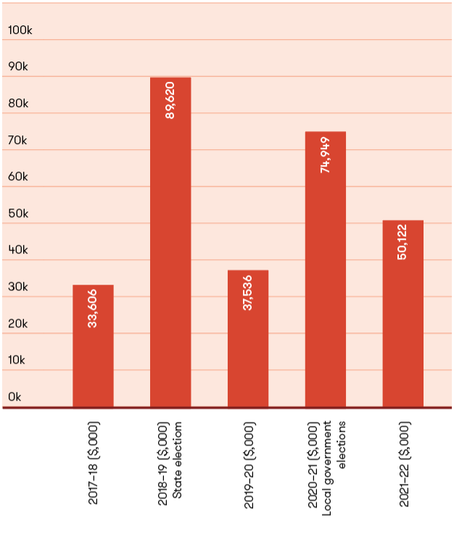
The VEC received $50.12 million in funding for 2021–22, which is significantly less than the prior year of $74.95 million. The VEC is funded solely from Government special appropriations and this amount represents the reimbursement to the VEC for all its cash payments.
In addition, the VEC administers or manages other activities and resources on behalf of the State and local governments, and this income for the year was $18.45 million. This is not shown in the VEC financial results or in the financial statements, but is presented in Note 4.1: Administered (non-controlled) items. The administered activities are made up of:
revenue collected by the VEC on behalf of the State, which is forwarded to the Department of Treasury and Finance as consolidated revenue
monies receipted from election fines and forfeited candidate deposits collected by the VEC on behalf of councils and the State
payment of 2022 State election advance public funding and administrative expenditure funding following the introduction of political funding and disclosure legislation in August 2018.

Expenditure
The VEC incurred $50.74 million in operational expenses for the financial period. The majority of VEC’s funding was committed towards enhancing the operational environment, conducting by-elections and commercial elections, and early planning towards the November 2022 State election. Expenditure towards State election commitments include inventory such as ballot material, the early onboarding and appointment of election staff to enhance workforce capability, maintenance improvements to VEC’s bespoke in-house systems and other associated programs.

Financial position
The VEC’s financial position remains strong with total assets of $30.94 million, liabilities at $7.92 million and overall net equity of $23.02 million. The VEC’s assets are largely comprised of the new Election Management System (EMS2), the Funding and Disclosure system, enhancements to VEC enterprise platforms, ongoing investment in election infrastructure, cyber security, and election inventory including PPE, many of which are investments ahead of the November 2022 State election. The majority of VEC systems and programs are custom built to enable the VEC to conduct elections in accordance with legislative requirements. These capital investments are presented as intangible assets. Further, the VEC does not hold a cash reserve in its bank accounts as it is reimbursed daily for all outgoings incurred.
The VEC’s liabilities largely comprise employee entitlements and year-end expenditure accruals. The equity of the VEC is split into contributed capital, asset reserve and accumulated loss. The contributed capital represents the amount of funding contributed by the Government of Victoria for the purchase and development of VEC non-current assets. The accumulated loss represents the accumulated result from continuing its operations.

Operational and budgetary objectives and performance against objectives
The VEC has three performance measures that relate specifically to Budget Paper Number 3 (BP3) Service Delivery, in accordance with the Department of Treasury and Finance (DTF) FRDs. The following table (Figure 3) provides details of the output report provided by the VEC to the Government, including performance measures and targets for agreed outputs, and the actual performance results for the VEC over the full year ending 30 June 2022.
Figure 3: Performance against Budgetary Objectives, 2017–18 to 2021–22
 | STATE ELECTIONS, LOCAL GOVERNMENT AND STATUTORY ELECTIONS, BY-ELECTIONS, POLLS AND ELECTORAL REPRESENTATION REVIEWS | LEGAL CHALLENGES TO VEC CONDUCT UPHELD | CHANGES TO ELECTOR DETAILS OR ADDITIONS TO THE VICTORIAN ENROLMENT REGISTER PROCESSED WITHIN SET TIMEFRAMES
2017–18 BP3 target | 32 | - | 95%
2017–18 BP3 actual | 27 | - | 82%
Variance | -16%¹ | 0% | -14%²
2018–19 BP3 target | 115 | - | 95%
2018–19 BP3 actual | 117 | - | 97%
Variance | 2% | 0% | 2%
2019–20 BP3 target | 22 | - | 95%
2019–20 BP3 actual | 23 | - | 100%
Variance | 4.5% | 0% | 5%
2020–21 BP3 target | 22 | - | 90%
2020–21 BP3 actual | 10 | - | 100%
Variance | -55%³ | 0% | 10%⁴
2021–22 BP3 target | 28 | - | 90%
2021–22 BP3 actual | 21 | - | 98.9%
Variance | -25% | 0% | 9%
¹ Less than anticipated number of local government vacancies to be filled by a countback. Additionally, a reduction to the number of liquor licensing polls conducted.
² The VEC’s enrolment campaign schedules were extended early in the reporting year due to the sudden insolvency of the VEC’s mail services contractor and the Australian Marriage Law Postal Survey. Enrolment turnaround times measured above 95% for key VEC electoral events.
³ The 2020 local government election program was only listed as 1 election event whereas the VEC actually conducted elections for 76 individual councils.
The delivery of 2020 local government elections resulted in fewer by-elections and countbacks arising after the event.
⁴ The VEC introduced improvements to scheduling and processing activities that ensured enrolment transactions were processed within set timeframes.
Despite the challenges of COVID-19, the VEC has successfully adapted, implementing working arrangements to support the processing of enrolment transactions throughout the reporting period.

Our strategic plan

The VEC continued to make good progress towards the goals of the VEC’s strategic plan, Strategy 2023. The VEC’s five-year goal is that it is change-ready and has the people, systems and relationships to make the most of its opportunities.

The VEC is currently focusing on three priority themes in order to deliver on the VEC’s five-year goal: Inspired People, Empowered Electors and Smart Solutions.
Inspired people
Our people are engaged, capable and equipped to support democracy in Victoria
As an employer of choice, we will create an environment that inspires our people to reach their full potential. Our skilled workforce will have an innovation mindset and be equipped for the challenges ahead. Our people will embrace change as ‘business as usual’.
Our priorities
Capability development and learning and development
Trusted leadership at all levels
Innovation and new ways of working
Continuous learning environment and reflective practice
Diversity and inclusion initiatives
Empowered electors
Our services are relevant, accessible and inclusive, and place electors at the centre of everything we do
We are an outward-looking organisation, attuned to the needs of electors. We will learn from and work with Victorian communities to improve access for all Victorians through secure, smart and technology-enabled services. Electors will have service choice, control and confirmation to the standard they expect, now and into the future.
Our priorities
- Accessible, elector-centric services with a strong focus on user experience standards
- Integrity and trust in our services and the electoral system
- Stakeholder engagement and strategic partnerships
Smart solutions
VEC’s systems and processes are sustainable, enabling and continually improving
Our business practices will be efficient, sustainable and transparent, and our conduct will support trust and confidence in Victoria’s democracy. We will make smart decisions, on time and by the book, and make intelligent use of information and resources to solve problems and improve services. Our technology will help drive continuous improvement and enable our team to deliver seamlessly.
Our priorities
Data- and research-driven continuous improvement
Data-driven planning and decision making
Business sustainability
Secure, trusted and resilient technology
Embedding electoral and corporate compliance controls

Implementation
The Strategy 2023 implementation plan for 2021–22 included 24 programs, projects and initiatives scheduled for commencement or completion from July 2021 to June 2022.
A total of 6 projects (23%) are either complete or on track towards their completion date. A further 6 projects are still experiencing delay, for various reasons including COVID constraints, workforce resourcing challenges and organisational capacity due to State election workload priorities.
These delayed projects are expected to be successfully delivered by June 2023.
In anticipation of a new strategic plan in 2023, the VEC established a standalone Future Focus program to continue the envisioning of VEC service design beyond 2023, whilst leveraging the improvement initiatives planned for the 2022 State election.

Inspired people
A refresh of the VEC People and Culture strategy was undertaken and introduced in October 2021, focusing on:
Meaningful work
Responsive leadership
Positive work environment
Growth opportunities
Trusted leadership
A project to improve career pathways for staff was deferred in order to align with an organisational review planned for early 2023.
Following last year’s Leadership Excellence Accelerator Program (LEAP), a comprehensive People Leaders Essentials course and toolkit was developed to help people leaders further improve their management capabilities. The program is on track for implementation after the 2022 State election.
A flexible work framework was introduced in line with the broader VPS model, introducing a hybrid office-first approach, which best suits the operational requirements of the VEC. Work continues to bed in this new way of working whilst ramping up for the 2022 State election.
The VEC’s People impact measures are taken from the Victorian Public Sector Commission’s People Matter Survey, and aim to show how well our people are engaged, capable and equipped to support democracy in Victoria. A total of 77% of VEC staff responded in 2022. Overall, the survey showed steady progress in engagement, manager support and staff satisfaction.
Staff engagement remains steady since 2021 whilst staff satisfaction has improved. Reporting of bullying behaviours dropped significantly. More staff reported that they were developing and learning in their role; however, they also indicated that they wanted more priority placed on learning and development. This is something we will continue to focus on in the last year of Strategy 2023.
Figure 4: People
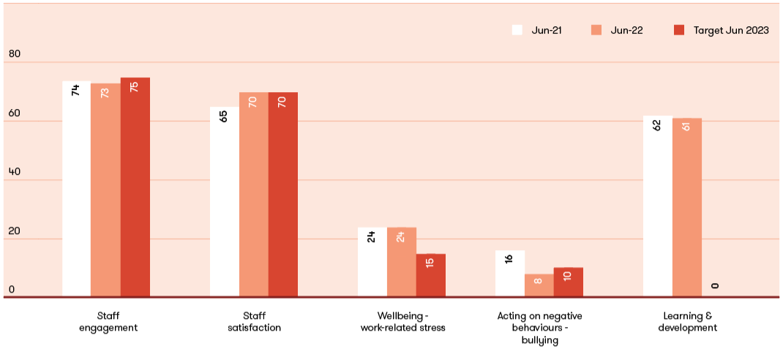

Empowered electors
Significant work was done to improve the VEC’s major project planning, with high-level planning now reaching out at least 18 months to prioritise new initiatives alongside essential systems maintenance. The aforementioned Future Focus program will align further with this from 2023, providing the VEC with improved capability to truly innovate through secure, smart and technology-enabled services.
A number of important digital communication initiatives commenced in this financial year in support of the 2022 State election, including strategies to expand digital communication with electors. This will enable the VEC to communicate important information in relation to electoral matters and also enhance our crisis communications.
Work commenced on a media literacy and misinformation advertising concept for the 2022 State election. Other supporting resources such as a disinformation register for the VEC website commenced development.
Implementation of the Geospatial Strategy continued. Geospatial functionality was incorporated into more VEC systems to provide more accurate voting centre location information for voters. Work commenced on the upgrade of the voting centre locator interactive map for the upcoming State election to show users nearest voting locations within their district and include more accessibility information. Geospatial tools and services were incorporated into the initial design of the new Roll Management System and other systems to support the use of geospatial intelligence in the preparation and provision of electoral services well into the future.
A key ongoing impact measure for Empowered Electors is the Victorian enrolment rate. The VEC’s target is to stay within 1% of the national enrolment rate as reported by the Australian Electoral Commission. The June 2022 enrolment rate for Victoria is 96.4% which is 0.1% below the current national enrolment rate.
The VEC’s FY2022 target was to achieve a 40% improvement on the number of complaints resolved within the VEC’s declared target response times. This was achieved and exceeded, with 85% of complaints resolved within desired response times. The focus for the coming election year will be to maintain a high response rate during a period of peak activity.
The remaining Empowered Electors impact measures are related to voter engagement, voter participation and elector centricity in the 2022 State election and will be reported upon in next year’s annual report.

Smart solutions
Work on many of the projects related to Smart Solutions has been delayed due to resourcing pressures. All initiatives are expected to be fully completed by June 2023.
Significant progress was made in the development of a Corporate Compliance Framework and Electoral Compliance Framework. These complementary tools will better underpin the efficiency, transparency and integrity of the VEC’s compliance responsibilities across the board. Policy development to support both frameworks has commenced and will be completed in the next financial year.
Significant work related to technology security and risk was completed in this financial year, in preparation for the upcoming State election.
In terms of security, resilience, efficiency and compliance impact metrics, the VEC has almost reached its June 2023 target for compliance with both the rigorous ASD ‘Essential Eight’ maturity model for cyber security and with the Victorian Protective Data Security Standards (VPDSS). Staff security awareness is slightly behind schedule but well on track for completion ahead of the State election.
Figure 5: Smart Solutions: Security, Resilience, Efficiency, Compliance
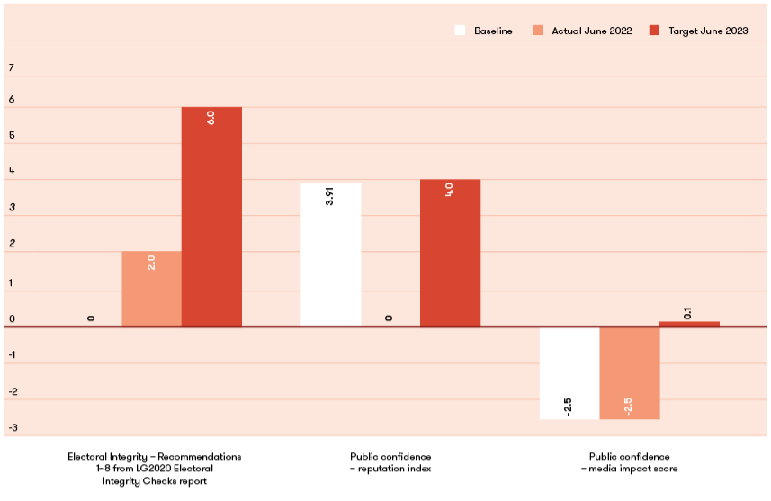
Figure 6: Smart Solutions: Electoral Integrity, Public Confidence
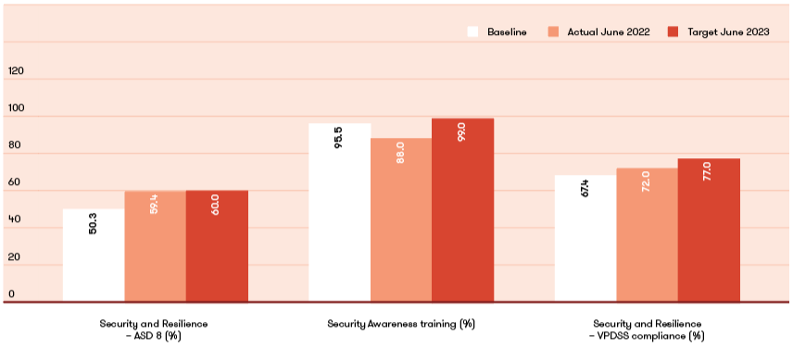

Spotlight on
Anika Clynick
Manager, Information Protection
Information and Knowledge Management


“The VEC is an inclusive and diverse workplace that is full of people who are incredibly passionate about democracy and delivering elections.”
The VEC’s vision is for all victorians to participate in their democracy. How does your role contribute to this?
I contribute to the VEC’s vision by overseeing access to VEC information, protecting information privacy, advising on lawful information sharing, promoting effective information security at the VEC, and managing the customer feedback team. Our organisation holds a vast amount of personal and sensitive information, so it is critical we treat this information with respect and share it appropriately in the spirit of open government.
My team ensures VEC information can be managed in accordance with its value and risk profile. I like to say that we prefer to be part of planning a solution, not just solving a problem! If I do my job correctly, the VEC’s information will be fully exploited as a strategic asset to deliver better government and improved service delivery to the community.
What makes the VEC an innovative and engaging place to work?
The VEC is an inclusive and diverse workplace that is full of people who are incredibly passionate about democracy and delivering elections. This means a lot, as we get to see very different business areas collaborate on projects and programs to enable each other to meet the VEC’s vision. The people are key to the VEC being able to adapt and innovate within the parameters of our legislative environment and the changing landscape of elections in Australia.
2021–22 was a non-election year. Did anything significant happen in your team/role during this time that you would like to highlight?
While we have ‘non-election’ years, these are often just as busy for the VEC as the critical time to upgrade and update its internal processes and systems and begin planning for the next major electoral event. For me, this involved looking at the structure of my team and making some strategic adjustments to ensure all my portfolios were supported appropriately. I also got to be a part of the development of a whole of VEC security strategy that reaches across all of the security domains (personnel, physical, cyber and information). This is groundbreaking work within the VPS and I was really proud of the outcome.
What do you like to do on the weekends?
On the weekends you will find me on the closest beach or on a big walk with my dog and a coffee. I love Melbourne’s foodie culture, so I also try and get out to different cafes and restaurants with my friends and family when I can.

Our commission

Achievements 2021–22
Supported the Electoral Boundaries Commission to finalise State electoral boundaries.
Completed project and business readiness activities for development of the new Roll Management System.
Robust management of the continued COVID-19 complexities on VEC electoral services.
Established dedicated electoral compliance capability through a specialised electoral compliance team.
Significant enhancements to the VEC Disclosure system.

Outlook 2022–23
Continuing work to deliver a new Roll Management System.
Continuing preparations for the 2022 State election, including early workforce and program planning.
Delivering enrolment stimulation and integrity activities for the 2022 State election.
Implementing new State electoral boundaries across VEC systems ahead of the 2022 State election.
Providing administrative and technical support as required to the Electoral Representation Advisory Panel when established under the Local Government Act 2020 (LGA 2020).
Developing a public online submission and mapping tool for Victorians to participate in upcoming reviews of local government electoral structures and ward boundaries.
Contributing to an independent review primarily looking at Victoria’s political funding and donation disclosure laws.
Continuing to build on the VEC’s expanded electoral compliance capability.
Working with the University of Adelaide to understand and address informal voting.
Table in Parliament a report on the South Gippsland Shire Council general election.

Governance
The VEC is the administrative agency through which the Electoral Commissioner’s legislative obligations are exercised. The VEC is committed to ensuring its policies and practices reflect good governance and comply with relevant legislation. Adherence to the governance framework demonstrates accountability to stakeholders and ensures the vitality and impartiality of the electoral system, now and into the future. Staffing and work practices are determined by the Public Administration Act 2004 and guided by the VPSC.
The VEC is an independent agency operating under the auspices of the Department of Premier and Cabinet (DPC). The VEC is not subject to the direction or control of the relevant minister in respect to the performance of its responsibilities and functions, or the exercise of its powers.
The Hon. Danny Pearson MP, Minister for Government Services, has responsibility for the Electoral Act.
The Secretary of the DPC, Jeremi Moule, is responsible for providing support to the Premier and Cabinet on matters relating to the VEC. The VEC thanks the Secretary for his assistance in conveying relevant information to Government on the operations of the VEC. Figure 7 (below) shows the governance and consultation structure of the VEC.
Figure 7: Governance and Consultation Structure of the VEC
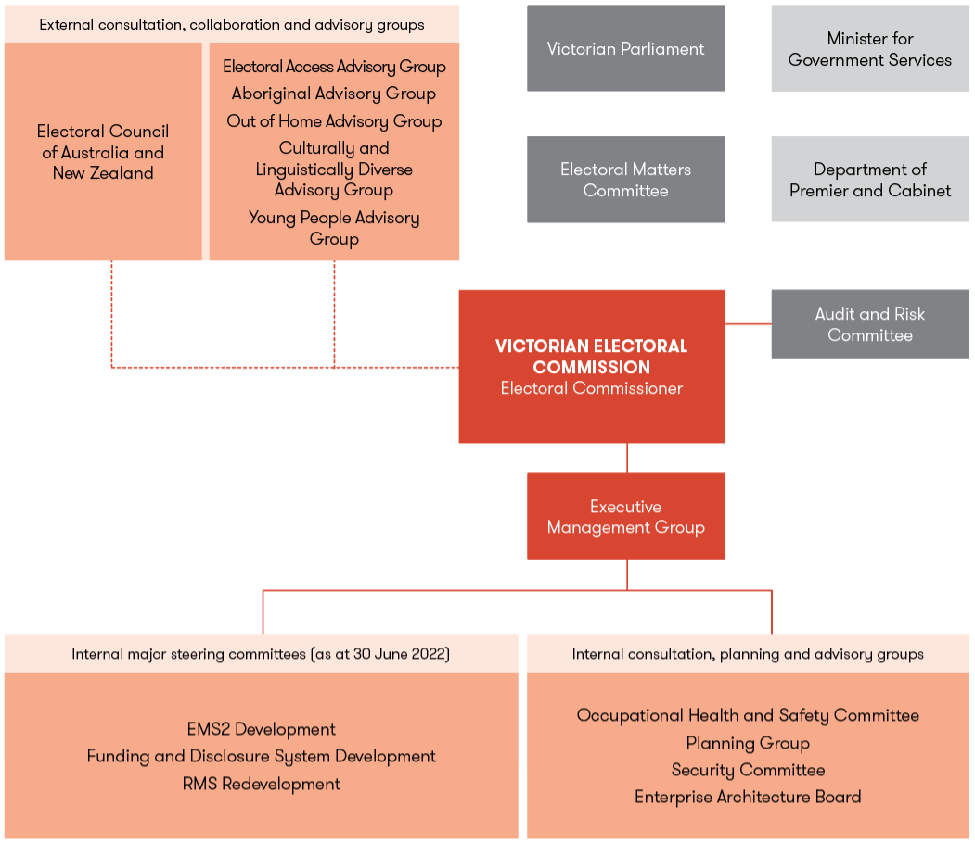

Organisational structure
The VEC’s organisational structure reflects its main activity areas (see Figure 8).
The Executive Management Group (EMG) works closely with the Electoral Commissioner, the Deputy Electoral Commissioner and the Executive Director, Corporate Services to develop and implement strategic and operational plans.
Figure 8: VEC Organisational Structure
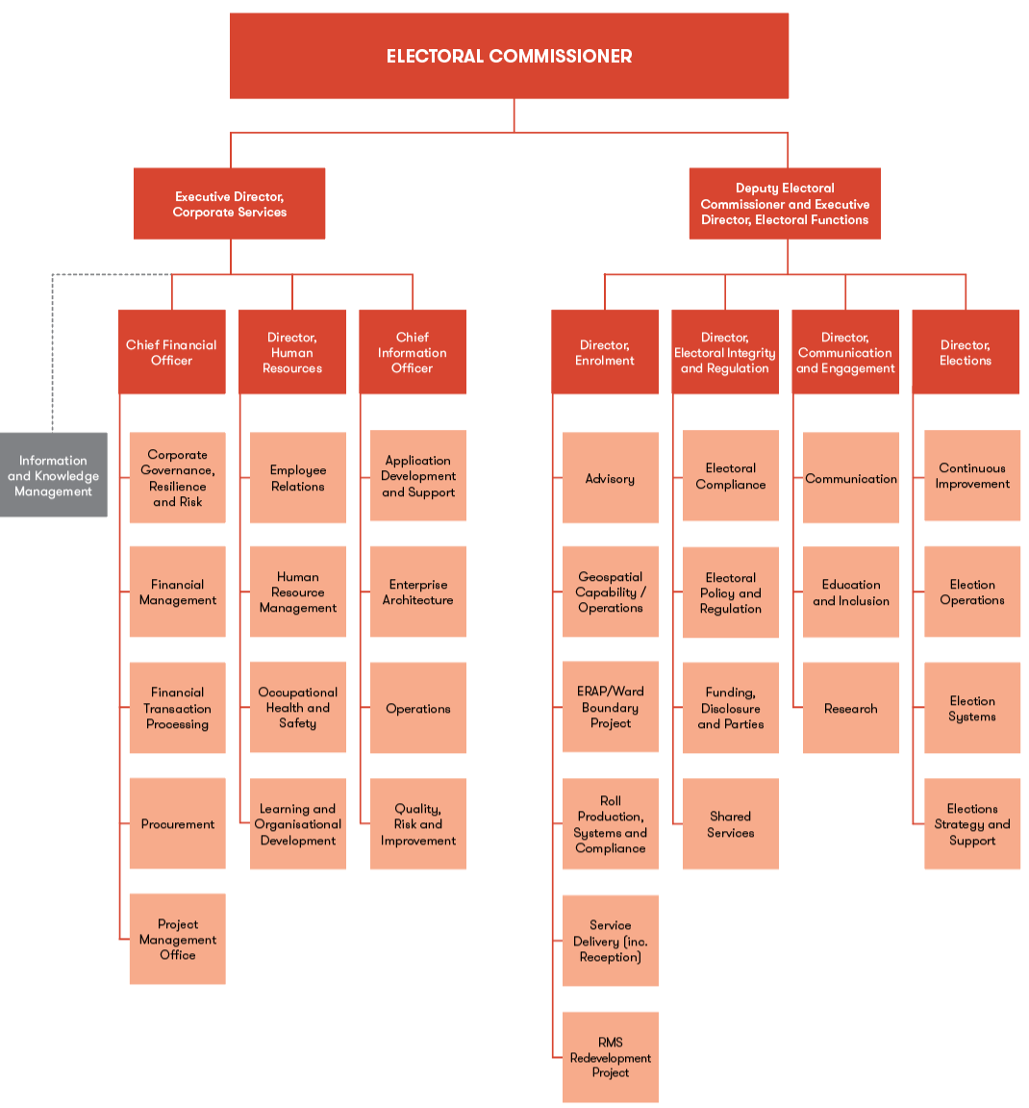

The Office of the Electoral Commissioner



Warwick Gately AM
MDefStud, BA, GAICD
Electoral Commissioner

The Electoral Commissioner is appointed by the Governor in Council for a period of 10 years and is responsible for the administration of the enrolment process and the conduct of Parliamentary elections and referendums in Victoria.
Mr Warwick Gately AM was appointed as the Electoral Commissioner for Victoria on 29 April 2013.
Following an early career with the Royal Australian Navy, Warwick joined the Western Australian Electoral Commission as the Deputy Electoral Commissioner in 2003.
Subsequently appointed as the Electoral Commissioner in August 2006, he was responsible for three State elections and State-wide referendums on retail trading hours and daylight saving. He also participated in State electoral boundary reviews and conducted local government elections every two years. Continuing his longstanding career in public service, now as Victorian Electoral Commissioner, Warwick is committed to the provision of effective electoral services to the Victorian community, as evidenced by the 2014 and 2018 State elections and the 2016 and 2020 local government election programs.
The Electoral Commissioner, assisted by the Deputy Electoral Commissioner, is the Chief Executive Officer and remains responsible for all elements of the VEC’s performance and compliance.

Dana Fleming
BCom, FCA, CTA, GAICD
Deputy Electoral Commissioner

Dana joined the VEC in August 2021 as the Deputy Electoral Commissioner. Dana has over 25 years’ experience as both a corporate leader and senior public servant with a proven track record of executive leadership in complex environments. She brings a wealth of experience from her previous roles as a senior partner at KPMG and serving as the Deputy Commissioner for Superannuation & Employer Obligations at the Australian Taxation Office – understanding regulation and compliance, delivery of government programs and working closely with stakeholders.
As Deputy Electoral Commissioner, Dana works closely with the Electoral Commissioner and the Executive Director, Corporate Services, in the management and administration of the VEC. She also leads the Electoral Functions Group, which has responsibility for the delivery of elections, enrolment services, communication and community engagement, and the administration of Victoria’s political funding and disclosure laws.
Dana is focused on translating her broad experience to the critical function of delivering for Victoria all State, local government and commercial elections and managing the VEC’s work with other Australian electoral authorities, the Electoral Matters Committee and local stakeholders to foster continuous innovation and improved accessibility in the VEC’s electoral program delivery.



Máiréad Doyle
BE CEng
Executive Director, Corporate services

As Executive Director, Corporate Services, Máiréad works closely with the Electoral Commissioner and Deputy Electoral Commissioner in the leadership and administration of the VEC. Máiréad’s role as head of the Corporate Services Group encompasses Human Resources, Finance, Information Technology and Information Management, as well as corporate strategy, planning and governance. Her principal remit is to oversee and shape strategies, systems and policies to ensure the VEC’s ongoing ability to respond to current and future requirements.
Máiréad’s early profession as a chartered mechanical engineer in the oil and gas sector in Europe led to a 30-year career in executive leadership roles in the private, public and not-for-profit sectors focusing on productivity and operational resilience.
A Fellow of the Institute of Managers and Leaders, Máiréad is the recipient of the Governor-General’s National Emergency Medal, the Australian Red Cross Meritorious Service Award and the New Zealand Red Cross Emergency Management Medal for her work in disasters.

The Executive Management Group
The Executive Management Group (EMG) comprises the Electoral Commissioner, Deputy Electoral Commissioner, Executive Director, Corporate Services and the seven directors leading the main functional areas of the VEC.
Working cooperatively, the EMG sets the VEC’s direction and delivers the operational, financial, workforce and other plans that underpin the efficient and effective delivery of electoral services to all Victorians. This is assisted through the professional mastery and experience contributed by each member. At regular intervals, the EMG considers the risks, issues and opportunities facing the VEC including succession planning and knowledge transfer, along with staff and system performance and productivity matters, and general compliance and reporting obligations. Staff wellbeing and development remains a high priority for the EMG.



Sue Lang
BA (Media Studies)
Director

Sue joined the VEC in 2006 after spending much of her career within Victoria’s public service in senior leadership roles at Maroondah City Council, Melbourne Water, South East Water, and Victoria’s former Department of Infrastructure and the Department of Treasury and Finance. She has significant expertise in major public awareness and stakeholder engagement programs, reputation management and digital communication techniques. Leading a high-functioning multi-disciplinary team, Sue’s focus is on the delivery of research-based internal and external communication, aiming for increased public awareness and, where appropriate, behavioural change. Sue is an advocate of human-centred design for service, product and communication development.

Communication and Engagement Branch
The Communication and Engagement Branch comprises three distinct teams and provides a number of communication, outreach and education services including:
provision of internal communication and corporate communication services for the VEC
development and implementation of major public awareness campaigns for electoral events across traditional and digital channels for all Victorian electors to ensure regulatory compliance
development of stakeholder engagement programs relating to electoral participation and inclusion
provision of electoral education and outreach services
provision of advice on electoral legislation, electoral structures and strategic matters
provision of research services and information.


Ben Sutherland
BSocSc (Criminal Justice), Juris Doctor, GDip Legal Practice
Director

Ben joined the VEC in 2021 initially as the Manager, Election Operations. Prior to this, he worked in senior roles with the Australian Electoral Commission and the Department of Justice and Regulation. He brings significant experience in managing large-scale operations across the State of Victoria. As Director, Elections, Ben’s focus is on planning the delivery of the VEC’s electoral events along with being the operational lead for the organisation.
He is driven by service excellence and looks to the delivery of each event as an opportunity to further refine and improve the VECs operating model.

Elections Branch
The Elections Branch is responsible for overseeing the planning and conduct of State, local government and fee-for-service elections, by-elections, countbacks and polls.
Key responsibilities include:
election service agreements with Victoria’s local councils, and contracts with statutory and fee‑for‑service clients
development and maintenance of election procedures, instructional materials and systems
recruitment and training of the VEC’s pool of Senior Election Officials, and casual workforce, in preparation for appointment to election management roles
services to candidates
design, preparation, printing and distribution of election material
operation of large-scale centralised operations for postal voting, computerised counts and telephone assisted voting
establishment of election office and early voting centre infrastructure
appointment of election day voting centres
management of the VEC warehouse
compulsory voting enforcement.


Dahna Bond
BBus (Management), EMPA
Director

Dahna joined the VEC as Director, Enrolment, in 2019. With a background in service delivery leadership roles across New Zealand and Victorian public service organisations, Dahna has extensive experience in managing large multi-functional service delivery teams in regulatory environments and leading service delivery transformation programs. Her leadership career has spanned different regulatory environments such as public housing, tenancy services, consumer affairs, education, building, employment and justice.
Dahna moved from Wellington to Melbourne in 2015 and has held senior leadership roles at the Department of Education and Training and the Department of Justice and Community Safety Victoria.
In her role as Director, Enrolment, Dahna is the Electoral Registrar and responsible for the establishment, maintenance and update of the Victorian register of electors, preparation of electoral rolls, provision of enrolment information to political parties, members and candidates, and enrolment objections. She is also responsible for supporting local government structure and boundary reviews and State redivision review programs, which ensure the establishment of electoral structures that represent voters fairly.

Electoral Enrolment Branch
The Electoral Enrolment Branch is responsible for maintaining an up-to-date and accurate register of electors. The Electoral Enrolment Branch services include:
delivery of electoral enrolment programs
support for local government electoral structure reviews by the Electoral Representation Advisory Panel
conducting reviews of local government ward boundaries
support for electoral boundary redivisions by the Electoral Boundaries Commission
production of electoral rolls, roll products and mapping products to support the work of the VEC
provision of advice on electoral enrolment matters.



Keegan Bartlett
MPPM, BA, GDipCom, GAICD
Director

Keegan joined the VEC in 2010 as a policy officer before moving to lead the VEC’s local government and fee-for-service election programs in 2011.
In 2017, Keegan joined the EMG as Director, Enrolment and—after holding both roles for several months— moved to fill the new position of Director, Electoral Integrity and Regulation full-time in 2019. The role brings together Keegan’s electoral practice in Victoria with his background in Australia and New Zealand developing policies and relationships to promote good governance, a commitment to compliant practices and continuous improvement, and effective, transparent decision-making processes.
As Director, Electoral Integrity and Regulation, Keegan provides expert advice and support to the Electoral Commissioner and across the organisation on key compliance, integrity, policy and regulatory matters, and leads the VEC’s strategic engagements with other enforcement and integrity partners. He represents the VEC on national and state electoral compliance working groups and oversees the VEC’s contributions to electoral law.

Electoral Integrity and Regulation Branch
The Electoral Integrity and Regulation Branch administers the VEC’s electoral integrity, compliance, enforcement and regulatory activities, and oversees Victoria’s political funding and disclosure laws. The Branch informs and supports the planning and delivery of the VEC’s electoral functions to enhance and protect the integrity of Victoria’s electoral processes.
The Branch coordinates disputes and litigation involving the Electoral Commissioner and partners closely with all stakeholders to ensure the successful conduct of electoral programs within a highly regulated environment.


Binh Le
BFin, GradCertAcct, FIPA, FFA, GAICD
Chief Financial Officer

Binh joined the VEC in 2016 and brings a wealth of experience and knowledge in finance, audit, governance and corporate management. A Fellow of the Institute of Public Accountants and graduate member of the Australian Institute of Company Directors, Binh serves as a key member of the EMG, providing strategic leadership and advice on financial and corporate matters.
Binh has held several senior financial positions in the private and public sector, namely as the Group Business Manager in the Agriculture, Energy and Resources portfolio in the Victorian Government; Senior Finance Manager for the National Transport Commission; and Financial Controller for the online travel agent Webjet.

Finance and Corporate Governance Branch
The Finance and Corporate Governance Branch ensures the VEC has an effective financial management and governance environment, including:
governance, compliance, procurement and risk practices
program management and reporting
financial management structures, systems, policies and procedures
financial planning, budgeting and reporting
sound financial operations
crisis and resilience management.



Angela Kelly
BAppSc, GDip HR
Director

Angela joined the VEC in 2019, coming from a diverse corporate background across a variety of sectors, including the arts, professional services, agriculture, IT, and banking and finance.
With extensive senior HR leadership experience, Angela is a skilled change agent, driven to ensure that HR helps deliver exceptional organisational outcomes and employee experiences, making sure that people and culture programs directly support the strategic plan.
As the Director of Human Resources, Angela leads a small team of professionals dedicated to ensuring the VEC is an amazing place to work!

Human Resources Branch
The Human Resources Branch supports the development of a workforce of skilled, accountable, collaborative people who are adaptable to change and supported to be the best.
This is achieved through the five pillars of the human resources strategy:
providing meaningful work
developing responsive leadership
cultivating a positive work environment
enabling growth opportunities
supporting trusted leadership.


Chris Pivec
BSc(Hons)
Chief Information Officer

Chris joined the VEC in November 2021 as the Chief Information Officer (CIO). Chris has over 25 years’ experience as a technology leader and CIO in a range of large and complex organisations across the private, financial services, public, and not-for-profit sectors. He brings a wealth of experience in leading and building customer-focused teams through continuous improvement, major projects, and enterprise transformation.
Chris’s remit is to evangelise technology, drive information governance, develop the VEC’s enterprise architecture, and ensure that the Commission is supported by future ready, high quality information technology, enabling the VEC to deliver trusted service to the Victorian public now and into the future. He believes in strong stakeholder partnership and an inclusive leadership style where people are empowered and supported to deliver their best.

Information Technology Branch
The IT Branch is responsible for Application Design, Development and Quality Assurance, as well as Enterprise Architecture, Cyber security, Helpdesk, and operating the VEC’s core cloud platforms, servers, and network.

Internal committees and groups

Several consultation committees and groups assist the Electoral Commissioner and the EMG with the development and implementation of strategies and policies, providing expertise and promoting staff consultation.

EMS2 Development Steering Committee
The VEC’s Election Management System (EMS) redevelopment program was formally closed on Friday 24 June. The EMS2 Development Steering Committee met monthly during 2021–22 to ensure correct project controls were applied and to provide oversight of schedule, budget and risk.
The Committee members were:
Director, Elections (Chair)
Chief Information Officer
Chief Financial Officer
Enterprise Architect.
The following were also attendees at each meeting:
Manager, Project Management Office
Head of Applications
Manager, Election Systems.
During 2021–22, the Committee was focused on finalising delivery of the program prior to work required for the 2022 State election.
The final release was made to production in week ending 1 April 2022.
The deliverables included:
a Voting Enforcement module for the administration of Compulsory Voting
election configuration functionality (Election Management and Venue and Resource Management modules).

Funding and Disclosure System Development Steering Committee
Internal oversight and governance for the development of Victoria’s online political donation disclosure and reporting system, VEC Disclosures, is provided by the Funding and Disclosure System Development Steering Committee. The Committee meets regularly during peak periods of development to ensure correct project controls are being applied to VEC Disclosures, along with providing oversight of schedule, budget and risk.
The Committee members were:
Director, Electoral Integrity and Regulation (Chair)
Manager, Application Support and Development
Manager, Education and Inclusion
Manager, Geospatial Capability
Manager, Voting and Enforcement Services (to 6 October 2021)
Manager, Candidate Services (from 15 November 2021)
During 2021–22, the Committee was focused on supporting a project to implement two tranches of major enhancements to its online disclosures system VEC Disclosures to further improve the capability and functionality of the system, from both the user experience and the compliance perspective. The enhancements were successfully implemented on schedule and within budget. An improved stakeholder experience and improved compliance is expected.

Occupational Health and Safety Committee
The Occupational Health and Safety Committee (OHSC) is a forum that facilitates engagement and communication between the EMG and employees. The focus of the OHSC is the proactive support in those areas and issues likely to affect the health, safety and welfare of all staff in VEC workplaces in accordance with the requirements of the Occupational Health and Safety Act 2004.
In 2021–22, the OHSC continued to monitor the VEC Occupational Health and Safety Management System (OHSMS) functions and the delivery of health and wellbeing program activities.
Bi-monthly OHSC meetings were held over the year, including reviews of the hazard risk register, regular reviews of the safety action plans, identifying and implementing process improvements, and contributing to activities such as Occupational Health and Safety (OHS) Month. Health and Safety Representatives continued with quarterly inspections and incident and hazard reviews.
The OHSC played a significant role in 2021–22 in understanding employee health and safety insights and supporting employee needs in a flexible hybrid working environment. Emphasis was on building staff OHS capability to reduce risk exposure, increased onboarding and induction support.
OHSC members continue to work upstream and downstream providing insights and input into the wider VEC health and safety programs for their collective branches. The OHSC will continue to support staff safety and wellbeing in the lead up to and delivery of the 2022 State election.

Planning Group
The Planning Group (PG) is the VEC’s major cross-organisational work group that tracks and monitors the planning and delivery of electoral events. The group comprises managers from across the organisation, is responsible for fostering intra-agency cooperation and reporting on event preparation and projects.
During 2021–22, PG’s focus has primarily been on planning for the State election 2022. A draft service plan was published in December 2021, with a revised plan to be published mid August. A work program structure for delivery of the 2022 State election was implemented from the end of 2021. This structure covers all delivery requirements outlined in the service plan. Leaders of the 14 work programs provide regular reporting to PG.
This year, PG also focused on the delivery of other key electoral events including a general election for the South Gippsland Shire Council and 3 local government by-elections. Several countbacks and fee-for-service and statutory elections were also conducted.

Resource Smart Committee

Environmental sustainability report

The VEC’s Resource Smart Committee (RSC) endeavoured to meet regularly, however it was challenged by the constraints of COVID-19 and the lack of on-site presence meant targeted 2021–22 initiatives could not be achieved.
The RSC however remains dedicated to driving positive change within the workplace and will press forward with the following initiatives:
drive resource efficiency and sustainable business practices throughout VEC operations
leverage and influence VEC networks to improve sustainable performances and practices of the electoral sector
prioritise sustainability in procurement and investment decisions and work with VEC suppliers to pursue and develop sustainable business outcomes for Victoria
build the capability and capacity of VEC staff to undertake their roles more sustainably, and actively communicate information to encourage and assist employees with sustainability
implement a holistic and transparent sustainability strategy, including measurable targets where applicable
actively engage with Victorians to promote sustainability through electoral processes.
The RSC has refined its Sustainability Action Plan 2023, setting environmental and sustainability targets for the two years. This will take into consideration planning for the 2022 State election program and various social procurement opportunities. The RSC will continue to promote sustainable practices within the workplace and look to recruit additional support where possible.

RMS Redevelopment Steering Committee
The RMS Redevelopment Steering Committee provides internal oversight and governance for the VEC’s Roll Management System (RMS) redevelopment project. The Committee meets regularly to provide guidance to the project team and ensures adequate controls are applied across the project. This includes risk mitigation, budget expenditure, schedule tracking and quality of deliverables.
The Committee members are:
Deputy Electoral Commissioner (Chair)
Chief Financial Officer
Director, Elections
Director, Enrolment
Chief Information Officer
The following are additional attendees at each meeting:
Manager, Project Management Office
RMS Product Owner
RMS Project Manager
During 2021–22, the Committee has maintained its oversight of the project, with a particular focus on understanding resourcing requirements and subsequent implications for other strategic activities. The Committee has also monitored total cost projections as the project design firms to ensure the cost/benefit outcomes remain positive and the final solution is appropriate for VEC needs.

Security Committee
Good security includes ensuring that the VEC’s people, tangible assets, information assets, financial information, elector data and other sensitive details are secure, and that the organisation is protected against threats and attacks that could result in business disruption, physical threat, asset theft or unauthorised access to information. A key achievement of the Security Committee was oversight of the VEC Security Strategy 2022–24, which was approved by the EMG in December 2021.
The Committee members were:
Chief Information Officer (Chair)
Enterprise Architect
Manager, Compliance and Risk
Program Manager, Information and Knowledge Management
Head of Technology
Manager, Infrastructure, Design and Warehouse
Manager, Enterprise Platforms and Support
Manager, HR Operations
Manager, Information Protection.

External advisory groups

The VEC is fortunate to have representation from a broad range of community organisations and individuals who provide invaluable advice and insight into issues that impact electors’ ability to participate in elections.
The VEC has four active community advisory groups:
Aboriginal Advisory Group
Culturally and Linguistically Diverse (CALD) Advisory Group
Electoral Access Advisory Group
Out of Home Advisory Group (representing people experiencing homelessness or in prison).
An additional advisory group representing young people and the youth sector is in development, with expressions of interest received in preparation for a first meeting in August 2022.
All groups met separately at least once this year and were involved in one combined meeting providing input and feedback on planning for the 2022 State election. These meetings continued to be held online due to COVID-19 restrictions and member preferences. Members also supported the VEC by providing expert advice on the implementation of the Multicultural Inclusion Plan, the Disability Access and Inclusion Plan and the Young People Inclusion Plan, and input to inform the development of the Out of Home Action Plan and preliminary input on the development of the Aboriginal Inclusion Plan.
The VEC would like to thank all advisory group members for their extraordinary commitment, time and advice during the last 12 months to continue to support the electoral engagement of those traditionally under-represented in the electoral process.

Aboriginal Advisory Group
This group continues to be comprised of nine highly respected Aboriginal elders and leaders from across Victoria. In its first full year, the Aboriginal Advisory Group has proven to be a source of insight and cultural guidance. The VEC has been working on strengthening its relationships with members to ensure that its Statement on Self-determination Policy is embedded in the planning and ongoing implementation and evaluation of all electoral engagement initiatives which target Aboriginal people living in Victoria. A number of Elders attended a 3 day Democracy Ambassador Cultural Training Camp, which brought them together with young DA’s to help them learn about their history, the importance of connection to country and passing on their knowledge to help nurture the next generation of emerging Aboriginal leaders.
Individuals also attended community engagement events alongside the Aboriginal Inclusion team, and regularly assisted the VEC by providing feedback and insight on internal processes and documents, to shape and provide a culturally safe approach to all internal and external communications.
Overall, their cultural knowledge and their personal reputation and standing in their own communities has helped the VEC to work in a culturally safer way internally, whilst also helping to facilitate more meaningful connections within Aboriginal communities across Victoria.

Culturally and Linguistically Diverse Advisory Group
The CALD Advisory Group comprises 11 representatives from multicultural organisations across community and government sectors including the Victorian Multicultural Commission, AMES Australia and the Ethnic Communities Council of Victoria, along with those with expertise in engaging CALD communities. Their contributions helped ensure the VEC’s work was more reflective of CALD communities’ electoral participation needs and ensures the communities’ voice is at the centre of its work.
This year, members provided expert insight and advice on the implementation of the VEC’s Multicultural Inclusion Plan (MIP). Members also provided important feedback on the planning of projects in the lead up to the 2022 State election. Finally, a big thank you to Carringbush Adult Education for adopting the VEC Talking Democracy resources kit as part of their teaching tools. This will mean more people from multicultural communities can learn about their rights and responsibilities in the electoral process.

Electoral Access Advisory Group
The Electoral Access Advisory Group (EAAG) comprises 20 representatives of people with disabilities, their supporters and disability support agencies including Office of the Public Advocate, Scope, Vision Australia, Blind Citizens Australia, Expressions Australia and Amaze. Members of the group were consulted on:
the layout and designs of the State election ballot papers
the VEC Writing Style Guide
how to educate Medical Practitioners before completing removal from roll forms
the Electoral Regulations review
how the VEC can support the deaf community and people who are hard of hearing to enrol and vote.
Members also received reports and provided input on:
the VEC’s Disability Access and Inclusion Plan 2019–23
online and face-to-face electoral outreach and opportunities to recruit new Democracy Ambassadors with a lived experience and/or understanding of disability
initiatives for the engagement of people with disabilities for the 2022 State election.

Out of Home Advisory Group
The Out of Home Advisory Group, previously known as the Homelessness Advisory Group, was further expanded in the last year to include representation of the prison sector. There are 10 members providing representation from the homelessness sector including the Salvation Army Crisis Centre, Sacred Heart Mission and the Council to Homeless Persons, along with peer support workers and people with lived experience of homelessness and prison. The group provided advice on development of the VEC’s first Out of Home Action Plan, homelessness and prison sector networks and the ongoing challenges faced due to COVID-19. Members also attended the joint advisory group meeting in December 2021 and provided valuable feedback to assist in the planning of projects for the 2022 State election.

Young People Advisory Group
A Young People Advisory Group is being established as part of the VEC Young People Inclusion Plan deliverables with the aim of supporting young people to be active citizens and exercise a lifelong engagement with democracy. Expressions of interest for membership of the Young People Advisory Group have been sought.

2022 VEC Advisory Group Effectiveness
Following the 2018 State election, the Electoral Matters Committee recommended that the VEC explore ways to objectively measure the effectiveness of its Advisory Groups to address the challenges faced by certain groups of voters. In response to this recommendation, the VEC developed a set of Advisory Group effectiveness measures, several of which are included in the Advisory Group Survey.
The VEC Advisory Group Survey is conducted biennially to provide members with a formal opportunity to provide feedback about their role. The online 2022 Advisory Group Survey was sent to 46 Advisory Group members; 26 responded (a 57% response rate).
VEC Advisory Group members who responded to the survey were satisfied overall (89%). Members are also satisfied with the communication (92%) and support (81%) from the VEC.
Aspects of Advisory Group membership that respondents most appreciated were having the opportunity to stay informed and connected, being involved with the VEC, representing their sector, and having a say. Advisory Group members provided suggestions including having more opportunity to comment on draft work, considering creative ways to engage due to constraints caused by COVID-19, and a calendar of meetings to help members better schedule and attend meetings.
The VEC has considered these results and is using the feedback to continuously improve the way it supports its Advisory Groups. Data on the other effectiveness measures (including meeting attendance, member networks and composition, and the number of times advice is sought and adopted) is currently being collected.
The Advisory Group effectiveness measures will be reported and monitored on an ongoing basis to ensure Advisory Group members are supported to advise the VEC so that communities and individuals are empowered to enrol and vote.

Governing legislation and tribunals

The three pieces of legislation that set out the VEC’s primary responsibilities are the Constitution Act 1975, Electoral Act 2002 and Local Government Act 2020.
In accordance with this legislation, the VEC conducts State Parliamentary elections, local government elections and by-elections, and certain statutory and fee-for-service elections. The VEC also provides advice to the Government and Parliament on electoral issues. Other legislation and regulations imposing certain duties on the Electoral Commissioner are listed in Appendix B.

Legislative and regulatory amendments
In March 2022, Parliament passed the Regulatory Legislation Amendment (Reform) Act 2022. The legislation makes miscellaneous changes to several Acts in Victoria, including the Electoral Act 2002 and the Electoral Boundaries Commission Act 1982.
The electoral provisions of the legislation commenced on 1 June 2022. The changes will be implemented for the 2022 State election. The changes clarify the rules governing political signage near voting centres; introduce the role of a contact person for the VEC to provide advance notice for the purposes of a recount; aligning the authorised period for processing early votes and postal votes to begin 10 hours before the close of voting; allow scrutineers to observe early processing of early votes and postal votes; prevent a person or agency other than the VEC distributing a postal vote application; and removed outdated provisions in the Electoral Boundaries Commission Act 1982.

Victorian Civil and Administrative Tribunal
The Victorian Civil and Administrative Tribunal (VCAT) is responsible for hearing disputes on the validity of an election under section 311 of the Local Government Act 2020 (LGA 2020). Applications for a review of the declaration of the results of an election must be lodged within 14 days of the declaration and can be made by a candidate in the election, 10 persons who were entitled to vote at the election, or the VEC.
There have been no applications to VCAT in respect to any local government elections (including general elections, by-elections and countbacks) held during the reporting period. Of the four applications carried over from the 2020 local government elections into the reporting period, three applications were consolidated as they all related to the Loddon Shire Council and were each dismissed by VCAT on 15 September 2021.

Moreland City Council, North-West Ward election
The application relating to the Moreland City Council, North-West Ward election remains on foot. The VEC initiated this application after identifying evidence of possible interference in the postal voting process.
During the reporting period, the VEC has provided detailed analysis and submissions to assist VCAT and the other parties to the proceeding to progress the matter. The VEC has also foreshadowed its intention to amend its application to include the countback held in March 2022 to fill an extraordinary vacancy in North-West Ward.
The issue was also reported to the Local Government Inspectorate (LGI) and Victoria Police at the time of the election. The VEC notes three people have since been charged by police with related offences through a separate criminal investigation.

Accountability and transparency

The VEC has legislative and organisational processes in place to ensure transparency and accountability to the Victorian public. These processes include internal and external auditing, regular reporting to stakeholders including Parliament, Government and the public, and tabling of audited financial statements as part of this report.

Audit and Risk Committee
The VEC’s Audit and Risk Committee assists and advises the Electoral Commissioner in meeting financial compliance and reporting obligations, and in managing risk. The Committee consists of the following members:
David Nairn, Chairman (independent member)
Michael Ulbrick (independent member – extended to August 2021)
Taryn Rulton (independent member – commenced 15 June 2021)
Kerrie Howard (independent member – commenced 4 October 2021)
The responsibilities of the Committee are to monitor and oversee the:
financial performance and reporting process, including the annual financial statements
scope of work, performance and independence of internal audits
engagement and management of the internal audit contractor
scope of work, independence and performance of the external auditor
operation and implementation of the risk management framework
matters of accountability and internal control affecting VEC operations
effectiveness of management information systems and other systems of internal control
VEC’s process for monitoring compliance with laws and regulations and its own code of conduct and code of financial practice
VEC’s compliance with the Financial Management Compliance Framework (FMCF) Standing Directions.
The Committee met formally on 4 occasions during the year, with 3 meetings held online. The Committee’s positive support and guidance to the Electoral Commissioner was valuable with its focus again on risk, compliance, and business continuity.

Complaints and Customer Feedback Framework and Policy
The VEC handles complaints in three main areas. These include complaints that:
allege a breach of the Electoral Act 2002 (Electoral Act)
allege a breach of the LGA 2020
are about a process, performance or service related to an interaction with the VEC.
As the VEC does not have authority to follow up allegations of a breach of the LGA 2020, it forwards these complaints to the LGI in accordance with an established protocol.
The VEC received 508 written complaints during 2021–22. Of these complaints, 219 related to an electoral event.
Of the electoral events, 49 complaints related to the South Gippsland Shire general election of which 24% (12 cases) were referred to the LGI for investigation, and 76% (37 cases) were resolved in house.
A total of 164 cases related to allegations concerning advertising or electoral campaign material.
Complaints received that were not connected to an election event included those related to VEC administration or processes (103), receiving a fine (55), enrolment (34) and voting (33).
As the regulator of allegations of a breach of the Electoral Act, the VEC investigated and resolved 59 cases relating to the authorisation and/or distribution of electoral matter.
The VEC received 13 complaints related to information privacy. The VEC reminded electors who suspected their privacy was breached that the VEC has obligations under legislation to provide candidates, political parties and Members of Parliament with electoral rolls for purposes including campaigning. More information about who receives enrolment information is available at ‘Privacy at the Victorian Electoral Commission’ on the VEC website.
The VEC dealt with all complaints in accordance with its procedures. Complaints were resolved through providing an explanation, follow-up and responsive action where required. The VEC is committed to responding to simple complaints within five working days or providing an update to complex complaints after 10 working days. The average complaint response time was 1.9 working days.

Customer Service Charter
The VEC’s Customer Service Charter ensures that the organisation complies with best practice customer service and is relevant to VEC operations. The Charter is reviewed regularly and is available on the VEC’s website.

Corporate reporting
The VEC has a comprehensive program of stakeholder reporting that supports its goals of accountability and transparency. Internal reporting is aligned with lines of authority and cross-organisational channels to meet organisational needs.
External reporting is based on legislative and governance obligations, transparency objectives and commitments to stakeholders. The standard of reporting is high. For example, last year’s Annual Report fully complied with the Department of Treasury and Finance (DTF) model report requirements and achieved a Gold award at the 2022 Australasian Reporting Awards.
During 2021–22, the VEC tabled one report in Parliament: the Victorian Electoral Commission Annual Report 2020–21.
Other reporting obligations include:
the provision of a quarterly report to the Department of Premier and Cabinet (DPC) in relation to budgetary objectives and impact of COVID-19
monthly financial reporting to DTF
annual attestation on compliance with the Financial Management Compliance Framework (FMCF) requirements to various stakeholders including DTF, DPC, responsible Minister, VAGO
twice-yearly reporting to the Attorney-General on infringements activity
advertising campaign reporting
reporting for the Electoral Boundaries Commission (EBC), for which the VEC provides secretarial services and technical support. The VEC also prepares an annual report for the EBC. This report can be found at Appendix I on page 155.
annual attestation to the Office of the Victorian Information Commissioner, on the progress of activities identified in the VEC Protective Data Security Plan (PDSP)
annual report to the Office of the Victorian Information Commissioner on the number and outcomes of freedom of information requests.
All reports were delivered on schedule and within budget, where applicable. Annual reports and other reports and publications are available on the VEC website and from the VEC’s head office.

Gender Equality Act Reporting
The VEC actively participates in Gender Equality reporting and auditing in line with the Gender Equality Act 2020. In 2021–22, the VEC completed its inaugural Workplace Gender Audit, creating a baseline for future initiatives. From the audit a Gender Equality Action Plan was developed in consultation with staff, union representatives and the Executive Management Group. These plans will be in place from 2021 to 2025 and provide long-range actions and initiatives to support, engage and improve gender equality across the VEC.

Financial Management Compliance Framework
The Financial Management Compliance Framework (FMCF) assures the Minister for Finance that Victorian Government entities have implemented the appropriate systems to ensure compliance with the FMCF. The FMCF provides for effective, efficient and responsible financial management of public resources.
The FMCF Standing Directions cover:
financial code of conduct, financial governance including the establishment of an Audit and Risk Committee, financial risk management, delegations, and internal and external audits
financial management structure, systems, policies and procedures. This includes roles and responsibilities of the financial management team and identified Key Management Personnel, managing outsourced services, information technology management, operations, development and change, and education and training
financial management reporting, which includes internal and external reporting, reporting requirements for financial statements and reports of operations, performance management and evaluation, financial management compliance obligations, tax compliance, purchasing cards, and thefts and losses compliance.
Other obligations have been brought into the FMCF framework for organisations to report against. Some of these do not apply to the VEC.
The VEC’s compliance with the FMCF Standing Directions is assessed by the internal auditor annually and is reviewed and endorsed by the Audit and Risk Committee. The 2021–22 internal review reported the VEC’s overall compliance with the Framework in the annual attestation to DTF.

Identifying and managing risk
The Victorian Government’s Risk Management Framework provides for a minimum standard across public sector entities. As the Accountable Officer, the Electoral Commissioner is responsible for the development, implementation and maintenance of the Framework to ensure risks are identified and managed consistently across the organisation.
Risk management is embedded in the VEC’s operations, including in regular workshops and assessments to identify and monitor organisational risks, evaluating existing risk controls and developing new controls where required. The VEC’s risk practice is managed through an integrated enterprise risk system, with regular reporting to the Audit and Risk Committee, which oversees risk management and provides an independent perspective on the VEC’s practices.
Risks are profiled and rated according to their potential hazard level across operational and non-operational activities. The Audit and Risk Committee will independently assess and determine whether risks are adequately scoped, and whether sufficient controls are in place to mitigate and manage risks.
At an operational level, the VEC has comprehensive risk management plans for all electoral events and major projects. These are developed, discussed and analysed at branch level and at election planning groups during the planning phase and cover areas such as election management, infrastructure, communication, recruitment and information technology.

Internal audit
The VEC’s internal audit program is designed to provide an independent, objective assurance to improve operations. The rolling four-year internal audit strategy and program is designed to be comprehensive and to enable effective and regular review of all operational, financial and related activities.
Part of the annual program includes annual attestations and certification reviews, such as Risk and Fraud Certification and compliance with Memorandums of Understandings entered into with other agencies. The VEC’s internal audit program is reviewed annually and designed in consultation with the Audit and Risk Committee and the EMG.
In addition to standing items, internal audits this year covered the VEC’s risk control environment, workforce planning framework, stakeholder management and an assessment of the VEC’s cyber security environment, ahead of the 2022 State election. The audits each revealed matters and recommendations of medium-to-low risk to the VEC and requiring operational attention.

Disclosures

Additional information available on request
Information relating to the 2020–21 reporting period is made available to Ministers, Members of Parliament and the public on request (subject to the Freedom of Information Act 1982 (FOI Act)) and is listed in Appendix C.

Advertising disclosure
FRD 22 issued by the Australian Accounting Standards Board requires Victorian Government agencies to disclose advertising expenditure on campaigns with a media spend of $100,000 or greater. The VEC spent just over $723,000 on an advertising campaign for the 2022 State election.

Attestation to Public Sector Standards Commissioner
The Electoral Commissioner completed an annual attestation of hospitality and gifts as required.

Building Act 1993
The VEC does not own or control any Government buildings and, consequently, is exempt from notifying compliance with the building and maintenance provisions of the Building Act 1993.

Child Safe Standards
In 2015, the Child Safety and Wellbeing Act 2005 was amended to include Child Safe Standards for all organisations involved in child-related work in Victoria.
The Commission for Children and Young People determined that the VEC is required to comply with the Child Safe Standards, primarily due to its work in student civics education. Throughout 2021–22, the VEC has continued to support the application of the Child Safety Standards across the breadth of the work conducted.
The VEC’s policies and procedures, position descriptions, advertising, recruitment and training procedures reflect the VEC’s strong position on and in support of Child Safe Standards.

Consultancies and contracts

Major contracts
In accordance with the requirements of FRD 12, the VEC disclosed all contracts greater than $10 million in value entered into during the year ended 30 June 2022. No contracts greater than $10 million in value were entered into by the VEC during 2021–22.

Consultancy expenditure

Details of consultancies under $10,000
In 2021–22, 21 consultancies were engaged where the total fees payable to the individual consultants was less than $10,000. The total expenditure incurred during 2021–22 in relation to these consultancies was $76,158 (excluding GST).

Details of consultancies (valued at $10,000 or greater)
In 2021–22, there were 23 consultancies where the total fees payable to the consultants was $10,000 or greater. The total expenditure incurred during 2021–22 in relation to these consultancies was $1,918,031 (excluding GST). See Figure 9.

Disability Act 2006
The Disability Act 2006 requires all public sector bodies to prepare a disability action plan and all departments to report on the implementation of their disability action plan in their annual report. The VEC’s Disability Access and Inclusion Plan was developed and launched in 2019. The VEC provided a report on its progress with deliverables to the EAAG. See ‘Disability Access and Inclusion Plan’ for more information.

Disclosure index
The Annual Report of the VEC is prepared in accordance with all relevant Victorian legislation and pronouncements. A disclosure index has been prepared to facilitate identification of the VEC’s compliance with statutory disclosure requirements. The disclosure index is included as Appendix A.

Employment and conduct principles
The VEC maintains and implements a suite of policies and guidelines with respect to upholding public sector conduct, managing and valuing diversity, employment, managing underperformance, reviewing personal grievances, and selecting on merit.

Figure 9: Consultancies valued at $10,000 or greater
CONSULTANT | PURPOSE OF CONSULTANCY | TOTAL APPROVED PROJECT FEE  (EX GST) | EXPENDITURE 2021–22  (EX GST) | FIXTURE EXPENDITURE  (EX GST)
BMS Advisory Group | Tender evaluation support services | 33,375 | 33,375 | -
Clayton Utz | Legal advisory services | 170,893 | 163,166 | 7,727
Data#3 | IT network and security consulting | 22,050 | 22,050 | -
Deloitte Consulting Pty Ltd | Website strategy and design | 44,500 | 44,500 | -
Directioneering | Career transition services | 12,000 | 12,000 | -
Dr Kate Brady | Community recovery | 12,188 | 12,188 | -
Explainmate! | Production of state redivision animation | 76,350 | 36,350 | 40,000
FOI Solutions | Advice and support on freedom of information matters | 12,056 | 12,056 | -
Group Hug Creative | Media campaign | 18,640 | 18,640 | -
Herbert Smith Freehills | Legal advisory services | 28,302 | 28,302 | -
iSentia Pty Ltd | Advertising – media services | 42,225 | 42,225 | -
Jones Lang LaSalle Corporate (VIC) | Hub acquisitions and lease renewals | 163,000 | 163,000 | -
Maniq Pty Ltd T/AS Documents in Dispute | Expert document examination | 200,060 | 121,430 | 78,630
Opal Translation T/AS Ethnolink | Multicultural market research | 28,000 | 28,000 | -
Optimum Media Direction | Advertising direction on various campaigns | 4,956,825 | 133,069 | 4,823,756
Oracle Customer Management Solution | Public Enquiry System | 105,099 | 10,510 | 94,589
Pesel & Carr | Reputation management consultancy | 96,394 | 96,394 | -
Pitcher Partners Consulting Pty Ltd | Probity advisory service | 23,940 | 23,940 | -
Reconciliation Victoria | Production of content supporting the engagement of Aboriginal and Torres Strait Islander Victorians in the 2022 State election | 49,000 | 49,000 | -
Reputation.Com Inc | Social listening | 60,112 | 60,112 | -
Saatchi & Saatchi Australia Pty Ltd | State election 2022 advertising campaign | 1,189,313 | 723,417 | 465,896
Secmon 1 Pty Ltd | Digital forensics | 54,532 | 45,207 | 9,325
Votar Partners | Knowledge management framework | 39,100 | 39,100 | -

Environmental performance
The VEC has continued its commitment to reducing the negative impact of its operations on the environment, with ongoing communication and information programs to encourage positive behavioural changes.
The VEC’s Environmental Sustainability Report for 2021–22 is included in ‘Our Commission’.

Executive Officer disclosures
The Electoral Commissioner and Deputy Electoral Commissioner are appointed by the Governor in Council as statutory office holders. These appointments do not fall within the definition of Executive Officer under the Public Administration Act 2004; therefore, disclosures were not necessary.

Freedom of information
The FOI Act gives the community the right to access information in the possession of the VEC. Of the 11 requests received by the VEC under the FOI Act, all but one were satisfied outside of the process. Information about how to lodge an application under the FOI Act is available on the VEC website or in Appendix E.

Gifts, benefits and hospitality register
In complying with Victorian Public Sector Commission standards for Victorian public sector employees on the giving and receiving of gifts, the VEC publishes its Gifts, Benefits and Hospitality Register on a quarterly basis. These reports are available on the VEC website.

Grants and transfer payments (other than contributions by owners)
Included in the ‘Total expenses from transactions’ are payments of grants and assistance to certain companies and organisations. During 2021–22, the VEC provided grants totalling $306,421 to 7 organisations (see Figure 10).
Figure 10: Grants to external bodies, 2021–22
Organisation | Purpose of grant | Amount (ex GST)
Department of Families, Fairness & Housing | VMC sponsorship | 20,000
Leadership Victoria | Collaborative project to train CALD community leaders in active citizenship and electoral engagement | 83,818
Richmond Football Club | Support for the Richmond Emerging Aboriginal Leaders (REAL) program coordinated by the Korin Gamadji Institute for Aboriginal and Torres Strait Islander youth to build their leadership skills through active citizenship and position them as role models within their community | 114,985
StreetSmart | Sponsorship of meals to people experiencing homelessness with inclusion of electoral information including No-Fixed-Address- Enrolment forms | 10,000
University of Adelaide | Joint research project into informal voting | $15,000
University of Melbourne | Development of Electoral Law Library and ongoing support of Electoral Regulation Research Network (ERRN) Sponsorship | $36,000
YMCA Victoria | Sponsorship of five youth Parliament teams and development of online electoral education modules | $26,618
Total |  | $306,421

Information and records management
The VEC has responsibility for managing information in accordance with standards issued by the Public Records Office Victoria (PROV) and the Office of the Victorian Information Commissioner (OVIC). The types of information managed by the VEC are in the VEC Information Asset Register.
During 2021–22 the VEC:
used SharePoint as the VEC electronic document and records management system
used business impact levels, privacy impact and security risk assessments to make good information management decisions in relation to managing and releasing information
met reporting obligations imposed by the Privacy and Data Protection Act 2014.

Legislation
The VEC is subject to, and complies with, a range of legislation listed in Appendix B and detailed in this report as applicable.

National Competition Policy
Competitive neutrality requires Government businesses to ensure that, where services compete with another Government business or, potentially, with the private sector, any advantage arising solely from their government ownership be removed if it is not in the public interest. Government businesses are required to cost and price these services as if they were privately owned and, thus, the services must be fully cost reflective.
Competitive neutrality policy provides Government businesses with a tool to enhance decisions on resource allocation. This policy does not override other policy objectives of Government and focuses on efficiency in the provision of service. The VEC continues to comply with the requirements of the National Competition Policy.

Occupational health and safety management
The goal of the VEC’s occupational health and safety (OHS) system is to ensure all staff remain safe and healthy at work. An OHS management system is in place and VEC branches have implemented local OHS action plans aimed at enhancing safety performance and ensuring safe systems of work.
In 2021–22, there was zero lost time injury. For more on human resource management at the VEC, including performance against OHS management measures, see the ‘Our People’ section of this report.

Pecuniary interest declarations
The Electoral Commissioner and the Deputy Electoral Commissioner completed declarations of pecuniary interests as required.

Public Interest Disclosures Act 2012
The VEC is committed to the aims and objectives of the Public Interest Disclosures Act 2012 (PID Act), previously the Protected Disclosure Act 2012. Improper conduct by its employees, officers or members is not tolerated, nor is reprisal against those who come forward to disclose such conduct.
The VEC recognises the value of transparency and accountability in its administrative and management practices, and supports the making of disclosures that reveal corrupt conduct, conduct involving a substantial mismanagement of public resources, or conduct involving a substantial risk to public health and safety or the environment. For details about reporting procedures under the PID Act, see Appendix D.

Victorian Industry Participation Policy
The Victorian Industry Participation Policy Act 2003 requires public bodies and departments to report on the implementation of the Victorian Industry Participation Policy (VIPP). Departments and public bodies are required to apply VIPP in all tenders over $3 million in metropolitan Melbourne and $1 million in regional Victoria. No contracts to which the VIPP applies were commenced or completed by the VEC during 2021–22.

Information Technology

Service improvements
Year on year, VEC applications and services are enhanced with a focus on integrity, elector centricity and user experience. This is achieved through continuous improvements to our application development standards, maturity of our agile delivery methodology, increased use of automation in testing, and an integrated cloud architecture. There has also been a strong focus throughout the development process on inclusion, accessibility, and performance, as well as applying insights from customer journey mapping.
Further, a conscious shift has occurred towards achieving a balance between bespoke applications and commercial off-the-shelf platforms in support of sustainability, enabling VEC to utilise both cloud native technologies to support customised operations, as well as out of the box systems for more commonly used business processes. This year, in anticipation of higher uptake of online services during the upcoming State election, there has been a particular focus towards improved scalability, disaster recovery and security of applications, such as Check my enrolment, Interactive Maps and Online Postal Vote.

Cyber security
The VEC’s drive to uplift its cyber security posture began in early 2018 by implementing the Australian Signals Directorate’s Essential Eight standards (ASD8). Significant work had been completed over several phases (along with maturation in the ASD8 and other best practice guidance) over the period which has placed the VEC’s cyber security posture in a strong position to protect information and systems against more advanced, sophisticated, and adaptive adversaries. The VEC Security Strategy (December 2021) informs priority investment through to 2024 in this critical area (and reflects significant changes in our cyber threat and legislative climate).

Platforms
VEC election management systems, roll management systems, geospatial and public facing websites have been upgraded and migrated to cloud platforms. This ensures continuous resilience through built-in redundancy across multiple datacentres, multiple regions, high availability and real time geo-replication of infrastructure data and backups. By using these platforms, VEC can effectively scale election systems, as well as easily further increase scaling to support critical election periods or decrease scaling to reduce operational costs. Close monitoring, logging and alerting have been embedded into platforms, so election activities are well supported. This ensures that election systems and platforms are optimised and highly available.

Major projects
Significant development work is undertaken in the lead up to a major election event. In addition to ongoing development and support work, this year’s software development pipeline consisted of 13 major projects and programs, all to be completed and tested in-depth prior to the 2022 State election. These initiatives included development and enhancements to the VEC’s core suite of applications and incorporated feedback and lessons learnt from previous election events.
A major milestone achieved this financial year was the completion of the Election Management System (EMS) redevelopment program. This program required innovative work over a number of years to progressively build the new platform while continuously supporting all commercial, local and parliamentary elections, as well as by-elections in the legacy system. Progressively moving functionality to the new system (retaining both in operation) was a key approach used to mitigate risk by progressively ‘proving’ the new system.

Strategic and forward planning
In 2017, the VEC revised its IT Strategy and developed a roadmap to support existing and new business capabilities. The IT Strategy 2018–2023 outlined 28 initiatives and provided the overarching reference for IT decision making, including investment and architectural decisions. Completing these initiatives has helped the VEC build a strong foundation to pursue the next phase of its digital transformation and deliver high-quality, accessible, customer centric and innovative electoral services.
Embarking on the next wave of modernisation to the VEC’s digital presence, user interface and ease of use requires a new IT strategy (to be developed in 2023) that is aligned with changes in our internal and external operating environments, organisation and branch strategies, priorities, and customer journey map findings. This strategy will be developed in tandem with the new organisational strategy which is also due to be refreshed in 2023. Preliminary work on an IT strategic framework (to inform IT strategy development) was undertaken in 2021–22.

Culture
The Information Technology branch supports a strong culture with a focus on diversity, workplace flexibility, learning and development, and a strong safety climate. The IT branch continues to embrace a positive workplace that lives the public sector values and supports staff to be their authentic ‘best self’ while being part of a high-performing customer focused team.

Warehouse

Warehousing and distribution facilities play a key role in supporting the core business of the VEC and ensure a high level of operational readiness is maintained. As the VEC prepares to enter another major election cycle, the focus of warehouse operations is on preparation and planning.
Key activities undertaken at the warehouse in 2021–22 included:
resources picked and consignments prepared for deliveries to support the South Gippsland Shire Council general election
picking and assembly of resources for the election offices for two local government by-elections
repair and maintenance of election resources with electrical testing and tagging, and general repairs being undertaken
preparation of voting centre stationery kits for over 1,660 election day voting centres
facilitating the secure storage of election records
annual stocktake of all election resources stored at the warehouse
ordering, receipt and storage of resources with long production lead times such as ballot paper stock, envelopes and cardboard products (approximately 4,700 pallets of material)
detailed logistics planning for the delivery, transfer and collection of election resources and materials
refined staffing profile in line with the increased complexity of State-wide events to reduce periods of increased hours.
The outlook for 2022–23 is largely focused on assembly and deployment of resources for the 2022 State election. Activities will include:
review of resource requirements to support operations at all election venues for the 2022 State election
servicing and maintenance of equipment, purchasing additional or replacement resource items where required
receipt of materials produced to support the delivery of the 2022 State election
picking and assembly of stationery, office equipment and materials for election offices, early voting centres and centralised support locations
the dispatch of 1,000 pallets of paper stock and envelopes to printing and mail house facilities
the delivery, transfer and collection of election resources and materials for over 1,800 election venues and support locations
sorting of returned election venue equipment, stationery, forms and envelopes
facilitating the secure storage of election records.

Spotlight on
Paul Webb
Election Services Support Coordinator
Elections Branch

“l have seen first-hand the continual drive by the VEC to improve its own benchmarks in how we run elections for all Victorians.”

The VEC’s vision is for all Victorians to participate in their democracy. How does your role contribute to this?
I like to think part of my role has helped me help a greater range of Victorians to participate in elections (State & local government) through the development and improvement of the VEC’s Online Postal Vote Application (OPVA), where any Victorian wishing to apply for a postal vote for an attendance election can complete one from any smart phone, tablet, laptop or PC. Which means that more Victorian electors, in any part of the world, are able to apply and submit a postal vote, allowing them to participate in the democratic process.
I have also participated in projects that help create braille and large print ballot papers for electors with low vision.

What makes the VEC an innovative and engaging place to work?
Over the past 20+ years of my time with the VEC, I have seen first-hand the continual drive by the VEC to improve its own benchmarks in how we run elections for all Victorians. Especially through the redevelopment of its election management systems, voter education and engagement over the years.
The encouragement to strive for better innovation and processes, from not only the whole VEC, but more importantly of ourselves in how we conduct each step of the electoral process, has kept me thoroughly engaged with the VEC as a workplace.

What do you like to do on the weekends?
As most within the VEC would know, I am a very passionate and proud member of the Richmond Football Club and during the year apparently a game is played called ‘Spot Paul in his tigers’ suit’ whenever the mighty tigers are playing on television. It’s been a joyous couple of years being a Tigers fan, I can tell you, and with more premierships to come!!

Our core business

Achievements 2021–22
Successful delivery of the 2021 South Gippsland Shire Council general election.
Enhanced the Check My Enrolment online tool to make it easier for electors to check their enrolment details.
Established a dedicated electoral compliance capability and specialised electoral compliance team.
Delivered new State election results functionality for the VEC website.
Successfully piloted the VEC’s own Online Research Panel to embed the voice of the voter into service and communication design.
Significant enhancements to the VEC Disclosures system improving capability and functionality.
Delivered 3 local government by-elections, 6 fee-for-service elections and polls and 11 local government countbacks
Robust management of the continued COVID-19 complexities on VEC electoral services.
Prepared and delivered the election reports and invoices for the South Gippsland Shire Council general election and the 3 by-elections by June 2022.

Outlook 2022–23
Delivering the 2022 State election.
Implementing new State electoral boundaries across VEC systems ahead of the 2022 State election.
Delivering detailed design and development of the new Roll Management System.
Providing administrative and technical support to the Electoral Representation Advisory Panel, once established.
Contributing to an independent review primarily looking at Victoria’s political funding and donation disclosure laws.
Finalising development of the Election Management System.
Progression of an academic study into voting informality with the University of Adelaide.
Expanding the VEC BeHeard Democracy Ambassador program, leading up to the 2022 State election.
Implementing the VEC Stakeholder Engagement Strategy.

Electoral activity

The VEC conducted a general election for the South Gippsland Shire Council in October 2021. In addition, 20 other electoral events were conducted, including three local government by-elections, 11 local government countbacks and six fee-for-service elections and polls.

All events were successfully conducted as scheduled and within budget, with no result overturned.

2021 South Gippsland Shire Council general election

Snapshot
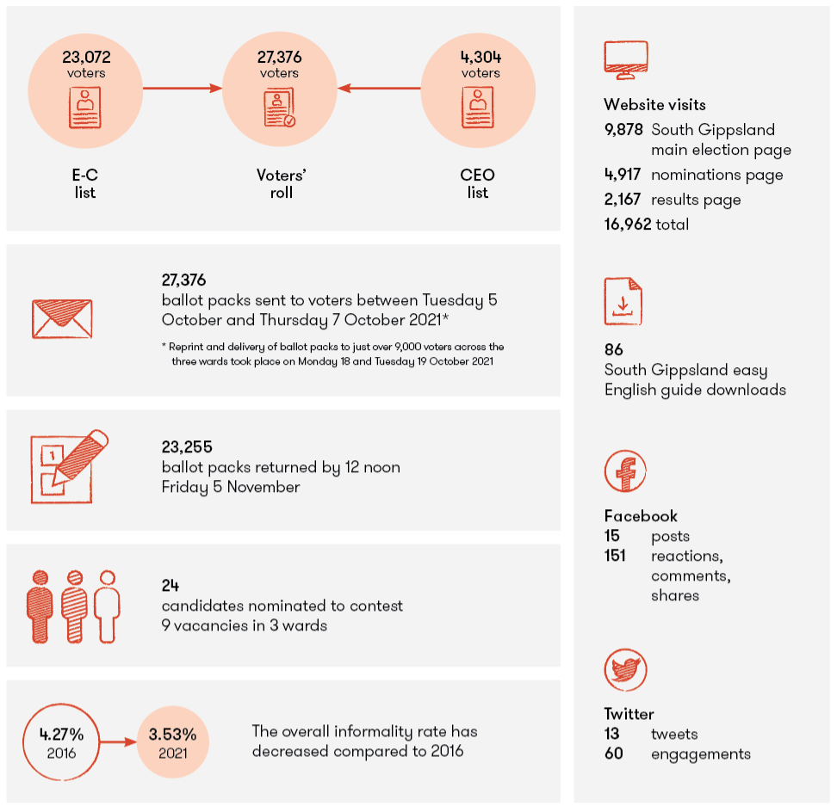

The South Gippsland Shire Council general election was held on 23 October 2021. Having recently finalised the 2020 local government elections, the VEC was in a good position to conduct the South Gippsland Shire Council general election in 2021 using the 2020 Election Service Plan as a base, and making minor adjustments and improvements whilst taking into consideration the current COVID-19 environment.
The 2020 local government elections were the first to be governed by Victoria’s new Local Government Act 2020 (LGA 2020). The legislation was passed by Parliament in March 2020, and the electoral provisions of the LGA 2020 came into effect in April 2020. The changes, where relevant, also applied to the 2021 South Gippsland Shire Council general election.
A key reform of the LGA 2020 stipulated that a single voting system (either attendance voting or postal voting) must be used for general elections and by-elections and must be determined by the Minister. In accordance with the Minister’s determination, all 2020 elections were held by postal voting and this applied to the 2021 South Gippsland Shire Council general election.
A total of 27,376 voters were enrolled at the close of rolls with 23,072 voters on the Victorian Electoral Commissioner’s (EC) List and 4,304 on the Chief Executive Officer’s (CEO) List. The voters’ roll for the South Gippsland Shire Council general election was certified by the VEC’s Registrar on Thursday 16 September 2021.
The VEC established an election office within the council area at 37 Bair Street Leongatha with an Election Manager and Assistant Election Manager appointed from a pool of available senior election officials.
Over the nomination period from 9 am on Thursday 16 September to 12 noon on Tuesday 21 September 2021, a total of 25 nominations for 9 vacancies in 3 wards were received. One nomination was withdrawn, leaving 24 active nominations at the close of nominations.
All elections were contested with 7 candidates in Coastal-Promontory Ward, 7 candidates in Strzelecki Ward, and 10 candidates in Tarwin Valley Ward.
Ballot packs were mailed between Tuesday 5 October and Thursday 7 October 2021. Over the three-day period, the VEC mailed 27,376 ballot packs and worked closely with Australia Post to confirm that ballot packs had been delivered to voters.
On Friday 15 October, the VEC became aware that several voters across all 3 South Gippsland Shire Council wards had not received their ballot packs. On investigation, it was identified that the issue was isolated to ballot packs lodged on Tuesday 5 October, day 1 of the general mail-out. In order to ensure that all voters had adequate time to cast a considered vote and thus ensure the integrity of the election, the Electoral Commissioner, in accordance with regulation 60(1)(b) of the LG Regulations and under regulation 57(3)(a) of the Regulations, made the decision to extend the close of voting by 1 week from 6 pm on Friday 22 October to 6 pm on Friday 29 October 2021.
A reprint of the ballot material for affected voters took place and ballot packs were re-issued with delivery taking place to voters on Monday 18 and Tuesday 19 October 2021. Just over 9,000 voters across the 3 wards were affected.
Voters had until close of voting, 6 pm on Friday 29 October 2021, to have either mailed or hand delivered their completed ballot material to the election office. By the close of voting, 21,683 ballot paper envelopes had been returned. Ballot material received at the election office between the close of voting and the close of the extended postal vote receipt period could be considered, if it was determined to have been completed by the voter before the close of voting – 1,572 votes were received during this period.
The 2021 South Gippsland general elections were conducted by computer count. Computer counting is used where a proportional representation count is required. Trained data entry operators, in the presence of scrutineers and election officials, enter preferences from ballot papers into the VEC’s computer count application. A calculation step follows the completion of the computer count to determine the successful candidates.
The VEC counted votes in two stages. The first stage included votes received up until the close of voting. The second stage included all votes received up until the end of the extended postal vote receipt period.
The computer count results were calculated once all formal ballot papers had been entered into the VEC’s computer count application and the total number of informal votes to be included had been updated. The computer count results for all wards were calculated on Tuesday 9 November 2021.
The calculation of the result is a public event where candidates, scrutineers and other interested parties were invited to attend. The VEC had appropriate measures in place to ensure all events complied with COVIDSafe guidelines.
The results of the South Gippsland Shire Council general election were declared at 1:30 pm on Tuesday 9 November 2021.
The overall voter turnout for the 2021 South Gippsland Shire Council general election was 81.51% which was higher than the Statewide average at the 2020 local government elections of 81.47% (excluding Melbourne City Council), and higher than the turnout of 79.89% at the 2016 general election for South Gippsland Shire Council.
The informal rate was 3.53% of total votes, which was lower than the 4.72% informal rate recorded for the 2020 local government elections. The informal rate was also lower than the 4.27% rate recorded previously for South Gippsland in 2016. Strzelecki Ward recorded the highest informal rate of all 3 wards at 3.93%, closely followed by Tarwin Valley at 3.84% and Coastal-Promontory at 2.60%.
The VEC processed and responded to 49 complaints during the election period. Of those complaints, 24% were referred to the Local Government Inspectorate (LGI) as they related to possible breaches of the LGA 2020. The average response time was one working day.
The Victorian Civil and Administrative Tribunal (VCAT) is responsible for hearing disputes on the validity of an election under section 311 of the LGA 2020. Applications for a review of the declaration of the results of an election must be lodged within 14 days of the election and can be made by a candidate in the election, 10 persons who were entitled to vote at the election, or the VEC.
There were no applications to VCAT disputing the result of the South Gippsland Shire Council general election.
The VEC has responsibility for the enforcement of compulsory voting. A total of 1,920 Apparent Failure to Vote Notices (AFTVN) were mailed in late November 2021, and recipients had 21 days to reply. Subsequently 1,476 Infringement Notices were issued in early January 2022 to those who either did not respond to the AFTVN or did not provide a sufficient reason for failing to vote.
During the Penalty Reminder Notice stage of enforcement 1,102 notices were issued in late February to those who did not pay the infringement penalty, hadn’t had their infringement withdrawn or who had sought to go directly to the Magistrates’ Court. The VEC will lodge the file of any remaining non-voters with Fines Victoria at the conclusion of the Penalty Reminder Notice stage. Further detail on enforcement is provided on page 54.
In accordance with the LGA 2020, a report was delivered to the South Gippsland Shire Council in February 2022. A consolidated report on the conduct of the elections will be provided to the Minister for Local Government and likely tabled in Parliament in August 2022.

Response to public health crisis: COVID-19
In response to COVID-19, a State of Emergency was declared in Victoria on 16 March 2020. The VEC’s operating model was adjusted to deliver a compliant election while meeting health, safety, social distancing and hygiene obligations to voters, election staff, councils, candidates, and all other stakeholders.
In addition, on Wednesday 1 September 2020, the Governor in Council made amendments to the regulations to allow certain provisions to be varied in response to COVID-19. Specifically, the amendments allowed the VEC to determine an appropriate method for eligible candidates to lodge their nomination form and pay their nomination fee electronically; and to allow the Election Manager to determine the maximum number of scrutineers that may be present for any activity at any one time. The amended regulations commenced the day after they were made and remained in place until 26 April 2022.
On 29 September 2020, the Governor in Council made further changes to the Regulations to provide greater clarity of mitigation options for any disruptions to the voting timeline, including delays across the postal network that could threaten the integrity of the elections. The changes allowed the Electoral Commissioner to alter the last day of voting and/or the extended postal vote receipt deadline if necessary, to maintain and protect election integrity.
In 2020, the VEC developed a COVIDSafe Election Plan in consultation with the Department of Health and Human Services which complemented the VEC’s Service Plan. The COVIDSafe Election Plan outlined the VEC’s actions and strategies to deliver safe and compliant local government elections.
For the 2021 South Gippsland Shire Council general election, the VEC implemented several changes, such as (but not limited to) electoral operations and activities including:
acquiring a larger election office space to accommodate social distancing practices
moving operations from face-to-face to online (when legislation permitted), for example:
the VEC’s briefing meeting with council
the candidate information sessions
modifying the timeline for ballot paper extraction and counting activities
modifying scrutineer practices.
In addition to the VEC’s COVIDSafe Election Plan, for the 2020 local government elections, the VEC produced a COVIDSafe handbook, covering election office operations. The handbook outlined measures to ensure that the VEC met government health and safety guidelines, while mitigating the risk of any COVID-19 event that could have affected election staff, voters, candidates, and other members of the public.
For the 2020 local government elections, the handbook was regularly reviewed and updated to align with health advice and directions, to ensure compliance with all requirements. The Department of Health and Human Services indicated their satisfaction that appropriate public health risk mitigation strategies had been considered and integrated into election arrangements.
For the South Gippsland Shire Council general election, the handbook was regularly reviewed to ensure that it continued to align with health advice and directions, to ensure compliance with all requirements.

Costing expectations
As in previous local government elections, the VEC applied a marginal cost recovery model to the South Gippsland Shire Council general election, where all direct costs are recovered. The VEC invoiced in three stages:
Stage 1: An invoice for election services was sent to South Gippsland Shire Council in April 2022.
Stage 2: An invoice for the dispatch and processing of Apparent Failure to Vote Notices (AFTVNs) and Infringement Notices was sent to South Gippsland Shire Council also in April 2022.
Stage 3: An invoice for the dispatch and processing of the Penalty Reminder Notice was sent to South Gippsland Shire Council in June 2022. Further invoices will be issued if prosecution costs are incurred. These will be raised in the following financial years.

Performance target outcomes
The 14 performance targets identified for the 2020 local government general elections were also applied to the South Gippsland Shire Council general election and the service level agreement with the council.
These targets ranged from aspirational measures to enhance voter participation, to more operational measures, such as roll accuracy, results reconciliation and outreach services. The targets were measured against election preparation, election conduct and election outcomes. Overall, 12 of the 14 targets were fully achieved with the remaining 2 partially achieved due to the reprint of ballot packs and the extension of the close of voting by one week.

Planned initiatives
The 2021 South Gippsland Shire Council general election had 4 initiatives:

Candidate information
The VEC developed a suite of resources that were accessible to prospective candidates prior to the nomination period. From early September 2021, candidates were able to access the VEC’s information about the process of nominating and becoming a candidate for the election.
The VEC encouraged prospective candidates to attend a candidate information session prior to the conduct of the election. Due to the COVID-19 restrictions, for the South Gippsland Shire Council general election, the VEC’s candidate information session was recorded and available for online streaming from the VEC website.
The recorded video was complemented by an interactive candidate information webinar which consisted of a panel from the VEC’s leadership team who were able to answer questions regarding the election process or clarify information presented.
This arrangement also allowed prospective candidates to review the session in their own time and was more accessible to those who would normally be unable to attend an in-person session.

VoterAlert advisories
For the South Gippsland Shire Council general election, the VEC’s notification service, VoterAlert, was successfully used to send key election reminders to State-enrolled voters by SMS, email or both. VoterAlert reminders were sent to over 11,000 voters during the election period where the voters were reminded to check their enrolment details prior to the close of rolls, and to vote via 2 reminders sent during the voting period. In addition, VoterAlert was successfully used to advise voters that the voting deadline had been extended.

Computer count
The computer count for the South Gippsland Shire Council general election was conducted locally at the election office. Following the extraction of ballot papers admitted to the count for all wards, preferences on ballot papers were data entered into VEC’s computer counting application at the election office. The application distributes preferences using the proportional representation method once data entry of ballot paper preferences is complete. The computer count information session explaining the process was recorded and available for online streaming from the VEC website from Thursday 28 October 2021. Results were calculated at the election office on Tuesday 9 November 2021.
The provisional results were published to the VEC website as they became available. Results were updated as finalised¹ once declarations had taken place.
¹ A preference distribution report can be found at 2021 South Gippsland Shire council election results
Victorian Electoral Commission (vec.vic.gov.au).

Updates to the VEC’s Ballot Paper Envelope Reconciliation Process
Embedded in the VEC’s Election Management System is a module that captures all returned votes. The ballot paper envelope reconciliation (BPER) module is used by each election office to reconcile the number of general mail-out and replacement votes and whether they were accepted or rejected. Data processed via the BPER provides each Election Manager with the number of votes to progress to extraction.
For the 2020 local government elections, several enhancements were made to the BPER process in the election management system. Primarily the changes allowed for the processing of returned postal votes in numbered batch groups to provide better alignment with the manual sorting process undertaken each day mail is received at the office. Additional reporting was also added to allow for ease of reconciliation with the physical items.
During the 2020 local government elections, the new process was found to be simpler than at previous elections and provided better system-driven reconciliation.
Further enhancements were made prior to the South Gippsland Shire Council general election to strengthen reporting and reconciliation requirements.

Local government by-elections and countbacks
An extraordinary vacancy arises in a council when a councillor resigns, dies or can no longer hold office as a councillor. The LGA 2020 provides for a countback to be conducted in the first instance when an extraordinary vacancy arises in a multi-councillor ward or unsubdivided council. A by-election is necessary when an extraordinary vacancy arises in a single-councillor ward, or where the vacancy cannot be filled by a countback because of a failed countback, or because there are no eligible candidates for the election.
During 2021–22, the VEC conducted 3 local government by-elections and 11 countbacks to fill extraordinary vacancies.
The details of all by-elections and countbacks conducted during 2021–22 are included in Figures 11 and 12 on page 52.
The number of extraordinary vacancies was comparable in 2021–22 to 2017–18, which is the previous reporting year matching this stage of the local government term, when there were 2 by-elections and 10 countbacks.
In 2021–22, all countbacks were held online via a webinar (initially Cisco Webex then Microsoft Teams). using the VEC’s web-based computer countback application.
The average cost of a countback in 2021–22 was $1,550.62 (including GST). This cost includes public notices placed in local newspapers (where requested), configuration of the countback application, and staff time.
All by-elections and countbacks were conducted in compliance with legislative requirements, within budget and with no elections failed or overturned. The VEC achieved its aim of providing value for money local government election services.

State by-elections
A State by-election occurs if a Member of Parliament for the Legislative Assembly resigns or can no longer hold office. The VEC maintains the capability and capacity to conduct State by-elections as required, within minimum prescribed timeframes. There were no State by-elections in 2021–22.
The VEC reviewed and refined the State by-election event plan in the first half of 2022 to maintain readiness. The plan includes information on relevant stakeholders, communication strategies, resourcing and infrastructure requirements.

Other elections and polls
Under Victorian legislation, the VEC is required to conduct certain elections and polls. Depending on the legislation, these elections and polls may be partly or wholly funded by the VEC. The VEC also conducts fee-for-service and non-statutory elections that meet certain criteria, including the number of electors, the existence of formal election rules, and election timing.
During 2021–22, the VEC conducted 6 fee-for-service elections and polls. All were conducted in accordance with their relevant rules or legislation and were delivered on time and within budget.
The Burke Rd Wine Pty Ltd Liquor Licensing Poll did not proceed as the Victorian Liquor Control Reform Amendment Bill 2021 abolished dry area polls with effect on 16 December 2021 and the Victorian Commission for Gambling and Liquor Regulation (VCGLR) cancelled the request. With this change, the VEC is no longer required to conduct ‘Dry Area’ Liquor Licensing polls.

Figure 11: Electoral Activity, 2017–18 to 2021–22
TYPE OF ACTIVITY | 2017–18 | 2018–19 | 2019–20 | 2020–21 | 2021–22
State elections (88 districts, 8 regions) | - | 1 | - | - | -
State by-elections | 1 | - | - | - | -
Local government (council) general elections | 1 | - | - | 76 | 1
Local government (council) by-elections | 2 | 5 | 4 | 3 | 3
Local government countbacks | 10 | 18 | 12 | 4 | 11
Liquor licensing polls | 1 | - | 3 | - | 2
Commercial elections and polls | 12 | 4 | 5 | 3 | 4
Total | 27 | 28 | 24 | 86 | 21
Figure 12: Elections, by-elections, countbacks and polls, 2021–22
ELECTION | TYPE | ELECTION DATE | VOTING METHOD | LOCATION | ELECTORS
Cardinia Shire Council,  Westernport Ward | Municipal by-election | 24 July 2021 | Postal | Koo Wee Rup | 8,285
Strathbogie Shire Council,  Lake Nagambie Ward | Municipal countback | 15 September 2021 | N/A | VEC via Cisco Webex | N/A
Emergency Services Superannuation (ESSSuper) Scheme Member Board Election | Fee-for-service election | 23 September 2021 | Not required as the number of nominations received was less than the number of vacancies to be filled | VEC | N/A
Aikido Hospitality Liquor Licensing Poll | Fee-for-service election | 4 October 2021 | Postal | VEC | 1,456
Greenhart Wine Bar Liquor Licensing Poll | Fee-for-service election | 4 October 2021 | Postal | VEC | 1,758
South Gippsland Shire Council | General election | 23 October 2021 | Postal | Leongatha | 27,376
Moira Shire Council | Municipal countback | 14 December 2021 | N/A | VEC via Cisco Webex | N/A
Moira Shire Council | Municipal countback | 19 January 2022 | N/A | VEC via Cisco Webex | N/A
Alpine Shire Council | Municipal countback | 19 January 2022 | N/A | VEC via Cisco Webex | N/A
Yarra Ranges Shire Council, Streeton Ward | Municipal by-election | 19 February 2022 | Postal | Silvan | 12,184
Victorian Strawberry Industry Development Order poll | Fee-for-service election | 24 February 2022 | Postal | VEC | 112
Mitchell Shire Council | Municipal countback | 9 March 2022 | N/A | VEC via Cisco Webex | N/A
Indigo Shire Council | Municipal countback | 9 March 2022 | N/A | VEC via Cisco Webex | N/A
Maroondah City Council, Wonga Ward | Municipal by-election | 12 March 2022 | Postal | Ringwood East | 9,479
Moreland City Council,  North-West Ward | Municipal countback | 21 March 2022 | N/A | VEC via Cisco Webex | N/A
Victorian Canine Association Management Committee Elections | Fee-for-service election | 8 April 2022 | Postal | VEC | 8,348
Borough of Queenscliffe Council | Municipal countback | 12 April 2022 | N/A | VEC via Microsoft Teams | N/A
Mildura Rural City Council | Municipal countback | 20 April 2022 | N/A | VEC via Microsoft Teams | N/A
Wodonga City Council | Municipal countback | 27 April 2022 | N/A | VEC via Microsoft Teams | N/A
Glen Eira City Council,  Rosstown Ward | Municipal countback | 27 April 2022 | N/A | VEC via Microsoft Teams | N/A
Lake Tyers Aboriginal Trust Committee of Management Election | Fee-for-service election | 23 June 2022 | Attendance | Lake Tyers | 297

Enforcement of compulsory voting
The VEC enforces compulsory voting (CV) requirements after elections, by-elections and polls in which voting is compulsory. To conduct CV follow‑up, the Electoral Commissioner appoints a VEC staff member as the Prosecution Officer.
During 2021–22, the VEC finalised CV enforcement for all 76 councils that went to election in October 2020 and 3 local council by-elections which took place in 2020–21. Enforcement was also undertaken for the 2021 South Gippsland Shire Council general election in addition to 3 local council by-elections and 2 liquor licensing polls which took place during 2021–22.
The first stage of the non-voter follow-up process is conducted under Part 9, Division 2 of the Electoral Act 2002, or section 266 of the LGA 2020 (previously section 40 of the Local Government Act 1989 (LGA 1989)). Subsequent follow-up of electors who do not respond, or who provide an invalid response, is conducted under the Infringements Act 2006.
The VEC manages three stages of enforcement (or non-voter follow-up):
- Dispatch of Apparent Failure to Vote Notices to electors who appear not to have voted in an election. Apparent non-voters have 28 days from the date of the notice to provide a valid excuse for failing to vote.
- Follow-up (by Infringement Notice) of electors who did not respond, or who provided an invalid response to the Apparent Failure to Vote Notice. A penalty amount is applied (currently set at $91). Non-voters have 35 days to respond to the Infringement Notice by making the penalty payment or seeking a review of the infringement. The VEC also considers written correspondence from non-voters detailing their reasons for failing to vote.
- A Penalty Reminder Notice is sent to those who do not pay the infringement penalty. An amount for prescribed costs is added to the original penalty amount (currently set at $26.20). Non-voters have 28 days to respond to the Penalty Reminder Notice by making the penalty payment or seeking a review of the infringement.
During the infringement period, non-voters have several options under the Infringements Act 2006, including to:
pay the penalty in full
seek a payment plan
or
seek an internal review of the infringement – the legislation sets out the criteria by which a review can be requested and the process for conducting the review.
Penalties collected during the infringement period are reconciled and transferred to consolidated revenue or forwarded to councils as required. The VEC also collates and transfers all penalties collected by Fines Victoria. A total of $575,409.05 was paid into consolidated revenue in August 2021 and February 2022 from parliamentary elections. In addition, $5,188,047.99 was forwarded to councils in August 2021 and February 2022 from the 2020 local government elections, by-elections in 2021–22 or monies collected by Fines Victoria from older elections. Further remittance to councils will occur as more payments are received from Fines Victoria.

Lodgement with the courts
During the infringement and penalty reminder stages of enforcement, non-voters can choose to have their matter heard in the Magistrates’ Court. During 2021–22, the VEC commenced proceedings against 3 non-voters from the 2020 local government elections.
At the completion of the penalty reminder stage, the VEC lodged 172,621 outstanding non-voter records from the 2020 local government elections with Fines Victoria for further action. Following the three stages of enforcement for the local council by-elections and liquor licensing polls held in 2021–22, the VEC lodged 1,729 outstanding non-voter records with Fines Victoria.
Figure 13: Enforcement of compulsory voting, 2021–22
ELECTION | NOTICE TYPE* | MAILOUT | RECORDS | PENALTIES COLLECTED TO 30 JUNE 2022 | INFRINGEMENT COURT LODGEMENT | NUMBER OF RECORDS
Northern Grampians Shire Council  South West Ward By-election  27/11/2020 | 1 | 24 April 2021 | 128 | $3,678.80 | 17 September 2021 | 46
 | 2 | 9 June 2021 | 101 | $3,678.80 | 17 September 2021 | 46
 | 3 | 6 August 2021 | 63 | $3,678.80 | 17 September 2021 | 46
Hindmarsh Shire Council  East Ward By-election  4/12/2020 | 1 | 24 April 2021 | 116 | $1,883.60 | 17 September 2021 | 48
Hindmarsh Shire Council  East Ward By-election  4/12/2020 | 2 | 9 June 2021 | 93 | $1,883.60 | 17 September 2021 | 48
Hindmarsh Shire Council  East Ward By-election  4/12/2020 | 3 | 6 August 2021 | 58 | $1,883.60 | 17 September 2021 | 48
Northern Grampians Shire Council  Kara Kara Ward By-election  19/2/2021 | 1 | 24 April 2021 | 286 | $7,124.80 | 17 September 2021 | 130
 | 2 | 9 June 2021 | 220 | $7,124.80 | 17 September 2021 | 130
 | 3 | 6 August 2021 | 162 | $7,124.80 | 17 September 2021 | 130
Cardinia Shire Council  Westernport Ward By-election  24/07/2021 | 1 | 20 August 2021 | 1,021 | $26,353.20 | 18 January 2022 | 502
 | 2 | 17 September 2021 | 825 | $26,353.20 | 18 January 2022 | 502
 | 3 | 12 November 2021 | 590 | $26,353.20 | 18 January 2022 | 502
Ashburton Liquor Licensing Poll  (Aikido Hospitality)  04/10/2021 | 1 | 25 November 2021 | 194 | $4,981.60 | 13 April 2022 | 60
 | 2 | 11 January 2022 | 136 | $4,981.60 | 13 April 2022 | 60
 | 3 | 25 February 2022 | 82 | $4,981.60 | 13 April 2022 | 60
Camberwell Liquor Licensing Poll  (Greenhart Wine Bar)  04/10/2021 | 1 | 25 November 2021 | 340 | $10,026.60 | 13 April 2022 | 77
 | 2 | 11 January 2022 | 248 | $10,026.60 | 13 April 2022 | 77
 | 3 | 25 February 2022 | 130 | $10,026.60 | 13 April 2022 | 77
South Gippsland Shire Council  General election  23/10/2021 | 1 | 25 November 2021 | 1,920 | $42,597.40 | 13 April 2022 | 866
South Gippsland Shire Council  General election  23/10/2021 | 2 | 11 January 2022 | 1,476 | $42,597.40 | 13 April 2022 | 866
South Gippsland Shire Council  General election  23/10/2021 | 3 | 25 February 2022 | 1,102 | $42,597.40 | 13 April 2022 | 866
Yarra Ranges Shire Council  Streeton Ward By-election  19/02/2022 | 1 | 1 April 2022 | 1,659 | $35,343.20 | N/A | N/A
 | 2 | 29 April 2022 | 1,314 | $35,343.20 | N/A | N/A
 | 3 | 16 June 2022 | 767 | $35,343.20 | N/A | N/A
Maroondah City Council  Wonga Ward By-election  12/03/2022 | 1 | 1 April 2022 | 1,262 | $21,140.80 | N/A | N/A
Maroondah City Council  Wonga Ward By-election  12/03/2022 | 2 | 29 April 2022 | 931 | $21,140.80 | N/A | N/A
Maroondah City Council  Wonga Ward By-election  12/03/2022 | 3 | 16 June 2022 | 557 | $21,140.80 | N/A | N/A
*1 - Apparent Failure to Vote
2 - Infringement
3 - Penalty Reminder

Electoral structure and boundary reviews

During this financial year, the VEC provided technical and administrative support to the Electoral Boundary Commission’s redivision of Victoria’s State electoral boundaries. In addition, the VEC continues to plan for and advise the Minister for Local Government on the delivery of local government electoral structure and boundary reviews.

State electoral boundary redivisions
State electoral boundary redivisions are conducted periodically to help ensure fair and equitable representation for Victorian electors.
Commencing in 2020, the VEC has provided administrative and technical assistance to the Electoral Boundaries Commission (EBC) for the redivision of State electoral boundaries. The final boundaries were published on 28 October 2021 and tabled at Parliament on the same day. All information pertaining to the redivision, including public submissions, public hearing transcripts, mapping resources and the proposed and final boundaries reports are available online at ebc.vic.gov.au. The Report of the Electoral Boundaries Commission 2021–22 is included as Appendix I.
For the VEC, the completion of the redivision initiated a range of activities to incorporate the boundary changes into enrolment and election systems. To provide updated electoral information to registered political parties and Members of Parliament.

Geospatial Support and Tools
The Geospatial team provided technical expertise to the EBC for the redivision of State electoral boundaries, including analysis of public submissions, testing of boundary models, and creating over 100 detailed maps of the final boundaries. The spatial file of the final boundaries has subsequently been provided to DELWP for inclusion in the VicMap dataset and work is underway to implement the new electoral boundaries across VEC systems ahead of the 2022 State election.
The VEC has developed an interactive map that allows users to compare old and new districts and regions, available at www.ebc.vic.gov.au.
Figure 14: 2021–22 State redivision timeline
30 June 2021 – 18 August 2021 | Stage Two consultation of redivision of State electoral boundaries
28 October 2021 | Final report released (final boundaries)
4 November 2021 | Boundaries lodged with Central Plan Office
1 November 2022 | New boundaries come into effect
26 November 2022 | Election day – 2022 Victorian State election

Local government electoral structure and ward boundary reviews
Under the Local Government Act 1989 (LGA 1989), the VEC was responsible for conducting regular representation reviews according to a prescribed trigger (generally every 12 years). The Local Government Act 2020 (LGA 2020) introduced changes to these reviews. Representation reviews are now referred to as electoral structure reviews.
Under the LGA 2020, there is no longer a prescribed trigger for conducting an electoral structure review. Instead, the Minister for Local Government decides when a review should occur. Further, the VEC is no longer responsible for conducting the review. Under the LGA 2020, the electoral structure review needs to be conducted by an Electoral Representation Advisory Panel (ERAP). The members of the ERAP are appointed by the Minister. The Electoral Commissioner (or delegate) is required to be on this panel. The VEC is required to provide technical and administrative support to the ERAP.
Engagement with Local Government Victoria (LGV) is continuing, including discussions about the impact of the legislative changes to electoral structure reviews as well as timing, scheduling and the level or model of support the VEC is required to provide to the ERAP.
The ways that councils can be structured has also changed under the LGA 2020. The LGA 2020 sets out only three allowable structures, reduced from five previously. In addition, the LGA 2020 specifies that single-councillor wards are the default structure.
The LGA 2020 also provides for the VEC to conduct ward boundary reviews (previously known as subdivision reviews under the LGA 1989). Under the LGA 2020, if the VEC advises the Minister that the number of voters per councillor in one or more wards of the municipal district of the council will vary from the average number of voters per councillor for all the wards by more than 10% by the time that the next general election is held, the Minister may request the VEC to conduct a ward boundary review. The provisions of the LGA 2020 relating to ward boundary reviews are like those which related to subdivision reviews under the previous Act.
The VEC continues to monitor which councils are projected to require a ward boundary review prior to the next general election in 2024.
Figure 15: Electoral structure and boundary reviews, 2017–18 to 2021–22
TYPE OF ACTIVITY | 2017–18 | 2018–19 | 2019–20 | 2020–21 | 2021–22
Representation reviews | - | 12 | 19 | - | -
Subdivision reviews | - | - | 7 | - | -
State redivisions | - | - | - |  | 1
Total |  | 12 | 26 |  | 1

Register of electors

One of the VEC’s key objectives is to maintain the accuracy and security of the register of electors, increase the proportion of eligible electors enrolled year-on-year and maintain this measure at or above the national average. The VEC undertakes a range of activities to keep the register of electors current and complete, and to ensure electors vote and vote correctly.

Joint Enrolment programs
The VEC works closely with the Australian Electoral Commission (AEC) to maintain a joint enrolment process. This enables enrolment information provided to one agency to be shared with the other agency. The VEC has a service level agreement with the AEC, managed by a Joint Roll Management Committee (JRMC) that typically meets at least every 6 months and a Joint Roll Management Board (JRMB), which meets annually.
The JRMC focus in 2021–22 was identifying, reducing, and preventing divergence between the Commonwealth and State registers of electors. With the federal election in May 2022 and planning well underway for the Victorian 2022 State election, the JRMC concentrated on providing mutual support to ensure each commission would meet their objectives. This work, coupled with 188,611 enrolment updates in April resulting from the Federal election close of roll, puts the register of electors in a position of strength leading into the State election in November 2022.

VEC enrolment programs
Under section 26 of the Electoral Act 2002 (Electoral Act), the VEC receives or can request information from specified people to support the preparation, maintenance or review of the Victorian register of electors. We receive data from the Registrar of Births, Deaths and Marriages (BDM) which enables the VEC to identify and remove deceased persons from the register of electors. The Department of Justice and Community Safety provide data relating to prisoners who are serving a sentence of 5 years or more, who under section 48(2)(b) of the Constitution Act 1975 (Vic) are not entitled to be enrolled as an elector.
To maintain the accuracy of the register of electors, the VEC has a range of strategic programs to help Victorians enrol or update their enrolment. The VEC undertakes regular direct enrolment of eligible persons, using data sourced from the Department of Transport (DoT) and the Victorian Curriculum and Assessment Authority (VCAA). The VEC also uses several measures to identify individuals who may need to enrol or update their enrolment and encourage them to update their details, including SMS and email prompts.
The VEC also uses information provided by the VCAA to undertake its youth enrolment program, which encourages and assists young people to enrol. The program includes:
Sending birthday cards with enrolment information to all Victorian students turning 17, inviting them to provisionally enrol; this year the VEC sent birthday cards to 63,111 young people which resulted in 9,257 (14.7%) provisional enrolments
Sending youth brochures to provisionally enrolled 17-year-olds to explain how voting and enrolment works in Federal, State and local government elections in Victoria; the VEC sent youth brochures to 9,441 newly enrolled young electors this year
A direct enrolment campaign for 18-year-old school leavers who have not yet enrolled; this year 7,315 school leavers were enrolled by the VEC through the program.

Enrolled electors
The number of Victorians enrolled to vote on the register of electors increased over the year by 58,787 (1.4%) to 4,369,200 as at 30 June 2022.
Figure 16: Enrolment by age range as at 30 June 2018 to 2022
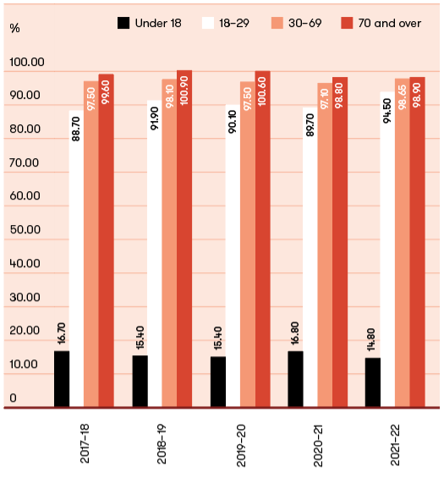
Note: Enrolment rates greater than 100% reflect inherent definitional and data collection differences between the Victorian Register of Electors and the Australian Bureau of Statistics’ population estimates.

Victorian enrolment rate
Using available data, it is estimated that the enrolment rate for Victoria at 30 June 2022 was 97.8%. This is within our target of +/-1% variation from the national enrolment rate which was 97.1%. The enrolment rate has increased by 1.9 percentage points since 30 June 2021.
In 2021–22, the VEC introduced a new methodology for calculating the Victorian enrolment rate using enrolment figures from the Victorian register of electors and estimated eligible population data provided by the AEC. Previously, the Victorian enrolment rate was calculated by the AEC using federal enrolment figures.
Figure 17: Proportion of eligible population enrolled from 30 June 2018 to 2022
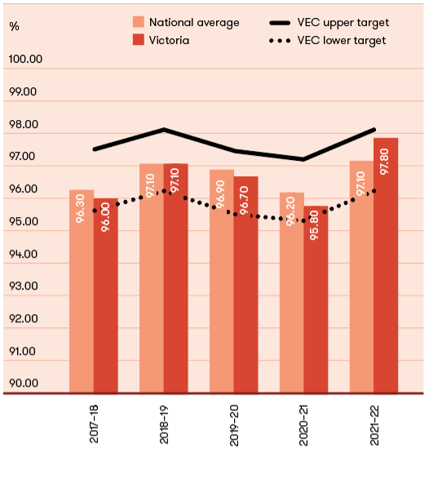
Note: enrolment rates for 2017–18 to 2020–21 have been recalculated using VEC enrolment figures.

Enrolment rate by age
Enrolments across each age range increased during the year compared to 30 June 2021, with the exception of under 18 provisionally enrolled electors. At 30 June 2022, there were 10,038 under-18-year-olds (12.9% decrease) 785,895 18–29-year-olds (1.7% increase), 2,849,956 30–69-year-olds (0.8% increase) and 733,136 electors aged 70 years and older (3.2% increase) enrolled to vote.
In 2021–22, the VEC commenced reporting enrolment rate by age using enrolment figures from the Victorian register of electors and estimated eligible population data provided by the AEC. At 30 June 2022, the VEC estimates the proportion of eligible Victorians who were enrolled to vote was 14.8% of under 18-year-olds, 94.5% of 18–29-year-olds, 98.5% of 30–69-year-olds and 98.9% of people 70 years and older as shown at Figure 16. By 30 June 2023, the VEC will set targets for enrolment rate for each age range, allowing for a period of benchmarking.
Figure 18: Enrolment by age range as at 30 June 2018 to 2022
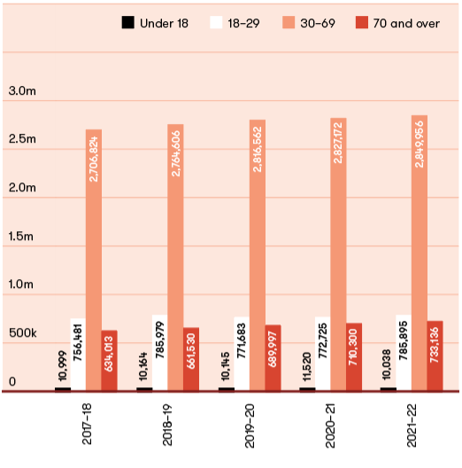
Figure 19: Enrolment transactions as at 30 June 2018 to 30 June 2022
VEC ENROLMENT PROGRAM TRANSACTIONS¹ | 2017–18 | 2018–19 | 2019–20 | 2020–21 | 2021–22
New to roll | 12,748 | 5,868 | 17,388 | 19,795 | 19,490
Reinstatements | 425 | 254 | 68 | 175 | 42
Removals | 40,912 | 39,028 | 41,390 | 45,478 | 43,335
Change of details | 5,501 | 3,368 | 1,331 | 537 | 388
Total | 59,586 | 48,518 | 60,177 | 65,985 | 63,255

JOINT ENROLMENT PROGRAM TRANSACTIONS | 2017–18 | 2018–19 | 2019–20 | 2020–21 | 2021–22
New to roll | 162,125 | 157,863 | 100,959 | 111,400 | 124,461
Reinstatements | 32,737 | 43,704 | 16,949 | 22,273 | 29,853
Removals | 53,105 | 66,283 | 57,189 | 68,648 | 83,601
Change of details | 442,460 | 556,491 | 349,859 | 474,262 | 511,283
Total | 690,427 | 824,341 | 524,956 | 676,583 | 749,198

OTHER ENROLMENT-RELATED TRANSACTIONS AND OUTREACH ACTIVITIES | 2017–18 | 2018–19 | 2019–20 | 2020–21 | 2021–22
Special category applications² | 7,053 | 24,622³ | 487 | 584 | 1,269
Provisional enrolment (17 year olds) | 8,927 | 10,680 | 9,766 | 12,420 | 9,257
Other enrolment campaigns | 3,041 | 13,378 | 619 | 8,384 | 1,907
¹ The VEC processes enrolment transactions using information from the Registrar of Births, Deaths and Marriages, the Department of Justice and Community Safety, the Department of Transport and the Victorian Curriculum and Assessment Authority. From 24 July 2020 direct enrolment transactions from the Australian Electoral Commission (AEC) are being directly accepted and are now reported under joint enrolment program transactions.
² Special category applications received by the VEC include: applications to become General Postal Voters (GPVs), silent electors, itinerant or eligible overseas electors. Some of these transactions are processed by the VEC and some are passed to the AEC for processing under the Commonwealth Electoral Act 1918.
³ A General Postal Voter campaign was promoted by some candidates and registered political parties within the six weeks leading up to the close of roll for the 2018 State election, targeting electors 70 years of age or older. This led to a large-scale increase in GPV applications during this period.

Roll management system redevelopment
The VEC’s Roll Management System (RMS) is a technology platform that enables the Commission to maintain the register of electors and create electoral rolls and other roll products. In March 2020, the VEC commenced a project to replace RMS.
The business has since made significant progress to ensure readiness for development of the new system which will commence in July 2022. These readiness activities included structuring the enrolment branch to ensure VEC staff are positioned to support the project with a broad range of subject matter expertise, and reviewing existing processes, procedures, and business rules to ensure the new RMS is built to support their delivery. From a project perspective, considerable time has been spent understanding the resourcing requirements and ensuring all governance practices are in place. Change management activities have commenced and the steering committee is well informed and positioned to provide strategic oversight.
The VEC is now poised to begin detailed design and development of the new RMS commencing in July 2022, with a target date of December 2023 for the new platform to be ready for use.

Geospatial services
The VEC maintains a range of spatial datasets, including electoral boundaries, statistics, and a Victorian address dictionary. This enables the VEC to accurately analyse voter information relating to the elector’s enrolled address.
The VEC’s delivery of geospatial products and services is guided by the Geospatial Strategy 2021–24, which aims to use geospatial intelligence in the delivery of high-quality electoral services to support Victorians to actively participate in their democracy. In 2021–22, the VEC:
established governance and advisory mechanisms to support delivery of the strategy
delivered a spatial data management policy to support internal use of geospatial tools and data
enhanced the internal web-based map browser to support enrolment, election services, education, outreach and research teams in their work targeting services for electors
supported the inclusion of geospatial functionality in the design and build of its election management system (EMS) enabling more accurate voting centre location information being provided to voters via its voting centre locator map
refreshed the voting centre locator map in preparation for the upcoming State election. This application shows users the nearest voting locations, opening times and accessibility information
collaborated with the VEC’s Enterprise Architecture Broad (EAB) to consider a model for the provision of spatial services to new RMS and other systems to support the use of geospatial intelligence in the preparation and provision of electoral services well into the future.

Figure 21: Elector statistics by region, 30 June 2022
Elector statistics by region for 2021–22 appear below:
Total number of electorates: 8
Total number of electors: 4,369,200
Average number of electors per region: 546,150
REGION | ELECTOR COUNT | VARIANCE TO AVERAGE (%)
Eastern Metropolitan | 474,874 | -13.1%
Eastern Victoria | 575,611 | 5.4%
Northern Metropolitan | 576,268 | 5.5%
Northern Victoria | 556,541 | 1.9%
South-Eastern Metropolitan | 528,573 | -3.2%
Southern Metropolitan | 506,044 | -7.3%
Western Metropolitan | 585,012 | 7.1%
Western Victoria | 566,277 | 3.7%

Figure 23: Elector statistics by district, 30 June 2022
Elector statistics by district for 2021–22 appear below:
Total number of electorates: 88
Total number of electors: 4,369,200
Average number of electors per district: 49,650
DISTRICT | ELECTOR COUNT | VARIANCE TO AVERAGE (%)
Albert Park | 52,484 | 5.7%
Altona | 59,975 | 20.8%
Bass | 76,091 | 53.3%
Bayswater | 44,495 | -10.4%
Bellarine | 55,931 | 12.7%
Benambra | 52,086 | 4.9%
Bendigo East | 52,657 | 6.1%
Bendigo West | 47,804 | -3.7%
Bentleigh | 44,424 | -10.5%
Box Hill | 44,669 | -10.0%
Brighton | 45,314 | -8.7%
Broadmeadows | 44,904 | -9.6%
Brunswick | 54,814 | 10.4%
Bulleen | 45,376 | -8.6%
Bundoora | 41,192 | -17.0%
Buninyong | 48,750 | -1.8%
Burwood | 44,000 | -11.4%
Carrum | 50,505 | 1.7%
Caulfield | 45,800 | -7.8%
Clarinda | 45,001 | -9.4%
Cranbourne | 72,738 | 46.5%
Croydon | 43,491 | -12.4%
DISTRICT | ELECTOR COUNT | VARIANCE TO AVERAGE (%)
Dandenong | 43,492 | -12.4%
Eildon | 46,901 | -5.5%
Eltham | 44,157 | -11.1%
Essendon | 49,413 | -0.5%
Euroa | 51,531 | 3.8%
Evelyn | 44,188 | -11.0%
Ferntree Gully | 41,135 | -17.2%
Footscray | 54,124 | 9.0%
Forest Hill | 39,453 | -20.5%
Frankston | 45,045 | -9.3%
Geelong | 48,418 | -2.5%
Gembrook | 56,765 | 14.3%
Gippsland East | 49,158 | -1.0%
Gippsland South | 45,317 | -8.7%
Hastings | 52,302 | 5.3%
Hawthorn | 45,682 | -8.0%
Ivanhoe | 47,400 | -4.5%
Kew | 43,793 | -11.8%
Keysborough | 47,324 | -4.7%
Kororoit | 59,344 | 19.5%
Lara | 48,628 | -2.1%
Lowan | 43,773 | -11.8%

DISTRICT | ELECTOR COUNT | VARIANCE TO AVERAGE (%)
Macedon | 48,402 | -2.5%
Malvern | 43,427 | -12.5%
Melbourne | 60,038 | 20.9%
Melton | 60,082 | 21.0%
Mildura | 45,537 | -8.3%
Mill Park | 47,699 | -3.9%
Monbulk | 42,953 | -13.5%
Mordialloc | 47,058 | -5.2%
Mornington | 48,043 | -3.2%
Morwell | 50,084 | 0.9%
Mount Waverley | 39,167 | -21.1%
Mulgrave | 40,592 | -18.2%
Murray Plains | 48,538 | -2.2%
Narracan | 57,628 | 16.1%
Narre Warren North | 45,203 | -9.0%
Narre Warren South | 52,035 | 4.8%
Nepean | 53,082 | 6.9%
Niddrie | 45,164 | -9.0%
Northcote | 49,831 | 0.4%
Oakleigh | 43,808 | -11.8%
Ovens Valley | 45,284 | -8.8%
Pascoe Vale | 52,593 | 5.9%
DISTRICT | ELECTOR COUNT | VARIANCE TO AVERAGE (%)
Polwarth | 49,331 | -0.6%
Prahran | 50,387 | 1.5%
Preston | 46,676 | -6.0%
Richmond | 54,995 | 10.8%
Ringwood | 42,183 | -15.0%
Ripon | 50,441 | 1.6%
Rowville | 39,580 | -20.3%
Sandringham | 46,925 | -5.5%
Shepparton | 50,811 | 2.3%
South Barwon | 65,162 | 31.2%
South-West Coast | 49,593 | -0.1%
St Albans | 46,491 | -6.4%
Sunbury | 47,533 | -4.3%
Sydenham | 53,855 | 8.5%
Tarneit | 64,349 | 29.6%
Thomastown | 50,239 | 1.2%
Warrandyte | 43,348 | -12.7%
Wendouree | 46,168 | -7.0%
Werribee | 53,228 | 7.2%
Williamstown | 51,536 | 3.8%
Yan Yean | 66,990 | 34.9%
Yuroke | 73,287 | 47.6%

Footnote: After the introduction of new electoral boundaries resulting from the 2021 State redivision, it is anticipated that 2 districts may exceed the average number of electors per district by more than 10%. This compares to 36 current electoral districts that exceed the average number of electors per district by more than 10%.

Provision of enrolment information
The register of electors contains personal enrolment information, including name, address, date of birth and gender. Protecting the privacy of electors’ personal enrolment information is of fundamental importance to the VEC, and information is only disclosed as required by legislation.

Mandatory provision of enrolment information
The Electoral Act 2002 (Electoral Act) stipulates several circumstances in which electoral information must be made available and how it must be made available.
The list of Victorian electors (names and addresses only), excluding silent electors, must be made available for public inspection at the offices of the VEC and updated every six months. Information can only be searched by name.
The latest print of any electoral roll produced for an election (which contains name and address details only) must be made available for public inspection, free of charge, at locations and during times determined by the VEC.
Enrolment information, excluding silent electors, must be provided to registered political parties and Members of Parliament for permitted purposes.
A copy of the electoral roll, excluding silent electors, is provided to candidates for an election.
Enrolment information is also provided under other legislation. Under section 19 of the Juries Act 2000, the VEC provides lists to Juries Victoria of people who are eligible for jury service, and processes exemptions from jury service on a monthly basis. A total of 77 jury rolls were provided under this legislation during 2021–22.
The VEC also shares enrolment information with councils for the purposes of local government elections. The VEC and councils share enrolment information pursuant to Part 8 of the LGA 2020, and as required under Regulation 15 of the Local Government (Electoral) Regulations 2020 for the purposes of preparing accurate voters’ rolls.
Section 254 of the Local Government Act 2020 provides for the release of enrolment information (a copy of the voters’ roll) to the Chief Executive Officer (CEO) of a council on request. The voters’ roll can be used for the purpose of communicating or consulting with the municipal community in relation to the performance of the council’s functions. In 2021‑22 the VEC did not receive any requests to release information under this provision.

Discretionary provision of enrolment information
The Electoral Act strictly regulates the way the VEC collects, uses and discloses enrolment information. The Act ensures that electors’ enrolment information is protected and not made freely available to the public.
Section 34 of the Electoral Act provides the mechanism under which the VEC may release enrolment information in defined circumstances. The VEC may enter into an information-sharing deed with an applicant. This occurs when the public interest in providing the requested information outweighs the public interest in protecting the privacy of personal information. Strict conditions regulate the provision of information and penalties apply for non-compliance or misuse of enrolment information.
Enrolment information was provided to five organisations under existing agreements subject to section 34 of the Electoral Act (see Figure 22). A standing agreement has been in place with Victoria Police since 2005, which allows immediate secure access to the register of electors.
Figure 22: Information provided to organisations under section 34 of the Electoral Act, 2021–22*
ORGANISATION | LOOK UPS REQUESTED | UNSUCCESSFUL SEARCHES | INFORMATION PROVIDED
Adoption Information Service (previously Family Information Networks and Discovery) | 109 | 49 | 60
Victorian Assisted Reproductive Treatment Authority | 65 | 16 | 49
State Revenue Office | (List of electors provided monthly)
BreastScreen | (List of electors within relevant cohort provided quarterly)
Department of Health and Human Services | (Once-off list of electors provided)
Victoria Police | 13,634 searches

*For more information around the purpose of these agreements, please visit: vec.vic.gov.au/privacy/release-of-enrolment-information

Communication services

Advertising
The VEC published 19 statutory advertisements (including reminder advertisements) across 3 local newspapers during the 2021 South Gippsland Shire Council general election. All printed material was developed in-house.
One statutory advertisement was published in relation to the 2020–21 State electoral boundary redivision.
The VEC also published statutory advertising for 3 local government by-elections and 11 countbacks. A total of 83 statutory and non-statutory advertisements (including reminder advertisements) were published. This includes fee-for-service events and registered political party notices.

Media services
The VEC maintains an open and informative relationship with Victorian media outlets. Throughout 2021–22, the VEC provided metropolitan and regional media outlets with media releases around local government electoral events (including by-elections and countbacks). The VEC also distributed media releases regarding its register of political parties, including de-registrations of political parties and applications to change parties’ names or logos. The VEC distributed a total of 61 media releases throughout 2021–22.
The VEC commits to responding to all media queries within 3 business days. In 2021–22, the VEC responded to 85 media enquiries, with 81 resolved within one business day and 4 within 3 business days.
In 2021–22, the VEC also provided administrative support to the Electoral Boundaries Commission for the 2020–21 State Redivision program, which included media services. The aim of the media campaign was to drive awareness of, and participation in, the public consultation on changes to Victoria’s electoral boundaries.
The were 58 stage one submissions as part of the State Redivision, significantly more than the 17 in 2013. There were 127 stage 2 submissions, significantly fewer than the 608 in 2013. However, at least half of the 2013 submissions were form letters. The submissions in 2021 were of much better quality, providing useful information to the EBC.
The other key media campaign included the 2021 South Gippsland Shire Council general election. The focus was to increase news coverage, as well as drive awareness of, and participation in, the election. The overall participation rate was 77.85%, an increase from the previous election in 2016 (77.06%).
During the 2021 South Gippsland Shire Council general election ballot paper delivery period, the VEC issued 7 council-specific releases.

Selections: the VEC newsletter
‘Selections’ is the VEC’s annual stakeholder newsletter. It is distributed to State and local government representatives, government departments, the Electoral Matters Committee (EMC) of Parliament, VEC employees, senior election officials and registered political parties. The 2021 edition was published in November and highlighted key activities from 2020–21. The newsletter was distributed digitally through e-marketing software, with the stories hosted on the VEC website. The stories received a combined 1,708 views.

Social media
The VEC’s social media channels continue to be a critical medium for community outreach, education and engagement, as well as publicising information about incidental electoral events such as local government by-elections.
In 2021–22, the VEC also continued to focus on addressing misinformation and disinformation on social media aimed at undermining trust and confidence in Victoria’s electoral system.
Over the course of the year, the VEC published 84 tweets, 83 Facebook posts, 28 Instagram posts and 30 LinkedIn posts, generating over 12,000 visits to the website.

VEC website
The VEC website continues to be the first point of contact with the VEC for hundreds of thousands of Victorians each year. People visit the website to obtain information about election events, perform enrolment transactions, and learn about the VEC’s programs and activities.
In 2021–22, a total of 852,007 users visited the VEC website, and 60.6% of these visits were made via a mobile device.
In January 2022, the VEC completed a development project to ensure the website was prepared to deliver the 2022 State election. This involved the build of new functionality, which included a State election results summary hub, where website visitors will be able to get a snapshot of election results on election night and throughout election weekend.
In February 2022, the VEC also introduced a new web governance platform that offers continuous monitoring and reporting on website accessibility compliance. This will ensure the VEC is placed to quickly address any website accessibility issues that arise and ensure continued compliance with Web Content Accessibility Guidelines (WCAG) 2.1 Level AA.

VoterAlert
The VEC’s notification service, VoterAlert, was successfully used to send key election reminders to State-enrolled electors by SMS, email or both for one local council general election and 3 local council by-elections held during 2021–22.
Across all elections, more than 110,000 VoterAlert reminders were sent to alert electors to:
the close of roll date
the ballot pack mail-out period
the last week to return completed ballot material.
VoterAlert will continue to be deployed at all future elections to raise awareness and increase participation.

Research and development

The VEC conducts research and development activity on an ongoing basis. A research policy and plan guides the conduct of research relating to service delivery and participation in the electoral process across a range of stakeholder groups.

Effect of age on voting turnout
The VEC continued research into voter turnout by age cohorts over the 5 Victorian State elections held from 2002 to 2018. This research has revealed that voting behaviour by individual electors changes as they age, though there are signs that voter turnout by younger age cohorts is tending to decline. Electors who were enrolled at 18 show consistently higher turnout rates than those who enrolled later. This research is being done in collaboration with a researcher in Western Australia, and the findings of the combined research will have nationwide significance when completed (expected to be late 2022).

Electoral Regulation Research Network
The VEC joined with the New South Wales Electoral Commission and the University of Melbourne in March 2012 to establish the Electoral Regulation Research Network (ERRN). The purpose of ERRN is to foster exchange and discussion among academics, electoral commissions and other interested groups on research relating to electoral regulation.
The COVID-19 pandemic forced a remodelling of ERRN seminars from physical events to online webinars conducted via Zoom. An advantage of this change is that events could be nationwide or even international. ERRN hosted or sponsored a total of 13 events in 2021–22, the largest of which was a worldwide event on constitutional change, breakdown and renewal, which comprised 9 webinars over 5 days, with 50 speakers from five continents. Unsurprisingly, many of the ERRN webinars dealt with the effect of COVID-19 on the conduct of elections. Other matters covered included money and politics, and truth in political advertising.
ERRN also hosted a 2-day course in May 2021 on the Regulation of Elections. The course included background papers, presentations and discussions involving leading academics and practitioners in the fields of political science, constitutional law, and election administration. Over 60 participants from Australia and New Zealand debated and exchanged ideas on topics such as the constitutional framework of elections, voting rights, the media in elections and political finance laws.

Online Research Panel
The VEC piloted an Online Research Panel from December 2020, having recruited a representative sample of some 1,800 Victorian electors. The intent was to provide an ability to embed the voice of voters into its communication and service design, evaluate performance and measure any movements in the perception of the VEC’s reputation as an independent, fair and impartial service provider. Panel members have contributed thoughts on satisfaction with election services for local government elections held in 2020; the VEC’s proposed 2022 State election advertising campaign; voter expectations for service delivery for the 2022 State election (several over time) and the establishment of a reputation index baseline. The pilot was successful and embedded as part of the VEC’s ongoing research capability.

Research Partnership with the University of Adelaide
In partnership with the University of Adelaide, the VEC was successful in March 2021 in being granted funding of $200,000 from the Australian Research Council to undertake a project to understand and address informal voting in Victoria. This collaboration will address the problem of informal voting at both State and local government levels over 3 election periods. The first transfer of informal vote data occurred on 14 December 2021, following the complete analysis of some 162,000 informal votes cast during the 2020 local government elections. These votes will now be subject to critical academic analysis. The VEC’s financial commitment to the research over 4 years is $60,000 plus an in-kind contribution equivalent to $214,050.

Funding and disclosure

Victoria’s political funding and donation disclosure laws impose bans or caps on certain political donations, provide greater accountability and transparency through disclosure and real-time reconciliation of political donations, and provide access to public funding streams for Victoria’s Parliamentary elections. The VEC administers and enforces these laws.
The funding and disclosure regime includes disclosure obligations for those giving and receiving political donations, and provides candidates, elected members and registered political parties with access to three streams of funding:
administrative expenditure funding
policy development funding
public funding¹.
Administrative expenditure funding and policy development funding entitlements occur annually and are subject to an annual return following the end of each calendar year. Public funding is calculated from first preference votes received at the last State election and may be paid in instalments in advance of the next State election. Any over-payment as a result of advance funding will be corrected and recovered in accordance with the Electoral Act.
Section 217Q of the Electoral Act requires that donation caps, thresholds and funding amounts are to be indexed annually. The indexation increase factor for the 2021–22 financial year was 1.012831.
For the 2021–22 reporting year, the caps, thresholds and funding amounts were applied as set out in Figure 23 below:

VEC Disclosures: The online disclosure system
VEC Disclosures is the VEC’s online disclosure reporting system. It serves as the integrated political donations disclosure and annual return submission tool for all stakeholders governed by the obligations outlined in Part 12 of the Electoral Act.
The VEC Disclosures system was the subject of two major enhancements this year to further improve the capability and functionality of the system, from both user experience and compliance perspectives.
New features include:
the ability to manage multiple entities under a single account
a simplified registration process
the ability to nominate agents to act on your behalf
an enhanced donation disclosure process
a donation linking tool.
In addition, the sign-in process, browser compatibility, and look and feel were improved. These enhancements will greatly benefit stakeholders and make donation disclosures easier, which is also likely to improve compliance.

Figure 23: Donation caps, thresholds and funding amounts, 30 June 2022
 | Amount
Disclosure threshold | $1,050.00
General cap | $4,210.00
Public funding MLA | $6.33 per vote
Public funding MLC | $3.16 per vote
Administrative expenditure funding (per year)  Capped at 45 members. | $210,870 for the first member  $73,790 for the second member  $36,910 for the third to forty-fifth members
Policy development funding | $1.05 per first preference vote or $26,350 (whichever is greater)

¹ Public funding is available for Members of the Legislative Assembly (MLA) and Members of the Legislative Council (MLC). Different entitlement amounts apply per member.

Annual returns
Annual returns for the 2020–21 reporting period were required to be lodged by 20 October 2021.
The VEC published 74 annual returns, of which:
15 were from registered political parties
55 were from associated entities
3 were from nominated entities
1 was from a third-party campaigner.
With 96% of annual returns received before the deadline, there was a significant improvement in compliance with the timeframe for lodging annual returns compared with previous years.
Following the publication of the annual returns, information from the returns has informed the Funding and Disclosure Unit’s compliance program, including investigations into potential offences against the Act.

Compliance and enforcement
The VEC has adopted a constructive compliance approach for its regulatory activities. Accordingly, the VEC is committed to—in the first instance—engaging with stakeholders to promote and support compliance with Victoria’s funding and disclosure laws. In situations of specific non-compliance, the VEC will assess the nature of the issue and determine an appropriate compliance and enforcement response.
The VEC may initiate an investigation and is empowered to issue notices to require information to assist with investigations. Depending on the extent of any offence, the VEC may issue a formal caution or initiate a prosecution within a period of three years from the time of the offence.
The Electoral Integrity and Regulation Branch was restructured this year to build the VEC’s regulatory capability. The new electoral compliance function will take the lead for investigating alleged offences against the Electoral Act.
To support the VEC in its regulation of Victoria’s funding and disclosure requirements, the Electoral Act provides for employees to be appointed as compliance officers under the Act. The limited powers provided to compliance officers allow them to require certain people to produce documents or other information, or to appear to give evidence.
The VEC is conscious of the responsibility of this power and limits its use of Part 12 powers to when deemed necessary. During the reporting period, the Electoral Commissioner established a Coercive Notice Control Board to provide ongoing governance and advice on the use and review of compliance officer powers. The Board comprises the Executive Director, Corporate Services (Chair), Director, Enrolment, and an independent member from the VEC’s Audit and Risk Committee.
During the reporting period, compliance officers issued 15 written notices under Part 12 of the Electoral Act. Of these 15 notices, 12 required the subject of the notice to provide documents or other materials while 3 notices requested the person to appear before a compliance officer. During COVID-19 restrictions, these appearances were all facilitated online.
One notice was reviewed by request of the person issued the notice. The Coercive Notice Control Board considered the issuing of this notice, and the Electoral Commissioner reviewed this notice pursuant to section 222C of the Act. The Electoral Commissioner affirmed the decision of the compliance officer to issue the notice. In all matters considered for the reporting period, compliance officer powers enabled the provision of evidence and material which supported the VEC in its regulatory function.

Donations disclosure
During the reporting period, the VEC published 314 donation disclosures through VEC Disclosures, the online disclosure system. The published donations amounted to $872,367.29.
Only donations over the disclosure threshold are required to be disclosed. Donations under the disclosure threshold from the same donor are aggregated and the aggregated amount must be disclosed once it reaches or exceeds the disclosure threshold.
Donations over the general cap during the 4-year election period (the time between general elections) and all donations from overseas donors are banned. There were 7 donations disclosed above the general cap during the reporting period and, following investigation into those donations, they were deemed to be exempt from the general cap. Accordingly, the VEC received no reports of banned donations during the reporting period.
Ongoing data matching is undertaken by the Funding, Disclosure and Parties team to assess compliance with the donation disclosure requirements of Part 12 of the Electoral Act.

Political funding
During the reporting period, the VEC facilitated payment of a total of $12,550,810.65 on behalf of the State to eligible registered political parties, independent elected members and candidates entitled to access funding. This included:
$5,913,568.09 in public funding
$6,605,090.19 in administrative expenditure funding
$32,152.37 for policy development funding.
The VEC also recovered $205,983.30 in relation to over-payments for political funding paid during the previous financial year. Over-payments most often occur when funding recipients do not incur the full entitlement paid to them as claimable expenditure. The VEC routinely audit funding returns and commences steps to recover funding amounts which are not correctly acquitted.

Stakeholder engagement
On 16 May 2022, the Party Registration function transferred from the Elections Branch to the Funding, Disclosure and Parties team. This provides a central point for the ongoing administration and contact with registered political parties and any political parties applying for registration.
The VEC has continued to correspond with stakeholders to alert them to their obligations under Part 12 of the Electoral Act. During the reporting period, the Funding, Disclosure and Parties team received 608 emails and 171 telephone calls in relation to funding and disclosure matters. The VEC sent 1,154 emails and made 639 telephone calls in response to these enquiries.

Spotlight on
Marie Guerin
Manager, Communication
Communication and Engagement Branch

“The VEC is always striving to improve its services and find new and better ways to engage voters.”

The VEC’s vision is for all victorians to participate in their democracy. How does your role contribute to this?
My role is directly tied to the VEC’s vision – I raise awareness of elections and encourage people to enrol, vote and be active citizens. I do this through managing a wonderfully talented team of communications professionals who look after everything communication-related at the VEC. Media, advertising, website, digital communications, social media, resource production, branding, video production, copy-writing, editing and proofing – everything contributes to the Commission’s purpose.

What makes the VEC an innovative and engaging place to work?
The VEC is always striving to improve its services and find new and better ways to engage voters. A great example of this is the mass SMS and email reminder service, VoterAlert. It started out in 2018 as a great step into the unknown – contacting over 2 million enrolled Victorians with election reminders! But now it’s become part of the every day. It’s great to work for an organisation committed to this level of innovation.

2021–22 was a non-election year. Did anything significant happen in your team/role during this time that you would like to highlight?
There’s never a dull day in the Communication Team! During 2021–22, the team supported the Electoral Boundaries Commission with the State Redivision program; promoted the South Gippsland Shire Council general election; and made crucial preparations for the 2022 State election. It may just be a single day in November for most Victorians, but, behind the scenes, my team has been working hard for more than a year to make the State election happen.

What do you like to do on the weekends?
Anything active! Badminton, hiking, swimming, yoga, going to my favourite ice cream place (this counts as walking) and shopping (also walking).

Our stakeholders

Achievements 2021–22
Development of a Stakeholder Register for the 2022 State election
Using the VEC Self-determination and Improved Outcomes for Aboriginal Victorians Policy to plan the development of a new VEC Aboriginal Inclusion Plan
Launch of the VEC Out of Home Action Plan (for people experiencing homelessness or incarceration)
Expansion of the VEC Homelessness Advisory Group to include people with lived experience of incarceration and a subsequent change of name to the Out of Home Advisory Group
Provision of administrative and technical assistance to the Electoral Boundaries Commission (EBC) to finalise the redivision of State electoral boundaries.

Outlook 2022–23
Completing a program logic for the Aboriginal Inclusion Plan
Collaborating with the broad range of community stakeholders and VEC Community Advisory Groups to support the engagement of under-represented groups in the 2022 State election
Establishment and first meeting of the new VEC Young People Advisory Group
CASE STUDY
Active citizenship leadership program
A partnership between the VEC and Leadership Victoria

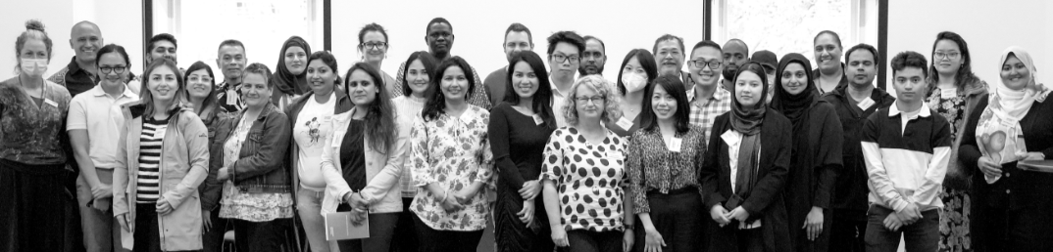
A partnership was made with Leadership Victoria (LV) to develop and deliver an Active Citizenship Leadership Program for people from culturally and linguistically diverse (CALD) communities. The aim was to recruit and equip 26 participants with leadership skills and tools to share knowledge about electoral participation and active citizenship within their communities. This included leadership concepts, but also discussions about the value of voting, how to vote correctly and build trust in the democratic process. On completion of the program, participants were then encouraged to apply for roles as State Election 2022 Democracy Ambassadors and other casual election roles across the VEC.
Owing to high demand during the recruitment phase, where 161 applications were received, the VEC expanded the program to accommodate a further 25 CALD community leaders. There was great diversity across the group including gender, age, faiths, and city and regional dwellers. Participants spoke 43 different languages.
The practical outcome of the program was immediately evident with participants sharing their learnings with their families, communities and social networks, including:
- how preferential voting impacts election results and why voting with intention is important versus donkey voting
- a Vietnamese leader wrote an article in language on democracy and active citizenship and shared it with her 20,000 social media followers. Comments included: it is great to see this type of information in Vietnamese language; it is written in simple language that we can understand
- a young Burmese leader delivered a session on the 3 levels of the government and how to complete ballot papers correctly to her classmates at an English learning centre. Her class enjoyed and learnt from the session and her teacher confided that she realised she has always been voting informally and didn’t know
- during the program, a leader from one of the South Sudanese communities said he’d been voting using ticks for years and was disappointed to learn his votes were informal and excluded as a result. Following the program, he proudly informed everyone he voted formally at the 2022 Federal election for the first time
- a young Afghan leader is now integrating active citizenship into his work projects with strategies including how to support young people to stay in Shepparton, forming a youth advisory group and how to access and use grants
- Another Afghan leader spoke with her mothers’ group about why voting is important and taught some first-time voters how to complete ballot papers correctly
- a male leader spoke with 25 residents in his apartment block (those from multicultural backgrounds with limited English language proficiency) on how to complete ballot papers correctly.
The graduation for program participants was held in June 2022 and was attended by VEC executive and staff, LV staff and friends and family of the participants. The VEC thanks LV for its collaboration on this project and celebrates the value of working in partnership with community organisations.

Inclusion and participation

Informed citizens actively participating in free and fair elections is vital to any healthy, functioning democracy. Providing accessible, engaging electoral information and education is a fundamental part of ensuring full electoral participation across the community.

Diversity and Inclusion
The VEC Diversity and Inclusion Framework continues to provide an organisation-wide approach to proactive embracing of the diversity of staff, voters and communities within Victoria.
The inward focus of the Framework continues to be provided primarily through the VEC’s HR Strategy, with support from the VEC’s Education and Inclusion team. The external focus and engagement are delivered through the various inclusion plans shown in the following diagram. Work began over the last year to develop an evaluation plan incorporating measures in order that the VEC can ensure it is meeting the goals of the Framework.

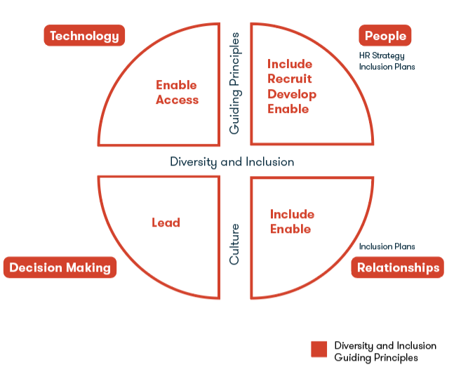
List of Inclusion Plans:
Disability Access and Inclusion Plan
Multicultural Inclusion Plan
Young People Inclusion Plan
Out of Home Action Plan

Specific diversity and inclusion initiatives 2021–22

Inclusion of Aboriginal communities

Aboriginal community engagement
The VEC continued to work amid COVID‑19 restrictions in the first half of the financial year, making good connections in some of the key Aboriginal regions such as Mildura and Shepparton. Connections were made with representatives from the following services and networks:
Korin Gamadji Institute – Richmond Football Club’s Aboriginal Leadership arm
Bunurong Land Council Reconciliation Victoria
Elizabeth Murdoch College Koorie Student Unit
NAIDOC Victoria
Mildura District Aboriginal Service.
In February 2022, a team of inspiring, young Aboriginal people were recruited as Democracy Ambassadors. Democracy Ambassadors are the face of the VEC’s community engagement work throughout Victoria in the lead up to the State election. A 3 day Cultural Gathering Camp was held for Aboriginal Democracy Ambassadors, along with representatives from the VEC’s Aboriginal Advisory Group. Core values of connection to country, identity and language were explored. Discussion centred on how the empowerment of those key Indigenous foundations can be intertwined with the democratic process to support the electoral engagement of Aboriginal communities.

Partnership project with Reconciliation Victoria
To ensure culturally informed engagement of Aboriginal communities for the 2022 State election, the VEC is working in partnership with Reconciliation Victoria to develop and distribute a series of educational videos. The videos will include a mix of animation and live interviews with some of the Aboriginal Democracy Ambassadors on the importance of voting as an important step towards self-determination. Reconciliation Victoria is working with an Indigenous production company to produce the videos.

ECANZ Indigenous Engagement Working Group
The VEC continues to be represented on the ECANZ Indigenous Electoral Participation Working Group, which shares information and ideas to better support the electoral engagement of Aboriginal and Torres Strait Islander communities across Australia. Prior to the 2022 Federal election, the VEC supported distribution of election employment opportunities to Victorian Aboriginal communities.

Korin Gamadgi Institute’s (KGI) REAL Program
The VEC and the Richmond Football Club’s Korin Gamadji Institute (KGI) celebrated a decade of ongoing partnership, a very significant milestone and one that reflects the importance of time to build trusting relationships with stakeholders and communities. This was evident in the inclusion of seven KGI alumni who agreed to become Democracy Ambassadors for the 2022 State election.
Work during the year included a number of school sessions, leadership camps and community outreach opportunities that further cemented the VEC’s relationship with the community.

Aboriginal Inclusion Plan
An Aboriginal Inclusion Plan is being developed using self-determination principles, which align with the VEC’s policy and Statement on Self Determination and Improved Outcomes for Aboriginal Victorians. As a result, work during the last year has focused on building strong relationships with Aboriginal Elders, community leaders and members. This is essential for ensuring the VEC develops a plan with Aboriginal people at the centre and is formed from the ideas and expertise that communities are willing to share.

Inclusion of multicultural communities

Multicultural Inclusion Plan 2020–23
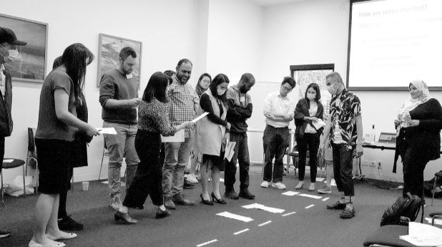

The VEC completed the second year of delivery for its Multicultural Inclusion Plan (MIP). This included actions related to the following four key priority areas:
access – to culturally responsive information and services
employment – staff recruitment and retention
community – engagement, capacity building, collaboration and partnerships
capability – building staff capability to provide culturally responsive information and services.
Some key deliverables completed in the last year include:
research on electoral engagement with Mandarin and Cantonese speaking communities
Carringbush Adult Education adopted the VEC’s Talking Democracy resource kit as part of its teaching tools
embedding diversity and inclusion into the VEC project management template
delivery of an Active Citizenship Leadership Program in partnership with Leadership Victoria
sponsorship of the Victorian Multicultural Commissioner’s Cultural Diversity Week events throughout 2022 including the Premier Gala dinner, Refugee Award in May and Multicultural Film Festival in August.

CASE STUDY
Aboriginal Democracy Ambassador
Cultural Camp
Oasis Camp, Mt Evelyn 18th – 20th March 2022

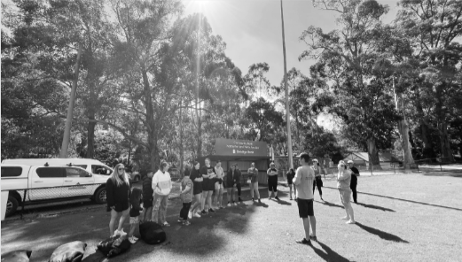
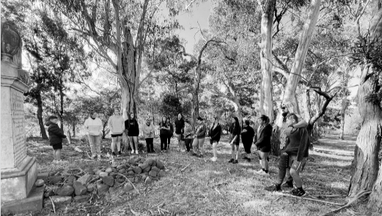
In early 2022, the VEC launched its newly formed Aboriginal Democracy Ambassador (DA) Youth leadership group. These DA’s, recruited from across Victoria are a dynamic team of young leaders, that will engage with Aboriginal communities about being an active part of the democratic process and how important it is for Aboriginal cultural revitalisation.
In late March, 10 Aboriginal DA’s were welcomed onto Wurundjeri country around Mt Evelyn, Healesville and Coranderrk by Wurundjeri leader, Aunty Mandy Nicholson and her daughter Ky-ya to participate in our very first DA Cultural Leadership Camp.
This camp was a first for the VEC, as it allowed the participants to use an Indigenous lens to explore important cultural concepts including identity, connection to country, and language, whilst exploring the links between the revitalisation of many of those cultural pillars, and actively participating in the democratic process. Throughout the camp, they participated in activities that focused on important topics such as key milestones and role models in Aboriginal democratic history, what does self-determination truly mean, and how can we develop cultural tools for them to use when they are working with Aboriginal communities.
Using the VEC’s Statement of Self-Determination policy as a guide, one of the core objectives was to embed a strong, culturally intelligent approach to community engagement that demonstrated how active participation in the electoral process can help restore cultural practices, language, ceremonies, and nurture the belief that their voices do matter in today’s Australia.
Facilitating the discussions were elders from VEC’s Aboriginal Advisory Group, and a special online presentation from the New Zealand Race Relations Commissioner, Mr Meng Foon, who spoke about growing up in rural New Zealand amongst the Maori people, and how that influenced him to become a strong advocate for Indigenous rights. Those experiences shaped his career in local and national government and created a passion for helping to change society and to address racism. One of the core themes of the camp was Connection to Country. After the Welcome to Country and Smoke Ceremony conducted by Aunty Mandy on Friday night, participants were woken at 5.30 Saturday morning to take a pre-dawn walk through the forests behind Silvan Reservoir. They walked for an hour and spoke about the challenges of being out of their comfort zones and how invigorating and inspiring it was to rise early and to hear, see and feel what Country truly means.
Later, participants were hosted again by Aunty Mandy at Coranderrk Station, at the burial site of William Barak, where she and Aunty Nellie Flagg shared the history of that special place for their mob, and of the legacy Barak left for his people.
Applying a strong cultural lense for the camp allowed for genuine connection in an environment that was supported by Aboriginal mentors and elders. This new cohort of young Aboriginal Democracy Ambassadors gained a greater insight into the potential they hold in their hands to change the future – by combining the strength and knowledge of their heritage and the democratic processes available to them.

Active citizenship workshop and outreach electoral education for cultural and linguistically diverse (CALD) communities
The VEC delivered 3 active citizenship workshops to 52 CALD community leaders and ethno-specific service providers. The aim of these workshops was to enhance electoral literacy skills and knowledge for community leaders and service providers who support CALD community members.
Workshops were delivered to:
2 groups through the Leadership Victoria Active Citizenship Leadership Program
Ethnic Communities Council of Victoria’s Intercultural Youth Advocacy Leadership Program.
A total of 57 electoral education outreach sessions were delivered to CALD communities throughout 2021–22, reaching 1,357 participants. There was a large increase in requests for sessions in the lead-up to the Federal election in May 2022. The VEC monitors new citizen data to ensure it supports new and emerging CALD communities. This included hosting an online session with members of the Chin Fam community using an interpreter to teach them about enrolling, updating their details and voting.
Furthermore, the VEC attended 85 community network meetings and engagements either online or face‑to‑face. This included:
Federation of Ethnic Communities council of Australia 2022 Conference
Hume Refugee Week
City of Yarra Health and Wellbeing Expo
Victorian Local Government Multicultural Issues Network
Services Australia
Casey CALD Network
Melton New and Emerging Communities Network
Moreland Multicultural and Settlement Services Network
Multicultural Advisory Forum
Maribyrnong City Council – Intercultural Maribyrnong Workshop
IPAA Victoria: African-Australian Community of Practice – Africa Day Forum
Ethnolink: 5 Ways to Enhance Multilingual Government Communications
South East CALD Network
Hume Interfaith Network.

2022 Cultural Diversity Week
In March 2022, the VEC sponsored the Victorian Multicultural Commission’s Cultural Diversity Week. As part of the sponsorship the VEC was represented at the Gala dinner, which provided an opportunity to network with other CALD service providers. The VEC also produced a short video to promote the 2022 State election to CALD communities at public events as part of Cultural Diversity Week.

The VEC also participated in a range of other events as part of Cultural Diversity Week including:
Ethnolink’s exploration of cultural diversity event
City of Hobson Bay Harmony Week
Melton City Council Harmony Week
City of Banyule Malahang Wellbeing Festival.

Talking Democracy online resource
The VEC continues to offer the Talking Democracy resource kit to CALD communities and English-language learning centres.
In 2021–22, there were:
1,103 visits to the landing page
11 downloads of various components
1,533 views of the ‘Three levels of government’ video
384 views of the ‘Enrolling and voting’ video
200 hard copies of the resource were mailed to community groups and English-language learning centres.

People experiencing homelessness or incarceration – Out of Home Action Plan

Out of Home Action Plan
The VEC’s Out of Home Action Plan (OOHAP) was launched in June 2022. This is the first of its kind for electoral engagement of people experiencing homelessness or incarceration. The development of the OOHAP was informed by extensive input from community partners and stakeholders. Consultations were completed with the following organisations in the homelessness and prison sectors:
- Salvation Army Crisis Centre
- Star Health
- Medically Supervised Injecting Rooms – North Richmond Community Health
- Mental Health Legal Service – Inside Access
- Corrections Victoria
- Department of Justice
- Diversitat – Financial Counselling Service for maximum security prisons
- Victorian Equal Opportunity and Human Rights Commission.
Key deliverables already implemented include:
- reigniting the MythBusting campaign developed for the 2020 local council elections to address misinformation about electoral engagement for people experiencing homelessness
- updating the Victorian Prison Guide, which covers enrolling and voting for people with sentences under 5 years
- revision of the Out of Home Advisory Group to ensure membership is comprehensive, diverse and active and includes representatives with lived experience of the prison environment to inform, support and provide feedback on VEC prison sector deliverables
- recruiting and training of 2 Democracy Ambassadors with lived experience or connection to the Out of Home sector to work in the lead-up to the 2022 State election.

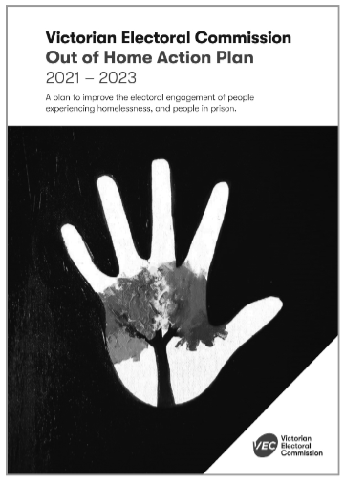
Cover artwork for the VEC Out of Home Action Plan – One Tree, Many Leaves, by artist Ashlee Harris. Ashlee says the artwork reflects ‘no matter who you are, where you come from, or even the past, that everyone can make their mark and become something extraordinary. The tree shows that we are all connected, yet we are all our own person’.
Ashlee was referred to us by one of our key stakeholders – HoMie. HoMie is a not-for-profit organisation supporting young people affected by homelessness or hardship. The VEC will continue collaborating with HoMie to produce VEC‑branded resources that are distributed to key homelessness services across Victoria.
Along with implementing the Out of Home Action Plan, the VEC has commenced development of a new advertising campaign for the 2022 State election. The ‘Voting Matters’ campaign is a collaborative venture with VEC partner, The Big Issue. This attitude change campaign aims to encourage people experiencing homelessness to rethink their level of engagement in electoral matters. It achieves this by using the voices from the community who share their views as to why voting matters. In the lead-up to the 2022 State election, the VEC has also initiated a sponsorship agreement with StreetSmart, which provides meals to homelessness services. This sponsorship arrangement allows the VEC to link with these services to provide election-related information along with meals.
The VEC attended the ‘After Prison Network’ webinars and attended the 2022 National Housing Conference. Other actions that continued to support engagement included material aid resourcing to homelessness services along with electoral messaging, and the recruitment and training of DA’s with a lived experience or understanding of homelessness. Prison‑related activities included the development of a communication plan for the upcoming State election, and working with the AEC to better address the enrolment needs of people in prison.

Inclusion of people with disabilities

Electoral education
Voter education plays a key part in the inclusion of people with disabilities in Victoria’s democracy. It enables people to learn about enrolling, voting and government and why this can be important to their everyday lives. Electoral education sessions enable supporters to also learn how they can best support people to vote and to prepare to make decisions about who to vote for at an election. Empowering people to understand their rights and how the VEC and others can support the process enables more Victorians to be active citizens. Working with disability service providers, schools, TAFE colleges, Australian Disability Enterprises (ADE), Supported Disability Accommodation (SDA) services and self-advocacy groups, the VEC continued to deliver voter education sessions either face-to-face or online during COVID-19 restrictions. The VEC delivered 41 sessions this year and reached 569 Victorians with disabilities and their supporters.
Recruitment and training commenced for more DA’s, providing peer-to-peer education and the opportunity to assist the VEC with delivering voter education across Victoria for the 2022 State election. The VEC now has 11 trained people with disabilities to assist with delivering these sessions.
New Easy English resources have been developed for VEC staff to distribute at voter education sessions about ‘how to prepare to vote’, and ‘what happens at a voting centre’ so that people may continue their learning at home. A new flyer has been created for families, carers and supporters about enrolment and voting for people with cognitive impairment or age‑related illnesses, to assist more people to learn the facts about voting options and supports available.
The VEC also participated in roundtables with the Inclusion Design Lab and Melbourne University to explore options for increasing voter participation for people with cognitive and intellectual disabilities.

Access and inclusion for the deaf and hard‑of‑hearing community
The VEC engaged Deaf Victoria to complete focus groups to seek feedback from deaf community members and people who are hard‑of‑hearing about electoral supports and the best ways to educate community members. The findings will be incorporated into upcoming election plans, as well as in the VEC’s next Disability Access and Inclusion Plan.

Disability Access and Inclusion Plan
This was the third implementation year of the VEC’s Disability Access and Inclusion Plan (DAIP) 2019–23. A range of actions were implemented under the following four priority areas:
access to premises, information and services
employment, staff recruitment, training and retention
community engagement and consultation
changing attitudes, lead by example.
The following outputs were achieved:
VEC staff with lived experience of disability were supported to share their stories in internal newsletters
2 people completed paid internships through the Australian Network on Disability (AND) Stepping Into program
the VEC was successful in advocating for the inclusion of 4 actions in the State Disability Plan 2022–26 related to voting and the involvement of people with disabilities in our democracy.
The Education and Inclusion team developed and implemented an organisation-wide inclusive event, meeting and training checklist, to assist all staff with inclusive practices. The VEC has completed 27 out of 50 actions of its current plan, with progress being made to complete the 14 actions currently in progress.

Inclusion of young people

Young People Inclusion Plan 2021–23
Since the launch of the VEC’s inaugural Young People Inclusion Plan (YPIP) last year, branches and teams across the organisation have been committed to working on the Plan’s deliverables. A whole-of-organisation plan such as this provides a wealth of opportunities for staff to collaborate with new colleagues, gain insights to unfamiliar portfolios, and work on meaningful projects that have an impact both within and outside of the VEC, whilst ensuring that young Victorians can actively participate in their democracy.
This plan aims to address the issue of lower electoral participation by young people compared to other age groups. A range of actions are included based on evidence and in some cases co-designed with young people. Key achievements this last year include:
appointment of The Future of Democracy Young People’s Internship – focused on researching the barriers that exist for young people’s participation in their democracy and looking at possible solutions
geospatial mapping to determine the reach of the VEC’s young people engagement programs and effective targeting of resources to impact priority areas and cohorts
appointment of Young People DA’s to facilitate peer-to-peer electoral education sessions with senior school students to impact enrolment and participation in the 2022 State election
design and delivery of a series of online civics and citizenship teacher professional learning workshops. The objectives of this mass provision of tailored professional learning was to increase teachers’ civic knowledge and upskill schools in the use of Passport to Democracy resources, and to engage them as partners in the provision of curriculum-aligned and engaging units of work that prepare young people to actively participate in their democracy.

YMCA Victoria Youth Parliament
Youth Parliament is a program designed to give young Victorians a chance to be heard at the highest levels of State Government on a wide range of issues relevant to young people’s lives. The VEC continued an ongoing partnership with this event in 2021–22. Six teams (each including 6 young people) were sponsored to attend the annual YMCA Victorian Youth Parliament in June 2022.
The sponsored teams comprised young people aged 15–25 from communities including regional Victorians, Aboriginal and Torres Strait Islander communities, people experiencing homelessness and people from disadvantaged and low socio-economic backgrounds. The sponsored teams represented the following organisations:
Mildura Rural Council
Korin Gamadji Institute
CREATE Foundation
Moyne Shire Council – Next Gen!
Education First Youth Foyer
CRC Sydenham



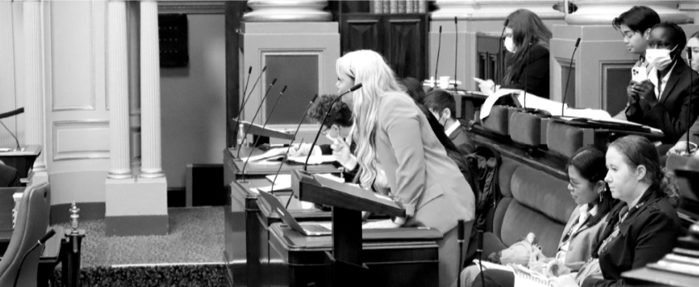

Democracy Ambassador Program
Based on the external evaluation of the VEC’s 2018 Democracy Ambassador Program delivery, the program is being expanded in the lead-up to the 2022 State election. This peer-to-peer model is on track to have a pool of up to 70 casual DA’s who provide electoral education and information either online or face-to-face.

Passport to Democracy
Passport to Democracy (PTD) is the VEC’s flagship outreach program for the electoral education of young people and is now in its 14th year. The PTD website offers information, activities, games and other useful resources, while skilled educators are available to work with schools and other organisations to tailor education sessions that suit their needs and contexts. The free school incursion program, built around the facilitation of a mock election to demonstrate to young people how the preferential voting system works, has become increasingly popular.
However, due to COVID-19, the PTD program needed to be revised in order to remain relevant and viable for schools and other organisations requiring remote delivery only. Schools and community groups have been hit particularly hard by lockdowns and are still dealing with sickness, staffing shortages and program disruption. These organisations are crucial partners for the VEC in terms of access to engage and educate students and other young people in large numbers and in meaningful ways.
Throughout 2021, the VEC consulted with stakeholders, developed new resources and explored alternative methods of session delivery that would enable the conduct of the PTD outreach program entirely remotely. A range of different presentations was produced, some for live delivery online via video conferencing software, others pre-recorded for use by stakeholders at a time and in a context of their choosing. The VEC also increased its range of teaching resources, including step-by-step instructions to conduct a mock election and, importantly, how the count process of a preferential vote works. To make the online delivery of education sessions as engaging as possible, the VEC started using software such as Mentimeter, an Audience Engagement Platform (AEP).
The VEC has also implemented a PTD delivery prioritisation strategy, which was designed to:
maximise the Commission’s impact and align more closely with its Education and Inclusion outreach priorities and its Diversity and Inclusion Framework
enable the strategic allocation of resources so that the VEC is as efficient and effective as possible, particularly in terms of managing increasing requests for school incursions
be a proactive, rather than reactive, model of operation, targeting priority cohorts who are either unsure how to tackle civics education and/or are not aware of the VEC’s Program
reach more teachers/schools/students by empowering and supporting teachers and facilitators to deliver the mock elections themselves in the future, which releases VEC staff to approach schools not currently delivering the Program.
By combining data such as informal voting and voter turnout statistics (mapped to areas of Victoria and designated as ‘priority areas’) together with socio-economic measures and unenrolled data from the Australian Electoral Commission, the VEC has identified specific areas that could benefit from its outreach program and the VEC reached out to schools in those areas. This has seen an increase in outreach delivered for the VEC’s priority areas.
What the pandemic has demonstrated is that a hybrid program delivery model can be effective.
The PTD program has again delivered pleasing growth in the VEC’s outreach to schools and community organisations. We have provided resources to 682 schools and reached a total of 26,257 students. Of the 183 organisations who booked formal incursions (delivered primarily online), 99 were government schools, 54 Catholic, 19 independent and a further 11 from tertiary and non-school settings.

CASE STUDY
Youth Employment Program

Overview and reflection by Kelly Machin
Overview
The VEC’s Young People Inclusion Plan 2021–23 includes an action to increase the recruitment channels for the employment of young people (18–29). This, together with other deliverables including the regular recruitment of a student internship position, and commitments towards the percentage of the casual election workforce who are aged 18–29, aims to make the VEC an employer of choice for young people. It is hoped that these measures will enable the Commission to benefit from the skills and insights of young people and thereby better address their needs when it comes to enrolling and voting in their democracy.
In late 2020, the VEC applied to participate in a new Youth Employment Program (YEP) launched by the Working for Victoria (WFV) Fund, in partnership with the Community and Public Sector Union (CPSU), and facilitated by the Department of Premier and Cabinet (DPC). A new position was created called the Young People Inclusion Officer (at VPS Grade 1 level as per program requirements) and, following a recruitment process in April 2021, Kelly Machin was appointed in the role.
Kelly’s Reflection

For my placement as part of the Youth Employment Program, I was lucky enough to work as part of the ‘Young People’ portfolio in the Education and Inclusion team at the VEC. My role, the Young People Inclusion Officer, primarily assisted with the delivery and implementation of the Young People Inclusion Plan. I worked with colleagues on the planning, development and delivery of specific projects and deliverables, and I learnt how to draft a project brief and plans, the importance of approval channels, internal and external stakeholder engagement, and was able to work on monitoring and evaluation materials.
I also provided administration support for the Passport to Democracy (PTD) outreach program. I began this work in my first few days, which was a great way for me to feel connected to our outreach work and learn what happens behind the scenes for effective program management. My work varied each day depending on what projects were on the go and what deadlines were approaching. The PTD administration was great work to conduct on a daily basis, keeping a consistency in my day-to-day tasks. Another great learning experience was the opportunity to sit in on, and contribute to, many meetings with internal and external stakeholders. I attended meetings of other branches and presented our work, and I scheduled meetings, took minutes and liaised with external organisations on collaborative projects, and as part of our formal partnerships.
I enjoyed contributing to the broader Education and Inclusion team by assisting with different tasks and projects on its agenda. From ordering new merchandise for the team, to assisting with the recruitment and training process for the 2022 Democracy Ambassador program, I was able to learn valuable skills from team members, including communication with external stakeholders, data management, and general organisational and administrative skills. Additionally, as part of my personal development plan at the VEC, I completed a number of professional learning short courses which, together with my on-the-job experience, has helped me gain valuable skills for future employment. The Youth Employment Program provided me with the chance to see what it is like to work at the VEC and I would like to thank everyone there for this wonderful opportunity.

Services to political parties

Party registration function
On 16 May 2022, following an internal restructure, administration of the party registration activities transitioned from the Elections Branch to the Electoral Integrity and Regulation Branch.

Changes to registered political parties
On 13 January 2022, the Victorians Party applied to register as a political party. The VEC advertised the application and invited objections to the application. No objections were received and, on 8 March 2022, the VEC granted the application and registered the party.
The VEC processed changes to the registered officers of the Democratic Labour Party (DLP) and the Animal Justice Party. The VEC also processed an application to appoint a Deputy Registered Officer as requested by the Victorians Party and a change of Deputy Registered Officer for the Victorian Socialists.
Changes of address were provided by Fiona Patten’s Reason Party, the National Party of Australia – Victoria, and the Transport Matters Party.

Register of political parties
The Electoral Act requires the VEC to establish and maintain a register of political parties. To qualify for registration, a political party must have:
a written constitution
at least 500 members who are Victorian electors, party members in accordance with the party’s rules, and who are not members of another registered political party or party applying for registration.
It is not compulsory for political parties to be registered to contest an election, but registration gives a party several important entitlements. These include:
the right to have the party’s registered name or abbreviation and registered logo opposite its endorsed candidates or group on ballot papers
access to enrolment and voter information on a periodic basis
public funding for parties obtaining enough first preference votes
administrative expenditure funding for endorsed elected members of Parliament
policy development funding if eligible.
Applications to register a political party, or for currently registered political parties to change their registered particulars, must be made at least 120 days before a State general election. The VEC cannot make changes to the register of political parties, including registering a party, during the period of a State general election, commencing on the day the writs are issued for the election.
In anticipation of this deadline in July 2022, the VEC commenced an extensive public awareness campaign during the reporting year.

Figure 24: Registered political parties, 30 June 2022
POLITICAL PARTY | POLITICAL PARTY LOGO | REGISTERED OFFICER | ADDRESS
Animal Justice Party  Abbreviated name: AJP |  | Ms Meg Watkins Secretary | Level 5, 13/55 Buckingham Street  Surry Hills NSW 2010
Australian Labor Party – Victorian Branch  Abbreviated name:  Australian Labor Party |  | Mr Christopher Ford  State Secretary | 438 Docklands Drive  Docklands VIC 3008
Democratic Labour Party (DLP)  Abbreviated name: Labour DLP |  | Mr Stephen Campbell  Interim State Secretary | 1D Aughton Street  Bayswater WA 6053
Derryn Hinch’s Justice Party  Abbreviated name: None registered |  | Ms Ruth Stanfield  Secretary | 2/4 Small Street  Hampton VIC 3188
Fiona Patten’s Reason Party  Abbreviated name: Reason |  | Ms Ange Hopkins  Registered Officer | 36 Jamieson Street  Coburg VIC 3058
Health Australia Party  Abbreviated name: HAP |  | Mr Andrew Hicks  VIC State Secretary | 1 Erinne Court  St Helena VIC 3088
Liberal Democratic Party  Abbreviated name:  Liberal Democrats |  | Mr Tim Quilty  Registered Officer | Level 1, 203–205 Blackburn Road  Mount Waverley VIC 3149
Liberal Party of Australia –  Victorian Division  Abbreviated name: Liberal |  | Mr Sam McQuestin  State Director | Level 12, 257 Collins Street  Melbourne VIC 3000
National Party of Australia –  Victoria  Abbreviated name: The Nationals |  | Mr Matthew Harris  State Director | Level 13, 30 Collins Street  Melbourne VIC 3000
Pauline Hanson’s One Nation  Abbreviated name: PHON |  | Ms Pauline Hanson  Registered Officer | Unit 17, 109 Holt Street  Eagle Farm QLD 4009
Shooters, Fishers and Farmers Party Victoria  Abbreviated name: Shooters, Fishers & Farmers Vic |  | Ms Nicole Bourman  Secretary | Suite 504  365 Little Collins Street  Melbourne VIC 3000
Sustainable Australia Party – Stop overdevelopment/ corruption  Abbreviated name: Sustainable Australia Party |  | Mr William Bourke  Registered Officer | 20 Burlington Street  Crows Nest NSW 2065
The Australian Greens – Victoria  Abbreviated name:  Australian Greens |  | Mr Martin Shield  State Director | Level 1, 45 William Street  Melbourne VIC 3000
Transport Matters Party  Abbreviated name:  Transport Matters |  | Mr Rodney Barton  Registered Officer | Suite 1, 128–136 Jolimont Road East Melbourne VIC 3002
Victorian Socialists  Abbreviated name: None registered |  | Mr Corey Oakley  Registered Officer | 54 Victoria Street  Carlton VIC 3053
Victorian Socialists  Abbreviated name: None registered | Logo registration application pending | Mr Oscar Yildiz  Registered Officer | 43 Eastgate Street  Pascoe Vale South VIC 3044

Interaction with electoral bodies

The VEC works with various national and international electoral bodies with the aim of supporting increased innovation and electoral harmonisation. The exchange of ideas, collaborative research and discussion on key matters of interest with other electoral bodies (including through established forums) is an important basis for continued innovation. These interactions also support the VEC’s capacity to recommend and advise on relevant legislative change in Victoria.
Figure 25: Support provided to other electoral commissions, 2021–22
Election date | Jurisdiction | Election | Total votes issued | Notes
4 December 2021 | NSW | Local government elections | N/A | Provided brochures and information on using iVote
19 March 2022 | SA | State election | 379
7 May 2022 | TAS | Legislative Council elections for Elwick, Huon and McIntyre | 50 | 13 Elwick  22 Huon  15 McIntyre
Total |  |  | 429

Arrangements with other electoral agencies
In a reciprocal arrangement, the VEC provides election services such as voting services and information provision for other electoral agencies. There were 3 requests for the VEC to support other electoral commissions with electoral events during 2021–22, as seen in the above table.
Assistance was provided to the AEC for the Federal election in May 2022, with VEC staff managing Secure Telephone Voting centres in Melbourne and Ballarat.

Electoral Boundaries Commission
A redivision of the State electoral boundaries commenced in November 2020 and concluded with the publishing of the final Report on the Redivision of Victorian Electoral Boundaries on 28 October 2021. The trigger for this review was that 2 general elections had taken place since the last redivision in 2012–13. As required by legislation, the VEC provided administrative and technical services to the Electoral Boundaries Commission (EBC), an independent statutory agency which comprises the Chief Judge of the County Court, the Surveyor-General and the Electoral Commissioner.
Following the release of a proposed boundaries report on 30 June 2021, a second stage of public consultation and public hearings was held with final boundaries published and tabled at State Parliament on 28 October 2021. The final boundaries will apply at the next State election in November 2022.The Report of the Electoral Boundaries Commission 2020–21 is included in this report (See Appendix I on page 155).

Electoral Council of Australia and New Zealand
The Electoral Council of Australia and New Zealand (ECANZ) is a consultative forum with membership comprising Commonwealth, New Zealand and State and Territory Electoral Commissioners. This forum recognises the strong association and commonality existing between these organisations. ECANZ met on 4 occasions in 2021–22 including an informal meeting to view the AEC election command facility.
ECANZ considers best practice, innovation and integrity in activities such as the maintenance of electoral rolls, the operation of new electoral legislation and the management of elections. ECANZ has also established several cross-jurisdictional working groups to advance projects on common topics.
This year, ECANZ again considered election operations under COVID-19 restrictions with case studies arising from elections in several jurisdictions including the Australian Federal election. Other matters considered were the security of national electoral systems, social media in elections and the national status of enrolment. The sharing of equipment, staff and knowledge has been a hallmark of the engagement. The Interjurisdictional Working Group on Electoral Integrity and Security established out of the Council of Australian Governments did not meet this year, with a next meeting likely in November 2022. As a sub-group of ECANZ, the Deputy Electoral Commissioners group continued to meet to share information and strategies around election operations, election evaluation and security.

Electoral Matters Committee
The VEC has an interest in the work of the Electoral Matters Committee (EMC), a joint investigatory committee of the Parliament of Victoria. Its powers and responsibilities are determined by the Parliamentary Committees Act 2003.
The EMC tabled its report into the impact of social media on Victorian elections and Victoria’s electoral administration on 14 September 2021. There were 33 recommendations made on which the VEC will be consulted as Government seeks to implement the findings.
The VEC also contributed to a further EMC inquiry into whether Victoria should participate in a national electoral roll platform with this report tabled in Parliament on 14 February 2022. The EMC recommendations generally aligned with the VEC’s position to monitor the development of such a common platform before committing to a complex electoral roll management system. Government has until September 2022 to respond.

Spotlight on
Adam Wilson
Manager Funding, Disclosure and Parties (for the reportable period)
Electoral Integrity and Regulation Branch


“l’m extremely proud to work for an organisation that not only recognises its importance in the delivery of democracy but also its role in continual education and outreach to the community.”

The VEC’s vision is for all victorians to participate in their democracy. How does your role contribute to this?
The introduction of Part 12 into the Electoral Act was in major part due to Parliament’s desire to bring accountability to the political donation process in Victoria. As the saying goes, often the best police officer is the shining of a light. Part 12 shines transparency over the donations given to politicians, political parties and the groups that support them. My role helps all of those that are governed by Part 12 to understand their obligations and also to facilitate the pathways for meeting these obligations.

What makes the VEC an innovative and engaging place to work?
I’m extremely proud to work for an organisation that not only recognises its importance in the delivery of democracy but also its role in continual education and outreach to the community. Additionally, I’m amazed at the capacity of the innovation behind the scenes. The emergence of the Project Management Office (PMO) and its operations with IT and specific functional lines have delivered innovative solutions to long existing business problems. For example, the most recent deployment of VEC Disclosures included a software solution for external users to access multiple entities they have reporting obligations for. This solution was so innovative it was new ground for the very experienced Microsoft Dynamics development team contracted for the work.

2021–22 was a non-election year. Did anything significant happen in your team/role during this time that you would like to highlight?
There are too many fantastic activities that we have undertaken this past year to list them all; however, one tremendous achievement we recently celebrated was the successful deployment of the ‘State Election Readiness Enhancement’ project undertaken to uplift VEC Disclosures. This delivery was the final large piece after 3 years of planning, development and testing. We have taken Microsoft Dynamics, an ‘out of the box’ product, and designed a fully operational bespoke disclosure system. A tremendous achievement and one that makes me incredibly proud of the work put in by EIR.

What do you like to do on the weekends?
I’m originally from Brisbane and I would be forever envious of the live shows available to Melbournians throughout the year. Now that I’m lucky enough to live here, not often a week goes by that I don’t go to one of the many comedy clubs in and around the city. Couple this with a nice restaurant and a sleep in and this is a perfect weekend.

Our people

Achievements 2021–22
Supported the attraction and retention of 133 employees through a period of attrition and growth.
Successful deployment of the annual People Matter Survey and Pulse surveys, continuing to focus the VEC on its people and their engagement.
Continued to provide bespoke and targeted learning outcomes support through predominantly online modalities while ensuring face-to-face delivery capabilities maintained.
Refined and enhanced the employee onboarding experience and aligned content to support ongoing compliance training needs.
Supported staff and people leaders in the growth of the hybrid flexible working model across the VEC with a firm alignment between operational and individual needs.
Continued to grow the business partnering model across the VEC, firmly placing Human Resources as a trusted partner in operational planning and delivery.

Outlook 2022–23
Continuing to use the People and Culture Strategy as the road map for Human Resources service delivery.
Supporting a comprehensive review of the Occupational Health and Safety Management System in the second half of 2022–23.
Support growth of an inclusive and responsive workplace through implementation of Gender Equality Action Plans 2021–25.
Supporting the delivery of the 2022 State election through a newly created State Election Workforce Support Program role focusing on workforce planning, resourcing, and wellbeing.
Support of the 2022 State election capability development and growth through continued learning and development activities.
Embedding employee induction and onboarding to create early engagement and delivery capability.

Inspired people

VEC people are engaged, capable and equipped to support democracy in Victoria.

As an employer of choice, the VEC aims to create an environment that inspires its people to reach their full potential. Its skilled workforce will be equipped for the challenges ahead, and for an environment where change is the norm. The VEC does this to support services that are adaptive to the needs of electors and responsive to legislative change.

Promoting and Supporting Flexible working models
The VEC adopted a hybrid approach to flexible work throughout 2021–22. With an office-first focus, staff are supported to ‘work anywhere’. Service delivery and operational excellence remain the cornerstone of this hybrid approach. In addition to working remotely, flexible work practices include flexible start and finish times, compressed work fortnights, job share, purchased leave, banking and taking ‘flex-time’ and the provision of ‘make-up time’.
Working flexibly will continue to be an important factor for the workforce, and initiatives are in place to further support availability and use of flexible work options, such as people leader and all staff support resources and alignment with Victorian Public Sector Commission resources, recognising the need to balance personal and operational needs as the VEC delivers the 2022 State election.
The VEC also supports increased mobility within the VEC and across the wider Victorian Public Sector and recognises that secure and flexible employment is essential to this, with initiatives and activities to promote and support internal secondments as well as recognising and removing barriers to mobility and flexibility.

Best practice hiring and onboarding staff
Recognising that the VEC is not clear of the COVID-19 pandemic, Human Resources continues to ensure hiring and onboarding new staff in a hybrid model is timely, effective and engaging. This is to align technology and formal processes to ensure they remain fit for purpose but without losing the connectivity of face‑to‑face interactions.
The VEC recognises the importance of ensuring new staff are supported and engaged early in their employment. Working in a hybrid model presents hiring managers and new staff with unique challenges.
People leaders are supported through these processes to ensure new staff have the required tools to do their role, as well as ever-evolving onboarding and induction materials to ensure all staff feel connected and engaged.

Workforce profile
The VEC workforce continues to grow, increasing from 149 ongoing roles in 2020–21 to 168 ongoing roles in 2021–22 to support operational delivery. Growth in 2021–22 was predominately to support future State election delivery in November 2022.
In 2021–22, staff turnover increased on last year at 19.05%, up from 14.98% in 2020–21. As for last year, turnover was driven by long-serving staff retiring and others taking up career development opportunities, and movements within the broader Victorian Public Sector (VPS) and private sector.
Gender diversity remains relatively unchanged year on year with 47% male, 52% female and 1% self-described. Representation across all age groups is relatively balanced with a slight skew to the 35–44 and 25–34 age brackets. There is a fairly normal distribution across the Victorian Public Sector grades.

Learning and development

Performance management
This financial year witnessed a relaunch of the performance and management program called ADVANCE. The relaunch signified the culmination of 2 years of work to address both the method and the supporting technology underpinning performance management in the organisation.
This work has involved designing a process unique to the organisation and its culture. One that complies with the VPS Enterprise Agreement 2020, yet offers a modern method of performance management focused on people and their potential and effective workforce management. It is supported by a technology that provides an intuitive user experience with greater autonomy, flexibility and transparency for employees and their people leaders, and greater functionality for the organisation to track productivity and achievement of organisational objectives.
To support the embedding of the program, the VEC facilitated planning workshops to enable the alignment of organisational and branch objectives with individual and team goals. People leader and employee webinars introduced the technology’s functionality and navigation. Individual walkthroughs and support were also provided. A suite of user guides for employees and people leaders were developed for ongoing access and support.

Leadership and talent management
Another focus this financial year was the continued delivery of the Leadership Excellence Accelerator Program (LEAP). Like ADVANCE, LEAP integrates the VEC’s Leadership Capability Framework. The framework guides the development of leadership capabilities across the organisation in 4 distinct tiers with a philosophy that everyone has an opportunity to lead at the VEC.
At the end of this financial year, approximately half of the organisation has completed fundamental leadership training. A total of 42 leadership training workshops, along with 25 peer learning sessions were held during 2021–22.
In addition, the VEC increased its use of the Hogan 360, Hogan Insight assessments, and DISC assessments to support individual coaching and talent development. These tools provide emerging and existing leaders with a concise overview of their strengths, performance risks and core values. These resources help leaders improve self‑awareness of their attitude, behaviour and leadership effectiveness, performance, and reputation.

Other learning programs
The last financial year realised the development of a framework, resources and tools to support important social learning programs such as mentoring and communities of practice. The work of growing and embedding those programs has continued this year. Individuals from the VEC participated in 2 industry mentoring programs, one from within the sector and one external to the sector.
During this financial year, the VEC completed a refresh and relaunch of a standardised onboarding and induction package for ongoing employees. Work also commenced on basic training and an accompanying toolkit to support new people leaders or people leaders new to the organisation with the fundamental activities of managing people at the VEC.
The VEC also invested in accreditation in workshop facilitation, technical skills in authoring eLearning and skills and capability development to deliver an engaging learning and development program to the VEC.

Electoral training
Traditionally, the development and delivery of training for electoral staff, particularly field staff associated with the conduct of the election, has been the domain of the Elections team at the VEC.
Encouraging a shared service approach to training delivery, the team facilitated a discovery workshop to understand roles, responsibilities and training infrastructure needs for the upcoming State election. As an outcome, the learning and development team procured a functional temporary learning platform that can economically deliver scaled training to election field staff.
The learning and development team are excited to support election training delivery through the platform, including supporting technical issues, content management and reporting on learning. Additionally, the team will be responsible for providing security awareness and inclusive work practices compliance training for this election.

Code of Conduct – VEC values
Ensuring staff are aware of and comply with established and expected behaviours and values is key to strong and aligned performance and delivery. All employees are provided with a copy of the VPS Code of Conduct on engagement. Compliance-based training supports understanding. The VPS values, as outlined in the Code of Conduct, also continue to be a feature in the employee Performance and Development (PD) program.
Below-the-line behaviours (inappropriate behaviours) are called out when witnessed or identified, and appropriate action is taken. Throughout 2021–22, raising awareness of reporting processes and actively supporting staff to be champions of their own and others’ professional wellbeing and psychosocial safety has been a strong focus of the Human Resources team.
Figure 26: Recruitment, departures and turnover, 2017–18 to 2021–22
 | HEADCOUNT (ONGOING) | FTE  (ONGOING, FIXED TERM AND CASUAL) | COMMENCEMENTS  FTE | DEPARTURES  FTE | STAFF  TURNOVER
2017–18 | 109 | 103.3 | 24 | 16.5 | 15.97%
2018–19 | 119 | 137.01 | 25.6 | 17 | 12.41%
2019–20 | 143 | 179.01 | 45.2 | 16.6 | 9.27%
2020–21 | 149 | 171.51 | 29.6 | 25.7 | 14.98%
2021–22 | 168 | 160.87 | 53.62 | 30.64 | 19.05%
*The Departures FTE includes resignations, fixed-term contract ends and dismissals.
Figure 27: Recruitment (FTE ongoing), 2017–18 to 2021–22
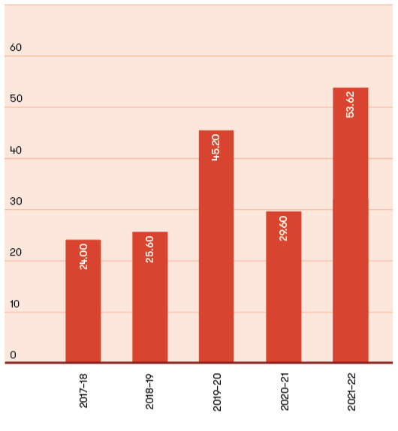
Figure 28: VEC staff by gender, 2017–18 to 2021–22
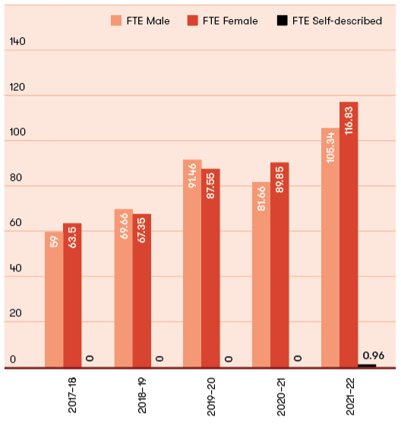

Staff profile

Comparative workforce data
Figure 29: VEC active staff profile, last pay period June 2022 (not including statutory appointees)
 | 2020–21 |  |  |  |  | 2021–22
 | ONGOING |  | FIXED TERM and CASUAL | TOTAL |  | ONGOING |  | FIXED TERM and CASUAL | TOTAL
 | HEAD- COUNT | FTE | HEAD- COUNT | FTE | FTE | HEAD- COUNT | FTE | HEAD- COUNT | FTE | FTE
Gender
Male | 72.00 | 70.66 | 11.00 | 11.00 | 81.66 | 80 | 76.61 | 30 | 28.73 | 105.33
Female | 77.00 | 71.75 | 20.00 | 18.10 | 89.85 | 88 | 84.27 | 34 | 32.56 | 116.83
Self-described |  |  |  |  |  | 0 | 0 | 1 | .96 | .96
Total | 149.00 | 142.41 | 31.00 | 29.10 | 171.51 | 168 | 160.87 | 65 | 62.24 | 223.12
Age
Under 25 | - | - | 2.00 | 2.00 | 2.00 | 1 | .96 | 3 | 2.87 | 3.83
25–34 | 29.00 | 28.90 | 9.00 | 9.00 | 37.90 | 34 | 32.56 | 25 | 23.94 | 56.50
35–44 | 55.00 | 52.56 | 9.00 | 8.60 | 61.16 | 65 | 62.24 | 16 | 15.32 | 77.56
45–54 | 37.00 | 34.95 | 8.00 | 7.10 | 42.05 | 37 | 35.43 | 12 | 11.49 | 46.92
55–64 | 18.00 | 17.20 | 3.00 | 2.40 | 19.60 | 24 | 22.98 | 7 | 6.70 | 29.68
Over 64 | 10.00 | 8.80 |  |  | 8.80 | 7 | 6.70 | 2 | 1.92 | 8.62
Total | 149.00 | 142.41 | 31.00 | 29.10 | 171.51 | 168 | 160.87 | 65 | 62.24 | 223.12
Classification
Executive Officer* | 1.00 | 1.00 | - | - | 1.00 | 0 | 0.00 | 2 | 1.92 | 1.92
Senior Executive Service* | 5.00 | 5.00 | - | - | 5.00 | 2 | 1.92 | 3 | 2.87 | 4.79
STS | 4.00 | 4.00 | - | - | 4.00 | 5 | 4.79 | 0 | 0.00 | 4.79
VPS Grade 1 | - | - | 1.00 | 1.00 | 1.00 | 0 | 0.00 | 2 | 1.92 | 1.92
VPS Grade 2 | 17.00 | 15.41 | 3.00 | 2.10 | 17.51 | 19 |  | 6 | 5.75 | 23.94
VPS Grade 3 | 32.00 | 29.60 | 9.00 | 8.60 | 38.20 | 29 |  | 21 | 20.11 | 47.88
VPS Grade 4 | 33.00 | 31.20 | 14.00 | 13.40 | 44.60 | 45 |  | 16 | 15.32 | 57.41
VPS Grade 5 | 41.00 | 40.20 | 4.00 | 4.00 | 44.20 | 50 |  | 8 | 7.66 | 55.54
VPS Grade 6 | 16.00 | 16.00 |  |  | 16.00 | 18 |  | 7 | 6.70 | 23.94
Total | 149.00 | 142.41 | 31.00 | 29.10 | 171.51 | 168 | 160.87 | 65 | 62.24 | 223.12
*Data not available for FY2019–20.
Excluded are external contractors and temporary staff employed by employment agencies, election appointees to statutory offices as defined in the Public Administration Act 2004, and election casual staff employed under the Electoral Act.
Figure 30: Full time equivalent (FTE) staffing trends, 30 June 2018 to 30 June 2022
 | ONGOING EMPLOYEES |  |  |  | FIXED TERM |  | CASUAL |  | TOTALS
 | NUMBER (HEAD COUNT) | FULL TIME (HEAD COUNT) | PART-TIME (HEAD COUNT) | FTE | NUMBER (HEAD COUNT) | FTE | NUMBER (HEAD COUNT) | FTE | NUMBER (HEAD COUNT) | FTE
2018 | 109.00 | 93.00 | 15.00 | 103.30 | 20.00 | 18.60 | 2.00 | 0.80 | 131.00 | 122.70
2019 | 119.00 | 122.00 | 23.00 | 113.60 | 24.00 | 23.30 | 1.00 | 0.10 | 145.00 | 137.00
2020 | 143.00 | 124.00 | 19.00 | 136.61 | 46.00 | 42.40 | 1.00 | 0.10 | 189.00 | 179.01
2021 | 149.00 | 130.00 | 19.00 | 142.41 | 27.00 | 28.90 | 2.00 | 0.20 | 178 | 171.51
2022 | 168 | 150 | 18 | 160.87 | 62 | 59.37 | 3 | 2.87 | 233 | 223.12

Occupational health and safety

Building a safe and inclusive workplace through 2021–22.
The VEC provides a safe and positive workplace, without risk to employees’ physical or mental wellbeing. The ongoing health, safety and wellbeing of staff is paramount and is supported through continuous improvement practices that identify and address risks to staff.
A refresh of the People and Culture Strategy in 2021‑22 supported strengthened focus on ensuring ‘our people are engaged, capable and equipped to support democracy in Victoria’. Intrinsic to this is the physical, emotional, financial and social wellbeing of all staff.
Inherent in staff reaching their full potential is staff feeling safe in their roles and their access to tools and support to make the right decisions, specifically in line with legislation and policies.
Risk identification and minimisation, incident reporting investigation and regular workplace audits remain a priority for the VEC.
Staff are supported working in a safe environment through sound onboarding, compliance and skills-based training and refresher programs.
The Occupational Health and Safety (OHS) Committee has continued to take an active role in monitoring the application of the Occupational Health and Safety Management System (OHSMS) by taking part in all quarterly inspections, reviewing OHS documentation and supporting OHS events, such as OHS Month.
Formal quarterly reporting on OHS data and activity has continued throughout 2021–22. The reports provide executives and managers with oversight of OHS performance and trends.

Hazards, incidents and injuries
During 2021–22, the VEC received a total of 10 incident notifications (see Figure 32).
The decrease in reported incidents in 2021–22 was driven by proactive safe awareness campaigns and strong staff compliance. Further there were no claims for worker compensation and no days lost as a result of a workplace‑related injury.
As detailed in Figure 35, the VEC increased on-site work area inspections as staffing levels increased during 2021–22. The VEC continues to demonstrate compliance in on-site work area inspections from home, including completion of Working from Home Checklists by all employees and encouragement to review onsite arrangements. These checklists ensured employees’ work areas onsite or remote were safe and conducive to productive and safe working.

Living with COVID-19
The COVID-19 working group established to support business continuity and staff communication continued to provide support and guidance to the wider business throughout 2021–22, albeit at a reduced requirement level.
Policies and guidelines were monitored and updated in line with Victorian and federal government requirements, including management of COVID-19 positive test results, revised working from home guidelines, leave and other management support.
Additional initiatives were created to reinforce staff health, wellbeing, and connectedness in the new remote working environment, including ‘Wellness Wednesday’ events and regular communication on new safety and support measures being put in place.
It is recognised that this ever-changing pandemic environment and subsequent impacts will remain a reality for the VEC in the immediate future. The VEC has ensured it remains agile and adaptive, so it can respond swiftly and decisively without losing focus on the smooth delivery of electoral services.

COVIDSafe elections
The COVIDSafe Election Plan developed in 2020 was reviewed in line with the Victorian Government directions and updated as required for the South Gippsland Shire Council general election in October 2021 and the 3 local government by-elections during 2021–22. Other key sources were referenced including Safe Work Australia, WorkSafe Victoria and the Department of Health. This ensured that the work of the VEC continued safely and was able to withstand possible COVID-19 outbreaks or restrictions throughout the delivery of the elections.
Figure 31: Claims for WorkCover, 2017–18 to 2021–22
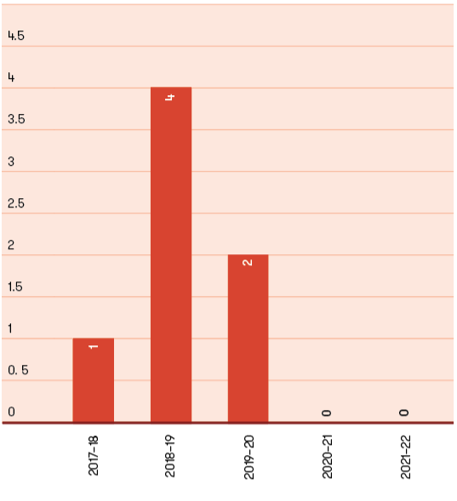

Figure 32: Days lost as a result of workplace-related injury, 2017–18 to 2021–22
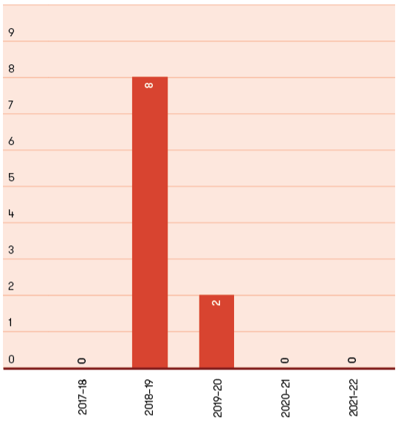

Figure 33: Hazards, incidents and injuries reported, 2017–18 to 2021–22
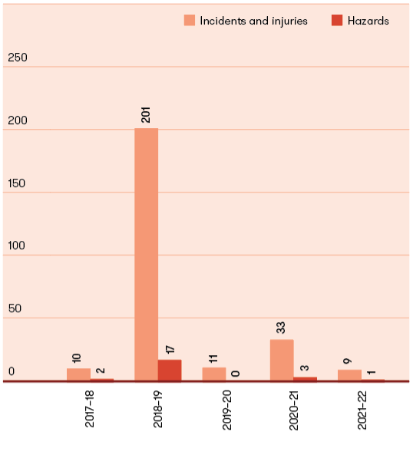
Figure 34: Reported incidents, hazards and near misses – by affected person, 2021–22
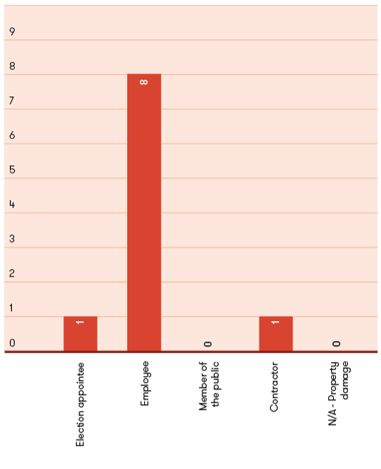

Figure 35: Reported incidents, hazards and near misses – by type, 2021–22
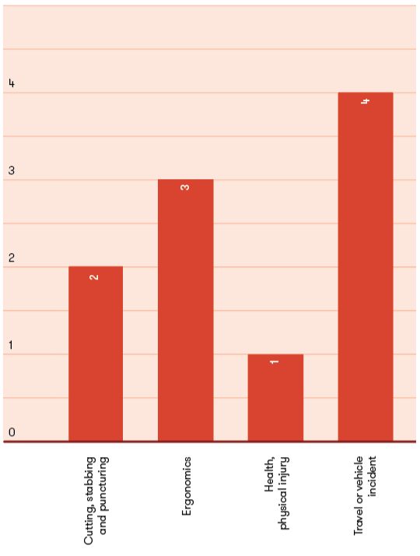

Staff wellbeing services
The VEC continued to focus on delivery of a wellbeing program to support all staff in feeling safe, valued and respected at work.
The VEC continued to utilise technology in 2021–22 to promote wellbeing. The dedicated Microsoft Teams channel was a primary vehicle for sharing wellbeing communications and to support collaboration of staff to discuss, share wellbeing ideas and resources. The VEC’s intranet and monthly all-staff newsletters continued to be used to promote and educate staff on wellbeing related articles and news items.
Working within a hybrid flexible model, the VEC continued to provide a range of wellbeing service offerings throughout 2021–22:
promotion and education of mental health and support seeking through R U OK? Day and World Mental Health Day
VEC-funded attendance at the Institute of Public Administration Australia’s International Women’s Day event
a flu vaccination program with free on-site flu vaccinations offered to all staff. Staff unable to attend the office to obtain a flu vaccination were offered reimbursements for the cost of their vaccination
celebration of International Day against Homophobia, Transphobia and Biphobia, celebration of Harmony Week, including the development of a VEC Cookbook to showcase the diversity of VEC staff
promotion of various wellbeing webinar series offered by WorkSafe Victoria
promotion of financial wellbeing seminar offerings from Vic Super as the VEC’s default superannuation partner.
The VEC Mental Health and Wellbeing Commitment Statement, introduced in 2018, remains active to provide clarity on the responsibilities and expectations of the VEC, managers and employees to prevent and address psychological injury or illness and contribute to a culture of positive wellbeing.
The wellbeing of staff and contractors has remained a priority. The Employee Assistance Program (EAP) is actively promoted and is available to staff and contractors and their immediate family members. 2021–22 realised increased usage of the EAP service.
Support for people leaders through the Senior Leadership Group has continued, as has the use of regular staff communications focused on recognising their challenges, as well as corrective actions or services to overcome these challenges.
Figure 36: The VEC’s performance against OHS management measures, 2017–18 to 2021–22
MEASURE | KPI | 2017–18 | 2018–19 | 2019–20 | 2020–21 | 2021–22
Incidents | Staff FTE (VPS only) | 122.7 | 137 | 179.01 | 171.51 | 223.12
Incidents | Number of incidents | 10 | 16³ | 11 | 83 | 10
Incidents | Rate per 100 FTE | 8.1 | 11.7 | 6.1 | 4.7 | 4.5
Claims | Number of standard claims | ¹ | 1 | 2 | - | 0
Claims | Rate per 100 FTE | 0.8 | 0.7 | 1.1 | - | 0.0
Claims | Number of lost time claims | - | 1 | 1 | - | 0
Claims | Rate per 100 FTE | - | 0.7 | 0.5 | - | 0.0
Claims | Number of claims exceeding 13 weeks | - | - | - | - | 0
Claims | Rate per 100 FTE | - | - | - | - | 0.0
Fatalities | Fatality claims | - | - | - | - | -
Claim costs | Average cost per standard claim | 452 | 479 | 706.18 | - | 0.00
Return to work (RTW) | Percentage of claims with RTW plan <30 days | - | - | - | - | 0
Management | Evidence of OHS policy statement, OHS commitment objectives, regular reporting to senior management of OHS, and OHS plans (signed by CEO or equivalent) | Completed | Completed | Completed | Completed | Completed
Management | Evidence of OHS criteria in purchasing guidelines (including goods, services and personnel) | Completed | Completed | Completed | Completed | Completed
Consultation | Evidence of agreed structure of designated workgroups (DWGs), health and safety participation representatives (HSRs) and issue resolution procedures (IRPs) | Completed | Completed | Completed | Completed | Completed
Consultation | Compliance with agreed structure on DWGs, HSRs and IRPs | Completed | Completed | Completed | Completed | Completed
Risk management | Percentage of internal audits/inspections conducted as planned | 75% | 88% | 50% | 25% | 80%
Risk management | Percentage of issues identified and actioned arising from:
Risk management | internal audits | N/A | 100% | 100% | 100% | 100%
Risk management | HSR provisional improvement notices (PINs) | N/A | N/A | N/A | N/A | Nil
Risk management | WorkSafe notices | N/A | N/A | N/A | N/A | Nil
Training | Percentage of managers and staff that have received OHS training:
Training | induction | 100% | 100% | 100% | 100% | 100%
Training | management training | 78% | 0% | 0% | 0% | 75%
Training | contractors, temps and visitors | 36% | 9%⁵ | 100% | 100% | 100%
Training | Percentage of HSRs trained:
Training | acceptance of role | 100% | 100% | 100% | 100% | 100%
Training | refresher training | 100% | 100% | 100% | 100% | 100%
Training | reporting of incidents and injuries | 100% | 100% | 100% | 100% | 100%
¹ Figure does not include casual staff
² Figure does not include casual staff or members of the public
³ Figure does not include incidents incurred by casual staff or members of the public. Does not include hazards or near misses.
⁴ Figure includes casual election staff
⁵ Figure does not include casual election staff

Spotlight on
Jenni Davies
Senior Business Advisor
Electoral Enrolment Branch


“Every role at the VEC contributes to supporting and enabling Victoria’s democracy.”

The VEC’s vision is for all victorians to participate in their democracy. How does your role contribute to this?
The Enrolment Branch is responsible for maintaining Victoria’s register of electors and delivering programs that ensure Victorians enrol and maintain their enrolment details. In layman’s terms the register of electors is the list of Victorians who are eligible to vote in an election – an important pillar of our democratic process. My role supports the branch in areas of governance, strategic planning, corporate compliance, information management and performance reporting.

What makes the VEC an innovative and engaging place to work?
For me, having a sense of purpose in my work is really important. Every role at the VEC contributes to supporting and enabling Victoria’s democracy – what could be more engaging than that?

2021–22 was a non-election year. Did anything significant happen in your team/role during this time that you would like to highlight?
Whilst it was a non-election year, 2021–22 was definitely busy! My team have recently been involved in renegotiating our information sharing agreements with the Registry of Births, Deaths and Marriages and the Victorian Curriculum Assessment Authority. Both are important stakeholders in our work to keep the register of electors up to date.

What do you like to do on the weekends?
Being a keen traveller, I have been somewhat thwarted on the travel front over the last two years. However, having lived 14 of the last 17 years in London, I am rediscovering many wonderful places in Victoria. From hiking in the Grampians, Otways and Cathedral Ranges to wine tasting in Rutherglen, Yarra Valley and Mornington Peninsula; not to mention MTC theatre, art at NGV and Heide, movie and comedy festivals and of course catching up with friends and family, I am loving being back home!

Financial statements

Achievements 2021–22
Continued compliance with the Standing Directions of the Minister for Finance – no reportable deficiencies.
Implementation of VEC financial sustainability strategy.
Delivery of the VEC’s major programs and initiatives within the available funding envelope.
Maturity to project governance framework including expansion to cover Future Focus initiatives as part of pipeline planning.
Implementation of new corporate compliance register and framework to coordinate and manage regulatory responsibilities.

Outlook 2022–23
Successful financial and corporate support to the 2022 State election program.
Establishment of VEC program slate post - State election 2022.

Financial report

The objective of the financial report is to provide stakeholders with an understanding of the VEC’s financial performance and position over the 2021–22 reporting period.

Assets – what the VEC owns
Non-financial assets make up the majority of the VEC’s assets. Assets include debtor receivables, election inventory including PPE, plant and equipment, and intangible assets, which cover all VEC systems and programs. The organisation continued to invest in the IT environment over the year with the delivery and launch of EMS2, further enhancements to the Funding and Disclosure platform, improvements to VEC cyber security and development of roll look-up system.
VEC ASSETS ($’000)
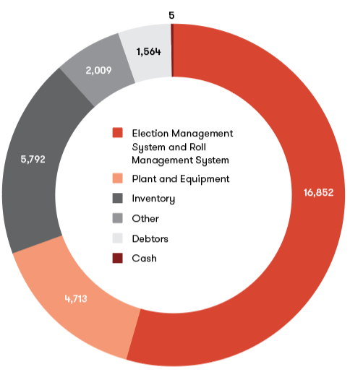

Liabilities – what the VEC owes
The VEC’s liabilities are largely represented by employee provisions (annual leave and long service leave owing to staff) and supplier commitments. Money owed to suppliers and creditors was timing related at 30 June 2022, based on terms of trade between the VEC and respective suppliers. Utilising strong internal cash flow management, the VEC endeavours to keep outstanding supplier commitments to a minimum ensuring payments are made within agreed trade terms. Trade creditor balances owing at 30 June 2022 were subsequently cleared the following month. The impact of COVID-19 meant staff were unable to book holidays and take leave, causing staff entitlement provision to increase considerably in comparison to previous reporting periods. The liability is being monitored and managed by VEC management.
VEC LIABILITIES ($’000)
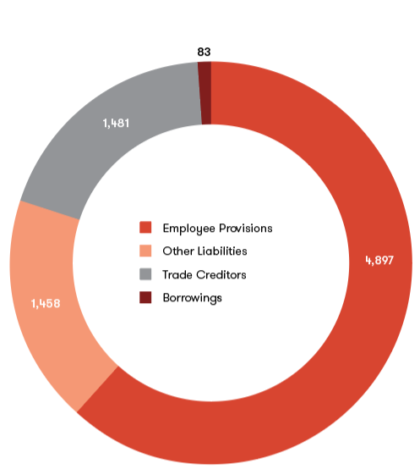

Equity – what the VEC is worth
The VEC’s equity is measured as the net of its assets less its liabilities. The VEC’s total equity position at 30 June 2022 is $23.02 million, comprising contributed capital and carrying accumulated deficit.

Funding fluctuations
The VEC’s only source of funding is its special appropriation from the State Government. The VEC’s funding fluctuates year-on-year depending on the electoral activity being delivered (see Figure 36). Every two years, the VEC conducts either a State election or local government elections, which significantly increase the VEC’s funding for the particular year. With 2021–22 being a non-election year, the VEC’s funding decreased to $50.12 million (2020–21: $74.95 million). Special appropriation funding does not include non‑cash expenses, such as depreciation, staff entitlement provisions and year-end accruals.

Expenses – how the VEC’s funding is utilised
The major cost categories where resources were committed over the period included:
wages and overheads - upscaling election workforce and election officials
training and workforce readiness
election advertising and awareness campaigns
purchase of ballot paper
engagement of mail and postage services
election office accommodation and rental
election infrastructure including IT and security
PPE equipment in support of COVIDSafe practices.

Administrative services
The VEC also manages administrative services on behalf of the State and local governments. Funding collected and dispersed during 2021–22 was $18.45 million. This is not shown in the VEC financial results or in the financial statements, but is declared in Note 4.1: Administered (non-controlled) items. This included:
collection and distribution of fines
advance payment of 2022 State election public funding
administrative expenditure funding (Funding and Disclosure legislation).

VEC OPERATIONAL EXPENDITURE ($’000)
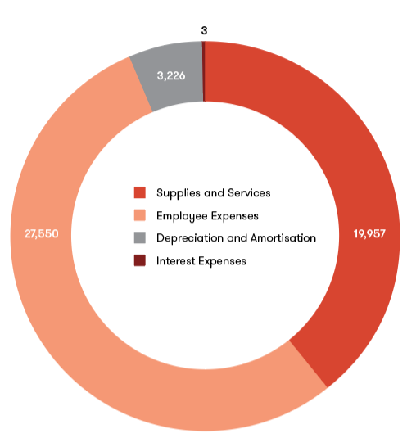

Figure 37: Special appropriation 2017–18 to 2021–22 ($’000)
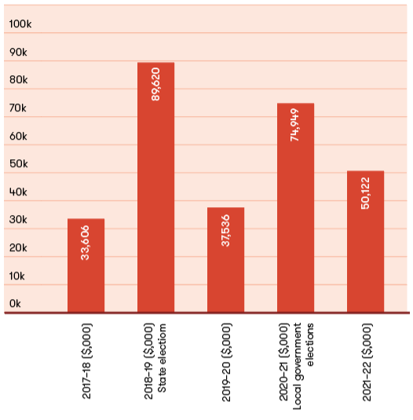

Declaration in the financial statements
The attached financial statements for the Victorian Electoral Commission have been prepared in accordance with Directions 5.2 of the Standing Directions of the Assistant Treasurer under the Financial Management Act 1994, applicable Financial Reporting Directions, Australian Accounting Standards, including Interpretations, and other mandatory professional reporting requirements.
We further state that, in our opinion, the information set out in the comprehensive operating statement, balance sheet, statement of changes in equity, cash flow statement and accompanying position of the Commission is correct as at 30 June 2022.
At the time of signing, we are not aware of any circumstance which would render any particulars included in the financial statements to be misleading or inaccurate.
We authorise the attached financial statements for issue on 11 August 2022.

Warwick Gately AM
Electoral Commissioner
Victorian Electoral Commission
Melbourne 11 August 2022

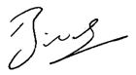
Binh Le
Chief Financial Officer
Victorian Electoral Commission
Melbourne 11 August 2022

Comprehensive operating statement

for the financial year ended 30 June 2022
 | NOTES | 2022  $’000 | 2021  Restated*  $’000
Continuing operations
Income from transactions
Special appropriations | 2.1 | 50,122 | 74,949
Total income from transactions |  | 50,122 | 74,949
Expenses from transactions
Employee expenses | 3.1.1 | (27,550) | (35,062)
Depreciation and amortisation | 5.1.1 | (3,226) | (3,269)
Interest expense |  | (3) | (3)
Capital asset charge | 3.2 | - | (129)
Other operating expenses | 3.3 | (19,957) | (41,910)
Total expenses from transactions |  | (50,736) | (80,373)
Net result from transactions (net operating balance) |  | (614) | (5,424)
Other economic flows included in net result
Net gain/(loss) on non financial assets | 9.2 | 61 | -
Other gains/(losses) from other economic flows | 9.2 | 311 | 86
Total other economic flows included in net result |  | 372 | 86
Comprehensive result |  | (242) | (5,338)
The comprehensive operating statement should be read in conjunction with the notes to the financial statements.
*The 2021 figures were restated; refer to note 9.7

Balance sheet

as at 30 June 2022
 | NOTES | 2022  $’000 | 2021  Restated*  $’000
Assets
Financial assets
Cash and deposits | 7.1 | 5 | 3
Receivables | 6.1 | 1,564 | 779
Total financial assets |  | 1,569 | 782
Non-financial assets
Inventories | 6.3 | 5,792 | 2,946
Property, plant and equipment | 5.1 | 4,713 | 4,546
Intangible assets | 5.2 | 16,852 | 14,605
Prepayments | 6.4 | 2,009 | 1,464
Total non-financial assets |  | 29,366 | 23,561
Total assets |  | 30,935 | 24,343
Liabilities
Payables | 6.2 | 1,481 | 1,009
Borrowings |  | 83 | 101
Employee-related provisions | 3.1.2 | 4,897 | 4,384
Other provisions | 6.5 | 1,458 | 1,301
Total liabilities |  | 7,919 | 6,795
Net assets |  | 23,016 | 17,548
Equity
Accumulated (deficit) / surplus |  | (36,856) | (36,614)
Contributed capital |  | 59,872 | 54,162
Net worth |  | 23,016 | 17,548
The balance sheet should be read in conjunction with the notes to the financial statements.
*The 2021 figures were restated refer to note 9.7

Statement of changes in equity

for the financial year ended 30 June 2022
 | NOTES | ACCUMULATED  SURPLUS  $’000 | CONTRIBUTED  CAPITAL  $’000 | TOTAL  $’000
Balance at 1 July 2020 (*restated) |  | (31,276) | 49,155 | 17,879
Net result for the year |  | (5,338) |  | (5,338)
Capital appropriations | 9.10 | - | 5,007 | 5,007
Balance at 30 June 2021 |  | (36,614) | 54,162 | 17,548
Net result for the year |  | (242) | - | (242)
Capital appropriations | 9.10 | - | 5,710 | 5,710
Balance at 30 June 2022 |  | (36,856) | 59,872 | 23,016
The statement of changes in equity should be read in conjunction with the notes to the financial statements.
*The 2021 figures were restated refer to note 9.7

Cash flow statement

for the financial year ended 30 June 2022
 | NOTES | 2022  $’000 | 2021  RESTATED*  $’000
Cash flows from operating activities
Receipts
Receipts from Government |  | 50,122 | 74,938
Net Goods and Services Tax recovered from the ATO | (i) | 2,105 | 4,733
Total receipts |  | 52,227 | 79,671
Payments
Payments to suppliers and employees |  | (52,430) | (79,909)
Interest and other costs of finance paid |  | (3) | (3)
Total payments |  | (52,433) | (79,912)
Net cash flows from / (used in) operating activities | 7.1.1 | (206) | (241)
Cash flows from investing activities
Purchases of non-financial assets |  | (5,483) | (4,753)
Net cash flows (used in) / from investing activities |  | (5,483) | (4,753)
Cash flows from financing activities
Owner contributions by State Government |  | 5,710 | 5,007
Repayment of principal portion of lease liabilities | (ii) | (19) | (10)
Net cash flows from / (used in) financing activities |  | 5,691 | 4,997
Net increase / (decrease) in cash and cash equivalents |  | 2 | 3
Cash and cash equivalents at the beginning of the financial year |  | 3 | -
Cash and cash equivalents at the end of the financial year | 7.1 | 5 | 3
The above cash flow statement should be read in conjunction with the notes to the financial statements.
Notes:
(i) Goods and Services Tax recovered from the ATO is presented on a net basis
(ii) The VEC has recognised cash payments for the principal portion of lease payments as financing activities; cash payments for the interest portion as operating
activities consistent with the presentation of interest payments and short-term lease payments for leases and low-value assets as operating activities.
*The 2021 figures were restated refer to note 9.7

Notes to the financial statements

for the financial year ended 30 June 2022

Note 1: About this report
The Victorian Electoral Commission (the VEC) is an independent body of the State of Victoria, established pursuant to an order made by the Premier under the Electoral Act 2002.
Its principal address is:
Victorian Electoral Commission
Level 11, 530 Collins Street
Melbourne VIC 3000
The VEC is an administrative agency acting on behalf of the Crown.
A description of the nature of the VEC’s operations and its principal activities is included in the report of operations which does not form part of these financial statements.
The VEC is funded by parliamentary appropriations for the provision of outputs. It provides on a fee-for-service basis election services for local government and commercial elections. The fees charged for these services are determined by prevailing market forces.

Basis of preparation
These financial statements cover the VEC as an individual reporting entity and include all of its controlled activities.
These financial statements are presented in Australian dollars and prepared in accordance with the historical cost convention unless a different measurement basis is specifically disclosed in the note associated with the item measured on a different basis.
The accrual basis of accounting has been applied in the preparation of these financial statements whereby assets, liabilities, equity, income and expenses are recognised in the reporting period to which they relate, regardless of when cash is received or paid. The only exception is for special appropriation revenue, which is recognised on a cash basis when the amount appropriated for a specific purpose is received by the VEC.
Judgements, estimates and assumptions are required to be made about financial information being presented. The significant judgements made in the preparation of these financial statements are disclosed in the notes where amounts affected by these judgements are disclosed. Estimates and associated assumptions are based on professional judgements derived from historical experience and various other factors that are believed to be reasonable under the circumstances. Actual results may differ from these estimates.
Revisions to accounting estimates are recognised in the period in which the estimate is revised and also in future periods that are affected by the revision. Judgements and assumptions made by management in the application of AASs that have significant effects on the financial statements and estimates relate to:
the fair value of measurement of property, plant and equipment (refer to 5.1)
superannuation contributions (refer to 3.1.3)
employee and provisions (refer to 3.1.1 and 3.1.2)
useful lives of property, plant and equipment (refer to 5.1.1).
All amounts in the financial statements have been rounded to the nearest thousand dollars, unless otherwise stated.

Compliance information
These general purpose financial statements have been prepared in accordance with the Financial Management Act 1994 and applicable Australian Accounting Standards (AAS) which include Interpretations, issued by the Australian Accounting Standards Board (AASB). In particular, they are presented in a manner consistent with the requirements of the AASB 1049 Whole of Government and General Government Sector Financial reporting.
Where appropriate, those AAS paragraphs applicable to not-for-profit entities have been applied.
Accounting policies are selected in a manner which ensures that the resulting financial information satisfies the concepts of relevance and reliability, thereby ensuring that the substance of the underlying transactions or other events is reported.

Note 2: Funding delivery of our services

Introduction
The VEC’s purpose is to deliver high quality, accessible electoral services with innovation, integrity and independence to enable all Victorians to actively participate in the democratic process.

Objectives
The VEC’s overall objective is to provide election services to State and Local Government, as well as conducting various fee for service elections.
To enable the VEC to fulfil its objectives and outputs, it receives parliamentary appropriations.

2.1 Summary of Income that funds the delivery of services
 | NOTES | 2022  $’000 | 2021  $’000
Special appropriations | 2.2 | 50,122 | 74,949
Total income from transactions |  | 50,122 | 74,949

2.2 Appropriations
Special appropriations income becomes controlled and is recognised by the VEC when it is appropriated from the Consolidated Fund by the Victorian Parliament, via the Department of Premier and Cabinet (DPC) and applied for the administration of the Electoral Act 2002 under section 181(2) Appropriation of money.

Note 3: The cost of delivering services

Introduction
This section provides an account of the expenses incurred by the VEC in delivering services and outputs. In Note 2, the funds that enable the provision of services were disclosed and in this note the cost associated with provision of services are recorded.

3.1 Expenses incurred in delivery of services
 | NOTES | 2022  $’000 | 2021  $’000
Employee expenses | 3.1.1 | 27,550 | 35,062
Capital asset charge | 3.2 | - | 129
Other operating expenses | 3.3 | 19,957 | 41,910
Total expenses incurred in delivery of services |  | 47,507 | 77,101

3.1.1 Employee benefits in the comprehensive operating statement
 | 2022  $’000 | 2021  $’000
Defined benefit and contribution superannuation expense | 2,266 | 2,650
Salaries and wages, annual leave and long service leave | 25,284 | 32,412
Total employee expenses | 27,550 | 35,062

Employee expenses include all costs related to employment including wages and salaries, superannuation, fringe benefits tax, leave entitlements, redundancy payments and Workcover premiums.
The amount recognised in the comprehensive operating statement in relation to superannuation is employer contributions for members for both defined benefit and defined contribution superannuation plans that are paid or payable during the reporting period.
The VEC does not recognise any defined benefit liability in respect of the plan(s) because the entity has no legal or constructive obligation to pay future benefits relating to its employees: its only obligation is to pay superannuation contributions as they fall due. The Department of Treasury and Finance (DTF) discloses the State’s defined benefit liabilities in its disclosure for administered items.

3.1.2 Employee benefits in the balance sheet
Provision is made for benefits accruing to employees in respect of wages and salaries, annual leave and long service leave for services rendered to the reporting date and recorded as an expense during the period the services are delivered.
 | 2022  $’000 | 2021  $’000
Current provisions
Annual leave
Unconditional and expected to be settled within 12 months | 1,843 | 1,002
Unconditional and expected to be settled after 12 months | 24 | 814
Long service leave
Unconditional and expected to be settled within 12 months | 181 | 117
Unconditional and expected to be settled after 12 months | 1,350 | 1,203
 | 3,398 | 3,136
Provisions for on-costs
Unconditional and expected to be settled within 12 months | 318 | 170
Unconditional and expected to be settled after 12 months | 217 | 306
 | 535 | 476
Total current employee-related provisions | 3,933 | 3,612
Non-current provisions
Employee benefits | 833 | 670
On-costs | 131 | 102
Total non-current employee-related provisions | 964 | 772
Total employee-related provisions | 4,897 | 4,384

Reconciliation of movement in on-cost provision
2022
$’000
Opening balance | 578
Additional provisions recognised | 1,839
Reductions arising from payments / other sacrifices of future economic benefits | (1,751)
Closing balance | 666
Current | 535
Non-current | 131
Total employee benefits | 666

Annual leave
Liabilities for annual leave and related on-costs are recognised as part of the employee benefit provision as current liabilities, because the VEC does not have an unconditional right to defer settlement of these liabilities. Liabilities expected to be settled within 12 months of the reporting period are measured at undiscounted amounts. Liabilities that are not expected to be settled within 12 months are also recognised in the provision for employee benefits as current liabilities, but are measured at present value of the amounts expected to be paid when the liabilities are settled using the remuneration rate expected to apply at the time of settlement.
Employment on-costs such as payroll tax, workers compensation and superannuation are not employee benefits. They are disclosed separately as a component of the provision for employee benefits when the employment to which they relate has occurred.

Long service leave
Unconditional LSL is disclosed as a current liability, even where the VEC does not expect to settle the liability within 12 months because it will not have the unconditional right to defer the settlement of the entitlement should an employee take leave within 12 months:
The components of this current LSL are measured at:
undiscounted value – if the VEC expects to wholly settle within 12 months; or
present value – if the \/EC does no, expect to wholly settle within 12 months.
Conditional LSL is disclosed as a non-current liability.There is an unconditional right to defer the settlement of the entitlement until the employee has completed the requisite years of service. This non-current LSL liability is measured at present value.
Any gain or loss following revaluation of the present value of non-current LSL liability is recognised as a transaction, except to the extent that a gain or loss arises due to changes in bond interest rates for which it is then recognised as other economic flows included in the net result.

3.1.3 Superannuation contributions
Employees of the VEC are entitled to receive superannuation benefits and the VEC contributes to both defined benefit and defined contribution plans. The defined benefit plan(s) provides benefits based on years of service and final average salary.
PAID CONTRIBUTION FOR THE YEAR
 | 2022  $’000 | 2021  $’000
Defined benefit plans
State Superannuation Fund – revised and new (i) | 36 | 41
Defined contribution plans
Aware Super | 822 | 977
Other | 1,408 | 1,632
Total | 2,266 | 2,650
Note: (i) The basis for determining the level of contributions is determined by the various actuaries of the defined benefit superannuation plans.
There were no outstanding contributions at year end.

3.2 Capital asset charge
 | 2022  $’000 | 2021  $’000
Capital asset charge | - | 129

A capital asset charge is a charge levied on the written down value of controlled non-current physical assets in the VEC’s balance sheet. It aims to attribute to the VEC outputs, a cost of capital used in service delivery. Imposing this charge provided incentives for the VEC to identify and dispose of underutilised or surplus non-current physical assets.
The government discontinued the capital asset charge policy from 2021 -22, and accordingly no charge was levied on VEC this year. This does not have an impact on the financial performance of the VEC because it was funded for their capital asset charge expense, and then immediately paid the same amount back into the Consolidated Fund.

3.3 Other operating expenses
 | 2022  $’000 | 2021  $’000
Purchase of supplies and consumables | 671 | 6,165
Purchase of services | 11,684 | 24,904
Maintenance | 2,307 | 1,134
Accommodation expenses | 5,295 | 6,985
GST on behalf of the State (refer to note 9.7) | - | 2,722
Total other operating expenses | 19,957 | 41,910
*The 2021 figures were restated refer to note 9.7
Other operating expenses generally represent the day-to-day running costs incurred in normal operations and are recognised as an expense in the reporting period in which they are incurred.

Note 4: Administered financial information output

4.1 Administered (non-controlled) items
In addition to the specific VEC operations which are included in the financial statements (comprehensive operating statement, balance sheet, statement of change in equity and cash flow statement), the VEC administers or manages, but does not control, other activities and resources on behalf of the State and local government. Administered income includes the provision of services for conducting Local Government elections, fines and electoral entitlements.
Administered expenses include payments made in conducting local government elections, payments to Councils and payments for Administrative Expenditure, Policy Development and Advance Public funding. Administered assets include government income earned but not yet collected.
 | STATE |  | LOCAL GOVERNMENT |  | TOTAL
 | 2022  $’000 | 2021  $’000 | 2022  $’000 | 2021  $’000 | 2022  $’000 | 2021  $’000
Administered income from transactions
Income from Elections | 1,349 | 27,357 | - | - | 1,349 | 27,357
Fines | 573 | 473 | 3,675 | 5,336 | 4,248 | 5,809
Electoral entitlements | 12,551 | 11,955 | - | - | 12,551 | 11,955
Transfer of GST liability to controlled entity (b) | - | 2,722 | - | - | - | 2,722
Receipts for Funding and Disclosure | 303 | 275 | - | - | 303 | 275
Total administered income from transactions | 14,776 | 42,782 | 3,675 | 5,336 | 18,451 | 48,118
Administered expenses from transactions
Payments into the Consolidated Fund (b) | 8,572 | 23,973 | - | - | 8,572 | 23,973
Fines to remit to Councils (a) | - | - | 3,675 | 5,336 | 3,675 | 5,336
Payments for Funding and Disclosure | 6,637 | 6,489 | - | - | 6,637 | 6,489
Total administered expenses from transactions | 15,209 | 30,462 | 3,675 | 5,336 | 18,884 | 35,798
Total administered net result from transactions (net operating balance) | (433) | 12,320 | - | - | (433) | 12,320
Administered assets
Cash | - | - | 1,225 | 2,782 | 1,225 | 2,782
Receivables | 422 | 6,746 | - | - | 422 | 6,746
Advanced Funding | 30,316 | 24,452 | - | - | 30,316 | 24,452
Total administered assets | 30,738 | 31,198 | 1,225 | 2,782 | 31,963 | 33,980
Administered liabilities
Payables | 533 | 560 | - | - | 533 | 560
Compulsory Voting Fines | - | - | 1,225 | 2,782 | 1,225 | 2,782
Total administered liabilities | 533 | 560 | 1,225 | 2,782 | 1,758 | 3,342
Total administered net assets | 30,205 | 30,638 | - | - | 30,205 | 30,638
(a) The amount disclosed has changed from what was presented in 2021. The income and expense amounts should be equal to reflect the operating statement movement. In 2021, the movement was through bank account but should represent fines paid.
(b) The 2021 figures were restated as part of the prior period adjustment outlined in note 9.7. This is no impact on the rest of the net result in this note.

Note 5: Key assets available to support output delivery

Introduction
The VEC controls property, intangibles, plant and equipment that are used in fulfilling its objectives and conducting its activities. They represent the resources that have been entrusted to the VEC to be utilised for delivery of those outputs.

5.1 Total property, plant and equipment
 | GROSS CARRYING AMOUNT |  | ACCUMULATED  DEPRECIATION |  | NET CARRYING AMOUNT
 | 2022  $’000 | 2021  $’000 | 2022  $’000 | 2021  $’000 | 2022  $’000 | 2021  $’000
Plant, equipment, fixtures & fittings and vehicles at fair value (i) | 9,725 | 8,564 | (6,318) | (5,603) | 3,407 | 2,961
Leasehold improvements | 6,567 | 6,372 | (5,261) | (4,787) | 1,306 | 1,585
Net carrying amount | 16,292 | 14,936 | (11,579) | (10,390) | 4,713 | 4,546
Note: (i) Right of use motor vehicles with a net carrying amount of $82,628 (2021 $101,232) are included in this balance.

Initial recognition
All non-financial physical assets are measured initially at cost and subsequently revalued at fair value less accumulated depreciation and impairment.
The cost of leasehold improvements is capitalised as an asset and amortised over the shorter of the remaining term of the lease or the estimated useful life of the improvements.
The VEC recognises a right of use asset and a lease liability at the lease commencement date. The right of use asset is initially measured at cost which comprises the initial amount of the lease liability adjusted for any lease payments made before the commencement date, any initial direct costs incurred and lease incentives received. Right of use assets are subsequently measured at fair value less accumulated depreciation and impairment.
Fair value of plant, equipment, fixtures and fittings and motor vehicles that are specialised in use (such that is rarely sold other than as a part of a going concern) is determined using the current replacement cost method.
Refer to Note 8.3 for additional information on fair value determination of plant and equipment.

Impairment of property, plant and equipment
The recoverable amount of primarily non-cash-generating assets of not-for-profit entities, which are typically specialised in nature and held for continuing use of their service capacity, is expected to be materially the same as fair value determined under AASB 13 Fair Value Measurement, with the consequence that AASB 136 does not apply to such assets that are regularly revalued.

5.1.1 Depreciation and amortisation
CHARGE FOR THE PERIOD | 2022  $’000 | 2021  $’000
Property, plant and equipment | 1,261 | 1,591
Intangible assets | 1,965 | 1,678
Total depreciation and amortisation | 3,226 | 3,269

All property, plant and equipment and other non-financial physical assets that have finite useful lives are depreciated. Depreciation is calculated on a straight-line basis, at rates that allocate the asset’s value, less any estimated residual values, over its estimated useful life.
Intangible produced assets with finite lives are amortised as an ‘expense from transactions’ on a straight-line basis over their useful lives.
The estimated useful lives, residual values and depreciation method are reviewed at the end of each annual reporting period, and adjustments made where appropriate.
The following are typical estimated useful lives for the different asset classes for current and prior years.

ASSET CLASS | USEFUL LIFE (YEARS)
Leasehold Improvements | 10 - 12
Leased motor vehicles | 3
Plant & equipment | 5 - 10
Furniture & fittings | 5 - 14
Computer equipment and software | 3 - 7
Intangible produced assets - software development | 14 - 16

5.1.2 Reconciliation of movements in carrying amounts of property, plant, equipment and vehicles
 | PLANT, EQUIPMENT, FIXTURES AND FITTINGS AND VEHICLES AT FAIR VALUE |  | LEASEHOLD IMPROVEMENTS |  | TOTAL
 | 2022  $’000 | 2021  $’000 | 2022  $’000 | 2021  $’000 | 2022  $’000 | 2021  $’000
Opening balance | 2,961 | 2,660 | 1,585 | 1,805 | 4,546 | 4,465
Additions | 1,303 | 1,450 | 196 | 238 | 1,499 | 1,688
Disposals | (71) | (16) | - | - | (71) | (16)
Depreciation | (787) | (1,133) | (474) | (458) | (1,261) | (1,591)
Closing balance | 3,406 | 2,961 | 1,307 | 1,585 | 4,713 | 4,546

5.2 Intangible assets
 | 2022  $’000 | 2021  $’000
Gross carrying amount
Opening balance | 33,213 | 29,894
Addition from internal development | 4,212 | 3,319
Closing balance | 37,425 | 33,213
Accumulated amortisation
Opening balance | (18,608) | (16,930)
Amortisation expense (i) | (1,965) | (1,678)
Closing balance | (20,573) | (18,608)
Net book value | 16,852 | 14,605
Note: (i) The consumption of intangible produced assets is included in ‘depreciation and amortisation’ line item on the Comprehensive Operating Statement

5.2.1 Reconciliation of movements in carrying amounts of intangibles
 | software |  | work in progress |  | total
 | 2022  $’000 | 2021  $’000 | 2022  $’000 | 2021  $’000 | 2022  $’000 | 2021  $’000
Opening balance | 11,191 | 9,593 | 3,414 | 3,371 | 14,605 | 12,964
Additions | 4,212 | - | - | 3,319 | 4,212 | 3,319
Transfer to software | 2,994 | 3,276 | (2,994) | (3,276) | - | -
Amortisation | (1,965) | (1,678) | - | - | (1,965) | (1,678)
Closing balance | 16,432 | 11,191 | 420 | 3,414 | 16,852 | 14,605

Initial recognition
Purchased intangible assets are initially recognised at cost. When the recognition criteria in AASB 138 Intangible Assets are met, internally generated intangible assets are recognised at cost. Subsequently, intangible assets with finite useful lives are carried at cost less accumulated amortisation and accumulated impairment losses. Depreciation and amortisation begins when the asset is available for use, that is, when it is in the location and condition necessary for it to be capable of operating in the manner intended by management.
An internally-generated intangible asset arising from development (or from the development phase of an internal project) is recognised if, and only if, all of the following are demonstrated:
- the technical feasibility of completing the intangible asset so that it will be available for use or sale
- an intention to complete the intangible asset and use or sell it
- the ability to use or sell the intangible asset
- the intangible asset will generate probable future economic benefits
- the availability of adequate technical, financial and other resources to complete the development and to use or sell the intangible asset
- the ability to measure reliably the expenditure attributable to the intangible asset during its development.

Subsequent measurement
Intangible produced assets with finite useful lives are amortised as an ‘expense from transactions’ on a straight-line basis over their useful lives. Produced intangible assets have useful lives of 14 – 16 years.
Intangible non-produced assets with finite useful lives are amortised as an ‘other economic flow’ on a straight-line basis over their useful lives. The amortisation period is 14 - 16 years.

Impairment of intangible assets
All intangible assets with indefinite useful lives are not depreciated or amortised, but are tested for impairment by comparing its recoverable amount with its carrying amount:
- annually
- whenever there is an indication that the intangible asset may he impaired.
Intangible assets with finite useful lives are tested for impairment whenever an indication of impairment is identified.

Significant intangible assets
The VEC has capitalised software development expenditure for the development of its election management and electoral rolls development. The carrying amount of the capitalised software development expenditure of $16.9 million (2021: $ 14.6 million) includes existing developed software and software under development.

Note 6. Other assets and liabilities
This section sets out those assets and liabilities that arose from the VEC’s controlled operations.

6.1 Receivables
 | 2022  $’000 | 2021*  $’000
Current receivables
Statutory
GST input tax credit recoverable | 1,290 | 767
Total statutory receivables | 1,290 | 767
Contractual
Other receivables | 274 | 12
Total contractual receivables | 274 | 12
Total current receivables | 1,564 | 779
Total receivables | 1,564 | 779
*The 2021 figures were restated refer to note 9.7

Contractual receivables are classified as financial instruments and categorised as ‘financial assets measured at amortised costs’. They are initially recognised at fair value plus any directly attributable transaction costs. The VEC holds the contractual receivables with the objective to collect the contractual cash flows, and therefore subsequently measured at amortised cost using the effective interest method, less any impairment. They include mainly debtors in relation to goods and services.
Statutory receivables do not arise from contracts and are recognised and measured similarly to contractual receivables (except for impairment), but are not classified as financial instruments for disclosure purposes. The VEC applies AASB 9 for initial measurement of the statutory receivables and as a result statutory receivables are initially recognised at fair value plus any directly attributable transaction cost.
All Receivables are neither past due nor impaired.

6.2 Payables
 | 2022  $’000 | 2021  $’000
Current payables
Contractual
Supplies and services (i) | 1,375 | 975
Other payables | 106 | 34
Total current payables | 1,481 | 1,009
Total payables | 1,481 | 1,009
Note: (i) The average credit period is 30 days. No interest is charged on payables.

Contractual payables, classified as financial instruments and measured at amortised cost. Accounts payable represent liabilities for goods and services provided to the VEC prior to the end of the financial year that are unpaid.

Maturity analysis of contractual payables (i)
MATURITY DATES
 | CARRYING  AMOUNT  $’000 | NOMINAL  AMOUNT  $’000 | LESS THAN  1 MONTH  $’000 | 1–3  MONTHS  $’000
2022 Payables
Trade and other payables | 1,481 | 1,481 | 1,481 | -
Total | 1,481 | 1,481 | 1,481 | -
2021 Payables
Trade and other payables | 1,009 | 1,009 | 1,009 | -
Total | 1,009 | 1,009 | 1,009 | -
Note: (i) Maturity analysis is presented using the contractual undiscounted cash flows.

6.3 Inventories
 | 2022  $’000 | 2022  $’000
Current inventories
Supplies and consumables
At cost | 5,792 | 2,946
Total inventories | 5,792 | 2,946

Inventories include goods and other property for distribution at zero or nominal cost, or for consumption in the ordinary course of business operations. Inventories held for distribution are measured at cost, adjusted for any loss of service potential. Costs for all other inventory is measured on the basis of weighted average cost. Bases used in assessing loss of service potential for inventories held for distribution include current replacement cost and technical or functional obsolescence. Technical obsolescence occurs when an item still functions for some or all of the tasks it was originally acquired to do, but no longer marches existing technologies. Functional obsolescence occurs when an item no longer functions the way it did when it was first acquired.

6.4 Other non-financial assets
 | 2022  $’000 | 2021  $’000
Current other non-financial assets
Prepayments | 2,009 | 1,464
Total current other non-financial assets | 2,009 | 1,464

Other non-financial assets include prepayments which represent payments in advance of receipt of goods or services or that part of expenditure made in one accounting period covering a term extending beyond that period.

6.5 Other provisions
 | 2022  $’000 | 2021  $’000
Non-current provisions
Make good-provision (i) | 1,458 | 1,301
Total other provisions | 1,458 | 1,301
Note: (i) In accordance with the Centralised Accommodation Management agreement with the Department of Treasury and Finance (DTF), VEC is required to provide for the removal of leasehold improvements from the occupied Head office and warehouse facilities and restore the premises to its original condition at the end of the agreement term.

Note 7. How we financed our operations
This section provides information on the sources of finance the VEC used during its operations, along with interest expense (the cost of borrowings) and other information related to financing the VEC’s activities.
This section includes disclosures of balances that are financial instruments (such as borrowings and cash balances).

7.1 Cash balances and cash flow information
Cash and deposits comprise cash on hand and cash at bank which are held for the purpose of meeting short-term cash commitments rather than for investment purposes, and which are readily convertible to known amounts of cash and are subject to an insignificant risk of changes in value.
 | 2022  $’000 | 2021  $’000
Total cash and deposits disclosed in the balance sheet | 5 | 3
Balance as per cash flow statement | 5 | 3

The VEC does not hold a cash reserve in its bank accounts. Cash received from generation of income is generally paid into the State of Victoria bank account (‘public account’). Similarly, VEC expenditure, including in the form of cheques drawn for the payments to its suppliers and creditors, are made via the public account. The public account remits to the VEC the cash required upon presentation of cheques by the VEC’s suppliers or creditors.
These funding arrangements can result in the VEC having a notional shortfall in the cash at bank required for payment of unpresented cheques at reporting date. At 30 June 2022, cash at bank included the notional shortfall for the payment of cheques. There were no unpresented cheques at 30 June 2022.

7.1.1 Reconciliation of net result for the period to cash flow from operating activities
 | 2022  $’000 | 2021*  $’000
Net result for the period | (242) | (5,338)
Non-cash movements
Depreciation and amortisation of non-current assets | 3,226 | 3,269
Movements in assets and liabilities
(Increase)/decrease in receivables | (785) | 645
(Increase)/decrease in inventories | (2,846) | 563
(Increase)/decrease in other non-financial assets | (545) | 173
Increase/(decrease) in payables | 472 | (412)
Increase/(decrease) in provisions | 514 | 859
Increase/(decrease) in other liabilities | - | -
Net cash flows from/(used in) operating activities | (206) | (241)
*The 2021 figures were restated - refer to note 9.7

7.2 Commitments for expenditure
Commitments for future expenditure include operating and capital commitments arising from contracts. These commitments are recorded at their nominal value and inclusive of the goods and services tax (GST) payable. In addition, where it is considered appropriate and provides additional relevant information to users, the net present values of significant individual projects are stated. These future expenditures cease to be disclosed as commitments once the related liabilities are recognised in the balance sheet.
The following commitments have not been recognised as liabilities in the financial statements:

7.2.1 Total commitments payable
nominal value | less than  1 year  $’000 | 1–5 years  $’000 | Total  $’000
2022
Accomodation services payable | 5,972 | - | 5,972
Joint electoral roll arrangement payable | 2,141 | 4,283 | 6,424
Total other commitments | 8,113 | 4,283 | 12,396
Total commitments (inclusive of GST) | 8,113 | 4,283 | 12,396
Less GST recoverable from the Australian Taxation Office | (738) | (389) | (1,127)
Total commitments (exclusive of GST) | 7,375 | 3,894 | 11,269
2021
Accomodation services | 1,698 | - | 1,698
Joint electoral roll arrangement payable | 2,030 | 6,088 | 8,118
Total other commitments | 3,728 | 6,088 | 9,816
Total commitments (inclusive of GST) | 3,728 | 6,088 | 9,816
Less GST recoverable from the Australian Taxation Office | (339) | (553) | (892)
Total commitments (exclusive of GST) | 3,389 | 5,535 | 8,924

Note 8. Risks, contingencies and valuation judgements
The VEC is exposed to risk from its activities and outside factors. In addition, it is often necessary to make judgements and estimates associated with recognition and measurement of items in the financial statements. This section sets out financial instrument specific information (including exposures to financial risks), as well as those items that are contingent in nature or require a higher level of judgement to be applied, which for the VEC relates mainly to fair value determination.

Note 8.1 Financial instruments specific disclosures

Introduction
Financial instruments arise out of contractual agreements that give rise to a financial asset of one entity and a financial liability or equity instrument of another entity. Due to the nature of the VEC’s activities, certain financial assets and financial liabilities arise under statute rather than a contract. Such financial assets and financial liabilities do not meet the definition of financial instruments in AASB 132 Financial Instruments: Presentation. For example, statutory receivables arising from taxes, fines and penalties do not meet the definition of financial instruments as they do not arise under contract. However, guarantees issued by the treasurer on behalf of the VEC are financial instruments because, although authorised under statute, the terms and conditions for each financial guarantee may vary and are subject to an agreement.
The VEC applies AASB 9 Financial Instruments and classifies all of its financial assets based on the business model for managing the assets and the asset’s contractual terms.

Categories of financial assets

Financial assets at amortised cost
Financial assets are measured at amortised costs if both the following criteria are met and the assets are not designated as fair value through net result:
the assets are held by the VEC to collect the contractual cash flows, and
the assets contractual terms give rise to cash flows that are solely payments of principal and interests.
These assets are initially recognised at fair value plus any directly attributable transaction costs and subsequently measured at amortised cost using the effective interest method less any impairment.
The VEC recognises the following assets in this category;
cash and deposits;
receivables (excluding statutory receivables).

Categories of financial assets
Receivables and cash are financial instrument assets with fixed and determinable payments that are not quoted on an active market. They are initially measured at fair value plus any directly attributable transaction costs. Subsequent to initial measurement, these are measured at amortised cost using the effective interest method, less any impairment. The VEC recognises the following assets in this category:
cash and deposits;
receivables (excluding statutory receivables).

Categories of financial liabilities
Financial liabilities at amortised cost are initially recognised on the date they are originated. They are initially measured at fair value plus any directly attributable transaction costs. Subsequent to initial recognition, these financial instruments are measured at amortised cost with any difference between the initial recognised amount and the redemption value being recognised in profit and loss over the period of the interest-bearing liability, using the effective interest rate method.
The VEC recognises the following liabilities in this category:
payables (excluding statutory payables); and
borrowings (including lease liabilities).

Derecognition of financial assets
A financial asset (or, where applicable, a part of a financial asset or part of a group of similar financial assets) is derecognised when:
the rights to receive cash flows from the asset have expired; or
the VEC retains the right to receive cash flows from the asset, but has assumed an obligation to pay them in full without material delay to a third party under a ‘pass through’ arrangement; or
the VEC has transferred its rights to receive cash flows from the asset either:
has transferred substantially all the risks and rewards of the asset; or
has neither transferred nor retained substantially all the risks and rewards of the asset, but has transferred control of the asset.
Where the VEC has neither transferred nor retained substantially all the risks and rewards or transferred control, the asset is recognised to the extent of the VEC’s continuing involvement in the asset.

Derecognition of financial liabilities
A financial liability is derecognised when the obligation under the liability is discharged, cancelled or expires.
When an existing financial liability is replaced by another from the same lender or under substantially different terms, or the terms of an existing liability are substantially modified, such an exchange or modification is treated as a derecognition of the original liability and the recognition of a new liability. The difference in the respective carrying amounts is recognised as an ‘other economic flow’ in the comprehensive operating statement.

Reclassification of financial instruments
Subsequent to initial recognition reclassification of financial liabilities is not permitted. Financial assets are required to be reclassified between fair value through net result, fair value through other comprehensive income and amortised cost when and only when the VEC business model for managing its financial assets has changes such that its previous model would no longer apply.
However, the VEC is generally unable to change its business model because it is determined by the Performance Management Framework (PMF) and all Victorian government agencies are required to apply the PMF under the Standing Directions of the Assistant Treasurer 2018.
If under rare circumstances an asset is reclassified, the reclassification is applied prospectively from the reclassification date and previously recognised gains, losses or interest should not be restated. If the asset is reclassified to fair value, the fair value should be determined at the reclassification date and any gain or loss arising from a difference between the carrying amount and fair value is recognised in net result.

8.1.1 Financial instruments: categorisation
 | FINANCIAL ASSETS AT AMORTISED COST  $’000 | FINANCIAL LIABILITIES AT AMORTISED COST  $’000 | 2022  TOTAL  $’000
2022
Contractual Financial assets
Cash and deposits | 5 | - | 5
Receivables (i) | 274 | - | 274
Total contractual financial assets | 279 | - | 279
Contractual Financial liabilities
Payables (i) | - | 1,481 | 1,481
Borrowings | - | 83 | 83
Total contractual financial liabilities | - | 1,564 | 1,564
Note: (i) The total amounts disclosed here exclude statutory amounts (e.g. Amounts owing from Victorian Government, GST input tax credit recoverable, and GST payables).

 | FINANCIAL ASSETS AT AMORTISED COST  $’000 | FINANCIAL LIABILITIES AT AMORTISED COST  $’000 | 2022  TOTAL  $’000
2021
Contractual Financial assets
Cash and deposits | 3 | - | 3
Receivables (i) | 12 | - | 12
Total contractual financial assets | 15 | - | 15
Contractual Financial liabilities
Payables (i) | - | 1,009 | 1,009
Borrowings | - | 101 | 101
Total contractual financial liabilities | - | 1,110 | 1,110
Note: (i) The total amounts disclosed here exclude statutory amounts (e.g. Amounts owing from Victorian Government, GST input tax credit recoverable, and GST payables).
*The 2021 figures were restated refer to note 9.7

8.1.2 Financial risk management objectives and policies
The main purpose in holding financial instruments is to prudentially manage the VEC’s financial risks within the Government policy parameters.
The VEC’s main financial risks include credit risk and liquidity risk. The VEC manages these financial risks in accordance with its financial risk management policy.
The VEC uses different methods to measure and manage the different risks to which it is exposed. Primary responsibility for the identification and management of financial risks rests with the Electoral Commissioner in consultation with the Audit and Risk Committee.

Financial instruments: Liquidity risk
Liquidity risk is the risk that the VEC would be unable to meet its financial obligations as and when they fall due. The VEC operates under the Government fair payments policy of settling financial obligations within 30 days and in the event of a dispute, making payments within 30 days from the date of resolution.
The VEC’s maximum exposure to liquidity risk is the carrying amounts of financial liabilities as disclosed in the face of the balance sheet. The VEC’s exposure to liquidity risk is deemed insignificant based on prior periods’ data and current assessment of risk.

Financial instruments: Credit risk
Credit risk arises from the contractual financial assets of the VEC, which comprise cash and deposits, and non-statutory receivables. The VEC’s exposure to credit risk arises from the potential default of a counter party on their contractual obligations resulting in financial loss to the VEC. Credit risk is measured at fair value and is monitored on a regular basis.
In addition, the VEC does not engage in hedging for its contractual financial assets and mainly obtains contractual financial assets that are on fixed interest, except for cash assets, which are mainly cash at bank. As with the policy for debtors, the VEC’s policy is to only deal with banks with high credit ratings.
Provision of impairment for contractual financial assets is recognised when there is objective evidence that the VEC will not be able to collect a receivable. Objective evidence includes financial difficulties of the debtor, default payments, debts which are more than 60 days overdue, and changes in debtor credit ratings.
The carrying amount of contractual financial assets recorded in the financial statements, net of any allowances for losses, represents the VEC’s maximum exposure to credit risk without taking account of the value of any collateral obtained. The VEC is not exposed to any material credit risk at balance date.

Impairment of financial assets under AASB 9
The VEC records the allowance for expected credit loss for the relevant financial instuments applying AASB 9’s Expected Credit Loss approach. Subject to AASB 9 impairment assessment include the VEC’s contractual receivables and statutory receivables.
Equity instruments are not subject to impairment under AASB 9. Other financial assets mandatorily measured or designated at fair value through net result are not subject to impairment assessment under AASB 9. While cash and cash equivalents are also subject to the impairment requirements of AASB 9, the identified impairment loss was immaterial.
There has been no material change to the VEC’s credit risk profile in 2021–22.

Financial instruments: Market risk
The VEC’s exposures to market risk are primarily through foreign currency risk. Objectives, policies and processes used to manage this risk are disclosed below.

Foreign currency risk
The VEC is exposed to foreign currency risk mainly through its payables relating to purchases of supplies and consumables from overseas. This is because of a limited amount of transactions denominated in foreign currencies and a relatively short timeframe between commitment and settlement.
Based on past and current assessment of economic outlook, it is deemed unnecessary for the VEC to enter into any hedging arrangements to manage the risk.
The VEC is not exposed to any material foreign currency risk.

Interest rate risk
Fair value interest rate risk is the risk that the fair value of a financial instrument will fluctuate because of changes in market interest rates. The VEC does not hold any interest-bearing financial instruments that are measured at fair value, therefore has no exposure to fair value interest rate risk.
Cash flow interest rate risk is the risk that the future cash flows of a financial instrument will fluctuate because of changes in market interest rates.
The VEC has no exposure to cash flow interest rate risks as cash is non-interest bearing, at fixed interest rates.
The VEC’s financial assets and liabilities are all non-interest bearing, except lease liabilities which are at fixed interest rates.

8.2 Contingent assets and contingent liabilities
Contingent assets and contingent liabilities are not recognised in the balance sheet, but are disclosed and, if quantifiable, are measured at nominal value. Contingent assets and liabilities are presented inclusive of GST receivable or payable respectively.

Contingent assets
Contingent assets are possible assets that arise from past events, whose existence will be confirmed only by the occurrence or non-occurrence of one or more uncertain future events not wholly within the control of the entity.
These are classified as either quantifiable, where the potential economic benefit is known, or non-quantifiable.

Contingent liabilities
Contingent liabilities are:
possible obligations that arise from past events, whose existence will be confirmed only by the occurrence or non-occurrence of one or more uncertain future events not wholly within the control of the entity, or
present obligations that arise from past events but are not recognised because:
it is not probable that an outflow of resources embodying economic benefits will be required to settle the obligations or
the amount of the obligations cannot be measured with sufficient reliability.
Contingent liabilities are also classified as either quantifiable or non-quantifiable.
There are no contingent assets or contingent liabilities as at 30 June 2022 (2021 - Nil)

8.3 Fair value determination

Significant judgement: Fair value measurements of assets and liabilities
Consistent with AASB 13 Fair Value Measurement, the VEC determines the policies and procedures for both recurring fair value measurements such as property, plant and equipment and financial instruments, in accordance with the requirements of AASB 13 and the relevant Financial Reporting Directions.
Fair value determination requires judgement and the use of assumptions. This section discloses the most significant assumptions used in determining fair values. Changes to assumptions could have a material impact on the results and financial position of the VEC.
This section sets out information on how the VEC determined fair value for financial reporting purposes. Fair value is the price that would be received to sell an asset or paid to transfer a liability in an orderly transaction between market participants at the measurement date.
The following assets and liabilities are carried at fair value:
property, plant and equipment.
In addition, the fair values of other assets and liabilities that are carried at amortised cost, also need to be determined for disclosure purposes.
The VEC determines the policies and procedures for determining fair values for both financial and non-financial assets and liabilities as required.

Fair value hierarchy
All assets and liabilities for which fair value is measured or disclosed in the financial statements are categorised within the fair value hierarchy, described as follows, based on the lowest level input that is significant to the fair value measurement as a whole:
Level 1 - Quoted (unadjusted) market prices in active markets for identical assets or liabilities
Level 2 - Valuation techniques for which the lowest level input that is significant to the fair value measurement is directly or indirectly observable and
Level 3 - Valuation techniques for which the lowest level input that is significant to the fair value measurement is unobservable.
For the purpose of fair value disclosures, the VEC has determined classes of assets and liabilities on the basis of the nature, characteristics and risks of the asset or liability and the level of the fair value hierarchy as explained above.
In determining fair values a number of inputs are used. The VEC uses only Level 3 unobservable inputs.
Level 3 - valuation techniques for which the lowest level input that is significant to the fair value measurement is unobservable.

How this section is structured
For those assets and liabilities for which fair values are determined, the following disclosures are provided:
carrying amount and the fair value (which would be the same for those assets measured at fair value)
which level of the fair value hierarchy was used to determine the fair value and
in respect of those assets and liabilities subject to fair value determination using Level 3 inputs:
a reconciliation of the movements in fair values from the beginning of the year to the end and
details of significant unobservable inputs used in the fair value determination.
This section is divided between disclosures in connection with fair value determination for financial instruments (refer to Note 8.3.1) and non-financial physical assets (refer to Note 8.3.2).

8.3.1 Fair value determination of financial assets and liabilities
The fair values and net fair values of financial assets and liabilities are determined as follows:
Level 1 – the fair value of financial instrument with standard terms and conditions and traded in active liquid markets are determined with reference to quoted market prices:
Level 2 – the fair value is determined using inputs other than quoted prices that are observable for the financial asset or liability, either directly or indirectly; and
Level 3 – the fair value is determined in accordance with generally accepted pricing models based on discounted cash flow analysis using unobservable market inputs.
The VEC considers that the carrying amount of financial instrument assets and liabilities recorded in the financial statements to be a fair approximation of their fair values, because of the short-term nature of the financial instruments and the expectation that they will be paid in full.

8.3.2 Fair value determination: Non-financial physical assets

Fair value measurement hierarchy for assets as at 30 June 2022
($ thousands)  CARRYING AMOUNT |  |  | Fair value measurement at end of  reporting period using:
 |  |  | LEVEL 1 (i) | LEVEL 2 (i) | LEVEL 3 (i) | LEVEL 1 (i) | LEVEL 2 (i) | LEVEL 3 (i)
 | 2022 | 2021 | 2022 | 2022 | 2022 | 2021 | 2021 | 2021
Property, plant and equipment at fair value | 4,713 | 4,546 |  |  | 4,713 |  |  | 4,546
Total of property, plant and equipment at fair value | 4,713 | 4,546 |  |  | 4,713 |  |  | 4,546
Note: (i) Classified in accordance with the fair value hierarchy, see Note 8.3.1Plant, equipment, fixtures and fittings and vehicles

Plant, equipment, fixtures and fittings and vehicles
Plant, equipment, fixtures and fittings and equipment are held at fair value. When plant and equipment is specialised in use, such that it is rarely sold other than as part of a going concern, fair value is determined using the current replacement cost method.
There have been no transfers between levels during the period.
There were no changes in valuation techniques throughout the period to 30 June 2022.
For all assets measured at fair value, the current use is considered the highest and best use.

Reconciliation of Level 3 fair value movements
 | Property, plant and equipment
2022
Opening balance | 4,546
Purchases (sales) | 1,499
Disposals | (71)
Depreciations | (1,261)
Closing balance | 4,713
2021
Opening balance | 4,465
Purchases (sales) | 1,688
Disposals | (16)
Depreciations | (1,591)
Closing balance | 4,546

Description of significant unobservable inputs to Level 3 valuations
VALUATION TECHNIQUE |  | SIGNIFICANT UNOBSERVABLE INPUTS
Plant, equipment, fixtures & fittings and vehicles | Current replacement cost | Useful life

Note 9: Other disclosures

Introduction
This section includes additional material disclosures required by accounting standards or otherwise, for the understanding of this financial report.
structure
9.1 | Ex-gratia expenses
9.2 | Other economic flows included in net result
9.3 | Economic dependancy
9.4 | Responsible persons
9.5 | Remuneration of executives
9.6 | Related parties
9.7 | Correction of prior period error
9.8 | Remuneration of auditors
9.9 | Subsequent events
9.10 | Other accounting policies
9.11 | Australian Accounting Standards issued that are not yet effective
9.12 | Glossary of technical terms and style conventions

9.1 Ex-gratia expenses
The VEC made no ex-gratia payments during the reporting period. (2021 - Nil)

9.2 Other economic flows included in net result
Other economic flows are changes in the volume or value of an asset or liability that do not result from transactions. Other gains/(losses) from other economic flows include the gains or losses from:
the revaluation of the present value of the long service leave liability due to changes in the bond interest rates
reclassified amounts relating to available-for-sale financial instruments from the reserves to net result due to a disposal or derecognition of the financial instrument. This does not include reclassification between equity accounts due to machinery of government changes or ‘other transfers’ of assets.

 | 2022  $’000 | 2021  $’000
Net gain(loss) on non-financial assets
Net gain/(loss) on disposal of property plant and equipment | 61 | -
Other gain/(loss) from other economic flows
Net gain/(loss) arising from revaluation of long service liability (i) | 311 | 86
Total net gain/(loss) from other economic flows | 372 | 86
Total Other economic flows included in net result | 372 | 86
Note: (i) Revaluation gain/(loss) due to changes in bond rates

9.3 Economic dependency
The Victorian Electoral Commission is dependent upon the State of Victoria, via the Department of Premier and Cabinet, for the funding of its operations. At the date of this report, management has no reason to believe that this financial support will not continue.

9.4 Responsible persons
In accordance with the Ministerial Directions issued by the Assistant Treasurer under the Financial Management Act 1994, the following disclosures are made regarding responsible persons for the reporting period.
Section 7 of the Electoral Act 2002 states that the ‘Commission (the VEC) consists of one member being the person who is appointed as the Electoral Commissioner’. Section 10 of the Electoral Act 2002 also states that the VEC is not subject to the direction or control of the Minister in respect of the performance of its responsibilities and functions and the exercise of its powers, therefore the accountable officer including a person delegated to act in this capacity by the VEC is listed below.
Section 16(2) - Functions, powers and duties of the Electoral Act 2002 states that if the Electoral Commissioner is absent or unavailable to discharge the duties of his or her office or the office of Electoral Commissioner is temporarily vacant, the Deputy Commissioner has all the functions, powers and duties specified in subsection (1) being the functions, powers and duties of the Electoral Commissioner as delegated by the Commission (the VEC).

Names

Responsible Minister
The Hon. Danny Pearson MP
Minister for Government Services since June 2020
Minister for Regulatory Reform since June 2020
Minister for Housing since June 2020
Assistant Treasurer since June 2020
Minister for Creative Industries September 2020 to June 2022

Accountable Officers
Mr Warwick Gately AM
Electoral Commissioner – Accountable Officer
1 July 2021 to 30 June 2022

Ms Dana Fleming
Deputy Electoral Commissioner
18 August 2021 to 30 June 2022

Remuneration of Responsible Persons
Remuneration received or receivable by the accountable officer in connection with the management of the VEC during the reporting period was in the range:
The Responsible Persons, excluding ministers, received remuneration for the financial year ended 30 June 2022. The number of Responsible Persons whose total remuneration in connection with the affairs of the VEC as shown in the following bands, were:
INCOME BAND | TOTAL  REMUNERATION  30 JUNE 2022  NO. | TOTAL  REMUNERATION  30 JUNE 2021  NO.
$230,000 - $239,999 | - | 1
$280,000 - $289,999 | 1 | -
$370,000 - $379,999 | 1 | 1
Total number of responsible persons | 2 | 2
 | $’000 | $’000
Total remuneration received, or due and receivable by Responsible Persons from VEC Services for the financial period: | 662 | 617

9.5 Remuneration of executives
There were no other Executive Officers with key management responsibilities in the 2021–22 financial year. (2021 – Nil)

9.6 Related parties
The VEC is a wholly owned and controlled entity of the State of Victoria.
Related parties of the VEC include:
all key management personnel and their close family members and personal business interests (controlled entities, joint ventures and entities they have significant influence over)
all cabinet ministers and their close family members
all departments and public sector entities that are controlled and consolidated into the whole of state consolidated financial statements.
All related party transactions have been entered into on an arm’s length basis.

Significant transactions with government-related entities

Controlled
The VEC received funding of $50.1 million (2021: $74.9 million).

Administered
The VEC received funding and made payments to the Consolidated Fund of $12.6 million (2021: $11.9 million) and $8.6 million (2021: $23.9 million) respectively.

Remuneration of Key Management Personnel (KMP):
Mr Warwick Gately AM, Electoral Commissioner
Ms Dana Fleming, Deputy Electoral Commissioner
The compensation below excludes the salaries and benefits the Portfolio Minister receives. The Minister’s remuneration and allowances is set by the Parliamentary Salaries and Superannuation Act 1968 and is reported within the Department of Parliamentary Services’ Financial Report.

Compensation of KMPs
 | 2022  $’000 | 2021  $’000
Short-term benefits | 596 | 555
Post-employment benefits | 58 | 53
Other long-term benefits | 8 | 9
Total compensation | 662 | 617

Transactions and balances with key management personnel and other related parties
The VEC has prepared the related party disclosures for the year based on reasonable enquiries made by management in relation to the portfolio ministers and their related parties and the information available to the organisation.
There were no related party transactions that involved key management personnel, their close family members and their personal business interests. No provision has been required, nor any expense recognised, for impairment of receivables from related parties.

9.7 Correction of prior period error
In 2021, the VEC assumed (and paid) a liability for GST on behalf of the State. This had previously been recognised as a debtor rather than an expense, the impact was assets were overstated by $2.722 million and net result/accumulated deficit was understated by $2.722 million.
The 2021 reported figures have been re-stated as per below

Operating Statement
 | NOTES | Previously  reported  2021  $’000 | Correction  $’000 | Re-stated  2021  $’000
Income from transactions
Special appropriations | 2.1 | 74,949 | - | 74,949
Total income from transactions |  | 74,949 | - | 74,949
Expenses from transactions
Employee expenses | 3.1.1 | (35,062) | - | (35,062)
Depreciation and amortisation | 5.1.1 | (3,269) | - | (3,269)
Interest expense |  | (3) | - | (3)
Capital asset charge | 3.2 | (129) | - | (129)
Other operating expenses (i) | 3.3 | (39,188) | (2,722) | (41,910)
Total expenses from transactions |  | (77,651) | (2,722) | (80,373)
Net result from transactions  (net operating balance) |  | (2,702) | (2,722) | (5,424)
Other economic flows included in net result
Net gain/(loss) on non financial assets | 9.2 | - | - | -
Other gains/(losses) from other economic flows | 9.2 | 86 | - | 86
Total other economic flows included in net result |  | 86 | - | 86
Comprehensive result |  | (2,616) | (2,722) | (5,338)

Balance Sheet
 | NOTES | Previously  reported  2021  $’000 | Correction  $’000 | Re-stated  2021  $’000
Assets
Financial assets
Cash and deposits | 7.1 | 3 | - | 3
Receivables (i) | 6.1 | 3,501 | (2,722) | 779
Total financial assets |  | 3,504 | (2,722) | 782
Non-financial assets
Inventories | 6.3 | 2,946 | - | 2,946
Property, plant and equipment | 5.1 | 4,546 | - | 4,546
Intangible assets | 5.2 | 14,605 | - | 14,605
Prepayments | 6.4 | 1,464 | - | 1,464
Total non-financial assets |  | 23,561 | - | 23,561
Total assets |  | 27,065 | (2,722) | 24,343
Liabilities
Payables | 6.2 | 1,009 | - | 1,009
Borrowings |  | 101 | - | 101
Employee-related provisions | 3.1.2 | 4,384 | - | 4,384
Other provisions | 6.5 | 1,301 | - | 1,301
Total liabilities |  | 6,795 | - | 6,795
Net assets |  | 20,270 | (2,722) | 17,548
Equity
Accumulated (deficit) / surplus |  | (33,892) | (2,722) | (36,614)
Contributed capital |  | 54,162 | - | 54,162
Net worth |  | 20,270 | (2,722) | 17,548

Cash flow statement
 | NOTES | Previously  reported  2021  $’000 | Correction  $’000 | Re-stated  2021  $’000
Cash flows from operating activities
Receipts
Receipts from Government |  | 74,938 | - | 74,938
Net Goods and Services Tax recovered from the ATO |  | - | 4,733 | 4,733
Total receipts |  | 74,938 | 4,733 | 79,671
Payments
Payments to suppliers and employees |  | (73,110) | (6,799) | (79,909)
Net Goods and Services Tax refunded from the ATO |  | (2,066) | 2,066 | -
Interest and other costs of finance paid |  | (3) | - | (3)
Total payments |  | (75,179) | (4,733) | (79,912)
Net cash flows from / (used in) operating activities |  | (241) | (0) | (241)
Cash flows from investing activities
Purchases of non-financial assets |  | (4,753) | - | (4,753)
Net cash flows (used in) / from investing activities |  | (4,753) | - | (4,753)
Cash flows from financing activities
Owner contributions by State Government |  | 5,007 | - | 5,007
Repayment of principal portion of lease liabilities |  | (10) | - | (10)
Net cash flows from / (used in) financing activities |  | 4,997 | - | 4,997
Net increase / (decrease) in cash and cash equivalents |  | 3 | (0) | 3
Cash and cash equivalents at the beginning of the financial year |  | - | - | -
Cash and cash equivalents at the end of the financial year | 7.1 | 3 | (0) | 3

7.1.1 Reconciliation of net result for the period to cash flow from operating activities
 | Previously  reported  2021  $’000 | Correction  $’000 | Re-stated  2021  $’000
Net result for the period | (2,616) | (2,722) | (5,338)
Non-cash movements:
(Gain)/loss on sale or disposal of non-current assets | - | - | -
Depreciation and amortisation of non-current assets | 3,269 | - | 3,269
Movements in assets and liabilities
(Increase) / decrease in receivables | (2,077) | 2,722 | 645
(Increase) / decrease in inventories | 563 | - | 563
(Increase) / decrease in other non-financial assets | 173 | - | 173
Increase / (decrease) in payables | (412) | - | (412)
Increase / (decrease) in provisions | 859 | - | 859
Increase / (decrease) in other liabilities | - | - | -
Net cash flows from/(used in) operating activities | (241) | - | (241)

9.6 Remuneration of auditors
VICTORIAN AUDITOR-GENERAL’S OFFICE | 2022  $’000 | 2021  $’000
Audit of the financial statements | 25 | 25
Total remuneration of auditors | 25 | 25

9.9 Subsequent events
The Victorian Electoral Commission has no material or significant events occurring after the reporting date.

9.10 Other accounting policies

Contributions by owners
Consistent with the requirements of AASB 1004 Contributions, contributions by owners (that is, contributed capital and its repayment) are treated as equity transactions and, therefore, do not form part of the income and expenses of the VEC.
Additions to net assets that have been designated as contributions are recognised as contributed capital. Other transfers that are in the nature of contributions to or distributions by owners have also been designated as contributions by owners.

9.11 Australian Accounting Standards Boards issued that are not yet effective
Certain new AASBs have been published that are not mandatory for the 30 June 2022 reporting period. DTF assesses the impact of these new standards and advises the VEC of their applicability and early adoption where applicable.
As at 30 June 2022, the following AASBs have been issued by the AASB but not yet effective. They become effective for the first financial statements for reporting periods commencing after the stated operative dates as follows:
STANDARD/  INTERPRETATION | SUMMARY | APPLICABLE FOR ANNUAL REPORTING PERIODS BEGINNING ON | IMPACT ON VEC FINANCIAL STATEMENTS
‘AASB 2020–1 Amendments to Australian Accounting Standards - Classification of Liabilities as Current or  Non-Current.’ | This Standard amends AASB 101 to clarify requirements for the presentation of liabilities in the statement of financial position as current or non-current. It initially applied to annual reporting periods beginning on or after 1 January 2022 with earlier adoption permitted however the AASB has recently issued AASB2020–1 Amendments to Australian Accounting Standards - Classification of Liabilities as Current or Non-current - Deferral of Effective Date with the intention to defer the application by one year to periods beginning on or after 1 January 2023. The Commission will not early adopt the Standard. | 1 Jan 2023 | The VEC is in the process of analysing the impacts of this Standard. However, it is not anticipated to have a material impact.

Several other amending standards and AASB interpretations have been issued that apply to future reporting periods, but are considered to have limited impact on the VEC’s reporting.

9.12 Glossary of technical terms and style conventions

Glossary

Amortisation
Amortisation is the expense which results from the consumption, extraction or use over time of a non‑produced physical or intangible asset. This expense is classified as an other economic flow.

Borrowings
Borrowings refers to leases.

Comprehensive result
The net result of all items of income and expense recognised for the period. It is the aggregate of operating result and other comprehensive income.

Capital asset charge
The capital asset charge represents the opportunity cost of capital invested in the non-financial physical assets used in the provision of outputs.

Commitments
Commitments include those operating, capital and other outsourcing commitments arising from non-cancellable contractual or statutory sources.

Depreciation
Depreciation is an expense that arises from the consumption through wear or time of a produced physical or intangible asset. This expense is classified as a ‘transaction’ and so reduces the ‘net result from transaction’.

Employee benefits expenses
Employee benefits expenses include all costs related to employment including wages and salaries, fringe benefits tax, leave entitlements, redundancy payments, defined benefit superannuation plans and defined contribution superannuation plans.

Ex-gratia payments
Ex-gratia expenses mean the voluntary payment of money or other non-monetary benefit (e.g. a write off) that is not made either to acquire goods, services or other benefits for the entity or to meet a legal liability, or to settle or resolve a possible legal liability or claim against the entity.

Financial asset
A financial asset is any asset that is:
- cash
- an equity instrument of another entity
- a contractual or statutory right:
to receive cash or another financial asset from another entity; or
to exchange financial assets or financial liabilities with another entity under conditions
that are potentially favourable to the entity; or
- a contract that will or may be settled in the entity’s own equity instruments and is:
a non-derivative for which the entity is or may be obliged to receive a variable number of the entity’s own equity instruments; or
a derivative that will or may be settled other than by the exchange of a fixed amount of cash or another financial asset for a fixed number of the entity’s own equity instruments.

Financial instrument
A financial instrument is any contract that gives rise to a financial asset of one entity and a financial liability or equity instrument of another entity. Financial assets or liabilities that are non contractual (such as statutory receivables or payables that arise as a result of statutory requirements imposed by governments) are not financial instruments.

Financial liability
A financial liability is any liability that is:
- a contractual obligation:
- To deliver cash or another financial asset to another entity; or
- To exchange financial assets or financial liabilities with another entity under conditions that are potentially unfavourable to the entity; or
- A contract that will or may be settled in the entity’s own equity instruments and is:
- A non-derivative for which the entity is or may be obliged to deliver a variable number of the entity’s own equity instruments; or
- A derivative that will or may be settled other than by the exchange of a fixed amount of cash or another financial asset for a fixed number of the entity’s own equity instruments. For this purpose the entity’s own equity instruments do not include instruments that are themselves contracts for the future receipt or delivery of the entity’s own equity instruments.

Financial statements
A complete set of financial statements comprises:
- balance sheet as at the end of the period;
- a comprehensive operating statement for the period;
- a statement of changes in equity for the period;
- a cash flow statement for the period;
- notes, comprising a summary of significant accounting policies and other explanatory information;
- comparative information in respect of the preceding period as specified in paragraphs 38 of AASB 101 Presentation of Financial Statements; and
- a statement of financial position as at the beginning of the preceding period when an entity applies an accounting policy retrospectively or makes a retrospective restatement of items in its financial statements, or when it reclassifies items in its financial statements in accordance with paragraphs 41 of AASB 101.

General government sector
The general government sector comprises all government departments, offices and other bodies engaged in providing services free of charge or at prices significantly below their cost of production. General government services include those which are mainly non-market in nature those which are largely for collective consumption by the community and those which involve the transfer or redistribution of income. These services are financed mainly through taxes, or other compulsory levies and user charges.

Intangible produced assets
Refer to produced assets in this glossary.

Interest expense
Costs incurred in connection with the borrowing of funds includes the interest component, of finance lease repayments.

Net result
Net result is a measure of financial performance of the operations for the period. It is the net result of items of income, gains and expenses (including losses) recognised for the period, excluding those that are classified as ‘other economic flows - other comprehensive income’.

Net worth
Assets less liabilities, which is an economic measure of wealth.

Other economic flows included in net result
Other economic flows included in net result are changes in the volume or value of an asset or liability that do not result from transactions. It includes gains and losses from disposals, revaluations and impairments of non-financial physical and intangible assets and fair value changes of financial instruments.

Other economic flows – other comprehensive income
Other economic flows - other comprehensive income comprises items (including reclassification adjustments) that are not recognised in net result as required or permitted by other Australian Accounting Standards.

Payables
Includes short and long term trade debt and accounts payable, grants, taxes and interest payable.

Produced assets
Produced assets include plant and equipment, inventories and certain intangible assets. Intangible produced assets include computer software.

Receivables
Includes amounts owing from government through appropriation receivable, short and long term trade credit and accounts receivable.

Sales of goods and services
Refers to income from the direct provision of goods and services and includes fees and charges for services rendered, sales of goods and services, fees from regulatory services and work done as an agent for private enterprises. It also includes rental income under operating leases and on produced assets such as buildings and entertainment, but excludes rent income from the use of non-produced assets such as land. User charges includes sale of goods and services income.

Supplies and services
Supplies and services generally represent cost of goods sold and the day-to-day running costs, including maintenance costs, incurred in the normal operations of the Commission.

Transactions
Transactions are those economic flows that are considered to arise as a result of policy decisions, usually an interaction between two entities by mutual agreement. They also include flows within an entity such as depreciation where the owner is simultaneously acting as the owner of the depreciating asset and as the consumer of the service provided by the asset. Taxation is regarded as mutually agreed interactions between the government and taxpayers. Transactions can be in kind (e.g. assets provided/given free of charge or for nominal consideration) or where the final consideration is cash. In simple terms, transactions arise from the policy decisions of the government.

Style conventions
Figures in the tables and in the text have been rounded. Discrepancies in tables between totals and sums of components reflect rounding. Percentage variations in all tables are based on the underlying unrounded amounts.
The notation used in the tables is as follows:
- zero, or rounded to zero
(xxx.x) negative numbers
20xx year period
20xx–xx year period

Auditor–General’s report
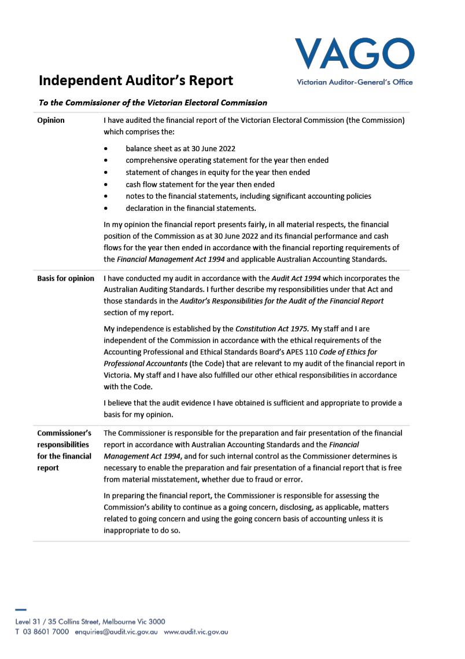

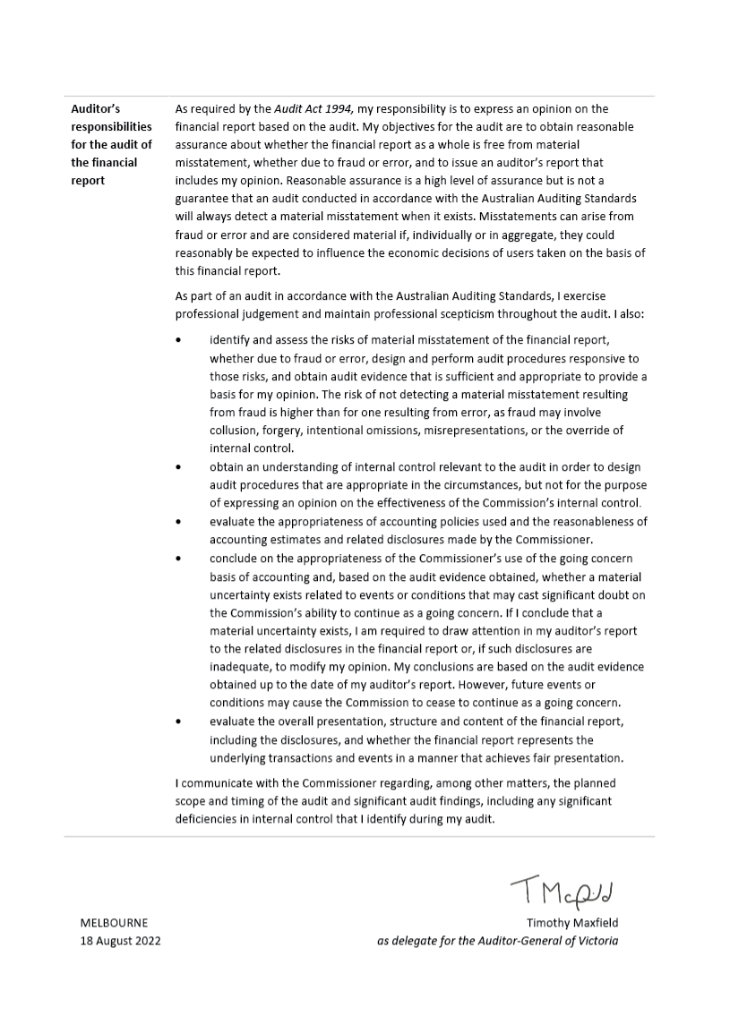

Appendices

Appendix A
Disclosure index

Appendix B
Governing legislation and regulations

Appendix C
Additional information available on request

Appendix D
Reporting procedures under the Public Interest Disclosures Act 2012

Appendix E
Making a request under the Freedom of Information Act 1982

Appendix F
Attestation for compliance

Appendix G
Asset Management Accountability maturity assessment for year ended 30 June 2021

Appendix H
Social procurement

Appendix I
Report of the Electoral Boundaries Commission 2020–21

Appendix A:

Disclosure index
Requirement
Ministerial Directions
Report of operations—FRD guidance
Charter and purpose
FRD 22H | Manner of establishment and the relevant Ministers
FRD 22H | Purpose, functions, powers and duties
FRD 22H | Nature and range of services provided
Management and structure
FRD 22H | Organisational structure
Financial and other information
FRD 8D | Budget portfolio outcomes
FRD 10A | Disclosure index
FRD 12B | Disclosure of major contracts
FRD 15D | Executive Officer disclosures
FRD 22H | Disclosure of government advertising expenditure
FRD 22H | Operational and budgetary objectives and performance against objectives
FRD 22H | Employment and conduct principles
FRD 22H | Occupational health and safety policy
FRD 22H | Summary of the financial results for the year
FRD 22H | Significant changes in financial position during the year
FRD 22H | Major changes or factors affecting performance
FRD 22H | Subsequent events
FRD 22H | Application and operation of Freedom of Information Act 1982
FRD 22H | Compliance with building and maintenance provisions of Building Act 1993
FRD 22H | Statement on National Competition Policy
FRD 22H | Application and operation of the Protected Disclosures Act 2012
FRD 22H | Application and operation of the Carers Recognition Act 2012
FRD 22H | Details of consultancies over $10,000
FRD 22H | Details of consultancies under $10,000
FRD 22H | Statement of availability of other information
FRD 24C | Reporting of office-based environmental impacts
FRD 25D | Local jobs first
FRD 29C | Workforce data disclosures
Compliance attestation and declaration
SD 3.7.1 | Attestation for compliance with Ministerial Standing Direction
SD 5.2.3 | Declaration in report of operations
Financial Report
Financial statements
Declaration
SD 5.2.2 | Declaration in the financial statements
Other requirements under Standing Directions 5.2
SD 5.2.1(a) | Compliance with Australian Accounting Standards and other authoritative pronouncements
SD 5.2.1(b) | Compliance with Standing Directions
SD 5.2.2(a) | Accountable officer’s declaration
SD 5.2.2(b) | Compliance with Model Financial Report
Other disclosures as required by FRDs in notes to the financial statements
FRD 9A | Departmental disclosure of Administered Assets and Liabilities by Activity
FRD 11A | Disclosure of ex-gratia expenses
FRD 13 | Disclosure of parliamentary appropriations
FRD 21C | Disclosures of responsible persons, executive officers and other personnel (contractors with significant management responsibilities) in the Financial Report
FRD 102A | Inventories
FRD 103H | Non-financial physical assets
FRD 106B | Impairment of assets
FRD 109A | Intangible assets
FRD 110A | Cash flow statements
FRD 112D | Defined benefit superannuation obligations
FRD 114C | Financial Instruments—General Government Entities and  public non-financial corporations

Appendix B:

Governing legislation and regulations

Legislation
Agricultural Industry Development Act 1990
Building Act 1993
Charter of Human Rights and Responsibilities Act 2006
City of Greater Geelong Act 1993
City of Melbourne Act 2001
Constitution Act 1975
Electoral Act 2002
Electoral Boundaries Commission Act 1982
Equal Opportunity Act 2010
Essential Services Act 1958
Financial Management Act 1994
Fines Reform Act 2014
Freedom of Information Act 1982
Infringements Act 2006
Juries Act 2000
Legal Profession Act 2004
Liquor Control Reform Act 1998
Local Government Act 2020
Local Jobs Act 2003
Monetary Units Act 2004
Privacy and Data Protection Act 2014
Public Interest Disclosures Act 2012
Public Records Act 1973
Shop Trading Reform Act 1996
Vital State Projects Act 1976

Regulations
Agricultural Industry Development (Polls) Regulations 2011
City of Melbourne (Electoral) Regulations 2012
Electoral Regulations 2012
Fines Reform Regulations 2017
Infringements (General) Regulations 2006
Infringements (Reporting and Prescribed Details and Forms) Regulations 2006
Legal Profession (Board Election) Regulations 2006
Liquor Control Reform Regulations 2009
Local Government (Electoral) Regulations 2016 (to 7 July 2020)
Local Government (Electoral) Regulations 2020 (from 7 July 2020)
Appendix C:

Additional information available on request
On request, the following information sets are available from the VEC:
details of publications produced by the VEC about itself, and where these can be obtained
details of changes in prices, fees, charges, rates and levies charged by the VEC
details of any major external reviews carried out in respect of the operation of the VEC
details of major research and development activities undertaken by the VEC that are not otherwise covered in this report
details of overseas visits undertaken, including a summary of the objectives and outcomes of each visit
details of assessments and measures undertaken to improve the occupational health and safety of employees, not otherwise detailed in this report
a general statement on industrial relations within the VEC and details of time lost through industrial accidents and disputes.
Appendix D:

Reporting procedures under the Public Interest Disclosures Act 2012¹
Disclosures of improper conduct or detrimental action by the Electoral Commissioner or another officer of the VEC must be made to the Independent Broad-based Anti-corruption Commission (IBAC).
Independent Broad-based Anti-corruption Commission
GPO Box 24234
Melbourne VIC 3001
Phone 1300 735 135

Further information
Written guidelines outlining the system for reporting disclosures of improper conduct or detrimental action by the VEC or its employees, and the disclosure handling procedures, are available from the VEC.

¹ Formerly known as the Protected Disclosure Act 2012
Appendix E:

Making a request under the Freedom of Information Act 1982
As detailed in section 17 of the FOI Act, access to documents may be obtained through written request to the Freedom of Information Officer.
In summary, requests should:
be in writing
identify as clearly as possible which document is being requested
and
be accompanied by the appropriate application fee (the fee may be waived in certain circumstances).
Requests for documents in the possession of the VEC should be lodged by email to foi@vec.vic.gov.au or by mail addressed to:
Freedom of Information Officer
Victorian Electoral Commission
Level 11, 530 Collins Street
Melbourne VIC 3000
Access charges may also apply once documents have been processed and a decision on access is made; for example, photocopying and search and retrieval charges.
The VEC may arrange with the applicant to provide information or documents outside of the FOI Act. This avoids the need for processing a formal FOI request.
Information that may be released outside of the FOI Act includes:
information relating only to the applicant
information that may have been previously released to another applicant
publicly available information.
Further information regarding Freedom of Information can be found at the Victorian Government Freedom of Information website (ovic.vic.gov.au).

Appendix F:

Attestation for compliance
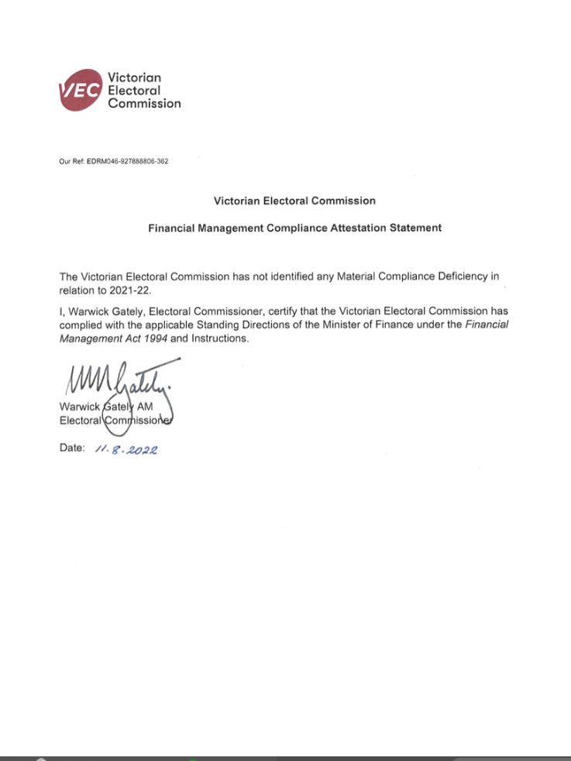
Appendix G:

Asset Management Accountability (AMAF) maturity assessment for year ended 30 June 2022
The following summarises the VEC’s assessment of maturity against the requirements of the Asset Management Accountability Framework (AMAF). The VEC’s target maturity rating is ‘competence’, meaning systems and processes are fully in place, consistently applied and systematically meeting the AMAF requirement, including a continuous improvement process to expand system performance above AMAF minimum requirements.

Leadership and Accountability (requirements 1-19)
The VEC has met its target maturity level within this category.

Planning (requirements 20-23)
The VEC has met its target maturity level within this category.

Acquisition (requirements 24 and 25)
The VEC has met its target maturity level within this category.

Operation (requirements 26-40)
The VEC has met its target maturity level within this category.

Disposal (requirement 41)
The VEC has met its target maturity level within this category.

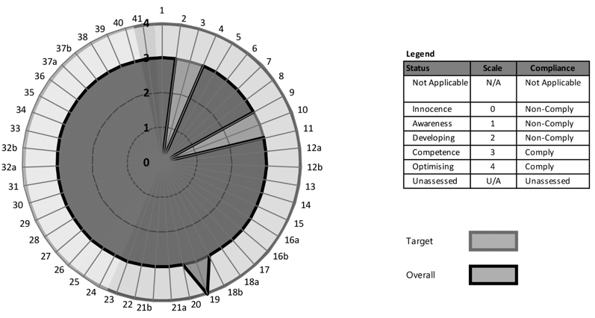

Appendix H:

Social Procurement
The VEC continues to commit to its social procurement strategy in 2021–22 in line with the Victorian social procurement framework and the VEC’s core legislative purpose. The following table provides an overview of the objectives and achievements reportable in the year, which include activities related to State election 2022 readiness.
Due to the COVID-19 restrictions, a range of planned activities were not able to proceed e.g. procuring artists and performers for NAIDOC, National Reconciliation Week and for the launch of the VEC’s Aboriginal Advisory Group.
SOCIAL PROCUREMENT FRAMEWORK (SPF) OBJECTIVES | PROCUREMENT ACTIVITIES AND ACHIEVEMENTS IN 2020–22
Opportunities for Victorian Aboriginal people. | Procured range of services from Indigenous businesses and suppliers including artwork for the 2022 State election Acknowledgment of Country poster, production of electoral engagement videos and cultural expertise to support better engagement of Aboriginal communities. .  Supply of services and engagement initiatives with Indigenous groups such as Korin Gamadji Institute, Reconciliation Victoria, and representatives on the VEC Aboriginal Advisory Group to help promote electoral engagement across the Victorian Aboriginal community.  Number of business and suppliers engaged: 4 (2020–21: 5 suppliers)  Total spend: $129,386 (2020–21: $163,181)
Opportunities for Victorians with disability.  Opportunities for disadvantaged Victorians.  Supporting safe and fair workplaces.  Women’s equality and safety. | Procured range of services, artworks and products from business supporting disadvantaged Victorians. Acquisition include artwork for the Out of Home Action plan supporting people experiencing homelessness or in prison and merchandise such as facemasks and socks produced by Homie, a social enterprise supporting young people with experiences of homelessness.  Employment opportunities for casual Democracy Ambassadors with disabilities or those who have an understanding of homelessness to provide electoral education to the community in the lead up to the 2022 State election as part of the VEC’s BeHeard Democracy Ambassador program.  Supply of services and engagement initiatives with a range of key stakeholders such as YMCA Victoria Youth Services, VEC Electoral Access Advisory Group members, Homelessness Advisory Group members, Culturally and Linguistically Diverse Advisory Group members and a range of community service providers to help promote electoral engagement across the Victorian community.  Number of business and suppliers engaged: 11 (2020–21: 6 suppliers)  Total spend: $286,426 (2020–21: $147,468)
Environmentally sustainable outputs.  Environmentally sustainable business practices. | Where possible, the VEC will continue to leverage from whole-of-government contracts and services that target sustainable and environmental benefits.  The VEC also has the ‘Resource Smart’ in-house team, which drives environmentally sustainable practice within the organisation. Due to the constraints of COVID, various initiatives forming part of the VEC Sustainability Action Plan could not be delivered. Strategy activities deferred to 2023.  The purchased of ballot material and paper from locally sourced providers in readiness for State election program.  Number of business and suppliers engaged: 4 (2020–21: 6 suppliers)  Total spend: $2.776 million (2020–21: $147,682)

Appendix I:

Report of the Electoral Boundaries Commission, 2021–22
The Electoral Boundaries Commission (EBC) is constituted under the Electoral Boundaries Commission Act 1982 (EBC Act) and must establish and maintain electorates of approximately equal enrolment (that is, not varying by more than 10% from the average for each House of Parliament) for the conduct of Parliamentary elections.
The members of the EBC during 2021–22 were:
Chief Judge Peter Kidd of the County Court of Victoria (Chair)
Mr Warwick Gately AM, Electoral Commissioner
Mr Craig Sandy LS, Surveyor-General of Victoria.
The VEC provides administrative and technical support to the EBC. Dr Paul Thornton-Smith of the VEC was the EBC secretary up until the completion of the redivision in October 2021, at which point Ashley Carr of the VEC assumed the responsibility.
The EBC Act provides that the EBC must conduct a redivision if certain conditions apply in the period 24 to 18 months before the next scheduled State election. These conditions are that enrolments for a certain number of electorates have been more than 10% outside the State average for at least 2 months, that there have been more than 2 general elections since the previous redivision, or that the number of electorates has changed. On 26 November 2020 the ‘general election’ trigger took effect, as there had been 2 general elections (in 2014 and 2018) since the last redivision. As well, enrolments for 28 of the 88 electoral districts were more than 10% outside the average, and 7 districts were more than 20% outside the average.
During an online information session on 16 December 2020, the EBC set out the procedures for the redivision, described the resources available for those who wished to make a submission, and heard from expert demographers and from Geographic Names Victoria.
The EBC invited submissions from the public and received 58 submissions by the deadline of 1 March 2021. An online public hearing held on 29–30 March 2021 was another opportunity for public input.
On 30 June 2021, the EBC released proposed electoral boundaries. This was followed by a second round of public submissions, where 127 submissions were received by the deadline of 30 July 2021 and a second online public hearing held on 17–18 August 2021. In developing the final boundaries, the EBC considered the various suggestions and objections presented in public submissions and at the public hearings. The final boundaries were released on 28 October 2021 and tabled at State Parliament on the same day.
As required by legislation, the final boundaries were delivered to the State’s Central Plan Office (4 November 2021) and published in the Victorian Government Gazette (12 November 2021).

At the close of the redivision, the EBC also requested the outgoing and incoming EBC secretaries to prepare a memo identifying any arguments in support of amendments to the EBC Act and/or improvements to the redivision process. The memo was distributed to EBC members and is under consideration, alongside changes to the EBC Act brought about by the recent Regulatory Legislation Amendment (Reform) Act 2022.


Glossary

Attendance election
In an attendance election, voting is conducted at voting centres on election day, although voters may vote at early voting centres or by postal vote.

Ballot
A method of secret voting.

By-election
A by-election is an election in a single-member electorate to fill a casual vacancy caused by the departure of a sitting Member of Parliament or local government councillor before the term expires. A by‑election may also be held in a multi-member electorate when no unsuccessful candidates remain for a countback.

Candidate
A candidate is an eligible elector who nominates for election.

Community of interest
The VEC defines a community of interest as a group of people who share a range of common concerns or aspirations. A community of interest may occur where people are linked with each other geographically (e.g. a town or valley) or economically, such as where people work in similar industries (e.g. tourism) or where people work in mutually dependent industries (e.g. fruit growers, transporters and canners).
A community of interest may also appear where people share a number of special needs because of similar circumstances (such as people who have recently immigrated to Australia and may have low English literacy or need assistance with housing or employment).

Compulsory enrolment
All Australian citizens 18 years and over are required by law to enrol.

Compulsory voting
All enrolled electors must vote at State elections. With some exceptions, enrolled voters must vote at local government elections.

Contested election
A contested election is an election where more candidates than the number of vacancies for the election have nominated by the close of nominations.

Continuous Roll Update (CRU)
The CRU process consists of a range of strategies to ensure that the electoral roll is continuously kept up to date by using internal and external data to direct roll review activities to targeted people and residences.

Councillor
An elected representative of a local government council.

Countback
Method of filling extraordinary vacancies in multi-member wards and unsubdivided municipalities in electorates where general election results were obtained using the proportional representation method. Votes are transferred to the previously unelected candidates to fill the vacancy.

District
One of the 88 Legislative Assembly electorates in Victoria. Each district elects one member and as of 30 June 2022 comprises approximately 49,650 electors.

Election
An event at which electors choose their representatives.

Election date
The legislated date of the election.

Election Manager
A person appointed by the Electoral Commissioner to conduct an election for a State electoral district or region or a local government election.

Elector
A person whose name appears on the register of electors and who is entitled to vote in elections.

Electoral Commissioner
The statutory officer appointed by the Governor in Council with responsibility for the proper conduct of Parliamentary and statutory elections.

Electoral Matters Committee (EMC)
The EMC comprises 10 Members of Parliament drawn from both Houses and is a Joint Investigatory Committee of the Parliament of Victoria. The EMC is constituted under section 9A of the Parliamentary Committees Act 2003. The Committee holds inquiries into, considers and reports to the Parliament on any proposal, matter or thing concerned with the conduct of Parliamentary elections and referendums in Victoria, the conduct of elections of councillors under the LGA 2020 and the administration of, or practices associated with, the Electoral Act and any other law relating to electoral matters.

Electoral roll
A list of names of all the people who are entitled to vote in an election under relevant legislation.

Electronically assisted voting
A method of casting a vote in State elections by electors who are blind, have low vision or have a motor impairment.

Enrolment
The placement of a person’s name and address on the register of electors. A person cannot vote in an election unless they are enrolled.

Enrolment information
The information about electors that is held by the VEC.

Geo-coding
Geo-coding is the process of assigning geographic identifiers (e.g., codes or geographic coordinates expressed as latitude-longitude) to map features and other data records, such as street addresses.

Informal vote
A ballot paper that is either left blank or is incorrectly marked. These ballot papers do not contribute to the election of a candidate.

Legislative Assembly (Lower House)
One of the 2 Houses in the Victorian State Parliament. There are 88 Members of the Legislative Assembly (MLAs), one from each electoral district. The party or coalition of parties that win majority support in this House forms the Government.

Legislative Council (Upper House)
One of the two Houses in the Victorian State Parliament. There are 40 Members of the Legislative Council (MLCs), five from each region. The Legislative Council is often referred to as the ‘House of Review’.

Lost Time Injury (LTI)
An LTI is an occupational injury or illness that results in days away from work on any rostered shift subsequent to that on which the injury occurred. A fatality is also recorded as an LTI.

Marginal costs
Marginal costs include direct labour and associated on-costs, materials, equipment, mail processing, postage, advertising, printing, rent, utilities, insurance, IT equipment and software licences purchased especially for the specific activity.

Postal election
In a postal election, voting papers are posted to voters by the Election Manager. A vote is cast by completing a ballot paper and returning it to the Election Manager in the reply-paid envelope provided.

Preferential voting
A vote for candidates in order of preference. If no candidate has an absolute majority of first preference votes, preferences are distributed until one candidate has an absolute majority.

Proportional representation
A system of voting designed to elect representatives in proportion to the amount of support each has in the electorate.

Redivision
The redrawing of electoral boundaries to ensure that there are, as near as possible, equal numbers of voters in each electorate within Victoria.

Region
One of the 8 Legislative Council electorates. As of 30 June 2022, each region comprises approximately 546,150 electors and elects 5 members.

Register of electors
The VEC’s database of all Victorian electors.

Registered political party
A political party that is registered under the Electoral Act. A registered party must have at least 500 members who are Victorian electors and not members of another registered political party.

Senior Election Official (SEO)
A trained election official who may be appointed to act as an Election Manager for a Parliamentary election or an Election Manager or Assistant Election Manager for a local government election.

Victorian Electoral Commission (VEC)
The VEC is the independent statutory body that conducts State elections and certain statutory elections. The VEC also conducts local government elections, and commercial and community elections. The VEC also conducts electoral research, maintains the Victorian register of electors, provides education and information services, and assists with redivisions of State electoral boundaries. From 2018, the VEC has administered political funding and disclosure laws.

Voter
An elector who votes in an election.

Voting centre
A place at which electors can vote in an election. There are three types of voting centres that operate in State elections: early voting centres, mobile voting centres and election day voting centres.

Index
2021 South Gippsland Shire Council general election
2022 Cultural Diversity Week
2022 VEC Advisory Group Effectiveness
A
Abbreviations and acronyms
Aboriginal Advisory Group
Aboriginal Inclusion Plan
About the VEC
About this report
Accountability and transparency
Additional information available on request
Additional information available on request, list
Administrative services
Advertising
Advertising disclosure
Annual returns
Appendices
Arrangements with other electoral agencies
Asset Management Accountability Framework (AMAF)
Assets, what the VEC owns
Attestation for compliance
Attestation, Public Sector Standards Commissioner
Audit and Risk Committee
Auditor-General’s report
B
Balance sheet
Best practice hiring and onboarding staff
Building Act 1993, Disclosures
C
Case study
Cash flow statement
Changes to registered political parties
Chief Financial Officer, Finance and Corporate Governance Branch, profile
Chief Information Officer, Information Technology Branch, profile
Child Safe Standards
Claims for WorkCover
Code of conduct—VEC values
Communication and Engagement Branch
Communication services
Comparative workforce data
Complaints and Customer Feedback Framework and Policy
Compliance and enforcement
Comprehensive operating statement
Consultancies and contracts
Consultancies over $10,000
Consultancies under $10,000
Contents
Corporate reporting
Culturally and Linguistically Diverse (CALD) Advisory Group
Culture
Customer service charter
D
Declaration in the financial statements
Democracy Ambassador program
Deputy Electoral Commissioner, profile
Director, Communication and Engagement Branch, profile
Director, Elections Branch, profile
Director, Electoral Enrolment Branch, profile
Director, Electoral Integrity and Regulation Branch, profile
Director, Human Resource, profile
Disability Access and Inclusion Plan
Disability Act 2006, Disclosures
Disclosure index, Appendices
Disclosure index, Disclosures
Disclosures
Discretionary provision of enrolment information
Diversity and inclusion
Donations disclosure
E
Effect of age on voting turnout
Elections Branch
Elections, by-elections, countbacks and polls, 2020–21
Elector statistics, District
Elector statistics, Region
Electoral Access Advisory Group
Electoral activity
Electoral Boundaries Commission (EBC)
Electoral Commissioner, profile
Electoral Council of Australia and New Zealand (ECANZ)
Electoral Enrolment Branch
Electoral Integrity and Regulation Branch
Electoral Matters Committee (EMC)
Electoral Regulation Research Network (ERRN)
Employment and conduct principles
Empowered electors, our strategic plan
EMS2 Development Steering Committee
Enforcement of compulsory voting
Enforcement of compulsory voting, statistics
Enrolled electors
Enrolment rate by age
Enrolment transactions, summary
Environmental performance
Environmental sustainability report
Equity, what the VEC is worth
Executive Director, Corporate Services, profile
Executive officer disclosures
Expenditure
Expenses, how the VEC’s funding is utilised
External advisory groups
F
Feedback on this report
Finance at a glance
Finance and Corporate Governance Branch
Financial management and compliance
Financial management compliance framework
Financial performance
Financial position
Financial report
Financial statements
Freedom of information
Freedom of information, request procedures
FTE staffing trends
Funding
Funding and disclosure
Funding and Disclosure System Development Steering Committee
Funding fluctuations
G
Gender Equality Act Reporting
Geospatial services
Gifts, benefits and hospitality register
Glossary
Governance
Governing legislation and regulations, list
Governing legislation and tribunals
Grants and transfer payments, Disclosures
H
Hazards, incidents and injuries
Hazards, incidents and injuries reported
Human Resources Branch
I
Identifying and managing risk
Implementation
Inclusion and participation
Inclusion of Aboriginal communities
Inclusion of multicultural communities
Inclusion of Out of Home communities
Inclusion of people with disabilities
Inclusion of young people
Index
Information and records management
Information technology
Information Technology Branch
Inspired people
Inspired people, our strategic plan
Interaction with electoral bodies
Internal audit
Internal committees and groups
L
Learning and development
Legislation
Legislative and regulatory amendments
Letter of transmittal
Liabilities, what the VEC owes
Little respite
Living with COVID-19
Local government by-elections and countbacks
M
Major contracts
Major projects
Managing the future
Mandatory provision of enrolment information
Media services
Moreland City Council, North-West Ward election
N
National Competition Policy
Notes to the financial statements
O
Occupational health and safety
Occupational Health and Safety Committee
Occupational health and safety management
Online Research Panel
Operational and budgetary objectives and performance against objectives
Organisational structure
Other elections and polls
Our commission
Our core business
Our highlights/Our challenges
Our history and functions
Our people
Our people and partners
Our people; our teams; our leadership
Our purpose
Our stakeholders
Our strategic plan
Our values
Our vision
Our year, message from the Electoral Commissioner
Out of Home Advisory Group
Over-arching programs, our strategic plan
Over the horizon
P
Passport to Democracy
Pecuniary interest declaration
Planning Group
Plans and operations
Political funding
Promoting and supporting flexible working models
Public Interest Disclosures Act 2012, reporting procedures
Public Interest Disclosures Act 2012
Provision of enrolment information
R
Recruitment (FTE ongoing)
Recruitment, departures and turnover
Register of electors
Register of political parties
Report of the Electoral Boundaries Commission (EBC)
Research and development
Research partnership with the University of Adelaide
Resource Smart Committee
Responding to governing legislation and inquiries
RMS Redevelopment Steering Committee
Roll management system redevelopment
S
Security Committee
Selections: the VEC newsletter
Service improvements
Services to political parties
Smart solutions, our strategic plan
Social media
Social procurement
Specific diversity and inclusion initiatives 2021–22
Spotlight on…
Staff profile
Staff wellbeing services
Stakeholder engagement
State by-elections
Statement of changes in equity
Strategic and forward planning
T
The Executive Management Group (EMG)
The Office of the Electoral Commissioner
V
VEC Disclosures: The online disclosure system
VEC staff by gender
VEC website
VEC’s performance against OHS management measures
Victorian Civil and Administrative Tribunal (VCAT)
Victorian Industry Participation Policy (VIPP)
VoterAlert
W
Warehouse
Workforce profile
Y
Young People Advisory Group
Young People Inclusion Plan 2021–23

Feedback on this report is welcome.
Please mark to the attention of:
Corporate Services
Victorian Electoral Commission
Level 11, 530 Collins Street
Melbourne VIC 3000
Phone: (03) 8620 1100
Email: info@vec.vic.gov.au
Australasian Reporting Awards
2020–21 Best Cover Design 2022
2019-20 Gold
2018-19 Gold
2017-18 Gold
2016–17 Gold
2015–16 Gold
2014–15 Gold
2013–14 Gold
2012–13 Gold
2011–12 Gold
2010–11 Silver
2009–10 Gold
2008–09 Silver
Creative
This report was designed and produced by Cordial Creative
www.cordialcreative.com


© State of Victoria
(Victorian Electoral Commission)
October 2022
This work, the VEC 2021–22 Annual Report, is licensed under a Creative Commons Attribution 4.0 licence (http://creativecommons.org/licenses/by/4.0/). You are free to re-use the work under that licence, on the condition that you credit the State of Victoria (Victorian Electoral Commission) as author, indicate if changes were made and comply with the other licence terms. The licence does not apply to any branding, including government logos.

