Victorian Electoral Commission
Annual Report 2017-2018
Department of Health
Enabling electors every day.

About the VEC

Our vision
All Victorians actively participating in their democracy.

Our purpose
To deliver high quality, accessible electoral services with innovation, integrity and independence.

Our values
- Independence: acting with impartiality and integrity
- Accountability: transparent reporting and effective stewardship of resources
- Innovation: shaping our future through creativity and leadership
- Respect: consideration of self, others and the environment
  - Collaboration: working as a team with partners and communities

Our people and parntners
The Victorian Electoral Commission (VEC) has a core staff of dedicated and highly skilled people whose specialised knowledge ensures the success of its operations. At times of peak activity, the VEC draws on the experience and expertise of a number of associated personnel, such as election officials and contractors, to complement the work of its core staff. Valued partnerships with suppliers also contribute greatly to the VEC’s achievements.
To ensure inclusion and participation, the VEC works closely with a range of advisory and community groups. These groups primarily consist of representatives of under-represented communities, including:
- Aboriginal and Torres Strait Islander communities
- Young people
- People experiencing homelessness
- People living with disabilities
  - Culturally and linguistically diverse communities
The VEC thanks all advisory and community group members and their organisations for their contributions to its work during 2017–18.
The VEC pays respect to Victoria’s traditional owners and their elders past and present who have been custodians of this country for many thousands of years. Their living culture and their role in the life of Victoria is acknowledged by the VEC.

Our history and functions
Elections for the Victorian Parliament began when Victoria achieved independence from New South Wales in 1851. In 1910, Victoria’s first Chief Electoral Inspector was appointed to head the new State Electoral Office.
The State Electoral Office existed as part of a public service department for 70 years. However, it became increasingly clear that it was inappropriate for the conduct of elections to be subject to ministerial direction. On 1 January 1989, legislation established the independent statutory office of Electoral Commissioner who was to report to Parliament instead of a Minister. In 1995, the State Electoral Office was renamed the Victorian Electoral Commission.
The VEC’s functions and operations are governed by six main pieces of legislation:
- Electoral Act 2002 - establishes the VEC as an independent statutory authority, sets out the functions and powers of the VEC and prescribes processes for State elections
- Constitution Act 1975 - sets out who is entitled to enrol as an elector, who is entitled to be elected to Parliament, and the size and term of Parliament
- Financial Management Act 1994 - governs the way the VEC manages finances and financial reporting
- Electoral Boundaries Commission Act 1982 - governs the determination of State electoral boundaries. Under this legislation, the Victorian Electoral Commissioner is nominated as a member of the Electoral Boundaries Commission
- Local Government Act 1989 - provides for the conduct of local government elections and electoral representation reviews
  - Infringements Act 2006 - provides for stages 2 and 3 of compulsory voting enforcement
Subject to these Acts, the VEC:
- maintains the electoral enrolment register
- conducts State elections, local government elections, statutory elections and commercial and community elections
  - conducts electoral boundary reviews
The VEC also has a mandated role to conduct electoral research, provide communication and education services and to inform and engage Victorians in the democratic process.
A list of legislation and regulations governing the VEC is included in Appendix B on page 124.

Victorian Electoral Commission
Level 11, 530 Collins Street
Melbourne Vic 3000
Telephone: (03) 8620 1100
Fax: (03) 9629 8632
Website: vec.vic.gov.au
Email: info@vec.vic.gov.au
Office hours:
8.30 am – 5.00 pm
Monday – Friday

Letter of transmittal
The Hon. Gavin Jennings MLC
Special Minister of State
1 Treasury Place
Melbourne Vic 3002
Dear Minister
In accordance with the requirements of the Financial Management Act 1994, I am pleased to submit the Annual Report of the Victorian Electoral Commission for the year ending 30 June 2018 for presentation to Parliament. Also included is the Report of the Electoral Boundaries Commission for the year ending 30 June 2018.
Yours sincerely

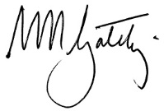
Warwick Gately AM
Electoral Commissioner

Contents
about the vec 3
About this report 8
Our highlights 10
Our year 11
Finance at a Glance 16
our STRATEGIC plan 20
our STRATEGIC INITIATIVES 21
Our commission 27
GOVERNANCE 28
organisational structure 29
the electoral commissioner 30
THE VEC executive management group 33
internal committees and groups 40
External Advisory Groups 43
governing legislation and tribunals 46
accountability and transparency 47
disclosures 51
Our core business 57
electoral activity 58
enforcement of compulsory voting 65
Register of electors 67
WAREHOUSE 74
research and development 75
Our stakeholders 78
Inclusion and participation 79
services to political parties 88
interaction with electoral bodies 91
our people 94
human resource management 95
Staff profile 100
occupational health and safety 102
FINANCIAL STATEMENTS 107
FINANCIAL REPORT 108
Accountable officer’s and chief finance and accounting officer’s declaration 111
COMPREHENSIVE OPERATING STATEMENT 112
BALANCE SHEET 113
STATEMENT OF CHANGES IN EQUITY 115
CASH FLOW STATEMENT 116
NOTES TO THE FINANCIAL STATEMENTS 117
Auditor–General’s report 150
Appendices 152
GLOSSARY 161
INDEX 165

About this report
This report provides a summary of programs and initiatives implemented to meet the key objectives set out in the Strategic Plan 2013–14 to 2017–18 and the steps taking place to implement a new five-year Strategic Plan commencing in July 2018.

This report has been published in accordance with Financial Reporting Direction (FRD) 30C. As part of the VEC’s environmental sustainability activity, only the required number was printed, and environmentally friendly paper and printing processes were used.

Our year
In this section, the Electoral Commissioner, Warwick Gately AM, provides a summary of key activities and achievements for 2017–18 and the outlook for 2018–19. The report includes, among other things, planning and preparation for the 2018 State election, development of a new five-year Strategic Plan and finalising the Information Technology Branch restructure.
Chief Financial Officer, Binh Le, provides an overview of the VEC’s financial performance.
A summary of achievement against the VEC’s strategic initiatives is included in this section. Of note, the 27 strategic initiatives associated with the 2013-14 to 2017-18 Strategic Plan have been actioned and the foundation work relating to service delivery, business systems and information management is now complete.

Our Commission
Good corporate governance and transparent reporting help ensure continued public confidence in the VEC and its processes.
This section provides detail of the VEC’s regulatory environment and governance and organisational structures, key persons and staff profiles, disclosure requirements and the corporate systems that enable the VEC to deliver its core business and operate effectively and efficiently on a day-to-day basis.
Accountability to the Victorian public and Parliament is critical, and the VEC’s good corporate citizenship is evidenced by its performance in areas such as diversity, inclusion, accessibility, sustainability, information management and reporting.
Information relating to internal and external advisory groups is also detailed in this section. These advisory groups play an important role with the VEC.

Our core business
The VEC’s core business includes the conduct of elections, maintenance of the register of electors and ensuring fair and equitable representation for voters at State and local government levels.
Election activity was steady during the year with a by-election conducted in the State District of Northcote, a general election conducted for the Greater Geelong City Council and a by-election conducted for Melbourne City Council Lord Mayor along with other commercial elections, by-elections and polls.
Preparations for the next major cyclical event, the 2018 State election, continued.

Our stakeholders
This section includes details of the VEC’s efforts to inform and engage electors as voters and candidates, provide accessible voting services and ensure electors know how to cast a formal vote.
In the lead up to the November 2018 State election, the VEC has noted an increase in the number of applications for political party registration and has begun briefing Registered Political Parties on the State election.
Information about key stakeholder groups such as voters with particular requirements, political parties and the media is detailed in this section. How the VEC interacts with other electoral bodies is also discussed.

Our people
The VEC aims to provide staff with the environment and opportunity to learn and thrive on a personal and professional level.
Occupational health and safety remains a priority at the VEC. This section provides the OHS performance metrics and details the ‘lead’ activities undertaken in 2017–18, including actions taken in response to an OHS internal audit.

Financial statements
The VEC is pleased to provide ‘value for money’ electoral services to the Victorian public. Once again, the VEC’s sound financial management is evidenced by an unqualified report from the Auditor-General. This section provides the VEC’s audited financial statements for 2017–18.

Appendices 121

Glossary 129

Index 132

Our highlights
All elections, by-elections and polls conducted on schedule, within budget and in accordance with legislation, rules and guidelines

New service level agreement with the Australian Electoral Commission governs joint enrolment activities for the benefit of all Victorians

Migration of enterprise-wide systems, Aurion and Attache, to a cloud based environment.

Compliance with the Standing Directions of the Minister for Finance 2016 – no reportable deficiencies

Delivery of the LAUNCH – Leadership and Management development program

Successfully completed 27 strategic initiatives over the life of the 2013-2014 to 2017-18 Strategic Plan, creating a strong foundation for the next Plan, Strategy 2023

Organisation commitment to diversity and inclusion and the mental health and wellbeing of all staff

VEC Annual Report 2016–17 achieved Gold at the 2018 Australasian Reporting Awards

Our year
This year, falling between major election events, provided the Victorian Electoral Commission (VEC) space to evaluate its organisational design, key roles and relationships, and the effectiveness of supporting systems in delivering on our statutory responsibilities. This was important given the population-driven growth in demand for services and changing elector expectations of how these services are delivered.

Warwick Gately AM
Electoral Commissioner

Celebrating success
Among its responsibilities, the VEC is to promote public awareness of electoral matters through community education and information programs. One program provided to Victorian schools, ̒Passport to Democracyʼ, is in its tenth year and growing in influence year on year.
Passport to Democracy, an active citizenship education module, was born in 2008 to provide students with a positive experience in the workings of the democratic process around issues of interest. It is the VECʼs community education centrepiece and, to date, has interacted with over 50,000 students and teachers. I commend the architects of the program and those now actively involved in its expanding delivery.

Maintaining strategic capacity
This year, falling between major election events provided the VEC space to evaluate its organisational design, key roles and relationships and the effectiveness of supporting systems in delivering on our statutory responsibilities. This was important given the population-driven growth in demand for services and the changing expectation of electors of how these services are delivered.
One consequence of the evaluation was the creation of a Corporate Services Group and an Electoral Functions Group, distinguishing between the support and delivery arms of the VEC and aimed at improving service delivery while providing depth and succession opportunity.
As components, adjustments to the Information Technology (IT) Branch and the Communication and Engagement Branch structures were made, recognising the extent of needed system developments and the digital environment in which the VEC is operating and in which messages are delivered.
The approach to system and application development was also reviewed. The long-standing Election Management System Redevelopment Board was dissolved, given its diminishing role in a program that is within budget and 80% complete. An IT strategy was developed and an evolved Project Governance Board and an Enterprise Architecture Board put in place to assess and monitor future technology investments. Key developments for the 2018 State election were identified, resourced and are scheduled for completion at the end of June 2018. Associated with this was an internal audit into IT security and the completion of a Business Continuity Framework and plan.

Operations
While there was no large scale election event scheduled during the reporting year, short notice demands for election services arose with a by-election for the District of Northcote along with a by-election for the Lord Mayor vacancy for the Melbourne City Council. These elections followed the passing of the Member for Northcote and the resignation of the Lord Mayor. Additionally, the VEC conducted elections for the City of Greater Geelong in October 2017, reinstating that Council following a 12-month period of administration. These high-profile elections were well conducted, with the declaration of results occurring as scheduled.
A further 24 election activities were conducted during the year, including local government elections, countbacks and commercial elections and polls. In addition, work continued on the follow up of non-voter court matters for the 2016 Local Government elections.

Our people
Developing the capacity of VEC staff again received attention. A leadership and management development program was initiated, providing VEC managers with various learning opportunities through forums, master classes and discussions. Succession planning was also considered, with key roles identified and where practicable ̒succession benchesʼ created or recruitment strategies documented. A mental health and wellbeing commitment statement was established and mental health training for managers scheduled in 2018–19. With the launch of the new Learning Management System, staff completed a number of compliance training modules, including Equal Employment Opportunity, Bullying and Harassment and the application of the Charter of Human Rights in the Public Sector. Diversity was celebrated with an International Women’s Day event and several activities to coincide with Cultural Diversity Week.

Financial management
While the year’s appropriation reflected the absence of a major election event, it provided adequately for recurrent operational and capital expenditure in line with the yearʼs plans and projections. Recruitment, particularly to the new IT structure and of other consultants to advance IT projects, coupled with platform and infrastructure upgrades, required significant funds, while costs associated with the Northcote District by-election and establishing the Funding and Disclosure regime were absorbed.
The Audit and Risk Committee met on four occasions, with close attention to the risk management framework and internal audit reporting. A change in provider for internal audit services was positive, supporting the Committee’s risk focus on cyber and data security and information management. The move to streamlined financial reporting this year meets a previous commitment.

Compliance, reporting and engagement
During the year, compliance and reporting obligations were met, accounting in full for the VEC’s activities. Along with a review of the delegations framework, the internal Committee and decision making structure was also considered.
The VEC’s community advisory groups were engaged early in 2018. While outlining plans for the State election, this ongoing dialogue builds confidence within the represented groups that the VEC is working to address their particular election needs. The Aboriginal and Torres Strait Islander Advisory group has been difficult to convene given staff changes, similarly affecting the progress of the VEC’s Reconciliation Action Plan. This will be a focus for next year.
The Electoral Council of Australia and New Zealand (ECANZ) met on three occasions to consider electoral legislation, electoral roll matters and collaboration in operations and technology. As a first, ECANZ was successful in promoting to the Council of Australian Governments (COAG) the idea of a national electronic voting solution and will develop a business case on the proposal. The issue of cyber security and physical security around elections was also considered by COAG in response to international developments. Harmonisation across jurisdictions was pleasing.
The Electoral Regulation Research Network (ERRN) was again active, with 14 seminars held around Australia covering matters such as deliberative democracy, populism in elections and disqualification from Federal Parliament. A very successful biennial workshop was held in November 2017, focusing on evident change in the democratic process.

Court matters, parliament and legislation
Arising from the 2016 Local Government elections, the VEC was involved in seven Municipal Electoral Tribunal (MET) matters brought by candidates for a review of aspects of their elections. Three matters carried over into this financial year where the VEC applied to the Victorian Civil and Administrative Tribunal (VCAT) for a review of the two MET decisions. In one case, it was necessary to seek leave to appeal to the Supreme Court. While the VEC was successful in each case in overturning original MET decisions and re-establishing statute intent, the resource cost was considerable. Also from these elections 306 electors referred their non-voting matters to the Magistrates Court, and these were being worked through as the year ended.
The VEC contributed to the Electoral Matters Committee (EMC) Inquiry into Civics and Electoral Participation in Victorian State Parliamentary Elections by way of submission and appearance at a public hearing. While the Committee’s report will not be available until late in 2018, the VEC is rightly proud of its ongoing and targeted community education activities aimed at increasing voter connection with democratic participation at electoral events.
In responding to an earlier EMC Inquiry into Electronic Voting in Victoria, the Government favoured a national approach, distinct from Victoria proceeding independently. Thereafter, in concert with Electoral Commissions from other jurisdictions, an approach was made to the COAG to advance this proposition. While the option to offer a limited remote electronic voting service at the State election in 2018 did not progress, the idea of a nationally available system for the future is logical and will be supported by the VEC.
The Government’s legislative agenda included changes to the Electoral Act 2002 (the Act) and a rewrite of the Local Government Act 1989 (LG Act). Both impact the VEC. Proposed changes to the Act created a Funding and Disclosure regime for Victoria and required the VEC to establish capability to administer the new laws, including development of an online disclosure system. Despite the very short time available, an operating regime has been developed to support new legislation. While the rewrite of the LG Act was a longer term undertaking, one concern was the removal of an established VEC statutory role in the independent design of local government electoral representation structures. The Electoral Legislation Amendment Bill 2018 and the Local Government Bill 2018 remained under the consideration of Parliament as the reporting year ended. In addition, the introduction of the Fines Reform Act 2014 in December 2017 impacted non-voter processes previously lodged with the Infringements Court.

State election planning and preparations
In mid-2017, the Planning Group shifted its focus to the 2018 State election. This important cross-organisational work group has approached this State election with a refined planning model centred on 11 program groups with distinct projects or deliverables and aimed at improving control and coordination across the VEC. The release of the State election draft service plan in December 2017 provided stakeholders with an early idea as to how the election would be conducted, identifying objectives, priorities, initiatives and performance measures by which the VEC could be assessed.
As a complication, proposed changes to the Act remained unresolved at the end of this reporting period, raising the risk profile in the administration of some activities, notably postal voting, vote counting, political party registration and campaigning regulation. While Government intentions regarding the disclosure of political donations were signalled early, certain assumptions have been necessary to progress the development of a near real time disclosure system and associated handbooks and compliance materials. State election process improvements were also considered. A changed election office and staff model and the adjusted centralisation of postal voting will maximise election night vote counting. Associated with this, analysis identified the optimum roll out of electronic roll marking facilities aimed at providing more efficient declaration vote processes. The scanning of ballot papers was also examined, but not progressed at this time. A telephone voting call centre was identified as a viable voting service option for voters with certain disabilities.
At the end of June, election preparations were well advanced, with all contracts let, training of senior election officials advancing, voting centre sites identified and being leased, and stakeholders engaged.

Staffing
Staff numbers in the VEC increased in the year, driven by the State’s growing population, their changing demand for services and additional Commission responsibilities with the proposed introduction of Funding and Disclosure legislation. For many years, the VEC has been operating ̒leanʼ, with little depth in some key functional areas and risk to knowledge transfer. This has been addressed as evidenced in the transfer of several key contractor positions to permanent public sector roles. As for all VEC staff, I remain impressed by their enthusiasm and commitment to the important task at hand and once again thank them for their support and hard work during the year.
Changes to the Executive Management Group (EMG) also occurred. My thanks go to Simon Hancock for his contribution over many years to the important information, communication and technology function, and I welcome Jonathan Underwood into the Director role in his place. I also welcome Máiréad Doyle into the new role of Executive Director Corporate Services, and note their contribution to the management and life of the VEC.

Looking ahead
Expiry of the 2013-18 Strategic Plan provided opportunity for the executive to recast the direction of the organisation for the next five years. Initiatives identified in the expiring plan were achieved, with many providing a solid foundation for the future. The VEC’s new plan, ̒Strategy 2023̓, recognises and capitalises on the changing information, communication and technology environment in which the VEC operates, so that all Victorians can participate in their democracy. Specific actions for this next year are to progress the IT strategy, develop a monitoring and evaluation framework, improve knowledge management and progress our governance structure.
Alongside these actions, the VEC will direct its energy into conducting the 2018 State election. While it is easy to consider each State election as simply an exercise in repetition, the dynamic nature of the Victorian electoral landscape requires a customised response: population growth and dispersion is significant; electors expect to vote at their convenience and with ready access to information; results are to be immediate, accurate and of the highest integrity. The challenge for the VEC is to respond, and the next Annual Report will outline our efforts and successes.

Warwick Gately AM
Electoral Commissioner

Finance at a glance
The VEC’s Special Appropriation funding fluctuates significantly over the four year electoral cycle, as can be seen in Figure 1.
Every two years, the VEC undertakes either a State election or local government elections on behalf of the State.
As the reporting financial year was a non-election year, the VEC’s overall funding and expenditure decreased significantly in comparison to 2016-17. Total funding received during 2017-18 was $33.61 million. Funding was largely allocated to maintenance and enhancements to the organisation’s operating environment, conducting a total of 27 electoral events, and progressive planning and commitment towards the 2018 State election.

Financial performance
Being a non-election year, special appropriations and expenditure transactions decreased considerably compared to the previous year. A summary of performance is outlined below showing the movement in special appropriation, expenses, balance sheet items and net cash flow.
FIGURE 1: FIVE YEAR FINANCIAL SUMMARY 2013–14 TO 2017–18
 | 2013-2014  ($,000) | 2014-2015  ($,000) | 2015-2016  ($,000) | 2016-2017  ($,000) | 2017-2018  ($,000)
Electoral activity |  | State Election |  | Local Government
Special appropriation | 23,062 | 62,623 | 25,260 | 52,336 | 33,606
Total expenses from transactions | 24,987 | 65,735 | 24,946 | 51,453 | 34,260
Net result from transactions | (1,925) | (3,112) | 314 | 883 | (654)
Net result for the period | (1,936) | (3,142) | 253 | 917 | (652)
Net cash flow from/(used in) operating activities | (1) | - | 18 | (4) | -
Total assets | 11,520 | 9,953 | 11,730 | 12,746 | 17,158
Total liabilities | 3,675 | 4,924 | 5,457 | 5,056 | 5,280
Net assets | 7,845 | 5,029 | 6,273 | 7,690 | 11,878

FIGURE 2: SPECIAL APPROPRIATION ($,000) 2013–14 TO 2017–18
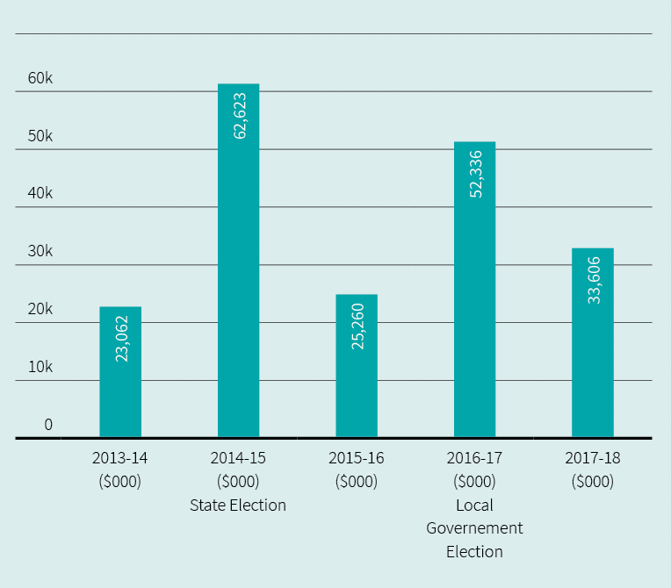

Funding
The VEC received $33.61 million in funding for 2017–18. The VEC is funded solely from Government Special Appropriations and this amount represents the reimbursement to the VEC for all its cash payments.

Expenditure
The VEC incurred $34.26 million in operational expenses from transactions for the reported financial period. The majority of VEC’s funding was committed towards enhancing the operational environment, conducting by-elections and commercial elections, and planning towards the November 2018 State election. Expenditure towards State election commitments include inventory such as ballot material, the appointment of additional staff to enhance workforce capability, improvements to VEC’s Election Management System (EMS) and other associated applications. Further, the VEC does not hold a cash reserve in its bank accounts, as it is reimbursed on a daily basis for all outgoings incurred.

Operational and budgetary objectives and performance against objectives
The VEC has a number of performance measures that relate specifically to Budget Paper Number 3 Service Delivery (BP3), in accordance with the Department of Treasury and Finance, Financial Reporting Directions (FRD). The following table (Figure 3) provides details of the output report provided by the VEC to the Government, including performance measures and targets for agreed outputs, and the actual performance results for the VEC over the full year ending 30 June 2018.

Financial position
The VEC’s financial position remains strong and stable, with total assets of $17.16 million, liabilities at $5.28 million and overall net equity of $11.88 million. The VEC’s assets largely comprise of the Election Management System (EMS) and election associated inventory and equipment. Towards year-end, additional inventory was acquired in preparation for the 2018 State election such as ballot paper material, accessories to support election offices and new logistical equipment. The EMS software system also underwent further enhancements in readiness for the upcoming 2018 State election. The system is custom-built to enable the VEC to conduct elections, and is recorded as an intangible asset.
The VEC’s liabilities largely comprise of employee entitlements and year-end expenditure accruals. The equity of the VEC is split into contributed capital, asset reserve and accumulated loss. The contributed capital represents the amount of funding contributed by the Government of Victoria for the purchase and development of VEC non-current assets. The accumulated loss represents the accumulated result from continuing its operations.
Figure 3: Performance against budgetary objectives, 2013-14 to 2017-18
 | STATE ELECTIONS, LOCAL GOVERNMENT AND STATUTORY ELECTIONS, BY-ELECTIONS, POLLS AND ELECTORAL REPRESENTATION REVIEWS | LEGAL CHALLENGES TO VEC CONDUCT UPHELD | CHANGES TO ELECTOR DETAILS OR ADDITIONS TO THE VICTORIAN ENROLMENT REGISTER PROCESSED WITHIN SET TIMEFRAMES
2013-14 BP3 Target | 24 | - | 98%
2013-14 BP3 Actual | 33 | - | 100%
Variance | 38%¹ | 0% | 2%²
2014-15 BP3 Target | 142 | - | 98%
2014-15 BP3 Actual | 135 | - | 97%
Variance | -5%³ | 0% | -1%⁴
2015-16 BP3 Target | 39 | - | 90%
2015-16 BP3 Actual | 40 | - | 92%
Variance | 3% | 0% | 2%
2016-17 BP3 Target | 99 | - | 95%
2016-17 BP3 Actual | 96 | - | 99%
Variance | -3%⁵ | 0% | 4%⁶
2017-18 BP3 Target | 32 | - | 95%
2017-18 BP3 Actual | 27 | - | 82%
Variance | -16%⁷ | 0% | -14%⁸
¹ The number of Local Government by-elections and countbacks was higher than anticipated. These electoral events are triggered when a sitting councillor resigns, passes away or (as happens on rare occasions) is removed from office. The nature of these triggers means that accurate estimates are impossible. The VEC develops its estimates based on historical data to help ensure adequate resource planning.
² Further streamlining of enrolment processes and procedures along with continuing implementation of direct enrolment legislation have contributed to a 100% performance result in this area. This objective will be reviewed in 2014-15.
³ Victorian Commission for Gambling and Liquor Regulation excluded Restaurant and Café Licence applications from the dry area category partway through FY2014-15, with the result that Liquor Licensing Polls will no longer be conducted by the VEC from that date.
⁴ Enrolment transactions received at voting centres and election offices during the State election were higher than was anticipated and planned for. Staff numbers were increased to meet anticipated needs, but as it transpired, not in sufficient numbers to manage the number of transactions within set time-frames. It was expected and observed that there would be fewer transactions received overall during the election than at the 2010 election due to the introduction of direct enrolment and an online enrolment facility, both introduced since the previous election.
⁵ The 2016–17 election events number is lower than the 2016–17 target due to the number of actual extraordinary vacancies in the Legislative Assembly and on local councils tracking lower than projected for the 2016–17 reporting year.
⁶ The 2016–17 full year actual is higher than the target due to a stronger focus on the highest value enrolment programs relating to the 2016 Local Government elections.
⁷ Less than anticipated number of local government vacancies to be filled by a countback. Additionally a reduction to the number of liquor licensing polls conducted.
⁸ The VEC's enrolment campaign schedules were extended early in the reporting year due to the sudden insolvency of the VEC's mail services contractor and the Australian Marriage Law Postal Survey. Enrolment turnaround times measured above 95% for key VEC electoral events.

Our strategic plan
Developed under the authority of the Electoral Commissioner, the VEC Strategic Plan 2013-14 to 2017-18 has shaped the day-to-day work of the VEC over the past five years, in pursuit of the VEC’s vision of all Victorians actively participating in their democracy.

A total of 27 strategic initiatives have now been successfully completed, significantly improving operational effectiveness and efficiency, and delivering a strong planning framework to ensure robust long and short-term plans.
This year the remaining five strategic initiatives were completed and have created a very strong foundation for the VEC’s future aspirations to be realised via ̒Strategy 2023ʼ.
FIGURE 4: VEC PLANNING DOCUMENTATION HIERARCHY
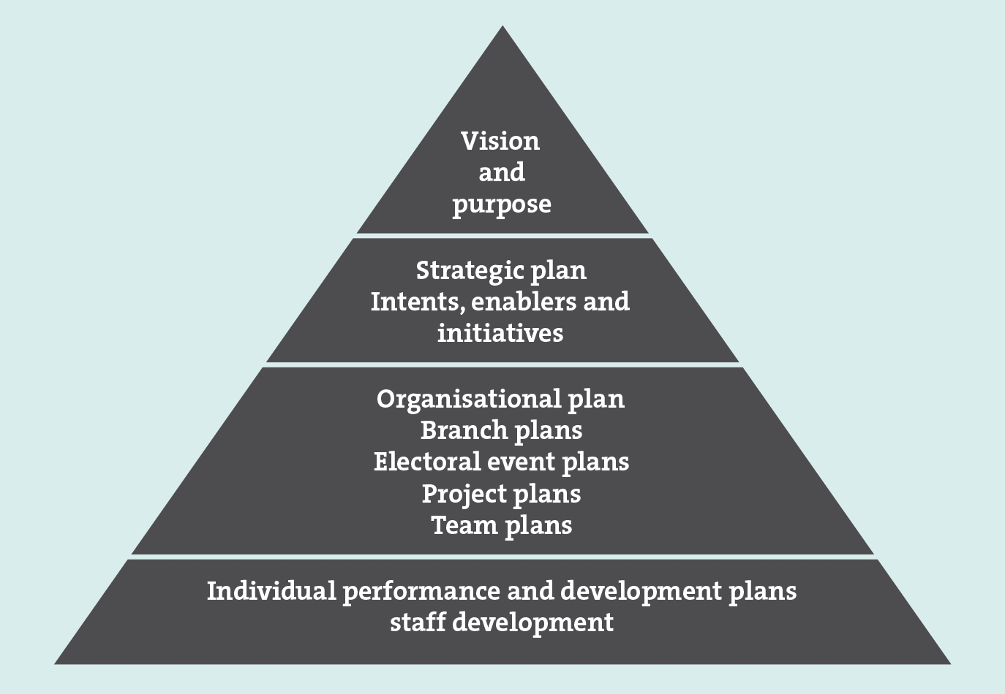

Figure 5: Snapshot of the VEC strategic plan with number of initiatives successfully completed, 2013–14 to 2017–18

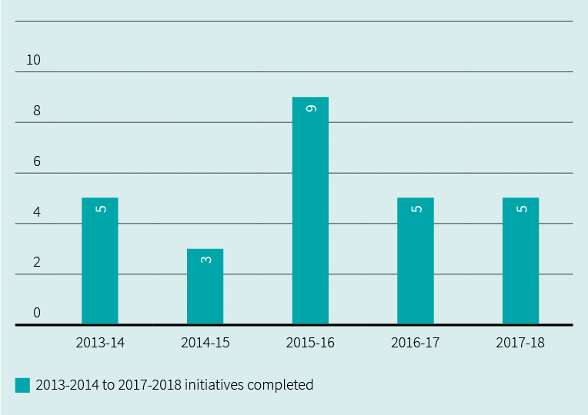

Our strategic initiatives

First strategic intent
The VEC will provide high quality and innovative opportunities for all Victorians to participate in the democratic process.

Legend for status of strategic intents
 Completed successfully and moved to business as usual

Strategic initiative |  | Enabler | Comprehensive Electoral Event Programs
 | Status | Strategic initiative | Success indicators
01 |  | Maintain an effective set of electoral event plans | - Electoral events delivered within legislative and organisational requirements  - VEC project management framework applied consistently in managing electoral events  Event plans are ready for immediate implementation as required
02 |  | Maintain and enhance support structures for electoral representation activities | - Electoral Boundaries Commission has the necessary information to make decisions  - Local Government Minister has the necessary information and recommendations to make decisions
03 |  | Review and improve enrolment programs | - Enrolment program targets achieved
04 |  | Review and improve enrolment system | - Enrolment transactions captured effectively  - Enrolment systems are elector-centric  - Successful security audit
05 |  | Identify enrolment and voting barriers and emerging trends | - Research conducted and utilised to inform service design and delivery
06 |  | Design and implement responsive electoral education and awareness programs | - Increased community awareness of electoral matters  - Electoral engagement program targets are met  - Enrolment, turnout and informality rates inform success
07 |  | Identify and engage key partners | - Partnerships contribute to the achievement of VEC objectives
08 |  | Establish robust and resilient partnering arrangements
09 |  | Identify, encourage and facilitate service and product improvements | - VEC services represent best practice  - VEC services respond to community requirements and expectations
10 |  | Identify and engage relevant stakeholders | - VEC stakeholder engagement objectives are met

Second strategic intent
The VEC will have transparent and accountable governance and business support systems that reinforce and sustain organisational capacity.

strategic initiative |  | Enabler | EFFECTIVE MANAGEMENT OF RESOURCES
 | Status | Strategic initiative | Success indicators
11 |  | Map, document and regularly review key organisational business processes | - VEC systems and processes are efficient and effective  - Consistent business methodologies are applied  - VEC internal and external reporting framework meets legislative and organisational requirements  - Project management and corporate reporting processes are consistent across the VEC  - Corporate knowledge is accessible  - Corporate data is maintained and accessed in accordance with legislative requirements
12 |  | Review business systems to ensure they support business processes
13 |  | Develop and implement a VEC Project Management Framework
14 |  | Develop and implement a VEC Corporate Reporting Framework
15 |  | Develop and implement an Information Management System
16 |  | Further develop the VEC’s Risk Management Framework | - Risk management is integrated into all business operations and managed in accordance with government requirements
17 |  | Develop and implement effective workforce and succession planning | - Staff levels are appropriate and flexible to needs  - Critical business roles are identified with succession plans in place
18 |  | Review and implement an effective business planning and budgeting process | - Activities are conducted on schedule and within budget  - Resource management targets are achieved
19 |  | Minimise the VEC’s environmental footprint | - Environmental management targets are achieved

Third strategic intent
The VEC will have a culture that fosters professional growth and development, ensures a safe, inclusive and engaging work environment and leads to high quality staff performance.

strategic initiative |  | Enabler | ROBUST PERFORMANCE MANAGEMENT AND  PROFESSIONAL DEVELOPMENT
 | Status | Strategic initiative | Success indicators
20 |  | Enhance staff performance and development | - Performance is recognised and acknowledged  - Succession is informed by performance and development  - All performance expectations are understood, agreed and monitored on a regular basis  - Staff skills are appropriate to organisational needs  - Performance and development is aligned with corporate planning  - Core competency training delivered to staff where there is an identified need  - Staff satisfaction targets are met
21 |  | Effectively engage staff in the Performance and Development Program
22 |  | Develop and implement targeted organisation-wide learning and development
23 |  | Build and foster an effective health & safety and wellbeing framework | - Compliance with OH&S and Equal Opportunity requirements  - Staff satisfaction targets are met  - Diversity is recognised, encouraged and respected
24 |  | Develop and implement a workplace diversity and inclusion strategy
25 |  | Create ways to share knowledge and experiences | - Key learnings from external programs are shared within the organisation  - New ways of sharing and storing information are identified and implemented  - Skill and knowledge capabilities are enhanced
26 |  | Identify opportunities for individuals to work across and within branches and across organisations to increase skills and knowledge
27 |  | Review current operating model and respond accordingly | - VEC operating model is fit for purpose

Progress report on initiatives 2017–18

STrATEGIC INITIATIVE | initiatives completed in 2017–18
 | Strategic initiative | Achievements for 2017-2018
9 | Identify, encourage and facilitate service and product improvements | - This initiative has delivered:  - Feedback on proposed legislative amendments  - Redevelopment of the VEC’s online submission and public modelling tool to contribute to electoral boundary review activities  - Introduction of a Project Governance Board to manage and prioritise strategic projects
12 | Review business systems to ensure they support business processes | - This initiative has delivered:  - Development of a new Information Technology Strategy, which documents the overarching strategy for investment in and use of technology at the VEC  - Further development of the VEC’s business system road map  - Enhancements to the VEC’s election management system and computer count application ahead of the 2018 State election  - Development of a new Funding and Disclosure system in support of anticipated legislative changes
24 | Develop and implement a workplace diversity and inclusion strategy | - This initiative has delivered:  - Development and implementation of the VEC Diversity and Inclusion Commitment Statement  - Development of the Cultural Competency Training strategy  - Development and launch of the Mental Health and Wellbeing Commitment, new Return to Work procedures and training for managers to assist with the support of staff experiencing mental health challenges
25  26 | Create ways to share and store information  Identify opportunities for individuals to work across and within branches and across organisations to increase skills and knowledge | - This initiative has delivered:  - Key learnings captured post formal training events  - Intranet prototype developed with anticipated roll-out scheduled in 2019  - Establishment of formal secondment program with all State Election roles published on an internal job board

Spotlight on...

Name
Guil Deng
Title
Enrolment Services Officer
Department
Electoral Enrolment Branch

What I like about my job
The Victorian Electoral Commission (VEC) is a great place to work because of all the lovely people that make the work environment so special!
I love my job because it gives me the opportunity to make a positive impact on the community. Many community members can gain a better understanding of and participate more effectively in our democracy.
I joined the VEC four years ago and I have enjoyed all the roles I have been assigned.
Starting as a community educator, I really enjoyed delivering electoral information sessions to the CALD community across Victoria, and I learned a lot through interaction with people from different cultures and backgrounds.
My role at Head Office reception helped me to acquire more skills and knowledge through helping Victorians interact with the VEC.
In March, I started a new role as an Enrolment Services Officer and I am learning one of the VEC’s core business processes of electoral enrolment.
I feel very lucky to be part of such a great team.

On the weekends
My wife and I enjoy watching our three children play basketball games on Saturdays - I’m the team manager for my son’s under 12 team.
On Sundays, I enjoy driving with my son to watch him play soccer. I’m a big soccer fan and cannot wait to see the world cup. I go for the Socceroos, France and Brazil - my favourite team Netherland ‘Oranje’ did not make it!
In the AFL, I support my children’s favourite team the Richmond ‘Tigers’.

Our commission

ACHIEVEMENTS 2017–18
- Unqualified report from the Victorian Auditor-General, evidencing effective management of financial resources
- All reports provided to relevant bodies on schedule and within budget
- Annual Report 2016-17 achieves Gold at the 2018 Australasian Reporting Awards
- Completed recruiting to the new Information Technology (IT) Branch structure, developed a revised IT strategy and delivered an ambitious system development pipeline
- Completed all Strategic Initiatives from the expiring strategic plan and released a new five-year strategic plan, ̒Strategy 2023ʼ
- Implemented changes to the Executive structure with the creation of a Corporate Services Group and an Electoral Functions Group, to distinguish between the support and service delivery arms of the VEC
- Delivered an Information Management policy framework and principles document
  - Delivered a transitional Funding and Disclosure Implementation program and commenced building a political donations disclosure system

OUTLOOK 2018–19
- Deliver the 2018 State election
- Implement a Business Continuity Framework for the 2018 State election
- Commence implementation of ‘Strategy 2023’
- Establishment of a Funding and Disclosure Unit to manage legislative responsibilities as enacted and deliver an operating political donations disclosure system
  - Develop and implement a VEC-wide monitoring and evaluation framework

Governance
The VEC is the administrative agency through which the Electoral Commissioner’s legislative obligations are exercised. The VEC is committed to ensuring that its policies and practices reflect good governance, as well as complying with all relevant legislation. Adherence to the VEC’s governance framework demonstrates accountability to stakeholders and ensures the vitality and impartiality of the electoral system, now and into the future. Staffing and work practices are determined by the Public Administration Act 2004 and guided by the Victorian Public Sector Commission.
The VEC is an independent agency operating under the auspices of the Department of Premier and Cabinet, within the portfolio of the Special Minister of State. The VEC is not subject to the direction or control of the Minister in respect to the performance of its responsibilities and functions, or the exercise of its powers.
The Secretary of the Department of Premier and Cabinet, Chris Eccles AO, is responsible for providing support to the Minister and Cabinet on matters relating to the VEC and is thanked for his assistance in conveying relevant information to Government. Figure 6 shows the governance and consultation structure of the VEC.
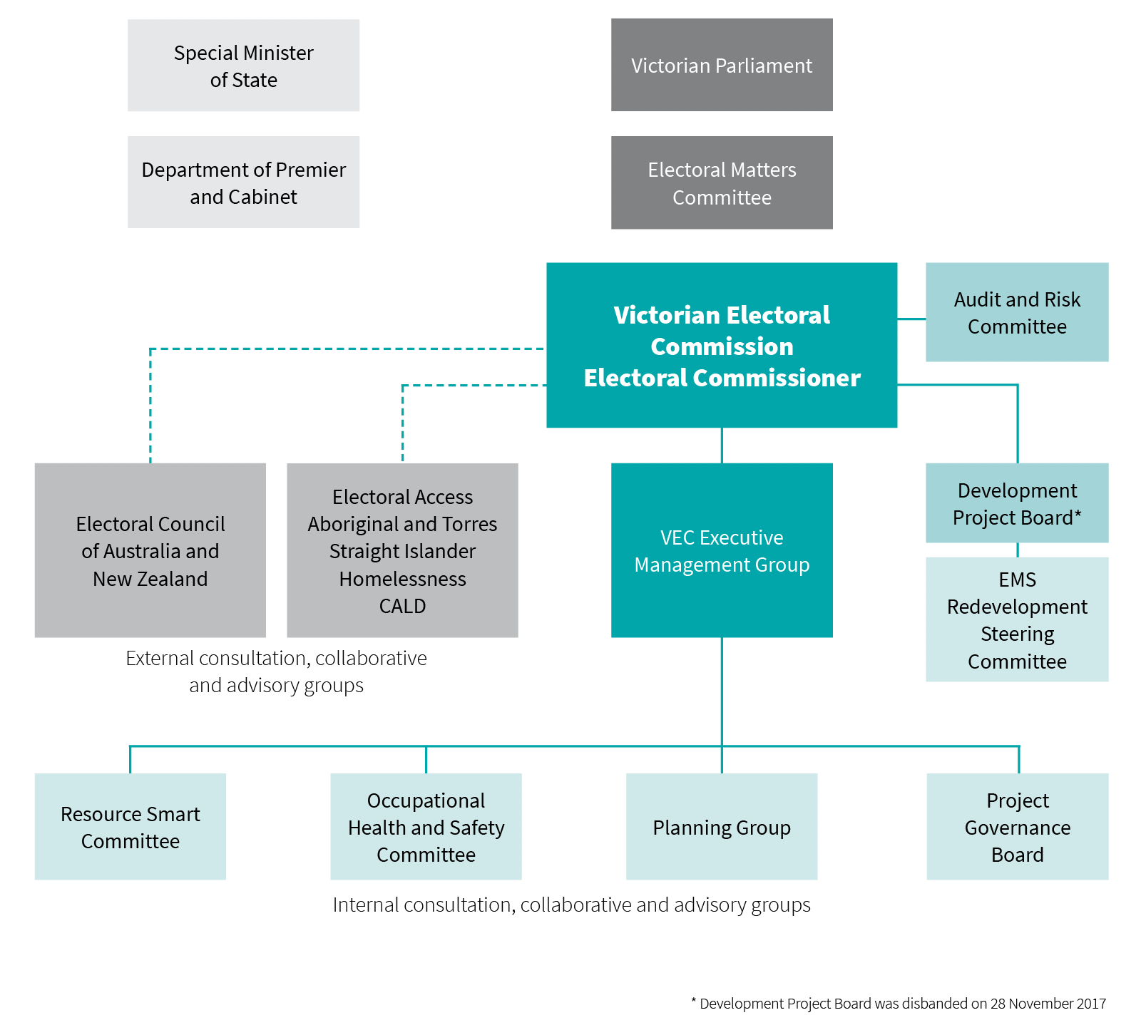
FIGURE 6: Governance and consultation structure of the VEC

Organisational structure
The VEC’s organisational structure reflects the main activity areas of the Commission (see Figure 7). The structure was amended with effect 1 December 2017, with the creation of a Corporate Services Group and an Electoral Functions Group. The purpose was to improve service delivery while creating staff depth and succession opportunities.
The VEC Executive Management Group works closely with the Electoral Commissioner, the Deputy Electoral Commissioner and the Executive Director, Corporate Services to develop and implement strategic and operational plans.
FIGURE 7: VEC ORGANISATIONAL STRUCTURE plans.
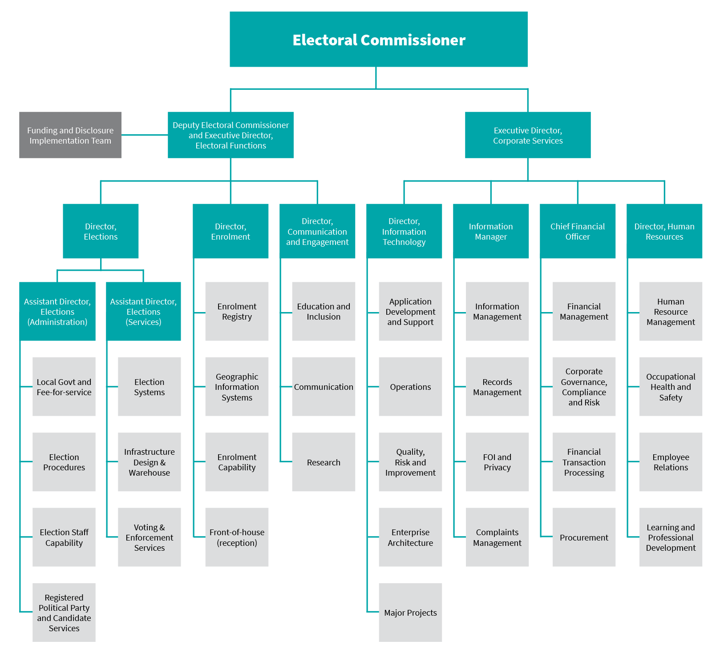

The Electoral Commissioner

Warwick Gately AM

Electoral Commissioner
The Electoral Commissioner is appointed by the Governor in Council for a period of 10 years, and is responsible for the administration of the enrolment process and the conduct of parliamentary elections and referendums in Victoria. Mr Warwick Gately AM was appointed as the Electoral Commissioner for Victoria on 29 April 2013.
Following an early career with the Royal Australian Navy, Warwick joined the Western Australian Electoral Commission as the Deputy Electoral Commissioner in 2003. He was appointed as the Electoral Commissioner for Western Australia in August 2006, and reappointed in 2009 for a further five-year term.
During this time, he was responsible for the conduct of the 2005, 2008 and 2013 State general elections and state-wide referendums on retail trading hours and daylight saving. He oversaw State electoral boundary reviews, and conducted local government elections every two years. Continuing his long-standing career in public service, now as Victorian Electoral Commissioner, Warwick is committed to the provision of effective electoral services to the Victorian community.
The Electoral Commissioner, assisted by the Deputy Electoral Commissioner, is the Chief Executive Officer of the Victorian Electoral Commission and remains responsible for all elements of the Commissionʼs performance and compliance.

Liz Williams

Deputy Electoral Commissioner / Executive Director, Electoral Functions
As Deputy Electoral Commissioner, Liz works closely with the Electoral Commissioner in the management and administration of the VEC. Liz also leads the VEC’s Electoral Functions Group which has responsibility for the delivery of elections, enrolment services and community engagement activities.
Liz has significant electoral experience gained in various roles since moving to the VEC in 1992 from a career in education. Liz was appointed Deputy Electoral Commissioner in 2005, and was reappointed for a further term in 2015. Liz was Acting Electoral Commissioner between May 2012 and April 2013, and was appointed Executive Director, Electoral Functions in 2017.
Liz believes in fostering a working environment that promotes learning and collaboration to drive innovation and excellence; and that efficient and inclusive electoral processes are integral to full democratic participation.

Máiréad Doyle

Executive Director, Corporate services
Máiréad joined the VEC in early 2018 as Executive Director Corporate Services, providing leadership and direction to the VEC’s Corporate Services Group, incorporating Human Resources, Finance, Information Technology and Information Management. Her overarching remit is to oversee and shape strategies, systems and policies to ensure the VEC’s ongoing ability to respond to current and future requirements.
A chartered engineer and Fellow of the Australian Institute of Managers & Leaders, Máiréad has over thirty yearsʼ experience in the private, public and not-for-profit sectors at executive level.
Máiréad comes to the VEC from the National Stroke Foundation where she served as Executive Director Corporate Services. Previously Máiréad held a number of senior roles at Australian Red Cross, focusing on domestic disaster response and operational resilience. She currently sits on the Australian Red Cross Victorian State Advisory Board and International Humanitarian Law Committee.
Máiréad is the recipient of the Governor-General’s National Emergency Medal, the Australian Red Cross Meritorious Service Award and the New Zealand Red Cross Emergency Management Medal for her work in disasters.

THE VEC Executive Management Group

Executive Management Group
The Executive Management Group (EMG) comprises the Electoral Commissioner, Deputy Electoral Commissioner, Executive Director, Corporate Services and the six Directors leading the main functional areas of the VEC.
Working cooperatively, the EMG sets the Commission’s direction and delivers the operational, financial, workforce and other plans that underpin the efficient and effective delivery of election services to all Victorians. This is assisted through the professional mastery and experience contributed by each member. At regular intervals, the EMG considers the risks, issues and opportunities facing the Commission including succession planning and knowledge transfer, along with staff and system performance and productivity matters and general compliance and reporting obligations. Staff well-being and development remains a high priority for the EMG.

Glenda Frazer

Director
Glenda commenced with the VEC in 1988 as an election manager, moving to a full-time position in 1995. Glenda has extensive knowledge of the conduct of elections with significant experience in the application of information technology to elections. She is responsible for the planning and delivery of all elections conducted by the VEC. Glenda believes that thorough planning and preparation enables voters to experience trouble-free elections. Glenda and her team are focused on the efficient and effective delivery of election services.
Glenda is supported by two Assistant Directors, the Assistant Director, Elections (Administration) and the Assistant Director, Elections (Services).

Elections Branch
The Elections Branch is responsible for overseeing the planning and conduct of State, local government and fee-for-service elections and key responsibilities include:
- election service agreements with Victoria’s local councils, and contracts with statutory and fee-for-service clients
- development and maintenance of election procedures
- large-scale recruitment, training and support programs for the VEC’s temporary workforce of around 25,000 election appointees
- services to candidates including political party registration
- design, preparation, printing and distribution of election material
- operation of large scale centralised operations for postal voting and computerised counts
- development and support of election systems
- establishment of election offices and voting centres
- management of the VEC warehouse
  - compulsory voting enforcement

Keegan Bartlett

Director
Keegan joined the VEC as a policy officer in 2010. Keegan became the Director of the Electoral Enrolment Branch in January 2017, after nearly six years managing the VEC’s local government and fee-for-service election programs, including the 2012 and 2016 Local Government elections.
Before moving to Australia in 2010, Keegan worked for central and local government in New Zealand where his roles focused on building and implementing initiatives that promoted inclusive and accountable decision-making through good governance, democratic participation and effective stakeholder management. In addition to his role as Director, Keegan is also the Electoral Registrar, with responsibility for the preparation, maintenance and review of the Register of Electors and State and local council electoral rolls.

Electoral Enrolment Branch
The Electoral Enrolment Branch is responsible for maintaining an up-to-date and accurate Register of Electors. The Electoral Enrolment Branch services include:
- implementation of electoral enrolment programs
- conduct of electoral representation reviews for councils and support for electoral boundary work by the Electoral Boundaries Commission
- production of electoral rolls, other roll products and mapping data
  - provision of advice on electoral enrolment matters.
The principle underpinning the VEC’s enrolment programs is ensuring the integrity and quality of the Register of Electors. The Branch is also involved in managing electoral representation reviews and supporting the work of the Electoral Boundaries Commission. The Electoral Enrolment Branch employs a variety of administrative, technological and geo-spatial experts whose knowledge and skills help ensure that Victorian voters have fair and equitable representation.

Sue Lang

Director
Sue joined the VEC in 2006 after spending much of her career in senior communication roles within the metropolitan water industry, local government, statutory authorities and State government. She has particular experience in major public awareness and stakeholder engagement programs. With her team, she aims to effectively communicate electoral information and education, across all media platforms, to the many diverse groups throughout Victoria.

Communication and Engagement Branch
The Communication and Engagement Branch comprises three distinct teams and provides a number of communication and education services, including the:
- provision of internal communication services for the VEC
- development and implementation of major public awareness campaigns for electoral events across traditional and digital channels
- development of stakeholder engagement programs relating to electoral participation and inclusion
- provision of electoral education and outreach services
- provision of advice on electoral legislation, electoral structures and strategic matters and
  - provision of research services and information.

Jonathan Underwood

Director
Jonathan is a business-focused information technology leader, with a demonstrated track record in partnering with stakeholders to deliver robust, high performing IT solutions.
Since commencing with the VEC in late 2017, Jonathan has developed an IT strategy and roadmap that will deliver an information technology environment supporting cloud computing, application rationalisation, integration, a digital workplace, information management and cyber security. Based on this foundation, he has initiated a program of transformation and service improvement to enable the VEC for the future.
While a technologist, Jonathan is ultimately a people leader and gets his energy and drive from working with people to solve problems and deliver high quality results in complex situations. He believes integrity, professionalism and accountability are vital in the successful delivery of information technology.

Information Technology Branch
The Information Technology Branch supports the VEC’s business systems and networks, ensuring a secure and robust technology environment; delivering infrastructure and integrated applications for everyday VEC activities as well as critical events such as State Elections. IT comprises:
- Operations team - maintaining security of the network; delivering enterprise systems; enabling mobile services and encompassing innovation in infrastructure and cloud computing.
  - Application Development team - transforming services and enabling high quality outcomes by modernising and consolidating applications while delivering continuous improvement.

Binh Le

Chief Financial Officer
Binh joined the VEC in November 2016 and brings a wealth of experience in finance, governance and corporate management. As a key member of the Executive Management Group, he provides strategic leadership and advice on financial and corporate matters.
For the past 13 years, Binh has held a number of senior financial positions, namely as the Group Business Manager in the Agriculture, Energy and Resources portfolio in the Victorian Government; Senior Finance Manager for the National Transport Commission; and Financial Controller for the online travel agent Webjet.

Finance Branch
The Finance Branch ensures the VEC has an effective financial management and governance environment, including:
- governance and compliance, procurement and risk
- financial management structures, systems, policies and procedures
- financial planning, budgeting and reporting and
  - financial transactions processing.

Bernadette Lamaro

Director
Bernadette joined the VEC in 2013 having established her career in the private sector, working predominantly in global consulting organisations as a human resources professional.
Bernadette has extensive experience as an HR leader with a focus on delivering people and culture strategies in alignment with organisational priorities and strategic plans. A career human resource professional, Bernadette has specialised in several HR disciplines including learning and professional development, workforce management, talent acquisition and remuneration and benefits, with roles incorporating project management, learning facilitation, consulting, people management and program leadership.

Human Resources
The Human Resources team is focused on the ongoing review of current work place practices and policies, assessing and evaluating the impact of existing programs and identifying opportunities for improvement with regard to integrated solutions for improving organisational effectiveness and employee engagement.

Internal committees and groups
A number of consultation committees and groups assist the Electoral Commissioner and the Executive Management Group with the development and implementation of strategies and policies, providing expertise and promoting staff consultation.

EMS Redevelopment Steering Committee
Internal oversight and governance for the VEC’s Election Management System (EMS) redevelopment program and EMS enhancement projects are provided by the EMS Redevelopment Steering Committee. The Committee meets monthly to ensure correct project controls are being applied to EMS redevelopment and enhancement projects – along with providing oversight of schedule, budget and risk. Committee members include the Directors of Election Services and Information Technology, the Chief Financial Officer, the lead Program Architect, the IT Program Manager and the Assistant Director Elections (Services). The Committee was chaired by the Deputy Electoral Commissioner until November 2017, with the Director, Elections assuming the chair from December 2017.
During 2017–18, the Committee was focused on ensuring the successful delivery of EMS functionality required for the 2018 State election, including:
- the development of software to support the preparation of ballot papers
- enhancements to the VEC’s online facility for candidates
- enhancements for the upload and management of how-to-vote cards
- redevelopment of the module supporting the registration of political parties
- redevelopment of the computerised counting application and enhancements to results data capture
- enhancements to enable more transparent reporting of integrity measures
  - continuing work on enterprise architecture and security.
A further and significant project was the more detailed scoping of remaining EMS2 functionality to complete the EMS2 redevelopment program. This work has allowed greater visibility of the remaining effort required for this program, enabling more effective resource planning for other development priorities.
In 2017–18, the EMS Redevelopment Steering Committee focused on EMS functionality to support the Greater Geelong City Council elections in October 2017, the 2018 State election and other VEC functions.

Project Governance Board
The VEC’s Project Governance Board (PGB) meets quarterly and functions as a decision‑making committee responsible for the assessment and ongoing oversight of major VEC projects. The PGB assesses, prioritises and monitors the execution of all major projects to ensure alignment with the VEC’s core responsibilities and strategic direction.

Planning Group
The Planning Group is the VEC’s major cross-organisational work group that tracks and monitors the preparation and implementation of electoral events. The group is comprised of a changing complement of key managers from across the organisation, and is responsible for fostering inter-agency co-operation and reporting on event preparation and projects.
This year, Planning Group has focused on preparation for the delivery of the November 2018 State election. A new delivery model made up of 11 program groups, each led by a program lead and overall program sponsor will ensure coordination across all projects and their deliverables. The new delivery model will be assessed at the conclusion of the election.
During the year, Planning Group was also focused on the delivery of the by-election for the Northcote District, the City of Greater Geelong General elections and the Melbourne City Council Lord Mayor by-election, as well as a number of other by-elections and polls.

Occupational Health and Safety Committee
The Occupational Health and Safety Committee (OHSC) is a forum that facilitates cooperation and communication between the VEC’s Executive Management Group (EMG) and employees. Issues considered by the OHSC include those that are likely to affect the health, safety and welfare of VEC workplaces in accordance with the requirements of the Occupational Health and Safety Act 2004.
In 2017-18, the OHSC continued to monitor the VEC OHS Management System (OHSMS) functions and the delivery of health and wellbeing program activities. Six OHSC meetings were held over the year which attended to various matters, including major reviews of the hazard risk register, regular reviews of the safety action plans, identifying and implementing process improvements, and contributing to activities such as OHS Month. Health and Safety Representatives continued with quarterly inspections and incident and hazard reviews.
The OHSC supported a significant program of work to internally audit the five key areas that were identified in the OHS performance survey. These focus areas were managing grievances or interpersonal conflict, mental health, ergonomics, managing fatigue, and health and fitness. The audits involved investigation of the OHS risk, current practice, and recommendations to the EMG to action. Three of the five audits have been completed and the final two, managing fatigue and health and fitness, will be completed in early 2018-19. The OHSC will continue to monitor the progress of the implementation of the recommendations.

Resource Smart Committee

Environmental sustainability report

Ten years of Smart Resourcing
The VEC’s Resource Smart Committee (RSC) completed a decade of service in 2018 and continued in its role of exploring and overseeing environmental efficiency gains, reducing resource consumption, and making improvements in waste management.
During the year, RSC members published and delivered on a calendar of events aimed at keeping sustainable thinking in mind. RSC branded emails were used to promote ideas across the organisation, and this was supported with regular short presentations at staff meetings.

Highlights 2017-18:
- campaign to raise awareness and funds in support of World Water Aid - 'Pay To Pee'
- significant power usage (and cost) reduction at the VEC warehouse by the installation of industrial grade LED lights throughout
- promotion and distribution of re-usable coffee cups and mugs as a response to the prominent ABC TV series ‘War on Waste’
- promotion of a no plastic bags in the workplace policy, in line with the government announced Victoria-wide ban on single-use plastic bags
  - conduct of a well-supported terrarium workshop; a smaller ‘human scaleʼ activity to promote sustainable gift giving.
In addition, the RSC worked cooperatively with the 530 Collins Street building management to support its launch of improved recycling with the satellite bin system designed to reduce waste contamination with stronger demarcation of landfill, co-mingle, organic and paper waste receptacles.
Overall, the VEC head office recorded a recycling rate of 90% in an office audit conducted in August 2017 – some 30% above the overall performance of the entire building.

Baseline Report
This year, the RSC commissioned and received the VEC Sustainability Baseline Report in order to further improve understanding of the VEC’s environmental performance. The report, made in conjunction with Citizen Consulting, was delivered in April 2018. It contained an impressive level of detail regarding the organisation’s environmental footprint, and included items such as staff travel distances, transport modes and times. The report will provide a solid base on which to develop new, achievable, measurable targets that will be incorporated into the VEC Sustainability Strategy.

Day-to-day work practices
As ever, the RSC continued to look for and monitor efficiencies in day-to-day work practices such as:
- automatic sleep mode for office computers during non-work hours
- energy saving lights (installed on the Head Office additional floor space at 530 Collins St, Melbourne)
  - maintenance and improvements in the efficiency of head office paper, plastics and organic waste recycling.

What next?
For the remainder of 2018, the Resource Smart team will be working on the new VEC Sustainability Strategy to replace the previous environmental management plan. The strategy will be developed by the Resource Smart team in conjunction with Citizen Consulting and be in line with the VEC’s corporate strategy.
As the 2018 State election approaches, the focus will be on ensuring sustainability is considered in all aspects of the roll-out and conduct of the election.

External Advisory Groups

The VEC is fortunate to have a number of advisory groups, which provide advice and insight into community issues, which may impact electors’ ability to participate in elections.

The VEC has three active community advisory groups: The Electoral Access Advisory Group (EEAG), Culturally and Linguistically Diverse (CALD) Advisory Group and Homelessness Advisory group. All groups met twice during 2017-18. Members have had an opportunity to provide feedback on the 2018 State election plan and many members attended workshops to develop an initial theory of change for the Be Heard! Democracy Ambassador project.

Annual advisory group surveys
The VEC surveys all advisory group members bi-annually to ensure that their views of the effectiveness of their involvement and any suggestions for improvement are taken into account.

Electoral Access Advisory Group
This group is comprised of representatives of disability support agencies and people living with a disability.
Members of the group were consulted on a staff resource called Understanding Access and Inclusion and the Voters Voice app.
Members also received reports on the progress of:
- the VEC’s Disability Action Plan
- Voters Voice app
- research project with La Trobe University looking at the strategies to support people with intellectual disability to vote
- electoral outreach and sector networking activity.

Homelessness Advisory Group
This group is comprised of practitioners from the homelessness sector, peer support workers and people experiencing homelessness.
Members of the group provided advice on outreach materials, sector networking and best practice approaches to engaging with people experiencing homelessness.

Aboriginal and Torres Strait Islander Advisory group
The VEC’s Aboriginal and Torres Strait Islander Advisory Group has not met this year. The VEC is currently exploring culturally appropriate ways to consult with Aboriginal and Torres Strait Islander communities.

Culturally and Linguistically Diverse Advisory Group
This group is comprised of representatives from multicultural organisations across the community and government sectors.

Members of the group provided expert advice on key projects such as the Talking Democracy teacher’s kit and a youth leadership partnership project with the Centre for Multicultural Youth.

Photos from the High Tea at Parliament House in celebration and gratitude of the members of the VEC Advisory Committees.

Case study

Cald youth leadership project
The VEC partnered with the Centre for Multicultural Youth (CMY) to deliver a two-phase CALD Youth Leadership active citizenship project to culturally diverse young people aged 18 – 25 years old. The ultimate aim is to have a team of young multicultural people who are active, engaged and passionate and want to make a positive change for their peers and community by being a part of the VEC Democracy Ambassador program, encouraging their communities to vote and working for the VEC leading up to and during the November 2018 State election.
For young people, active citizenship can mean many things. Essentially, at the heart of active citizenship is people and their communities as reflected in the following quotes:
’Active citizenship means making a difference in our community and the world as a whole’.
’Being compassionate, respect the rights of others, and an openness to diversity’.
’Paying attention to what’s happening in the community’.

Governing legislation and tribunals
The three pieces of legislation that set out the VEC’s primary responsibilities are the Constitution Act 1975, the Electoral Act 2002 and the Local Government Act 1989.

In accordance with this legislation, the VEC conducts State and local government elections and by-elections, and certain statutory and fee-for-service elections. The VEC also provides advice to the Special Minister of State and Parliament on electoral issues. Other legislation and regulations imposing certain duties on the Electoral Commissioner are listed in Appendix B.

Legislative and regulatory amendments
The Electoral Legislation Amendment Bill 2018 was under consideration by the Legislative Council as at 30 June 2018. The Bill introduces a comprehensive system of financial disclosure and public funding. The system restricts the level of political donations, provides for prompt disclosure of donations, and extends public funding of registered political parties and independent members of Parliament. Other proposed amendments to the Electoral Act 2002 include:
- aligning enrolment provisions with those of the Commonwealth
- allowing early voting as of right, replacing its restriction to electors who would be unable to reach a voting centre on election day
- introducing online applications for postal votes
- ending the distribution of postal vote applications containing political party messaging, while requiring the VEC to provide details of applicants to registered political parties and Independent candidates
- placing a deadline on applications to register a political party, while providing for registration of party logos
  - restricting political signage around voting centres.
The Local Government Bill 2018 was under consideration by the Legislative Council as at 30 June 2018. The Bill will completely replace the Local Government Act 1989. Key electoral provisions in the Bill are:
- restriction of the range of allowable electoral structures for councils
- replacement of the current system of regular independent electoral representation reviews of councils with Minister-appointed electoral representation advisory panels
- a consistent election method for all councils
- a centralised and faster system for disclosure of donations to candidates
- disputes over election results to be heard by the Victorian Civil and Administrative Tribunal instead of the Municipal Electoral Tribunal
  - a change to the system of countbacks to fill vacancies on councils.

Cases arising from 2016 Local Government elections
Section 45 of the Local Government Act 1989 (LG Act) provides for a candidate, a group of ten voters, or the Returning Officer at a local government election who dispute the validity of the election, to apply for an inquiry into the election by a Municipal Electoral Tribunal (MET). In two cases arising from the 2016 Local Government elections, the MET upheld the application and voided the election result.
Section 48(2) of the LG Act allows a person whose interests are affected by a MET decision to apply to the Victorian Civil and Administrative Tribunal (VCAT) for a review of that decision. The VEC considered that the MET had misinterpreted the provisions of the Act in the two cases mentioned above, and applied to VCAT for review. In one case (relating to the Manningham City Council election), VCAT overturned the MET’s decision. In the other case (relating to the Moonee Valley City Council election), VCAT upheld the MET’s decision. The VEC then applied to the Supreme Court for permission to appeal VCAT’s decision. On 21 December 2017, Mr Justice Garde of the Supreme Court overturned the VCAT decision, restoring the original result of the election.
The outcome of these cases has clarified the qualifications of candidates and the grounds on which election results can be challenged.

Accountability and transparency
The VEC has legislative and organisational processes in place to ensure transparency and accountability to the Victorian public. These processes include internal and external auditing, regular reporting to stakeholders including Parliament, Government and the public, and tabling of audited financial statements as part of this report.

Financial Management Compliance Framework
The Financial Management Compliance Framework (FMCF) provides the Minister for Finance an assurance that Victorian Government entities have implemented the appropriate systems to ensure compliance with the Framework. The Framework provides for effective, efficient and responsible financial management of public resources.
The directions cover:
- financial code of conduct, financial governance including the establishment of an Audit and Risk Committee, financial risk management, delegations, and internal and external audits
- financial management structure, systems, policies and procedures – which includes role and responsibilities of the financial management team and identified Key Management Personnel (KMPs), policies and procedures, managing outsourced services, information technology management, operations, development and change, education and training
  - financial management reporting – which includes internal and external reporting, reporting requirements for Financial Statements and Report of Operations in accordance with new FMCF Standing Directions, performance management and evaluation, financial management compliance obligations, tax compliance, purchasing cards and thefts and losses compliance.A further and significant project was the more detailed scoping of remaining EMS2 functionality to complete the EMS2 redevelopment program. This work has allowed greater visibility of the remaining effort required for this program, enabling more effective resource planning for other development priorities.
The VEC’s compliance with FMCF Standing Directions is audited by the internal auditor annually, and is reviewed and endorsed by the Audit and Risk Committee. The 2017-18 internal review reported the VEC’s overall compliance with the framework as reported in the annual attestation.

Audit and Risk Committee
The VEC has an established Audit and Risk Committee to assist and advise the Electoral Commissioner in meeting obligations around financial compliance and reporting, and in the management of risk. The Committee consists of the following members:
- David Nairn, Chairman (independent member)
- Carol Pagnon (independent member)
  - Michael Ulbrick (independent member)
The main responsibilities of the Committee are to monitor and oversee the:
- financial performance and the financial reporting process, including the annual financial statements
- scope of work, performance and independence of internal audit
- engagement and management of the internal audit contractor
- scope of work, independence and performance of the external auditor
- operation and implementation of the risk management framework
- matters of accountability and internal control affecting the operations of the VEC
- effectiveness of management information systems and other systems of internal control
- VEC’s process for monitoring compliance with laws and regulations and its own code of conduct and code of financial practice
  - VEC's compliance with FMCF Standing Directions
The Committee met on four occasions during the year and provided positive support and guidance to the Electoral Commissioner in meeting its oversight role.

Identifying and managing risk
The State Government’s Risk Management Framework provides for a minimum risk management standard across public sector entities. As the Accountable Officer, the Electoral Commissioner is responsible for the development and implementation of the risk management framework and processes, to ensure that risks are managed in a consistent manner across the organisation.
Risk management is embedded into the VECʼs operations, including regular workshops and assessments to identify and monitor organisational risks, evaluating risk controls in place and developing new controls where required. The Audit and Risk Committee plays an oversight role to the risk framework.
Risks are profiled and rated according to their potential hazard across operational and non-operational activities. Risk ratings are presented to the Audit and Risk Committee in accordance with its charter. In an independent capacity, the Committee determines whether risks are adequately scoped and if sufficient controls are in place to mitigate and manage risks.
At an operational level, the VEC has comprehensive risk management plans for all electoral events and major projects. These are developed, discussed and analysed at branch level and at election planning groups during the planning phase, covering areas such as election management, infrastructure, communication, recruitment and information technology.

Development Project Board
The Development Project Board (DPB) was established to oversee and provide advice to the VEC’s EMS Redevelopment Steering Committee in relation to the VEC’s EMS redevelopment program of works. The DPB ensured that correct program controls were being applied and reported progress to external government stakeholders and the VEC’s Audit and Risk Committee through the Electoral Commissioner. Given the status of the redevelopment program, with 80% of work complete and within budget, the decision was taken by the DPB to transfer oversight responsibility to the VEC’s internal Project Governance Board for direct reporting to the Audit and Risk Committee. The remaining works associated with the redevelopment will complete in 2019-20 under this arrangement.
The DPB met on two occasions in late 2017 before taking the decision on 28 November 2017 to disband. The following people constituted the DPB during 2017:
- Warwick Gately AM, Electoral Commissioner – Chair
- David Fahey (independent member).
- In addition, the following provided ex-officio support to the DPB:
- Liz Williams, Deputy Electoral Commissioner
  - Jonathan Underwood, VEC IT Director – Secretary.

Corporate planning
Developed under the authority of the Electoral Commissioner, the VEC Strategic Plan 2013-14 to 2017-18 has shaped the day-to-day work of the VEC over the past five years, in pursuit of the VEC’s vision of all Victorians actively participating in their democracy.
A total of 27 strategic initiatives have been successfully completed, significantly improving operational effectiveness and efficiency, and delivering a strong planning framework to ensure robust long and short-term plans. In 2017-18, implementation of the remaining initiatives in the Plan was completed. See page 12 for an overview of the VEC’s yearly achievements against the Plan.
A new plan, ‘Strategy 2023ʼ, will take effect from July 2018. Strategy 2023 will build on the foundations set by the current Plan, ensuring the Commission is ready to effectively respond to, and leverage opportunities arising from, an ever-changing environment.

Corporate reporting
The VEC has a comprehensive program of stakeholder reporting that supports its goals of accountability and transparency. Internal reporting is aligned with lines of authority and cross-organisational channels to meet organisational needs.
External reporting is based on legislative and governance obligations, transparency objectives and commitments to stakeholders. The standard of reporting is high. For example, last year’s Annual Report fully complied with Department of Treasury and Finance model report requirements and also achieved a gold award at the 2018 Australasian Reporting Awards.
During 2017-18, the VEC tabled three reports before Parliament: Victorian Electoral Commission Annual Report 2016-17; Victorian Electoral Commission Report on the Northcote District By-election held on 18 November 2017; and the Victorian Electoral Commission Report on the Greater Geelong City Council general election 2017.
Other reporting obligations include:
- the provision of a quarterly report to the Department of Premier and Cabinet in relation to budgetary objectives
- monthly financial reporting and cash flow forecasting to the Department of Treasury and Finance
- twice-yearly reporting to the Attorney-General on infringements activity
- whole of government multicultural affairs reporting
- advertising campaign reporting
  - reporting for the Electoral Boundaries Commission (EBC) for whom the VEC provides secretarial services. The VEC also prepares an annual report for the EBC. This report can be found at Appendix G of this Report.
All reports were delivered on schedule and within budget, where applicable. Annual reports and other reports and publications are available on the Victorian Electoral Commission website (vec.vic.gov.au) and from the VEC.

Internal audit
The VEC conducted a tender and appointed Protiviti as the internal audit service provider. The appointment was made in September 2017. The internal audit program’s function is to provide an independent, objective assurance to improve the VECʼs operations. The rolling four-year internal audit strategy and program is designed to be comprehensive and to enable effective and regular review of all operational, financial and related activities.
Part of the annual program includes annual attestations and certification reviews such as Risk and Fraud Certification and the VECʼs compliance with Memorandums of Understandings (MOUs) entered into with other agencies. The VECʼs internal audit program is designed in consultation with the Audit and Risk Committee and the VECʼs Executive Management Group.

Customer Service Charter
As an annual activity, the VEC’s Customer Service Charter was reviewed to ensure that it complied with best practice and was relevant to VEC operations. The Charter is available on the VEC’s website.

Complaints
The VEC handles complaints in three main areas:
- complaints alleging a breach of the Electoral Act 2002
- (the Act)
- complaints alleging a breach of the Local Government Act 1989 (LG Act)
  - complaints about a process, performance or service related to an interaction with the VEC.
As the VEC does not have authority to follow up allegations of a breach of the LG Act, these complaints are forwarded to and handled by the Local Government Inspectorate (LGI) in accordance with an established protocol.
The VEC received 47 written complaints during 2017-18. Of these complaints, 42 related to an election event. There were no complaints related to information privacy or the release of information under the Freedom of Information legislation.
Two subjects were topical: voting entitlements and obligations and use of enrolment information.
Electors were educated on the unique voting entitlements and compulsory voting obligations in relation to the 2018 Melbourne City Council Lord Mayor by-election.
The VEC regularly reminded electors who suspected their privacy was breached, that the VEC has obligations under the legislation to provide candidates, political parties and Members of Parliament with electoral rolls for purposes including campaigning. For more information about who receives enrolment information, refer ‘Privacy at the Victorian Electoral Commission’ on the VEC website.
All complaints were dealt with in accordance with VEC procedures and were resolved by providing an explanation, follow-up and responsive action where required. The VEC aims to respond to complaints within five working days for straight forward complaints and this was achieved.

Disclosures

Additional information available on request
Information relating to the 2017-18 reporting period is made available to Ministers, Members of Parliament and the public on request (subject to the Freedom of Information Act 1982) and is listed in Appendix C on page 125.

Advertising disclosure
Financial Reporting Direction 22D issued by the Australian Accounting Standards Board requires Victorian Government agencies to disclose advertising expenditure on campaigns with a media spend of $150,000 or greater. No reportable advertising expenditure occurred during 2017-18.

Attestation to public sector standards Commissioner
The Electoral Commissioner completed an annual attestation of hospitality and gifts as required.

Building Act 1993
The VEC does not own or control any Government buildings and consequently is exempt from notifying compliance with the building and maintenance provisions of the Building Act 1993.

FIGURE 8: CONSULTANCIES VALUED AT $10,000 OR GREATER
Consultant | Purpose of Consultancy | Total  approved  Project Fee  (ex Gst) | EXPENDITURE  2017/18  (ex gst) | Fixture  EXPENDITURE  (ex gst)
BMS Advisory Group | Tender management of the Telephone Enquiry Service for the 2018 State Election | 26,600 | 26,600 | -
Briarbird & Co Pty Ltd | Website transformation and Content Management Systems discovery | 26,600 | 26,600 | -
Clear Horizon Consulting Pty Ltd | Strategic planning and performance measures | 59,288 | 59,288 | -
K&L Gates | Employment advice | 16,000 | 16,000 | -
Oakton Services | Intranet strategy and design | 188,200 | 168,050 | 20,150
Pitcher Partners | Probity services | 59,579 | 54,632 | 4,947
Social Ventures Australia Limited | Outcomes management framework and evaluation | 44,298 | 33,023 | 11,275
Terra Firma | Business Continuity Planning services | 70,900 | 48,000 | 22,900
The Social Research Centre | Non-voter research project | 109,025 | 109,025 | -

Consultancies and contracts

Major contracts
In accordance with the requirements of Financial Reporting Directive 12A, the VEC discloses all contracts greater than $10 million in value which it entered into during the year ended 30 June 2018.
No contracts greater than $10 million in value were entered into by the VEC during 2017-18.

Consultancy expenditure

Details of consultancies under $10,000
In 2017-18, there were 8 consultancies engaged during the year, where the total fees payable to the individual consultants was less than $10,000. The total expenditure incurred during 2017–18 in relation to these consultancies was $39,254 (excluding GST).

Details of consultancies (valued $10,000 or greater)
In 2017-18, there were 9 consultancies where the total fees payable to the consultants were $10,000 or greater. The total expenditure incurred during 2017-18 in relation to these consultancies was $541,218 (excluding GST). See Figure 8.

Disability Act 2006
The Disability Act 2006 requires that all public sector bodies prepare a disability action plan and that departments report on the implementation of their disability action plan in their annual report.
The VEC’s Electoral Access Advisory Group (EAAG) were provided with a report on the VEC’s performance against every action item due for attention in 2017-18.

Disclosure index
The Annual Report of the VEC is prepared in accordance with all relevant Victorian legislation and pronouncements. A disclosure index has been prepared to facilitate identification of the VEC’s compliance with statutory disclosure requirements. The disclosure index is included as Appendix A on page 122.

Employment and conduct principles
The VEC maintains and implements a suite of policies and guidelines with respect to upholding public sector conduct, managing and valuing diversity, employment, managing underperformance, reviewing personal grievances, and selecting on merit.

Environmental performance
The VEC has continued its commitment to reducing the negative impact of its operations on the environment, with ongoing communication and information programs to encourage continued positive behavioural changes.
The VEC Environmental Sustainability Report for 2017-18 is included in ‘Our Commission’ on page 28.

Executive officer disclosures
The Electoral Commissioner and Deputy Electoral Commissioner are appointed by the Governor in Council as statutory office holders. These appointments do not fall within the definition of Executive Officer under the Public Administration Act 2004.

Freedom of information
The Freedom of Information Act 1982 (FOI Act) gives the community the right to access information in the possession of the VEC. Of the two requests received by the VEC under FOI legislation, one was satisfied outside of the process, the other is being processed.
For information about how to lodge an application under the FOI Act, see the VEC website or Appendix E on page 126.

Grants and transfer payments (other than contributions by owners)
Included in the ‘Total expenses from transactions’ on page 9 are payments of grants and assistance to certain companies and organisations. During 2017-18, the VEC provided grants totalling $203,838 to seven organisations (see Figure 9 on page 37).

Gifts, benefits and hospitality register
The Victorian Public Sector Commission issued updated standards for Victorian public sector employees on the giving and receiving of gifts, benefits and hospitality, effective 12 December 2016. To reflect these changes, the VEC now publishes its Gifts, Benefits and Hospitality Register on a quarterly basis and these reports are available on the VEC website.

Occupational health and safety management
The goal of the VEC’s Occupational Health and Safety (OHS) strategy is to ensure all staff remain safe and healthy at work. An OHS management system is in place and branches within the VEC have implemented OHS local action plans aimed at enhancing safety performance and ensuring safe systems of work. In 2017-18, there were no lost days arising from injuries. For more on human resource management at the VEC, including performance against OHS management measures, see the Our People section of this report (see page 76).

Information and records management
The VEC has responsibility for managing information in accordance with standards issued by the Public Records Office of Victoria and the Victorian Information Commissioner. The types of information managed by the VEC are detailed in the VEC Information Asset Register.
The VEC adopted a new Retention and Disposal Authority for Records of the Victorian Electoral Function (PROS 17/05) in October 2017. This authority acknowledged significant changes in Victorian electoral functions, including legislative change, changes to the VEC’s statutory responsibilities and changes to the interface between the Australian Electoral Commission (AEC) and the VEC.
During 2017-18 the VEC business classification scheme was updated to better support VEC functions and responsibilities.

Privacy
The VEC collects and handles personal information in relation to both the Victorian public and VEC staff in order to fulfil its functions under the Electoral Act 2002. The VEC’s policies regarding the management of personal information comply with the Privacy and Data Protection Act 2014 and are set out in its Privacy Policy, available on the VEC website.
During 2017-18, the VEC’s Privacy Officer collaborated with the Office of the Victorian Information Commissioner. Updates were given to affected and interested VEC officers, as appropriate. No privacy breaches were reported to the VEC during 2017‑18.
Each year the VEC responds to queries relating to the release of information to certain people and organisations, as authorised by legislation. These queries are not treated as privacy complaints or breaches.

Legislation
The VEC is subject to, and complies with, a range of legislation as listed in Appendix B on page 124, and detailed in this report as applicable.

National Competition Policy
Competitive neutrality requires government businesses to ensure where services compete, or potentially compete with the private sector, any advantage arising solely from their government ownership be removed if they are not in the public interest. Government businesses are required to cost and price these services as if they were privately owned and thus be fully cost reflective. Competitive neutrality policy provides government businesses with a tool to enhance decisions on resource allocation. This policy does not override other policy objectives of government and focuses on efficiency in the provision of service. The VEC continues to comply with the requirements of the National Competition Policy.

Pecuniary interest declarations
The Electoral Commissioner and the Deputy Electoral Commissioner completed declarations of pecuniary interests, as required.

Protected Disclosure Act 2012
The VEC is committed to the aims and objectives of the Protected Disclosure Act 2012 (PDA). Improper conduct by its employees, officers or members is not tolerated, nor is reprisal against those who come forward to disclose such conduct.
The VEC recognises the value of transparency and accountability in its administrative and management practices, and supports the making of disclosures that reveal corrupt conduct, conduct involving a substantial mismanagement of public resources, or conduct involving a substantial risk to public health and safety or the environment. For details about reporting procedures under the PDA see Appendix D on page 125.

Victorian Industry Participation Policy
The Victorian Industry Participation Policy Act 2003 requires public bodies and departments to report on the implementation of the Victorian Industry Participation Policy (VIPP). Departments and public bodies are required to apply VIPP in all tenders over $3 million in metropolitan Melbourne and $1 million in regional Victoria. No contracts to which the VIPP applies were commenced or completed by the VEC during 2017-18.
FIGURE 9: GRANTS TO EXTERNAL BODIES, 2017–18
organisation | purpose of grant | amount  (ex gst)
Richmond Football Club | Support for Richmond Emerging Aboriginal Leaders camps (at Korin Gamadji Institute) for Aboriginal and Torres Strait Islander youth to build their leadership skills through active citizenship and position them as role models within their community. | $119,723
Electoral Regulation Research Network (ERRN) | Ongoing support of ERRN to foster exchange and discussion of research relating to electoral regulation. | $40,000
Youth Parliament | Sponsorship of four youth teams and a fifth team from the Korin Gamadji Institute. | $20,115
Latrobe University – Living with Disability Research Centre | Sponsorship of PhD research into barriers to enrolling and voting for people with intellectual impairment. Multi-year project into barriers to enrolling and voting for people with intellectual impairment.  Paid final 50% this year.  *Contributions towards this project received from five other electoral commissions. | $15,000
Victorian School Representative Council | Congress sponsorship to gain access to students and teachers to promote the VEC’s Passport to Democracy Program. | $5,000
Belonging Matters | Conference sponsorship to gain access to people with disabilities, advocacy groups, disability services with a view to promoting outreach services. | $1,000
Ethnic Communities Council of Victoria | State Conference sponsorship to gain access to sector workers and people from culturally and linguistically diverse communities with a view to promoting outreach services. | $3,000
Total |  | $203,838

Spotlight on...

Name
Celeste Armstrong
Title
Election Administration Project Officer
Department
Election Administration

What I like about my job
I enjoy working at the VEC because of the people I come into contact with every day. I work with some incredibly talented individuals who all offer a new and interesting perspective, and who are always willing to provide advice, guidance and assistance.
What I also enjoy about working here, is that the workforce is just as diverse as the work I do. There’s a lot of variety in my responsibilities and every day offers new and exciting challenges and opportunities.
It’s rewarding to play a role in ensuring Victoria remains a thriving democracy.

Achievements
In 2017, I successfully recruited 88 of the next generation of Senior Election Officials.

Our core business

ACHIEVEMENTS 2017–18
- Finalisation of compulsory voting services for 78 councils following the 2016 elections meeting service plan performance targets
- Preparation and tabling in Parliament of report on the conduct of the 2017 Northcote State District By-election and the 2017 Greater Geelong City Council general election
- Conduct of the 2018 Melbourne City Council Lord Mayor By-election
- Delivered draft 2018 State election service plan, implemented a revised planning model centred on 11 program groups and achieved all project milestones as scheduled
- Conduct of a further 24 elections, by-elections, countbacks and polls on schedule, within budget and in accordance with legislation, regulations, rules and guidelines
- Successful deployment of election management system enhancements for electoral events including Political Party Management module
- Completion of research into direct enrolment activities and attitudes
- Research project to establish the attitudes and motivation of non-voters
- Continuation of a research partnership with Latrobe University’s Living with Disability Research Centre looking at inclusion and participation strategies for voters with intellectual disabilities
  - Implementation of a new Service Level Agreement with the Australian Electoral Commission to govern both agencies’ contribution to the standing Joint Roll Arrangement

OUTLOOK 2018–19
- Finalisation and release of the VEC’s 2018 Victorian State Election Service Plan
- Planning and conduct of the 2018 Victorian State election
- Delivery of election management system requirements for the 2018 State election
- Finalisation of matters in the Magistrates’ Court resulting from the 2016 Local Government elections
- Finalisation of compulsory voting enforcement for the Northcote District by-election, Greater Geelong City Council general election, Melbourne City Council Lord Mayor by-election and other compulsory elections and polls including lodgement of outstanding infringements with Fines Victoria
- Delivery of a pilot project during the 2018 State election for voters with intellectual disability
  - Planning and commencing the 2019-20 program of electoral representation and subdivision reviews

Electoral activity
The VEC conducted the general election for Greater Geelong City Council in 2017-18. In addition, 26 other events were conducted including one State by-election, two local government by-elections, 10 local government countbacks and 13 fee-for-service elections and polls. All events were successfully conducted on schedule and within budget, with none overturned.

Preparing for the 2018 State election
On 24 November 2018, the VEC will conduct the State election, in which over 4.1 million eligible Victorians will cast their vote to elect the 59th Victorian Parliament. Representatives will be elected to 88 Legislative Assembly districts and eight Legislative Council regions.
An event of this size requires considerable planning and extensive preparation and co-ordination. Planning commenced in April 2017 with development of the election program, later reflected in the Draft Service Plan released in December 2017.
The VEC’s intention is that every eligible Victorian will vote at an election that is fully compliant with State law, transparent, fair and accurate, and delivered to the highest standards.
Key performance indicators (KPIs) closely aligned to the VEC’s Strategic Plan will be developed to assess the performance of the Commission, and to identify where future performance improvement initiatives are required. The KPIs will look at areas that will include but are not limited to:
- program and project delivery – on schedule and on budget
- enrolment – ensuring that as many Victorians as possible are enrolled to vote
- participation and inclusion
- voter experience
  - candidate and registered political party support and compliance.
Recruitment for senior election positions commenced in late 2017 and plans are in place to deliver training content face-to-face and online to election staff from the beginning of July 2018 leading up to the State election. Resource purchasing such as cardboard and furniture, advertising preparation and infrastructure identification also commenced in late 2017. Potential election offices and voting centres have been identified and acquired to support the delivery of the election. Work commenced on reviewing and updating election manuals, candidate and scrutineer handbooks to support all election officials in completing their key election tasks and responsibilities.

State by-elections
A State by-election occurs if a Member of Parliament for the Legislative Assembly resigns or can no longer hold office. The VEC maintains the capability and capacity to conduct State by-elections as required, within minimum prescribed timeframes. One State by-election was conducted during 2017-18 following the death on 23 August 2017 of sitting member, the Honourable Fiona Richardson MP.

Northcote by-election
Following the death of the sitting member for Northcote District, a writ was issued on Thursday 21 September for a by-election to be held on Saturday 18 November. The roll closed for the by-election on Thursday 28 September with 48,113 electors enrolled.
Twelve candidates nominated for the by-election. Eight independent candidates nominated and the Australian Greens, Liberal Democratic Party, Australian Labor Party and Animal Justice Party each endorsed a candidate. The Liberal Party did not nominate a candidate for the by-election.The turnout rate of 79.04% was lower than the turnout rate of 91.67% for Northcote District in the 2014 State election and the average turnout of 82.60% for the five preceding State by-elections.
The informality rate of 5.10%, with twelve candidates, was an increase on the informality rate of 4.22% for Northcote District with seven candidates at the 2014 State election. Yet the informality rate was lower than the average informality rate of 7.14% for the five preceding State by-elections.
In line with observed trends, the proportion of total votes cast prior to election day in person or by post, was 34.54%, an increase from 23.01% for Northcote District at the 2014 State election.
The result of the by-election was declared on Friday 24 November 2017, and the writ was returned to the Speaker, the Hon. Colin Brooks MP, on Monday 27 November 2017.
The report on the conduct of the by-election was tabled in Parliament on 22 May 2018.

2017 Greater Geelong City Council general election
In April 2016, the Greater Geelong City Council was dismissed by the Minister for Local Government and went into administration. Consequently, the general election for the council, scheduled for October 2016, was postponed to October 2017.
The Greater Geelong City Council is divided into four wards with three wards each electing three councillors (Bellarine, Brownbill and Kardinia) and one ward (Windermere) electing two councillors. This structure differed from the 2012 general election, where the voters of the City of Greater Geelong elected 12 councillors (each representing one single-councillor ward) and, for the first time, a directly elected Mayor.
The general election was held by postal voting with an election day of 28 October 2017. The VEC was responsible for the preparation of the voters roll for the election. At entitlement day (Friday 1 September) 194,721 voters were on the roll. The roll was certified by the Registrar on Thursday 21 September, triggering the opening of nominations.
At the close of nominations, 53 candidates had nominated to contest the eleven vacancies across the four wards with ballot packs being mailed to voters as per the legislated timeframe. During the voting period, it was identified that a candidate for Bellarine Ward was ineligible to be a candidate for the election. On Friday 20 October 2017, in accordance with clause 9A of Schedule 2 of the LG Act, the candidate was retired.
The turnout rate of 76.84% at the election was 0.86% lower than at the 2012 general election (77.70%) but 3.09% higher than other postal elections in the 2016 Local Government general elections (excluding Melbourne City Council Leadership Team - 73.75%).
Informality rates were high in this general election, at 6.53% across the four wards, compared to 2.41% across 12 wards in the mayoral election in 2012. This increase is most likely due to the average number of candidates in each election increasing from 4.54 in 2012 to 13.25 in 2017.
At the close of the extended postal vote receipt period, 156,300 votes had been returned, with 149,955 admitted to extraction and counting. Ballot papers at the election were counted using proportional representation. The counts were supported using the VEC’s computer count application, where preferences from ballot papers are captured by data entry operators prior to calculation of results.
The results of the Greater Geelong City Council general election were declared at 4.00 pm on Monday 6 November 2017.
The VEC responded to six written complaints in relation to the Greater Geelong City Council general election. Four complaints were in relation to the administration of the election and two related to the conduct of a participant in the election.
The report on the conduct of the election was tabled in Parliament on 5 June 2018.

Mount Alexander Shire Council - Tarrengower Ward by- election
An extraordinary vacancy occurred in Tarrengower Ward within Mount Alexander Shire Council due to the resignation of Councillor Sharon Telford on Friday 6 October 2017.
Nominations opened on Thursday 11 January 2018 and closed on Tuesday 16 January 2018 at 12 noon. At the close of nominations, the Returning Officer had received three nominations.
The VEC mailed out 2,174 ballot packs between Tuesday 30 January and Thursday 1 February 2018. Voting in the by-election closed at 6.00 pm on Friday 16 February 2018. The Returning Officer had received 1,567 returned ballot paper envelopes by the close of voting. The election result was determined manually with Steven William Gardner declared the successful candidate.

2018 Melbourne City Council Lord Mayor by‑election
An extraordinary vacancy occurred for the Lord Mayor of Melbourne City Council due to the resignation of Mr Robert Doyle AC on Sunday 4 February 2018.
Under section 24(1) of the City of Melbourne Act 2001 (the CoM Act), a vacancy arising for the office of Lord Mayor more than 6 months before the general election is due requires that a by-election be held to fill the vacancy.
Melbourne City Council is comprised of the Leadership Team (including the Lord Mayor and Deputy Lord Mayor) and nine councillors elected from an unsubdivided municipality. The structure was last reviewed through an electoral representation review in 2012.
The by-election was held by postal voting with an election day of 12 May 2018. Melbourne City Council prepared the voters roll for the Lord Mayor by-election in accordance with the CoM Act. The VEC provided a list of voters enrolled within the City of Melbourne under the Electoral Act 2002 to be enrolled without application in accordance with sections 9A(1) and 11 of the CoM Act. The VEC was also able to provide assistance to Melbourne City Council to compile the voters roll.
Pursuant to section 11D(5)(a) of the CoM Act, the Registrar, the Chief Executive Officer of Melbourne City Council, certified the voters roll, which included 144,550 enrolled voters, on Thursday 5 April 2018, triggering the opening of nominations.
At the close of nominations, 14 candidates had nominated to contest the Lord Mayor vacancy, with ballot packs being mailed to voters as per the legislated timeframe.
A total of 83,473 ballot paper envelopes were returned by the close of the extended voting period (12 noon on Friday 18 May), comprising 81,937 accepted envelopes and 1,536 rejected envelopes. The extraction of ballot papers was held at the Election Office based at Level 4/530 Collins Street, Melbourne from 9.00 am on Tuesday 15 May 2018.
A computer count was held on Level 11 at the same venue, commencing at 8.00 am on Thursday 17 May, with the results calculated at the Election Office at approximately 7.00 pm. Sally Capp was the successful candidate.
Ms Capp was declared elected at the Melbourne Town Hall at 10.30 am on Monday 21 May 2018.

Local government countbacks
An extraordinary vacancy arises in a council when a councillor resigns, dies or can no longer hold office as a councillor. The LG Act provides for a countback to be conducted in the first instance when an extraordinary vacancy arises in a multi-councillor ward or unsubdivided council. A by-election is necessary when an extraordinary vacancy arises in a single-councillor ward or where the vacancy cannot be filled by a countback because of a failed countback or because there are no eligible candidates for the election.
During 2017–18, the VEC conducted 10 countbacks to fill extraordinary vacancies on local councils. A report on each countback was prepared and provided to the relevant council within the legislated three month period.
In 2017–18, all countbacks were held within the respective local council area using the VEC’s web-based computer countback application. The average cost of a countback held in 2017–18 was $2,393 (including GST). The cost of a countback includes public notices, configuration of the countback application, and staff time.
A further countback is where a countback has already occurred and the successful candidate at the countback has failed to declare that they are eligible to be elected within the 48 hour period prescribed in the LG Act, and there is at least one remaining eligible candidate to be elected. Two further countbacks were conducted during 2017–18.
All countbacks were conducted in compliance with legislative requirements and within budget. The VEC achieved its aim of providing ‘value for money’ local government election services.

Other elections and polls
Under Victorian legislation, the VEC is required to conduct certain elections and polls. Depending on the legislation, these elections and polls may be partly or wholly funded by the VEC. The VEC also conducts fee-for-service and non-statutory elections that meet certain criteria, including the number of electors, the existence of formal election rules, and election timing.
During 2017–18, the VEC conducted 13 fee-for-service elections polls. All were conducted in accordance with their relevant rules or legislation and were delivered on time and within budget.

Electoral representation and subdivision reviews
One of the VEC’s functions under the LG Act is to conduct electoral representation and subdivision reviews. All local councils in Victoria are subject to regular electoral representation reviews prior to every third general election, approximately every 12 years, or earlier at the request of the Minister for Local Government.
A regular electoral representation review helps maintain fair and equitable representation for the voters within each council by considering the electoral structure of the council and its number of councillors.
No electoral representation reviews or subdivision reviews were scheduled to be conducted during 2017–18. Planning for the next program of reviews will commence late 2018.

Figure 10: Electoral activity, 2013-14 to 2017-18
TYPE OF ACTIVITY | 2013-14 | 2014-15 | 2015-16 | 2016-17 | 2017-18
State elections (88 districts 8 regions) | - | 1 | - | - | -
State by-elections | - | 1 | 2 | - | 1
Local government (council) general elections | - | - | - | 78 | 1
Local government (council) by-elections | 7 | 5 | 4 | - | 2
Local government countbacks | 10 | 11 | 9 | 4 | 10
Liquor licencing polls | 7 | 6 | - | 1 | 1
Commercial elections, and polls | 9 | 4 | 7 | 12 | 12
Representation reviews | - | 12 | 12 | - | -
Subdivision reviews | - | - | 6 | - | -
Total | 33 | 40 | 40 | 95 | 27

FIGURE 11: Elections, by-elections, countbacks and polls, 2017–18
ELECTION | TYPE | ELECTION DATE | VOTING METHOD | LOCATION | VOTERS
Mitchell Shire Council Enterprise Agreement Ballot | Fee-for-service election | 30/08/2017 | Postal | VEC | 349
Emergency Services Superannuation Board Elections | Fee-for-service election | 21/09/2017 | Postal | VEC | 10,705
Yarrawonga Mulwala Bridge Plebiscite | Fee-for-service election | 22/09/2017 | Postal | VEC | 8,824
Whittlesea City Council | Municipal countback | 04/10/2017 | N/A | South Morang | N/A
Ostlers North Balwyn Cellars Liquor Licensing Poll | Liquor licencing poll | 17/10/2017 | Postal | VEC | 1,719
Greater Geelong City Council General Election | General election | 27/10/2017 | Postal | Geelong | 194,721
Moonee Valley City Council Enterprise Agreement Ballot | Fee-for-service election | 09/11/2017 | Postal | VEC | 1,08/1
Frankston City Council Enterprise Agreement Ballot | Fee-for-service election | 09/11/2017 | Postal | VEC | 942
Wangaratta Rural City Council | Municipal countback | 13/11/2017 | N/A | Wangaratta | N/A
Northcote District | State by-election | 18/11/2017 | Attendance | Northcote | 48,113
Wellington Shire Council | Municipal countback | 15/11/2017 | N/A | Sale | N/A
Mount Alexander Shire Council | Municipal countback | 20/11/2017 | N/A | Castlemaine | N/A
Moreland City Council | Municipal countback | 22/11/2017 | N/A | Coburg | N/A
Ararat Rural City Council | Municipal countback | 29/11/2017 | N/A | Ararat | N/A
Melbourne City Council | Municipal countback | 15/01/2018 | N/A | VEC | N/A
Mount Alexander Shire Council | Municipal by‑election | 17/02/2018 | Postal | Castlemaine | 2,174
Victorian Canine Association Management Committee Elections | Fee-for-service election | 01/03/2018 | Postal | VEC | 7,969
Victorian Strawberry Industry Development Order Poll | Fee-for-service election | 27/04/2018 | Postal | VEC | 105
Framlingham Aboriginal Trust Committee of Management Election | Fee-for-service election | 30/04/2018 | Attendance | Warrnambool | 24
Greater Sunraysia Pest Free Industry Development Order Poll | Fee-for-service election | 01/05/2018 | Postal | VEC | 946
Mount Alexander Shire Council | Municipal countback | 05/05/2018 | N/A | Castlemaine | N/A
Victorian Legal Services Board Elections | Fee-for-service election | 09/05/2018 | Postal | VEC | 21,940
Melbourne City Council Lord Mayor | Municipal by‑election | 12/05/2018 | Postal | VEC | 144,839
Department of Health and Human Services Enterprise Agreement Ballot | Fee-for-service election | 24/05/2018 | Postal | VEC | 6,519
Ararat Rural City Council | Municipal countback | 21/05/2018 | N/A | Ararat | N/A
Ararat Rural City Council | Municipal countback | 06/06/2018 | N/A | Ararat | N/A
Lake Tyers Aboriginal Trust Committee of Management Election | Fee-for-service election | 24/06/2018 | Attendance | Lake Tyers | 186

Enforcement of compulsory voting
After the conduct of elections, by-elections and polls in which voting is compulsory, the VEC implements compulsory voting enforcement. In order to conduct compulsory voting follow-up, the Electoral Commissioner appoints a VEC staff member as the prosecution officer.
During 2017-18, the VEC continued enforcing compulsory voting for the 2016 Local Government elections as well as conducting the compulsory voting enforcement for other smaller election events.
The VEC has statutory responsibility to conduct elections and polls under the Local Government Act 1989, including the follow up of non-votes and prosecution in the Infringements Court (now Fines Victoria).
The first stage of the non-voter follow-up process is conducted under Part 9, Division 2 of the Electoral Act 2002 or section 40 of the Local Government Act 1989. Subsequent follow-up of electors who do not respond to, or who provide an invalid response is conducted under the Infringements Act 2006.
Three stages of enforcement (or non-voter follow-up) are managed by the VEC:
- Dispatch of Apparent Failure to Vote Notices to those electors who appear not to have voted in an election. Apparent non-voters have 28 days from the date of the notice to provide a valid excuse for failing to vote.
- Follow-up (by Infringement Notice) of electors who did not respond, or who provided an invalid response to the Apparent Failure to Vote Notice. A penalty amount is applied (currently set at $79). Non-voters have 42 days to respond to the Infringement Notice by making the penalty payment or seeking a review of the infringement. Consideration is also given to written correspondence detailing reasons for failing to vote.
- A Penalty Reminder Notice is sent to those who do not pay the infringement penalty. An amount for prescribed costs is added to the original penalty amount (currently set at $23.70). Non-voters have 42 days to respond to the Penalty Reminder Notice by making the penalty payment or seeking a review of the infringement.
During the infringement period, non-voters have a number of options under the Infringements Act 2006 including:
- pay the penalty in full
- seek a payment plan or
  - seek a review of the infringement - the legislation sets out the criteria on which a review can be requested and the process for conducting the review.
Penalties collected during the infringement period are reconciled and forwarded to councils. A total of $17,404,740.15 was refunded to councils that had elections in October 2016. Refunds were made in June, September and December 2017 and June 2018.
Further remittance to councils will occur as payments are received from the court.

Lodgement with the courts
During the infringement and penalty reminder stages of enforcement, non-voters can opt to have their matter heard directly in the Magistrates’ Court. The VEC commenced proceedings against 308 non-voters from the infringement and penalty reminder stages who opted to go to court in late 2017.
To date, a number of these matters have been finalised and progressive invoices issued to affected councils. The VEC is aiming for all to have been lodged with the courts prior to the November 2018 State election.
In 2017–18, the VEC concluded non-voter follow-up for one liquor licensing poll.
Enforcement of compulsory voting commenced for one liquor licensing poll, the Greater Geelong City Council general election, one district by-election and one local council by-election, which are due to be finalised early in the 2018–19 financial year. Penalties collected for State by-elections and liquor licensing polls are transferred to consolidated revenue. Penalties collected on behalf of the council are transferred to council at the conclusion of stage three of the enforcement.
Figure 12: Enforcement of compulsory voting, 2017-18
ELECTION | NOTICE TYPE* | MAILOUT  DATE | rECORDs | PENALTIES COLLECTED TO 30 JUNE 2018 | INFRINGEMENT COURT LODGEMENT | NO. OF RECORDS
Mount Alexander Shire Council  Tarrengower Ward By-election  17-Feb-2018 | 1  2  3 | 20-Mar-2018  7-May-2018  25 June 2018 | 136  90  53 | N/A  $1,738  $316 | due to be lodged  7-Nov-2018
Northcote District  By-election  18-Nov-2017  # | 1  2  3 | 19-Jan-2018  7-Mar-2018  2-May-2018 | 7,867  5,700  3,855 | N/A  $115,739  $56,972  $4,496 | 14-Jun-2018 | 2,888
Greater Geelong City Council  General Election  28-Oct-2017  # | 1  2  3 | 19-Jan-2018  7-Mar-2018  2-May-2018 | 21,312  15,527  11,166 | N/A  $259,753  $142,815  $12,295 | 14-Jun-2018 | 8,974
Balwyn North LLP  Ostlers North Balwyn Cellars  17-Oct-2017  # | 1  2  3 | 19-Jan-2018  7-Mar-2018  2-May-2018 | 403  217  97 | N/A  $5,293  $1,121  $287 | 14-Jun-2018 | 66
Camberwell LLP  Murphy’s Wine Bar  21-Mar-17  # | 1  2  3 | 20-Apr-17  31-May-17  7-Aug-2017 | 242  157  95 | N/A  $3,198  $2,736  $2,120 | 05-Oct-17 | 63
2016 Local Government Elections  76 Councils  22-Oct-16  # | 1  2  3 | 19-Jan-17 to 8-Feb-17  14-Mar-17 to 9-May-17  16-May-17 to 17-Aug-17 | 598,913  430,262  292,473 | N/A  $7,269,147  $6,179,616  $4,021,343 | 25-Jul-17 to  17-Aug-17 | 224,478
*1 - Apparent Failure to Vote
2 – Infringement
3 - Penalty Reminder
# - Fines Victoria penalties collected or late payments received

Register of electors
Key objectives for the VEC are to maintain the accuracy and security of the Register of Electors, increase the proportion of eligible electors enrolled year-on-year and maintain this measure at a level higher than the national average. The VEC undertakes a range of activities to keep the Register of Electors current and complete, and to ensure electors vote and do so correctly.

Enrolment programs
To maintain the accuracy of the Register of Electors on an ongoing basis, the VEC has a range of strategic programs to help Victorians enrol or update their enrolment. The VEC undertakes regular direct enrolment of electors, using data sourced primarily from the Australian Electoral Commission (AEC) and VicRoads. Direct enrolment remains the most effective way of maintaining an accurate Register of Electors.
More broadly, the VEC continues to work with the AEC under the Joint Roll Arrangement to maintain a joint enrolment process. During 2017-18, the AEC and VEC entered into a new service level agreement to govern its joint enrolment operations. The new arrangement is managed by the Joint Roll Management Committee, which met twice during 2017-18, and the Joint Roll Management Board, which met once in June 2018. The service level agreement and the oversight layers have already led to enhanced collaboration between both agencies, coordinated messaging, and improved enrolment service delivery for Victorians.
Electors can also enrol or update their enrolment details online. Enrolment forms are available year round from the VEC website and other locations throughout the community.

FIGURE 13: PROPORTION OF VOTER ELIGIBLE POPULATION ENROLLED AT 30 JUNE 2014-2018
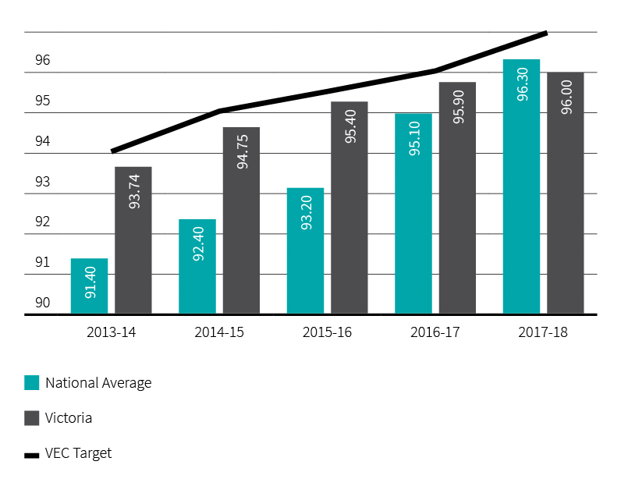

Enrolment
The number of Victorians enrolled to vote on the Register of Electors increased by 123,449 to 4,096,692 (3.11%) in 2017-18. Using available data, it is estimated that 96% of eligible electors are enrolled. This is an increase of 0.1% from 2016–17 and slightly less than the national figure of 96.3%. Although the VEC sets a target for enrolment to be at least 1% higher than the national average, the 2017 Australian Marriage Law Postal Survey prompted a significant increase in enrolments, both nationally and across Victoria. With the national population count being increased for Victoria following the release of the results of the 2016 Australian Census, the Victorian enrolment rate was 0.3% lower than the national rate (see Figure 14).

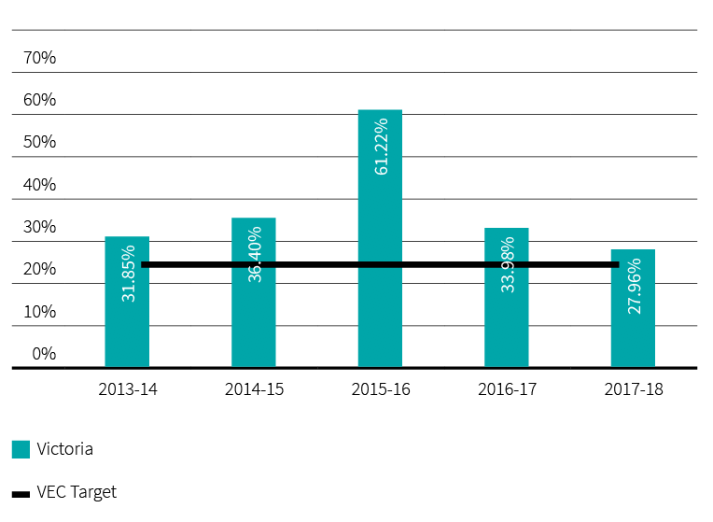
Figure 14: Proportion of enrolment updates sourced from VEC programs, 2013–14 to 2017–18

Figure 15: Elector statistics by region, 30 June 2018
Below are the elector statistics by region for 2017-18
Total number of electorates: 8
Total number of electors: 4,096,692
Average number of electors: 512,086
REGION | ELECTOR COUNT | VARIANCE TO AVERAGE (%)
Eastern Metropolitan | 469,734 | -8.27
Eastern Victoria | 525,168 | 2.55
Northern Metropolitan | 532,213 | 3.93
Northern Victoria | 517,431 | 1.04
South-Eastern Metropolitan | 504,248 | -1.53
Southern Metropolitan | 490,646 | -4.19
Western Metropolitan | 539,536 | 5.36
Western Victoria | 517,716 | 1.10

Figure 16: Elector statistics by district, 30 June 2018
Below are the elector statistics by district for 2017-18
Total number of electorates: 88
DISTRICT | ELECTOR COUNT | VARIANCE TO AVERAGE (%)
Dandenong | 42,168 | -9.42
Eildon | 44,413 | -4.60
Eltham | 44,702 | -3.98
Essendon | 47,827 | 2.74
Euroa | 48,642 | 4.49
Evelyn | 42,819 | -8.02
Ferntree Gully | 40,927 | -12.09
Footscray | 51,026 | 9.61
Forest Hill | 39,963 | -14.16
Frankston | 44,118 | -5.23
Geelong | 47,139 | 1.26
Gembrook | 49,932 | 7.26
Gippsland East | 45,760 | -1.70
Gippsland South | 42,072 | -9.63
Hastings | 50,931 | 9.40
Hawthorn | 44,642 | -4.10
Ivanhoe | 46,379 | -0.37
Kew | 44,152 | -5.16
Keysborough | 45,021 | -3.29
Kororoit | 50,607 | 8.71
Total number of electors: 4,096,692
Average number of electors: 45,553
DISTRICT | ELECTOR COUNT | VARIANCE TO AVERAGE (%)
Albert Park | 48,271 | 3.69
Altona | 54,711 | 17.52
Bass | 55,587 | 19.41
Bayswater | 43,795 | -5.92
Bellarine | 48,395 | 3.96
Benambra | 48,012 | 3.13
Bendigo East | 48,182 | 3.50
Bendigo West | 44,821 | -3.72
Bentleigh | 42,354 | -9.02
Box Hill | 43,903 | -5.69
Brighton | 45,090 | -3.14
Broadmeadows | 43,358 | -6.86
Brunswick | 52,665 | 13.13
Bulleen | 43,966 | -5.56
Bundoora | 40,870 | -12.21
Buninyong | 44,790 | -3.79
Burwood | 42,895 | -7.86
Carrum | 48,284 | 3.72
Caulfield | 44,952 | -3.44
Clarinda | 44,452 | -4.51
Cranbourne | 60,173 | 29.26
Croydon | 42,846 | -7.96

DISTRICT | ELECTOR COUNT | VARIANCE TO AVERAGE (%)
Polwarth | 45,551 | -2.15
Prahran | 49,913 | 7.22
Preston | 45,254 | -2.79
Richmond | 53,848 | 15.67
Ringwood | 41,169 | -11.57
Ripon | 47,219 | 1.43
Rowville | 39,790 | -14.53
Sandringham | 44,575 | -4.25
Shepparton | 48,271 | 3.69
South Barwon | 52,830 | 13.48
South-West Coast | 46,959 | 0.87
St Albans | 46,623 | 0.15
Sunbury | 44,920 | -3.51
Sydenham | 50,437 | 8.34
Tarneit | 52,791 | 13.40
Thomastown | 44,315 | -4.81
Warrandyte | 43,192 | -7.22
Wendouree | 42,928 | -7.79
Werribee | 45,590 | -2.07
Williamstown | 50,485 | 8.45
Yan Yean | 56,659 | 21.71
Yuroke | 56,064 | 20.43

DISTRICT | ELECTOR COUNT | VARIANCE TO AVERAGE (%)
Lara | 46,388 | -0.35
Lowan | 43,199 | -7.20
Macedon | 44,862 | -3.63
Malvern | 42,483 | -8.74
Melbourne | 50,493 | 8.46
Melton | 52,318 | 12.38
Mildura | 43,977 | -5.53
Mill Park | 46,369 | -0.40
Monbulk | 43,186 | -7.23
Mordialloc | 45,612 | -2.02
Mornington | 46,740 | 0.40
Morwell | 47,744 | 2.56
Mount Waverley | 38,892 | -16.46
Mulgrave | 40,537 | -12.92
Murray Plains | 46,665 | 0.24
Narracan | 51,354 | 10.31
Narre Warren North | 44,727 | -3.92
Narre Warren South | 49,366 | 6.04
Nepean | 49,043 | 5.35
Niddrie | 44,519 | -4.37
Northcote | 48,568 | 4.33
Oakleigh | 41,319 | -11.24
Ovens Valley | 42,927 | -7.79
Pascoe Vale | 50,409 | 8.28

Figure 17: Enrolment transactions, 2013–14 to 2017–18
VEC ENROLMENT TRANSACTIONS¹ | 2013-14 | 2014-15 | 2015-16 | 2016-17 | 2017-18
State direct enrolment activity | 246,362 | 257,972 | 191,849 | 131,030 | 186,736
VEC online enrolment | - | 41,262 | 11,138 | 19,614 | 1,693
VEC enrolment forms received | 40,892 | 90,781 | 31,339 | 19,936 | 20,432
Total enrolment transactions through VEC’s enrolment programs | 287,254 | 390,015 | 234,326 | 170,580 | 208,861

ENROLMENT APPLICATION TRANSACTIONS PROVIDED BY THE AEC AND IMPORTED  INTO VICTORIAN REGISTER OF ELECTORS | 2013-14 | 2014-15 | 2015-16 | 2016-17 | 2017-18
Additions
New to roll | 130,931 | 102,224 | 129,296 | 82,861 | 131,326
Reinstatements | 67,246 | 51,311 | 41,927 | 36,254 | 43,018
Subtotal | 198,177 | 153,535 | 171,223 | 119,115 | 174,344
Changes
Change of address | 558,763 | 478,409 | 518,439 | 484,617 | 572,760
Total AEC Import Transactions | 756,940 | 631,944 | 689,662 | 603,732 | 747,104
Total VEC Sourced Transactions | 287,254 | 390,015 | 234,326 | 170,580 | 208,861
Total collected through AEC’s enrolment programs | 469,686 | 241,929 | 455,336 | 433,152 | 538,243
VEC sourced enrolments as a percentage of the total | 37.95% | 61.72% | 33.98% | 28.55% | 27.96%

OTHER ENROLMENT-RELATED TRANSACTIONS² | 2013-14 | 2014-15 | 2015-16 | 2016-17 | 2017-18
Special category applications | 1,297 | 4,026 | 2,135 | 3,625 | 1,732
Non-application changes | 13,469 | 57,836 | 6,269 | 1,345 | 986
Subtotal | 14,766 | 61,862 | 8,404 | 4,970 | 2,718
TOTAL VEC enrolment transactions | 302,020 | 451,877 | 242,730 | 175,550 | 211,579
¹ The VEC undertakes direct enrolment using a number of data sources, including VicRoads and the AEC. This allows the VEC to both update details and enrol electors for the first time without requiring a form to be completed. Where the VEC is unable to verify a person’s eligibility to enrol, a paper form is sent to them. Electors may enrol for the first time, or update their enrolment details using the VEC Online Enrolment Service. However, when an elector prefers to use a paper form, they are able to do so and can access forms from a number of sources including Australia Post Offices, the VEC website and council offices. In addition, the VEC provides forms to all students as they turn 17, using data received from the Victorian Curriculum and Assessment Authority so that they may provisionally enrol.
² Special category applications received by the VEC include: applications to become General Postal Voters (GPV), Silent Electors, Itinerant or Eligible Overseas Electors. Some of these transactions are processed by the VEC and some are passed to the AEC for completion under the Commonwealth Electoral Act 1918. Non-application changes include administrative changes made to ensure the integrity and accuracy of the electoral register and the processing of return to sender mail.

Provision of enrolment information
The Register of Electors contains personal enrolment information, including name, address, date of birth and gender. Protecting the privacy of electors’ personal enrolment information is of fundamental importance to the VEC, and information is only disclosed according to legislation.

Mandatory provision of enrolment information
The Electoral Act 2002 stipulates several requirements with regard to electoral information to be made available:
- The list of Victorian electors (names and addresses only), excluding silent electors, must be made available for public inspection at the offices of the VEC and updated every six months. Information can only be searched by name.
- The latest print of any electoral roll produced for an election (which contains name and address details only) must be made available for public inspection, free of charge, at locations and during times determined by the VEC.
- Enrolment information, excluding silent electors, must be provided a number of times each year (and at the time of an election) to registered political parties, Members of Parliament and election candidates for permitted purposes.
Enrolment information is also provided under other legislation. Under section 19 of the Juries Act 2000, to enable people to be called for jury duty, jury rolls are prepared as requested by the Juries Commission for any of Victoria’s 14 jury districts (silent electors are included in this process). A total of 43 jury rolls were provided under this legislation during 2017–18. Under section 21 of the Local Government Act 1989, enrolment information is provided to councils for elections.

Discretionary provision of enrolment information
The Electoral Act 2002 strictly regulates the way in which the VEC collects, uses and discloses enrolment information, and ensures that electors’ enrolment information is protected and not made freely available to the public.
Section 34 of the Electoral Act 2002 provides the mechanism under which the VEC may release enrolment information in defined circumstances. Where the public interest in providing the requested information outweighs the public interest in protecting the privacy of personal information, the VEC and the applicant can enter into an information sharing deed. Strict conditions regulate the provision of information and penalties apply for non-compliance or misuse of enrolment information.
One Information Sharing Deed, under section 34 of the Electoral Act 2002, was entered into in the 2017-18 reporting period.
A standing agreement has been in place with Victoria Police since 2005, which allows immediate, secure access to the Register of Electors. Enrolment information was provided to seven organisations under existing agreements subject to section 34 (see Figure 18).
Figure 18: Information provided to organisations under section 34 of the Electoral Act 2002, 2017–18
ORGANISATION | LOOK UPS REQUESTED | UNSUCCESSFUL SEARCHES | INFORMATION PROVIDED
Anglicare | 3 | - | 3
Family Information Networks and Discovery (FIND) | 137 | 46 | 91
Victorian Assisted Reproductive Treatment Authority (VARTA) | 119 | 40 | 79
State Revenue Office | (List of electors provided monthly)
BreastScreen | (List of electors within relevant cohort provided quarterly)
Cancer Council | (List of electors within relevant cohort provided biannually)
Victoria Police | N/A | N/A | 7222

Warehouse
Warehousing and distribution facilities play a key role in supporting the core business of the VEC and ensure a high level of operational readiness is maintained. As the VEC prepares to enter another major election cycle, the focus of warehouse operations is on preparation and planning.

This year, warehouse lighting was upgraded with the installation of 200 energy efficient LED lighting fixtures. The new lights have resulted in an overall improvement in the quality of lighting in the space, while also reducing the carbon footprint. With the introduction of the new lighting, peak rate power consumption has been reduced by over 60 percent. This has made a significant contribution to the VEC’s Resource Smart achievements for the year. As a bonus, the cost savings generated by this upgrade have already covered the supply and installation costs.
Activities undertaken at the warehouse this year focused on planning and preparation for the 2018 State election and included:
- servicing and maintenance of equipment
- inspection and maintenance of over 2,500 electrical items, including electrical safety checks and the ‘test and tag’ of cables
- ordering, receipt and storage of resources with long production lead times such as ballot paper stock, envelopes and cardboard products (approximately 4,700 pallets of material)
  - picking and assembly of stationery kits, office equipment and materials.
The outlook for 2018–19 is largely focused on preparation and deployment of resources for the 2018 State election.
Activities for 2018-19 will include:
- trialling the use of unit load devices (ULD) to improve ballot paper security during deliveries and introduce efficiencies in material handling and transportation
- picking and assembly of approximately 2,800 pallets of equipment and materials for multiple deliveries to 88 election offices throughout Victoria
- the dispatch of 1,000 pallets of paper stock and envelopes to printing and mail house facilities
- preparation of election cardboard consignments and coordination of delivery and collection for approximately 1,800 voting centres throughout Victoria
- sorting of returned election office equipment, stationery, forms and envelopes
- facilitating the secure storage of election records
  - an annual stock take of approximately 750 products.

Research and development
Research and development activity is conducted on an ongoing basis across the VEC. A research policy and plan guides the conduct of research relating to service delivery and participation in the electoral process - across a range of stakeholder groups.

Electoral Regulation Research Network
The VEC joined with the New South Wales Electoral Commission and the University of Melbourne in March 2012 to establish the Electoral Regulation Research Network (ERRN). The purpose of the Network is to foster exchange and discussion among academics, electoral commissions and other interested groups on research relating to electoral regulation.
ERRN hosted a total of six seminars in Victoria and others interstate, covering topics including the consequences of section 44 of the Commonwealth constitution, improving discourse in election and referendum campaigns, and deliberative democracy in local government. An Australia-wide biennial workshop in Perth on 9-10 November 2017 covered a wide range of topics, such as the funding of political parties, judicial review of elections, and challenges to electoral agencies. There were two editions of the ERRN newsletter.
ERRN is sponsoring two research projects that harness the complementary skills of academics and electoral commission staff – one on the desirability and feasibility of expanding convenience voting in Australia, and the other on implications of changes to voting in Australia. The VEC is directly involved in the convenience voting project, the main findings of which are that there has been an exponential increase in incidence of convenience voting (broadly meaning voting before election day) over the past two decades, which has been facilitated by legislative and administrative changes. Despite the concerns of some parliamentarians and party representatives, the general public has enthusiastically embraced convenience voting.

Non-voter research
The VEC interrogated its own databases and engaged a market research company to learn about the nature, attitudes and demographics of non-voters in Victorian State and local government elections. Key findings of the research are:
- non-voters are predominantly male and young
- the great majority of non-voters are ‘one-off’ offenders
- most non-voters believe that voting is an important part of the democratic process, and that voting should be compulsory
  - proposals to improve voter turnout include the use of digital and online channels to inform and remind people about elections, and, if possible, the introduction of online voting for voters overseas.

Research into best practice inclusion for people with intellectual disability
La Trobe University’s Living with Disability Research Centre is working with the VEC on a two-stage action research project, with the aims of identifying the factors that facilitate or obstruct voting of people with intellectual disability, and of trialling and evaluating strategies to support voting tailored to the Australian cultural and political context. The VEC and the La Trobe University Centre will work on a pilot project involving a metropolitan and a regional disability support service at the 2018 State election.
This initiative will be evaluated and a final report will be provided to the VEC in early 2019. Interest from other Australian electoral commissions has resulted in financial contributions to the cost of this research - with a view to sharing this Australian-first research across the industry.

Research into queuing at voting centres
One of the major causes of voter dissatisfaction at election time is the length of queues at some voting centres. The VEC became aware that an organisation in the United States had developed a small electronic device that could monitor queue times in a voting centre by reading the Wi-Fi emissions from mobile phones. The concept, design and software were available under the Open Source domain. The VEC engaged Monash University to develop a prototype that could be trialled at the 2018 State election. The device would need to deliver real-time online queuing information to voters, who would thus be able to avoid voting centres with long queues.
Despite the valuable work of the Monash University researchers, technical difficulties prevented the VEC from putting the device into operation. The privacy settings on most mobile phones prevented the device from tracking individual phones, the device could measure the volume of phones around a voting centre, but this was not a reliable measure of queuing time.
The VEC will continue to investigate ways of providing queuing information to voters.

Spotlight on…

Name
Sam Zamani
Title
Enterprise Architect
Department
Information Technology

What I like about my job
There are so many things that I like about my job. Let’s start with the people: I have great respect for the people that I work with. They are intelligent, open minded, helpful, highly committed and work so well together. Next is my job itself: at times, I must deal with complex and tedious IT and architectural matters, and the support I receive from my colleagues and executives makes my job so much easier. I really enjoy my work: it is exciting, involves innovation and creativity; it gives me the opportunity to use my skills and contribute to our democracy; it gives me a great sense of achievement. Like everyone else at VEC, I take great pride in what I do.

Achievements
Running elections is a serious matter and involves a massive operation. As a member of the IT branch, I have been involved with supporting the business in running elections. As an Enterprise Architect, my primary focus is in developing IT strategy, to ensure IT has the necessary capabilities to support the VEC in achieving its goals. We are going through a major IT transformation this year and, so far, we have made significant progress in our transformation. I am confident we will continue kicking goals.

Our stakeholders

ACHIEVEMENTS 2017–18
- Submission to the Electoral Matters Committee Inquiry into Civics and Electoral Participation in Victorian State Parliamentary Elections
- Enhancement of the award winning Voters Voice app for voters in readiness for the 2018 State election
- Design of a trial initiative for voters with intellectual disability at the 2018 State election to enhance participation
  - Production of a communication and awareness program for the 2018 State election

OUTLOOK 2018–19
- Implementation of the Prisoner Education Program and a mobile voting pilot in prisons
- Implementation of a state-wide roll-out of the VoterAlert notification service
- Delivery of the communication and awareness program for the 2018 State election
  - Mobile-first design for the State election website, including Voting Centre Locator

Inclusion and participation

Having informed citizens actively participating in free and fair elections is vital to any healthy, functioning democracy. Providing accessible, up-to-date electoral information and education services is a fundamental part of ensuring full electoral participation across the community.

Communication activities

Your vote will help shape Victoria
The VEC developed a new animated advertising campaign for the 2014 State election and will continue with the same campaign in 2018. The campaign tagline is ‘Your vote will help shape Victoria’. The focus of the campaign was driven by focus group testing with young, disengaged electors, which indicated that if they felt their one vote could actually make a difference, they would be more inclined to vote as a result.
The 2018 updated campaign is in full production and will go to air from early October 2018.

Selections: the VEC newsletter
Selections is the VECʼs annual newsletter. It is distributed to State and local government representatives, government departments, the Electoral Matters Committee, VEC employees, senior election officials and registered political parties. The 2018 edition (due for distribution in August) is focused on the coming State election, and other key activity from 2017-18. The newsletter is now distributed electronically and enables the inclusion of rich media content and links to the VEC website.

Digital communication
Effort has been focused on the provision of an interactive map within the VEC website for the upcoming 2018 State election. The map is searchable by address, street name and locality, to provide detailed voting centre, early voting centre and election office information. The map will show voting centres nearest to any search result and will provide information about the facilities, including wheelchair accessibility.

Social media
With no major electoral event in 2017-18, the VEC used its social media channels to publicise incidental electoral events, including the Greater Geelong City Council elections, the Northcote by-election, and the Melbourne City Council Lord Mayor by-election. Social platforms were used to respond to enquiries and engage the community in the lead up to the State election. Journalists are prolific Twitter users and the VEC follows many of Victoria’s media voices to help communicate electoral information directly. Facebook and Instagram have been used to communicate with a wider, less election-focused audience.

Electoral outreach
A key feature of the VEC’s electoral inclusion strategy is to provide outreach services to priority community groups to assist with enrolment (particularly no-fixed-address enrolment), dealing with outstanding voting fines, and teaching people how to vote correctly.
There is, necessarily, a particular focus on communities typically under-represented within the electoral system, including Aboriginal and Torres Strait Islanders, young people, people experiencing homelessness, people from culturally and linguistically diverse communities, people living with a disability and prisoners.
The VEC’s electoral outreach sessions are delivered in formal and informal learning settings, as well as targeted community and cultural events. The following table provides an overview of outreach sessions conducted this year:
Figure 19: Overview of outreach sessions, 2016-17 compared to 2017-18
Priority community group |  | 2016-17 | 2017-18
CALD | Sessions | 75 | 30
 | Participants | 1,748 | 992
Youth (incl. Passport to Democracy) | Sessions | 21 | 110
 | Participants | 1,107 | 6579
Disability | Sessions | 14 | 67
 | Participants | 202 | 1021
Aboriginal & Torres Strait Islanders | Sessions | 5 | 10
 | Participants | 71 | 233
People experiencing homelessness | Sessions | 26 | 5
 | Participants | 200 | 45
Total - all groups | Sessions | 141 | 222
 | Participants | 3,328 | 8,870

Case study

Talking Democracy kit
Talking Democracy is a partner project between the VEC and Carringbush Adult Education. It is an electoral vocabulary teaching kit that can be used in various learning settings from formal courses at TAFEs (English language classes) to community learning centres.
Margaret Corrigan, Manager of Carringbush Adult Education, stated ‘Carringbush Adult Education has chosen to be part of the project because we can have direct input into the resources kit that is responsive to culturally and linguistically diverse (CALD) people’s learning needs. Carringbush Adult Education worked in collaboration with the VEC on the development and trialling of resources for CALD learners. Teachers worked together to provide feedback on resources and these resources were then focus tested with students’.

Why do you think your students should learn about enrolling and voting?
‘The process of voting is a cornerstone of Australian democracy. Everyone, no matter their language or cultural background, should be helped to understand their rights and responsibilities as citizens of Australia. Voting is compulsory in Australia. I believe that the students should have a say and understand why they should vote. For some students, they could not vote in the country they came from.’

Why should other learning centres get the VEC into their classrooms?
‘The VEC has well developed approaches to working with CALD learners. The materials they have produced are very user-friendly, providing teachers with a variety of choices as well as clear explanations. Both teachers and students will find the resources to be very useful, allowing for interactive learning.’

From Figure 19, of these sessions:
- a total of 222 outreach sessions were held for 8,870 people
- 83 people were assisted to enrol to vote
- disability session numbers increased significantly due to the recruitment of an additional electoral inclusion officer
  - election specific sessions were held for the Northcote by-election, Greater Geelong City Council election and Melbourne City Council Lord Mayor by-election.
The VEC also had stands at the Belonging Matters disability conference, the VALiD Have Your Say Conference, the Dandenong Multicultural Festival and the Ethnic Communities Council of Victoria Annual Conference. Attendance at conferences and events such as these are important in developing networks and generating further outreach sessions.
Finally, in April the VEC was pleased to launch Phase 1 of the Be Heard! Democracy Ambassador program for the 2018 State election. As at 30 June 2018, 80 community members have been selected for training as Democracy Ambassadors to deliver electoral education to their communities in the lead-up to the 2018 State election. For more information see vec.vic.gov.au/beheard.

Community partnerships and collaborations
Partnerships and collaborative approaches took a central role in the VEC’s efforts to achieve positive outcomes for people experiencing barriers to electoral participation. Through a shared process, community members have had greater input into the development of responsive electoral services and resources, ultimately building their capacity to participate in Victorian elections.
A number of new partnerships were developed this year:
- Talking Democracy with Carringbush Adult Education: This electoral vocabulary teaching kit can be used in various learning settings from formal courses at TAFEs (English language classes) to community learning centres. Content was co-designed and focus-tested with seven teachers and two groups of English as an Additional Language learners.
- See vec.vic.gov.au/talkingdemocracy. The case study on page 57 provides more detail about the value of working collaboratively.
- Youth leadership with the Centre for Multicultural Youth: This project has delivered four active citizenship workshops for 91 culturally diverse young people aged 18-25 years old. Outcomes include:
    - 18 young people completing a four day active citizenship course
    - creation of a social media campaign called #GO4IT which reached 17,000 people and 6,897 engaging with the content
    - seven participants of the program applying to become VEC Democracy Ambassadors
- Inclusion Melbourne’s I can vote resource: This resource encourages people with intellectual disability to work with their circles of support (including family members and disability support workers) to learn about voting. It provides specific advice about how to incorporate strategies for election day into a care plan, ensuring people with intellectual disability have appropriate supports in place to enable electoral participation.
- A collaboration with Corrections Victoria and the Australian Electoral Commission to produce Voting in Elections - A resource for Victorian Prisons. Distributed to all public prisons in Victoria, this resource contains information for prisoners about electoral rights and responsibilities, and aims to help overcome any procedural or informational barriers people in prison may face when it comes to voting.
- Banyule City Council Youth Summit: In May 2018, VEC facilitators held an active citizenship workshop for over 100 high school students to explore ideas about democracy and engage in learning activities focused on active citizenship.
The VEC also continued with the following, ongoing partnerships:
- Korin Gamadgi Institute’s REAL Program: Eight in-depth electoral education workshops were delivered to nearly 250 young Aboriginal and Torres Strait Islanders this year. Outcomes from these sessions include 46% of participants reporting that they have increased their knowledge of governmental processes. This partnership, now in its ninth year, has matured to the point that VEC staff are able to train alumni from the program to assist in the development and delivery of these workshops.

KGI REAL program graduation

- Leadership Victoria’s Be Informed workshops: Four active citizenship sessions were delivered to 72 participants in Melbourne and Wodonga.
- Victorian Student Representative Council (VicSRC): The VEC provided support for the VicSRC Congress, which was held in July 2017. This was a student-run event (engaging over 230 students from approximately 70 schools) where young people debate, decide and act on the issues that matter most to their education. VEC sponsorship enabled 20 metropolitan-based students from Aboriginal and Torres Strait Islander, CALD and low socio-economic backgrounds (who could not afford to pay full fees) to attend the Congress.
  - YMCA Victoria Youth Parliament: The VEC has provided five scholarships to Victorian schools and community groups enabling students and young people from disadvantaged and diverse backgrounds to participate in the 2018 Victorian Youth Parliament. Students attended four days of intensive training in June 2018 and will participate in a sitting of the Youth Parliament at Parliament House in July 2018.

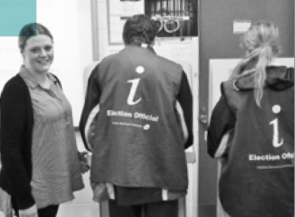

Case study

About the Passport to Democracy program
Erin Silfo and her students participating in a VEC Passport to Democracy school visit and mock election.
By providing a framework in which students can develop their critical thinking skills, the VEC’s Passport to Democracy (PTD) Program prompts young people to consider how they can make an impact on issues they care about and, ultimately, how they can engage with the community and meaningfully participate in the democratic process. Research reveals that by providing young people with a positive experience of democracy in a school setting can set them up for a life-time of civic participation1 and the PTD program is a unique way to do this.
The lesson plans written for the PTD program are aligned to the Victorian Curriculum and the Australian Curriculum for the teaching of Civics and Citizenship content across Years 5-10. In addition, the PTD website offers summative and formative assessment resources. It includes assignment instructions, a submission checklist and curriculum-aligned rubrics, plus a list of assessment for learning PTD activities.
The PTD program also contains an additional resource, Partner Up, which has specifically been designed to be used with Victorian Certificate of Applied Learning (VCAL) students. This program’s four phases support VCAL students to form a partnership with a local organisation and take practical action on an issue in their community. The Partner Up resource includes ‘quality assurance’ templates, teacher guides, student workbooks (available free from the VEC via online download and/or hard copy) and supporting video resources.
‘The program is extremely valuable in assisting students develop their understanding of ‘democracy’ and how as citizens they can participate in Australia’s democratic society. The program provides students with a practical and engaging example of how democracy and the preferential voting system works…’
Erin Silfo, Commerce and Civics and Citizenship Domain Leader, Berwick College

Schools program: Passport To Democracy (PTD)
The VEC’s PTD program, now in its tenth year, continues to grow in reach and impact. The use by schools of the program’s web-based resources, together with the demand for in-school education sessions (including mock elections) facilitated by VEC educators, has risen markedly over the last few years.
This year, VEC officers have delivered 110 incursions (generally in the form of a mock election) to 6,579 primary and secondary school students. This is up from 12 incursions delivered in 2016-17. As at 30 June, the PTD website had 64,000 unique page views this year, an increase of 24% from 2016-17. Teachers from 312 separate education institutions downloaded one or more PTD lesson plans, which were delivered to an estimated 16,270 students.
One of the reasons for this increase may be due to the fact that civics and citizenship is now mandated for delivery in all government schools across Victoria. The PTD program offers a reputable, pedagogically sound and affordable option for schools to enrich their civics and citizenship curriculum.
The growing demand for the program can also be attributed to the promotion (via education publications, events such as teacher conferences and, importantly, word of mouth from satisfied stakeholders) which has ensured that more educators are ‘discovering’ the program and its resources.
¹ http://www.aec.gov.au/About_AEC/Publications/youth_study/

Inclusion plans
In addition to an overall Diversity and Inclusion Statement, the VEC has two key inclusion plans, the Disability Action Plan (2016-2019) and the Reconciliation Action Plan (2017-2019).

Disability Action Plan
The VEC continues to make progress in its commitment to electoral access for people living with a disability. Now in its third year, a number of achievements can be listed.
- The establishment of new networks with disability service providers across the State, to increase the awareness of getting people with a disability to vote, which includes disability residential support services, disability day services, self-advocacy services, Australia Disability Enterprises, TAFE colleges, NDIS Local Area Coordinators and community centres. An email database has been established and is maintained to increase the distribution of information across services in Victoria.
- The promotion and explanation of the DAP to all new VEC core staff as a part of their induction to the organisation’s policies and processes.
- Workplace modifications and reasonable adjustments have been organised for staff within the VEC upon recruitment, and in the course of their roles.
- Closed caption and audio descriptions have been utilised in external videos accessible by the public, and some internal videos for staff training.
- The VEC’s award-winning Voters Voice app is being further enhanced for rollout at the November 2018 State election. The primary audiences for the app are people with complex communication difficulties, those with literacy and English language difficulties and people who speak Auslan. Enhancements include extending the app across iOS and Android devices to enable access on both tablets and smartphones. Voters Voice will also include an ability to manage multiple user profiles, request an enrolment form and an interactive map to locate the user’s nearest voting centres.
- Easy English publications were produced and distributed for the Greater Geelong City Council elections.
- Supporting the employment of people with a disability by ensuring all positions are advertised across VEC email networks.
- Investigation of portable hand-held hearing loops for early voting centres for the 2018 State election.
- The purchase of a portable Roger Phonak Hearing loop to use during outreach sessions, enabling more people to adequately hear and engage within the learning space.
- Continuing communication access accreditation from Scope for customer contact by phone and in person at the VEC head office.
  - Working with Vision Australia and Blind Citizens Australia to provide key election information at the enrolment and voting phases of the 2017 Greater Geelong City Council election. The information provided to the 525 people on the membership lists was provided in DAISY/CD/audio, braille, large print and e-text formats.

Accessibility for the Northcote By-Election
Access to venues is an important consideration for all VEC elections. Venues for the Northcote By-election were all rated.
- The early voting centres located in Fairfield and at the VEC’s Office in Melbourne were rated Assisted Wheelchair Access (AWA), mainly due to the distance between the disabled car park and the entrance to the early voting centre.
- The early voting centre at the election office at the VEC warehouse, Melbourne Airport, was assessed as Independent Wheelchair Access (IWA).
  - Of the 14 election day voting centres, 11 were rated Assisted Wheelchair Access (AWA) and the remaining three were rated as having Limited or No Wheelchair Accessibility (LNWA). To assist voters, a brief description of accessibility limitations was included on the VEC’s website for venues rated AWA or LNWA.

Reconciliation Action Plan
The VEC Innovate Reconciliation Action Plan (RAP) is a key document to demonstrate the VEC’s commitment to embracing reconciliation within the organisation and across Victoria’s electoral system. The VEC’s RAP Committee met quarterly to monitor implementation. On 30 June 2018, the halfway point for the life of the RAP was reached; of the 62 deliverables identified, 54% are either completed or on track. A number of highlights were identified.
- Relationship building with Aboriginal and Torres Strait Islander community leaders and organisations, which includes Korin Gamadji Institute, Aboriginal Advancement League, Victorian Aboriginal Community Services Association Ltd and Victorian Aboriginal Education Association Inc.
  - Development of a cultural awareness strategy for all VEC staff, which includes an online training module on the VEC’s internal training platform.
  - Development of a survey to capture VEC’s staff knowledge and understanding of Aboriginal and Torres Strait Islander cultures and commitment towards reconciliation.
  - Supporting employment of Aboriginal and Torres Strait Islander people by advertising all vacancies in the Koori Mail, recruiting Aboriginal and Torres Strait Islander people as Democracy Ambassadors to facilitate electoral education sessions within their community, and reviewing current employment practices.
  - Working in collaboration with the Korin Gamadji Institute to deliver civic education workshops with young Aboriginal and Torres Strait Islander people on their REAL program in June, September and December 2017 and April 2018.
  - Working with Korin Gamadji Institute REAL program graduates to train and engage them in co-facilitation of VEC sessions for new and emerging leaders.
  - Sponsoring an Indigenous team for the YMCA Youth Parliament 2018.
  - Completing the annual RAP Impact Measurement Questionnaire, which was included in Reconciliation Australia’s Impact Report for 2017.

Case study

Active citizenship workshop for community leaders
For two years, the VEC has been working in partnership with Leadership Victoria delivering Be informed workshops to the New and Emerging Leadership Program, the Women’s Leadership Program and the African Leadership Program. Over 300 community leaders have completed the workshop, where they learned about the principles of Australian democracy, how the government works and the importance of preferential voting.
During one of the workshops, one community leader said to the group: ‘I have been living in Australia for over 20 years and voted in many elections. I just put number 1 in a box on a ballot paper and that is it. I have been teaching my community members to vote this way. Today, I have learned how to vote correctly for the first time. As a community leader, my job is now to go back to my community and teach people how to vote correctly.’

Services to political parties

Register of political parties
The Electoral Act 2002 (the Act) requires the VEC to establish and maintain a register of political parties. In order to qualify for registration, a political party must have a written constitution and at least 500 members who are Victorian electors, party members in accordance with the party’s rules, and not members of another registered political party or of a party applying for registration.
It is not compulsory for political parties to be registered to contest an election, but registration gives a party a number of important entitlements. These include:
- the right to have the party’s name on ballot papers
- access to enrolment and voter information on a periodic basis
  - public funding for parties that attain a specified level of first preference votes

New applications for registration
As at 1 July 2017, two political parties were in the process of applying for registration. The VEC registered the Australian Conservatives (Vic.) on 18 July 2017. In contrast, the application by the Help End Marijuana Prohibition (HEMP) Party was refused on 26 July 2017, as the VEC was not satisfied that the party had sufficient members to be eligible for registration.
In the lead-up to a State election, there is often a rush of applications for registration by new political parties. The VEC received applications from the Transport Matters Party on 25 January 2018, Derryn Hinch’s Justice Party on 1 February, the Health Australia Party on 2 February, Pauline Hanson’s One Nation on 1 March, The Flux Party Victoria on 5 March, the Victorian Socialists on 3 May and Sustainable Australia (VIC) on 21 June.
Before registering a party, the VEC must be satisfied that the party is an ‘eligible political party’ within the meaning of the Act. There are two main ways in which the VEC tests a party’s eligibility, after confirming that the application is in order. First, the VEC advertises the application, inviting objections to the application. Objections must be received within 30 days after the VEC’s notice. At the same time, the VEC writes to the people on the party’s membership list, asking those people to confirm whether they are eligible members of the party. To facilitate responses, the VEC includes a simple form and a reply-paid envelope with its letter.
The VEC received a total of two objections to applications to party registration in 2017. The objections were to the name of the party as being misleading or confusingly similar to the name of an existing registered party.
In considering objections, the VEC was guided by the Act and the only grounds of objection that the VEC can consider are that the party is not an eligible political party, that the application was not correctly made, or that the party’s name is inadmissible. As the objections were not on these grounds, they had to be rejected.
Responses to the VEC’s mail-outs to the lists of party members varied considerably. The VEC allowed parties to provide a supplementary list of members, and wrote to those on the supplementary list. This process can take some time. The VEC only registered a party when it was satisfied, through the independent, signed confirmation of the members themselves, that the party had at least 500 eligible members.
The application by The Flux Party-Victoria was refused on 18 June 2018, as the VEC was not satisfied that the party had sufficient members to be eligible for registration.

De- registration of political parties
On 22 November 2017, the VEC de-registered the Australian Christians due to the party ceasing to exist. The members had voted to join the Australian Conservatives.
The VEC was obliged to review the registration of the Animal Justice Party in December 2017, after the party failed to reach the threshold of 4% of first-preference votes at the Northcote District by-election of 18 November 2017. The party provided information that satisfied the VEC that the party still had at least 500 members, and so could retain its registration.

Changes to registered political parties
On 6 December 2017, the Australian Sex Party (Victoria) applied to change its name to Reason Victoria. As required by the Act, the VEC advertised the application and invited objections to the proposed change. No objections were received, and on 16 January 2018, the VEC granted the application to change the party’s name.
The VEC also processed changes of registered officer by the Australian Country Party, the Democratic Labour Party (DLP), the Liberal Party of Australia – Victorian Division, the Liberal Democratic Party, the National Party of Australia – Victoria, the Socialist Alliance (Victoria), and the Voluntary Euthanasia Party (Victoria) and changes of address by the Australian Country Party, the Australian Greens – Victoria, the Democratic Labour Party (DLP) and Reason Victoria.
Figure 20: Registered political parties, 30 June 2018
POLITICAL PARTY | REGISTERED OFFICER | ADDRESS
Animal Justice Party | Ms Magda Wozny  Secretary | 113 Milpera Crescent  Wantirna VIC 3152
Australian Conservatives (Vic) | Senator Cory Bernardi  Chairman | 28 King William Street  Kent Town SA 5067
Australian Country Party | Mr Costantino di Biase  Registered Officer | 88 Barkly Street  Maryborough VIC 3465
Australian Labor Party -  Victorian Branch | Mr Samuel Rae  State Secretary | 438 Docklands Drive  Docklands VIC 3008
Democratic Labour Party (DLP) | Mr Stephen Campbell  State Secretary | 11 Wheatsheaf Road  Ceres VIC 3221
Derryn Hinch’s Justice Party | Ms Annette Philpott  Secretary | 4th floor, St Kilda Towers, 1 Queens Road  Melbourne VIC 3004
Health Australia Party | Mr Andrew Hicks  Victoria State Secretary | 1 Erinne Court  St Helena VIC 3088
Liberal Democratic Party | Senator David Leyonhjelm  Registered Officer | 405/19 Roseby Street  Drummoyne NSW 2047
Liberal Party of Australia -  Victorian Division | Mr Nick Demiris  State Director | 104 Exhibition Street  Melbourne VIC 3000
National Party of Australia – Victoria | Mr Matthew Harris  State Director | Suite 908, Level 9, 343 Little Collins Street  Melbourne VIC 3000
Pauline Hanson’s One Nation | Pauline Hanson  Registered Officer | 2/38 Hudson Road  Albion QLD 4010
Reason Victoria | Ms Ange Hopkins  Registered Officer | 64 Hamilton Street  Gisborne VIC 3437
Shooters, Fishers and Farmers Party Victoria | Ms Nicole Bourman  Secretary | Suite 504, 365 Little Collins Street  Melbourne VIC 3000
Socialist Alliance (Victoria) | Mr Dave Holmes  Registered Officer | Resistance Centre, Level 5, 407 Swanston Street  Melbourne VIC 3000
The Australian Greens – Victoria | Mr Gurmeet Sekhon  Registered Officer | Level 1, 45 William Street  Melbourne VIC 3000
Transport Matters Party | Mr André Baruch  Registered Officer | 6 Lockhart Street  Caulfield VIC 3162
Victorian Socialists | Mr Stephen Jolly  Registered Officer | 54 Victoria Street  Carlton VIC 3053
Voluntary Euthanasia Party (Victoria) | Ms Judi Burgess  Secretary | 41 Little Bourke Street  Waranga Shores VIC 3162
Vote 1 Local Jobs | Mr James Purcell  Registered Officer | 35 Bank Street  Port Fairy VIC 3284

Interaction with electoral bodies

The VEC works with various national and international electoral bodies with the aim of supporting increased innovation and electoral harmonisation across Australia and globally. The exchange of ideas, collaborative research and discussion on key matters of interest with other electoral bodies (including through established forums), is an important basis for continued innovation. These interactions also support the VEC’s capacity to recommend and advise on relevant legislative change in Victoria.

Electoral Council of Australia and New Zealand
The Electoral Council of Australia and New Zealand (ECANZ) is a consultative forum with membership comprising Commonwealth and New Zealand and State and Territory Electoral Commissioners. This forum recognises the strong association and commonality existing between these organisations. ECANZ met on three occasions in 2017-18.
ECANZ considers best practice and innovation in activities such as the maintenance of electoral rolls, the operation of new electoral legislation and the management of elections. During the year the ECANZ consulted on a range of issues including enrolment strategies, material management, education of electors, electronic voting and technology generally. In February 2018 as a first, ECANZ was successful in putting before the Council of Australian Governments (COAG) the concept of developing an internet voting system at the national level, distinct from single jurisdiction systems. This was noted by COAG along with the need to consider cyber security for national election systems and physical security at elections. These matters will be advanced by ECANZ members.

Electoral Boundaries Commission
The VEC is required by legislation to provide administrative and technical services to the Electoral Boundaries Commission (EBC). The Report of the Electoral Boundaries Commission 2017-18 is included in this Report (See Appendix G on page 128).
The EBC was not required to meet in 2017-18. The next redivision of State electoral boundaries will commence in November 2020.

Other interactions
The Electoral Commissioner and Deputy Electoral Commissioner attended an Electoral Innovation Conference hosted by the Australian Electoral Commission in Sydney in early March 2018. International participants included Mr O.P. Rawat, Chief Electoral Commissioner India, Mr Stephane Perrault, Acting Chief Electoral Officer, Elections Canada and Ms Alicia Wright, Chief Electoral Officer, New Zealand. The conference considered various examples of innovation in election operations and procedures and the challenges being faced by electoral administrators.
In February 2018, the Electoral Commissioner and the Deputy Electoral Commissioner met with Mr Scott Bates, Deputy Secretary of the State of Connecticut, to discuss principally re-districting. This was followed in June 2018 with a similarly focused meeting with Mr Timor Sharan, Deputy Minister for Policy and Technical Affairs, Afghanistan.

Electoral Matters Committee
The VEC has an interest in the work of the Electoral Matters Committee (EMC), a joint investigatory committee of the Parliament of Victoria. The EMC comprises seven Members of Parliament drawn from both Houses. Its powers and responsibilities are determined by the Parliamentary Committees Act 2003.
The EMC tabled a report on its Inquiry into Electronic Voting in May 2017, with the Government providing its response on 2 November 2017.
In February 2018, the VEC provided the EMC with a cost-benefit analysis for a State-wide roll-out of electronic roll-marking facilities for the 2018 State election and a report on ballot paper scanning and possible use of this technology in Victoria. These reports were in response to recommendations in the EMC report.
The EMC’s Inquiry into Civics and Electoral Participation has continued during this reporting period with the VEC providing a submission on its extensive work in this area in July 2017 and appearing before the Committee to expand on its submission in October 2017. The Committee is expected to table its report on this Inquiry in August 2018.

Arrangements with other electoral agencies
In a reciprocal arrangement, the VEC provides election services such as voting services and information provision for other electoral agencies (See Figure 21).
The VEC works with other Australian electoral agencies in providing staff for short periods to assist with electoral events and to gain experience in different election operations. Two VEC staff assisted with the Queensland State general election in November 2017 and three VEC staff supported the South Australian general election in March 2018. Support was provided with postal vote processing, assisted voting for blind and low vision electors, and call centre operations.
Figure 21: Voting services provided for other electoral agencies, 2017-18
date | Jurisdiction | Election | Total Votes
27 August 2016 | Northern Territory | Legislative Assembly general election | 41
12 October 2016 | New South Wales | State District by-elections, Canterbury, Orange and Wollongong** | -
15 October 2016 | Australian Capital Territory | Legislative Assembly election | 159
3 December 2016 | New Zealand | Mt Roskill District by-election | 1
25 February 2017 | New Zealand | Mt Albert District by-election | 2
11 March 2017 | Western Australia | State general election | 701
8 April 2017 | New South Wales | State District by-elections, Gosford, Manly and North Shore** | -
6 May 2017 | Tasmania | Legislative Council elections | 3
** The VEC was not required to provide voting services for the New South Wales by-elections; instead the VEC provided access to a computer to allow voters to register for an internet vote.

Spotlight on…
Name
Nitin Rohmetra
Title
Application Development & Support Manager
Department
Information Technology

What I like about my job
IT is going through a transformational phase and the last few months have been challenging to say the least. Therefore, it is equally rewarding to see how much we have achieved in a very short span of time. This role pushes me and my abilities to full potential which fills me with great satisfaction.

Achievements
I recently took up a challenge to take part in a Tough Mudder run as a friendly bet, though I never thought I would be able to complete it. This is an endurance event series in which participants attempt 18 km long obstacle courses that test mental as well as physical strength. I started training with a few small runs every week. This grew into regular training sessions and eventuated in me completing the run and, of course, winning the bet! This gave me a great sense of achievement and self-belief, as well as making me realise that starting small can create a much needed momentum to achieve greater things.

Our people

ACHIEVEMENTS 2017–18
- Establishment of the VEC Diversity and Inclusion Statement
- Implementation of a new Learning Management System (LMS)
- Design and implementation of an Election Secondment Program, which provides development opportunities for internal staff
- Development of a Leadership Succession Bench through the identification of high potential employees
- Design, development and implementation of a leadership and management development program - LAUNCH
- Development of a Cultural Competency Strategy - as an outcome of the VEC Reconciliation Action Plan (RAP)
- Establishment of a Leadership Community of Practice with an intranet-based support platform
  - Delivery of OHS actions in response to internal survey results

OUTLOOK 2018–19
- Delivery of the LAUNCH – Leadership and Management development program
- Delivery of all commitments within the RAP
- Workforce planning for the 2018 State election
- Building organisational capability to enable delivery of the Strategy 2023
  - Continuing to build succession bench strength

Human resource management

The investment in building capability continued throughout 2017-18 with a focus on establishing programs to support employee development and engagement.

Staff engagement
The VEC participated in the 2017 Victorian Public Sector Commission (VPSC) People Matter Survey (PMS) with positive results and an increased response rate of 78%. The survey sought feedback on staff perception of the application of the Victorian Public Sector (VPS) values and employment principles at the VEC, as well as job satisfaction and engagement levels. The VEC elected to include two additional survey modules to explore staff perception of change management and wellbeing.
The survey results indicated that the VEC performed well across the VPS values compared to the comparator group, with all results in the top quartile. The employment principles and job satisfaction results were also positive, though highlighted some areas for improvement, such as grievance management. Following the survey, the VEC has undertaken a review of the dispute resolution procedure, and provided education to managers and staff on raising and managing grievances.
The VEC committed to further action and reinstituted the PMS Action Groups to establish new action plans for 2018. Actions for 2018 include: education on change management principles, support for managers to effectively address informal grievances, a formal launch of the VEC’s new strategic plan, and celebrating what we do well at the VEC as indicated via the PMS, which includes excellence in operations, customer focus, high level of integrity and intrinsic belief in what we do.
The EMG elected to participate in the survey biennially and the survey will be conducted again in 2019.

Organisational capabilty development
The focus for the 2017-18 financial year has been operationalising the Learning and Development framework. Key achievements this year have included:
- embedding the 70:20:10 learning and development model
- building leadership and management capability
- reducing succession risk
  - leveraging on technology to deliver just-in-time learning.

Embedding the 70:20:10 learning and development model
The VEC utilises the 70:20:10 learning and development model for all staff development activities, and uses it to reinforce learning opportunities that occur every day, through a combination of formal and informal situations, through others, and not only at formal training events. This shift away from the traditional event centric approach has allowed the VEC to integrate the model into performance and talent management processes, learning and development activities, and business strategy. Adoption of the 70:20:10 model has facilitated increased involvement of managers in the development of staff capability. Active measures taken include the identification of stretch projects, a dedicated agenda item in Branch meetings for shared learning and encouragement of self-direction of individuals in pursuit of personal mastery.

The 70:20:10 model breakdown is:
Formal training and education – 10%
Social learning through relationships
and networks – 20%
On the job, experience based learning – 70%

Building leadership and management capability
In September 2017, the VEC rolled out its first leadership and management development program Launch - a foundational development opportunity for all managers at the VEC. The program reflects the baseline capabilities that all managers need, and is central to ensuring the VEC’s middle management and leadership capabilities are consistent and transferable across the organisation, providing the basis for a responsive and adaptive VEC.
Delivered over an 18-month period, the 2017-18 cohort of 27 managers participated in a range of development opportunities across the full 70:20:10 spectrum, including self-reflection (using the behavioural, motivational and emotional intelligence profiles), face-to-face workshops and masterclasses, e-learning assigned via the LMS, wide reading and social learning through a dedicated management and leadership community of practice.
Six themed workshops were delivered:
- DISC Leadership
- Managing for performance
- Safety and wellbeing leadership
- Managing operations
- Risk leadership
  - Advanced presentation and communication skills
In addition to anecdotal evidence of improved management practice, the Launch program contributes to balancing the relationships between leadership, management and technical skills at middle management level, and complements the VEC’s succession risk management efforts.

Reducing succession risk
To supplement the formalised Succession Risk Management Framework introduced in 2016-17, the VEC has nurtured the building of bench strength across the organisation. Through a deliberate integration of learning objectives with higher duties and secondment opportunities the VEC has effectively connected learning with work, which is an underpinning principle of the 70:20:10 model, and an outcome that supports the development of a responsive and adaptive VEC.

Leveraging on technology
A new learning management system (LMS) was implemented to support the development of VEC employees and to administer the online learning required for the casual election workforce. Following successful installation, commissioning and testing late in 2017, the new LMS has delivered:
- over 2,000 e-learning experiences for VEC employees as part of the VEC’s:
    - Launch leadership and management development program
    - new employee onboarding program
    - organisation-wide compliance essentials campaign (encompassing sexual harassment, workplace bullying, anti-discrimination, equal opportunity and human rights training)
  - induction training for over 3,500 casuals for the Northcote District by-election and the Greater Geelong City Council general election
Given the strong performance of the LMS during the Geelong and Northcote elections late in 2017, the LMS will be utilised to deliver e-learning to over 25,000 election casuals ahead of the November 2018 State election.

Diversity and inclusion
A diverse workforce provides different skills and perspectives that help the VEC grow and better serve the community, and inclusivity creates a culture where all employees can flourish. In December 2017, the VEC launched the Diversity and Inclusion Statement, which summarises the VECʼs approach to fostering a diverse and inclusive workplace. The Statement includes a commitment to:
- create a workplace culture that is inclusive, equitable and safe for all
- increase our awareness and understanding of barriers to inclusion and to addressing these barriers in our practices
- provide a workplace that enables employees to bring their full selves to work, and where their diversity is celebrated and appreciated
  - recognise and celebrating diversity as a strength and corporate asset
The Reconciliation Action Plan (RAP) is a key component of the VECʼs diversity and inclusion framework. The VEC has progressed a number of the commitments in 2017-18 that relate to employee cultural awareness and supporting employment opportunity for Aboriginal and Torres Strait Islander people. A Cultural Competency Program has been developed for all staff, which includes a blended learning approach with online learning and participation in NAIDOC and Reconciliation Week activities. The program has a mandatory requirement for all managers, executives, and human resources to attend face-to-face cultural awareness training at the Koorie Heritage Trust. The VECʼs current RAP activities will conclude in 2019 and all achievements will be reported to Reconciliation Australia.

Workforce profile
In 2017-18, the VEC has undergone a period of growth and change due to the implementation of a new organisational structure as a result of organisational structure reviews across a number of branches. The changes have provided new opportunities at management level and an improved capacity to deliver on organisational objectives. Permanent headcount has increased by 33%, and temporary headcount increased by 47% as at 30 June 2018.
Turnover at the VEC for 2017-18 was 15.97%, similar to previous years.
Gender equity remains a priority with 55% female representation at leadership level and 15 (45%) female managers.

Flexible work arrangements
The VEC has continued to support employees to utilise flexible work arrangements, which include flexible start and finish times, compressed work fortnights, job-share, purchased leave, banking and taking of flex-time and the provision of ‘make-up time’.
Working flexibly will continue to be an important factor for the workforce, and a number of mobility measures are in progress to further improve the availability of flexible work options.

Figure 22: Recruitment, departures and turnover, 2013-14 to 2017-18
 | HEADCOUNT (ONGOING) | FTE | COMMENCEMENTS FTE | DEPARTURES FTE | STAFF TURNOVER  (% DEPARTURES/FTE)
2013–14 | 65 | 62.5 | 10.5 | 4.6 | 7.36%
2014–15 | 62 | 59.8 | 4 | 5 | 8.36%
2015–16 | 67 | 64.4 | 13 | 10 | 15.50%
2016–17 | 82 | 77.1 | 13 | 11 | 14.30%
2017-18 | 109 | 103.3 | 24 | 16.5 | 15.97%

Figure 23: Recruitment (FTE ongoing), 2013-14 to 2017-18

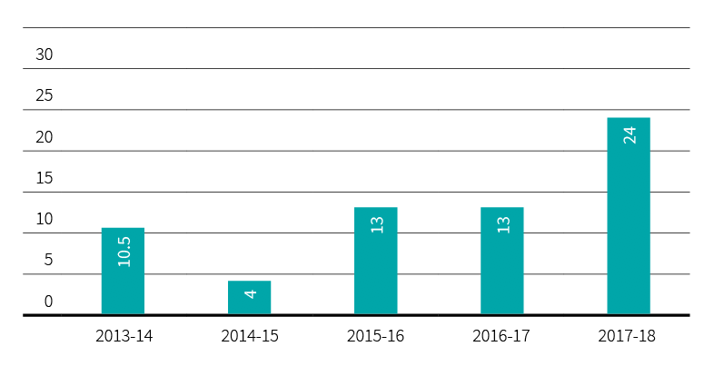

Figure 24: VEC staff by gender, 2013-14 to 2017-18

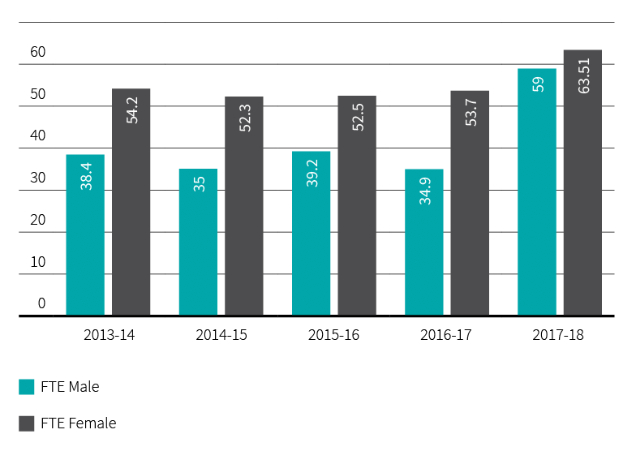

Code of conduct – VEC values
All employees are provided with a copy of the VPS Code of Conduct on commencement of employment. The VPS values, as outlined in the Code of Conduct, continue to be a feature in the Employee Performance and Development program. Staff are required to establish behavioural intentions at the commencement of the performance year and document examples of meetings these intentions throughout the performance cycle.
Below-the-line behaviours (inappropriate behaviours), when witnessed or identified, are called out and appropriate action is taken.

Election staffing
The VEC developed a Senior Election Official (SEO) recruitment campaign to source SEOs for the 2018 State election. The overall objective of the campaign was to recruit up to 100 new SEOs in order to maintain a pool of 300+ SEOs for the 2018 State election. This ensures optimum staffing numbers and geographic coverage for the 176 plus Election Manager (EM) and Assistant Election Manager (AEM) roles that are required at the election. At the close of recruitment there were 240 applicants, 88 of which successfully passed the interview and orientation training phases of the recruitment process.
The VEC also maintains an ongoing database of individuals interested in working during elections. There are approximately 30,500 registered in this database. People may register at any time. This database is utilised to recruit the large volumes of casual appointments required for each electoral event. The upgrade to the VEC’s personnel system, Aurion, at the end of May provided a more modern, user friendly system. This, in turn, will better support the 88 election offices being established for the 2018 State election as they work to recruit and appoint around 17,000 people to work on election day.
The VEC also maintains an ongoing Personnel Helpline to support casual election staff in the registration and appointment process.
In addition to the external recruitment campaign, a secondment framework was developed to support Program Leads and Project Managers to resource State election projects. The framework aims to provide opportunities for VEC staff to be seconded to election specific roles outside of their area of expertise to expand and develop their electoral knowledge and experience.

Staff profile

Comparative workforce data
Figure 25: VEC staff profile, last pay period June 2018 (not including statutory appointees)
 | 2017 |  |  |  |  | 2018
 | ongoing |  | fixed term & casual | total |  | ongoing |  | fixed term & casual | total
 | head- count | fte | head- count | fte | fte | head- count | fte | head- count | fte | fte
Gender
Male | 33 | 32.3 | 3 | 2.6 | 34.9 | 54 | 52.5 | 7 | 6.6 | 59.1
Female | 49 | 44.9 | 12 | 8.8 | 53.7 | 55 | 50.8 | 15 | 12.8 | 63.6
Total | 82 | 77.2 | 15 | 11.4 | 88.6 | 109 | 103.3 | 22 | 19.4 | 122.7
Age
Under 25 | 2 | 2 | - | - | 2 | 2 | 2 | - | - | 2
25-34 | 12 | 10.9 | 2 | 1.6 | 12.5 | 26 | 25.4 | 6 | 5.6 | 31
35-44 | 18 | 16.6 | 8 | 5.8 | 22.4 | 29 | 26.5 | 11 | 9.4 | 35.9
45-54 | 33 | 31.3 | 2 | 1.8 | 33.1 | 32 | 30.8 | 3 | 2.8 | 33.6
55-64 | 14 | 13.4 | 2 | 1.2 | 14.6 | 16 | 14.6 | 1 | 1 | 15.6
Over 64 | 3 | 3 | 1 | 1 | 4 | 4 | 4 | 1 | 0.6 | 4.6
Total | 82 | 77.2 | 15 | 11.4 | 88.6 | 109 | 103.3 | 22 | 19.4 | 122.7
Classification
STS | 3 | 3 | - | - | 3 | 3 | 3 | 2 | 1.8 | 4.8
VPS Grade1 | - | - | - | - | - | - | - | - | - | -
VPS Grade2 | 16 | 14.6 | 3 | 2.1 | 16.7 | 17 | 15.7 | 4 | 3.2 | 18.9
VPS Grade3 | 21 | 19.6 | 4 | 2.1 | 21.7 | 28 | 25.8 | 7 | 6.2 | 32
VPS Grade4 | 13 | 11.9 | 6 | 5.4 | 17.3 | 20 | 18.6 | 4 | 3.4 | 22
VPS Grade5 | 24 | 23.2 | 2 | 1.8 | 25 | 32 | 31.4 | 5 | 4.8 | 36.2
VPS Grade6 | 5 | 4.8 | - | - | 4.8 | 9 | 8.8 | - | - | 8.8
Total | 82 | 77.2 | 15 | 11.4 | 88.6 | 109 | 103.3 | 22 | 19.4 | 122.7
Excluded are those absent on secondment, external contractors and temporary staff employed by employment agencies, election appointees to statutory offices as defined in the Public Administration Act 2004, and election casual staff employed under the Electoral Act 2002.

FIGURE 26: FULL TIME EQUIVALENT (FTE) STAFFING TRENDS AS AT 30 JUNE, 2012 TO 2017
 | ongoing employees |  |  |  | fixed term |  | casual |  | totals
 | number (head  count) | full time (head  count) | part-time (head  COunt) | fte | number (head  count) | fte | Number (head  count) | fte | number (head  count) | fte
2014 | 65 | 56 | 9 | 62.5 | 20 | 18.8 | 14 | 11.3 | 99 | 92.6
2015 | 62 | 54 | 8 | 59.8 | 23 | 21.2 | 16 | 6.3 | 101 | 87.3
2016 | 67 | 59 | 8 | 64.4 | 25 | 22.8 | 12 | 5.7 | 112 | 92
2017 | 82 | 69 | 13 | 77.2 | 13 | 11.2 | 2 | 0.2 | 97 | 88.6
2018 | 109 | 93 | 15 | 103.3 | 20 | 18.6 | 2 | 0.8 | 131 | 122.7

Occupational health and safety
During 2017-18, the VEC conducted reviews of key OHS survey focus areas and implemented review recommendations.

The VEC aims to provide a safe and positive workplace, without risk to employee's physical or mental wellbeing. The VEC recognises that Occupational Health and Safety (OHS) requires continuous improvement to ensure all elements of health and safety are considered. The focus for 2017-18 has been to further develop the education and management of employee mental health and wellbeing, while continuing to monitor and manage the VECʼs established Occupational Health and Safety Management System (OHSMS) and functions.
An OHS staff feedback survey was conducted in 2016-17 to provide a snapshot of staff perception of OHS performance. Results identified five priority focus areas. Internal audits were undertaken in 2017-18 for three of the focus areas: managing interpersonal conflict, managing mental health and ergonomics.
The audit recommendations prompted the following actions:
- staff education on complaint and dispute management process, with a focus on early resolution
- refresher training on code of conduct and equal opportunity
- development of guidelines and training for staff in public facing roles
- development of a mental health and wellbeing commitment statement
- development of a procedure to manage and support ill and injured employees, including mental health issues
- identification of training for managers to respond to and manage staff experiencing mental health challenges
  - organising wellbeing program activities that aim to increase understanding of mental health and reduce the stigma of mental health in the workplace
In 2018-19, the VEC will finalise the implementation of the actions from the completed audits, and will conduct further audits on the remaining focus areas: fatigue and health and fitness.
The OHS Committee has continued to take an active role in monitoring the application of the OHSMS by taking part in all quarterly inspections, reviewing OHS documentation and supporting OHS events, such as OHS month. Formal quarterly reporting on OHS data and activity has continued throughout 2017-18. The reports are provided to executives and managers to provide oversight of OHS performance and identify trends.

Staff wellbeing services
The VEC’s Wellbeing Strategy for 2017-20 established a framework to develop a culture that fosters professional growth and development, ensures a safe, inclusive and engaging work environment and leads to high quality staff performance. In 2017-18, the VEC has continued to deliver a program of wellbeing events and initiatives that contribute to this strategic intent.
The activities offered to staff included:
- promotion and education of mental health and support seeking through R U Ok? day and World Mental Health day
- OHS month delivering an information series about health and safety in the workplace and providing fruit baskets over the period
- a staff workshop on mediation and mindfulness run by an external facilitator
- International Women’s Day events, with an onsite staff panel discussion, and a competition for four VEC employees to attend Institute of Public Administration Australia’s (IPAA) International Women’s Day Gala Dinner
- the flu vaccination program
  - promotion and celebration of International day against homophobia, transphobia and biphobia and men’s health
In addition to the Wellbeing Strategy, the VEC has developed a Mental Health and Wellbeing Commitment Statement to further highlight the importance of mental wellbeing in the workplace. The commitment was one of the recommendations in the OHS audit and aligns to feedback from the People Matter Survey Wellbeing module. The commitment provides clarity on the responsibilities and expectations of the VEC, managers, and employees to prevent and address psychological injury or illness and contribute to a culture of positive wellbeing.

Hazards, incidents and injuries
During 2017–18, the VEC received 10 incident notifications and two hazard notifications (see Figure 29). There was one WorkCover claim from the previous financial year, which concluded in April 2018.
Figure 30 on page 76 shows that there has been a decrease in the number of OHS incidents reported. This is primarily due to no major electoral events occurring during the year, despite a significant and rapid increase of staff and new workspaces. There was an increase in OHS hazards reported, which is noted as a positive indicator due to increased efforts in proactive health and safety management.
All OHS incidents and hazards reported during the year have been investigated by health and safety representatives and management. All corrective action is monitored and reviewed on the VEC’s Safety Action Plan on a regular basis to ensure effectiveness.

Figure 27: Claims for workcover, 2013–14 to 2017–18
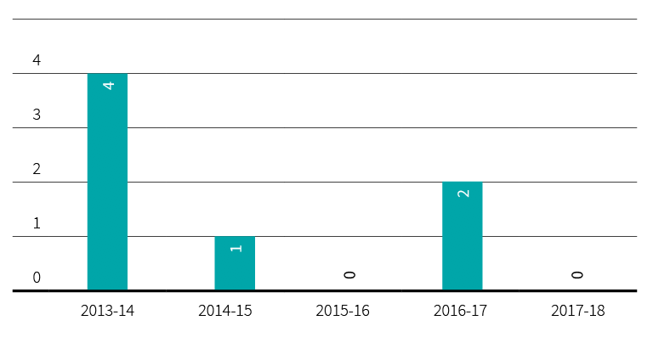

Figure 28: Days lost as a result of workplace-related injury, 2013–14 to 2017-18
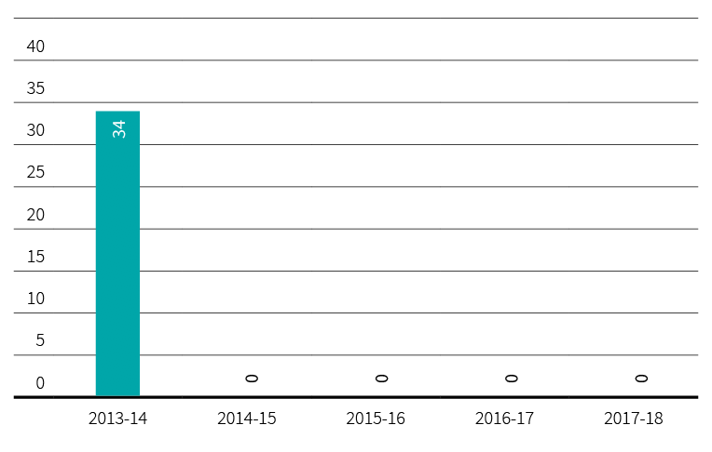

Figure 29: Hazard, incidents and injuries reported, 2013–14 to 2017-18
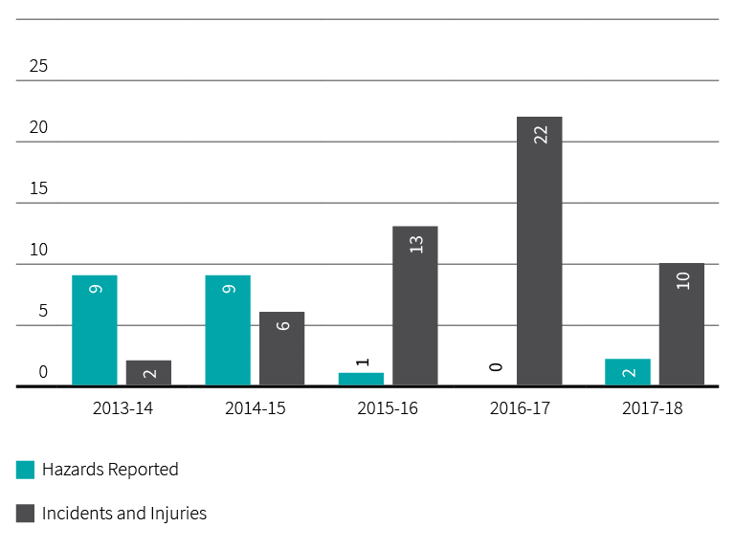

Figure 30: The VEC’s performance against OHS management measures, 2013-14 to 2017-18
measure | kpi | 2013-2014 | 2014-2015 | 2015-2016 | 2016-2017 | 2017-2018
Incidents | Staff FTE  No. of incidents  Rate per 100 FTE | 81.3  9  11.07 | 81  6  7.41 | 86.2  13  15.08 | 88.6¹  5²  5.6 | 122.7  10  8.1
Claims | No. of standard claims  Rate per 100 FTE  No. of lost time claims  Rate per 100 FTE  No. of claims exceeding 13 weeks  Rate per 100 FTE | 2  2.46  2  2.46  -  - | -  -  -  -  -  - | -  -  -  -  -  - | 1³  1.1  -  -  1  1.1 | 1  0.8  -  -  -  -
Fatalities | Fatality claims | - | - | - | - | -
Claim costs | Average cost per standard claim | 2,274 | 8,576 | - | 8,210 | 452
Return to work | Percentage of claims with RTW plan <30 days | - | - | - | - | -
Management | Evidence of OHS policy statement, OHS commitment objectives, regular reporting to senior management of OHS, and OHS plans (signed by CEO or equivalent)  Evidence of OHS criteria in purchasing guidelines (including goods, services and personnel) | Completed  Completed | Completed  Completed | Completed  Completed | Completed  Completed | Completed  Completed
Consultation | Evidence of agreed structure of designated workgroups (DWGs), health and safety participation representatives (HSRs), and issue resolution procedures (IRPs)  Compliance with agreed structure on DWGs, HSRs, and IRPs | Completed  Completed | Completed  Completed | Completed  Completed | Completed  Completed | Completed  Completed
Risk management | Percentage of internal audits/inspections conducted as planned  Percentage of issues identified and actioned arising from:  - internal audits  - HSR provisional improvement notices (PINs)  - WorkSafe notices | 100%  100%  N/A  N/A | 100%  100%  N/A  N/A | 100%  100%  N/A  N/A | 100%  100%  N/A  N/A | 75%  N/A  N/A  N/A
Training | Percentage of managers and staff that have received OHS training:  - induction  - management training  - contractors, temps and visitors  Percentage of HSRs trained:  - acceptance of role  - refresher training  - reporting of incidents and injuries | 100%  *0%  N/A  100%  100%  100% | 100%  100%  100%  100%  100%  100% | 100%  0%  100%  100%  0%  100% | 100%  100%  50%  100%  100%  100% | 100%  78%  36%  100%  100%  100%
¹ Figure does not include casual staff
² Figure does not include casual staff or members of the public
³ Figure includes casual election staff
*Figure corrected

Spotlight on…

Name
Lachlan Downing
Title
Records Management Administrator
Department
Information Management

What I like about my job
I love teaching and making people’s lives easier. I get to do so by helping staff across the organisation work out how information management can help them rather than it being something they’re forced to do.

on the weekends
I use my voice to create tales as a narrator, wield a camera to capture landscapes, and enjoy brunch and coffee far too much. There might be a gym visit thrown in as well (have to work off brunch somehow!).

Financial statements

ACHIEVEMENTS 2017–18
- Compliance with the Standing Directions of the Minister for Finance 2016 – no reportable deficiencies
- Migration of enterprise-wide systems, Aurion and Attache, to a cloud based environment
  - Delivery of VEC programs and initiatives within available funding envelope

OUTLOOK 2018–19
- Readiness for the 2018 State election including transaction and operational support
- Enhance the VEC corporate governance and compliance roadmap
  - Develop and implement an enterprise-wide inventory and asset management system

Financial report
The financial review is prepared to provide stakeholders with an understanding of the VEC’s financial performance and position over the 2017-18 reporting period.
As 2017-18 was a non-election year, the organisation’s focus was on the delivery of the Strategic Plan, enhancing the organisation’s operating environment and planning for the upcoming 2018 State election.

Funding fluctuations
The VEC’s only source of funding is Special Appropriation from the State Government. The Commission’s funding fluctuates year-on-year depending on the electoral activity being delivered (see Figure 31). Every two years, the VEC conducts either a State election or local government elections, which will significantly increase the VEC’s funding for the particular year. As 2017-18 was a non-election year, the VEC’s funding decreased to $33.61 million (2016–17: $52.34 million).

Equity – what the VEC is worth
The VEC’s equity is measured as the net of the Commission’s assets less its liabilities. The VEC’s total equity position at 30 June 2018 is $11.88 million, comprising contributed capital and carrying accumulated deficit.

Administrative services
Following on from the 2016 Local Government elections, the VEC also manages administrative services on behalf of the State government and local councils. This came in the form of issuing compulsory voting notices, infringement letters and the collection and distribution of council election-related funds. As at 1 July 2017 $0.81 million collected was carried forward. As at 30 June 2018, the VEC collected a further $7.70 million and distributed $8.51 million to councils during the financial period. Funding from administrative services does not form part of the VEC’s Special Appropriation funding.
Figure 31: Special appropriation 2013–14 to 2017–18 ($’000)
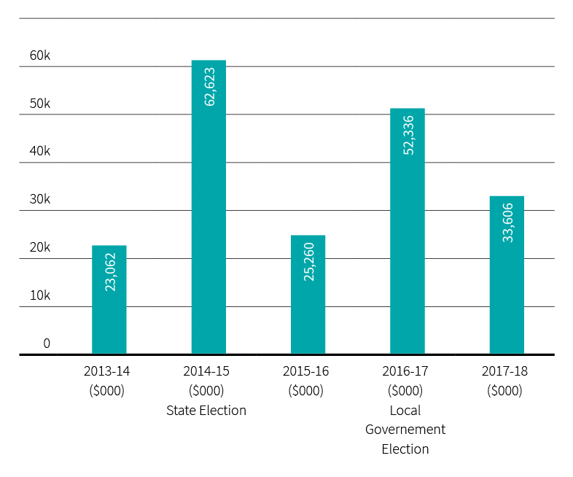

Expenses – How the VEC’s funding is utilized
The VEC's expenditure was largely committed to the delivery of commercial business and by-elections, and planning for the 2018 State election. Funding was committed to workforce costs, engagements with key service providers and general operational outgoings, such as rentals, logistics and telecommunications.
VEC Operational Expenditure ($’000)
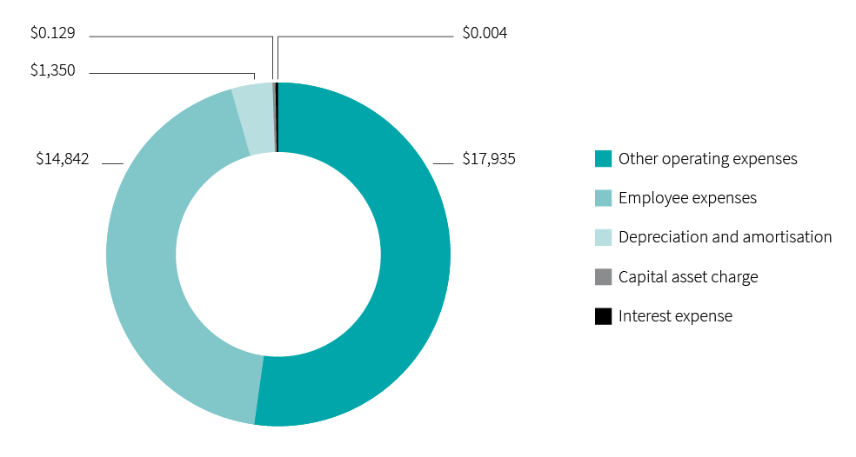

Assets – What the VEC owns
Assets owned by the VEC are largely within election inventory and plant and equipment across its two locations. The largest asset owned and developed by the VEC is the Election Management System, which underpins the VEC’s ability to manage and host election activities. The system undergoes ongoing development and enhancement to meet election needs and legislative changes and to improve the efficiency and delivery of elections. The VEC also committed to investments in inventory and election-based assets ahead of the 2018 State election.
VEC assets
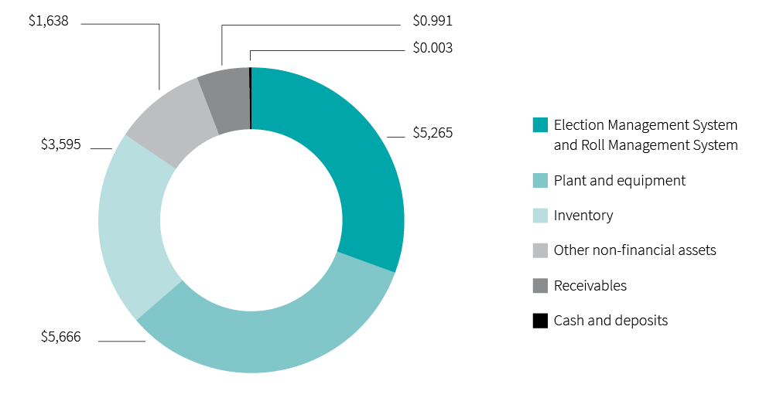

Liabilities – What the VEC owes
The VEC’s liabilities are largely represented by employee provisions (annual leave and long service leave owing to staff) and supplier commitments. Money owed to suppliers and creditors was timing related at 30 June 2018, based on terms of trade between the VEC and respective suppliers. Utilising strong internal cash flow management, the VEC endeavors to keep outstanding supplier commitments to a minimum ensuring payments are made within agreed trade terms. Trade creditor balances owing at 30 June 2018 were subsequently cleared the following month.
VEC liabilities

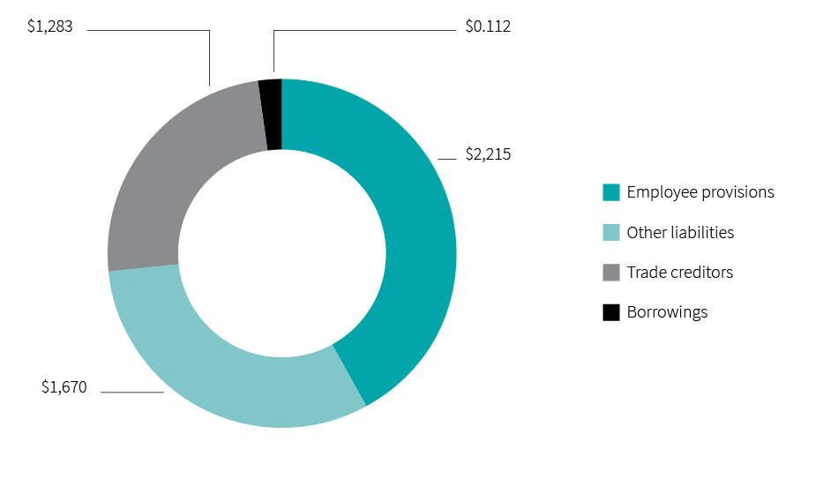

Accountable officer’s and chief finance and accounting officer’s declaration

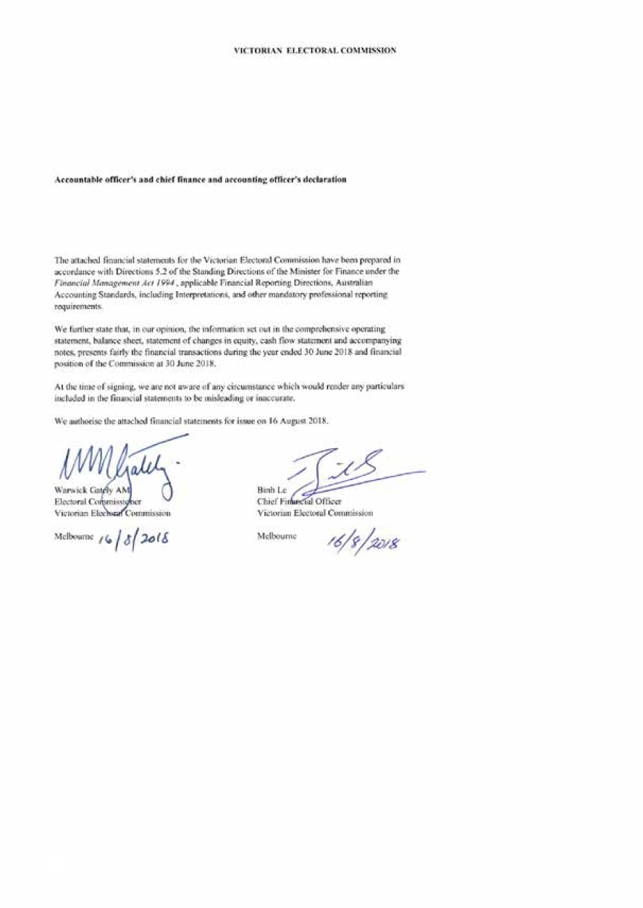

Comprehensive operating statement

for the financial year ended 30 June 2018
 | Notes | 2017  $’000 | 2018  $’000
Continuing operations
Income from transactions
Special appropriations | 2.1 | 52,336 | 33,606
Total income from transactions |  | 52,336 | 33,606
Expenses from transactions
Employee expenses | 3.1.1 | (20,607) | (14,842)
Depreciation and amortisation | 5.1.1 | (849) | (1,350)
Interest expense |  | (1) | (4)
Capital asset charge | 3.2 | (129) | (129)
Other operating expenses | 3.3 | (29,867) | (17,935)
Total expenses from transactions |  | (51,453) | (34,260)
Net result from transactions (net operating balance) |  | 883 | (654)
Other economic flows included in net result
Other gains / (losses) from other economic flows | 9.2 | 34 | 2
Total other economic flows included in net result |  | 34 | 2
Net result |  | 917 | (652)
Comprehensive result |  | 917 | (652)
The comprehensive operating statement should be read in conjunction with the notes to the financial statements.

Balance sheet

as at 30 June 2018
 | Notes | 2017  $’000 | 2018  $’000
Assets
Financial assets
Cash and deposits | 7.1 | 3 | 3
Receivables | 6.1 | 2,853 | 991
Total financial assets |  | 2,856 | 994
Non-financial assets
Inventories | 6.3 | 1,975 | 3,595
Property, plant and equipment | 5.1 | 2,605 | 5,666
Intangible assets | 5.2 | 4,979 | 5,265
Other non financial assets | 6.4 | 331 | 1,638
Total non-financial assets |  | 9,890 | 16,164
Total assets |  | 12,746 | 17,158
Liabilities
Payables | 6.2 | 956 | 1,283
Borrowings |  | 73 | 112
Employee-related provisions | 3.1.2 | 2,028 | 2,215
Other provisions | 6.5 | 667 | 574
Other liabilities | 6.6 | 1,332 | 1,096
Total liabilities |  | 5,056 | 5,280
Net assets |  | 7,690 | 11,878
Equity
Accumulated (deficit) / surplus |  | (24,878) | (25,530)
Contributed capital |  | 32,568 | 37,408
Net worth |  | 7,690 | 11,878
Commitments for expenditure | 7.2
Contingent assets and contingent liabilities | 8.2

The balance sheet should be read in conjunction with the notes to the financial statements.

Statement of changes in equity

for the financial year ended 30 June 2018
 | Notes | ACCUMULATED  SURPLUS  $’000 | CONTRIBUTED  CAPITAL  $’000 | TOTAL  $’000
Balance at 1 July 2016 |  | (25,795) | 32,068 | 6,273
Net result for the year |  | 917 | - | 917
Capital appropriations |  | - | 500 | 500
Balance at 30 June 2017 |  | (24,878) | 32,568 | 7,690
Net result for the year |  | (652) | - | (652)
Capital appropriations |  | - | 4,840 | 4,840
Balance at 30 June 2018 |  | (25,530) | 37,408 | 11,878
The statement of changes in equity should be read in conjunction with the notes to the financial statements.

Cash flow statement

for the financial year ended 30 June 2018
 | Notes | 2017  $’000 | 2018  $’000
Cash flows from operating activities
Receipts
Receipts from Government |  | 52,573 | 36,761
Net Goods and Services Tax recovered from the ATO |  | - | 2,059
Total receipts |  | 52,573 | 38,820
Payments
Payments to suppliers and employees |  | (52,198) | (38,859)
Net Goods and Services Tax paid to the ATO | (i) | (249) | -
Capital asset charge payments |  | (129) | -
Interest and other costs of finance paid |  | (1) | -
Total payments |  | (52,577) | (38,859)
Net cash flows from / (used in) operating activities | 7.1.1 | (4) | (39)
Cash flows from investing activities
Purchases of non-financial assets |  | (500) | (4,840)
Sales of non-financial assets |  | 5 | -
Net cash flows (used in) / from investing activities |  | (495) | (4,840)
Cash flows from financing activities
Owner contributions by State Government |  | 500 | 4,840
Repayment of finance leases |  | - | 39
Net cash flows from / (used in) financing activities |  | 500 | 4,879
Net increase / (decrease) in cash and cash equivalents |  | 1 | -
Cash and cash equivalents at the beginning of the financial year |  | 2 | 3
Cash and cash equivalents at the end of the financial year | 7.1 | 3 | 3

The above cash flow statement should be read in conjunction with the notes to the financial statements.
Notes: (i) Goods and Services Tax paid to the ATO is presented on a net basis

Notes to the financial statements

for the financial year ended 30 June 2018

Note 1. About this report
The Victorian Electoral Commission (the Commission) is an independent body of the State of Victoria, established pursuant to an order made by the Premier under the Electoral Act 2002.
Its principal address is:
Victorian Electoral Commission
Level 11, 530 Collins Street
Melbourne VIC 3000
The Commission is an administrative agency acting on behalf of the Crown.
A description of the nature of the Commissionʼs operations and its principal activities is included in the report of operations which does not form part of these financial statements.

Objectives
The Commissionʼs overall objective is to provide election services to State and Local Government, as well as conducting various fee for service elections.
The Commission is funded by accrual-based parliamentary appropriations for the provision of outputs. It provides on a fee for service basis election services for Local Government and Commercial elections. The fees charged for these services are determined by prevailing market forces.

Basis of preparation
These financial statements cover the Victorian Electoral Commission as an individual reporting entity and include all of its controlled activities.
These financial statements are presented in Australian dollars, and prepared in accordance with the historical cost convention unless a different measurement basis is specifically disclosed in the note associated with the item measured on a different basis.
The accrual basis of accounting has been applied in the preparation of these financial statements whereby assets, liabilities, equity, income and expenses are recognised in the reporting period to which they relate, regardless of when cash is received or paid. The only exception is for special appropriation revenue, which is recognised on a cash basis when the amount appropriated for a specific purpose is received by the Commission.
Judgements, estimates and assumptions are required to be made about financial information being presented. The significant judgements made in the preparation of these financial statements are disclosed in the notes where amounts affected by these judgements are disclosed. Estimates and associated assumptions are based on professional judgements derived from historical experience and various other factors that are believed to be reasonable under the circumstances. Actual results may differ from these estimates.

Revisions to accounting estimates are recognised in the period in which the estimate is revised and also in future periods that are affected by the revision. Judgements and assumptions made by management in the application of AASs that have significant effects on the financial statements and estimates relate to:
- the fair value of measurement of property, plant and equipment (refer to 5.1)
- superannuation contributions (refer to 3.1.3)
- employee and provisions (refer to 3.1.1 and 3.1.2)
  - useful lives of property, plant and equipment (refer to 5.1.1)
All amounts in the financial statements have been rounded to the nearest thousand dollars, unless otherwise stated. Figures in the financial statements may not equate due to rounding. Please refer to the end of Note 9 for a style convention explaining that minor discrepancies in totals of tables are due to rounding.

Compliance information
These general purpose financial statements have been prepared in accordance with the Financial Management Act 1994 and applicable Australian Accounting Standards (AAS) which include Interpretations, issued by the Australian Accounting Standards Board (AASB). In particular, they are presented in a manner consistent with the requirements of the AASB 1049 Whole of Government and General Government Sector Financial reporting.
Where appropriate, those AAS paragraphs applicable to not-for-profit entities have been applied.
Accounting policies are selected in a manner which ensures that the resulting financial information satisfies the concepts of relevance and reliability, thereby ensuring that the substance of the underlying transactions or other events is reported.

Note 2. Funding delivery of our services
The Commissionʼs purpose is to deliver high quality, accessible electoral services with innovation, integrity and independence to enable all Victorians to actively participate in the democratic process.
2.1 Summary of Income that funds the delivery of services
 | NOTES | 2017  $’000 | 2018  $’000
Special appropriations | 2.2 | 52,336 | 33,606
Total income from transactions |  | 52,336 | 33,606

2.2 Appropriations
Annual parliamentary appropriations income becomes controlled and is recognised by the Commission when it is appropriated from the Consolidated Fund by the Victorian Parliament via the Department of Premier and Cabinet and applied to the purposes defined under the Electoral Act 2002.
Special appropriations
The appropriation revenue is recognised on a cash basis when the operating bank account is funded by the State government.

Note 3. The cost of delivering services

Introduction
This section provides an account of the expenses incurred by the Commission in delivering services and outputs. In Note 2, the funds that enable the provision of services were disclosed and in this note the cost associated with provision of services are recorded.
3.1 Expenses incurred in delivery of services
 | NOTES | 2017  $’000 | 2018  $’000
Employee expenses | 3.1.1 | 20,607 | 14,842
Capital asset charge | 3.2 | 129 | 129
Other operating expenses | 3.3 | 29,867 | 17,935
Total expenses incurred in delivery of services |  | 50,603 | 32,906

3.1.1 Employee benefits in the comprehensive operating statement
 | 2017  $’000 | 2018  $’000
Defined benefit and contribution superannuation expense | 1,514 | 1,162
Salaries and wages, annual leave and long service leave | 19,093 | 13,680
Total employee expenses | 20,607 | 14,842

Employee expenses include all costs related to employment including wages and salaries, superannuation, fringe benefits tax, leave entitlements, redundancy payments and WorkCover premiums.
The amount recognised in the comprehensive operating statement in relation to superannuation is employer contributions for members for both defined benefit and defined contribution superannuation plans that are paid or payable during the reporting period.
The Commission does not recognise any defined benefit liability in respect of the plan(s) because the entity has no legal or constructive obligation to pay future benefits relating to its employees; its only obligation is to pay superannuation contributions as they fall due. The Department of Treasury and Finance (DTF) discloses the Stateʼs defined benefit liabilities in its disclosure for administered items.

3.1.2 Employee benefits in the balance sheet
Provision is made for benefits accruing to employees in respect of wages and salaries, annual leave and long service leave for services rendered to the reporting date.
 | 2017  $’000 | 2018  $’000
Current provisions
Annual leave
Unconditional and expected to be settled within 12 months (i) | 610 | 665
Unconditional and expected to be settled after 12 months (ii) | 25 | 53
Long service leave
Unconditional and expected to be settled within 12 months (i) | 114 | 121
Unconditional and expected to be settled after 12 months (ii) | 779 | 955
 | 1,528 | 1,794
Provisions for on-costs
Unconditional and expected to be settled within 12 months (i) | 112 | 121
Unconditional and expected to be settled after 12 months (ii) | 124 | 156
 | 236 | 277
Total current employee related provisions | 1,764 | 2,071
Non-current provisions
Employee benefits (i) | 229 | 125
On-costs | 35 | 19
Total non-current employee related provisions | 264 | 144
Total employee related provisions | 2,028 | 2,215
Note: (i) Employee benefits consist of annual leave and long service leave accrued by employees. On-costs such as payroll tax and workersʼ compensation insurance are not employee benefits and are reflected as a separate provision.
(ii) Amounts are measured at present values.

Reconciliation of movement in on-cost provision
2018
$’000
Opening balance | 271
Additional provisions recognised | 717
Reductions arising from payments / other sacrifices of future economic benefits | (692)
Closing balance | 296
Current | 277
Non-current | 19
Total employee benefits | 296

Wages, salaries and annual leave
Liabilities for wages and salaries (including non-monetary benefits, annual leave and on-costs) are recognised as part of the employee benefit provision as current liabilities, because the Commission does not have an unconditional right to defer settlement of these liabilities.
The liability for wages and salaries are recognised in the balance sheet at remuneration rates which are current at the reporting date. As the Commission expects the liabilities to be wholly settled within 12 months of reporting date, they are measured at undiscounted amounts.
The annual leave liability is classified as a current liability and measured at the undiscounted amount expected to be paid, as the Commission does not have an unconditional right to defer settlement of the liability for at least 12 months after the end of the reporting period.
Employment on-costs such as payroll tax, workers compensation and superannuation are not employee benefits. They are disclosed separately as a provision for employee benefits when the employment to which they relate has occurred.

Long service leave
Liability for long service leave (LSL) is recognised in the provision for employee benefits. Unconditional LSL is disclosed in the notes to the financial statements as a current liability, even where the Commission does not expect to settle the liability within 12 months because it will not have the unconditional right to defer the settlement of the entitlement should an employee take leave within 12 months:
The components of this current LSL are measured at:
- undiscounted value - if the Commission expects to wholly settle within 12 months; or
  - present value - if the Commission does not expect to wholly settle within 12 months.
Conditional LSL is disclosed as a non - current liability.
There is an unconditional right to defer the settlement of the entitlement until the employee has completed the requisite years of service. This non-current LSL liability is measured at present value.
Any gain or loss following revaluation of the present value of non-current LSL liability is recognised as a transaction, except to the extent that a gain or loss arises due to changes in bond interest rates for which it is then recognised as an other economic flows included in the net result.
3.1.3 Superannuation contributions
Employees of the Commission are entitled to receive superannuation benefits and the Commission contributes to both defined benefit and defined contribution plans. The defined benefit plan(s) provides benefits based on years of service and final average salary.
The Commission does not recognise any defined benefit liabilities because it has no legal or constructive obligation to pay future benefits relating to its employees. Instead the DTF discloses in its annual financial statements the net defined benefit cost related to the members of these plans as an administered liability (on behalf of the State of Victoria as the sponsoring employer).
As noted before, the defined benefit liability is recognised in DTF as an administered liability. However, superannuation contributions paid or payable for the reporting period are included as part of employee benefits in the comprehensive operating statement of the Commission.
The name, details and amounts expensed in relation to the major employee superannuation funds and contributions made by the Commission are as follows:

 | PAID CONTRIBUTION for the year |  | Contribution outstanding
 | 2017  $’000 | 2018  $’000 | 2017  $’000 | 2018  $’000
Defined benefit plans:
State Superannuation Fund - revised and new (i) | 52 | - | - | -
Defined contribution plans:
Vicsuper | 696 | 542 | - | -
Other | 766 | 620 | - | -
Total | 1,514 | 1,162 | - | -
Notes: (i) The bases for determining the level of contributions is determined by the various actuaries of the defined benefit superannuation plans

3.2 Capital asset charge
 | 2017  $’000 | 2018  $’000
Capital asset charge | 129 | 129

A capital asset charge is a charge levied on the written down value of controlled non-current physical assets in the Commissionʼs balance sheet. It aims to attribute to the Commission outputs, a cost of capital used in service delivery. Imposing this charge provided incentives for the Commission to identify and dispose of underutilised or surplus non-current physical assets.

3.3 Other operating expenses
 | 2017  $’000 | 2018  $’000
Purchase of supplies and consumables | 5,352 | 2,718
Purchase of services | 20,644 | 11,897
Maintenance | 654 | 653
Other | 89 | 109
Operating lease rental expense | 3,128 | 2,558
Total other operating expenses | 29,867 | 17,935

Other operating expenses generally represent the day-to-day running costs incurred in normal operations and are recognised as an expense in the reporting period in which they are incurred.
The exception to this is operating lease payments, which are recognised on a straight-line basis over the lease term.

Note 4. Disaggregated financial information by output

Note 4.1 Administered (non-controlled) items
Administered income includes provision of services for conducting Local Government elections, fines and electoral entitlements. Administered expenses include payments made in conducting Local Government elections and payments to Councils. Administered assets include government income earned but not yet collected.
In addition to the specific Commission operations which are included in the financial statements (comprehensive operating statement, balance sheet, statement of changes in equity and cash flow statement), the Commission administers or manages, but does not control, other activities and resources on behalf of the State and Local Government. The transactions relating to these activities are reported as administered items.
 | State |  | local Government |  | total
 | 2017  $’000 | 2018  $’000 | 2017  $’000 | 2018  $’000 | 2017  $’000 | 2018  $’000
Administered income from transactions
Income from conducting Local Government Elections | 26,273 | 2,275 | - | - | 26,273 | 2,275
Fines | 630 | 414 | 11,796 | 7,703 | 12,426 | 8,117
Candidates deposits | - | 3 | - | - | - | 3
Electoral entitlements | - | 56 | - | - | - | 56
Total administered income from transactions | 26,903 | 2,748 | 11,796 | 7,703 | 38,699 | 10,451
Administered expenses from transactions
Payments to Conduct Local Government Elections | 25,945 | 2,786 | - | - | 25,945 | 2,786
Payments to Councils | - |  | 9,767 | 8,505 | 9,767 | 8,505
Total administered expenses from transactions | 25,945 | 2,786 | 9,767 | 8,505 | 35,712 | 11,291
Total administered net result from transactions (net operating balance) | 958 | (38) | 2,029 | (802) | 2,987 | (840)
Administered financial assets
Cash | - | - | 2,029 | 1,227 | 2,029 | 1,227
Receivables | 1,165 | 1,363 | - | - | 1,165 | 1,363
Total administered financial assets | 1,165 | 1,363 | 2,029 | 1,227 | 3,194 | 2,590
Administered liabilities
Payables | - | 236 | - | - | - | 236
Compulsory Voting Fines | - | - | 2,029 | 1,227 | 2,029 | 1,227
Total administered liabilities | - | 236 | 2,029 | 1,227 | 2,029 | 1,463
Total administered net assets | 1,165 | 1,127 | - | - | 1,165 | 1,127

Note 5. Key assets available to support output delivery

Introduction
The Commission controls property, intangibles, plant and equipment that are used in fulfilling its objectives and conducting its activities. They represent the resources that have been entrusted to the Commission to be utilised for delivery of those outputs.
Note 5.1 Total property, plant and equipment
 | GROSS Carrying amount |  | ACCUMULATED  DEPRECIATION |  | NET CARRYING amount
 | 2017 $’000 | 2018 $’000 | 2017 $’000 | 2018 $’000 | 2017 $’000 | 2018 $’000
Plant, equipment, fixtures & fittings and vehicles at fair value | 3,171 | 5,577 | (2,473) | (2,801) | 698 | 2,776
Leasehold Improvements | 4,071 | 5,628 | (2,164) | (2,738) | 1,907 | 2,890
Net carrying amount | 7,242 | 11,205 | (4,637) | (5,539) | 2,605 | 5,666

Initial recognition
All non-financial physical assets are measured initially at cost and subsequently revalued at fair value less accumulated depreciation and impairment.
The cost of leasehold improvements is capitalised as an asset and amortised over the shorter of the remaining term of the lease or the estimated useful life of the improvements.
The initial cost for non-financial physical assets under a finance lease is measured at amounts equal to the fair value of the leased asset or, if lower, the present value of the minimum lease payments, each determined at the inception of the lease.
The fair value of plant, equipment and vehicles, is normally determined by reference to the assetʼs depreciated replacement cost. For plant, equipment and vehicles, existing depreciated historical cost is generally a reasonable proxy for depreciated replacement cost because of the short lives of the asset concerned.

5.1.1 Depreciation and impairment
Charge for the period | 2017  $’000 | 2018  $’000
Property, plant and equipment | 466 | 967
Intangible assets | 383 | 383
Total depreciation and amortisation | 849 | 1,350

All property, plant and equipment and other non-financial physical assets (excluding items under operating leases) that have finite useful lives are depreciated. Depreciation is calculated on a straight-line basis, at rates that allocate the assetʼs value, less any estimated residual value, over its estimated useful life.
Intangible produced assets with finite lives are amortised as an ʻexpense from transactionsʼ on a straight-line basis over their useful lives.
The estimated useful lives, residual values and depreciation method are reviewed at the end of each annual reporting period, and adjustments made where appropriate.
The following are typical estimated useful lives for the different asset classes for current and prior years.

Asset class | Useful life (years)
Leasehold Improvements | 10 - 12
Leased motor vehicles | 3 - 5
Plant & equipment | 2 - 10
Furniture & fittings | 5 - 14
Computer equipment | 2 - 3
Intangible produced assets - software development | 17 (2017 - 11 years)

Impairment
All items of property, plant and equipment are assessed annually for indications of impairment, except for inventories. If there is an indication of impairment, the assets concerned are tested as to whether their carrying value exceeds their recoverable amount. Where an assetʼs carrying value exceeds its recoverable amount, the difference is written off as an other economic flow included in net result, except to the extent that the write-down can be debited to an asset revaluation surplus amount applicable to that class of asset.
If there is an indication that there has been a reversal in impairment, the carrying amount shall be increased to its recoverable amount. This reversal of the impairment loss occurs only to the extent that the assetʼs carrying amount does not exceed the carrying amount that would have been determined, net of depreciation or amortisation, if no impairment loss has been recognised in prior years.
It is deemed that, in the event of the loss or destruction of an asset, the future economic benefits arising from the use of the asset will be replaced unless a specific decision to the contrary has been made.
The recoverable amount for most assets is measured at the higher of current replacement cost and fair value less costs to sell.

5.1.2 Classification by ʻPublic Administrationʼ Purpose Group - Movements in carrying amounts
 | PLANT, EQUIPMENT, FIXTURES AND FITTINGS AND VEHICLES AT FAIR VALUE |  | LEASEHOLD IMPROVEMENTS |  | total
 | 2017  $’000 | 2018  $’000 | 2017  $’000 | 2018  $’000 | 2017  $’000 | 2018  $’000
Opening balance | 366 | 698 | 2,259 | 1,907 | 2,625 | 2,605
Additions | 458 | 2,518 | 2 | 1,653 | 460 | 4,171
Disposals | (14) | (47) | - | (96) | (14) | (143)
Depreciation | (112) | (393) | (354) | (574) | (466) | (967)
Closing balance | 698 | 2,776 | 1,907 | 2,890 | 2,605 | 5,666
Note: (i) Fair value assessments have been performed for all classes of assets within this purpose group and the decision was made that movements were not material (less than or equal to 10 per cent) for a full revaluation.

Note 5.2 Intangible assets
 | 2017  $’000 | 2018  $’000
Gross carrying amount
Opening balance | 19,888 | 19,928
Addition from internal development | 40 | 669
Closing balance | 19,928 | 20,597
Accumulated amortisation
Opening balance | (14,566) | (14,949)
Amortisation expense (i) | (383) | (383)
Closing balance | (14,949) | (15,332)
Net book value | 4,979 | 5,265
Note: (i) The consumption of intangible produced assets is included in 'depreciation and amortisation' line items.

Initial recognition
Purchased intangible assets are initially recognised at cost. Subsequently, intangible assets with finite useful lives are carried at cost less accumulated amortisation and accumulated impairment losses. Costs incurred subsequent to initial acquisition are capitalised when it is expected that additional future economic benefits will flow to the Commission.
When the recognition criteria in AASB 138 Intangible Assets are met, internally generated intangible assets are recognised and measured at cost less accumulated depreciation / amortisation and impairment.
An internally-generated intangible asset arising from development (or from the development phase of an internal project) is recognised if, and only if, all of the following are demonstrated:
- the technical feasibility of completing the intangible asset so that it will be available for use or sale
- an intention to complete the intangible asset and use or sell it
- the ability to use or sell the intangible asset
- the intangible asset will generate probable future economic benefits
- the availability of adequate technical, financial and other resources to complete the development and to use or sell the intangible asset
- the ability to measure reliably the expenditure attributable to the intangible asset during its development

Subsequent measurement
Intangible produced assets with finite useful lives are amortised as an expense from transactions on a systematic (typically straight-line) basis over the assetʼs useful life. Amortisation begins when the asset is available for use, that is, when it is in the location and condition necessary for it to be capable of operating in the manner intended by management.

Impairment of intangible assets
All intangible assets with indefinite useful lives are not depreciated or amortised, but are tested for impairment by comparing its recoverable amount with its carrying amount:
- annually
- whenever there is an indication that the intangible asset may be impaired
Intangible assets with finite useful lives are tested for impairment whenever an indication of impairment is identified.

Significant intangible assets
The Commission has capitalised software development expenditure for the development of its election management and electoral rolls development. The carrying amount of the capitalised software development expenditure of $5.3 million (2017: $4.9 million) includes existing developed software and software and software under development.
The existing election management software was fully amortised in 2011 and the electoral roll software development fully amortised in 2015.

Note 6. Other assets and liabilities
This section sets out those assets and liabilities that arose from the Commissionʼs controlled operations.
6.1 Receivables
 | 2017  $’000 | 2018  $’000
Current receivables
Statutory
GST input tax credit recoverable | 176 | 654
 | 176 | 654
Contractual
Other receivables | 2,677 | 337
 | 2,677 | 337
Total current receivables | 2,853 | 991
Total receivables | 2,853 | 991

Contractual receivables are classified as financial instruments and categorised as receivables as financial instruments and categorised as receivables (refer to Note 8.1.1 for recognition and measurement). They include mainly debtors in relation to goods and services.
Statutory receivables are recognised and measured similarly to contractual receivables (except for impairment), but are not classified as financial instruments because they do not arise from a contract. They include predominantly amounts owing from the Victorian Government and GST input tax credits recoverable.
Doubtful debts: Receivables are assessed for bad and doubtful debts on a regular basis. Those bad debts considered as written off by mutual consent are classified as a transaction expense. Bad debts not written off by mutual consent and the allowance for doubtful receivables are classified as other economic flows in the net result.
A provision for doubtful receivables is recognised when there is objective evidence that the debts may be not be collected, and bad debts are written off when identified.

6.1.1 Ageing analysis of contractual receivables (i)
($ʼ000) Past due but not impaired
 | Carrying  amount | Neither past  due nor  impaired | less than  1 month | 1-3  months | 3 months  - 1 year | 1-5  years | 5+  years
2017
Receivables
Other Receivables | 2,677 | 2,677 | - | 2,677 | - | - | -
Total | 2,677 | 2,677 | - | 2,677 | - | - | -
2018
Receivables
Other Receivables | 337 | 337 | - | 337 | - | - | -
Total | 337 | 337 | - | 337 | - | - | -
6.2 Payables
 | 2017  $’000 | 2018  $’000
Current payables
Contractual
Supplies and services (i) | 929 | 1,267
Other payables | 27 | 16
Total current payables | 956 | 1,283
Total payables | 956 | 1,283
Note: (i) The average credit period is 30 days. No interest is charged on payables.
Contractual payables are classified as financial instruments and categorised as financial liabilities at amortised cost. Accounts payable represent liabilities for goods and services provided to the Commission prior to the end of the financial year that are unpaid, and arise when the Commission becomes obliged to make future payments in respect of the purchase of those goods and services.

Maturity analysis of contractual payables (i)
($ʼ000) maturity dates
 | Carrying  amount | nominal amount | less than  1 month | 1-3  months | 3 months  - 1 year | 1-5  years | 5+  years
2017
Payables
Trade and other payables | 956 | 956 | 956 | - | - | - | -
Total | 956 | 956 | 956 | - | - | - | -
2018
Payables
Trade and other payables | 1,283 | 1,283 | 1,283 | - | - | - | -
Total | 1,283 | 1,283 | 1,283 | - | - | - | -
Note: (i) Maturity analysis is presented using the contractual undiscounted cash flows.
6.3 Inventories
 | 2017  $’000 | 2018  $’000
Current inventories
Supplies and consumables
At cost | 1,975 | 3,595
Total inventories | 1,975 | 3,595

Inventories include goods and other property for distribution at zero or nominal cost, or for consumption in the ordinary course of business operations. Inventories held for distribution are measured at cost, adjusted for any loss of service potential. Bases used in assessing loss of service potential for inventories held for distribution include current replacement cost and technical or functional obsolescence. Technical obsolescence occurs when an item still functions for some or all of the tasks it was originally acquired to do, but no longer matches existing technologies. Functional obsolescence occurs when an item no longer functions the way it did when it was first acquired.

6.4 Other non-financial assets
 | 2017  $’000 | 2018  $’000
Current other non-financial assets
Prepayments | 331 | 1,638
Total current other non-financial assets | 331 | 1,638

Other non-financial assets include prepayments which represent payments in advance of receipt of goods or services or that part of expenditure made in one accounting period covering a term extending beyond that period.

6.5 Other provisions
 | 2017  $’000 | 2018  $’000
Non-current provisions
Make good-provision (i) | 667 | 574
Total other provisions | 667 | 574
(i) In accordance with the lease agreement over the Head office and warehouse facilities, the VEC must remove any leasehold improvements from the leased premises and restore the premises to its original condition at the end of the lease term.
A provision has been established for make good of the leased premises to cover those make good costs expected to be incurred at the expiry of the leases.
6.6 Other liabilities
 | 2017  $’000 | 2018  $’000
Current other liabilities
Lease incentive | 293 | 236
Total current other liabilities | 293 | 236
Non-current other liabilities
Lease incentive | 1,039 | 860
Total non-current other liabilities | 1,039 | 860
Total other liabilities | 1,332 | 1,096

Other liabilities refer to lease incentives granted for the Head office and warehouse facilities on the execution of the lease agreements respectively.
All incentives for the agreement of a new or renewed operating lease are recognised as an integral part of the consideration agreed for the use of the leased asset.
In the event that lease incentives are received to enter into operating leases, the aggregate cost of incentives are recognised as a reduction of rental expense over the lease term on a straight-line basis, unless another systematic basis is more representative of the time pattern in which economic benefits from the lease asset are consumed.
Under AASB117 and Interpretation 115, lease incentives are to be recognised and amortised over the life of the lease on a straight line basis.

Note 7. How we financed our operations
This section provides information on the sources of finance the Commission used during its operations, along with interest expense (the cost of borrowings) and other information related to financing the Commission's activities.
This section includes disclosures of balances that are financial instruments (such as borrowings and cash balances).
Note 7.1 Cash balances and cash flow information
 | 2017  $’000 | 2018  $’000
Total cash and deposits disclosed in the balance sheet | 3 | 3
Balance as per cash flow statement | 3 | 3

The Commission does not hold a large cash reserve in its bank accounts. Cash received from generation of income is generally paid into the State of Victoria bank account ('public account'). Similarly, Commission expendidure, including in the form of cheques drawn for the payments to its suppliers and creditors, are made via the public account. The public account remits to the Commission the cash required upon presentation of cheques by the Commission's suppliers or creditors.
7.1.1 Reconciliation of net result for the period to cash flow from operating activities
 | 2017  $’000 | 2018  $’000
Net result for the period | 917 | (652)
Non-cash movements:
(Gain)/loss on sale or disposal of non-current assets | (12) | 143
Depreciation and amortisation of non current assets | 849 | 1,350
Movements in assets and liabilities
(Increase) / decrease in receivables | (2,437) | 1,862
(Increase) / decrease in inventories | 640 | (1,620)
(Increase) / decrease in other non-financial assets | 419 | (1,307)
Increase / (decrease) in payables | (123) | 327
Increase / (decrease) in provisions | (21) | 94
Increase / (decrease) in other liabilities | (236) | (236)
Net cash flows from/(used in) operating activities | (4) | (39)

Note 7.2 Commitments for expenditure
Commitments for future expenditure include operating and capital commitments arising from contracts. These commitments are recorded at their nominal value and inclusive of the goods and services tax (GST) payable. In addition, where it is considered appropriate and provides additional relevant information to users, the net present values of significant individual projects are stated. These future expenditures cease to be disclosed as commitments once the related liabilities are recognised in the balance sheet.
The following commitments have not been recognised as liabilities in the financial statements:
7.2.1 Total Commitments payable
nominal value | 2017  $’000 | 2018  $’000
Operating and lease commitments (i)
Less than one year | 3,269 | 4,847
Longer than one year and not longer than five years | 14,399 | 20,441
Five years or more | 2,172 | -
Total operating and lease commitments | 19,840 | 25,288
Other commitments (ii)
Less than one year | 1,518 | 1,009
Total other commitments | 1,518 | 1,009
Total commitments (inclusive of GST) | 21,358 | 26,297
Less GST recoverable from the Australian Taxation Office | (1,804) | -
Total commitments (exclusive of GST) | 19,554 | 26,297
Notes: (i) Operating leases relate to office and warehouse facilities with lease terms between one to twelve years. All operating lease contracts contain market review clauses in the event that the Commission exercises its option to renew. The Commission does not have an option to purchase the leased asset at the expiry of the lease period.
(ii) Commitments under outsourcing contracts are for joint electoral roll procedure at the end of the reporting period.

Note 8. Risks, contingencies and valuation judgements
The Commission is exposed to risk from its activities and outside factors. In addition, it is often necessary to make judgements and estimates associated with recognition and measurement of items in the financial statements. This section sets out financial instrument specific information (including exposures to financial risks), as well as those items that are contingent in nature or require a higher level of judgement to be applied, which for the Commission relates mainly to fair value determination.

Note 8.1 Financial instruments specific disclosures

Introduction
Financial instruments arise out of contractual agreements that give rise to a financial asset of one entity and a financial liability or equity instrument of another entity. Due to the nature of the Commission's activities, certain financial assets and financial liabilities arise under statute rather than a contract. Such financial assets and financial liabilities do not meet the definition of financial instruments in AASB 132 Financial Instruments: Presentation. For example, statutory receivables arising from taxes, fines and penalties do not meet the definition of financial instruments as they do not arise under contract. However, guarantees issued by the Treasurer on behalf of the Commission are financial instruments because, although authorised under statute, the terms and conditions for each financial guarantee may vary and are subject to an agreement.
Where relevant, for note disclosure purposes, a distinction is made between those financial assets and financial liabilities that meet the definition of financial instruments in accordance with AASB 132 and those that do not.
Categories of financial instruments
Receivables and cash are financial instrument assets with fixed and determinable payments that are not quoted on an active market. They are initially measured at fair value plus any directly attributable transaction costs. Subsequent to initial measurement, these are measured at amortised cost using the effective interest method, less any impairment. The Commission recognises the following assets in this category:
- cash and deposits
  - receivables (excluding statutory receivables)

Financial liabilities at amortised cost are initially recognised on the date they are originated. They are initially measured at fair value plus any directly attributable transaction costs. Subsequent to initial recognition, these financial instruments are measured at amortised cost with any difference between the initial recognised amount and the redemption value being recognised in profit and loss over the period of the interest-bearing liability, using the effective interest rate method.
The Commission recognises the following liabilities in this category:
- payables (excluding statutory payables)
  - borrowings

Derecognition of financial assets
A financial asset (or, where applicable, a part of a financial asset or part of a group of similar financial assets) is derecognised when the rights to receive cash flows from the asset have expired.
Impairment of financial assets
At the end of each reporting period, the Commission assesses whether there is objective evidence that a financial asset or group of financial assets is impaired. All financial instrument assets, except those measured at fair value through profit or loss, are subject to annual review for impairment.
Derecognition of financial liabilities
A financial liability is derecognised when the obligation under the liability is discharged, cancelled or expires.

8.1.1 Financial instruments: categorisation
 |  | 2017  $’000 | 2018  $’000
Financial assets | Category
Cash and deposits | Receivables and cash | 3 | 3
Receivables (i) | Receivables and cash | 2,677 | 337
Total contractual financial assets |  | 2,680 | 340
Financial liabilities
Payables (i) | Amortised cost | 956 | 1,283
Borrowings | Amortised cost | 73 | 112
Total contractual financial liabilities |  | 1,029 | 1,395
(i) The total amounts disclosed here exclude statutory amounts (e.g. Amounts owing from Victorian Government, GST input tax credit recoverable, and GST payables).

8.1.2 Financial risk management objectives and policies
The main purpose in holding financial instruments is to prudentially manage the Commission's financial risks within the Government policy parameters.
The Commission's main financial risks include credit risk, liquidity risk and interest rate risk. The Commission manages these financial risks in accordance with its financial risk management policy.
The Commission uses different methods to measure and manage the different risks to which it is exposed. Primary responsibility for the identification and management of financial risks rests with the Electoral Commissioner in consultation with the Audit and Risk Committee.
Liquidity Risk
Liquidity risk is the risk that the Commission would be unable to meet its financial obligations as and when they fall due. The Commission operates under the Government fair payments policy of settling financial obligations within 30 days and in the event of a dispute, making payments within 30 days from the date of resolution.
The Commission's maximum exposure to liquidity risk is the carrying amounts of financial liabilities as disclosed in the face of the balance sheet. The Commission's exposure to liquidity risk is deemed insignificant based on prior periods' data and current assessment of risk.
Credit Risk
Credit risk arises from the contractual financial assets of the Commission, which comprise cash and deposits, and non-statutory receivables. The Commission's exposure to credit risk arises from the potential default of a counter party on their contractual obligations resulting in financial loss to the Commission. Credit risk is measured at fair value and is monitored on a regular basis.
In addition, the Commission does not engage in hedging for its contractual financial assets and mainly obtains contractual financial assets that are on fixed interest, except for cash assets, which are mainly cash at bank. As with the policy for debtors, the Commission's policy is to only deal with banks with high credit ratings.
Provision of impairment for contractual financial assets is recognised when there is objective evidence that the Commission will not be able to collect a receivable. Objective evidence includes financial difficulties of the debtor, default payments, debts which are more than 60 days overdue, and changes in debtor credit ratings.
The carrying amount of contractual financial assets recorded in the financial statements, net of any allowances for losses, represents the Commission's maximum exposure to credit risk without taking account of the value of any collateral obtained. The Commission is not exposed to any material credit risk at balance date.
Market risk
The Commission's exposures to market risk are primarily through foreign currency risk and interest rate risk. Objectives, policies and processes used to manage each of these risks are disclosed below.
Foreign currency risk
The Commission is exposed to foreign currency risk mainly through its payables relating to purchases of supplies and consumables from overseas. This is because of a limited amount of transactions denominated in foreign currencies and a relatively short timeframe between commitment and settlement.
Based on past and current assessment of economic outlook, it is deemed unnecessary for the Commission to enter into any hedging arrangements to manage the risk.
The Commission is not exposed to any material foreign currency risk.
Interest rate risk
Fair value interest rate risk is the risk that the fair value of a financial instrument will fluctuate because of changes in market interest rates. The Commission does not hold any interest bearing financial instruments that are measured at fair value, therefore has no exposure to fair value interest rate risk.
Cash flow interest rate risk is the risk that the future cash flows of a financial instrument will fluctuate because of changes in market interest rates.
The Commission has no exposure to cash flow interest rate risks as cash is non-interest bearing.
The Commission's financial assets and liabilities are all non-interest bearing, except finance leases which are at fixed interest rates.

8.2 Contingent assets and contingent liabilities
Contingent assets and contingent liabilities are not recognised in the balance sheet, but are disclosed and, if quantifiable, are measured at nominal value. Contingent assets and liabilities are presented inclusive of GST receivable or payable respectively.
Contingent assets
Contingent assets are possible assets that arise from past events, whose existence will be confirmed only by the occurrence or non-occurrence of one or more uncertain future events not wholly within the control of the entity.
These are classified as either quantifiable, where the potential economic benefit is known, or non-quantifiable.
Contingent liabilities
Contingent liabilities are:
- possible obligations that arise from past events, whose existence will be confirmed only by the occurrence or non-occurrence of one or more uncertain future events not wholly within the control of the entity, or
- present obligations that arise from past events but are not recognised because:
    - it is not probable that an outflow of resources embodying economic benefits will be required to settle the obligations, or
    - the amount of the obligations cannot be measured with sufficient reliability.

Contingent liabilities are also classified as either quantifiable or non-quantifiable.
There are no contingent assets or contingent liabilities as at 30 June 2018 (2017 - Nil).

8.3 Fair value determination
Significant judgement: Fair value measurements of assets and liabilities
Consistent with AASB 13 Fair Value Measurement, the Commission determines the policies and procedures for both recurring fair value measurements such as property, plant and equipment and financial instruments, in accordance with the requirements of AASB 13 and the relevant Financial Reporting Directions.
Fair value determination requires judgement and the use of assumptions. This section discloses the most significant assumptions used in determining fair values. Changes to assumptions could have a material impact on the results and financial position of the Commission.
This section sets out information on how the Commission determined fair value for financial reporting purposes. Fair value is the price that would be received to sell an asset or paid to transfer a liability in an orderly transaction between market participants at the measurement date.
The following assets and liabilities are carried at fair value:
  - property, plant and equipment.
In addition, the fair values of other assets and liabilities that are carried at amortised cost, also need to be determined for disclosure purposes.
The Commission determines the policies and procedures for determining fair values for both financial and non-financial assets and liabilities as required.
Fair value hierarchy
All assets and liabilities for which fair value is measured or disclosed in the financial statements are categorised within the fair value hierarchy, described as follows, based on the lowest level input that is significant to the fair value measurement as a whole:
Level 1 - Quoted (unadjusted) market prices in active markets for identical assets or liabilities
Level 2 - Valuation techniques for which the lowest level input that is significant to the fair value measurement is directly or indirectly observable; and
Level 3 - Valuation techniques for which the lowest level input that is significant to the fair value measurement is unobservable.
For the purpose of fair value disclosures, the Commission has determined classes of assets and liabilities on the basis of the nature, characteristics and risks of the asset or liability and the level of the fair value hierarchy as explained above.
In determining fair values a number of inputs are used. The Commission uses only Level 3 unobservable inputs.
  - Level 3 - valuation techniques for which the lowest level input that is significant to the fair value measurement is unobservable.
How this section is structured
For those assets and liabilities for which fair values are determined, the following disclosures are provided:
- carrying amount and the fair value (which would be the same for those assets measured at fair value);
- which level of the fair value hierarchy was used to determine the fair value; and
- in respect of those assets and liabilities subject to fair value determination using Level 3 inputs:
    - a reconciliation of the movements in fair values from the beginning of the year to the end; and
    - details of significant unobservable inputs used in the fair value determination.

This section is divided between disclosures in connection with fair value determination for financial instruments (refer to Note 8.3.1) and non-financial physical assets (refer to Note 8.3.2).

8.3.1 Fair value determination of financial assets and liabilities
The fair values and net fair values of financial assets and liabilities are determined as follows:
- Level 1 - the fair value of financial instrument with standard terms and conditions and traded in active liquid markets are determined with reference to quoted market prices;
- Level 2 - the fair value is determined using inputs other than quoted prices that are observable for the financial asset or liability, either directly or indirectly; and
  - Level 3 - the fair value is determined in accordance with generally accepted pricing models based on discounted cash flow analysis using unobservable market inputs.
The Commission considers that the carrying amount of financial instrument assets and liabilities recorded in the financial statements to be a fair approximation of their fair values, because of the short-term nature of the financial instruments and the expectation that they will be paid in full.

8.3.2 Fair value determination: Non-financial physical assets
Fair value measurement hierarchy for assets as at 30 June 2018
($'000) CARRYING AMOUNT |  |  | FAIR VALUE MEASUREMENT AT THE END OF REPORTING PERIOD using:
 |  |  | LEVEl 1(i) | LEVEL2(i) | LEVEL3(i) | LEVEL1(i) | LEVEL2(i) | LEVEL3(i)
 | 2017 | 2018 | 2017 | 2017 | 2017 | 2018 | 2018 | 2018
Plant, equipment, fixtures and fittings and vehicles at fair value
Plant and equipment | 626 | 2,664 |  |  | 626 |  |  | 2,664
Vehicles (ii) | 72 | 112 |  |  | 72 |  |  | 112
Total of plant, equipment and vehicles at fair value | 698 | 2,776 |  |  | 698 |  |  | 2,776
Note: (i) Classified in accordance with the fair value hierarchy, see Note 8.3.
(ii) Vehicles are categorised to Level 3 assets as the current replacement cost is used in estimating the fair value
(refer Description of significant unobservable inputs to Level 3 valuations)

Plant and equipment
Plant and equipment is held at fair value. When plant and equipment is specialised in use, such that it is rarely sold other than as part of a going concern, fair value is determined using the current replacement cost method.
Vehicles
Vehicles are valued using the current replacement cost method. The Commission acquires new vehicles and at times disposes of them before the end of their economic life. The process of acquisition, use and disposal in the market is managed by experienced fleet managers in the Victorian government who set relevant depreciation rates during use to reflect the utilisation of the vehicles.
There were no changes in valuation techniques throughout the period to 30 June 2018.
For all assets measured at fair value, the current use is considered the highest and best use.

Reconciliation of Level 3 fair value movements
 | Plant and equipment  ($ʼ000) | Vehicles  ($ʼ000)
2017
Opening balance | 272 | 94
Purchases (sales) | 436 | 8
Depreciations | (82) | (30)
Closing balance | 626 | 72
2018
Opening balance | 626 | 72
Purchases (sales) | 2,407 | 64
Depreciations | (369) | (24)
Closing balance | 2,664 | 112

Description of significant unobservable inputs to Level 3 valuations
Valuation technique |  | Significant Unobservable Inputs
Vehicles | Current replacement cost | Useful life of vehicles
Plant and equipment | Current replacement cost | Useful life of plant and equipment

Note 9. Other Disclosures

Introduction
This section includes additional material disclosures required by accounting standards or otherwise, for the understanding of this financial report.

9.1 Ex-gratia expenses
The Commission made no ex-gratia payments during the reporting period. (2017 - Nil)

9.2 Other economic flows included in net result
Other economic flows are changes in the value of an asset or liability that do not result from transactions. Gains/(losses) from other economic flows include the gains or losses from:
  - the revaluation of the present value of the long service leave liability due to changes in the bond interest rate.

structure
9.1 | Ex-gratia expenses
9.2 | Other economic flows included in net result
9.3 | Economic dependency
9.4 | Responsible persons
9.5 | Remuneration of executives
9.6 | Related parties
9.7 | Remuneration of auditors
9.8 | Subsequent events
9.9 | Other accounting policies
9.10 | Australian Accounting Standards issued that are not yet effective
9.11 | Glossary of technical terms and style conventions

Other gain/(loss) from other economic flows
 | 2017  $’000 | 2018  $’000
Other gain/(loss) from other economic flows
Net gain/(loss) arising from revaluation of long service liability (i) | 34 | 2
Total net gain/(loss) from other economic flows | 34 | 2
Total Other economic flows included in net result | 34 | 2
Note: (i) Revaluation gain/(loss) due to changes in bond rates

9.3 Economic Dependency
The Victorian Electoral Commission is dependent upon the State of Victoria, via the Department of Premier and Cabinet, for the funding of its operations. At the date of this report management has no reason to believe that this financial support will not continue.

9.4 Responsible persons
In accordance with the Ministerial Directions issued by the Minister for Finance under the Financial Management Act 1994, the following disclosures are made regarding responsible persons for the reporting period.
Section 7 of the Electoral Act 2002 states that the ʻCommission consists of one member being the person who is appointed as the Electoral Commissionerʼ. Section 10 of the Electoral Act 2002 also states that the ʻCommission is not subject to the direction or control of the Minister in respect of the performance of its responsibilities and functions and the exercise of its powersʼ, therefore the accountable officer including a person delegated to act in this capacity by the Commission is listed below.
Section 16(2) - Functions, powers and duties of the Electoral Act 2002 states that ʻif the Electoral Commissioner is absent or unavailable to discharge the duties of his or her office or the office of Electoral Commissioner is temporarily vacant, has the duty to act in the office of Electoral Commissioner in which case the Deputy Commissioner has all the functions, powers and duties specified in subsection (1) being the functions, powers and duties of the Electoral Commissioner as delegated by the Commission.
Names
Responsible Minister
The Hon. Gavin Jennings MLC
Special Minister of State
1 July 2017 to 30 June 2018
Accountable Officer
Electoral Commissioner
Mr Warwick Gately AM
1 July 2017 to 30 June 2018
Deputy Electoral Commissioner
Ms Elizabeth Williams
1 July 2017 to 30 June 2018
Remuneration of Responsible Persons
Remuneration received or receivable by the accountable officer in connection with the management of the Commission during the reporting period was in the range:
The Responsible Persons, excluding ministers, received remuneration for the financial year ended 30 June 2018. The number of Responsible Persons whose total remuneration in connection with the affairs of VEC as shown in the following bands, were:
income band | Total  remuneration  30-Jun-17  No. | Total  remuneration  30-Jun-18  No.
$240,000 - $249,999 | 1 | 1
$320,000 - $329,999 | 1 | -
$330,000 - $339,999 | - | 1
Total number of responsible persons | 2 | 2
 | $ʼ000 | $ʼ000
Total remuneration received, or due and receivable by Responsible Persons from VEC Services for the financial period: | 569 | 580

9.5 Remuneration of executives
There were no other Executive Officers with key management responsibilities in the 2017-18 financial year. (2017 Nil)

9.6 Related parties
The Commission is a wholly owned and controlled entity of the State of Victoria. Related parties of the Commission include:
- all key management personnel and their close family members and personal business interests (controlled entities, joint ventures and entities they have significant influence over)
- all cabinet ministers and their close family members
  - all departments and public sector entities that are controlled and consolidated into the whole of state consolidated financial statements
All related party transactions have been entered into on an arm's length basis.

Significant transactions with government-related entities
The Commission received funding and made payments to the Consolidated Fund of $33.6 million (2017: $52.3 million) and $2.7 million (2017: $28.5 million) respectively.
Key Management Personnel (KMP) of the Commission include:
Mr Warwick Gately AM
Electoral Commissioner
Ms Elizabeth Williams
Deputy Electoral Commissioner
The compensation below excludes the salaries and benefits the Portfolio Minister receives. The Ministerʼs remuneration and allowances is set by the Parliamentary Salaries and Superannuation Act 1968 and is reported within the Department of Parliamentary Servicesʼ Financial Report.

Compensation of KMPs
 | 2017  $’000 | 2018  $’000
Short-term benefits | 487 | 518
Post-employment benefits | 68 | 49
Other long-term benefits | 14 | 13
Total compensation | 569 | 580

Transactions and balances with key management personnel and other related parties
The Commission has prepared the related party disclosures for the year based on reasonable enquiries made by management in relation to the portfolio ministers and their related parties and the information available to the organisation.

9.7 Remuneration of auditors
Victorian Auditor Generalʼs Office | 2017  $ʼ000 | 2018  $ʼ000
Audit of the financial statements | 25 | 24
 | 25 | 24

9.8 Subsequent events
The Victorian Electoral Commission has no material or significant events occurring after the reporting date.

9.9 Other accounting policies
Contributions by owners
Consistent with the requirements of AASB 1004 Contributions, contributions by owners (that is, contributed capital and its repayment) are treated as equity transactions and, therefore, do not form part of the income and expenses of the Commission.
Additions to net assets that have been designated as contributions are recognised as contributed capital. Other transfers that are in the nature of contributions to or distributions by owners have also been designated as contributions by owners.

9.10 Australian Accounting Standards Boards (AASB) standards issued that are not yet effective
Certain new AASBs have been published that are not mandatory for the 30 June 2018 reporting period. DTF assesses the impact of these new standards and advises the Commission of their applicability and early adoption where applicable.
As at 30 June 2018, the following AASBs have been issued by the AASB but not yet effective. They become effective for the first financial statements for reporting periods commencing after the stated operative dates as follows:
Standard / Interpretation | Summary | Applicable for annual reporting periods beginning on | Impact on VEC financial statements
AASB 16 Leases | The key changes introduced by AASB 16 include the recognition of most operating leases (which are current not recognised) on balance sheet. | 1 Jan 2019 | The assessment has indicated that as most operating leases will come on balance sheet, recognition of the right-of-use assets and lease liabilities will cause net debt to increase.  Rather than expensing the lease payments, depreciation of right-of-use assets and interest on lease liabilities will be recognised in the income statement with marginal impact on the operating surplus.  No change for lessors.
AASB 2016-4 Amendments to Australian Accounting Standards – Recoverable Amount of Non-Cash-Generating Specialised Assets of Not-for-Profit Entities | The standard amends AASB 136 Impairment of Assets to remove references to using depreciated replacement cost (DRC) as a measure of value in use for not-for-profit entities. | 1 Jan 2017 | The assessment has indicated that there is minimal impact. Given the specialised nature and restrictions of public sector assets, the existing use is presumed to be the highest and best use (HBU), hence current replacement cost under AASB 13 Fair Value Measurement is the same as the depreciated replacement cost concept under AASB 136.
AASB 1058 Income of Not-for-Profit Entities | This standard replaces AASB 1004 Contributions and establishes revenue recognition principles for transactions where the consideration to acquire an asset is significantly less than fair value to enable to not-for-profit entity to further its objectives. | 1 Jan 2019 | The assessment has indicated that revenue from capital grants that are provided under an enforceable agreement that have sufficiently specific obligations, will now be deferred and recognised as performance obligations are satisfied. As a result, the timing recognition of revenue will change.

9.11 Glossary of technical terms and style conventions
Glossary
Amortisation
Amortisation is the expense which results from the consumption, extraction or use over time of a non-produced physical or intangible asset. This expense is classified as an other economic flow.
Borrowings
Borrowings refers to finance leases.
Comprehensive result
The net result of all items of income and expense recognised for the period. It is the aggregate of operating result and other comprehensive income.
Capital asset charge
The capital asset charge represents the opportunity cost of capital invested in the non-financial physical assets used in the provision of outputs.
Commitments
Commitments include those operating, capital and other outsourcing commitments arising from non-cancellable contractual or statutory sources.
Depreciation
Depreciation is an expense that arises from the consumption through wear or time of a produced physical or intangible asset. This expense is classified as a ʻtransactionʼ and so reduces the ʻnet result from transactionʼ.
Employee benefits expenses
Employee benefits expenses include all costs related to employment including wages and salaries, fringe benefits tax, leave entitlements, redundancy payments, defined benefit superannuation plans and defined contribution superannuation plans.
Ex gratia payments
Ex gratia expenses mean the voluntary payment of money or other non‑monetary benefit (e.g. a write off) that is not made either to acquire goods, services or other benefits for the entity or to meet a legal liability, or to settle or resolve a possible legal liability or claim against the entity.

Financial asset
A financial asset is any asset that is:
- cash;
- an equity instrument of another entity;
- a contractual or statutory right:
  - to receive cash or another financial asset from another entity; or
  - to exchange financial assets or financial liabilities with another entity under conditions that are potentially favourable to the entity; or
- a contract that will or may be settled in the entityʼs own equity instruments and is:
- a non-derivative for which the entity is or may be obliged to receive a variable number of the entityʼs own equity instruments; or
  - a derivative that will or may be settled other than by the exchange of a fixed amount of cash or another financial asset for a fixed number of the entityʼs own equity instruments.
Financial instrument
A financial instrument is any contract that gives rise to a financial asset of one entity and a financial liability or equity instrument of another entity. Financial assets or liabilities that are non-contractual (such as statutory receivables or payables that arise as a result of statutory requirements imposed by governments) are not financial instruments.
Financial liability
A financial liability is any liability that is:
- A contractual obligation:
- To deliver cash or another financial asset to another entity; or
- To exchange financial assets or financial liabilities with another entity under conditions that are potentially unfavourable to the entity; or
- A contract that will or may be settled in the entityʼs own equity instruments and is:
- A non-derivative for which the entity is or may be obliged to deliver a variable number of the entityʼs own equity instruments; or
- A derivative that will or may be settled other than by the exchange of a fixed amount of cash or another financial asset for a fixed number of the entityʼs own equity instruments. For this purpose the entityʼs own equity instruments do not include instruments that are themselves contracts for the future receipt or delivery of the entityʼs own equity instruments.

Financial statements
A complete set of financial statements comprises:
- a balance sheet as at the end of the period;
- a comprehensive operating statement for the period;
- a statement of changes in equity for the period;
- a cash flow statement for the period;
- notes, comprising a summary of significant accounting policies and other explanatory information;
- comparative information in respect of the preceding period as specified in paragraphs 38 of AASB 101 Presentation of Financial Statements ; and
- a statement of financial position as at the beginning of the preceding period when an entity applies an accounting policy retrospectively or makes a retrospective restatement of items in its financial statements, or when it reclassifies items in its financial statements in accordance with paragraphs 41 of AASB 101.
General government sector
The general government sector comprises all government departments, offices and other bodies engaged in providing services free of charge or at prices significantly below their cost of production. General government services include those which are mainly non-market in nature those which are largely for collective consumption by the community and those which involve the transfer or redistribution of income. These services are financed mainly through taxes, or other compulsory levies and user charges.
Intangible produced assets
Refer to produced asset in this glossary.
Interest expense
Costs incurred in connection with the borrowing of funds includes the interest component, of finance lease repayments.
Net result
Net result is a measure of financial performance of the operations for the period. It is the net result of items of income, gains and expenses (including losses) recognised for the period, excluding those that are classified as ʻother economic flows - other comprehensive incomeʼ.
Net worth
Assets less liabilities, which is an economic measure of wealth.
Other economic flows included in net result
Other economic flows included in net result are changes in the volume or value of an asset or liability that do not result from transactions. It includes gains and losses from disposals, revaluations and impairments of non-financial physical and intangible assets and fair value changes of financial instruments.
Other economic flows - other comprehensive income
Other economic flows - other comprehensive income comprises items (including reclassification adjustments) that are not recognised in net result as required or permitted by other Australian Accounting Standards.
Payables
Includes short and long term trade debt and accounts payable, grants, taxes and interest payable.
Produced assets
Produced assets include plant and equipment, inventories and certain intangible assets. Intangible produced assets include computer software.
Receivables
Includes amounts owing from government through appropriation receivable, short and long term trade credit and accounts receivable.
Sales of goods and services
Refers to income from the direct provision of goods and services and includes fees and charges for services rendered, sales of goods and services, fees from regulatory services and work done as an agent for private enterprises. It also includes rental income under operating leases and on produced assets such as buildings and entertainment, but excludes rent income from the use of non-produced assets such as land. User charges includes sale of goods and services income.
Supplies and services
Supplies and services generally represent cost of goods sold and the day-to-day running costs, including maintenance costs, incurred in the normal operations of the Commission.
Transactions
Transactions are those economic flows that are considered to arise as a result of policy decisions, usually an interaction between two entities by mutual agreement. They also include flows within an entity such as depreciation where the owner is simultaneously acting as the owner of the depreciating asset and as the consumer of the service provided by the asset. Taxation is regarded as mutually agreed interactions between the government and taxpayers. Transactions can be in kind (e.g. assets provided/given free of charge or for nominal consideration) or where the final consideration is cash. In simple terms, transactions arise from the policy decisions of the government.
Style conventions
Figures in the tables and in the text have been rounded. Discrepancies in tables between totals and sums of components reflect rounding. Percentage variations in all tables are based on the underlying unrounded amounts.
The notation used in the tables is as follows:
- zero, or rounded to zero
(xxx.x) negative numbers
200x year period
200x-0x year period

Auditor–General’s report

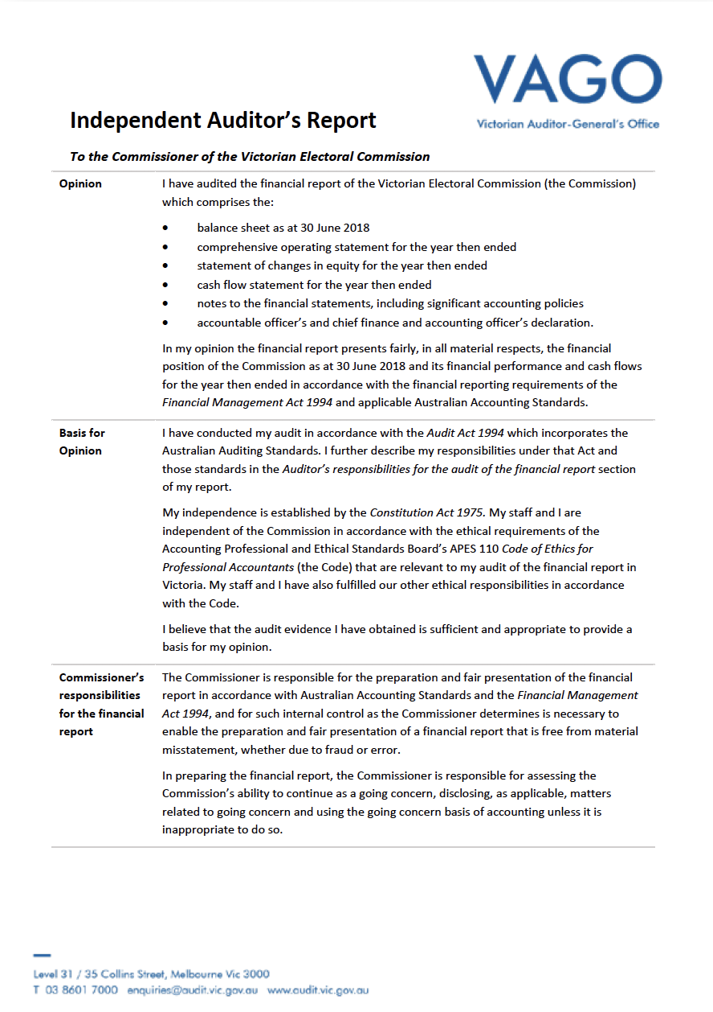
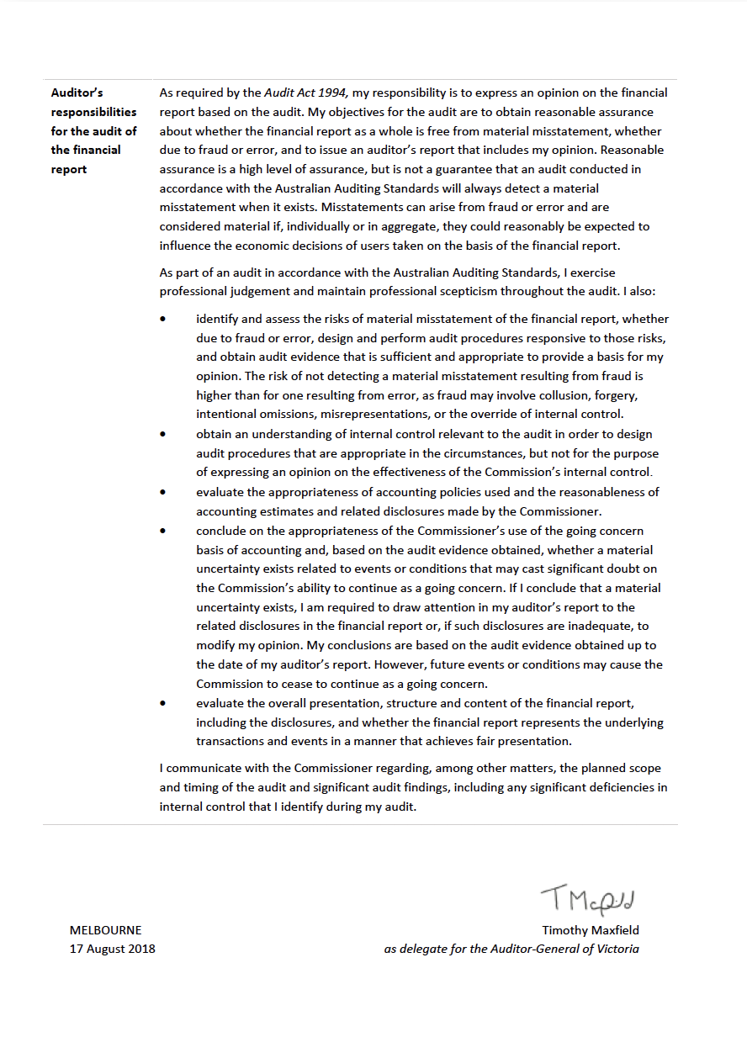

Appendices

Appendix A: Disclosure Index

Appendix B: Governing Legislation and Regulations

Appendix C: Additional Information Available on Request

Appendix D: Reporting Procedures under the Protected Disclosures Act 2012

Appendix E: Making a Request under the Freedom of Information Act 1982

Appendix F: Attestation for compliance

Appendix G: Report of the electoral boundaries commission 2017-18

Appendix A: Disclosure index
Requirement
MINISTERIAL DIRECTIONS
Report of operations - FRD Guidance
Charter and purpose
FRD 22H | Manner of establishment and the relevant Ministers
FRD 22H | Purpose, functions, powers and duties
FRD 22H | Nature and range of services provided
Management and structure
FRD 22H | Organisational structure
Financial and other information
FRD 8D | Budget portfolio outcomes
FRD 10A | Disclosure index
FRD 12B | Disclosure of major contracts
FRD 15E | Executive Officer disclosures
FRD 22H | Comparative Workforce data
FRD 22H | Advertising disclosure
FRD 22H | Operational and budgetary objectives and performance against objectives
FRD 22H | Employment and conduct principles
FRD 22H | Occupational health and safety policy
FRD 22H | Summary of the financial results for the year
FRD 22H | Significant changes in financial position during the year
FRD 22H | Major changes or factors affecting performance
FRD 22H | Subsequent events
FRD 22H | Application and operation of Freedom of Information Act 1982
FRD 22H | Compliance with building and maintenance provisions of Building Act 1993
FRD 22H | Statement on National Competition Policy
FRD 22H | Application and operation of the Protected Disclosures Act 2012
FRD 22H | Application and operation of the Carers Recognition Act 2012
FRD 22H | Details of consultancies over $10,000
FRD 22H | Details of consultancies under $10,000
FRD 22H | Statement of availability of other information
FRD 24D | Reporting of office-based environmental impacts
FRD 25C | Victorian Industry Participation Policy disclosures
FRD 29C | Workforce Data disclosures
Compliance attestation and declaration
SD 5.1.4 | Attestation for compliance with Ministerial Standing Direction
SD 5.2.3 | Declaration in report of operations
FINANCIAL REPORT
Financial statements
Declaration
SD 5.2.2 | Declaration in financial statements
Other requirements under Standing Directions 5.2
SD 5.2.1(a) | Compliance with Australian accounting standards and other authoritative pronouncements
SD 5.2.1(a) | Compliance with Ministerial Directions
SD 5.2.2(a) | Accountable officer’s declaration
SD 5.2.1(b) | Compliance with Model Financial Report
Other disclosures as required by FRDs in notes to the financial statements
FRD 9B | Departmental disclosure of administered assets and liabilities by activity
FRD 11A | Disclosure of ex-gratia expenses
FRD 13 | Disclosure of parliamentary appropriations
FRD 21C | Disclosures of responsible persons, executive officers and other personnel  (contractors with significant management responsibilities) in the Financial Report
FRD 102A | Inventories
FRD 103G | Non-financial physical assets
FRD 104 | Foreign currency
FRD 106B | Impairment of assets
FRD 109A | Intangible assets
FRD 110A | Cash flow statements
FRD 112D | Defined benefit superannuation obligations
FRD 114B | Financial Instruments - General Government Entities and public non-financial corporations

Appendix B: Governing legislation and regulations

Legislation
- Agricultural Industry Development Act 1990
- Building Act 1993
- Charter of Human Rights and Responsibilities Act 2006
- City of Greater Geelong Act 1993
- City of Melbourne Act 2001
- Constitution Act 1975
- Electoral Act 2002
- Electoral Boundaries Commission Act 1982
- Equal Opportunity Act 2010
- Essential Services Act 1958
- Financial Management Act 1994
- Freedom of Information Act 1982
- Infringements Act 2006
- Juries Act 2000
- Legal Profession Act 2004
- Liquor Control Reform Act 1998
- Local Government Act 1989
- Monetary Units Act 2004
- Privacy and Data Protection Act 2014
- Protected Disclosure Act 2012
- Public Records Act 1973
- Shop Trading Reform Act 1996
  - Vital State Projects Act 1976

Regulations
- Agricultural Industry Development (Polls) Regulations 2011
- City of Melbourne (Electoral) Regulations 2012
- Electoral Regulations 2012
- Infringements (General) Regulations 2006
- Infringements (Reporting and Prescribed Details and Forms) Regulations 2006
- Legal Profession (Board Election) Regulations 2006
- Liquor Control Reform Regulations 2009
  - Local Government (Electoral) Regulations 2016

Appendix C: Additional information available on request
- Details of publications produced by the VEC about itself, and where these can be obtained
- Details of changes in prices, fees, charges, rates and levies charged by the VEC
- Details of any major external reviews carried out in respect of the operation of the VEC
- Details of major research and development activities undertaken by the VEC that are not otherwise covered in this report
- Details of overseas visits undertaken, including a summary of the objectives and outcomes of each visit
- Details of assessments and measures undertaken to improve the occupational health and safety of employees not otherwise detailed in this report
  - A general statement on industrial relations within the VEC and details of time lost through industrial accidents and disputes

Appendix D: Reporting procedures under the Protected Disclosure Act 2012
Disclosures of improper conduct or detrimental action by the Victorian Electoral Commissioner or another officer of the VEC must be made to the Independent Broad-based Anti-corruption Commission (IBAC).
Independent Broad-based Anti-corruption Commission
GPO Box 24234
Melbourne VIC 3001
Phone 1300 735 135

FURTHER INFORMATION
Written guidelines outlining the system for reporting disclosures of improper conduct or detrimental action by the VEC or its employees and the disclosure handling procedures are available from the VEC.

Appendix E: Making a request under the Freedom of Information Act 1982
As detailed in section 17 of the Freedom of Information Act 1982 (FOI Act), access to documents may be obtained through written request to the Freedom of Information Officer.
In summary, the requirements for making a request are:
- it should be in writing
- it should identify as clearly as possible which document is being requested and
  - it should be accompanied by the appropriate application fee (the fee may be waived in certain circumstances).
Requests for documents in the possession of the VEC should be lodged by email to foi@vec.vic.gov.au or by mail addressed to:
Freedom of Information Officer
Victorian Electoral Commission
Level 11, 530 Collins Street
Melbourne VIC 3000
Access charges may also apply once documents have been processed and a decision on access is made; for example, photocopying and search and retrieval charges.
The VEC may make arrangements with the applicant to provide information or documents outside of the FOI Act. This avoids the need for processing a formal FOI request.
Information that may be released outside of the FOI Act may include:
- information relating only to the applicant
- information that may have been previously released to another applicant
  - publicly available information
Further information regarding Freedom of Information can be found at the Victorian Government Freedom of Information website (foi.vic.gov.au).

Appendix F: Attestation for compliance
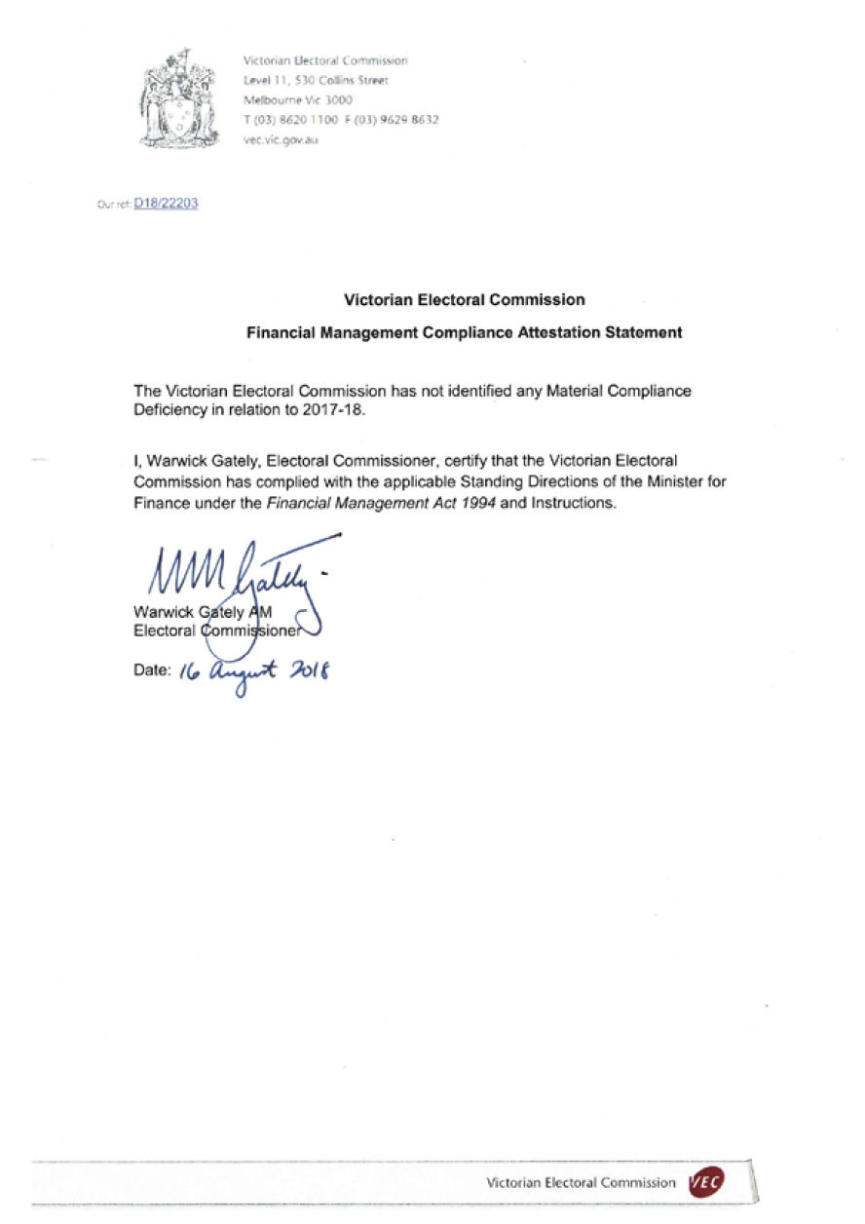

Appendix G: Report of the Electoral Boundaries Commission, 2017–18
The Electoral Boundaries Commission (EBC) is constituted under the Electoral Boundaries Commission Act 1982 (the Act). The EBC must establish and maintain electorates of approximately equal enrolment (that is, not varying by more than 10% from the average for each House of Parliament) for the conduct of parliamentary elections.
The members of the EBC during 2017–18 were:
- the Honourable Justice Peter Kidd, Chief Judge of the County Court of Victoria (Chairman)
- Mr Warwick Gately AM, Electoral Commissioner
  - Mr Craig Sandy, Surveyor-General (from August 2017. Mr David Boyle was the Acting Surveyor-General until August 2017)
The VEC provides administrative and technical support to the EBC and Dr Paul Thornton-Smith of the VEC is the secretary.
The EBC was not required to meet during 2017-18. The next redivision of electoral boundaries will take place before the 2022 State election, in accordance with the provision that a redivision must take place after every two general elections.

GLOSSARY
Attendance election
In an attendance election most voting is conducted at voting centres on election day, although voters may vote at early voting centres or by postal vote.
Ballot
A method of secret voting.
By-election
A by-election is an election in a single-member electorate to fill a casual vacancy caused by the departure of a sitting Member of Parliament or Local Government councillor before the term expires. A by-election may also be held in a multi-member electorate when no unsuccessful candidates remain for a countback.
Candidate
A candidate is an eligible elector who nominates for election.
Community of interest
The VEC defines a community of interest as a group of people who share a range of common concerns or aspirations. A community of interest may occur where people are linked with each other geographically (e.g. a town or valley) or economically, such as where people work in similar industries (e.g. tourism) or where people work in mutually-dependent industries (e.g. fruit growers, transporters and canners).
A community of interest may also appear where people share a number of special needs because of similar circumstances (such as new immigrants who may have little English, require assistance with housing or need help finding employment).
Compulsory enrolment
All Australian citizens 18 years and over are required by law to enrol.
Compulsory voting
All enrolled electors must vote at State elections. With some exceptions, enrolled voters must vote at Local Government elections.
Contested election
A contested election is an election where more candidates than the number of vacancies for the election have nominated by the close of nominations.
Continuous Roll Update (CRU)
The CRU process consists of a range of strategies to ensure that the electoral roll is continuously kept up-to-date by using internal and external data to direct roll review activities to targeted people and residences.
Councillor
An elected representative on a Local Government council.

Countback
Method of filling extraordinary vacancies in multi-member wards and unsubdivided municipalities in electorates where general election results were obtained using the proportional representation method. The votes of the vacating councillor are transferred to the previously unelected candidates to fill the vacancy.
District
One of the 88 Legislative Assembly electorates in Victoria. Each District elects one member and comprises approximately 45,000 electors.
Election
An event at which electors choose their representatives.
Election date
The legislated date of the election.
Election Manager
A person appointed by the Electoral Commissioner to conduct an election for an electoral district or region.
Elector
A person whose name appears on the register of electors and who is entitled to vote in elections.
Electoral Commissioner
The statutory officer appointed by the Governor-in-Council with responsibility for the proper conduct of parliamentary and statutory elections.
Electoral Matters Committee (EMC)
The EMC comprises seven Members of Parliament drawn from both Houses and is a Joint Investigatory Committee of the Parliament of Victoria. Its powers and responsibilities are determined by the Parliamentary Committees Act 2003. The EMC inquiries into, considers and reports to the Parliament on any proposal, matter or thing concerned with the conduct of parliamentary elections and referendums in Victoria, the conduct of elections of councillors under the Local Government Act 1989 and the administration of, or practices associated with, the Electoral Act 2002 and any other law relating to electoral matters.
Electoral roll
A list of names of all the people who are entitled to vote in an election under relevant legislation.
Electronically Assisted Voting
A method of casting a vote under legislation by electors who are blind or have low vision, are not literate in English, have a motor impairment or are located interstate or overseas.
Enrolment
The placement of a person’s name and address on the Register of Electors. A person cannot vote at an election unless they are enrolled.
Enrolment information
The information about electors that is held by the VEC.

Entitlement date
To be eligible to vote at a Local Government election, people must be on the State or Local Government voters roll 57 days before election day. This is called the ‘entitlement date’.
Geo-coding
Geo-coding is the process of assigning geographic identifiers (e.g. codes or geographic coordinates expressed as latitude-longitude) to map features and other data records, such as street addresses.
Informal vote
A ballot paper that is either left blank or is incorrectly marked. These ballot papers do not contribute to the election of a candidate.
Legislative Assembly (Lower House)
One of the two Houses in the Victorian State Parliament. There are 88 Members of the Legislative Assembly (MLAs), one from each electoral district. The party or coalition of parties that wins majority support in this House forms the Government.
Legislative Council (Upper House)
One of the two Houses in the Victorian State Parliament. There are 40 Members of the Legislative Council (MLCs), five from each region. The Legislative Council is often referred to as the ‘House of review’.
Lost Time Injury (LTI)
An LTI is an occupational injury or illness that results in days away from work on any rostered shift subsequent to that on which the injury occurred. A fatality is also recorded as an LTI.
Marginal costs
Marginal costs include direct labour and associated on-costs, materials, equipment, mail processing, postage, advertising, printing, rent, utilities, insurance, IT equipment and software licences purchased especially for the specific activity.
Postal election
In an all-postal election, voting papers are posted to voters by the Returning Officer. A vote is cast by completing a ballot paper and returning it to the Returning Officer in the reply-paid envelope provided.
Preferential voting
A vote for all candidates in order of preference. If no candidate has an absolute majority of first preference votes, preferences are distributed until one candidate has an absolute majority.
Proportional representation
A system of voting designed to elect representatives in proportion to the amount of support each has in the electorate.
Redivision
The redrawing of electoral boundaries to ensure that there are, as near as possible, equal numbers of voters in each electorate within Victoria.
Region
One of the eight Legislative Council electorates. Each region comprises approximately 496,000 electors and elects five Members.

Register of Electors
The VEC’s database of all Victorian electors.
Registered Political Party (RPP)
A political party that is registered under the Electoral Act 2002. A registered party must have at least 500 members who are Victorian electors and not members of another registered political party.
Resource Smart Committee (RSC)
Comprising a representative from each branch of the VEC and a member of the VEC Management Group, the Resource Smart Committee oversees the implementation of the VEC’s Environmental Management Plan.
Senior Election Official
A trained election official who may be appointed to act as an Election Manager for a parliamentary election. Senior Election Officials may also be appointed to act as Returning Officers or Deputy Returning Officers for a Local Government election.
Victorian Electoral Commission (VEC)
The VEC is the independent statutory body that conducts State elections and certain statutory elections. The VEC conducts Local Government elections, and commercial and community elections. The VEC also conducts boundary reviews and electoral research, maintains the Victorian electoral enrolment register and provides education and inclusion services.
Voter
An elector who votes in an election.
Voting centre
A place at which electors can vote in an election. There are three types of voting centres that operate in State elections: early voting centres, mobile voting centres and election day voting centres.

INDEX

#
2017 Greater Geelong City Council general elections
2018 Melbourne City Council Lord Mayor
by-election
A
Aboriginal and Torres Strait Islander Advisory Group
About the VEC
About This Report
Accountability and Transparency
Accountable officerʼs and chief finance and accounting officerʼs declaration
Additional information available on request
Additional information available on request, list
Advertising disclosure
Annual advisory group surveys
Appendices
Arrangements with other electoral agencies
Assets, what the VEC owns
Attestation for compliance
Attestation, Public Sector Standards Commissioner
Audit and Risk Committee
Auditor-General’s report
B
Balance Sheet
Building Act 1993, compliance
Building leadership and management capability
C
CALD youth leadership project
Case study
Cases arising from the 2016 Local Government elections
Cash Flow Statement
Celebrating success
Changes to registered political parties
Claims for workcover
Code of Conduct - VEC values
Communication activities
Communication and Engagement Branch
Community partnerships and collaborations
Comparative workforce data
Complaints
Compliance, reporting and engagement
Comprehensive Operating Statement
Consultancies over $10,000
Consultancies under $10,000
Contents
Consultancies and contracts
Corporate planning
Corporate reporting
Court matters, parliament and legislation
Culturally and linguistically diverse (CALD) communities
Culturally and Linguistically Diverse (CALD) Advisory Group
Customer service charter
D
Days lost as a result of workplace-related injury
Deputy Electoral Commissioner profile
De-registration of political parties
Development Project Board
Digital and online research and strategy development
Disability Act 2006, Compliance
Disclosure index, disclosures
Disclosure Index, appendices
Disclosures
Discretionary provision of enrolment information
Diversity and inclusion
E
Election staffing
Elections Branch
Elections, by-elections, countbacks and polls, 2017–18
Elections (Administration)
Elections (Services)
Elector statistics, District
Elector statistics, Region
Electoral Access Advisory Group
Electoral activity
Electoral Boundaries Commission (EBC)
Electoral Commissioner, profile
Electoral Council of Australia and New Zealand (ECANZ)
Electoral Enrolment Branch
Electoral Matters Committee (EMC)
Electoral outreach
Electoral Regulation Research Network ( ERRN)
Electoral representation and subdivision reviews
Employment and conduct principles
Embedding the 70:20:10 model
EMS redevelopment steering committee
Enforcement of compulsory voting
Enforcement of compulsory voting, statistics
Enrolment
Enrolment programs
Enrolment transactions, summary
Environmental performance
Environmental sustainability report
Equity, what the VEC is worth
Executive Director, Corporate Services, profile
Executive Management Group (EMG)
Executive officer disclosure
Expenditure
Expenses, how the VECʼs funding is utilised
External Advisory Groups
F
Finance at a glance
Finance Branch
Financial management
Financial management compliance framework
Financial performance
Financial position
Financial report
Financial statements
First strategic intent
Flexible work arrangements
Freedom of Information
Freedom of Information, request procedures
FTE staffing trends
Funding
Funding fluctuations
G
Gifts, Benefits and Hospitality Register
Glossary
Governance
Governing legislation and regulations, list
Governing Legislation and Tribunals
Grants and Transfer Payments, disclosure
H
Hazards, incidents and injuries
Hazards, incidents and injuries reported
History and Functions, VEC
Homelessness Advisory Group
Human resource management
Human resources
I
Identifying and managing risk
Inclusion and Participation
Inclusion plans
Index
Information and records management
Information privacy
Information Technology Branch
Interaction with electoral bodies
Internal audit
Internal committees and groups
L
Legislation
Legislative and regulatory amendments
Letter of transmittal
Leveraging on technology
Liabilities, what the VEC owes
Local government by-elections and countbacks
Lodgement with the courts, compulsory voting
Looking ahead
M
Maintaining strategic capacity
Mandatory provision of enrolment information
Mount Alexander Shire Council – Tarrengower Ward by-election
Municipal Electoral Tribunal (MET)
N
National Competition Policy
New applications for registration
Non-voter research
Northcote by-election
Notes to the financial statements
O
Occupational health and safety
Occupational Health and Safety Committee
Occupational health and safety management
Operational and budgetary objectives and performance against objectives
Operations
Organisational capability development
Organisational structure
Other elections and polls
Other interactions
Our Commission
Our Core Business
Our Highlights
Our People
Our people, our year
Our Stakeholders
Our strategic plan
Our Year, message from the Electoral Commissioner
P
Pecuniary interest declaration
People and partners, VEC
Planning Group
Preparing for the 2018 State election
Progress report on initiatives 2017–18 and focus 2018–19
Project Governance Board
Protected Disclosure Act 2012, reporting procedures
Protected Disclosures Act 2012
Provision of enrolment information
Purpose, VEC
R
Reconciliation action plan (RAP), VEC
Recruitment, departures and turnover
Recruitment (FTE ongoing)
Reducing succession risk
Register of electors
Register of political parties
Registered political parties, list
Report of the Electoral Boundaries
Commission (EBC)
Research and Development
Research into queuing at voting centres
Resource Smart Committee
S
Second strategic intent
Services to Political Parties
Schools program: Passport to Democracy (PTD)
Spotlight on…
Staff well-being services
Staffing
State by-elections
State election planning and preparations
State electoral boundaries
Statement of Changes in Equity
T
Third strategic intent
V
Values, VEC
VEC staff by gender
VEC staff profile
VEC’s performance against OHS management measures
Victorian Civil and Administrative Tribunal (VCAT)
Victorian Industry Participation policy
Vision, VEC
Voting services provided to other electoral agencies
W
Warehouse
Workforce profile

Feedback on this report is welcome.
Please mark to the attention of:
Executive Services
Victorian Electoral Commission
Level 11, 530 Collins Street
Melbourne VIC 3000
Phone: (03) 8620 1100
Email: info@vec.vic.gov.au
Australasian Reporting Awards
2016–17 Gold
2015–16 Gold
2014–15 Gold
2013–14 Gold
2012–13 Gold
2011–12 Gold
2010–11 Silver
2009–10 Gold
2008–09 Silver
Creative
This report was designed and produced by Cordial Creative
www.cordialcreative.com

© State of Victoria
(Victorian Electoral Commission)
September 2018
This work, the VEC 2017-18 Annual Report, is licensed under a Creative Commons Attribution 4.0 licence (http://creativecommons.org/licenses/by/4.0/). You are free to re-use the work under that licence, on the condition that you credit the State of Victoria (Victorian Electoral Commission) as author, indicate if changes were made and comply with the other licence terms. The licence does not apply to any branding, including government logos.

