Local council ward boundary review

## About the review

If a council is subdivided into wards, the number of voters in each ward should be within +/-10% of the average across all wards to comply with the *Local Government Act 2020* (Vic).

Changes to the population, location of housing areas, and voting entitlements all impact the number of voters in wards.

In accordance with section 17 of the Act, the Minister for Local Government has asked the Victorian Electoral Commission (VEC) to review the ward boundaries for South Gippsland Shire Council.

Adjusting ward boundaries aims to ensure voters are represented equally at the next council general election.

During its review, the VEC will look at South Gippsland Shire Council’s:

* enrolled voter numbers
* projected voter numbers
* ward boundary locations.

As a local you know your council area better than anyone. You can have your say on the suggested ward boundary adjustments:

1. in a response submission to the preliminary report
2. at an online public hearing, if you ask to speak in your response submission.

About South Gippsland Shire Council

The Traditional Custodians of the land in the South Gippsland Shire Council area are the Bunurong and Gunaikurnai peoples.

South Gippsland is a rural shire council located south-east of Melbourne. Covering an area of 3,309 km2, its entire southern boundary consists of the Bass Strait and Corner Inlet coastlines. The council area also borders Cardinia Shire and Bass Coast Shire councils in the west, Baw Baw Shire Council in the north, and Latrobe City and Wellington Shire councils in the east. In 2021, the population was 30,577.

The population of the council area is projected to grow by over 14% by 2036, with the main areas of growth being in the north around the localities of Nyora, Leongatha, Korumburra and Mirboo North.

Leongatha is the largest town by population and the shire’s main service town, providing access to employment, education and health services. Other key towns include Korumburra, Foster and Mirboo North, with smaller settlements at Fish Creek, Loch, Meeniyan, Nyora, Poowong and Toora.

A key industry in South Gippsland is agriculture, which makes up 19% of economic output. Tourism is also a prominent economic driver, with 1.2 million visitors per year.

The council’s southern coastal area is known for its national parks and Wilsons Promontory, which is the southernmost geographic point of mainland Australia.

## Current structure

South Gippsland Shire Council is divided into 3 wards with 3 councillors per ward. There are 9 councillors in total.

## Last review

The VEC conducted an electoral representation review of South Gippsland Shire Council in 2012.

Visit the VEC website at [vec.vic.gov.au](https://www.vec.vic.gov.au/electoral-boundaries/local-councils/south-gippsland-shire-council) to access a copy of the 2012 review final report.

Review process

Monday 12 and Tuesday 13 February

### Information sessions

Session 1: 12 noon, Monday 12 February

Session 2: 12 noon, Tuesday 13 February

These sessions will give you more information about the review process. You will be able to register for a session on the VEC website.

Wednesday 14 February

### Preliminary report

The VEC will release a preliminary report with one or more options for the ward boundaries on Wednesday 14 February.

**You can make a response submission from this date.**

Wednesday 13 March

### Response submissions

The VEC must receive your submission by   
5 pm on Wednesday 13 March.

The VEC will not accept late submissions.

Wednesday 20 March

### Public hearing

The VEC will hold an online public hearing if anyone asks to speak about their response submission at 2 pm Wednesday 20 March.

The public hearing will not be held if no one asks to speak.

Wednesday 17 April

### Final report

The VEC will submit a final report to the Minister for Local Government including its advice for the adjustments to ward boundaries on Wednesday 17 April.

The minister will consider the VEC’s advice regarding the adjustments. Any change is expected to apply at the next local council general election.

## Submission guide

You can download a submission guide from the VEC website at [vec.vic.gov.au](https://vec365.sharepoint.com/sites/EDRM-256/Council%20fact%20sheet/vec.vic.gov.au)

## How to make a submission Untitled-1

On the VEC website at [vec.vic.gov.au](http://vec.vic.gov.au/)

By email to:

[SouthGippsland.WardReview@vec.vic.gov.au](mailto:SouthGippsland.WardReview@vec.vic.gov.au)

LetterBy post to:

Ward boundary review panel  
Victorian Electoral Commission  
Level 11, 530 Collins St  
Melbourne VIC 3000

Submissions must include your:

* full name
* contact phone number or email address
* residential or postal address.

Your submission will be published on the VEC website, including your name and suburb or town but not your full address or contact details. See the submission guide or VEC website at [vec.vic.gov.au/privacy](https://www.vec.vic.gov.au/privacy) for privacy information.

## One vote, one value

The ‘one vote, one value’ democratic principle is enshrined in the *Local Government Act 2020*. This means every person’s vote counts equally.

When a local council is subdivided into wards, the number of voters each councillor represents in each ward must be plus-or-minus 10% of the average number of voters per councillor for all wards.

The map below includes the current number of voters in each ward and the ward’s current deviation from the average. The VEC will also consider projected population and voter changes to ensure the structure remains fair.

If you make a submission online, you can use a mapping tool to build your preferred ward boundaries. The tool uses current voter numbers to tell you the deviations of the wards you make. This will help your proposal meet the requirements of the Act.

Current electoral structure

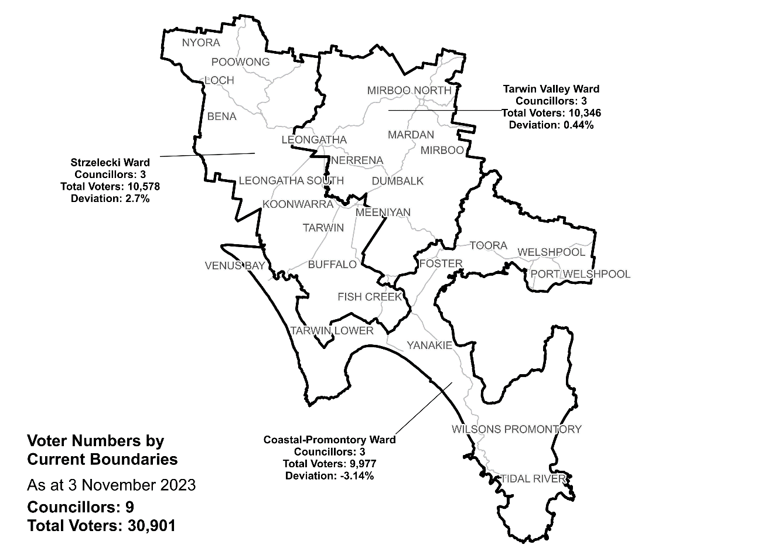

|  |  |  |  |
| --- | --- | --- | --- |
| Ward | Councillors | Voters | Deviation |
| Coastal-Promontory* | 3 | 9,977 | -3.14% |
| Strzelecki* | 3 | 10,578 | +2.70% |
| Tarwin Valley* | 3 | 10,346 | +0.44% |

*The deviations of these wards are forecast to be outside of +/-10% by October 2024.

## Statistics

Area (km2) 3,310

Voters

### Voters per square km

9.3

### Average voters per councillor

3,433

Population

### Current population

30,577

### Forecast population growth

1.3% p.a

More Census statistics available at [abs.gov.au](https://www.abs.gov.au/census/find-census-data/search-by-area)

Voter numbers by locality (map)

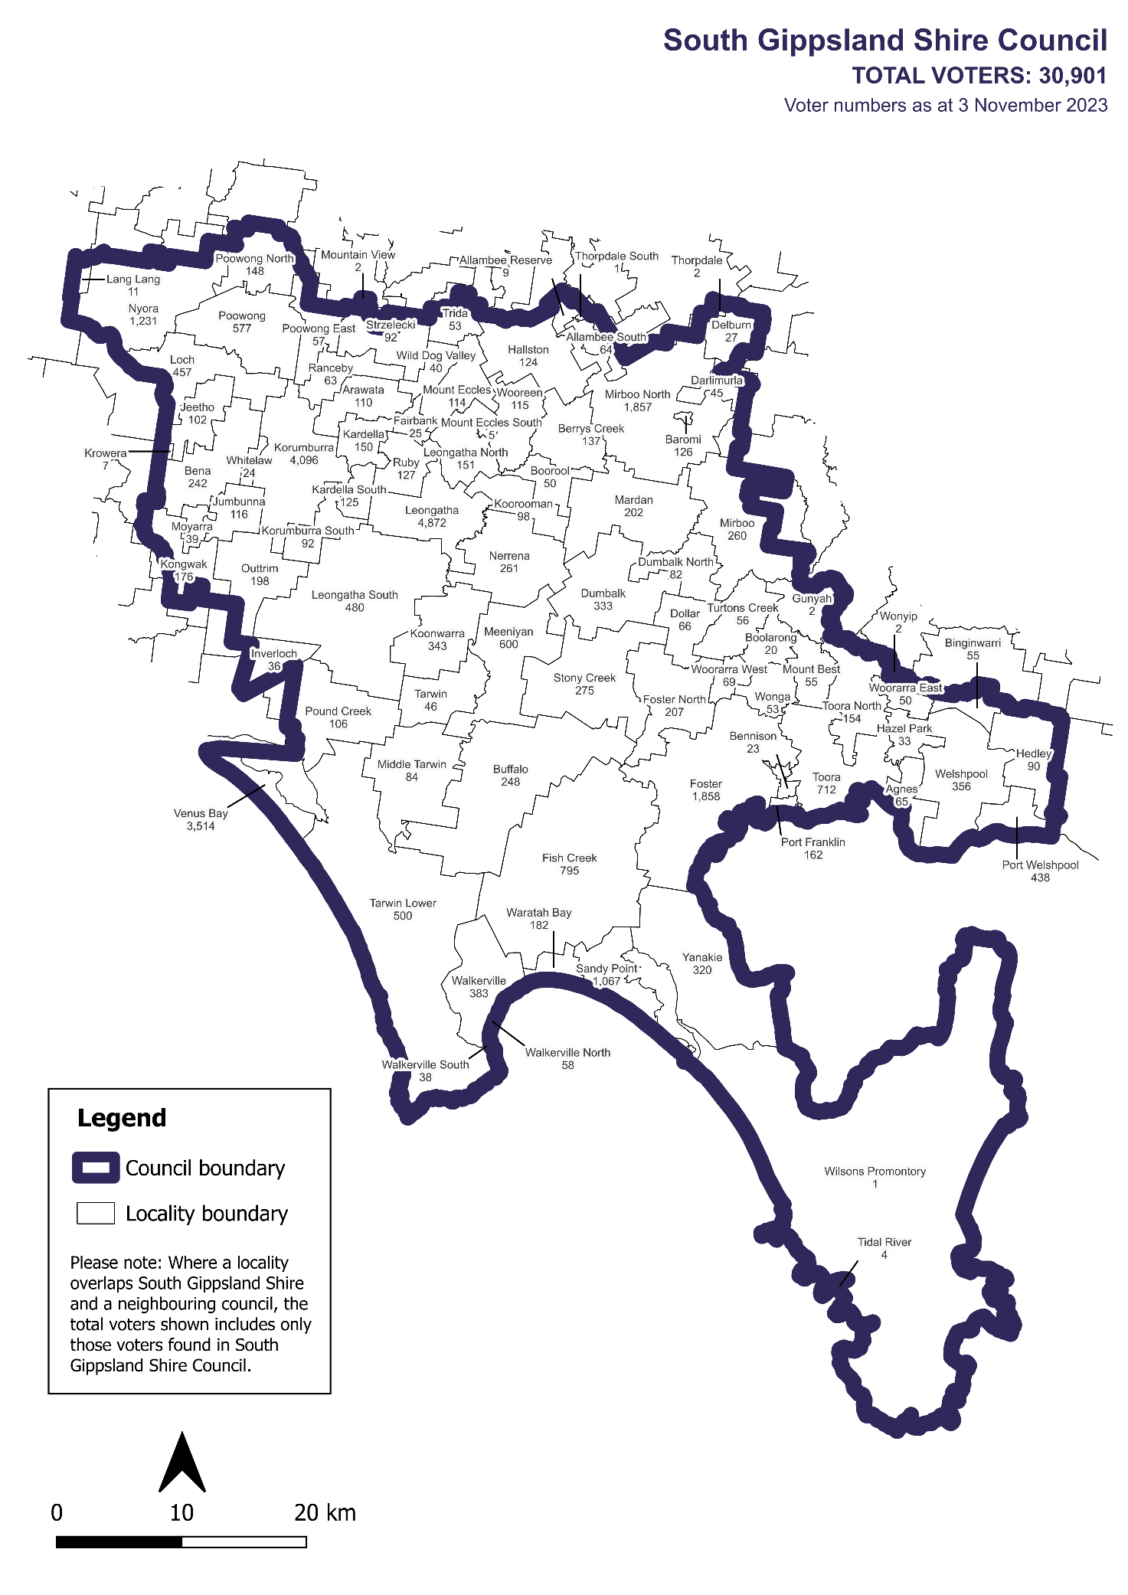

Voter numbers by locality (table)

## South Gippsland Shire Council voter numbers at 3 November 2023

|  |  |
| --- | --- |
| Locality | Voters |
| Agnes | 65 |
| Allambee Reserve | 9 |
| Allambee South | 64 |
| Arawata | 110 |
| Baromi | 126 |
| Bena | 242 |
| Bennison | 23 |
| Berrys Creek | 137 |
| Binginwarri | 55 |
| Boolarong | 20 |
| Boorool | 50 |
| Buffalo | 248 |
| Darlimurla | 45 |
| Delburn | 27 |
| Dollar | 66 |
| Dumbalk | 333 |
| Dumbalk North | 82 |
| Fairbank | 25 |
| Fish Creek | 795 |
| Foster | 1,858 |
| Foster North | 207 |
| Gunyah | 2 |

|  |  |
| --- | --- |
| Locality | Voters |
| Hallston | 124 |
| Hazel Park | 33 |
| Hedley | 90 |
| Inverloch | 36 |
| Jeetho | 102 |
| Jumbunna | 116 |
| Kardella | 150 |
| Kardella South | 125 |
| Kongwak | 176 |
| Koonwarra | 343 |
| Koorooman | 98 |
| Korumburra | 4,096 |
| Korumburra South | 92 |
| Krowera | 7 |
| Lang Lang | 11 |
| Leongatha | 4,872 |
| Leongatha North | 151 |
| Leongatha South | 480 |
| Loch | 457 |
| Mardan | 202 |
| Meeniyan | 600 |
| Middle Tarwin | 84 |

|  |  |
| --- | --- |
| Locality | Voters |
| Mirboo | 260 |
| Mirboo North | 1,857 |
| Mount Best | 55 |
| Mount Eccles | 114 |
| Mount Eccles South | 5 |
| Mountain View | 2 |
| Moyarra | 39 |
| Nerrena | 261 |
| Nyora | 1,231 |
| Outtrim | 198 |
| Poowong | 577 |
| Poowong East | 57 |
| Poowong North | 148 |
| Port Franklin | 162 |
| Port Welshpool | 438 |
| Pound Creek | 106 |
| Ranceby | 63 |
| Ruby | 127 |
| Sandy Point | 1,067 |
| Stony Creek | 275 |
| Strzelecki | 92 |
| Tarwin | 46 |

|  |  |
| --- | --- |
| Locality | Voters |
| Tarwin Lower | 500 |
| Thorpdale | 2 |
| Thorpdale South | 1 |
| Tidal River | 4 |
| Toora | 712 |
| Toora North | 154 |
| Trida | 53 |
| Turtons Creek | 56 |
| Venus Bay | 3,514 |
| Walkerville | 383 |
| Walkerville North | 58 |
| Walkerville South | 38 |
| Waratah Bay | 182 |
| Welshpool | 356 |
| Whitelaw | 24 |
| Wild Dog Valley | 40 |
| Wilsons Promontory | 1 |
| Wonga | 53 |
| Wonyip | 2 |
| Woorarra East | 50 |
| Woorarra West | 69 |
| Wooreen | 115 |
| Yanakie | 320 |

|  |  |  |  |
| --- | --- | --- | --- |
| **Version** | **Date approved** | **Approved by** | **Brief description of change** |
| 1.1 | 21 February 2024 | Program sponsor | Dates adjusted for close of submissions, public hearing and final report. |