© State of Victoria (Victorian Electoral Commission) 2017
This work, Direct Enrolment Report, is licensed under a Creative Commons Attribution Non-Derivatives 4.0 licence (http://creativecommons.org/licenses/by-nd/4.0/). You are free to share this work under that licence, on the condition that you do not change any content and you credit the State of Victoria (Victorian Electoral Commission) as author and comply with the other licence terms. The licence does not apply to any branding, including Government logos.

Contents
Direct enrolment in Victoria
1. Origins and development of direct enrolment 1
2. The nature of directly enrolled electors 4
Overall numbers 4
Gender 4
Age groups 5
Geographic distribution 6
3. Directly enrolled electors and voting 11
Overall numbers 11
Gender 11
Age groups 12
Geographic distribution 13
4. Feedback from directly enrolled electors 18
4. Conclusions 21

Direct enrolment in Victoria

1. Origins and development of direct enrolment
Electoral enrolment has been compulsory in Australia since 1911, but there has never been a time when all those eligible to enrol have been properly enrolled. Some people have never enrolled to vote, or have dropped off the roll for a variety of reasons, while a larger group have changed their address or name but have been slow to update their enrolment.
A complete and accurate electoral roll is desirable in principle, as it is the basis of democratic elections. Government, and in particular the electoral authorities, have always played a part in trying to achieve a complete and accurate roll. In preparation for the first Federal election conducted under Commonwealth legislation, the fledgling Commonwealth electoral administration directed the police to canvass every household in Australia in 1902-1903, with the result that an estimated 96 per cent of the eligible population was enrolled.
For much of the twentieth century, electoral authorities relied on habitation reviews to maintain the electoral roll. In these reviews, electoral officials doorknocked every household, checking that enrolment records for the address were correct and providing enrolment forms to eligible people who needed to enrol or to update their enrolment. Habitation reviews were very costly, and in the 1990s electoral commissions turned to Continuous Roll Update (CRU) as a more efficient way of updating the roll. Using data obtained from government and other agencies (such as VicRoads and Eastern Energy in Victoria), electoral commissions wrote to people who were likely to need to enrol or to change their enrolment, inviting them to complete an enrolment form. One successful initiative, introduced more than a decade ago, was the birthday card that the VEC sent to students who were about to turn 17, encouraging them to enrol provisionally.
However, over time the return rate from CRU mail-outs tended to diminish. Another problem identified by some observers was that while the information provided by agencies assisted electoral commissions to take electors off the roll on the grounds of non-residence, the commission had to wait on individuals to complete and send enrolment forms before they could be placed on the roll. As a result, the enrolment rate (enrolled electors as a proportion of the eligible population) tended to decline over the first decade of this century. By 2010, an estimated 1.5 million eligible Australians were not enrolled. Consequently, there were growing calls for automatic, or direct, enrolment, under which electoral commissions would use the data provided by agencies to place electors directly on the roll or update their enrolment.
In 2009, the New South Wales Parliament passed the Parliamentary Electorates and Elections Amendment (Automatic Enrolment) Act 2009, which enabled the SmartRoll process of direct enrolment in that State. The following year, the Victorian Parliament introduced direct enrolment through the Electoral Amendment (Electoral Participation) Act 2010. Two years later, the Commonwealth Parliament passed the Electoral and Referendum Amendment (Protecting Elector Participation) Act 2012, enabling direct enrolment, and the Electoral and Referendum Amendment (Maintaining Address) Act 2012, enabling direct update of electors’ enrolment details.
In 2010, the Victorian Opposition of the time opposed the legislation providing for direct enrolment. However, the report by Parliament’s Electoral Matters Committee on the conduct of the 2010 State election supported automatic (direct enrolment), and recommended legislative amendment to allow data obtained by the VEC as part of the Australian Electoral Commission (AEC)/VEC joint enrolment process to be used for automatic enrolment purposes. The Justice Legislation Amendment Act 2013 permitted the VEC to use data obtained from the AEC under the joint enrolment arrangement to directly enrol electors, and AEC data has become an important source of direct enrolments. The main current issue arising from direct enrolment is divergence between the Commonwealth and Victorian electoral rolls, which is the consequence of an AEC decision not to accept State data as a basis for Federal direct enrolment, and of State legislation requiring a witness for new enrolments.
The VEC has taken a cautious approach to the implementation of direct enrolment. In 2010, the VEC began by writing to 1,932 students registered with the Victorian Curriculum and Assessment Authority (VCAA), who were 18 years old and not yet enrolled. Some 93 per cent of these students were directly enrolled. The VEC gradually expanded the scope of direct enrolment, to new sources of information, particularly VicRoads, and to enrolment updates as well as new enrolments. At each stage, the VEC considered the nature and reliability of the database, checked the data for eligibility using information from Births, Deaths and Marriages and from the Department of Immigration and Border Protection, and measured the results of each mail-out. As Figure 1 shows, the number of direct enrolment transactions has grown enormously, from 5,904 in 2010-11 to 191,849 in 2015-16.

With more than 850,000 transactions in six years, direct enrolment is one of the main sources of enrolment updates in Victoria. Direct enrolment has been responsible for a steady rise in Victoria’s enrolment rate (electors as a proportion of the estimated eligible population), from 90.95% in 2010 to 95.4 % in 2016. Nevertheless, there have been concerns that direct enrolment will encourage passivity on the part of electors, and that directly enrolled electors will be less inclined to vote. In this context, it is useful to examine the nature and voting behaviour of directly enrolled electors, and to learn their own views about direct enrolment.

2. The nature of directly enrolled electors
The VEC’s Electoral Enrolment Branch generated a report of all enrolment transactions between 1 January 2013 and 17 June 2016, covering an extended period in which direct enrolment has been in full operation. This has enabled a comparison of directly enrolled electors and electors in general according to a range of categories. Transactions have been divided into two main categories – new enrolments and changes of address. Within the changes of address group are reinstated electors – those who were previously on the roll but who were removed for various reasons (mostly for non-residence after leaving their address and failing to update their enrolment), and who were later picked up by the direct enrolment program. The period that these reinstated electors had been off the roll range from a few months to almost 20 years.

Overall numbers
Table 1 shows the number of directly enrolled electors, and compares enrolment transactions as a whole over 2013-2016.
Type of Change | Directly enrolled | Total enrolments
New enrolments | 63,915  13.93% of total transactions | 458,720
Address changes | 693,961  41.42% of total changes | 1,675,577
Reinstatements | 46,999  6.77% of direct updates
Table 1: Number of direct enrolments
Direct enrolments make up a comparatively small proportion of new enrolments, but almost half of address updates. This reflects the growth of the direct enrolment program, and in particular its approach of promptly updating electors’ enrolments when it receives information from VicRoads. Reinstated electors comprise only one in 15 directly enrolled updates.

Gender
Table 2 shows the gender balance of directly enrolled electors, compared with enrolment transactions as a whole.
Type of Change | Gender | Directly enrolled | Total enrolments
New enrolments | Male | 36,307 (56.81%) | 230,634 (50.28%)
 | Female | 27,600 (43.18%) | 227,851 (49.67%)
Address changes | Male | 354,178 (51.04%) | 809,899 (48.34%)
 | Female | 339,778 (48.96%) | 865,619 (51.66%)
Reinstatements | Male | 29,638 (63.06%)
 | Female | 17,361 (36.94%)
Table 2: Gender balance of direct enrolments
While enrolment transactions as a whole were fairly evenly balanced between male and female, there was a distinct male preponderance in direct enrolments. This was particularly the case with reinstated electors (63% male) and with new direct enrolments. This male lead applied across all age groups, though it was not as marked with young new electors (males comprised 52.46 per cent of new electors aged 18-19), as for new electors who were slightly older (61.83 per cent of 25-29 year olds and 65.47 per cent of 30-34 year olds were male). It appears that males aged 20 and over are more reluctant than females to enrol, and are picked up by the direct enrolment program.

Age groups
Table 3 shows the age breakdown of directly enrolled electors, compared with enrolment transactions as a whole.
Age group | New enrolments |  | Address changes |  | Reinstatements
 | Directly enrolled | Total enrolments | Directly enrolled | Total enrolments
18-19 | 45.82% | 44.88% | 2.06% | 2.12% | 0.08%
20-24 | 22.87% | 12.56% | 15.3% | 13.23% | 5.64%
25-29 | 13.22% | 11.21% | 18.75% | 17.32% | 14.22%
30-34 | 8% | 10.44% | 15.81% | 15.26% | 18.02%
35-39 | 4.63% | 6.62% | 12.05% | 11.57% | 17.15%
40-44 | 1.99% | 4.35% | 10.21% | 9.74% | 16.11%
45-49 | 1.01% | 2.99% | 7.49% | 7.31% | 10.7%
50-54 | 0.76% | 2.13% | 5.97% | 6.18% | 7.62%
55-59 | 0.61% | 1.46% | 4.51% | 5.05% | 4.93%
60-64 | 0.46% | 1.26% | 3.34% | 4.13% | 2.81%
65+ | 0.64% | 2.11% | 4.5% | 8.11% | 2.72%
Table 3: Age breakdown of direct enrolments
The age distribution of directly enrolled electors and all enrolment transactions is broadly comparable. In both groups, most new electors were young. More than 57% of total new enrolments were younger than 25. The pattern is stronger with directly enrolled electors, with 22.87 per cent of directly enrolled new electors aged 20-24, compared to 12.56 per cent of all new electors. The sources of the VEC’s direct enrolment program contribute to this weighting: the VEC uses VicRoads and VCAA data to capture new licence holders and Year 11 and 12 students as soon as they become eligible to enrol. Conversely, directly enrolled new electors are under-represented in older age groups (30 and over) compared to new electors as a whole.
Turning to address changes, there is relatively little difference between those directly enrolled and enrolment transactions in general. All age groups above 20 are well represented, with a bulge of electors in their 20s and 30s. Electors aged 20-39 make up 61.91 per cent of all directly enrolled address updates, while the corresponding figure for all enrolment transactions is 57.38 per cent. In contrast, the proportions of older age groups whose addresses were directly updated are lower than for address updates as a whole. Older electors tend to be less mobile than younger ones, and so less likely to be captured in the VicRoads database.
Reinstated electors have a somewhat older age profile. Few are younger than 25 – understandably, because they would not have had time to enrol, be taken off the roll, and then be reinstated. Some two thirds of them are aged between 25 and 44 (compared to 54% of total enrolment updates).

Geographic distribution
Table 4 shows enrolment transactions by electoral district, in terms of each district’s deviation from the State district average. Districts that deviate by more than 30 per cent are highlighted (in orange for those above the average and green for those below the average).
District | New enrolments |  | Address changes |  | Reinstatements
 | Directly enrolled | Total enrolments | Directly enrolled | Total enrolments
Albert Park | .782 | 1.544 | 1.473 | 1.586 | 1.648
Altona | 1.235 | 1.574 | 1.21 | 1.165 | 1.204
Bass | 1.292 | .884 | 1.472 | 1.415 | 1.597
Bayswater | .929 | .763 | .898 | .907 | .951
Bellarine | .819 | .683 | 1.114 | 1.178 | 1.035
Benambra | .939 | 1.292 | 1.014 | 1.024 | 1.144
Bendigo East | .797 | .846 | 1.217 | 1.261 | 1.052
Bendigo West | .866 | .752 | 1.082 | 1.094 | 1.129
Bentleigh | .706 | .857 | .759 | .786 | .751
Box Hill | .595 | 1.002 | .778 | .875 | .655
Brighton | .709 | .972 | 1.074 | 1.125 | 1.129
Broadmeadows | 2.078 | 1.211 | .792 | .642 | 1.093
Brunswick | .873 | 1.565 | 1.39 | 1.537 | 1.21
Bulleen | .669 | .841 | .644 | .683 | .657
Bundoora | .686 | .803 | .701 | .698 | .633
Buninyong | .848 | .736 | 1.109 | 1.08 | .942
Burwood | .669 | .967 | .793 | .875 | .67
Carrum | 1.195 | .899 | 1.263 | 1.214 | 1.494
Caulfield | .862 | 1.107 | .997 | 1.041 | .929
Clarinda | .932 | 1.152 | .746 | .748 | .76
Cranbourne | 1.744 | 1.487 | 1.618 | 1.515 | 1.517
Croydon | .759 | .74 | .854 | .928 | .8
Dandenong | 1.213 | 1.295 | .861 | .76 | 1.019
Eildon | .872 | .686 | .859 | .874 | .989
Table 4.1: Geographic distribution of direct enrolments
Eltham | .753 | .756 | .682 | .695 | .541
Essendon | .856 | 1.144 | 1.036 | 1.107 | .923
Euroa | .98 | .873 | 1.014 | .995 | 1.226
Evelyn | .877 | .721 | .799 | .813 | .747
Ferntree Gully | .768 | .758 | .702 | .708 | .76
Footscray | 1.353 | 1.358 | 1.199 | 1.161 | 1.264
Forest Hill | .588 | .802 | .552 | .599 | .47
Frankston | 1.219 | .823 | 1.211 | 1.113 | 1.592
Geelong | .989 | .834 | 1.287 | 1.265 | 1.241
Gembrook | 1.26 | .936 | 1.203 | 1.177 | 1.118
Gippsland East | .949 | .736 | .931 | .949 | 1.118
Gippsland South | .779 | .703 | .896 | .922 | .932
Hastings | 1.399 | 1.011 | 1.205 | 1.144 | 1.391
Hawthorn | .686 | 1.15 | .984 | 1.13 | .758
Ivanhoe | .794 | .906 | .845 | .908 | .687
Kew | .713 | 1.04 | .783 | .861 | .683
Keysborough | 1.137 | 1.032 | .781 | .732 | .685
Kororoit | 1.598 | 1.245 | 1.032 | .895 | 1.15
Lara | 1.17 | .817 | 1.102 | 1.018 | 1.46
Lowan | .72 | .769 | .839 | .816 | .687
Macedon | .797 | .712 | .86 | .877 | .846
Malvern | .642 | .975 | .901 | .98 | .736
Melbourne | .958 | 2.22 | 1.413 | 1.724 | 1.376
Melton | 1.757 | 1.025 | 1.382 | 1.232 | 1.592
Mildura | 1.157 | 1.008 | .909 | .857 | 1.215
Mill Park | 1.197 | 1.057 | .876 | .809 | .837
Monbulk | .863 | .755 | .718 | .749 | .773
Mordialloc | .829 | .817 | .877 | .933 | .846
Mornington | .825 | .788 | 1.004 | 1.039 | .854
Morwell | 1.293 | .83 | 1.153 | 1.029 | 1.311
Mount Waverley | .649 | .993 | .602 | .628 | .549
Mulgrave | .821 | .919 | .635 | .644 | .667
Murray Plains | 1.038 | .858 | .924 | .909 | 1.054
Narracan | 1.086 | .809 | 1.168 | 1.139 | 1.223
Narre Warren North | 1.341 | 1.036 | .84 | .745 | .888
Narre Warren South | 1.59 | 1.424 | 1.007 | .911 | 1.075
Table 4.2: Geographic distribution of direct enrolments
Nepean | .983 | .617 | 1.26 | .729 | 1.436
Niddrie | .727 | .707 | .713 | .729 | .624
Northcote | .708 | 1.113 | 1.174 | 1.296 | .964
Oakleigh | .72 | 1.116 | .834 | .903 | .71
Ovens Valley | .793 | .749 | .891 | .901 | .966
Pascoe Vale | 1.185 | 1.128 | 1.012 | 1.028 | .99
Polwarth | .865 | .712 | .888 | .914 | .906
Prahran | .954 | 1.855 | 1.651 | 1.759 | 1.706
Preston | .947 | .983 | .938 | .94 | .944
Richmond | .895 | 1.681 | 1.609 | 1.81 | 1.417
Ringwood | .628 | .845 | .837 | .886 | .695
Ripon | .778 | .713 | .93 | .937 | 1.017
Rowville | .945 | .864 | .59 | .568 | .513
Sandringham | .609 | .851 | .862 | .931 | .663
Shepparton | 1.217 | .964 | 1.11 | 1.036 | 1.198
South Barwon | .883 | .875 | 1.33 | 1.338 | 1.028
South-West Coast | 1.026 | .857 | 1.138 | 1.104 | .983
St Albans | 1.413 | 1.183 | .805 | .687 | 1.002
Sunbury | .989 | .763 | .942 | .845 | 1.013
Sydenham | 1.498 | 1.161 | .882 | .795 | .781
Tarneit | 1.695 | 1.738 | 1.168 | 1.088 | 1.166
Thomastown | 1.231 | .965 | .845 | .751 | .848
Warrandyte | .695 | .876 | .611 | .633 | .582
Wendouree | .858 | .759 | 1.222 | 1.177 | .953
Werribee | 1.231 | 1.109 | 1.016 | .94 | 1.138
Williamstown | .989 | 1.056 | 1.129 | 1.165 | 1.142
Yan Yean | 1.26 | 1.009 | 1.375 | 1.346 | 1.155
Yuroke | 1.784 | 1.459 | 1.162 | 1.017 | 1.176
Table 4.3: Geographic distribution of direct enrolments
The geographic distribution of enrolments is broadly comparable for all groups, with a concentration of enrolment transactions in outer suburbs and a comparative deficit in a block of suburbs on the eastern side of Melbourne. This pattern appears to be related to age distribution, as the band of suburbs in the east has an older, more settled population, while the new growth suburbs have a younger age profile. Country areas, which have an older population, tended to have fewer enrolment transactions than average.
The contrast between the over-represented outer suburbs and the under–represented mid-eastern suburbs is strongest among directly enrolled new enrolments. The direct enrolment program appears to be effective in capturing young new driver licence holders, who live in greater numbers in the new suburbs. The pattern is more muted for new electors as a whole.
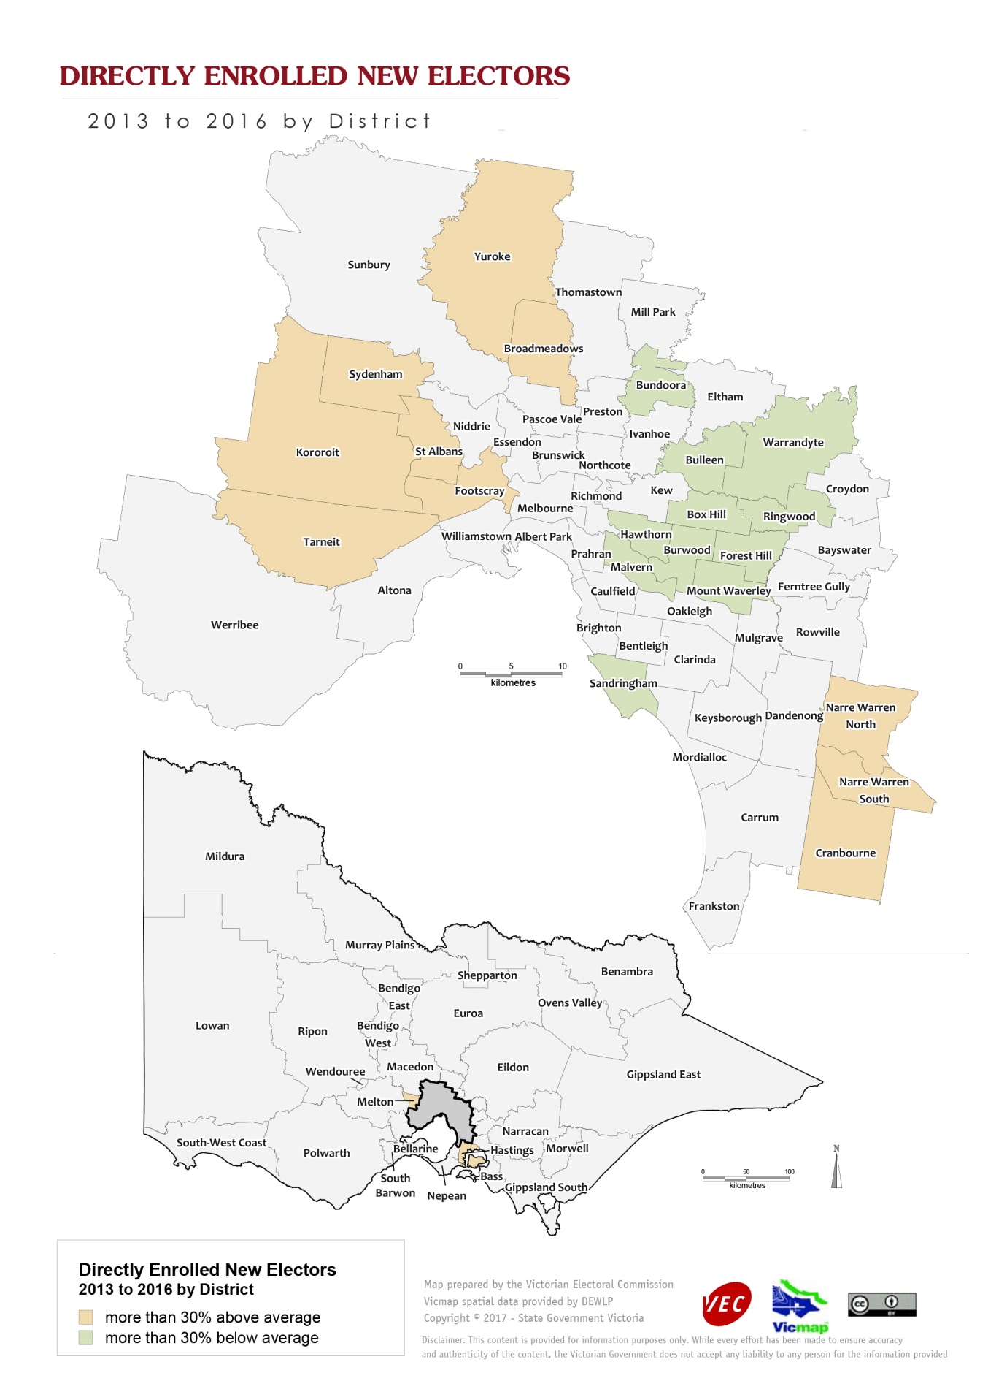
One difference from those directly enrolled is that new electors as a whole are concentrated in the inner suburbs (Albert Park, Melbourne, Prahran, Richmond). The inner suburbs have very mobile populations, which would produce a high rate of enrolment transactions. Possibly new electors in these suburbs, which have more public transport options, are less likely to have driver licences and so are less likely to be detected through the VEC’s use of the VicRoads database.
Turning to electors whose enrolled address has changed, there is little difference between the directly enrolled group and enrolment updates in general. Both groups display a concentration of transactions in the inner suburbs and the urban fringe growth areas, and deviations below the average in the middle band of suburbs.
Reinstated electors are most prevalent in inner Melbourne and in urban/rural fringe districts, and there are relatively few of them in districts with stable populations on the eastern side of the metropolitan area.

3. Directly enrolled electors and voting
At the time of the introduction of direct enrolment, there was some speculation that it would simply shift the problem of non-participation from enrolment to voting – that a large contingent of those who had hitherto stayed unenrolled would be conscripted onto the roll, but would then not vote. Peter Brent has argued that this is already occurring, as shown by low voter turnout at the 2016 Federal election. Statistics from the 2014 Victorian State election provide an opportunity to test this hypothesis.

Overall numbers
In 2014 there were relatively few directly enrolled electors. Only 35,687 electors were new to the roll, compared to 63,915 directly enrolled new electors by mid-2016. The number of electors whose address had been updated was much larger (306,988 in 2014), but had more than doubled (to 693,961) by 30 June 2016. There were 27,693 reinstated electors, comprising less than a tenth of the electors whose address had been updated
Table 5 shows voter turnout by these groups in 2014, and compares it to total voter turnout.
Group of voters | Voter turnout rate
Directly enrolled – new enrolments | 61.73%
Directly enrolled – address updates | 84.98%
Directly enrolled – reinstated | 55.97%
Total voters | 93.01%
Table 5: Voter turnout by directly enrolled electors, 2014 State election
Voter turnout by directly enrolled new electors was only two-thirds that of Victorians as a whole. Voter turnout by reinstated electors was even lower than that by new electors. Electors whose enrolment had been updated by the VEC were more inclined to vote, but their participation rate was still lower than that for all voters. These figures suggest that the above theory is correct, and that lower voting rates by directly enrolled electors will tend to depress the overall figure. In fact, the State’s turnout rate in 2014 increased marginally (by 0.05 percentage points) from that in 2010. In 2014, directly enrolled new electors plus reinstated electors comprised only 1.67% of the total – not enough to have a significant effect on the overall figure.

Gender
Table 6 shows voter turnout of directly enrolled voters by gender.
Gender | New enrolments | Address changes | Reinstatements
Male | 58.73% | 82.91% | 54.27%
Female | 65.65% | 87.21% | 58.82%
Table 6: Voter turnout of directly enrolled electors by gender, 2014 State election
Male voter turnout was lower than that of their female counterpart. As a majority of directly enrolled electors, males’ relative disinclination to vote further depressed voter turnout by directly enrolled electors as a whole.

Age groups
Directly enrolled electors tend to be younger than electors in general, and this younger age profile is a factor contributing to lower voter turnout by those directly enrolled. Table 7 shows voter turnout by age group, comparing directly enrolled electors with all voters.
Age group | New enrolments | Address updates | Reinstatements | Total voters | Age group – total voters
18-19 | 79.44% | 87.12% | 45.45% | 88.0 | 18-19
20-24 | 48.57% | 84.12% | 58.52% | 80.5 | 20-24
25-29 | 44.65% | 83.05% | 54.32% | 78.3 | 25-29
30-34 | 43.5% | 83.27% | 53.84% | 81.6 | 30-34
35-39 | 43.32% | 84.44% | 54.34% | 85.7 | 35-39
40-44 | 49.72% | 85.53% | 56.33% | 88.9 | 40-44
45-49 | 59.44% | 86.65% | 57.44% | 90.7 | 45-49
50-54 | 53.22% | 88.16% | 60.98% | 91.9 | 50-54
55-59 | 53.01% | 88.64% | 59.42% | 92.7 | 55-59
60-64 | 45.99% | 90.35% | 59.49% | 93.6 | 60-64
65+ | 55.11% | 86.82% | 54.19% | 94.2 | 65-69
 |  |  |  | 89.9 | 70+
Table 7: Voter turnout of directly enrolled electors by age group, 2014 State election
The pattern for directly enrolled new electors was very unusual. New electors aged 18 and 19 had a solid voter turnout of 79.44%. These young electors comprised almost half (45.48%) of directly enrolled new electors in 2014. Voter turnout by all other directly enrolled new electors was drastically lower – less than 50% for all electors aged 20-44, and just above 50% for older electors. Voting is a rite of passage for young people, and voter turnout tends to be higher for young electors’ first election, before falling away in their 20s. The 18 and 19 year old electors would have included many Year 11 and 12 VCE students in the VCAA database, who were educated and probably favourably disposed to voting. In contrast, the older new electors would have been gathered through the VicRoads database. These are people who had stayed off the roll for a variety of reasons until they were directly enrolled, and who presumably brought the same habits of non-participation to voting in an election.
The voting pattern for reinstated electors was quite different. Two thirds of these electors were aged between 25 and 44. Only 2.5% of these electors were aged 65 or over, and insignificant numbers were younger than 20. Voter turnout by the main group of reinstated electors was consistently in the low 50s, and was slightly higher for those aged 50-64.
Voting by the age groups of electors whose address had been directly updated paralleled that for voters in general, but generally at a slightly lower level. There was a good voter turnout by voters who were 18 and 19, with a decline for those in their 20s, then a slow rise up to the mid-60s, with a slight decline for the oldest voters.

Geographic distribution
Table 8 shows voter turnout by electoral district, in terms of each district’s deviation from the State district average. Districts that deviated by more than 3 percentage points are highlighted (in orange for those above the average and green for those below the average).
District | New enrolments | Address updates | Reinstatements | Total votes
Albert Park | 53.33% | 81.45% | 52.61% | 88.45%
Altona | 57.17% | 84.18% | 56.44% | 92.64%
Bass | 55.14% | 85.94% | 57.14% | 94.37%
Bayswater | 60.27% | 86.29% | 59.49% | 94.1%
Bellarine | 65.96% | 88.49% | 61.18% | 95.38%
Benambra | 59.47% | 82.54% | 46.25% | 92.88%
Bendigo East | 62.33% | 87.18% | 56.13% | 94.95%
Bendigo West | 55.29% | 85.38% | 52.84% | 93.83%
Bentleigh | 69.64% | 87.47% | 60.79% | 93.56%
Box Hill | 73.04% | 87.7% | 58.82% | 93.4%
Brighton | 72.32% | 85.94% | 57.64% | 92.05%
Broadmeadows | 56.75% | 74.59% | 48.67% | 88.14%
Brunswick | 58.17% | 84.1% | 56.89% | 90.4%
Bulleen | 70.92% | 88.19% | 64.11% | 93.34%
Bundoora | 63.86% | 85.9% | 55.34% | 93.98%
Buninyong | 61.96% | 86.59% | 52.69% | 94.29%
Burwood | 67.91% | 85.81% | 56.68% | 93.41%
Carrum | 60.74% | 84.06% | 52.46% | 93.21%
Caulfield | 56.57% | 86.18% | 59.17% | 90.66%
Clarinda | 68.49% | 82.49% | 52.94% | 91.92%
Cranbourne | 60.44% | 85.08% | 56.12% | 93.42%
Croydon | 70.19% | 86.28% | 55.47% | 94.68%
Dandenong | 53.41% | 77.21% | 54.46% | 89.62%
Eildon | 58.79% | 87.76% | 63.21% | 94.14%
Eltham | 76.55% | 89.45% | 63.91% | 94.91%
Essendon | 62.54% | 86.52% | 60.69% | 92.43%
Euroa | 59.27% | 84.1% | 56.15% | 93.89%
Evelyn | 69.8% | 87.44% | 60.7% | 94.98%
Table 8.1: Voter turnout by electoral district, 2014 State election
Ferntree Gully | 70.13% | 85.89% | 51.29% | 92.86%
Footscray | 53.66% | 80.08% | 51.91% | 89.53%
Forest Hill | 76.5% | 85.81% | 62.67% | 94.02%
Frankston | 52.49% | 81.3% | 53.71% | 91.99%
Geelong | 59.26% | 86.82% | 58.47% | 93.89%
Gembrook | 65.59% | 87.32% | 61.11% | 94.38%
Gippsland East | 54.2% | 84.11% | 50% | 93.58%
Gippsland South | 59.46% | 85.9% | 59.93% | 94%
Hastings | 58.97% | 85% | 55.94% | 93.83%
Hawthorn | 62.35% | 88.39% | 61.54% | 92.96%
Ivanhoe | 66.06% | 87.07% | 53.77% | 92.85%
Kew | 72.18% | 89.37% | 58.54% | 93.68%
Keysborough | 70.72% | 84.48% | 56.14% | 93.17%
Kororoit | 64.05% | 81.99% | 52.99% | 92.05%
Lara | 59.57% | 84.05% | 58.44% | 93.52%
Lowan | 56.11% | 88.08% | 50% | 95.01%
Macedon | 67.72% | 86.71% | 54.72% | 94.76%
Malvern | 67.59% | 87.03% | 58.26% | 92.53%
Melbourne | 48.18% | 82.03% | 48.67% | 87.54%
Melton | 55.76% | 82.27% | 55.97% | 92.56%
Mildura | 57.05% | 81.91% | 52.47% | 92.34%
Mill Park | 65.45% | 85.37% | 56.18% | 94.14%
Monbulk | 71.71% | 85.37% | 62.1% | 94.48%
Mordialloc | 67.68% | 87.44% | 60.55% | 94.01%
Mornington | 65.85% | 88.71% | 63.41% | 94.2%
Morwell | 59.21% | 82.81% | 52.32% | 93.4%
Mount Waverley | 76.72% | 86.29% | 53.16% | 93.29%
Mulgrave | 63.19% | 83.3% | 56.37% | 92.93%
Murray Plains | 59.09% | 83.47% | 51.11% | 93.73%
Narracan | 61.36% | 85.66% | 55.36% | 94.07%
Narre Warren North | 64.66% | 83.31% | 52.61% | 92.61%
Narre Warren South | 67.43% | 84.22% | 59.15% | 93.61%
Nepean | 51% | 84.99% | 54.3% | 92.69%
Niddrie | 71.23% | 88.07% | 62.19% | 94.36%
Northcote | 57.09% | 86.82% | 57.86% | 91.67%
Oakleigh | 58.51% | 85.97% | 54.55% | 92.08%
Table 8.2: Voter turnout by electoral district, 2014 State election
Ovens Valley | 59.46% | 85.39% | 56.99% | 93.67%
Pascoe Vale | 61.66% | 83.96% | 50.93% | 91.15%
Polwarth | 58.19% | 86.9% | 55.35% | 94.88%
Prahran | 52.93% | 83.76% | 55.62% | 88.47%
Preston | 53.4% | 82.77% | 50.46% | 90.8%
Richmond | 50.27% | 83.67% | 58.76% | 89.21%
Ringwood | 65.65% | 86.9% | 67.93% | 93.77%
Ripon | 58.22% | 86.07% | 62.78% | 94.78%
Rowville | 76.35% | 88.07% | 64.71% | 94.97%
Sandringham | 70.23% | 87.41% | 59.28% | 93.4%
Shepparton | 53.96% | 81.83% | 46.13% | 92.82%
South Barwon | 68.03% | 88.92% | 66.15% | 94.89%
South-West Coast | 61.08% | 87.8% | 59.14% | 94.93%
St Albans | 56.22% | 78.49% | 51.28% | 89.55%
Sunbury | 67.35% | 85.39% | 54.68% | 93.92%
Sydenham | 68.75% | 84.73% | 50.6% | 93.75%
Tarneit | 59.7% | 81.81% | 57.5% | 92.23%
Thomastown | 63.13% | 83.22% | 54.98% | 92.27%
Warrandyte | 78.39% | 87.8% | 57.89% | 94.29%
Wendouree | 56.21% | 86.87% | 52.38% | 94.19%
Werribee | 57.01% | 82.34% | 51.79% | 92.74%
Williamstown | 61.65% | 84.59% | 58.47% | 92.09%
Yan Yean | 68.03% | 88.04% | 60.75% | 95.36%
Yuroke | 60.1% | 82.66% | 47.71% | 92.44%
Victoria | 61.73% | 84.98% | 55.97% | 93.01%
Table 8.3: Voter turnout by electoral district, 2014 State election
Voter turnout by directly enrolled new electors ranged from 48.18% in Melbourne District to 78.39% in Warrandyte District. Voter turnout was lowest in inner suburban districts, which have a young, mobile population, and in some districts with high proportions of residents speaking languages other than English. Somewhat surprisingly, a number of sparsely populated country districts such as Lowan and Gippsland East also had comparatively low participation rates. Voter turnout was highest in established suburbs on the eastern side of Melbourne, and in some urban-rural fringe districts.
Voter turnout by electors whose enrolment had been directly updated ranged from 74.59% in Broadmeadows District to 89.45% in Eltham District. These electors showed less variation, probably because they were a much larger group. As with new electors, voter turnout was highest in the eastern suburbs. Voter participation by this group in the inner suburbs was close to the State average. It was lowest in ethnically diverse districts in the metropolitan area and in the country (Mildura and Shepparton).

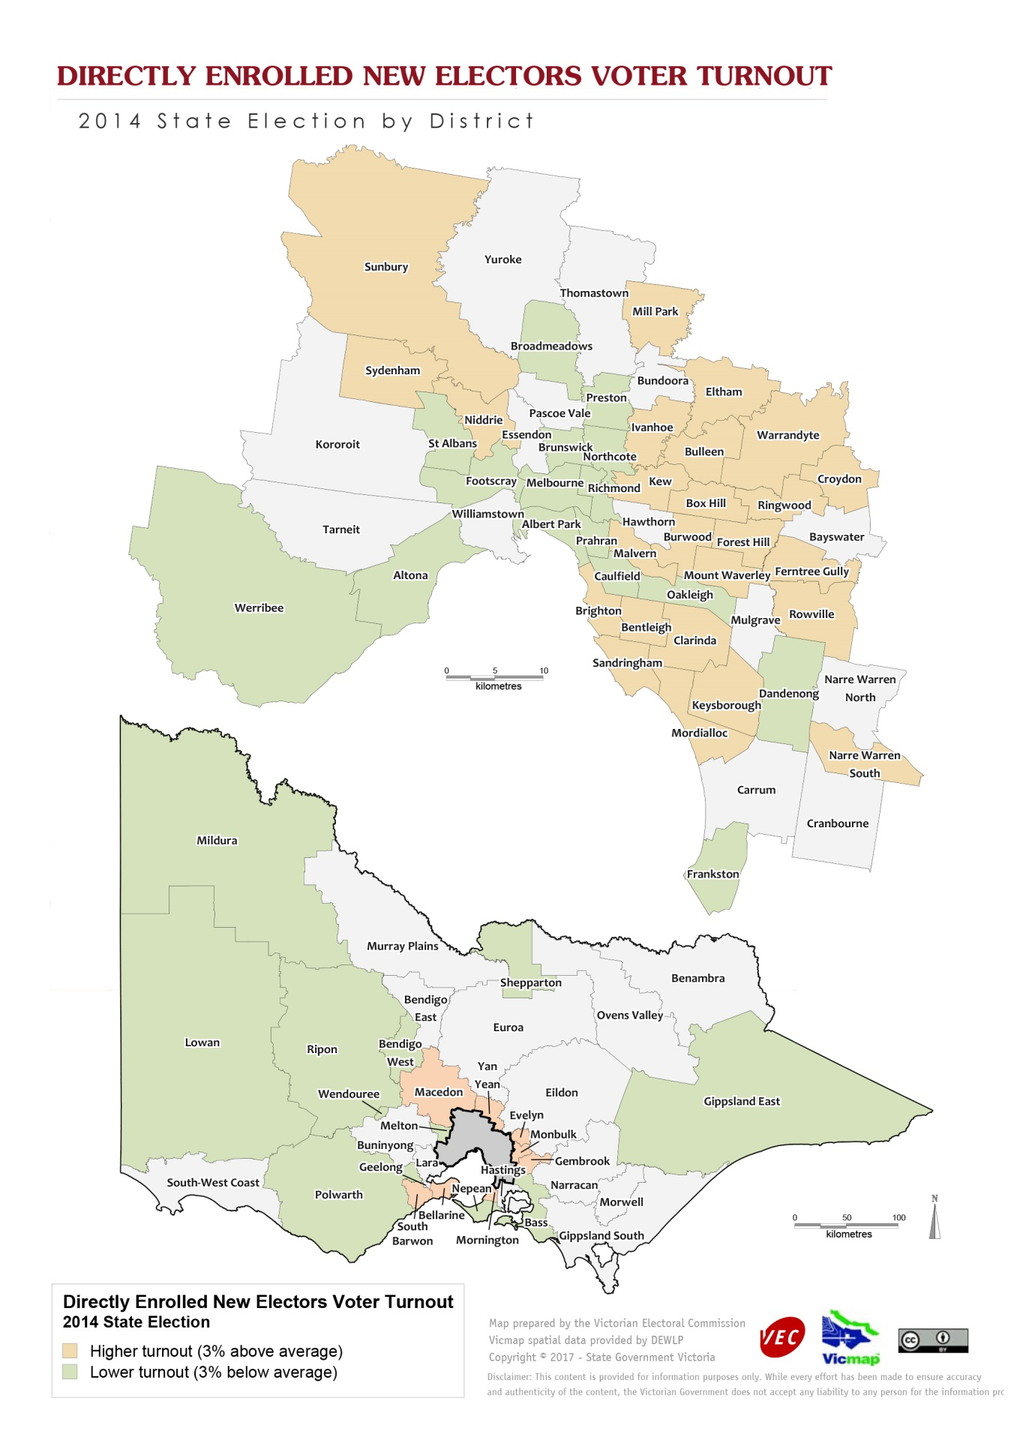
Insert D17/24813
Reinstated electors had the lowest voter turnout, with the very lowest in Benambra District (46.25%) and the highest in Ringwood District (67.93%). Seven districts had a voter turnout rate of 50% or less. The voting pattern was inconsistent, but turnout tended to be lowest in parts of inner Melbourne, in the more ethnically diverse suburbs, and in the outer rural districts, and was highest in districts in the eastern metropolitan area.
Voter turnout by electors in general ranged from 87.54% in Melbourne District to 95.38% in Bellarine District. Variations were much more muted than in the smaller groups, but there were similar patterns. The lowest voter turnout was in the mobile inner suburbs and in some ethnically diverse districts such as Dandenong and St Albans. Voter turnout was higher in the eastern suburbs, outer suburban growth areas such as Yan Yean, and country electorates such as Lowan.

4. Feedback from directly enrolled electors
It was important to learn the views of electors themselves about direct enrolment. In August 2016 the VEC wrote to 4,000 randomly selected directly enrolled electors (2,000 each of new enrolments and address updates), inviting them to complete an online survey. To encourage participation, the VEC offered the chance to win one of three $300 Coles-Myer vouchers.
There were 159 responses from newly enrolled electors, and 95 from electors whose address had been updated. Respondents to a survey will inevitably be more engaged than the general population. The survey respondents were more likely to be born in Australia (79%) than Victorians as a whole (65% at the 2016 census), and were more likely to speak English at home (86% compared to 68% for all Victorians). Most survey respondents were female (58%), unlike directly enrolled electors as a whole. In terms of income and geographic distribution, though, the respondents to these surveys were broadly similar to Victorians in general.
The surveys tested electors’ knowledge of enrolment, the reasons why they had not already enrolled or updated their enrolment, and their attitudes to enrolment and voting. Respondents to the survey of newly enrolled electors generally knew that it is compulsory to enrol, with 86% answering that enrolment is compulsory and only 7% thinking that it is not. Most respondents (64%) were aware that the VEC had directly enrolled them, though 28% did not know. Respondents gave a range of reasons as to why they had not enrolled themselves:
Reason for not enrolling | Responses
I didn’t know I had to enrol | 13%
I didn’t know how to enrol | 14%
I forgot about enrolling | 13%
I was going to get around to enrolling | 30%
I assumed the Electoral Commission would enrol me | 42%
I didn’t want to be enrolled | 7%
Table 9: Reasons why directly enrolled electors had not enrolled
An assumption that the Electoral Commission would enrol them was the largest single response. This response reveals the need for direct enrolment, and how it has become part of people’s expectations. Lack of knowledge (about having to enrol or how to enrol) affected a significant minority (27% of respondents), further underlining the necessity for a direct enrolment program. More respondents (43% of the total) were simply apathetic, having forgotten about it or being slow to act. Only a small minority (7%) did not want to be enrolled. In the comments section for this question, 65 respondents stated that they thought they had already enrolled. These responses may reflect a timing issue, as many respondents may have enrolled themselves for the 2016 Federal election. As well, there appear to have been some technical problems with targeting this survey to new enrollees only.
A strong majority (82%) of respondents agreed with the VEC directly enrolling electors, and only 4% disagreed with direct enrolment. Even so, most respondents (64%) thought that they would update their enrolment if they changed address, while 24% predicted they would wait for the Electoral Commission to update their enrolment. Comments were overwhelmingly positive (54 of 66 comments), with respondents focussing on the convenience of the VEC enrolling people who have busy lives. For instance, one respondent observed that “Enrolling is compulsory, so this should actually be ‘one less thing to do’ allowing you not to worry about enrolment”. Another confessed: “Made the process easy. I would’ve forgotten to enrol had they not done it for me”. One respondent saw direct enrolment as democratically desirable: “We all should have a say and some people may not know how to go about doing it. The more people having a say has a much better result at the end of the day. Majority wins!”. On the other hand, one person objected that “using information that you do not have permission from the office holder is not correct”. And another opposed the whole notion of direct enrolment as well as the voting system:
The government has imposed a contract on me against my will that will last for the rest of my life or until i renounce my Australian citizenship. They have also taken away my ability to engage in a passive political protest by not enrolling in a voting system that does not serve the Australian people. It is my understanding that almost 25% of young people feel the same way and have chosen not to enroll and that the direct enrollment process is used to hide the fact that many people do not believe the voting system or the two options for government it presents are worthwhile or serve their interests.
Questioned on their attitude to voting in State and Federal elections, 78% responded that they would vote because it is important, and 19% responded that they would vote because they had to. Only a tiny minority (1.2% for each response) stated that they would vote informally as a protest, or would not vote. Comments were mostly positive (24 of 31 comments), with respondents seeing voting as their way of having a say in who runs the country. One respondent asserted: “I feel that every Australian should have a say in Australia’s future and it important for EVERYONE to participate in State and Federal elections”. A young elector disclosed: “I am currently in year 12 studying legal studies and I’ve been taught the importance of voting and our democratic right to vote, therefore I want to vote to have a say in who is running our country”. A few respondents were resigned rather than enthusiastic: “We are told we have to vote and if we don’t we will be fined. Nobody wants a fine we all vote and follow the guidelines”. Some respondents were critical of the politicians on offer, and a couple opposed compulsory voting: “Voting should not be compulsory. People would vote better if it was not. Too many people are ill-informed and do not vote correctly”.
The results of the survey of electors whose enrolment had been directly updated were very similar. Ninety per cent of respondents knew that enrolment is compulsory, and the remainder were not sure. Almost 80% of respondents were aware that the VEC had directly updated their enrolment. When asked why they had not updated their enrolment, 39% stated that they thought their details were up to date. The second largest response (29% of the total) was from those who were going to get around to it, while 15% of respondents assumed that the Electoral Commission would do it for them. In the comments section, a number of respondents stated they had updated their own enrolment. The complications created by separate Commonwealth and Victorian systems explain some of these responses. Other comments show the system working well: “We notified VicRoads online of our change of address January 2016. We then received your advice dated 17 February 2016 detailing our change”. As this example shows, the VEC acts promptly to update electors’ enrolment.
Some 95% of respondents agreed with the VEC directly updating electors’ enrolment, and only one disagreed. Slightly more than half thought that they would update their enrolment in future, while 29% preferred to wait for the Electoral Commission to do so. Nearly all comments were positive, praising the convenience of direct enrolment update, under which informing one government agency would flow on to others. One respondent enthused:
I thought it was great. There are so many organizations to update when you have moved house. We had been in the same place for 10 years, so had heaps of contacts to inform, so it takes quite a deal of time, on top of daily living, to get round to all of them. When the electoral roll update arrived after we had updated our driving licence, that make life that little bit easier - one less for us to do. We figured that the driving licence was the most important to have current and the VEC was further down the list of priorities.
In relation to voting, 84% of respondents wrote that they would vote because it is important, 14% said that they would vote because they had to, and only one respondent declared an intention not to vote. Nearly all comments strongly supported voting, such as “Every vote counts no matter the party you are voting for”, though two respondents thought that both the major parties were not aligned with their views.

4. Conclusions
The VEC’s direct enrolment program has been responsible for a substantial increase in the enrolment rate in Victoria, to more than 95% of the estimated eligible population. Newly enrolled electors under this program have particular characteristics: they are younger than new enrolments in general, are predominantly male, and are concentrated in outer suburban areas. Their numbers are comparatively modest (63,915 between 2013 and 2016), but they are a growing component of Victorian electors.
Electors whose enrolment has been updated by the VEC are much larger in number, comprising 693,961 of total enrolled address changes from 2013 to 2016. As they are such a large group, they vary less from electors in general than do directly enrolled new electors. The direct enrolment update group are slightly more male and have a slightly younger age profile than enrolment updates in general, but their geographic distribution is very similar to that of all enrolment transactions.
There is some ground for concern that directly enrolled electors will not vote in the same proportions as others. In the 2014 State election, only 61.73% of directly enrolled new electors voted. The youngest new electors voted in good numbers, but the turnout rate of those aged 20 and over was less than 50%. The non-voters tended to be male and concentrated in the outer suburbs and inner urban areas. Participation by electors whose enrolment had been updated was much stronger at 84.98%, but was still significantly below that of electors in general. Further research on non-voters may inform the design of strategies to address this issue.
Nevertheless, feedback from directly enrolled electors was generally positive. Respondents to the VEC’s surveys were aware that enrolment was compulsory, supported direct enrolment and appreciated its convenience, and declared their intention to vote because it was important. Direct enrolment provides a useful service to electors, expands the comprehensiveness of the electoral roll which is the basis of democratic elections, and is capturing a group of electors who otherwise may have stayed out of the system. It is now the task of the VEC to facilitate participation by all these electors.

See “Enrolling the People: Electoral Innovation in the New Australian Commonwealth”, by Marian Sawer, in Graeme Orr, Bryan Mercurio and George Williams: Realising Democracy: Electoral Law in Australia, Federation Press, Annandale, 2003.
See for example, Peter Brent: “Time to introduce automatic enrolment in Australia”, Democratic Audit of Australia, Discussion Paper 3/2008 (February 2008).
Electoral Matters Committee: Inquiry into the conduct of the 2010 Victorian State election and matters related thereto, May 2012, pp. 39-42.
Australian Electoral Commission: ‘Electoral Roll Divergence: Submission to JSCEM’, 20 February 2015.
Victorian Electoral Commission: Report to Parliament on the 2010 Victorian State election, 2011, p. 19.
The VEC suspended direct enrolment activities in 2016 to prevent them cutting across the 2016 federal election. This is why numbers in 2015-16 were lower than in the previous year.
2016 census figures reveal that in inner suburban districts, many private dwellings (up to 49.2% of the total in Melbourne) have no registered motor vehicles, while in outer suburban districts there are very few such dwellings (as few as 1.7% of the total in Yan Yean).
Peter Brent: “Is Technology Outpacing Compulsory Voting?”, Inside Story, 19 April 2017.
However, if reinstated electors are removed from the direct updates group, voter turnout for this group increases to 87.86%.

