Final Report
2016 Mornington Peninsula Shire Council Subdivision Review
Wednesday 6 April 2016

This page has been left intentionally blank
Contents
1 Recommendation 4
2 Review background 5
2.1 Legislative basis 5
2.2 Scope 5
2.3 The VEC’s approach 6
3 Current review 7
3.1 Council background 7
3.2 Subdivision review preliminary report 9
3.3 Public response 9
4 Recommendation 10
4.1 The VEC’s findings 10
4.2 The VEC’s recommendation 13
Appendix 1: Public involvement 14
Appendix 2: Recommended ward boundaries map 15

- Recommendation
The Victorian Electoral Commission (VEC) recommends adjustments to the boundaries of the following wards within Mornington Peninsula Shire Council:
- Cerberus Ward
- Nepean Ward
- Red Hill Ward
- Seawinds Ward.
This recommendation is submitted to the Minister for Local Government as required by the Local Government Act 1989.
Recommended ward boundaries are illustrated in the map in Appendix 2.
- Review background
  - Legislative basis
The Local Government Act 1989 (the Act) requires the Victorian Electoral Commission (VEC) to conduct a subdivision review to ensure the equitable representation of all voters in a municipality.
A subdivision review considers adjustments to ward boundaries so that the number of voters represented by each councillor is within 10 per cent of the average number of voters per councillor for the whole municipality. This is known as the ‘equality requirement’.
As population changes affect voter numbers and distribution in subdivided municipalities, one or more wards may be unlikely to meet this requirement at the next general election. A subdivision review considers adjustments to existing ward boundaries so the voter-to-councillor ratio in all wards meets the equality requirement.
Subdivision reviews only apply to subdivided councils:
- that are not scheduled for an electoral representation review before the next general election and
- where, two years before the council is to hold a general election, the VEC considers one or more wards are unlikely to meet the equality requirement at the time of the next general election.
The VEC notified the Minister for Local Government that Nepean Ward was unlikely to meet the equality requirement at the 2016 general election. The Minister then advised the VEC that a subdivision review of Mornington Peninsula Shire Council was required before the general election.
  - Scope
A subdivision review only considers the location of ward boundaries. A subdivision review cannot consider changes to the number of councillors or wards.
These changes are considered in a council’s periodic electoral representation review. The next scheduled representation review for Mornington Peninsula Shire Council will be held before the 2024 general election. An earlier review may take place if required.

A subdivision review also cannot:
- change the external boundaries of the municipality
- divide municipalities or
- amalgamate municipalities.
These changes can only be made by an Order in Council.
  - The VEC’s approach

Developing recommended changes
Recommended changes to ward boundaries are modelled using both population growth data provided by .id (Informed Decisions) Pty Ltd, and voter statistics prepared by the VEC.
Where possible, models are developed using a ‘minimal change’ approach, so recommended changes affect as few voters as possible.
The VEC also considers the following factors in developing its recommendation:
- relevant issues identified in the council’s last representation review
- communities of interest
- geographic features
- means of transport and traffic routes and
- the likelihood of population changes before the next election.

Public involvement
Public input is accepted by the VEC via:
- written submissions to the subdivision review preliminary report and
- a public hearing for people to speak about their submission.
Submissions are an important part of the process, but are not the only consideration during a review. The VEC ensures its recommendations are in compliance with the Act and are formed through careful consideration of public input, independent research, and analysis of all relevant factors.

- Current review
  - Council background

Council profile
Mornington Peninsula Shire is located at the fringe of Melbourne’s outer southern suburbs, between 40 and 80 kilometres south of the Melbourne CBD. The Shire borders the Cities of Casey and Frankston in the north, and on other sides is bounded by Port Phillip Bay, Western Port and Bass Strait. The Shire covers approximately 724 square kilometres, and includes 40 townships and localities spread across the peninsula. The number of residents in 2014 was approximately 153,800 people and is expected to increase by approximately 20,000 between 2011 and 2026 (or around 13.3 per cent). This rate of increase is significantly lower than for most other councils on the metropolitan fringe.
The Shire is demographically and socially diverse. The median age ranges from 21 in HMAS Cerberus to 56 in Flinders-Shoreham-Point Leo. Socio-economic indicators differ within the Shire: for example, the proportion of managers and professionals varies between 11.4 per cent in HMAS Cerberus and 49.4 per cent in the Red Hill area. There is a wide range in the level of social disadvantage across the Shire, from Rosebud West, with a SEIFA index of 898.9, to Mount Eliza, with 1,105.9.
The rate of forecast population growth also varies widely. The population of the Dromana-Safety Beach area is predicted to increase by 36.5 per cent between 2011 and 2026, largely as a result of the Martha Cove development. Other areas predicted to grow substantially include Hastings, Rosebud-Rosebud West-McCrae, and Bittern-Crib Point. In contrast, some rural areas, such as Flinders, Moorooduc and Red Hill, are forecast to decline slightly in population.

Electoral structure
The last representation review for Mornington Peninsula Shire Council took place in 2011–12. Following the review, the Minister for Local Government approved the VEC’s recommendation that the municipality change from 11 single-councillor wards to consist of 11 councillors elected from two three-councillor wards, one two-councillor ward and three single-councillor wards. Diagram 1 details this structure and voter statistics by ward as at 3 December 2015.
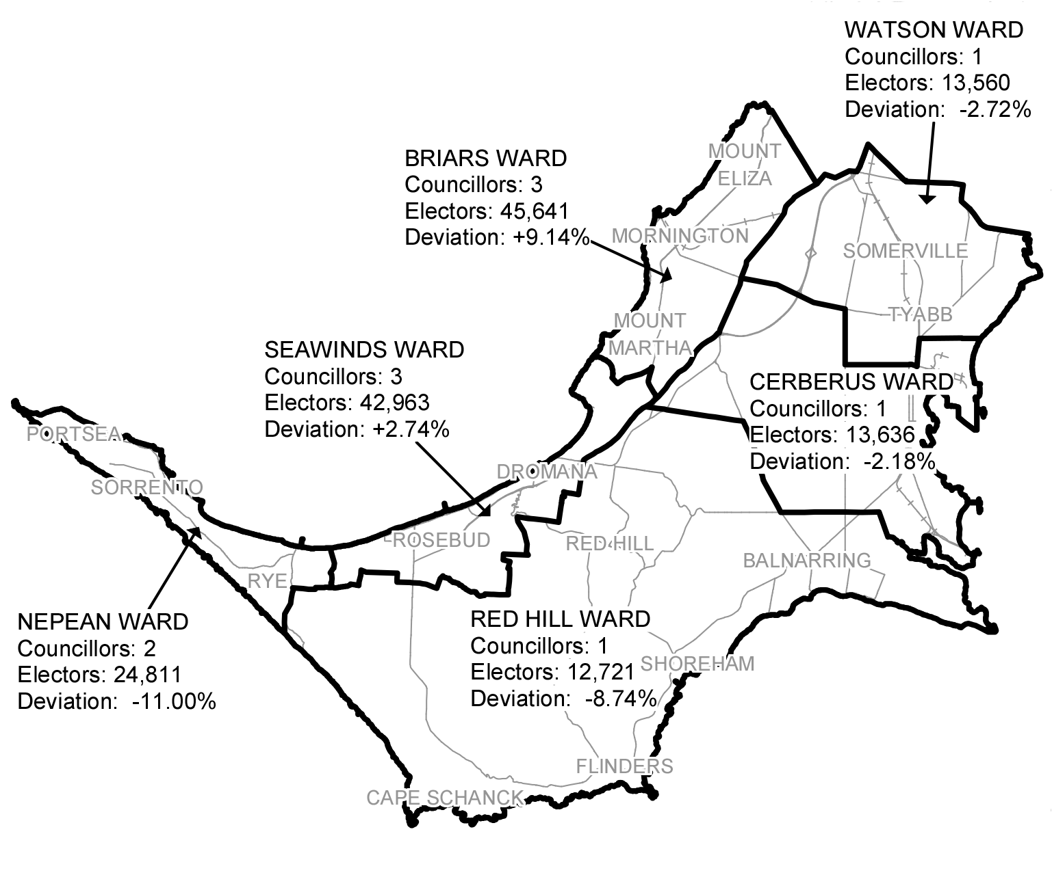
Diagram 1: Mornington Peninsula Shire Council electoral structure and voter statistics
The multi-councillor wards cover the built-up areas along Port Phillip Bay, and the single-councillor wards cover the more rural parts of the Shire. The VEC considered that this structure would fit broad communities of interest better than the single-councillor ward structure. In addition, the multi-councillor wards would be likely to provide voters with a wider choice of candidates and councillors, and to encourage diversity of representation. The VEC recommended single-councillor wards for the eastern side of the peninsula because communities in this area were more differentiated than in the more urban areas.

Voter numbers
Table 1 shows the number of voters in each ward as at 3 December 2015, ranked by the percentage this deviates from the average number of voters per councillor for the whole municipality.
Table 1: Voter numbers per ward as at 3 December 2015
Ward | Councillors | Voters | Deviation (%)
Nepean | 2 | 24,811 | -11.00%
Briars | 3 | 45,641 | +9.14%
Red Hill | 1 | 12,721 | -8.74%
Seawinds | 3 | 42,963 | +2.74%
Watson | 1 | 13,560 | -2.72%
Cerberus | 1 | 13,636 | -2.18%
Total for municipality | 11 | 153,332
Population shifts in Mornington Peninsula Shire have not been as dramatic as in most other metropolitan-rural fringe municipalities. Nevertheless, those shifts have been large enough for Nepean Ward’s enrolment to drop below the allowable 10 per cent variation from the average, triggering the current subdivision review. Enrolments for Briars and Red Hill Wards are close to the 10 per cent tolerance.
  - Subdivision review preliminary report
The VEC’s subdivision review of Mornington Peninsula Shire Council commenced with the release of a preliminary report on Tuesday 9 February 2016. The report contained proposed ward boundary changes based on analysis of enrolment information.
Advertisements were placed in the following newspapers on Tuesday 9 February notifying the public of the proposed changes:
- Mornington News
- Mornington Peninsula Leader
- Southern Peninsula News
- Western Port News
  - Public response

Public submissions
The VEC accepted submissions responding to the preliminary report from 9 February until
9 March. The VEC received six public submissions. The submissions are discussed in detail in Section 4.1.
A list of people who made a submission can be found in Appendix 1.

Public hearing
The VEC held a public hearing for those wishing to speak about their submission at 7.00 pm on Wednesday 16 March at the Mornington Peninsula Shire Offices, 90 Besgrove Street, Rosebud. There were two speakers at the hearing, which is discussed in detail in Section 4.1.
A list of people who spoke can be found in Appendix 1.

- Recommendation
  - The VEC’s findings
As noted above, the VEC generally adopts a minimal change approach to subdivision reviews, focussing on ensuring that numbers enrolled for each ward will be within 10 per cent of the average at the coming election.
In the current review, Nepean Ward needs to be enlarged to increase its voter catchment and bring its enrolment back within the 10 per cent tolerance. Consequently, changes are required to other wards.

Boundaries proposed in the preliminary report
The VEC proposed to transfer Tootgarook from Seawinds Ward to Nepean Ward. Other proposed changes were for the thinly populated south-eastern corner of Rye to be included in Nepean Ward, and for the rural northern part of Balnarring to be transferred from Cerberus Ward to Red Hill Ward. Under the proposed boundaries, 4,765 voters (3.11 per cent of the total) would be transferred to another ward.
The proposed boundaries ensured that enrolments for all wards would comply with the equality requirement for at least the 2016 general election. Nepean Ward’s enrolment would be comfortably above the average. Red Hill Ward’s current enrolment is 8.74 per cent below the average and is tending to decline, so the VEC proposed to add the balance of Balnarring to the ward to provide a cushion against its enrolment falling below the 10 per cent tolerance. In contrast, the VEC did not consider it necessary to change the boundaries of Briars Ward; that ward’s enrolment is 9.14 per cent above the average, but is tending to decline away from the 10 per cent threshold. The proposed boundaries reduced Seawinds Ward’s enrolment to 7.97 per cent below the average, but this ward is tending to grow.
The VEC considered that the proposed boundaries were clear, and followed geographic communities of interest. Tootgarook has close links with both Rye to the west and Rosebud West to the east, and from a community of interest viewpoint could fit equally well in either Nepean or Seawinds Ward. The other proposed changes united localities into the same ward, putting all of Rye in Nepean Ward and all of Balnarring in Red Hill Ward.

Issues raised in the public response
The VEC received six public submissions in response to the VEC’s preliminary report.
One submission disputed the constitutional validity of local government in Victoria.
Two submissions, from the Friends of Cape Schanck and the Balnarring Beach Community Association, argued that Red Hill Ward was too large and diverse for one part-time councillor. They suggested changes such as dividing the ward in two, or giving the ward two councillors. These proposals were outside the scope of the subdivision review, which cannot consider changes to the number of councillors or to the electoral structure.
Eddie Matt argued against transferring the south-eastern corner of Rye (which will be referred to as The Dunes area, as it includes The Dunes Golf Links) from Red Hill Ward to Nepean Ward. Mr Matt observed that the area is zoned agricultural, is part of the Green Wedge, and will remain so. He believed that the six farms in the area had more in common with the rural Red Hill Ward than with the urban Nepean Ward.
Andrew Raff of Fingal took a different approach. Mr Raff submitted that his area had very little to do with Red Hill Ward and its councillor, and much more in common with Nepean Ward. He proposed that the whole area west of Truemans Road, including The Dunes area, St Andrews Beach and most of Fingal, be transferred from Red Hill Ward to Nepean Ward.
The Nepean Ratepayers Association also submitted that areas should be switched from Red Hill Ward to Nepean Ward. The Association pointed to examples of development in Nepean Ward, and a comparative lack of development in Seawinds Ward, and requested that Tootgarook not be transferred from Seawinds Ward to Nepean Ward. Instead, the Association proposed that Nepean Ward gain St Andrews Beach plus The Dunes area from Red Hill Ward. The Association stated that St Andrews Beach was not readily connected with Red Hill Ward, but was easily accessible to Rye, which was the source of goods and services for St Andrews Beach residents. The management of ocean beaches, wildlife and development of vacant land were common issues for St Andrews Beach and Nepean Ward. The Association estimated that the addition of St Andrews Beach to Nepean Ward would change the ward’s enrolment to 6.85 per cent below the average – comfortably within the 10 per cent tolerance.
At the public hearing, Barrie Rimmer spoke on behalf of the Friends of Cape Schanck and David Gill spoke on behalf of the Balnarring Beach Community Association. They acknowledged that their ideas for Red Hill Ward were outside the scope of the subdivision review, but were looking forward to the next representation review of Mornington Peninsula Shire Council. They had no particular objections to the ward boundaries in the VEC’s preliminary report.

Consideration of issues raised
Mr Matt, Mr Raff and the Nepean Ratepayers Association all based their views on community of interest, but in varying ways. For Mr Matt, what was vital was the nature of the area that concerned him: as a rural area, The Dunes had more in common with the rural Red Hill Ward and so should remain in that ward. For Mr Raff and the Nepean Ratepayers Association the key factors were links and accessibility. Both points of view are valid ways of looking at community of interest.
St Andrews Beach is much closer to Rye than to the bulk of Red Hill Ward, with ready access to Rye via Dundas Street. As a small ocean beach and golfing community, it could be seen as having features in common with both Nepean and Red Hill wards, and could logically fit in either ward.
However, the proposals of Mr Raff and the Nepean Ratepayers Association do not comply with the equality requirement of the Act. Under Mr Raff’s proposed boundaries, Nepean Ward’s enrolment would be 11.13 per cent above the average, and Red Hill Ward’s enrolment would be 19.07 per cent below the average. Under the Association’s proposal, Nepean Ward’s enrolment would be satisfactory at -6.75 per cent, but Red Hill Ward’s enrolment would be 15.44 per cent below the average. Adding other rural areas to Red Hill Ward would still leave that ward’s enrolment below the 10 per cent tolerance, while significantly increasing the size of the ward. Therefore the VEC is unable to agree to these suggestions.
In assessing Mr Matt’s proposal, it should be noted that The Dunes area is next to the built-up area of Rye, and is part of the Rye locality. This is why the VEC proposed that the area be transferred to Nepean Ward. On the other hand, The Dunes area is also part of the Mornington Peninsula Green Wedge, most of which is covered by Red Hill Ward. In the 2011-2012 representation review, the VEC regarded Red Hill Ward as the ward covering the more sparsely populated parts of the Shire, and The Dunes area fits this description. Mr Matt’s submission contains detailed information about the rural nature of The Dunes area, including the types of farms and residences. Arguably this rural area would be better represented in a rural ward than as a tiny minority in an urban ward.
As The Dunes area contains only 35 voters, shifting it to another ward has little effect on ward numbers. Allocation of the area to Red Hill Ward slightly shifts ward enrolments towards the average, compared to the proposed boundaries in the preliminary report (Nepean Ward’s enrolment falls from +5.19 per cent to +5.06 per cent, and Red Hill Ward’s enrolment rises from
-7.19 per cent to -6.94 per cent).
Mr Matt has made a strong case on community of interest grounds, and his proposal is acceptable in terms of voter numbers. The VEC therefore recommends that The Dunes area be retained in Red Hill Ward, instead of being transferred to Nepean Ward as in its preliminary report.

  - The VEC’s recommendation
The Victorian Electoral Commission (VEC) recommends adjustments to the boundaries of the following wards within Mornington Peninsula Shire Council:
- Cerberus Ward
- Nepean Ward
- Red Hill Ward
- Seawinds Ward.
Recommended ward boundaries are illustrated in the map in Appendix 2.

Appendix 1: Public involvement
Public submissions
Public submissions were received from:
Balnarring Beach Community Association
Samuel Crane
Friends of Cape Schanck
Eddie Matt
Nepean Ratepayers Association Inc.
Andrew Raff
Public hearing
The following individuals spoke at the public hearing:
Barrie Rimmer on behalf of Friends of Cape Schanck
David Gill on behalf of Balnarring Beach Community Association

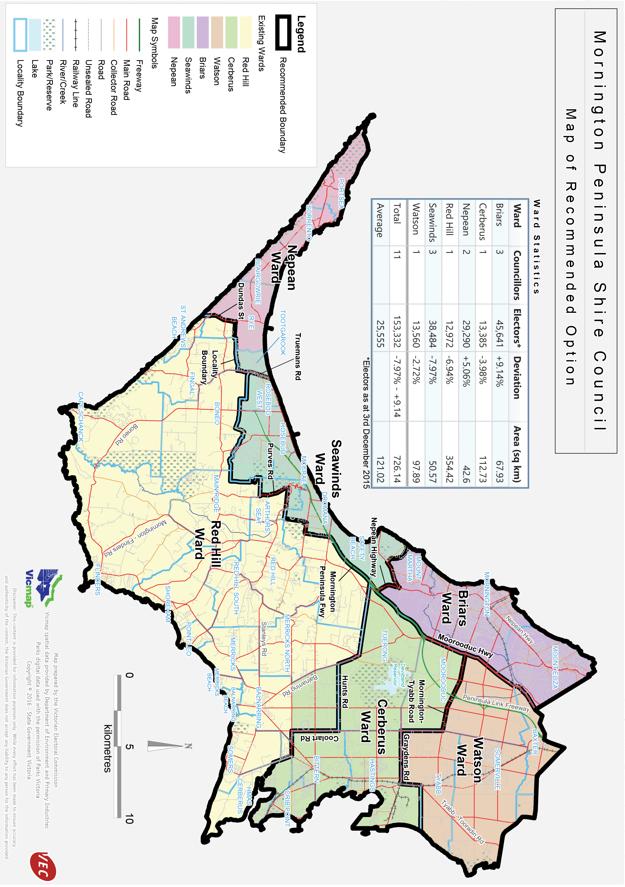
Appendix 2: Recommended ward boundaries map

Victorian Electoral Commission
Level 11, 530 Collins Street
Melbourne VIC 3000
131 832
morningtonpeninsula.review@vec.vic.gov.au

.id is a company specialising in population and demographic analysis that builds suburb-level demographic information products in most jurisdictions in Australia and New Zealand.
The SEIFA (Socio Economic Indexes for Areas) index of disadvantage measures the relative level of socio-economic disadvantage based on a range of census characteristics, such as low income, low educational attainment, high unemployment, and jobs in relatively unskilled occupations. A lower score on the index means a higher level of disadvantage.
Derived from .id’s community profile, http://profile.id.com.au/mornington-peninsula
Victorian Electoral Commission: Electoral Representation Review, Mornington Peninsula Shire Council – Final Report, p. 28.

