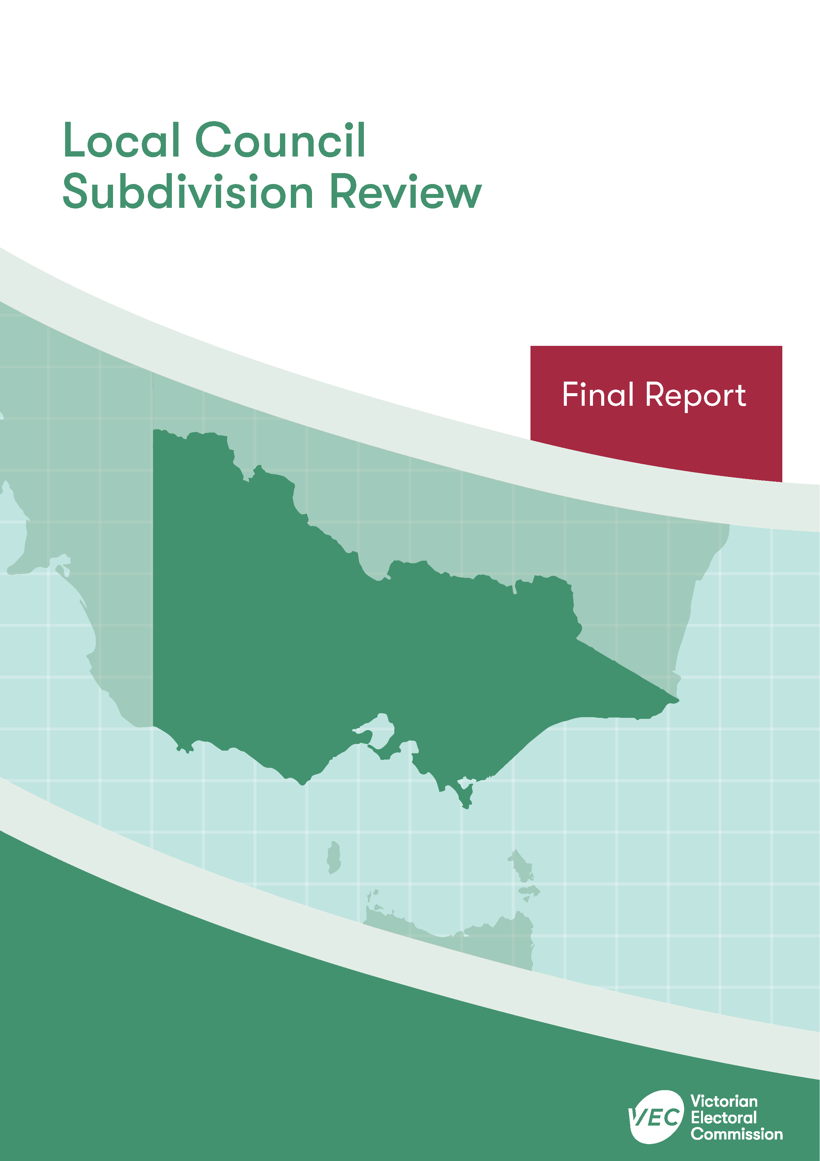



**Hume City Council**

**April 2020**

Contents

Recommendation 1

Executive summary 2

Background 4

Legislative basis 4

The VEC’s approach 5

Profile of Hume City Council 7

Population trends 8

Current number of councillors and electoral structure 9

Current subdivision review 10

Preliminary report 11

Public response 13

Response submissions 13

Public hearing 16

Findings and recommendation 19

The VEC’s findings 19

The VEC’s recommendation 24

Appendix 1: Public involvement 25

Appendix 2: Recommended ward boundaries map 26

Appendix 3: Public information program 28

Recommendation

The Victorian Electoral Commission recommends adjustments to the boundaries of all wards within Hume City Council:

* Aitken Ward
* Jacksons Creek Ward
* Meadow Valley Ward

This recommendation is submitted to the Minister for Local Government as required by the *Local Government Act 1989*.

Please see Appendix 2 for a detailed map of the recommended ward boundaries.

Executive summary

The *Local Government Act 1989* (LG Act) requires the Victorian Electoral Commission (VEC) to conduct a subdivision review to ensure the equitable representation of all voters in a local council.[1] The LG Act prescribes that the number of voters per councillor in each ward must be within plus-or-minus 10% of the average number of voters per councillor across the local council. [2] This is known as the ‘equality requirement’.

As population changes affect voter numbers and distribution in subdivided local councils, one or more wards may be unlikely to meet this requirement at the next general election. In such circumstances, the VEC recommends adjustments to internal ward boundaries to ensure that all wards meet the equality requirement before the next election and ideally, until the next scheduled electoral representation review.

Current number of councillors and electoral structure

Hume City Council currently comprises 11 councillors elected from three wards (one three-councillor ward and two four-councillor wards). More information on Hume City Council is available on the VEC website at [vec.vic.gov.au](http://vec.vic.gov.au).

In 2018, the VEC notified the Minister for Local Government that one or more wards were unlikely to meet the equality requirement at the 2020 general election. Accordingly, the Minister notified the VEC that a subdivision review of Hume City Council was required before the 2020 general election.

Preliminary report

A preliminary report was released on Wednesday 26 February 2020 proposing adjustments to the boundaries that affect all wards within Hume City Council:

* Aitken Ward
* Jacksons Creek Ward
* Meadow Valley Ward

Response submissions

The VEC received four submissions responding to the preliminary report by the deadline of 5.00 pm on Wednesday 25 March 2020.

Public hearing

The VEC conducted a public hearing for those wishing to speak about their response submission at 7.00 pm on Monday 30 March 2020. Two people spoke at the hearing.

Recommendation

The Victorian Electoral Commission recommends adjustments to the boundaries of all wards within Hume City Council:

* Aitken Ward
* Jacksons Creek Ward
* Meadow Valley Ward

This recommendation is submitted to the Minister for Local Government as required by the *Local Government Act 1989*.

Please see Appendix 2 for a detailed map of the recommended ward boundaries.

Background

Legislative basis

The *Local Government Act 1989* (LG Act) requires the Victorian Electoral Commission (VEC) to conduct a subdivision review to ensure the equitable representation of all voters in a local council. The LG Act prescribes that the number of voters per councillor in each ward must be within plus-or-minus 10% of the average number of voters per councillor across the local council. [3] This is known as the ‘equality requirement’.

As population changes affect voter numbers and distribution in subdivided local councils, one or more wards may be unlikely to meet this requirement at the next general election. In such circumstances, the VEC recommends adjustments to internal ward boundaries to ensure that all wards meet the equality requirement before the next election and ideally, until the next scheduled electoral representation review.

Subdivision reviews only apply to subdivided councils:

* that are not scheduled for an electoral representation review before the next general election

and

* where, two years before the council is to hold a general election, the VEC considers one or more wards are unlikely to meet the equality requirement at the time of the next general election.

### Scope

A subdivision review only considers the location of ward boundaries. A subdivision review cannot consider changes to the number of councillors or wards.

These changes are considered in an electoral representation review. Following the passing of the *Local Government Act 2020*, such matters will be considered by an electoral representation advisory panel.

A subdivision review also cannot change the external boundaries of the local council, divide local councils, or amalgamate local councils. These changes can only be made by an Order in Council.

The VEC’s approach

### Public information program

The VEC conducted a public information program to inform the community of the subdivision review, including:

* a public notice printed in local papers
* a media release announcing the release of the preliminary report
* an information email campaign targeted at known community groups and communities of interest in the local council area
* sponsored social media advertising geo-targeted to users within the local council   
  area
* ongoing information updates and publication of submissions on the VEC website.

More information on the VEC’s public information program for the subdivision review of Hume City Council can be found at Appendix 3.

### Public consultation

Public input was encouraged by the VEC via:

* response submissions to the preliminary report
* a public hearing that provided an opportunity for people who had made a response submission to expand on their submission.

### Developing recommendations

The VEC bases its recommendations for ward boundaries on:

* internal research specifically relating to the local council under review, including voter statistics from the Victorian electoral roll
* small area forecasts provided by .id[4]
* the VEC’s expertise in mapping, demography and local government
* consideration of all input from the public in written submissions received during the review.

In determining which ward boundaries are most appropriate, the VEC considers the:

* number of voters in each ward, to ensure that each ward meets the equality requirement for the next election
* number of voters affected by the changes, with the aim of affecting as few voters as possible
* communities of interest
* significance of natural and man-made features (such as roads and waterways), to ensure clear and identifiable ward boundaries
* geographic factors, such as size and topography
* longevity of the structure.

### Communities of interest

Each local council contains a number of communities of interest. Where practicable, ward boundaries should be designed to ensure they are fairly represented, and that geographic communities of interest are not split. This allows communities with shared concerns to elect a councillor.

Hume City Council

Profile of Hume City Council

Hume City Council is located north-west of the Melbourne CBD, at the interface between metropolitan Melbourne and the surrounding rural area. The local council includes the localities of Attwood, Broadmeadows, Bulla, Campbellfield, Coolaroo, Craigieburn, Dallas, Gladstone Park, Greenvale, Jacana, Kalkallo, Meadow Heights, Melbourne Airport, Mickleham, Oaklands Junction, Roxburgh Park, Somerton, Sunbury, Westmeadows, Wildwood and Yuroke, as well as parts of Clarkefield, Diggers Rest, Fawkner, Keilor and Tullamarine.

The City of Hume comprises both urban and rural areas. The Melbourne Urban Growth Boundary covers much of the local council’s eastern area, with an additional pocket of Urban Growth Boundary in the west of the local council area covering Sunbury and surrounds.

Within the Urban Growth Boundary, the local council area includes residential, commercial and industrial areas, with large areas of former agricultural land currently undergoing residential development. The Northern State Significant Industrial Precinct is located along the Hume Freeway corridor, with the bulk of this precinct situated in Craigieburn, Somerton, Campbellfield, Coolaroo and Broadmeadows.

Additional smaller industrial areas are located in Sunbury, Tullamarine and Westmeadows. A number of retail areas and shopping centres are also located in the local council, including Broadmeadows Central and Craigieburn Central. The Sunbury Green Wedge comprises the area outside the Urban Growth Boundary and separates Sunbury from the developed area to the east. This area of Green Wedge includes agricultural land, conservation areas and the Melbourne Airport.

The City of Hume is also home to the Maygar Army Barracks, Victoria Police Attwood complex, Broadmeadows Hospital and Sunbury Day Hospital, the Kangan Institute Broadmeadows Campus and various golf clubs.

Although specific areas of the local council are experiencing lower than average levels of disadvantage compared to Greater Melbourne, disadvantage across the City of Hume is higher than average overall.[5] The City of Hume weekly median personal income ($529) and weekly median household income ($1,379) are lower than the medians for Greater Melbourne ($673 and $1,542 respectively). Unemployment within the local council is at 8.7%, which is higher than for Greater Melbourne (6.8%) and regional Victoria (6.0%).[6]

Levels of cultural and linguistic diversity within the City of Hume are slightly higher compared to Greater Melbourne, and the population has become increasingly diverse over time.[7] At least 35.7% of residents were born overseas and 44.9% speak a language other than English at home, compared to 33.8% and 32.3% respectively across Greater Melbourne. For those born overseas, the most common countries of birth at the time of the 2016 Census were Iraq (5.4%), India (4.4%), Turkey (3.1%), Lebanon (1.8%) and New Zealand (1.7%).[8]

Aboriginal and Torres Strait Islander people comprise 0.7% of the population, which is higher than the Greater Melbourne average of 0.5%.[9] The Wurundjeri people are the traditional custodians of the land known as the City of Hume.[10]

The median age within the City of Hume (33 years) is lower than that of Greater Melbourne (36 years) and families are predominantly comprised of couples with children (54.7%).[11]

Population trends

Hume City Council is experiencing high population growth. At the time of the 2016 Census, the local council had a population of 197,376.[12] From 2011–2018, the population is estimated to have grown at an average of 3.5% per annum.[13] The population is expected to continue growing at an average rate of 2.4% per annum from 2018­­–2036, reaching 343,990 by 2036.[14] This rate of growth is higher than the overall growth rate of 1.9% per annum expected for Greater Melbourne over the 2018–2036 period.[15]

Uneven levels of growth are occurring across the local council area. Most of the population resides within the Urban Growth Boundary and higher population growth is expected in areas with new residential developments. The greatest rates of growth are expected within Kalkallo and Mickleham in the north-east of the local council. Slower growth and in some cases population decline is expected for established suburbs in the south of the local council and for rural areas outside of the Urban Growth Boundary.[16]

There are currently an estimated 152,629 registered voters for Hume City Council, with an average of 13,875 voters per councillor.

Current number of councillors and electoral structure

Hume City Council currently comprises 11 councillors elected from three wards   
(one three-councillor ward and two four-councillor wards). Prior to the last representation review in 2012, Hume City Council was comprised of nine councillors elected from four wards (one three-councillor ward and three two-councillor wards).

Diagram 1 (on the next page) illustrates the current electoral structure and voter statistics by ward as at 15 October 2019.

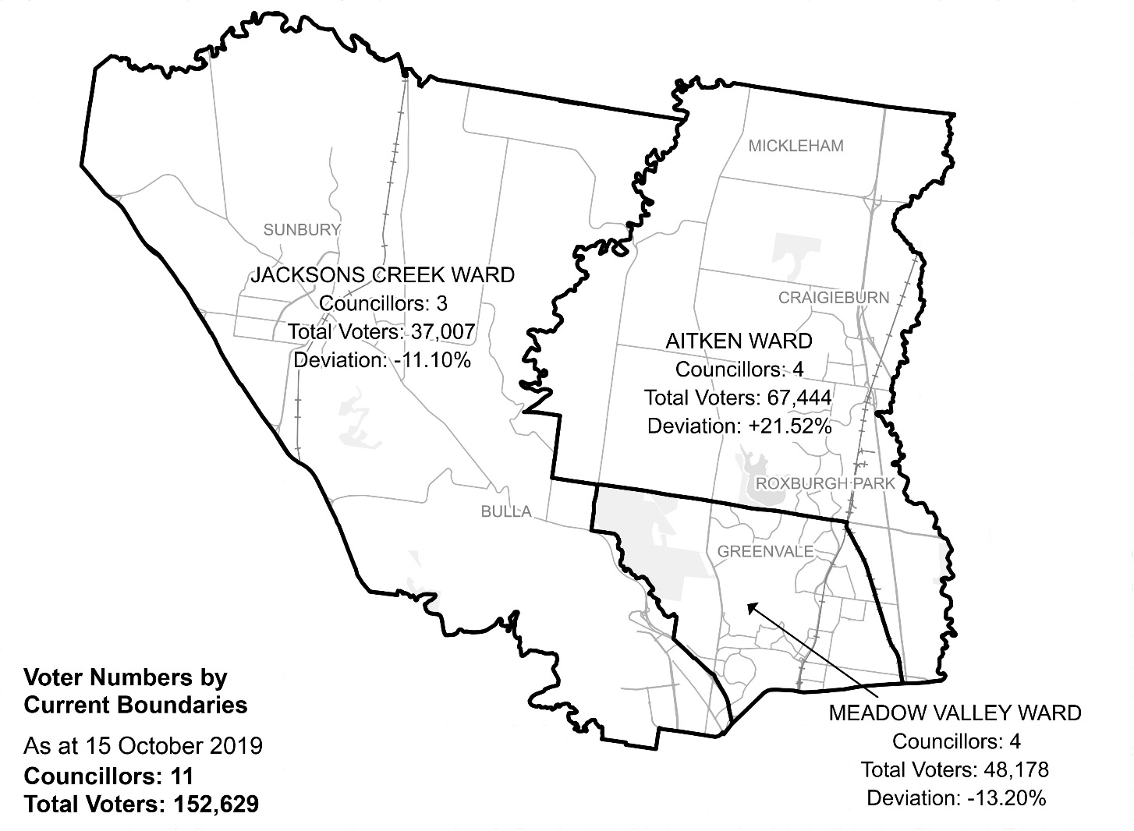

Diagram 1: Hume City Council electoral structure and voter statistics.

Current subdivision review

The current subdivision review of Hume City Council is required due to the voter-to-councillor ratios in all wards being more than 10% above or below the average voter-to-councillor ratio for the local council. Consequently, all ward boundaries will need to be adjusted so that ward enrolments will be within the 10% tolerance at the 2020 general election.

Table 1 shows the number of voters in each ward as at 15 October 2019, ranked by the percentage this deviates from the average number of voters per councillor for the whole local council.

|  |  |  |  |
| --- | --- | --- | --- |
| Table 1: Voter numbers per ward | | | |
| **Ward** | **Councillors** | **Voters** | **Deviation (%)** |
| Aitken | 4 | 67,444 | +21.52 |
| Meadow Valley | 4 | 48,178 | -13.20 |
| Jacksons Creek | 3 | 37,007 | -11.10 |
| **Total for council** | **11** | **152,629** |  |

Preliminary report

The VEC’s subdivision review of Hume City Council commenced with the release of a preliminary report on Wednesday 26 February 2020. The report contained proposed ward boundary changes based on analysis of enrolment information and internal research.

The main aim of this subdivision review was to devise ward boundary adjustments that would ensure that voter-to-councillor ratios for all wards were within the legislated plus-or-minus 10% tolerance at the time of the 2020 local government general elections. More substantial changes to the electoral structure of Hume City Council may occur through the new process to be established under the *Local Government Act 2020*.

In the preliminary report, the VEC proposed to move the ward boundary between Meadow Valley and Aitken Wards, so that part of Roxburgh Park and all of the area east of the Craigieburn Railway Line and south of Craigieburn Road East (comprising Campbellfield, Somerton and part of Craigieburn) would be within Meadow Valley Ward. The proposed Meadow Valley-Aitken Ward boundary would follow, from west to east: Somerton Road, transmission line (following Aitken Avenue, Pinnock Reserve, Kirwan Park Reserve), the Craigieburn Railway Line and Craigieburn Road East.

The VEC also proposed to move the ward boundary between Meadow Valley and Jacksons Creek Wards, so that the sections of Attwood and Westmeadows located to the west of Mickleham Road would be within Jacksons Creek Ward. The proposed Meadow Valley-Jacksons Creek Ward boundary would instead follow, from north to south: Oaklands Road, Greenvale locality boundary, Moonee Ponds Creek, Attwood locality boundary, Mickleham Road and the Tullamarine Freeway.

Based on current enrolments, the proposed boundary changes would impact 12,472 voters (8.2% of current enrolment).

Table 2 details the number of voters in each ward as a result of the proposed boundary change.

|  |  |  |  |
| --- | --- | --- | --- |
| Table 2: Voter numbers per ward with proposed boundaries | | | |
| **Ward** | **Councillors** | **Voters** | **Deviation (%)** |
| Aitken | 4 | 57,269 | +3.18 |
| Meadow Valley | 4 | 56,056 | +1.00 |
| Jacksons Creek | 3 | 39,304 | -5.58 |
| **Total for council** | **11** | **152,629** |  |

Public response

Response submissions

The VEC accepted submissions responding to the preliminary report from Wednesday 26 February 2020 until 5.00 pm on Wednesday 25 March 2020. The VEC received four response submissions. A list of people and organisations that made a response submission can be found in Appendix 1.

### Uniting more localities

Councillor Andrew Jessop provided an independent submission. He ‘generally support[ed] the rationale and outcome of the VEC’s preliminary report’. However, Councillor Jessop believed that the proposed boundaries could be improved to reduce the number of localities split by the current and proposed ward boundaries.

According to Councillor Jessop, residents strongly related to their suburb, which was especially the case in Craigieburn, Greenvale and Roxburgh Park in Aitken Ward. Councillor Jessop noted that the VEC’s proposed ward boundary adjustments would split the localities of Attwood, Westmeadows and Roxburgh Park, in addition to localities such as Greenvale, which were already split in the current structure.

Councillor Jessop supported the VEC’s boundary adjustments but proposed an additional boundary adjustment between Aitken and Meadow Valley Wards in order to unite Greenvale in Meadow Valley Ward and unite Roxburgh Park in Aitken Ward. Councillor Jessop wrote that this would leave Attwood and Westmeadows ‘unavoidably’ split by the new ward boundaries but reduce the total number of communities of interest and localities split in the VEC’s proposal.

### Uniting Greenvale

The Greenvale Residents’ Association Incorporated advocated for Greenvale to be united in one ward. It was submitted that since the VEC’s last electoral representation review in 2012, Greenvale’s residents and voters have been disadvantaged by being divided across Aitken and Meadow Valley Wards. Voters had been confused about which ward they were in, and while thousands of new residents had settled in Greenvale in the past nine years, Greenvale was unable to gain adequate council representation, evident in the lack of ‘decent council infrastructure…such as a library, leisure centre, Roads, Park improvements etc’.

Greenvale Residents’ Association argued that if Greenvale was to be united in one ward, it would increase their chance of electing a councillor dedicated to their issues. While advocating for all of Greenvale to be in one ward, ultimately, the association believed ward boundaries needed to be ‘completely redrawn’ with ‘smaller wards’ to serve the various communities in the council area.

### Ward boundaries reflecting Hume Integrated Growth Area Plans

Councillor Naim Kurt of Meadow Valley Ward also provided an independent submission. Councillor Kurt supported a different set of ward boundary adjustments to the VEC’s proposal. Councillor Kurt argued that his proposed boundaries would deliver wards that better reflect the three main communities of interest in the council area, as well as ‘address anomalies’ which exist in the current structure.

Councillor Kurt submitted that there were three main communities of interest in the City of Hume – the growth areas in the north, the established suburbs in the south, and the rural areas to the west of which the largest population was in Sunbury. He proposed aligning council ward boundaries with the Council’s Hume Integrated Growth Area Planning (HIGAP) documents, which manage and address population and economic growth in the City of Hume. Councillor Kurt had drawn on the three available Hume Integrated Growth Area Plan (HIGAP) documents, which included definitions of the areas within the Hume Corridor, Sunbury and the City’s rural region.[17]

Councillor Kurt’s ward boundaries presented several changes. Notably, his preferred ward boundaries included extending much of the eastern boundary of Jacksons Creek Ward (north of Somerton Road) from the current Deep Creek and Wildwood Road boundary to Mickleham Road and into parts of Greenvale west. Councillor Kurt’s proposed adjustment of the Jacksons Creek Ward boundary would result in the localities of Oaklands Junction, Yuroke and Greenvale west being within Jacksons Creek Ward. In the south, Woodlands Historic Park in Meadow Valley Ward would also become a part of Jacksons Creek Ward.

Councillor Kurt also submitted that currently Tullamarine and Campbellfield were included in wards and alongside communities which they have had ‘little engagement with’. Councillor Kurrt proposed using Somerton Road as the southern boundary of Aitken Ward, which would enable Campbellfield to become a part of Meadow Valley Ward. Another proposed boundary adjustment would result in Tullamarine (remaining in Jacksons Creek Ward in the VEC’s proposal) becoming a part of Meadow Valley Ward.

Councillor Kurt concluded that his alternative proposal would result in wards, which ‘consigned’ areas to ‘like-type wards’. He argued that his boundaries were preferable because they would enable councillors to focus more exclusively on the issues relevant to their ward and because they would align with the Council’s strategies.

### Out of scope

The VEC received one submission that was out of scope.

In a submission, Elaine Brogan of Sunbury advocated for the Sunbury region to constitute a standalone council. Ms Brogan explained that Sunbury ‘was and would still like to be a lovely country village’. However, due to continued residential and urban development, the Sunbury area had not received adequate infrastructure or support for conserving the landscape and cultural heritage in and around Sunbury. Ms Brogan believed that with the continued growth of Tullamarine within Jacksons Creek Ward, Sunbury and surrounds could operate as an independent council area.

The VEC could not consider this submission because it sought to change the Council’s external boundaries.

Public hearing

The VEC conducted a public hearing via Cisco Webex for those wishing to speak about their response submission at 7.00 pm on Monday 30 March 2020. Two people spoke at the public hearing, Charlie Grech, Secretary of Greenvale Residents Association Incorporated and Councillor Naim Kurt of Meadow Valley Ward.

### Greenvale Residents’ Association Incorporated on uniting Greenvale

At the public hearing, Mr Grech stated that Greenvale would continue to be disadvantaged by the VEC’s proposed ward boundary adjustments. Mr Grech explained that there had been one councillor who recently moved into Greenvale but prior to that, all Aitken and Meadow Valley Ward councillors were ‘voted in’ from areas outside of Greenvale. Mr Grech advocated for Greenvale north and south of Somerton Road to be in one ward, which would increase their chance of electing a dedicated representative, as well as providing just one set of councillors for residents to approach.

Responding to questions from the VEC, Mr Grech confirmed that Greenvale north of Somerton Road was predominantly rural up until about eight or 10 years’ ago but was now characterised by newer residential development. Greenvale south, on the other hand, was distinguished by its established residential areas. He acknowledged that there were some different issues for residents north and south of Somerton Road, but emphasised that Greenvale Residents’ Association represented all of Greenvale.

Mr Grech further explained that despite having eight councillors to approach, councillors in both Aitken and Meadow Valley Wards could be ‘remote’; they served diverse interests; and they were more likely to neglect Greenvale when there were pressures from other communities and areas. He also commented that four-councillor wards were ‘very big’ and that ultimately, smaller wards would better serve communities within the City of Hume.

Responding to questions from the VEC, Mr Grech considered Meadow Valley Ward more appropriate for the whole of Greenvale to be united within. He noted that Greenvale had more commonalities with Attwood to the south, than Craigieburn to the north which was ‘quite some kilometres away’.

**Mickleham Road boundary**

Mr Grech was also asked whether Greenvale Residents’ Association would support extending the eastern boundary of Jacksons Creek to Mickleham Road. Mr Grech did not consider Mickleham Road appropriate and commented that it would divide Greenvale.

### Councillor Naim Kurt of Meadow Valley Ward

At the public hearing, Councillor Kurt explained there were three main communities of interest in the City. They included the growth areas in the north, the established suburbs in the south and the rural communities in the west. Councillor Kurt highlighted the importance of placing communities that share issues into their relevant ward and explained that his proposed ward boundaries would be in line with the Council’s strategic HIGAP documents, which would continue to govern council spending on the different areas in the next two to three decades.

Councillor Kurt commented that currently the rural areas stretch across all wards. Councillor Kurt told the VEC that he did not support spreading the rural area across all wards. Instead, he supported wards which predominantly contained one of the three broad communities of interest. Councillor Kurt also commented that although Woodlands Historic Park was used by residents from all localities in the council area, the issues of managing parks and reserves was more connected with the rural area HIGAP strategy.

Responding to a question about whether there were interconnected issues that would be better served by wards which contain a mix of each broad community of interest, Councillor Kurt emphasised that the allocation of work and focus for the councillors meant, for example, that the Meadow Valley Ward councillors were focused on urban renewal and town planning issues rather than precinct structure plans, which were a focus of the Aitken Ward councillors in the growing areas to the north.

Councillor Kurt further explained that the problem for the councillors in Meadow Valley and Aitken Wards was they were often not as across all of the issues for the rural areas as the Jacksons Creek Ward councillors. He considered that containing all the rural areas in a larger Jacksons Creek Ward would also benefit the rural community and would ensure that their issues are not lost in the competing demands in the predominantly urban wards.

Councillor Kurt also noted that at present Tullamarine and Campbellfield were both misplaced in the current structure. Tullamarine’s residents and voters relied on facilities and services in Gladstone Park and Broadmeadows within Meadow Valley Ward and were not well represented by the Jacksons Creek Ward councillors. Similarly, Councillor Kurt noted that Campbellfield’s residents tended to gravitate towards Broadmeadows in Meadow Valley Ward, rather than Craigieburn in Aitken Ward.

Responding to the VEC’s question about the larger area covered by the Jacksons Creek Ward in his preferred model, Councillor Kurt commented that although the Aitken and Meadow Valley Wards in his model would cover smaller areas, these urban wards would be similar to the geographically larger Jacksons Creek Ward in terms of population demands.

**Greenvale and Roxburgh Park**

Responding to a question from the VEC about the splitting of Greenvale, Councillor Kurt commented that he would prefer that the two predominantly urban wards did not contain parts of the rural areas to the west. Councillor Kurt questioned whether this could be achieved with Greenvale contained in one ward.

Responding to a further question from the VEC regarding which ward was more appropriate if all of Greenvale was to be contained in one ward, Councillor Kurt considered that Greenvale was likely to be better placed in Jacksons Creek Ward because the suburb was previously part of the Shire of Bulla, and the older community in Greenvale would share commonalities with the rural communities to the west.

Due to the residential development in Greenvale north of Somerton Road, Councillor Kurt also believed that Greenvale could fit with Aitken Ward.

Regarding Roxburgh Park, Councillor Kurt commented that the suburb would be better placed in Meadow Valley Ward, if that was a decision that needed to be made. He noted that Roxburgh Park had a culturally and socially diverse population and was likely to share commonalities with suburbs and populations in Meadow Valley Ward.

**Roxburgh Park, Attwood and Westmeadows**

Councillor Kurt noted that residents and voters in Roxburgh Park, Attwood and Westmeadows were unlikely to support the VEC’s proposal because their suburbs would be divided across wards.

Councillor Kurt also commented that a four or five-ward electoral structure was likely to be better for local representation in the City of Hume because it would also recognise the smaller distinct localities and communities of interest – but he acknowledged that changing the number of wards was not within the ambit of the subdivision review.

Findings and recommendation

The VEC’s findings

**The VEC’s proposed boundary adjustments**

In the preliminary report, the VEC noted that its proposed ward boundary adjustments:

* followed easy to recognise geographic features
* enabled much of the existing Jacksons Creek Ward boundary to remain as is, much of which follows easily recognisable natural features and captures the Sunbury region community of interest
* enabled the majority of the Northern State Significant Industrial Precinct to remain united within one ward
* united the Westmeadows industrial area with the closely related Melbourne Airport and Tullamarine Industrial area.

Based on current enrolments, the VEC’s original proposed boundary changes would impact 12,472 voters (or 8.2% of the total enrolment).

At the final stage of the review, the VEC remains of the view that its proposed ward boundary adjustments would meet the main aim of a subdivision review and consideration for fair representation of communities of interest.

However, the VEC had noted that one of the potential drawbacks of its proposed ward boundary adjustments was that it would split the suburbs of Attwood, Westmeadows and Roxburgh Park across wards. As noted in the preliminary report, the divisions were necessary to balance ward deviations.

At the final stage of the review, the VEC closely considered all submissions and found Councillor Jessop’s proposal of an additional boundary adjustment between Aitken and Meadow Valley Wards to present marginally greater advantages than the VEC’s preliminary proposed ward boundary adjustments alone and it recommends this additional boundary adjustment.

The VEC also considered Councillor Kurt’s alternative proposed ward boundary adjustments. While the VEC acknowledged the merits of Councillor Kurt’s proposal, it could not recommend these ward boundary adjustments. They represented more significant change and disruption for voters in the City of Hume. In some cases, they did not fit with the VEC’s findings and research on communities of interest in an area, and the proposal – though appealing for the councillor’s broad conceptualisation of communities of interest in the City of Hume – could not provide a balance in meeting the requirements and considerations in a subdivision review.

**Councillor Kurt’s proposal**

Councillor Kurt presented strong arguments in favour of his preferred ward boundary adjustments, which the VEC considered to have potential advantages for representing the three broad communities of interest. However, the VEC could not recommend the alternative proposal in part, or in its entirety, for several notable reasons.

The VEC modelled Councillor Kurt’s boundaries and found that they would affect 17,228 voters (or 11.29% of the total enrolment). This number would be substantially more than the 12,472 voters affected by the VEC’s proposed ward boundary adjustments. It would, in fact, lead to 4,756 more voters who would need to change wards at the 2020 general council election, which would increase disruption and potential confusion for voters.

The VEC prefers to make minimal ward boundary adjustments in subdivision reviews in order to affect the least possible number of voters while at the same time ensuring that the electoral structure will provide fair and equitable representation for voters until the next election. Councillor Kurt’s proposal did not reflect a ‘minimal change’ approach and therefore, could not be considered in its entirety.

Moreover, the VEC noted that the alternative proposed by Councillor Kurt would require dividing several suburbs and communities of interest – more so than the VEC’s final recommendation. While all of Roxburgh Park would remain in Aitken Ward, Attwood and Westmeadows would still be divided across wards. Councillor Kurt’s alternative boundaries would also more significantly divide Greenvale, splitting the suburb three ways, and placing most of residential Greenvale into rural Jacksons Creek Ward, which neither the Greenvale Residents’ Association or Councillor Jessop had proposed.

Perhaps the most significant aspect of Councillor Kurt’s proposals was to shift the eastern boundary of Jacksons Creek Ward to Mickleham Road to better recognise the current limits of Melbourne’s urban growth in the City of Hume. The VEC recognised the merits of this argument but preferred retaining the Deep Creek and Wildwood Road boundary. This is because Deep Creek is a longstanding boundary at council and state levels, and it has divided the Sunbury-Bulla rural community of interest from the outer urban areas for a long time.

Further, while the area between Mickleham Road and Deep Creek would be allocated to Jacksons Creek Ward in Councillor Kurt’s proposal, the VEC is of the view that while this area is still mainly rural; it is affected by urban growth; and it has closer links to the east (and Craigieburn) compared to the west. With only one bridge across Deep Creek, there is little interaction between the Mickleham area and the Sunbury-aligned area west of Deep Creek.

Under Councillor Kurt’s alternative, the Northern State Significant Industrial Precinct would be divided, with Somerton in Aitken Ward and Campbellfield in Meadow Valley Ward. The industrial precinct is known to stretch north from the Metropolitan Ring Road along Merri Creek to include Campbellfield, Somerton and a small section of Craigieburn.

The VEC does not favour splitting the industrial precinct, which it has kept intact in its past electoral representation reviews. The VEC considers that there is a stronger case for keeping the industrial precinct and this community of interest intact. The VEC notes that its proposed boundary adjustments would keep the whole industrial precinct within Meadow Valley Ward, which would also respond to Councillor Kurt’s support for Campbellfield to be in Meadow Valley Ward. The VEC had previously placed the industrial precinct in Aitken Ward out of necessity, for the Council’s three wards to meet the legislated equality requirement.

The VEC also considered Councillor Kurt’s preference for Tullamarine to be in Meadow Valley Ward, but it could not make this change based on numbers alone. According to current enrolments, Tullamarine has 5,519 voters. To include Tullamarine in Meadow Valley Ward would substantially compromise the VEC’s other boundary adjustments in this subdivision review. Moreover, the VEC was reluctant to split Tullamarine from the closely related Melbourne Airport and the related Westmeadows industrial precinct.

**Councillor Jessop’s proposal – uniting Greenvale and Roxburgh Park**

The VEC also considered Councillor Jessop’s proposal. Councillor Jessop’s additional boundary adjustment between Aitken and Meadow Valley Wards would unite two major suburbs, Greenvale (which was split at the last electoral representation review) and Roxburgh Park (which the VEC proposed to split in this subdivision review). It would also respond to the Greenvale Residents Association’s support for Greenvale to be in one ward.

The VEC considered it a strength of Councillor Jessop’s proposal to reduce the number of localities split by the current and proposed ward boundaries. It noted that this additional ward boundary adjustment would reduce the total number of localities split through the subdivision review to just Attwood, Westmeadows and a very small section of Craigieburn east.

However, the VEC noted that there were also possible drawbacks to Councillor Jessop’s proposal. Ward boundaries are more convoluted than those proposed in the preliminary report. More importantly, the VEC considered that Greenvale and Roxburgh Park may not be in the most appropriate wards. According to the demographic information available, Roxburgh Park is a well-established suburb, with greater cultural and linguistic diversity and a high degree of social diversity. In this sense, as Councillor Kurt had suggested Roxburgh Park was likely to be a better fit for Meadow Valley Ward. On the other hand, the VEC observed that Greenvale is mixed, containing both established and growth areas but including a large component of growing residential areas north of Somerton Road, which would suggest that Greenvale could be a better fit with Aitken Ward.

The VEC modelled a variation of Councillor Jessop’s proposal in which Greenvale would be in Aitken Ward and Roxburgh Park would be in Meadow Valley Ward, but it found a significantly large number (28,094 voters or close to 20% of the total enrolment) would be affected by this variation. The VEC therefore could not consider this variation any further.

The VEC found that Councillor Jessop’s proposal would also result in a small reduction in the number of voters affected in this subdivision review. By uniting Greenvale and keeping Roxburgh Park in Aitken Ward, 11,797 voters (or 7.7% of the total enrolment) would be affected and would change wards at the next election. The VEC noted that this would result in 675 fewer voters affected by the ward boundary adjustments recommended in this subdivision review compared to the boundary adjustments proposed in the preliminary report.

Despite the potential drawbacks, the VEC recommends the inclusion of Councillor Jessop’s additional ward boundary adjustment because of two factors:

* A slightly smaller number of voters would be affected by the ward boundary adjustments, which was in line with the VEC’s principle to effect minimal change when conducting subdivision reviews.
* The communities of interest in Greenvale and Roxburgh Park would be wholly contained within wards, which the VEC considered an improvement to its proposal because it would reduce the number of suburbs split by the current ward boundaries and proposed boundary adjustments.

By uniting Greenvale in one ward, the VEC reasoned that it would provide the opportunity for Greenvale’s voters to elect a representative at the next election. Similarly, Roxburgh Park’s voters would not be disadvantaged by being divided. Although not in a ward with the other established suburbs, the VEC reasoned that Roxburgh Park had been in Aitken Ward with the growing residential areas in the north of the City of Hume over the past 15 years.

**Summary**

The VEC therefore recommends its proposed ward boundary adjustments with an additional boundary adjustment between Aitken and Meadow Valley Wards to ensure Greenvale is wholly contained in one ward and Roxburgh Park is not split.

The new ward boundary between Aitken and Meadow Valley Wards would follow from west to east: Somerton Road, Moonee Ponds Creek, Dunhelen Lane, property boundaries in the north of Greenvale, Aitken Boulevard, Somerton Road, the railway line and Craigieburn Road.

By including this additional ward boundary adjustment, the total number of voters affected by changes in this subdivision review was reduced to 11,797 (or 7.7% of the total enrolment).

|  |  |  |  |
| --- | --- | --- | --- |
| Table 3: Voter numbers per ward with recommended boundaries | | | |
| **Ward** | **Councillors** | **Voters** | **Deviation (%)** |
| Aitken | 4 | 57,944 | +4.40% |
| Meadow Valley | 4 | 55,381 | -0.22% |
| Jacksons Creek | 3 | 39,304 | -5.58% |
| **Total for council** | **11** | **152,629** |  |

The VEC’s recommendation

The Victorian Electoral Commission recommends adjustments to the boundaries of all wards within Hume City Council:

* Aitken Ward
* Jacksons Creek Ward
* Meadow Valley Ward

This recommendation is submitted to the Minister for Local Government as required by the *Local Government Act 1989*.

Please see Appendix 2 for a detailed map of the recommended ward boundaries.

# Appendix 1: Public involvement

Response submissions

Response submissions were made by:

Brogan, Elaine

Greenvale Residents Association Inc.

Jessop, Andrew (Councillor)

Kurt, Naim (Councillor)

Public hearing

The following individuals spoke at the public hearing:

Grech, Charlie for Greenvale Residents Association Inc.

Kurt, Naim (Councillor)

# Appendix 2: Recommended ward boundaries map

The map is provided on the next page.

# Appendix 3: Public information program

Advertising

Public notices of the release of the preliminary report were placed in the following newspapers:

|  |  |
| --- | --- |
| **Newspaper** | **Date of publication** |
| *Hume Leader* | Tuesday 25 February 2020 |
| *Sunbury Macedon Leader* | Tuesday 25 February 2020 |

Media releases

A media release was prepared and distributed to local media to promote the publication of the preliminary report on Monday 24 February 2020. A final media advisory was circulated on the publication date of this final report.

VEC website

The VEC website delivered up-to-date information to provide transparency and facilitate public participation during the review process. All public submissions were published on the website.

### Online submission tool

An online submission tool was developed and made available during the submission period of the review. The tool allowed people to make a submission from the VEC website.

Email and social media engagement

The VEC delivered an information email campaign targeted at known community groups and communities of interest in the local council area. This included a reminder email at each milestone of the subdivision review process.

The VEC also published sponsored social media advertising that was geo-targeted to users within the local council area. The total reach of these posts was 14,797.

Council communication resources

The VEC provided the Council with a communication pack that included information on the review in various formats. While the council is encouraged to distribute this information and raise awareness about the review, the VEC is an independent reviewer and all communications resources include reference and links to the VEC website and core materials.

This page has been left intentionally blank

This page has been left intentionally blank

This page has been left intentionally blank

|  |
| --- |
| **© State of Victoria**  (Victorian Electoral Commission) **April 2020** |
| This work, Local Council Subdivision Review – Final Report Hume City Council 2020,  is licensed under a Creative Commons Attribution 4.0 licence (http://creativecommons.org/ licenses/ by/4.0/). You are free to re-use the work under that licence, on the condition that you credit the State of Victoria (Victorian Electoral Commission) as author, indicate if changes were made and comply with the other licence terms. The licence does not apply to any branding, including government logos. |
|  | |
| Level 11, 530 Collins Street  Melbourne Victoria 3000  T 131 832  info@vec.vic.gov.au  vec.vic.gov.au | |
|  | |



1. Section 219H of the *Local Government Act* *1989.*
2. Section 219L of the *Local Government Act* *1989.*
3. Section 219L of the *Local Government Act* *1989.*
4. .id is a consulting company specialising in population and demographic analysis and prediction information products in most jurisdictions in Australia and New Zealand.
5. .id, ‘City of Hume, SEIFA by profile area’, <https://profile.id.com.au/hume/seifa-disadvantage-small-area>, accessed 7 April 2020.
6. Australian Bureau of Statistics, ‘2016 Census QuickStats: Hume (C)’, <https://quickstats.censusdata.abs.gov.au/census_services/getproduct/census/2016/quickstat/LGA23270?opendocument>, accessed 7 April 2020. See also: ‘2016 Census QuickStats: Greater Melbourne’ and ‘2016 Census QuickStats: Rest of VIC’.
7. .id, ‘Hume City: Population highlights’, <https://profile.id.com.au/hume/highlights-2016>, accessed 7 April 2020.
8. Australian Bureau of Statistics, ‘2016 Census QuickStats: Hume (C)’, loc. cit.
9. Ibid.
10. Aboriginal Victoria, ‘Acknowledgement of Traditional Owners’, <https://www.aboriginalvictoria.vic.gov.au/acknowledgement-traditional-owners>, accessed 4 February 2020. See also Hume City Council, ‘Aboriginal and Torres Strait Islander Peoples’, <https://www.hume.vic.gov.au/Services_For_You/Other_Services/Aboriginal_and_Torres_Strait_Islander_peoples>, accessed 7 April 2020.
11. Australian Bureau of Statistics, ‘2016 Census QuickStats: Hume (C)’, loc. cit.
12. Ibid.
13. .id, ‘Hume City: Estimated Resident Population (ERP)’, <https://profile.id.com.au/hume/population-estimate>, accessed 7 April 2020.
14. Department of Environment, Land, Water and Planning, ‘Victoria in Future 2019’, <https://www.planning.vic.gov.au/land-use-and-population-research/victoria-in-future>, accessed 7 April 2020.
15. Calculated from the VIF2019 Major Regions 2056 Data Table accompanying:   
    Department of Environment, Land, Water and Planning, ‘Victoria in Future 2019’.
16. .id, ‘Hume City: Population and age structure map’, <https://forecast.id.com.au/hume/population-age-structure-map>, accessed 7 April 2020.
17. The documents are available at Hume City Council, ‘Strategies’, accessed 31 March 2020, <https://www.hume.vic.gov.au/About_Us_Contact_Details/Your_Council/Media_Publications_amp_Forms/Policies_Strategies/Strategies>.