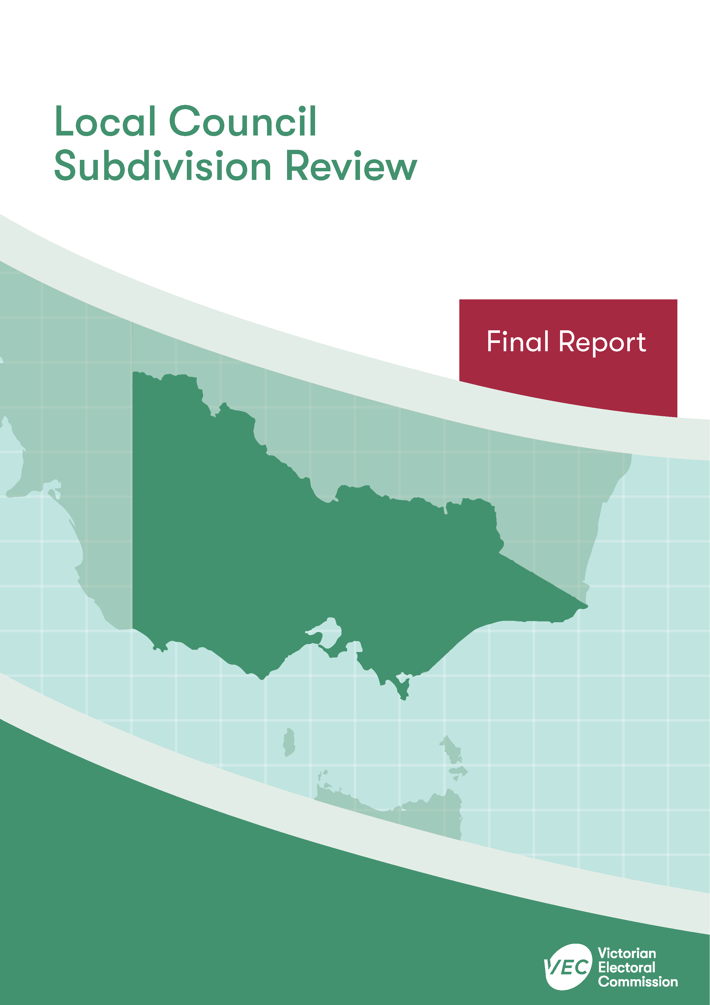



**Yarra Ranges Shire Council**

**April 2020**

Contents

Recommendation 1

Executive summary 2

Background 4

Legislative basis 4

The VEC’s approach 5

Profile of Yarra Ranges Shire Council 7

Population trends 8

Current number of councillors and electoral structure 9

Current subdivision review 10

Preliminary report 10

Public response 13

Response submissions 13

Public hearing 16

Findings and recommendation 20

The VEC’s findings 20

The VEC’s recommendation 24

Appendix 1: Public involvement 25

Appendix 2: Recommended ward boundaries map 26

Appendix 3: Public information program 28

Recommendation

The Victorian Electoral Commission recommends adjustments to the boundaries of the following wards within Yarra Ranges Shire Council:

* Billanook Ward
* Chandler Ward
* Chirnside Ward
* Lyster Ward
* Melba Ward
* Ryrie Ward
* Streeton Ward

This recommendation is submitted to the Minister for Local Government as required by the *Local Government Act 1989*.

Please see Appendix 2 for a detailed map of the recommended ward boundaries.

Executive summary

The *Local Government Act 1989* (LG Act) requires the Victorian Electoral Commission (VEC) to conduct a subdivision review to ensure the equitable representation of all voters in a local council.[1] The LG Act prescribes that the number of voters per councillor in each ward must be within plus-or-minus 10% of the average number of voters per councillor across the local council. [2] This is known as the ‘equality requirement’.

As population changes affect voter numbers and distribution in subdivided local councils, one or more wards may be unlikely to meet this requirement at the next general election. In such circumstances, the VEC recommends adjustments to internal ward boundaries to ensure that all wards meet the equality requirement before the next election and ideally, until the next scheduled electoral representation review.

Current number of councillors and electoral structure

Yarra Ranges Shire Council currently comprises nine councillors elected from nine single-councillor wards. More information on Yarra Ranges Shire Council is available on the VEC website at [vec.vic.gov.au](http://vec.vic.gov.au).

In 2018, the VEC notified the Minister for Local Government that one or more wards were unlikely to meet the equality requirement at the 2020 general election. Accordingly, the Minister notified the VEC that a subdivision review of Yarra Ranges Shire Council was required before the 2020 general election.

Preliminary report

A preliminary report was released on Wednesday 19 February 2020 proposing adjustments to the boundaries of the following wards within Yarra Ranges Shire Council:

* Billanook Ward
* Chandler Ward
* Chirnside Ward
* Lyster Ward
* Melba Ward
* Ryrie Ward
* Streeton Ward

Response submissions

The VEC received eight submissions responding to the preliminary report by the deadline of 5.00 pm on Wednesday 18 March 2020.

Public hearing

The VEC conducted a public hearing for those wishing to speak about their response submission at 5.30 pm on Wednesday 25 March 2020. Five people spoke at the hearing.

Recommendation

The Victorian Electoral Commission recommends adjustments to the boundaries of the following wards within Yarra Ranges Shire Council:

* Billanook Ward
* Chandler Ward
* Chirnside Ward
* Lyster Ward
* Melba Ward
* Ryrie Ward
* Streeton Ward

This recommendation is submitted to the Minister for Local Government as required by the *Local Government Act 1989*.

Please see Appendix 2 for a detailed map of the recommended ward boundaries.

Background

Legislative basis

The *Local Government Act 1989* (LG Act) requires the Victorian Electoral Commission (VEC) to conduct a subdivision review to ensure the equitable representation of all voters in a local council. The LG Act prescribes that the number of voters per councillor in each ward must be within plus-or-minus 10% of the average number of voters per councillor across the local council. [3] This is known as the ‘equality requirement’.

As population changes affect voter numbers and distribution in subdivided local councils, one or more wards may be unlikely to meet this requirement at the next general election. In such circumstances, the VEC recommends adjustments to internal ward boundaries to ensure that all wards meet the equality requirement before the next election and ideally, until the next scheduled electoral representation review.

Subdivision reviews only apply to subdivided councils:

* that are not scheduled for an electoral representation review before the next general election

and

* where, two years before the council is to hold a general election, the VEC considers one or more wards are unlikely to meet the equality requirement at the time of the next general election.

### Scope

A subdivision review only considers the location of ward boundaries. A subdivision review cannot consider changes to the number of councillors or wards.

These changes are considered in a council’s periodic electoral representation review. The next scheduled representation review for Yarra Ranges Shire Council will be held before the 2028 general election. An earlier review may take place if required.

A subdivision review also cannot change the external boundaries of the local council, divide local councils, or amalgamate local councils. These changes can only be made by an Order in Council.

The VEC’s approach

### Public information program

The VEC conducted a public information program to inform the community of the subdivision review, including:

* a public notice printed in local papers
* a media release announcing the release of the preliminary report
* an information email campaign targeted at known community groups and communities of interest in the local council area
* sponsored social media advertising geo-targeted to users within the local council   
  area
* ongoing information updates and publication of submissions on the VEC website.

More information on the VEC’s public information program for the subdivision review of Yarra Ranges Shire Council can be found at Appendix 3.

### Public consultation

Public input was encouraged by the VEC via:

* response submissions to the preliminary report
* a public hearing that provided an opportunity for people who had made a response submission to expand on their submission.

### Developing recommendations

The VEC bases its recommendations for ward boundaries on:

* internal research specifically relating to the local council under review, including voter statistics from the Victorian electoral roll
* small area forecasts provided by .id[4]
* the VEC’s expertise in mapping, demography and local government
* consideration of all input from the public in written submissions received during the review.

In determining which ward boundaries are most appropriate, the VEC considers the:

* number of voters in each ward, to ensure that each ward meets the equality requirement for the next election
* number of voters affected by the changes, with the aim of affecting as few voters as possible
* communities of interest
* significance of natural and man-made features (such as roads and waterways), to ensure clear and identifiable ward boundaries
* geographic factors, such as size and topography
* longevity of the structure.

### Communities of interest

Each local council contains a number of communities of interest. Where practicable, ward boundaries should be designed to ensure they are fairly represented, and that geographic communities of interest are not split. This allows communities with shared concerns to elect a councillor.

Yarra Ranges Shire Council

Profile of Yarra Ranges Shire Council

Yarra Ranges Shire is located east of Melbourne’s CBD on the metropolitan fringe. It covers an area of 2,466 square kilometres and is the largest Melbourne metropolitan council by geographical area. It includes natural environments, such as the Dandenong and Yarra Ranges, the Yarra River and numerous reservoirs, which contribute to Melbourne’s water supply. Vast areas of land are national park and most of the Shire is located outside of the urban growth boundary.

The Shire includes over 50 different suburbs, small communities and townships. Most of the population is concentrated in the west of the Shire in suburbs such as Chirnside Park, Lilydale, Mooroolbark, Montrose and Belgrave. Major townships located throughout the centre and the east of the Shire include Healesville, Yarra Junction and Warburton.

The median age of people living in Yarra Ranges Shire is 40 years, which is higher than that for Greater Melbourne (36).[5] The Shire generally has low levels of cultural and ethnic diversity: about 78% of the population were born in Australia and 88% of the population speak only English at home.[6]

The Shire rates above the national, state and Greater Melbourne averages on measures of social and economic well-being.[7] The most common industries of employment are construction (13.2%), health care and social assistance (11.8%) and retail (10.1%), with the most common occupations being technicians and trade workers (18.6%), professionals (17.8%) and clerical and administrative workers (13.5%).[8]

Tourism is an important contributor to the local economy, including natural attractions such as the Dandenong and Yarra Ranges, and wineries throughout the Yarra Valley. Agriculture, including grazing, viticulture and horticulture, is also significant and primary production accounts for almost a third of all land use.[9]

Population trends

Between 2011 and 2018 the Yarra Ranges Shire population increased by 6.2% or almost 9,300 people, from 148,901 to 158,173.[10] Since the last representation review in 2015, voter numbers increased from 113,596 (as at June 2015) to 120,239 (as at October 2019).

Population growth will continue to occur at a projected rate of about 0.8% per year for the period 2018-36, which is below the annual growth rate for both Greater Melbourne and regional Victoria.[11] By 2026 it is expected the population will be 168,480, and 183,820 by 2036.[12]

Most of the growth in population will take place in the west of the Shire, in the suburbs of Chirnside Park, Lilydale and Mooroolbark. The population is expected to decline in some parts of the Shire, including the south-west and some of the rural areas. Significant growth is expected to occur in Chirnside Ward, which will increase at a rate well above the Shire average. Streeton, Chandler and Lyster Wards are in relative decline, while the Shire’s other wards are expected to remain relatively stable.

There are currently an estimated 120,239 registered voters within Yarra Ranges Shire, with an average of 13,360 voters per councillor.

Current number of councillors and electoral structure

Yarra Ranges Shire Council currently comprises nine councillors elected from nine single‑councillor wards.

Diagram 1 illustrates this structure and voter statistics by ward as at 3 October 2019.   
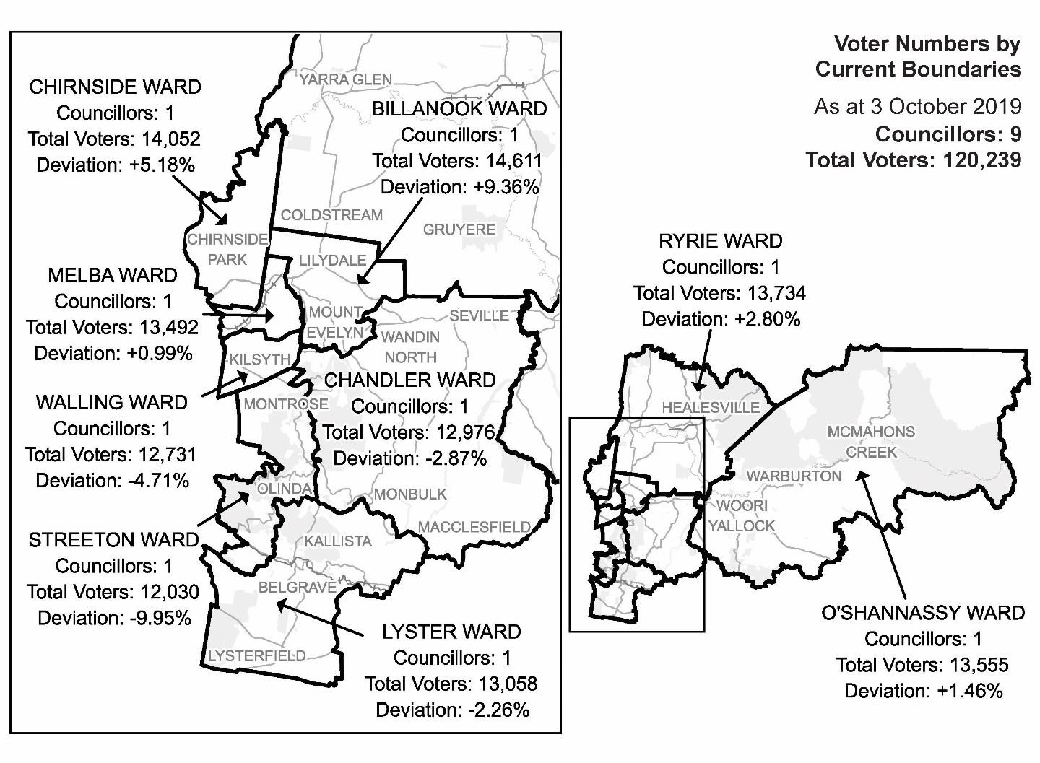

Diagram 1: Yarra Ranges Shire Council electoral structure and voter statistics

Current subdivision review

The current subdivision review of Yarra Ranges Shire Council was required due to the voter‑to-councillor ratios in Chirnside and Streeton Wards, which were projected to vary by more than 10% from the average number of voters per councillor by the 2020 general election. The VEC was also concerned about Billanook Ward. Although voter numbers in Billanook Ward were expected to undergo some decline relative to the growth in other wards, at +9.36% the number of voters per councillor was close to the accepted plus-or-minus 10%. Consequently, ward boundaries had to be adjusted to Chirnside and Streeton Wards in particular, and to a lesser extent Billanook Ward, so that the enrolment in all wards would be within the 10% tolerance at the 2020 general election.

Table 1 shows the number of voters in each ward as at 3 October 2019, ranked by the percentage this deviates from the average number of voters per councillor for the whole local council.

|  |  |  |  |
| --- | --- | --- | --- |
| ***Table 1: Voter numbers per ward*** | | | |
| **Ward** | **Councillors** | **Voters** | **Deviation (%)** |
| Streeton | 1 | 12,030 | -9.95% |
| Billanook | 1 | 14,611 | +9.36% |
| Chirnside | 1 | 14,052 | +5.18% |
| Walling | 1 | 12,731 | -4.71% |
| Chandler | 1 | 12,976 | -2.87% |
| Ryrie | 1 | 13,734 | +2.80% |
| Lyster | 1 | 13,058 | -2.26% |
| O’Shannassy | 1 | 13,555 | +1.46% |
| Melba | 1 | 13,492 | +0.99% |
| **Total for council** | **9** | **120,239** |  |

Preliminary report

The VEC’s subdivision review of Yarra Ranges Shire Council commenced with the release of a preliminary report on Wednesday 19 February 2020. The report contained proposed ward boundary changes based on analysis of enrolment information and internal research.

In the current review, voter enrolments in Chirnside and Streeton Wards, and to a lesser extent Billanook Ward, were likely to vary by more than plus-or-minus 10% from the average number of voters per councillor prior to the 2020 general election. Chirnside and Billanook Wards had to decrease in size and voter population, while Streeton Ward had to expand to gain additional voters. Correcting these three wards impacted surrounding ward boundaries.

The VEC proposed to move the Chirnside Ward boundary with Ryrie Ward south to follow Paynes Road, Edward Road and a property boundary, so that parts of Yering, Coldstream and Chirnside Park would be transferred to Ryrie Ward. The change affected 458 voters from Chirnside Ward who would move to Ryrie Ward. The VEC considered this change acceptable from a community of interest perspective as the land in the north of Chirnside Ward was mainly rural and would fit the predominantly rural character of Ryrie Ward.

The VEC suggested a small boundary adjustment to the Chirnside-Melba Ward boundary in Mooroolbark. The proposed change followed Manchester Road, Old Kent Road and Hayrick Lane rather than the less clear boundary comprising Shadowplay Road, a property boundary and Turella Court. This change would affect 220 voters in Chirnside Ward who would move to Melba Ward. Together with the proposed change to the Chirnside-Ryrie Ward boundary, this brought Chirnside Ward comfortably within plus‑or‑minus 10% of the average number of voters per councillor for the 2020 general election.

The VEC proposed adjusting the Billanook-Chandler Ward boundary to Maurice Road, a property boundary and Boundary Road so that 185 voters in Billanook Ward would move to Chandler Ward. The change would unite Wandin North within Chandler Ward. The VEC considered this a minor change to ensure Billanook Ward remained within plus-or-minus 10% of the average number of voters per councillor for the 2020 general election.

The VEC proposed moving the ward boundary between Streeton and Chandler Wards north to contain more of Montrose in Streeton Ward. The change made better use of the natural landscape of the Dandenong Ranges and the more easily identifiable Moore Avenue as ward boundaries. It impacted 404 voters in Chandler Ward who would move to Streeton Ward. The VEC considered this a suitable change as the ward boundary would no longer divide a part of Montrose and overall provided clearer ward boundaries than is currently the case.

Finally, the VEC proposed moving part of the Streeton-Lyster Ward boundary to include more of Upwey in Streeton Ward. The current boundary split Upwey along Ferny Creek. Moving the boundary to follow more of Glenfern Road and then Eloera Street and Upwey South Recreation Reserve restored part of the boundary in place prior to the previous representation review in 2015. The change would affect 222 voters in Lyster Ward who would move to Streeton Ward and together with the above change satisfied the requirement for Streeton Ward to be within plus-or-minus 10% of the average number of voters per councillor for the next elections.

|  |  |  |  |
| --- | --- | --- | --- |
| Table 2: Voter numbers per ward with proposed boundaries | | | |
| **Ward** | **Councillors** | **Voters** | **Deviation (%)** |
| Streeton | 1 | 12,656 | -5.27 |
| Billanook | 1 | 14,426 | +7.98 |
| Chirnside | 1 | 13,374 | +0.11 |
| Walling | 1 | 12,731 | -4.71 |
| Chandler | 1 | 12,757 | -4.51 |
| Ryrie | 1 | 14,192 | +6.23 |
| Lyster | 1 | 12,836 | -3.92 |
| O’Shannassy | 1 | 13,555 | +1.46 |
| Melba | 1 | 13,712 | +2.64 |
| **Total for council** | **9** | **120,239** |  |

Together, the proposed ward boundary changes would bring all wards within the 10% tolerance for the 2020 general election, with a total of 1,489 voters (1.24%) affected. The new ward boundaries were considered to reflect and represent communities of interest and in most cases improved the current ward boundaries.

Public response

Response submissions

The VEC accepted submissions responding to the preliminary report from Wednesday 19 February 2020 until 5.00 pm on Wednesday 18 March 2020. The VEC received eight response submissions. A list of people who made a response submission can be found in Appendix 1.

David Hill argued that Ryrie Ward should be reduced in size as it covered a large and diverse geographical area and that it would be more appropriate for the less rural area of Seville to be in Chandler Ward. Mr Hill proposed extending the Ryrie-Chandler Ward boundary north so that a large section of Gruyere and Warramate Hills Nature Conservation Reserve would be contained in Chandler Ward.

Susanne Thompson objected to the splitting of Lilydale between Melba and Billanook Wards along Olinda Creek. Ms Thompson argued that the current situation was problematic for residents and businesses in the Lilydale area; having to negotiate with two ward councillors was difficult and disadvantaged local initiatives. Ms Thompson mapped three options to address the situation: extend Billanook Ward west to encompass most of Lilydale shopping district, offset by extending Chandler Ward to contain some of the rural areas of Billanook Ward; extend Melba Ward east to encompass most of Lilydale; and extend Melba Ward east to encompass a large part of Mount Evelyn, and Billanook Ward further west to contain most of Lilydale.

The Montrose Township Group (MTG) submitted that its community was divided across Melba, Streeton and Chandler Wards and as a result of the 2015 representation review the town’s social and economic hub had been split along Canterbury Road. The MTG argued that this posed significant problems, namely, having to negotiate with two councillors; establishing and maintaining a traders’ association had also been difficult under the current situation. While the MTG acknowledged that many localities in Yarra Ranges were divided between wards, Montrose was the only one to have its social and economic hub split between wards. The MTG urged the VEC to consider uniting the area under the one ward.

The Mount Evelyn Township Group (METG) argued that Mount Evelyn should be united under the one ward and represented by a single councillor. The METG suggested that with a population of 9,500 people the town was large and that splitting it between wards weakened representation of the community. The METG nominated Franc (Francis) Smith to speak on its behalf at the public hearing.

Mr Smith made a personal submission and noted his membership of Mount Evelyn’s three main community groups: Mount Evelyn Environmental Protection and Progress Association (MEEPPA), METG and the Friends of the Mount Evelyn Aqueduct (FoMEA). Mr Smith argued that Mount Evelyn had been increasingly divided and fragmented as a result of previous representation and subdivision reviews; the use of Olinda Creek as a ward boundary in particular divided the town; and the work of the town’s community groups had suffered due to the splitting of Mount Evelyn across two wards.

Mr Smith suggested that Mount Evelyn had little in common with Lilydale and more in common with the communities associated with the Dandenong Ranges. He argued, it would be more appropriate for Mount Evelyn to be united under Streeton Ward rather than Billanook Ward. Mr Smith submitted that further consideration should be given to Mount Evelyn being contained into Streeton Ward or at least extend Billanook Ward south to unite a larger part of Mount Evelyn under the one ward. As such, Mr Smith argued that if Billanook Ward was to remain as is, the ward boundary should be extended to encompass the Mount Evelyn Recreation, Picnic and Camp Reserve. Two options along these lines were mapped: one containing only the reserve in Billanook Ward and the other containing the reserve plus an area east to Monbulk Road.

MEEPPA also argued against the fragmentation and loss of identify of the Mount Evelyn community, which it likewise suggested had occurred as a result of previous reviews, and in particular the use of Olinda Creek as a ward boundary. MEEPPA similarly identified Mount Evelyn as having more in common with the foothills communities of the Dandenong Ranges rather than Lilydale. As such, it suggested that Mount Evelyn should be contained within Streeton Ward, which would prevent it being further absorbed into the Lilydale community. MEEPPA urged the VEC to make more substantial changes than proposed in the preliminary report and to effectively represent the Shire’s communities of interest.

At a minimum, MEEPPA suggested the need to reunite the environmentally and culturally significant Mount Evelyn Recreation, Picnic and Camp Reserve with Mount Evelyn under the one ward.

Yarra Ranges Shire Council provided a detailed submission with relevant maps, suggesting a number of ward boundary adjustments. Although Council indicated its support for all the VEC’s proposed ward boundary changes, except for an adjustment to the Melba-Chirnside Ward boundary, it proposed a series of ward boundary changes, many of which addressed concerns raised by other submitters. The Council’s main considerations were to accommodate population growth and change, keep communities of interest and infrastructure together in the relevant ward, provide clear ward boundaries and guarantee that all wards would meet the equality requirement for as long as possible.

The Council proposed adjusting the Billanook-Chandler Ward boundary to include the Mount Evelyn Recreation, Picnic and Camp Reserve in Billanook Ward and use Monbulk Road and Clegg Road as ward boundaries. This would unite a significant area of reserve land within Mount Evelyn in Billanook yet move part of Mount Evelyn to Chandler Ward. According to the Council, the ward boundary changes would have 190 voters now in Billanook and 356 now in Chandler Ward.

A further change to the Billanook-Chandler Ward boundary would extend Chandler Ward into a large portion of Billanook Ward, using the Warburton Highway and affecting 224 voters. These changes would also address the Council’s concerns about the long-term viability of Billanook Ward.

Council suggested extending the Ryrie-Chandler Ward boundary north to follow property boundaries, Darling and Chandler Roads. According to the Council, the change would unite Wandin North, Seville and Seville East in Chandler Ward. The Council also proposed a slight modification to the Ryrie-Billanook Ward boundary, which would contain in Ryrie Ward a small area of interest outside the Urban Growth Boundary.

The Council proposed extending the Walling-Streeton Ward boundary so that the Montrose commercial and shopping district would be contained in Walling Ward and not be divided along Canterbury Road. According to the Council this change would affect 599 voters.

A small change to the Chandler-Lyster Ward boundary was proposed, so that community facilities, such as Baynes Park and Monbulk Aquatic Centre, would be united with Monbulk in Chandler Ward.

The Council suggested extending Streeton Ward east to connect and contain community facilities in Olinda with the Olinda community.

The Council proposed extending the Streeton-Lyster Ward boundary south to contain more of Upwey in Streeton Ward. The change would impact 921 voters.

Finally, the Council proposed expanding the Lyster-Chandler Ward boundary so that Macclesfield and a part of Emerald would be in Lyster Ward. According to the Council, this change would affect 709 voters in Chandler Ward that would now be in Lyster Ward.

Public hearing

The VEC conducted a public hearing for those wishing to speak about their response submission at 5.30 pm on Wednesday 25 March 2020. The hearing was conducted online using CISCO Webex. Those unable to use the online facility spoke at the public hearing via telephone. A list of people who spoke at the hearing can be found in Appendix 1.

David Hill spoke in support of extending the Ryrie-Chandler Ward boundary north to contain a large part of Gruyere and the Warramate Hills Nature Conservation Reserve in Chandler Ward. Mr Hill argued that Ryrie Ward was increasing in voter numbers and advocated for a reduction in the size of the ward. He also proposed the ward boundary change so that all of Seville would be included in Chandler Ward. Mr Hill suggested that Seville connected more with the towns in Chandler and Billanook Wards rather than the towns in Ryrie Ward. Mr Hill did not object to the extension of Ryrie Ward in the south-west to include voters from Chirnside Ward.

Clare Worsnop spoke on behalf of the Mount Evelyn Environment Protection and Progress Association (MEEPPA) and outlined the 110-year history of the association. Ms Worsnop also outlined various social and cultural characteristics unique to the Mount Evelyn community. Ms Worsnop was concerned about further fragmentation of the Mount Evelyn community as a result of representation and subdivision reviews. She argued that Mount Evelyn had more in common with the foothill’s communities located in Streeton Ward than the towns located in Billanook Ward, particularly Lilydale.

Ms Worsnop suggested that if Mount Evelyn was to remain in Billanook Ward, it was important to unite it with the Mount Evelyn Recreation, Picnic and Camp Reserve. The Reserve, Ms Worsnop suggested, contained significant community, recreational and environmental features that should be in the same ward as Mount Evelyn. She also considered it crucial to contain the Mount Evelyn Primary School in Billanook Ward, as it too was closely linked with the Mount Evelyn community. Ms Worsnop did not consider it beneficial to have potentially two ward councillors to connect with.

Franc (Francis) Smith also outlined the importance of keeping the Mount Evelyn community together in the same ward. Mr Smith was concerned to prevent further fragmentation of Mount Evelyn and the community being absorbed within Lilydale. This, he suggested, had and would continue to negatively impact the infrastructure and services available to the Mount Evelyn community.

Mr Smith disagreed with the use of Olinda Creek as a ward boundary, which divided Mount Evelyn. He proposed extending the Billanook-Chandler Ward boundary along the Pipeline Track, Hunter Road and Monbulk Road to McKillop Road, to include the highly significant Mount Evelyn Recreation, Picnic and Camp Reserve in Billanook Ward. Mr Smith objected strongly to any proposal that would further divide Mount Evelyn between wards, including the Council’s suggestion to extend the Billanook-Chandler Ward north to Cleggs Road.

Chelsey Cooper spoke on behalf of the Montrose Township Group and the difficulties associated with Montrose being divided between different wards. It was particularly difficult, Ms Cooper suggested, with regard to the main shopping and commercial district of Montrose, which was divided along Canterbury Road. Ms Cooper pointed out that one side of the road, in Walling Ward, contained shops, a primary school, the Town Hall, the CFA and other community and recreational services; and the other side of the road, in Streeton Ward, contained shops, the library, a recreational reserve and other services.

Ms Cooper argued that having Montrose split by a ward boundary prevented the community from being united and effectively represented. Ms Cooper also suggested that having to deal with two councillors to address issues in the area had disadvantaged the community. Ms Cooper acknowledged the challenges involved in satisfying the equality requirement for all wards at the same time as addressing community concerns. She also indicated some support for the Council’s proposal to reunite part of the area in Walling Ward.

Yarra Ranges Shire Council was represented by Councillor Tony Stevenson, who spoke on behalf of the Council’s submission and the various ward boundary adjustments proposed. Cr Stevenson outlined the challenges involved in developing appropriate ward boundary adjustments, such as keeping communities of interest together and the knock-on effects one change had on surrounding wards. Cr Stevenson also acknowledged other submitters and speakers as strong advocates of their respective communities.

Cr Stevenson suggested that the Council’s submission had attempted to address community concerns, particularly where ward boundaries divided communities, and to achieve this with as little impact as possible. Cr Stevenson outlined the challenges involved in representing the Shire’s many community and township groups, and in cases where one community was located across two or more wards, the difficulties of having to engage with multiple councillors. Cr Stevenson also outlined the benefits for communities, such as Mount Evelyn, of being in the one ward and thus having a single point of contact in their ward councillor. This, he suggested, improved accountability and provided clarity for voters and residents.

Cr Stevenson indicated support for including the Mount Evelyn Recreation, Picnic and Camp Reserve in Billanook Ward and uniting this area with the Mount Evelyn community. It was suggested that this would also unite the sporting and recreational facilities located in the area with the residents that utilise them. Cr Stevenson indicated that the Council’s further proposed change to extend the Billanook-Chandler Ward boundary to Cleggs Road and include part of Mount Evelyn in Chandler Ward was to unite areas of common land use and to balance numbers. On the latter point, Cr Stevenson suggested that given the choice between the inclusion of the Reserve or the area from McKillop Road and Cleggs Road in Billanook Ward, Council preferred to unite the Reserve area with Mount Evelyn in Billanook Ward. However, Cr Stevenson indicated that Council would support the inclusion of both areas in Billanook Ward if this was possible.

Similar arguments were put forward in support of Council’s proposal to extend the Streeton-Chandler Ward boundary east to contain various facilities located in Olinda within Streeton Ward. This would address the anomaly, Cr Stevenson suggested, of having facilities located in one ward (Chandler Ward) but which were used primarily by residents in another ward (Streeton Ward). For the same reasons, a ward boundary change was proposed so that the Monbulk Aquatic Centre would be in Chandler Ward rather than Lyster Ward; and adjusting the Walling-Streeton Ward boundary so that the Montrose commercial and social hub would all be in Walling Ward, where most of the residents that use these services live. Cr Stevenson suggested that most of the ward boundary adjustments proposed by the Council were to unite people with the facilities they use and make it easier for them to connect with the relevant ward councillor.

The Council proposed an alternative boundary change to the Ryrie-Chandler Ward boundary than that put forward by the VEC or in the submission made by David Hill.   
Cr Stevenson pointed out that Council’s proposal addressed Mr Hill’s concerns but, importantly, reflected communities of interest by maintaining Gruyere within Ryrie Ward.

Other proposed changes, submitted by Council were to balance the numbers as well as providing for future growth, clear ward boundaries and communities of interest. This was particularly the case, Cr Stevenson suggested, with the proposed adjustments to the Lyster-Chandler Ward boundary and the Streeton-Lyster Ward boundary. Cr Stevenson also stated that the objection to the VEC’s proposed changes to the Melba-Chirnside Ward boundary was largely to balance the numbers.

Cr Stevenson indicated that, despite the large area already covered by Ryrie Ward, Council accepted extending it south-west to include voters currently in Chirnside Ward, especially if this was required to balance voter numbers.

Cr Stevenson also made the point that many of the Council’s proposals would impact very few voters. This was particularly the case in relation to the extension of Billanook Ward to encompass the Reserve area and the extension of Streeton Ward to encompass community facilities in Olinda and the large area of National Park land.

Findings and recommendation

The VEC’s findings

The VEC recognises the presence of multiple, distinct communities and townships within Yarra Ranges Shire Council. As was reflected in submissions, there is a strong desire for these communities and townships to remain intact within the one ward. This has not been possible in all cases and the VEC considers a full representation review as more appropriate to resolve some of these and related issues. As part of the subdivision review process, the VEC prefers to recommend ward boundary adjustments that have a minimal impact on voters, balanced with ensuring that as far as possible geographic communities of interest are represented in wards and clear ward boundaries are used.

The VEC is required to bring all wards within Yarra Ranges Shire Council to within plus-or-minus 10% of the average number of voters per councillor for the 2020 general election. Chirnside Ward is currently projected to be above 10% of the average number of voters per councillor by the 2020 general election and therefore must be reduced in size and voter numbers; Streeton Ward is expected to be more than 10% below the average number of voters per councillor by about the same time and conversely must be increased in size and voter numbers. At 9.36% above the average voter-to-councillor ratio, though expected to decline somewhat in coming years, Billanook Ward only required a minimal decrease in voter numbers. The flow-on effects of adjusting these three wards required further adjustments to Chandler, Lyster, Melba and Ryrie Wards.

In coming to its final recommendation, the VEC assessed population and voter data, as well as communities of interest, clear and easily identifiable ward boundaries and the arguments presented in submissions. Moreover, the VEC has considered all suggestions made in response to the VEC’s proposed ward boundary adjustments.

The VEC considered there to be significant challenges associated with making ward boundary adjustments to an electoral structure of nine single-councillor wards. Single-councillor wards are especially susceptible to deviating outside the 10% tolerance as a result of population shifts, requiring changes to ward boundaries. Yarra Ranges also includes a range of land-uses, such as urban, rural and State and National Parklands, which means the population distribution is uneven across the Shire. This presents further complexities when balancing voter numbers across nine wards, whilst maintaining the particular character of each. Communities in an interface Council such as Yarra Ranges are very unequal in size and cannot all be neatly included in a single ward. Furthermore, there are inevitably a large number of ward boundaries required in a single-councillor ward structure and this increases the possibility of boundaries dividing communities.

As such, the VEC considered the communities currently divided by ward boundaries in Yarra Ranges Shire Council, including: Montrose, which is divided between Walling, Streeton and Chandler Wards; Lilydale, which is divided between Melba and Billanook Wards; and Mount Evelyn, which is divided between Billanook and Chandler Wards.

While reuniting part of Mount Evelyn within Billanook Ward would involve minimal change, reuniting Montrose and Lilydale (or parts of) would require more significant changes to multiple wards. For instance, adopting the Council’s proposal to reunite the Montrose commercial and social hub within Walling Ward would have a domino effect impacting Streeton, Lyster and Chandler Wards and require significant movements of voters to ensure all wards satisfied the 10% equality requirement. Similarly, uniting Lilydale (or a major part of Lilydale) within either Billanook or Melba Wards would have a greater impact on surrounding wards and would therefore require substantial change to most features of the current ward structure.

The VEC also considered that uniting some communities within the one ward could, as a result of flow-on effects to other wards, create divisions amongst other communities. The VEC determined that this is potentially the case with extending the Lyster-Chandler Ward boundary east as proposed by the Council. The Council’s proposal to include more of Upwey in Streeton Ward was valid in itself but would have the consequence of having to expand Lyster Ward to the east, dividing communities in that area.

The VEC considered the Council’s argument to unite community and council facilities within the ward that most residents using these facilities live in. This was particularly the case in relation to the extension of Streeton Ward to contain community facilities in Olinda and the extension of Chandler Ward to unite the Monbulk Aquatic Centre with the town of Monbulk. While both adjustments affected a small number of voters, the VEC considered both changes to be unnecessary in relation to representation for the following reasons: council services and facilities are not determined or accessed according to ward boundaries and are for all residents regardless of the ward they live in; councillors are elected to represent the whole of the Shire, not just their own ward; unlike the proposals put forward in relation to Mount Evelyn, there was no impetus for change from the community; and adopting the proposed changes would disrupt the integrity of the affected wards.

The VEC also considered the arguments presented by submitters around the difficulties of having to connect with more than one councillor in situations where community interests are split between wards. Moreover, many submitters did not see advantages in having the opportunity to access more than one councillor regarding a particular issue. However, under the Act, Councillors are elected to represent the whole of the Shire, are required to make decisions affecting the whole council area and address issues that involve multiple wards. The VEC found no good reason why two or three councillors cannot work together to represent a specific community or community issue as would be encouraged in an unsubdivided or multi-councillor ward structure.

The VEC considered the current Ryrie-Chandler Ward boundary to be appropriate. It was determined that the changes to the ward boundary put forward by both the Council and Mr Hill would potentially divide the Gruyere community of interest, and that under current arrangements the rural area concerned fits well within Ryrie Ward. Furthermore, the VEC determined that the ward boundary changes were not necessary to balance voter numbers.

The VEC compared the total number of voters affected by the proposed ward boundary changes as presented in the preliminary report to be significantly fewer than those proposed by the Council. The VEC’s ward boundary adjustments would impact 1,489 voters, whereas those suggested by the Council would affect over 4,000 voters.

The VEC recommends the following changes as per the ward boundary adjustments put forward in the preliminary report:

* Extending Ryrie Ward south-west to encompass part of Chirnside Ward. This change impacts 458 voters and is considered acceptable from a community of interest perspective and to ensure the voter-to-councillor ratio in Chirnside Ward is acceptable and sustainable.
* Extending the Chandler-Billanook Ward boundary in a north-westerly direction to contain an area of largely rural land in Chandler Ward and unite Wandin North. The change affects 185 voters who will now be in Chandler Ward.
* Extending the Chirnside-Melba Ward boundary north to run along Manchester Road, Old Kent Road and Hayrick Lane. The change provides a clearer ward boundary and by affecting 220 voters that would now be in Melba Ward assists to decrease the number of voters in Chirnside Ward.
* Extending the Streeton-Chandler Ward boundary east to encompass more of Montrose in Streeton Ward. The change affects 404 voters and helps to increase the number of voters in Streeton Ward. The change also provides clearer ward boundaries and no longer divides this part of Montrose.
* Extending the Streeton-Lyster Ward boundary south to follow Glenfern Road, Eloera Street and the Upwey South Recreation Reserve. The change increases the number of voters in Streeton Ward by 222, restores part of the ward boundary in place prior to the 2015 representation review and reunites part of Upwey.

In addition to these changes, the VEC recommends extending the Billanook-Chandler Ward boundary to include the Mount Evelyn Recreation, Picnic and Camp Reserve and a small area between the Reserve and Monbulk Road into Billanook Ward. This change affects 124 voters and is considered to reflect and represent the Mount Evelyn community. Although Billanook Ward is at 8.91% above the average voter-to-councillor ratio, the VEC does not consider it necessary to alter the Billanook-Chandler Ward boundary or to reduce the number of voters in Billanook Ward any further. Analysis of voter statistics shows that in coming years voter numbers in Billanook Ward will be stable and even decline relative to the growth expected in other wards. Therefore, the VEC recommends maintaining the current ward boundary along McKillop Road.

Together, the above changes affect a total of 1,613 voters (1.34% of the total) and the VEC considers that the recommended ward boundary changes provide a minimal level of disruption to voters, reflect communities of interest and respond where appropriate to the suggestions raised in submissions.

|  |  |  |  |
| --- | --- | --- | --- |
| Table 3: Voter numbers per ward of recommended ward boundaries | | | |
| **Ward** | **Councillors** | **Voters** | **Deviation (%)** |
| Billanook | 1 | 14,550 | +8.91 |
| Chandler | 1 | 12,633 | -5.44 |
| Chirnside | 1 | 13,374 | +0.11 |
| Lyster | 1 | 12,836 | -3.92 |
| Melba | 1 | 13,712 | +2.64 |
| O’Shannassy | 1 | 13,555 | +1.46 |
| Ryrie | 1 | 14,192 | +6.23 |
| Streeton | 1 | 12,656 | -5.27 |
| Walling | 1 | 12,731 | -4.71 |
| **Total for council** | **9** | **120,239** |  |

The VEC’s recommendation

The Victorian Electoral Commission recommends adjustments to the boundaries of the following wards within Yarra Ranges Shire Council:

* Billanook Ward
* Chandler Ward
* Chirnside Ward
* Lyster Ward
* Melba Ward
* Ryrie Ward
* Streeton Ward

This recommendation is submitted to the Minister for Local Government as required by the *Local Government Act 1989*.

Please see Appendix 2 for a detailed map of the recommended ward boundaries.

# Appendix 1: Public involvement

Response submissions

Response submissions were made by:

Hill, David (Two submissions)

Montrose Township Group (MTG)

Mount Evelyn Environment Protection and Progress Association (MEEPPA)

Mount Evelyn Township Group (METG)

Smith, Francis (Franc)

Thompson, Susanne

Yarra Ranges Shire Council

Public hearing

The following individuals spoke at the public hearing:

Cooper, Chelsey (MTG)

Hill, David

Smith, Francis (Franc)

Stevenson, Tony (Councillor, Yarra Ranges Shire Council)

Worsnop, Clare (MEEPPA)

# Appendix 2: Recommended ward boundaries map

The map is provided on the next page.

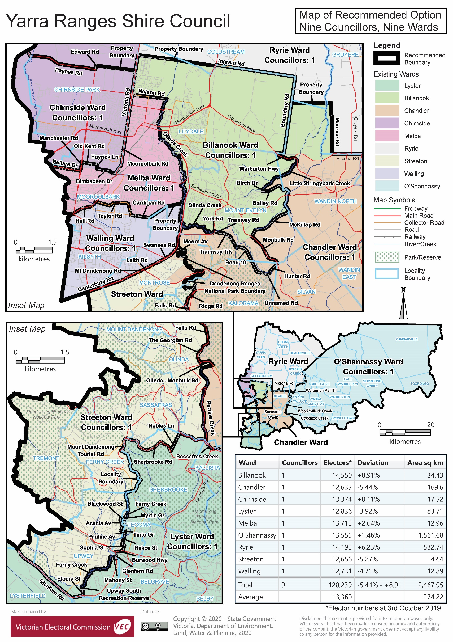

# Appendix 3: Public information program

Advertising

Public notices of the release of the preliminary report were placed in the following newspapers:

|  |  |
| --- | --- |
| **Newspaper** | **Date of publication** |
| *Ferntree Gully Belgrave Mail* | Tuesday 18 February 2020 |
| *Lilydale and Yarra Valley Leader* | Tuesday 18 February 2020 |
| *Mount Evelyn Mail* | Tuesday 18 February 2020 |
| *Mountain Views Mail* | Tuesday 18 February 2020 |
| *Ranges Trader Mail* | Tuesday 18 February 2020 |
| *Upper Yarra Mail* | Tuesday 18 February 2020 |

Media releases

A media release was prepared and distributed to local media to promote the publication of the preliminary report on Wednesday 19 February 2020. A final media advisory was circulated on the publication date of this final report.

VEC website

The VEC website delivered up-to-date information to provide transparency and facilitate public participation during the review process. All public submissions were published on the website.

### Online submission tool

An online submission tool was developed and made available during the submission period of the review. The tool allowed people to make a submission from the VEC website.

Email and social media engagement

The VEC delivered an information email campaign targeted at known community groups and communities of interest in the local council area. This included a reminder email at each milestone of the subdivision review process.

The VEC also published sponsored social media advertising that was geo-targeted to users within the local council area. The total reach of these posts was 11,688.

Council communication resources

The VEC provided the Council with a communication pack that included information on the review in various formats. While the council is encouraged to distribute this information and raise awareness about the review, the VEC is an independent reviewer and all communications resources include reference and links to the VEC website and core materials.

This page has been left intentionally blank

|  |
| --- |
| **© State of Victoria**  (Victorian Electoral Commission) **April 2020** |
| This work, the Local Council Subdivision Review ­– Final Report Yarra Ranges Shire Council 2020,  is licensed under a Creative Commons Attribution 4.0 licence (http://creativecommons.org/ licenses/ by/4.0/). You are free to re-use the work under that licence, on the condition that you credit the State of Victoria (Victorian Electoral Commission) as author, indicate if changes were made and comply with the other licence terms. The licence does not apply to any branding, including government logos. |
|  | |
| Level 11, 530 Collins Street  Melbourne Victoria 3000  T 131 832  info@vec.vic.gov.au  vec.vic.gov.au | |
|  | |



1. Section 219H of the *Local Government Act* *1989.*
2. Section 219L of the *Local Government Act* *1989.*
3. Section 219L of the *Local Government Act* *1989.*
4. .id is a consulting company specialising in population and demographic analysis and prediction information products in most jurisdictions in Australia and New Zealand.
5. Australian Bureau of Statistics, ‘2016 Quickstats: Yarra Ranges (S)’, <https://quickstats.censusdata.abs.gov.au/census_services/getproduct/census/2016/quickstat/LGA27450?opendocument>, accessed 28 January 2020.
6. Ibid.
7. .id, Yarra Ranges Council: community profile’, <https://profile.id.com.au/yarra-ranges>, accessed 28 January 2020.
8. Ibid.
9. Ibid.
10. .id, Yarra Ranges Council: community profile’, <https://profile.id.com.au/yarra-ranges>, accessed 28 January 2020.
11. Department of Environment, Land, Water and Planning (DELWP), *Victoria in Future 2019,* 2019, <https://www.planning.vic.gov.au/land-use-and-population-research/victoria-in-future> , accessed 28 January 2019.
12. Ibid.