Local council ward boundary review

## About the review

If a council is subdivided into wards, the number of voters in each ward should be within +/-10% of the average across all wards to comply with the *Local Government Act 2020* (Vic).

Changes to the population, location of housing areas, and voting entitlements all impact the number of voters in wards.

In accordance with section 17 of the Act, the Minister for Local Government has asked the Victorian Electoral Commission (VEC) to review the ward boundaries for Pyrenees Shire Council.

Adjusting ward boundaries aims to ensure voters are represented equally at the next council general election.

During its review, the VEC will look at Pyrenees Shire Council’s:

* enrolled voter numbers
* projected voter numbers
* ward boundary locations.

As a local you know your council area better than anyone. You can have your say on the suggested ward boundary adjustments:

1. in a response submission to the preliminary report
2. at an online public hearing, if you ask to speak in your response submission.

About Pyrenees Shire Council

The Traditional Custodians of the land in the Pyrenees Shire Council are the Dja Dja Wurrung, Eastern Maar, Wotjobaluk, Jaadwa, Jadawadjali, Wergaia and Jupagulk and the Wadawurrung peoples.

The shire is located in the Central Highlands region with its major population centre, Beaufort, around 145 km west of central Melbourne. The council covers an area of 3,435 km2. With a population of 7,671 it is one of Victoria’s least populated councils.

The shire comprises 66 localities with Beaufort and Avoca the largest townships. Smaller settlements such as Amphitheatre, Lexton, Moonambel, and Raglan also play an important social, service and community functions in their respective districts.

Prominent landscape features include the Pyrenees Ranges in the north and lakes in the south, which are habitats for native, and migratory birds. Much of the land is used for livestock grazing, and the warmer northern area of the council is home to the Pyrenees Wine Region.

The council is serviced by the Western, Sunraysia, Pyrenees, and Glenelg highways and 2 railway lines, one mostly a passenger service and one connecting freight commodities to ports.

The population consists mainly of older people born in Australia, living in freestanding houses in rural settings. The top occupations are associated with the agricultural sector, particularly sheep grazing.

## Current structure

Pyrenees Shire Council is divided into 5 wards with one councillor per ward. There are 5 councillors in total.

## Last review

The VEC conducted an electoral representation review of Pyrenees Shire Council in 2011.

Visit the VEC website at [vec.vic.gov.au](https://www.vec.vic.gov.au/) to access a copy of the 2011 review final report.

Review process

Monday 19 and Tuesday 20 February

### Information sessions

Session 1: 12 noon, Monday 19 February

Session 2: 12 noon, Tuesday 20 February

These sessions will give you more information about the review process. You will be able to register for a session on the VEC website.

Wednesday 21 February

### Preliminary report

The VEC will release a preliminary report with one or more options for the ward boundaries on Wednesday 21 February.

**You can make a response submission from this date.**

Wednesday 20 March

### Response submissions

The VEC must receive your submission by   
5 pm on Wednesday 20 March.

The VEC will not accept late submissions.

Wednesday 27 March

### Public hearing

The VEC will hold an online public hearing if anyone asks to speak about their response submission at 2 pm Wednesday 27 March.

The public hearing will not be held if no one asks to speak.

Wednesday 24 April

### Final report

The VEC will submit a final report to the Minister for Local Government including its advice for the adjustments to ward boundaries on Wednesday 24 April.

The minister will consider the VEC’s advice regarding the adjustments. Any change is expected to apply at the next local council general election.

## Submission guide

You can download a submission guide from the VEC website at [vec.vic.gov.au](http://vec.vic.gov.au/)

## How to make a submission Untitled-1

On the VEC website at [vec.vic.gov.au](http://vec.vic.gov.au/)

By email to:

[Pyrenees.WardReview@vec.vic.gov.au](mailto:pyrenees.wardreview@vec.vic.gov.au)

LetterBy post to:

Ward boundary review panel  
Victorian Electoral Commission  
Level 11, 530 Collins St  
Melbourne VIC 3000

Submissions must include your:

* full name
* contact phone number or email address
* residential or postal address.

Your submission will be published on the VEC website, including your name and suburb or town but not your full address or contact details. See the submission guide or VEC website at [vec.vic.gov.au/privacy](https://www.vec.vic.gov.au/privacy) for privacy information.

## One vote, one value

The ‘one vote, one value’ democratic principle is enshrined in the *Local Government Act 2020*. This means every person’s vote counts equally.

When a local council is subdivided into wards, the number of voters each councillor represents in each ward must be plus-or-minus 10% of the average number of voters per councillor for all wards.

The map below includes the current number of voters in each ward and the ward’s current deviation from the average. The VEC will also consider projected population and voter changes to ensure the structure remains fair.

If you make a submission online, you can use a mapping tool to build your preferred ward boundaries. The tool uses current voter numbers to tell you the deviations of the wards you make. This will help your proposal meet the requirements of the Act.

Current electoral structure

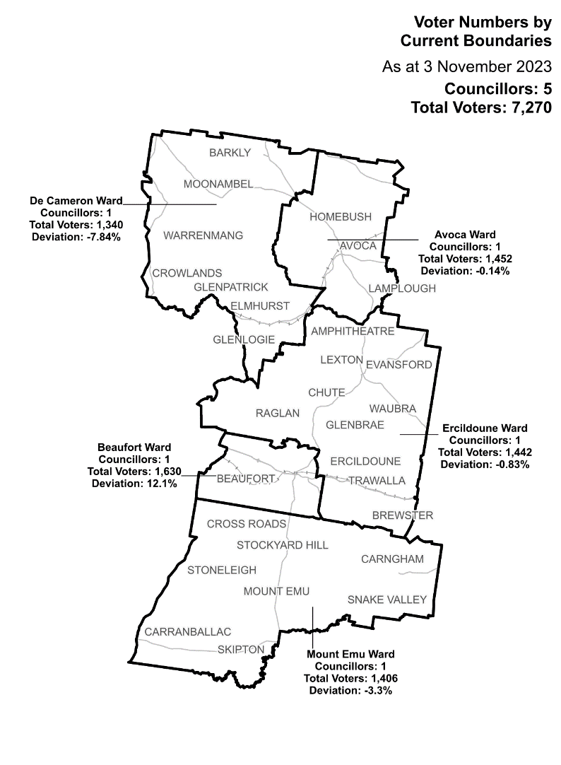

|  |  |  |  |
| --- | --- | --- | --- |
| Ward | Councillors | Voters | Deviation |
| Avoca Ward | 1 | 1,452 | -0.14% |
| Beaufort Ward* | 1 | 1,630 | 12.1% |
| De Cameron Ward* | 1 | 1,340 | -7.84% |
| Ercildoune Ward | 1 | 1,439 | -1.03% |
| Mount Emu Ward | 1 | 1,406 | -3.3% |

*The deviations of these wards are forecast to be outside of +/-10% by October 2024.

## Statistics

Area (km2) 3,435

Voters

### Voters per square km

2.1

### Average voters per councillor

1,454

Population

### Current population

7,671

### Forecast population growth

0.5% p.a.

More Census statistics available at [abs.gov.au](https://www.abs.gov.au/census/find-census-data/search-by-area)

Voter numbers by locality (map)

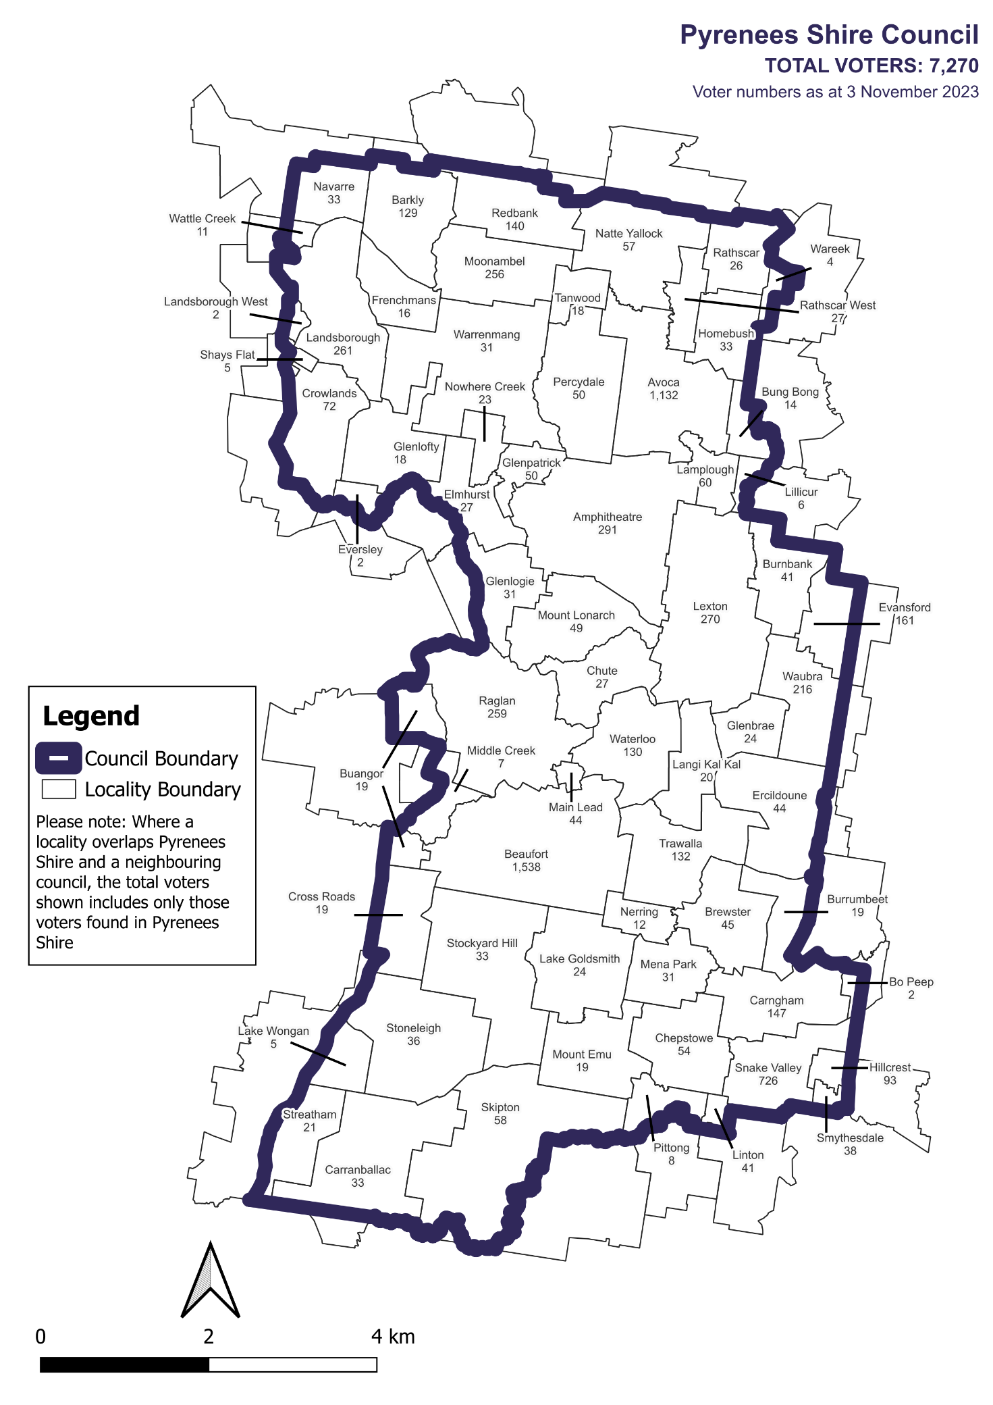

Voter numbers by locality (table)

|  |  |
| --- | --- |
| Locality | Voters |
| Frenchmans | 16 |
| Glenbrae | 24 |
| Glenlofty | 18 |
| Glenpatrick | 50 |
| Hillcrest | 93 |
| Homebush | 33 |
| Lake Goldsmith | 24 |
| Lake Wongan | 5 |
| Lamplough | 60 |
| Landsborough | 261 |
| Landsborough West | 2 |
| Langi Kal Kal | 20 |
| Lexton | 270 |
| Lillicur | 6 |
| Linton | 41 |
| Main Lead | 44 |
| Mena Park | 31 |
| Middle Creek | 7 |
| Moonambel | 256 |
| Mount Cole | 0 |
| Mount Emu | 19 |
| Mount Lonarch | 49 |

|  |  |
| --- | --- |
| Locality | Voters |
| Natte Yallock | 57 |
| Navarre | 33 |
| Nerrin Nerrin | 0 |
| Nerring | 12 |
| Nowhere Creek | 23 |
| Percydale | 50 |
| Pittong | 8 |
| Raglan | 259 |
| Rathscar | 26 |
| Rathscar West | 27 |
| Redbank | 140 |
| Scarsdale | 0 |
| Shays Flat | 5 |
| Skipton | 58 |
| Smythesdale | 38 |
| Snake Valley | 726 |
| Stockyard Hill | 33 |
| Stoneleigh | 36 |
| Stoney Creek (Talbot) | 0 |
| Streatham | 21 |
| Tanwood | 18 |
| Trawalla | 132 |

|  |  |
| --- | --- |
| Locality | Voters |
| Amphitheatre | 291 |
| Avoca | 1132 |
| Ballyrogan | 0 |
| Barkly | 129 |
| Beaufort | 1538 |
| Bo Peep | 2 |
| Brewster | 45 |
| Buangor | 19 |
| Bung Bong | 14 |
| Burnbank | 41 |
| Burrumbeet | 19 |
| Caralulup | 0 |
| Carngham | 147 |
| Carranballac | 33 |
| Chepstowe | 54 |
| Chute | 27 |
| Cross Roads | 19 |
| Crowlands | 72 |
| Elmhurst | 27 |
| Ercildoune | 44 |
| Evansford | 161 |
| Eversley | 2 |

## Pyrenees Shire Council voter numbers at 3 November 2023

|  |  |
| --- | --- |
| Locality | Voters |
| Vite Vite North | 0 |
| Wareek | 4 |
| Warrenmang | 31 |
| Waterloo | 130 |
| Wattle Creek | 11 |
| Waubra | 216 |
| Yalla-Y-Poora | 0 |

|  |  |  |  |
| --- | --- | --- | --- |
| **Version** | **Date approved** | **Approved by** | **Brief description of change** |
| 1.1 | 27 February 2024 | Program sponsor | Dates adjusted for close of submissions, public hearing and final report. |