Electoral Representation Review
Latrobe City Council
Final Report
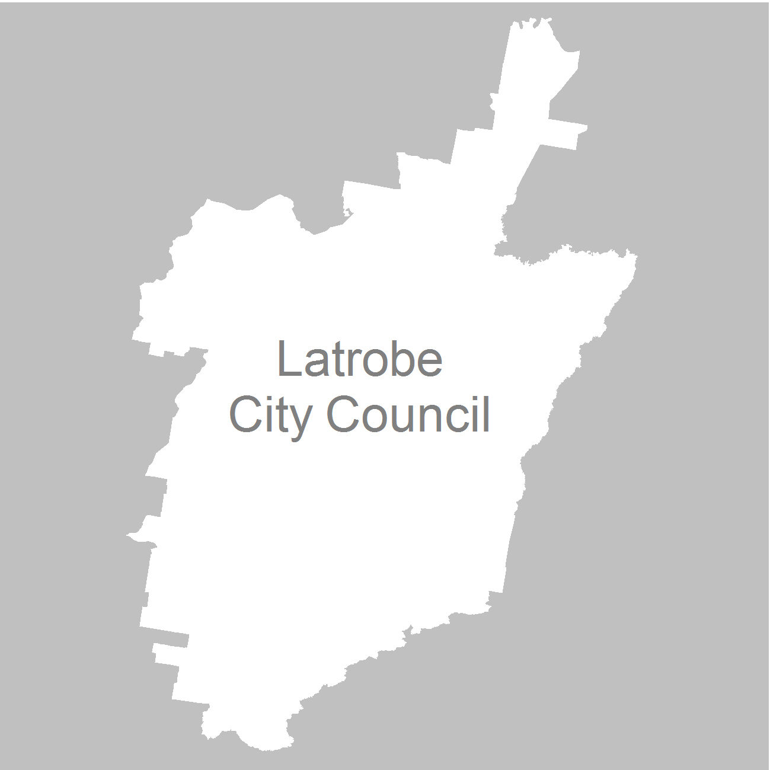

28 March 2012

Contents
Recommendation 3
Background 4
Legislative basis 4
The VEC and Electoral Representation Reviews 4
Profile of the City of Latrobe 5
Current electoral structure 6
The electoral representation review process 7
VEC research 8
Public involvement 9
Advertising 9
Media releases 9
Public information session 9
Information brochure and poster 10
Latrobe City Council website 10
Helpline 10
VEC website 10
Guide for Submissions 10
Preliminary report 11
Preliminary submissions 11
Analysis of Submissions 11
Preliminary Report 13
Public response 14
Response submissions 14
Public response 18
Findings and Recommendation 21
Appendix 1: List of submitters 31
Response submitters 31
Form letter – urban 33
Appendix 2: 38
Map of Recommended Boundaries 38

Recommendation
The Victorian Electoral Commission (VEC) recommends that
Latrobe City Council consist of four wards - one four-councillor ward, two two-councillor wards and one single-councillor ward.

The recommended ward boundaries are illustrated in the map at the back of this report.

Background

Legislative basis
The Local Government Act 1989 (the Act) requires the VEC to conduct an Electoral Representation Review of each municipality in Victoria at least every 12 years. The Act specifies that the purpose of a representation review is to recommend to the Minister for Local Government the number of councillors and the electoral structure for a municipality, which will provide ‘fair and equitable representation for the persons who are entitled to vote at a general election of the Council’.
The Act requires the VEC, as part of an Electoral Representation Review, to consider:
the number of councillors in a municipality;
whether a municipality should be unsubdivided or subdivided;
if it should be subdivided, whether ward boundaries:
  - provide for fair and equitable division of the municipality;
  - ensure equality of representation through the number of voters being represented by each councillor being within 10 per cent of the average number of voters represented by all councillors; and,
if it should be subdivided, the number of councillors that should be elected for each ward.

The VEC and Electoral Representation Reviews
The VEC has conducted Electoral Representation Reviews since 2004 on appointment by local councils. The Act was changed in 2010 to define the VEC as the only agency authorised to undertake the reviews.
The VEC drew on its experience in mapping and boundary modelling and also engaged consultants with experience in local government to provide advice on specific local representation issues during the review.

Profile of the City of Latrobe
The City of Latrobe is located 135 kilometres east of Melbourne and comprises four major urban centres: Churchill, Moe/Newborough, Morwell and Traralgon. It is one of the largest municipalities outside metropolitan Melbourne with over 69,000 residents.
Major features of the City include Morwell National Park, Tyers State Park, Monash University Gippsland Campus, Central Gippsland Institute of TAFE (Morwell and Yallourn Campuses), Latrobe Regional Hospital, Latrobe Regional Airport, PowerWorks Energy Technology Centre, Maryvale (Paper) Mill, Lake Narracan, Hazelwood Pondage, Traralgon commercial centre and several mines and power stations. The City is served by the Princes Freeway, Princes Highway, the Hyland Highway, the Strzelecki Highway and the Gippsland railway line.
The landscape of the City of Latrobe ranges from rich agricultural floodplains to the temperate rainforests of the Strzelecki Ranges. Approximately 40 per cent of the municipality’s land is used for forestry. The City of Latrobe is a significant energy provider for Victoria, and the largest industries are manufacturing, electricity, gas and water supply.
The vast amounts of brown coal deposits lying under the valley floor have attracted waves of migrants to work in the power generation industry. Over 9,000 of the residents of the City of Latrobe were born overseas and over 4,000 residents speak a language other than English at home. The main languages other than English are Italian, Maltese, Dutch, Greek and German. The municipality has a relatively young population with 45 per cent of residents aged under 35. Of these 25 per cent are aged under 10.
The City of Latrobe has a projected population growth of 4.22 per cent over the next ten years., with the highest growth forecast for Traralgon (8.05 per cent and the lowest estimated growth at Moe (0.96 per cent). Morwell has a projected population growth of 1.92 per cent with the balance of the municipality forecast to grow by 4.54 per cent.

Current electoral structure
The last representation review for Latrobe City Council took place in 2007. Following the review, the Minister for Local Government approved an electoral structure of:
Nine councillors;
- Divided into nine wards: Burnet Ward, Dunbar Ward, Galbraith Ward, Gunyah Ward, Farley Ward, Firmin Ward, Merton Ward, Rintoull Ward and Tanjil Ward; and
- With one councillor representing each ward.

The map below shows the electoral structure at 13 July 2011.

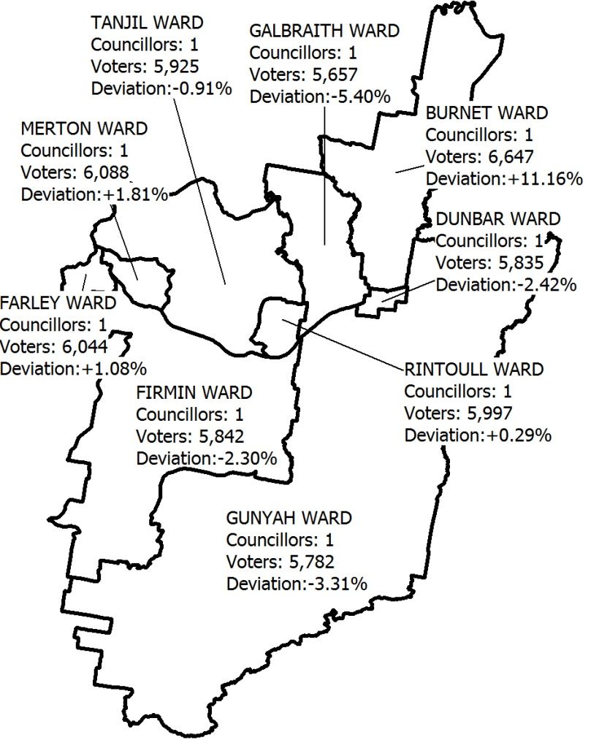

The electoral representation review process
The VEC proceeded on the basis of three main principles:
- Ensuring the number of voters represented by each councillor is within 10 per cent of the average number of voters per councillor for that municipality.
Populations are continually changing. Over time these changes can lead to some wards having larger or smaller numbers of voters. As part of the review, the VEC corrected any imbalances and also took into account likely population changes to ensure these boundaries provide equitable representation until the next review.
- Taking a consistent, State-wide approach to the total number of councillors.
The VEC was guided by its comparisons of municipalities of a similar size and category to the council under review. The VEC also considered any special circumstances that may warrant the municipality to have more or fewer councillors than similar municipalities.
- Ensuring communities of interest are as fairly represented as possible.
Each municipality contains a number of communities of interest and, where practicable, the electoral structure should be designed to take these into account. This allows elected councillors to be more effective representatives of the people in their particular municipality or ward.
The recommendation is based on:
- internal research specifically relating to the municipality under review;
- VEC experience from its work with other municipalities and in similar reviews for State elections;
- VEC expertise in mapping, demography and local government;
- careful consideration of all public input in the form of written and verbal submissions received during the review; and,
- advice received from consultants with wide experience in local government.

Public submissions were an important part of the process, but were not the only consideration during the review. The VEC seeks to combine the information gathered through public submissions with its own research and analysis of other factors, including the need to give representation to communities of interest. The recommendation is not based on a ‘straw poll’ of the number of submissions supporting a particular option.

VEC research
In addition to the information provided in submissions, the VEC created a profile of the municipality based on population trends, development projections and demographic indicators. The VEC used a variety of information sources including the Australian Bureau of Statistics 2006 data and census community profiles, the Department of Planning and Community Development projections and voter statistics from the Victorian electoral roll. The VEC also undertook field work to view current and possible boundaries for each of the options presented in the preliminary report to evaluate their effectiveness.

Public involvement
The VEC values the local knowledge and perspectives presented by the public in written submissions. The public were given two opportunities to provide submissions during the review. Their input was considered by the panel in forming the options in the preliminary report and they were also invited to respond to these options. In addition, a public hearing was held to enable people to speak in support of their submissions and supplement it with information.
To ensure transparency in the process, all written submissions were published on the VEC website and all verbal submissions were heard in a public environment.
To raise awareness of the review and encourage the public to engage with the process, a full public information campaign was undertaken.

Advertising
In accordance with section 219F (4) and 219 (7) of the Act, the VEC placed a public notice in the Latrobe Valley Express on Monday, 31 October 2011 detailing the process for the review and calling for public submissions.
A general notice covering several reviews was printed in The Age and the Herald Sun on Saturday, 22 October 2011.
The notice of the release of the Preliminary Report appeared in the Latrobe Valley Express on Monday, 30 January 2012. The notice detailed the options contained in the preliminary report, including a map of each option, instructions on how to receive a copy of the preliminary report and how to make a submission in response to the report.

Media releases
A media release was sent to the local media. Coverage was achieved in the Latrobe Valley Express and a VEC spokesperson was interviewed on ABC Gippsland about the process.

Public information session
The VEC held a public information session on Tuesday, 15 November 2011 in the Latrobe City Council Offices for people interested in the review process.

Information brochure and poster
An information brochure was provided to the council to be sent to residents through the council network and made available in service centres and libraries. A poster was also provided to Council as an extra publicity tool.

Latrobe City Council website
Information about the reviews was available on the Latrobe City Council website (latrobe.vic.gov.au) with a link to further details about the review process, a copy of the Guide for Submissions and a hyperlink to the VEC website.

Helpline
A dedicated helpline was established to assist with public enquiries concerning the review process.

VEC website
The VEC website (vec.vic.gov.au) delivered up-to-date information and provided transparency during the review process. An online submission tool was created to facilitate the submissions process and all preliminary submissions were published online. The preliminary report was available for download on the website too.

Guide for Submissions
Copies of the Guide for Submissions are available on the VEC website. They can also be obtained by calling the dedicated helpline. They were provided to the Council and handed out at the information sessions.

Preliminary report

Preliminary submissions
By the close of preliminary submissions at 5.00pm on Monday, 28 November 2011, the VEC had received 12 preliminary submissions.

Analysis of Submissions
Submissions were received from individuals and groups, and favoured or suggested a variety of electoral structures.
A number of submissions argued that the current structure had been supported by the community since 2000, was working well and enabled local representation. One submitter was concerned that any modifications ‘would threaten the advances made by council since amalgamation’ and another stated that only a ‘vocal minority’ wanted change.
Arguments against the current structure included that it had resulted in a voting bloc of five councillors within council that prevented residents of Traralgon from receiving fair and equitable representation.
Several submitters stated that old rivalries still existed between the townships of Traralgon, Morwell and Moe and suggested that ‘any ward structure that maintains the links with the old towns will not be successful.’ These rivalries were cited in two submissions as a reason for advocating an unsubdivided municipality. However, there was criticism of an unsubdivided structure from other submitters who expressed concern that this may lead to large ballot papers if there was a large number of candidates. These submitters also expressed concern about the difficulties candidates may face campaigning across the entire municipality and potential problems for electors in trying to access councillors.
Churchill District Community Association outlined a two-ward structure based on the concept of networked towns, stating it would serve the ‘two distinct groups of community interest’. Another submitter also argued for two wards with a north/south divide.
The Proportional Representation Society of Australia argued that the current structure of single-councillor wards is more likely to lead to uncontested elections, which restricts the choice for voters, highlighting Firmin Ward (which was uncontested in 2008) as an example and stating that multi-councillor wards are less affected by population changes.
Moe and District Residents Association and Traralgon Community Development Association (MADRA-TCDA) outlined a five-ward structure which it argued distinguished major and minor population centres, provided a tolerance for population growth and decline, and reflected the communities of interests.
Several submissions mentioned concerns about the Federal Government’s Carbon Tax and queried the validity of the VEC’s projected population data figures.
One submitter suggested that the number of councillors be increased to 11 and requested at least one such option be provided in the VEC’s Preliminary Report.
A list of submitters is available in Appendix One. Full submissions can be viewed on the VEC website: vec.vic.gov.au

Preliminary Report
The VEC released a Preliminary report outlining the preliminary options for the electoral structure of the Latrobe City Council. The report was released on Monday, 30 January 2012, and put forward four options for consideration.
Option A (Preferred Option)
Latrobe City Council should remain with nine single-councillor wards. Modifications should be made to the existing ward boundaries to correct existing imbalances in the voter numbers and to accommodate future population changes.
Option B (Alternative Option)
Latrobe City Council should become an unsubdivided municipality, with all the councillors elected by the municipality at large.
Option C (Alternative Option)
Latrobe City Council should consist of four wards. One four-councillor ward, two two-councillor wards and one single-councillor ward.
Option D (Alternative Option)
Latrobe City Council should increase to 11 councillors. There should be two four-councillor wards and one three-councillor ward.

Public response

Response submissions
A total of 887 response submissions were received by the closing date of 5.00pm on Monday, 27 February 2012. This included over 800 form letters from MADRA-TCDA in support of their model.
As indicated in its Guide for Submissions, the VEC values public submissions for their individual arguments and insight into community issues. While the number of submitters in support of an argument may be notable, it is the strength of the arguments in support of, and against, a structure that is valuable to the decision-making process.
In accordance with procedure, the VEC wrote to each submitter to acknowledge their submission. It became evident from phone calls that not every person who signed a form letter was fully aware of the details of the electoral representation review. Callers expressed confusion about the issue, did not recollect signing the form or requested that their names to be removed from the list on the website. The VEC also received a small number of acknowledgement letters marked returned to sender.
The petition letters represent a strong response to a VEC electoral representation review, with over twice as many submissions received than for any other review conducted by the VEC. The VEC acknowledges that this indicates a level of agreement with the sentiments expressed in the form letter The VEC also notes that the overwhelming majority of the respondents come from Traralgon.
Option A
Submissions supporting Option A stated that they have been well represented in the past, and pointed to the fact the same councillors were often re-elected as a sign that the silent majority was happy. They also mentioned that previous reviews had concluded that this was the best structure.
Submitters argued that there would always be issues in Latrobe, regardless of electoral structure and that some residents had not accepted amalgamation. They referred to the arguments put forward in other submissions about voting blocs, arguing that political party or lobby group involvement was a possibility in any structure.
These submitters believed their councillor had a good understanding of local issues, stating that they had been able to develop a strong working relationship with their councillor and were able to hold them to account. Some submitters were concerned that in a municipality, with such a diverse demography, local issues could be at a risk of being ignored in larger wards that these wards would be difficult to canvass and that their size might deter potential candidates from nominating. They also expressed concern that multi-member wards would result in large workloads for councillors and a consequent lack of representation.
Of the five councillors who made submissions, four maintained that they work well together and, as with several other submitters, were concerned that the City of Latrobe is going through a period of change caused by concerns related to plans for a low carbon future and stating a belief that it was the wrong time to introduce a new structure.
Submissions arguing against Option A alleged that the existing structure was responsible for the creation of a Labor/Union voting bloc which enabled funds to be directed away from Traralgon and to Morwell and Churchill. There were also accusations of pork-barrelling and gerrymandering.
MADRA-TCDA put forward a detailed submission that included analysis of the table of positive and less positive features of single-councillor wards documented in the VEC’s guide for submission and arguing that Latrobe City Council effectively demonstrates the less positive features. This submission also noted that in every election since 2000 there have been uncontested wards.
Submitters arguing against a single-councillor ward structure queried the VEC population projections, in the light of the effect of the Federal Carbon Tax and expressed concern about the likelihood of further boundary changes.
Other submitters expressed concern that councillors were only interested in problems within their own wards and that there was no opportunity to vote out councillors in other wards.
Option B
Supporters of Option B pointed to Tasmania, Wellington and East Gippsland as examples of effective unsubdivided structures. The merits of the proportional representation vote counting method were discussed, including the likelihood of rural candidates being elected under this system. The fact that subdivision reviews would not be necessary was also cited as an advantage.
Several submitters noted that people live, work and have interests across the municipality and that this structure would encourage councillors to take a more holistic approach.
The arguments against Option B included the possibility that councillors may only work for the urban areas as they are more likely to get votes from this area, which could lead to the council being controlled by pressure groups or political parties. There was also a concern that that multi-member wards could make it harder to hold representatives to account and that duplication of work is more likely. The difficulty for independent candidates to canvass large wards was also mentioned.
Just two submitters favoured this option, stating it links the four large towns with their related areas and is less open to domination by factions.
Option C
The submission by MADRA-TCDA stated that Option C was a weaker version of the option they put forward. Criticisms included the possibility of one ward dominating the decisions, the separation of the urban and rural areas, which could lead to councillors catering only for Traralgon, and an imbalance of representation resulting from a stronger, larger, east ward leaving the western ward to be represented in a ‘fractious’ manner.
The Proportional Representation Society also raised the possibility that Option C would provide an opportunity for a single-councillor ward to become the “Kingmaker”.
The submission by MADRA-TCDA also queried concerns expressed by the VEC in its Preliminary report about their proposed model isolating Traralgon and stating their belief that Rintoull, Merton, Farley and Dunbar Wards are already isolated in the current structure.
Option D
One submitter favoured option D because it most closely reflected her original submission. Other submitters felt it did not meet the requirement to align councillor numbers with other similar municipalities across Victoria, that it was too urban centric and that it would make it harder to achieve secession, (Note: Some individuals and groups within the municipality have at times suggested that the municipality itself should be divided. This is not a matter for the VEC, and is not within the scope of the review).
A number of submitters also argued for structures outside the options in the Preliminary Report.

Public hearing
A public hearing was held in the Council Offices in Morwell on Tuesday, 6 March 2012. Everyone who had made a submission in response to the preliminary report was invited to speak and 16 people chose to do so.
To ensure transparency in the process, the hearing was open to the public and some 40 people attended including members of the local media.
The hearing lasted four and a half hours and the VEC would like to thank everyone involved for their time and patience. The VEC is very grateful for the extra insight that was gained from speakers at the hearing.
A wide range of views was expressed, with no option emerging as a clear preference. Five people spoke in favour of Option A, three people in favour of Option B, five people spoke in favour of the Moe and District Resident Association and Traralgon District Community Association model, two people reiterated their support for models that were not included as options in the preliminary report and one person argued in support of multi-member wards in general.
Option A
Submitters arguing in favour of Option A (nine single-councillor wards) included two current councillors for Latrobe City Council. Arguments included that the current structure worked well and that it was supported by a clear administrative framework, which minimised confusion for residents.
These speakers argued that the diverse geographical make-up of the municipality meant that residents benefited from councillors who had a good understanding of local issues, knowing who to contact and having councillors that were accountable to their local community.
It was suggested that the small number of original submissions should be seen as a sign that the majority of people were happy with the structure. Councillor White stressed that it had been necessary for Council to make some unpopular choices for the good of the entire municipality and that it was vital that the current structure was continued in the light of the ‘low carbon future.’
One submitter suggested that the competing interests of pressure groups and a lack of cooperation were preventing progress, rather than the electoral structure itself.
Option B
The speakers arguing for Option B,(an unsubdivided structure) stated that residents of the City of Latrobe move around the municipality, living, working and participating in recreational activities in different areas, and that they therefore take an interest in the City as a whole and not just their ward.
One supporter mentioned Wellington Shire Council as an example of a similar municipality, with three main centres, and explained how it had a good geographic spread of councillors. He countered claims that it would be difficult to campaign across the municipality by stating that electors base their votes on the campaigns in the Latrobe Valley Express newspaper, which circulates across the whole City.
Another speaker explained that it should be easier for rural residents to be assured of representation in an unsubdivided municipality because the quota that must be gained would be lower. He also stated that because Latrobe City Council elections were conducted by post it should be easier for residents to take time to fill out their ballot papers correctly, even if they are larger.
It was also argued that an unsubdivided structure would enable a wider choice of candidates for voters and a better social and cultural mix.
Each of these speakers stated that the issues in Latrobe City are not just geographically based and that as people have interests in areas away from where they reside, they should be able to vote for all the councillors.
Another speaker opposed this option and spoke from personal experience about the high cost of a recent campaign in a single-councillor ward and expressed concern that the expense could prohibit candidates from nominating.
Option C
No one spoke in favour of Option C, but submitters spoke in favour of the structure put forward by Moe and District Residents Association (MADRA) and Traralgon Community District Association (TCDA) on which Option C was modelled.
Mr Tyler spoke on behalf of both MADRA and TCDA and argued that the people in Latrobe City identify as residents of the town they are from rather than as residents of ‘Latrobe City’. He also argued that parochialism could be seen as a positive feature and work as a force to strengthen the municipality.
He criticised the changes made by the VEC to the MADRA/TCDA model, combining Traralgon with its rural surrounds, stating that although the rural areas may look towards Traralgon, they have their own distinct needs and would not be guaranteed an effective voice under the VEC’s Option C.
He argued that the VEC had received its largest response of any review and although he understood the VEC was not swayed by straw polls he stressed it was a good indication of the strength of feeling and did add weight to the argument.
Other speakers argued in support of this model, stating that the multi-councillor wards gave residents a choice of councillors to approach, and that it gave the best possible grouping of the communities of interest.
Three speakers did not align themselves with any of the options. One speaker argued in support of smaller communities and the benefit of a two-ward structure that was based along the transport corridors. This option was discounted in the Preliminary Report for not offering fair and equitable representation. This speaker did not support Option C, believing it split the Churchill/Morwell corridor and gave the balance of power to one councillor.
Another speaker argued for a three-ward structure with nine councillors based on longitudinal lines, stating that the majority of the municipality interacts on a north – south basis. He also stressed the benefit of continual representation in a multi-councillor ward in the case of a councillor resigning or being away. He outlined his proposal for a five-ward structure too with 11 councillors.
Another speaker spoke in support of multi-councillor wards, stating that countbacks were easier to conduct than by-elections. She also noted the unsettling effect that the reviews were having on the community.

Findings and Recommendation
The broad content of the submissions is indicative of the complexity of this electoral representation review. Arguments in support of different structures along with opinions about the advantages and disadvantages of each structure were raised in the public submissions and at the public hearing.
The VEC also undertook some research into the options presented by Mr McDonald at the public hearing and in his response submission. The five-ward structure used boundaries that split the town of Traralgon and goes against the VEC’s principle of designing ward boundaries that encapsulate towns where possible and would not conform to the legislation for ensuring the number of voters represented by each councillor is within 10 per cent of the average number of electors per councillor for that municipality. The three-ward model is very similar to structure proposed as Option C in the Preliminary Report but it does not recognise Churchill as a major centre. As it does not offer a significant improvement on the current option, the VEC discounted this option too.
Every one of the four structures put forward in the Preliminary Report has merit and would serve the Latrobe community for the next 12 years.
Arguments about whether the council itself works well as a group are not the subject of this review. The VEC’s role is to recommend an electoral structure that provides fair and equitable representation for voters. It is up to the voters themselves, the elected councillors and the operation of good governance procedures to ensure that the Council operates effectively.
No electoral structure can prevent candidates from being funded by political parties or eliminate the possibility of voting blocs, or determine council decision-making. The VEC looks to three established principles of electoral representation to recommend the most suitable structure.
These principles have been applied to every electoral representation review in Victoria since 2004. They were clearly outlined in the Guide for Submissions and the Preliminary Report and they are the yardstick by which all reviews in Victoria are conducted. The valuable information that was gained in the public submissions and public hearing about communities of interest was integral to this analysis.

1. Ensuring the number of voters represented by each councillor is within 10 per cent of the average number of voters for that municipality.
All preliminary options upheld this principle. The VEC notes the concerns of several submitters that the carbon tax could have implications on the population of this municipality. The VEC uses its own enrolment information combined with the latest information from Forecast.id and the Department of Planning and Community Development to project future elector numbers as accurately as possible.
The VEC bases all its decisions on the best substantiated information that is available at the time of the review and applies this across all municipalities in Victoria. Arguments about possible effects of a carbon tax, while giving rise to a variety of concerns within communities around the country, were not able to be considered as part of this review.
The VEC uses a comparative table of all municipalities in Victoria and is guided by the principle of recommending that similar types of municipalities of a similar size have the same number of councillors, unless special circumstances justify a variation.
2. Taking a consistent, State-wide approach to the total number of councillors.

Municipality | Area | Estimate of voters | Number of councillors
Greater Geelong | 1,279 | 16,7034 | 12
Greater Bendigo | 2,999 | 77,705 | 9
Ballarat | 739 | 69,956 | 9
Latrobe | 1,425 | 53,263 | 9
Mildura | 22,084 | 37,217 | 9
Greater Shepparton | 2,421 | 42,193 | 7
Wodonga | 434 | 26,067 | 7
Warnambool | 120 | 24,451 | 7
Wangaratta | 3,646 | 26,390 | 7
Horsham | 4,264 | 15,150 | 7
Benalla | 2,350 | 11,291 | 7
Ararat | 4,208 | 8,975 | 7

The City of Latrobe fits in the middle of the nine-councillor band and after considering all relevant factors, the VEC considers that nine councillors is an appropriate number for Latrobe City Council.
The VEC did put forward an option for 11-councillors, as an alternative option (Option D), recognising that it could be argued that special features are evident within the municipality that could warrant an increased number of councillors beyond that indicated by the comparative table. These include social disadvantage levels above the regional Victorian average evident in some areas of the municipality a relatively large business sector compared with other regional municipalities that places extra demands for attention on councillors.
After testing this model, the VEC believes the social disadvantage is not of such a scale to warrant an increase in councillor numbers and this was confirmed by the lack of support in the community for 11councillors. The VEC is, therefore, dismissing this option.
3. Ensuring all communities of interest are as fairly represented as possible
The remaining structures were measured against the VEC’s principle of creating electoral structures that take communities of interest into account. This helps ensure that elected councillors are effective representative of the people in their municipality or ward. Communities of interest became the defining principle in the review.
The VEC recognises that the City of Latrobe is a diverse municipality with many non-geographic communities of interest, including forestry industries, paper pulp and manufacturing, tourism, coal and power production, farming and agriculture industries. Each of these interests impacts on the region’s economy, development and environment and may be of concern to the residents of the municipality.
However, the City of Latrobe also comprises strong geographic communities of interest with four major urban centres: Churchill, Moe/Newborough, Morwell and Traralgon, and the seven smaller townships of Boolarra, Glengarry, Toongabbie, Tyers, Traralgon South, Yallourn North, and Yinnar.
The VEC understands that the Latrobe Valley is facing a complex set of challenges as Australia transitions to a low carbon economy and this will place extra demands on councillors as a consequence. The VEC believes that an electoral structure that encourages diversity of representation will assist the Council to meet these challenges.
The challenge for the VEC was to develop an electoral structure that would provide fair and equitable representation to both geographic and non-geographic communities of interest.

Option A
Latrobe City Council has always consisted of single-councillor wards. At the previous electoral representation review, the VEC expressed misgivings that this structure split some of the major towns between wards.
Morwell is split between four wards and Traralgon is split between three wards. The VEC accepts that these boundaries have become established in the community over the years and to some extent the division was considered a positive feature as it was hoped that it would help unite interests relating to the towns.
The VEC considers that residents of a town share services and facilities and tend to have a unifying sense of community identity and similar needs from their councillor so wherever possible; ward boundaries acknowledge or respect town boundaries.
Over the years, the boundaries of the single-council wards have undergone representation reviews which have adjusted the boundaries to accommodate population changes. The VEC has concerns that the boundaries have become less representative of the communities of interest and more about balancing the numbers.
Nevertheless, the VEC put forward a single-councillor option as its preferred option because it had support from the community both in this review and the last, it was able to accommodate the legislated 10 per cent tolerance and because, as noted during the previous review, modelling a multi-councillor structure proved problematic with respect to a number of factors including capturing communities of interest and inappropriately separating or joining certain towns.
Option B
A structure without wards is an attractive option in a municipality that has a variety of non-geographic communities of interest. However, this structure does not always ensure representation for the geographic communities of interest, particularly if they are numerous.
The VEC notes that one submitter drew a comparison with the neighbouring Wellington Shire Council as a municipality that is successfully unsubdivided and the VEC acknowledges that Wellington Shire Council has a good geographic spread of councillors. However, Wellington Shire has only one main town, Sale, which has around a third of the population living in it. In contrast, Latrobe has four main towns and seven smaller townships and there is no guarantee that all these areas would achieve dedicated local representation in an unsubdivided structure. The VEC found arguments against an unsubdivided structure and in support of other structures more convincing in relation to Latrobe City Council.
Option C
Moe and District Residents Association and Traralgon Community Development Association (MADRA-TCDA) put forward an option based on defining communities of interest and ensuring they were represented within wards. As MADRA-TCDA notes, some compromises had to be made to keep townships together. For example, the Central Urban Ward includes Morwell along with Yallourn North, Hernes Oak, some of Hazelwood and Hazelwood North. While this is recognised as not ideal, MADRA-TCDA refer to ‘secondary communities of interest’, stating that residents of Yallourn North and Hernes Oak are as likely to travel to Morwell as to Moe for their shopping and access to other services.
The VEC’s concern with this model was the isolation of Traralgon in one ward. Although it groups Traralgon effectively as a community of interest, it isolates the town from the rural communities around it that would look to Traralgon as a focus and it creates what is known as a ‘doughnut’ ward.
The shapes of electoral ward boundaries are often referred to as ‘doughnuts’, ‘pies’ or ‘sandwiches’.
A doughnut describes a ward that wholly encloses another ward (with the inner ward forming the ‘hole’). A pie-shaped ward denotes an area divided more or less from the centre in a fashion that roughly resembles traditional slices of a pie. A sandwich has a layered look with vertical or horizontal boundaries.
All these shapes can be seen in electoral structures across the world. However, doughnuts have never been a real feature of Australian electoral boundaries where the broad principles of contiguity and community of interest have ruled them out of consideration. The Northern Territory, with its small electoral districts, is the only exception, and these exist due to the lack of viable alternatives.
Both the UK and USA have implemented doughnut shaped electorates, but they are very much on the decrease. They have been used in the past to lock in the conservative and non-conservative vote and to contrive political outcomes. Most electoral analysts and academics consider that doughnut wards divide communities of interest and fail to recognise the links that communities in the (usually) more rural ‘doughnut’ area have with the town that makes up the ‘doughnut hole’. There is also argument that the people on one side of the doughnut become artificially linked with those on the other side.
Analysis by McLean and Butler in 1996 of the boundary reviews in the UK has led to doughnut shape districts being somewhat discredited although they still enjoy some support from a particular political party. Bernard Blacks 1982 publication ‘Gerrymandering and doughnuts’ is consistent with this research.
In the USA, Minnesota’s state legislature is responsible for drawing the electorate ward boundaries but the Democratic Governor recently vetoed them for containing doughnuts, and the task was given to the Supreme Court. They re-released the maps last month without containing doughnut wards, following consideration of community of interest arguments.
In the model put forward by MADRA-TCDA, Traralgon would become the hole in the doughnut. The VEC is concerned that this would exclude the rural residents who share services and shopping with Traralgon and should therefore be considered as having community of interest with the Traralgon residents.
MADRA-TCDA argues that combining Traralgon with the surrounding rural area would ‘diffuse the representation interests of rural people, restricting their ability to achieve the specific and dedicated representation they need’. This argument implies that a town councillor will not or cannot represent the interests of rural voters. The VEC notes that it is the responsibility of all councillors to represent the interest of the whole community.
In a multi-councillor ward with a proportional representation vote counting system, any candidate with sufficient support from the rural community could be elected. Indeed, it is not inconceivable that two or more candidates from the rural area could get elected under the broader model.
Considering the views of electoral experts across the world, and the lack of any clear benefit to the community, along with broad community of interest and contiguity principles, the VEC is not prepared to recommend a doughnut ward for the Latrobe City Council. .
However, the VEC believes that, without the doughnut, the structure proposed by MADRA-TCDA best reflects the communities of interest in the municipality and that multi-member wards should facilitate fairer and more equitable representation for all of the Latrobe City Council voters.
The VEC did express concern in its Preliminary Report that the ward boundaries are very similar to the old municipal boundaries, especially in the Traralgon based ward and there could be a risk that these boundaries would give rise to old rivalries.
The consultation process has assisted the VEC to form the view that the people of the City of Latrobe have a strong sense of identity to their local towns, but they also have a shared sense of identity – that of belonging to the Latrobe Valley and surrounds. The VEC believes it may be beneficial to reflect these connections in the structure.
Conclusion
The City of Latrobe is a diverse and dynamic municipality that has achieved a great measure of success since its formation. It faces issues relating to socio-economic disadvantage, diversity of interests, ideas and aspirations and the management of environmental and economic issues across the municipality.
The continued provision of appropriate, effective services and infrastructure, and decision-making that meets the needs of the community is a vital part of the work of the Latrobe City Council.
The management of these issues is critical to the future form and character of the Latrobe City Council. The opportunity for fair and equitable representation is an important component of community support for, and participation in, the decision-making processes of the Council.
The VEC considers it important that the community has the opportunity to elect a council that is able to reflect and represent the City’s diversity and local communities of interest if it so chooses.
As in its previous review of the Latrobe City Council, the VEC recognises that many individuals and groups within the municipality feel that they are currently well represented and that they believe that a single-councillor ward structure is critical to the ongoing provision of such quality representation.
The VEC notes that as stated by submitters at the 2007 review, there are individuals and groups within the City who do not feel as though their views are being represented effectively and they believe that a multi-councillor ward structure would help ensure fair and equitable representation.
The VEC is of the view that the type of close representation that many residents currently enjoy could continue under the structure put forward as Option C in its Preliminary Report. Such a change would help address the concerns of those residents who feel under represented, and would help facilitate fairer, more diverse and more equitable representation for all of the City’s voters.
The VEC believes that the communities of interest within the municipality are captured best by the predominately multi-councillor ward structure of Option C.
The VEC considers that creating the single-councillor South Ward was preferable to including it in either the Central or East Ward. The proposed South Ward incorporates Churchill and its surrounds and helps ensure that voters from the south of the municipality have dedicated representation.
The VEC suggests that Latrobe City Council consider changing the ward names of East, West, Central and South wards to names that are unique and relevant to Latrobe City.

Recommendation
The VEC recommends an electoral structure with nine councillors in one four-councillor ward, two two-councillor wards and one single-councillor ward for the Latrobe City Council.

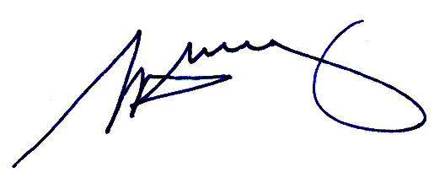

S. H. Tully
Electoral Commissioner

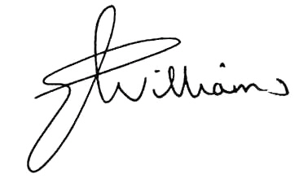

Liz Williams
Deputy Electoral Commissioner

Appendix 1: List of submitters
Preliminary submitters
Advance Morwell Inc.
Churchill District Community Association
Guy, J.V.
Jordan, D.
McDonald, B
McIntyre, G.
Middlemiss, G.
Moe District Residents Association and Traralgon Community Development Association
Murphy, A
Proportional Representation Society of Australia
Sykes, J.
Williams, H.

Response submitters

Advance Morwell Inc
Alexander, H.
Baker, G.
Barbara, G.
Bartholomeusz, W.
Boolarra Community Development Group
Churchill and District Community Association
Edwards, P.
Gibson, S.
Guy, J.
Hadley-Powell, H.
Jeffrey, E.
Johannesson, A.
Jordan, D.
Kerry, J.
Kerry, S.
Kilday, B.
Latrobe City Farm Ratepayers Association
Lougheed, B.
McDonald, B.
McIntryre, G.
McMahon, W.R.
Moe and District Residents Association Inc. And Traralgon Community Development Association Inc.
Moore, S.
Poole-Coughlan, J.
Price, L and Vermeulen, E.
Proportional Representation Society of Australia
Rayment, P.
Reid, L.
Scarlett, A
Sennett, G.
Sykes, J.
Van den Eynde, O.
White, D.
Williams, A.
Williams, H.
Williamson, M.
Willis, J.
Witchell, A.

Form letter – rural
Dawson , J.
Ikin , S.
Parr , B.
Pearce , A.
Taylor , D.
Whittaker , K.

Form letter – urban

Abblitt , D.
Abblitt , W.
Abery , K.
Aboltins , P.
Adams , J.
Adams , L.
Affleck , D.
Affleck , I.
Aitken , L.
Alimas , G.
Allcorn , J.
Alston , A.
Alston , B.
Alston , J.
Alston , V.
Ambler , K.
Apostoleris , P.
Ashford , K.
Ashford , S.
Ashinyano , V.
Atherton , A.
Atherton , J.
Atkinson , E.
Atkinson , J.
Aust , A.
Bailey , M.
Baker , W.
Barker , B.
Barker , B.
Barnes , K.
Bassett , V.
Bassler , F.
Batten , R.
Batten , V.
Baxter , J.
Beange , R.
Beaton , E.
Bechaz , J.
Becker , W.
Beddard , A.
Beer , P.
Beggs , K.
Bell , D.
Bell , E.
Benson , J.
Berkelmans , J.
Berrett , G.
Beveridge , W.
Binding , J.
Binding , L.
Bird , S.
Bishop , W.
Blake , M.
Blakeley , L.
Bloomfield , L.
Bolding , F.
Bömers , A.
Bonacci , M.
Bonnett , C.
Bonnett , M.
Bordonaro , J.
Bordonaro , K.
Boulton , A.
Boulton , L.
Boyd , S.
Brand , G.
Brand , L.
Breen , W.
Bremner , G.
Brooks , A.
Brooks , G.
Bryce , D.
Buhagiar , T.
Burge , M.
Burgess , S.
Butterworth , N.
Cambus , G.
Cameron , G.
Cameron , L.
Cameron , M.
Campbell , M.
Campbell , M.
Campbell , P.
Carrington , W.
Carstein , R.
Cattanach , M.
Champlin , J.
Chard , L.
Chard , F.
Charnley , T.
Chase , I.
Chenhall , K.
Chisholm , R.
Christensen , I.
Christensen , J.
Christensen , T.
Churchill , J.
Churchill , P.
Churchill , R.
Clark , M.
Clark , A.
Clifford , P.
Coffrey , F.
Collins , W.
Coney , C.
Conway , M.
Conway , W.
Cooper , D.
Cooper , J.
Cooper , M.
Cooper , S.
Costabile , M.
Couch , L.
Crabtree , J.
Crafter , D.
Crane , C.
Creswell , J.
Cross , B.
Cruickshank , D.
Cumming , A.
Cumming , M.
Curnick , H.
Dalton , C.
Daly , N.
D'Angelo , D.
Darmody , C.
Darmody , E.
Darmody , L.
Davidson , C.
Davidson , L.
Davies , A.
Davis , G.
Davis , G.
Davis , J.
Davis , N.
Davis , R.
De Tracy , S.
De Zwart , H.
Debono , M.
Deery , M.
Degnan , J.
Degnan , W.
Dell , B.
Derham , A.
Derham , J.
Derricott , K.
Di Sisto , L.
Dinsdale , C.
Dominguez , M.
Donley , J.
Doonan , H.
Doonan , K.
Doultree , T.
Downey , S.
Draper , C.
Draper , M.
Drenen , R.
Duach , S.
Duke , S.
Duncan , B.
Duncan , B.
Duncan , J.
Duncan , P.
Dunstone , A.
Dunstone , K.
Dwyer , T.
Dye , L.
Dyer , A.
Eacott , J.
Easter , B.
Easter , R.
Eastham , R.
Elder , G.
Elder , J.
Emmett , C.
Emmett , T.
Estrada , A.
Evans , J.
Ezard , P.
Falla , R.
Farley , K.
Farmer , R.
Fawkner , B.
Fawkner , J.
Fawkner , K.
Firth , L.
Firth , S.
Fisher , P.
Fisher , R.
Fkiaras , N.
Fkiaras , S.
Fleming , J.
Flenley , C.
Flynn , D.
Flynn , L.
Flynn , R.
Foenander , R.
Ford , E.
Fox , B.
Fox , J.
Francis , N.
Frankland , G.
Frankland , S.
Fraser , A.
Fraser , W.
Freeman , B.
Freeman , F.
Fricker , D.
Froud , D.
Fullard , G.
Furlong , R.
Gallop , E.
Gamble , I.
Gapper , A.
Gapper , B
Garrett , A.
Garrett , D.
Garrett , L.
Garrett , S.
Gaw , J.
Gibbons , E.
Gibbons , P.
Gibson , J.
Gilbert , C.
Gilbert , J.
Gilmour , J
Gilmour , J
Glover , L.
Glover , L.
Goldfinch , D.
Goldsborough , D.
Goodall , A.
Gooding , L.
Gordon , T.
Graham , A.
Graham , D.
Graham , G.
Graham , K.
Graham , L.
Graham , R.
Graham , R.
Grant , M.
Grass , M.
Grassens , B.
Gray , S.
Grazotis , R.
Greaves , T
Green , B.
Greenwood , M.
Griepsma , J
Grubb , J.
Grubb , J.
Grubb , T.
Grzegorczyn , S.
Gurd , A.
Hackman , B.
Hackman , P.
Haines , J.
Haley , T.
Hall , K.
Hammett , A.
Hammond , E.
Hampton , D.
Hare , R.
Harriman , C
Harriman , D
Harris , A.
Harris , E.
Harris , J.
Harris , K.
Harrup , G
Harrup , I
Harrup , M
Hart , J.
Hartley , J.
Hatfield , J.
Hegarty , R.
Hegarty , T.
Hemperger , S.
Henshaw , J.
Henwood , B.
Heskey , T
Hill , D.
Hill , I.
Hill , R.
Hill , S.
Hills , A.
Hilsley , D.
Hilsley , I.
Hobson , S.
Hodgens , C.
Hodgens , H.
Hogg , G.
Holland , J.
Holland , J.
Hollander , D.
Holmes , J.
Holmes , R.
Holmes , V.
Hood , J.
Hopley , M.
Hor , H.
Hore , R.
Hourigan , H.
Hourigan , K.
Hourigan , M.
Howe , D.
Howe , L.
Howes , A.
Hullah , E.
Hullah , M.
Hulley , D.
Hunt , J.
Hurst , D.
Husson , G.
Hutton , B.
Ierardi , L.
Imlach , J.
Imlach , K.
Inger , C.
Ingle , R.
Ingte , R.
Ioannou , C.
Irving , B.
Irving , J.
Irving , R.
Jackson , P.
Jenkins , D.
Johnson , D.
Johnson , I.
Johnson , J.
Johnson , M.
Johnson , M.
Johnstone , A.
Johnstone , C.
Johnstone , M.
Jones , D.
Jones , M.
Jordon , M.
Jovicic , M.
Joyce , K.
Kay , E.
Kay , S.
Keir , W.
Keir , W
Kelly , R.
Kenny , J.
Kerr , G.
Kerr , J.
Kesper , K.
Kesper , M.
Killeen , E.
King , D.
King , J.
King , K.
King , T.
Knee , G.
Knowles , J.
Kong , J.
Kop , J.
Krieger , J.
Kurrle , P.
Kurrle , R.
Lackas , H.
Lade , A.
Lade , T.
Laidlaw , E.
Lambert , C.
Lambert , R.
Lambert , T.
Lambert , T.
Lancaster , M.
Lang , H.
Langstaff , F.
Lansdown , I.
Lansdown , S.
Larsen , I.
Lawn , C.
Lawrence , A.
Lay , J.
Lelan , D.
Lesley , C.
Lewellin , E.
Lewellin , J.
Ley , K.
Limbom , M.
Linahan , J.
Lindley , R.
Little , D.
Little , M.
Livingston , R.
Lloyd , R.
Lonsdale , A.
Lowe , S.
Lucas , G.
Lucas , K.
Lucas , M.
Lyons , J.
Lyons , R.
MacManus , M.
Macneill , L.
Madey , V.
Maker , W.
Mansfield , K.
Marino , C.
Marino , C.
Marjoram , J.
Marsh , G.
Martin , J.
Masters , L.
Matters , R.
Matters , W.
Matthews , E.
Matthews , A
Maui , D.
May , C.
McAuley , P.
McCluskey , G.
McCulkin , W.
McDonald , C.
McDonald , S.
McDonald , T.
McEntee , W.
McGennisken , B.
McGennisken , B.
McGrath , D.
McGrath , J.
McGregor , D.
McIntosh , M.
McIntyre , G.
McIver , C.
McKay , D.
Mckay , J.
McKay , K.
McKenzie , T.
McLean , R.
McLure , D.
McNair , M.
McNeill , D.
McNeill , J.
McNeill , N.
McNeill , R.
McPhee , D.
Meers , J.
Membrey , M.
Membrey , M.
Mercovich , P.
Merrett , J.
Merrett , K.
Merry , R.
Miller , J.
Miller , S.
Millis , J.
Millist , D.
Millist , R.
Mills , A.
Mills , G.
Missen , C.
Missen , J.
Missen , J.
Mitchell , J.
Monaghan , E.
Moody , C.
Mooney , J.
Mooney , R.
Morgan , A.
Morley , R.
Morley , S.
Morrell , B.
Morrell , D.
Morton , E.
Moulden , E.
Murphy , B.
Murphy , M.
Musgrove , R.
Nalder , G.
Nancarrow , K.
Nancarrow , L.
Nancarrow , P.
Neave , B.
Neilson , B.
Nicholas , L.
Nicholson , K.
Nickels , Y.
Noble , M.
Noone , M.
North , D.
North , P.
Norton , V.
Nowak , D.
Nunn , B.
Nylum , D.
Nylund , H.
Oates , S.
O'Brien , J.
O'Brien , K.
O'Connor , M.
O'Dea , R.
O'Donnell , M.
O'Donnell , D
O'Keefe , D.
Oliver , A.
Oliver , D.
O'Loughlin , G.
O'Malley , K.
Orr , J.
Osborne , D.
Outram , J.
Owen , H.
Owen , R.
Pahl , I.
Pahl , J.
Pallot , B.
Pallot , J.
Palmer , A.
Palmer , B.
Panayiotou , A.
Pappas , I
Park , B.
Park , C.
Parker , A.
Parker , J.
Passalaqua , K.
Passalaqua , S.
Paterson , L.
Paul , D.
Paulet , G.
Paulet , I.
Paulet , L.
Pavey , M.
Pearse , M.
Peart , E.
Perks , S.
Petticrew , D.
Phan , V.
Philpott , A.
Pianta , D.
Pickard , S.
Pinchen , S.
Pinel , P.
Pinel , S.
Piper , J.
Piper , J.
Pitkethly , A.
Pkiams , T.
Plant , B.
Plant , W.
Platter , T.
Poke , D.
Pollard , B.
Pollard , J.
Pollard , R.
Porter , D.
Power , J.
Pozzo , P.
Pratt , G.
Pretto , O.
Price , G
Prigg , I.
Pronk , B.
Quigley , B.
Radford , E.
Radford , M.
Radford , S.
Rae , P.
Rainbow , N.
Reed , C.
Rees , D.
Rees , F.
Reeves , J.
Rentsch , M.
Respondino , G.
Rex , P.
Richards , E.
Richardson , A.
Richardson , B.
Richardson , S.
Richmond , M.
Richmond-Miller , C.
Ritchie , B.
Robertson , J.
Robertson , Q.
Rodda , M.
Rode , D.
Roimley , R.
Ronalds , T.
Roscoe , D.
Ross , J.
Rossiter , M
Rossiter , M
Rowley , L.
Ruff , H.
Ruff , J.
Ruff , N.
Ruff , P.
Ruff , S.
Runge , C.
Runge , M.
Runge , P.
Rutter , J.
Salerno , E.
Sammons , J.
Samson , J.
Sands , B.
Sands , J.
Scholtes , T.
Scott , J.
Scott , J.
Scott , R.
Scott , W.
Scully , B.
Seeber , G.
Sexton , G.
Seymour , A.
Seymour , C.
Seymour , N.
Sharpe , K.
Shaw , S.
Shea , N.
Shields , D.
Shields , S.
Sibly , J.
Silvester , J.
Simpson , S.
Skinner , V.
Smith , G.
Smith , H.
Smith , J.
Smith , K.
Speairs , K.
Spowart , A.
Stanley , D.
Starkey , P.
Stavrou , A.
Steer , D.
Stein , B.
Stevens , C.
Stevens , L.
Stirling , S.
Stockdale , A.
Stockdale , M.
Stoertebecker , N.
Stratton , M.
Stretton , D.
Stuckey , P.
Stuckey , S.
Stuckey , G.
Stuckey , M.
Suson , G.
Sutton , M.
Sutton , M.
Swiety , E.
Swiety , E.
Syme , J
Symons , B.
Symons , B.
Tate , M.
Taylor , C.
Taylor , G.
Teague , J.
Templeton , L.
Templeton , M.
Templeton , P.
Templeton , P.
Tethington , M.
Theissling , A.
Theissling , L.
Theocharoos , X.
Thomas , B.
Thomas , L.
Thompson , K.
Thompson , W.
Thomson , C.
Thomson , T.
Thor , J.
Tile , D.
Timbs , D.
Toikka , A.
Tosch , D.
Tosch , P.
Trewin , G.
Triggs , R.
Tripp , M.
Trolove , P.
Tsebelis , T.
Tulloch , J.
Tulloch , S.
Tyler , P.
Uhe , T.
Uren , B.
Vagg , .
van der Hock , M.
van der Hoek , S.
Van Der Meer , J.
Van der Velden , C.
Van der Werkk , J.
Van Dyke , R.
Van Geldeken , C.
Van Heergaarden , D.
Van Poppel , R.
Vandergeer , R
Vanstan , R.
Verlaan , C.
Vichas , J.
Vickery , A.
Walkley , P.
Wall , A.
Wallace , L.
Walmsley , C.
Walmsley , K.
Walsh , A.
Walsh , B.
Walters , P.
Waltham , J.
Wang , L.
Ward , E.
Ward , H.
Warminger , L.
Warwick , J.
Weber , B.
Wellington , M.
Wellington , R.
Welllington , S.
Wells , P.
Wheildon , J.
White , C.
White , D.
White , F
White , J
Whitehead , I.
Whitmore , G.
Whitmore , R.
Whitwam , J
Wight , L.
Wight , P.
Wilhelm , M.
Wilkerson , S.
Wilkinson , K.
Williams , B.
Williams , G.
Williams , M.
Williams , M.
Williams , T.
Williamson , R.
Williamson , V.
Willis , C.
Wilson , D.
Wilson , J.
Wilson , J.
Wilson , M.
Wilson , N.
Wilson , P.
Wilson , D.
Wilson , M.
Wiltshire , R.
Winterburn , D.
Wisby , P.
Wissmor , H.
Witchell , L.
Wolf , B.
Wolf , B.
Wolfe , B.
Wood , H.
Wood , P.
Wood , Y
Woodward , R.
Woodward , S.
Wylie , D.
Wylie , R.
Zalesiak , L.

Appendix 2:

Map of Recommended Boundaries

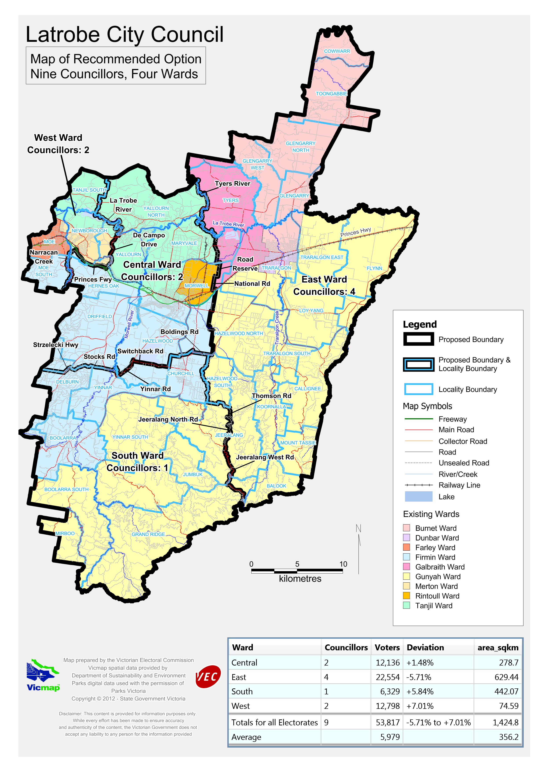

Victorian Electoral Commission
Level 11, 530 Collins Street
Melbourne, Vic 3000

131 VEC (131 832)
latrobre.review@vec.vic.gov.au
vec.vic.gov.au

Section 219D of the Local Government Act 1989.
Profile.id Community Profile, latrobe.vic.gov.au/about/stats
Latrobe City Council Annual Report pages 16-17
Australian Bureau of Statistics, Census 2006
Department of Planning and Community Development, Victoria in Future 2nd Release 2011-2021
McLean, I & Butler, D (eds) 1996, Fixing the boundaries: defining and redefining single-member electoral districts, Dartmouth Publishing, Aldershot, p17
Black, Bernard, 1982, ‘Gerrymandering and doughnuts’, Representation, vol 22, issue 88, pp25-31. Pp27-28

