Local council electoral structure review

March 2023

Hepburn Shire Council

Preliminary   
Report

Acknowledgement of Country

The electoral representation advisory panel acknowledges the Dja Dja Wurrung people as the Traditional Custodians of the lands and waters on which it is holding this review and pays respects to ancestors and Elders past, present and emerging. The panel acknowledges their custodianship for many thousands of years and their continuing living culture.

Document history and version control

|  |  |  |  |
| --- | --- | --- | --- |
| **Version** | **Date approved** | **Approved for publication by** | **Brief description** |
| 1 | 27 March 2023 | Electoral Commissioner | Final version |

Contents

Executive summary 4

Developing electoral structure models 4

Preliminary submissions 4

Electoral structure models 4

Next steps 4

Background 5

About the 2023–24 electoral structure reviews 5

The electoral representation advisory panel 5

Public engagement 6

Developing recommendations 6

About Hepburn Shire Council 9

Profile 9

Current number of councillors and electoral structure 10

Last electoral structure review 10

Preliminary submissions 11

Number of councillors 11

Electoral structure 12

Preliminary findings and models 15

Number of councillors 15

Electoral structure 16

Models for public feedback 19

Next steps 20

Response submissions 20

Public hearing 21

Final report 21

References 22

Appendix 1: Model maps 24

Appendix 2: Additional models considered 28

Appendix 3: List of preliminary submitters 29

# Executive summary

An independent electoral structure review panel appointed by the Minister for Local Government has reviewed the structure of Hepburn Shire Council.

The panel looked at:

* + whether the council had an appropriate number of councillors
  + whether it should be unsubdivided or subdivided.

This report outlines the preliminary models that the panel is presenting for the proposed new electoral structure of Hepburn Shire Council to meet the requirements of the *Local Government Act 2020* (the Act).

More information about the background to the reviews is available on page 5.

## Developing electoral structure models

The panel considered a range of factors when deciding on the models in this report, including:

* research and analysis
* voter growth or decline over time
* public submissions (see below).

More information on the way the panel decided on the models is available on page 6.

## Preliminary submissions

The panel received 18 preliminary submissions. Of these, 3 submissions included maps.   
A full analysis of submissions received can be found on page 11.

## Electoral structure models

After considering submissions and research, the panel is presenting the following electoral structure models for further public consultation:

Model 1: an unsubdivided electoral structure with 7 councillors.

Model 2: a subdivided electoral structure with a total of 8 councillors, 4 wards and 2 councillors per ward.

Model 3: a subdivided electoral structure with a total of 7 councillors, 7 wards and one councillor per ward.

Details on these models, including maps, are available on Appendix 1.

## Next steps

The panel is now seeking feedback on the electoral structure models. You can make a response submission to these models until 19 April 2023. If any response submitters wish to speak at a public hearing, the panel will hold an online public hearing on Wednesday 26 April 2023. Following this, it will present its final recommendation to the minister by Wednesday 24 May 2023.

More information about the review process is available on the Victorian Electoral Commission (VEC) website at [vec.vic.gov.au](https://www.vec.vic.gov.au/).

# Background

## About the 2023–24 electoral structure reviews

In October 2022, the Minister for Local Government formed 2 electoral representation advisory panels to review the electoral structures of 39 local councils, under section 16 of the *Local Government Act 2020* (the Act). If the minister accepts the electoral structures the panels recommend, they will take effect at the October 2024 elections.

The Act introduced several changes to local government representation, including the types of electoral structures local councils may have. Large and small rural shire councils (including Hepburn Shire Council) can have one of 3 electoral structures:

* + unsubdivided (entire council area with no wards)
  + single-councillor wards
  + multi-councillor wards with the same number of councillors per ward.

For Hepburn Shire Council, the electoral representation advisory panel is examining:

* the number of councillors
* whether the council should be subdivided into wards or unsubdivided.

For subdivided structures, it is also examining:

* + the number of wards
  + where the ward boundaries should be
  + the name of each ward
  + how many councillors should be elected for each ward.

The Act requires electoral structures to provide fair and equitable representation and facilitate good governance. For subdivided structures, each ward must have an approximately equal number of voters per councillor (within +/-10% of the average).

## The electoral representation advisory panel

The panel conducting the electoral structure review of Hepburn Shire Council has 3 members:

* The Honourable Frank Vincent AO KC (Chairperson)
* Ms Liz Williams PSM
* Electoral Commissioner Mr Warwick Gately AM.

The panel is independent of councils and the State government.

Under the Act, the VEC is not responsible for reviewing council electoral structures but must provide administrative and technical support to the panel. The Electoral Commissioner (or their delegate) must be a member of each panel.

## Public engagement

### Public information program

To educate and inform the public about the Hepburn Shire Council electoral structure review, the VEC began a public information program in mid-December 2022. The VEC:

* + printed public notices in state-wide, and some local, newspapers
  + held public information sessions to outline the review process and respond to questions from the community
  + sent out media releases to announce the start of the review
  + published information on its social media channels
  + provided updated website content on [vec.vic.gov.au](https://www.vec.vic.gov.au/electoral-boundaries/council-reviews/electoral-structure-reviews), including:
    - information on the review process
    - submission guides and fact sheets for each council under review with background information
    - preliminary submissions from the public.

The VEC will continue to promote the review during the response submissions stage via media releases, the VEC’s social media channels and updated content on the VEC website.

### Public consultation

The panel encouraged public input to the review of Hepburn Shire Council via preliminary submissions at the start of the review. The panel now invites further input via:

* + response submissions to this preliminary report
  + an online public hearing to provide anyone who makes a response submission the opportunity to expand on their submission.

Public submissions are an important part of the review process but the panel also considers other factors during a review. These are outlined below.

## Developing recommendations

The panel’s electoral structure models presented in this preliminary report comply with the Act and were developed through careful consideration of:

* + research and analysis conducted by the VEC support team, including geospatial and demographic factors
  + rates or patterns of population and voter growth or decline over time, and relevant forecasts of growth or decline based on forecast information provided by .id (informed decisions, a company specialising in demographics and forecasting)
  + input received from the public in written submissions during the preliminary submissions phase.

### Deciding on the number of councillors

The Act allows local councils to have between 5 and 12 councillors, but neither the Act nor the Local Government (Electoral) Regulations 2020 specify how to determine the number of councillors a council needs. Therefore, the models put forward by the panel in this report are guided by the Act’s intention for fairness and equity in voter representation.

In examining the number of councillors Hepburn Shire Council should have, the panel considered these factors:

* + the population and number of voters in the council area, compared to other councils with a similar population size and number of voters in the same category (for example, metropolitan, interface, regional city, large rural shire, small rural shire)
  + patterns of population change and voter growth or decline in the council area over time
  + the current and past numbers of councillors
  + the representation needs of the communities of interest in the council area
  + if a particular type of electoral structure best suits the council (see ‘Deciding the electoral structure’ below)
  + any matter raised in public submissions not already listed above.

Generally, local councils with a larger number of voters will have a higher number of councillors. Large populations are often more likely to have greater diversity, both in the type and number of communities of interest and issues relating to representation. However, the ideal number of councillors can also be influenced by the particular circumstances of a council, such as the:

* + nature and complexity of services the council provides
  + geographic size and topography of the area
  + forecast population and voter growth or decline
  + social diversity.

### Deciding the electoral structure

The electoral structure of large and small rural shire councils can be:

* + unsubdivided (entire council area with no wards)
  + made up of single-councillor wards

or

* + made up of multi-councillor wards with the same number of councillors per ward.

When developing electoral structure models for Hepburn Shire Council, the panel considered these main criteria:

* + whether the structure would comply with section 15(2) of the Act (see below), and for how long it would likely comply
  + the appropriate number of councillors, as outlined above
  + whether meaningful and effective ward boundaries can be established and whether these would be easily identifiable to local communities
  + representation of communities of interest
  + the voter distribution and physical features of the area, and the impact these may have on the shape and size of any wards
  + past elections for the council, including:
    - numbers of candidates nominating
    - incidences of uncontested elections
    - rates of informal voting.
  + other matters raised in public submissions not already listed above.

Under section 15(2) of the Act, subdivided structures must aim for an approximately equal number of voters per councillor in each ward. This means the number of voters represented by each councillor in a ward should be within +/-10% of the average number of voters per councillor for all wards.

The panel recommends structures that will comply with section 15(2) at the October 2024 local council elections and uses current voter numbers and forecasts of population and voter change to assess this with as much accuracy as possible. In some cases, population changes and other factors mean it is not possible for a subdivided electoral structure to comply with section 15(2) based on current voter numbers. If this occurs, compliance at the 2024 local government elections will be the priority to ensure each vote has approximately equal value.

# About Hepburn Shire Council

## Profile

Hepburn Shire Council is in the Central Highlands region of Victoria, about 110 km north west of Melbourne. It covers an area of 1,473 km2 and shares its border with Central Goldfields Shire Council and Mount Alexander Shire Council in the north, and with Macedon Ranges Shire Council in the east. Moorabool Shire Council is in the south and Ballarat City Council and Pyrenees Shire Council in the west.

The Traditional Custodians of the Hepburn area are the Dja Dja Wurrung people.

### Landscape

The shire is a popular tourist destination known for its natural landscapes, volcanic plains, forests and mineral springs. Within the shire is Lalgambook (Mt Franklin), one of the sites of significance for the Dja Dja Wurrung people (Department of Transport and Planning, 2021a).

At the 2021 Census, the shire’s population was 16,604 (ABS, 2021d), almost half lived in one of the 4 main urban centres of Daylesford – Hepburn Springs, Creswick, Clunes and Trentham.

The Daylesford – Hepburn Springs area is home to 22.5% of the shire’s population (ABS, 2021c) and boasts the highest concentration of mineral springs in Australia (Department of Transport and Planning, 2021a). The Swiss-Italian architecture throughout reflects the heritage of mining immigrants (Hepburn Shire Council, 2023b). The area is well known for its spas, and health and wellness services.

Creswick, about 15 minutes drive north of Ballarat, is a historic gold mining town. With a population of 2,794 (ABS, 2021b) it is the second largest town and serves as a regional service hub for the shire.

Clunes (population 886) (ABS, 2021a) is in the west of the shire and is known historically as the site of Victoria’s first gold strike (Clunes Tourist & Development Association, 2023). In the east of the shire by the Wombat Forest is Trentham with a population of 827 (ABS, 2021e). Trentham is known for its rich volcanic soil and potato production (Hepburn Shire Council, 2023b).

The Midland Highway crosses through the shire connecting major towns throughout the shire, and to Ballarat in the south west and Castlemaine in the north. Hepburn Shire is serviced by the Maryborough V/line train with stations in Creswick and Clunes. There are several V/line bus services connecting major towns in and out of the shire.

### Community

Hepburn Shire’s economy is largely built around agriculture and activities linked to tourism – accommodation, wellness services and cafes/restaurants. (Department of Transport and Planning, 2021b). Health Care and Social Assistance is the main industry of employment, making up 14.5% of the shire’s workforce (Remplan, 2021).

The profile of the shire is older than the overall state and regional averages: 53% of the population are aged 50 years or older and 60 to 69 year olds are the largest age group, comprising 18.6% of the shire’s population (Remplan, 2021). It is projected that by 2036 there will be 2,790 more people aged over 60 years living in the shire (Department of Transport and Planning, 2021b).

Almost 78% of residents living in the shire were born in Australia and 1.1% identified as Aboriginal and/or Torres Strait Islander people, which is slightly less than the 2% in regional Victoria (ABS, 2021d). English is the only language spoken at home for 87.4% of residents, compared to 86.4% for regional Victoria (ABS, 2021d).

Most people in the shire own their home, either outright or with a mortgage (81.5%), and the median weekly household income is $1,281 (ABS, 2021d).

Over the last decade the population has increased from 14,367 in 2011 (ABS, 2011) to 16,604 in 2021 (ABS, 2021d). This trend is expected to continue with an estimated annual growth rate of 0.8%.

## Current number of councillors and electoral structure

Hepburn Shire Council is currently divided into 5 wards with a total of 7 councillors:

* + 2 wards with 2 councillors (Birch and Creswick)
  + 3 wards with one councillor each (Cameron, Coliban and Holcombe).

There are approximately 16,283 voters in Hepburn Shire Council, with a ratio of 2,326 voters per councillor.

Visit the VEC website for [more information on Hepburn Shire Council](https://www.vec.vic.gov.au/electoral-boundaries/local-councils/hepburn-shire-council).

## Last electoral structure review

The VEC conducted an electoral representation review of Hepburn Shire Council in 2019. This representation review was carried out under the *Local Government Act 1989*, which was replaced by the *Local Government Act 2020*.

After conducting the review, the VEC recommended that Hepburn Shire Council continue to consist of 7 councillors elected from 5 wards (2 wards with 2 councillors and 3 wards with one councillor each).

Visit the VEC website at [vec.vic.gov.au](https://www.vec.vic.gov.au/electoral-boundaries/local-councils/hepburn-shire-council) to access a copy of the 2020 representation review final report.

Before the 2020 review, a representation review of Hepburn Shire Council was completed in 2007. This resulted in the current electoral structure being implemented. Before the 2007 representation review, Hepburn Shire Council had a total of 5 councillors elected from 5 single-councillor wards.

# Preliminary submissions

The panel received 18 preliminary submissions from the public by the deadline of 5 pm on Wednesday 1 March 2023. You can view these submissions on the VEC website at [vec.vic.gov.au/hepburn](https://www.vec.vic.gov.au/hepburn) and find a list of people or organisations who made a submission in Appendix 3.

The table below provides an overview of preferences in the preliminary submissions. You can read an analysis of submissions below this table.

|  |  |  |  |  |  |
| --- | --- | --- | --- | --- | --- |
|  | Unsubdivided structure | Single-councillor wards | Multi-councillor wards | Subdivided structure (unspecified) | No comment on structure |
| Fewer councillors | 1 | - | 3 | - | - |
| Maintain current councillor number | - | 8 | - | - | - |
| More councillors | - | - | 5 | - | - |
| No comment on number of councillors | 3 | - | 1 | 1 | - |

Note: 4 submitters supported more than one electoral structure or option for the total number of councillors

## Number of councillors

There were varying preferences for councillor numbers. Most submissions (8) wanted to keep the current number of councillors, while 5 proposed an increase and 4 proposed a reduction. The remaining 5 submissions did not comment on a preferred number of councillors.

### Maintaining 7 councillors

All of the 8 submitters wanting to maintain 7 councillors, supported a single-councillor structure of 7 wards. They highlighted the value of local representation to support the diverse communities. The submitters also noted 7 councillors as practical for the operation of the council.

One submitter noted the shire’s precarious financial situation to argue that increasing councillor numbers would have too great of a financial impact, while another suggested any reduction in councillor numbers would erode democracy.

### Reducing councillor numbers to 5 or 6

There were 3 submissions proposing a reduction in councillor numbers to 6, mainly to enable a multi-councillor structure of 3 wards with 2 councillors per ward.

Another submitter proposed reducing the number of councillors to 5, proposing this would improve the quality of councillors and their oversight of the whole shire. The same submitter also argued that having 6 councillors ‘would not work politically’ and an increase to 9 would be excessive.

### Increasing councillor numbers to 9

A total of 5 submissions proposed increasing councillor numbers to 9, largely due to a preference for a multi-councillor structure of 3 wards with 3 councillors per ward.

Several submitters felt 9 councillors would provide residents and communities with greater access to councillors and improve representation as a result. Others noted the benefits of group dynamics in decision making, and the potential for improved decision making with 9 councillors.

Some felt that by increasing councillor numbers it would provide voters with more choice and diversity of candidates at election times.

## Electoral structure

A common theme found throughout submissions was the preference for a subdivided electoral structure. Most felt it would best suit the geography of the shire and its distinct communities. As such, many were prepared to consider alternative subdivided electoral structures if their primary preference was not possible.

### Unsubdivided

An unsubdivided structure was supported by 4 submitters, most of whom felt it would promote fairness, diversity and equal representation for the shire.

Two submitters suggested an unsubdivided structure would better allow councillors/council to adopt a shire-wide approach to representation/council business, increase understanding of shire-wide needs and identify common goals for the shire as a whole.

Another felt an unsubdivided structure would help candidates develop more inclusive policies and platforms beyond a specific geographic area and would positively impact the shire. One submitter supported the structure based on their preference for electing candidates via proportional representation.

Various arguments against an unsubdivided structure were also put forward in submissions. Some believed it could lead to parties or special interest groups having too much ability to influence the council or candidate’s election campaigns.

Some submitters thought it was possible that an unsubdivided electoral structure for the more populous towns (Daylesford and Creswick) would dominate smaller or more rural areas and lead to inequitable representation and resource allocation. Those opposed to an unsubdivided structure suggested it might favour candidates campaigning in larger more populated towns or with greater financial resources. The challenge some councillors might face having to travel to connect with communities across the shire in an unsubdivided structure was also identified.

### Multi-councillor wards

There was a lot of support for multi-councillor wards. Five submitters supported a multi-councillor ward structure of 3 wards with 3 councillors per ward, and 3 submitters proposed a structure of 3 wards with 2 councillors per ward as an alternative.

These submitters suggested a multi-councillor ward structure would be better able to address increased demands on council services. They also suggested that it would attract councillors with a more strategic focus, encourage big picture and whole-of-shire thinking, and reduce what many saw as the parochial approach potentially associated with single-councillor wards.

Supporters of multi-councillor ward structures suggested they would provide better representation of the range of communities of interest in the shire and their varying needs. They also noted that they would give voters and residents improved access to councillors, and that such benefits outweighed any financial impact of increasing councillor numbers.

In relation to the method of proportional vote-counting in multi-councillor wards, one submitter proposed it would improve transparency for voters around the allocation of voting preferences and be consistent in terms of the quota that candidates required to be elected. It was also suggested that campaign costs for candidates would be reduced by not needing to reach voters spread across the whole shire.

In opposition to multi-councillor wards, one submitter felt there could be a risk of smaller towns being dominated by larger ones, resulting in poor local representation for smaller communities. Similarly, another suggested the potential dominance of councillors from areas with larger populations might lead to unfavourable decisions for other areas.

### Single-councillor wards

A single-councillor ward structure with 7 councillors was proposed by 8 submitters. Several themes and arguments were presented in favour of the structure, such as its ability to provide local representation, capture the shire’s diversity and improve access to councillors.

Some submitters suggested that single-councillor wards better reflected the needs of communities by facilitating the election of candidates with knowledge of their local area and its history. Single-councillor wards were also considered by some as more suited to the geography of the shire, including the differences between the eastern and western areas, which many felt didn’t share common interests. For one submitter, the lack of a shire-wide identity meant single-councillor wards were the most suited to community needs.

Submissions also highlighted the geographic diversity and distinct communities across the shire. Submitters noted a lack of commonality between the east and west of the shire, and that a single-councillor ward structure could stop a one size fits all approach from councillors in addressing the various issues and needs of different communities.

One submitter proposed the shire does not have a shire-wide community of interest and noted even power and water providers varied across the shire. The submitter also noted there is no shire-wide newspaper relying on their local councillor for community updates. They reasoned single-councillor wards would better embody the council’s distinct communities of interest.

Many felt access to local representatives would be enhanced through single-councillor wards. One suggested it was critical for the less populous towns and communities to have ‘grass roots’ representation. It was also noted that local representation would be of ongoing benefit as the shire’s population aged, and that single-councillor wards would provide representation that was responsive to community needs.

Those opposed to single-councillor wards argued that this structure would result in reduced cooperation on issues affecting the whole shire. They also suggested it could encourage parochialism with councillors only responsive to their ward rather than shire-wide needs and could increase the likelihood of uncontested elections. They proposed it worked to the advantage of incumbent councillors. Additional concerns were raised around single-councillor ward boundaries and noted the challenges of balancing population requirements. It was proposed that there could be a likelihood of larger towns such as Creswick and Daylesford being divided into smaller wards, which superficially capture communities of interest.

# Preliminary findings and models

## Number of councillors

After taking into consideration the requirements of the Act, public submissions and the agreed criteria, the panel found 7 or 8 councillors to be an appropriate number for Hepburn Shire Council.

The panel considered the characteristics of the shire in relation to similar rural shire councils, including its size and geography, population and the number and distribution of voters across the shire.

|  |  |  |  |  |  |  |
| --- | --- | --- | --- | --- | --- | --- |
| Similar rural shire councils to Hepburn Shire Council | | | | | | |
| Local council | Area (km2) | Number of voters at 2020 election | Population (2021 Census) | Current total estimate of voters | Number of councillors | Number of voters per councillor |
| Colac Otway Shire | 3,438 | 19,697 | 22,423 | 20,060 | 7 | 2,866 |
| Golden Plains Shire | 2,703 | 18,643 | 24,985 | 18,567 | 7 | 2,815 |
| Glenelg Shire | 6,219 | 16,862 | 20,152 | 17,061 | 7 | 2,437 |
| Mount  Alexander Shire* | 1,530 | 16,507 | 20,253 | 16,923 | 7 | 2,418 |
| **Hepburn Shire\*** | **1,473** | **14,858** | **16,604** | **16,283** | **7** | **2,326** |
| Swan Hill Rural City | 6,116 | 14,531 | 21,403 | 14,624 | 7 | 2,089 |
| Moyne Shire | 5,482 | 13,968 | 17,374 | 14,375 | 7 | 2,054 |
| Indigo Shire | 2,041 | 13,651 | 17,368 | 14,279 | 7 | 2,040 |
| Murrindindi Shire | 3,880 | 13,607 | 15,197 | 14,231 | 7 | 2,033 |

*This local council is undergoing an electoral structure review during 2023–24.

### Maintaining 7 councillors

Taking into consideration the size and geography of the shire and the relative population compared to other similar councils with 7 councillors (see table above), the panel determined that maintaining 7 councillors was appropriate. This would also ensure the least amount of change for the community and was the preferred option of most submitters.

### Increasing councillors

The panel considered arguments in submissions for increasing councillor numbers, alongside the size and geography of the shire, its population, projected rates of growth and voter-to-councillor ratio. Compared with other similarly sized councils, Hepburn Shire Council is near the upper end of councils with 7 councillors. However, the panel did not believe these factors alone would justify increasing councillor numbers. An increase was only considered where it may enable the creation of a favourable multi-councillor ward electoral structure. The panel found increasing to 8 councillors could be justified on this basis, however not an increase to 9 councillors.

### Reducing councillors

The panel found that reducing the number of councillors to 6 was not appropriate given the size and voter population of the shire. An electoral structure with 6 councillors would not provide better presentation of the various communities dispersed throughout shire.

## Electoral structure

To identify the most appropriate electoral structure, various factors were considered. This included the requirements of the Act, the communities of interest in the Hepburn Shire Council area, public submissions, the appropriateness of ward boundaries and which models best offered fair and equitable representation.

In developing the preliminary models presented in this report, a range of models were considered. The strongest 3 models have been put forward for further public comment.

The panel proposes 3 models for the consideration of the Hepburn Shire Council community:

* an unsubdivided electoral structure, with 7 councillors ([Model 1](#_Unsubdivided_structure_(Model))
* a subdivided electoral structure of 4 wards, with 2 councillors per ward (Model 2)
* a subdivided electoral structure of 7 single-councillor wards (Model 3).

Diagrams of the preliminary models are included in Appendix 1.

### Unsubdivided structure (Model 1)

Under this model, Hepburn Shire Council would adopt an unsubdivided electoral structure, represented by 7 councillors.

The panel considered an unsubdivided structure to be of potential benefit to Hepburn Shire. It could remove any possibility of ward boundaries dividing towns or communities and could eliminate the need for future ward boundary adjustments to balance population change across wards.

In response to arguments which suggested local representation would be diminished in an unsubdivided electoral structure, the panel reasoned that this would not necessarily be the case. The panel noted that at previous elections candidates have stood from across the shire.

The panel noted that elections under an unsubdivided structure are held using the proportional representation system. This means candidates with a good level of local support have a reasonable chance of reaching the quota of votes required to be elected.

A potential drawback is the possibility of an increase in voter informality if a large number of candidates appear on the ballot paper. However, the panel noted that at past elections Hepburn has had low rates of voting informality in all wards. In the 2020 local council elections, the shire’s average informality rate of 2.29% was well below the state-wide average of 4.76%.

### Multi-councillor ward structure (Model 2)

Under this model, Hepburn Shire Council would adopt a 4-ward structure. Each ward would be represented by 2 councillors, in line with the requirement of the *Local Government Act 2020* for there to be the same number of councillors per ward.

While the proposed boundaries of the 4 wards are significantly changed from the current boundaries, there is less overall movement of voters between wards than would be required to balance a 3-ward structure (as was proposed in public submissions).

A potential drawback to the model is including the communities of Yandoit, Franklinford and surrounds in the northern central corridor of the shire, in the proposed west ward of Birch Creek. The panel was concerned about the connectivity of these towns with those in the far west such as Clunes. Additionally, Allendale and Kingston are included in this ward, and although mostly farmland, may have a closer connection with the township of Creswick which is in a separate ward.

Overall, the 4 wards capture communities of interest and balance councillor numbers between the east and west sides of the shire. The panel agreed on the use of clear boundaries, gathering most of the western farmlands in one ward, maintaining Creswick township undivided in another ward, and Hepburn Springs and Daylesford townships forming an urban ward. This 4-ward multi-councillor model may also provide a suitable option for submitters supporting a multi-councillor ward structure for the shire. For these reasons the panel believes the model has benefits and is seeking public feedback.

### Single-councillor ward structure (Model 3)

Under this model, Hepburn Shire Council would adopt a 7-ward structure. Each ward would be represented by one councillor, in line with the requirement of the *Local Government Act 2020* for there to be the same number of councillors per ward.

The panel considered the proposed boundaries would preserve the existing communities of interest with minor adjustments to the existing wards. The panel also noted the significant support in public submissions for a 7-single councillor ward structure and acknowledged support in many submissions for wards to maintain local representation for smaller towns. However, while ward-based structures enable voters to elect a representative for the area of the ward, it should be noted that a ward-based structure does not guarantee a locally based representative will be elected. There is no requirement under the Act for a councillor to live in the ward they represent.

To balance population and projected growth, dividing the existing Creswick and Birch wards would create 2 additional wards. A new ward would encompass the town of Creswick and surrounds using the natural boundary following Creswick Creek, continuing eastward past Eatons Dam, along Long Swamp Road and Rocky Lead Creek through to the existing Birch Ward boundary. In this model, the town of Daylesford sits in a new ward separated from Hepburn Springs, and gains Eganstown from the current Creswick Ward.

While most of Creswick and Daylesford are captured by these new wards, not all of each town could be captured within a single ward. This was viewed as a potential drawback to the model. The divide between Daylesford and Hepburn Springs uses Raglan Street, the Midland Highway, then follows Daylesford-Trentham Road and Leitches Creek Road through to Giacomettis Lane in the east. Additionally, Franklinford moves across into Holcombe Ward.

The panel considered the boundaries captured the distinctive east-west geographic areas of the shire and would support the population distribution (and growth) with predicted compliance with the +/- 10% tolerance to the October 2024 local government elections.

### Models considered but not put forward

The panel discussed 3-ward structures presented in public submissions. The panel noted any 3-ward structure would require either a decrease to 6 councillors or an increase to 9 councillors. The panel did not consider this to be appropriate for the shire. It was considered that such a structure would be unlikely to provide effective representation for the dispersed population, diverse communities or the shire collectively. Any 3-ward structure would require very large wards, which would need to group sparsely populated rural farmland areas with parts of Hepburn and Daylesford to balance deviations. This risked most councillors coming from these towns and few or no councillors from the rural areas of the shire. A structure like this was thought unlikely to provide adequate representation for rural areas with dispersed populations. As such, 3-ward structures were not put forward for Hepburn Shire. See Appendix 2 for a diagram of this model.

## Models for public feedback

The panel considers all models outlined below to offer fair and equitable representation for voters in Hepburn Shire Council. Please see Appendix 1 for detailed maps of these models.

### Model 1

Hepburn Shire Council has an unsubdivided electoral structure with 7 councillors.

### Model 2

Hepburn Shire Council has 8 councillors and is divided into 4 wards with 2 councillors per ward.

### Model 3

Hepburn Shire Council has 7 councillors and is divided into 7 wards with one councillor per ward.

### Ward names

The panel has suggested ward names to identify the wards in Model 2 and Model 3 and invites comments from the community on these names as part of submissions responding to the preliminary report.

# Next steps

## Response submissions

Any person or group, including the local council under review, can make a response submission to the electoral representation advisory panel. In your submission you should address the models proposed by the panel in this preliminary report.

You can make a submission:

|  |  |
| --- | --- |
|  | **Online** Visit [vec.vic.gov.au](http://vec.vic.gov.au/" \o "Homepage of VEC website) to make a submission online.  You will need to make an account to use the online Public Submission Tool and can save a draft submission to finish later. |
|  | **By email** [Hepburn.ERAPSubmissions@vec.vic.gov.au](mailto:Hepburn.ERAPSubmissions@vec.vic.gov.au) |
|  | **By post**  Electoral Representation Advisory Panel c/o Victorian Electoral Commission Level 11, 530 Collins St Melbourne VIC 3000 |

The panel must receive all response submissions before 5 pm on Wednesday 19 April 2023. If you post your submission, make sure it has enough time to reach the panel before the deadline. Late submissions will not be accepted.

### Required information

For your submission to be considered, you must include your:

* full name
* contact phone number or email address
* postal or residential address.

The panel will not consider submissions without this information. If you are submitting as a group or organisation, you must include the name of a nominated contact person who is authorised to submit on behalf of your group.

The VEC will handle information provided by submitters in accordance with the privacy policy available at [vec.vic.gov.au/privacy](http://vec.vic.gov.au/privacy).

### Public access to submissions

To ensure transparency in the electoral structure review process, your submission will be published on the VEC website at [vec.vic.gov.au](http://www.vec.vic.gov.au/). The VEC will remove your signature and contact details, including residential and postal addresses, from all public copies but must publish your full name (or group name) and locality (suburb or town).

## Public hearing

If you make a response submission, you can also ask to speak at an online public hearing to support your submission and expand on your views.

The online public hearing is scheduled for:

Time: 10 am

Date: Wednesday 26 April 2023

The panel encourages participation in the public hearing. If you wish to speak at the public hearing, you **must** indicate this in your response submission. The public hearing will not be held if there are no requests to speak.

Anyone can attend a public hearing, but you will only be able to speak if you asked to in your response submission. If you ask to speak, the VEC will contact you to arrange a time for you at the hearing. You will have 10 minutes to address the public hearing panel, which will include at least 2 of the review panel members. The members of the public hearing panel may ask you questions.

Visit the VEC website at [vec.vic.gov.au](http://vec.vic.gov.au/) for more information on public hearings.

## Final report

Following the public hearing, the review panel will consider all evidence gathered and publish a final report for the Minister for Local Government containing a recommendation for the number of councillors and the electoral structure for the local council.

The final report is scheduled to be published on Wednesday 24 May 2023. If the recommendation is accepted, any changes will apply at the October 2024 local council elections.

The final report will be available on the VEC website at [vec.vic.gov.au](http://vec.vic.gov.au/) or you can request a printed copy by calling 131 832.

# References

Australian Bureau of Statistics. (2021a). *Census 2021 All persons QuickStats, Clunes.* <https://www.abs.gov.au/census/find-census-data/quickstats/2021/UCL221019> accessed 6 February 2023.

Australian Bureau of Statistics. (2021b). *Census 2021 All persons QuickStats, Creswick.* <https://www.abs.gov.au/census/find-census-data/quickstats/2021/UCL215028> accessed 6 February 2023.

Australian Bureau of Statistics. (2021c). *Census 2021 All persons QuickStats, Daylesford – Hepburn Springs.* <https://www.abs.gov.au/census/find-census-data/quickstats/2021/UCL215029> accessed 6 February 2023.

Australian Bureau of Statistics. (2021d). *Census 2021 All persons QuickStats, Hepburn.* <https://www.abs.gov.au/census/find-census-data/quickstats/2021/LGA22910> accessed 2 February 2023.

Australian Bureau of Statistics. (2021e). *Census 2021 All persons QuickStats, Trentham.* <https://www.abs.gov.au/census/find-census-data/quickstats/2021/UCL221074> accessed 6 February 2023.

Australian Bureau of Statistics. (2011). *Census 2021 All persons QuickStats, Hepburn.* <https://www.abs.gov.au/census/find-census-data/quickstats/2011/LGA22910> accessed 2 February 2023.

Clunes Tourist and Development Association. (2023). *Clunes, history.* <https://clunes.org/history> accessed 8 March 2023

Department of Transport and Planning. (2022a). *Hepburn Planning Scheme, ordinance 02.01.* <https://planning-schemes.app.planning.vic.gov.au/Hepburn/ordinance/02.01> accessed 31 January 2023

Department of Transport and Planning. (2022b). *Hepburn Planning Scheme, ordinance 02.03.* <https://planning-schemes.app.planning.vic.gov.au/Hepburn/ordinance/02.03> accessed 31 January 2023

Hepburn Shire Council. (2023a). *Places & Activities, Heritage.* <https://www.hepburn.vic.gov.au/Places-activities/About-Hepburn-Shire/Heritage> accessed 6 February 2023

Hepburn Shire Council. (2023b). *Places & Activities, Local communities.* <https://www.hepburn.vic.gov.au/Places-activities/About-Hepburn-Shire/Local-communities> accessed 14 February 2023.

*Local Government Act 1989* (Vic)

*Local Government Act 2020* (Vic)

Local Government (Electoral) Regulations 2020 (Vic)

Remplan. (2021). *Hepburn Community profile, Industries, Work.* <https://app.remplan.com.au/hepburn/community/work/industries?state=PZl3Tm!XNOdTnkNwUdDdapsr9rYJI9c4u9XWIWPHDuzuDtwupN7> accessed 7 March 2023.

# Appendix 1: Model maps

The following maps are included in this report:

|  |  |
| --- | --- |
| Map | Page |
| Model 1 – an unsubdivided electoral structure with 7 councillors | 25 |
| Model 2 – a multi-councillor ward structure with 8 councillors, 4 wards and 2 councillors per ward | 26 |
| Model 3 – a single-councillor ward structure with 7 councillors, 7 wards and one councillor per ward | 27 |

Forecast information in the text of this report is based on forecasts prepared by .id – informed decisions [id.com.au](http://id.com.au/) .id and its licensors are the sole and exclusive owners of all rights, title and interest subsisting in that part of the report content where .id are identified. Some of .id content is a derivative of ABS Data, which can be accessed from the website of the Australian Bureau of Statistics at [abs.gov.au](http://abs.gov.au/), and licensed on terms published on the ABS website.

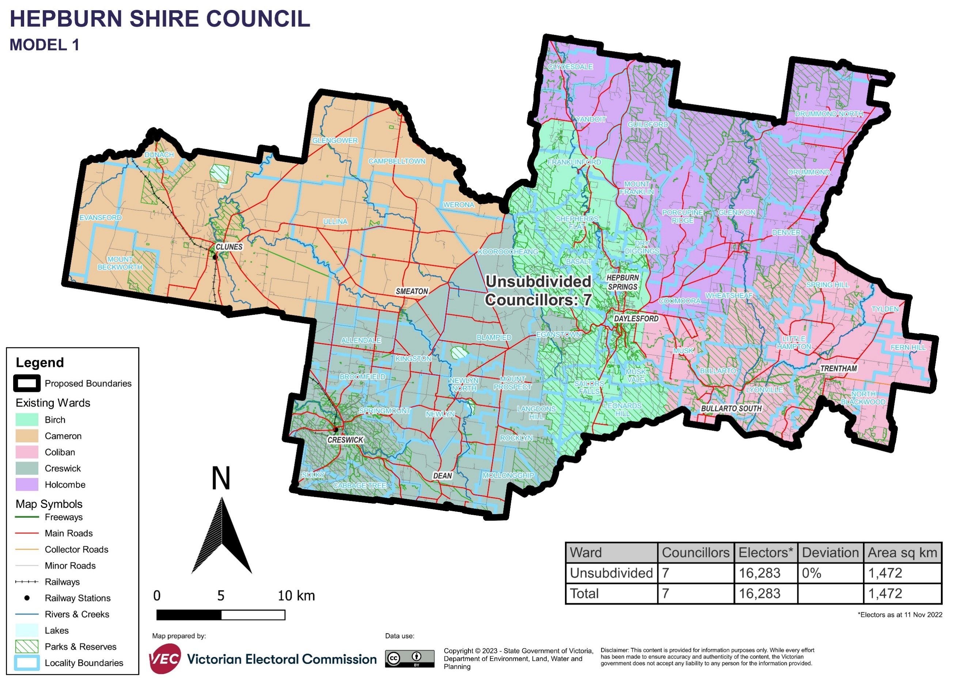

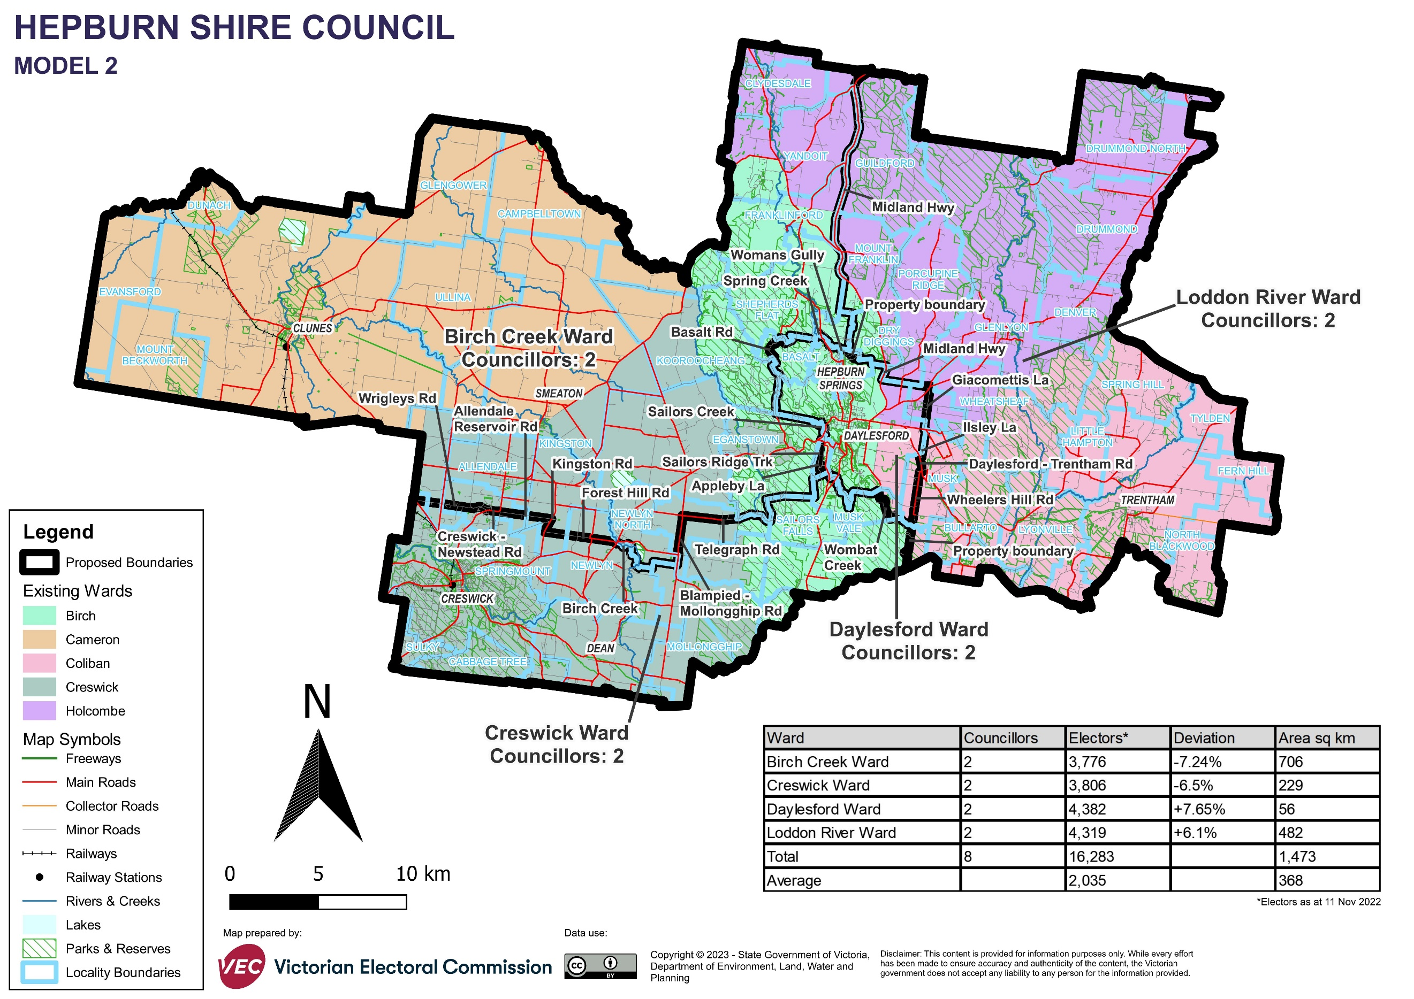

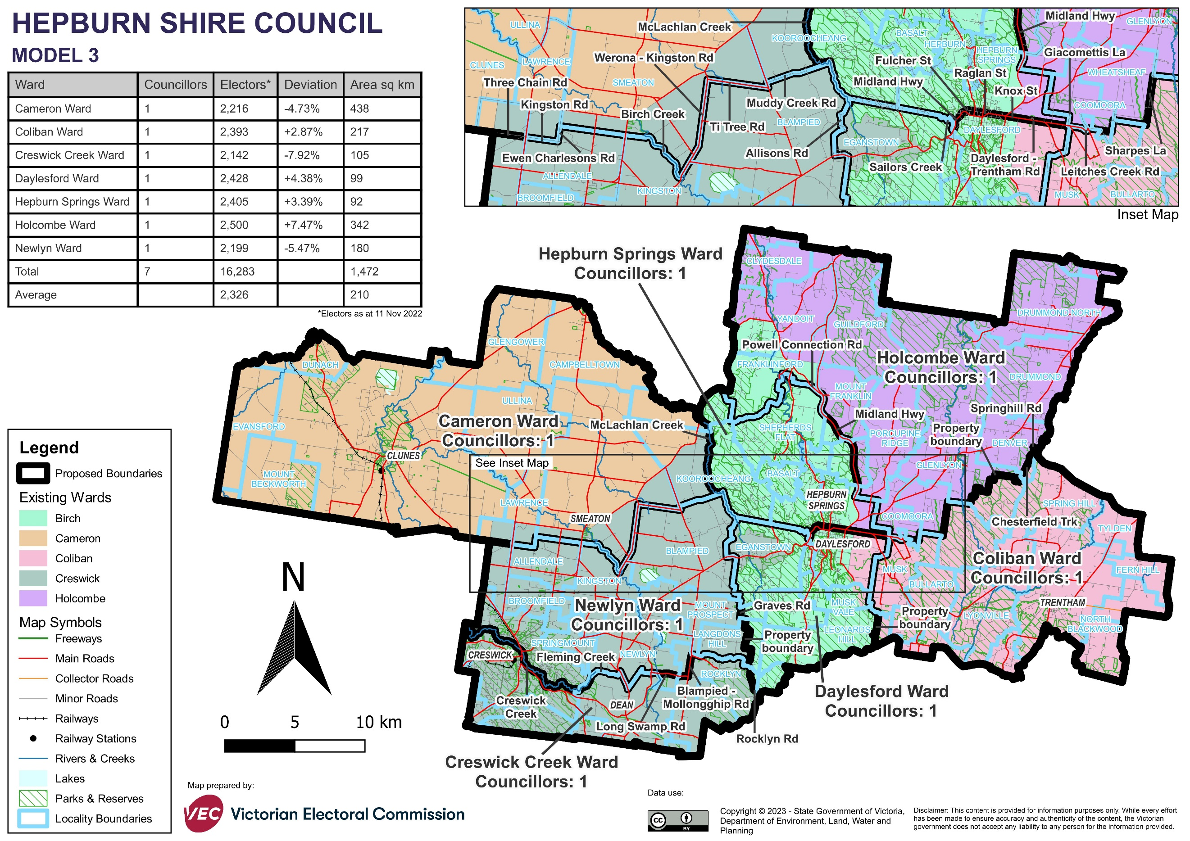

# Appendix 2: Additional models considered

The following models were closely considered by the panel but are not being put forward for further public consultation. See Models considered but not put forward for further information.

#### A multi-councillor ward model with 3 wards and 2 councillors per ward

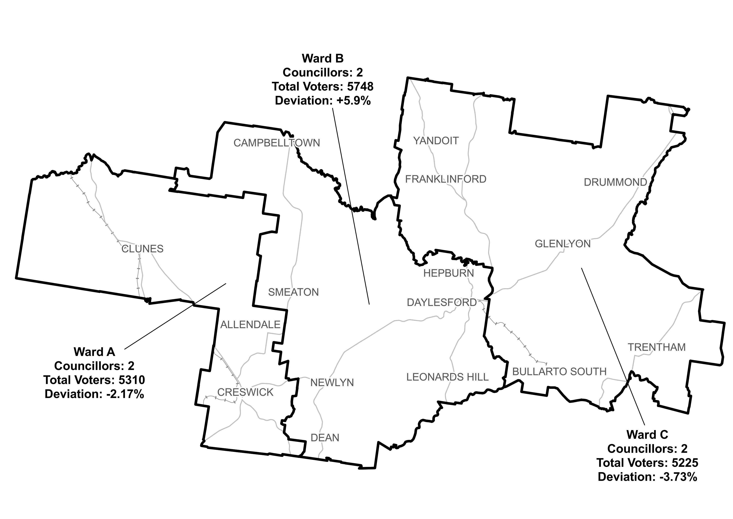

# Appendix 3: List of preliminary submitters

The review received 18 preliminary submissions.

Preliminary submissions were made by:

Anderson, Jonathan

Armstrong, Trevor

Beacham, Jenny

Bertrand, Graeme

Bray, Jen (Councillor)

Bray, Malcolm

Bray, Ruth

Dickenson, Mark

Drylie, Tim (Councillor)

Granger, Janine

Hewitt, Lesley (Councillor)

Hood, Brian (Councillor)

Irwin-Schutze, Anna

Johnson, Louise (with McDiarmid, Daniel and Bartak, David)

MacBean, Ian

Maloney, Warren

Rak, Mark

Sherlock, Charles