Local Council Representation and Subdivision Reviews 2019-20
Program Report

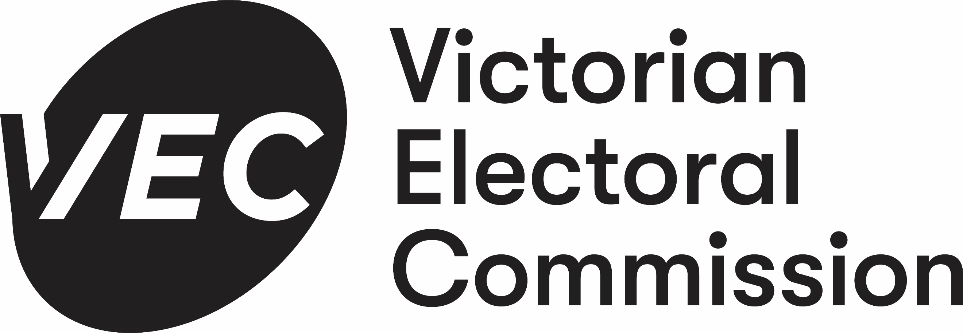
© State of Victoria
(Victorian Electoral Commission)
2020
This work, Local Council Representation and Subdivision Reviews 2019-20, is licensed under a Creative Commons Attribution 4.0 licence [http://creativecommons.org/licenses/by/4.0/]. You are free to share this work under that licence, on the condition that you do not change any content and you credit the State of Victoria (Victorian Electoral Commission) as author and comply with the other licence terms. The licence does not apply to any branding, including Government logos.

Level 11, 530 Collins Street
Melbourne Victoria 3000
T 131 832
info@vec.vic.gov.au
vec.vic.gov.au

Contents
Setting the scene 1
About the VEC 1
Statutory responsibility 1
About the reviews 5
Commencement of the 2019-20 electoral representation reviews 5
Principles underlying the VEC’s review work 5
How the VEC conducted the reviews 6
The VEC’s principles in practice 10
Number of councillors 11
Electoral structure 12
Subdivision reviews 17
Participation 19
Number of submissions 19
Who engaged in the reviews 24
Information sessions and public hearings 25
Public hearing statistics 26
Surveys 28
Number of survey respondents by review 28
Sources of information 31
Information sessions 32
Cost of reviews 37
Appendix one: overview of reviews
conducted during 2019-20 program 38
Appendix two: breakdown of marginal
costs for review program 52

Figures
Figure 1: The electoral representation review and subdivision review process 3
Figure 2: Map of councils undergoing an electoral representation or subdivision review, 2019-20 7
Figure 3: Preliminary options that became the VEC’s final recommendation from 2019-20 electoral representation reviews 10
Figure 4: Number of councillors recommended by VEC from 2019-20 electoral representation reviews 11
Figure 5: Types of structure recommended by VEC from 2019-20 electoral representation reviews 15
Figure 6: Source of submissions in 2019-20 representation and subdivision reviews 24
Figure 7: Sources of information about reviews (%) 32
Figure 8: ‘The preliminary report provided enough information to make an informed response submission’ 35
Figure 9: ‘The preliminary report was clear and easy to understand’ 35

Tables
Table 1: Expected number of councillors for councils banded by type and enrolment 11
Table 2: Submissions (* shows subdivision reviews) 21
Table 3: Total numbers of submissions in each round of representation reviews 23
Table 4: Sources of submissions across all reviews 24
Table 5: Public hearing statistics (* shows subdivision reviews) 27
Table 6: Survey responses by council 30
Table 7: Sources of information about reviews 31
Table 8: overview of reviews conducted during 2019-20 program 51
Table 9: breakdown of marginal costs 55

Setting the scene
About the VEC
The Victorian Electoral Commission (VEC) is an independent statutory authority, established under the Electoral Act 2002. The VEC’s principal functions are to:
- maintain the electoral enrolment register
- conduct State elections, local government elections, statutory elections and polls and fee-for-service elections
- support electoral representation processes for local councils and the Electoral Boundaries Commission
- promote public awareness and understanding of electoral issues and
- administer political funding and donation disclosure laws.
The VEC also has a mandated role to conduct electoral research, provide communication and education services and to inform and engage Victorians in the democratic process.
Statutory responsibility
Under the Local Government Act 1989 (LG Act 1989) the VEC was responsible for conducting electoral representation reviews of all local councils in Victoria. The purpose of an electoral representation review was to recommend an electoral structure that provided ‘fair and equitable representation for the persons who are entitled to vote at a general election of the Council.’
The matters considered by a review were:
- the appropriate number of councillors (between five and twelve)
- the electoral structure of the council (whether the council should be unsubdivided or divided into wards and, if subdivided, the details of the ward boundaries and the number of councillors per ward).
Each local council was required to be reviewed before every third general election after the council’s last review (approximately every 12 years), or earlier if gazetted by the Minister for Local Government. A review could not commence until two years before a council’s general election and had to be completed no later than six months before the general election.
If a local council was divided into wards, the number of voters represented by each councillor had to be within plus-or-minus 10% of the average number of voters per councillor across the council. This provision ensured equality of representation across the wards. If a ward model was being considered, the VEC would also consider appropriate ward names to assist with identifying wards and defining ward boundaries.
Electoral representation reviews
Under section 219F of the LG Act 1989, the electoral representation review process was to be consultative and transparent:
- The VEC published a notice of the review in local newspapers.
- Members of the public had 28 days to lodge written submissions with the VEC.
- The VEC prepared and released a preliminary report showing preferred and possibly alternative options for the council’s electoral structure. Public notice was provided.
- Members of the public had 28 days to lodge written submissions in response to the preliminary report.
- A public hearing was held for submitters who requested to speak in their response submission.
- The VEC prepared its final report containing the final recommendation from the review and published the report for the attention of the Minister for Local Government.
- The Minister could then recommend to the Governor in Council the making of such orders as were necessary to implement the recommendations of the final report, to come into effect for the purposes of the next general election.
Subdivision reviews
Division 3 of Part 10 of the LG Act 1989 provided for subdivision reviews. A subdivision review was required where a local council was not due for an electoral representation review, but where the numbers of voters enrolled for at least one of the wards in the council were likely to deviate beyond the legislated plus-or-minus 10% tolerance by the time of the next general election. Subdivision reviews had to be completed not more than six months before the general election.
The process followed for a subdivision review was similar to that of an electoral representation review. However, unlike an electoral representation review, subdivision reviews did not consider the number of councillors or the electoral structure of a local council, but only considered how to adjust ward boundaries to return the existing wards to approximate equality of enrolment. Section 219N of the LG Act 1989 provided that the VEC could engage in community consultation to conduct a subdivision review, but the relevant section of the LG Act 1989 did not specify the form that the consultation should take. In practice, the VEC consulted with the public in the same way as in an electoral representation review, but with one less stage:
- The VEC prepared and released a preliminary report with suggested boundary changes and published a notice in local newspapers.
- Members of the public had 28 days to lodge written submissions in response to the preliminary report.
- A public hearing was held for submitters who requested to speak in their response submission.
- The VEC prepared its final report containing the final recommendation from the review and published the report for the attention of the Minister for Local Government.
- The Minister could then recommend to the Governor in Council the making of such orders as were necessary to implement the recommendations of the final report, to come into effect for the purposes of the next general election.
A local council could not have two subdivision reviews in a row. If enrolments for any ward within a council were likely to deviate outside the plus-or-minus 10% tolerance for a second time prior to the council’s next scheduled electoral representation review, under section 219C (4) of the LG Act 1989 this triggered an early full electoral representation review.
The VEC has commonly observed ward enrolments moving outside of the plus-or-minus 10% tolerance in interface councils located along Greater Melbourne’s urban-rural divide, due to rapid population growth in these areas. Melbourne’s interface councils have therefore often required regular subdivision reviews to correct ward enrolments.
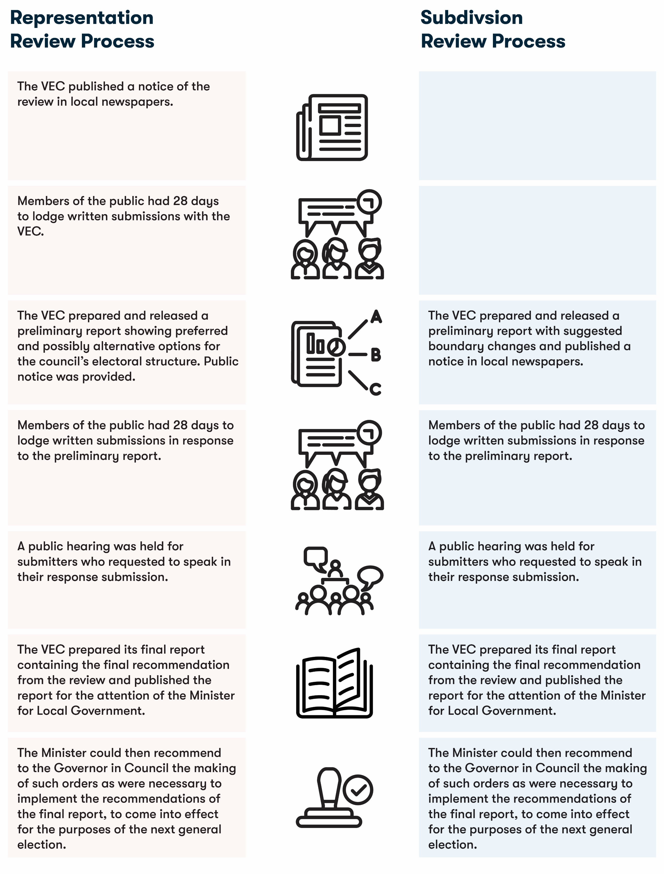
Figure 1: The electoral representation review and subdivision review process

Cost recovery
Under section 219P of the LG Act 1989, the VEC may send to each council an account of the reasonable expenses incurred as a consequence of conducting an electoral representation review or a subdivision review of that council. The VEC operates a marginal cost recovery model in respect to these activities and consulted with councils about the anticipated cost.
Legislative reform
The Victorian Government’s legislative reform of the LG Act 1989 overlapped with the VEC’s 2019-20 electoral representation and subdivision review program. The Local Government Bill 2019 was introduced to the Victorian Legislative Assembly on 13 November 2019 and received Royal Assent on 24 March 2020. The electoral provisions of the Local Government Act 2020 (LG Act 2020) came into operation on 6 April 2020, at which time the VEC was reviewing the final two local councils (Mitchell Shire Council and Whittlesea City Council) of the 31 local councils in the representation review program.
Under the LG Act 2020, an electoral representation advisory panel is to be established by the Minister for Local Government to conduct electoral representation reviews. According to the new provisions, the VEC is no longer the statutory provider of electoral representation reviews. The LG Act 2020 required that any electoral representation reviews currently underway were to cease while subdivision reviews were to continue.
For the purposes of this report, the VEC refers to the previous LG Act 1989 and its responsibilities to conduct electoral representation and subdivision reviews under this Act.

About the reviews
Commencement of the 2019-20 electoral representation reviews
The LG Act 1989 was changed in 2010 to require electoral representation reviews to be conducted before each council’s third general election. Before this, a review was required before every second general election. The transition to the new arrangement required the Minister for Local Government to select several councils to be the first to undergo reviews under the new schedule, which took place in 2011-12. The program of reviews conducted in 2015-16 was the second group of councils under the new review schedule. The program of reviews conducted in 2019-20 was the third and final group of councils under this schedule.
Accordingly, on 27 September 2018, the Minister for Local Government gave notice that the next electoral representation reviews for 31 councils would have to be completed by 22 April 2020 before the 2020 local government general elections.
These 31 councils comprised more than one-third of all Victorian local councils, the greatest number of councils reviewed at the one time. Of these councils, 27 had their last review in 2007-08 and four had their last review in 2011-12.
The VEC also conducted subdivision reviews for seven councils in 2020. For each of these councils, as required by the LG Act 1989, the VEC notified the Minister for Local Government that voter enrolment for at least one ward was likely to be outside the tolerance of plus-or-minus 10% of the average enrolment per councillor by the time of the 2020 local government general elections.
The Minister then advised the VEC that subdivision reviews of these seven councils were required.
The program of reviews was grouped into three ‘rounds’ depending on their required completion date, as gazetted on 28 September 2018. Round One consisted of the first 12 reviews, starting in January 2019 and concluding in June 2019. A further 12 reviews were completed in Round Two from June 2019 to October 2019. The final seven representation reviews were commenced in October 2019 and five were completed in April 2020. The seven subdivision reviews took place from February 2020 to April 2020.
Principles underlying the VEC’s review work
The three major principles underlying the VEC’s review work were:
Taking a consistent, State-wide approach to the total number of councillors.
The VEC was generally guided by voter enrolments of the local councils. Generally, the larger a council’s population, the more demands there are for its governance, and so it will need more councillors. The VEC recognised that the environment of the council area also affects demands on councillors and grouped councils into bands according to the type of local council, voter enrolments, and the number of councillors. The table was then used as the starting point to indicate an appropriate number of councillors for each council. In addition to the groupings, the VEC also considered any special circumstances that might warrant a council having more or fewer councillors than would be expected from the grouping. These circumstances were identified through public submissions to a review or from the VEC’s own research.
If subdivided, ensuring the number of voters represented by each councillor is within plus-or-minus 10% of the average number of voters per councillor for that local council.
This is the principle of ‘one vote, one value’ which means that every person’s vote counts equally. Approximate equality in the numbers of voters per councillor was required by section 219D(1)(c) of the LG Act 1989. In recommending ward boundaries, the VEC also considered likely future population changes with the aim of maintaining equitable representation until the next representation review.
Ensuring communities of interest are as fairly represented as possible.
Each local council contains several communities of interest. The VEC aimed to recommend the number of councillors and electoral structure that provided fair representation for communities of interest. Where possible, the VEC also tried to ensure that geographic communities of interest were not split by ward boundaries. This allowed communities with shared interests or needs to vote in the same election.
In addition to these principles, the VEC also considered the following matters.
First, in the interests of fair and equitable representation, the VEC aimed to recommend structures that were of a practical size for voters, candidates and elected councillors. Under the compulsory preferential voting system that operates in Victorian council elections, voters must write a preference into every box on their ballot paper. The VEC has observed a relationship between the number of candidates for an election and the level of the informal vote for that election. A long list of candidates in an unsubdivided council, for example, could lead to a very high informal vote. This could be as a result of unintentional numbering errors, and those informal voters are effectively not considered or counted in determining the election result.
In modelling various electoral structures, the VEC also considered councillors’ likely workloads and the size and accessibility of areas that councillors would need to travel across in order to represent communities. All these factors could affect councillors’ ability to effectively engage and represent voters.
Second, in subdivided electoral structures, the VEC aimed to use readily identifiable features as internal ward boundaries, such as rivers, railways and major roads. These boundaries would make it easier for voters, candidates and councillors to identify their wards and connect with each other.
Third, the VEC did not lightly overturn the existing electoral structure. The VEC had recommended an electoral structure during these councils’ first electoral representation reviews, which were conducted according to the same principles as the current reviews. There needed to be strong reasons to change the existing structure, such as significant population shifts or evidence that the structure was not functioning satisfactorily.
How the VEC conducted the reviews
The VEC’s review activities were overseen by the Local Government Program Manager and Director, Enrolment and involved staff from across the organisation. The list of councils required to be reviewed were scheduled in groups of three, with rolling deadlines. For instance, the reviews for the first group (Glenelg, Moyne and Southern Grampians Shire Councils) began on 23 January 2019 and concluded on 15 May 2019 (with the release of the final report); the second group (Ararat Rural City, Colac Otway Shire and Golden Plains Shire Councils) began and finished a week later, and so on. These arrangements ensured that the VEC had the internal capacity to conduct each review with sufficient consideration and responsiveness. Each electoral representation review took almost four months and followed a standard process designed to ensure appropriate and adequate community consultation.
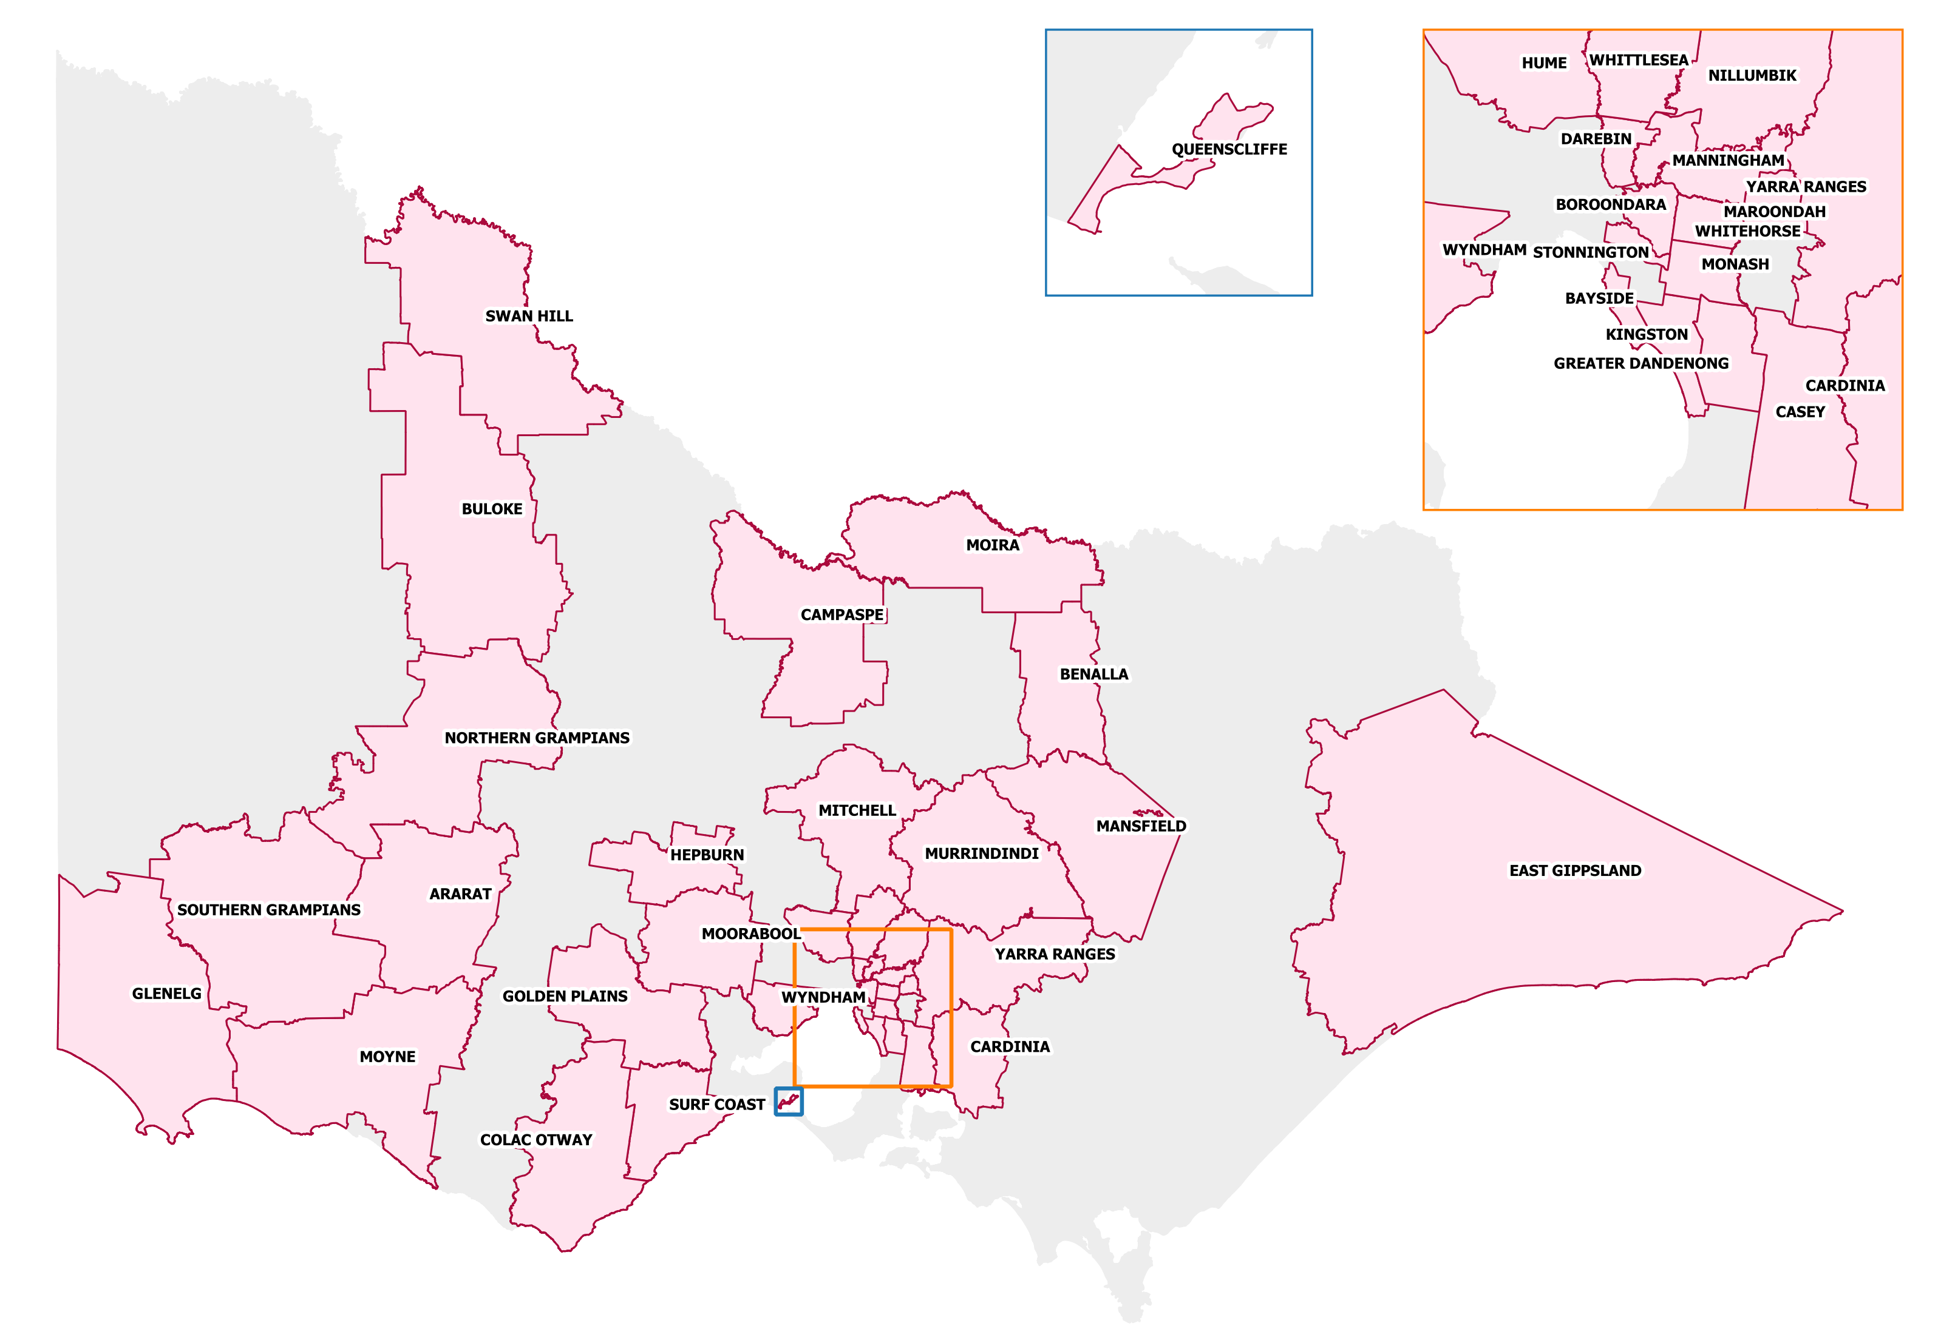
There was a dedicated project team consisting of a project manager, three project officers and a business support officer. Each project officer was assigned several reviews and completed all the research, analysis and report writing for their reviews. The team was advised by the VEC’s internal consultant and Manager, Information and Research who is also the secretary to the Electoral Boundaries Commission in Victoria
Figure 2: Map of councils undergoing an electoral representation or subdivision review, 2019-20
The VEC’s geospatial team supported the process by providing current and projected population and voter growth analysis, obtained using the VEC’s register of electors, Australian Bureau of Statistics and .id data.
Importantly, the geospatial team provided boundary modelling in each review using BoundaryMaker.
Knowledge of local government is crucial for electoral representation reviews. For the 2019-20 review program, the VEC engaged four consultants with extensive experience in local government to provide advice—Jenny McMahon, Michael Ulbrick, John Watson and Jeremy Wood.
An online submission tool was developed and made available during the submission periods of the review. The tool allowed people to make a written submission from the VEC website. During the preliminary submission stage, users also had the opportunity to map out their preferred subdivisions through the online submission tool using Boundary Builder. Boundary Builder included actual elector numbers so that users could see if their preferred structures and numbers of councillors met the plus-or-minus 10% rule. The map created with this tool could be included as part of an online submission.
Impact of Victorian Bushfires and COVID-19
Throughout Round Three of the review program and in the leadup to the subdivision reviews, severe bushfires affected areas of rural Victoria. The critical fire period began in late December 2019 and carried through to February 2020, coinciding with the period when the VEC was receiving response submissions for Round Three and the commencement of subdivision reviews.
The VEC took into consideration that the bushfires may have had an impact on the number of submissions received and continued to make its recommendation based on the quality of the arguments in the submissions and the principles of the review.
From late January 2020, Australia began recording the first cases of COVID-19 infections. The numbers of confirmed cases of the COVID-19 virus continued to increase throughout February and March, at which point Victoria announced a raft of public health measures designed to restrict the further spread of infection. These measures impacted workplaces, education facilities and public gatherings throughout the State.
On 19 March 2020 the VEC made the decision that staff not required to work from the office were to continue working remotely from home. At the same time, Victorian local councils were restricting the use of venues and other council facilities to enforce the prescribed social distancing measures. These developments impacted the conduct of the VEC’s scheduled public hearings.
In order to progress the representation review schedule and adhere to the advice concerning public gatherings, where people had requested to speak in support of their submission, the VEC held the public hearing online using Cisco Webex. A link to the event and instructions on how to watch or participate in the public hearing were provided to submitters who wished to talk to their submission and published on the VEC website. Speakers who were not able to access the necessary technology were able to telephone in to speak at the public hearing.
As such, the public hearing for the Mitchell Shire Council representation review was conducted online, as were the public hearings for the subdivision reviews of Surf Coast Shire Council, Yarra Ranges Shire Council, Hume City Council and Monash City Council.
Legislative Reform
The Local Government Bill 2018 was introduced into the Victorian Parliament during 2018 but lapsed at the end of the 58th Victorian Parliament. A revised version of the Bill (Local Government Bill 2019) was reintroduced by the Minister for Local Government to the 59th Parliament in 2019 and passed through both Houses of Parliament on 17 March 2020. The LG Act 2020 received Royal Assent on 26 March 2020 and the electoral provisions came into operation on 6 April 2020.
The immediate impact was the cancellation of the representation reviews of Whittlesea City Council and Mitchell Shire Council, the final reports of which were scheduled to be released on 8 April 2020. The proclamation of the new LG Act 2020 did not have a direct impact on the subdivision reviews, which were completed according to the schedule of reviews.
The LG Act 2020 stipulates a uniform system of single-councillor wards for all Victorian local councils. The Minister for Local Government may decide, however, that in some cases a local council can be unsubdivided or consist of multi-councillor wards with an equal number of councillors per ward.
The new LG Act 2020 and its imminent passage through the State Parliament created uncertainty for the VEC and relevant stakeholders, particularly during the latter half of the representation review program.
While the VEC was obliged to continue to conduct the representation review program according to the LG Act 1989, and communicated this requirement to local councils, many remained unsure about the impact of the new LG Act 2020. The VEC documented numerous enquiries and public submissions concerning the effects of the LG Act 2020 on current electoral structures, the representation review process and the final recommendations submitted by the VEC to the Minister.
The issue of costs incurred by local councils undergoing a representation review was another concern, particularly for local councils with limited financial resources. Many councils believed because of the new LG Act 2020 the costs of conducting a representation review would be a waste of council resources. The VEC was required by law, however, to conduct the representation review program according to schedule and implemented the marginal cost recovery program accordingly.
Finally, the VEC conducted the representation review program and recommended electoral structures in accordance with the LG Act 1989 and the principles of fair and equitable representation. As such, only two of the VEC’s final recommendations (Banyule City Council and Nillumbik Shire Council) complied with the new requirement for local councils to consist of single-councillor wards. The VEC did, however, recommend unsubdivided electoral structures for eight country local councils, including Swan Hill Rural City Council and Mansfield Shire Council.

The VEC’s principles in practice
The VEC’s principles for electoral representation reviews provided a guide to inform its deliberations. The principles did not provide a strict formula for producing a result but were considered throughout the review process to decide the appropriate number of councillors and electoral structure for fair and equitable representation. For most electoral representation reviews, a range of electoral structures and boundaries complied with the requirements of the LG Act 1989 and would be consistent with the VEC’s principles. However, the VEC was required to recommend to the Minster for Local Government what it considered was the most appropriate number of councillors and electoral structure for the local council under review.
In order to do this effectively and fairly the VEC:
- conducted internal research and small area forecasting
- drew on its extensive expertise in geospatial mapping, demography and the local government sector
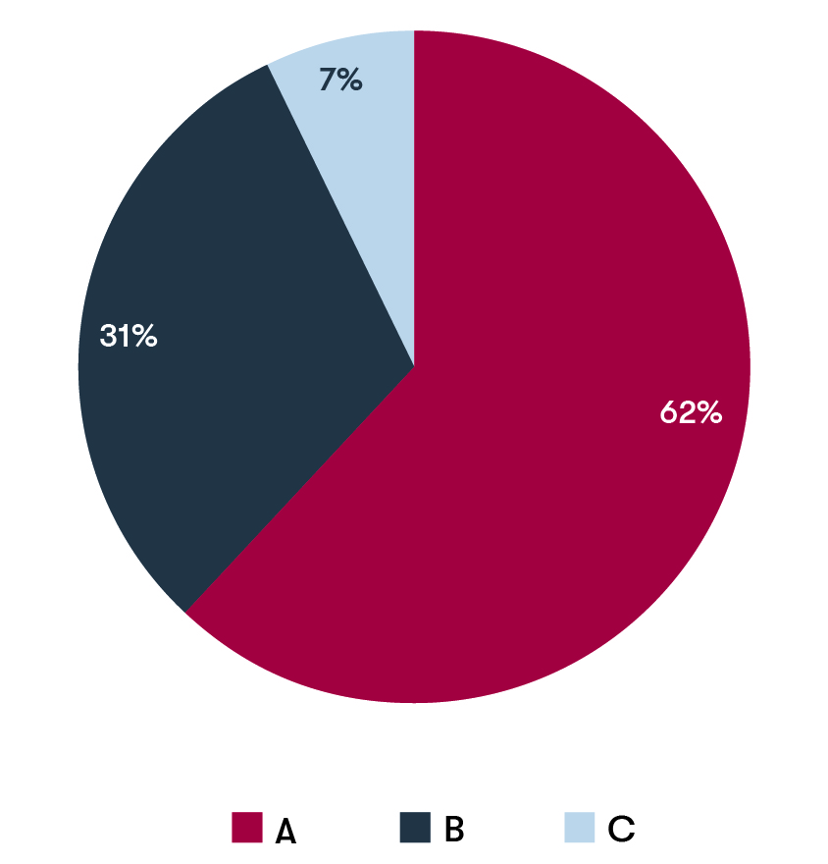
- engaged consultants with extensive experience in local government
- and critically, considered input from the public in the form of written submissions and public hearings.
After receiving public submissions and conducting its own research, the VEC published a preliminary report, which put forward electoral structure options for the public to consider. The LG Act 1989 required the VEC to put forward a preferred option (Option A) in its preliminary report for a review. The VEC could also propose alternative suitable options. In all cases each option put forward complied with the requirements of the LG Act 1989, was consistent with the VEC’s principles and was considered to provide fair and equitable representation for voters.
Figure 3: Preliminary options that became the VEC’s final recommendation from 2019-20 electoral representation reviews
For the review of Benalla Rural City Council, the VEC presented only one option in its preliminary report. Although the VEC explored other possible models for this local council, it considered that the model presented in the preliminary report was the only one that ensured fair and equitable representation for the local council. In the remaining 30 councils reviewed, the VEC put forward either two or three options for public consultation.
Following the publication of preliminary reports, the VEC received response submissions and held public hearings where one or more people requested to speak to their submission on which option would best ensure fair and equitable representation. It was at this point that proposals to vary any of the electoral structure options were also considered and mapped accordingly.
In coming to its final recommendation, the VEC considered all the information collected during the review process and the arguments presented in submissions.
For over half of the councils reviewed (18 councils) the VEC’s final recommendation was the same as its preferred option (Option A).
The VEC recommended an alternative option (either Options B or C) in 11 councils reviewed. The VEC’s recommendation of an alternative option was largely a result of public feedback. Figure 3 provides an indication of the frequency of recommendations for the VEC’s preferred and alternative options.

Number of councillors
As in previous reviews, the VEC’s starting point was a State-wide comparison. The VEC banded local councils according to their type (Metropolitan, Interface, Regional Centres, and Country Victorian councils) and their enrolment. All other factors being equal, the bands provided an expected number of councillors for councils of that nature. The table below shows the bands for the 2019-20 electoral representation reviews.
Number of councillors | Enrolment
 | Metropolitan Melbourne | Interface | Regional Centres | Country Victoria
5 or 6 | - | - | - | <11,000
7 or 8 | <80,000 | <50,000 | <35,000 | 11,000-28,000
9 or 10 | 80,000-120,000 | 50,000-130,000 | 35,000-100,000 | >28,000
11 or 12 | >120,000 | >130,000 | >100,000 | -
Table 1: Expected number of councillors for councils banded by type and enrolment

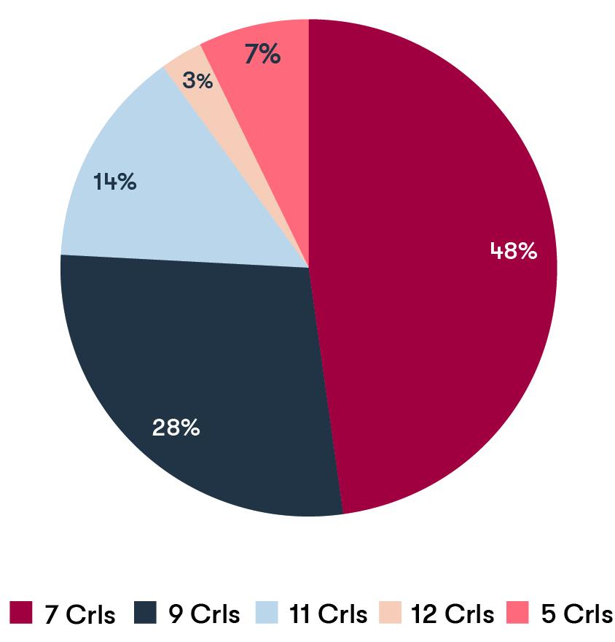
The State-wide comparison gave the VEC a solid basis for considering submissions advocating for more or fewer councillors. The VEC also considered any special circumstances, such as geography, population change and social diversity, which might warrant increasing or decreasing the number of councillors.
The LG Act 1989 permitted the number of councillors on a council to range between five and 12. The VEC recommended that two councils have five councillors, made 14 recommendations for seven councillors, eight recommendations for nine councillors, four recommendations for 11 councillors and recommended one council have 12 councillors.
Figure 4: Number of councillors recommended by VEC from 2019-20 electoral representation reviews
In most cases (24 councils), the VEC recommended that the number of councillors remain the same. In contrast, the VEC recommended an increase in the number of councillors for five councils reviewed. There were no recommendations for a reduced number of councillors for any of the councils reviewed. The net effect of the VEC’s recommendations was to increase the number of Victorian councillors by seven.
The five councils for which the VEC recommended an increase in the number of councillors were all metropolitan or interface. These recommendations were made primarily in response to population growth and were generally supported in public submissions. For example, in Casey City Council the VEC recommended increasing the number of councillors to 12, the maximum allowed under the LG Act 1989.
This was warranted because Casey City Council had the largest number of voters of all Victorian local councils, the highest voter-to-councillor ratio and was expected to continue to grow at a very high rate. It was recommended that councillor numbers in Banyule City Council be increased from seven to nine. This is due to sustained population grown since the council was formed from an amalgamation of councils in the 1990s.
In some instances, there was a significant push within the community to increase councillor numbers. Despite arguments for increasing the number of councillors in the Borough of Queenscliffe from five, the VEC found that as it was the smallest council by geographical area and with one of the lowest voter-to-councillor ratios, increasing councillor numbers was not warranted.
In some councils the VEC recommended retaining the current number of councillors even though there was a comparatively high voter-to-councillor ratio. For example, the VEC recommended Bayside City Council retain seven councillors based on voter projection information that indicated there would be minimal change to the population size in the area and no special circumstances to warrant an increase in councillor numbers. Similarly, in the review of Mansfield Shire Council, the VEC recommended retaining five councillors because there was little or no expected growth, as well as the high number of non-resident voters, which appeared to result in reduced councillor workloads.
In addition, in those councils with a history of low numbers of candidates, the VEC was reluctant to increase the number of councillors as there would be a greater likelihood of uncontested elections. This was particularly the case in the reviews of Victorian country and rural councils like Mansfield Shire Council.
Although in past reviews the VEC considered reducing the number of councillors due to the circumstances of particular councils, the VEC did not consider that a reduced number of councillors was appropriate for any of the councils reviewed during the 2019-20 review program. In a small number of councils there was a push in public submissions to decrease councillor numbers, but the VEC found that this was largely due to community dissatisfaction with councillor performance and therefore not within the scope of the representation review process.
The VEC made recommendations to retain the current number of councillors in a number of councils even when the voter-councillor ratio was comparatively low. In Buloke Shire Council, for instance, the VEC recommended retaining seven councillors. This was due to special circumstances, such as councillor workloads and burdensome travel times over a large geographical area. Although Greater Dandenong City Council had the lowest voter-to-councillor ration of 11-councillor metropolitan councils, the VEC recommended retaining 11 councillors. This was because the VEC considered that social and cultural diversity within the council and social disadvantage in some areas would place significant pressure on councillor workloads and Council services.
Electoral structure
Although the LG Act 1989 approached the number of councillors and the electoral structure separately, they are closely related. For this reason, the VEC’s electoral representation review deliberations required the number of councillors and electoral structure be considered together.
The number of councillors affects the range of electoral structures that may fit a local government area. Modelling for seven councillors for example, immediately rules out multi-councillor wards with the same number of councillors in each ward, and limits the possible electoral structures to unsubdivided, seven single-councillor wards, or a mixture of unequally-sized wards (e.g. one three-councillor ward and two two-councillor wards). This was the case with Buloke Shire Council, which the VEC recommended should continue to retain seven councillors elected from two two-councillor wards and one three-councillor ward. The VEC found that seven councillors were appropriate for representing voters in the Buloke Shire Council and the different wards provided fair and equitable representation for the Shire’s distinct communities. Similarly, Greater Dandenong City Council with 11 councillors necessitated unequally sized wards which were devised to fit local communities of interest.
Changing the number of councillors naturally impacts the electoral structure in those councils that have been divided into wards. However, in most cases, the impact of increasing councillor numbers was relatively minor. For example, in Banyule City Council, although the number of councillors increased from seven to nine, the structure of single-councillor wards was retained. In Whitehorse City Council, Kingston City Council and Casey City Council, increasing councillor numbers did not change the number of wards, but did require ward boundary adjustments to accommodate an additional councillor in one of the wards. In these reviews the VEC determined which ward, according to population growth, pressure on council services and councillor workloads, would be the most suited to having an extra councillor.
In some reviews the VEC presented options in the preliminary report that had different numbers of councillors. Each option was considered to provide fair and equitable representation, but for different reasons. In Golden Plains Shire Council, the VEC presented three options, two consisting of seven councillors and one consisting of eight councillors. The VEC’s final recommendation of seven councillors elected from three wards (Option B) considered the benefits of a subdivided structure, such as an improved representation of geographic communities of interest. The VEC also determined that Option B had significantly more community support, presented better boundaries and was more likely to accommodate the expected growth in the Bannockburn region. It was for these reasons that Option A (seven councillors elected from an unsubdivided structure) and Option C (eight councillors elected from three wards) were not recommended.
In considering electoral structures, the VEC followed its key principles of ensuring that the number of voters represented by each councillor was within plus-or-minus 10% of the average number of voters per councillor, and that communities of interest were as fairly represented as possible.
The 10% equality requirement
Ensuring that the number of voters represented by each councillor was within plus-or-minus 10% of the average number of voters per councillor in subdivided structures took priority in the VEC’s deliberations, as required by the LG Act 1989.
In nine of the councils scheduled for reviews, changes to the number of councillors, the electoral structure, or at a minimum the ward boundaries were required. This was due to one or more wards in these council electoral structures being outside of the required plus-or-minus 10% deviation at the review. In an additional six councils scheduled for reviews, one or more wards were projected to go outside of the 10% requirement within the 12 years to the next scheduled representation review. Various recommendations were made for these councils’ electoral structures including changing one or more ward boundaries, changing the number of councillors as well as one or more ward boundary adjustments, or changing to a different electoral structure.
As well as examining current voter numbers, the VEC considered likely population changes with the aim of keeping ward enrolments within the legislated tolerance for as long as possible. Although longevity was not an explicit requirement in the LG Act 1989, it was a logical consequence of the provisions of the legislation. It also provides an important level of certainty to the electorate. The purpose of an electoral representation review is to achieve fair and equitable representation of the voters of a local government area. This is in part achieved by ensuring equality of the number of voters represented by each councillor. By factoring in population changes, the VEC sought to maintain equitable representation for as long as possible, preferably until at least the next scheduled representation review to avoid frequent adjustments and potential confusion. All the VEC’s preliminary report options, except one (Casey City Council), were projected to remain within the 10% tolerance for each election until the next scheduled representation review.
Communities of interest
Another key consideration in determining the most appropriate electoral structures for a council is the representation needs of the various communities of interest within that council area. ‘Community of interest’ is a term common to electoral boundary reviews across many jurisdictions and can be applied to a local government area in multiple ways.
The VEC defines a community of interest as a group of people who share a range of common concerns or aspirations. They can be formed:
- geographically – for example, residents of a suburb, town or valley
- economically – for example, people working in similar industries or mutually-dependent industries
- by the needs of groups of people in similar circumstances – for example, new immigrants, retirees or job seekers.
Communities of interest are relevant to representation reviews because they have particular needs from their council. Because of this, it is important they have the opportunity to be fairly represented by their council.
The VEC sought to ensure that electoral structures not only met the 10% equality requirement, but also that they did not split geographic communities of interest. For example, in Cardinia Shire Council’s review, population growth in Pakenham and surrounds meant that internal ward boundaries had to change to meet the equality requirement. In exploring the possible ward boundary adjustments, the VEC also sought to ensure as far as possible that the urban community of interest centred on Pakenham would not be significantly divided by the boundary changes.
The VEC tends to focus on geographic communities of interest, but non-geographic communities also have a right to fair and equitable representation. In the review of Boroondara City Council many submissions argued for retaining single-councillor wards and the neighbourhoods they represented. However, the VEC found compelling evidence of communities of interest spanning larger areas than those contained within single-councillor wards, and groups with shared interests that were not necessarily determined by geographical location. This was one of the main reasons the VEC determined that larger, multi-councillor wards would be more appropriate for representing Boroondara’s diverse communities.
In numerous reviews the VEC determined that a change to the electoral structure was required to ensure fair and equitable representation for particular geographic communities. In Colac Otway Shire Council’s review, the VEC received strong support via community submissions to provide a subdivided structure. This structure would increase the opportunity of the coastal communities to elect a local representative on a council comprised mainly of representatives from the inland areas.
The review of Swan Hill Rural City Council, on the other hand, recommended changing from a multi-councillor to an unsubdivided electoral structure. This too was considered from a community of interest perspective in that it could potentially encourage more rural candidates to stand for election. This would provide a better opportunity for additional Robinvale-based councillors, and by giving voters a say on all candidates to enable both geographic and non-geographic communities of interest to be represented.
In addition to applying these principles, the VEC’s approach to the reviews also took account of the particular circumstances for each local council area. In Campaspe Shire Council, for example, the VEC considered that there were some strong arguments in favour of an unsubdivided structure particularly in light of drought-related issues and a declining local dairy industry, which suggested that there were benefits to promoting shire-wide representation of shared issues. However, community submissions indicated that the predominantly rural communities in Campaspe Shire had and would continue to benefit from local representatives who were more easily accessible and knowledgeable on local issues.
The use of clear and easily identifiable ward boundaries was another consideration. In the review of Darebin City Council, the VEC recommended the electoral structure remain the same, but adopted significantly clearer and more easily identifiable ward boundaries at the same time as satisfying the 10% equality requirement. Similarly, for Hepburn Shire Council’s review, the VEC recommended the existing electoral structure but made changes to the internal boundaries to provide better balance of the number of voters per councillor and present clearer ward boundaries for voters.
As previously mentioned, the VEC is reluctant to overturn previous representation review recommendations. There has to be convincing evidence and compelling arguments for changing the electoral structure. In most councils (17) the VEC recommended retaining the established electoral structure (though ward boundaries were changed in nine councils). For example, the VEC recommended that Maroondah City Council retain its current electoral structure. The VEC found that the current electoral structure provided fair and equitable representation and presented this structure as Option A in the preliminary report. The VEC also developed an Option B to test whether the same electoral structure with alternative ward boundaries could better reflect communities of interest in the City of Maroondah. At the final stage of the review the VEC reasoned that there were no compelling circumstances to warrant change.
In twelve reviews the VEC did recommend changes to the electoral structure and to the number of councillors. These changes varied widely:
- Four changed from unsubdivided to multi-councillor wards
- Two changed from a mixed structure to unsubdivided
- Two changed from single-councillor wards to multi-councillor wards
- Two changed from equal multi-councillor wards to multi-councillor wards of varying councillor numbers
- One changed from multi-councillor wards of varying councillor numbers to equal multi-councillor wards
- One increased the number of councillors but retained single-councillor wards.
At the core of these recommendations was the VEC’s consideration of the fair and equitable representation of diverse communities, taking the unique characteristics of each council into account.
Types of electoral structures
The VEC recommended a range of electoral structures during the 2019-20 representation review program for a total of 29 councils. This does not include the two council reviews which ceased due to the introduction of the LG Act 2020. Of the recommended electoral structures:
- Ten were multi-councillor wards of varying sizes
- Eight were unsubdivided electoral structures
- Five were equally sized multi-councillor wards
- Four were a combination of single-councillor and multi-councillor wards
- Two were single-councillor ward structures.
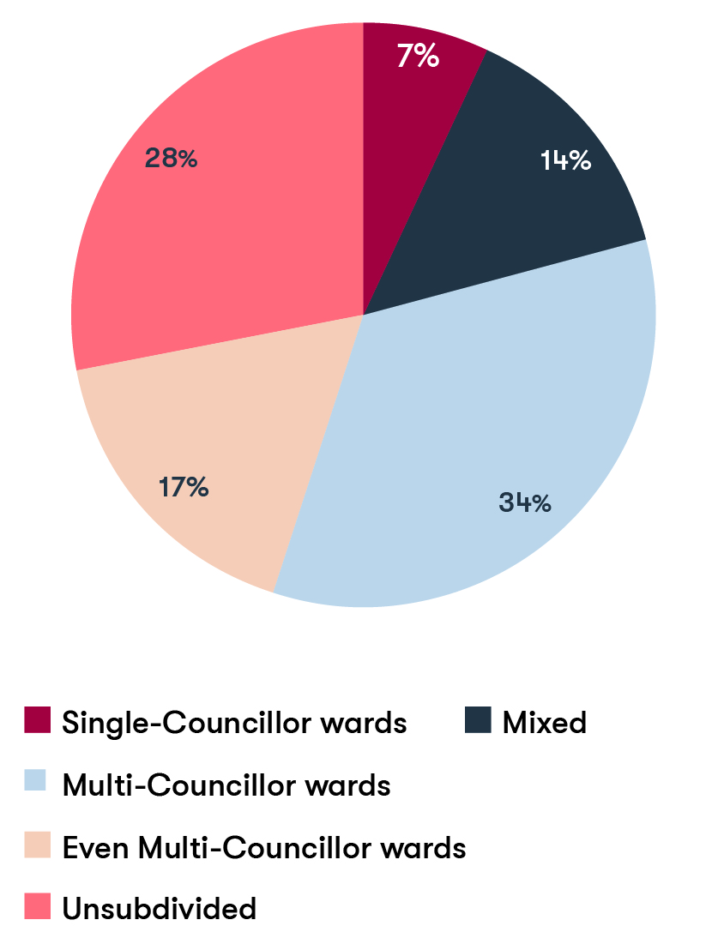
Figure 5: Types of structure recommended by VEC from 2019-20 electoral representation reviews
The VEC recommended an unsubdivided structure in eight reviews, all of which were in regional Victoria. The benefits of this structure are that it widens choice for voters, promotes representation of diversity, and encourages a council-wide outlook by candidates and councillors. More than this was needed, though, for the VEC to recommend an unsubdivided structure. In many of these reviews, the whole council area could be regarded as a single community.
In Benalla Rural City Council, for example, the main town of Benalla maintained important social, transport and economic links with the surrounding rural areas and there was strong evidence of common, municipality-wide interests. This was also the case in comparable country councils, where most of the population lives in one town or rural city such as Ararat Rural City Council and Southern Grampians Shire Council.
One frequently raised objection to an unsubdivided structure is that the council could be dominated by the main urban area, with smaller population centres left effectively unrepresented. This does not appear to be the case in most council areas that have unsubdivided electoral structures. In Moyne Shire Council public submissions emphasised the need to have a good geographical spread of councillors from across the Shire. On assessing the location of current and previous elected councillors, the VEC found that an unsubdivided electoral structure had resulted in a reasonable spread of councillors from across the Moyne Shire.
In four reviews (Colac Otway Shire Council, East Gippsland Shire Council, Golden Plains Shire Council and Moira Shire Council), the VEC recommended that previously unsubdivided councils be divided into wards. In Moira Shire Council the VEC was made aware of three key geographical communities of interest, consisting of eastern, central and western Moira. The VEC considered that the division of the Shire into three wards with equal numbers of councillors per ward would provide the best representation for these communities and the main townships they related to.
The VEC recommended a single-councillor ward structure in only two reviews (Nillumbik Shire Council and Banyule City Council), though this structure was put forward as an option in two other reviews (Boroondara City Council and Murrindindi Shire Council). The VEC did not consider single-councillor wards for other reviews for reasons largely connected with communities of interest. Single-councillor wards privilege geographic communities of interest, while other structures offer scope for representation of non-geographic communities as well. The tight number constraints in single-councillor wards meant that in many cases ward boundaries would have to cut through significant localities, weakening the argument that single-councillor wards best represent geographic communities of interest. Because single-councillor wards are relatively small, they are more vulnerable to population shifts pushing their enrolments outside the plus-or-minus 10% tolerance under the LG Act 1989, which would trigger a subdivision review or an early representation review.
The VEC recommended multi-councillor ward structures in 15 reviews. Again, communities of interest were a key factor for the VEC to recommend these structures. Under multi-councillor wards, there is representation of geographical areas, but on a wider scale than in single-councillor wards. The ward boundaries are more often able to be placed on clear locality boundaries and physical features and reflect the broad geographic communities within a local council.
Other reasons why the VEC recommended multi-councillor wards related to the operation of elections and representation. In single-councillor wards, the pool of possible candidates can be quite small, resulting in a lack of choice for voters. Quite frequently a ward is uncontested, meaning that voters have no choice at all. In contrast, in unsubdivided councils, there can be so many candidates that a meaningful choice is difficult for voters, and many voters inadvertently cast an informal vote. With multi-councillor wards, voters are more likely to be offered a wide choice of candidates without that choice being overwhelming. Between elections, constituents in a ward have a choice of councillors to contact and ward councillors can fill a gap if one of them is unavailable for any reason.
The VEC recommended five councils have multi-councillor wards with the same number of councillors in each ward. All things being equal, the VEC is disposed to favour wards of the same magnitude because it prevents any perceptions of inequality. The quota for election does vary according to the number to be elected for the ward; this is a consequence of the prescribed formula to elect candidates. However, the VEC considers that this aspect of the electoral system is relatively trivial. Fair and equitable representation can be achieved even if the size of the wards varies across the council area.

The VEC recommended multi-councillor wards of varying sizes in ten reviews and a mixed electoral structure with some single-councillor wards and some multi-councillor wards in four reviews. This is because those structures best suited the communities of interest in that council. In Northern Grampians Shire, for example, the multi-councillor wards captured the two main towns or communities—Stawell and St Arnaud—where most of the population resided; the single-councillor wards on the other hand contained the less populated rural area of the Shire and the growing tourism centre of Halls Gap.
As the diverse range of electoral structures recommended across all the reviews suggests, the VEC does not consider or apply a one-size-fits-all to local government representation. Local councils have varying and different needs. Even within one local council area there is often a diverse range of interests and communities, and demographics and local needs also change over time. This requires a range of different electoral structures, which can meet the specific representation needs of individual councils.
Subdivision reviews
Of the seven 2019-20 subdivision reviews, four were interface local councils, two were country and one was metropolitan. The rapid and uneven population growth in the councils located at the interface between urban and rural areas was the reason enrolment numbers had diverged beyond the 10% tolerance.
In conducting the subdivision reviews, the VEC was guided by similar principles to those it followed in the electoral representation reviews. As in representation reviews, the VEC was bound by the legislative requirement that the number of voters for each councillor must not vary more than plus-or-minus 10% from the average number of voters per councillor for the council. In subdivision reviews, the VEC adopts a ‘minimal change’ approach, so that recommended changes (which can be disruptive and confusing) affect as few voters as possible. Within these constraints, the VEC takes account of community of interest, clear boundaries and likely population changes.
The VEC’s recommended boundaries corrected imbalances and restored all wards to compliance with the LG Act 1989.
The subdivision reviews were a consultative process, with the VEC inviting submissions from the public about the proposed boundaries. The VEC received relatively few submissions (a total of 35 for all seven reviews), but they often addressed the key concerns of the subdivision review and few were outside of the review’s scope. For example, the submission provided by Yarra Ranges Shire Council for its subdivision review and the submission provided by Aireys Inlet and District Association (AIDA) for the review of Surf Coast Shire Council provided detailed maps and population data to propose alternative ward boundary adjustments to those proposed by the VEC. In both reviews there was also significant interest from the community, with 17 submissions received for Surf Coast and eight received for Yarra Ranges.
Local knowledge in submissions was particularly helpful when considering communities of interest. For Hume City Council, the VEC received two alternative ward boundary adjustments that presented different views on communities of interest in the City of Hume. These submissions helped the VEC to reassess its proposed ward boundary adjustments and the impact on local communities of interest, formed when residents also identify closely with their suburb of residence.
In three subdivision reviews (Surf Coast Shire Council, Yarra Ranges Shire Council and Hume City Council), the VEC amended its proposed boundaries in response to the information and arguments presented in the submissions and at public hearings. In the review of Surf Coast Shire Council, the VEC decided to adjust one of its proposed ward boundary changes in response to significant opposition from submissions towards the splitting of Fairhaven and Aireys Inlet between wards. The VEC’s final recommendation was to keep the two communities together in the same ward and make alternative boundary adjustments to satisfy the 10% equality requirement.
While the VEC considered all suggestions put forward in submissions, it did not adopt all the proposed ward boundary adjustments. Many of the submitted proposals identified changes that could better represent the communities of interest within the affected wards. However, most of the suggestions were not necessary to ensure all wards were within plus-or-minus 10% of the average voter-to-councillor ratio. The VEC determined that suggestions of this nature would be best addressed as a part of a full representation review.
In total, the ward boundary changes recommended by the VEC impacted 25,480 of 724,572 voters or 3.52% of total enrolments for all seven local councils. The local council with the largest proportion of voters impacted was Hume City Council with 7.7% of the total number of voters affected, followed by Surf Coast Shire (4.46%), Moorabool Shire (4.11%) and Monash City (4.05%) councils. A smaller proportion of voters were impacted in Stonnington City (1.31%), Yarra Ranges Shire (1.34%) and Wyndham City (1.80%) councils.

Participation
The electoral representation and subdivision reviews were a consultative process. Section 219F of the LG Act 1989 required the VEC to place two notices in local newspapers – an initial notice announcing the review and inviting preliminary submissions from the public, and a second notice announcing the release of the preliminary report and inviting public submissions in response to that report. The VEC considered the submissions and arranged for any person who had made a submission to be heard, if that person had requested to speak to the submission.
The VEC valued input from the public and aimed to ensure that interested voters in a local council were aware of a representation review. To meet its statutory requirements, the VEC took advice from councils on appropriate local newspapers for advertisements. Substantial advertisements were also placed in the Herald Sun at the start of each round of reviews. The VEC went beyond the requirements of the LG Act 1989 to engage voters – supplementing the paid newspaper advertisements with multiple additional communication strategies.
The VEC distributed 107 news releases and advisories to local media throughout the program, and the VEC’s spokespeople spoke to journalists about the reviews. The VEC’s website was regularly updated with information about the status of each review, and the VEC provided a communications pack to each council that linked back to its independent messaging for use on the Council’s website, social media and newsletters.
For the first time, the VEC delivered an email campaign targeted at known community groups and communities of interest in the local council area. Through the VEC’s email campaign over 28,000 emails were sent. Approximately 52% of the emails were opened and 19% of those who received the email clicked on the link to the VEC’s website. The VEC also used paid advertising on social media to distribute information about the reviews. The VEC’s social media posts were targeted to all relevant council areas and reached over 430,000 users across the program, which significantly expanded the VEC’s reach. The average numbers of users reached across the representation reviews was 11,646 per council.
Number of submissions
The VEC received a total of 1,567 public submissions across the reviews in 2019-20. Submissions came in two stages, preliminary and response, and were divided as follows:
- preliminary submissions (representation reviews only): 698
- response submissions (representation reviews only): 834
- response submissions (subdivision reviews): 35.
As in the 2015-16 reviews, the VEC received most submissions at the response stage. However, there were fewer response submissions than preliminary submissions in 14 out of the 31 scheduled representation reviews. The surge in a few councils, namely Boroondara City Council, Colac Otway Shire Council (and to a lesser extent Banyule City and Mitchell Shire Councils) put the total number of response submissions ahead. Subdivision reviews attracted fewer submissions, which was not surprising considering the limited nature of these reviews.

Number of submissions by review
Council Name |  | Preliminary submissions received | Response submissions received | Total submissions received | Total maps received
R1 | Ararat Rural City Council | 15 | 7 | 22 | 1
 | Benalla Rural City Council | 4 | 2 | 6 | 0
 | Boroondara City Council | 200 | 265 | 465 | 4
 | Borough of Queenscliffe | 22 | 13 | 35 | 2
 | Colac Otway Shire Council | 44 | 99 | 143 | 9
 | East Gippsland Shire Council | 25 | 20 | 45 | 2
 | Glenelg Shire Council | 15 | 13 | 28 | 2
 | Golden Plains Shire Council | 25 | 24 | 49 | 4
 | Moira Shire Council | 15 | 46 | 61 | 0
 | Moyne Shire Council | 12 | 14 | 26 | 0
 | Nillumbik Shire Council | 76 | 81 | 157 | 5
 | Southern Grampians Shire Council | 2 | 8 | 10 | 0
R2 | Banyule City Council | 30 | 48 | 78 | 6
 | Bayside City Council | 11 | 8 | 19 | 3
 | Buloke Shire Council | 6 | 5 | 11 | 0
 | Campaspe Shire Council | 3 | 7 | 10 | 0
 | Darebin City Council | 16 | 10 | 26 | 3
 | Greater Dandenong City Council | 22 | 14 | 36 | 1
 | Kingston City Council | 15 | 32 | 47 | 2
 | Manningham City Council | 6 | 5 | 11 | 1
 | Maroondah City Council | 8 | 9 | 17 | 0
 | Murrindindi Shire Council | 9 | 10 | 19 | 1
 | Swan Hill Rural City Council | 19 | 10 | 29 | 1
 | Whitehorse City Council | 24 | 11 | 35 | 7
R3 | Cardinia Shire Council | 8 | 4 | 12 | 4
 | Casey City Council | 30 | 18 | 48 | 9
 | Hepburn Shire Council | 5 | 7 | 12 | 4
 | Mansfield Shire Council | 10 | 8 | 18 | 3
 | Mitchell Shire Council | 9 | 26 | 35 | 3
 | Northern Grampians Shire Council | 7 | 9 | 16 | 1
 | Whittlesea City Council | 5 | 1 | 6 | 2
 | Total (Representation Reviews) | 698 | 834 | 1,532 | 80
SR | Hume City Council* |  |  | 4
 | Monash City Council* |  |  | 2
 | Moorabool Shire Council* |  |  | 0
 | Stonnington City Council* |  |  | 1
 | Surf Coast Shire Council* |  |  | 17 | 1
 | Wyndham City Council* |  |  | 3
 | Yarra Ranges Shire Council* |  |  | 8 | 3
 | Total (Subdivision Reviews) |  |  | 35 | 4
 | Total (All Reviews) |  |  | 1,567 | 84
Table 2: Submissions (* shows subdivision reviews)

The number of submissions received in each review differed widely (see Table 2). The reviews of Boroondara City Council, Nillumbik Shire Council and Colac Otway Shire Council in Round One attracted most interest, with dozens of substantial submissions and more proforma submissions where an organised community group drafted a submission that many people sent in, much like a petition. These were highly contested reviews. In the review of Boroondara City Council’s electoral structure, the submissions were deeply divided, with about half in support of the status quo and the rest for change. Councils with the fewest submissions included Benalla Rural City Council and Whittlesea City Council. During Benalla City Council’s review, the VEC found that the current unsubdivided structure was the only and most appropriate option and the community submissions received also supported the status quo. Past reviews of Whittlesea City Council’s representation have generally attracted fewer submissions overall.
Of the subdivision reviews, Surf Coast and Yarra Ranges Shire Councils received the most submissions as several proposed boundary adjustments affected residents with strong ties to local suburbs and areas. In the Yarra Ranges Shire Council review, the VEC received detailed submissions from the Council and from resident groups urging further adjustments to the proposed boundaries in order to protect local communities of interest. Conversely, Moorabool Shire Council’s subdivision review received no submissions, despite all ward boundaries being adjusted. These adjustments were required to accommodate growth in the peri-urban Bacchus Marsh area and relative decline in voter numbers for the rest of the Moorabool Shire.
Notably, public investigations into councillor conduct in Casey and Whittlesea City Councils coincided with these councils’ representation reviews. These separate government investigations were widely reported in the media. Community dissatisfaction with their councillors was particularly apparent in the submissions received during Casey City Council’s review. In this review, it was necessary for the VEC to emphasise to some submitters that the VEC’s reviews were independent of the government investigation into councillor conduct.
Boundary builder
The VEC launched its Boundary Builder application for the 2019-20 review program which provided submitters with the opportunity to map their preferred subdivided structure at the preliminary submissions stage. The VEC provided guidance on how to use Boundary Builder online. Some of the maps received did not meet the review’s requirements, suggesting people may have had difficulties with the technology or understanding the requirements. Nonetheless, the maps received often provided good insight into a preferred electoral structure. The VEC received a total of 80 maps. Of these, 65 were made via Boundary Builder. The number of maps received was steady across all rounds of the review, at an average of 27. The VEC received most maps during the Casey City Council review. Boundary Builder was not available for the subdivision reviews.
The VEC received a total of 1,047 submissions in Round One, which meant about two-thirds of submissions were received during the first round of reviews. Numbers of submissions dropped significantly during the second and third rounds, with 338 submissions received in Round Two and 147 submissions in Round Three. There were fewer councils reviewed in the final round. While lively interest in Boroondara City Council, Colac Otway Shire Council and Nillumbik Shire Councils’ reviews and proforma submissions raised the number of response submissions in Round One, there were a similar number of submissions received at both the preliminary and response stages of Rounds Two and Three (see Table 3).
The VEC observed that the decline in submissions between rounds One and Two coincided with the reintroduction of the Local Government Bill 2019 (the Bill) in Parliament. This occurred in November 2019. The Bill finished its passage through parliament months later (in March 2020) in the third round of reviews. As the Bill progressed through both houses of parliament, some submitters queried whether these reviews should continue at all, while others (including several councils which submitted) wanted to pre-empt the Bill becoming law by supporting an electoral structure that fitted the Bill’s requirements. The VEC considered all submissions based on the principles of the review, as tasked by the legislation at that time. To reduce confusion, the VEC distributed communication to relevant councils and responded to public enquiries by reiterating the requirement of the LG Act 1989 for the VEC to continue the reviews until such time as new legislation was enacted in Parliament.

Number of submissions by round
Round | Preliminary submissions | Response submissions | Total submissions
Round One | 455 | 592 | 1,047
Round Two | 169 | 169 | 338
Round Three | 74 | 73 | 147
Subdivision | — | 35 | 35
Total | 698 | 869 | 1,567
Table 3: Total numbers of submissions in each round of representation reviews

Who engaged in the reviews
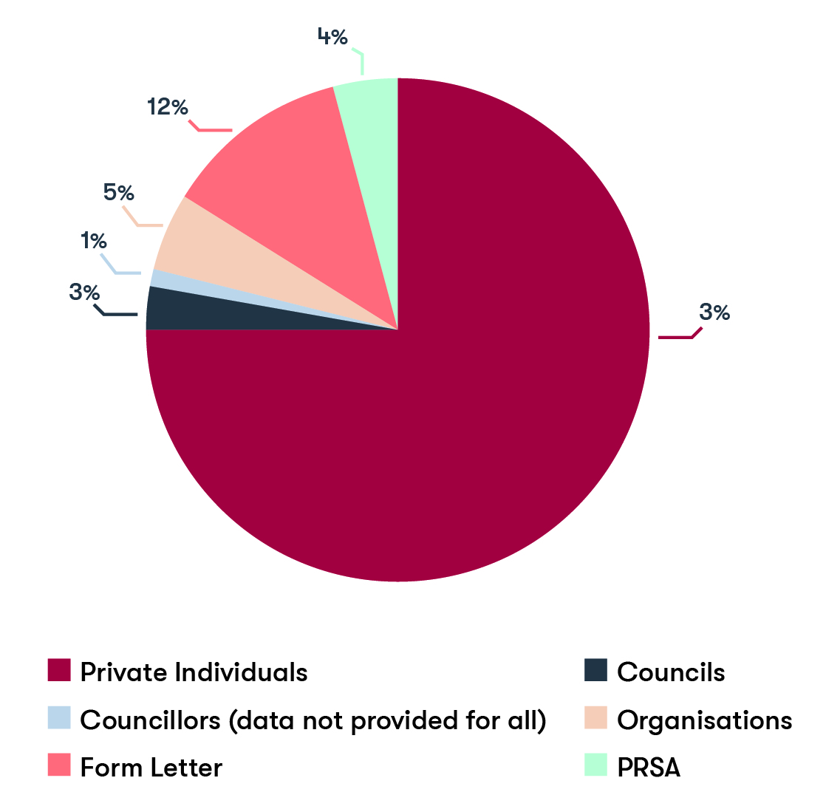
Figure 6: Source of submissions in 2019-20 representation and subdivision reviews

Source of submission | 2015-15 reviews (%) | 2019-20 reviews (%) | Change (percentage points)
Private individuals (incl. form letters) | 72.9% | 87% | +14.1%
Councils | 7.4% | 3% | -4.4%
Councillors | 4% | 1% | -3%
Organisations (incl. PRSA) | 15.6% | 9% | -6.6%
Table 4: Sources of submissions across all reviews
Submissions came from across the community – individual citizens (including a State Parliamentarian), councils, councillors and a wide variety of organisations. As in the 2015-16 reviews, the great majority of submissions were from private individuals. Submissions from councils, individual councillors and organisations comprised smaller percentages of the total submissions compared to the 2015-16 reviews, which may have been the result of the reduced community engagement that came with the reintroduction of the Local Government Bill in parliament (see Table 4).
Councils are entitled to lodge submissions and 21 out of 31 councils made a submission during their council’s representation review. Most chose to submit at the final response stage. Most councils supported the status quo but there were some exceptions. Swan Hill Rural City Council argued that an unsubdivided structure would give greater opportunity for the best candidates to be elected and respond to the desire in Robinvale (the second largest population centre) to gain more local representation. Whitehorse City Council argued that it warranted an extra councillor, based on current and projected population growth in the council area. Whitehorse City Council also provided detailed analysis in favour of two preferred ward divisions, which provided other preliminary submitters in this review with options to discuss early on. Casey City Council supported moving to the maximum number of councillors available and a single-councillor ward structure – which would respond to their rapid population growth and fit the requirements of the proposed legislative changes.
Several individual councillors also made submissions in representation reviews. Councillors had mixed views about their current electoral structure. In Nillumbik Shire Council’s review, Councillors Ashton and Brooker supported the current model. In contrast, Councillor Hart of Colac Otway Shire Council provided a substantial submission in support of adding wards to provide communities in the coastal south of the Colac Otway Shire a greater chance of electing a local representative. Councillors also often used their local knowledge to effect in reviews where both options were fundamentally the same model but with different boundary adjustments. This was beneficial as the VEC was seeking community feedback on which option better recognised communities of interest. This was certainly the case in the Darebin City Council, Greater Dandenong City Council and Maroondah City Council reviews.
The Proportional Representation Society of Australia (Victoria-Tasmania branch) contributed to all the representation reviews, making a consistent case for what it considered the fairest and most democratic electoral structure. All other organisations that submitted were locally based. Most of them were community aligned, such as the West Ivanhoe Sporting Club in Banyule City Council’s review. Some were council-wide such as ratepayer action groups, which often submitted to their council’s review. Council-wide community groups with ties to state-wide organisations also submitted, such as the Whitehorse branch of the Victorian Greens Party.
The VEC received most proforma submissions during the reviews for Boroondara City Council, Nillumbik Shire Council and Colac Otway Shire council. It also received some proforma submissions in Banyule City Council’s review in Round Two. The VEC emphasised in its information and reports that it did not base its recommendations on a “straw poll” of submissions but on the arguments and evidence included in submissions, and on the VEC’s independent research and analysis. In some reviews, distinct community support and strong argument for change helped the VEC to form its recommendations. This was the case in Colac Otway Shire Council’s review, where most submissions supported introducing wards, and the submitters made a strong case for their preferred electoral structure. In others, such as Nillumbik Shire Council’s review, community opinion was equally divided. In these cases, the VEC closely considered the submissions as well as its research into communities of interest to recommend an option that would provide the most benefits for voters across their council area.
Information sessions and public hearings
The VEC also valued face-to-face contact to inform voters about the reviews. At the outset of each review, the VEC held public information sessions to provide details of the review process and how to make a submission. The sessions included an introduction to the VEC’s online submission tool, including Boundary Builder. The VEC conducted a total of 48 information sessions at various council and community-based venues.
At the second stage of each review, the VEC enabled any person who had made a response submission to speak to the VEC. In the interests of transparency, these people spoke at a public hearing. A total of 120 people spoke at 32 public hearings for the representation and subdivision reviews (see Table 5). The number of speakers per hearing varied greatly, with most interest at the Boroondara City Council public hearing (19 speakers) and the Nillumbik Shire Council public hearing (14 speakers). Public hearings did not go ahead in five representation reviews as no submitters wished to speak. Public hearings went ahead in five of the seven subdivision reviews. Due to the restrictions on gatherings imposed in response to the COVID-19 pandemic, subdivision review public hearings were conducted online, as was the public hearing for the Mitchell Shire Council representation review.
Like the information sessions, the public hearings were held at council venues and community centres to ensure residents and voters could easily travel to their council’s public hearing. The VEC also sought to improve accessibility by ensuring a hearing loop was available at these venues.

Public hearing statistics
 | Council |  | Hearings scheduled | Hearings held | Speakers | Attendance at Hearing
R1 | Ararat Rural City Council |  | 1 | 1 | 1 | 4
 | Benalla Rural City Council |  | 1 | 0 | 0 | 0
 | Boroondara City Council |  | 2 | 2 | 19 | 32
 | Borough of Queenscliffe |  | 1 | 1 | 8 | 8
 | Colac Otway Shire Council |  | 1 | 1 | 7 | 12
 | East Gippsland Shire Council |  | 1 | 1 | 7 | 6
 | Glenelg Shire Council |  | 1 | 1 | 2 | 4
 | Golden Plains Shire Council |  | 1 | 1 | 5 | 8
 | Moira Shire Council |  | 1 | 1 | 6 | 6
 | Moyne Shire Council |  | 1 | 1 | 2 | 3
 | Nillumbik Shire Council |  | 1 | 2 | 14 | 40
 | Southern Grampians Shire Council |  | 1 | 0 | 0 | 0
R2 | Banyule City Council | 1 |  | 1 | 8 | 19
 | Bayside City Council |  | 1 | 1 | 1 | 4
 | Buloke Shire Council | 1 |  | 1 | 1 | 5
 | Campaspe Shire Council |  | 1 | 1 | 4 | 7
 | Darebin City Council | 1 |  | 1 | 4 | 11
 | Greater Dandenong City Council |  | 1 | 1 | 1 | 2
 | Kingston City Council | 1 |  | 1 | 1 | 4
 | Manningham City Council |  | 1 | 1 | 1 | 3
 | Maroondah City Council | 1 |  | 1 | 1 | 3
 | Murrindindi Shire Council |  | 1 | 1 | 3 | 9
 | Swan Hill Rural City Council | 1 |  | 1 | 2 | 3
 | Whitehorse City Council |  | 1 | 1 | 2 | 18
R3 | Cardinia Shire Council |  | 1 | 0 | 0 | 0
 | Casey City Council |  | 1 | 1 | 4 | 8
 | Hepburn Shire Council |  | 1 | 0 | 0 | 0
 | Mansfield Shire Council |  | 1 | 1 | 1 | 9
 | Mitchell Shire Council |  | 1 | 1 | 6 | 6
 | Northern Grampians Shire Council |  | 1 | 1 | 2 | 6
 | Whittlesea City Council |  | 1 | 0 | 0 | 0
SR | Hume City Council* |  | 1 | 1 | 2 | 5
 | Monash City Council* |  | 1 | 1 | 1 | 2
 | Moorabool Shire Council* |  | 1 | 0 | 0 | 0
 | Stonnington City Council* |  | 1 | 0 | 0 | 0
 | Surf Coast Shire Council* |  | 1 | 1 | 4 | 6
 | Wyndham City Council* |  | 1 | 0 | 0 | 0
 | Yarra Ranges Shire Council* |  | 1 | 1 | 6 | 4
 | Totals |  | 39 | 32 | 120 | 251
Table 5: Public hearing statistics (* shows subdivision reviews)

Surveys
The VEC invited participants in the reviews to complete anonymous written surveys. The surveys were designed to gain feedback about the review process – how people learned and participated – rather than the outcomes of the reviews. Feedback from the surveys informed improvements made to the VEC’s products, processes and services throughout the program.
In all, 247 surveys were returned. In the first round of reviews, participants were surveyed at two stages of the process – first, if they had attended an information session or made a preliminary submission (76 responses), and second, if they had made a response submission (42 responses). Close to half of those surveyed in the second stage of Round One had provided a preliminary submission. In Round One, the VEC received a total of 118 responses.
Surveying participants in two stages was, however, found to be an inefficient method due to the need for continual ‘buy-in’ from respondents, some of whom were asked to complete a survey at multiple stages of the review. In Round Two, the survey was collated into a single form and distributed following the public hearings to all who had contributed to any stage of the reviews.
In Round Two the VEC received a total of 62 responses. In Round Three, the VEC received a total of 45 responses.
The VEC also wanted to consider ways it could enhance the subdivision review process. To achieve this, the VEC also surveyed participants at the end of the subdivision reviews and received 22 survey responses.
Across these surveys, the VEC asked for feedback about the information session, the Submission Guide (and from Round Two, the VEC’s council fact sheets), the online submission tool and the review process generally. The VEC also surveyed participants in Round One about their experience using Boundary Builder.
Table 6 shows the number of responses by council. The volume of response by council tended to reflect public interest in the review rather than the size of the local council. The largest number of survey responses were received from participants in the review for Boroondara City Council.

Number of survey respondents by review
Council | Total survey responses received
Round One
Glenelg Shire Council | 10
Moyne Shire Council | 4
Southern Grampians Shire Council | 1
Ararat Rural City Council | 4
Colac Otway Shire Council | 23
Golden Plains Shire Council | 6
Benalla Rural City Council | 0
Moira Shire Council | 3
Borough of Queenscliffe | 6
Boroondara City Council | 40
East Gippsland Shire Council | 6
Nillumbik City Council | 11
Council not selected | 4
Round Two
Buloke Shire Council | 1
Campaspe Shire Council | 4
Swan Hill Rural City Council | 5
Bayside City Council | 7
Greater Dandenong | 4
Kingston City Council | 15
Banyule City Council | 17
Darebin City Council | 6
Manningham City Council | 2
Maroondah City Council | 0
Murrindindi Shire Council | 1
Whitehorse City Council | 0
Round Three
Hepburn Shire Council | 5
Mansfield Shire Council | 7
Northern Grampians Shire Council | 4
Cardinia Shire Council | 6
Casey City Council | 10
Mitchell Shire Council | 11
Whittlesea City Council | 2
Subdivision reviews
Surf Coast Shire Council | 11
Wyndham City Council | 2
Stonnington City Council | 0
Yarra Ranges Shire Council | 7
Hume City Council | 2
Monash City Council | 0
Moorabool Shire Council | 0
Total | 247
Table 6: Survey responses by council

Sources of information
Table 7 shows how respondents heard about their council’s review. The survey respondents could tick more than one box for this question, resulting in a larger number of responses than the total number of survey respondents.
Source of submission | Round 1 | Round 2 | Round 3 | Subdivision review | Total
Local newspaper | 33 | 19 | 22 | 5 | 79
Local community group | 34 | 17 | 12 | 6 | 69
Through the Council | 13 | 12 | 19 | 5 | 49
Friend/ family member | 23 | 4 | 5 | 4 | 36
Social media | 13 | 7 | 7 | 2 | 29
VEC website | 4 | 6 | 10 | 3 | 23
Email | 2 | 3 | 0 | 0 | 5
Political party | 1 | 2 | 0 | 0 | 3
Herald Sun | 1 | 0 | 2 | 0 | 3
Radio | 2 | 0 | 0 | 0 | 2
Total responses | 126 | 70 | 77 | 25 | 298
Table 7: Sources of information about reviews
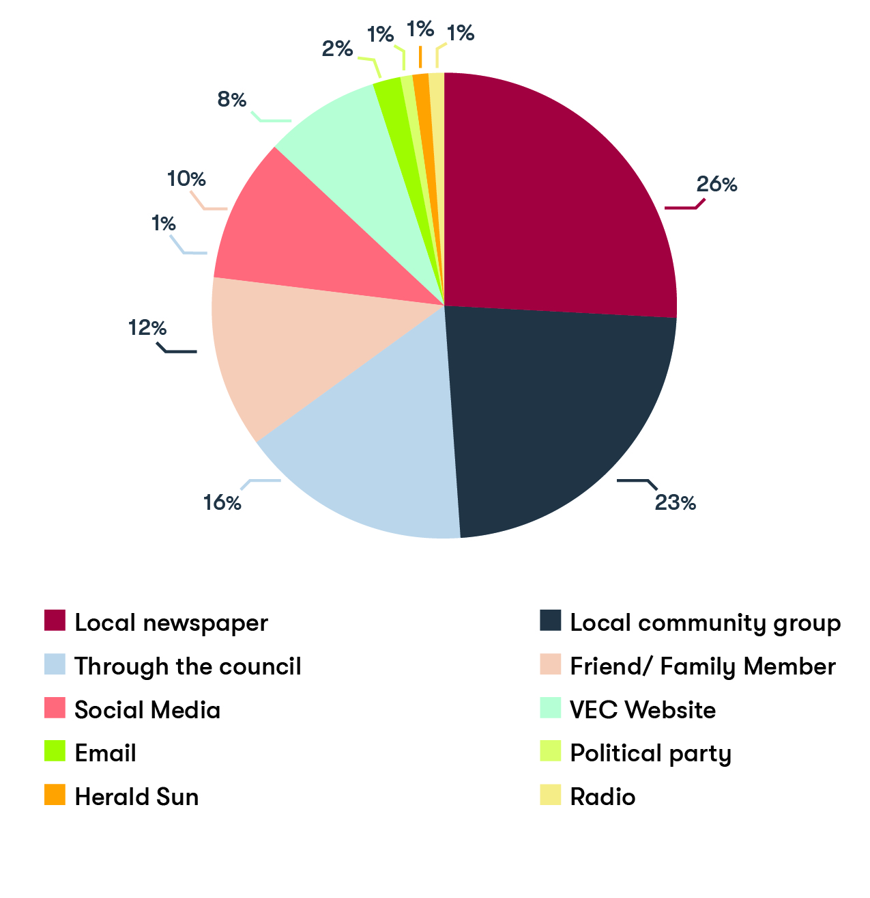
Figure 7: Sources of information about reviews (%)

Respondents found out about their council’s review primarily through local newspapers. The second most important source of information for the reviews were local community groups, followed by local councils. Friends or family members were another important source of information about the reviews.
Compared to the 2015-16 program, there was a marked increase in the percentage of respondents who found out about the reviews through their local community groups. In fact, local community groups did not figure as one of the top eight sources of information about the reviews for survey respondents in 2015-16. The jump in participants who learned about the reviews via a local community group was most likely the result of a concerted effort by the VEC to reach local groups during this program. As previously outlined, the 2019-20 program was the first time the VEC researched relevant community groups in each council area and sent emails out at both stages to notify these groups about the reviews.
This review program was also the first time the VEC embarked on a social media campaign, which significantly extended the VEC’s reach in the community. While social media was not the most popular channel for participants to find out about the reviews, it nonetheless made the top five channels of information about the reviews and engaged close to 10% of all survey respondents (see Figure 7).
Advertising for the reviews drew mixed responses. While close to half of the respondents (49%) considered that the review process was well advertised, approximately 30% disagreed with the statement that the review process was well advertised and 21% neither agreed nor disagreed. As in the earlier programs, several respondents believed there was a need for a mail-out to every postal address in their council area. The VEC sought to encourage participation in the reviews wherever possible and has extended its reach significantly through more cost-effective methods of emailing and social media advertising.
Information sessions
The information session effectively launched each review, so it was vital that the session was helpful for potential participants. Information sessions were also held for the subdivision reviews.
The numbers of people attending the information sessions differed widely but were generally low. The Banyule City Council information sessions attracted a larger number of about 15 to 20 people per session, while others such as the Darebin City Council information session attracted just two people. Of the survey respondents, between 22 and 32% attended their council’s information session. The largest percentage of respondents that attended an information session had participated in Round One (32%). Several respondents provided some indication as to why they did not attend. One respondent commented that the session or meetings needed to be arranged in various locations in the council area so that more people could attend. Another respondent considered that direct contact needed to be made with community leaders. Another respondent felt there had not been enough publicity about the information session and they noted that only one was held in that council.
Although the information sessions for some councils were thinly attended, of the survey respondents who attended an information session, (86%) agreed or strongly agreed that they had found out what they wanted to know at the information sessions. Over 77% of respondents surveyed in the representation reviews also agreed that the information sessions should be held again, if the reviews were to continue in a similar form in future.
East Gippsland Shire Council was reviewed during this program. Covering a distinctly large area that includes remote areas, the Council requested that one of its information sessions be live streamed via the council website for voters in the far reaches of the council area. The VEC supported this request, which proved successful in reaching these voters – evident in the submissions from Mallacoota. As in earlier programs, the VEC’s experience revealed new opportunities with technology to expand its reach into the community for the reviews.
Submission Guide and factsheet
The VEC produced information to assist people in making submissions including an overview of the council’s population (key demographic characteristics) and relevant maps showing the current electoral structure and voter numbers. During Round One, this information was packaged in a detailed Submission Guide. Survey respondents in Round One indicated that the Guide could be made more accessible by making the information easier to read and understand.
The VEC decided to separate the information contained in the submission guide into two separate products in response to feedback from Round One. The resulting Submission Guide provided in depth information about representation reviews generally and the council factsheet provided high level information about the council and review timeline including maps of the current electoral structure and the number of voters by locality. The resulting Guide and council factsheet were essential in helping the public make informed and relevant submissions in each review.
Just over 84% of survey respondents across the representation reviews had read their council’s Submission Guide. More respondents surveyed in the initial stage of Round One had read the Guide compared to those surveyed in the final stage. In the survey responses received for Round Two, just over 90% had read the Guide and over half had accessed the factsheet. Similarly, in Round Three, 91% of respondents had read the Guide with 75% of these respondents also having read the factsheet.
When surveyed about the quality of both products, most of these respondents (85%) felt that these items had provided the information they needed to participate. Most respondents in Rounds Two and Three also indicated that the relevant maps in the council factsheets were helpful.
Approximately 8% of respondents disagreed and a few provided suggestions for improvement. One respondent in Round One wanted the Submission Guide to be made ‘simpler’. Another respondent wanted more printed copies at the information sessions, and another respondent wanted more sample submissions to be included in the back of the Guide. The VEC took on board these suggestions where appropriate, evident in the improvements made to the Submission Guide following Round One.
Submission Guides were not available for the subdivision reviews. Instead, all the necessary information needed to make a submission was provided in the preliminary report. The VEC also published voter enrolment statistics for each council (at the locality and SA1 level). The VEC considered that this would help the public to focus on the key aim of these reviews, which was to consider the VEC’s proposed ward boundary adjustments.
Boundary Builder
The 2019-20 review program was the first time the VEC provided the opportunity for submitters to map their preferred electoral structure. Approximately 10% of survey respondents in the first stage of Round One had made use of Boundary Builder. In the surveys, most of these respondents indicated that Boundary Builder had helped them better understand the equality requirement.
Survey respondents also suggested ways that the VEC could improve Boundary Builder. One respondent wanted visual prompts or a ‘how to’ explanation of Boundary Builder which would provide a ‘run through’ for building a map. Following Round One, the VEC created an online video tutorial to assist submitters.
Another respondent considered that Boundary Builder could be improved if submitters could more easily identify the smaller divisions in their council’s map - so these smaller areas were not missed during the work of creating a map. Another respondent suggested having a coloured section for undecided or variable boundaries. Generally, those survey respondents who used Boundary Builder considered it to be a good addition to the written online submission tool and provided suggestions on how to make it more user-friendly.
The VEC only surveyed first round participants specifically about Boundary Builder. Later surveys asked more general questions about the online submission tool. Given the newness of the mapping tool, the VEC will consider further refining and testing the useability of Boundary Builder.
Online submission tool
The online submission tool was the main method by which the public could make a written submission and most submitters made use of the online submission tool. A smaller number sent their submission directly to the VEC’s review-specific email addresses and a very small number posted their submission. These options were provided to ensure more people could make a submission.
Most survey respondents (just over 80%) agreed or strongly agreed with the statement that the online submission tool was easy to use, with 15% neither agreeing or disagreeing, and just 2% disagreeing or strongly disagreeing. Most survey respondents also indicated that they did not encounter problems with using the online submission tool.
Respondents who experienced issues were invited to provide comments to help the VEC make improvements. A few comments indicated that the issues were mainly technical. One respondent noted difficulties in setting up a password for the account to make a written submission – required from Round Two onwards. The personal account would enable submitters to save their submission (written and or map) in draft stages. Another respondent had trouble submitting an especially large file. Several of these respondents noted that their problems were, however, quickly resolved when they contacted the VEC.
Preliminary report
The preliminary reports were vital for each review as they contained detailed discussions leading up to each option as well as the maps necessary for the final stage of public consultation. In most reviews, the VEC’s recommendation was one of its preliminary options (A/B/C) with no change, illustrating the considerable care the VEC took to present the best options for final consultation during each review.
As in earlier review programs, the VEC wanted to know what participants thought of the preliminary reports. The survey asked participants to provide an assessment of key statements such as: ‘The preliminary report provided enough information to make an informed response submission’ and ‘The information in the preliminary report was clear and easy to understand’
Figures 8 and 9 show survey respondents’ assessments of both statements, across the program.

Figure 8: ‘The preliminary report provided enough information to make an informed response submission’

Figure 9: ‘The preliminary report was clear and easy to understand’

Participants in the subdivision reviews had mixed assessments of the preliminary report, with six respondents disagreeing with both statements. Of the respondents who disagreed, two commented that the map provided for their council’s review was difficult to understand. However, other respondents in the subdivision reviews thanked the VEC for the opportunity to participate – and while some participants’ comments indicated that they disagreed with the outcome of their council’s review, they nevertheless agreed that the preliminary reports were accessible and clear.
A large number of survey respondents in each round responded to this part of the survey, and as the tables show, generally a larger number agreed or strongly agreed with the positive statements about the preliminary report.
The process of conducting the reviews
The VEC is an independent and impartial statutory body and it was tasked to conduct the reviews transparently.
One of the final questions in the survey was to find out what participants generally thought about the review process. Approximately 75% of survey respondents across the program agreed or strongly agreed with the statement: ‘The review process was straightforward and transparent’, while 14% neither agreed nor disagreed and 10% either disagreed or strongly disagreed.
A large number of survey respondents responded to this part of the survey. The percentage of respondents who considered the review process straightforward and transparent was reasonably high in Round Two (78% of total responses received for this question) and Round Three (75%). It was lower for participants in the subdivision reviews (60%). Those that disagreed with the positive statement in the subdivision reviews also tended to disagree with the following statement in the survey that the review process was well advertised. This indicates that there is still work to be done in educating and informing the public about the aims of these reviews, how to contribute effectively and the VEC’s role in supporting public consultation and recommending a viable outcome.

Cost of reviews
Under section 219P of the LG Act 1989, the VEC may send to each council an account of the reasonable expenses incurred as a consequence of conducting an electoral representation review or a subdivision review of that council. The VEC operates a marginal cost recovery program for on-charging its local government electoral activity. The program applies to local government elections, by-elections, countbacks, and these electoral representation and subdivision reviews.
For each council involved in the 2019-20 electoral representation and subdivision review program, the VEC provided a cost estimate for the review; a total of $1,410,930.67 (ex GST). The estimates were based on all reviews requiring public hearings and, when it provided these estimates, the VEC also advised each of the councils that it would continue to look for opportunities to reduce the cost impost on councils.
At the conclusion of the program the VEC invoiced a total of $1,340,814.21 (ex GST). A breakdown of the marginal costs associated with each review can be found in Appendix Two.
Appendix one: overview of reviews conducted during 2019-20 program
The following table provides an overview of each review, including the options and recommendation for the local council’s electoral structure developed by the VEC and the outcome of the review. The outcome of each review was determined by the Minister for Local Government, in line with the introduction of the LG Act 2020. More information can be found on the Local Government Victoria website.

Council name | Structure at the time of the review | Type of review | Preliminary report options | VEC recommendation and date | Outcome
Moyne Shire Council | Seven councillors elected from an unsubdivided municipality | Representation Review | A Seven councillors elected from an unsubdivided electoral structure  B Seven councillors elected from five wards (two two-councillor wards and three single-councillor wards)  C Seven councillors elected from three wards (two two-councillor wards and one three-councillor ward) | Continue to have seven councillors elected from an unsubdivided municipality  15 May 2019 | No change: Unsubdivided
Glenelg Shire Council | Seven councillors elected from an unsubdivided municipality | Representation Review | A Seven councillors elected from an unsubdivided electoral structure  B Seven councillors elected from two wards (one five-councillor ward and one two-councillor ward)  C Seven councillors elected from three wards (one four-councillor ward, one two-councillor ward and one single-councillor ward) | Continue to have seven councillors elected from an unsubdivided municipality  15 May 2019 | No change: Unsubdivided
Southern Grampians Shire Council | Seven councillors elected from an unsubdivided municipality | Representation Review | A Seven councillors elected from an unsubdivided electoral structure  B Seven councillors elected from four wards (one four-councillor ward and three single-councillor wards) | Continue to have seven councillors elected from an unsubdivided municipality  15 May 2019 | No change: Unsubdivided
Ararat Rural City Council | Seven councillors elected from an unsubdivided municipality | Representation Review | A Seven councillors elected from an unsubdivided electoral structure  B Seven councillors elected from four wards (one four-councillor ward and three single-councillor wards) | Continue to have seven councillors elected from an unsubdivided municipality  22 May 2019 | No change: Unsubdivided
Golden Plains Shire Council | Seven councillors elected from an unsubdivided municipality | Representation Review | A Seven councillors elected from an unsubdivided electoral structure  B Seven councillors elected from three wards (one three-councillor ward and two two-councillor wards)  C Eight councillors elected from three wards (two three-councillor wards and one two-councillor ward) | Change to have seven councillors elected from three wards (one three-councillor ward and two two-councillor wards)  22 May 2019 | No change: Unsubdivided
Colac Otway Shire Council | Seven councillors elected from an unsubdivided municipality | Representation Review | A Seven councillors elected from an unsubdivided electoral structure  B Seven councillors elected from three wards (two three-councillor wards and one single-councillor ward)  C Nine councillors elected from four wards (one four-councillor ward, one three-councillor ward and two single-councillor wards) | Change to have seven councillors elected from three wards (two three-councillor wards and one single-councillor ward)  22 May 2019 | No change: Unsubdivided
Moira Shire Council | Nine Councillors elected from an unsubdivided municipality | Representation Review | A Nine councillors elected from an unsubdivided electoral structure  B Nine councillors elected from three three-councillor wards | Change to have nine councillors elected from three three-councillor wards  22 May 2019 | No change: Unsubdivided
Benalla Rural City Council | Seven councillors elected from an unsubdivided municipality | Representation Review | A Seven councillors elected from an unsubdivided electoral structure | Continue to have seven councillors elected from an unsubdivided municipality  29 May 2019 | No change: Unsubdivided
Borough of Queenscliffe | Five councillors elected from an unsubdivided municipality | Representation Review | A Five councillors elected from an unsubdivided electoral structure  B Six councillors elected from an unsubdivided electoral structure | Continue to have five councillors elected from an unsubdivided municipality  29 May 2019 | No change: Unsubdivided
Nillumbik Shire Council | Seven councillors elected from seven single-councillor wards | Representation Review | A Seven councillors elected from three wards (one three-councillor ward and two two-councillor wards)  B Seven councillors elected from seven single-councillor wards, with adjustments to current ward boundaries | Continue to have seven councillors elected from seven single-councillor wards, with adjustments to current ward boundaries  5 June 2019 | Recommendation accepted  Gazetted  23 April 2020
East Gippsland Shire Council | Nine councillors elected from an unsubdivided municipality | Representation Review | A Nine councillors elected from an unsubdivided electoral structure  B Nine councillors elected from three wards (one four-councillor ward, one three-councillor ward and one two-councillor ward)  C Ten councillors elected from two five-councillor wards | Change to have nine councillors elected from three wards (one four-councillor ward, one three-councillor ward and one two-councillor ward)  5 June 2019 | No change: Unsubdivided
Boroondara City Council | Ten councillors elected from ten single-councillor wards | Representation Review | A Eleven councillors elected from four wards (three three-councillor wards and one two-councillor ward)  B Eleven councillors elected from five wards (four two-councillor wards and one three-councillor ward)  C Eleven councillors elected from eleven single councillor wards | Change to have eleven councillors elected from four wards (three three-councillor wards and one two-councillor ward)  5 June 2019 | Eleven single-councillor wards  Gazetted  9 July 2020
Buloke Shire Council | Seven councillors elected from three wards (two two-councillor wards and one three-councillor ward) | Representation Review | A Seven councillors elected from three wards (two two-councillor wards and one three-councillor ward)  B Seven councillors elected from an unsubdivided electoral structure | Continue to have seven councillors elected from three wards (two two-councillor wards and one three-councillor ward)  2 October 2019 | No change: Multi-councillor wards
Swan Hill Rural City Council | Seven councillors elected from four wards (one four-councillor ward and three single-councillor wards) | Representation Review | A Seven councillors elected from four wards (one four-councillor ward and three single-councillor wards)  B Seven councillors elected from an unsubdivided electoral structure | Change to have seven councillors elected from an unsubdivided electoral structure  2 October 2019 | Recommendation accepted  Gazetted  23 April 2020
Campaspe Shire Council | Nine councillors elected from five wards (two three-councillor wards and three single-councillor wards) | Representation Review | A Nine councillors elected from five wards with adjustments to current ward boundaries (two three-councillor wards and three single-councillor wards)  B Nine councillors elected from an unsubdivided electoral structure | Continue to have nine councillors elected from five wards with adjustments to current ward boundaries (wo three-councillor wards and three single-wards)  2 October 2019 | Recommendation accepted  Gazetted  23 April 2020
Bayside City Council | Seven councillors elected from three wards (one three-councillor ward and two two-wards) | Representation Review | A Seven councillors elected from three wards with adjustments to the current ward boundaries (one three-councillor ward and two two-councillor wards)  B Seven councillors elected from three wards, retaining the current electoral structure and ward boundaries (one three-councillor ward and two two-councillor wards) | Continue to have seven councillors elected from three wards with adjustments to the current ward boundaries (one three-ward and two two-wards)  9 October 2020 | Seven single-councillor wards  Gazetted  9 July 2020
Kingston City Council | Nine councillors elected from three three-councillor wards | Representation Review | A Nine councillors elected from three three-councillor wards with adjustments to the current ward boundaries  B Eleven councillors elected from three wards (two four-councillor wards and one three-councillor ward) | Change to have eleven councillors elected from three wards (two four-councillor wards and one three-councillor ward)  9 October 2019 | Eleven single-councillor wards  Gazetted  9 July 2020
Greater Dandenong City Council | Eleven councillors elected from four wards (three three-councillor wards and one two-councillor ward) | Representation Review | A Eleven councillors elected from four wards with adjustments to the current ward boundaries (three three-councillor wards and one two-councillor ward)  B Eleven councillors elected from four wards with adjustments to the current ward boundaries, different to Option A (three three-councillor wards and one two-councillor ward) | Continue to have eleven councillors elected from four wards, with adjustments to the current ward boundaries (three three-councillor wards and one two-councillor ward)  9 October 2019 | Eleven single-councillor wards  Gazetted  9 July 2020
Darebin City Council | Nine councillors elected from three three-councillor wards | Representation Review | A Nine councillors elected from three wards with adjustments to the current ward boundaries (three three-councillor wards)  B Nine councillors elected from three wards, with adjustments to the current ward boundaries, different to Option A (three three-councillor wards) | Continue to have nine councillors elected from three three-councillor wards, with adjustments to the current ward boundaries  16 October 2019 | Nine single-councillor wards  Gazetted  9 July 2020
Banyule City Council | Seven councillors elected from seven single-councillor wards | Representation Review | A Nine councillors elected from three three‑councillor wards  B Nine councillors elected from three three-councillor wards with different ward boundaries to Option A  C Nine councillors elected from nine single councillor wards | Change to have nine councillors elected from nine single-councillor wards  16 October 2019 | Recommendation accepted  Gazetted  23 April 2020
Manningham City Council | Nine councillors elected from three three-councillor wards | Representation Review | A Nine councillors elected from three three-councillor wards with adjustments to the current ward boundaries  B Nine councillors elected from three three-councillor wards with adjustments to the current ward boundaries different to Option A | Continue to have nine councillors elected from three three-councillor wards with adjustments to the current ward boundaries  16 October 2019 | Nine single-councillor wards  Gazetted  9 July 2020
Maroondah City Council | Nine councillors elected from three three-councillor wards | Representation Review | A Nine councillors elected from three three-councillor wards, retaining the current ward boundaries  B Nine councillors elected from three three-councillor wards, with adjustments to the current ward boundaries | Continue to have nine councillors elected from three three-councillor wards, retaining the current ward boundaries  23 October 2019 | Nine single-councillor wards  Gazetted  9 July 2020
Whitehorse City Council | Ten councillors elected from five two-councillor wards | Representation Review | A Eleven councillors elected from five wards (four two-councillor wards and one three-councillor ward)  B Ten councillors elected from five two-councillor wards, with adjustments to the current ward boundaries | Change to have eleven councillors elected from five wards (four two-councillor wards and one three-councillor ward)  23 October 2019 | Eleven single-councillor wards  Gazetted  9 July 2020
Murrindindi Shire Council | Seven councillors elected from seven single-councillor wards | Representation Review | A Seven councillors elected from three wards (two two-councillor wards and one three-councillor ward)  B Seven councillors elected from seven single-councillor wards, with adjustments to the current ward boundaries  C Seven councillors elected from an unsubdivided electoral structure | Change to have seven councillors elected from three wards (two two-councillor wards and one three-councillor ward)  23 October 2019 | Adjustments to ward boundaries  Gazetted  9 July 2020
Mansfield Shire Council | Five councillors elected from four wards (one two-councillor ward and three single-councillor wards) | Representation Review | A Five councillors elected from four wards with adjustments to the current ward boundaries (one two-councillor ward and three-single councillor wards)  B Five councillors elected from an unsubdivided electoral structure  C Seven councillors elected from an unsubdivided electoral structure | Change to five councillors elected from an unsubdivided electoral structure  25 March 2020 | Recommendation accepted  Gazetted  23 April 2020
Hepburn Shire Council | Seven councillors elected from five wards (two two-councillor wards and three single-councillor wards | Representation Review | A Seven councillors elected from five wards, retaining the current ward boundaries (two two-councillor wards and three single-councillor wards)  B Seven councillors elected from five wards, with adjustments to the current ward boundaries (two two-councillor wards and three single-councillor wards)  C Seven councillors elected from three wards (one three-councillor ward and two two-councillor wards) | Continue to have seven councillors elected from five wards, with adjustments to the current ward boundaries (two two-councillor wards and three single-councillor wards)  25 March 2020 | No change: Multi-councillor wards
Northern Grampians Shire Council | Seven councillors elected from four wards (one three-councillor ward, one two-councillor ward and two single-councillor wards) | Representation Review | A Seven councillors elected from four wards with adjustments to the current ward boundaries (one three-councillor ward, one two-councillor ward and two single-councillor wards)  B Seven councillors elected from an unsubdivided electoral structure. | Continue to have seven councillors elected from four wards, with adjustments to the current ward boundaries (one three-councillor ward, one two-councillor ward and two single-councillor wards)  25 March 2020 | No change: single and multi-councillor wards
Casey City Council | Eleven councillors elected from six wards (five two-councillor wards and one single-councillor ward) | Representation Review | A Twelve councillors elected from four three-councillor wards  B Twelve councillors elected from four three-councillor wards with different ward boundaries to Option A  C Twelve councillors elected from six two-councillor wards | Change to have twelve councillors elected from six two-councillor wards  1 April 2020 | No change: single and multi-councillor wards
Cardinia Shire Council | Nine councillors elected from three wards (one four-councillor ward, one three-councillor ward and one two-councillor ward) | Representation Review | A Nine councillors elected from three wards, with adjustments to the current ward boundaries (one four-councillor ward, one three-councillor ward and one two-councillor ward)  B Nine councillors elected from three three-councillor wards | Continue to have nine councillors elected from three wards, with adjustments to the current ward boundaries (one four-councillor ward, one three-councillor ward and one two-councillor ward)  1 April 2020 | Nine single-councillor wards  Gazetted  9 July 2020
Mitchell Shire Council | Nine councillors elected from three three-councillor wards | Representation Review | A Nine councillors elected from three three-councillor wards, with adjustments to the current ward boundaries  B Nine councillors elected from three wards (one four-councillor ward, one three-councillor ward and one two-councillor ward) | Incomplete as a result of legislative change | Adjustments to ward boundaries  Gazetted  9 July 2020
Whittlesea City Council | Eleven councillors elected from three wards (two four-councillor wards and one three-councillor ward) | Representation Review | A Eleven councillors elected from three wards, with adjustments to the current ward boundaries (two four-councillor wards and one three-councillor ward)  B Eleven councillors elected from three wards, with adjustments to the current ward boundaries different from those in Option A (two four-councillor wards and one three-councillor ward) | Incomplete as a result of legislative change | No change: Multi-councillor wards
Surf Coast Shire Council* | Nine councillors elected from four wards (one four-councillor ward, two two-councillor wards and one single-councillor ward) | Subdivision Review | Adjustments to ward boundaries | Modified adjustments to ward boundaries  8 April 2020 | Recommendation accepted  Gazetted  9 July 2020
Wyndham City Council* | Eleven councillors elected from three wards (two four-councillor wards and one three-councillor ward) | Subdivision Review | Adjustments to ward boundaries | Adjustments to ward boundaries  8 April 2020 | Recommendation accepted  Gazetted  9 July 2020
Stonnington City Council* | Nine councillors elected from three three-councillor wards | Subdivision Review | Adjustments to ward boundaries | Adjustments to ward boundaries  15 April 2020 | Recommendation accepted  Gazetted  9 July 2020
Yarra Ranges Shire Council* | Nine councillors elected from nine single-councillor wards | Subdivision Review | Adjustments to ward boundaries | Modified adjustments to ward boundaries  15 April 2020 | Recommendation accepted  Gazetted  9 July 2020
Hume City Council* | Eleven councillors elected from three wards (two four-councillor wards and one three-councillor ward) | Subdivision Review | Adjustments to ward boundaries | Modified adjustments to ward boundaries  22 April 2020 | Recommendation accepted  Gazetted  9 July 2020
Monash City Council* | Eleven councillors elected from three wards (three three-councillor wards and one two-councillor ward) | Subdivision Review | Adjustments to ward boundaries | Adjustments to ward boundaries  22 April 2020 | Recommendation accepted  Gazetted  9 July 2020
Moorabool Shire Council* | Nine councillors elected from four wards (one four-councillor ward, and three single-councillor wards) | Subdivision Review | Adjustments to ward boundaries | Adjustments to ward boundaries  22 April 2020 | Recommendation accepted  Gazetted  9 July 2020
Table 8: overview of reviews conducted during 2019-20 program

Appendix two: breakdown of marginal costs
for review program
Group | Council | Statutory advertising |  | Local advertising |  | Fixed-term and contract staffing | Consultancy fees | Population and projections research | Public events |  | Total  (ex GST)
 |  | Notice of review | Release of preliminary report | Notice of review | Release of preliminary report |  |  |  | Public info session | Public hearing
1.1 | Moyne Shire Council | $1,712.20 | $1,712.20 | $1,081.54 | $3,854.98 | $16,901.96 | $1,878.85 | $1,026.32 | $933.98 | $694.11 | $29,796.14
1.1 | Glenelg Shire Council | $1,712.20 | $1,712.20 | $1,488.35 | $5,366.45 | $16,901.96 | $1,878.85 | $1,026.32 | $1,566.04 | $783.87 | $32,436.24
1.1 | Southern Grampians Shire Council | $1,712.20 | $1,712.20 | $290.88 | $1,058.88 | $16,901.96 | $610.43 | $1,026.32 | $951.66 | $- | $24,264.53
1.2 | Ararat Rural City Council | $1,712.20 | $1,712.20 | $561.99 | $2,025.99 | $16,901.96 | $1,642.00 | $1,026.32 | $821.10 | $883.65 | $27,287.41
1.2 | Golden Plains Shire Council | $1,712.20 | $1,712.20 | $1,327.94 | $5,290.10 | $16,901.96 | $942.50 | $1,026.32 | $120.09 | $120.09 | $29,153.40
1.2 | Colac Otway Shire Council | $1,712.20 | $1,712.20 | $435.60 | $1,395.60 | $16,901.96 | $2,392.50 | $1,026.32 | $749.02 | $811.57 | $27,136.97
1.3 | Moira Shire Council | $1,712.20 | $1,712.20 | $818.86 | $2,538.86 | $16,901.96 | $4,409.46 | $1,026.32 | $1,438.20 | $958.45 | $31,516.51
1.3 | Benalla Rural City Council | $1,712.20 | $1,712.20 | $310.52 | $310.52 | $16,901.96 | $1,468.30 | $1,026.32 | $830.62 | $- | $24,272.64
1.3 | Borough of Queenscliffe | $1,712.20 | $1,712.20 | $1,041.90 | $2,514.54 | $16,901.96 | $4,082.77 | $1,026.32 | $144.16 | $144.16 | $29,280.21
1.4 | Nillumbik Shire Council | $1,712.20 | $1,712.20 | $579.54 | $2,398.80 | $16,901.96 | $6,843.16 | $11,526.32 | $33.32 | $33.32 | $41,740.82
1.4 | East Gippsland Shire Council | $1,712.20 | $1,712.20 | $855.18 | $2,717.58 | $16,901.96 | $5,786.80 | $1,026.32 | $1,466.76 | $987.01 | $33,166.01
1.4 | Boroondara City Council | $1,712.20 | $1,712.20 | $739.82 | $3,142.82 | $16,901.96 | $8,658.10 | $16,026.32 | $17.95 | $17.95 | $48,929.32
2.1 | Buloke Shire Council | $1,712.20 | $1,712.20 | $678.72 | $1,994.90 | $16,901.96 | $4,632.55 | $1,026.32 | $839.02 | $951.57 | $30,449.44
2.1 | Swan Hill Rural City Council | $1,712.20 | $1,712.20 | $568.98 | $1,795.92 | $16,901.96 | $4,898.95 | $1,026.32 | $1,544.28 | $1,041.73 | $31,202.54
2.1 | Campaspe Shire Council | $1,712.20 | $1,712.20 | $1,591.63 | $5,406.52 | $16,901.96 | $4,203.95 | $1,026.32 | $812.30 | $874.85 | $34,241.93
2.2 | Bayside City Council | $1,712.20 | $1,712.20 | $736.36 | $2,705.42 | $16,901.96 | $2,955.91 | $14,526.32 | $25.70 | $25.70 | $41,301.77
2. | Kingston City Council | $1,712.20 | $1,712.20 | $1,654.50 | $5,897.97 | $16,901.96 | $2,580.91 | $16,026.32 | $21.35 | $21.35 | $46,528.76
2.2 | Greater Dandenong City Council | $1,712.20 | $1,712.20 | $1,186.80 | $2,844.70 | $16,901.96 | $2,655.91 | $17,526.32 | $47.87 | $47.87 | $44,635.83
2.3 | Darebin City Council | $1,712.20 | $1,712.20 | $1,246.68 | $4,506.71 | $16,901.96 | $1,381.24 | $16,026.32 | $15.23 | $15.23 | $43,517.77
2.3 | Banyule City Council | $1,712.20 | $1,712.20 | $2,374.18 | $4,588.36 | $16,901.96 | $1,736.88 | $14,526.32 | $53.72 | $53.72 | $43,659.54
2.3 | Manningham City Council | $1,712.20 | $1,712.20 | $629.15 | $2,744.92 | $16,901.96 | $1,161.68 | $14,526.32 | $27.06 | $27.06 | $39,442.55
2.4 | Maroondah City Council | $1,712.20 | $1,712.20 | $669.44 | $2,437.73 | $16,901.96 | $1,145.18 | $14,526.32 | $43.25 | $43.25 | $39,191.53
2.4 | Whitehorse City Council | $1,712.20 | $1,712.20 | $717.45 | $2,629.80 | $16,901.96 | $1,370.18 | $16,026.32 | $35.50 | $35.50 | $41,141.11
2.4 | Murrindindi Shire Council | $1,712.20 | $1,712.20 | $1,215.03 | $4,260.71 | $16,901.96 | $1,670.78 | $1,026.32 | $1,279.08 | $194.48 | $29,972.76
3.1 | Mansfield Shire Council | $3,678.19 | $3,678.19 | $273.34 | $853.34 | $16,901.96 | $3,069.27 | $1,026.32 | $800.70 | $823.25 | $31,104.56
3.1 | Hepburn Shire Council | $3,678.19 | $3,678.19 | $1,033.80 | $5,142.42 | $16,901.96 | $1,063.94 | $1,026.32 | $694.62 | $- | $33,219.44
3.1 | Northern Grampians Shire Council | $3,678.19 | $3,678.19 | $842.32 | $2,649.26 | $16,901.96 | $2,704.01 | $1,026.32 | $1,404.20 | $900.41 | $33,784.86
3.2 | Casey City Council | $3,678.19 | $3,678.19 | $915.96 | $3,183.85 | $16,901.96 | $4,769.20 | $20,526.32 | $59.30 | $59.30 | $53,772.27
3.2 | Cardinia Shire Council | $3,678.19 | $3,678.19 | $814.37 | $2,807.22 | $16,901.96 | $2,325.00 | $14,526.32 | $73.58 | $- | $44,804.83
3.3 | Whittlesea City Council | $3,678.19 | $3,678.19 | $576.91 | $2,067.64 | $16,901.96 | $717.83 | $17,526.32 | $42.30 | $- | $45,189.34
3.3 | Mitchell Shire Council | $3,678.19 | $3,678.19 | $782.83 | $2,411.31 | $16,901.96 | $1,471.51 | $10,026.32 | $107.85 | $- | $39,058.16
SR | Surf Coast Shire Council |  |  |  | $1,982.79 | $8,450.98 |  | $10,026.32 |  | $- | $20,460.09
SR | Wyndham City Council |  |  |  | $908.07 | $8,450.98 |  | $20,526.32 |  | $- | $29,885.37
SR | Stonnington City Council |  |  |  | $20,289.09 | $8,450.98 |  | $14,526.32 |  | $- | $43,266.39
SR | Yarra Ranges Shire Council |  |  |  | $4,818.90 | $8,450.98 |  | $14,526.32 |  | $- | $27,796.20
SR | Hume City council |  |  |  | $1,951.89 | $8,450.98 |  | $17,526.32 |  | $- | $27,929.19
SR | Monash City Council |  |  |  | $20,258.97 | $8,450.98 |  | $17,526.32 |  | $- | $46,236.27
SR | Moorabool Shire Council |  |  |  | $1,564.21 | $8,450.98 |  | $10,026.32 |  | $- | $20,041.51
Table 9: breakdown of marginal costs

This page is intentionally left blank

This page is intentionally left blank

This page is intentionally left blank

This page is intentionally left blank

Section 219D of the Local Government Act 1989.
Ararat Rural City Council, Banyule City Council, Bayside City Council, Benalla Rural City Council, Boroondara City Council, Borough of Queenscliffe, Buloke Shire Council, Campaspe Shire Council, Cardinia Shire Council, Casey City Council, Colac Otway Shire Council, Darebin City Council, East Gippsland Shire Council, Glenelg Shire Council, Golden Plains Shire Council, Greater Dandenong City Council, Hepburn Shire Council, Kingston City Council, Manningham City Council, Mansfield Shire Council, Maroondah City Council, Mitchell Shire Council, Moira Shire Council, Moyne Shire Council, Murrindindi Shire Council, Nillumbik Shire Council, Northern Grampians Shire Council, Southern Grampians Shire Council, Swan Hill Rural City Council, Whitehorse City Council, Whittlesea City Council.
Surf Coast Shire Council, Wyndham City Council, Stonnington City Council, Yarra Ranges Shire Council, Hume City Council, Monash City Council, Moorabool Shire Council.
.id is a consulting company specialising in population and demographic analysis and prediction information products in most jurisdictions in Australia and New Zealand.
Boundary Maker is an internally developed software used to determine viable structures and boundaries for each council. BoundaryMaker has been successfully deployed to a number of other State electoral commissions across Australia and is also used by the VEC to assist and advise the Electoral Boundaries Commission during Victorian State redivisions.
At the last (2012) electoral representation review of Whittlesea City Council, the VEC received one preliminary submission and four response submissions. See, VEC, Electoral Representation Review: Whittlesea City Council: Final Report, Melbourne: VEC, 2012.
Statistical Areas Level 1 (SA1) are geographical areas. The SA1s have generally been designed as the smallest unit for the release of census data.

