Local council ward boundary review

February 2024

Bass Coast Shire Council

Preliminary   
report



© State of Victoria   
(Victorian Electoral Commission)   
February 2024

This work, Local council ward boundary review – Preliminary report – Bass Coast Shire Council, is licensed under a Creative Commons Attribution 4.0 licence [<http://creativecommons.org/licenses/by/4.0/>]. You are free to share this work under that licence, on the condition that you do not change any content and you credit the State of Victoria (Victorian Electoral Commission) as author and comply with the other licence terms. The licence does not apply to any branding, including Government logos.



Level 11, 530 Collins Street

Melbourne Victoria 3000

T 131 832

info@vec.vic.gov.au

vec.vic.gov.au

**Content approval**

|  |  |  |
| --- | --- | --- |
| Version | Date approved | Approved by |
| 1 | 7 February 2024 | Electoral Commissioner |
| 1 | 7 February 2024 | Program sponsor |

**Release approval**

|  |  |  |  |
| --- | --- | --- | --- |
| Version | Date approved | Approved by | Brief description |
| 1 | 9 February 2024 | Program sponsor | Final proofread and confirmed for publication |

**Acknowledgement of Country**

The Victorian Electoral Commission (VEC) acknowledges the Bunurong people as the Traditional Custodians of the lands and waters for which it is holding this review and pays respects to ancestors and Elders past, present and emerging. The VEC acknowledges their custodianship for many thousands of years and their continuing living culture.

Contents

Executive summary 5

Ward boundary models 5

Next steps 5

Background 6

About the 2024 ward boundary reviews 6

The ward boundary review panel 6

Public engagement 7

Considerations in developing models 7

About Bass Coast Shire 9

Profile 9

Current electoral structure 11

Last electoral structure review 11

Preliminary findings and models 12

Ward boundary models for public feedback 12

Next steps 15

Response submissions 15

Public hearing 16

Final report 16

References 17

Appendix 1: Model maps 17

# Executive summary

Under section 17 of the *Local Government Act 2020* (Vic) (the Act), the Minister for Local Government has asked the Victorian Electoral Commission (VEC) to conduct ward boundary reviews for 10 local council areas prior to the next general local council elections in October 2024.

For these 10 councils, the number of voters per councillor is forecast to be out of balance by October 2024, with the number of voters per councillor in one or more wards forecast to vary from the average number of voters per councillor for all of the wards by more than 10 per cent.

Bass Coast Shire Council is one of the 10 local council areas under review. The purpose of this review is to correct this forecast imbalance for the October 2024 local council election.

In its review, the VEC is looking at:

* + the number of currently enrolled voters in each ward
  + the forecast number of enrolled voters at the next election
  + adjustments to the locations of existing ward boundaries.

At the end of the review, the VEC will recommend ward boundary changes to the minister, with the aim of all wards in Bass Coast Shire Council being within the legislated +/-10% tolerance at the time of the 2024 local council election.

This preliminary report presents proposed ward boundary adjustments for Bass Coast Shire Council.

More information about the background to the review is available on page 6.

## Ward boundary models

After considering research and the requirements of the Act, the VEC is presenting 2 models for public consultation. These models propose different options for ward boundary changes to Bass Coast Shire Council.

Details on these models, including maps, are available in Appendix 1.

## Next steps

The VEC is now seeking feedback on its preliminary ward boundary models. You can make a response submission to the preliminary models until 5 pm on Wednesday 6 March 2024. If any submitters ask to speak at a public hearing, the VEC will hold this online on Thursday 14 March 2024. Following the hearing, the VEC will present its final recommendation to the minister on Wednesday 10 April 2024.

More information about the review process is available on the VEC website at [vec.vic.gov.au](https://www.vec.vic.gov.au)

# Background

## About the 2024 ward boundary reviews

Under section 15(2) of the *Local Government Act 2020* (Vic), for a council that is divided into wards:

* 1. each ward should have an approximately equal number of voters per councillor; and
  2. the number of voters per councillor in a ward should not vary from the average number of voters per councillor for all of the wards by more than 10 per cent.

On 22 February 2023, the VEC provided advice to the Minister for Local Government on councils that were projected to have at least one ward with the number of voters per councillor outside this +/-10% range at the time of the October 2024 local council elections.

This advice was based on:

* current enrolment and enrolment trends
* future population projections
* legislated changes to council entitlements for council-enrolled voters.

On 20 April 2023, in response to this advice and under section 17 of the Act, the minister asked the VEC to conduct ward boundary reviews for 10 local council areas before the October 2024 local council elections. These reviews aim to balance the number of voters per councillor for the wards of these 10 councils in time for the 2024 elections.

Bass Coast Shire Council is one of the 10 local council areas under review.

In its review, the VEC is looking at:

* + the number of currently enrolled voters in each ward
  + the forecast number of enrolled voters at the next election
  + adjustments to the locations of existing ward boundaries.

A ward boundary review does not change a council’s electoral structure, number of councillors, or ward names. A ward boundary review also cannot change the external boundaries of a local council, divide local councils, or amalgamate local councils.

At the end of the review, the VEC will recommend ward boundary adjustments to the minister, with the aim of all wards in Bass Coast Shire Council being within the legislated +/-10% tolerance at the time of the 2024 local council election.

## The ward boundary review panel

Leading the VEC’s review is a ward boundary review panel, which has 2 members:

* the Electoral Commissioner – Mr Sven Bluemmel (Chairperson)
* the Program Sponsor, Electoral Structure and Boundary Review Program – Ms Kirsty Williamson.

Administrative and technical support for the panel is provided by the VEC’s team of electoral structure and boundary review experts as well as specialists from across the VEC.

## Public engagement

### Public information program

The VEC is conducting a public information and awareness program about the Bass Coast Shire Council ward boundary review. This includes:

* + printed public notices in state-wide newspapers
  + public information sessions to outline the review process and respond to questions from the community
  + a media release to announce the start of the review
  + information on social media channels
  + website content on [vec.vic.gov.au](https://www.vec.vic.gov.au/), including:
    - current information on the review process
    - fact sheets for each council under review and a submission guide.

Bass Coast Shire Council was also offered 2 optional methods to promote the reviews:

* + printed public notices in local newspapers
  + targeted social media advertisements for the council area.

Bass Coast Shire Council took up the option for targeted social media but not the option for local newspaper notices.

### Public consultation

The VEC now invites input to the ward boundary review of Bass Coast Shire Council via:

* + response submissions to this preliminary report
  + an online public hearing for anyone who makes a response submission and wishes to speak to the ward boundary review panel and expand on their submission.

Public submissions are an important part of the review process and the VEC will consider them alongside other factors during the review. These factors are outlined below.

## Considerations in developing models

The models in this preliminary report comply with the Act and were developed through careful consideration of:

* + research and analysis conducted by the VEC, including geospatial, electoral and demographic data
  + rates or patterns of population and voter change over time, and relevant forecasts of growth or decline based on forecast information provided by .id (informed decisions, a company specialising in demographics and forecasting).

When developing the preliminary models for Bass Coast Shire Council, the VEC considered:

* + whether the adjusted wards would comply with section 15(2) of the Act (see below), and how long they are likely to comply
  + whether meaningful and effective ward boundaries could be established and whether these would be easily identifiable to local communities
  + the representation of communities of interest
  + the voter distribution and physical features of the area, and the impact these may have on the shape and size of wards
  + the scale of ward boundary changes, aiming for minimal change (where possible).

In addition to the above, the VEC’s final recommendation will also consider matters raised in public response submissions.

Under section 15(2) of the Act, subdivided structures must aim for an approximately equal number of voters per councillor across all wards. This means the number of voters represented by each councillor in a ward should be within +/-10% of the average number of voters per councillor for all wards of that council.

During this review, the VEC aims to recommend ward boundary adjustments that help ensure a council’s wards comply with section 15(2) at the time of the 2024 local council elections and, if possible, also comply based on voter numbers at the time the review is conducted. The VEC uses forecasts of population and voter change to assess compliance at the 2024 elections with as much accuracy as possible.

In some cases, population change and other factors impacting voter numbers mean it is not possible to adjust the ward boundaries of a council so that both ‘current’ (at the time of the review) and ‘forecast’ (at October 2024) voter numbers are within the legislated +/-10% tolerance. Where this happens, the VEC prioritises compliance at the October 2024 elections to ensure each vote will have approximately equal value at the 2024 elections. In some cases, the VEC’s recommended model may set the current ward deviations outside the +/-10% tolerance. This is because the ward deviations are forecast to change over a short period of time and move within the +/-10% tolerance by the time of the 2024 local council elections.

One of the factors that may impact compliance with section 15(2) is the number of current and forecast voters with ratepayer-based voting entitlements, also known as council-enrolled electors. Voters’ rolls include both state-enrolled electors (the majority of the roll) and a smaller number of council-enrolled electors. The Act introduced changes to ratepayer-based entitlement categories, which come into full effect at the 2024 local council elections. The VEC will take this change to the makeup of voters’ rolls, and therefore compliance with section 15(2) of the Act, into consideration during this review.

# About Bass Coast Shire Council

## Profile

Bass Coast Shire Council is located about 130 kms south-east of Melbourne and covers an area of 866 km2. The landscape is defined by large rural areas and extensive coastal regions.

The council area stretches from Jam Jerup in the north, south to Phillip Island, and east to major residential and holiday locations in Wonthaggi, Cape Paterson, and Inverloch. It is bordered by Westernport Bay in the north-west, Cardinia Shire Council in the north-east, South Gippsland Shire Council to the east and Bass Strait to the south.

In 2021 the population of the council was 40,789 (ABS 2022a), residing across the major towns of Wonthaggi, Cowes, Inverloch, San Remo, and Grantville along with numerous smaller townships and rural areas.

The Traditional Custodians of the council area are the Bunurong people (VAHC 2023).

### Landscape

Bass Coast Shire Council has many different landscapes and natural features. Coastal communities feature along the Western Port shoreline leading to Phillip Island and the Bass Strait. Cowes is the major population centre on Phillip Island with numerous smaller towns also on the island.

Located 5 kms from the southern coast, Wonthaggi is the regional centre of the shire. It provides important services to residents and is home to the historical Victorian State Coal Mine.

Moving away from the coastline to the interior, the beaches, cliffsides, and coastal vegetation transition to a mixture of rolling hills and farmlands. Small townships and homesteads dot the area, reflecting the character of a region known for its agriculture and rural landscapes. Further north and east, the land slowly rises leading into the foothills of the Strzelecki Ranges.

Seal Rocks, the Penguin Parade, and Maru Koala and Animal Park are some of the nature and wildlife attractions in the council (.id 2023). It also features the Phillip Island Grand Prix circuit and the Wonthaggi State Coal Mine Heritage Area.

The Bass and South Gippsland highways are the major transport routes within the council.

### Community

The population of the council grew from 33,464 to 41,798 between 2016 to 2022 (.id 2023). The annual growth rate was 3.8% (2016-2022), higher than the average of 1.13% for regional Victorian (.id 2023). Towns such as Wonthaggi, Dalyston, and Grantville have relatively affordable house prices and expect to continue growing as younger residents and families move to these areas from Melbourne (.id 2023).

A significant feature of Bass Coast Shire is the high number of seasonal residents. Coastal communities experience significant population surges over the warmer months and school holidays.

Nearly 40% of homes were unoccupied at the 2021 census. This rate was as high as 50% in holiday areas like Cowes (the biggest town on Phillip Island) (ABS 2022a). In comparison, the overall rate of unoccupied homes in Victoria at the 2021 census was 11.1% (ABS 2022a). Nearly 47% of occupied private dwellings are owned outright, compared to about 39% for the rest of Victoria, while fewer are owned with a mortgage (28.7% compared to 33.2% for the rest of Victoria). Rented occupied private dwellings account for 20.6% of the housing tenure type, compared to 23.6% across the rest of Victoria (ABS 2022a, ABS 2022b).

The median age across Bass Coast is 51, compared to 43 across regional Victoria (.id 2023). In 2021, 22.7% of residents were born outside Australia, compared with 35% across Victoria. The main countries of origin were England, New Zealand, the Netherlands, Italy, and Scotland. 6.8% of households spoke a language other than English at home.

Nearly half (49.5%) of the population participate in the workforce, lower than the Victorian average of 62.4%. The biggest industries are health care (4.6%), retail (3.6%), education (2.8%), aged care residential services (2.6%), and other social assistance services (2.4%) (ABS 2022a). The median weekly household income is $1,163, about $220 less than the rest of Victoria (ABS 2022a, ABS 2022b).

## Current electoral structure

Bass Coast Shire Council has a total of 9 councillors and is divided into 3 wards with 3 councillors per ward (Bunurong Ward, Island Ward, and Western Port Ward).

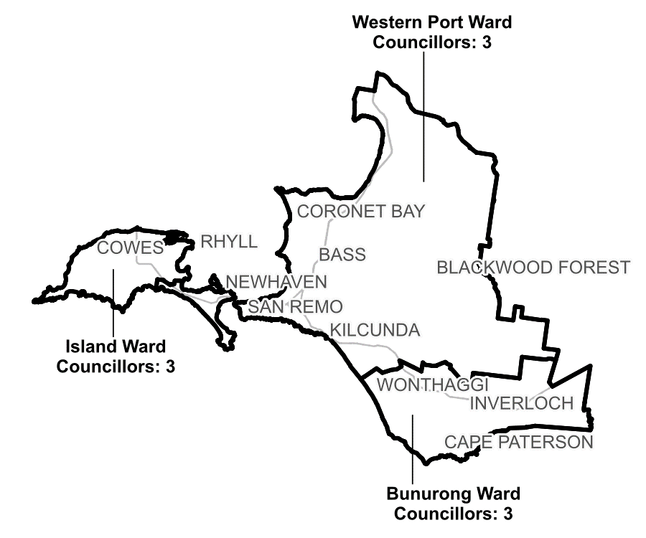

***Figure 1:*** *Diagram of current electoral structure of Bass Coast Shire Council.*

There are an estimated 41,245 voters in Bass Coast Shire Council, with an estimated ratio of 4,583 voters per councillor.

By October 2024, the voter-to-councillor ratio of Bunurong Ward is forecast to be outside +10%, and the voter-to-councillor ratio of Island Ward is forecast to be outside -10%.

Visit the VEC website at [vec.vic.gov.au](https://www.vec.vic.gov.au/electoral-boundaries/local-councils/bass-coast-shire-council) for more information on Bass Coast Shire Council.

## Last electoral structure review

The VEC conducted an electoral representation review of Bass Coast Shire Council in 2015. That review was carried out under the *Local Government Act 1989* (Vic), which was replaced by the *Local Government Act 2020* (Vic).

After conducting the review, the VEC recommended that Bass Coast Shire Council adopt a structure of 9 councillors elected from 3 wards (3 wards with 3 councillors each).

Visit the VEC website at [vec.vic.gov.au](https://www.vec.vic.gov.au/electoral-boundaries/local-councils/bass-coast-shire-council) to read the 2015 representation review final report.

# Preliminary findings and models

## Ward boundary models for public feedback

The VEC considered a range of ward boundary adjustments for Bass Coast Shire Council and chose the strongest 2 models for public consultation.

The following 2 models are presented for community consideration:

* Model 1, which proposes changes to the boundaries of all wards.
* Model 2, which proposes changes to the boundaries of all wards, with different boundaries to Model 1.

Maps of the preliminary models are included in Appendix 1.

### Model 1

Model 1 makes adjustments to the current ward boundaries in 3 areas, which incorporate all of Phillip Island in a single ward and improve the current ward boundary through North Wonthaggi.

Under the current ward boundaries, Island Ward contains most of Phillip Island, except for a small part of the eastern section in Western Port Ward. Model 1 combines all of Phillip Island as a community of interest into the one ward – Island Ward. This single ward creates a more easily identifiable ward boundary for voters while also bringing the ward’s deviations within the legislated +/-10% range for the October 2024 local council elections.

The other change impacts the boundary between Bunurong and Western Port wards through North Wonthaggi.

Currently, this ward boundary divides North Wonthaggi along a minor road and splits a small part of North Wonthaggi into Westernport Ward, while the remainder of North Wonthaggi is within Bunurong Ward. The placement of this ward boundary was necessary at the 2015 review to balance voter-to-councillor deviations across wards, however, population growth since then means this boundary must now be reshaped. Model 1 addresses this by placing the ward boundary along the Bass Highway, which is also the locality boundary between Wonthaggi and North Wonthaggi. This results in a far more identifiable ward boundary and the entire Wonthaggi North locality being captured within a single ward.

The VEC considered options that kept Wonthaggi and North Wonthaggi together in a single ward. However, these resulted in arbitrary divisions in other areas like Inverloch. The strong growth forecasts in Wonthaggi and North Wonthaggi, compared with the rest of the council, meant it was difficult to avoid dividing these two locations without creating boundaries that will need further adjustments in the near future.

The third major change in this model is for the Bunurong-Western Port Ward boundary east of Wonthaggi. Currently this boundary follows a mix of property boundaries and minor roads. In Model 1 this boundary is moved north to follow the Powlett River, resulting in a small number of voters including the community of Wattle Bank being transferred from Western Port Ward into Bunurong Ward. This creates a more recognisable ward boundary and assists in balancing voter-to-councillor deviations across wards.

These adjustments are forecast to bring the deviations of all wards within the legislated +/-10% range by the October 2024 local council elections, and they are expected to remain within this range though to 2028.

### Model 2

Model 2 is similar to Model 1, with the difference being the boundary between the Island and Western Port wards.

In this model, the Newhaven community at the far east of Phillip Island is included in Western Port Ward. This proposed boundary adjustment provides an alternative to Model 1 that groups Newhaven in the same ward as mainland San Remo. This option gives consideration to the connection that these localities may share due to their close proximity and connection via the San Remo Bridge. The VEC is interested in the community’s feedback on this proposal, and whether it appropriately reflects Phillip Island’s communities of interest.

Outside of Phillip Island, Model 2 makes the same boundary adjustments between Bunurong and Western Port wards as are made in Model 1.

As for Model 1, these adjustments are forecast to bring the deviations of all wards within the legislated +/-10% range by the October 2024 local council elections, and they are expected to remain within this range though to 2028.

# Next steps

## Response submissions

Any person or group, including the local council under review, can make a response submission to the VEC. Your submission should address the model or models proposed in this preliminary report.

You can make a submission:

|  |  |
| --- | --- |
|  | **Online** Visit [vec.vic.gov.au](http://vec.vic.gov.au/) and make an account to use the online Public Submission Tool. You may save a draft submission to finish later. |
|  | **By email** [BassCoast.WardReview@vec.vic.gov.au](mailto:BassCoast.WardReview@vec.vic.gov.au) |
|  | **By post**  Ward boundary review panel Victorian Electoral Commission Level 11, 530 Collins St Melbourne VIC 3000 |

The panel must receive all response submissions before 5 pm on Wednesday 6 March 2024. If you post your submission, it must reach the VEC before the deadline. Late submissions will not be accepted.

### Required information

To be considered, your submission must include your:

* full name
* contact phone number or email address
* postal or residential address.

To protect the integrity and transparency of the review process, the VEC will not consider submissions without this information. If you are submitting as a group or organisation, you must include a nominated contact person authorised to submit on behalf of your group.

The VEC will handle information provided by submitters in accordance with its privacy policy at [vec.vic.gov.au/privacy](http://vec.vic.gov.au/privacy)

### Public access to submissions

To ensure transparency in the ward boundary review process, your submission will be published on the VEC website at [vec.vic.gov.au](http://www.vec.vic.gov.au/). The VEC will remove your signature and contact details, including residential and postal addresses, from all public copies but must publish your full name (or group name) and locality (suburb or town).

Please note that any submission content that is potentially defamatory, offensive, obscene or that includes the personal information of people or organisations who are not a party to the submission may also be redacted before publication.

## Public hearing

If you make a response submission, you can also ask to speak at an online public hearing to support your submission and expand on your views.

The online public hearing is scheduled for:

Time: 2 pm

Date: Thursday 14 March 2024

The VEC encourages participation in the public hearing. If you wish to speak at the public hearing, you **must** indicate this in your response submission. The public hearing will not be held if there are no requests to speak.

Anyone can attend a public hearing, but you will only be able to speak if you expressly asked to speak in your response submission. If you ask to speak, the VEC will contact you to arrange a time for you to speak at the hearing. You will have 10 minutes to address the public hearing panel. The members of the public hearing panel may ask you questions.

Visit the VEC website at [vec.vic.gov.au](http://vec.vic.gov.au/) for more information on public hearings.

## Final report

Following the public hearing, the VEC will consider all evidence and prepare a final report for the Minister for Local Government containing recommended ward boundary adjustments for the local council.

The final report is scheduled to be provided to the minister on Wednesday 10 April 2024. The minister will consider the final reports, including any determination to make the reports publicly available. Any change to the ward boundaries of Bass Coast Shire Council following this review is expected to apply at the October 2024 local council elections. Under the Act, the final council electoral structure will be set by an Order in Council published in the Victoria Government Gazette.

# References

ABS (Australian Bureau of Statistics) (2022a) [*Census All persons QuickStats, Bass Coast (LGA)*](https://abs.gov.au/census/find-census-data/quickstats/2021/LGA20740), ABS, accessed 22 January 2024.

—(2022b) [*2021 Census All Persons QuickStats, Rest of Vic. (greater capital city statistical areas)*](https://www.abs.gov.au/census/find-census-data/quickstats/2021/2RVIC), ABS, accessed 22 January 2024.

Geographic Place Names Act 1998 (Vic)

.id (Informed Decisions) (2023) [*Bass Coast Shire*](https://profile.id.com.au/bass-coast/), accessed 22 January 2024.

Local Government Act 1989 (Vic)

Local Government Act 2020 (Vic)

Local Government (Electoral) Regulations 2020 (Vic)

Victorian Aboriginal Heritage Council (VAHC) (2023) [*Registered Aboriginal Parties in Victoria*](https://achris.vic.gov.au/weave/wca.html), Aboriginal Cultural Heritage Council, accessed 29 January 2024.

# Appendix 1: Model maps

The following maps are included in this report:

|  |  |
| --- | --- |
| Map | Page |
| Model 1 – with proposed changes to the boundaries of all wards. | 18 |
| Model 2 – with proposed changes to the boundaries of all wards, with different boundaries to Model 1. | 20 |

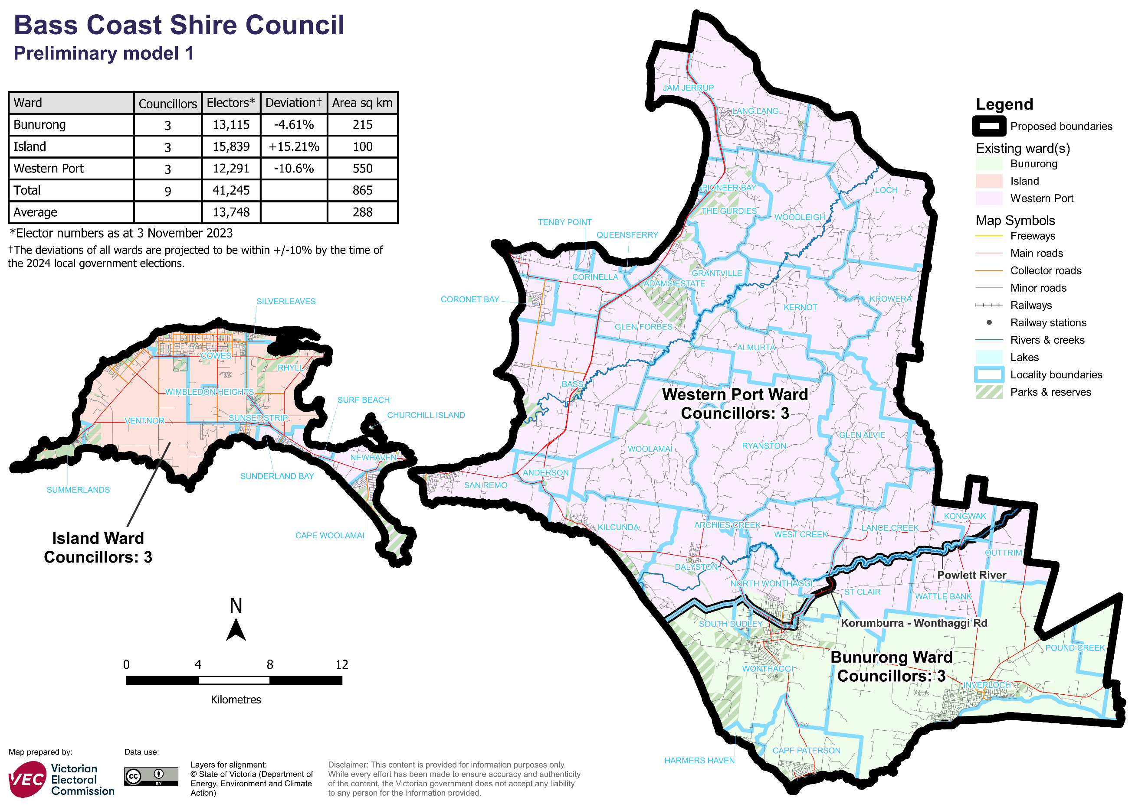

### Data for Model 1

|  |  |  |  |
| --- | --- | --- | --- |
| Ward | Electors* | Deviation† | Area# (square km) |
| Bunurong Ward | 13,115 | -4.61% | 215.1 |
| Island Ward | 15,839 | +15.21% | 99.7 |
| Western Port Ward | 12,291 | -10.6% | 549.8 |
| **Total** | **41,245** | **n/a** | **864.6** |
| **Average** | **13,748** | **n/a** | **288.2** |

*Elector numbers at 3 November 2023

† The deviations of all wards are forecast to be within +/-10% by the time of the 2024 local council elections. The current deviation of some wards may be set outside +/-10% at the time of the review to offset forecast change between the review and the 2024 election.

#Ward area (square km) and total council area is measured at level of accuracy required for electoral boundaries. This may vary slightly from other data sources (for example, the ABS).

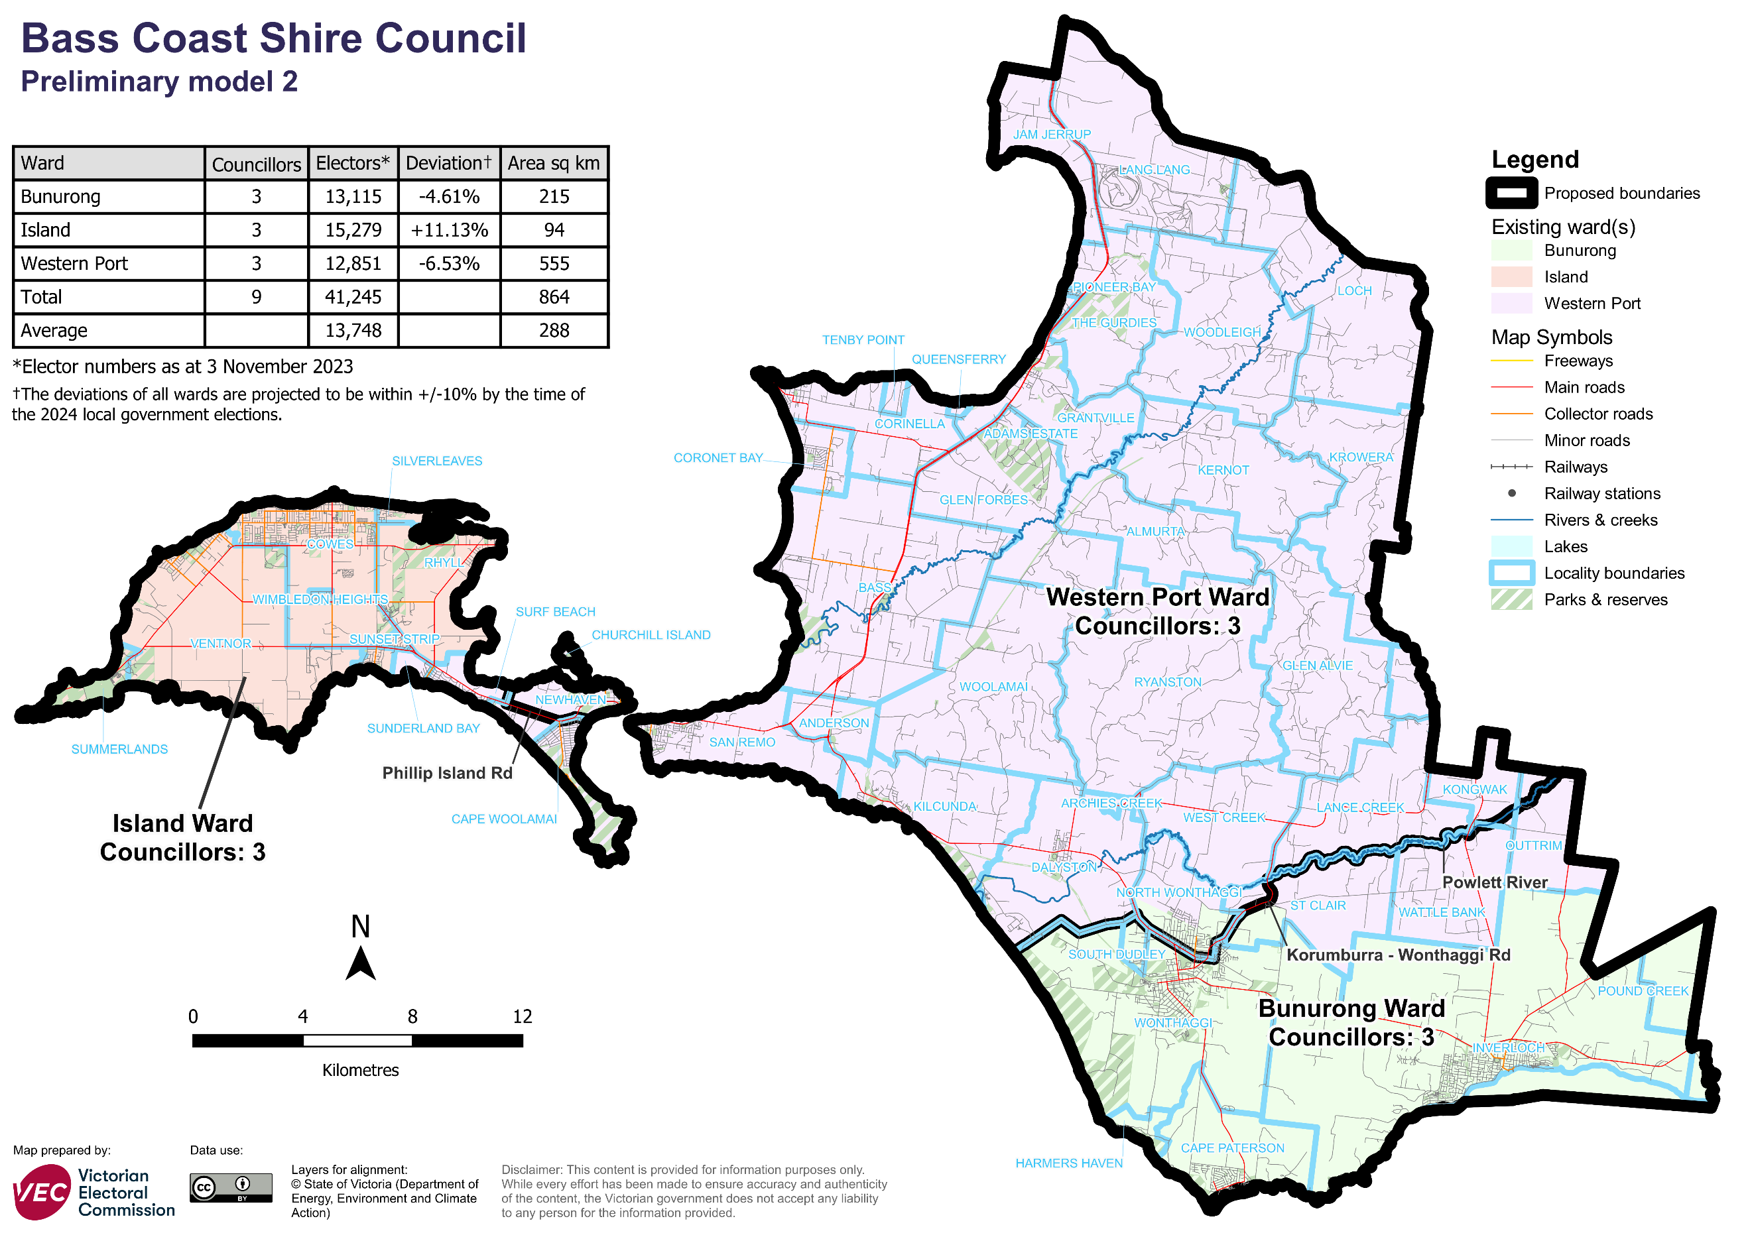

### Data for Model 2

|  |  |  |  |
| --- | --- | --- | --- |
| Ward | Electors* | Deviation† | Area# (square km) |
| Bunurong Ward | 13,115 | -4.61% | 215.1 |
| Island Ward | 15,279 | +11.13% | 94.3 |
| Western Port Ward | 12,851 | -6.53% | 555.2 |
| **Total** | **41,245** | **n/a** | **864.6** |
| **Average** | **13,748** | **n/a** | **288.2** |

*Elector numbers at 3 November 2023

† The deviations of all wards are forecast to be within +/-10% by the time of the 2024 local council elections. The current deviation of some wards may be set outside +/-10% at the time of the review to offset forecast change between the review and the 2024 election.

#Ward area (square km) and total council area is measured at level of accuracy required for electoral boundaries. This may vary slightly from other data sources (for example, the ABS).

Forecast information referred to in the text of this report is based on forecasts prepared by .id – informed decisions [id.com.au](http://id.com.au) .id and its licensors are the sole and exclusive owners of all rights, title and interest subsisting in that part of the report content where .id are identified. Some of .id content is a derivative of ABS Data, which can be accessed from the website of the Australian Bureau of Statistics at [abs.gov.au](http://abs.gov.au), and licensed on terms published on the ABS website.

