Local council electoral structure review

March 2023

Northern Grampians Shire Council

Preliminary   
Report

Acknowledgement of Country

The electoral representation advisory panel acknowledges the Barengi Gadjin and the Dja Wurrung people as the Traditional Custodians of the lands and waters on which it is holding this review and pays respects to ancestors and Elders past, present and emerging. The panel acknowledges their custodianship for many thousands of years and their continuing living culture.

Document history and version control

|  |  |  |  |
| --- | --- | --- | --- |
| **Version** | **Date approved** | **Approved by** | **Brief description** |
| 1 | 14 March 2023 | Electoral Commissioner | Final version |

# Contents

Contents 3

Executive summary 4

Developing electoral structure options 4

Preliminary submissions 4

Electoral structure models for public feedback 4

Next steps………………………………………………………. 4

Background 5

About the 2023–24 electoral structure reviews 5

The electoral representation advisory panel 5

Public engagement 6

Developing recommendations 6

About Northern Grampians Shire Council 9

Profile…………………………………………………… 9

Current number of councillors and electoral structure 10

Last electoral structure review 10

Preliminary submissions 11

Number of councillors 11

Electoral structure 12

Preliminary findings and options 14

Number of councillors 14

Electoral structure 15

Models for public feedback 18

Next steps 19

Response submissions 19

Public hearing 20

Final report…………………………………………………. 20

References 21

Appendix 1: Model maps 22

Appendix 2: Additional models considered 25

Appendix 3: List of preliminary submitters 26

# Executive summary

An independent electoral structure review panel appointed by the Minister for Local Government has reviewed the structure of Northern Grampians Shire Council.

The panel looked at:

* whether the council had an appropriate number of councillors
* whether it should be unsubdivided or subdivided.

This report outlines the preliminary options that the panel is presenting for the proposed new electoral structure of Northern Grampians Shire Council in order to meet the requirements of the *Local Government Act 2020*.

More information about the background to the reviews is available on page 5.

## Developing electoral structure options

The panel considered a range of factors when deciding on the models in this report, including:

* research and analysis
* voter growth or decline over time
* public submissions (see below).

More information on the way the panel decided on the models is available on page 6.

## Preliminary submissions

The panel received 11 preliminary submissions. There were no submissions that included maps.

A full analysis of submissions received can be found on page 11.

## Electoral structure models for public feedback

After considering submissions and research, the panel is presenting the following electoral structure models for further public consultation:

Model 1: an unsubdivided electoral structure with 7 councillors.

Model 2: a subdivided electoral structure with a total of 6 councillors – 3 wards with 2 councillors per ward.

Details on these models, including maps, are available in Appendix 1.

## Next steps

The panel is now seeking feedback on the electoral structure models. You can make a response submission to these models until Wednesday 5 April 2023. If any response submitters wish to speak at a public hearing, the panel will hold an online public hearing on Wednesday 12 April 2023. Following this, it will present its final recommendation to the Minister by Wednesday 10 May 2023. More information about the review process is available on the Victorian Electoral Commission (VEC) website at [vec.vic.gov.au](https://www.vec.vic.gov.au/electoral-boundaries/council-reviews/electoral-structure-reviews/gannawarra/preliminary-submissions)

# Background

## About the 2023–24 electoral structure reviews

In October 2022, the Minister for Local Government formed 2 electoral representation advisory panels to review the electoral structures of 39 local councils, under section 16 of the *Local Government Act 2020* (the Act). If the Minister accepts the electoral structures the panels recommend, they will take effect at the October 2024 elections.

The Act introduced several changes to local government representation, including the types of electoral structures local councils may have. Large and small rural shire councils (including Northern Grampians Shire Council) can have one of 3 electoral structures:

* + unsubdivided (entire council area with no wards)
  + single-councillor wards
  + multi-councillor wards with the same number of councillors per ward.

For Northern Grampians Shire Council, the electoral representation advisory panel is examining:

* the number of councillors
* whether the council should be subdivided into wards or unsubdivided.

For subdivided structures, it is also examining:

* + the number of wards
  + where the ward boundaries should be
  + the name of each ward
  + how many councillors should be elected for each ward.

The Act requires electoral structures to provide fair and equitable representation and facilitate good governance. For subdivided structures, each ward must have an approximately equal number of voters per councillor (within +/-10% of the average).

## The electoral representation advisory panel

The panel conducting the electoral structure review of Northern Grampians Shire Council has 3 members:

* Ms Julie Eisenbise (Chairperson)
* Mr Tim Presnell
* Deputy Electoral Commissioner Ms Dana Fleming (Electoral Commissioner delegate).

The panel is independent of councils and the State government.

Under the Act, the VEC is not responsible for reviewing council electoral structures but must provide administrative and technical support to the panel. The Electoral Commissioner (or their delegate) must be a member of each panel.

## Public engagement

### Public information program

To educate and inform the public about the Northern Grampians Shire Council electoral structure review, the VEC began a public information program in mid-December 2022. The VEC:

* + printed public notices in state-wide newspapers
  + held public information sessions to outline the review process and respond to questions from the community
  + sent out media releases to announce the start of the review
  + published information on its social media channels
  + provided updated website content on [vec.vic.gov.au](https://www.vec.vic.gov.au/electoral-boundaries/council-reviews/electoral-structure-reviews/northern-grampians/preliminary-submissions), including:
    - information on the review process
    - submission guides and fact sheets for each council under review with background information
    - preliminary submissions from the public.

The VEC will continue to promote the review during the response submissions stage via media releases, the VEC’s social media channels and updated content on the VEC website.

### Public consultation

The panel encouraged public input to the review of Northern Grampians Shire Council via preliminary submissions at the start of the review. The panel now invites further input via:

* + response submissions to this preliminary report
  + an online public hearing to provide anyone who makes a response submission the opportunity to expand on their submission.

Public submissions are an important part of the review process but the panel also considers other factors during a review. These are outlined below.

## Developing recommendations

The panel’s electoral structure models presented in this preliminary report comply with the Act and were developed through careful consideration of:

* + research and analysis conducted by the VEC support team, including geospatial and demographic factors
  + rates or patterns of population and voter growth or decline over time, and relevant forecasts of growth or decline based on forecast information provided by .id (informed decisions, a company specialising in demographics and forecasting).
  + input received from the public in written submissions during the preliminary submissions phase.

### Deciding on the number of councillors

The Act allows local councils to have between 5 and 12 councillors, but neither the Act nor the Local Government (Electoral) Regulations 2020 specify how to determine the number of councillors a council needs. Therefore, the models put forward by the panel in this report are guided by the Act’s intention for fairness and equity in voter representation.

In examining the number of councillors Northern Grampians Shire Council should have, the panel considered these factors:

* + the population and number of voters in the council area, compared to other councils with a similar population size and number of voters in the same category (for example, metropolitan, interface, regional city, large rural shire, small rural shire)
  + patterns of population change and voter growth or decline in the council area over time
  + current and past numbers of councillors
  + the representation needs of the communities of interest in the council area
  + if a particular type of electoral structure best suits the council (see ‘Deciding the electoral structure’ below)
  + any matter raised in public submissions not already listed above.

Generally, local councils with a larger number of voters will have a higher number of councillors. Large populations are often more likely to have greater diversity, both in the type and number of communities of interest and issues relating to representation. However, the ideal number of councillors can also be influenced by the particular circumstances of a council, such as the:

* + nature and complexity of services the council provides
  + geographic size and topography of the area
  + forecast population and voter growth or decline
  + social diversity.

### Deciding the electoral structure

The electoral structure of large and small rural shire councils can be:

* + unsubdivided (entire council area with no wards)
  + made up of single-councillor wards

or

* + made up of multi-councillor wards with the same number of councillors per ward.

When developing electoral structure models for Northern Grampians Shire Council, the panel considered these main criteria:

* + whether the structure would comply with section 15(2) of the Act (see below), and for how long it would likely comply
  + the appropriate number of councillors, as outlined above
  + whether meaningful and effective ward boundaries can be established and whether these would be easily identifiable to local communities
  + representation of communities of interest
  + the voter distribution and physical features of the area, and the impact these may have on the shape and size of any wards
  + past elections for the council, including:
    - numbers of candidates nominating
    - incidences of uncontested elections
    - rates of informal voting.
  + other matters raised in public submissions not already listed above.

Under section 15(2) of the Act, subdivided structures must aim for an approximately equal number of voters per councillor in each ward. This means the number of voters represented by each councillor in a ward should be within +/-10% of the average number of voters per councillor for all wards.

The panel recommends structures that will comply with section 15(2) at the October 2024 local government elections and uses current voter numbers and forecasts of population and voter change to assess this with as much accuracy as possible. In some cases, population changes and other factors mean it is not possible for a subdivided electoral structure to comply with section 15(2) based on current voter numbers. If this occurs, compliance at the 2024 local government elections will be the priority to ensure each vote has approximately equal value.

# About Northern Grampians Shire Council

## Profile

Northern Grampians Shire Council is in central-western Victoria, approximately 230 kms from Melbourne. It covers an area of 5,730 km² and shares its borders with Yarriambiack and Buloke shires to the north, the Loddon, Central Goldfields and Pyrenees shires to the east, the Rural City of Ararat and Southern Grampians Shire to the south and the Rural City of Horsham to the west.

The Traditional Custodians of the land within Northern Grampians Shire are the Barengi Gadjin and Dja Wurrung peoples.

### Landscape

The shire borders contain significant national parks, including the well-known Gariwerd (Grampians) in the south-east and Kara Kara in the north-east. The Wimmera River flows in a north-west direction through the shire and the Avoca River comprises part of shire’s eastern boundary.

Stawell and St Arnaud are the 2 largest towns – home to over 70% of the shire’s population. The towns are approximately 74 km apart, with no direct main road connecting them. Smaller towns in the shire include Halls Gap, Great Western, Glenorchy, Navarre and Marnoo (Remplan 2023).

The main transport corridor is the Western Highway, which links Horsham, Stawell and Nhill with Melbourne and Adelaide. The Sunraysia Highway (running north-south) and the Wimmera Highway (running east-west) pass through St Arnaud, providing direct access to Bendigo and Maryborough.

Two rail lines run through the shire. These are the east-west interstate railway line connecting Melbourne and Adelaide, which runs through the towns of Stawell and Glenorchy, and a freight line, which connects Maryborough and Mildura and runs through St Arnaud.

### Community

As is common throughout regional Victoria, the shire’s median age of 49 years is higher than the state average and varies across the shire. Halls Gap has a median age of 45 years, while St Arnaud has a median age of 52 years (ABS 2021). The shire has declined in population, from 12,054 in 2011 to 11,948 in 2021, with this trend forecast to continue. By 2028, the population is projected to be approximately 11,700 (ABS 2021; Remplan 2022).

The unemployment rate in the shire sits at 3.7%, which is lower than the regional Victoria average. The largest contributor to annual economic output in the shire is manufacturing, representing 21.1% of total output. More than half the population participates in the labour force, with the main employment sectors being health care and social assistance (17.7%), agriculture, forestry and fishing (13.2%) and manufacturing (11.5%). Accommodation and food services (7.4%) is an important employment sector in the tourist region of Gariwerd (Grampians National Park) and specifically for the town of Halls Gap (ABS, 2021; Remplan 2022).

Of the population, 81.2% were born in Australia, and 85.9% speak only English at home, which is slightly below the regional Victoria average (ABS 2021). People of Aboriginal and/or Torres Strait Islander heritage are 1.9% of the population, close to the regional Victoria average (2.0%) (ABS 2021).

Across the shire, median personal, family and household incomes are lower than the regional Victoria averages. Home ownership is widespread, with about 48% of homes owned outright and a further 27% owned with a mortgage. Fewer people rent within the shire (20.1%) than in regional and rural Victoria overall (23.6%) (ABS 2021).

## Current number of councillors and electoral structure

Northern Grampians Shire Council is divided into 4 wards with a total of 7 councillors:

* one ward with 3 councillors (Stawell)
* one ward with 2 councillors (Kara Kara)
* 2 wards with one councillor each (Central and South West).

There are currently approximately 10,172 voters in Northern Grampians Shire Council, equating to a ratio of 1,453 voters per councillor.

Visit the VEC website at [vec.vic.gov.au](https://www.vec.vic.gov.au/electoral-boundaries/council-reviews/electoral-structure-reviews/northern-grampians) or more information on Northern Grampians Shire Council.

## Last electoral structure review

The VEC conducted an electoral representation review of Northern Grampians Shire Council in 2020. This representation review was carried out in accordance with the requirements of the *Local Government Act 1989*, which was replaced by the *Local Government Act 2020*.

After conducting the review, the VEC recommended that Northern Grampians Shire Council continue to consist of 7 councillors elected from 4 wards (1 ward with 3 councillors, 1 ward with 2 councillors and 2 wards with 1 councillor).

Visit the VEC website at [vec.vic.gov.au](https://www.vec.vic.gov.au/electoral-boundaries/council-reviews/electoral-structure-reviews/northern-grampians) to access a copy of the 2020 representation review final report.

Prior to the 2020 review, a representation review of Northern Grampians Shire Council was completed in 2007. This resulted in the current electoral structure being implemented. Prior to the 2007 representation review, Northern Grampians Shire Council was comprised of 2 wards with a total of 9 councillors:

* + one ward with 3 councillors
  + one ward with 6 councillors.

# Preliminary submissions

The panel received 11 preliminary submissions from the public by the deadline of 5 pm on Wednesday 15 February 2023. You can view these submissions on the VEC website at [vec.vic.gov.au](https://www.vec.vic.gov.au/electoral-boundaries/council-reviews/electoral-structure-reviews/northern-grampians/preliminary-submissions) and find a list of people or organisations who made a submission in Appendix 3.

The table below provides an overview of preferences in the preliminary submissions. You can read an analysis of submissions below this table.

|  |  |  |  |  |  |
| --- | --- | --- | --- | --- | --- |
|  | Unsubdivided structure | Single-councillor wards | Multi-councillor wards | Subdivided structure (unspecified) | No comment on structure |
| Decreased number of councillors | - | - | 1 | - | - |
| Maintain current councillor number | 3 | - | - | - | - |
| Increased number of councillors | - | - | 1 | - | - |
| No comment on number of councillors | - | - | - | 6 | - |

## Number of councillors

Three submitters proposed retaining the current number of councillors at 7. One submission proposed 2 options – decreasing to 6 councillors or increasing to 9 councillors.

**Maintaining 7 councillors**

Northern Grampians Shire Council argued 7 councillors was appropriate for the geographic size of the shire, its population and its various communities. It also stated the current number of councillors had proved fit for purpose and any reduction would disenfranchise some communities of interest and jeopardise fair representation.

Geraldine Ryan took the same position as the council in proposing a 7-councillor structure, based on it being one of the larger ‘smaller’ rural councils.

The St Arnaud Lions Club submitted that a change in current councillor numbers would reduce the interaction with councillors.

**Changing current councillors**

A submission from Peter Rose proposed 2 options:

* Reducing the councillors to 6 to allow the formation of a 3-ward council structure.
* Increasing to 9 councillors because councillor workloads and travel times were too much for 7 councillors. Rose argued this currently discourages people from standing for council.

## Electoral structure

Three submitters favoured an unsubdivided electoral structure, while the remaining 8 broadly supported keeping a subdivided ward structure.

### Unsubdivided

The submissions from Northern Grampians Shire Council, Geraldine Ryan and Sarah Cole supported an unsubdivided electoral structure consisting of 7 councillors.

Ryan argued this structure would better enable councillors to understand the issues impacting communities of interest in the shire and encourage a shire-wide approach to representation.

In its submission, Northern Grampians Shire Council argued an unsubdivided ward structure would:

* reduce the chance of uncontested elections
* provide a greater choice of diverse candidates at election time
* remove the requirement for future ward boundary changes to maintain the voter-to-councillor ratio within the +/-10% tolerance.

The council summarised its submission by expressing that an unsubdivided municipality better ensures all communities of interest would be represented.

Three submissions presented opposing views, suggesting an unsubdivided ward structure would be unfavourable for the council and community representation. Peter Rose argued that an unsubdivided shire would be unrealistic, given that St Arnaud and Stawell have no shared communities of interest.

### Subdivided

Eight submissions proposed the council keep a subdivided ward structure, arguing it provides better representation for the different communities across the entire council region.

One submitter (Anthony Kumnick) commented that a multi-councillor ward structure would better represent communities that may otherwise not have a voice.

Similarly, Bruce Ahchow argued that ward structures would ensure the shire’s distinct communities of interest are properly represented.

A submission from Anne Hughes argued that the current 3-ward structure has resulted in too much focus on Stawell and the south-west part of the shire. To better align the communities of interest, Hughes proposed a 2-ward structure, with 4 councillors in the Stawell region (southern ward) and 4 councillors in the St Arnaud region (north-eastern ward).

Rose’s detailed submission proposed a 3-ward model and argued that Central Ward, created at the 2007 representation review, does not capture or represent a geographic or demographic community of interest. Because Central Ward covers almost half of the shire (from Banyena to the edge of Stawell and along the Western Highway), the residents at both ends have different orientations and communities of interest. One way to restore balance, Rose proposed, was to abolish this ward and move to a 3-ward, 6-councillor structure.

In its submission, Northern Grampians Shire Council argued that the 2 options available under a subdivided ward structure were not preferable because:

* single-councillor wards would require Stawell and St Arnaud each to have multiple wards, with arbitrary boundaries
* multi-councillor wards would require an even number of councillors, resulting in a higher or lower ratio of council representation than appropriate.

# Preliminary findings and options

## Number of councillors

After taking into consideration the requirements of the Act, public submissions and the agreed criteria, the panel found either 6 or 7 councillors to be an appropriate number of councillors for Northern Grampians Shire Council.

The panel considered the characteristics of the shire in relation to similar rural shire councils, including its size and geography, population and the number and distribution of voters across the shire.

|  |  |  |  |  |  |  |
| --- | --- | --- | --- | --- | --- | --- |
| Similar rural shire councils to Northern Grampians Shire Council | | | | | | |
| Local council | Area (km2) | Number of voters at 2020 election | Population (2021 Census) | Current total estimate of voters | Number of councillors | Number of voters per councillor |
| Alpine Shire | 4,788 | 11,169 | 13,235 | 11,566 | 7 | 1,652 |
| Central Goldfields Shire**\*** | 1.553 | 11,169 | 13,483 | 11,329 | 7 | 1,618 |
| Strathbogie Shire**\*** | 3.303 | 9,806 | 11,455 | 10,963 | 7 | 1,566 |
| Mansfield Shire | 3,844 | 10,205 | 10,178 | 10,910 | 5 | 2,182 |
| Northern Grampians | 5,730 | 10,424 | 11,948 | 10,172 | 7 | 1,453 |
| Gannawarra Shire**\*** | 3,738 | 9,129 | 10,683 | 9,449 | 7 | 1,350 |
| Ararat Rural City | 4,211 | 8,955 | 11,880 | 9,002 | 7 | 1,286 |
| Pyrenees Shire | 3,435 | 7,063 | 7,671 | 7,233 | 5 | 1,447 |
| Loddon Shire | 6,696 | 7,072 | 7,759 | 7,146 | 5 | 1,429 |

*This local council is undergoing an electoral structure review during 2023–24.

### Maintaining 7 councillors

The panel considered population and voter data, comparing it to similar Victorian local councils and other factors such as communities of interest and special circumstances. The panel determined that the voter-to-councillor ratio of 1,453 for Northern Grampians Shire Council was similar to other rural Victorian shire councils with 7 councillors.

### Changing councillor numbers

The panel noted limited support to change the current number of councillors. At a voter-to-councillor ratio of 1,695 the panel considered 6 councillors could be justified on the basis that it provides for an appropriate multi-councillor ward electoral structure.

## Electoral structure

To identify the most appropriate electoral structure, various factors were considered. This included the requirements of the Act, the communities of interest in Northern Grampians Shire, public submissions, the appropriateness of ward boundaries and which models best offered fair and equitable representation.

In developing the preliminary models presented in this report, a range of models were considered. The strongest 2 models have been put forward for further public comment.

Diagrams of the preliminary models are included in Appendix 1.

The past 2 general council elections have had consistently low candidate numbers and uncontested wards:

* At the 2020 general election, there were 5 candidates in total. Central, Kara Kara and Stawell wards were uncontested and South West ward failed.
* At the 2016 general election, there were 10 candidates in total. Central, Kara Kara and South West wards were uncontested.

While uncontested elections could mean voters are satisfied with an elected candidate, they may not support fair and equitable representation because voters do not have a choice of representatives.

### Unsubdivided structure (Model 1)

Under this model, Northern Grampians Shire Council would adopt an unsubdivided electoral structure, represented by 7 councillors.

The panel considered the main advantages of an unsubdivided electoral structure to be:

* providing voters with a greater choice of candidates at election time
* reduce the likelihood of uncontested elections
* retaining 7 councillors.

In an unsubdivided electoral structure, all candidates would be required to achieve the same quota of votes to be elected. This structure would encourage candidates to appeal to voters across the whole shire.

This structure could also lead to a reduction in uncontested elections and, with no internal ward boundaries, there would be no need for future boundary adjustments to ensure the structure complied with the Act.

Several submissions suggested an unsubdivided structure would lead to a concentration of candidates from the town of Stawell. However, this is not necessarily the case as in an unsubdivided electoral structure, candidates are elected using the proportional representation method. This means there is one quota of votes that all candidates must achieve to be on the council. In many cases this quota (number) is well below the threshold required for election in a ward structure.

The panel acknowledged the possibility that candidates from less-populated areas might have difficulties connecting with voters in more populated parts of the shire. However, a candidate with local support would have a reasonable chance of achieving the quota in an unsubdivided structure.

### Multi-councillor ward structure (Model 2)

Under this model, Northern Grampians Council would adopt a 3-ward structure. Each ward would be represented by 2 councillors, in line with the requirement of the *Local Government Act 2020* (Vic) for there to be the same number of councillors per ward.

Acknowledging that 8 submissions proposed a subdivided or multi-ward council, the panel spent time considering the most viable multi-councillor ward model.

There has been a history of local support for a ward-based electoral structure, evident in past representation reviews. One of the panel’s objectives was to choose a compliant subdivided structure that would best serve the communities of interest.

The panel chose a model of 6 councillors elected from 3 wards, with 2 councillors in each ward, for further public comment. The panel considered this multi-councillor ward structure beneficial as it minimised the division of towns by ward boundaries. Although the town of Stawell is divided in this model, the division follows the rail line, which provides a clear and logical boundary. Also, Stawell would no longer be contained solely in one ward and would include connected rural areas, mitigating possible concerns over wards being Stawell centric. The western boundary of the current South West Ward moves north to the intersection of the shire boundary and Stawell-Warracknabeal Road to create a new Central Ward boundary. The northern boundary line for the new Central Ward follows a series of roads, from the town of Crowlands in the south-east through to the intersection of Bismark-Lybeck and Glenorchy roads in the north-west. Kara Kara Ward increases in size from 1,796 km² to 3,268 km² to accommodate 2 councillors and ensures St Arnaud remains intact.

The panel considered the advantages of Model 2 to be:

* the potential to reduce uncontested elections
* its support in several public submissions
* its ability to sustain uneven growth across council wards.

### Models considered but not put forward

#### A multi-councillor ward model with 2 wards and 3 councillors per ward

The panel considered a model of 6 councillors elected from 2 wards, with 3 councillors in each ward (see Appendix 2). The panel found this model less balanced than a 3-ward structure. It would group Stawell with Great Western in one ward covering 216 km², and the rest of the shire in a ward that covered 5,514 km² that stretched from Halls Gap in the south through to St Arnaud in the north.

Following deliberation, the panel decided the geographic communities of interest were not clearly reflected in a 2-ward structure. Although this structure was supported by one submission, the panel considered a 3-ward structure a more balanced model for the broader communities of interest in the shire

#### A single-councillor ward model with 7 councillors

The panel considered a model of 7 single-councillor wards (see Appendix 2), because it would maintain the current councillor numbers, and the ward boundaries in the mapping model supported infrastructure and followed geographical features.

It was acknowledged that this model appeared to capture communities of interest but was not considered worthy of further public comment.

To balance voter-to-councillor ratios Stawell would need to be divided into 4 wards and St Arnaud into 2 wards. There were serious reservations about dividing the main towns of the shire to this degree and that creating arbitrary boundaries in each town may cause disharmony in these 2 communities. This model also received no support in any of the submissions, with several submissions preferring a multi-councillor ward structure.

## Models for public feedback

The panel considers all models outlined below to offer fair and equitable representation for voters in Northern Grampians Shire Council. Please see Appendix 1 for detailed maps of these models.

### Model 1

Northern Grampians Shire Council has an unsubdivided electoral structure with 7 councillors.

### Model 2

Northern Grampians Shire Council has 6 councillors and is divided into 3 wards with 2 councillors per ward.

### Ward names

The panel has suggested ward names to identify the wards in model 2 and invites comments from the community on these names as part of submissions responding to the preliminary report.

# Next steps

## Response submissions

Any person or group, including the local council under review, can make a response submission to the electoral representation advisory panel. In your submission, you should address the options proposed by the panel in this preliminary report.

You can make a submission:

|  |  |
| --- | --- |
|  | **Online** Visit [vec.vic.gov.au](http://vec.vic.gov.au/" \o "The VEC website) to make a submission online.  You will need to make an account to use the online Public Submission Tool and can save a draft submission to finish later. |
|  | **By email** [NorthernGrampians.ERAPSubmissions@vec.vic.gov.au](mailto:NorthernGrampians.ERAPSubmissions@vec.vic.gov.au) |
|  | **By post**  Electoral Representation Advisory Panel c/o Victorian Electoral Commission Level 11, 530 Collins St Melbourne VIC 3000 |

The VEC must receive all response submissions before 5 pm on Wednesday 5 April 2023. If you post your submission, make sure it has enough time to reach the VEC before the deadline. Late submissions will not be accepted.

### Required information

For your submission to be considered, you must include your:

* full name
* contact phone number or email address
* postal or residential address.

The panel will not consider submissions without this information. If you are submitting as a group or organisation, you must include the name of a nominated contact person who is authorised to submit on behalf of your group.

The VEC will handle information provided by submitters in accordance with the privacy policy available at [vec.vic.gov.au/privacy](http://www.vec.vic.gov.au/privacy).

### Public access to submissions

To ensure transparency in the electoral structure review process, your submission will be published on the VEC website at [vec.vic.gov.au](https://www.vec.vic.gov.au/electoral-boundaries/council-reviews/electoral-structure-reviews/northern-grampians/preliminary-submissions). The VEC will remove your signature and contact details, including residential and postal addresses, from all public copies but must publish your full name (or group name) and locality (suburb or town).

## Public hearing

If you make a response submission, you can also ask to speak at an online public hearing to support your submission and expand on your views.

The online public hearing is scheduled for:

Time: 2 pm

Date: Wednesday 12 April 2023

The panel encourages participation in the public hearing. If you wish to speak at the public hearing, you **must** indicate this in your response submission. The public hearing will not be held if there are no requests to speak.

Anyone can attend a public hearing, but you will only be able to speak if you asked to in your response submission. If you ask to speak, the VEC will contact you to arrange a time for you at the hearing. You will have 10 minutes to address the public hearing panel, which will include at least 2 of the review panel members. The members of the public hearing panel may ask you questions.

Visit the VEC website at [vec.vic.gov.au](https://www.vec.vic.gov.au/electoral-boundaries/council-reviews/electoral-structure-reviews/northern-grampians/preliminary-submissions) for more information on public hearings.

## Final report

Following the public hearing, the review panel will consider all evidence gathered and publish a final report for the Minister for Local Government containing a recommendation for the number of councillors and the electoral structure for the local council.

The final report is scheduled to be published on Wednesday 10 May 2023. If the recommendation is accepted, any changes will apply at the October 2024 general council elections.

The final report will be available on the VEC website at [vec.vic.gov.au](https://www.vec.vic.gov.au/electoral-boundaries/council-reviews/electoral-structure-reviews/northern-grampians/preliminary-submissions) or you can request a printed copy by calling 131 832.

# References

Australian Bureau of Statistics. (2021). *Census 2021 All persons QuickStats, Northern Grampians*.  
<https://www.abs.gov.au/census/find-census-data/quickstats/2021/LGA25810> accessed 19 January 2023.

Australian Bureau of Statistics. (2021). *Census 2021 All persons QuickStats, Stawell*.  
<https://www.abs.gov.au/census/find-census-data/quickstats/2021/SAL22354> accessed 9 February 2023.

Australian Bureau of Statistics. (2021). *Census 2021 All persons QuickStats, St Arnaud*.  
<https://www.abs.gov.au/census/find-census-data/quickstats/2021/SAL22334> accessed 9 February 2023.

Australian Bureau of Statistics. (2021). *Census 2021 All persons QuickStats, Halls Gap*.  
[https://www.abs.gov.au/census/find-census-data/quickstats/2021/SAL21127 accessed 9 February 2023](https://www.abs.gov.au/census/find-census-data/quickstats/2021/SAL21127%20accessed%209%20February%202023).

*Local Government Act 1989* (Vic)

*Local Government Act 2020* (Vic)

*Local Government (Electoral) Regulations 2020* (Vic)

Northern Grampians Shire Council. (2023). *Economic Development Plan & Strategy 2021*.  
<https://www.ngshire.vic.gov.au/Business/Business-Investment/Economic-Development-Strategy-and-Plan> accessed 30 January 2023.

Northern Grampians Shire Council. (2023). *About Northern Grampians*.  
<https://www.ngshire.vic.gov.au/Council/About-Northern-Grampians> accessed 18 January 2023

Remplan. (2023). *Northern Grampians Shire Council. Economy, Jobs and Business Insights*.  
<https://app.remplan.com.au/northerngrampians/economy/summary?state=pW7RFx9Xas2YvKWU6xqO2DIQHJH8GM> accessed 27 January 2023.

Remplan. (2023). *Northern Grampians Shire Council. Our Place – Our Community.*  
<https://app.remplan.com.au/northerngrampians/community/summary?state=4mYgUmr3efxKKpvTqn4J9zFVuJukJ7> accessed 27 January 2023.

# Appendix 1: Model maps

The following maps are included in this report:

|  |  |
| --- | --- |
| Map | Page |
| Model 1 – an unsubdivided electoral structure with 7 councillors | 23 |
| Model 2 – a multi-councillor ward structure with 6 councillors, 3 wards and 2 councillors per ward | 24 |

Forecast information in the text of this report is based on forecasts prepared by .id – informed decisions [id.com.au](http://id.com.au) .id and its licensors are the sole and exclusive owners of all rights, title and interest subsisting in that part of the report content where .id are identified. Some of .id content is a derivative of ABS Data, which can be accessed from the website of the Australian Bureau of Statistics at [abs.gov.au](http://abs.gov.au), and licensed on terms published on the ABS website.

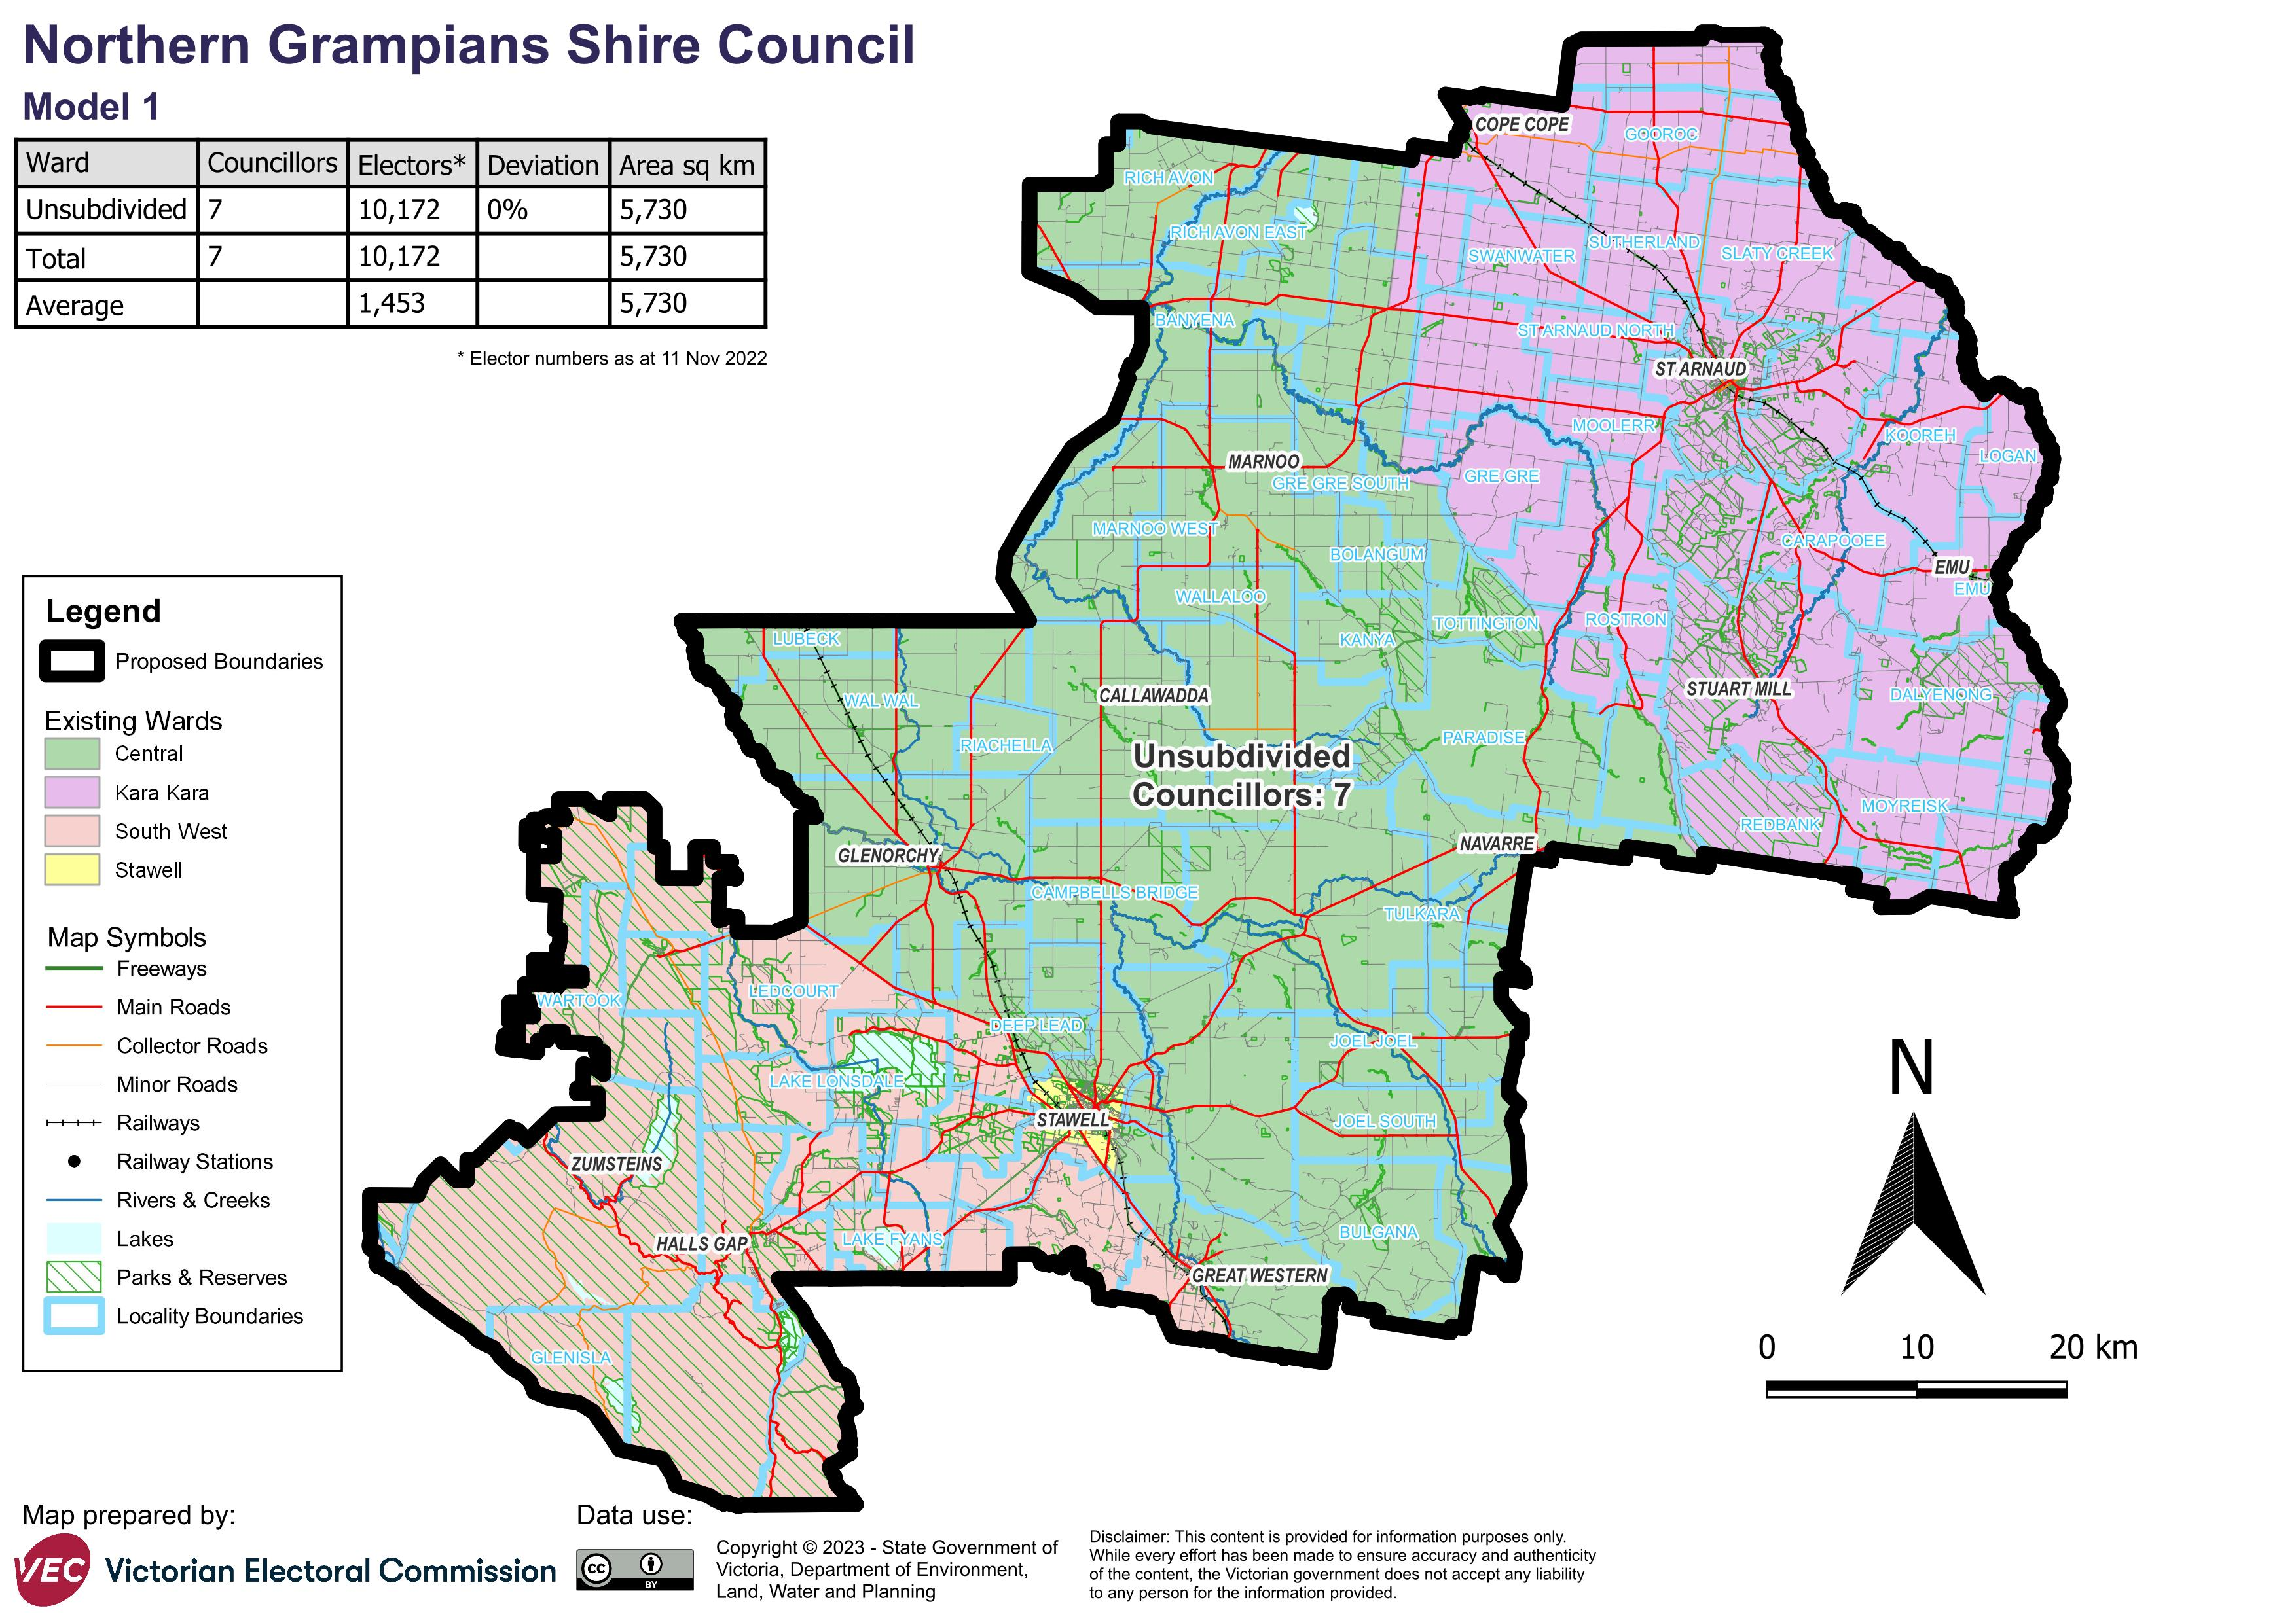

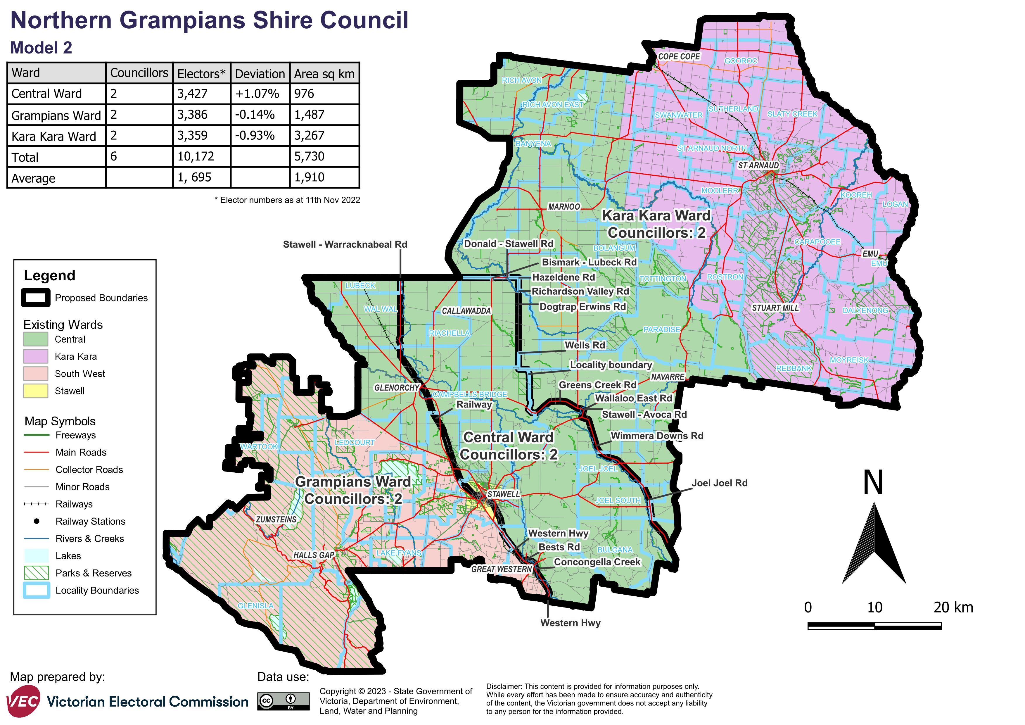

# Appendix 2: Additional models considered

The following models were closely considered by the panel but are not being put forward for further public consultation. See Models considered but not put forward for further information.

#### A multi-councillor ward model with 2 wards and 3 councillors per ward

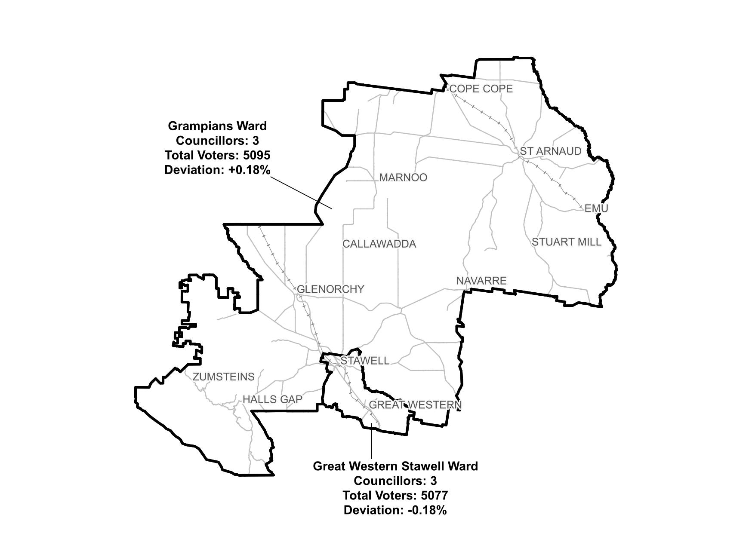

#### A single-councillor ward model with 7 councillors

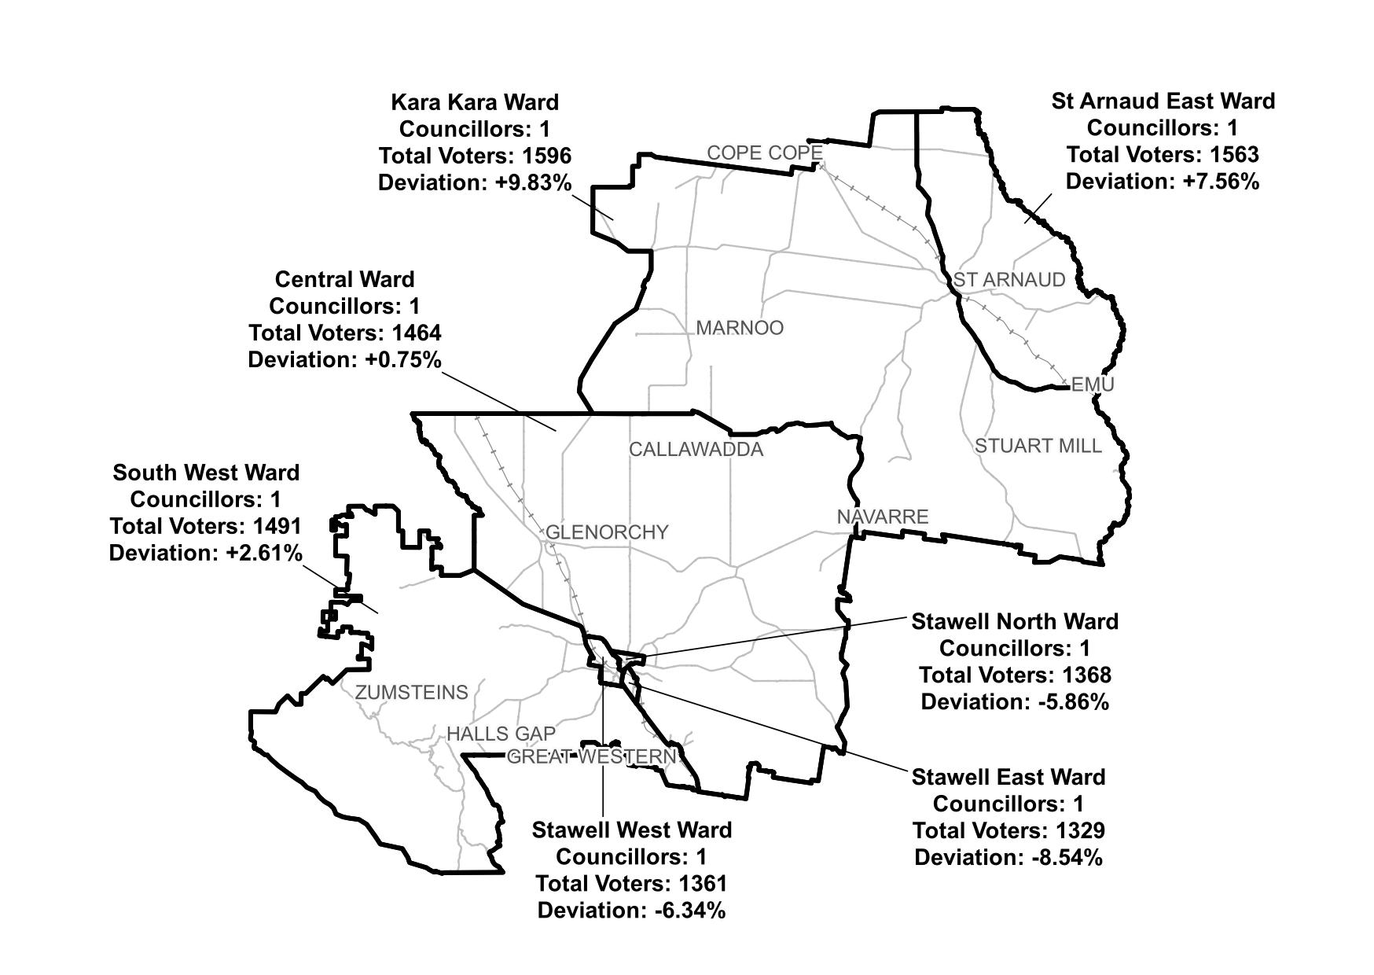

# Appendix 3: List of preliminary submitters

The review received 11 preliminary submissions.

Preliminary submissions were made by:

Ahchow, Bruce

Blatchford, Trevor

Cairns, Brian

Coates, Colin

Coles, Sarah

Hughes, Anne

Kumnick, Anthony

Northern Grampians Shire Council

Rose, Peter

Ryan, Geraldine

St Arnaud Lions Club