ELECTORAL REPRESENTATION REVIEW
Loddon Shire Council
Final Report
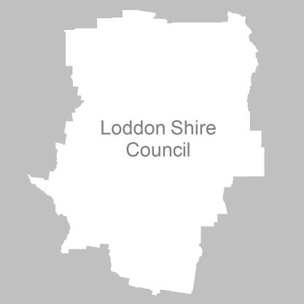
25 May 2011

Contents
Recommendation 3
Background 4
Legislative basis 4
The VEC and Electoral Representation Reviews 4
Profile of Loddon Shire Council 4
Current electoral structure 5
The electoral representation review process 5
VEC research 6
Public involvement 6
Preliminary report 8
Preliminary submissions 8
Preliminary options 9
Public response 11
Response submissions 11
Analysis of submissions 11
Public hearing 12
Findings and Recommendation 14
Number of councillors 14
Electoral structure 14
Summary 16
Recommendation 17
Appendix 1: List of submitters 18
Appendix 2: Map 19

Recommendation
The Victorian Electoral Commission (VEC) recommends that
Loddon Shire Council consists of five councillors to be elected from
five single-councillor wards.

Background

Legislative basis
The Local Government Act 1989 (the Act) requires the VEC to conduct an Electoral Representation Review of each municipality in Victoria at least every 12 years. The Act specifies that the purpose of a representation review is to recommend to the Minister for Local Government the number of councillors and the electoral structure for a municipality, which will provide ‘fair and equitable representation for the persons who are entitled to vote at a general election of the Council’.
The Act requires the VEC, as part of an electoral representation review, to consider:
- the number of councillors in a municipality;
- whether a municipality should be unsubdivided or subdivided;
- if it should be subdivided, whether ward boundaries:
  - provide for fair and equitable division of the municipality;
  - ensure equality of representation through the number of voters being represented by each councillor being within 10 per cent of the average number of voters represented by all councillors; and,
- if it should be subdivided, the number of councillors that should be elected for each ward.

The VEC and Electoral Representation Reviews
The VEC has conducted electoral representation reviews since 2004 on appointment by local councils. The Act was changed in 2010 to define the VEC as the only agency authorised to undertake the reviews.
The VEC drew on its experience in mapping and boundary modelling and also engaged consultants with experience in local government to provide advice on specific local representation issues during the review.

Profile of Loddon Shire Council
Loddon Shire was formed in 1995 by the amalgamation of the Shires of East Loddon and Korong, parts of the Shires of Gordon, Bet Bet, Maldon and Tullaroop, and part of the Rural City of Marong.
At the 2006 census, the Shire recorded a population of 7,836 people. According to the Department of Planning and Community Development’s Victoria in Future projections, the population of Loddon Shire will decline by 2.55 per cent by 2020.

Current electoral structure
The last Electoral Representation Review for Loddon Shire Council took place in
2004–2005. Following the review, the Minister for Local Government determined the structure of Loddon Shire Council would be:
- five councillors;
- divided into four wards — Boort Ward, Kooyoora Ward, Terrick Ward and Wedderburn Ward; and,
- with two councillors from the Kooyoora Ward and one councillor from each of the remaining wards.

The electoral representation review process
The VEC proceeded on the basis of three main principles:
- Ensuring the number of voters represented by each councillor is within 10 per cent of the average number of voters per councillor for that municipality.
Populations are continually changing. Over time these changes can lead to some wards having larger or smaller numbers of voters. As part of the review, the VEC corrected any imbalances and also took into account likely population changes to ensure these boundaries provide equitable representation until the next review.
- Taking a consistent, State-wide approach to the total number of councillors.
The VEC was guided by its comparisons of municipalities of a similar size and category to the Council under review. The VEC also considered any special circumstances that may warrant the municipality to have more or fewer councillors than similar municipalities.
- Ensuring communities of interest are as fairly represented as possible.
Each municipality contains a number of communities of interest and, where practicable, the electoral structure should be designed to take these into account. This allows elected councillors to be more effective representatives of the people in their particular municipality or ward.
The recommendation is based on:
- internal research specifically relating to the municipality under review;
- VEC experience from its work with other municipalities and in similar reviews for State elections;
- VEC expertise in mapping, demography and local government;
- careful consideration of all public input in the form of written and verbal submissions received during the review; and,
- advice received from consultants with wide experience in local government.
Public submissions were an important part of the process, but were not the only consideration during the review. The VEC seeks to combine the information gathered through public submissions with its own research and analysis of other factors, such as the need to give representation to communities of interest. The recommendation is not based on a ‘straw poll’ of the number of submissions supporting a particular option.

VEC research
In addition to the information provided in submissions, the VEC created a profile of the municipality based on population trends, development projections and demographic indicators. The VEC used the Australian Bureau of Statistics 2006 census community profiles, the Department of Planning and Community Development projections and voter statistics from the Victorian electoral roll. The VEC also undertook field work to view current and possible boundaries for each of the options presented in the preliminary report to evaluate their effectiveness.

Public involvement
The VEC values the local knowledge and perspectives presented by the public in written submissions. The public were given two opportunities to provide submissions during the review. Their input was considered by the panel in forming the options in the preliminary report and they were also invited to respond to these options. In addition, a public hearing was held to enable people to speak in support of their submissions and supplement it with information.
To ensure transparency in the process, all written submissions were published on the VEC website and all verbal submissions were heard in a public environment.
To raise awareness of the review and encourage the public to engage with the process, a full public information campaign was undertaken.

Advertising
In accordance with sections 219F(4) and 219F(7) of the Act, the VEC ensured public notices were placed in local newspapers.
Notification of the review appeared in the Loddon Times and Bendigo Advertiser on Wednesday, 9 February 2011. The notice detailed the process for the review and called for public submissions. A general notice covering several reviews was printed in The Age and the Herald Sun on Tuesday, 1 February 2011.
Notification of the release of the preliminary report appeared in the Loddon Times and Bendigo Advertiser on Wednesday, 30 March 2011. The notice detailed the options contained in the preliminary report, including a map of each option, instructions on how to access a copy of the preliminary report and how to make a submission in response to the report.

Media release
The VEC produced two media releases for this review. The first release, distributed to local media through the Council, provided information on the review and overall process. A second release, distributed to local media by the VEC, detailed the options in the preliminary report and how to make a submission in response to the report.Public information session
The VEC held a public information session for people interested in the review process on Monday, 21 February 2011 at the Serpentine Council Chamber, 37 Peppercorn Way, Serpentine.

Information brochure and poster
An information brochure was provided to the Council to be distributed to residents through the Council’s network, such as in libraries and service centres. A poster was provided to the Council to be displayed in public spaces.

Helpline
A dedicated helpline was established to assist with public enquiries concerning the review process.

VEC website
The VEC website delivered up-to-date information to provide transparency during the preliminary and response stages of the review process. All submissions were posted on the website and an online submission tool was created to facilitate the submission process. The preliminary report was available for electronic download on the website.

Guide for submissions
A guide for submissions was developed and distributed to those interested in making submissions. Copies of the guide for submissions were available on the VEC website, in hardcopy on request, and were provided to the Council.

Preliminary report
In accordance with the Act, the VEC produced a preliminary report outlining its proposed options for Loddon Shire Council. The report was released on Wednesday,
30 March 2011.

Preliminary submissions
Submissions were received from three residents of Loddon Shire (from the localities of Pyramid Hill and Laanecoorie), from an individual outside the Shire and from three organisations — Loddon Shire Council, the Pyramid Hill Progress Association, and the Proportional Representation Society of Australia.
Three submissions called for the formation of five single-councillor wards. Submitters suggested that a single-councillor ward structure would allow residents to establish a relationship with their representative, who can in turn take their views to Council, whereas it can be difficult to know which councillor to contact in an unsubdivided or multi-councillor ward structure. Several submitters also argued that the current structure leads to an inequitable workload for the two councillors in Kooyoora Ward.
The submission from Loddon Shire Council supported the five single-councillor ward structure but mentioned that an electoral structure containing six single-councillor wards may also be appropriate.
Three submitters supported an unsubdivided municipality. The submitters argued that all councillors should be elected using the one counting method. The Act requires councillors in a multi-councillor ward or an unsubdivided municipality to be elected through proportional representation and councillors in single-councillor wards through preferential allocation of votes. Under the current structure, the two councillors for Kooyoora Ward are elected using the proportional representation method while councillors in the single-councillor wards are elected through the preferential allocation of votes in their ward. Both systems require the voter to choose a preference for all candidates. Submitters believed an unsubdivided municipality, using the proportional vote counting method, was the fairest way of achieving equal voting power across the municipality. One submitter mentioned that an unsubdivided municipality would lead to the fewest possible ‘wasted’ votes.
Finally, one submitter believed the current structure was effective and argued to retain the status quo. The submitter believed that the risk with an unsubdivided municipality was that councillors might be too far away from their constituents to effectively engage and represent their issues. The submitter also argued that wards are used to define communities of interest and encourage shared decision-making within the ward.
A list of submitters, by name, is available in Appendix 1. Copies of the submissions can be viewed on the VEC website at vec.vic.gov.au.

Preliminary options
The VEC assessed a range of electoral representation models that may suit Loddon Shire. The VEC considered the projected population change, the desire to maintain communities of interest and the number of voters and number of councillors compared with other rural municipalities, such as the Shires of Pyrenees, Mansfield and West Wimmera. Three options were developed for public consultation.
Loddon Shire sits comfortably in the band of municipalities that have five councillors. There were no arguments raised in submissions that directly supported changing the number of councillors and, with a slight decline in population projected, the VEC has only considered five-member options.
In considering possible boundaries, the VEC referred to population projections provided by the Department of Planning and Community Development, which anticipate a slight decline in the Shire’s overall population. The Act requires individual wards to be within +/- 10 per cent of the average number of electors per councillor across the municipality as a whole. Due to changes in population within the ward since the previous review, the VEC needed to address some wards that were likely to move outside of the accepted +/- 10 per cent tolerance. This meant, as a minimum, slight adjustments to particular ward boundaries were required.
The preliminary report also noted that industry in Loddon Shire is predominantly based around agricultural activities, presenting a strong commonality across the Shire. However, this was also balanced with the large number of local towns, which each have a particular identity, that service the vast area of farmland.
Of the three options put forward in the preliminary report, the preferred option (Option A) recommended Loddon Shire retains the current electoral structure, but with slightly adjusted ward boundaries. The VEC noted Option A had the advantage of bringing the wards safely within the tolerance level accepted under the Act and caused the least disruption to voters. The two alternative options put forward for public discussion affected a larger number of voters because of more significant boundary shifts (for Option B) and the change to an unsubdivided structure (for Option C). Consequently, the preliminary report recommended Option A as the VEC’s preferred option but, based on the suggestions contained in preliminary submissions, the report provided the two alternative options to test through the public consultation process.

The options were:
- Option A (Preferred Option) that Loddon Shire Council consist of five councillors to be elected from four wards, with two councillors elected for one ward and one councillor elected for each of the remaining wards. Small adjustments for population change should be made to the current ward boundaries.
- Option B (Alternative Option) that Loddon Shire Council consist of five councillors to be elected from five single-councillor wards.
- Option C (Alternative Option) that Loddon Shire Council consist of five councillors to be elected by the municipality at-large (an unsubdivided municipality).

Public response

Response submissions
Response submissions on the electoral representation review of Loddon Shire Council opened on Wednesday, 30 March 2011 and closed at 5.00pm on Friday, 29 April 2011. The VEC received eight response submissions. Table 1 shows the levels of support for each option based on the preferences expressed in each response submission.
Table 1: Preferences expressed in response submissions for each option.
Option A  (Preferred Option) | Option B  (Alternative Option) | Option C  (Alternative Option) | Other
1 | 4 | 2 | 1

Analysis of submissions
One submission supported Option A (Preferred Option), which proposed five councillors elected from one two-councillor ward and three single-councillor wards (the status quo model). The submission detailed the community activity among the residents of Kooyoora Ward, and, in particular, their relationship with Kooyoora State Park. The submission supported Option A, the status quo model, though the submitter asked for modifications to the boundary to keep the Park within Kooyoora Ward.
Four submissions supported Option B (Alternative Option), which proposed five councillors elected from five single-councillor wards. The submissions that supported this option, including that of the Loddon Shire Council, noted the advantage of local representation for local issues. The submissions argued that a shift to five single-councillor wards would provide fairer representation for residents. In addition, the Council’s submission noted that the workload for councillors in the multi-councillor ward was excessive and out of proportion to the single-councillor wards. The Council suggested that this issue would be addressed by splitting the current multi-councillor ward into two single-councillor wards.
Two submissions supported Option C (Alternative Option), which proposed an unsubdivided municipality with all five councillors elected by the voters at-large. The Proportional Representation Society argued that the unsubdivided option permits greater voting power across the municipality for the most number of voters with fewer ‘wasted’ votes, i.e. the most number of votes are used to elect candidates. The Society also added that an unsubdivided structure is less likely to return candidates unopposed at local council elections. An individual submission from Councillor Allen Brownbill supported Option C as it would be likely to return fairer participation within the Council’s own decision-making procedures. The submission argued that there are common characteristics across the municipality — and therefore, no particular communities of interest require special representation.
Shire resident Mr John Hancock did not support any of the options being considered by the VEC. Mr Hancock’s submission argued that an introduction to proportional representation for Loddon Shire would best be achieved by merging the current Boort, Terrick and Wedderburn Wards to create one three-councillor ward covering the north of the municipality, and retaining the two-councillor Kooyoora Ward in the south of the municipality. The submission noted that this would allow the ‘Northern Ward’ to experience the benefits of proportional representation and ‘prepare’ the Shire for a future unsubdivided structure (such as Option C) or annexation with other municipalities.
A list of submitters, by name, is available in Appendix 1. Copies of the submissions can be viewed on the VEC website at vec.vic.gov.au.

Public hearing
A public hearing was held in the Serpentine Council Chamber on Wednesday, 4 May 2011 at 6.30pm. All submitters who responded to the preliminary report were invited to speak to their submissions. The Loddon Shire Council and Mr Hancock accepted.
The Chief Executive Officer, Mr John McLinden, spoke on the Council’s behalf and argued in support of Option B — five single-councillor wards — on the basis that single-councillor wards provided equitable representation for voters across the Shire. The Council submitted that the Shire is made up of many proud and parochial communities — the largest having only 600–800 people — and residents expect councillors to attend all events within their own ward. The Council felt single-councillor wards ‘guaranteed’ local representation, allowing councillors to bring local knowledge to Shire-wide decision-making. Mr McLinden noted that, under Option A in the preliminary report, there was no natural division of responsibilities in the proposed Bridge Ward, which would provide significant workload issues for those councillors. The panel asked Mr McLinden if the Council had considered the impact of the proposed boundary change between Boort Ward and Wedderburn Ward, which moved Korong Vale into Boort Ward to return it to safely within the +/- 10 per cent tolerance. Mr McLinden noted that while this was not ideal, residents were still likely to be represented by the councillor representing Wedderburn Ward. In addition, the Council submitted that Option B, if adopted, would be sustainable until the next review.
Mr Hancock believed, amongst other things, that the Shire could be split into two wards with three councillors in the ‘Northern Ward’ and two in the ‘Southern Ward’. The submitter argued that proportional representation, which was instituted in the current Kooyoora Ward following the previous review, would be beneficial for the whole of the Shire as it would push the Council to consider voters’ needs and focus on larger issues, such as drainage and flooding. Mr Hancock argued that a ‘natural boundary’ through Serpentine separates the north of the Shire from the south and the two areas faced different local issues. In addition, he tabled a number of documents highlighting aspects of the review that were considered by the panel, including a diagram showing the distribution of current community representatives in the municipality. Mr Hancock noted that as communities in Loddon Shire were used to having local representation, a two-ward structure could help to prepare residents for a future unsubdivided structure (outlined in the VEC’s Option C).

Findings and Recommendation
The VEC consulted on three options, including, as its preferred option, retaining the status quo. This report has summarised the process the VEC completed to gather information, including public submissions, and to develop and consult on the options under consideration. The VEC now provides its findings for recommendation to the Minister.

Number of councillors
As part of its electoral representation review, the Act requires the VEC to recommend the appropriate number of councillors for Loddon Shire. The Act allows for a municipality to have between five and 12 councillors. Currently, with five councillors, Loddon Shire sits near the top of the band of rural councils with five councillors.
No arguments were raised in submissions that directly supported increasing the number of councillors; although the Council’s own preliminary submission advised, as a second preference, it would support a shift to six councillors. While Loddon Shire is one of the largest municipalities in the area in Central Victoria, a slight decline in population is projected. In addition, the VEC has a preference for an odd number of councillors in order to reduce the likelihood of tied votes on Council as, in the event of a tied vote, the Mayor has a casting vote. This effectively gives one councillor twice the voting power as the others and the VEC does not believe that such a situation is conducive for providing fair and equitable representation. For these reasons, the VEC did not put forward any options that would increase the number of councillors.
Accordingly, the VEC recommends a Council of five councillors for Loddon Shire Council.

Electoral structure
The Act requires the VEC to recommend an appropriate electoral structure within the municipality. The VEC considers whether a municipality should be unsubdivided or subdivided into wards and, if subdivided, the positioning of ward boundaries and the number of councillors to be elected for each ward to provide fair and equitable division and ensure equality of representation. Currently, the municipality is divided into four wards, with three single-councillor wards and one two-councillor ward. The options put forward by the VEC included:
- retaining the current structure with slightly adjusted boundaries;
- create five single-councillor wards; and,
- an unsubdivided structure.
All of the options were put forward in the preliminary report as they were considered to be most likely to meet the VEC’s main electoral representation review principles. In addition, the VEC looked for longevity in the boundaries — allowing options which contained wards to carry through to the next scheduled electoral representation review without the need for a subdivision review in the interim. The VEC was conscious that the variation of population change between within a municipality can make ward structures more vulnerable to deviating outside the tolerance accepted under the Act. While this is unlikely to occur in Loddon Shire, as the population forecasts project a slight decline over time, the preliminary report observed Loddon Shire has experienced subtle shifts in population that have affected the ward tolerances.
While the preliminary report noted commonalities that exist across the Shire, such as the prevalence of farming activity, as well as the consistent economic and demographic profile, submitters raised additional issues that were isolated to particular areas within the municipality, and would be more suited for local representation, such as the strong identities held by local communities, as well as flooding and farming irrigation issues. Consequently, the VEC is not prepared to recommend an unsubdivided option for the municipality, proposed as Option C in the preliminary report.
The VEC does not support the alternative model to create a ‘North Ward’ (with three councillors) and a ‘South Ward’ (with two councillors model) suggested by a response submitter. Although the north and south of the municipality may face some different issues, the VEC believes that effective representation through the introduction of this model would not be achieved. The suggestion was put forward on the basis of a transition to an unsubdivided municipality with the introduction of proportional representation.
The VEC also noted concerns expressed in submissions related to the drawing of boundaries around Kooyoora State Park in Options A and B. A response submitter, who was not present at the public hearing, requested the VEC to consider the placement of the boundary around Kooyoora State Park to keep the park within the proposed ‘Bridge Ward’ under Option A as there is a greater connection between the park and the community in this ward. Evidence was presented at the Public Hearing that suggested the Park is significant to the municipality as a whole, rather than any particular ward, as it is used by large numbers of visitors from outside of the Shire. Therefore, the VEC notes that adjustments to the ward boundary are primarily to keep the wards within the +/- 10 per cent tolerance accepted in the Act and maintain clear and sensible ward boundaries, which prompted the VEC to use locality boundaries that intersect the eastern edge of the Park.
A strong theme through preliminary and response submissions noted concerns about the unequal workload among Loddon Shire councillors as a result of the current two-councillor Kooyoora Ward. The Council’s submission, among others, identified an expectation that councillors actively participate in all events within their ward, meaning councillors in the more populous, two-councillor ward have greater ward responsibilities than their single-councillor ward colleagues. The VEC recognises that while workload is generally a matter for individual councillors, a ward structure can have an impact on the capacity of councillors to adequately represent their local communities. The VEC acknowledges that the preferred option in the preliminary report would not address these workload concerns, but is of the view that other alternatives to resolve the issue, such as a sharing arrangement between the two councillors, could be explored.
In 2005, the VEC considered an option for five single-councillor wards. Accordingly, at the previous review, the model was provided for public consultation in the preliminary report as the least preferred (or ‘second alternative’) option. Given slight population changes within the Shire since 2005, the VEC is of the view that five single-councillor wards, using the boundaries provided in Option B, accommodate communities of interest and do not divide the communities of Inglewood and Bridgewater, as originally proposed in the option put forward in the previous review. Option B also groups the communities in the south of the municipality together into the proposed Tarnagulla Ward. Had this option been available at the time of the last review, this would have been the VEC’s preferred option.
Finally, the VEC notes that there may be an appetite among residents for future reviews to consider an unsubdivided structure for Loddon Shire.

Summary
The VEC believes Option B (Alternative Option), with five single-councillor wards provides the most effective electoral structure for the residents of Loddon Shire. The municipality consists of a large rural community serviced by a number of small towns where local demands on councillors are significant. While there are merits in an unsubdivided electoral structure, the demand for local representation on local issues outweighs the advantages of an at-large Council in the current environment. For these reasons, the VEC recommends Option B (Alternative Option) from the preliminary report.

Recommendation
The Victorian Electoral Commission (VEC) recommends that Loddon Shire Council consists of five councillors to be elected from the following five single-councillor wards:
- Boort Ward (a current ward with slightly adjusted boundaries);
- Inglewood Ward (formed from the northern part of the current Kooyoora Ward, with slightly adjusted boundaries);
- Tarnagulla Ward (formed from the southern part of the current Kooyoora Ward, with slightly adjusted boundaries);
- Terrick Ward (a current ward with slightly adjusted boundaries); and,
- Wedderburn Ward (a current ward with slightly adjusted boundaries).

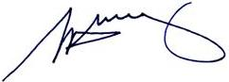
S. H. Tully
Electoral Commissioner

Appendix 1: List of submitters
Preliminary submissions were received from:
Name
L Allan
J D Brooke
A Brownbill
Loddon Shire Council
A Mann
Proportional Representation Society of Australia (Victoria-Tasmania) Inc.
Pyramid Hill Progress Association

Response submissions were received from:
Name
A Brownbill
J Hancock*
Loddon Shire Council*
L May
P McEwen and E Bradley
Proportional Representation Society of Australia (Victoria-Tasmania) Inc.
T and M Ralph
B Rodwell
* Indicates those submitters who spoke in support of their submission at the public hearing on Wednesday, 4 May 2011.

Appendix 2: Map
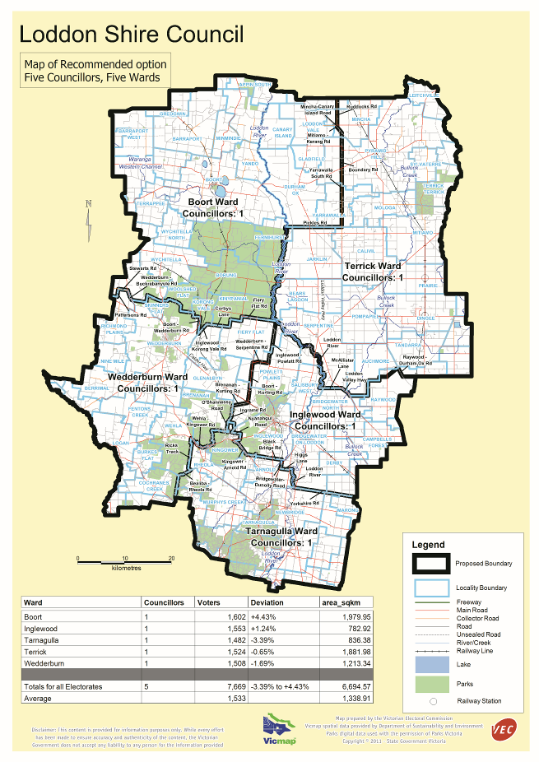

Victorian Electoral Commission
Level 8, 505 Little Collins Street
Melbourne, Vic 3000

131 VEC (131 832)
info@vec.vic.gov.au
vec.vic.gov.au

Section 219D of the Local Government Act 1989.

