Victorian Electoral Commission Report on the Melbourne District by-election held on 21 July 2012

October 2012

LETTER OF TRANSMITTAL
The Honourable Bruce Atkinson, MLC President of the Legislative Council
The Honourable Ken Smith, MP Speaker of the Legislative Assembly
I am pleased to submit to you, for presentation to Parliament, this report on the conduct of the Melbourne District by-election held on 21 July 2012.
The report is presented in accordance with section 8(2)(b) of the Electoral Act 2002.


Liz Williams
Acting Electoral Commissioner October 2012

Victorian Electoral Commission Level 11
530 Collins Street Melbourne Victoria 3000
Tel: +61 3 8620 1100 Fax: +61 3 9629 8632
Email: info@vec.vic.gov.au
vec.vic.gov.au
This publication is available online at vec.vic.gov.au
ABN 46 583 749 552 ISBN 978-0-9804629-9-9
©State of Victoria 2012
This publication is copyright. No part may be reproduced by any process except in accordance with the provisions of the Copyright Act 1968.
Please address all feedback and enquiries to the Victorian Electoral Commission.

CONTENTS

Executive Summary
i
1 2
4 4 4 4 5 5
6
6 6 6 7
7 7 8 8 9
10
10 10
11 11
12 12 12 12 12 13 13 13
14 14 15 15
15 15 15
16 16 17 17
18
20
22
23
32
34
38
1. Snapshot Participation
2. Background The writ
Election timetable
Preliminary arrangements with other agencies The former member
The electorate
3. Budget
4. Election personnel Election Manager
Support for Election Manager Recruitment and training
5. Services to electors
Enrolment
Services for electors with special needs
Services for electors from non-English speaking backgrounds Arrangements for voting before election day
Voting on election day
6. Services to registered political parties and candidates Candidate support
Registration of how-to-vote cards
By-election briefi ngs for parties and candidates
7. Communication services Direct mail
Newspaper advertising Telephone enquiry service Media relations
Email information Social media Website
8. Electronic roll mark-off
9. Counting the votes
10. Declaration of result, return of the writ
11. Participation Enrolment Turnout Informal voting
12. Refund of nomination deposits
13. Electoral entitlements
14. Enforcement of compulsory voting
15. Complaints
Appendix A: Detailed voting statistics
Appendix B: Distribution of preference votes
Appendix C: Two candidate preferred results (ALP and Greens)
Appendix D: Communication products
Appendix E: Voter Participation
Appendix F: Analysis of informal votes
Appendix G: Electronic roll mark-off statistics

EXECUTIVE SUMMARY

A by-election for the Melbourne State District was triggered by the resignation, on 7 May 2012, of the sitting member, the Honourable Bronwyn Pike, MP.
The election-ready positioning of the Victorian Electoral Commission (VEC), its planning, processes and systems and the strong capabilities of VEC staff meant that the VEC was able to conduct this by-election at short notice without critical disruption to the preparations for the 2012 council elections in October. Solid partnerships with our efficient and reliable suppliers and contractors also feature as a key component of the successful conduct of the Melbourne District by-election on 21 July 2012.
Compulsory voting follow-up has commenced, so costs have not been finalised at the time of printing. It is anticipated that the by-election will be conducted well within budget.
A communication campaign that included a householder letter and a range of newspaper advertisements helped ensure that electors were aware of details of the by-election, their voting options and the result. Information was available in a range of languages and through an interpreter telephone service.
Sixteen candidates nominated for the by-election. The Australian Labor Party, the Democratic Labor Party, the Australian Greens, the Australian Christians, Family First and the Australian Sex Party each endorsed
a candidate. Ten independent candidates also nominated. Jennifer Kanis, the candidate for the Australian Labor Party — Victorian Branch, who polled 33.38% of the first preference votes, was elected at the 14th exclusion.
The turnout rate of 68.62% for the by-election was lower than the turnout rate of 86.93% for Melbourne District in the 2010 State election. The turnout rate for the Melbourne by-election was lower than the average turnout of 81.35% for the six most recent State by-elections (excluding Melbourne). Detailed information about the participation rate is included as Appendix E.
The informality rate of 9.34%, with 16 candidates, was an increase on the informality rate of 3.69% for the Melbourne District with seven candidates at the 2010 State election. The informality rate was also higher than the average informality rate of 7.75% for the six most recent State by-elections (excluding Melbourne). An analysis of the informal votes has been conducted and is included as Appendix F.
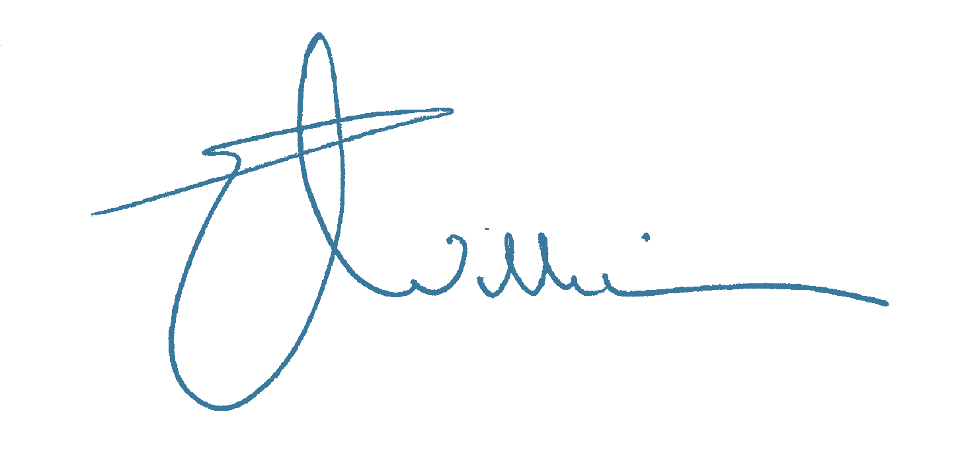
I take this opportunity to thank all VEC staff, contractors and suppliers, Election Manager, Chris Browne and Assistant Election Managers, Rose McVicar and Ted Marks for their contributions to the very successful conduct of the Melbourne District by-election.

Liz Williams
Acting Electoral Commissioner

i
1. SNAPSHOT

First preference votes (% of first preference votes)
4.04%

3.01%

0.24%

4.66%

0.52%

0.57%

0.58%

1.87%

0.74%

4.74%

0.74%

0.61%

6.56%

1.22%
33.38%

36.52%

1
AHMED, Berhan

FENN, Ashley (Family First)

SCHOREL-HLAVKA, Gerrit Hendrik

NOLTE, David

PERKINS, John

KANIS, Jennifer
(ALP)
COLLYER, David James

O'CONNOR, Patrick

MURPHY, Michael
(DLP)

TOSCANO, Joseph

MAYNE, Stephen

BORLAND, Kate

WHITEHEAD, Adrian
PATTEN, Fiona
(Sex Party)
OKE, Cathy
(Greens)
BENGTSSON, Maria (Australian Christians)

Two candidate preferred vote (ALP and Greens)

KANIS, Jennifer (ALP) 51.37%

OKE, Cathy (GREENS) 48.63%

Results after distribution of preferences

KANIS, Jennifer (ALP) 51.51%

OKE, Cathy (GREENS) 48.49%

Participation
Participation at Melbourne District by-election 2012
7,815

2,878
44,889

30,803

27,925

Total enrolment

Total votes

Votes before election day

Formal votes

Informal votes

Voter turnout at Victorian State by-elections 2007–12 (% of total enrolment)
68.62%

84.80%

78.45%

86.02%

83.20%

84.93%

70.67%
Melbourne District
21 July 2012
Niddrie District
24 March 2012
Broadmeadows District
19 Feb 2011
Altona District
13 Feb 2010
Kororoit District
28 Jun 2008
Williamstown District
15 Sept 2007
Albert Park District
15 Sept 2007

2

Informal votes at Victorian State by-elections 2007–12 (% of total votes)
4.96%

6.30%

6.79%

7.47%
11.48%

25.37%

23.63%

22.39%

26.80%

23.14%
9.34%

9.50%
Melbourne District
21 July 2012
Niddrie District 24 March 2012
Broadmeadows District
19 Feb 2011
Altona District
13 Feb 2010
Kororoit District
28 Jun 2008
Williamstown District
15 Sept 2007
Albert Park District
15 Sept 2007

Pre-poll votes at Victorian State by-elections 2007–12 (% of total votes)
19.56%

Postal votes

3
11.15%

Early votes
8.41%

Votes cast before election
12.16%
13.21%

10.30%
13.33%

11.78% 10.61%

10.39%
15.87%

6.13%
17.01%

6.92%
10.37%
17.29%

Melbourne District
21 July 2012

Niddrie District
24 March 2012

Broadmeadows District
19 Feb 2011

Altona District
13 Feb 2010

Kororoit District
28 Jun 2008

Williamstown District
15 Sept 2007

Albert Park District
15 Sept 2007
2. BACKGROUND

The writ Preliminary arrangements
with other agencies
The Speaker of the Legislative Assembly issued a writ for the by-election for Melbourne District on Monday, 28 May 2012. The writ set out the timetable for the by-election.

Election timetable
Issue of the writ Monday, 28 May 2012
Nominations opened Tuesday, 29 May 2012
Close of roll 8.00 pm, Monday
4 June 2012
Close of nominations 12 noon, Thursday (party candidates) 21 June 2012
Close of nominations 12 noon, Friday (independent candidates) 22 June 2012
Early voting commenced 4.00 pm, Friday
22 June 2012
Registration of how-to-vote 8.30 am, Monday cards opened 25 June 2012
Registration of how-to-vote 12 noon, Friday cards closed 13 July 2012
Postal vote applications 6.00 pm, Thursday closed 19 July 2012
Early voting closed 6.00 pm, Friday
20 July 2012
Election day voting 8.00 am – 6.00 pm
Saturday, 21 July 2012
Results From 6.00 pm, Saturday
21 July 2012
Return of the writ On or before 10 August 2012
(returned 1 August 2012)

4
Victorian Civil and Administrative Tribunal
The VEC made preliminary arrangements with the Victorian Civil and Administrative Tribunal (VCAT) to ensure that any matters relating to how-to-vote cards could be heard within a 24 hour period.
The VEC thanks VCAT for its support during the election.

Victorian Government Solicitor’s Office
The VEC made preliminary arrangements with the Victorian Government Solicitor’s Office (VGSO) to have a senior legal advisor on standby 24 hours a day during the election period, to ensure that any matters were dealt with in a timely fashion.
The VEC thanks the VGSO for its support during the election.

Victoria Police
The VEC contacted the Chief Commissioner of Police to request a discreet police presence at all voting centres during the hours of voting on election day. The VEC provided a full list of all voting venues to Victoria Police to assist with this request.
The VEC formally records its appreciation for the support received from the Chief Commissioner and Victoria Police.

Supreme Court
The VEC made preliminary arrangements with the Supreme Court, through the Department of Justice to ensure that a Practice Court and presiding judge would be available to hear any applications for injunctions if the need arose on election day.
The VEC thanks the Department and the Supreme Court for its support.

The former member
Historical pattern of the District
1955 – present: Australian Labor Party

Past results for Melbourne District
2010 State election results
The Honourable Bronwyn Pike, MP, represented the District of Melbourne from 1999 to 2012 and
was Minister of Education in Victoria in the Brumby Government. Ms Pike was appointed the Minister for Housing and Aged Care and Minister Assisting the Health Minister in the Bracks Government.
In 2002, Ms Pike was appointed as Minister for Community Services and Minister Assisting the Premier on Community Building.
Elected Member PIKE, Bronwyn
Total Enrolment 43,916
Formal Votes 36,767
Informal Votes 1,409
Total Votes 38,176

Candidate First preference
votes PIKE, Bronwyn (ALP) 13,116
LAZZARI, Peter 231
FENSOM, Maxine 142
MARTIN, Luke (Liberal) 10,281
WALTERS, Brian (Greens) 11,735
KILLEN, Roy (Sex Party) 1,061
PERKINS, John L. 201

2006 State election results
Elected Member PIKE, Bronwyn
Total Enrolment 38,853
Formal Votes 31,750
Informal Votes 1,214
Total Votes 32,964

Candidate First preference
votes COLLINS, Isabell (People Power) 526
DI NATALE, Richard (Greens) 8,704
PIKE, Bronwyn (ALP) 14,149
GEBBING, Rebecca (Family First) 496
PAPAS, Steve (Liberal) 7,009
CHAMBERLIN, Kevin F 866
3.69%
86.93%

%

35.67%
0.63%
0.39%
27.96%
31.92%
2.89%
0.55%

3.68%
84.84%

%

1.66%
27.41%
44.56%
1.56%
22.08%
2.73%

5
The electorate
Melbourne District is a central metropolitan electorate covering an area of approximately 31 square kilometres. It includes the suburbs or localities of Carlton, Carlton North, East Melbourne, Flemington, Kensington, Newmarket, North Melbourne, Parkville,
West Melbourne and parts of Ascot Vale.
The District encompasses densely populated residential areas and the city’s business precinct. Its features include Royal Park, the Zoological Gardens, the Fitzroy Gardens, Princes Park, the MCG, Parliament House, the Museum of Victoria, the University of Melbourne, the Queen Victoria Market, the Royal Agricultural Society Showground and the Flemington Racecourse.

Map of the District

Baroda St

PARKVILLE
CARLTON
NORTH
I
NORTH MELBOURNE
CARLTON

MELBOURNE DOCKLANDS

Yarra River
Ascot Vale Rd
Langs Rd
Leonard Cr
Fisher Pde
FLEMINGTON
KENSINGTON

WEST MELBOURNE
I
I
3. 4.
BUDGET ELECTION PERSONNEL

Election Manager
Ms Chris Browne was appointed the Election Manager for Melbourne District.
The Election Manager was responsible for:
• staffing the election office
• receiving candidate nominations
• conducting the draw for ballot paper positions
• dealing with electoral enquiries
• appointing voting centre managers and election officials
The VEC estimated a marginal cost of $400,000 for the conduct of the Melbourne District by-election.
This includes expenses and obligations related to salaries of temporary election personnel, advertising, and associated infrastructure including office accommodation, transport and office requisites. An additional $50,000 was allowed for electoral entitlements.

• training voting centre managers
• receipt of how-to-vote cards for registration by the VEC
• supervising voting, and receiving and recording results
• declaring the election.
The Election Manager was assisted by VEC staff and other election officials.

Support for Election Manager
Ms Rose McVicar and Mr Ted Marks were appointed as Assistant Election Managers.
The VEC supported the Election Manager through the provision of:
• advice on election management
• office equipment and furniture, computers, telephones and fax machines, ballot boxes, voting screens and voting centre furniture
• help desk support and assistance for the VEC’s election management system and with other technical issues
• electoral materials, including voting centre and office forms and manuals
• a voter information campaign for the by-election
• assistance with public and media relations
• netbooks for use in voting centres.

6
5.
SERVICES TO ELECTORS

Enrolment
Recruitment and training
A total of 159 staff (including the Election Manager and two Assistant Election Managers) were appointed for the by-election.
Of these, 113 were appointed as election officials at voting centres on election day. A further 43 election casuals were appointed by the Election Manager to assist with early voting at the early voting centres, mobile voting, and administrative duties including counts conducted at the election office.
A three-hour training session was conducted for the voting centre managers, assistant voting centre
managers, early voting centre managers and election liaison officers. The Election Manager and Assistant Election Managers had previous recent election experience and did not require additional training.
Mobile early voting centre team leaders received training prior to commencing work.
One VEC staff member provided dedicated help desk support to the Election Manager and Assistant Election Managers during the election period.
The day after the issue of the writ for Melbourne District, the VEC sent written notification of the by-election to every household in the electorate. The letter advised that, since a by-election would be held soon, eligible people who were not on the electoral roll should enrol, and those who had recently moved should update their enrolment details. This provided four working days
for electors to ensure that they were correctly enrolled and eligible to vote in the by-election.
Enrolment advertisements were placed in both major daily papers (see Appendix D for sample communication products).
Enrolment forms could be downloaded from the VEC website (vec.vic.gov.au), and printed copies were available from Australia Post offices, Australian Electoral Commission (AEC) divisional offices or by contacting
the VEC election office.
The VEC election office remained open until 8.00 pm on Monday, 4 June 2012. The VEC also made arrangements with the AEC Melbourne office to remain open until 8.00 pm on Monday, 4 June 2012.
Between the issue of the writ and the close of rolls, 1,568 electors enrolled or updated their enrolment details. At the close of roll, there were 44,889 electors enrolled, 973 more than at the close of roll for the 2010 State election.

7

Services for electors from non-English speaking backgrounds
Services for electors with special needs
In line with the VEC’s Disability Action Plan, assistance services, including braille ballot papers upon request, were provided to electors with special needs at the Melbourne District by-election.
Every early voting centre and election day voting centre was rated, using an audit tool, according to its wheelchair accessibility. The audit tool complies with relevant Australian Standards and addresses building access as well as the availability of accessible parking and the approach to the building.
Both early voting centres were rated as ‘Assisted Wheelchair Accessible’.
Of the 14 election day voting centres in Melbourne District, two were ‘Fully Wheelchair Accessible’ and 12 were rated ‘Assisted Wheelchair Accessible’.
The rating of all voting centres was listed in press advertisements, on the EasyVote letter sent to electors and on the VEC’s website. The lack of fully accessible voting centres for lease continues to be of concern to the VEC.

8
According to the Australian Bureau of Statistics 2011 Census, 10.21% of the usually resident population of Melbourne District were reported as speaking English not well or not at all. English was stated as the only language spoken at home by 51.5% of persons usually resident in Melbourne District.
According to the 2011 Census, two or more languages are spoken in 45.6% of households within Melbourne District, which is nearly double the rate for Victoria as
a whole. The most common languages other than English spoken at home were: Mandarin, Cantonese, Indonesian, Vietnamese and Italian.
Advertising in print media included multi-lingual telephone enquiry service numbers that operate all year round. These included the five most common languages spoken in Melbourne District.
These numbers were also incorporated on the enrolment and voting letters sent to householders/electors in Melbourne.
Translated introductory information on the by-election was recorded on each of the language lines advertised. Callers were able to hold the line for interpreter assistance via a three-way phone call between the staff at the Victorian Interpreting and Translating Service, the VEC and the caller.
Electors could also access voting instructions translated into 21 languages (including English) placed inside each voting screen. Across 12 of the 14 election day voting centres, 31 election staff spoke a language other than English and were on hand to assist with interpreting where required.

Arrangements for voting before election day
Voting interstate and overseas
Early voting services were provided at seven interstate locations and at one overseas location.
Some 41 early votes were cast outside Victoria for the Melbourne District by-election. This compares with 342 for the District for the 2010 State election.

Postal voting
Electors unable to attend a voting centre on election
day could apply for a postal vote. Postal vote applications were available to download at vec.vic.gov.au, and could be obtained at any post office in the District or by calling the VEC.
Postal vote applications were also printed and distributed by the Australian Labor Party and the Greens.
Four postal votes were issued outside the State for the Melbourne District by-election. This compares with 105 at the 2010 State election.
To help ensure the efficient delivery of ballot packs, postal vote applications were processed on the day they were received by the VEC. As postal vote applications may be received up until 6.00 pm on the Thursday prior to the election, the VEC contacted anyone whose application was received on that day to advise them that their vote had to be postmarked before or on election day to be included in the count, and to inform them of their voting options.
A total of 3,993 postal vote applications plus 514 votes cast by General Postal Voters were processed, and 3,745 postal votes were counted for the by-election.
Figure 1 shows the percentage of total votes that were cast before election day.
Early voting
Electors unable to vote on election day had the opportunity to vote early at the early voting centres located at the Australian Electoral Commission (AEC) Melbourne office and the VEC’s Melbourne early voting centre in Melbourne District.
The early voting centres for the Melbourne District by-election were located at:
• AEC Melbourne Early Voting Centre (AWA) Level 1, Urban Workshop
50 Lonsdale Street, Melbourne
• Melbourne Early Voting Centre (AWA) Level 38, 530 Collins Street, Melbourne
Early voting centres were open between 8.30 am and 6.00 pm, Monday to Friday from Monday, 25 June 2012. Extended opening hours were available on Saturday,
14 July 2012 (9.00 am to 2.00 pm) and Thursday, 19 July 2012 (8.30 am to 8.00 pm).
A total of 4,070 electors (13.21% of total enrolment) voted early, in person, for the by-election, compared with 6,453 (16.90% of total enrolment) for the District at the 2010 State election. Reasons for early voting
provided by electors included having to work, or planning to be interstate or overseas on election day.

Mobile voting
A total of 129 electors took advantage of mobile voting, with a mobile voting team visiting 12 venues in the week prior to election day.
12.16%
13.21%
Postal votes
Early votes

Figure 1: Votes cast before election day, Melbourne District by-election 2012 (% of total votes)

9
6.
SERVICES TO REGISTERED POLITICAL PARTIES AND CANDIDATES

Voting on election day Candidate support
Election day voting centres
Sixteen candidates nominated for the Melbourne District by-election compared with seven candidates for the District in the 2010 State election.
Candidate nomination forms could be completed on the VEC website or could be obtained by calling the
VEC directly. Parties nominated their candidates directly with the VEC and independent candidates nominated through the election office.
The VEC provided a handbook explaining aspects of electoral law directly relating to candidates. Candidates also received a VEC Candidates’ Kit containing:
• a how-to-vote card declaration
• an ‘Appointment of Scrutineer’ form
• an Electoral Roll Confidentiality Agreement
• a list of voting centres in the District (and early voting centres)
• estimated votes and the number of issuing points at each voting centre
• Election Manager contact details
• a nomination form
• a District fact sheet.
After nominating and upon request, candidates were provided with a copy of the electoral roll for the District, on CD ROM, for the purposes of campaigning – in compliance with section 33(6) of the Electoral Act 2002.
Electors could vote at any of the 14 voting centres open across the District on election day.

Provisional votes
Legislative changes introduced in 2010 enabled votes to be cast by people who were not on the roll but who claimed to be entitled to enrol and vote. They were required to show a proof of identification such as a
driver licence or learner permit, or to nominate a service provider to be contacted for identity verification.
Votes cast in this manner were classified as ‘provisional’ votes until the person’s enrolment details could be verified through confirmation by VicRoads, an electricity utility or a council.
A total of 239 provisional votes (28.8% of the 830 provisional votes received) were admitted to the count. Most of the provisional votes received could not be included as the voters were enrolled outside the Melbourne District. These included people who lived in
the City of Melbourne but not in the Melbourne District, and people who considered they were residents of Greater Melbourne but were not residents of the Melbourne District. Also, a number of non citizens applied but their application could not be accepted.

10

Registration of how-to-vote cards
By-election briefings for parties and candidates
Registered political parties were invited to attend individual briefing sessions between 1 and 6 June 2012. Five parties participated.
Prospective independent candidates were invited to attend a briefing sessions conducted on 4 June 2012 at the VEC.

11
How-to-vote cards that are distributed within 400 metres of a voting centre on election day must be registered with the VEC. Political parties were required to register how-to-vote cards directly with the VEC. Independent candidates could submit their cards with the Election Manager for registration by the VEC.
A how-to-vote card checklist was provided in each candidate’s handbook, to ensure that all cards were correct, authorised and properly registered.
A total of 35 how-to-vote cards were registered for the Melbourne District by-election (see Figure 2). As required by legislation, all registered how-to-vote cards were published on the VEC website.

Party/Candidate/Stakeholder # HTVCs Schorel-Hlavka, Gerrit 11
Toscano, Giuseppe 1
Family First Victoria Inc. 1
Australian Labor Party 3
Perkins, John 2
Borland, Kate 2
O’Connor, Patrick 1
Whitehead, Adrian 1
Collyer, David 1
Australian Christians 1
Democratic Labor Party 1
Nolte, David 2
Ahmed, Berhan 2
Australian Sex Party 1
The Australian Greens 2
Mayne, Stephen 1
Nolte, David 2
Figure 2: How-to-vote cards registered at the Melbourne District by-election 2012
7.
COMMUNICATION SERVICES

Telephone enquiry service
The election office operated a dedicated telephone enquiry service from 29 June 2012.
Calls to the office peaked each time a mailout occurred, with electors calling to:
• check enrolment details
• ask for advice about what to do if they could not attend a voting centre on election day
• inquire about the location of election day voting centres.

Media relations
The VEC distributed five media releases to local and State-wide media throughout the election period. A media results advisory notice was also issued.
Enquiries relating to the by-election were received from 13 journalists, with most contacting the VEC a number of times throughout the election period. A large number of enquiries was received between election night and the following Monday.
The majority of the enquiries concerned the timing of the by-election, where the media could film the count, and when results would be available.
The Melbourne District by-election communication campaign consisted of direct mail, newspaper advertising, a telephone enquiry service, media relations, Facebook, Twitter posts, information and services provided on the VEC website.

Direct mail
The VEC distributed 39,136 enrolment information letters to households in Melbourne District from 29 May 2012.
Following the close of rolls, an EasyVote letter was sent to each elector on the roll (excluding General Postal Voters).
The EasyVote letter included information about early voting, postal voting, overseas and interstate voting and election day voting arrangements. It also included the location and accessibility rating of all voting centres, and a suggestion that the elector take the letter to the voting centre to help streamline the voting experience.
A total of 44,375 EasyVote letters were lodged for distribution on 8 June 2012. General postal voters were sent ballot material two business days after nominations closed.

Newspaper advertising
A series of advertisements that met the requirements set out in the Electoral Act 2002 appeared in local newspapers, as well as in The Age and Herald Sun throughout the election period (see Appendix D for placement details and advertisement samples).

12

Email information Website
Electors could also email the VEC with requests and queries via its info@vec.vic.gov.au email address.
From the day the writ was issued, the VEC website provided information about the by-election for electors in the District, candidates and the general public. Traffic to the website increased significantly from
28 May 2012 through to election day, when usage spiked with more than 25,000 unique visitors accessing the site.
Electors were able to update their enrolment details online via an Australian Electoral Commission interactive form.
Information available online detailed voting obligations, and provided information on options for electors if they could not vote on election day.
Postal vote applications were available for download, and the locations of early (in-person) voting centres and all interstate and overseas locations were provided.
During this period, the most frequently accessed content was mapping and geographic information followed by
the ‘check your enrolment’ service and the form to update enrolment online.
Candidate information, nomination forms and how-to-vote cards were also available on the website.
Election day voting centres and their accessibility rating were listed, with maps showing the physical location of each centre.
Results were made available on the VEC website progressively via the VEC’s Election Management System.

13
The main types of queries received during the election period related to:
• voting overseas
• who must vote
• where to vote
• employment opportunities.
The VEC received 118 emails via its info email address.

Social media
Both Facebook and Twitter were used by the VEC throughout the Melbourne District by-election to help disseminate key election information and updates.
To encourage enrolment, advertisements that targeted 18-35 year old Melbournians were run on Facebook. This activity was bolstered by frequent posts by the VEC Communication team on the VEC Facebook ‘wall’. These included enrolment, nominations and voting.
The Melbourne District by-election was the first electoral event that the VEC promoted using Twitter which proved to be an ideal platform to communicate directly with electors and the media. Throughout the event the VEC’s Twitter following grew from approximately 60 users after the beginning of the election period to nearly 600 on election night as results were posted.
Melbourne District by-election posts were predominantly grouped around the ‘#MelbVotes’ tag. There were
4,722 posts during the election period using that tag, including posts from activists, political parties, candidates, commentators, electors and the VEC. In
addition, journalists who were covering the by-election were visible contributors to the ‘#MelbVotes’ feed which resulted in fewer media enquiries through other channels.
8. 9.
ELECTRONIC ROLL MARK-OFF COUNTING THE VOTES

The by-election for the State District of Melbourne was the second time that an entire VEC election has been conducted with all electors being marked off on an electronic roll (eRoll).
After the 6.00 pm close of voting, the first-preference count took place in the voting centres and the results were phoned through to the election office.
A two-candidate-preferred (2CP) count, to distribute preferences to the two candidates considered most likely to be in the lead after the distribution of preferences, was conducted following each count of first-preference votes.
Postal and early votes were counted in the election office on election night in the same count order as in the voting centres. The result of the 2CP count between the ALP and the Greens is included as Appendix C.
Provisional votes were checked on the Monday after election day and those entitled to be admitted were counted.
A recheck was conducted on all ballot papers on the Monday and Tuesday following the election. As there was not a clear majority, a preference distribution was conducted to determine the result of the election.
Early voting was conducted using netbooks. On election day, around 75 netbooks were deployed across the 14 voting centres and by close of voting 22,665 votes had been issued.
During the early voting period, 22 June – 20 July,
over 3,952 early votes were taken including 129 votes at 12 mobile early voting venues in the District, 2,140 at the AEC Melbourne Office, 50 Lonsdale Street, Melbourne and 1,683 at the Early Voting Centre at 530 Collins St, Melbourne.
Training in the use of netbooks was provided for early voting staff, voting centre managers and election officials using a mixture of face-to-face sessions, paper documents, DVD and video distributed over YouTube.
The aim was to familiarise all users on the operation of the netbooks well in advance of election day, and to advise them that all ordinary votes were to be marked off electronically.
The eRoll system and Next-G network performed well during the early voting period and on election day.
On election day, roll-marking progress was reported in real time and immediately available to users, the Election Manager and to the VEC support team.
The recording of a timestamp with each roll mark enabled a comprehensive track of voting behaviour during an election day, as well as an immediate indication of individual user and voting centre activity.
Online reporting of votes issued was instantly available to voting centre managers, and ballot paper reconciliation was completed speedily following the close of voting.
The use of netbooks for roll mark-off also eliminates the risk of a person voting more than once in their own name.
Other than the entry of final postal votes and provisional votes taken on the day, roll mark-off was essentially complete by 6.00 pm on election day. With the need for scanning of paper rolls removed, the compulsory voting follow-up commenced as soon as the by-election was finished.
See Appendix G for details of number of electors marked off by hour and by voting centre.
14
10.
DECLARATION OF RESULT, 11.
RETURN OF THE WRIT PARTICIPATION

Jennifer Kanis (Australian Labor Party – Victorian Branch) The VEC uses three measures to determine participation was declared the successful candidate on 26 July 2012. in the electoral system:
The writ was returned on 1 August 2012. 1. Enrolment: the degree to which those who are eligible
enrol to vote
2. Turn-out: the degree to which those who are enrolled vote in elections
3. Informality of voting: the degree to which those who vote cast an informal vote.

Enrolment
Between the issue of the writ and the close of roll, 1,568 electors enrolled or updated their enrolment details. At the close of roll, there were 44,889 electors enrolled, 973 more than at the close of roll for the 2010 State election.
See Section 5 of this report for information about enrolment.

Turnout
The turnout for the Melbourne District by-election was 68.62%. This participation rate was the second lowest for any Victorian Legislative Assembly election since the introduction of compulsory voting in 1926.
The lowest recorded turn-out rate is 66.82% at the Melbourne District by-election of 17 December 1977.
See Appendix E for an analysis of voter turnout for the 2012 Melbourne District by-election.

Informal voting
The informality rate of 9.34% was an increase on the informality rate of 3.69% at the 2010 State election for Melbourne District.
The informality rate for Melbourne District is higher than the average informality rate of 7.75% for the six most recent State by-elections (excluding Melbourne).
An analysis of informal voting at the Melbourne District by-election is included in Appendix F.

15
12.
REFUND OF NOMINATION 13.
DEPOSITS ELECTORAL ENTITLEMENTS

Upon nominating for an election, candidates (or their party) must provide a deposit of $350. This deposit is refunded if the candidate obtains at least 4% of the
An amount of $1.5573 per vote was payable to political parties and independent candidates for this election where candidates obtained at least 4% of the first-preference votes.
An entitlement exists for three party candidates and three independent candidates. At the time of this report, only the Australian Labor Party had been paid the full entitlement.
first preference vote or is elected. Deposits were refunded on 3 August 2012.
Of the sixteen candidates, six were refunded their deposit, and ten candidates forfeited the deposit with the funds being forwarded to consolidated revenue.

Registered Political Parties Entitlement
Australian Labor Party $14,515.59
Australian Sex Party $2,852.97
The Australian Greens $15,879.79
$33,248.35

Independent Candidates Entitlement
AHMED, Berhan $1,755.08
NOLTE, David $2,027.60
MAYNE, Stephen $2,063.42
$5,846.10

16
14. ENFORCEMENT OF
15. COMPLAINTS

The VEC registered eleven formal complaints about the Melbourne District by-election.
The complaints related to a variety of matters including unauthorised electoral matter, the content of (non-VEC) social media tweets, how-to-vote-card registration, voting times and the level of communication about the by-election.
None of the matters alleged was considered to constitute a breach the Electoral Act 2002, and all were dealt with by the Election Manager with the support of the VEC.

17
COMPULSORY VOTING

Postal vote declarations received too late for the count, and elector information reports completed at voting centres on election day — detailing elector excuses for not voting – were processed through the compulsory voting module of the VEC’s Election Management System.
The first stage of the non-voter follow-up process is conducted under Part 9, Division 2 of the Electoral Act 2002.
Subsequent follow-up of electors who do not respond to the ’Apparent Failure to Vote’ notice or who provide
an invalid response is conducted under the Infringements Act 2006.
Electors who are deemed to be non-voters may receive two further notices from the VEC. The first is an Infringement Notice providing notification of liability for a penalty amount (currently set at $70). The second is a penalty reminder notice and includes costs as well as the original penalty.
Payment of penalties may be by cheque, money order, cash, EFTPOS, via the internet using BPAY, or at any Australia Post outlet using the PostBillPay facility.
The first stage of compulsory voting follow-up commenced on 3 August 2012 with 11,866 Apparent Failure to Vote notices mailed out. On 13 September 2012, 7,885 Infringement notices were mailed to apparent non-voters who either did not respond to the Apparent Failure to Vote notice, or provided an invalid excuse.
It is anticipated that enforcement of compulsory voting provisions will be completed by February 2013.
Further details of enforcement of compulsory voting provisions at the Melbourne District by-election will be included in the VEC’s Annual Report.
STATISTICS

(9.34% of total votes)
(68.62% of electors enrolled)

KANIS,
Jennifer SCHOREL-
HLAVKA,
Gerrit NOLTE, PERKINS, Hendrik David John
(AUSTRALIAN
LABOR PARTY)
547
631
466
186
454
802
369
879
282
296
706
316
320
395
(FAMILY
FIRST)
COLLYER, David James
10
8
4
3
12
10
2
7
9
6
14
4
7
8

104

0
31
0
25
41 5
27 1
17 1
39 0
46 5
43 3
17 0
61 6
34 3
53 1
47 3
36 3
30 4
42 1
81 10
191 6
142 0
80 4
141 2
49 7
6 3
76 13
32 3
22 6
122 13
36 9
37 3
35 3
APPENDIX A: DETAILED VOTING

Electorate Results (Voting Centres)
Melbourne district (recheck)
Total enrolment 44,889
Formal votes 27,925
Informal votes 2,878
Total votes 30,803

NUMBER OF FIRST PREFERENCE VOTES POLLED BY EACH CANDIDATE

FENN, Ashley
AHMED,
Berhan
Carlton 167
Carlton Central 28
Carlton North 27
Docklands 27
East Melbourne 36
Flemington 213
Hotham Hill 129
Kensington 73
Melbourne 24
Melbourne Central 27
North Melbourne 60
North Melbourne East 34
Parkville 41
South Kensington 33

Total Ordinary Votes 919 533 36 1050 82 6649

Marked as Voted 0 0 0 0 0 4
Postal Vote 112 166 19 121 30 1402
Provisional 16 10 0 7 1 57
Early Vote 80 132 11 124 32 1209

Total Declaration Votes 208 308 30 252 63 2672 56

TOTAL ALL VOTE TYPES 1127 841 66 1302 145 9321 160

Percentage of Formal Vote Polled by Candidate 4.04% 3.01% 0.24% 4.66% 0.52% 33.38% 0.57%

18

MURPHY,
Michael
(D.L.P. -DEMOCRATIC
O’CONNOR, LABOR TOSCANO, MAYNE, BORLAND, WHITEHEAD,
Patrick PARTY) Joseph Stephen Kate Adrian
9 46 20 62 16 19
7 23 8 82 12 14
2 12 6 77 18 9
5 22 8 42 4 9
6 34 12 174 5 5
8 41 16 55 47 9
2 19 4 10 1 2
18 28 10 83 12 7
3 25 5 56 4 4
5 25 10 30 5 8
15 25 8 52 11 10
4 19 18 47 2 8
2 16 6 45 3 6
7 19 6 29 4 7

93 354 137 844 144 117

0 0 0 0 0 0
41 84 49 224 32 34
2 2 1 7 1 1
26 81 21 250 30 17

69 167 71 481 63 52

162 521 208 1325 207 169

0.58% 1.87% 0.74% 4.74% 0.74% 0.61%
OKE, BENGTSSON, PATTEN, Cathy Maria
Fiona
(AUSTRALIAN (AUSTRALIAN Informal
(SEX PARTY) GREENS) CHRISTIANS) Votes
103 609 12 260
108 838 11 195
94 550 10 143
101 242 10 90
149 427 12 210
113 727 16 297
43 218 7 139
139 973 30 279
109 410 12 91
117 488 17 107
138 1003 21 199
75 454 10 113
67 363 21 73
84 435 13 104

1440 7737 202 2300

0 3 0 1
148 909 72 271
12 97 4 21
232 1451 64 285

392 2460 140 578

1832 10197 342 2878

6.56% 36.52% 1.22%
Total Votes
Polled
2017
2190
1578
872
1730
2456
971
2694
1106
1223
2447
1188
1044
1225

22741

8
3745
239
4070

8062

30803

19

APPENDIX B: DISTRIBUTION OF PREFERENCE VOTES

Total valid first preference votes polled for all candidates
Number of votes required to constitute an absolute majority on first count
Number of informal votes

Candidates Names
(in ballot-paper order)
Total first preference votes recorded for each candidate
Transfer of 66 ballot-papers of SCHOREL-HLAVKA, Gerrit Hendrik (1st excluded candidate)
Progressive Total
Transfer of 149 ballot-papers of PERKINS, John (2nd excluded candidate)
Progressive Total
Transfer of 173 ballot-papers of WHITEHEAD, Adrian (3rd excluded candidate)
Progressive Total
Transfer of 182 ballot-papers of O’CONNOR, Patrick (4th excluded candidate)
Progressive Total
Transfer of 210 ballot-papers of COLLYER, David James (5th excluded candidate)
Progressive Total
Transfer of 254 ballot-papers of TOSCANO, Joseph (6th excluded candidate)
Progressive Total
Transfer of 313 ballot-papers of BORLAND, Kate (7th excluded candidate)
Progressive Total
Transfer of 360 ballot-papers of BENGTSSON, Maria (8th excluded candidate)
Progressive Total
Transfer of 618 ballot-papers of MURPHY, Michael (9th excluded candidate)
Progressive Total
Transfer of 1313 ballot-papers of FENN, Ashley (10th excluded candidate)
Progressive Total
Transfer of 1730 ballot-papers of MAYNE, Stephen (11th excluded candidate)
Progressive Total
Transfer of 2115 ballot-papers of NOLTE, David (12th excluded candidate)
Progressive Total
Transfer of 2643 ballot-papers of PATTEN, Fiona (13th excluded candidate)
Progressive Total
Transfer of 4443 ballot-papers of AHMED, Berhan (14th excluded candidate)
FINAL TOTAL
Name of ELECTED candidate: KANIS, Jennifer

20
27,925

13,963
2,878

SCHOREL-
AHMED, FENN, HLAVKA, NOLTE, PERKINS, KANIS,
Berhan Ashley Gerrit Hendrik David John Jennifer
1127 841 66 1302 145 9321

9 10 18 4 5
1136 851 1320 149 9326
4 6 36 14
1140 857 1356 9340
7 6 4 4
1147 863 1360 9344

10 11 14 13

1157 874 1374 9357
46 10 31 32
1203 884 1405 9389
23 15 15 18
1226 899 1420 9407
63 14 26 27
1289 913 1446 9434
15 156 17 31
1304 1069 1463 9465
35 244 38 143
1339 1313 1501 9608
496 268 226
1835 1769 9834
564 346 265
2399 2115 10099
1191 446
3590 10545
853 892
4443 11437
2947

14384

COLLYER, O’CONNOR, MURPHY, TOSCANO, MAYNE, BORLAND, WHITEHEAD, PATTEN, OKE, BENGTSSON,
David James Patrick Michael Joseph Stephen Kate Adrian Fiona Cathy Maria TOTAL
160 162 521 208 1325 207 169 1832 10197 342 27925

2 4 2 2 2 2 0 1 5 0 66
162 166 523 210 1327 209 169 1833 10202 342 27925
22 9 2 4 11 2 4 20 13 2 149
184 175 525 214 1338 211 173 1853 10215 344 27925
4 7 1 6 15 37 10 70 2 173
188 182 526 220 1353 248 1863 10285 346 27925

22 21 16 18 11 10 31 5 182

210 547 236 1371 259 1873 10316 351 27925
18 18 15 8 20 12 0 210
565 254 1386 267 1893 10328 351 27925
9 63 46 21 40 4 254
574 1449 313 1914 10368 355 27925
4 86 22 66 5 313
578 1535 1936 10434 360 27925
40 22 18 61 360
618 1557 1954 10495 27925
69 32 57 618
1626 1986 10552 27925
104 101 118 1313
1730 2087 10670 27925
244 311 1730
2331 10981 27925
312 166 2115
2643 11147 27925
898 2643
12045 27925
1496 4443

13541 27925

21
APPENDIX C:
TWO CANDIDATE PREFERRED RESULTS
(ALP AND GREENS)

KANIS, OKE, Jennifer Cathy
(ALP) (GREENS)
964 828
958 1062
725 708
414 372
866 683
1219 963
556 282
1195 1233
453 561
504 623
1051 1226
492 588
515 477
560 558
10472 10164
4 4
2032 1445
97 120
1866 1966
14471 13699

Voting Centre Carlton
Carlton Central Carlton North Docklands
East Melbourne Flemington Hotham Hill Kensington Melbourne Melbourne Central North Melbourne
North Melbourne East Parkville
South Kensington
Ordinary Votes
Marked as Voted Postal Vote Provisional Early Vote
Total
Percentage Of Formal Vote 51.37% 48.63%

22
Informal Total Mis-sorts Votes votes polled
7 219 2018
2 168 2190
0 142 1575
1 84 871
3 175 1727
1 273 2456
1 132 971
1 263 2692
0 90 1104
3 93 1223
2 167 2446
1 107 1188
1 51 1044
0 107 1225
23 2071 22730
0 0 8
0 268 3745
1 21 239
0 248 4080
24 2608 30802

APPENDIX D: COMMUNICATION PRODUCTS

Communication Schedule

Release 1 Issue of the writ Monday, 28 May 2012

Advertisement Issue of the writ Tuesday, 29 May 2012

Direct mail Letter to households Tuesday, 29 May 2012

Release 2 Call for nominations Tuesday, 29 May 2012

Advertisement Enrolment reminder Saturday, 2 June 2012

Release 3 Rolls closed (statistics) Tuesday, 5 June 2012

Direct mail EasyVote letter Friday, 8 June 2012

Release 4 16 candidates to contest Friday, 22 June 2012

Advertisement Early voting Monday, 25 June 2012

Release 5 Voting options for Melbourne District electors Friday, 29 June 2012

Advertisement How to vote Monday, 16 July 2012

Advisory Photo opportunity/Access Results Wednesday, 18 July 2012

Advertisement Voting on election day Saturday, 21 July 2012

Advertisement Results and return of the writ Friday, 10 August 2012

23

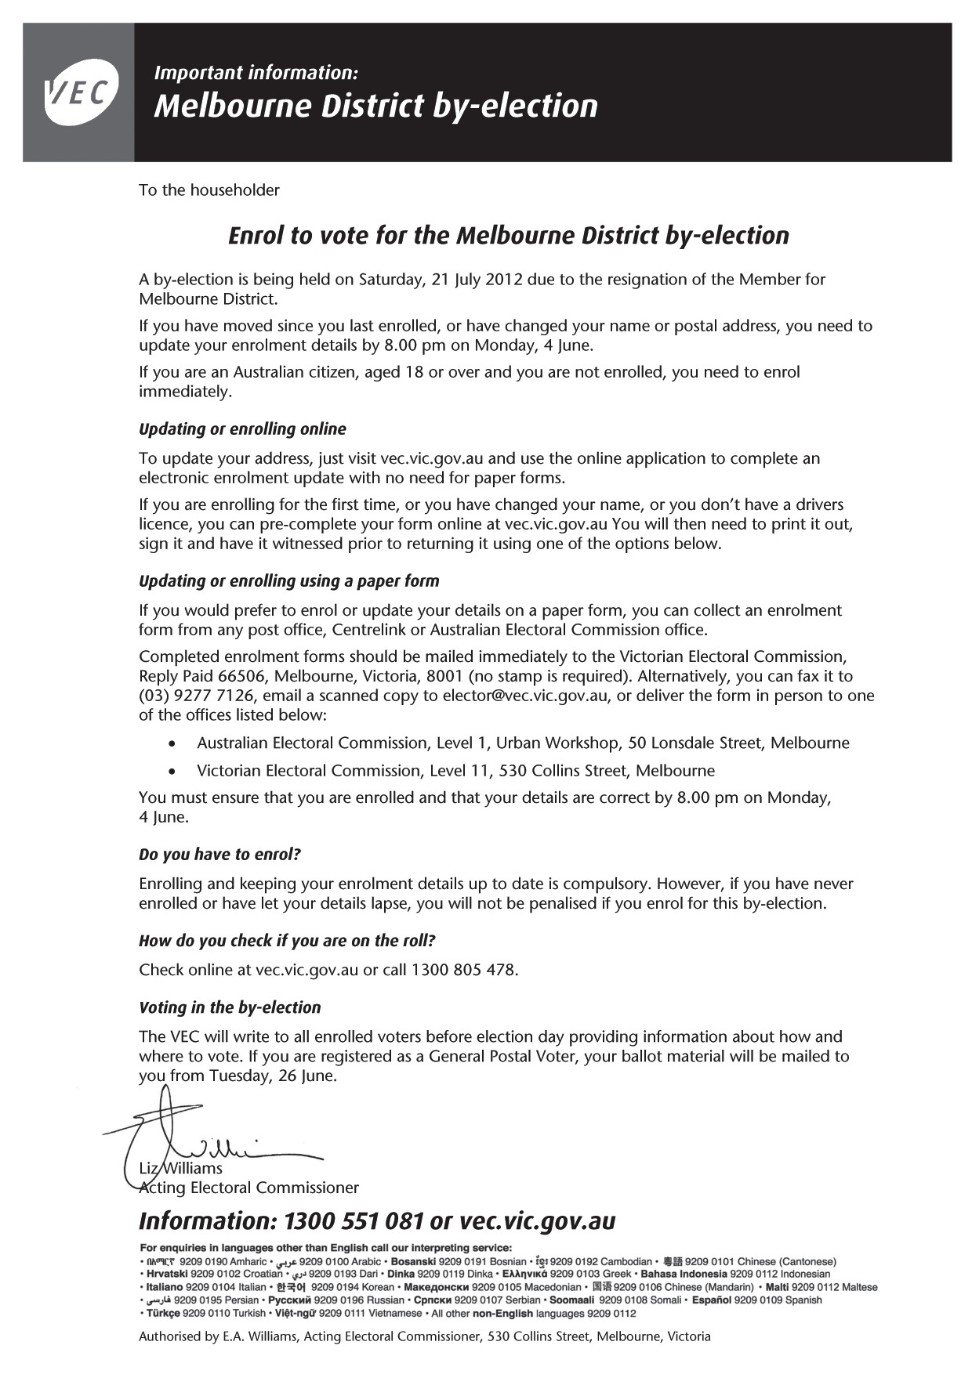
Letter to households advising of election

24

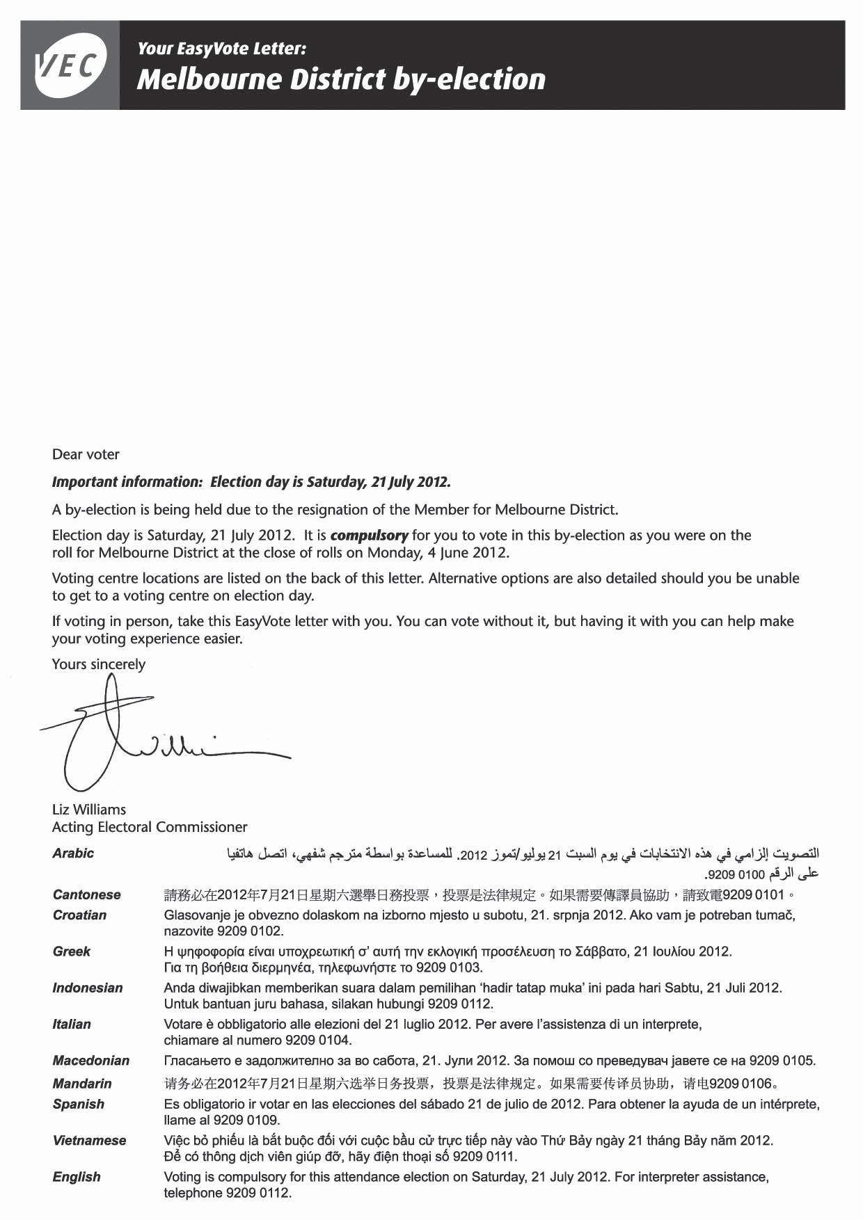
EasyVote letter (Page 1)

25

EasyVote letter (Page 2)
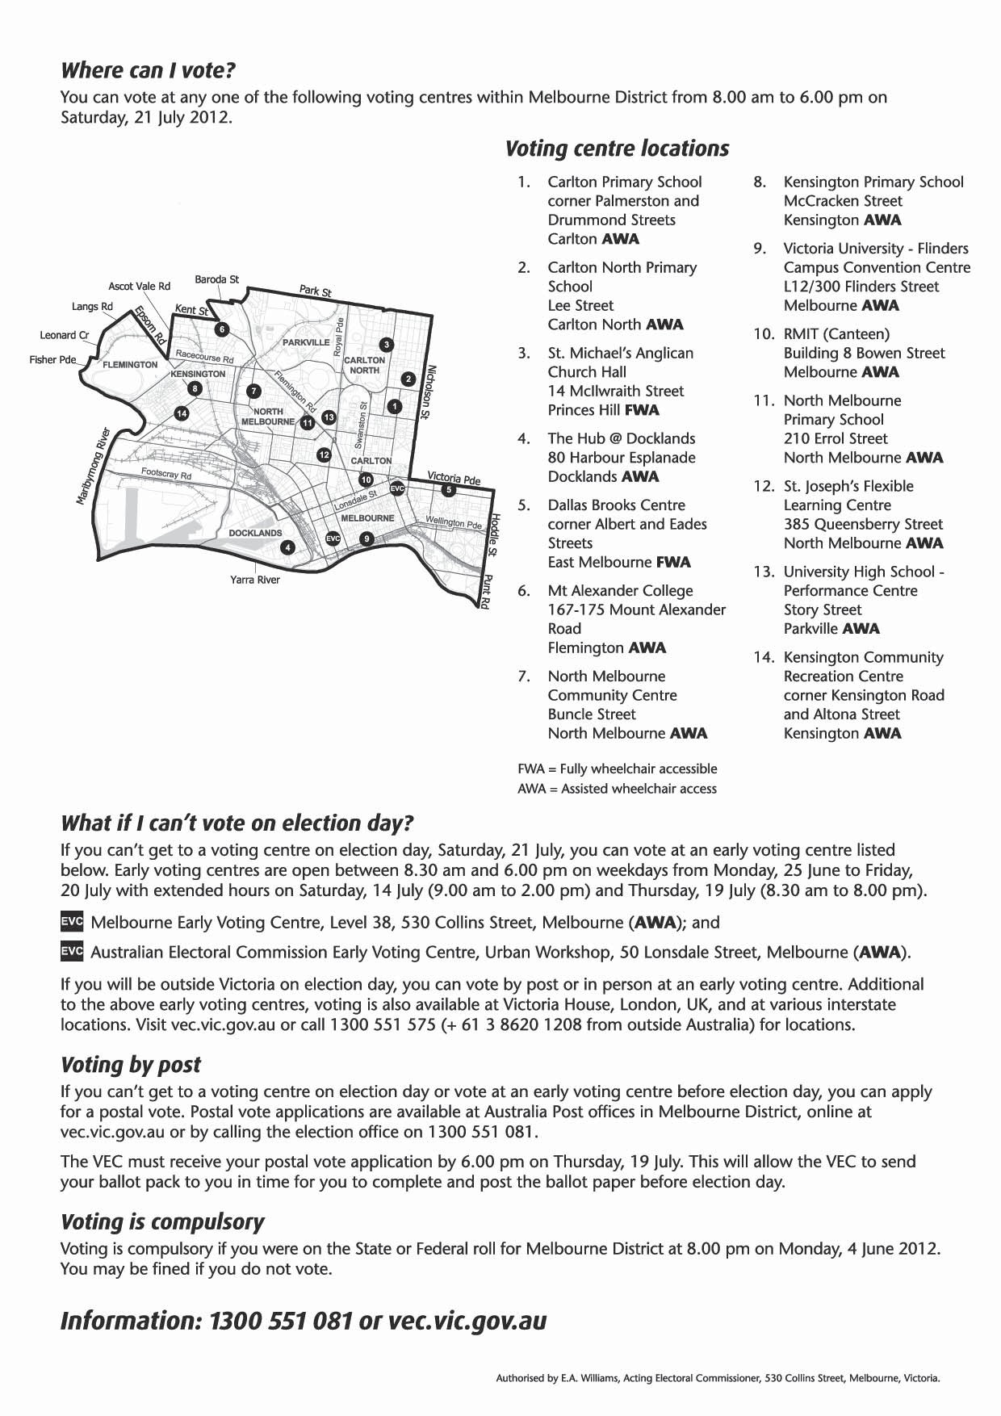

26

Notice of election: Issue of writ/enrolment/nominations
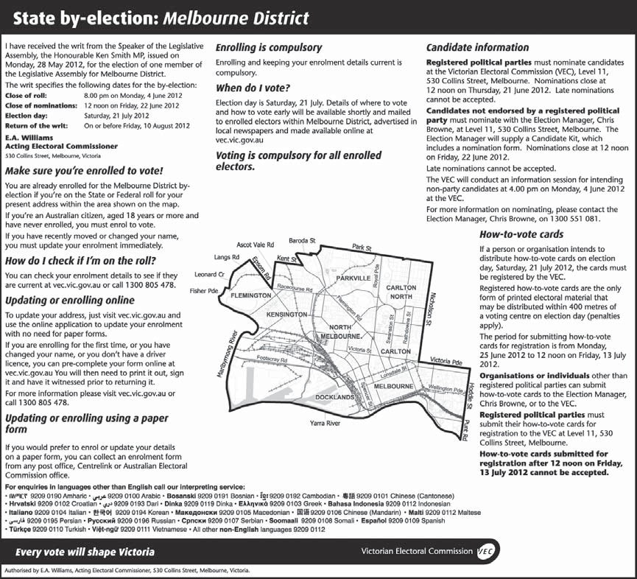

27

Enrolment/nominations reminder
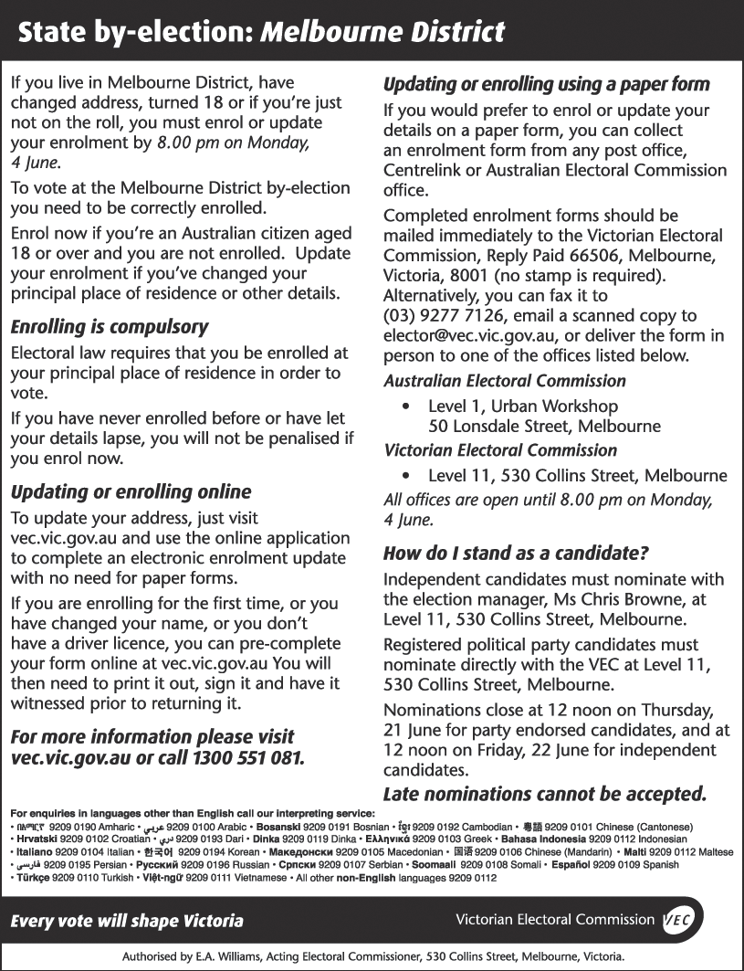

28

Early voting
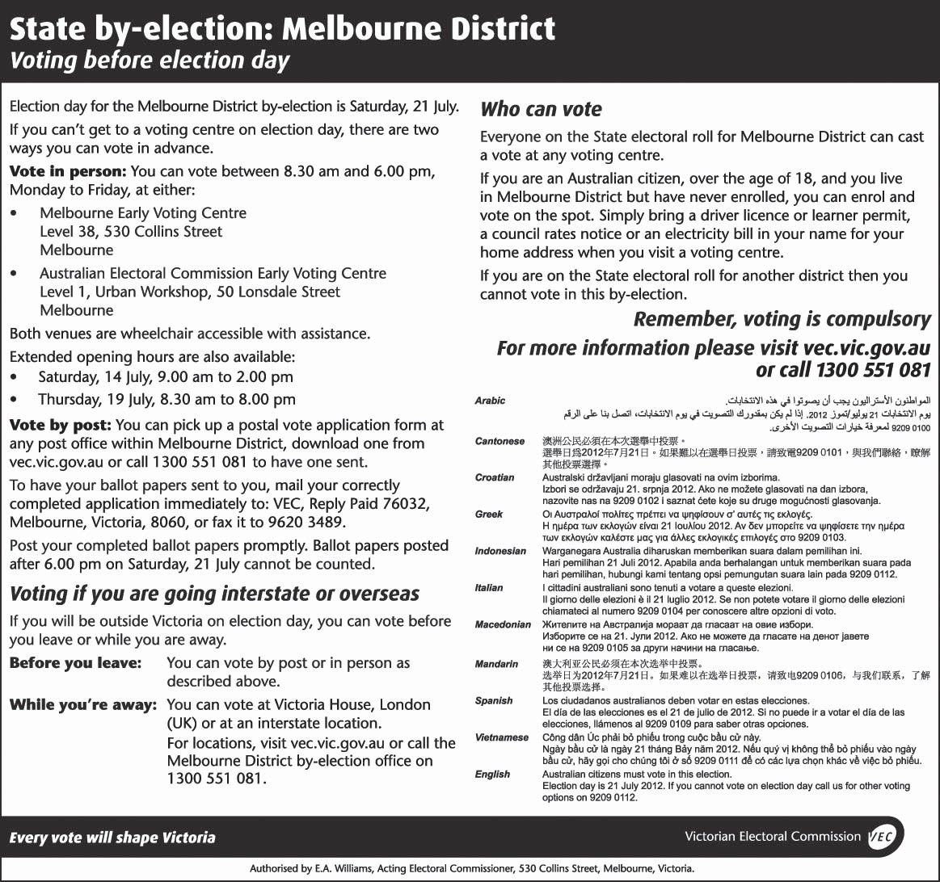

29

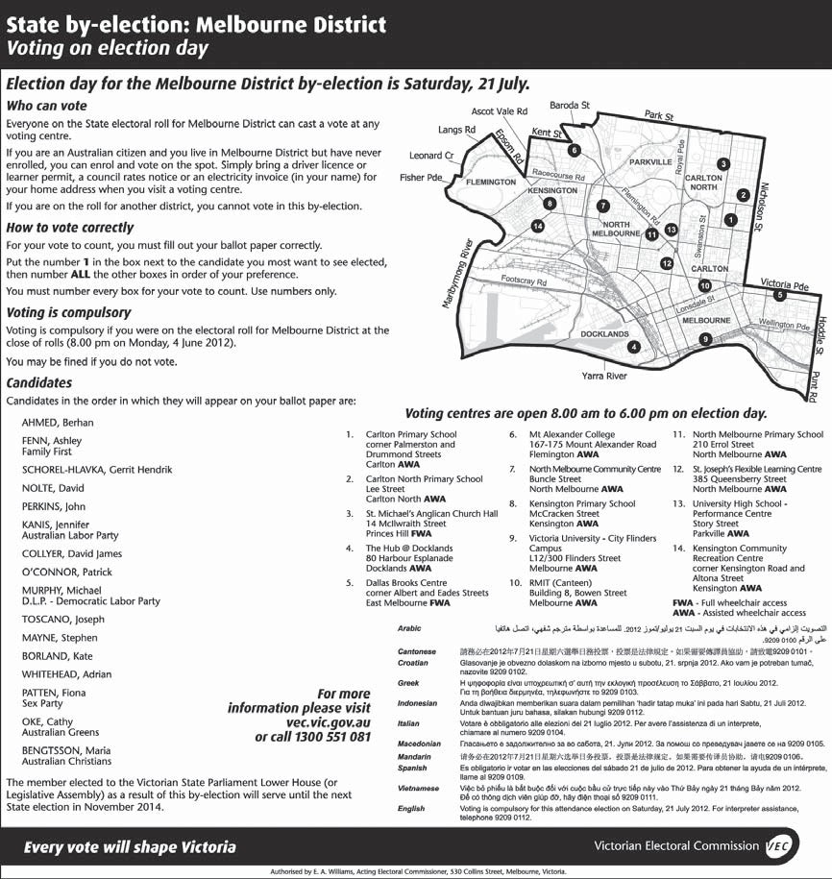
How to vote correctly

30

Voting on election day
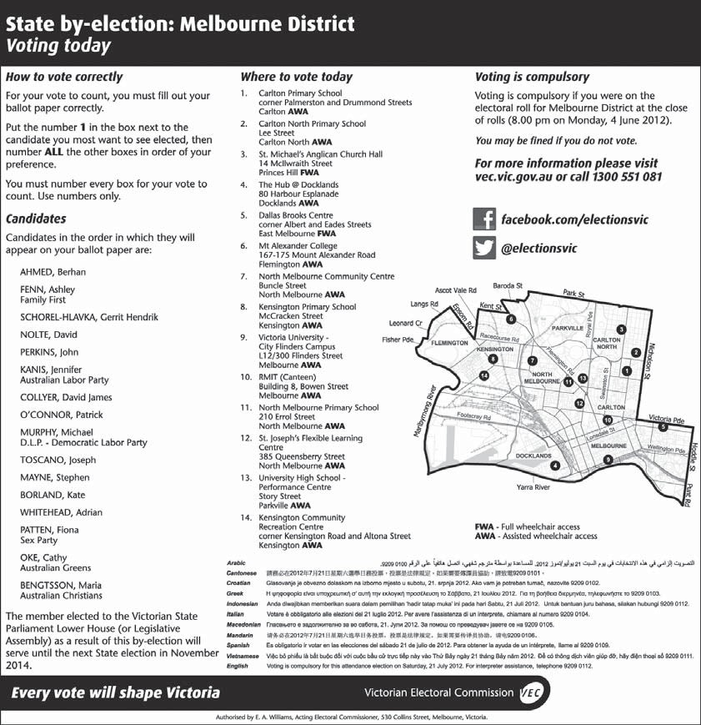

Return of the writ
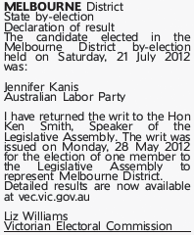

31

APPENDIX E: VOTER PARTICIPATION

The total vote at the by-election was 30,803 – 68.62% of the 44,889 enrolled electors. This participation rate was the second lowest for any Victorian Legislative Assembly election since the introduction of compulsory voting in 1926. (The lowest turn-out rate of all was 66.82% at the Melbourne District by-election of 17 December 1977, which took place a week after a Federal election.)
Commentators immediately after the by-election pointed to widespread public apathy and disillusionment and the absence of a Liberal candidate as reasons for the poor turn-out. In the VEC’s view, possible explanations focus on three areas: the nature of the electorate, the nature of by-elections in general, and features of this particular by-election.
Detailed examination of the election statistics offers some clues. Melbourne District is very diverse, ranging from stable, affluent East Melbourne, to the mushrooming high-rise apartments in the city and Docklands, to the gentrifying old inner suburbs to the north and west of the city, to pockets of social disadvantage in the public housing towers in Carlton, North Melbourne, Flemington and Kensington. However, this diversity was not reflected in the numbers voting at the various voting centres, which were generally similar to the 2010 figures except
in areas where 2010 voting centres had been abolished (Newmarket and North Melbourne Central) or a new voting centre created (South Kensington).

32
Overall, the number of ordinary votes was only 2.3% lower than at the State election. Votes at the 2010 Liberal strongholds of Docklands and East Melbourne declined
by not much more than the average, casting some doubt on the argument that the absence of a Liberal candidate was responsible for the low turn-out. Declaration votes showed more variation, with postal votes increasing by 11.9% while there were 36.9% fewer early votes than at the State election. There was no absent voting at the by-election.
At the State election there were 4,495 absent votes for Melbourne – much higher than the average per district of 2,508. Population mobility may partly account for this
high absent vote at the State election, with electors who had recently moved out of the district without updating their enrolment voting in their new neighbourhood on election day. Unable to cast an absent vote at the by-election, such electors may not have voted at all.
As the above indicates, the nature of the electorate contributed to the low voter turn-out. The population of the District of Melbourne is unusually young (the median age is 28 compared to Victoria’s 37) and highly mobile. Young adults, who change address frequently, tend to be slow to update their enrolment. This means that the roll includes many electors who no longer live in the district; some of these cast absent votes at State elections, while others do not vote. This is the main reason why voter participation rates are consistently low in a group of inner suburban electorates.
Despite the high profile of the by-election, voter participation declined by an unprecedented 18.31 percentage points from the State election. The lack of a Liberal candidate must have contributed to this fall. At by-elections over the past decade the decrease in
participation has been significantly greater where a major party has not contested the election (a median of 10.32 percentage points compared to 8.28 percentage points at by-elections where both major parties were standing).
At the 2010 State election 27.96% of the votes were cast for the Liberal candidate. Some of these Liberal supporters would have voted for other candidates at the by-election; some would have voted informal; but some would have refused to vote at all. As well, the absence of a Liberal candidate may have dissuaded other voters from participating. With no Government representative
in the by-election, some voters may have felt it was more like shadow-boxing rather than a real contest that would make a difference.

33

Melbourne District had the lowest voter turn-out in the State at the 2006 and 2010 State elections, and has been among the lowest over at least the past 20 years. Thus low participation at the by-election was not surprising.
By-elections as such have lower participation rates than general elections. The median voter turn-out rate at Victorian State elections since 1992 is 93.2%. Over the same period, the median voter turnout rate for State district by-elections (separate from State elections) is 85.03%. By-elections generally have a lower profile than general elections and electors are less inclined to take an interest. This pattern appears to have strengthened over the past decade¹. As well, facilities for voters are not as widespread.
While many by-elections have a relatively low public profile, it would be difficult to make this case for the Melbourne by-election. The election period was unusually long at almost two months, and both the Australian Labor Party and the Greens conducted vigorous campaigns to win the seat. The parties flooded every address in the district with repeated direct mail. As well, the VEC sent an enrolment leaflet to every household and an EasyVote letter to every elector. There was extensive media coverage of the by-election.

See Charles Richardson: “Byelection apathy: there’s more to the Melbourne story”, in Crikey, 25 July 2012.
1

APPENDIX F: ANALYSIS OF INFORMAL VOTES

There were 2,878 informal votes at the by-election, comprising 9.34% of total votes. The informal voting rate was not as high as the 11.48% at the March 2012 Niddrie by-election, nor the 9.5% rate at the 2011 Broadmeadows by-election. Even so, it was higher than at any other election this century. And the increase from the State election was extraordinary – from 3.69% (well under the State average), the informal voting rate almost tripled
at the by-election. This report examines the increase in the informal vote at the by-election. The report also describes the types of mistakes that informal voters
made and how they varied from those at the 2010 State election.
The number of candidates can affect the informal voting rate. A large number of candidates can increase the informal vote, through voters making numbering errors. There were sixteen candidates at the by-election – a substantial increase on the seven candidates for Melbourne District at the State election, and the most candidates for a district since the Frankston East supplementary election of October 1999. Analysis of the 2005 and 2008 local government elections reveals that the informal vote increases in line with the number of
candidates, particularly once the number of candidates is greater than ten².

See the VEC’s Report of local government electoral activity 2008-09, Part1, Report of the conduct of the 2008 local government elections, pp. 41-42.

34
The range of candidates also has an effect. In district by-elections over the past decade where both major parties were standing, the informal vote was a median of 1.33 percentage points lower than at the preceding State election. In contrast, where a major party was not standing, the informal vote was 3.14 percentage points higher than at the State election. It appears than some
party supporters prefer to vote informally than to vote for another party or candidate.
At the Melbourne by-election, the absence of a Liberal candidate probably contributed to the increase in the informal vote. Some twenty informal ballot papers explicitly complained about the lack of a Liberal candidate – for instance: “INFORMAL – LIBERAL CANDIDATE REQUIRED – NO DEMOCRACY”.
Informal voting rates varied at voting centres within the district, ranging from 6.99% at Parkville to 14.32% at Hotham Hill. Informal voting was highest in areas with social disadvantage and residents who are not fluent
in English (Hotham Hill, Kensington, Flemington and Carlton) and also in the normally Liberal-voting centres of East Melbourne and Docklands.
The informal voting rate increased at all voting centres between the State election and the by-election, with the greatest being a 9.3 percentage point increase at East Melbourne. The number of informal votes rose by more than 300 per cent at East Melbourne – another indication of Liberal voters refusing to vote for other candidates.
2
Category Description
Blank The bulk of these ballot papers were
presumably deliberately informal, though they might include ballot papers lodged by people who had diffi-culties with the whole voting process.
Numbers (1 only)
Numbers Ballot papers including insufficient (insufficient) numbers to constitute a formal vote.
Numbers Ballot papers including number se-(apparently quences such all ‘1’s, or ‘0’, or ‘1’, ‘10’, deliberate) ‘300’, which indicate an intention to
cast an informal vote.

In the survey of informal ballot papers, the VEC used the same categories as in its analyses of informal ballot papers since the 2006 State election³. These categories are described in Figure 1.
By far the largest category of informal votes was ‘numbers – other’, with 966 votes, or 33.6% of the total. These votes were informal due to a variety of numbering errors, such as including two 1s, or skipping or duplicating numbers. This category was dramatically larger than at the 2010 State election (9.5% in Melbourne) and at the March 2012 Niddrie by-election (16.9%).
Blank ballot papers were the second largest category of informal votes, with 18.7% of the total. There was a
lower incidence of blank ballot papers than at the State election (23.6%) and at the Niddrie by-election (22.1%).

Numbers (other)
Ticks/crosses Ballot papers indicating a clear prefer-(preference) ence for a candidate through a single
tick or cross.
Ticks/crosses Ballot papers with ticks or crosses in (apparently every square, indicating an intention deliberate) to reject all the candidates.
Ticks/crosses (other)
Writing Ballot papers with writing or drawings (apparently indicating opposition to all the can-deliberate) didates, including those with a cross
over the whole paper.
Writing Vague scrawls not indicating any (other) intention.
Possibly Ballot papers which are arguably formal formal.
Figure 1: Categories used by the VEC in analysis of ballot papers

Victorian Electoral Commission: Report to Parliament on the 2006 Victorian State election, p. 91.

35
3
Figure 3 shows the results of the survey in broader categories.

Category Number %

Blank 539 18.7%

Numbers 1,630 56.6%

Ticks/crosses 188 6.5%

Writing 521 18.1%

TOTAL 2,878

Figure 3: Results of survey of informal votes cast at Melbourne by-election 2012 – broad categories
Numbering errors were by far the largest of these categories, with 56.6% of the total, increasing from the 51.1% of informal votes in this category at the State election. Ticks and crosses were comparatively insignificant, and had declined from the 10.4% in this category at the State election. At 18.1%, writing errors
made up a greater proportion of the informal votes than the 14% at the State election.

Just behind the previous category was ‘Writing –deliberate’, with 18% of the total. This proportion was higher than at the 2010 State election (12.9%) but considerably lower than at Niddrie (24.9%).
The fourth largest category was ‘Numbers – insufficient’, with 357 votes, or 12.4% of the total. These ballot papers had a clear first preference, but did not fill in enough squares for the vote to be counted as formal. This category was somewhat larger than at the State election (10.4%) and more than twice as large as at Niddrie (5.9%).
As at other by-elections, the proportion of informal ballot papers with a single 1 (5.5%) was much lower than at the State election (23.9%). Without the confusion of the Upper House ballot paper (on which most voters do vote ‘1’), very few Melbourne by-election voters made this mistake. Figure 2 shows the results of the survey.

Category Number %

Blank 539 18.7%
Numbers – 1 only 159 5.5%
Numbers – insufficient 357 12.4%
Numbers – deliberate 148 5.1%
Numbers – other 966 33.6%
Ticks/crosses – preference 59 2.1%
Ticks-crosses – deliberate 106 3.8%
Ticks/crosses – other 23 0.8%
Writing – deliberate 517 18.0%
Writing – other 4 0.1%
Possibly formal 0 0.0%
TOTAL 2,878
Figure 2: Results of survey of informal ballot papers cast at Melbourne by-election 2012 – detailed categories

36

Figure 4 groups the various categories of deliberately informal votes and shows the result when the blank ballot papers are added to the marked ballot papers that were deliberately informal. It also groups the ballot papers that indicated a clear preference (either through the number “1” or a single tick or cross).

Category Number %

Apparently deliberate 771 26.8%

Apparently deliberate including blank 1,310 45.5%

Indicating preference 575 20.0%

Figure 4: Deliberately informal votes in grouped categories
At 45.5%, the proportion of apparently deliberate informal votes was very similar to that in Melbourne District at the State election (46.7%). The bulk of these apparently deliberate votes were by voters who expressed their dissatisfaction in writing, some of whom may have been reacting to the absence of a Liberal candidate.
However, unlike most recent by-elections, Melbourne was distinguished by a high proportion of accidental informal votes. The voters in the ‘Numbers – other’ and ‘Numbers – insufficient’ categories (comprising 46% of the total) do not seem to have spoiled their ballots on purpose, but to have made an unsuccessful attempt at a formal vote. Faced with a list of 16 candidates, it is very easy to make a numbering mistake. The number of candidates appears to have been the primary cause of the high informal vote at the Melbourne by-election.

37

APPENDIX G: ELECTRONIC ROLL MARK-OFF STATISTICS

Number of roll mark-offs per hour at election day voting centre
400

350

300

250

200

150

100

50

0
08:00– 09:00– 10:00– 11:00– 12:00– 13:00– 14:00– 15:00– 16:00– 17:00–09:00 10:00 11:00 12:00 13:00 14:00 15:00 16:00 17:00 18:00

Carlton Flemington North Melbourne
Carlton Central Hotham Hill North Melbourne East
Carlton North Kensington Parkville
Docklands Melbourne South Kensington
East Melbourne Melbourne Central

38

Victorian Electoral Commission Level 11
530 Collins Street Melbourne Victoria 3000
Tel: +61 3 8620 1100 Fax: +61 3 9629 8632
vec.vic.gov.au
This publication is available online at vec.vic.gov.au

