ELECTORAL REPRESENTATION REVIEW
Greater Bendigo City Council
Final Report
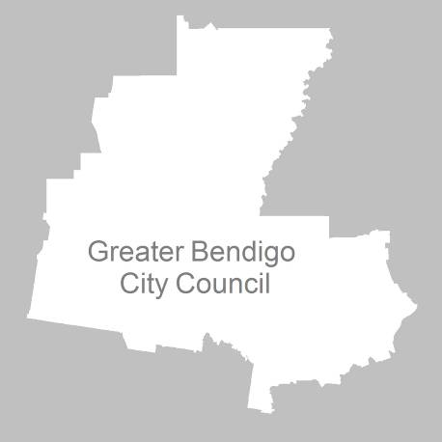
24 May 2011

Contents
Recommendation 4
Background 5
Legislative basis 5
The VEC and Electoral Representation Reviews 5
Profile of Greater Bendigo City Council 6
Current electoral structure 6
The electoral representation review process 7
VEC research 8
Public involvement 8
Preliminary report 11
Preliminary submissions 11
Preliminary options 11
Public response 13
Response submissions 13
Analysis of submissions 13
Public hearing 14
Findings and Recommendation 17
Recommendation 18
Appendix 1: List of submitters 19
Appendix 2: Maps 21

Recommendation
The Victorian Electoral Commission (VEC) recommends that Greater Bendigo City Council consists of three wards with three councillors representing each ward.
The recommended ward boundaries are illustrated in the map at the back of this report (Appendix 2).
This is a change to the existing structure of nine wards, with one councillor representing each ward.

Background

Legislative basis
The Local Government Act 1989 (the Act) requires the VEC to conduct an Electoral Representation Review of each municipality in Victoria at least every 12 years. The Act specifies that the purpose of a representation review is to recommend to the Minister for Local Government the number of councillors and the electoral structure for a municipality, which will provide ‘fair and equitable representation for the persons who are entitled to vote at a general election of the Council’.
The Act requires the VEC, as part of an Electoral Representation Review, to consider:
- the number of councillors in a municipality;
- whether a municipality should be unsubdivided or subdivided;
- if it should be subdivided, whether ward boundaries:
  - provide for fair and equitable division of the municipality;
  - ensure equality of representation through the number of voters being represented by each councillor being within 10 per cent of the average number of voters represented by all councillors; and,
- if it should be subdivided, the number of councillors that should be elected for each ward.

The VEC and Electoral Representation Reviews
The VEC has conducted Electoral Representation Reviews since 2004 on appointment by local councils. The Act was changed in 2010 to define the VEC as the only agency authorised to undertake the reviews.
The VEC drew on its experience in mapping and boundary modelling and also engaged consultants with experience in local government to provide advice on specific local representation issues during the review.

Profile of Greater Bendigo City Council
The City of Bendigo is geographically one of the larger municipalities in Victoria. It was formed in 1994 by the amalgamation of the former Shires of Huntly, Strathfieldsaye, Marong and McIvor, the City of Bendigo and the Borough of Eaglehawk.
The City encompasses a total land area of 2,999 square kilometres; with a large proportion of it comprising rural parkland that surrounds the city. Most of the city’s retail space is found in the Central Business District (CBD) or along the main roads. There are a few industrial developments in the suburbs around the CBD.
The City is served by the Calder Highway, the Loddon Valley Highway, the McIvor Highway, the Midland Highway and the Melbourne–Bendigo–Echuca railway line.
At the 2006 census, the City recorded a population of 93,952 people, with only a small proportion of the population born overseas (6.1%) and 94.1% of the population recording English as their first language.
Over the next 10 years the population is projected to grow by 21.7% across the municipality.

Current electoral structure
The last Electoral Representation Review for Greater Bendigo City Council took place in 2004. Following the review, the Minister for Local Government determined the structure of Greater Bendigo City Council would be:
- nine wards — Eaglehawk Ward, Eppalock Ward, Epsom Ward, Flora Hill Ward, Golden Square Ward, Kangaroo Flat Ward, North West Plains Ward, Sandhurst Ward and Strathfieldsaye Ward; with
- one councillor representing each ward.
The VEC noted there was substantial growth in the City of Greater Bendigo — a 12% population increase between 1994 and 2003 and a 22% growth in the number of voters between 1996 and 2004. In light of this growth and the size of the City compared to other regional centres, the VEC recommended the number of councillors be increased from seven to nine. The VEC recommended that the City retain a single-councillor ward structure to represent strong local communities of interest.
Diagram 1: Current structure of Greater Bendigo City Council

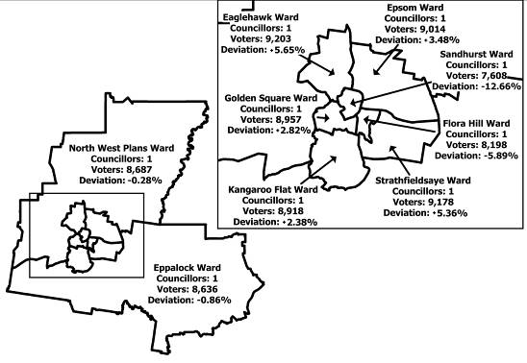

The electoral representation review process
The VEC proceeded on the basis of three main principles:
- Ensuring the number of voters represented by each councillor is within 10 per cent of the average number of voters per councillor for that municipality.
Populations are continually changing. Over time these changes can lead to some wards having larger or smaller numbers of voters. As part of the review, the VEC corrected any imbalances and also took into account likely population changes to ensure these boundaries provide equitable representation until the next review.
- Taking a consistent, State-wide approach to the total number of councillors.
The VEC was guided by its comparisons of municipalities of a similar size and category to the council under review. The VEC also considered any special circumstances that may warrant the municipality to have more or fewer councillors than similar municipalities.
- Ensuring communities of interest are as fairly represented as possible.
Each municipality contains a number of communities of interest and, where practicable, the electoral structure should be designed to take these into account. This allows elected councillors to be more effective representatives of the people in their particular municipality or ward.

The recommendation is based on:
- internal research specifically relating to the municipality under review;
- VEC experience from its work with other municipalities and in similar reviews for State elections;
- VEC expertise in mapping, demography and local government;
- careful consideration of all public input in the form of written and verbal submissions received during the review; and,
- advice received from consultants with wide experience in local government.
Public submissions were an important part of the process, but were not the only consideration during the review. The VEC seeks to combine the information gathered through public submissions with its own research and analysis of other factors, such as the need to give representation to communities of interest. The recommendation is not based on a ‘straw poll’ of the number of submissions supporting a particular option.

VEC research
In addition to the information provided in submissions, the VEC created a profile of the municipality based on population trends, development projections and demographic indicators. The VEC used the Australian Bureau of Statistics 2006 census community profiles, the Department of Planning and Community Development projections and voter statistics from the Victorian electoral roll. The VEC also undertook field work to view current and possible boundaries for each of the options presented in the preliminary report to evaluate their effectiveness.

Public involvement
The VEC values the local knowledge and perspectives presented by the public in written submissions. The public were given two opportunities to provide submissions during the review. Their input was considered by the panel in forming the options in the preliminary report and they were also invited to respond to these options. In addition, a public hearing was held to enable people to speak in support of their submissions and supplement it with information.
To ensure transparency in the process, all written submissions were published on the VEC website and all verbal submissions were heard in a public environment.
To raise awareness of the review and encourage the public to engage with the process, a full public information campaign was undertaken.

Advertising
In accordance with sections 219F(4) and 219F(7) of the Act, the VEC ensured public notices were placed in local newspapers. Notification of the review appeared in Heathcote McIvor Times on Wednesday, 2 February 2011, in Bendigo Weekly on Friday, 4 February 2011 and in Bendigo Advertiser on Tuesday, 8 February 2011.
A general notice covering several reviews was printed in The Age and the Herald Sun on Tuesday, 1 February 2011.
A further notice advertising the public information session was placed in Bendigo Advertiser on Saturday, 19 February 2011.
Notification of the release of the preliminary report appeared in Heathcote McIvor Times and Bendigo Advertiser on Wednesday, 30 March and Bendigo Weekly on Friday, 1 April 2011. The notice detailed the options contained in the preliminary report, including a map of each option, instructions on how to access a copy of the preliminary report and how to make a submission in response to the report.

Media releases
The VEC produced two media releases for this review. The first release, distributed to local media through the Council, provided information on the review and the overall process. A second release, distributed to local media by the VEC, detailed the options in the preliminary report and how to make a submission in response to the report.

Public information session
The VEC held a public information session for people interested in the review process on Tuesday, 22 February in Bendigo Town Hall at 7.00pm.

Information brochure and poster
An information brochure was provided to the Council to be distributed to residents through the Council’s network, such as in libraries and service centres. A poster was also provided to the Council as an extra publicity tool.

Guide for Submissions
A guide for submissions was developed and distributed to those interested in making submissions. Copies of the guide for submissions were available on the VEC website, via post on request, and were provided to the Council.

Greater Bendigo City Council website
Information about the reviews is highlighted on the Greater Bendigo City council website (bendigo.vic.gov.au) with a link to further details about the review process, a copy of the Guide for Submissions and a hyperlink to the VEC website.

Greater Bendigo City Council newsletter
An article about the review featured in the summer edition of Greater Bendigo News. It was distributed to all residents, ratepayers and businesses in the area.

Radio interview
Paul Thornton-Smith, VEC Senior Information and Research Officer, was interviewed on ABC Regional Radio on Thursday, 30 March about the review process and the options put forward in the preliminary report.

Helpline
A dedicated helpline was established to assist with public enquiries concerning the review process.

VEC website
The VEC website delivered up-to-date information to provide transparency during the preliminary and response stages of the review process. All submissions were posted on the website and an online submission tool was created to facilitate the submission process. The preliminary report was available on the website.

Preliminary report
In accordance with the Act, the VEC produced a preliminary report outlining its proposed options for Greater Bendigo City Council. The report was released on Wednesday, 30 March 2011.

Preliminary submissions
By the close of preliminary submissions at 5.00pm on Tuesday, 8 March, the VEC received nine submissions.
The majority of submissions supported multi-member wards, believing these would absorb the future population growth, provide councillors with a stronger chance for re-election and therefore a sense of continuity to the community, and also enable councillors to share workloads.
Greater Bendigo City Council proposed a change to the current ward structure to ensure that six of the wards outside central Bendigo would have a section of both urban and rural communities.
Two submitters preferred an unsubdivided municipality and it was also favoured as an alternative option by the Proportional Representation Society, which put forward the case for councillors to be elected by the proportional representation counting method.
A list of submitters, by name, is in Appendix 1. Copies of the submissions can be viewed on the VEC website at vec.vic.gov.au.

Preliminary options
After careful consideration of the preliminary submissions, the VEC put forward five options:
Option A (Preferred Option)
Greater Bendigo City Council should be divided into seven wards — six wards each with one councillor and one inner urban ward with three councillors.
Option B (Alternative Option)
Greater Bendigo City Council should remain with nine wards, with one councillor representing each ward. Minor adjustments should be made to the ward boundaries.
Option C (Alternative Option)
Greater Bendigo City Council should consist of four wards — three outer wards with two councillors representing each ward, and one inner ward with three councillors.
Option D (Alternative Option)
Greater Bendigo City Council should be divided into three wards with three councillors representing each ward.
Option E (Alternative Option)
Greater Bendigo City Council should be divided into nine wards, six of which would include a part of the rural area of the municipality. (This option was submitted by Greater Bendigo City Council.)

Public response

Response submissions
Response submissions opened on Wednesday, 30 March and closed at 5.00pm on Friday, 29 April 2011. The VEC received 11 response submissions. Table 1 shows the levels of support for each option based on the preferences expressed in each response submission.
Option A  (Preferred Option) | Option B  (Alternative Option) | Option C  (Alternative Option) | Option D  (Alternative Option) | Option E  (Alternative Option) | Other
0 | 0 | 2 | 6 | 2 | 1
Table 1.

Analysis of submissions
None of the submissions from members of the public supported Options A or B. Option D (three three-councillor wards) was the most popular structure. Submitters argued that it offered a range of councillors to approach, which was particularly important when councillors are unfortunately called away for business for long periods or have to take sick leave (as was the case in Greater Bendigo City Council). They also noted that multi-member wards allow for minority opinions to be represented, deal with population changes more readily and prevent by-elections in the case of an extraordinary vacancy. Option C (three two-councillor wards and one three-councillor ward) was also favoured by two submitters for the same reasons.
The Proportional Representation Society favoured Option D on the grounds that future elections would be conducted via the proportional representation counting method.
Option A, the VEC’s preferred option, did not receive any support and the option put forward by the Council, Option E, only received two submissions in its favour — one from the Council, stating that no sound argument had been put forward for a change from single-member wards, and a personal submission from Councillor Phillips, who argued that multi-member wards cause factions and lead to work overload.
A list of submitters, by name, is in Appendix 1. Copies of the submissions can be viewed on the VEC website at vec.vic.gov.au.

Public hearing
A public hearing was held at Greater Bendigo City Council Offices on Tuesday,
3 May at 6.30pm. Everyone who made a submission in response to the report was invited to speak to their submissions and five people accepted. Members of the public were invited to attend. The public hearing gave submitters the opportunity to amplify their submissions and allowed the panel to ask questions and gain further insight.
The first speaker, Councillor Fyffe, Mayor of Greater Bendigo City Council, spoke on behalf of the Council in support of its single-councillor ward option. He drew the panel’s attention to the previous review, in which the VEC, at the time, recognised the value of single-councillor wards as the best way to represent the communities of interest. He also stated that the multi-member wards did not have culturally similar communities of interest as suggested in the preliminary report and explained that the university has a strong influence on Flora Hill and Golden Square.
In clarifying the reasons for Option E, the Mayor explained how most of the wards follow the settlement patterns of the City, by flowing out from the City encompassing a slice of urban, rural living and farming communities.
He also spoke about the heavier workloads of the rural councillors and how multi-member wards would not help this situation as residents have an expectation that each Councillor will go to each community event, leading to an unnecessary duplication of effort.
He also described how each ward currently has township meetings and district plans that are tailored to cover the unique needs of each ward by taking into consideration their communities of interest.
The second speaker, Councillor Phillips, outlined the methods used by the Council to come up with Option E, explaining ‘that it varies considerably from the current ward arrangement and indicates that there is no resistance to change and that change is justified.’
He also gave a personal insight into his workload as a Councillor for North West Plains Ward, illustrating the extra work undertaken in a rural ward by juxtaposing his current diary with the diary he had when he was a Councillor for the more urban Grassy Flat Ward (see table below). He used the table to challenge the assumption that an equal number of voters equates to a similar workload, describing it as a ‘fallacy’, and added a personal appeal for change, saying he felt ‘run down’.
When asked by the panel whether multi-member wards would help alleviate the extra workload, Councillor Phillips echoed the Mayor’s argument that all Councillors are expected to serve all electors and it could lead to a duplication of effort and factions on the Council.
Table 2: Comparison of responsibilities in an urban ward and rural ward, as supplied by Councillor Phillips.
Responsibilities | Urban  Grassy Flat Ward | Rural  North West Plains Ward
Number of voters | Around the same | Around the same
Area | Very small | Very large
Number of communities | Essentially one | Discernibly nine
Average travel time | 5 minutes | 20 + minutes
Number of requests per year | 40 | 150
Diary clashes | 5% | 25%

The third speaker, Mr Jones, an ex-Mayor of Greater Bendigo, supported Option D, on the grounds that at least 75% of the votes would be required to elect the three candidates which enables a broader variety of views to be represented, and, in his opinion, would result in at least one rural candidate being elected.
He drew on his experience in office to explain how the idea of a local councillor as a ‘local champion’ can be corrupted in instances when the majority of other councillors over-rule unpopular proposals a councillor has been asked to put forward or when smaller communities of interest dominate the ward.
When questioned by the panel about the division of the CBD in Option D, the submitter stated that he felt the boundaries were drawn logically and that to consider the urban centre as one community of interest limited the consideration of the CBD to just a geographical area when there are in fact a range of communities of interest in the CBD. He also felt that not many people have all their interaction in just one ward and they are interested in the entirety of Bendigo as a City. He felt that Option D would ensure that a wider range of issues were discussed and a more ‘holistic approach was taken across the Council’.
The fourth speaker, Mr Coleman, described himself as ‘an interested resident’ and pointed out that all the public submissions had called for a change to multi-member wards with the notable exception of the Council option. He spoke in favour of Option D, as it was the closest to his preferred option of an unsubdivided municipality; arguing that recent technological developments made it easy to relate across geographical boundaries. He argued against single-councillor wards, as he felt they don’t encourage people to engage and they don’t allow for election via the proportional representation counting method.
Mr Coleman also expressed his view about the Council’s process in coming to its position, believing they should have consulted more widely. The VEC indicated that it would convey his view when preparing its final report at the conclusion of all the reviews, when all matters of process will be raised with the relevant Minister.
The final speaker, Ms Rivendell, also an ex-Mayor of Greater Bendigo City Council, favoured an unsubdivided municipality on the grounds that it fostered a ‘positive and inclusive sense of identity’. She gave the example of people identifying with the City of Bendigo, when they are asked where they are from, and not with their specific ward. She also reasoned that communities of interest and population can change throughout the lifespan of an electoral structure because populations are now more mobile.
An unsubdidvided municipality had already been discounted by the VEC in its Prelimimary Report as unworkable. However, in response to the submitter, the Electoral Commissioner clarified the difficulties of an unsubdivided structure for a large municipality. He explained that a large number of candidates nominating for an election would lead to a large and unwieldy ballot paper which can be overwhelming and confusing for voters and increase the likelihood of mistakes and informal votes as full preferential voting is required at this time.

Findings and Recommendation
The VEC took all the written submissions into consideration and was pleased to be able to gain further insight from the five speakers who generously gave their time at the public hearing.
The arguments made by Greater Bendigo City Council and Councillor Phillips about the imbalance of workloads were persuasive. The VEC now considers that the advantage of guaranteeing representation for the rural members of the municipality in Option A (the preferred option) and Option B (an alternative option) are outweighed by the extra burden that is put on those councillors due to the large areas they have to represent and distances they need to travel.
The VEC appreciates the Council’s recommendation of including a slice of rural, urban and farming communities in most of the wards as a partial solution to the problem of larger wards. However, as mentioned in the Preliminary Report, there is still no guarantee that a rural member would be elected with this structure creating an unjustifiably high risk that a large community of interest would not receive fair representation.
Although the voter numbers in Option E satisfy legislative requirements in the short term, the VEC has serious concerns about the option’s ability to absorb future population growth. The VEC contacted the Council following the hearing to ask for the data that was used to model the Council’s boundaries, and this information was promptly provided. The VEC mapping team used the Council data in conjunction with planning data from the Department of Planning and Community Development to project future voter numbers and does not share the Council’s confidence that these numbers would ensure equitable representation for the next 12 years. By 2017, only one ward would be within the 10% projected tolerance level and four wards would in fact deviate by over 20%, with one ward set to deviate by upwards of 40%.
Two of the VEC’s three guiding principles are ensuring communities of interest are fairly represented and sustaining the number of voters to within a 10% average for each Councillor for the municipality until the next review. As Option E cannot be guaranteed to attain these principles the VEC had to reject this model.
The majority of submissions favoured multi-member wards, and this is perhaps not surprising in the light of the situation in Eppalock Ward, where residents have not had equitable representation for a few years due to unfortunate circumstances (one Councillor is on long-term sick leave and the previous Councillor had to juggle business commitments abroad). It is therefore understandable that residents would point to the benefits of multi-member wards providing continued representation, sharing workloads, and avoiding by-elections or unopposed elections.
The VEC was convinced by submissions at the previous representation review that communities of interest were best represented by single-councillor wards in Bendigo. However, in considering the rapid growth areas of Strathfieldsaye, Epsom and Maiden Gully that are proving very difficult to contain within a single-councillor ward structure, the VEC now believes a multi-member ward structure would provide more effective and sustainable representation to the residents of the municipality.
Of the multi-member ward options, Option D had the strongest arguments put forward in its support. In the Preliminary Report, the VEC outlined its concerns with this model as it slices the CBD into three wards. However, on further consideration of the council’s submission that a good geographical mix is desirable, and the evidence from submitters stating that the boundaries are drawn logically with industrial and retail areas of the CBD captured effectively, the VEC is now convinced that this model would offer the fairest and most equitable representation to all voters.

Recommendation
The Victorian Electoral Commission (VEC) recommends that Greater Bendigo City Council consists of three wards, with three councillors representing each ward. This structure was designated as option D in the preliminary report and is shown on the maps in Appendix 2 of this report.
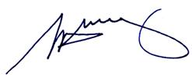
S. H. Tully
Electoral Commissioner

Appendix 1: List of submitters
Preliminary submissions were received from:
Name
Allan, L
City of Greater Bendigo Council
Coleman, T
Jones, D
Lennon, D
Mulqueen, S
Proportional Representation Society of Australia
Toman, M
Wright, D

Response submissions were received from:
Name
City of Greater Bendigo Council
Clark, N
Coleman, T
Fraser, S
*Jones, D
Lennon, D
*Phillips, B
Proportional Representation Society of Australia
Radford, W
*Rivendell, J
*Toman, M
*Spoke at the public hearing.

Appendix 2: Maps
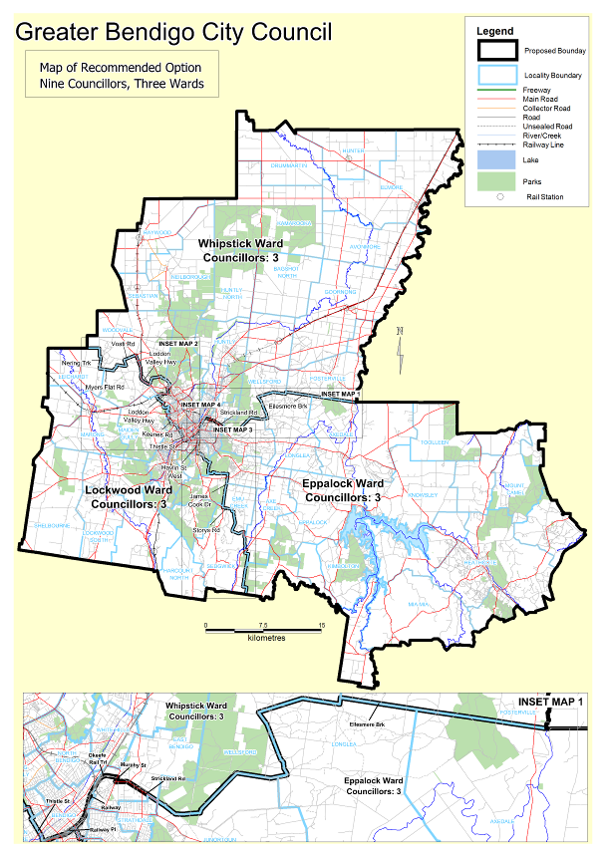

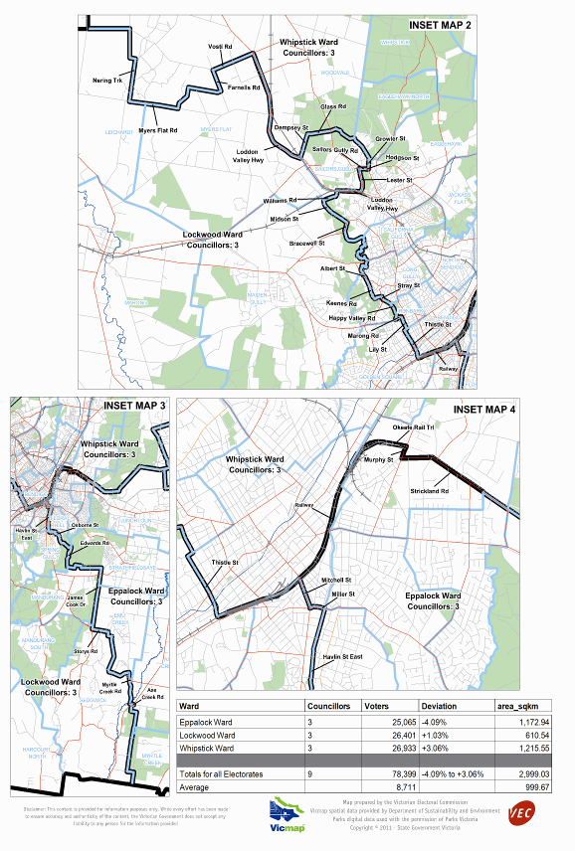

Victorian Electoral Commission
Level 8, 505 Little Collins Street
Melbourne, Vic 3000

131 VEC (131 832)
info@vec.vic.gov.au
vec.vic.gov.au

Section 219D of the Local Government Act 1989.
Australian Bureau of Statistics, Census of Population and Housing 2006.
Victoria in Future, Department of Planning and Community Development.

