Local council electoral structure review

## About the review

Under Victoria’s *Local Government Act 2020*, Stonnington City Council must now have a single-councillor ward electoral structure.

The Minister for Local Government has appointed an electoral representation advisory panel to conduct an electoral structure review of the council. The panel will advise the Minister on the most appropriate single-councillor ward structure for Stonnington City Council.

The panel is looking at:

* the appropriate number of councillors and wards
* the location of ward boundaries
* appropriate ward names.

Electoral structure reviews are an important part of democracy, and your input is valuable. As a local, you know your local council area better than anyone. This is your chance to let the panel know your thoughts about the single-councillor ward electoral structure that you believe would best provide representation for your community.

There are 2 opportunities for you to have your say on the electoral structure of the council:

1. in a response submission to the preliminary report
2. in an online public hearing, if you request to speak in your response submission.

About Stonnington City Council

The Traditional Custodians of the land in the Stonnington City Council area are the Wurundjeri and Bunurong peoples.

Stonnington City Council is in inner east of Melbourne, about 5-to-10 km from the city centre. The council covers 26 km2 and had a population of 104,703 at the 2021 Census.

The council area comprises the suburbs of Armadale, Glen Iris, Kooyong, Malvern, Malvern East, Prahran, South Yarra, Toorak, and Windsor.

The council area is well connected to public transport, with the Sandringham, Frankston, Pakenham, Cranbourne, and Glen Waverley railway lines running through its boundaries, as well as several tram and bus lines. The Monash Freeway forms part of the council’s eastern boundary.

Over half of the council area’s working population is employed in either professional services, healthcare and social assistance or retail and food services.

Home ownership (owned outright and with a mortgage) in 2021 was 52.4%, which was lower than the Greater Melbourne rate of 66.8%. The proportion of households renting was significantly higher in 2021 (44.9%) than the Greater Melbourne rate of 30.2%.

Stonnington City Council is one of the most affluent and advantaged local government areas in Victoria. In 2021 it had a median weekly household income of $2,210, more than the Greater Melbourne median of $1,901

## Current structure

Stonnington City Council is divided into 3 wards with a total of 9 councillors:

* 3 wards with 3 councillors each.

## Last review

The VEC conducted an electoral representation review of Stonnington City Council in 2011.

Review process

17 and 18 July

### Information sessions

Session 1: 12 noon, Monday 17 July 2023

Session 2: 6 pm, Tuesday 18 July 2023

Information sessions are for anyone wanting to find out more about the review process. Links to register for an information session will be available on the VEC website.

Wednesday 19 July

### Preliminary report

The panel will release a preliminary report including one or more options for the electoral structure on Wednesday 19 July 2023.

**Response submissions open from this date.**

Wednesday 9 August

### Response submission close

The panel must receive all submissions by 5 pm on Wednesday 9 August 2023.

Late submissions will not be accepted.

Tuesday 15 August

### Public hearing

The panel will hold an online public hearing if anyone requests to speak about their response submission at 10 am, Tuesday 15 August 2023.

The public hearing will not be held if there are no requests to speak.

Wednesday 13 September

### Final report

The review panel will submit a final report to the Minister for Local Government including the panel’s advice for the electoral structure on Wednesday 13 September 2023.

The Minister will then consider the panel’s advice before recommending a change to the electoral structure. Any change to the electoral structure of the council following on from the review will apply at the October 2024 local council elections.

## Untitled-1How to make a submission

On the VEC website at [vec.vic.gov.au](http://vec.vic.gov.au/)

By email to

[Stonnington.ERAPSubmissions  
@vec.vic.gov.au](mailto:Stonnington.ERAPSubmissions@vec.vic.gov.au)

LetterBy post to

Electoral Representation Advisory Panel  
c/o Victorian Electoral Commission  
Level 11, 530 Collins Street  
Melbourne VIC 3000

Submissions must include your:

* full name
* contact phone number or email address
* residential or postal address.

All submissions will be published on the VEC website. Your name and locality (suburb or town) will be published, but your full address and contact details will be removed. See the submission guide and VEC website at [vec.vic.gov.au/privacy](https://www.vec.vic.gov.au/privacy) for privacy information.

## Submission guide

Download the submission guide from the VEC website at [vec.vic.gov.au](http://vec.vic.gov.au/) for more information on the review process and making a submission.

## One vote, one value

The ‘one vote, one value’ democratic principle is enshrined in the *Local Government Act 2020*. This means that every person’s vote counts equally.

When a local council area is subdivided into wards, the number of voters each councillor represents in each ward must be plus-or-minus 10% of the of the average number of voters per councillor for all the wards.

The map below includes the current number of voters in each ward and the ward’s current deviation from the average. The review panel will consider likely population and voter changes to ensure the structure remains equitable.

If you make a submission online, you can use a mapping tool to build your preferred electoral structure. The tool uses current voter numbers to tell you the deviations of the wards you make. This will help you propose a structure that meets the requirements of the Act.

Current electoral structure

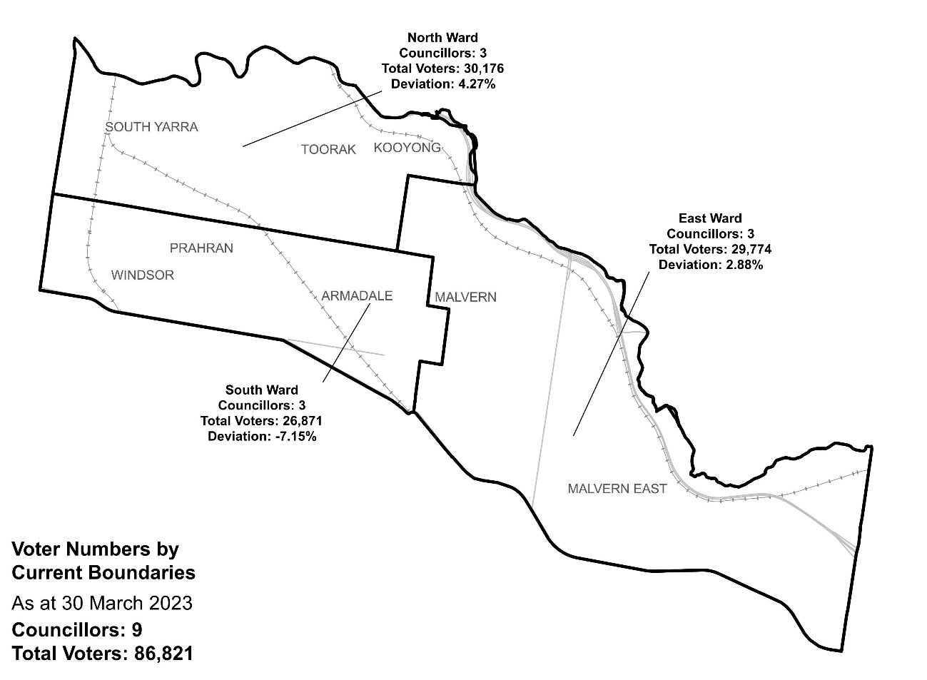

|  |  |  |  |
| --- | --- | --- | --- |
| Ward | Councillors | Voters | Deviation |
| East Ward | 3 | 29,774 | +2.88% |
| North Ward | 3 | 30,176 | +4.27% |
| South Ward | 3 | 26,871 | -7.15% |

## Statistics

Area (km2) 26

Voters

### Voters per square km

3,339.3

### Average voters per councillor

9,646

Population

### Current population

104,703

### Forecast population growth

1% p.a.

Further census statistics available at [abs.gov.au](http://www.abs.gov.au/)

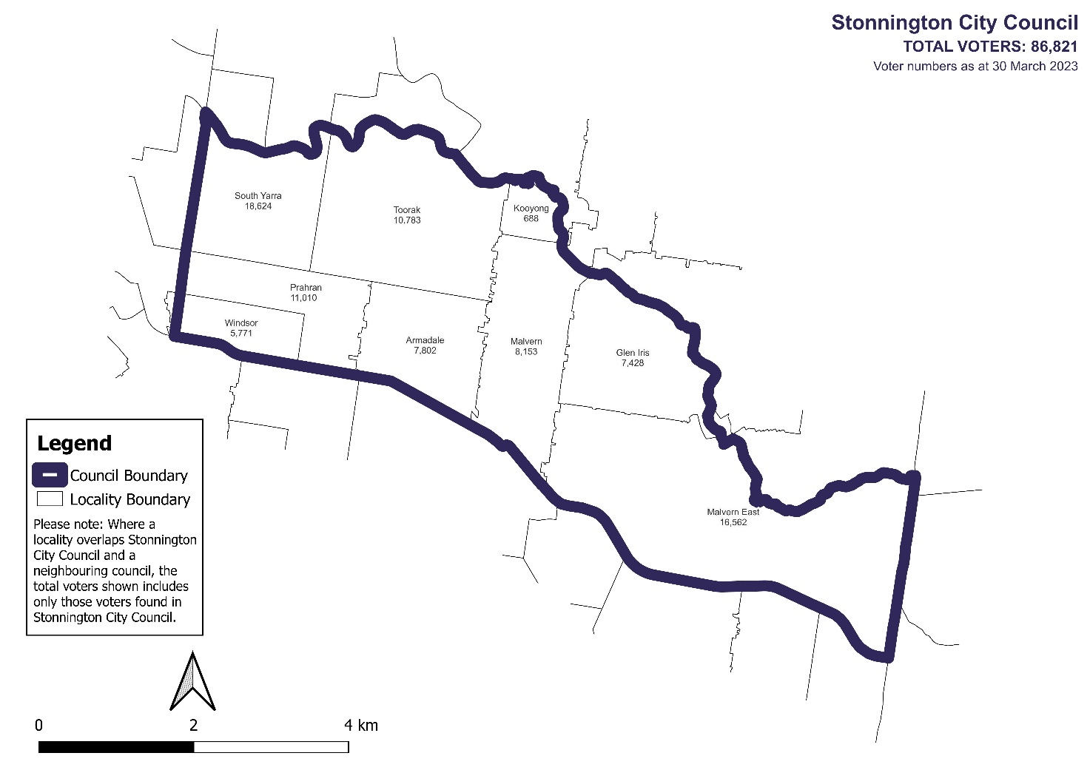Voter numbers by locality (map)

Voter numbers by locality (table)

## Stonnington City Council voter numbers at 30 March 2023

|  |  |
| --- | --- |
| Locality | Voters |
| Armadale | 7,802 |
| Glen Iris | 7,428 |
| Kooyong | 688 |
| Malvern | 8,153 |
| Malvern East | 16,562 |
| Prahran | 11,010 |
| South Yarra | 18,624 |
| Toorak | 10,783 |
| Windsor | 5,771 |