Scrutineer Handbook
Melbourne City Council elections 2020

Contents
Introduction 1
1. Appointment of Scrutineers 2
1.1 Role 2
1.2 Appointment and declaration of scrutineers 2
1.3 Disqualifications 3
1.4 Identification 3
1.5 Briefing of scrutineers 4
2. The voting period 5
2.1 Posting the ballot packs 5
2.2 Preliminary scrutiny of ballot paper envelopes 5
2.3 Unenrolled votes 6
2.4 Close of postal vote receipt period 6
3. Obtaining the results 7
3.1 Overview 7
3.2 Opening admitted ballot paper envelopes 7
3.3 Total ballot papers 8
3.5 The Leadership Team election 8
3.6 The councillor election 8
3.7 Recount of votes 10
4. Offences 11
4.1 Offences by scrutineers 11
4.2 Interference with rights 11
4.3 Offences relating to ballot papers 11
4.4 Interfering with postal ballot materials 12
4.5 Infringement of secrecy 12
4.6 False or misleading declaration 13

Appendices 14
Appendix 1: Leadership Team ballot paper formality rules 14
Appendix 2: Councillor ballot paper formality rules 19
Appendix 3: Damaged ballot papers 23
Glossary 24
Electoral Personnel 24
Electoral Terms 25

Introduction

This handbook is intended to assist scrutineers in the 2020 Melbourne City Council postal elections conducted by the Victorian Electoral Commission (VEC).
The handbook outlines aspects of electoral law that relate directly to scrutineers. The handbook is not a substitute for the law and should be read in conjunction with the City of Melbourne Act 2001, Local Government Act 2020 (the Act), City of Melbourne (Electoral) Regulations 2020 and the Local Government (Electoral) Regulations 2020. The public can access the most recent versions of Victorian legislation at legislation.vic.gov.au.
The Covid-19 pandemic may impact election activities. The VEC will provide further information to candidates and scrutineers about any restrictions on election activities as required.

1. Appointment of Scrutineers
1.1 Role
A candidate may appoint one or more scrutineers to observe election proceedings on their behalf. A scrutineer represents a candidate’s interests by ensuring the integrity of the election process.
Scrutineers have the right to observe certain election activities prior to the close of voting and to observe the counting of votes. They may challenge the admission or rejection of ballot paper envelopes and the formality of ballot papers, but the ruling of the Election Manager over any challenge is final.
The election activities a scrutineer may observe include:
- the posting of postal ballot envelopes
- the opening and emptying of a post office box
- the opening and emptying of a postal ballot receptacle
- the receipt and processing of ballot paper envelopes
- the extraction, counting and recounting of ballot papers.
Each candidate can be represented by no more than one scrutineer for every election official involved in the election activity being observed. Scrutineers can only observe activities for the specific election they are appointed for.
Scrutineers must cooperate with election officials and should refrain from making unreasonable requests or queries. Any misconduct or failure to obey the lawful directions of an election official is an offence and the offender may be removed from the venue. For information regarding offences, refer to Chapter 4.
1.2 Appointment and declaration of scrutineers
Before a scrutineer can perform their role at an election activity they must submit a fully completed Appointment and Declaration of Scrutineer form available from the Election Manager, and online at vec.vic.gov.au or in the Candidate Information Kit. The appointment section of the form must be signed by the candidate on whose behalf the scrutineer is acting. Electronic candidate signatures will not be accepted; however, a scanned and printed copy of an original signature is acceptable (that is, candidates must sign the form by hand, however the form may then be scanned and printed for use by the scrutineer). The scrutineer must sign the declaration section in the presence of an election official.

Election activities may take place at different venues during the election period and a scrutineer must provide a separate appointment form for each venue they attend before they can observe the election activities.
After signing a form in front of an election official, a scrutineer may enter that venue at any time during election activities, taking care not to cause interruptions. A scrutineer may also leave a specific venue at any time and their place may be taken by another appointed scrutineer for the same candidate.
If a scrutineer is visiting the same venue and representing the same candidate over several days, they are not required to present a new form each time. Instead, the time and date of each attendance will be noted on the reverse of the Appointment and Declaration of Scrutineer form.
1.3 Disqualifications
A person cannot be appointed as a scrutineer if they are:
- a councillor of the council
- a candidate at the election or at any other election for that council conducted simultaneously with that election
- a person appointed by the VEC to be involved in the conduct of the election.
1.4 Identification
When signing in, scrutineers will be issued with identification which must be displayed at all times during the performance of their duties.
Scrutineers must not wear or display a candidate’s badge, emblem or political slogan while inside a venue where voting is taking place.
Scrutineers may, throughout the day, check in and check out of the venue where an election activity is being conducted. Scrutineers must advise an election official of any movement as this will need to be recorded.

1.5 Briefing of scrutineers
Scrutineers will be briefed on their rights and responsibilities and will be provided with a detailed explanation of processes before each activity commences.
Scrutineers will be advised:
- they can only be present when ballot papers for their candidate’s election are being processed
- of the total envelopes or ballot papers involved in each activity prior to its commencement
- they have the right to observe all aspects of the processing of ballot papers, but they must not unnecessarily communicate with anyone during the election activity
- they are permitted to use mobile phones, but this must not interfere with election activities (for example, phones should be used away from the extraction/counting area)
- that if they are involved in loud or distracting conversations, they will be asked to step away from election staff
- they must allow space for staff to carry out their duties
- that at all times they must wear the provided scrutineer identification that is colour-coded to the council or ward they are observing
- they must return their identification at the end of the day’s activities or when they leave the building for the last time
- they must not under any circumstances handle ballot paper envelopes or ballot papers
- any challenge or query must be drawn to the attention of the Election Manager or a person authorised by the Election Manager in charge of the election activity
- the Election Manager’s decision in relation to challenges raised by scrutineers will be final.
Candidates will be advised of the venue and approximate start time for each election activity. It is the responsibility of each candidate and their scrutineer(s) to ensure that scrutineers arrive promptly to avoid missing briefings.
Note: Candidates will be advised of any major changes to commencement times and/or venues and are responsible for notifying their scrutineers accordingly.
2. The voting period
2.1 Posting the ballot packs
Ballot packs will be prepared by the VEC’s contracted mail house under the supervision of the VEC. The general mail-out of ballot packs will take place over three days, with no more than 35% of the ballot packs being posted or delivered to voters on any one day.
Scrutineers are entitled to observe the posting of the ballot packs at the lodgement point but can only be present during the posting of ballot papers for the Melbourne City Council Elections.
Note: The VEC mail house is the lodgement point where scrutineers may observe posting of ballot packs.
Returned ballot material will be delivered to the election office by Australia Post, or collected from the local postal facility by the Election Manager, or a person appointed by the Election Manager.
2.2 Preliminary scrutiny of ballot paper envelopes
All returned ballot paper envelopes will be checked for validity and the voter will be marked off the roll. The returned ballot paper envelopes must have been signed by the voter in order to be admitted to the count. Where more than one envelope has been received from any voter (for example, a general mail-out and a replacement ballot pack) the Election Manager will determine which, if any, of the envelopes is to be admitted to the count. Any invalid ballot paper envelopes will be rejected.
Admitted and rejected envelopes will be separated and stored in a secure location until they are ready for further processing. After voting has closed, the admitted ballot paper envelopes will be brought to the counting area, the declaration flaps will be removed, and the envelopes will be opened in the presence of any scrutineers in attendance. Scrutineers will be advised of the number of envelopes admitted to the count.
Note: Scrutineers may challenge the admission or rejection of ballot paper envelopes prior to the count.
This activity may take place in two stages. The first stage follows the close of voting and the second stage follows the close of the postal receipt period.
2.3 Unenrolled votes
The declaration details of envelopes received from individuals who do not appear to be on the voters’ roll are referred to the Chief Executive Officer of the Council, as the registrar for the Melbourne City Council voters’ roll, to confirm if their vote can be admitted to the count or must be rejected.
2.4 Close of postal vote receipt period
Postal voting closes at 6.00 pm on the last working day before election day.
Postal votes may be admitted to further scrutiny if:
- the voter voted before 6.00 pm on the last working day before election day, and
- the ballot paper envelope is received by the Election Manager before 12 noon on the fifth working day after Election Day.
In determining whether a vote was completed by the required deadline, election officials will refer to the date that the declaration on the ballot paper envelope was signed by the voter.
Postal votes received after the last day of voting that do not satisfy these requirements will be rejected.

3. Obtaining the results
3.1 Overview
The Local Government (Electoral) Regulations 2020 allow for postal votes to be received until 12 noon on the fifth working day after election day. Results cannot be finalised until after this time. The Election Manager will advise candidates of local counting arrangements after the close of nominations.
Scrutineers are entitled to observe the processing of ballot papers to obtain the results of the election, but must not handle ballot papers, ballot paper envelopes or any other election material.
Scrutineers are permitted to view all markings on ballot papers but should not communicate with anyone or delay the activity, except where necessary in the performance of their duties. Scrutineers should be aware that Election Managers and their staff are generally temporary or casual appointments by the VEC, and their positions require them to be compliant with strict procedures and timeframes.
Due to the extended postal vote receipt period, counting may take place over more than one day. Candidates will be advised of the count schedule.
Note: Scrutineers present at an activity will be informed of any adjournment and will be advised of the location and time that proceedings will continue.
3.2 Opening admitted ballot paper envelopes
The process for opening all admitted envelopes is:
- The declaration flaps containing the voters’ details are removed from the ballot paper envelopes and set aside.
- The ballot paper envelopes are opened, and ballot papers are extracted.
- The ballot papers for the Leadership Team and councillor elections are separated.
- The ballot papers are bundled into 50s.
- The empty ballot paper envelopes are bundled and set aside.

3.3 Total ballot papers
When all ballot papers have been extracted from their envelopes the total number of ballot papers to be accounted for during each count will be announced. This figure may vary from the total number of envelopes as voters may not return both ballot papers for the election. Envelopes containing ballot papers for elections other than Melbourne City Council will be rejected.
3.5 The Leadership Team election
Counting for the Leadership Team election will be conducted by computer.
To prepare for the count ballot papers for the Leadership Team election will be batched in preparation for data entry, with obviously informal ballot papers isolated into one batch.
The total ballot papers after batching will be reconciled and ballot paper batches will be secured and transported to the computer count venue.
Counting method
For the Leadership Team election, the preferential method is used to determine the result. Under the preferential method a team must obtain an absolute majority to be elected. An absolute majority is more than 50% of the total formal votes.
Refer to Appendix 1 for Leadership Team ballot paper formality rules.
3.6 The councillor election
Counting for the councillor election will be conducted by computer.
To prepare for the count ballot papers for the councillor election will be sorted as follows:
- ballot papers marked above-the-line will be sorted and counted into their respective groups
- ballot papers marked below-the-line will be batched in preparation
for data entry
- obviously informal ballot papers will be separated and rechecked at the computer count venue.
Once all councillor ballot papers have been sorted and accounted for, ballot papers marked below-the-line will be batched in preparation for data entry and all ballot papers will be secured and transported to the computer count venue.
Counting method
For the councillor election, the proportional representation (PR) counting method will be used to determine the result. Under this method a candidate must obtain a quota to be elected. The quota is calculated as follows, with any remainder disregarded:
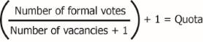
PR counting is complex and time-consuming, so such counts are conducted by computer.
Refer to Appendix 2 for councillor ballot paper formality rules.
Computer count
Computers will be used to obtain the results of during Melbourne City Council elections and scrutineers are entitled to observe all aspects of the computer count for the election they are appointed to. When using computers, ballot papers will be amalgamated and batched into 50s. The preferences on each ballot paper will be entered into the computer count application by data entry operators.
The computer checks each ballot paper for formality during data entry and any informal ballot papers will be identified and removed from the count.
For the Leadership Team election, the Election Manager will check all informal ballot papers and any determined to be formal will be returned to data entry (see Appendix 1 for Leadership Team formality rules).
For the councillor election the Election Manager will check all informal ballot papers and any determined to be formal below-the-line (see Appendix 2 for 90% rule) will be returned to data entry, or, if determined to be formal above-the-line, will be returned for inclusion with the Group Ticket Votes (GTVs). Only the preferences entered from formal ballot papers will be saved to the computer count application.
For formal ballot papers marked above-the-line in the councillor election, the tally for each group is entered into the computer count application and preferences allocated according to the GTVs lodged by that group. When all ballot papers marked below-the-line have been data entered and accounted for, a result will be calculated.
Two reports will be available periodically during computer counts for each election:
- progressive first preference results during data entry
- ballot paper details to enable a comparison of the preferences entered into the computer count application against the actual ballot papers for a particular batch.
When data entry for all ballot papers is complete and the result calculated, scrutineers will be provided with the distribution of preferences report for the relevant election.

Challenges during a computer count
Scrutineers may ask computer count team leaders for information at any time during the course of the count and may express concerns about the accuracy of a data entry operator, or the entry of a specific batch. If this occurs, the team leader will review the relevant ballot papers with the scrutineer, comparing them to the preferences shown on the ballot paper details report. If any errors are found, the team leader will correct these in the computer count application.
3.7 Recount of votes
At any time before a candidate has been declared elected, the Election Manager may -
- if they believe it is necessary, or
- at the written request of a candidate specifying reasons
open any sealed parcel containing ballot papers and recount the ballot papers.
The following applies to recounts:
- a recount may be conducted at the discretion of the Election Manager
- the Election Manager may conduct one or more recounts
- the Election Manager must make reasonable efforts to notify candidates or their representatives before a recount is conducted.
The Election Manager may recount designated parcels of ballot papers or all ballot papers and may reverse any decision in relation to any ballot paper.
The result of a recount supersedes the original count.

4. Offences
4.1 Offences by scrutineers
The Election Manager (or other election official) may have a scrutineer removed from a venue if:
- more than one scrutineer for each election official involved in each electoral activity is present at one time
- the scrutineer commits any breach of the Acts or Regulations
- the scrutineer handles any ballot papers
- the scrutineer obstructs or hinders the electoral activities
- the scrutineer fails to obey a lawful direction given by an election official.
4.2 Interference with rights
It is an indictable offence for a person to hinder or interfere with the free exercise or performance of any other person's political right or duty relevant to an election under the Local Government Act 2020 [section 301(1) of the Act].
PENALTY: 600 penalty units or imprisonment for five years.
4.3 Offences relating to ballot papers
It is an indictable offence to:
- forge any ballot-paper, prescribed form or other form or document submitted or lodged in connection with an election or
- utter any forged ballot-paper, prescribed form or other form or document submitted or lodged in connection with an election or
- forge the signature of any person on any ballot-paper, prescribed form or other form or document submitted or lodged in connection with an election [section 294(1) of the Local Government Act 2020].
PENALTY: 600 penalty units or imprisonment for five years.

It is an indictable offence to, in respect of an election:
- vote in the name of another person, including a dead or fictitious person or
- vote more than once or
- apply for a ballot-paper in the name of another person [section 294(3) of the Local Government Act 2020].
PENALTY: 600 penalty units or imprisonment for five years.
It is an indictable offence to:
- open any sealed envelope containing a ballot paper or break the seal or open any ballot-box or parcel sealed under the Act or the Regulations or
- deal with any ballot-papers, voters' rolls or other material used at an election under this Act or the regulations.
This does not apply to person authorised by the Act or Regulations [section 296 of the Local Government Act 2020].
PENALTY: 600 penalty units or imprisonment for five years.
4.4 Interfering with postal ballot materials
It is an indictable offence for a person to interfere with any material being, or to be, sent or delivered to a voter by the VEC at an election. This does not apply to a person who is acting with the authority of the VEC [section 299 of the Local Government Act 2020].
PENALTY: 600 penalty units or imprisonment for five years.
4.5 Infringement of secrecy
Except as authorised by law, it is an offence for a person who is present when a voter votes to:
- ascertain or disclose by word, act or other means, the vote of the voter or
- directly or indirectly require, induce or attempt to induce the voter to show how the voter intends to vote or
- communicate with or assist the voter while voting or look at the voter’s vote or ballot paper [section 297 of the Local Government Act 2020].
PENALTY: 120 penalty units or imprisonment for one year.
4.6 False or misleading declaration
It is an indictable offence for a person to make a statement knowing that it is false in a material particular in any information provided orally or in writing in relation to voter enrolment or in any declaration or application in relation to an election under the Act or the Regulations [section 293 of the Local Government Act 2020].
PENALTY: 600 penalty units or imprisonment for five years.

Appendices
Appendix 1: Leadership Team ballot paper formality rules
In order for a ballot paper to be formal it must contain the number 1. All other boxes must be numbered in sequential order from 1 to the number of teams in the election.
The following should be used as a guide to ballot paper formality. Any challenges to the formality of ballot papers must be referred to the Election Manager.
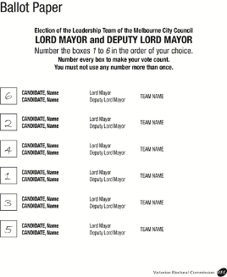  FORMAL  The numbers are consecutive, starting at 1 |  | 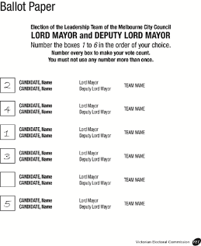  FORMAL  Only one box left blank, clearly last preference
1. All boxes should be numbered using the full sequence of numbers as indicated on the ballot paper. |  | 2. The only exception is where one box is left blank and would logically have contained the last preference.
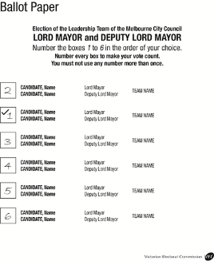  FORMAL  Even though there is a tick the number 1 is clear |  | 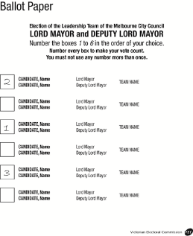  INFORMAL  More than one box left blank
3. Each ballot paper must have a number 1 in, adjacent to, or level with one box. |  | 4. More than one box left blank  makes the ballot paper informal.
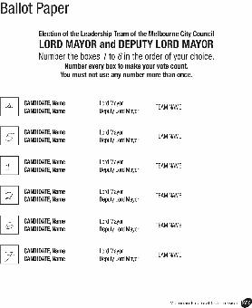  INFORMAL  Sequence  discontinued  between 2 and 4  (3 is missing) |  | 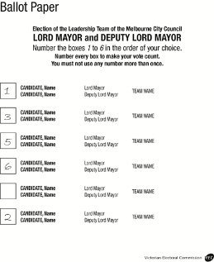  INFORMAL  The number 4 has been omitted from the sequence
5. Any omission of a number from the sequence makes the ballot paper informal. |  | 6. Any omission of a number from the sequence makes the ballot paper informal.
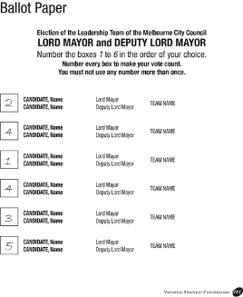  INFORMAL  The number 4 appears twice |  | 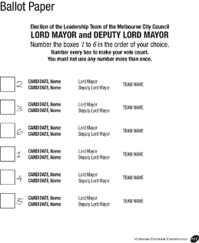  FORMAL  Numbers outside boxes are still clearly allocated
7. Any duplicate of a number in the sequence makes the ballot paper informal. |  | 8. Numbers next to names are acceptable providing the voter’s intention is clear.
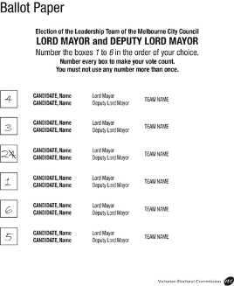  FORMAL  The correction is clear |  | 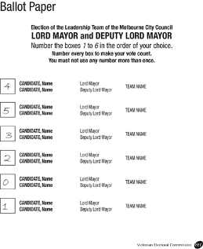  INFORMAL  Sequence must be 1, 2, 3, etc. Zero (0) is not permitted
9. Amendments are acceptable providing the voter’s intention is clear. All other marks are to be ignored. |  | 10. The number ‘0’ (zero) makes the ballot paper informal as it is outside the range of numbers indicated in the instructions on the ballot paper.
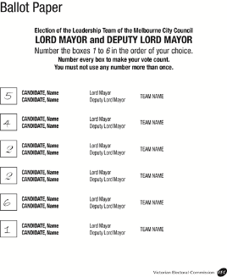  INFORMAL  Numbers in the third and fourth boxes cannot be distinguished |  | 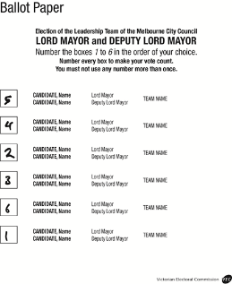  FORMAL  Numbers can be determined by taking whole ballot paper into account
11. Poorly formed numbers must be considered in the context of the whole ballot paper. |  | 12. Poorly formed numbers are acceptable if they can reasonably be construed as numbers comprising part of the sequence.
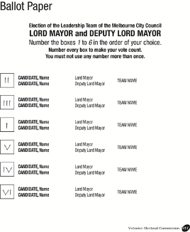  FORMAL  All figures clearly represented in  unconventional format |  | 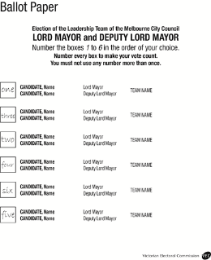  FORMAL  Written numbers are acceptable
13. Unconventional but recognisable numbers such as Roman numerals or continental numbers are acceptable. |  | 14. Numbers may also be written (one, two, three, etc.), but non-English words or characters are not acceptable.
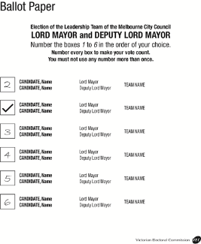  INFORMAL  No number one |  | 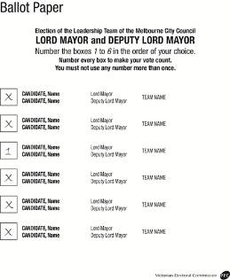  INFORMAL  Sequence stops after number one
15. Ticks, crosses, As and Bs, etc., are not acceptable as indicators of preference. Must have a number 1. |  | 16. Ticks, crosses, As and Bs, etc., are not acceptable as indicators of preference.

Appendix 2: Councillor ballot paper formality rules
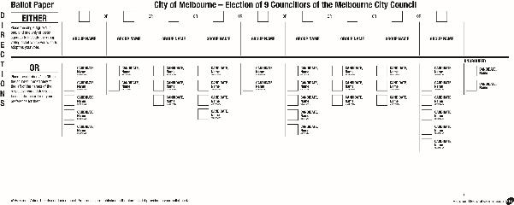
Voting above-the-line
Ballot papers marked above-the-line are formal if a preference mark is placed in one square only. A single tick, a cross or a number ‘1’ is an acceptable indicator of preference and any other mark must be ignored.
Voting below-the-line
Ballot papers marked below-the-line are formal if the number ‘1’ appears against one candidate only and at least 90% of the boxes are numbered using the full sequence of numbers (or figures that with a change to no more than ‘1’ would be in sequence).
Ticks, crosses, a zero (‘0’) and any other marks are not acceptable as indicators of preference and must be ignored.
When distributing preferences for formal ballot papers marked below-the-line, only the voter’s actual figures are to be considered. Formal ballot papers that have not been marked using the full sequence of numbers (see example 7 in Appendix 1) are exhausted once a break or repetition in the sequence is reached during the preference distribution.
Markings above-the-line and below-the-line
If a ballot paper is marked both above-the-line and below-the-line, the marks below-the-line are considered first. If the marks below-the-line comply with formality requirements it will be counted as a vote below-the-line. If the marks below-the-line would result in the ballot paper being informal, they are ignored, and the voter is deemed to have voted above-the-line.

Councillor ballot paper formality examples
1.
FORMAL
Below-the-line is informal as not enough boxes are numbered but above-the-line is formal (numbers ‘2’ and ‘3’ must be ignored).
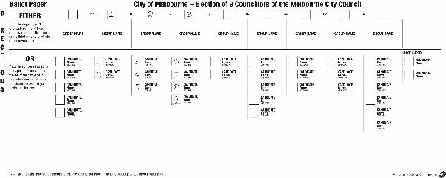
2.
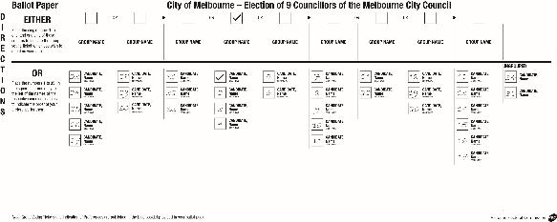
FORMAL
Below-the-line is informal but above the line is formal. A single tick in one box is an acceptable preference mark above-the-line only.

3. 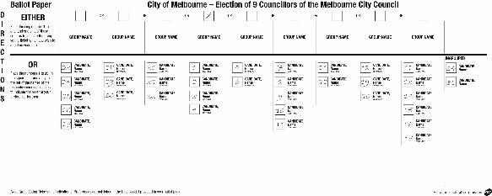
FORMAL
Below-the-line is formal as all boxes are numbered in consecutive sequence.
Above-the-line is also formal but will not be considered in this case.
4.
FORMAL
Below-the-line is formal as at least 90% of the boxes are numbered in consecutive sequence. Preferences will exhaust after 32. Above-the-line is informal but can be ignored in this case.
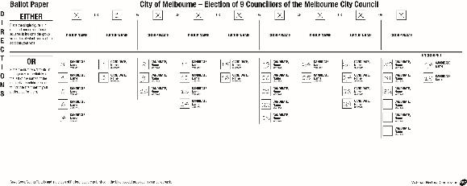
5.
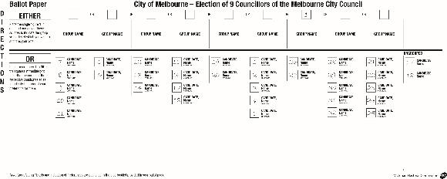
FORMAL
Above-the-line is formal but below the line is informal (the numbers 5, 17 and 18 are repeated breaking the sequence).

6.
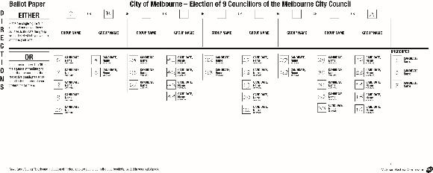
FORMAL
Above-the-line is informal (‘A’ is not an acceptable preference mark). Below-the-line is formal. Although there is a break in the sequence after number 10, 90% of the boxes would be in sequence with a change to only one box. Preferences would exhaust after 10.

7.
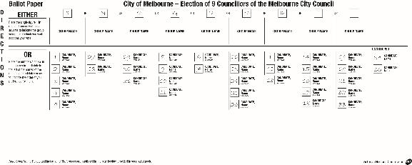
FORMAL
Below-the-line is informal as there are two number 1s. Above-the-line is formal (‘X’ is a preference mark, other marks are ignored).
8.
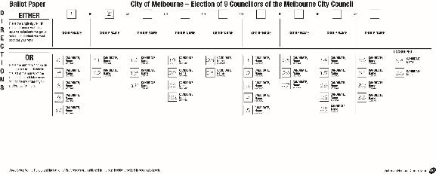
FORMAL
Below-the-line is informal as there are two errors in the sequence of numbers (‘16’ is repeated and ‘13’ is missing). Above-the-line is formal as only one box has been marked with preference mark ‘1’ (the other ‘1’ has been crossed out, a clear correction).

Appendix 3: Damaged ballot papers
Election officials may come across ballot papers that have been damaged.
Where an official can determine a voter had access to all candidate information on the ballot paper when recording their preferences, such a ballot paper can be ruled ‘formal’ if all formality requirements have otherwise been met.
If, from the intact part, the official can determine that the voter had access to the names of all candidates then look at the formality requirements.
Leadership Team election
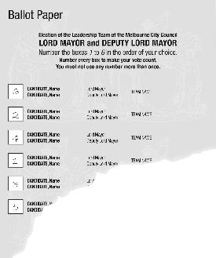  FORMAL  All preferences are discernible | 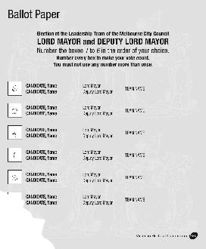  INFORMAL  The number five is missing and cannot be assumed to exist
Councillor election
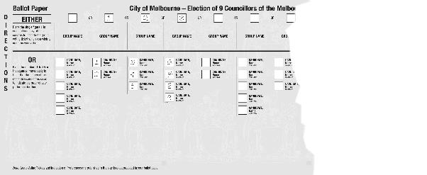
INFORMAL
Integrity of ballot paper has been compromised. Some candidate details and preference boxes missing

Glossary
Electoral Personnel
Candidate | A person who nominates to contest an election for a council.
Chief Executive Officer | The person appointed by a council to be its Chief Executive Officer or any person acting in that position.
Electoral Commissioner | The person responsible for the administration of electoral law in Victoria. This responsibility includes the maintenance of the electoral roll, the conduct of all parliamentary elections and the conduct of council elections.
Election Manager | The person appointed by the Electoral Commissioner to be responsible for the administration of a council election.
Scrutineer | A person appointed by a candidate to observe certain procedures on the candidate’s behalf at an election.

Electoral Terms
Absolute majority | More than 50% of the formal votes in an election.
Act | The Local Government Act 2020 [Act] and amending legislation.
Ballot pack | For an election conducted by post, the VEC mails out to each voter an envelope containing the ballot materials needed by the voter. It includes:  - a ballot paper for the leadership team  - a ballot paper for the councillor election  - candidates’ and group statements and indication of preferences  - voting instructions  - a multi-language leaflet for relevant elections  - a ballot paper envelope with a flap for the voter’s declaration  - a Reply-Paid envelope in which to return the completed ballot material to the Election Manager.
Ballot paper | The paper listing the names of all the candidates contesting the election on which the voter records their preferences for each candidate in the election.
Ballot paper envelope | An envelope used by the voter to enclose their completed ballot paper. The envelope includes a detachable flap containing the name and address of the voter. The voter is required to sign the flap.
Computer count | The electronic counting of votes.
Council | A local government authority as defined and set out in the Act.
Disadvantaged voter | Any voter who:  - is wholly or partially blind; or  - is unable to read or write; or  - has severe difficulty in reading or writing; or  - is not sufficiently familiar with the English language to vote without assistance and an interpreter is not available.
Distribution of preferences | The process used to determine the successful candidate in an election when no candidate receives an absolute majority for a single vacancy election, or quota of formal first preference votes for a multiple vacancy election.
Early voting | An Election Manager may issue a voter with a ballot paper prior to the general mail-out if satisfied that special circumstances exist, e.g. where a voter is about to go overseas prior to the general mail-out and will not be returning prior to the close of voting.
Election Day | Means the day of an election fixed under section 257 or 260 of the Local Government Act 2020.
Group | Two or more candidates for a councillor election who make a request to the Election Manager under the City of Melbourne Act (2001) to group their names on the ballot paper.
Leadership Team | Consists of a Lord Mayor and Deputy Lord Mayor. Candidates for these positions must nominate jointly.
Preliminary scrutiny | The validation of envelopes containing postal, unenrolled and other declaration votes.
Proportional representation | The process used to elect representatives in proportion to their level of support in an election with multiple vacancies.
Quota | Using the proportional representation method, a candidate is elected on receiving a number of votes equal to or exceeding a quota. The quota is determined by dividing the total number of formal votes by the number of vacancies plus 1 and adding one to the result.
Recount | A provision whereby the Election Manager may, at any time before the declaration of the election, open any sealed parcel containing ballot papers and conduct a fresh count. A recount usually occurs or is requested when the result of an election is close.
Regulations | The Local Government (Electoral) Regulations 2020 [Reg.].
Replacement vote | A replacement vote is issued when a voter claims to have lost or spoilt their ballot material or claims that they did not receive a ballot pack.
Scrutiny | The checking and counting of ballot papers and declaration envelopes to ascertain the result of an election.
Unenrolled vote | A vote made by a person who claims to be entitled to vote but whose name cannot be found on the voters roll.
Unsubdivided council | A council that is not divided into wards.
Victorian Electoral Commission (VEC) | The statutory body responsible for the conduct of State Parliamentary and local council elections in Victoria. The Electoral Commissioner is the statutory head of the VEC.
Voter | A person enrolled on the voters’ roll.
Voters’ roll | The certified voters’ roll is a merger of the CEO List provided by council with the Electoral Commissioner’s list of State electors in that council. A separate roll is created for each individual election.
Ward | A subdivision of a council. In subdivided councils, councillors are elected to represent a ward.

