Local council ward boundary review

February 2024

South Gippsland Shire Council

Preliminary   
Report



© State of Victoria   
(Victorian Electoral Commission)   
February 2024

This work, Local council ward boundary review – Preliminary report – South Gippsland Shire Council, is licensed under a Creative Commons Attribution 4.0 licence [<http://creativecommons.org/licenses/by/4.0/>]. You are free to share this work under that licence, on the condition that you do not change any content and you credit the State of Victoria (Victorian Electoral Commission) as author and comply with the other licence terms. The licence does not apply to any branding, including Government logos.



Level 11, 530 Collins Street

Melbourne Victoria 3000

T 131 832

info@vec.vic.gov.au

vec.vic.gov.au

**Content approval**

|  |  |  |
| --- | --- | --- |
| Version | Date approved | Approved by |
| 1 | 7 February 2024 | Electoral Commissioner |
| 1 | 7 February 2024 | Program sponsor |

**Release approval**

|  |  |  |  |
| --- | --- | --- | --- |
| Version | Date approved | Approved by | Brief description |
| 1.1 | 21 February 2024 | Program sponsor | Dates adjusted for close of submissions, public hearing and final report. |

**Acknowledgement of Country**

The Victorian Electoral Commission (VEC) acknowledges Bunurong and Gunaikurnai peoples as the Traditional Custodians of the lands and waters for which it is holding this review and pays respects to ancestors and Elders past, present and emerging. The VEC acknowledges their custodianship for many thousands of years and their continuing living culture.

Contents

Executive summary 5

Ward boundary model 5

Next steps 5

Background 6

About the 2024 ward boundary reviews 6

The ward boundary review panel 6

Public engagement 7

Considerations in developing models 7

About South Gippsland Shire 9

Current electoral structure 11

Last electoral structure review 11

Preliminary findings and model 12

Ward boundary model for public feedback 12

Next steps 14

Response submissions 14

Public hearing 15

Final report 15

References 16

Appendix 1: Preliminary model map 17

# Executive summary

Under section 17 of the *Local Government Act 2020* (Vic) (the Act), the Minister for Local Government has asked the Victorian Electoral Commission (VEC) to conduct ward boundary reviews for 10 local council areas prior to the next general local council elections in October 2024.

For these 10 councils, the number of voters per councillor is forecast to be out of balance by October 2024, with the number of voters per councillor in one or more wards forecast to vary from the average number of voters per councillor for all of the wards by more than 10 per cent.

South Gippsland Shire Council is one of the 10 local council areas under review. The purpose of this review is to correct this forecast imbalance for the October 2024 local council election.

In its review, the VEC is looking at:

* + the number of currently enrolled voters in each ward
  + the forecast number of enrolled voters at the next election
  + adjustments to the locations of existing ward boundaries.

At the end of the review, the VEC will recommend ward boundary changes to the minister, with the aim of all wards in South Gippsland Shire Council being within the legislated +/-10% tolerance at the time of the 2024 local council election.

This preliminary report presents proposed ward boundary adjustments for South Gippsland Shire Council.

More information about the background to the review is available on page 6.

## Ward boundary model

After considering research and the requirements of the Act, the VEC is presenting a single model for public consultation, outlining the proposed ward boundary changes to South Gippsland Shire Council.

Details on this model, including a map, are available in Appendix 1.

## Next steps

The VEC is now seeking feedback on its preliminary ward boundary model. You can make a response submission to the preliminary model until 5 pm on Wednesday 13 March 2024. If any submitters ask to speak at a public hearing, the VEC will hold this online on Wednesday 20 March 2024. Following the hearing, the VEC will present its final recommendation to the minister on Wednesday 17 April 2024.

More information about the review process is available on the VEC website at [vec.vic.gov.au](https://www.vec.vic.gov.au/)

# Background

## About the 2024 ward boundary reviews

Under section 15(2) of the *Local Government Act 2020* (Vic), for a council that is divided into wards:

* 1. each ward should have an approximately equal number of voters per councillor; and
  2. the number of voters per councillor in a ward should not vary from the average number of voters per councillor for all of the wards by more than 10 per cent.

On 22 February 2023, the VEC provided advice to the Minister for Local Government on councils that were projected to have at least one ward with the number of voters per councillor outside this +/-10% range at the time of the October 2024 local council elections.

This advice was based on:

* current enrolment and enrolment trends
* future population projections
* legislated changes to council entitlements for council-enrolled voters.

On 20 April 2023, in response to this advice and under section 17 of the Act, the minister asked the VEC to conduct ward boundary reviews for 10 local council areas before the October 2024 local council elections. These reviews aim to balance the number of voters per councillor for the wards of these 10 councils in time for the 2024 elections.

South Gippsland Shire Council is one of the 10 local council areas under review.

In its review, the VEC is looking at:

* + the number of currently enrolled voters in each ward
  + the forecast number of enrolled voters at the next election
  + adjustments to the locations of existing ward boundaries.

A ward boundary review does not change a council’s electoral structure, number of councillors, or ward names. A ward boundary review also cannot change the external boundaries of a local council, divide local councils, or amalgamate local councils.

At the end of the review, the VEC will recommend ward boundary adjustments to the minister, with the aim of all wards in South Gippsland Shire Council being within the legislated +/-10% tolerance at the time of the 2024 local council election.

## The ward boundary review panel

Leading the VEC’s review is a ward boundary review panel, which has 2 members:

* the Electoral Commissioner - Mr Sven Bluemmel (Chairperson)
* the Program Sponsor, Electoral Structure and Boundary Review Program - Ms Kirsty Williamson.

Administrative and technical support for the panel is provided by the VEC’s team of electoral structure and boundary review experts as well as specialists from across the VEC.

## Public engagement

### Public information program

The VEC is conducting a public information and awareness program about the South Gippsland Shire Council ward boundary review. This includes:

* + printed public notices in state-wide newspapers
  + public information sessions to outline the review process and respond to questions from the community
  + a media release to announce the start of the review
  + information on social media channels
  + website content on [vec.vic.gov.au](https://www.vec.vic.gov.au/), including:
    - current information on the review process
    - fact sheets for each council under review and a submission guide.

South Gippsland Shire Council was also offered and took up 2 optional methods to promote the reviews:

* + printed public notices in local newspapers
  + targeted social media advertisements for the council area.

### Public consultation

The VEC now invites input to the ward boundary review of South Gippsland Shire Council via:

* + response submissions to this preliminary report
  + an online public hearing for anyone who makes a response submission and wishes to speak to the ward boundary review panel and expand on their submission.

Public submissions are an important part of the review process and the VEC will consider them alongside other factors during the review. These factors are outlined below.

## Considerations in developing models

The model in this preliminary report complies with the Act and was developed through careful consideration of:

* + research and analysis conducted by the VEC, including geospatial, electoral and demographic data
  + rates or patterns of population and voter change over time, and relevant forecasts of growth or decline based on forecast information provided by .id (informed decisions, a company specialising in demographics and forecasting).

When developing the preliminary model for South Gippsland Shire Council, the VEC considered:

* + whether the adjusted wards would comply with section 15(2) of the Act (see below), and how long they are likely to comply
  + whether meaningful and effective ward boundaries could be established and whether these would be easily identifiable to local communities
  + the representation of communities of interest
  + the voter distribution and physical features of the area, and the impact these may have on the shape and size of wards
  + the scale of ward boundary changes, aiming for minimal change (where possible).

In addition to the above, the VEC’s final recommendation will also consider matters raised in public response submissions.

Under section 15(2) of the Act, subdivided structures must aim for an approximately equal number of voters per councillor across all wards. This means the number of voters represented by each councillor in a ward should be within +/-10% of the average number of voters per councillor for all wards of that council.

During this review, the VEC aims to recommend ward boundary adjustments that help ensure a council’s wards comply with section 15(2) at the time of the 2024 local council elections and, if possible, also comply based on voter numbers at the time the review is conducted. The VEC uses forecasts of population and voter change to assess compliance at the 2024 elections with as much accuracy as possible.

In some cases, population change and other factors impacting voter numbers mean it is not possible to adjust the ward boundaries of a council so that both ‘current’ (at the time of the review) and ‘forecast’ (at October 2024) voter numbers are within the legislated +/-10% tolerance. Where this happens, the VEC prioritises compliance at the October 2024 elections to ensure each vote will have approximately equal value at the 2024 elections. In some cases, the VEC’s recommended model may set the current ward deviations outside the +/-10% tolerance. This is because the ward deviations are forecast to change over a short period of time and move within the +/-10% tolerance by the time of the 2024 local council elections.

One of the factors that may impact compliance with section 15(2) is the number of current and forecast voters with ratepayer-based voting entitlements, also known as council-enrolled electors. Voters’ rolls include both state-enrolled electors (the majority of the roll) and a smaller number of council-enrolled electors. The Act introduced changes to ratepayer-based entitlement categories, which come into full effect at the 2024 local council elections. The VEC will take this change to the makeup of voters’ rolls, and therefore compliance with section 15(2) of the Act, into consideration during this review.

# About South Gippsland Shire

South Gippsland Shire was created in 1994 when the former Shire of South Gippsland was amalgamated with the Shire of Mirboo, and parts of the Shire of Korumburra and Shire of Woorayl. It is located in south-eastern Victoria, around 100 km from the Melbourne CBD. Covering an area of 3,309 km2. The Shire’s southern boundary consists of the Bass Strait and Corner Inlet coastlines and it borders Cardinia and Bass Coast councils in the west, Baw Baw in the north, and Latrobe and Wellington councils in the east.

The Traditional Custodians of the land in South Gippsland Shire Council are the Bunurong and Gunaikurnai peoples (VAHC 2024).

### Landscape

The major transport routes servicing the council area are the South Gippsland, Bass and Strzelecki highways, which all intersect at Leongatha, with the former extending all the way to the town of Sale in Victoria’s east.

Important geographical features include the Strzelecki Ranges, Corner Inlet Marine and Coastal Park, Cape Liptrap Coastal Park, and Wilsons Promontory National Park, which are all major tourist attractions.

### Community

In 2021 the population of the council area was approximately 30,577, an increase of 12.3% since 2011 when the population was 27,208 (ABS 2022a, ABS 2022e). The population is projected to grow by around 14% by 2036, with the main areas of growth expected mostly in the north, around the localities of Nyora, Leongatha, Korumburra and Mirboo North (.id 2024).

Leongatha is the largest town by population, and the shire’s main service town, providing access to employment, education and health services (DTP 2024). Other key towns include Korumburra, Foster and Mirboo North, with smaller settlements at Fish Creek, Loch, Meeniyan, Nyora, Poowong and Toora. The shire has large concentrations of council-enrolled voters, mostly due to the prevalence of holiday homes found around Venus Bay and Sandy Point.

At 49, the median age of residents is significantly higher than in Greater Melbourne and Victoria (37 and 38), while at around 6.5%, unemployment is higher than the metropolitan and state averages (ABS 2022a, 2022b, 2022c).

A key industry in South Gippsland is agriculture, which makes up 15% of employment (.id 2024), and 19% of economic output (REMPLAN 2024). Dairy production is a major industry, with around 10% of all Victorian dairy farms found within the council area (SGSC 2021). Tourism is also a prominent economic driver, particularly in the southern coastal area, with the municipality attracting over 1.2 million visitors per year (SGSC 2021).

Home ownership, at 80.5%, is higher than the regional Victoria rate of 72.5% (owned outright and with a mortgage), while the proportion of households renting is lower (15.6% compared with 23.6%) (ABS 2022a, ABS 2022d). The weekly median household income is $1,266, which is lower than the regional Victoria median of $1,386 (ABS 2022a, ABS 2022d).

The shire’s demographic profile is comparable to regional Victoria. Nearly 16% of residents have both parents born overseas, similar to the rest of regional Victoria at 16.4% (ABS 2022a, ABS 2022d), while almost 90% of the population speaks only English at home, compared with the regional Victoria rate of 86.4% (ABS 2022a, ABS 2022d).

## Current electoral structure

South Gippsland Shire Council has a total of 9 councillors and is divided into 3 wards with 3 councillors per ward (Coastal-Promontory, Strzelecki and Tarwin Valley wards).

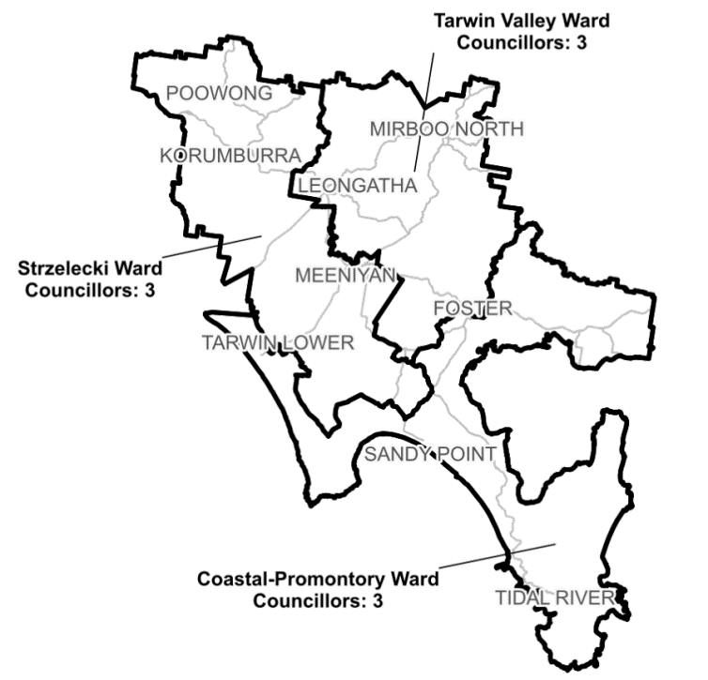

***Figure 1:*** *Diagram of current electoral structure of South Gippsland Shire Council.*

There are an estimated 30,901 voters in South Gippsland Shire Council, with an estimated ratio of 3,433 voters per councillor.

By October 2024, the voter-to-councillor ratios of Strzelecki and Tarwin Valley wards are forecast to be outside of +10%, and the voter-to-councillor ratio of Coastal-Promontory Ward is forecast to be outside of -10%.

Visit the VEC website at [vec.vic.gov.au](https://www.vec.vic.gov.au/electoral-boundaries/local-councils/south-gippsland-shire-council) for more information on South Gippsland Shire Council.

## Last electoral structure review

The VEC conducted an electoral representation review of South Gippsland Shire Council in 2012. That review was carried out under the *Local Government Act 1989* (Vic), which was replaced by the *Local Government Act 2020* (Vic).

After conducting the review, the VEC recommended that South Gippsland Shire Council continue to consist of 9 councillors elected from 3 wards (3 wards with 3 councillors each)

Visit the VEC website at [vec.vic.gov.au](https://www.vec.vic.gov.au/electoral-boundaries/local-councils/south-gippsland-shire-council) to access a copy of the 2012 representation review final report.

# Preliminary findings and model

## Ward boundary model for public feedback

The VEC considered a range of ward boundary adjustments for South Gippsland Shire Council and chose the strongest model for public consultation.

The following model is presented for community consideration:

* Preliminary model, which proposes changes to the boundaries of Coastal-Promontory, Strzelecki and Tarwin Valley wards.

A map of the preliminary model is included in Appendix 1.

### Preliminary model

After considering various options, the panel decided to put forward one model. The model was considered to affect a minimal number of voters, essentially shifting the current northern boundary of Coastal-Promontory Ward further north to rebalance its lower voter population relative to the 2 northern wards of Tarwin Valley and Strzelecki.

While the panel explored other options, the preliminary model was the only structure considered appropriate for the communities of South Gippsland Shire. This is because the concentrated populations in the towns of Leongatha and Korumburra, coupled with the sparse population distribution throughout the centre of the shire, severely limits the ability to create sensible ward boundaries that adhere to the legislated +/-10% requirement. Of the models considered, this was the most stable for the purposes of adhering to the +/-10% requirement during the 2024 local government elections, but also has a reasonable chance to remain within legislated deviations for the 2028 elections too.

An additional challenge to creating ward boundaries for South Gippsland is the high prevalence of council-enrolled voters found mostly in the south along the coastline, with notable concentrations around Venus Bay and Sandy Point. This factor further limited the options for creating sensible ward boundaries. Due to these constraints, the panel viewed other models that, while compliant with the Act, would likely not satisfactorily cater to communities of interest. This included options for splitting the coastal areas between wards, and options combining the disparate locations of Wilsons Promontory and Leongatha.

In the preliminary model, the northern boundary of Coastal-Promontory Ward now follows the Tarwin River and Tarwin River-East Branch for almost the entire length, with small deviations from the river in the east using roads, trails and property boundaries. This was regarded as a good outcome when considering the prominent nature of the river in the area, which presents as a strong and easily recognisable boundary. The panel also noted that most boundaries between the current Strzelecki and Tarwin Valley wards would remain in place in the preliminary model, with only very minor adjustments near Leongatha. This too was considered a good outcome as electors would likely be familiar with these boundaries, including the use of Tarwin Valley River-West Branch, roads, and property boundaries.

The panel noted that shifting the Coastal-Promontory Ward boundaries further north might result in some communities that have less in common with the coastal area of the shire being included in a ward with these coastal areas. This shift would mean the more central towns of Meeniyan, Stony Creek and Dumbalk would now be contained within the southern Coastal-Promontory Ward. While the panel acknowledged this could have potential drawbacks, and that these towns might constitute communities of interest more aligned with the north, it was felt that such change was necessary to sensibly rebalance all wards to adhere to the +/-10% requirement.

Of the all the options considered, it was seen that the preliminary model would impact the least number of voters, with 2,800 voters (or about 9%) changing wards (based on current enrolments). In Coastal-Promontory Ward 2,796 voters are affected, with 1,598 and 1,198 affected from Tarwin Valley and Strzelecki wards respectively. An additional 4 voters change from Strzelecki Ward to Tarwin Valley Ward.

Overall, the panel found that the adjustments in the preliminary model struck a good balance between the least amount of change to meet legislated requirements and catering to communities of interest, while also creating sensible ward boundaries. Given the constraints presented by concentrations of population centres and council-enrolled voters, the panel considered that the proposed ward boundaries in the preliminary model would be a good outcome for the shire and is now seeking public feedback about the proposed model.

# Next steps

## Response submissions

Any person or group, including the local council under review, can make a response submission to the VEC. Your submission should address the model or models proposed in this preliminary report.

You can make a submission:

|  |  |
| --- | --- |
|  | **Online** Visit [vec.vic.gov.au](http://vec.vic.gov.au/" \o "Link to VEC website homepage) and make an account to use the online Public Submission Tool. You may save a draft submission to finish later. |
|  | **By email** [SouthGippsland.WardReview@vec.vic.gov.au](mailto:SouthGippsland.WardReview@vec.vic.gov.au) |
|  | **By post**  Ward boundary review panel Victorian Electoral Commission Level 11, 530 Collins St Melbourne VIC 3000 |

The panel must receive all response submissions before 5 pm on Wednesday 13 March 2024. If you post your submission, it must reach the VEC before the deadline. Late submissions will not be accepted.

### Required information

To be considered, your submission must include your:

* full name
* contact phone number or email address
* postal or residential address.

To protect the integrity and transparency of the review process, the VEC will not consider submissions without this information. If you are submitting as a group or organisation, you must include a nominated contact person authorised to submit on behalf of your group.

The VEC will handle information provided by submitters in accordance with its privacy policy at [vec.vic.gov.au/privacy](http://vec.vic.gov.au/privacy)

### Public access to submissions

To ensure transparency in the ward boundary review process, your submission will be published on the VEC website at [vec.vic.gov.au](http://www.vec.vic.gov.au/). The VEC will remove your signature and contact details, including residential and postal addresses, from all public copies but must publish your full name (or group name) and locality (suburb or town).

Please note that any submission content that is potentially defamatory, offensive, obscene or that includes the personal information of people or organisations who are not a party to the submission may also be redacted before publication.

## Public hearing

If you make a response submission, you can also ask to speak at an online public hearing to support your submission and expand on your views.

The online public hearing is scheduled for:

Time: 2 pm

Date: Wednesday 20 March 2024

The VEC encourages participation in the public hearing. If you wish to speak at the public hearing, you **must** indicate this in your response submission. The public hearing will not be held if there are no requests to speak.

Anyone can attend a public hearing, but you will only be able to speak if you expressly asked to speak in your response submission. If you ask to speak, the VEC will contact you to arrange a time for you to speak at the hearing. You will have 10 minutes to address the public hearing panel. The members of the public hearing panel may ask you questions.

Visit the VEC website at [vec.vic.gov.au](http://vec.vic.gov.au/) for more information on public hearings.

## Final report

Following the public hearing, the VEC will consider all evidence and prepare a final report for the Minister for Local Government containing recommended ward boundary adjustments for the local council.

The final report is scheduled to be provided to the minister on Wednesday 17 April 2024. The minister will consider the final reports, including any determination to make the reports publicly available. Any change to the ward boundaries of South Gippsland Shire Council following this review is expected to apply at the October 2024 local council elections. Under the Act, the final council electoral structure will be set by an Order in Council published in the Victoria Government Gazette.

# References

ABS (Australian Bureau of Statistics) (2022a) [*2021 South Gippsland, Census All persons QuickStats,*](https://abs.gov.au/census/find-census-data/quickstats/2021/LGA26170) ABS website, accessed 11 January 2024.

—— (2022b) [*2021 Greater Melbourne, Census All persons QuickStats,*](https://abs.gov.au/census/find-census-data/quickstats/2021/2GMEL) ABS website, accessed 11 January 2024.

—— (2022c) [*2021 Victoria Census All persons QuickStats,*](https://abs.gov.au/census/find-census-data/quickstats/2021/2) ABS website, accessed 11 January 2024.

—— (2022d)[*2021 Rest of Vic. Census All persons QuickStats,*](https://abs.gov.au/census/find-census-data/quickstats/2021/2RVIC) ABS website, accessed 11 January 2024.

—— (2022e) [*2011 South Gippsland, Census All persons QuickStats,*](https://abs.gov.au/census/find-census-data/quickstats/2011/LGA26170) ABS website, accessed 11 January 2024.

DTP (Department of Transport and Planning) (2024) [*South Gippsland planning scheme*](https://planning-schemes.app.planning.vic.gov.au/South%20Gippsland/ordinance), DTP website, accessed 29 January 2024.

.id (Informed Decisions) (2024), [*South Gippsland Shire: Industry sector of employment*](https://profile.id.com.au/south-gippsland/industries), .id website, accessed 29 January 2024.

Local Government Act 1989 (Vic).

Local Government Act 2020 (Vic).

Local Government (Electoral) Regulations 2020 (Vic).

REMPLAN (2024), [*South Gippsland Shire Council: Economy, Jobs and Business Insights*](https://app.remplan.com.au/southgippsland/economy/summary?state=ZmY8TV3M6C3LxBYtgdXdPwFjhnhEQR), REMPLAN website, accessed 29 January 2024.

SGSC (South Gippsland Shire Council) (2021), [*Economic Development Strategy 2021-2031*](https://www.southgippsland.vic.gov.au/info/20004/your_council/274/council_strategies), South Gippsland Shire Council website, accessed 29 January 2024.

VAHC (Victorian Aboriginal Heritage Council) (2021) [*Registered Aboriginal Parties in Victoria*](https://achris.vic.gov.au/weave/wca.html), Aboriginal Victoria website, accessed 29 January 2024.

# Appendix 1: Preliminary model map

The following map is included in this report:

|  |  |
| --- | --- |
| Map | Page |
| Preliminary model – with proposed changes to the boundaries of Coastal-Promontory, Strzelecki and Tarwin Valley wards. | 18 |

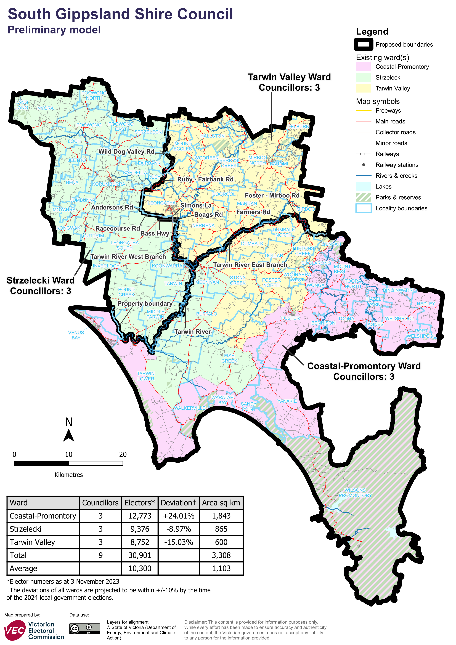

Data for preliminary model

|  |  |  |  |
| --- | --- | --- | --- |
| Ward | Electors* | Deviation† | Area# (square km) |
| Coastal-Promontory | 12,773 | +24.01% | 1,843 |
| Strzelecki | 9,376 | -8.97% | 865 |
| Tarwin Valley | 8,752 | -15.03% | 600 |
| **Total** | **30,901** | **n/a** | **3,308** |
| **Average** | **10,300** | **n/a** | **1,103** |

*Elector numbers at 3 November 2023

† The deviations of all wards are forecast to be within +/-10% by the time of the 2024 local council elections. The current deviation of some wards may be set outside +/-10% at the time of the review to offset forecast change between the review and the 2024 election.

#Ward area (square km) and total council area is measured at level of accuracy required for electoral boundaries. This may vary slightly from other data sources (for example, the ABS).

Forecast information referred to in the text of this report is based on forecasts prepared by .id – informed decisions [id.com.au](http://id.com.au/) .id and its licensors are the sole and exclusive owners of all rights, title and interest subsisting in that part of the report content where .id are identified. Some of .id content is a derivative of ABS Data, which can be accessed from the website of the Australian Bureau of Statistics at [abs.gov.au](http://abs.gov.au/), and licensed on terms published on the ABS website.

