Local council electoral structure review

## About the review

Under Victoria’s *Local Government Act 2020*, Glen Eira City Council must now have a single-councillor ward electoral structure.

The Minister for Local Government has appointed an electoral representation advisory panel to conduct an electoral structure review of the council. The panel will advise the Minister on the most appropriate single-councillor ward structure for Glen Eira City.

The panel is looking at:

* the appropriate number of councillors and wards
* the location of ward boundaries
* appropriate ward names.

Electoral structure reviews are an important part of democracy, and your input is valuable. As a local, you know your local council area better than anyone. This is your chance to let the panel know your thoughts about the single-councillor ward electoral structure that you believe would best provide representation for your community.

There are 2 opportunities for you to have your say on the electoral structure of the council:

1. in a response submission to the preliminary report
2. in an online public hearing, if you request to speak in your response submission.

About Glen Eira City Council

The Traditional Custodians of the lands in Glen Eira City Council are the Bunurong and Wurundjeri peoples.

Glen Eira City Council is in the inner south-east of metropolitan Melbourne, approximately 6 km from the city centre.

With a population of 148,908 in 2021, the municipality covers an area of 38 km2 including the suburbs of Elsternwick, Caulfield, Glen Huntly, Ormond, McKinnon, Bentleigh and Carnegie. Bentleigh East has the most residents, at 30,159, while Glen Huntly is the most densely populated suburb. The population is forecast to grow at an average annual rate of approximately 1%, concentrated around Caulfield North, Caulfield East and Carnegie.

The municipality contains 465 km of roads, including the Princes Highway along its north border and the Nepean Highway along parts of the south border. There are 3 train lines and 5 tram routes servicing the council area.

Approximately 40% of Glen Eira City Council residents were born overseas, with 4.5% born in China and 4.4% born in India. Nearly 36% of the population speaks another language at home, with the most common language being Mandarin (5.6%), Greek (3.6%), Russian (2.1%), Hebrew (2.1%) and Hindi (1.2%).

The municipality is also religiously diverse. There is a large Jewish community, mainly in St Kilda East, Caulfield North, Caulfield and Elsternwick. Judaism is the largest religious group comprising 17.6% of the population. There are also significant Catholic (16.1%) and Eastern Orthodox (5.8%) communities.

## Current structure

Glen Eira City Council is divided into 3 wards with a total of 9 councillors:

* 3 wards with 3 councillors each.

## Last review

The VEC conducted an electoral representation review of Glen Eira City Council in 2011.

Visit the VEC website at [vec.vic.gov.au](https://www.vec.vic.gov.au/electoral-boundaries/local-councils/glen-eira-city-council) to access a copy of the 2011 review final report.

Review process

Monday 17 and Tuesday 18 July

### Information sessions

Session 1: 12 pm, Monday 17 July

Session 2: 6 pm, Tuesday 18 July

Information sessions are for anyone wanting to find out more about the review process. Links to register for an information session will be available on the VEC website.

Wednesday 19 July

### Preliminary report

The panel will release a preliminary report including one or more options for the electoral structure on Wednesday 19 July.

**Response submissions open from this date.**

Wednesday 9 August

### Response submission close

The panel must receive all submissions by 5 pm on Wednesday 9 August.

Late submissions will not be accepted.

Wednesday 16 August

### Public hearing

The panel will hold an online public hearing if anyone requests to speak about their response submission at 2 pm on Wednesday 16 August.

The public hearing will not be held if there are no requests to speak.

Wednesday 13 September

### Final report

The panel will submit a final report to the Minister for Local Government including its advice on the electoral structure on Wednesday 13 September.

The Minister will then consider the panel’s advice before recommending a change to the electoral structure. Any change to the electoral structure of the council following on from the review will apply at the next local council elections.

## Untitled-1How to make a submission

On the VEC website at [vec.vic.gov.au](http://vec.vic.gov.au/)

By email to

[GlenEira.ERAPSubmissions  
@vec.vic.gov.au](mailto:GlenEira.ERAPSubmissions@vec.vic.gov.au?subject=Glen%20Eira%20City%20Council%20electoral%20structure%20review)

LetterBy post to

Electoral Representation Advisory Panel  
c/o Victorian Electoral Commission  
Level 11, 530 Collins Street  
Melbourne VIC 3000

Submissions must include your:

* full name
* contact phone number or email address
* residential or postal address.

All submissions will be published on the VEC website. Your name and locality (suburb or town) will be published, but your full address and contact details will be removed. See the submission guide and VEC website at [vec.vic.gov.au/privacy](https://www.vec.vic.gov.au/privacy) for privacy information.

## Submission guide

Download the submission guide from the VEC website at [vec.vic.gov.au](http://vec.vic.gov.au/) for more information on the review process and making a submission.

## One vote, one value

The ‘one vote, one value’ democratic principle is enshrined in the *Local Government Act 2020*. This means that every person’s vote counts equally.

When a local council area is subdivided into wards, the number of voters each councillor represents in each ward must be plus-or-minus 10% of the of the average number of voters per councillor for all the wards.

The map below includes the current number of voters in each ward and the ward’s current deviation from the average. The panel will consider likely population and voter changes to ensure the structure remains equitable.

If you make a submission online, you can use a mapping tool to build your preferred electoral structure. The tool uses current voter numbers to tell you the deviations of the wards you make. This will help you propose a structure that meets the requirements of the Act.

Current electoral structure

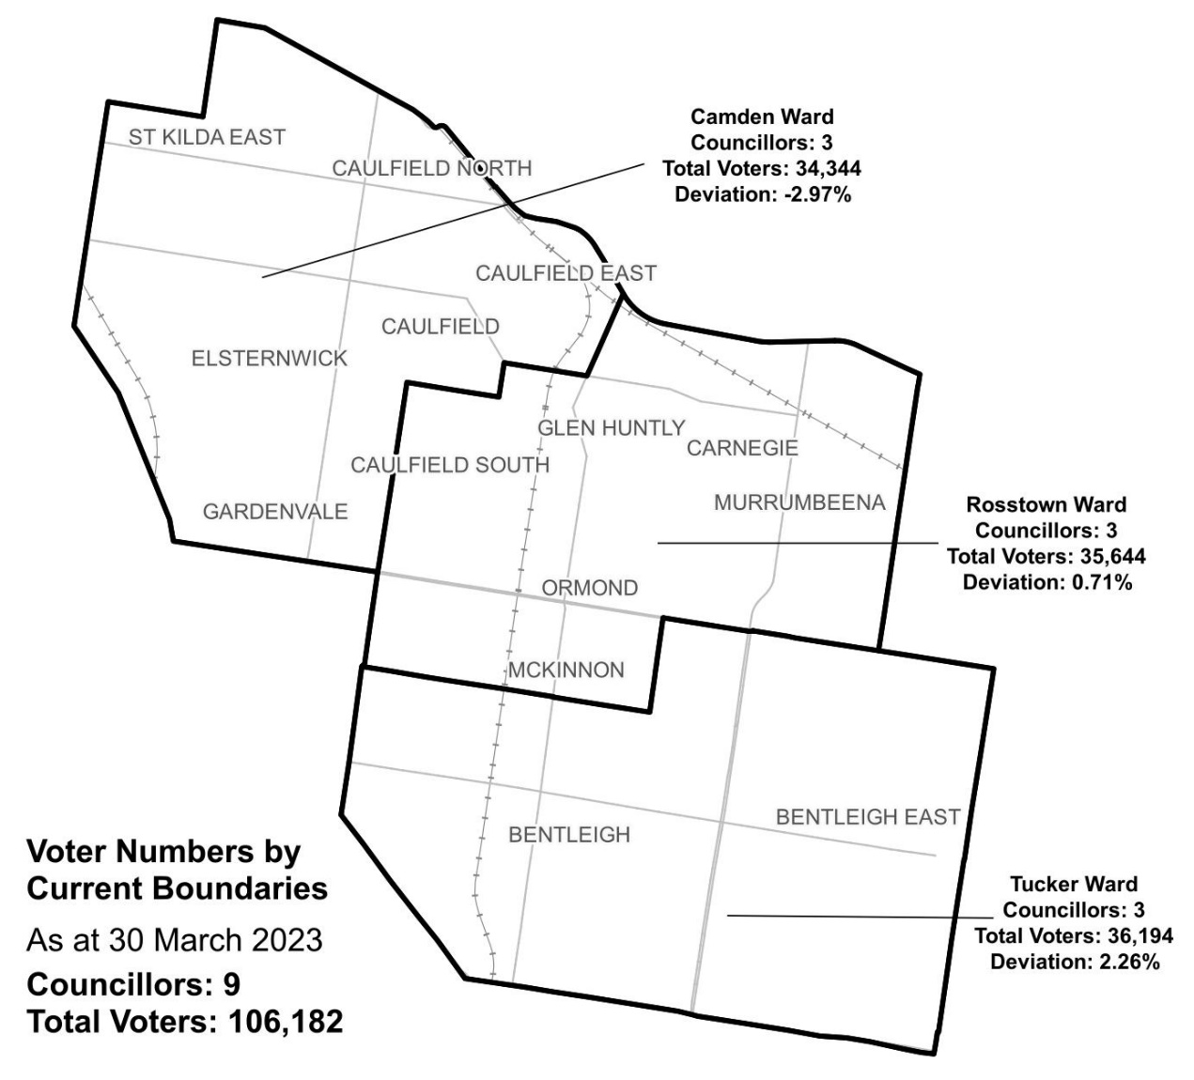

|  |  |  |  |
| --- | --- | --- | --- |
| Ward | Councillors | Voters | Deviation |
| Camden Ward | 3 | 34,344 | -2.97 |
| Rosstown Ward | 3 | 35,644 | 0.71% |
| Tucker Ward | 3 | 36,194 | 2.26% |

## Statistics

Area (km2) 39

Voters

### Voters per square km

2,722.6

### Average voters per councillor

11,797

Population

### Current population

148,908

### Forecast population growth

1.0% p.a.

Further census statistics available at [abs.gov.au](http://www.abs.gov.au/)

Voter numbers by locality (map)

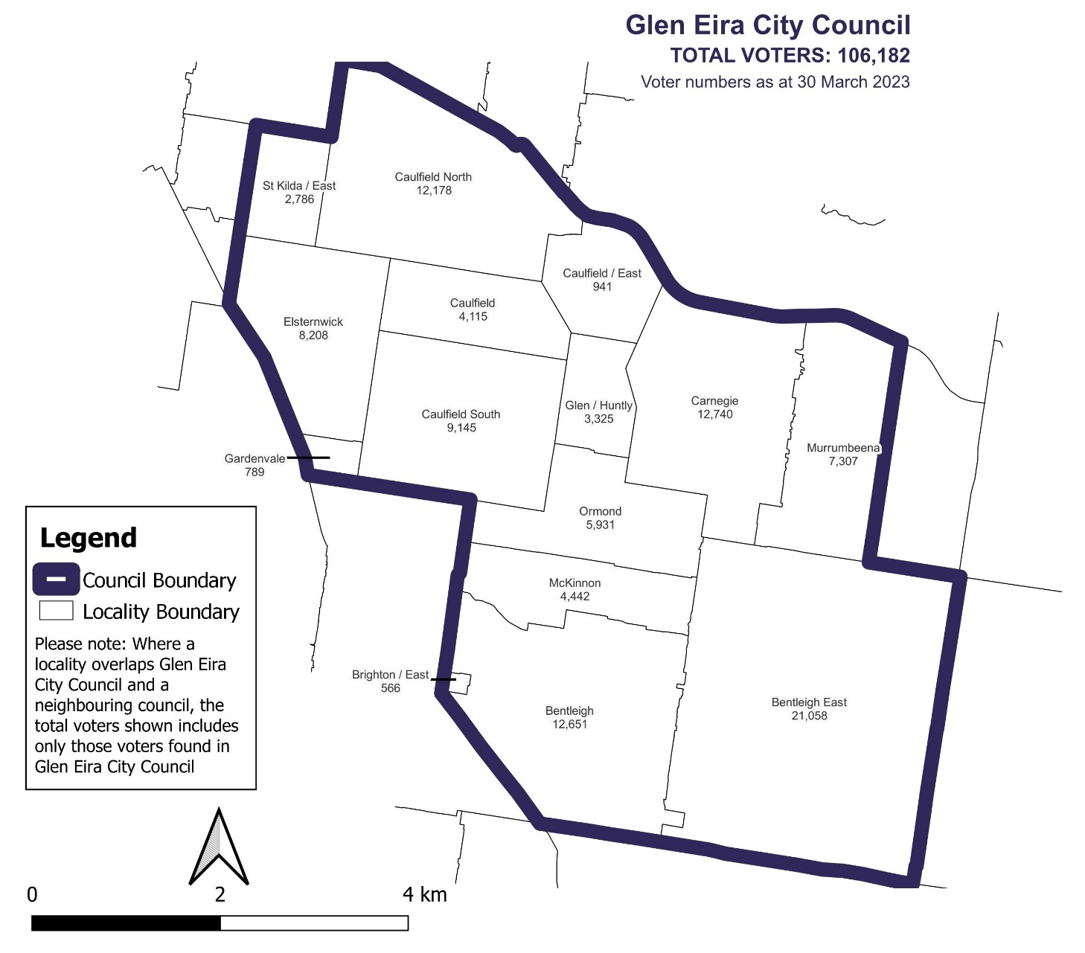

Voter numbers by locality (table)

## Glen Eira City Council voter numbers at 30 March 2023

|  |  |
| --- | --- |
| Locality | Voters |
| Bentleigh | 12,651 |
| Bentleigh East | 21,058 |
| Brighton East | 566 |
| Carnegie | 12,740 |
| Caulfield | 4,115 |
| Caulfield East | 941 |
| Caulfield North | 12,178 |
| Caulfield South | 9,145 |
| Elsternwick | 8,208 |
| Gardenvale | 789 |
| Glen Huntly | 3,325 |
| McKinnon | 4,442 |
| Murrumbeena | 7,307 |
| Ormond | 5,931 |
| St Kilda East | 2,786 |