Victorian Electoral Commission
Annual Report 2018-2019
Department of Health
Spotlight on Democracy.

About the VEC

Our vision
All Victorians actively participating in their democracy.

Our purpose
To deliver high quality, accessible electoral services with innovation, integrity and independence.

Our values
- Independence: acting with impartiality and integrity
- Accountability: transparent reporting and effective stewardship of resources
- Innovation: shaping our future through creativity and leadership
- Respect: consideration of self, others and the environment
  - Collaboration: working as a team with partners and communities

Our people and partners
The Victorian Electoral Commission (VEC) has a core staff of dedicated and highly skilled people whose specialised knowledge ensures the success of its operations. At times of peak activity, the VEC draws on the experience and expertise of a number of associated personnel, such as election officials and contractors, to complement the work of its core staff. Valued partnerships with suppliers also contribute greatly to the VEC’s achievements.
To ensure inclusion and participation, the VEC works closely with a range of advisory and community groups. These groups primarily consist of representatives of under-represented communities, including:
- Aboriginal and Torres Strait Islander communities
- Young people
- People experiencing homelessness
- People living with disabilities
  - Culturally and linguistically diverse communities
The VEC thanks all advisory and community group members and their organisations for their contributions to its work during 2018–19.
The VEC pays respect to Victoria’s traditional owners and their elders past, present and emerging who have been custodians of this country for many thousands of years. Their living culture and their role in the life of Victoria is acknowledged by the VEC.

Our history and functions
Elections for the Victorian Parliament began when Victoria achieved independence from New South Wales in 1851. In 1910, Victoria’s first Chief Electoral Inspector was appointed to head the new State Electoral Office.
The State Electoral Office existed as part of a public service department for 70 years. However, it became increasingly clear that it was inappropriate for the conduct of elections to be subject to ministerial direction. On 1 January 1989, legislation established the independent statutory office of Electoral Commissioner who was to report to Parliament instead of a Minister. In 1995, the State Electoral Office was renamed the Victorian Electoral Commission.
The VEC’s functions and operations are governed by six main pieces of legislation:
- Electoral Act 2002 - establishes the VEC as an independent statutory authority, sets out the functions and powers of the VEC and prescribes processes for State elections
- Constitution Act 1975 - sets out who is entitled to enrol as an elector, who is entitled to be elected to Parliament, and the size and term of Parliament
- Financial Management Act 1994 - governs the way the VEC manages finances and financial reporting
- Electoral Boundaries Commission Act 1982 - governs the determination of State electoral boundaries. Under this legislation, the Victorian Electoral Commissioner is nominated as a member of the Electoral Boundaries Commission
- Local Government Act 1989 - provides for the conduct of local government elections and electoral representation reviews
  - Infringements Act 2006 - provides for stages 2 and 3 of compulsory voting enforcement.
Subject to these Acts, the VEC:
- maintains the electoral enrolment register
- conducts State elections, local government elections, statutory elections and polls and fee-for-service elections
  - conducts electoral boundary reviews and administers political funding and disclosure laws.
The VEC also has a mandated role to conduct electoral research, provide communication and education services and to inform and engage Victorians in the democratic process.
A list of legislation and regulations governing the VEC is included in Appendix B on page 136.

Victorian Electoral Commission
Level 11, 530 Collins Street
Melbourne Vic 3000
Telephone: (03) 8620 1100
Fax: (03) 9629 8632
Website: vec.vic.gov.au
Email: info@vec.vic.gov.au
Office hours:
8.30 am – 5.00 pm
Monday – Friday

Letter of transmittal
The Hon. Gavin Jennings MLC
Special Minister of State
1 Treasury Place
Melbourne Vic 3002
Dear Minister
In accordance with the requirements of the Financial Management Act 1994, I am pleased to submit the Annual Report of the Victorian Electoral Commission for the year ending 30 June 2019 for presentation to Parliament. Also included is the Report of the Electoral Boundaries Commission for the year ending 30 June 2019.
Yours sincerely

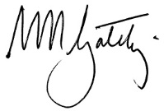
Warwick Gately AM
Electoral Commissioner

Contents
about the vec 3
About this report 8
Our highlights 10
Our year 11
Finance at a Glance 16
our STRATEGIC plan 20
our STRATEGIC INITIATIVES 21
Our commission 27
GOVERNANCE 28
organisational structure 29
the electoral commissioner 30
THE VEC executive management group 33
internal committees and groups 40
External Advisory Groups 43
governing legislation and tribunals 46
accountability and transparency 47
disclosures 51
Our core business 57
electoral activity 58
enforcement of compulsory voting 65
Register of electors 67
WAREHOUSE 74
research and development 75
Our stakeholders 78
Inclusion and participation 79
services to political parties 88
interaction with electoral bodies 91
our people 94
human resource management 95
Staff profile 100
occupational health and safety 102
FINANCIAL STATEMENTS 107
FINANCIAL REPORT 108
Accountable officer’s and chief finance and accounting officer’s declaration 111
COMPREHENSIVE OPERATING STATEMENT 112
BALANCE SHEET 113
STATEMENT OF CHANGES IN EQUITY 115
CASH FLOW STATEMENT 116
NOTES TO THE FINANCIAL STATEMENTS 117
Auditor–General’s report 150
Appendices 152
GLOSSARY 161
INDEX 165

About this report

This report provides a summary of programs and initiatives implemented to meet the key objectives set out in Strategy 2023.

This report has been published in accordance with Financial Reporting Direction (FRD) 30C. As part of the VEC’s environmental sustainability activity, only the required number was printed, and environmentally friendly paper and printing processes were used.

Our year
In this section, the Electoral Commissioner, Warwick Gately AM, provides a summary of key activities and achievements for 2018–19 and the outlook for 2019–20. The report includes, among other things, an overview of the 2018 State election, progress in implementing Strategy 2023 and commentary on how the VEC has met its general compliance and accountability responsibilities.
Chief Financial Officer, Binh Le, provides an overview of the VEC’s financial performance. A summary of achievement against the VEC’s strategic initiatives is included in this section.

Our Commission
Good corporate governance and transparent reporting help ensure continued public confidence in the VEC and its processes.
This section provides detail of the VEC’s regulatory environment and governance and organisational structures, key persons and staff profiles, disclosure requirements and the corporate systems that enable the VEC to deliver its core business and operate effectively and efficiently on a day-to-day basis.
Accountability to the Victorian public and Parliament is critical, and the VEC’s good corporate citizenship is evidenced by its performance in areas such as diversity, inclusion, accessibility, sustainability, information management and reporting.
Information relating to internal and external advisory groups is also detailed in this section. These advisory groups play an important role for the VEC.

Our core business
The VEC’s core business includes the conduct of elections, maintenance of the register of electors and ensuring fair and equitable representation for voters at State and local government levels.
The 2018 State election was a significant ‘whole of Commission’ event. Yet, it was not the only electoral event during the year. A further 39 election activities were conducted, including local government by-elections, countbacks, commercial elections and polls, and local government electoral representation reviews.

Our stakeholders
This section includes details of the VEC’s efforts to inform and engage electors as voters and candidates, provide accessible voting services and ensure electors know how to cast a formal vote.
In the lead up to the November 2018 State election, the VEC experienced an increase in the number of applications for political party registration resulting in 23 parties registered at the election. All Registered Political Parties were briefed on the State election.
Information about key stakeholder groups, such as voters with particular requirements, political parties and the media, is detailed in this section. How the VEC interacts with other electoral bodies is also discussed.

Our people
The VEC is developing a working environment that is empowering, engaging, stimulating and inspiring.
This section highlights the VEC’s investment in building capability across the organisation, and its approach to supporting Strategy 2023.

Financial statements
The VEC is pleased to provide ‘value for money’ electoral services to the Victorian public. Once again, the VEC’s sound financial management is evidenced by an unqualified report from the Auditor-General. This section provides the VEC’s audited financial statements for 2018–19.

Appendices

Glossary

Index

Our highlights

2018 State election delivered to over 4.1 million electors in accordance with the Service Plan

ICT Strategy received critical attention including system hardening as part of the election cyber security response

Strategy 2023 outcomes made steady progress with 28 projects underway at year end, in parallel with State election priorities

Commenced the local government representation review and subdivision review programme completing 12 of 31 reviews during 2018-19

New VoterAlert notification system successfully rolled out Statewide for the 2018 State election

Successful roll-out of Victoria’s new political funding and disclosure regime

Compliance with the Standing Directions of the Minister for Finance 2018 – no reportable deficiencies

VEC Annual Report 2017–18 achieved Gold at the 2019 Australasian Reporting Awards

Our challenges
Meeting our stated commitment to deliver on the Reconciliation Action Plan in its final year
Providing enough skilled senior election officials to deliver critical election activities
Implementing operational changes imposed by late amendments to legislation
Maintaining the early momentum of the VEC’s Leadership and Management program (LAUNCH) in combination with State election work commitments

Our year

“I can say that by every measure this State election year has been very successful for the Victorian Electoral Commission. As evidence, the Commission exceeded its election night count target of 75% of the Legislative Assembly total vote and over the year met all its administration responsibilities.”
Warwick Gately AM
Electoral Commissioner

Service delivery excellence
The year was dominated by the November 2018 Victorian State election. As stated last year, while it is easy to consider each State election as simply an exercise in repetition, this is not the case. Unique challenges arise, and it is the Victorian Electoral Commission’s (VEC’s) preparedness in responding that is critical. Of course, a State election is a significant event, yet the VEC, as a public sector body, must continue to function and meet its compliance and accountability responsibilities. I can say that by every measure this State election year has been very successful for the VEC. As evidence, the Commission exceeded its election night count target of 75% of the Legislative Assembly total vote and over the year met all its administration responsibilities.
But first, the State election. Within this report and a consequent report to the Parliament of Victoria, greater detail on the election is provided. In summary, the VEC delivered quality, timely voting services to over 4.1 million electors through a variety of channels recognising the disparate needs of all Victorians. With electors changing their voting behaviour, the VEC responded with strong digital messaging, expanded early voting facilities and adjusted vote counting operations enabling 79% of the Legislative Assembly total vote to be counted on election night. This was a remarkable achievement giving great confidence in the early identification of the incoming Victorian Government, leading to the swearing in of the Ministry just five days after election day. The writs were returned as scheduled.

Operational planning and action
The VEC’s Planning Group (PG) was active all year in preparing for the State election. The refined planning model used by PG centred on 11 program groups with distinct projects or deliverables, improved control, coordination and visibility across the VEC.
With this discipline, individual projects making up the State election were scoped, costed, resourced and managed to conclusion. The risks to each were assessed and mitigated and the many interdependencies between projects tracked against their due dates. Critical stage reporting to PG meant resources and priorities could be adjusted and issues managed. Pleasingly, all project milestones and statutory dates were met, and the State election was delivered fully compliant with State law. This refined planning model will be used for the 2020 local government elections.
The State election aside, a further 39 electoral activities were conducted during the year including local government by-elections, countbacks, commercial elections and polls, representation reviews, and four by-elections and eight countbacks as a direct result of councillors being elected to State Parliament.
Important to the success of all activities was the availability and reliability of Information Technology (IT) systems. The Commission’s technology strategy ensured infrastructure resilience during the year and at critical times during the State election, while identifying the future investment needed in technology solutions and services out to 2022.
Cyber security, as one part of the IT Strategy, received critical attention. At the start of this reporting period, the VEC was already active in hardening IT systems and applications and improving security controls. This was enhanced by a “health check” performed by the Australian Cyber Security Centre with the focus principally on mitigating potential election vulnerabilities. Related to this, the VEC improved markedly its Business Continuity and Disaster Recovery plans: desktop exercises, alternative operating site arrangements and inclusion in Victoria’s Emergency Management structure gave confidence in the Commission’s ability to deliver the election in the event of a natural disaster or other incident. These measures were necessary improvements now and for the future.

Strategic planning and capacity building
Strategy 2023 has been in place for a year, but the demands of the State election meant commencement of some major projects occurred around this event, and this is discussed in this report. The plan to December 2019 lists 33 major and branch projects for completion and at June 2019, 28 projects had realised steady progress, with five yet to commence. Progress against our strategy outcomes was carefully monitored throughout the year and achieved in part through the Major Projects Group, supporting the previous Project Governance Board in providing improved Commission-wide visibility of critical project pathways. At year end, there was delay in the commencement of major projects associated with the location (GIS) strategy, roll management strategy, spatial data policy development and the election management system redevelopment finalisation. These will receive attention in the next reporting period.
To make better use of the full resources of the Commission, investment was made in the website, the intranet and a replacement electronic document management system. At the desktop, a new operating system and business application suite was provided with these measures supported by a knowledge management framework and the commitment to a business intelligence platform.
Having been in place for over 12 months, the Corporate Services Group and Electoral Functions Group were reviewed and a number of benefits and areas for improvement were identified.

Financial management
The total appropriation for the year of $90 million provided for State election expenditure of $60 million. While this covered an expanding suite of election services, this is an increase in State election-related costs of some $30 million since the 2014 State election and can be attributed to the growth in elector numbers, their expectations around voting, along with increased staffing salary rates, material costs and general inflationary pressures. These factors will always be exacerbated given an immovable and compressed statutory election timeline.
The Audit and Risk Committee met on four occasions, with close attention given to the VEC’s financial compliance and reporting, risk management and the outcomes from internal audits. The Committee took the opportunity to view first-hand elements of the VEC’s State election operations, commenting favourably on the experience. The direction and support provided by the Committee in the year was welcome. Again, the VEC’s disciplined financial management resulted in an unqualified report from the Victorian Auditor General.

Meeting our statutory and administrative responsibilities
This year there were significant amendments to governing legislation. While late in their assent, the changes did impact the State election. Included in the Electoral Legislation Amendment Act 2018 were provisions introducing into Victoria a political donation disclosure regime. This change not only imposed many requirements around political donations and their reporting, but required the VEC to develop a real-time donation disclosure system and establish an operating compliance function. In the year ahead, the Funding and Disclosure unit will expand, and the online disclosure system enhanced.
Other provisions in this legislation had an immediate election impact. The introduction of political party logos onto ballot papers, changes to postal voting provisions, the simplifying of how-to-vote card registration requirements and the removal of personal declaration provisions to vote early required responses. There were also signage and campaigning restrictions imposed outside voting centres. The introduction of these changes was well managed.
For elections in Victoria, the Electoral Act 2002 provides for certain decisions taken by the VEC to be reviewed by the Victorian Civil Administration Tribunal (VCAT). Also, election results can be challenged before the Supreme Court acting as the Court of Disputed Returns. These review opportunities provide an important judicial safeguard to the State’s election processes. During this State election the VEC appeared before the VCAT, the Supreme Court and the Court of Appeal, and made preparation to appear before the Court of Disputed Returns, prior to a petition being withdrawn. These matters are discussed within the report. The VEC welcomed each opportunity to publicly explain its decision process.

Communication and engagement
In this election year, the Commission’s external focus was sharpened. In engaging with the electors of Victoria, the VEC expanded its use of digital communications. While television, print media, direct mail and public space advertising made up a large component of the VEC’s information campaign, some two million electors were personally contacted by SMS or email and provided with up to three short alerts to remind them of voting options and dates. This, a very engaging Facebook presence and active Twitter dialogue, ensured all electors had the information needed via their channel of choice to participate in the election.

The Commission’s enduring community inclusion programs were also active and are described fully in the report. Passport to Democracy, as the community education centrepiece, interacted with over 11,500 students intent on understanding election processes. The Democracy Ambassador program was expanded to include ambassadors representing the disabled, those experiencing homelessness, the culturally and linguistically diverse and Aboriginal and Torres Strait Islanders; over 90 such ambassadors delivered information sessions to their communities. The VEC’s advisory groups were also engaged for their input into election planning.
The Electoral Council of Australia and New Zealand (ECANZ) met on four occasions, continuing the important dialogue around electoral best practice and collaboration. On appeal from ECANZ, the Council of Australian Governments remains engaged on the possible impact of cyber or physical threats to the nation’s election processes. In response, an interjurisdictional working group formed this year to which the VEC is contributing.
The Electoral Regulation Research Network (ERRN) was very active with 10 seminars held around Australia, including the Northern Territory for the first time. As a pilot, a very successful two-day course was held at the University of Melbourne – the “Regulation of Australian Elections”, which attracted 30 participants from State and Territory electoral commissions and other agencies. Topics covered the constitutional framework of elections, voting rights, electoral boundaries and political finance. This course will now occur biennially.

Our next significant event
Victorian local government elections will be held in October 2020. These elections are complex. Under present laws, the State’s 79 councils can choose to conduct their elections by post or by voting in person at established centres. Well over 2,000 candidates can be expected to contest some 650 vacancies in a mix of municipal electoral structures. Planning Group has now convened to manage this event.
As a precursor, in January the VEC commenced a representation review program. Generally, every 12 years, municipalities in turn have their councillor numbers and electoral structure examined to ensure electors are provided fair and equitable representation. This program will be completed by April 2020 when 31 representational reviews and eight subdivision reviews will have been conducted.
At year end, Parliament is considering extensive changes to the Local Government Act 1989, some of which may impact the electoral structure of councils and this preliminary representation work of the VEC and components of election delivery. The VEC will be ready to respond.

Our people
A key pillar of the VEC’s strategic plan is that of “people”. Investment in our staff is aimed at creating a skilled, accountable and collaborative workforce able to take advantage of emerging opportunities and threats. While early in implementation, this is being achieved through a transformational leadership model. This model will be assisted by a new capability framework, which identifies the skills needed for success at the individual and organisation levels. At the end of the year, this important project was 70% complete. Other initiatives this year have included an employee-focused wellbeing program through the State election period, and a refocused human resources strategy.
The VEC delivered an extensive training and learning program, preparing over 200 senior election officials and nearly 25,000 casual staff for their roles in the State election. This training was role-specific incorporating on‑line learning, manuals and reference material, and face-to-face training with practical activities. A post-election survey noted this training as highly successful.
Staff numbers in the VEC increased in the year, driven by the State’s growing population and the increasing complexity of election operations. Changes in statutory responsibility is a further factor.
Reflecting on our people, given the demands of the State election, I note how effectively all VEC staff came together to deliver a best practice election. I thank them all for their contribution. My thanks also to the Commission’s Executive Management Group (EMG) for their very professional leadership and support.
Changes to the EMG also occurred. My thanks go to Bernadette Lamaro for her very positive contribution to the important Director Human Resources role and I welcome Angela Kelly into that position.

Looking ahead
As mentioned, the next 12 months will largely be occupied with preparation for the October 2020 local government elections. The development of an election service plan will be followed by discussions with client councils over the VEC’s agreed service delivery arrangements.
Strategy 2023 will also remain a focus. The associated major projects pipeline is extensive, comprising system improvements and developments, and supporting frameworks and schema. Bringing these projects to completion will require close coordination across the Commission so that all benefits will be realised within budget.
Cyber security will continue to require attention and investment. Election systems as critical national infrastructure have, overseas, proven vulnerable to interference and the VEC must remain resilient and vigilant.
For our staff, the Executive will remain focused on providing interesting and challenging work in an environment of opportunity where presenting daily for that work is a positive experience.

Warwick Gately AM
Electoral Commissioner

Finance at a glance

Financial performance

Being a State election year, the VEC’s special appropriation funding and expenditure levels increased significantly in comparison to 2017-18. Total funding received during the year was $89.62 million, which was largely allocated to the conduct of the 2018 State election. Every two years, the VEC undertakes either a State election or local government elections on behalf of the State. As can be seen in Figure 1, the electoral cycle has a significant impact on the VEC’s special appropriation funding pattern over the five-year period. The table summarises movement in special appropriation funding, expenses, balance sheet items and net cash flows.

FIGURE 1: FIVE YEAR FINANCIAL SUMMARY 2014–15 TO 2018–19
 | 2014-2015  ($,000) | 2015-2016  ($,000) | 2016-2017  ($,000) | 2017-2018  ($,000) | 2018-2019  ($,000)
Electoral activity | State  election |  | Local government elections |  | State  election
Special appropriation | 62,623 | 25,260 | 52,336 | 33,606 | 89,620
Total expenses from transactions | 65,735 | 24,946 | 51,453 | 34,260 | 94,298
Net result from transactions | (3,112) | 314 | 883 | (654) | (4,678)
Net result for the period | (3,142) | 253 | 917 | (652) | (4,780)
Net cash flow from/(used in) operating activities | - | 18 | (4) | (39) | (14)
Total assets | 9,953 | 11,730 | 12,746 | 17,158 | 17,939
Total liabilities | 4,924 | 5,457 | 5,056 | 5,280 | 5,805
Net assets | 5,029 | 6,273 | 7,690 | 11,878 | 12,134

Funding
The VEC received $89.62 million in funding for 2018–19, which is significantly higher than the prior year of $33.61 million and is mainly due to the costs incurred in delivering the State election in November 2018. The VEC is funded solely from Government Special Appropriations and this amount represents the reimbursement to the VEC for all its cash payments.
In addition, the VEC administers or manages other activities and resources on behalf of the State and local government, and this income for the year was $32.40 million. This is not shown in the VEC financial results or in the financial statements, but is declared in Note 4.1: Administered (non-controlled) items. The administered activities are made up of:
- revenue collected by the VEC on behalf of the State, which is forwarded to the Department of Treasury and Finance as consolidated revenue
- monies receipted from local government election fines and forfeited candidate deposits collected by the VEC on behalf of councils and remitted to the appropriate council payment of 2018 State election entitlement funding
  - payment of 2022 advance public funding and administrative funding following the introduction of political funding and disclosure legislation in August 2018.

Figure 2: Special appropriation ($,000) 2014–15 to 2018–19
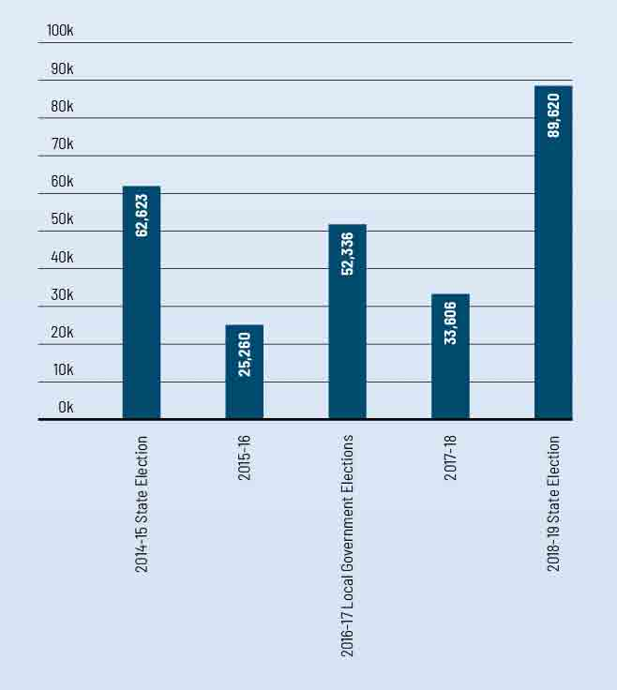

Expenditure
The VEC incurred $94.30 million in operational expenses for the financial period. This is slightly higher than the Special Appropriation received from government, which is due to non-cash expenditure such as depreciation, accruals and staff entitlement provisions. Government reimbursement for appropriation does not include non-cash expenses.
In relation to the 2018 State election, major areas of expenditure included:
- upscaled workforce of around 25,000 election staff including casuals and election officials
- infrastructure overheads to support 88 election offices and 148 early voting centres (45 interstate and overseas)
- enhanced IT security infrastructure to manage and protect VEC’s Roll Management System and Election Management System
- advertising and awareness campaigns
- print and production of ballot material and
  - special outreach programs (homeless, ethnic groups, prisoners, disability and Aboriginal and Torres Strait Islanders).

Cash flows
The net cash flow from/used in operating activities for the year was $14,000, which is consistent with the small amounts previously reported over the last five years.
This reflects the Government funding model that reimburses the Commission for all its cash payments during the year. Further, the VEC does not hold a cash reserve in its bank accounts, as it is reimbursed on a daily basis for its cash payments.

Financial position
The VEC’s financial position remains strong and stable with total assets of $17.94 million, liabilities at $5.80 million and overall net equity of $12.13 million. The VEC’s assets are largely comprised of the Election Management System (EMS), the Funding and Disclosure system, enhancements to mapping tools, uplift to infrastructure, system security, and election inventory and equipment.
The VEC’s liabilities largely comprise employee entitlements and year-end expenditure accruals. The equity of the VEC is split into contributed capital, asset reserve and accumulated loss. The contributed capital represents the amount of funding contributed by the Government of Victoria for the purchase and development of VEC non-current assets. The accumulated loss represents the accumulated result from continuing its operations.

Operational and budgetary objectives and performance against objectives
The VEC has a number of performance measures that relate specifically to Budget Paper Number 3 Service Delivery (BP3), in accordance with the Department of Treasury and Finance, Financial Reporting Directions (FRD). The following table (Figure 3) provides details of the output report provided by the VEC to the Government, including performance measures and targets for agreed outputs, and the actual performance results for the VEC over the full year ending 30 June 2019.

Figure 3: Performance against budgetary objectives, 2014-15 to 2018-19
 | State elections, local government and statutory elections, by-elections, polls and electoral representation reviews | Legal challenges to VEC conduct upheld | Changes to elector details or additions to the Victorian enrolment register processed within set timeframes
2014-15 BP3 Target | 142 | - | 98%
2014-15 BP3 Actual | 135 | - | 97%
Variance | -5%¹ | 0% | -1%²
2015-16 BP3 Target | 39 | - | 90%
2015-16 BP3 Actual | 40 | - | 92%
Variance | 3% | 0% | 2%
2016-17 BP3 Target | 99 | - | 95%
2016-17 BP3 Actual | 96 | - | 99%
Variance | -3%³ | 0% | 4%⁴
2017-18 BP3 Target | 32 | - | 95%
2017-18 BP3 Actual | 27 | - | 82%
Variance | -16%⁵ | 0% | -14%⁶
2018-19 BP3 Target | 115 | 0 | 95
2018-19 BP3 Actual | 117 | 0 | 97
Variance | 2% | 0% | 2%
¹ Victorian Commission for Gambling and Liquor Regulation excluded restaurant and café license applications from the dry area category partway through FY2014-15, with the result that liquor licensing polls will no longer be conducted by the VEC for this category from that date.
² Enrolment transactions received at voting centres and election offices during the State election were higher than anticipated. Staff numbers were increased to meet anticipated needs, but as it transpired, not in sufficient numbers to manage the number of transactions within set time-frames. It was expected and observed that there would be fewer transactions received overall than at the 2010 election due to the introduction of direct enrolment and an online enrolment facility, both introduced since the previous election.
³ The 2016–17 election events number is lower than the 2016–17 target due to the number of actual extraordinary vacancies in the Legislative Assembly and on local government tracking lower than projected for the 2016–17 reporting year.
⁴ The 2016–17 full year actual is higher than the target due to a stronger focus on the highest value enrolment programs relating to the 2016 local government elections.
⁵ Less than anticipated number of local government vacancies to be filled by a countback. Additionally a reduction to the number of liquor licensing polls conducted.
⁶ The VEC's enrolment campaign schedules were extended early in the reporting year due to the sudden insolvency of the VEC's mail services contractor and the Australian Marriage Law Postal Survey. Enrolment turnaround times measured above 95% for key VEC electoral events.

Our strategic plan

July 2018 realised the launch of the VEC’s Strategy 2023, developed through extensive consultation with staff and consideration of the VEC’s external and internal operating environment. The five-year goal is that the VEC is change-ready and has the people, systems and relationships to make the most of opportunities.

Create an environment that inspires our people to reach their full potential

Provide our people and Victorians with smart, safe technology that is value for money and easy to use

Make smart decisions on time and by the book

Learn from others outside the VEC about opportunities and challenges

Strategy 2023 created eight areas of focus in order to deliver on our goal

People
  - Develop transformational leaders who build teams and empower people to recognise and respond to emerging opportunities and challenges.
  - Recruit and develop our people against the key competencies and behaviours critical to our ongoing success.

Technology
  - Implement the VEC IT Strategy, driving excellence in infrastructure, process, security, integration, digital tools and technological innovation.
  - Realise opportunities to capture and use VEC knowledge to improve operations, inform plans, and increase business intelligence.

Decision-making
  - Strengthen process and decision-making pathways to enable transparent, innovative and improved ways of working.
  - Embed an evidence-based approach for all aspects of VEC operations.

Relationships
  - Use our existing and new networks to grow our evidence base.
  - Grow relationships to maximise customer reach and opportunities for innovation.

Figure 4: VEC corporate planning framework
Delivery of Strategy 2023 projects and initiatives is embedded in the VEC’s corporate planning framework, and is monitored by the Executive Management Group.

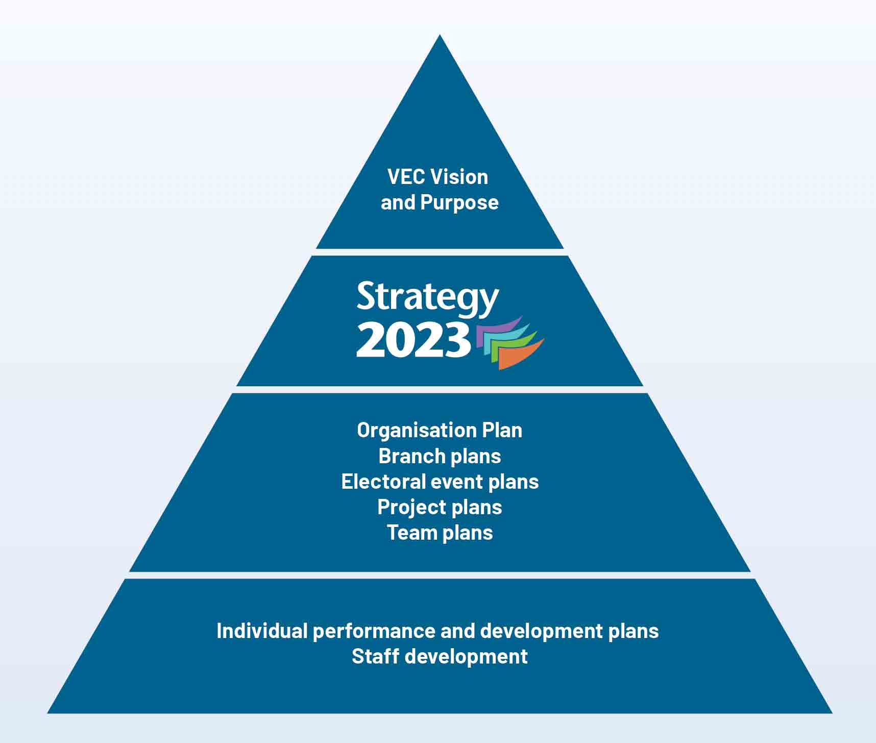
A total of 33 key projects and initiatives were identified in the first phase of Strategy 2023. Some 28 were initiated in FY2019 and are progressing, with a further five to be initiated in FY2020. This was an ambitious workplan whilst focusing on the delivery of the 2018 State election. Most of these projects will be brought to completion in FY2020.
The approach to strategy implementation was also refreshed by augmenting the delivery of individual strategic initiatives with an outcomes-focused approach.
The guiding principles were:
  - a focus on the end goal, with impact and outcomes monitoring as important as activity and output monitoring
  - defining success in a balanced way, without perverse targets
  - a mix of quantitative and qualitative measures
  - the use of easily interpreted measures that are meaningful and useful to the internal audience
  - a commitment to using monitoring and evaluation information to improve the strategy.
Many of the qualitative measures were sourced from two key staff surveys; the biennial Victorian Public Sector Commission’s (VPSC) People Matters Survey (PMS) and a second staff survey undertaken to assess the maturity of the VEC’s knowledge management practices against best practice benchmarks.

People
In the move towards a transformational leadership model, action started with the development of a Capability Framework, which provides a common language for how the VEC works at role-specific levels. The Capability Framework will now feed into a broader HR Strategy for the VEC, which will be finalised in FY2020. Work on a more comprehensive HR Strategy was delayed due to the departure of the Director HR in early 2019.
The VEC’s People impact indicators are sourced from the PMS compiled in May 2019 and indicate progress in achieving the 2021 interim targets.

Figure 5: People statistics as at June 2019
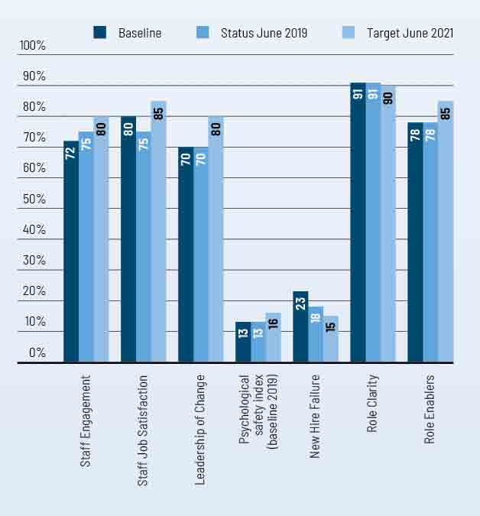

Decision-making
Work in relation to this pillar was focused on an evidence-based evaluation of the delivery of the 2018 State election. This evaluation resulted in wide-ranging recommendations to further strengthen transparent, innovative and improved ways of working, and proposed changes to the Electoral Act 2002 itself.
Also this year, the VEC’s current Education & Inclusion Strategy, Reconciliation Action Plan, Disability Action Plan and Digital Engagement Strategy drew to a close. These programs of work are currently under review, and recommendations will be developed to further improve the impact of this work in communities. These recommendations may also initiate further project work and add to the VEC’s outcome measures for the remainder of Strategy 2023.
Work on the development of a corporate monitoring and evaluation framework was deferred until the above reviews have been completed, so that a more contemporary approach can be taken. This will now be commenced in FY2020, alongside work on a mid-stream evaluation of Strategy 2023 implementation.
The current decision-making outcome indicators focus on the VEC’s approach to continuous improvement via lessons learned, and its knowledge and information management maturity. Further work was done this year on establishing baselines for corporate compliance and governance maturity through a comprehensive internal audit process. Progress against these baselines will be reported upon in FY2020.

Figure 6: DECISION-MAKING statistics as at June 2019
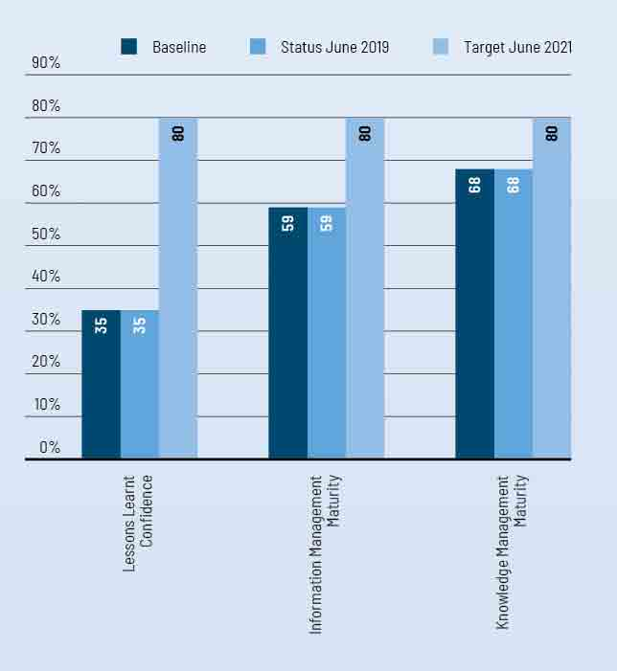

Technology
Led by the VEC’s IT Strategy, the VEC’s focus was on cyber-security, a major infrastructure improvement program, upgrading knowledge management tools such as the website and intranet, and improvement work on critical business applications such as the Election Management System. This was an ambitious change agenda against the backdrop of the 2018 State election.
Most of the major project work in this area continues into FY2020; the new user infrastructure, intranet and document management system are scheduled to go live in late 2019. Other initiatives, which commenced in FY2019 and will be delivered in FY2020, include the development of the VEC’s Electoral Roll Management Strategy and improvement of some public-facing tools such as the interactive map application.
Planned work to review and upgrade HR systems was deferred to FY2020 due to the departure of the Director HR in early 2019.
The strength and success of the VEC comes from the collective knowledge and experience of its people. Making full use of this knowledge and experience is key to the delivery of high quality, accessible electoral services with innovation, integrity and independence. To this end, the VEC developed a Knowledge Management Framework, which sets out a series of priority initiatives to progressively improve our knowledge sharing culture, processes, systems and governance. Implementation of this Framework will continue into FY2020 and beyond.
The Technology impact indicators are two-fold: some focus on security, risk and compliance, whilst others look at user experience. Again, good progress is being made towards the interim targets.

Figure 7: Technology statistics as at June 2019
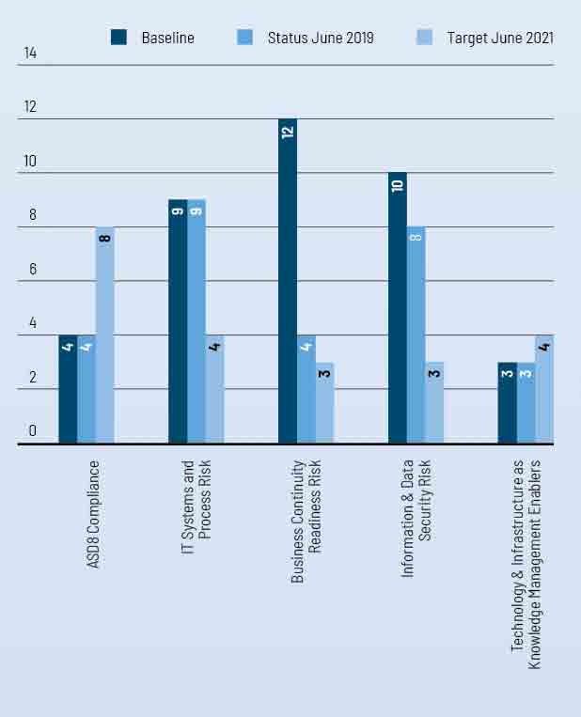

Relationships
Much of the work on the VEC’s community-facing programs also fed into this strategic goal, including the review and evaluation of its Education & Inclusion Strategy, Reconciliation Action Plan, Disability Action Plan and Digital Engagement Strategy.
The evaluation of these community-facing programs have helped establish baselines for how the VEC’s relationships drive the Commission to better understand, anticipate and respond to external opportunities and challenges. These will be reported from FY2020.
Progress was made against the goals of the VEC Sustainability Action Plan. The VEC strongly supported the ERRN program of work and contributed to activities in relation to ECANZ priorities. See page 63 (Research & Development) for more information.
IN PROGRESS

Strategic Goal | 2018-19 Progress
PEOPLE
Transformational Leadership model is now defined.
VEC Staff Capability Framework is now published.
Work commenced on a new VEC HR Strategy, expected to be finalised in late 2019. The Strategy will incorporate implementation plans for both the Transformational Leadership model and the Staff Capability Framework.
DECISION-MAKING
A comprehensive review of the delivery of the 2018 State election operations and support functions was undertaken to inform future events, improve organisational performance, provide recommendations for future legislative consideration and progress the VEC research agenda. Recommendations from this review will inform the VEC’s election report for the Victorian Parliament, to be submitted in late 2019.
Phase 1 of a Corporate Governance project was completed, which delivered a detailed gap analysis of the VEC’s Corporate Compliance Framework. This project aims to streamline corporate governance systems to ensure decision-making pathways are clear, prompt and consistent. The recommendations of Phase 1 will be actioned in the next two years as Phase 2 of the project.
A new Information Management Framework, incorporating a full suite of Information Management policies, was developed.
Development of a corporate monitoring and evaluation framework was deferred until the completion of Phase 1 of the Corporate Governance Project and Knowledge Management Framework, both delivered in June 2019. This work will now be undertaken in FY2020.
TECHNOLOGY
VEC Business Applications
Work commenced on the improvement of a number of VEC business applications including:
- business application lifecycle management
- voting centre data handling
- image management
- redistricting submission tool
- website interactive map.
Work continued on the redevelopment of the VEC Election Management System.
Strong progress was also made on the delivery of a number of new corporate systems, all for delivery late 2019:
- intranet
- Records Management System
- corporate website
- business intelligence (BI) platform.
Work was deferred on a review of the VEC’s HR systems due to the departure of the Director HR in early 2019. This is now scheduled for FY2020.
Knowledge Management Tools
A Knowledge Management framework, roadmap and investment plan were developed, which will guide the VEC towards a more collaborative, knowledge-sharing culture in line with Strategy 2023.
Phase 1 of the VEC’s Records Digitisation program was progressed in 2018-19, and is on schedule for completion in late 2019.
Cyber-Security
The VEC is working towards compliance with the Australian Signals Directorate Essential Eight (ASD8) mitigation strategies.
Significant progress was made on Phase 1 of the VEC Cyber-Security program. The VEC was compliant with four of the eight mitigation strategies by June 2019, with the remaining requirements on schedule to be met by December 2019.
Infrastructure
The VEC’s IT Infrastructure Uplift program included investment in new desktop and server hardware, as well as commencement of a cloud migration strategy. The Infrastructure Uplift program is on schedule for completion in late 2019.
RELATIONSHIPS
Formal evaluation of the VEC’s Education & Inclusion Strategy commenced as the VEC reached the end of its five-year implementation period. This includes a review of the Reconciliation Action Plan (RAP) and Disability Action Plan (DAP) as the VEC look forward to the next four years. Significantly informed by the 2018 State Election review (see above), this evaluation work will be completed in late 2019.
Work also continued on delivering the goals of the VEC Sustainability Action Plan, which aims to:
- drive resource efficiency and sustainable business practices throughout VEC operations
- leverage and influence VEC networks to improve the performance and practices of the electoral sector
- prioritise sustainability in VEC procurement and investment decisions and work with suppliers to pursue and develop sustainable business outcomes
- build the capability and capacity of VEC staff to undertake their roles more sustainably
- actively engage with Victorians to promote sustainability through electoral processes.
As a founder member of the Electoral Regulation Research Network (ERRN), the VEC continued its collaboration with academics, electoral commissions and other interested groups on research relating to electoral regulation. See page 63 (Research & Development) for more detail.

Spotlight on...
Name
Geoff Nott
Title
Manager, Voting and Enforcement Services
Department
Elections Branch
The VEC’s vision is for all Victorians to actively participate in their democracy. How does your role contribute to this?
I lead the team responsible for delivery of timely and convenient postal voting services for Victorian electors, including an emailed ballot material option for electors travelling in remote locations with no fixed address. We establish early voting facilities at interstate and overseas locations; work with the Australian Antarctic Division to ensure that electors employed in, or travelling to or from Antarctica are able to vote; provide Telephone Assisted Voting services to electors who are unable to vote without assistance because they are blind, have low vision or a motor impairment and for the first time at a State election conducted the centralised count of postal ballot papers for all districts and regions.
What makes the VEC an innovative and engaging place to work?
The VEC prides itself on being one of Australia’s leading electoral bodies. We recognise and understand the diversity of the voting community. Our people are motivated and encouraged to be creative and innovative in identifying opportunities to improve the voting experience for all Victorians, such as the VEC’s online postal vote application.
After elections my team implements the compulsory voting enforcement program; both challenging and rewarding as staff engage directly with non-voters in assessing their reason for failing to vote fairly and objectively; being respectful and courteous as they work within the law.

What’s a key lesson you learned from working on the 2018 State election?
The challenges of this event far exceeded any previous election and stretched the resolve and capacity of the team to deliver successful outcomes. Too much for too few!
We must implement a strategy to retain our staff, give opportunities for them to grow their operational experience and enable the team to focus on knowledge and leadership sharing.

What do you like to do outside of work?
After a week in the office I enjoy outdoor activities that provide some exercise and inspiration like gardening, bike riding and long walks with our French bulldog - Betty. We have a camper trailer so any chance to get away camping for a long weekend is always memorable. If I’m not at the MCG during winter, you will find me relaxing at home planning our next adventure over dinner with family and friends.

Our commission

ACHIEVEMENTS 2018–19
- Delivered the 2018 State election
- Implemented a Business Continuity Framework for the 2018 State election
- Commenced implementation of ‘Strategy 2023’
- Established a Funding and Disclosure Unit to manage legislative responsibilities as enacted and the delivery of an operating political donations disclosure system
- Developed and implemented a VEC-wide monitoring and evaluation framework

OUTLOOK 2019–20
  - Complete the local government representation review and subdivision review programme
  - Complete system and application hardening, meeting the Australian Signals Directorate Essential Eight requirements
  - Planning for the 2020 local government elections, including meeting with councils
  - Integrate the Funding and Disclosure Unit into a new Electoral Integrity and Regulation Branch, as a hub for the VEC’s regulatory and compliance activities
  - Develop a compliance framework to capture the VEC’s new and evolving regulatory responsibilities

Governance
The VEC is the administrative agency through which the Electoral Commissioner’s legislative obligations are exercised. The VEC is committed to ensuring that its policies and practices reflect good governance, as well as complying with all relevant legislation. Adherence to the VEC’s governance framework demonstrates accountability to stakeholders and ensures the vitality and impartiality of the electoral system, now and into the future. Staffing and work practices are determined by the Public Administration Act 2004 and guided by the Victorian Public Sector Commission.
The VEC is an independent agency operating under the auspices of the Department of Premier and Cabinet, within the portfolio of the Special Minister of State. The VEC is not subject to the direction or control of the Minister in respect to the performance of its responsibilities and functions, or the exercise of its powers.
The Secretary of the Department of Premier and Cabinet, Chris Eccles AO, is responsible for providing support to the Minister and Cabinet on matters relating to the VEC and is thanked for his assistance in conveying relevant information to Government. Figure 8 shows the governance and consultation structure of the VEC.
Figure 8: Governance and consultation structure of the VEC
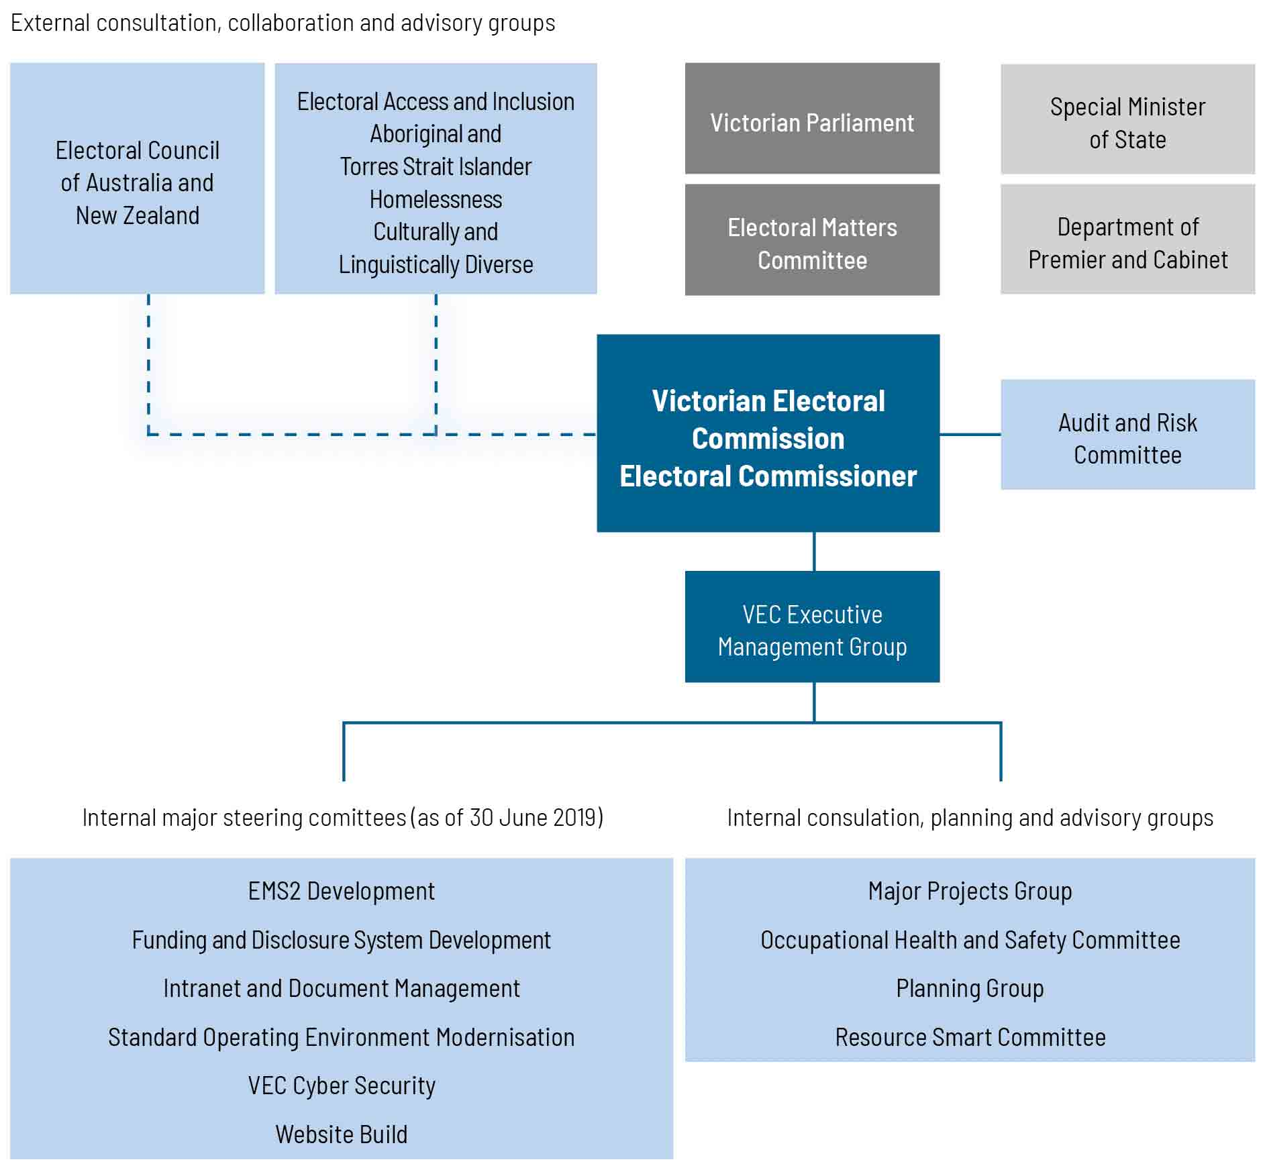

Organisational structure
The VEC’s organisational structure reflects the main activity areas of the Commission (see Figure 9).
The VEC Executive Management Group works closely with the Electoral Commissioner, the Deputy Electoral Commissioner and the Executive Director, Corporate Services to develop and implement strategic and operational plans.

Figure 9: VEC organisational structure
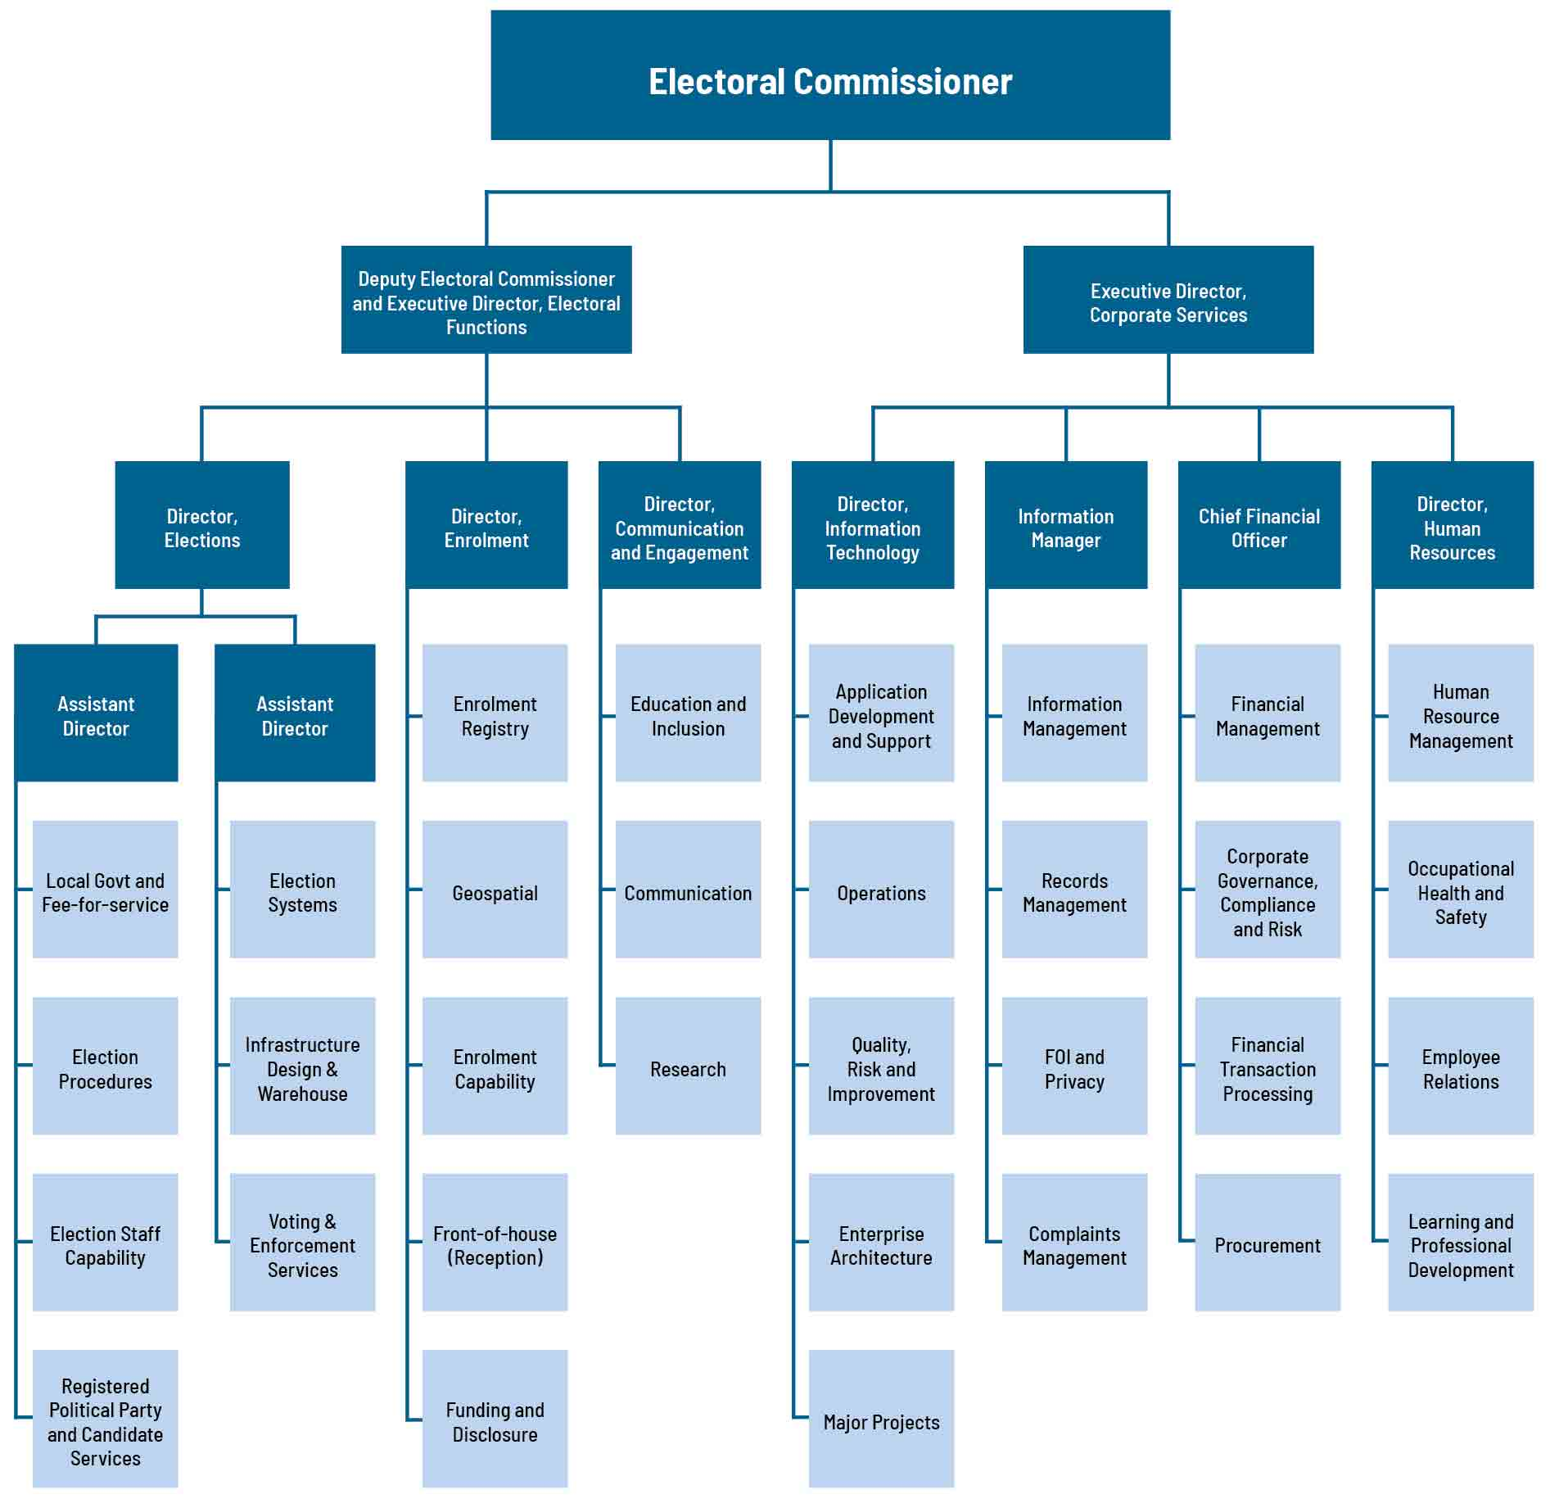

The Office of the Electoral Commissioner

Warwick Gately AM

Electoral Commissioner
The Electoral Commissioner is appointed by the Governor in Council for a period of 10 years, and is responsible for the administration of the enrolment process and the conduct of parliamentary elections and referendums in Victoria. Mr Warwick Gately AM was appointed as the Electoral Commissioner for Victoria on 29 April 2013.
Following an early career with the Royal Australian Navy, Warwick joined the Western Australian Electoral Commission as the Deputy Electoral Commissioner in 2003. Subsequently appointed as the Electoral Commissioner in August 2006, he was responsible for the 2005, 2008 and 2013 State general elections and State-wide referendums on retail trading hours and daylight saving. He oversaw State electoral boundary reviews, and conducted local government elections every two years. Continuing his long-standing career in public service, now as Victorian Electoral Commissioner, Warwick is committed to the provision of effective electoral services to the Victorian community, as evidenced with the 2014 and 2018 State elections.
The Electoral Commissioner, assisted by the Deputy Electoral Commissioner, is the Chief Executive Officer of the Victorian Electoral Commission and remains responsible for all elements of the Commission’s performance and compliance.

Liz Williams

Deputy Electoral Commissioner and Executive Director, Electoral Functions
As Deputy Electoral Commissioner, Liz works closely with the Electoral Commissioner and the Executive Director, Corporate Services in the management and administration of the VEC. Liz also leads the VEC’s Electoral Functions Group, which has responsibility for the delivery of elections, enrolment services and community engagement activities.
Liz has significant electoral experience gained in various roles since moving to the VEC in 1992 from a career in education. Liz was appointed Deputy Electoral Commissioner in 2005, and was reappointed for a further term in 2015. Liz was Acting Electoral Commissioner between May 2012 and April 2013, and was appointed Executive Director, Electoral Functions in 2017.
Liz believes in fostering a working environment that promotes learning and collaboration to drive innovation and excellence; and that efficient and inclusive electoral processes are integral to full democratic participation.

Máiréad Doyle

Executive Director, Corporate services
As Executive Director, Corporate Services, Máiréad works closely with the Electoral Commissioner and Deputy Commissioner in the leadership and administration of the VEC. Máiréad’s role as head of the Corporate Services Group encompasses Human Resources, Finance, Information Technology and Information Management, as well as corporate strategy, planning and governance. Her principal remit is to oversee and shape strategies, systems and policies to ensure the VEC’s ongoing ability to respond to current and future requirements.
Máiréad’s early profession as a chartered mechanical engineer in the oil and gas sector in Europe led to a thirty-year career in executive leadership roles in the private, public and not-for-profit sectors focusing on productivity and operational resilience.
A Fellow of the Institute of Managers and Leaders, Máiréad is the recipient of the Governor-General’s National Emergency Medal, the Australian Red Cross Meritorious Service Award and the New Zealand Red Cross Emergency Management Medal for her work in disasters.

THE VEC Executive Management Group

The Executive Management Group
The Executive Management Group (EMG) comprises the Electoral Commissioner, Deputy Electoral Commissioner, Executive Director, Corporate Services and the six Directors leading the main functional areas of the VEC.
Working cooperatively, the EMG sets the Commission’s direction and delivers the operational, financial, workforce and other plans that underpin the efficient and effective delivery of election services to all Victorians. This is assisted through the professional mastery and experience contributed by each member. At regular intervals, the EMG considers the risks, issues and opportunities facing the Commission including succession planning and knowledge transfer, along with staff and system performance and productivity matters and general compliance and reporting obligations. Staff well-being and development remains a high priority for the EMG.

Glenda Frazer

Director
Glenda commenced with the VEC in 1988 as an election manager, moving to a full-time position in 1995. With over 30 years’ electoral experience, Glenda has extensive knowledge of the conduct of elections with significant experience in the application of information technology to elections. Glenda is program manager for State elections and is responsible for the planning and delivery of all elections conducted by the VEC.

Elections Branch
The Elections Branch is responsible for overseeing the planning and conduct of State, local government and fee-for-service elections, by-elections and polls.
Key responsibilities include:
- election service agreements with Victoria’s local councils, and contracts with statutory and fee-for-service clients
- development and maintenance of election procedures and instructional materials
- large-scale recruitment, training and support programs for the VEC’s temporary workforce of around 25,000 election appointees
- services to candidates including political party registration
- design, preparation, printing and distribution of election material
- operation of large-scale centralised operations for postal voting and computerised counts
- development and support of election systems
- establishment of election offices and voting centres
- management of the VEC warehouse
- compulsory voting enforcement.

Keegan Bartlett

Director
Keegan joined the VEC as a policy officer in 2010. Keegan became the Director, Enrolment in January 2017, after nearly six years managing the VEC’s local government and fee-for-service election programs.
Before moving to Australia in 2010, Keegan worked for central and local government in New Zealand where his roles focused on building and implementing initiatives that promoted inclusive and accountable decision-making through good governance, democratic participation and effective stakeholder management. The Director, Enrolment is also appointed as Victoria’s Electoral Registrar, with responsibility for the preparation, maintenance and review of the Register of Electors and State and local government electoral rolls.

Electoral Enrolment Branch
The Electoral Enrolment Branch is responsible for maintaining an up-to-date and accurate Register of Electors. The Electoral Enrolment Branch services include:
- implementation of electoral enrolment programs
- conduct of electoral representation reviews for councils and support for electoral boundary work by the Electoral Boundaries Commission
- production of electoral rolls, other roll products and mapping data
  - provision of advice on electoral enrolment matters.
The principle underpinning the VEC’s enrolment programs is ensuring the integrity and quality of the Register of Electors. The Branch is also involved in managing electoral representation reviews and supporting the work of the Electoral Boundaries Commission.
During 2018-19, Electoral Enrolment Branch also had caretaker responsibility for the Funding and Disclosure Unit. The Director, Enrolment worked closely with the Electoral Commissioner, Deputy Electoral Commissioner and Chief Financial Officer to establish the Funding and Disclosure Unit following changes to the Electoral Act 2002 in July 2018.

Sue Lang

Director
Sue joined the VEC in 2006 after spending much of her career in senior communication roles within the metropolitan water industry, local government, statutory authorities and State government. She has significant expertise in major public awareness and stakeholder engagement programs. With her team, Sue aims to effectively communicate electoral information and education, across all media platforms, to the many diverse groups throughout Victoria. A particular focus is on access and inclusion to ensure all voters are equal at the ballot box.

Communication and Engagement Branch
The Communication and Engagement Branch comprises three distinct teams and provides a number of communication and education services, including the:
- provision of internal and external communication services for the VEC
- development and implementation of major public awareness campaigns for electoral events across traditional and digital channels
- development of stakeholder engagement programs relating to electoral participation and inclusion
- provision of electoral education and outreach services
- provision of advice on electoral legislation, electoral structures and strategic matters
- provision of research services and information.

Jonathan Underwood

Director
Jonathan is a business-focused information technology leader with a demonstrated track record in partnering with stakeholders to deliver robust, secure, high performing IT solutions. Since commencing with the VEC in late 2017, he has developed an IT strategy and roadmap to deliver an information technology environment that supports cloud computing, application rationalisation, integration, information management, cyber security and a modern workplace.
This year, the focus has been on the 2018 State election and aligning the VEC’s cyber security environment to comply with Australian Signals Directorate essential 8. While a technologist, Jonathan is ultimately a people leader who is motivated to solve problems and deliver high quality results in complex situations. He believes integrity, professionalism and accountability are vital in the successful delivery of information technology.

Information Technology Branch
The IT Branch supports the VEC’s business systems and networks, ensuring a secure and robust technology environment. The Branch delivers infrastructure and integrated applications for business as usual VEC activities and elections. The 2018 State election was successfully delivered utilising a mobile communications network for the first time. The IT Branch comprises:
- operations - maintaining security of the network and delivering enterprise systems
- devOps - delivering cyber security and innovation in infrastructure and cloud computing
- application development - transforming services and enabling high quality outcomes by modernising and consolidating applications while delivering continuous improvement.

Binh Le

Chief Financial Officer
Binh joined the VEC in November 2016 and brings a wealth of experience in finance, governance and corporate management. As a key member of the Executive Management Group, he provides strategic leadership and advice on financial and corporate matters.
Binh has held a number of senior financial positions, namely as the Group Business Manager in the Agriculture, Energy and Resources portfolio in the Victorian Government; Senior Finance Manager for the National Transport Commission; and Financial Controller for the online travel agent Webjet.

Finance Branch
The Finance Branch ensures the VEC has an effective financial management and governance environment, including:
- governance and compliance, procurement and risk practices
- financial management structures, systems, policies and procedures
- financial planning, budgeting and reporting
- financial operations.

Angela Kelly

Director
Angela joined the VEC in 2019, coming from a diverse corporate background across a variety of sectors including; the arts, professional services, agriculture, IT, banking and finance.
With extensive senior HR leadership experience, Angela is an experienced change agent driven to ensure that HR helps deliver exceptional organisational outcomes and employee experiences; making sure that people and culture programs are directly supporting the strategic plan.
As the Director of Human Resources, Angela leads a small team of human resources professionals dedicated to ensuring that the VEC is an amazing place to work!

Human Resources
The Human Resources Branch supports the development of a workforce of skilled, accountable, collaborative people who are adaptable to change and supported to be the best.
This is achieved through the five pillars of the human resources strategy:
- providing meaningful work
- developing responsive leadership
- cultivating a positive work environment
- enabling growth opportunities
- supporting trusted leadership.

Internal committees and groups

A number of consultation committees and groups assist the Electoral Commissioner and the Executive Management Group with the development and implementation of strategies and policies, providing expertise and promoting staff consultation.

EMS Redevelopment Steering Committee
Internal oversight and governance for the VEC’s Election Management System (EMS) redevelopment program and EMS enhancement projects are provided by the EMS Redevelopment Steering Committee. The Committee meets monthly to ensure correct project controls are being applied to EMS redevelopment and enhancement projects – along with providing oversight of schedule, budget and risk. Committee members include the Directors of Elections and Information Technology, the Chief Financial Officer, the Enterprise Architect, the IT Program Manager and the Manager, Election Systems. The Committee is chaired by the Director, Elections.
During 2018–19, the Committee was focused on ensuring the successful delivery of functionality required for the 2018 State election, much of which arose due to changes to legislation, and advancing preparations for the remaining modules to complete the EMS2 redevelopment program. This included:
- enhancements to the automation of election products to incorporate new requirements for registered party logos to be included on ballot papers
- enhancements to support new legislation in regard to how-to-vote card registration and to streamline publication to the website
- the development of a new online postal vote application and a facility to support the ability to automate the emailing of postal vote material to electors in remote locations
- the development of a telephone assisted voting facility
- enhancements to the computer count application to provide greater resilience
- development and enhancement of reports
- system stabilisation and disaster recovery enhancements.

Major Projects Group
Major Projects Group (MPG) is responsible for guiding and monitoring the execution of all VEC major projects, which are projects with a large budget, complex project risks or a whole-of-organisation impact.
MPG has an “all of VEC” governance responsibility, with a focus on Strategy 2023 outcomes and interdependencies between major projects that may influence the VEC’s ability to meet enterprise goals.
In 2018-19, MPG oversaw the delivery of 28 large-scale projects, enhanced the management of inter-project dependencies and risks, improved project reporting mechanisms and formats, and commissioned a review of the VEC’s Project Management Excellence Framework.

Occupational Health and Safety Committee
The Occupational Health and Safety Committee (OHSC) is a forum that facilitates cooperation and communication between the VEC’s Executive Management Group (EMG) and employees. Issues considered by the OHSC include those that are likely to affect the health, safety and welfare of VEC workplaces in accordance with the requirements of the Occupational Health and Safety Act 2004.
In 2018-19, the OHSC continued to monitor the VEC OHS Management System (OHSMS) functions and the delivery of health and wellbeing program activities. Five OHSC meetings were held over the year with regard to various matters, including major reviews of the hazard risk register, regular reviews of the safety action plans, identifying and implementing process improvements, and contributing to activities such as OHS Month. Health and Safety Representatives continued with quarterly inspections and incident and hazard reviews.
The OHSC supported a significant program of work to internally audit the five key areas that staff identified in the OHS performance survey. These focus areas were managing grievances or interpersonal conflict, mental health, ergonomics, managing fatigue, and health and wellbeing. The audits involved investigation of the OHS risk, current practice, and recommendations to the EMG to action. Four of the five audits have been completed and the final, managing fatigue will be completed in mid-2019. The OHSC will continue to monitor the progress of the implementation of recommendations.

Planning Group
The Planning Group (PG) is the VEC’s major cross-organisational work group that tracks and monitors the preparation and implementation of electoral events. The group is comprised of a changing complement of key managers from across the organisation, and is responsible for fostering intra-agency co-operation and reporting on event preparation and projects.
In 2018-19, PG’s focus was on the delivery of the November 2018 State election. Moving into 2019, the focus shifted to assessing the delivery of the election and the success of the program delivery model implemented by PG for the State election. Finalisation of project reports and recommendations have also been key.
During 2018-19, PG also focused on the delivery of other key electoral events including by-elections for Pyrenees Shire Council, Hepburn Shire Council, Knox City Council and Swan Hill Rural City Council, as well as a number of fee-for-service by‑elections and elections.
PG activities around the 2018 State election have now concluded, with the focus now moving to the October 2020 local government elections.

Resource Smart Committee

Environmental sustainability report

Ten years of Smart Resourcing
The VEC’s Resource Smart Committee (RSC) had limited opportunities to meet during the first six months of 2018-19 due the demands of the State election; yet, the RSC ensured recycling and sustainable practices were incorporated into election operations, such as the provision of recycling bins at election offices and at every voting centre. Additional work was undertaken to ensure that resources provided to support the election did not result in high wastage after the election.

Highlights 2018-19:
Highlights during the year included:
- pictorial reminders of E-waste disposal facilities, enabling batteries, appliances, gadgets and other cast-offs of the digital age to be disposed of safely and allow for the recovery of some of the valuable
- and/or toxic materials they contain
- implementation of a ‘power down’ campaign to remind staff to switch off their computers where possible when leaving the office in order to contribute to the reduction in greenhouse pollution
- the launch of the VEC’s Sustainability Policy and Action Plan and
  - the implementation of a program to encourage, collect and share sustainability initiatives taking place across the VEC to allow the RSC to capture and report on progress towards sustainability goals.
In addition, the RSC continued to work cooperatively with the 530 Collins Street building management to support its improved recycling satellite bin system designed to reduce waste contamination with stronger demarcation of landfill, co-mingle, organic and paper waste receptacles.

Sustainability Policy and Action Plan
Following the development of the VEC’s Sustainability Baseline Report in 2017-18, the RSC developed and launched the VEC’s Sustainability Policy and Action Plan that came into effect in August 2018. The RSC will continue to report on its achievements against the plan.
The key sustainability commitments at the VEC are to:
- drive resource efficiency and sustainable business practices throughout VEC operations
- leverage and influence VEC networks to improve sustainable performances and practices of the electoral sector
- prioritise sustainability in procurement and investment decisions and work with VEC suppliers to pursue and develop sustainable business outcomes
- build the capability and capacity of VEC staff to undertake their roles more sustainably, and actively communicate information that will encourage and assist employees to adopt a culture of sustainability
- implement a holistic and transparent sustainability strategy, including measurable targets, where applicable, and publicly report on progress
  - actively engage with Victorians to promote sustainability through electoral processes.

What’s next?
For the remainder of 2019 the Resource Smart team will look to establish a mechanism to report on the commitments within the Sustainability Policy, to develop the calendar of Resource Smart events and activities for the forward 12 months, and to work on how to further contribute to sustainable practices as the October 2020 local government elections approach.

External Advisory Groups

The VEC is fortunate to have representation from a broad range of community organisations and individuals who provide invaluable advice and insight into issues which impact electors’ ability to participate in elections.
The VEC has three active community advisory groups: the Electoral Access Advisory Group (EAAG), the Culturally and Linguistically Diverse (CALD) Advisory Group and the Homelessness Advisory group. All groups met twice during 2018-19, were involved in a feedback workshop post the 2018 State election and participated in the bi-annual feedback survey on how well the groups are coordinated. Members also supported the VEC by providing information to their networks on Be Heard Democracy Ambassador outreach sessions, the Voters Voice app and a range of resources and services available to support elector engagement with the 2018 State election.

Electoral Access Advisory Group
This group is comprised of representatives of disability support agencies and people with a lived experience of disability. Members of the group were consulted on telephone assisted voting, Voters Voice app and promotion of Democracy Ambassador outreach to disability services across Victoria.
Members also received reports on the progress of:
- the VEC’s Disability Action Plan
- research project with La Trobe University looking at the strategies to support people with intellectual disability to vote
- electoral outreach.

Homelessness Advisory Group
This group is comprised of practitioners from the homelessness sector, peer support workers and people with lived experience of homelessness. Members of the group provided advice on outreach materials, homelessness sector networks and best practice approaches to engaging with people experiencing homelessness.
This group was instrumental in promoting the ‘no-fixed-address’ enrolment sessions and early mobile voting, which was offered as part of the homelessness service in the lead up to the 2018 State election.

Culturally and Linguistically Diverse Advisory Group
This group is comprised of representatives from multicultural organisations across the community and government sectors and those with expertise on engaging CALD communities.
Members of the group provided expert advice on key projects such as the Talking Democracy teacher’s kit and a youth leadership partnership project with the Centre for Multicultural Youth.
Celebratory High Tea with Advisory Group members and stakeholders at Parliament House

Bi-annual Advisory Group Feedback Survey
The bi-annual advisory group feedback survey sent to all advisory group members indicated that members were satisfied or very satisfied with how the VEC coordinated and provided opportunities for input on electoral engagement and inclusion. Suggestions were received on expanding the representation on various groups, which will be explored in 2019-20.

Aboriginal and Torres Strait Islander advisory representation
The VEC completed an in-depth literature review on electoral engagement and participation of Aboriginal and Torres Strait Islander people and began exploring - in collaboration with Melbourne University - the most culturally inclusive ways to seek advice and input from this community. The VEC is committed to ensuring a genuine connection is established with Aboriginal and Torres Strait Islander people and communities, which increases understanding of the broad range of influences and barriers impacting Aboriginal Victorians with regard to enrolling and voting.

Figure 10: feedback provided by advisory group members at the post 2018 State election workshop, February 2019
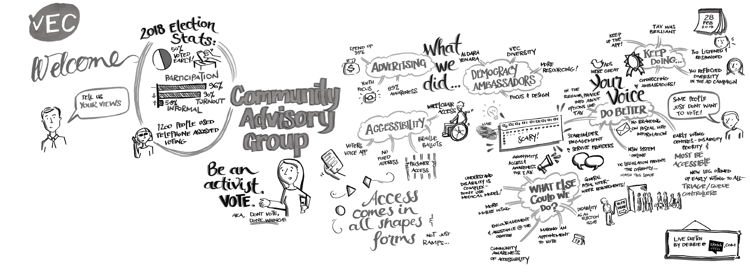

Culturally and Linguistically Diverse Advisory Group committee member
– Shabnam Daliri
My name is Shabnam Daliri. In 2011, I migrated to Australia to complete a master’s degree in Social Work at RMIT University. I now work as a Health Promotion and Research Project Officer on the Gambling Awareness Project at the Multicultural Centre for Women’s Health. I support CALD community members who are affected directly or indirectly by gambling-related harms.
I came to the CALD Advisory Group after meeting Asvin Phorugngam, Electoral Inclusion Officer at a Leadership Victoria event.
Coming from a Persian background, I bring my lived experience and professional judgement and practice to contribute to the work of the VEC. From my experience, many women with whom I have worked faced many barriers in civic participation owing to their low level of proficiency in English or due to lack of information about their rights in Australia.
As a member of the advisory group, I hope to share my knowledge and experience with the VEC to increase civic participation, including educating women with immigrant and refugee backgrounds about their rights and empowering them to make informed decisions for themselves.

Governing legislation and tribunals

The three pieces of legislation that set out the VEC’s primary responsibilities are the Constitution Act 1975, Electoral Act 2002 and Local Government Act 1989.
In accordance with this legislation, the VEC conducts State and local government elections and by-elections, and certain statutory and fee-for-service elections. The VEC also provides advice to the Special Minister of State and Parliament on electoral issues. Other legislation and regulations imposing certain duties on the Electoral Commissioner are listed in Appendix B on page 136.

Legislative and regulatory amendments
The Electoral Legislation Amendment Act 2018 received royal assent on 31 July 2018. The Electoral Amendment Regulations 2018 were made on the same day.
The legislation introduced a comprehensive system of financial disclosure and public funding. The system restricts the level of political donations, prohibits anonymous and foreign donations, provides for prompt disclosure of donations, extends public funding of registered political parties and independent members of Parliament, and establishes an administrative structure providing for agents, annual returns and State campaign accounts.
Other amendments to the Electoral Act 2002 included:
- aligning enrolment provisions with those of the Commonwealth
- allowing early voting as of right, replacing its restriction to electors who would be unable to reach a voting centre on election day
- introducing online applications for postal votes
- ending the distribution of postal vote applications attached to political party messaging, while requiring the VEC to provide details of applicants to registered political parties and independent candidates
- placing a deadline on applications to register a political party, while providing for registration of party logos
  - restricting political signage around voting centres.
The general amendments to the legislation were in operation at the 2018 State election, while most of the public funding and disclosure provisions came into operation on 25 November 2018, the day after the election.
The Local Government Bill 2018, intended to replace the Local Government Act 1989, lapsed at the expiration of the Parliament in October 2018.

Cases arising from 2018 State election
The State election gave rise to several court matters. The cases related to the parties entitled to stand at the election, what voters were permitted to see when they went to vote, and the result of the election.
- The Victorian Civil and Administrative Tribunal (VCAT) rejected an application by the Flux Party to overturn the VEC’s decision to refuse to register the party.
- The Supreme Court rejected an application by the Australian Labor Party (ALP) to compel the VEC to reprint ballot papers for Yan Yean District, deleting the party affiliation of the candidate who was no longer endorsed by the Liberal Party.
- The VCAT granted an application by the ALP to overturn the VEC’s registration of four Liberal Party how-to-vote cards that listed the disendorsed candidate for Yan Yean as the Liberal candidate. VCAT’s decision was upheld on appeal to the Supreme Court, and the Court of Appeal refused leave for a further appeal.
- The VCAT rejected an application by Ms Susanna Sheed (independent candidate for Shepparton District) to overturn the VEC’s decision to refuse registration of her how-to-vote card.
- The VCAT granted an application by the Liberal Party to overturn the VEC’s registration of two how-to-vote cards registered for Northcote District by a group identifying as ‘Citizens for Stable Government’.
- Mr Brendan Eckel (an Independent candidate for Buninyong District) withdrew an application to the Court of Disputed Returns to void the result of the election for Buninyong because of alleged bribery by the Premier and State Secretary of the ALP.
- Ms Sarah de Santis, the ALP candidate for Ripon District, filed a petition with the Court of Disputed Returns seeking an order that the VEC conduct a recount of all used ballot papers for Ripon. However, in May 2019, Ms De Santis withdrew her petition just before the case was due to go to court.

Accountability and transparency

The VEC has legislative and organisational processes in place to ensure transparency and accountability to the Victorian public. These processes include internal and external auditing, regular reporting to stakeholders including Parliament, Government and the public, and tabling of audited financial statements as part of this report.

Financial Management Compliance Framework
The Financial Management Compliance Framework (FMCF) provides the Minister for Finance an assurance that Victorian Government entities have implemented the appropriate systems to ensure compliance with the Framework. The Framework provides for effective, efficient and responsible financial management of public resources.
The Standing Directions cover:
- financial code of conduct, financial governance including the establishment of an Audit and Risk Committee, financial risk management, delegations, and internal and external audits
- financial management structure, systems, policies and procedures, which includes role and responsibilities of the financial management team and identified Key Management Personnel (KMPs), policies and procedures, managing outsourced services, information technology management, operations, development and change, education and training
  - financial management reporting, which includes internal and external reporting, reporting requirements for Financial Statements and Report of Operations in accordance with new FMCF Standing Directions, performance management and evaluation, financial management compliance obligations, tax compliance, purchasing cards and thefts and losses compliance.
The VEC’s compliance with FMCF Standing Directions is audited by the internal auditor annually, and is reviewed and endorsed by the Audit and Risk Committee. The 2018-19 internal review reported the VEC’s overall compliance with the Framework as reported in the annual attestation.

Audit and Risk Committee
The VEC has an established Audit and Risk Committee to assist and advise the Electoral Commissioner in meeting obligations around financial compliance and reporting, and in the management of risk. The Committee consists of the following members:
- David Nairn, Chairman (independent member – re‑appointed as Chair in April 2019)
- Carol Pagnon (independent member)
  - Michael Ulbrick (independent member).
The main responsibilities of the Committee are to monitor and oversee the:
- financial performance and the financial reporting process, including the annual financial statements
- scope of work, performance and independence of internal audit
- engagement and management of the internal audit contractor
- scope of work, independence and performance of the external auditor
- operation and implementation of the risk management framework
- matters of accountability and internal control affecting the operations of the VEC
  - effectiveness of management information systems and other systems of internal control
VEC’s process for monitoring compliance with laws and regulations and its own code of conduct and code of financial practice
VEC's compliance with FMCF Standing Directions.
The Committee met formally on four occasions during the year, with an additional site visit in November to the VEC’s Central Processing Centre where postal votes for the State election were managed.
The Committee’s positive support and guidance to the Electoral Commissioner were much appreciated.

Identifying and managing risk
The State Government’s Risk Management Framework provides for a minimum risk management standard across public sector entities. As the Accountable Officer, the Electoral Commissioner is responsible for the development, implementation and ongoing maintenance of the risk management framework, to ensure that risks are managed in a consistent manner across the organisation.
Risk management is embedded into the VECʼs operations, including regular workshops and assessments to identify and monitor organisational risks, evaluating risk controls in place and developing new controls where required. The Audit and Risk Committee plays an oversight role to the risk framework and provides an independent perspective on VEC risk management practices.
Risks are profiled and rated according to their potential hazard across operational and non-operational activities. Risk ratings are presented to the Audit and Risk Committee in accordance with its charter. In an independent capacity, the Committee determines whether risks are adequately scoped and if sufficient controls are in place to mitigate and manage risks.
At an operational level, the VEC has comprehensive risk management plans for all electoral events and major projects. These are developed, discussed and analysed at branch level and at election planning groups during the planning phase, covering areas such as election management, infrastructure, communication, recruitment and information technology.

Corporate reporting
The VEC has a comprehensive program of stakeholder reporting that supports its goals of accountability and transparency. Internal reporting is aligned with lines of authority and cross-organisational channels to meet organisational needs.
External reporting is based on legislative and governance obligations, transparency objectives and commitments to stakeholders. The standard of reporting is high. For example, last year’s Annual Report fully complied with Department of Treasury and Finance model report requirements and also achieved a gold award at the 2019 Australasian Reporting Awards.
During 2018-19, the VEC tabled one report in Parliament being the Victorian Electoral Commission Annual Report 2017-18.
Other reporting obligations include:
- the provision of a quarterly report to the Department of Premier and Cabinet in relation to budgetary objectives
- monthly financial reporting and cash flow forecasting to the Department of Treasury and Finance
- twice-yearly reporting to the Attorney-General on infringements activity
- advertising campaign reporting
  - reporting for the Electoral Boundaries Commission (EBC) for whom the VEC provides secretarial services. The VEC also prepares an annual report for the EBC. This report can be found at Appendix G on page 140.
All reports were delivered on schedule and within budget, where applicable. Annual reports and other reports and publications are available on the VEC website (vec.vic.gov.au) and from the VEC.

Internal audit
The VEC’s internal audit program is designed to provide an independent, objective assurance to improve the VECʼs operations. The rolling four-year internal audit strategy and program is designed to be comprehensive and to enable effective and regular review of all operational, financial and related activities.
Part of the annual program includes annual attestations and certification reviews such as Risk and Fraud Certification and the VECʼs compliance with Memorandums of Understandings (MOUs) entered into with other agencies. The VECʼs internal audit program is designed in consultation with the Audit and Risk Committee and the VECʼs Executive Management Group.
In 2017, the VEC procured and appointed Protiviti as the internal audit service provider.

Customer Service Charter
The VEC’s Customer Service Charter ensures that it complies with best practice and is relevant to VEC operations. The Charter is reviewed regularly and is available on the VEC’s website.

Complaints
The VEC handles complaints in three main areas:
- complaints alleging a breach of the Electoral Act 2002
- complaints alleging a breach of the Local Government Act 1989 (LG Act)
  - complaints about a process, performance or service related to an interaction with the VEC.
As the VEC does not have authority to follow up allegations of a breach of the LG Act, these complaints are forwarded to the Local Government Inspectorate (LGI) for handling, in accordance with an established protocol.
The VEC received 921 written complaints during 2018-19. Of these complaints, 861 were received within the State election period, with the vast majority resolved by the provision of information or clarification to legislation. An analysis of the State election-related complaints will be included in the VEC’s Report to Parliament on the 2018 Victorian State election.
Complaints received outside of the election period related to online employment application and training, authorisation of electoral material and candidate conduct, and were connected to the upcoming State election. There were no substantiated complaints related to information privacy or the release of information under the Freedom of Information legislation.
The VEC regularly reminded electors who suspected their privacy was breached, that the VEC has obligations under the legislation to provide candidates, political parties and Members of Parliament with electoral rolls for purposes including campaigning. For more information about who receives enrolment information, refer ‘Privacy at the Victorian Electoral Commission’ on the VEC website.
All complaints were dealt with in accordance with VEC procedures and were resolved by providing an explanation, follow-up and responsive action where required. The VEC aims to respond to complaints within five working days for straightforward complaints and this was achieved.

Disclosures

Additional information available on request
Information relating to the 2018-19 reporting period is made available to Ministers, Members of Parliament and the public on request (subject to the Freedom of Information Act 1982) and is listed in Appendix C on page 137.

Advertising disclosure
Financial Reporting Direction 22D issued by the Australian Accounting Standards Board requires Victorian Government agencies to disclose advertising expenditure on campaigns with a media spend of $150,000 or greater. During 2018-19, the VEC expended $3.8 million on advertising to promote the 2018 State election.

Attestation to Public Sector Standards Commissioner
The Electoral Commissioner completed an annual attestation of hospitality and gifts as required.

Building Act 1993
The VEC does not own or control any Government buildings and consequently is exempt from notifying compliance with the building and maintenance provisions of the Building Act 1993.
FIGURE 11: CONSULTANCIES VALUED AT $10,000 OR GREATER
Consultant | Purpose of consultancy | Total approved project fee  (ex GST) | Expenditure 2018/19  (ex GST) | Fixture expenditure  (ex GST)
Clayton Utz | Legal advisory services | 23,500 | 23,500 | -
Colmar Brunton | State election research | 91,185 | 91,185 | -
Data#3 | Intranet and Microsoft 365 modernisation strategy and design | 679,362 | 77,385 | 601,977
Davidson Executive and Boards Pty Ltd | Professional development and structural review | 11,750 | 11,750 | -
Deliberate Practice Pty Ltd | Capability framework review | 36,000 | 36,000 | -
Deloitte Consulting Pty Ltd | Website strategy and design | 750,000 | 450,000 | 300,000
ID (Informed Decisions) Pty Ltd | Elector forecasts | 141,000 | 141,000 | -
Jeremy Wood | Representation reviews | 23,052 | 23,052 | -
Mapdojo | Geographic information systems consultancy services | 114,000 | 114,000 | -
Microsoft Pty Limited | Cyber security advisory and support | 42,788 | 42,788 | -
Percept IT Pty Ltd | System development | 354,997 | 354,997 | -
Pitcher Partners Consulting Pty Ltd | Probity and procurement services | 85,718 | 39,120 | 46,598
Saatchi & Saatchi Australia Pty Ltd | State election advertising services | 487,844 | 487,844 | -
Social Ventures Australia Ltd | Outcomes management framework and evaluation | 50,362 | 50,362 | -
Terra Firma | Business Continuity Planning services | 19,400 | 19,400 | -
Votar Partners | Knowledge management framework | 41,731 | 41,731 | -

Child Safe Standards
In 2015, the Child Safety and Wellbeing Act 2005 was amended to include Child Safe Standards for adoption by all organisations involved in child-related work in Victoria.
The Commission for Children and Young People (CCYP) determined that the VEC is required to comply with the Child Safe Standards – primarily due to its work in student education. In early 2019, the VEC worked with CCYP on the following:
- Child Safe Code of Conduct
- Child Safety Policy
- Statement of Commitment to Child Safety
- Child Safety Risk Management Overview
  - Child Safety Role Mapping Matrix.
In addition, advertising, recruitment and training procedures were also updated to reflect the Child Safe Standards.

Consultancies and contracts

Major contracts
In accordance with the requirements of Financial Reporting Directive 12A, the VEC discloses all contracts greater than $10 million in value entered into during the year ended 30 June 2019. No contracts greater than $10 million in value were entered into by the VEC during 2018-19.

Consultancy expenditure

Details of consultancies under $10,000
In 2018-19, there were nine consultancies engaged during the year, where the total fees payable to the individual consultants was less than $10,000. The total expenditure incurred during 2018–19 in relation to these consultancies was $35,205 (excluding GST).

Details of consultancies (valued $10,000 or greater)
In 2018-19, there were 16 consultancies where the total fees payable to the consultants was $10,000 or greater. The total expenditure incurred during 2018-19 in relation to these consultancies was $2,004,114 (excluding GST). See Figure 11.

Disability Act 2006
The Disability Act 2006 requires that all public sector bodies prepare a disability action plan and that departments report on the implementation of their disability action plan in their annual report.
The VEC’s Electoral Access Advisory Group (EAAG) was provided with a report on the VEC’s performance against every action item due for attention in 2018-19. See Disability Action Plan report on page 72 for more information.

Disclosure index
The Annual Report of the VEC is prepared in accordance with all relevant Victorian legislation and pronouncements. A disclosure index has been prepared to facilitate identification of the VEC’s compliance with statutory disclosure requirements. The disclosure index is included as Appendix A on page 134.

Employment and conduct principles
The VEC maintains and implements a suite of policies and guidelines with respect to upholding public sector conduct, managing and valuing diversity, employment, managing underperformance, reviewing personal grievances, and selecting on merit.

Environmental performance
The VEC has continued its commitment to reducing the negative impact of its operations on the environment, with ongoing communication and information programs to encourage continued positive behavioural changes.
The VEC Environmental Sustainability Report for 2018-19 is included in ‘Our Commission’ on page 30.

Executive officer disclosures
The Electoral Commissioner and Deputy Electoral Commissioner are appointed by the Governor in Council as statutory office holders. These appointments do not fall within the definition of Executive Officer under the Public Administration Act 2004.

Freedom of information
The Freedom of Information Act 1982 (FOI Act) gives the community the right to access information in the possession of the VEC. Of the two requests received by the VEC under FOI legislation, one was satisfied outside of the process, the other was processed within the legislated timeframe. The VEC contributed to a request that was made to a Federal government agency under the Freedom of Information Act 1982 (Cth).
For information about how to lodge an application under the FOI Act, see the VEC website or Appendix E on page 138.

Grants and transfer payments (other than contributions by owners)
Included in the ‘Total expenses from transactions’ on page 41 are payments of grants and assistance to certain companies and organisations. During 2018-19, the VEC provided grants totalling $203,420 to 7 organisations (see Figure 12 on page 41).

Gifts, benefits and hospitality register
The VPSC issued updated standards for Victorian public sector employees on the giving and receiving of gifts, benefits and hospitality, effective 12 December 2016. To reflect these changes, the VEC now publishes its Gifts, Benefits and Hospitality Register on a quarterly basis and these reports are available on the VEC website.

Occupational health and safety management
The goal of the VEC’s Occupational Health and Safety (OHS) system is to ensure all staff remain safe and healthy at work. An OHS management system is in place and branches within the VEC have implemented OHS local action plans aimed at enhancing safety performance and ensuring safe systems of work. In 2018-19, there were 8 lost days arising from injuries. For more on human resource management at the VEC, including performance against OHS management measures, see the Our People section of this report (see page 81).

Information and records management
The VEC has responsibility for managing information in accordance with standards issued by the Public Records Office of Victoria and the Victorian Information Commissioner. The types of information managed by the VEC are detailed in the VEC Information Asset Register.
During 2018-19:
- the VEC business classification scheme was updated to better support VEC functions and responsibilities
- the VEC met reporting obligations imposed by the Privacy and Data Protection Act 2014.

Privacy
The VEC collects and handles personal information in relation to both the Victorian public and VEC staff in order to fulfil its functions under the Electoral Act 2002. The VEC’s policies regarding the management of personal information comply with the Privacy and Data Protection Act 2014 and are set out in its Privacy Policy, available on the VEC website.
During 2018-19, the VEC’s Privacy Officer collaborated with the Office of the Victorian Information Commissioner (OVIC). Updates were given to affected and interested VEC officers, as appropriate. No privacy breaches were reported to the VEC during 2018‑19.
Each year, the VEC responds to queries relating to the release of information to people and organisations, as authorised by legislation. These queries are not treated as privacy complaints or breaches.

Legislation
The VEC is subject to, and complies with, a range of legislation as listed in Appendix B on page 136, and detailed in this report as applicable.

National Competition Policy
Competitive neutrality requires Government businesses to ensure where services compete, or potentially compete with the private sector, any advantage arising solely from their government ownership be removed if they are not in the public interest. Government businesses are required to cost and price these services as if they were privately owned and thus be fully cost reflective.
Competitive neutrality policy provides government businesses with a tool to enhance decisions on resource allocation. This policy does not override other policy objectives of Government and focuses on efficiency in the provision of service. The VEC continues to comply with the requirements of the National Competition Policy.

Pecuniary interest declarations
The Electoral Commissioner and the Deputy Electoral Commissioner completed declarations of pecuniary interests, as required.

Protected Disclosure Act 2012
The VEC is committed to the aims and objectives of the Protected Disclosure Act 2012 (PDA). Improper conduct by its employees, officers or members is not tolerated, nor is reprisal against those who come forward to disclose such conduct.
The VEC recognises the value of transparency and accountability in its administrative and management practices, and supports the making of disclosures that reveal corrupt conduct, conduct involving a substantial mismanagement of public resources, or conduct involving a substantial risk to public health and safety or the environment. For details about reporting procedures under the PDA see Appendix D on page 137.

Victorian Industry Participation Policy
The Victorian Industry Participation Policy Act 2003 requires public bodies and departments to report on the implementation of the Victorian Industry Participation Policy (VIPP). Departments and public bodies are required to apply VIPP in all tenders over $3 million in metropolitan Melbourne and $1 million in regional Victoria. No contracts to which the VIPP applies were commenced or completed by the VEC during 2018-19.

Figure 12: Grants to external bodies, 2018–19
Organisation | Purpose of grant | Amount (ex GST)
Richmond Football Club | Support for Richmond Emerging Aboriginal Leaders camps (at Korin Gamadji Institute) for Aboriginal and Torres Strait Islander youth to build their leadership skills through active citizenship and position them as role models within their community. | $122,117
Electoral Regulation Research Network (ERRN) | Ongoing support of ERRN to foster exchange and discussion of research relating to electoral regulation. | $40,000
Youth Parliament | Sponsorship of four youth teams and a fifth team from the Korin Gamadji Institute. | $21,136
La Trobe University – Living with Disability Research Centre | Sponsorship of PhD research into barriers to enrolling and voting for people with intellectual impairment. Multi-year project into barriers to enrolling and voting for people with intellectual impairment.  *Contributions towards this project received from five other electoral commissions. | $15,969
National Homelessness Conference | Conference sponsorship to gain access to the Homelessness Sector to promote the VEC’s outreach and no-fixed-address enrolment. | $1,200
Melbourne Deaf Expo | Conference sponsorship to gain access to people with disabilities, advocacy groups, disability services with a view to promoting outreach services. | $1,240
Victorian Local Government Multicultural Issues Network | State Forum sponsorship to gain access to sector workers and people from culturally and linguistically diverse communities with a view to promoting outreach services. | $2,727
Total |  | $204,389

Spotlight on...
Name
Tania Kyriakou
Title
Geospatial Capability Manager
Department
Geospatial Team, Electoral Enrolment Branch
The VEC’s vision is for all Victorians to actively participate in their democracy. How does your role contribute to this?
When people think about Victorians participating in their democracy, elections usually come to mind. I enjoy the work I do because it allows people to engage with democracy in additional ways to voting. The Redistricting Submission tool for which I am responsible, allows people to draw their own Council structures and ward boundaries using a Google Maps platform. Victorians can determine whether their Council structure and boundaries fall within equality parameters while they create their structure.
The tool is made up of building blocks of elector numbers - users combine them to create wards, and the calculations are automatically provided. Prior to the development of the tool users would have had to do their calculations manually, which would have been time-consuming and in most cases prohibitive. The tool will be enhanced to allow Victorians to draw boundaries for our State Redivision commencing in 2020.
What makes the VEC an innovative and engaging place to work?

I enjoy the work we do because it has value for the community. Feeling confident that your elections are run well and impartially is something easy to take for granted. I’m happy to say my work contributes to Victorians’ confidence in the work the VEC does.

What do you like to do outside of work?
I enjoy shopping for vintage clothes and homewares. I have a particular love of things from the 50s to 80s. Other than going out for brunch I really enjoy doing nothing and having no plans – that’s actually my favourite kind of weekend. Not a single thing planned – ah, what luxury. This happens rarely.

Our core business

ACHIEVEMENTS 2018–19
- Finalised and released the VEC’s 2018 Victorian State Election Service Plan
- Successful conduct of the 2018 Victorian State election
- Delivered election management system requirements for the 2018 State election
- Finalised matters in the Magistrates’ Court resulting from the 2016 local government elections
- Finalised compulsory voting enforcement for the Northcote District by-election, Greater Geelong City Council general election, Melbourne City Council Lord Mayor by-election and other compulsory elections and polls including lodgement of outstanding infringements with Fines Victoria
- Delivered a pilot project during the 2018 State election for voters with intellectual disability
- Commenced the program of electoral representation and subdivision reviews, of which 12 of 38 reviews have now been completed
- Established a Funding and Disclosure Unit to administer new public funding and political donation requirements introduced to Victorian elections in July 2018

OUTLOOK 2019–20
- Complete the current program of electoral representation and subdivision reviews, including 19 representation reviews and seven subdivision reviews
- Respond to anticipated changes to the Local Government Act 1989, affecting election operations
- Progress Funding and Disclosure system enhancements
- Delivery of the 2020 local government service plan
- Tabling the report on the 2018 State election in Parliament

2018 State election

887 candidates contested the 2018 State election

99.33% own district early votes counted on election night

4,139,326 people on the electoral roll

67.13% increase in the number of general postal voters

1.3m people used the Voting Centre Locator

8,704 media mentions during election period

96.60% of eligible Victorians on the electoral roll

24,375 separate election roles

90.16% voter turnout

9,311 votes cast at interstate and overseas voting centres

A number of significant legislative changes preceded the 2018 State election, including the introduction of the State’s new funding and political donation disclosure laws, restrictions on signs near voting centres, and allowing all electors to access early voting without having a specific reason for doing so.

Enrolment and turnout
There were 4,139,326 people enrolled to vote at the 2018 State election. However, although more Victorians voted in the 2018 State election than at any previous State election, voter turnout as a proportion of enrolment was the lowest since 1945, at 90.16%. Part of this is due to the VEC’s success in enrolling people, with an estimated 96.6% of eligible Victorians now on the roll. Other factors include the surge in enrolments ahead of the 2017 Australian Marriage Law Postal Survey that did not translate into voting in elections; large numbers of Victorians travelling overseas; and low participation by young adults.

Communication services
During the 2018 election the VEC communicated with electors through advertising, social media, the VEC website, the digital VoterAlert system, and the published Election Guide and Easy English Guide. The VEC also provided a public enquiry service for electors who preferred to call for information.

Figure 13: Voter turnout by age group, 2018 State election

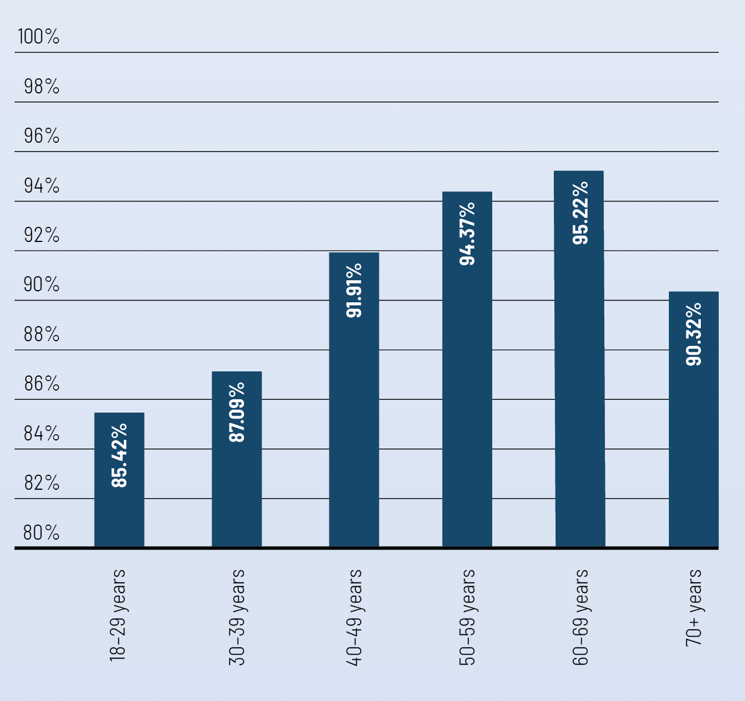

Services to candidates and political parties
Twenty registered political parties contested the 2018 State election. There was keen interest in party registration in the lead-up to the election, with applications for registration from 11 new political parties, nine of which were registered in time for the election.
A total of 887 candidates contested the election – 776 party candidates and 111 independent candidates – which was just nine candidates fewer than the 2014 election.

Media services
The VEC held media briefings, distributed media handbooks, created a dedicated media centre on the VEC website, and conducted 27 radio interviews. Thirty-one media releases generated 837 print and online news stories.

Education and inclusion services
The VEC’s Education and Inclusion Services Program delivers initiatives aimed at communities facing barriers to electoral participation, including Aboriginal and Torres Strait Islander communities, culturally and linguistically diverse (CALD) communities, people experiencing homelessness, and young people. The foundation program for the 2018 State election featured peer-based information delivery through the Be Heard! Democracy Ambassador Program. The VEC recruited 57 Democracy Ambassadors from target communities and reached 8,246 participants across 335 outreach sessions.
A supported mobile voting pilot was provided to eligible voters within prisons, specifically Fulham, Karreenga and Marngoneet Correctional Centres, Melbourne Assessment Prison and Tarrengower Prison. A total of 304 votes were received. General postal votes were also offered and 90 of these were returned.

Staffing
The VEC’s temporary election workforce comprises 24,375 separate roles, with approximately 15,000 of these roles operating on Election Day only. This requires an extraordinary recruitment, training, and staff management program.

Voting
The biggest change in voting behaviour has been an increase in early voting and a corresponding decrease in Election Day voting.

Counting the votes
The counting of votes began at the close of voting (6.00 pm) on Saturday 24 November and continued until Tuesday 11 December when the final results for the Legislative Council were published. For the first time, all postal votes were counted at the centralised Postal Vote Count Centre. This allowed election offices to focus on counting own district early votes and to minimise the movement of ballot papers across the State during the counting period. Legislative change ahead of the 2018 election allowed the extraction, sorting, and reconciliation of postal votes to begin early (8.00 am on Election Day) and for the processing of early votes (4.00 pm on Election Day).
Within two hours of the close of voting, 64.33% of voting centres had published their results, and one hour later that figure was 87.96%. 79% of the total votes counted for the election was counted on election night.

Funding and disclosure
Amendments to the Electoral Act 2002 introduced new laws governing political donations and funding in Victoria. These laws came into effect in two stages. Stage one commenced on 1 August 2018, banning anonymous donations over $1,000 and foreign donations, and introducing new administrative funding for registered political parties and independent elected members. Stage two commenced on 25 November 2018 – the day after Election Day – governing the disclosure and reporting of donations, and introducing advance public funding for eligible candidates. The VEC conducted an extensive engagement program to educate stakeholders and the public about the new laws.

Inquiries and disputes
There were three applications made to the Victorian Civil and Administrative Tribunal’s (VCAT’s) Review and Regulation List: two over the VEC’s decision to register how-to-vote cards and one over the VEC’s decision to decline to register a how-to-vote card.
There were two petitions to the Court of Disputed Returns. One was from an independent candidate for Buninyong District, who later sought leave to discontinue his petition and it was dismissed. The other was from the Australian Labor Party candidate in Ripon District, which was won by the Liberal candidate by a margin of just 15 votes. The petitioner later sought leave to discontinue the petition and it was dismissed.

Statistical overview
The informal voting rate for the Legislative Assembly was 5.83%, which is the highest ever recorded. The informal voting rate for the Legislative Assembly has increased at every election since 1996 when it was just 2.37%. In contrast, the informal voting rate for the Legislative Council has barely shifted in 22 years, rising from 2.58% in 1996 to 3.96% in 2018. Blank ballot papers were the most common form of informal voting (27.82%) for the Legislative Assembly, followed by papers marked with number 1 only (24.89%).
The proportion of people voting below-the-line on their region ballot paper has increased, from 6.08% in 2014 to 8.87% in 2018.

Figure 14: Election officials by age, 2018 State election
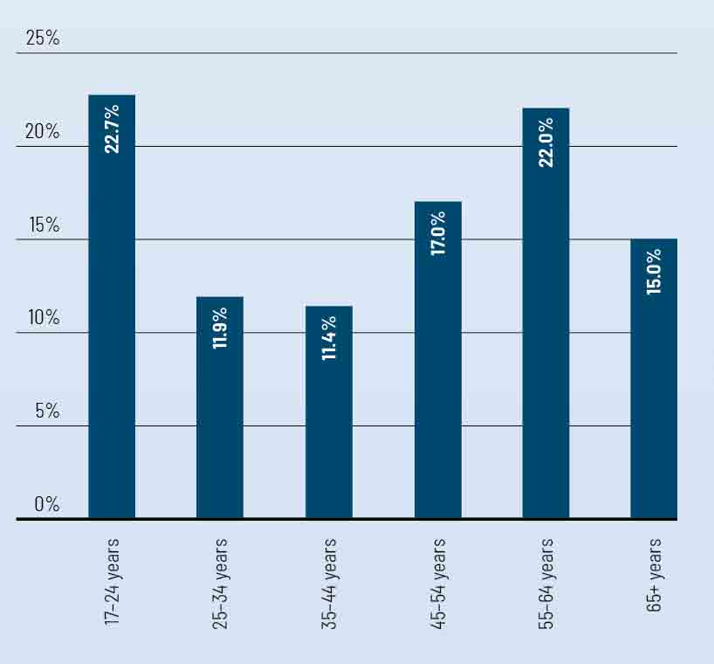

Analysis of results
Across both houses of Parliament, 30% of the members elected were new. The number of women in Parliament increased from 48 after the 2014 election (37.5% of all MPs) to 53 at the 2018 election (41.4% of all MPs). The youngest candidate was 18 years old and the oldest was 88 years old. The youngest candidate elected was 25 years old and the oldest candidate elected was 71 years old.

Evaluation
The VEC engaged research firm Colmar Brunton to conduct independent evaluation of election services. There was a very high rate of recall of information from the VEC during the election – 85%, compared to 79% at the previous election.

Complaints
The VEC received 861 complaints about the election. Of these complaints: 371 were about candidates and campaign workers; 258 were about services to voters (predominantly postal voting); 150 were about election officials and employment conditions; 76 were about election administration; and six complaints were about other electors.

Figure 15: Vote types, 2018 State election
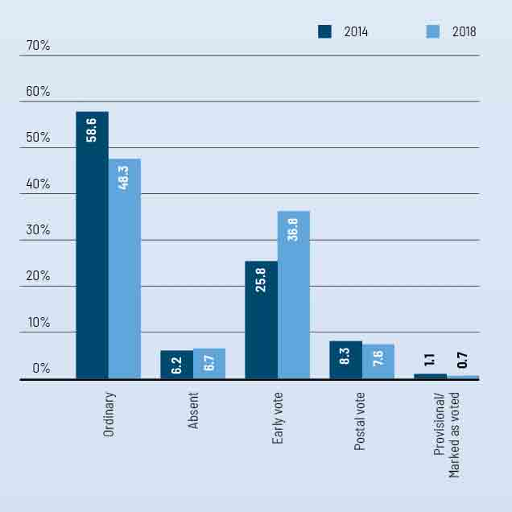

Compulsory voting
After a State election, the VEC carries out activities related to compulsory voting provisions in the Electoral Act 2002. Apparent Failure to Vote notices were sent to 255,151 enrolled electors who appeared not to have voted, who then had 28 days to provide a valid and sufficient excuse or provide information as to where and when they voted. Following this, Infringement notices were then sent to 191,452 non-voters who did not respond to the first notice or who did not provide a valid and sufficient excuse. Penalty Reminder notices would follow in July to those non-voters who did not pay the infringement penalty. At the conclusion of the penalty reminder stage penalties collected will be reconciled and forwarded to Consolidated Revenue. Later in 2019, outstanding infringements will be lodged with Fines Victoria and court proceedings will be commenced for those non-voters opting to go to court.
Figure 16: Satisfaction by voter type, Victorian State elections 2014-2018
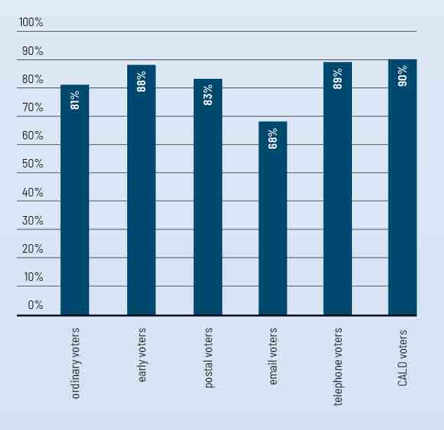

Other electoral activity

In addition to the 2018 State election, 39 other events were conducted including five local government by-elections, 18 local government countbacks, four fee-for-service elections and polls, and 12 electoral representation reviews. All events were successfully conducted on schedule and within budget, with no result overturned.

State by-elections
A State by-election occurs if a Member of Parliament for the Legislative Assembly resigns or can no longer hold office. The VEC maintains the capability and capacity to conduct State by-elections as required, within minimum prescribed timeframes. There were no State by-elections conducted in 2018-19.

Local government by-elections and countbacks
An extraordinary vacancy arises in a council when a councillor resigns, dies or can no longer hold office as a councillor. The Local Government Act 1989 (the LG Act) provides for a countback to be conducted in the first instance when an extraordinary vacancy arises in a multi-councillor ward or unsubdivided council. A by-election is necessary when an extraordinary vacancy arises in a single-councillor ward, or where the vacancy cannot be filled by a countback because of a failed countback, or because there are no eligible candidates for the election.
During 2018-19, the VEC conducted five local government by-elections and 18 countbacks to fill extraordinary vacancies. A report on each activity was prepared and provided to the relevant council within the legislated three-month period.
The details of all by-elections and countbacks conducted during 2018-19 are included in Figures 18 and 19 on page 52.
The number of extraordinary vacancies was higher than in 2014-15, which is the previous reporting year comparable to this stage of the local government term, when five by-elections and 11 countbacks were held. Four by-elections were conducted using postal voting and one by attendance voting.
In 2018-19, all countbacks were held within the respective local council area using the VEC’s web-based computer countback application. The average cost of a countback was $2,682 (including GST). The cost of a countback includes public notices, configuration of the countback application, and staff time.
A modified countback procedure is necessary when there is only one remaining eligible candidate for election, but public notice of the countback is still necessary. There were two modified countbacks during 2018–19. The Corangamite Shire Council countback was held within the municipality and cost $480 (including GST) and the Surf Coast Shire Council countback resulted in a by-election with the election day set for 30 August 2019.
A further countback is where a countback has already occurred and the successful candidate at the countback has failed to declare that they are eligible to be elected within the 48 hour period prescribed in the LG Act, and there is at least one remaining eligible candidate to be elected. Four further countbacks were conducted during 2018-19.
All by-elections and countbacks were conducted in compliance with legislative requirements, within budget and with no elections failed or overturned. The VEC achieved its aim of providing ‘value for money’ local government election services.

Pyrenees Shire Council, Beaufort Ward by-election
An extraordinary vacancy occurred in Beaufort Ward within Pyrenees Shire Council due to the death of Councillor Michael O’Connor on 15 May 2018.
Three nominations were received between 12 July 2018 and 12 noon on 17 July 2018.
The by-election was conducted by post with 1,584 ballot packs delivered to voters between 21 July 2018 and 2 August 2018 and 1,095 returned envelopes returned by close of voting. The election result was determined manually with Damian Ferrari declared the successful candidate.

Knox City Council, Collier Ward by-election
An extraordinary vacancy occurred in Collier Ward within Knox City Council due to the resignation of Councillor Jackson Taylor on 6 December 2018.
Three nominations were received between 21 February and 12 noon on 26 February 2019.
The by-election was held by attendance voting with Election Day being Saturday 30 March 2019. An early voting centre was established at the election office located in Wantirna from 27 February until the close of early voting at 6.00 pm on 29 March 2019. The Returning Officer issued 3,243 early votes. EasyVote letters were mailed to 12,867 enrolled voters on 1 March 2019, which detailed the voting options for the by-election.
Ballot papers were counted manually using the preferential method of counting. The Returning Officer declared Marcia Timmers-Leitch elected.

Hepburn Shire Council, Coliban Ward by-election
An extraordinary vacancy occurred in Coliban Ward within Hepburn Shire Council due to the resignation of Councillor Sebastian John Klein on 18 December 2018.
Four nominations were received between 21 February and 12 noon on 26 February 2019.
The by-election was conducted by post with 2,253 ballot packs issued to voters between 12 March and 14 March 2019 with 1,640 returned ballot envelopes. The election result was determined manually with Licia Kokocinski declared the successful candidate.

Swan Hill Rural City Council, Murray-Mallee and Robinvale Ward by-elections
An extraordinary vacancy occurred in Murray-Mallee Ward within Swan Hill Rural City Council due to the resignation of Councillor Gary Norton on 20 December 2018. Shortly after this vacancy occurred, an extraordinary vacancy also occurred in Robinvale Ward within Swan Hill Rural City Council due to the resignation of Councillor John Katis on 4 January 2019.
Both by-elections were conducted on the same timeline, with nominations opening on 21 February and closing at 12 noon on 26 February 2019. At the close of nominations, three nominations were received for Murray-Mallee Ward and only one nomination for Robinvale, resulting in an uncontested election with Jade Benham declared as the successful candidate.
As more than one nomination was received for the single vacancy within Murray-Mallee Ward the by-election continued and was held entirely by postal voting with 1,952 ballot packs issued to voters between 12 March and 14 March 2019. 1,390 completed ballot papers were returned. The election result was determined manually with Nicole McKay declared the successful candidate.

Other elections and polls
Under Victorian legislation, the VEC is required to conduct certain elections and polls. Depending on the legislation, these elections and polls may be partly or wholly funded by the VEC. The VEC also conducts fee-for-service and non-statutory elections that meet certain criteria, including the number of electors, the existence of formal election rules, and election timing.
During 2018-19, the VEC conducted four fee-for-service elections and polls. All were conducted in accordance with their relevant rules or legislation and were delivered on time and within budget.

Electoral representation and subdivision reviews
The VEC is prescribed as the ‘reviewer’ by the LG Act for the purposes of conducting electoral representation and subdivision reviews. All local councils in Victoria are subject to regular electoral representation reviews prior to every third general election, approximately every 12 years, or earlier at the request of the Minister for Local Government. Subdivision reviews may be required by the Minister for Local Government to correct enrolment imbalances in subdivided local councils in between scheduled electoral representation reviews.
During an electoral representation review, the VEC considers whether the particular council has the most suitable electoral structure and number of councillors to help ensure fair and equitable representation for voters.
These reviews help maintain fair and equitable representation for the voters within each council, including the one vote – one value principle. An electoral representation review considers the electoral structure of the council, whether it should be unsubdivided or subdivided into wards, and the number of councillors.
During 2018-19, the VEC conducted electoral representation reviews of 12 of the 31 local councils that are required to be completed before the 2020 general elections. All submission guides, preliminary reports and final reports for reviews conducted in 2018-19 are available at vec.vic.gov.au or from the VEC.
The councils reviewed during 2018-19 were:
- Ararat Rural City Council
- Benalla Rural City Council
- Boroondara City Council
- Borough of Queenscliffe
- Colac Otway Shire Council
- East Gippsland Shire Council
- Glenelg Shire Council
- Golden Plains Shire Council
- Moira Shire Council
- Moyne Shire Council
- Nillumbik Shire Council
  - Southern Grampians Shire Council.
Electoral representation reviews follow the process prescribed by the Local Government Act 1989 (outlined in Figure 17 on page 51). The review process included rigorous modelling at each stage of the review using purpose-built electoral boundary software, inputs from the Australian Census, along with population forecasts provided by a company specialising in demography and urban planning. Public consultation was an invaluable part of each review, with multiple stages of public submissions and an opportunity for further discussion at a public hearing.
The VEC considered all evidence, including public submissions, when determining the preliminary option(s) and final recommendations for each review. The Electoral Commissioner was advised by a panel of VEC officers and consultants with expertise in electoral boundaries, local government administration and governance, and public policy and research.
Jenny McMahon, John Watson, Michael Ulbrick and Jeremy Wood were the appointed consultants to the electoral representation review panel and provided independent advice from their extensive experience in local government matters. Ms McMahon, Mr Watson, Mr Ulbrick and Mr Wood are all former Chief Executive Officers or senior officers at local councils in Australia and within Victoria.
Final reports for electoral representation reviews conducted in 2018-19 are available on the VEC website (vec.vic.gov.au) or from the VEC.

Figure 17: The electoral representation review process
Commencement | The VEC conducts research and prepares material for the public.
Public notification | A notice detailing the process for the review and specifying the timeline for making a submission is published in local media. A Guide for Submissions is available at vec.vic.gov.au and from the VEC.
Public information session | One or more information sessions on the review process is held within the municipality. Those interested in making a submission are advised to attend.
Preliminary submissions (Closes 28 days after review commences) | An opportunity for the public to submit their views and local knowledge about issues relevant to the review.
Release of preliminary report | Based on the VEC’s research, including information presented by the public, the VEC models a series of options for the electoral structure of the municipality. The model or models that best fit the aim of ensuring voters have fair and equitable representation are presented and explained in the preliminary report. Copies of the preliminary report are made available on vec.vic.gov.au, from the VEC and can be inspected at the offices of the council under review.
Response submissions (Closes 28 days after release of preliminary report) | Any person or group may make a submission in response to the VEC’s preliminary report.
Public hearing | A public hearing is held within the municipality for submitters who request to be heard in person to discuss their submission. Where no submitters request to speak, the public hearing is not held.
Release of final report | After considering submissions in response to the preliminary report and information provided at the public hearing, the VEC prepares a final report making a recommendation as to the electoral structure to the Minister for Local Government. Copies of the final report are made available on vec.vic.gov.au, from the VEC and can be inspected at the offices of the council under review.
Minister’s determination | The Minister for Local Government considers the VEC’s recommendation and makes a determination.

The VEC’s representation review team
Present (from left to right back row): Jocelyn McDonald, Annette Aboltins, Dr Paul Thornton-Smith, Ashley Carr, Andrew Pertsch, Katrina Collins, Dr Pamie Fung.
(from left to right front row): Kelly Thong, Liz Williams and Keegan Bartlett. Absent: Yasmin Bilakhia, Rowan Dickson, Miria Kostiuk, Nick Walters and Warwick Gately.

Figure 18: Electoral activity, 2013-14 to 2018-19
TYPE OF ACTIVITY | 2013-14 | 2014-15 | 2015-16 | 2016-17 | 2017-18 | 2018-19
State elections (88 districts 8 regions) | - | 1 | - | - | - | 1
State by-elections | - | 1 | 2 | - | 1 | -
Local government (council) general elections | - | - | - | 78 | 1 | -
Local government (council) by-elections | 7 | 5 | 4 | - | 2 | 5
Local government countbacks | 10 | 11 | 9 | 4 | 10 | 18
Liquor licencing polls | 7 | 6 | - | 1 | 1 | -
Commercial elections, and polls | 9 | 4 | 7 | 12 | 12 | 4
Representation reviews | - | 12 | 12 | - |  | 12
Subdivision reviews | - | - | 6 | - | - | -
Total | 33 | 40 | 40 | 95 | 27 | 40

Figure 19: Elections, by-elections, countbacks and polls, 2018-19
ELECTION | TYPE | ELECTION DATE | VOTING METHOD | LOCATION | VOTERS
Maroondah City Council | Municipal countback | 16/07/2018 | N/A | Ringwood | N/A
Pyrenees Shire Council | Municipal by‑election | 18/08/2018 | Postal | Beaufort | 1,584
Colac Otway Shire Council | Municipal countback | 27/08/2018 | N/A | Colac | N/A
South Gippsland Shire Council | Municipal countback | 22/10/2018 | N/A | Leongatha | N/A
Greater Bendigo City Council | Municipal countback | 23/10/2018 | N/A | Bendigo | N/A
South Gippsland Shire Council | Municipal countback | 31/10/2018 | N/A | Leongatha | N/A
Mildura Rural City Council | Municipal countback | 13/11/2018 | N/A | Mildura | N/A
Corangamite Shire Council | Municipal countback | 18/12/2018 | N/A | VEC | N/A
Municipal Association of Victoria, Metro Southern Region | Fee-for-service election | 18/12/2018 | Postal | VEC | 4
Greater Dandenong City Council | Municipal countback | 08/01/2019 | N/A | Dandenong | N/A
Glen Eira City Council | Municipal countback | 09/01/2019 | N/A | Caulfield | N/A
Wodonga City Council | Municipal countback | 14/01/2019 | N/A | Wodonga | N/A
Mildura Rural City Council | Municipal countback | 15/01/2019 | N/A | Mildura | N/A
Maribyrnong City Council | Municipal countback | 21/01/2019 | N/A | Footscray | N/A
Municipal Association of Victoria, President and Board Elections | Fee-for-service election | 01/03/2019 | Postal | VEC | 77
Victorian Canine Association Management Committee Elections | Fee-for-service election | 05/03/2019 | Postal | VEC | 8,256
Lake Tyers Aboriginal Trust Committee of Management Election | Fee-for-service election | 18/03/2019 | Attendance | Lake Tyers | 299
Swan Hill Rural City Council | Municipal by‑election | 30/03/2019 | Postal | Swan Hill | 1,983
Swan Hill Rural City Council | Municipal by‑election | 30/03/2019 | Postal | Swan Hill | 1,952
Hepburn Shire Council | Municipal by‑election | 30/03/2019 | Postal | Trentham | 2,254
Knox City Council | Municipal by‑election | 30/03/2019 | Attendance | Wantirna | 13,087
South Gippsland Shire Council | Municipal countback | 01/04/2019 | N/A | Leongatha | N/A
South Gippsland Shire Council | Municipal countback | 01/04/2019 | N/A | Leongatha | N/A
Yarra City Council | Municipal countback | 06/05/2019 | N/A | Richmond | N/A
South Gippsland Shire Council¹ | Municipal countback | 27/05/2019 | N/A | Leongatha | N/A
Melton City Council | Municipal countback | 12/06/2019 | N/A | Melton | N/A
Surf Coast Shire Council | Municipal countback | 11/06/2019 | N/A | Surf Coast | N/A

Enforcement of compulsory voting
After elections, by-elections and polls in which voting is compulsory, the VEC implements compulsory voting enforcement. In order to conduct compulsory voting follow-up, the Electoral Commissioner appoints a VEC staff member as the prosecution officer.
During 2018-19, enforcement of compulsory voting commenced for the 2018 State election and three local government by-elections, which are due to be finalised in the 2019–20 financial year.
The first stage of the non-voter follow-up process is conducted under Part 9, Division 2 of the Electoral Act 2002 or section 40 of the Local Government Act 1989. Subsequent follow-up of electors who do not respond to, or who provide an invalid response, is conducted under the Infringements Act 2006.
Three stages of enforcement (or non-voter follow-up) are managed by the VEC.
- Dispatch of Apparent Failure to Vote Notices to those electors who appear not to have voted in an election. Apparent non-voters have 28 days from the date of the notice to provide a valid excuse for failing to vote.
- Follow-up (by Infringement Notice) of electors who did not respond, or who provided an invalid response to the Apparent Failure to Vote Notice. A penalty amount is applied (currently set at $81). Non-voters have 35 days to respond to the Infringement Notice by making the penalty payment or seeking a review of the infringement. Consideration is also given to written correspondence detailing reasons for failing to vote.
- A Penalty Reminder Notice is sent to those who do not pay the infringement penalty. An amount for prescribed costs is added to the original penalty amount (currently set at $25.10). Non-voters have 28 days to respond to the Penalty Reminder Notice by making the penalty payment or seeking a review of the infringement.
During the infringement period, non-voters have a number of options under the Infringements Act 2006 including:
- pay the penalty in full
- seek a payment plan or
  - seek an internal review of the infringement - the legislation sets out the criteria by which a review can be requested and the process for conducting the review.
Penalties collected during the infringement period are reconciled and transferred to consolidated revenue or forwarded to councils as required. A total of $2,126,841.21 was paid into consolidated revenue from the 2018 State election. In addition, $705,680.99 was forwarded to councils that had elections in 2018-19. Further remittance to councils will occur as payments are received from the court.

Lodgement with the courts
During the infringement and penalty reminder stages of enforcement, non-voters can opt to have their matter heard directly in the Magistrates’ Court. The VEC will commence proceedings against non-voters from the 2018 State election infringement and penalty reminder stages who opted to go to court in late 2019.
Additionally, at the completion of the penalty reminder stage, the VEC lodged final court files containing all outstanding infringements with Fines Victoria for further action. Following the three notice stages of enforcement for elections held in 2018-19, 10,365 outstanding non-voter records were lodged with Fines Victoria.
Figure 20: Enforcement of compulsory voting, 2018-19
ELECTION | NOTICE TYPE* | MAILOUT  DATE | rECORDs | PENALTIES COLLECTED TO 30 JUNE 2018 | INFRINGEMENT COURT LODGEMENT | NO. OF RECORDS
Hepburn Shire Council  Coliban Ward By-election  30-Mar-2019 | 1 | 15-May-2019 | 166 | N/A
 | 2 |  |  | N/A
 | 3 |  |  | N/A
Knox City Council  Collier Ward By-election  30-Mar-2019 | 1 | 15-May-2019 | 1,472 | N/A
 | 2 |  |  | N/A
 | 3 |  |  | N/A
Swan Hill Rural City Council  Murray-Mallee Ward  By-Election  30-Mar-2019 | 1 | 15-May-2019 | 199 | N/A
 | 2 |  |  | N/A
 | 3 |  |  | N/A
2018 State Election  24-Nov-2018 | 1 | 13 to 19 Mar-2019 | 255,151
 | 2 | 6 to 8 May-2019 | 191,452 | $2,145,412.21
 | 3 |  |  | N/A | due to be lodged 11-26 Sep-2019
Pyrenees Shire Council  Beaufort Ward By-election  18-Aug-2018  # | 1 | 18-Sep-2018 | 150 | N/A
 | 2 | 2-Jun-2018 | 100 | $1,296.00
 | 3 | 5-Mar-2019 | 76 | $586.40 | 30-Apr-2019 | 67
 |  |  |  | $318.30
Melbourne City Council  Lord Mayor By-election  12-May-2018  # | 1 | 27-Jul-2018 | 30,796 | N/A
 | 2 | 18-Sep-2018 | 22,040 | $431,577.99
 | 3 | 23-Nov-2018 | 13,476 | $185,574.40 | 11-Feb-2019 | 10,266
 |  |  |  | $84,174.90
Mount Alexander Shire Council  Tarrengower Ward  By-election  17-Feb-2018  # |  | 20-Mar-2018 | 136 | N/A
 |  | 7-May-2018 | 90 | N/A
 |  | 25-Jun-2018 | 53 | $1,012.30 | 10-Aug-2018 | 32
 |  |  |  | $1,140.70
*1 - Apparent Failure to Vote
2 - Infringement
3 - Penalty Reminder
# - Fines Victoria penalties collected or late payments received

Register of electors

Key objectives for the VEC are to maintain the accuracy and security of the Register of Electors, increase the proportion of eligible electors enrolled year-on-year and maintain this measure at a level higher than the national average. The VEC undertakes a range of activities to keep the Register of Electors current and complete, and to ensure electors vote and do so correctly.

Enrolment programs
To maintain the accuracy of the Register of Electors on an ongoing basis, the VEC has a range of strategic programs to help Victorians enrol or update their enrolment. The VEC undertakes regular direct enrolment of electors, using data sourced primarily from the Australian Electoral Commission (AEC) and VicRoads. Direct enrolment remains the most effective way of maintaining an accurate Register of Electors.
More broadly, the VEC continues to work with the AEC under the Joint Roll Arrangement to maintain a joint enrolment process. The VEC has a service level agreement with the AEC, managed by the Joint Roll Management Committee (which meets quarterly and as required) and a Joint Roll Management Board (which meets annually). The broad goal is enhanced collaboration between both agencies, coordinated messaging, and improved enrolment service delivery for Victorians. A particular focus of the Joint Roll Management Committee during 2018-19 was responding to divergence between the Register of Electors and Commonwealth Electoral Roll for Victoria and shared enrolment work programs for the 2018 State election and 2019 federal election.
After changes to the Electoral Act 2002 in July 2018, the VEC and AEC updated the joint enrolment form prior to the 2018 State election. Electors are always encouraged to enrol or update their details by completing an enrolment form. The enrolment form is online and paper forms are also available from the VEC and other locations throughout the community.

Enrolment
The number of Victorians enrolled to vote on the Register of Electors increased by 114,286 to 4,210,978 (2.79%) in 2018-19. Using available data, it is estimated that 97.1% of eligible electors are enrolled. This is an increase of 0.8% from 2017-18 and matches the enrolment participation rate nationally. Although the VEC sets a target for enrolment to be at least 1% higher than the national average, the 2017 Australian Marriage Law Postal Survey, 2018 State election and the 2019 federal election had a consolidated effect to significantly increase the enrolment rate (see Figure 21).
Figure 21: Proportion of eligible population enrolled at 30 June 2015-2019
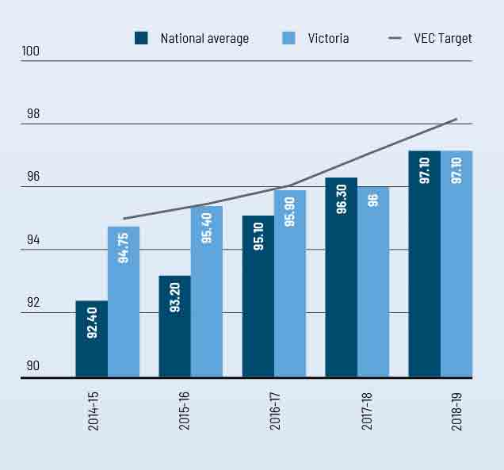

Figure 22: Proportion of enrolment updates sourced from VEC programs, 2014–15 to 2018–19
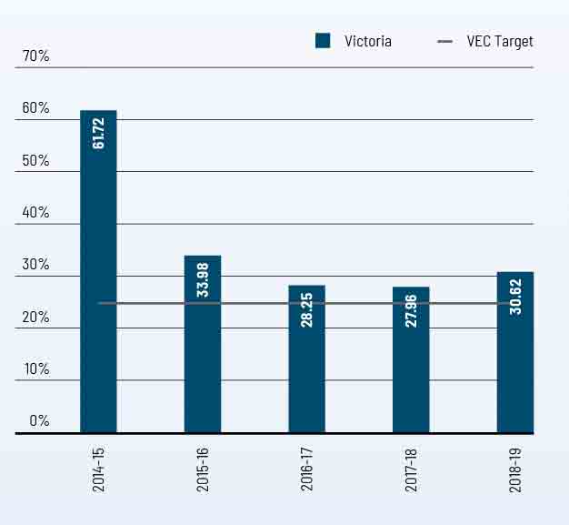

Figure 23: Elector statistics by region, 30 June 2019
Below are the elector statistics by region for 2018-19
Total number of electorates: 8
Total number of electors: 4,210,978
Average number of electors: 526,372
REGION | ELECTOR COUNT | VARIANCE TO AVERAGE (%)
Eastern Metropolitan | 474,587 | -9.84
Eastern Victoria | 545,418 | 3.62
Northern Metropolitan | 549,478 | 4.39
Northern Victoria | 533,147 | 1.29
South-Eastern Metropolitan | 514,278 | -2.30
Southern Metropolitan | 502,012 | -4.63
Western Metropolitan | 557,345 | 5.88
Western Victoria | 534,713 | 1.58

Figure 24: Elector statistics by district, 30 June 2019
Below are the elector statistics by district for 2018-19
Total number of electorates: 88
Average number of electors: 47,852
Total number of electors: 4,210,978

DISTRICT | ELECTOR COUNT | VARIANCE TO AVERAGE (%)
Albert Park | 50,319 | 5.16
Altona | 57,125 | 19.38
Bass | 62,133 | 29.84
Bayswater | 44,498 | -7.01
Bellarine | 50,631 | 5.81
Benambra | 49,921 | 4.32
Bendigo East | 49,862 | 4.20
Bendigo West | 46,016 | -3.84
Bentleigh | 43,468 | -9.16
Box Hill | 44,204 | -7.62
Brighton | 45,822 | -4.24
Broadmeadows | 44,102 | -7.84
Brunswick | 54,577 | 14.05
Bulleen | 44,535 | -6.93
Bundoora | 41,038 | -14.24
Buninyong | 46,379 | -3.08
Burwood | 43,492 | -9.11
Carrum | 49,396 | 3.23
Caulfield | 45,712 | -4.47
Clarinda | 44,469 | -7.07
Cranbourne | 64,511 | 34.81
Croydon | 43,416 | -9.27
DISTRICT | ELECTOR COUNT | VARIANCE TO AVERAGE (%)
Dandenong | 42,538 | -11.11
Eildon | 45,443 | -5.03
Eltham | 45,002 | -5.96
Essendon | 49,087 | 2.58
Euroa | 50,101 | 4.70
Evelyn | 43,450 | -9.20
Ferntree Gully | 41,650 | -12.96
Footscray | 52,373 | 9.45
Forest Hill | 39,909 | -16.60
Frankston | 44,760 | -6.46
Geelong | 47,872 | 0.04
Gembrook | 52,781 | 10.30
Gippsland East | 47,294 | -1.17
Gippsland South | 43,292 | -9.53
Hastings | 52,205 | 9.10
Hawthorn | 45,710 | -4.48
Ivanhoe | 47,250 | -1.26
Kew | 44,727 | -6.53
Keysborough | 46,024 | -3.82
Kororoit | 52,786 | 10.31
Lara | 47,671 | -0.38
Lowan | 43,503 | -9.09

DISTRICT | ELECTOR COUNT | VARIANCE TO AVERAGE (%)
Macedon | 45,928 | -4.02
Malvern | 43,643 | -8.80
Melbourne | 51,992 | 8.65
Melton | 54,892 | 14.71
Mildura | 44,972 | -6.02
Mill Park | 47,050 | -1.68
Monbulk | 43,573 | -8.94
Mordialloc | 46,647 | -2.52
Mornington | 47,729 | -0.26
Morwell | 48,936 | 2.27
Mount Waverley | 39,048 | -18.40
Mulgrave | 40,824 | -14.69
Murray Plains | 47,393 | -0.96
Narracan | 53,397 | 11.59
Narre Warren North | 45,033 | -5.89
Narre Warren South | 50,133 | 4.77
Nepean | 50,628 | 5.80
Niddrie | 45,098 | -5.76
Northcote | 49,920 | 4.32
Oakleigh | 42,106 | -12.01
Ovens Valley | 43,865 | -8.33
Pascoe Vale | 51,908 | 8.48
DISTRICT | ELECTOR COUNT | VARIANCE TO AVERAGE (%)
Polwarth | 46,668 | -2.47
Prahran | 51,321 | 7.25
Preston | 45,736 | -4.42
Richmond | 56,211 | 17.47
Ringwood | 41,811 | -12.62
Ripon | 48,495 | 1.34
Rowville | 39,943 | -16.53
Sandringham | 45,692 | -4.51
Shepparton | 49,370 | 3.17
South Barwon | 56,270 | 17.59
South-West Coast | 48,133 | 0.59
St Albans | 46,782 | -2.24
Sunbury | 46,397 | -3.04
Sydenham | 51,775 | 8.20
Tarneit | 56,287 | 17.63
Thomastown | 45,563 | -4.78
Warrandyte | 43,264 | -9.59
Wendouree | 44,199 | -7.63
Werribee | 47,590 | -0.55
Williamstown | 52,045 | 8.76
Yan Yean | 60,276 | 25.96
Yuroke | 61,381 | 28.27

Figure 25: Enrolment transactions, 2013–14 to 2017–18
VEC ENROLMENT TRANSACTIONS | 2014-15 | 2015-16 | 2016-17 | 2017-18 | 2018-19
State direct enrolment activity¹ | 257,972 | 191,849 | 131,030 | 186,736 | 209,627
VEC online enrolment² | 41,262 | 11,138 | 19,614 | 1,693 | 0
VEC enrolment forms received | 90,781 | 31,339 | 19,936 | 20,432 | 25,431
Total enrolment transactions through  VEC’s enrolment programs | 390,015 | 234,326 | 170,580 | 208,861 | 235,058

ENROLMENT APPLICATION TRANSACTIONS PROVIDED BY THE AEC AND IMPORTED  INTO VICTORIAN REGISTER OF ELECTORS | 2014-15 | 2015-16 | 2016-17 | 2017-18 | 2018-19
Additions
New to roll | 102,224 | 129,296 | 82,861 | 131,326 | 163,731
Reinstatements | 51,311 | 41,927 | 36,254 | 43,018 | 43,915
Subtotal | 153,535 | 171,223 | 119,115 | 174,344 | 207,646
Changes
Change of address | 478,409 | 518,439 | 484,617 | 572,760 | 559,896
Total AEC Import Transactions | 631,944 | 689,662 | 603,732 | 747,104 | 767,542
Total VEC Sourced Transactions | 390,015 | 234,326 | 170,580 | 208,861 | 235,058
Total collected through AEC’s enrolment programs | 241,929 | 455,336 | 433,152 | 538,243 | 532,484
VEC sourced enrolments as a percentage of the total | 61.72% | 33.98% | 28.55% | 27.96% | 30.62%

Other enrolment-related transactions | 2014-15 | 2015-16 | 2016-17 | 2017-18 | 2018-19
Special category applications⁴ | 4,026 | 2,135 | 3,625 | 1,732 | 28,568
Non-application changes | 57,836 | 6,269 | 1,345 | 986 | 2,977
Subtotal | 61,862 | 8,404 | 4,970 | 2,718 | 31,545
Total VEC enrolment transactions | 451,877 | 242,730 | 175,550 | 211,579 | 266,603
¹ The VEC undertakes direct enrolment using information from a range of sources, including VicRoads, the Victorian Curriculum and Assessment Authority, and the Australian Electoral Commission (AEC).
² The VEC ceased its online enrolment service during 2017-18 following work with the Australian Electoral Commission (AEC) to improve the joint enrolment form administered by the AEC as an online enrolment form.
³ Special category applications received by the VEC include: applications to become General Postal Voters (GPVs), silent electors, itinerant or eligible overseas electors. Some of these transactions are processed by the VEC and some are passed to the Australian Electoral Commission for processing under the Commonwealth Electoral Act 1918 (Cth). Non-application changes include administrative changes made to ensure the accuracy and integrity of the Register of Electors, as well as the processing of undelivered mail returned to the VEC.
⁴ The Electoral Act 2002 was amended in 2018-19 to introduce a new eligibility criteria for General Postal Voters (GPVs). This prompted a GPV campaign run by some candidates and Registered Political Parties within the six weeks leading up to the close of roll for the 2018 State election.

Provision of enrolment information
The Register of Electors contains personal enrolment information, including name, address, date of birth and gender. Protecting the privacy of electors’ personal enrolment information is of fundamental importance to the VEC, and information is only disclosed according to legislation.

Mandatory provision of enrolment information
The Electoral Act 2002 stipulates several requirements with regard to electoral information to be made available.
- The list of Victorian electors (names and addresses only), excluding silent electors, must be made available for public inspection at the offices of the VEC and updated every six months. Information can only be searched by name.
- The latest print of any electoral roll produced for an election (which contains name and address details only) must be made available for public inspection, free of charge, at locations and during times determined by the VEC.
- Enrolment information, excluding silent electors, must be provided a number of times each year (and at the time of an election) to registered political parties, Members of Parliament and election candidates for permitted purposes.
Enrolment information is also provided under other legislation. Under section 19 of the Juries Act 2000, to enable people to be called for jury duty. Jury rolls are prepared, as requested by Juries Victoria, for any of Victoria’s 14 jury districts (silent electors are included in this process). A total of 44 jury rolls were provided under this legislation during 2018-19. Under section 21 of the Local Government Act 1989, enrolment information is provided to councils for local government elections.

Discretionary provision of enrolment information
The Electoral Act 2002 strictly regulates the way in which the VEC collects, uses and discloses enrolment information, and ensures that electors’ enrolment information is protected and not made freely available to the public.
Section 34 of the Electoral Act 2002 provides the mechanism under which the VEC may release enrolment information in defined circumstances. Where the public interest in providing the requested information outweighs the public interest in protecting the privacy of personal information, the VEC and the applicant can enter into an information-sharing deed. Strict conditions regulate the provision of information and penalties apply for non-compliance or misuse of enrolment information.
A review of the provision of enrolment information under section 34 of the Electoral Act 2002 during 2018-19 led to the VEC terminating information-sharing arrangements with six organisations. Three new information-sharing deeds were entered into in the 2018-19 reporting period.
A standing agreement has been in place with Victoria Police since 2005, which allows immediate, secure access to the Register of Electors. During 2018-19, the VEC worked closely with Victoria Police to modernise the access gateway to connect the two agencies; the new technology went live in April 2019. Enrolment information was provided to seven organisations under existing agreements subject to section 34 (see Figure 26).A standing agreement has been in place with Victoria Police since 2005, which allows immediate, secure access to the Register of Electors. Enrolment information was provided to seven organisations under existing agreements subject to section 34 (see Figure 18).

Figure 26: Information provided to organisations under section 34 of the Electoral Act 2002, 2018–19
ORGANISATION | LOOK UPS REQUESTED | UNSUCCESSFUL SEARCHES | INFORMATION PROVIDED
Family Information Networks and Discovery (FIND) | 144 | 48 | 96
Victorian Assisted Reproductive Treatment Authority (VARTA) | 120 | 35 | 85
State Revenue Office | (List of electors provided monthly)
BreastScreen | (List of electors within relevant cohort provided quarterly)
Cancer Council | (List of electors within relevant cohort provided biannually)
University of Melbourne | (Current address information of relevant cohort was provided by the VEC)
Victoria Police | N/A | N/A | 9,617

Spotlight on...
Name
Steven Barrett
Title
Warehouse Manager
Department
Elections Branch
The VEC’s vision is for all Victorians to actively participate in their democracy. How does your role contribute to this?
My role is to ensure that all transport and logistics schedules are organised well in advance and that resources are acquired, consignments created, then delivered to all election support locations, including election offices, voting centres and early voting centres to enable a successful election.
What makes the VEC an innovative and engaging place to work?
The VEC is always looking to improve and that is a great atmosphere to work in, as it doesn’t become stale or stagnant. All managers that I work with are always open to suggestions, which allows for the research of new ideas and products that help improve our current practices.

What’s a key lesson you learned from working on the 2018 State election?

That you can never be too prepared; no matter how much planning you do, there is always something that will pop up unexpectedly and test you.

What do you like to do outside of work?
Weekends is family time - I have a five year old who is really active, so we play plenty of ball sports and do a lot of swimming. I also enjoy brewing beer and attending music festivals when I have time.

Warehouse
Warehousing and distribution facilities play a key role in supporting the core business of the VEC and ensure a high level of operational readiness is maintained. As the VEC entered another major election cycle, the focus of warehouse operations was on the preparation, deployment and return of resources from election venues across the State and the provision of logistical support for the 2018 State election.
Planning and preparation for the State election commenced in 2017-18 with the procurement of resources with long production lead times (over 4,700 pallets of materials), and the assembly of resource kits used State-wide. Key activities undertaken at the warehouse in 2018-19 included:
- the successful introduction of unit load devices (ULDs), which improved ballot paper security during deliveries and resulted in material handling and transportation efficiency gains
- the massive initial roll-out of resources (1,584 pallets) to 88 election offices over a three-week period
- the delivery of 1,000 skids of ballot paper stock to the printers in preparation for printing
- the preparation of election cardboard consignments (approximately 280 tonnes) and the coordinated delivery and collection for over 1,700 voting centres throughout Victoria over a three-week period before and after election day – especially challenging with schools closing for Christmas
- the successful completion of the declaration exchange, which involved the collection of declaration votes from all 88 election offices Statewide, centralised sorting and processing at the warehouse and delivery back to all election offices - all within 26 hours
- the provision of logistical support at the central processing centre and metropolitan computer count venues - to assist with the large volumes of ballot material being managed with over 450 pallets of material returned to the warehouse
- the collection and return of all used ballot papers and other resources and records from election offices and early voting locations in the 14 days prior to Christmas
- sorting 1,760 pallets of returned election office equipment, stationery, forms and envelopes
- facilitating the receipt and storage of 9,000 parcels of election records
  - an annual stock-take of approximately 750 products.
As well as undertaking resource heavy preparations for the election and following last year’s internal lighting improvements, exterior warehouse lighting was upgraded with the installation of energy efficient LED lighting fixtures. The new lights have resulted in an overall improvement in the quality of lighting, while also reducing the carbon footprint. With the introduction of the new lighting, off-peak rate power consumption has been reduced by over 30%. This has made a significant contribution to the VEC’s Resource Smart achievements for the year.
The outlook for 2019–20 is largely focused on planning and the preparation of resources for the 2020 local government elections.
Activities for 2019-20 will include:
- servicing and maintenance of election equipment - purchasing additional or replacement resource items where required
- inspection and maintenance of over 3,000 electrical items, including electrical safety checks and the ‘testing and tagging’ of cables and power boards
- ordering, receipt and storage of resources with long production lead times such as ballot paper stock, envelopes and cardboard products (approximately 3,000 pallets of material)
- picking and assembly of stationery kits, office equipment and materials.

Research and development

Research and development activity is conducted on an ongoing basis across the VEC. A research policy and plan guides the conduct of research relating to service delivery and participation in the electoral process - across a range of stakeholder groups.

Electoral Regulation Research Network
The VEC joined with the New South Wales Electoral Commission and the University of Melbourne in March 2012 to establish the Electoral Regulation Research Network (ERRN). The purpose of the Network is to foster exchange and discussion among academics, electoral commissions and other interested groups on research relating to electoral regulation.
ERRN hosted a total of six seminars in Victoria and others interstate, covering topics including convenience voting, the reversing of felon disenfranchisement in the United States, access and influence in Australian politics, ministerial advisers in Westminster systems, and problems with declining voter participation. There were two editions of the ERRN newsletter.
In October 2018, ERRN released a report, A Review of Convenience Voting in Victoria, which examined issues associated with the strong trend to voting before election day.
The report found that:
- the general public gives priority to a flexible voting experience, and has enthusiastically embraced convenience voting
- legislators have a more cautious outlook, some fearing that convenience voting will erode democratic engagement
- electoral authorities focus on the management of the multifaceted logistical challenges presented by the expansion of convenience voting, while emphasising the importance of enhancing the voter experience and the electoral process generally.

Research into best practice inclusion for people with intellectual disability
In April 2019, La Trobe University’s Living with Disability Research Centre provided the VEC with its research report, Strategies to Support People with Intellectual Disabilities to Participate in Voting. The aim of the research project was to explore the barriers and facilitators of voting for people with intellectual disabilities in order to understand how best to support their participation. The project included a capacity-building initiative implemented by the VEC in two disability organisations in the lead-up to the State election, aiming to increase awareness of voting and assistance to clients to vote. The project was conducted in collaboration with the VEC and with the financial support of other Australian electoral commissions.
The report revealed that barriers to voting centred around low expectations and limited support from staff and families, while facilitating factors include support from family members, staff acknowledgement of the rights of people to vote and willingness to provide some support for voting.
The initiative produced a small increase in voting and enrolment by people with intellectual disabilities and a significant increase in staff knowledge and motivation about voting. The report recommended that electoral commissions continue to promote strategies to build the capacity of organisations and their staff to support people with intellectual disabilities to participate in voting, while recognising that this is a long-term commitment. The report also recommended that electoral commissions and/or other bodies engage families in education about voting rights, and explore peer education as a way of building capacity. Matters to note were law reform to remove uncertainties about who has the right to vote, and strategies to provide people with intellectual disabilities with accessible information about political platforms and public affairs.

Evaluation of VEC services at 2018 State election
The VEC engaged Colmar Brunton, a market research company, to obtain feedback from voters, candidates and political parties on the VEC’s services at the 2018 State election. Voters recorded a very high level of satisfaction (84%) with their overall voting experience, with Culturally and Linguistically Diverse (CALD) voters being particularly satisfied at 90%. There was a very high rate of recall (85%) of information from the VEC during the election – a significant increase over the 79% recall rate at the 2014 election. Whereas in 2014 the fragmentation of the media led to a decline in awareness of VEC communication, in 2018 the broader scope of the VEC’s campaign appears to have had an effect. There was an increase in usage of the VEC’s website, and 85% of users were satisfied with the information the website contained. Turning to particular groups of voters, the great majority of ordinary and absent voters were satisfied with their experience at the voting centre; 87% of postal voters were satisfied with the ease of the application process; and 93% of Telephone Assisted Voters were satisfied with their voting experience.
There were some matters to note. A majority of ordinary voters stated that they had to queue before they voted, and queuing times were similar to those recorded in 2014. Provisional voters (those who could not be found on the roll when they presented to vote, and who needed to complete a special enrolment form) were less satisfied than voters in general. Voters who were interstate or overseas and who received their ballot papers via email were not pleased with the requirement to print, fold and post back their voting material, and many of them suggested it would be good to be able to vote entirely online. Most importantly, a tracking survey of young voters over the four weeks before the election revealed that while awareness of the election and of VEC communications increased substantially over the period, there was no significant change in attitudes to voting.
Political parties and candidates were very satisfied with the VEC’s management of the election, praising the VEC’s organisational and process management skills and the approachability of staff. There was some criticism of the location of voting centres, especially early voting centres, and of the vote counting process.

Funding and Disclosure

Victoria’s new funding and disclosure regime was inserted into the Electoral Act 2002 in July 2018. The new laws impose bans or caps on certain political donations, provide greater transparency through disclosure and real-time reconciliation of political donations, and introduce new public funding streams for Victoria’s parliamentary elections. The new laws are administered and enforced by the VEC.

A new regulatory function
The changes to Part 12 of the Electoral Act 2002 passed through Parliament in July 2018 as part of the Electoral Legislation Amendment Act 2018. The new funding and disclosure laws introduced a new regulatory function to the VEC’s core business.

About the regime
Victoria’s funding and disclosure regime:
- regulates the overall provision, receipt and disclosure of political donations
- defines banned donations, donation disclosure thresholds, limits and caps across various circumstances
- prescribes auditing and reporting requirements to monitor compliance
  - establishes three public funding streams for candidates, elected members, and registered political parties.
Funding and disclosure legislation is already in place for Federal elections, as well as in New South Wales, Queensland and South Australia. Compared with these other jurisdictions, Victoria’s funding and disclosure regime is considered among the most comprehensive and robust funding and disclosure requirements in Australia.

Staffing and capability development
Work commenced during the 2017-18 financial year, with the establishment of a program implementation team. The team commenced development of the online disclosure system, established stakeholder engagement policy and outreach models, and developed the operational structures that underpin the administration of the regime.
In the 2018-19 financial year, the VEC established an ongoing Funding and Disclosure Unit. The Funding and Disclosure Unit will build over time as the complexity and volume of the administration and enforcement of this new function evolves. During 2019-20, the VEC will integrate the Funding and Disclosure Unit into a new Electoral Integrity and Regulation Branch to build a hub for the VEC’s regulatory and compliance activities.

Progress and achievements
Extensive work was completed to develop the online disclosure system to accommodate legislative requirements. The system went live on 25 November 2018, and enhancements since that initial deployment have focused on increasing functionality to support new elements of the funding and disclosure regime and providing more streamlined user experiences.
Significant work has also been completed to build the community’s awareness and understanding of the new funding and disclosure obligations. The VEC identified and accessed stakeholders and system users, including registered political parties, elected members and donors, and provided information through face-to-face and online training sessions, presentations, and advertising through online, print and social media. A range of online resources and guides were also published.
At the end of the reporting period, all registered political parties had completed system registration and all published donations lodged in the system had been reconciled.

Future planning
The VEC will continue to develop and refine the online disclosure system based on continuous improvement, any further legislative changes, internal monitoring and reporting, and feedback from users. The new Electoral Integrity and Regulation Branch will provide the opportunity to build the VEC’s broader compliance programs.
The VEC will prioritise further initiatives for education, stakeholder engagement and outreach by strengthening communication models and creating materials that complement the existing suite resources and information.

Spotlight on...
Name
Asvin Phorugngam
Title
Electoral Inclusion Officer
Department
Communication and Engagement Branch
The VEC’s vision is for all Victorians to actively participate in their democracy. How does your role contribute to this?
I assisted with the development and then implemented Australia’s first Democracy Ambassador (DA) program, in partnership with the Ethnic Communities’ Council of Victoria, aimed at building the electoral knowledge of elections from Horn of Africa countries’. Today, the VEC has endorsed and adopted the DA program model as best practice and it is now at the heart of the VEC’s community engagement and education efforts to overcome barriers to electoral inclusion and participation.
Moreover, South Australia’s Electoral Commission modelled their CALD education program for 2017’s South Australian State election on the VEC’s DA project, which is keenly watched by other electoral commissions around Australia.
What makes the VEC an innovative and engaging place to work?
The VEC supports me to explore new potential community partnership opportunities. Most recently, I partnered with Carringbush Adult Education to co-design the Talking Democracy kit - a civic education kit for people studying English as an Additional Language, or other courses, at TAFE, school or community settings. The content was co-designed involving the centre manager and co-ordinator, user-testing with seven teachers and a further two sessions with students from Beginner and Intermediate levels.
The kit is available on the VEC’s website. The project enabled me to use my skills, knowledge and creativity.

What’s a key lesson you learned from working on the 2018 State election?
I have deepened my knowledge of electoral education and civic participation through an active citizenship lens. I embedded the VEC's messages into our key priority groups’ lived contexts. This made our messages meaningful and easy to understand, so the community knew what to do at the ballot box.

What do you like to do outside of work?
I am Thai. I love cooking and spicy foods. I also make killer coffees!

Our stakeholders

ACHIEVEMENTS 2018–19
- Mobile voting pilot provided to five prisons
- Implementation of a Statewide roll out of the VoterAlert notification service
- Successful roll out of Talking Democracy Toolkit
- 557% increase in outreach delivery over two years

OUTLOOK 2019–20
- External evaluation of the Passport to Democracy program
- Development of a Diversity and Inclusion Strategy
- Visual refresh of the VEC brand and website

Inclusion and participation

Informed citizens actively participating in free and fair elections is vital to any healthy, functioning democracy. Providing accessible, current electoral information and education services is a fundamental part of ensuring full electoral participation across the community.

Electoral education and outreach
Since July 2016, the VEC has had an Electoral Education and Inclusion Strategy. The strategy had the following five objectives:
- increase informed electoral participation through the provision of electoral outreach and targeted information resources
- encourage the early formation of positive voting behaviour by developing young people’s civic knowledge and skills
- gain access to priority communities by engaging in meaningful partnerships with relevant organisations
- extend the reach of the VEC’s electoral inclusion work by building the capacity of community organisations and workers
- create a culture of inclusion within the VEC by building staff capability during 2018-19.
These objectives were addressed by the following range of programs.

Latrobe University, Living with Disability Research Centre - Strategies to Support People with Intellectual Disabilities to Participate in Voting
The VEC commissioned research, which was supported by electoral commissions across Australia, to explore strategies to support people with intellectual disabilities to engage in voting. Further information is available in the research and development section on page 64.

Outreach education including the Democracy Ambassador program
The VEC’s outreach education was expanded in the lead up to the State election through the Democracy Ambassador (DA) program, which employed 57 community members to deliver face-to-face voter education and electoral enrolment sessions to people with disabilities, people experiencing homelessness, Indigenous communities, and culturally and linguistically diverse communities. The following table provides an overview of outreach sessions conducted in 2018-19 and demonstrates a 557% increase in outreach sessions over two years.

Figure 29: Overview of outreach sessions, 2016-17, 2017-18 and 2018-19
Priority community group |  | 2016-17 | 2017-18 | 2018-19
CALD | Participants | 1,748 | 992 | 6,906
Youth (incl. Passport to Democracy) | Participants | 1,107 | 6,579 | 11,500
Disability | Participants | 202 | 1,021 | 1,362
Aboriginal & Torres Strait Islanders | Participants | 71 | 233 | 895
People experiencing homelessness | Participants | 200 | 45 | 1,207
Total - all groups | Sessions | 141 | 222 | 520
 | Participants | 3,328 | 8,870 | 21,870

The VEC employed 57 community members as Democracy Ambassadors (DAs), who came from diverse backgrounds. Of the 45 that responded to a post-election survey in December 2018:

18% identified as having a disability, 7% identified as having an intellectual disability

7% identified as Aboriginal or Torres Strait Islander

16% identified as having been homeless at some point in their life

33% of the DAs were younger than 26

62% were born overseas (born in more than 20 different countries)

Demographics of Democracy Ambassadors employed by the VEC
VEC Democracy Ambassadors who provided peer-to-peer outreach education leading up to the 2018 State election.

Evaluation of the Democracy Ambassador program demonstrated that there were positive impacts in:
- recruiting the right people
- providing adequate training and support
  - increasing the knowledge and skills of participants who attended education sessions.

Talking Democracy Kit
In late June 2018, the VEC Talking Democracy Kit was made available on the VEC website and in hard copy. Subsequently, 110 copies have been posted and almost 2,000 individuals have visited the website. Of those people, at least 50% have downloaded at least one of the resources and there have been over 2,500 views of the videos.

Homeless not Voteless
Grampians Community Health homeless and family violence support worker Gemma Beavis
Photo courtesy of Grampians Community Health.
Grampians Community Health (GCH) was one of the key organisations that supported the VEC’s ‘Homeless not Voteless’ program, which aimed to support people experiencing homelessness to enrol and vote in the 2018 State election. People experiencing homelessness were able to enrol using the ‘no fixed address’ form.
The VEC worked with homelessness services and community organisations throughout Victoria by offering outreach enrolment sessions and mobile voting during the State election.
“Giving people the right to participate assists them to feel part of the community” — Gemma Beavis, GCH Homelessness and Family Violence Support Worker.

Partnership and Sponsorship programs
- Korin Gamadgi Institute’s REAL Program
Three electoral education workshops were delivered to 89 young Aboriginal and Torres Strait Islander people. The VEC sessions had a marked impact on levels of understanding and confidence in electoral processes, with high levels of understanding increasing from 5% to 53%, and high levels of confidence increasing from 13% to almost 60%. This partnership, now in its tenth year, has matured to the point that VEC staff are now working with alumni from the program to assist in the development and delivery of these workshops.
- Leadership Victoria’s Be Informed workshops
Five workshops were delivered to 78 community leaders, from a broad range of culturally and linguistically diverse backgrounds in Melbourne, Gippsland and Ballarat.
- Youth Parliament
Five teams of six young people were sponsored to attend the annual YMCA Victorian Youth Parliament in July 2018. Held annually since 1987, Youth Parliament is a program designed to give young Victorians a chance to be heard at the highest levels of State Government on a wide range of issues relevant to young people's lives.
- Victorian Student Representative Council 2018 Congress
Twenty individual sponsorships were granted to students from Indigenous, CALD and low socio-economic backgrounds. This annual event brings students together from across Victoria to debate, decide and act on the issues that matter to their education.

Passport to Democracy
The VEC’s main electoral education program for young people is Passport to Democracy (PTD), which continues to grow in popularity, reach and impact. Now in its eleventh year, the PTD program has evolved from a hard-copy resource to one that is now online and includes the opportunity for VEC staff to offer a free mock election. In the reporting year PTD has:
- visited 131 schools
- reached 11,500 students and
  - had 350 website program downloads.
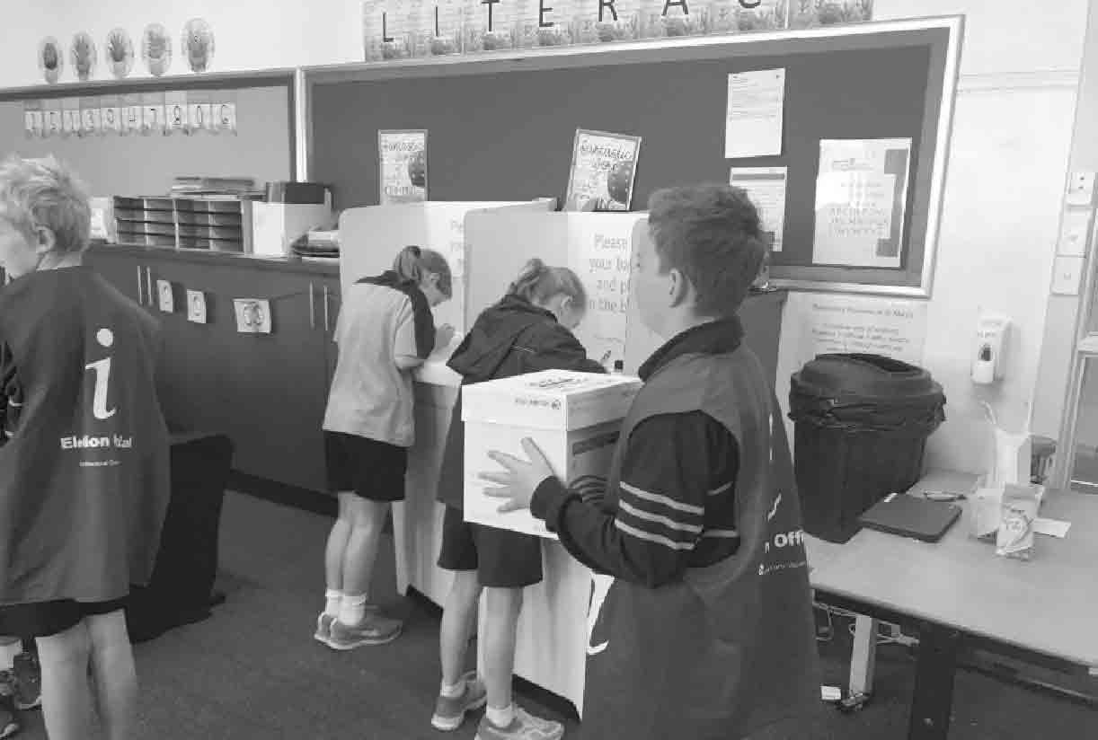
School students participating in a Passport to Democracy mock election.
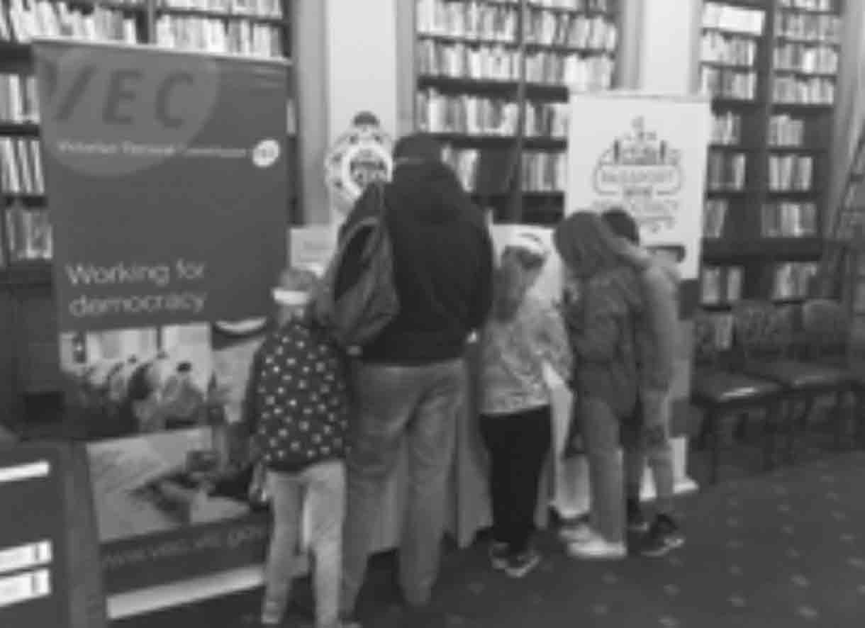
A family visits Open Day at Parliament House and participates in the Passport to Democracy display at Law Week 2019, which is an annual festival of events presented by the Victoria Law Foundation aimed at making learning about the law easy for the public.

² Victorian Electoral Commission Meltwater Insights Report, February 2019

Case study

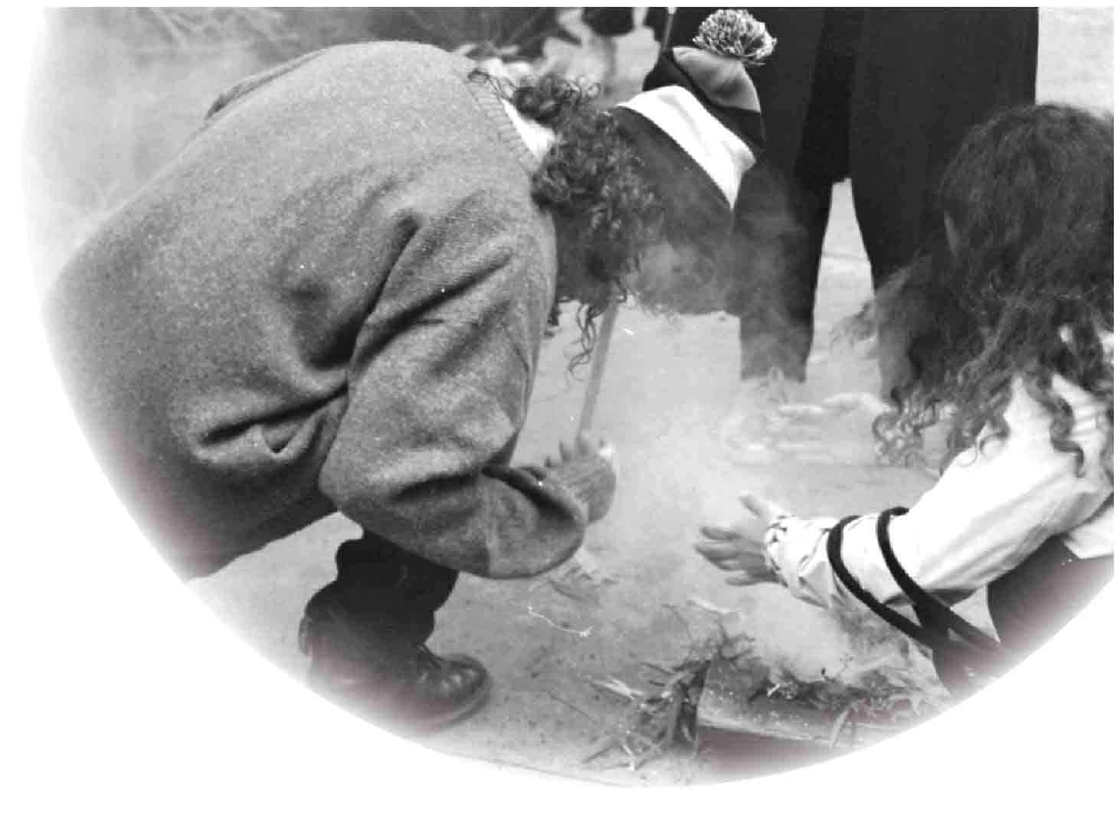

Koorie Youth Summit
The 2019 Koorie Youth Summit was held on Wurundjeri Country over the second weekend of May. The Summit is an annual event organised by the Koorie Youth Council and is the largest gathering of young Aboriginal and Torres Strait Islander people across the State. As well as sponsoring some of the delegates, the VEC also held a stall at the event to engage with young people about democracy, elections, the upcoming Victorian Treaty, and various democratic movements in the history of Australia’s Aboriginal population.
In the lead-up to the event, the VEC’s Aboriginal Inclusion Officer, Georgia Cromarty, trained two young Aboriginal people as part of the VEC’s Democracy Ambassador Program. Ben Lucas and Donny Imberlong accompanied Georgia as delegates to the Summit and helped to operate the VEC stall, educating their communities about the VEC’s vision and values of all Victorians actively participating in their democracy.
At the Summit, delegates took part in various cultural activities including a Treaty panel hosted by the Treaty Commissioner Jill Gallagher, film screenings, smoking ceremonies, traditional dances, yarning circles, and a festival on the final day of the Summit.
Ben Lucas described the Summit as “an important event for connecting to community and culture, and for strengthening my cultural identity” and is excited about attending again in the future.

Photo of Benjamin Lucas, VEC Democracy Ambassador, taking part in a smoking ceremony at Koorie Youth Summit.

Disability Action Plan

The VEC Disability Action Plan (DAP) 2016-2019 concluded on 30 June 2019. The three–year plan successfully completed 39 of the 43 deliverables (91%), which all aimed to improve the access and inclusion of people with disabilities in the electoral process.
The following achievements occurred in the final year:
- the Voters Voice app was relaunched for the 2018 State election to assist people with communication disabilities and those who are hard of hearing. Just under 2,280 people accessed the app
- 1,199 people accessed the Telephone Assisted Voting (TAV) service, which was available to people who are blind, have low vision or a motor impairment
- an Easy English State election publication was created and distributed throughout Victoria and online
- Democracy Ambassadors with a lived experience of disability or those with experience as a supporter/carer of someone with a disability were employed to provide outreach education. There was an increase of fully wheelchair accessible voting centres from 17% in 2014, to 24% for the 2018 State election
- all staff manuals for the 2018 State election included relevant information about access and inclusion in and around voting centres
- accessibility of early voting centres and election day voting centres was available through the VEC website, and the Voters Voice app. Accessibility status and location of centres was also sent out to each household across Victoria
  - applications for Braille ballot papers was promoted through mailouts to Vision Australia and Blind Citizens Australia.
The outcomes achieved by the VEC during the last three years were only made possible through the invaluable input from the Electoral Access Advisory Group - a range of community stakeholders - and the dedication of VEC staff.
Of the incomplete strategies, three will be carried over into the next plan, with slight amendments to enhance and support implementation.
- Work with the Australian Skills Quality Authority to embed civics and citizenship into the training packages implemented by registered training organisations for disability support workers and aged care workers.
- Liaise with State Government to ensure that the VEC’s access and inclusion requirements are incorporated into the development of the next State Disability Action Plan.
- Ensure a person with a disability delivers disability confidence training to Senior Election Officials, wherever possible.

Photo of Democracy Ambassador Simone Stevens (above) providing electoral education leading up to the 2018 State election.

Reconciliation Action Plan

The VEC’s Reconciliation Action Plan (RAP) 2017- 2019 concludes in December 2019. The RAP continues to be an important document to guide the VEC’s reconciliation journey and address the electoral participation barriers experienced by Aboriginal and Torres Strait Islander people living in Victoria.
The VEC has completed 58% of deliverables, is on track to achieve a further 31% by December 2019 and is experiencing issues with 11%, which will not be achieved.
- The RAP Committee achieved the following deliverables during 2018-19:
- the Committee now includes an Aboriginal staff member and the last meeting was also attended by a newly employed Aboriginal Democracy Ambassador
- updating the Terms of Reference (TOR) for the RAP Committee
  - the RAP Committee reaching out to a number of organisations with RAPs and gathering feedback to inform the next VEC RAP. These organisations included:
- Alfred Health
- Merri Community Health
- Melbourne City Mission
- Hepburn Shirt Council
- City of Wyndham
- City of Greater Dandenong
- City of Whittlesea
- Monash University
- University of Melbourne
- ACT Human Rights Commission
- Australian Bureau of Statistics
- Bureau of Meteorology
- Australian Broadcasting Authority
- Department of Premier and Cabinet
- Western Australian Electoral Commission
- Australian Electoral Commission
- City of Melbourne
- Victorian Bar Association

- filling the role of the Aboriginal Inclusion Officer in February 2019
- partnering with the Korin Gamadji Institute (KGI) for three civic education workshops for young Aboriginal people (aged 14-18 years old)
- collaborating with community partners civic education to 895 Aboriginal and Torres Strait Islander people in Victoria and
  - supporting an Indigenous team for the YMCA Youth Parliament in July 2018.
Many of the deliverables that have not been achieved relate to consulting with a VEC Aboriginal and Torres Strait Islander Advisory Committee. The VEC has not managed to maintain an ongoing Advisory Committee, but has consulted and engaged with Aboriginal and Torres Strait Islander people in a range of other ways. The VEC highly values and is committed to partnering with, and seeking advice and input from, Aboriginal and Torres Strait Islander people. During the State election, the VEC engaged Aldara Yenara to recruit, mentor and support Aboriginal and Torres Strait Islander people to work as election casuals.

Services to political parties

Register of political parties
The Electoral Act 2002 (the Act) requires the VEC to establish and maintain a register of political parties. In order to qualify for registration, a political party must have a written constitution and at least 500 members who are Victorian electors, party members in accordance with the party’s rules, and not members of another registered political party or of a party applying for registration.
It is not compulsory for political parties to be registered to contest an election, but registration gives a party a number of important entitlements. These include:
- the right to have the party’s registered name or abbreviation and registered logo opposite its endorsed candidates or group on ballot papers
- access to enrolment and voter information on a periodic basis
- public funding for parties obtaining enough votes
- administrative expenditure funding for endorsed elected members of Parliament
  - policy development funding if eligible.

New applications for registration
In the lead-up to a State election, there is often a rush of applications for registration by new political parties. Before registering a party, the VEC must be satisfied that the party is an ‘eligible political party’ within the meaning of the Act. There are two ways in which the VEC tests a party’s eligibility, after confirming that the application is in order. First, the VEC advertises the application, inviting objections to the application. Objections must be received within 30 days of the VEC’s notice. At the same time, the VEC writes to the people on the party’s membership list, asking those people to confirm whether they are eligible members of the party. To facilitate responses, the VEC includes a simple form and a reply-paid envelope with its letter, as well as providing members the opportunity to scan and email back responses to a dedicated email address.
During 2018-19, the VEC received the following applications for registration:
- Sustainable Australia (VIC) on 1 July 2018
- Hudson for Northern Victoria on 6 July 2018
- Australian Liberty Alliance on 10 July 2018
- Stop Live Exports on 16 July 2018 and
  - Aussie Battler Party on 1 August 2018.
The VEC received one objection to an application for a party registration in 2018. The objection related to the party’s lack of a published constitution, the registered officer of the party residing outside of Victoria and the legitimacy of the members on the list provided to the VEC.
In considering the objection, the VEC was guided by the Act and the only grounds of objection that the VEC can consider are that the party is not an eligible political party, that the application was not correctly made, or that the party’s name is inadmissible. As the objection was not on these grounds, it was rejected.
Responses to the VEC’s mail-outs to the lists of party members varied considerably. The VEC only registered a party when it was satisfied, through the independent, signed confirmation of the members themselves, that the party had at least 500 eligible members.
Party applications were refused for the Flux Party–Victoria on 18 June 2018 and Stop Live Exports on 20 August 2018, as the Commission was not satisfied that the parties had sufficient members to be eligible for registration.
Section 60 of the Act allows a person whose interests are affected by the decision to apply to the Victorian Civil and Administrative Tribunal (VCAT) for a review of that decision. The Registered Officer for The Flux Party–Victoria, Scott Millington, applied to the VCAT on 3 July 2018 for a review of the Commission’s decision. On 23 October 2018, the VCAT dismissed Mr Millington's application for review and affirmed the Commission’s decision to refuse to register The Flux Party–Victoria's application as a political party.
Of the total 23 political parties that were registered, 20 contested the 2018 State election.

Figure 33: Details of party registrations, 2018-19
Party Name | Application Date | Date of Registration | No. of Objections
Sustainable Australia (VIC) | 14-Jun-18 | 24-Jul-18 | 0
Hudson for Northern Victoria | 6-Jul-18 | 27-Aug-19 | 0
Australian Liberty Alliance | 10-Jul-18 | 1-Oct-18 | 0
Aussie Battler Party | 1-Aug-18 | 16-Oct-18 | 1

Changes to registered political parties
On 6 July 2018, Reason Victoria applied to change its name to Fiona Patten’s Reason Party. As required by the Act, the VEC advertised the application and invited objections to the proposed change. No objections were received, and on 14 August 2018, the VEC granted the application.
On 25 July 2018, the Australian Country Party applied to change its name to Australian Country Party/Give it Back. As required by the Act, the VEC advertised the application and invited objections to the proposed change. One objection was received.
In considering the objection, the VEC was guided by the Act. The VEC decided that the name ‘Australian Country Party/Give it Back’ was acceptable.
The Australian Country Party/Give it Back applied to reverse this change on 27 December 2018 and revert back to ‘Australian Country Party’ with the abbreviation ‘Country Party’. One objection was received, on the basis that the proposed abbreviation was similar, and likely to be mistaken for The National Party of Australia –Victoria.
The VEC rejected this argument and the application was approved on 1 March 2019.
The VEC also processed changes of registered officer by the Liberal Party of Australia – Victorian Division, the Victorian Socialists, the Australian Greens – Victoria, and the Voluntary Euthanasia Party (Victoria) and changes of address by the Australian Country Party/Give it Back and Fiona Patten’s Reason Party.

Registration of political party logos
Section 45 (3) of the Act allows parties to apply to have a logo included in the Register of Political Parties. On 1 August 2018, the VEC received applications to register a logo from all registered political parties apart from the Socialist Alliance. The VEC also received applications to register a logo from the following parties who were applying for registration at the time, including the Australian Liberty Alliance, Hudson for Northern Victoria, and Stop Live Exports. The VEC did not receive an application from the Aussie Battler Party.
After initial consideration of the application by the Transport Matters Party, the VEC concluded that the abbreviation shown on the logo was not a proper abbreviation of the party’s name and required the party to vary its application. Rather than adjust the proposed logo, the Transport Matters Party instead applied to change their registered abbreviation from TMP to Transport Matters. There were no objections to this change and the application was approved on 2 October 2018.
As required by the Act, the VEC advertised all applications and invited objections to the proposed logos. Two objections were received.
In considering objections, the VEC was guided by the Act and the only grounds of objection that the VEC can consider are that the logo: is obscene; is the logo of another political party or so nearly resembles the logo of another registered political party that it is likely to be confused with or mistaken for that logo; or comprises the words ‘Independent Party’.
One objection claimed the logo of the Voluntary Euthanasia Party so nearly resembled the logo of the federally registered ‘Help End Marijuana Prohibition’ that it was likely to be confused with that party. The VEC decided that the logo of the Voluntary Euthanasia Party was acceptable as Help End Marijuana Prohibition was not a registered party in Victoria.
The other objection claimed the logo of the Democratic Labour Party (DLP) was similar to the proposed logo of the Australian Labor Party – Victorian Branch, and likely to be mistaken for that logo. The VEC decided that the logo of the Democratic Labour Party (DLP) was acceptable.

Review of registered political parties
The VEC is obliged to review the registration of a political party as soon as possible after an election if the party obtains an average of less than 4% of the first-preference votes over all electorates contested by the party. Sixteen registered parties failed to reach the 4% threshold in the 2018 State election and were therefore due for review by the VEC.
To conduct the reviews, the VEC utilised the process developed for the 2015 reviews, which was less burdensome than in previous reviews, while still ensuring that the VEC could be confident about whether the party had enough members to retain its registration. Instead of writing to all on the membership lists provided by the parties, the VEC wrote to a random sample of 100 per party. If there was a poor response to a sample mail-out, the VEC wrote to everyone on the membership list.
As at 30 June 2019, nine parties had retained their registration. Reviews of five parties are ongoing at the time of this Report.

Voluntary de-registration of political parties
The VEC accepted requests from the following parties to voluntarily de-register:
- Hudson for Northern Victoria (18 February 2019)
- Australian Liberty Alliance (12 June 2019)
- Australian Conservatives (24 June 2019)

Figure 34: Registered political parties, 30 June 2019
POLITICAL PARTY | Political Party logo | REGISTERED OFFICER | ADDRESS
Animal Justice Party |  | Ms Magda Wozny  Secretary | 113 Milpera Crescent  Wantirna VIC 3152
Aussie Battler Party | (No logo registered) | Mr Stuart O’Neill  Secretary | 78 Luscombe Avenue  Carrum Downs VIC 3201
Australian Country Party |  | Mr Costantino di Biase  Registered Officer | 15 Derry Parade  Horsham VIC 3400
Australian Labor Party - Victorian Branch | 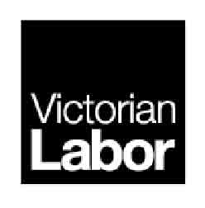 | Mr Samuel Rae  State Secretary | 438 Docklands Drive  Docklands VIC 3008
Democratic Labour Party (DLP) |  | Mr Stephen Campbell  State Secretary | 11 Wheatsheaf Road  Ceres VIC 3221
Derryn Hinch’s Justice Party |  | Ms Annette Philpott  Secretary | 4th floor, St Kilda Towers 1 Queens Road  Melbourne VIC 3004
Fiona Patten’s Reason Party |  | Ms Ange Hopkins  Registered Officer | 8 Shaftsbury Street  Coburg VIC 3058
Health Australia Party |  | Mr Andrew Hicks  Victoria State Secretary | 1 Erinne Court  St Helena VIC 3088
Liberal Democratic Party |  | Senator David Leyonhjelm  Registered Officer | 405/19 Roseby Street  Drummoyne NSW 2047
Liberal Party of Australia - Victorian Division |  | Mr Simon Frost  State Director | 104 Exhibition Street  Melbourne VIC 3000
National Party of Australia –  Victoria |  | Mr Matthew Harris  State Director | Suite 908, Level 9  343 Little Collins Street  Melbourne VIC 3000
Pauline Hanson’s One Nation |  | Pauline Hanson  Registered Officer | 2/38 Hudson Road  Albion QLD 4010
Shooters, Fishers and Farmers Party Victoria |  | Ms Nicole Bourman  Secretary | Suite 504  365 Little Collins Street  Melbourne VIC 3000
Sustainable Australia (VIC) |  | Mr William Bourke  Registered Officer | 20 Burlington Street  Crows Nest NSW 2065
Socialist Alliance (Victoria) | (No logo registered) | Mr Dave Holmes  Registered Officer | Resistance Centre  Level 5, 407 Swanston Street  Melbourne VIC 3000
The Australian Greens – Victoria |  | Mr Michael Brian Poland  State Director | Level 1, 45 William Street  Melbourne VIC 3000
Transport Matters Party |  | Mr André Baruch  Registered Officer | 6 Lockhart Street  Caulfield VIC 3162
Victorian Socialists |  | Mr Corey Oakley  Registered Officer | 54 Victoria Street  Carlton VIC 3053
Voluntary Euthanasia Party  (Victoria) |  | Mr Dermot Ryan  Secretary | 4 Punari Mews  Eltham VIC 3095
Vote 1 Local Jobs |  | Mr James Purcell  Registered Officer | 35 Bank Street  Port Fairy VIC 3284

Interaction with electoral bodies

The VEC works with various national and international electoral bodies with the aim of supporting increased innovation and electoral harmonisation. The exchange of ideas, collaborative research and discussion on key matters of interest with other electoral bodies (including through established forums), is an important basis for continued innovation. These interactions also support the VEC’s capacity to recommend and advise on relevant legislative change in Victoria.

Electoral Council of Australia and New Zealand
The Electoral Council of Australia and New Zealand (ECANZ) is a consultative forum with membership comprising Commonwealth, New Zealand and State and Territory Electoral Commissioners. This forum recognises the strong association and commonality existing between these organisations. ECANZ met on four occasions in 2018-19.
ECANZ considers best practice and innovation in activities such as the maintenance of electoral rolls, the operation of new electoral legislation and the management of elections. ECANZ has also established a number of cross-jurisdictional working groups to advance projects on particular topics.
During the year, the ECANZ consulted on a range of issues including the security of national electoral systems, indigenous electoral participation, and the challenges and opportunities associated with convenience voting. These topics will continue to be a focus for ECANZ over the next 12 months.
In June 2019, a sub-group of ECANZ was established for Deputy Electoral Commissioners (DECs). The group will focus on strategic matters and professional development opportunities relevant to these roles. The Victorian DEC will chair this group for the first 12 months.

Electoral Boundaries Commission
The VEC is required by legislation to provide administrative and technical services to the Electoral Boundaries Commission (EBC). The Report of the Electoral Boundaries Commission 2018-19 is included in this Report (See Appendix G on page 140).
The EBC was not required to meet in 2018-19. The next redivision of State electoral boundaries will commence in November 2020.

Other interactions
During the year, the Electoral Commissioner and Deputy Electoral Commissioner met with delegations from international organisations with an interest in the role and operation of the Victorian Electoral Commission. This included delegations from Vietnam National University and the Central People’s Government of Hong Kong.
In May 2019, the Deputy Electoral Commissioner was invited to represent the AEC at the Election Commission of India’s International Election Visitor's Programme for the 2019 Lok Sabha General Elections. This was a valuable opportunity to witness and learn from the largest democratic event in the world, involving around 900 million voters and 11 million election officials.

Electoral Matters Committee
The VEC has an interest in the work of the Electoral Matters Committee (EMC), a joint investigatory committee of the Parliament of Victoria. Its powers and responsibilities are determined by the Parliamentary Committees Act 2003.
The EMC tabled its report into civics and electoral participation in Victorian State parliamentary elections in August 2018, with the Government providing its response on 7 March 2019. The VEC has progressed many of the recommendations from this report.
The VEC also provided a briefing to the EMC on preparations for the 2018 State election in September 2018. This included arrangements for the implementation of the Electoral Legislation Amendment Act 2018, which amended the Electoral Act 2002. The amendments included a range of new and amended provisions including the introduction of electoral funding and political disclosure laws, provisions relating to campaigning and signage outside voting centres, and the ability for electors to make application for a postal vote online.
Members of a new EMC for the 59th Parliament were appointed on 30 April 2019 and a Terms of Reference for an inquiry into the conduct of the 2018 Victorian State election was received from the Legislative Assembly on 28 May 2019.
The VEC looks forward to assisting the EMC with this inquiry over the next 12 months.

Arrangements with other electoral agencies
In a reciprocal arrangement, the VEC provides election services such as voting services and information provision for other electoral agencies (See Figure 35).
The VEC works with other Australian electoral agencies in providing staff for short periods to assist with electoral events, and to gain experience in different election operations. Two VEC staff assisted with the South Australian State by-elections in February 2019 and the Tasmanian Legislative Council Elections in May 2019. Support was provided with postal vote processing, assisted voting for blind and low vision electors, and call centre operations.

Figure 35: Voting services provided for other electoral agencies, 2018-19
date | Jurisdiction | Election | Total Votes
8 September 2018 | New South Wales | State District by-election, Wagga Wagga* | -
9 February 2019 | South Australia | State By-elections - Enfield and Cheltenham | 13
23 May 2019 | New South Wales | State election* | -
4 May 2019 | Tasmania | Legislative Council elections – Montgomery,  Nelson and Pembroke | 76

* The VEC was not required to provide voting services for the New South Wales election/by-election; instead the VEC provided access to a computer to allow voters to register for an internet vote.

Spotlight on…
Name
Samantha Chan
Title
HR Coordinator
Department
Human Resources
What makes the VEC an innovative and engaging place to work?
It’s really engaging and motivating to work with people who are all so passionate about delivering elections!
What’s a key lesson you learned from working on the 2018 State election?
It might seem obvious, but I learned the State election is far more than just one Saturday in November! Planning starts months and months beforehand, and the close-out well into the new year.
I also got the opportunity to spend a couple of days at an election office and the Melbourne Showgrounds to assist with counting. This was a great chance for me to see first-hand how much hard work our election officials put into delivering the State election.
What do you like to do outside of work?
I usually start most weekends with a nice dinner on Friday night, reformer pilates class on Saturday morning and grocery shopping on Sunday afternoon. Anything else in between varies from weekend to weekend!

Our people

ACHIEVEMENTS 2018–19
- Implementation of an Election Secondment Program, which provides development opportunities for internal staff
- Development of a Leadership Succession Bench through the identification of high potential employees
- Workforce planning for the 2018 State election
- Building organisational capability to enable delivery of the Strategy 2023
- Engagement of a dedicated Change Manager to build organisational capability
- Ongoing Support of a Leadership Community of Practice with an intranet-based support platform

OUTLOOK 2019–20
- Extension of the VEC Leadership Capability Framework into success profiles that map critical behaviours, knowledge and skills
- Embedding of annual succession planning across all branches and building organisational bench strength
- Integration of VEC policies with VPSC Common Policies to eliminate duplication and administrative burden
- Enhancement of attraction and recruitment practices to support operational needs, including embedding risk management through Safety Screening processes
- Recruitment of approximately 150 Senior Election Officials (SEOs) to support the 2020 local government elections

Human resource management

The investment in building capability continued throughout 2018-19, with a focus on establishing programs to support Strategy 2023.

Capability framework
The VEC Capability Framework has been designed to support the implementation of Strategy 2023. It will focus on the work required to deliver on the People commitment by creating an environment that inspires VEC staff to reach their full potential. The framework was completed in April 2019 and is in use across the Commission. It created a customised set of behavioural indicators for successful performance. These capabilities are important in supporting staff development, innovation and collaboration.
The benefits to the VEC are:
- improved role descriptions for all levels of staff
- more effective recruitment for the skills needed, including ability and attitude (this will result in a better ‘fit’ for appointments and promotions)
- clear performance expectations through the VEC’s Performance and Development processes
- tailored development for staff to thrive in their roles and look to future opportunities based on their strengths and
  - planning of future workforce needs so that the VEC always has people ready for new challenges and to meet existing requirements for key roles.

Wellbeing for elections
In addition to the range of activities across the year, it is recognised that a State election results in increased workloads for all areas of the VEC. To support all staff, the Corporate Services Group identified a number of programs and approaches to be used during these busy periods. These included:
- clearly established working hours guidelines for staff during the election period, promoted and supported by the Electoral Commissioner and the Executive Management Group
- provision of healthy meal options for staff working longer than usual hours, as well as fresh fruit, herbal teas and motivational cookies available to staff throughout the election period
- initiatives designed to support staff in maintaining mental and physical well-being during peak periods, including resilience training, meditation sessions, provision of quiet spaces
- organisation-wide team building activities to encourage staff to take time out and refresh where possible, such as Play Doh competitions, smoothie days and jig-saws / mindfulness colouring
  - support of people leaders in managing their teams during the peak periods through the Managers’ Community of Practice.

Celebrating our diversity
The VEC’s Diversity and Inclusion Statement recognises that a diverse workforce provides different skills and perspectives to help the VEC grow and better serve the community. The VEC increased its awareness and understanding of barriers to inclusion and to addressing these barriers in its practices and continues to recognise and celebrate diversity as a strength and corporate asset.
International Women’s Day and Harmony Day gave all VEC staff the opportunity to participate in activities that share and celebrate diversity. An all-staff morning tea was hosted in celebration of International Women’s Day, that showcased the work that VEC Democracy Ambassadors undertake with presentations from women working with communities to highlight the importance of voting in a democracy. The Democracy Ambassadors were very active across Victoria in the months leading up to the Victorian election, so the morning tea presentation with staff encouraged them to reflect on the importance of their work.
Harmony Day and Cultural Diversity Week recognised the culturally diverse backgrounds of VEC staff and encouraged everyone to bring food to share reflecting their culture. This resulted in a feast of flavours from over 30 countries, as well as a meeting where staff provided a welcome in their language and shared stories of their heritage.
Staff participation in external networking events, such as “Let’s have a conversation with Kurt Fearnley” hosted by Scope Australia in March 2019, also provided valuable insights into breaking down communication barriers and ways of becoming a more inclusive organisation for people with disabilities.
Taking time in the day to acknowledge and understand the diverse experiences of staff is important in ensuring that everyone is welcome and accepted at the VEC. The VEC aims to provide a workplace that enables employees to bring their full selves to work, and where their diversity is celebrated and appreciated.

Change management
Effective change management is essential for the successful implementation of Strategy 2023.
The VEC needs to continue to grow change management skills in its managers and leaders. Effectively managing change is a core capability for all VEC managers, developing them to become more resilient and more prepared to make the most of opportunities.
Whilst the immediate focus of work is technology-driven, the introduction of a certified change management role will help to create capability to deal with the human impact of all planned change, so that when moving into the Transformational Leadership phase of the agenda, the VEC is better able to prepare and adapt. The VEC has engaged a certified change manager to upskill managers at all levels to lead their teams effectively through change. This has helped to deliver outcomes by facilitating “safe” individual and team change.

Code of Conduct – VEC values
All employees are provided with a copy of the VPS Code of Conduct on commencement of employment. The VPS values, as outlined in the Code of Conduct, continue to be a feature in the Employee Performance and Development program. Staff are required to establish behavioural intentions at the commencement of the performance year and document examples of meeting these intentions throughout the performance cycle.
Below-the-line behaviours (inappropriate behaviours) are called out when witnessed or identified, and appropriate action is taken.

Managers’ Community of Practice
Support for managers to operate effectively is provided through learning and development programs. A particularly effective way for managers to learn is to provide and support peer-led learning opportunities. The creation of a Managers Community of Practice at the VEC has facilitated managers coming together on a regular basis to understand challenges that they may face, and to contribute to the overall leadership of the VEC. Topics have included; the evaluation of support provided for staff working through the election period, contribution to the capability framework, developing their skills as managers and leaders of change, and updates on new systems to be introduced. This self-managing group builds capability and strengthens the network of managers as they grow their skills together.

Performance and Development champions
The Performance and Development (P&D) program is designed to promote ongoing conversations between a People Manager and an employee on what they are planning to achieve, and how they are progressing towards their goals and performance commitments.
Those employees that exceed all set KPIs and modelling all set values are recognised as high achievers and known as P&D Champions. In 2018, the VEC recognised five individuals for their achievements and two team leaders along with their teams. They can participate in additional development opportunities, in-house recognition programs and membership of the Institute of Public Administration Australia (IPAA).

Re-branded employee assistance services
In October 2018, the VEC’s Employee Assistance Program (EAP) service provider, Optum, re-branded to LifeWorks by Morneau Sheppell. Operating under the new global brand, the EAP provider brings together clinical support and user experience, to deliver a total well-being solution.
Employee wellbeing continues to be recognised as a key factor in employee effectiveness, and the VEC supports staff wellbeing by providing access to this EAP provider, offering a free and confidential service to employees and their immediate families. Services include face-to-face, telephone and online resources, and support staff are available for both work and non-work related matters.

Staff engagement
The VEC participated in the 2019 Victorian Public Sector Commission (VPSC) People Matter Survey (PMS) with a response rate of 54%. The apparent drop in participation rate from 78% in 2017 is attributed to the inclusion this year of contractor staff. The actual number (154 staff) exceeds past years’ participation. The survey sought feedback on staff perception of the application of the Victorian Public Sector (VPS) values and employment principles at the VEC, as well as job satisfaction and engagement levels. The VEC elected to include two additional survey modules to explore staff perception of change management and wellbeing.
The survey results will not be available until late July 2019. Results and ensuing action plans will be reported in the 2019-20 Annual Report.
The VEC is committed to understanding and actioning areas for improvement, as well as continuing to build on those areas reported as being well regarded.
The Executive remains committed to employee engagement and has elected to participate in the survey annually from 2020 in line with VPSC program changes.

Workforce profile
In 2018-19, the VEC continued to grow and change. The increase in the ongoing headcount is explained by roles converting from fixed-term to ongoing, and the introduction of new roles as a result of organisational structure reviews across a number of branches.
Permanent headcount has increased by 9% since 2017-18, and temporary headcount has increased by 18% as at 30 June 2019.
Turnover at the VEC decreased during 2018-19, which goes against the trend from the previous three years.

Flexible work arrangements
The VEC has continued to support employees to utilise flexible work arrangements, which include flexible start and finish times, compressed work fortnights, job-share, purchased leave, banking and taking of flex-time and the provision of ‘make-up time’.
Working flexibly will continue to be an important factor for the workforce, and a number of mobility measures are in progress to further improve the availability of flexible work options.

Figure 36: Recruitment, departures and turnover, 2014-15 to 2018-19
 | HEADCOUNT (ONGOING) | FTE | COMMENCEMENTS FTE | DEPARTURES FTE | STAFF TURNOVER  (% DEPARTURES/FTE)
2014–15 | 62 | 59.8 | 4 | 5 | 8.36%
2015–16 | 67 | 64.4 | 13 | 10 | 15.50%
2016–17 | 82 | 77.1 | 13 | 11 | 14.30%
2017-18 | 109 | 103.3 | 24 | 16.5 | 15.97%
2018-19 | 119 | 137.01 | 25.6 | 17 | 12.41%

Figure 37: Recruitment (FTE ongoing), 2014-15 to 2018-19
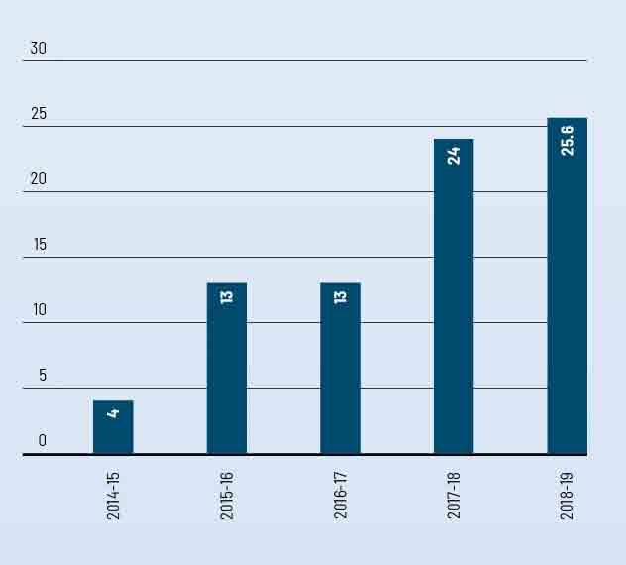

Figure 38: VEC staff by gender, 2014-15 to 2018-19
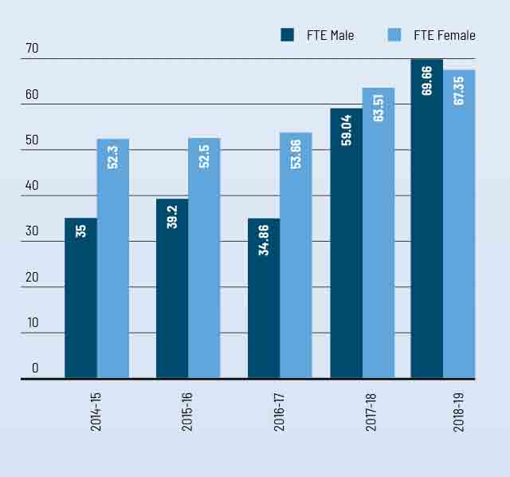

Staff profile

Comparative workforce data
Figure 39: VEC active staff profile, last pay period June 2019 (not including statutory appointees)
 | 2018 |  |  |  |  | 2019
 | ongoing |  | fixed term & casual | total |  | ongoing |  | fixed term & casual | total
 | head- count | fte | head- count | fte | fte | head- count | fte | head- count | fte | fte
Gender
Male | 54.00 | 52.50 | 7.00 | 6.60 | 59.10 | 60.00 | 58.66 | 11.00 | 11.00 | 69.66
Female | 55.00 | 50.80 | 15.00 | 12.80 | 63.60 | 59.00 | 54.95 | 15.00 | 12.40 | 67.35
Total | 109.00 | 103.30 | 22.00 | 19.40 | 122.70 | 119.00 | 113.61 | 26.00 | 23.40 | 137.01
Age
Under 25 | 2.00 | 2.00 | - | - | 2.00 | - | - | - | - | -
25-34 | 26.00 | 25.40 | 6.00 | 5.60 | 31.00 | 27.00 | 26.60 | 7.00 | 6.60 | 33.20
35-44 | 29.00 | 26.50 | 11.00 | 9.40 | 35.90 | 43.00 | 40.56 | 11.00 | 10.30 | 50.86
45-54 | 32.00 | 30.80 | 3.00 | 2.80 | 33.60 | 31.00 | 29.75 | 3.00 | 3.10 | 32.85
55-64 | 16.00 | 14.60 | 1.00 | 1.00 | 15.60 | 14.00 | 12.90 | 4.00 | 3.40 | 16.30
Over 64 | 4.00 | 4.00 | 1.00 | 0.60 | 4.60 | 4.00 | 3.80 |  | - | 3.80
Total | 109.00 | 103.30 | 22.00 | 19.40 | 122.70 | 119.00 | 113.61 | 26.00 | 23.40 | 137.01
Classification
STS | 3.00 | 3.00 | 2.00 | 1.80 | 4.80 | 8.00 | 8.00 | - | - | 8.00
VPS Grade1 | - | - | - | - | - | - | - | - | - | -
VPS Grade2 | 17.00 | 15.70 | 4.00 | 3.20 | 18.90 | 16.00 | 14.61 | 3.00 | 2.10 | 16.71
VPS Grade3 | 28.00 | 25.80 | 7.00 | 6.20 | 32.00 | 25.00 | 23.60 | 9.00 | 8.30 | 31.90
VPS Grade4 | 20.00 | 18.60 | 4.00 | 3.40 | 22.00 | 28.00 | 25.70 | 6.00 | 5.00 | 30.70
VPS Grade5 | 32.00 | 31.40 | 5.00 | 4.80 | 36.20 | 34.00 | 33.70 | 7.00 | 7.00 | 40.70
VPS Grade6 | 9.00 | 8.80 | - | - | 8.80 | 8.00 | 8.00 | 1.00 | 1.00 | 9.00
Total | 109.00 | 103.30 | 22.00 | 19.40 | 122.70 | 119.00 | 113.61 | 26.00 | 23.40 | 137.01
Excluded are those absent on secondment, external contractors and temporary staff employed by employment agencies, staff on leave without pay, election appointees to statutory offices as defined in the Public Administration Act 2004, and election casual staff employed under the Electoral Act 2002.

Figure 40: Full time equivalent (FTE) staffing trends as at 30 June, 2015 to 2019
 | ongoing employees |  |  |  | fixed term |  | casual |  | totals
 | number (head  count) | full time (head  count) | part-time (head  COunt) | fte | number (head  count) | fte | Number (head  count) | fte | number (head  count) | fte
2015 | 62.00 | 54.00 | 8.00 | 59.80 | 23.00 | 21.20 | 16.00 | 6.30 | 101.00 | 87.30
2016 | 67.00 | 59.00 | 8.00 | 64.40 | 25.00 | 22.80 | 12.00 | 5.70 | 112.00 | 92.00
2017 | 82.00 | 69.00 | 13.00 | 77.20 | 13.00 | 11.20 | 2.00 | 0.20 | 97.00 | 88.60
2018 | 109.00 | 93.00 | 15.00 | 103.30 | 20.00 | 18.60 | 2.00 | 0.80 | 131.00 | 122.70
2019 | 119.00 | 122.00 | 23.00 | 113.60 | 24.00 | 23.30 | 1.00 | 0.10 | 145.00 | 137.00

Occupational health and safety

From an Occupational Health and Safety (OHS) perspective, a significant period of the 2018-19 financial year was focused on supporting the delivery of the State election in a safe and sustainable way, whilst not losing sight of the VEC’s core OHS functions.
As in past years, the VEC continues to aim to provide a safe and positive workplace, without risk to employees’ physical or mental wellbeing. The VEC recognises that Occupational Health and Safety (OHS) requires continuous improvement to ensure all elements of health and safety are considered. The focus for 2018-19 has been to further develop the education and management of employee mental health and wellbeing, while continuing to monitor and manage the VECʼs established Occupational Health and Safety Management System (OHSMS) and functions.
In 2018-19, the VEC continued to focus on closing out initiatives identified in the 2016 OHS Survey. This year, the implementation of the actions from the completed audit on Health and Fitness (wellbeing) was finalised and the remaining focus area on fatigue will be addressed in mid-2019.
The OHS Committee has continued to take an active role in monitoring the application of the OHSMS by taking part in all quarterly inspections, reviewing OHS documentation and supporting OHS events, such as OHS month.
Formal quarterly reporting on OHS data and activity has continued throughout 2018-19. The reports are provided to executives and managers to provide oversight of OHS performance and identify trends.

Staff wellbeing services
The VEC has continued to focus on delivery against the VEC’s Wellbeing Strategy for 2017-20. The Strategy provides the framework to supports the personal and professional development of staff in a culture that is inclusive, supportive and engaging. Success in these areas will ensure that the VEC truly is a great place to work.
In 2018-19, the VEC delivered a program of wellbeing events and initiatives that contribute to this strategic intent.
The activities offered to staff included:
- promotion and education of mental health and support seeking through R U Ok? day and World Mental Health day
- International Women’s Day events, with an onsite staff panel discussion, and a competition for 10 VEC employees to attend the Institute of Public Administration Australia’s (IPAA) International Women’s Day Gala Dinner
- a flu vaccination program
  - promotion and celebration of International day against homophobia, transphobia and biphobia and men’s health.
The VEC Mental Health and Wellbeing Commitment Statement, introduced in 2018, remains actively in use to provide clarity on the responsibilities and expectations of the VEC, managers, and employees to prevent and address psychological injury or illness and contribute to a culture of positive wellbeing.

Hazards, incidents and injuries
During 2018-19, the VEC received a total of 201 incident notifications which included four near misses and 17 hazard notifications (see Figure 43).
The significant increase of reports is a result of both increased activity during the State election period and increased focus and drive on incident reporting through training programs. Of the 201 incident reports lodged, 80 involved election appointees/casuals, 91 involved members of the public and 20 incidents involved VEC employees. There were 142 incidents that resulted in an injury, but only four of these were submitted as WorkCover claims. Three WorkCover claims resulted in a total eight days’ lost time (see Figure 42). The remaining claim did not result in lost time.
Of note, 39.8% of all incidents were slips, trips and falls, reflected in Figure 45.
All OHS incidents and hazards reported during the year have been investigated by health and safety representatives and management. All corrective action is monitored and reviewed on the VEC’s Safety Action Plan on a regular basis to ensure effectiveness.
Figure 41: Claims for workcover, 2014–15 to 2018–19
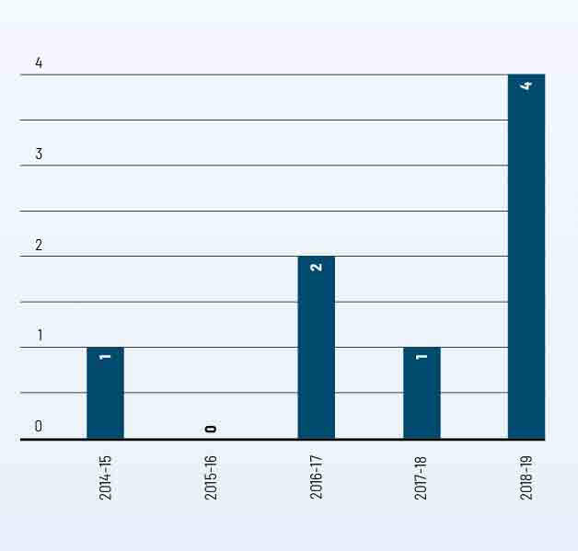

Figure 42: Days lost as a result of workplace-related injury, 2014–15 to 2018–19
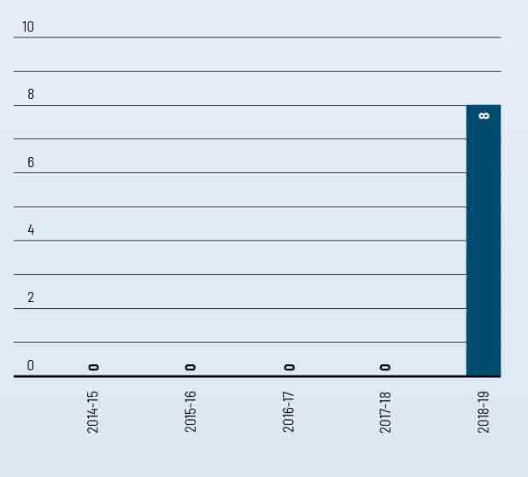
Figure 43: Hazard, incidents and injuries reported, 2014–15 to 2018–19
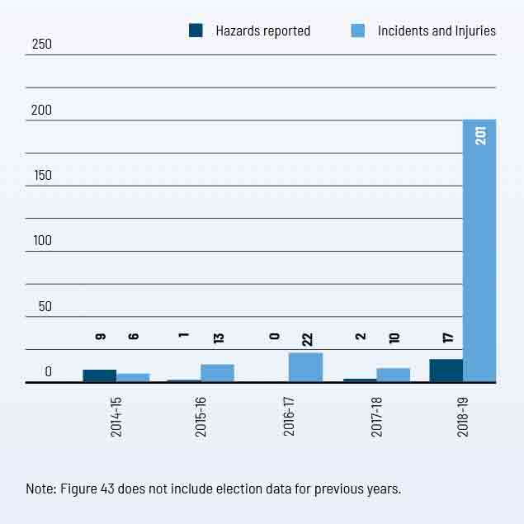

Figure 44: Reported incidents, hazards and near misses –
by affected person, 2018–19
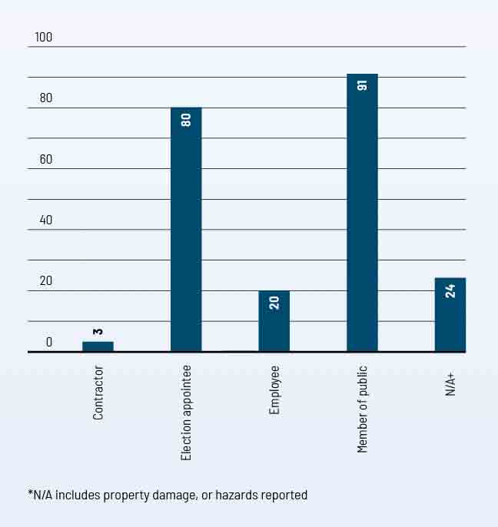

Figure 45: Reported incidents, hazards and near misses – by type, 2018–19
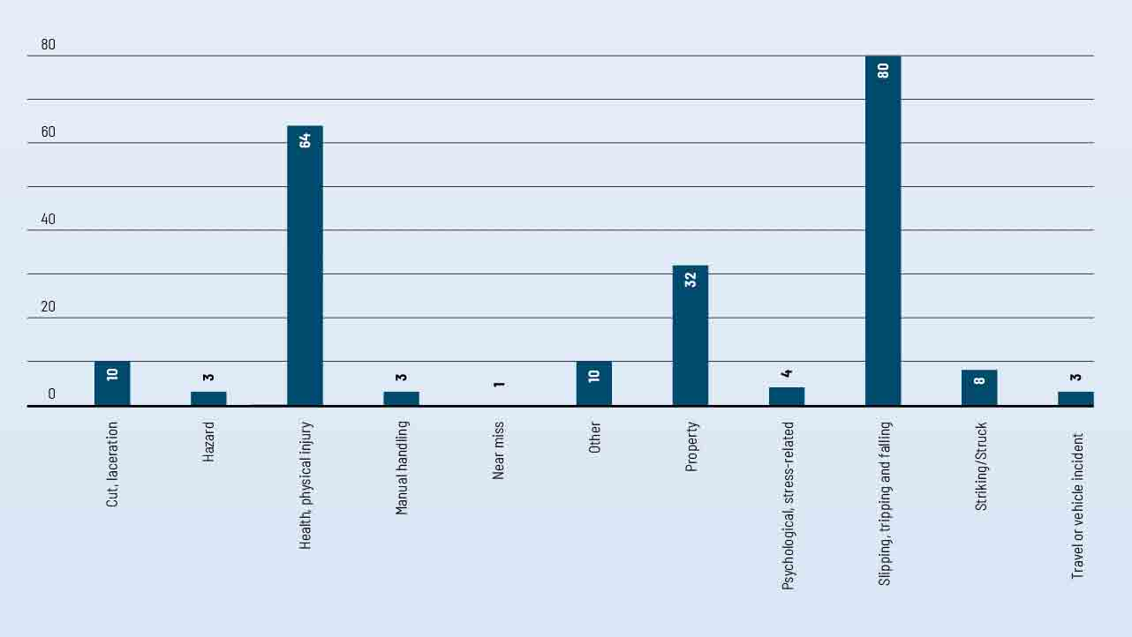

Figure 46: The VEC’s performance against OHS management measures,
2014-15 to 2018-19
measure | kpi | 2014-15 | 2015-16 | 2016-17 | 2017-18 | 2018-19
Incidents | Staff FTE (VPS only) | 81 | 86.2 | 88.6¹ | 122.7 | 137
 | No. of incidents | 6 | 13 | 5² | 10 | 16⁴
 | Rate per 100 FTE | 7.41 | 15.08 | 5.6 | 8.1 | 11.7
Claims | No. of standard claims | - | - | 1³ | 1 | 1
 | Rate per 100 FTE | - | - | 1.1 | 0.8 | 0.7
 | No. of lost time claims | - | - | - | - | 1
 | Rate per 100 FTE | - | - | - | - | 0.7
 | No. of claims exceeding 13 weeks | - | - | 1 | - | -
 | Rate per 100 FTE | - | - | 1.1 | - | -
Fatalities | Fatality claims | - | - | - | - | -
Claim costs | Average cost per standard claim | 8,576 | - | 8,210 | 452 | 479
Return to work | Percentage of claims with RTW plan <30 days | - | - | - | - | -
Management | Evidence of OHS policy statement, OHS commitment objectives, regular reporting to senior management of OHS, and OHS plans (signed by CEO or equivalent) | Completed | Completed | Completed | Completed | Completed
 | Evidence of OHS criteria in purchasing guidelines (including goods, services and personnel) | Completed | Completed | Completed | Completed | Completed
Consultation | Evidence of agreed structure of designated workgroups (DWGs), health and safety participation representatives (HSRs), and issue resolution procedures (IRPs) | Completed | Completed | Completed | Completed | Completed
 | Compliance with agreed structure on DWGs, HSRs, and IRPs | Completed | Completed | Completed | Completed | Completed
Risk management | Percentage of internal audits/inspections conducted as planned  Percentage of issues identified and actioned arising from: | 100% | 100% | 100% | 75% | 88%
 | - internal audits | 100% | 100% | 100% | N/A | 100%
 | - HSR provisional improvement notices (PINs) | N/A | N/A | N/A | N/A | N/A
 | - WorkSafe notices | N/A | N/A | N/A | N/A | N/A
Training | Percentage of managers and staff that have received OHS training:
 | - induction | 100% | 100% | 100% | 100% | 100%
 | - management training | 100% | 0% | 100% | 78% | 0%
 | - contractors, temps and visitors | 100% | 100% | 50 | 36% | 9%⁵
 | - Percentage of HSRs trained:
 | - acceptance of role | 100% | 100% | 100% | 100% | 100%
 | - refresher training | 100% | 0% | 100% | 100% | 100%
 | - reporting of incidents and injuries | 100% | 100% | 100% | 100% | 100%

¹ Figure does not include casual staff
² Figure does not include casual staff or members of the public
³ Figure includes casual election staff
⁴ Figure does not include incidents incurred by casual staff or members of the public. Does not include hazards or near misses.
⁵ Figure does not include casual election staff

Spotlight on…
Name
Julija Campelj
Title
Finance Coordinator
Department
Finance Branch
The VEC’s vision is for all Victorians to actively participate in their democracy. How does your role contribute to this?
My role is to provide support on finance matters to the organisation and staff in offices that are set up for an election period. I aim to provide a prompt and helpful service to ensure that the people I support can better spend their time on their own responsibilities.
What makes the VEC an innovative and engaging place to work?
The base logistics to run an election event are essentially the same each time. However, the organisation is continually reviewing current processes and is always looking to make improvements. This is done by the dedicated employees who each bring something different to the organisation and create a friendly team environment within to work.
What’s a key lesson you learned from working on the 2018 State election?
Never take it for granted that an election event will always be the same as the last one.
What do you like to do outside of work?
Spending time with family and friends. Movie marathons. Doing day trips to explore country towns and the surrounding area - this is my small way of supporting the local community.

Financial statements

ACHIEVEMENTS 2018–19
- Compliance with the Standing Directions of the Minister for Finance – no reportable deficiencies
- Successful delivery of the 2018 State election within the endorsed funding envelope
- Compliance with the new Funding and Disclosure legislation
- Delivery of the VEC’s programs and initiatives within available funding envelope

OUTLOOK 2019–20
- Enhance the VEC corporate governance and compliance roadmap, maintaining robust internal controls and operating policies and procedures
- Implementation of an enterprise-wide inventory and asset management system
- Financial management of VEC major programs including continued enhancements to infrastructure and system security, delivery of EMS2 build, new VEC website and intranet, and development of a Roll Management System Strategy
- Support to local government election planning

Financial report

The objective of the financial report is to provide stakeholders with an understanding of the VEC’s financial performance and position over the 2018-19 reporting period

Funding fluctuations
The VEC’s only source of funding is special appropriation from the State Government. The Commission’s funding fluctuates year-on-year depending on the electoral activity being delivered (see Figure 31). Every two years, the VEC conducts either a State election or local government elections, which significantly increased the VEC’s funding for the particular year. With 2018-19 being a State election year, the VEC’s funding increases to $89.62 million (2017–18: $33.61 million). Special appropriation funding does not include non‑cash expenses, such as depreciation, staff entitlement provisions and year-end accruals.
Equity – what the VEC is worth
The VEC’s equity is measured as the net of the Commission’s assets less its liabilities. The VEC’s total equity position at 30 June 2019 is $12.13 million, comprising contributed capital and carrying accumulated deficit.
Administrative services
The VEC also manages administrative services on behalf of the State Government and local government. Funding collected and dispersed during 2018-19 was $32.40 million. This is not shown in the VEC financial results or in the financial statements, but is declared in Note 4.1: Administered (non-controlled). Activities included:
- collection and payment of fines
- payment of 2018 State election entitlements
- advance payment of 2020 State election public funding
  - administrative funding (Funding and Disclosure legislation).

FIGURE 31: SPECIAL APPROPRIATION 2014–15 TO 2018–19 ($’000)
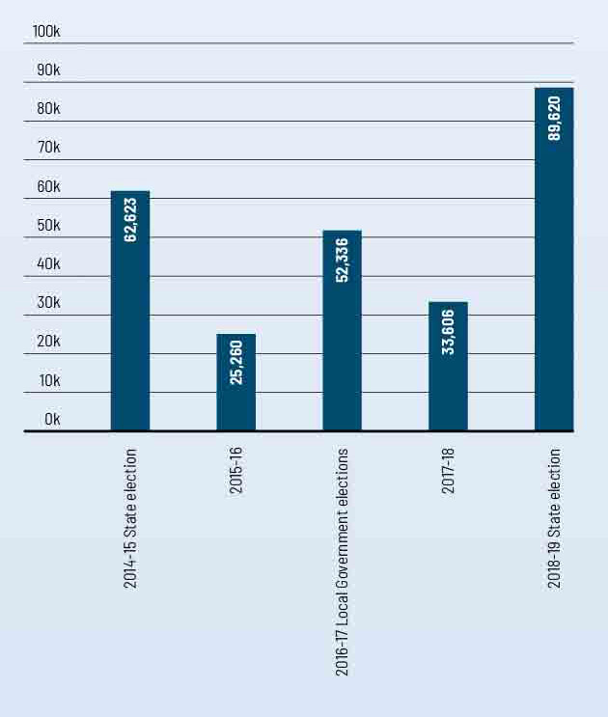

Expenses – how the VEC’s funding is utilized
In addition to the VEC standard operating costs, the additional funding received was committed towards running the 2018 State election. The major cost categories where resources were committed included:
- wages and overheads – upscaling election workforce, casuals and election officials
- election advertising and awareness campaigns
- ballot paper and printing
- election logistics support
- mail and postage services
- property rental (Melbourne Showgrounds counting centre, election offices and early voting locations)
  - election infrastructure including IT and security.
VEC operational expenditure ($’000)
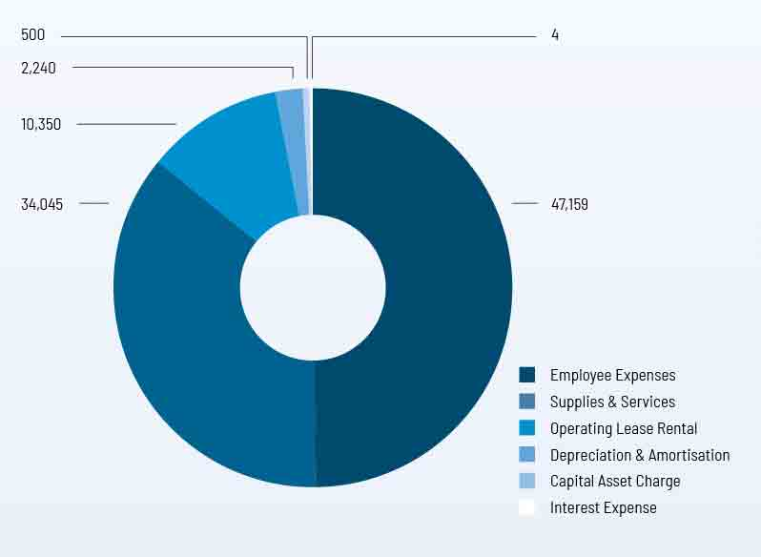

Assets – what the VEC owns
Non-financial assets make up the majority of the VEC’s assets. Assets include election inventory stored at the Tullamarine warehouse, PPE (property, plant and equipment) spread across the two locations, and intangible assets which cover all of the VEC systems and programs. Prior to the November 2018 election, significant resources were invested to ensure election-related systems were updated and ready for deployment. The enhancements also included robust security features for data management and integrity purposes. Following a change in legislation, the VEC also developed and deployed a new Funding and Disclosure system – allowing donors and political parties to disclose and reconcile political donations. This system is to undergo further enhancements in 2019-20, along with the scheduled completion of the EMS2.
VEC assets
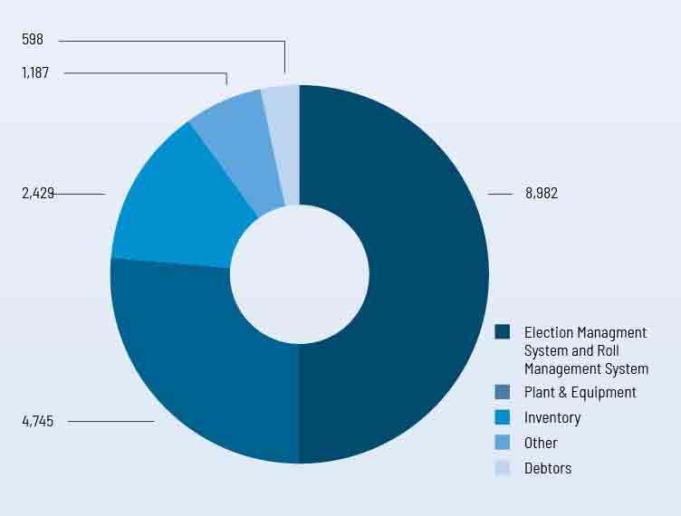

Liabilities – what the VEC owes
The VEC’s liabilities are largely represented by employee provisions (annual leave and long service leave owing to staff) and supplier commitments. Money owed to suppliers and creditors was timing related at 30 June 2019, based on terms of trade between the VEC and respective suppliers. Utilising strong internal cash flow management, the VEC endeavours to keep outstanding supplier commitments to a minimum - ensuring payments are made within agreed trade terms. Trade creditor balances owing at 30 June 2019 were subsequently cleared the following month.
VEC liabilities
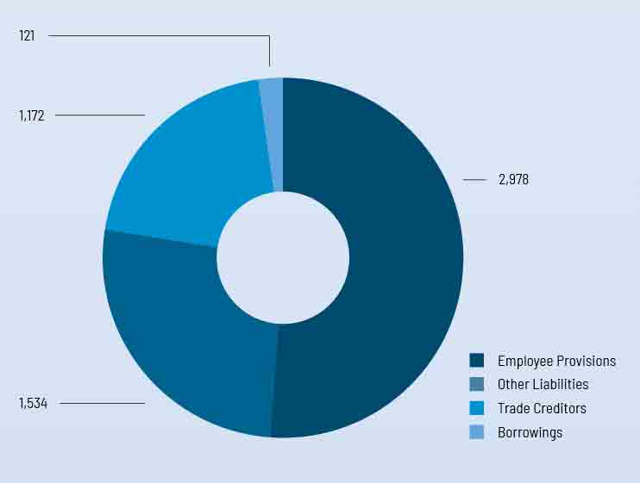

Accountable officer’s and chief finance and accounting officer’s declaration
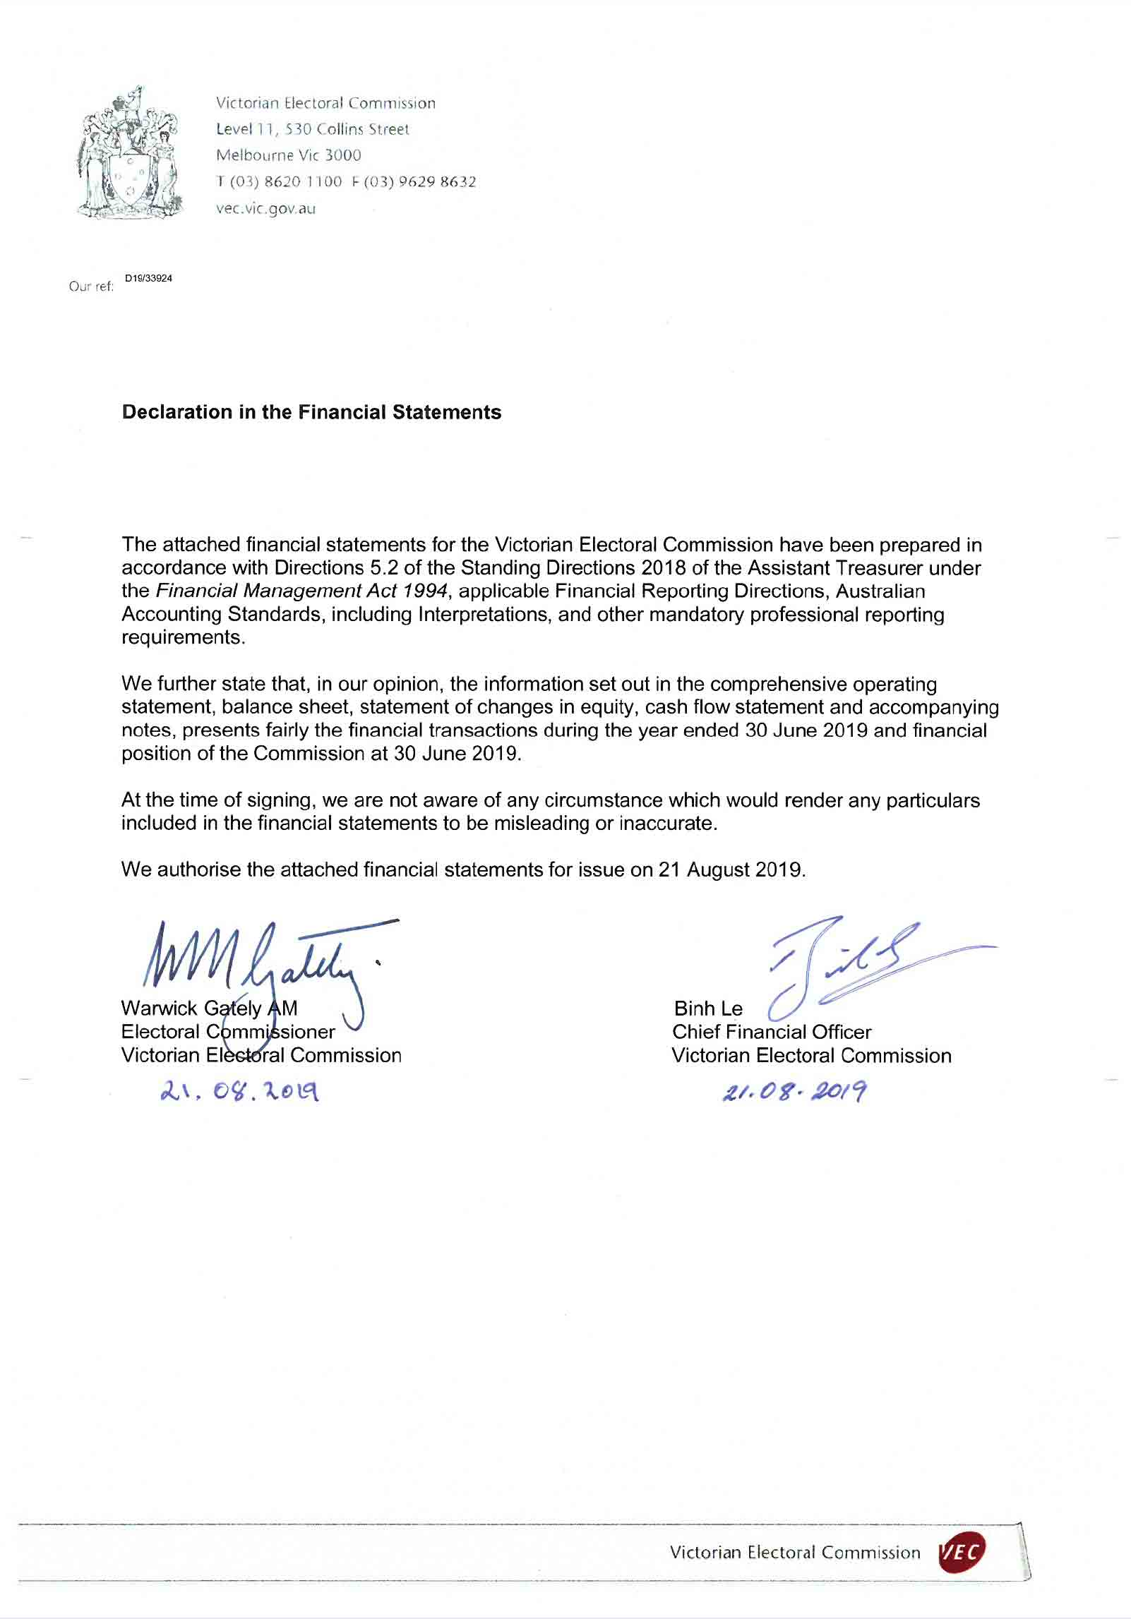

Comprehensive operating statement

for the financial year ended 30 June 2019
 | Notes | 2018  $’000 | 2019  $’000
Continuing operations
Income from transactions
Special appropriations | 2.1 | 33,606 | 89,620
Total income from transactions |  | 33,606 | 89,620
Expenses from transactions
Employee expenses | 3.1.1 | (14,842) | (47,159)
Depreciation and amortisation | 5.1.1 | (1,350) | (2,240)
Interest expense |  | (4) | (4)
Capital asset charge | 3.2 | (129) | (500)
Other operating expenses | 3.3 | (17,935) | (44,395)
Total expenses from transactions |  | (34,260) | (94,298)
Net result from transactions  (net operating balance) |  | (654) | (4,678)
Other economic flows included in net result
Net gain / (loss) arising from revaluation of long service liability |  | 2 | (102)
Total other economic flows included in net result |  | 2 | (102)
Net result |  | (652) | (4,780)
Comprehensive result |  | (652) | (4,780)

The comprehensive operating statement should be read in conjunction with the notes to the financial statements.

Balance sheet

as at 30 June 2019
 | Notes | 2018  $’000 | 2019  $’000
Assets
Financial assets
Cash and deposits | 7.1 | 3 | (2)
Receivables | 6.1 | 991 | 598
Total financial assets |  | 994 | 596
Non-financial assets
Inventories | 6.3 | 3,595 | 2,429
Property, plant and equipment | 5.1 | 5,666 | 4,745
Intangible assets | 5.2 | 5,265 | 8,982
Prepayments |  | 1,638 | 1,187
Total non-financial assets |  | 16,164 | 17,343
Total assets |  | 17,158 | 17,939
Liabilities
Payables | 6.2 | 1,283 | 1,172
Borrowings |  | 112 | 121
Employee-related provisions | 3.1.2 | 2,215 | 2,978
Other provisions | 6.4 | 574 | 675
Other liabilities | 6.5 | 1,096 | 859
Total liabilities |  | 5,280 | 5,805
Net assets |  | 11,878 | 12,134
Equity
Accumulated (deficit) / surplus |  | (25,530) | (30,310)
Contributed capital |  | 37,408 | 42,444
Net worth |  | 11,878 | 12,134

The balance sheet should be read in conjunction with the notes to the financial statements.

Statement of changes in equity

for the financial year ended 30 June 2019
 | Notes | ACCUMULATED  SURPLUS  $’000 | CONTRIBUTED  CAPITAL  $’000 | TOTAL  $’000
Balance at 30 June 2017 |  | (24,878) | 32,568 | 7,690
Net result for the year |  | (652) | - | (652)
Capital appropriations |  | - | 4,840 | 4,840
Balance at 30 June 2018 |  | (25,530) | 37,408 | 11,878
Net result for the year |  | (4,780) | - | (4,780)
Capital appropriations |  | - | 5,036 | 5,036
Balance at 30 June 2019 |  | (30,310) | 42,444 | 12,134

Cash flow statement

for the financial year ended 30 June 2019
 | Notes | 2018  $’000 | 2019  $’000
Cash flows from operating activities
Receipts
Receipts from Government |  | 36,761 | 89,113
Net Goods and Services Tax recovered from the ATO |  | 2,059 | 4,796
Total receipts |  | 38,820 | 93,929
Payments
Payments to suppliers and employees |  | (38,859) | (93,943)
Total payments |  | (38,859) | (93,943)
Net cash flows from / (used in) operating activities | 7.1.1 | (39) | (14)
Cash flows from investing activities
Purchases of non-financial assets |  | (4,840) | (5,036)
Net cash flows (used in) / from investing activities |  | (4,840) | (5,036)
Cash flows from financing activities
Owner contributions by State Government |  | 4,840 | 5,036
Repayment of finance leases |  | 39 | 9
Net cash flows from / (used in) financing activities |  | 4,879 | 5,045
Net increase / (decrease) in cash and cash equivalents |  | - | (5)
Cash and cash equivalents at the beginning of the financial year |  | 3 | 3
Cash and cash equivalents at the end of the financial year | 7.1 | 3 | (2)

The above cash flow statement should be read in conjunction with the notes to the financial statements.

Notes to the financial statements

for the financial year ended 30 June 2019

Note 1. About this report
The Victorian Electoral Commission (the Commission) is an independent body of the State of Victoria, established pursuant to an order made by the Premier under the Electoral Act 2002.
Its principal address is:
Victorian Electoral Commission
Level 11, 530 Collins Street
Melbourne VIC 3000
The Commission is an administrative agency acting on behalf of the Crown.
A description of the nature of the Commission’s operations and its principal activities is included in the report of operations, which does not form part of these financial statements.

Objectives
The Commission’s overall objective is to provide election services to State and local government, as well as conducting various fee-for-service elections.
The Commission is funded by accrual-based parliamentary appropriations for the provision of outputs. It provides on a fee-for-service basis election services for local government and commercial elections. The fees charged for these services are determined by prevailing market forces.

Basis of preparation
These financial statements cover the Victorian Electoral Commission as an individual reporting entity and include all of its controlled activities.
These financial statements are presented in Australian dollars, and prepared in accordance with the historical cost convention unless a different measurement basis is specifically disclosed in the note associated with the item measured on a different basis.
The accrual basis of accounting has been applied in the preparation of these financial statements whereby assets, liabilities, equity, income and expenses are recognised in the reporting period to which they relate, regardless of when cash is received or paid. The only exception is for special appropriation revenue, which is recognised on a cash basis when the amount appropriated for a specific purpose is received by the Commission.
Judgements, estimates and assumptions are required to be made about financial information being presented. The significant judgements made in the preparation of these financial statements are disclosed in the notes where amounts affected by these judgements are disclosed. Estimates and associated assumptions are based on professional judgements derived from historical experience and various other factors that are believed to be reasonable under the circumstances. Actual results may differ from these estimates.

Revisions to accounting estimates are recognised in the period in which the estimate is revised, and also in future periods that are affected by the revision. Judgements and assumptions made by management in the application of AASs that have significant effects on the financial statements and estimates relate to:
- the fair value of measurement of property, plant and equipment (refer to 5.1)
- superannuation contributions (refer to 3.1.3)
- employee and provisions (refer to 3.1.1 and 3.1.2)
  - useful lives of property, plant and equipment (refer to 5.1.1).
All amounts in the financial statements have been rounded to the nearest thousand dollars, unless otherwise stated. Figures in the financial statements may not equate due to rounding.

Compliance information
These general purpose financial statements have been prepared in accordance with the Financial Management Act 1994 and applicable Australian Accounting Standards (AAS), which include Interpretations issued by the Australian Accounting Standards Board (AASB). In particular, they are presented in a manner consistent with the requirements of the AASB 1049 Whole of Government and General Government Sector Financial reporting.
Where appropriate, those AAS paragraphs applicable to not-for-profit entities have been applied.
Accounting policies are selected in a manner which ensures that the resulting financial information satisfies the concepts of relevance and reliability, thereby ensuring that the substance of the underlying transactions or other events is reported.

Note 2. Funding delivery of our services
The Commission’s purpose is to deliver high quality, accessible electoral services with innovation, integrity and independence to enable all Victorians to actively participate in the democratic process.
To enable the Commission to fulfill its objectives and outputs, it receives parliamentary appropriations.

2.1 Summary of income that funds the delivery of services
 | NOTES | 2018  $’000 | 2019  $’000
Special appropriations | 2.2 | 33,606 | 89,620
Total income from transactions |  | 33,606 | 89,620

2.2 Appropriations
Annual parliamentary appropriations income becomes controlled and is recognised by the Commission when it is appropriated from the Consolidated Fund by the Victorian Parliament, via the Department of Premier and Cabinet, and applied to the purposes defined under the Electoral Act 2002.
Special appropriations
The appropriation revenue is recognised on a cash basis when the operating bank account is funded by the State Government.

Note 3. The cost of delivering services
Introduction
This section provides an account of the expenses incurred by the Commission in delivering services and outputs. In Note 2, the funds that enable the provision of services were disclosed and in this note the cost associated with provision of services is recorded.

3.1 Expenses incurred in delivery of services
 | NOTES | 2018  $’000 | 2019  $’000
Employee expenses | 3.1.1 | 14,842 | 47,159
Capital asset charge | 3.2 | 129 | 500
Other operating expenses | 3.3 | 17,935 | 44,395
Total expenses incurred in delivery of services |  | 32,906 | 92,054

3.1.1 Employee benefits in the comprehensive operating statement
 | 2018  $’000 | 2019  $’000
Defined benefit and contribution superannuation expense | 1,162 | 3,428
Salaries and wages, annual leave and long service leave | 13,680 | 43,731
Total employee expenses | 14,842 | 47,159

Employee expenses include all costs related to employment including wages and salaries, superannuation, fringe benefits tax, leave entitlements, redundancy payments and WorkCover premiums.
The amount recognised in the comprehensive operating statement in relation to superannuation is employer contributions for members - for both defined benefit and defined contribution superannuation plans - that are paid or payable during the reporting period.
The Commission does not recognise any defined benefit liability in respect of the plan(s) because the entity has no legal or constructive obligation to pay future benefits relating to its employees; its only obligation is to pay superannuation contributions as they fall due. The Department of Treasury and Finance (DTF) discloses the Stateʼs defined benefit liabilities in its disclosure for administered items.

3.1.2 Employee benefits in the balance sheet
Provision is made for benefits accruing to employees in respect of wages and salaries, annual leave and long service leave for services rendered to the reporting date.
 | 2018  $’000 | 2019  $’000
Current provisions
Annual leave (i)
Unconditional and expected to be settled within 12 months | 665 | 784
Unconditional and expected to be settled after 12 months (ii) | 53 | 301
Long service leave (i)
Unconditional and expected to be settled within 12 months | 121 | 127
Unconditional and expected to be settled after 12 months (ii) | 955 | 1,094
 | 1,794 | 2,306
Provisions for on-costs (i)
Unconditional and expected to be settled within 12 months | 121 | 140
Unconditional and expected to be settled after 12 months (ii) | 156 | 215
 | 277 | 355
Total current employee-related provisions | 2,071 | 2,661
Non-current provisions (ii)
Employee benefits (i) | 125 | 275
On-costs | 19 | 42
Total non-current employee-related provisions | 144 | 317
Total employee-related provisions | 2,215 | 2,978

Note: (i) Employee benefits consist of annual leave and long service leave accrued by employees. On-costs such as payroll tax and workersʼ compensation insurance are not employee benefits and are reflected as a separate provision.
(ii) Amounts are measured at present values.

Reconciliation of movement in on-cost provision
2019
$’000
Opening balance | 296
Additional provisions recognised | (792)
Reductions arising from payments / other sacrifices of future economic benefits | 893
Closing balance | 397
Current | 355
Non-current | 42
Total employee benefits | 397

Annual leave
Liabilities for annual leave and on-costs are recognised as part of the employee benefit provision as current liabilities. Liabilities expected to be settled within 12 months of the reporting period are measured at undiscounted amounts. Liabilities that are not expected to be settled within 12 months are also recognised in the provision for employee benefits as current liabilities, but are measured at present value of the amounts expected to be paid when the liabilities are settled using the remuneration rate expected to apply at the time of settlement.
Employment on-costs such as payroll tax, workers’ compensation and superannuation are not employee benefits. They are disclosed separately as a provision for employee benefits when the employment to which they relate has occurred.

Long service leave
Liability for long service leave (LSL) is recognised in the provision for employee benefits.
Unconditional LSL is disclosed in the notes to the financial statements as a current liability, even where the Commission does not expect to settle the liability within 12 months because it will not have the unconditional right to defer the settlement of the entitlement should an employee take leave within 12 months.
The components of this current LSL are measured at:
- undiscounted value - if the Commission expects to wholly settle within 12 months or
  - present value - if the Commission does not expect to wholly settle within 12 months.
Conditional LSL is disclosed as a non-current liability.
There is an unconditional right to defer the settlement of the entitlement until the employee has completed the requisite years of service. This non-current LSL liability is measured at present value.
Any gain or loss following revaluation of the present value of non-current LSL liability is recognised as a transaction, except to the extent that a gain or loss arises due to changes in bond interest rates for which it is then recognised as an other economic flows included in the net result.

3.1.3 Superannuation contributions
Employees of the Commission are entitled to receive superannuation benefits and the Commission contributes to both defined benefit and defined contribution plans. The defined benefit plan(s) provides benefits based on years of service and final average salary.
As noted in 3.1.1, the defined benefit liability is recognised in DTF as an administered liability. However, superannuation contributions paid or payable for the reporting period are included as part of employee benefits in the comprehensive operating statement of the Commission.
The name, details and amounts expensed in relation to the major employee superannuation funds and contributions made by the Commission (see following table on page 105).

 | PAID CONTRIBUTION for the year
 | 2018  $’000 | 2019  $’000
Defined benefit plans:
State superannuation fund - revised and new (i) | - | 8
Defined contribution plans:
VicSuper | 542 | 1,407
Other | 620 | 2,013
Total | 1,162 | 3,428
Notes: (i) The bases for determining the level of contributions is determined by the various actuaries of the defined benefit superannuation plans.
There were no outstanding contributions at year end.

3.2 Capital asset charge
 | 2018  $’000 | 2019  $’000
Capital asset charge | 129 | 500

A capital asset charge is a charge levied on the written down value of controlled non-current physical assets in the Commissionʼs balance sheet. It aims to attribute to the Commission outputs - a cost of capital used in service delivery. Imposing this charge provided incentives for the Commission to identify and dispose of underutilised or surplus non-current physical assets.

3.3 Other operating expenses
 | 2018  $’000 | 2019  $’000
Purchase of supplies and consumables | 2,718 | 14,422
Purchase of services | 12,006 | 18,038
Maintenance | 653 | 1,585
Operating lease rental expense | 2,558 | 10,350
Total other operating expenses | 17,935 | 44,395

Other operating expenses generally represent the day-to-day running costs incurred in normal operations and are recognised as an expense in the reporting period in which they are incurred. The exception to this is operating lease payments, which are recognised on a straight-line basis over the lease term.

Note 4. Administered financial information output

4.1 Administered (non-controlled) items
In addition to the specific Commission operations, which are included in the financial statements (comprehensive operating statement, balance sheet, statement of changes in equity and cash flow statement), the Commission administers or manages, but does not control, other activities and resources on behalf of the State and local government. Administered income includes the provision of services for conducting local government elections, fines and electoral entitlements. Administered expenses include payments made in conducting local government elections and payments to councils. Administered assets include government income earned but not yet collected.
Following Royal Assent on 31 July 2018, amendments were made to the Victorian Electoral Act 2002, which included a new funding and disclosure regime. The laws incorporate a number of changes such as caps on political donations and the introduction of new funding arrangements. Obligations under these laws came into effect on two stages:
- changes introduced 1 August 2018: introduction of Political Donation Provisions and Administrative Expenditure Funding.
  - changes introduced 25 November 2018: introduction of Policy Development Funding and Advance Public Funding.
Legislative activities are Administered by nature and disclosed in the following schedule.

 | State |  | local Government |  | total
 | 2018  $’000 | 2019  $’000 | 2018  $’000 | 2019  $’000 | 2018  $’000 | 2019  $’000
Administered income from transactions
Income from local government and commercial elections | 2,275 | 996 | - | - | 2,275 | 996
Fines | 414 | 2,208 | 7,703 | 4,128 | 8,117 | 6,336
Candidate deposits | 3 | 141 | - | - | 3 | 141
Electoral entitlements | 56 | 29,052 | - | - | 56 | 29,052
Total administered income from transactions | 2,748 | 32,397 | 7,703 | 4,128 | 10,451 | 36,525
Administered expenses from transactions
Payments into the consolidated fund | 2,786 | 4,408 | - | - | 2,786 | 4,408
Payments to councils | - | - | 8,505 | 4,518 | 8,505 | 4,518
Payments for Funding and Disclosure | - | 16,381 | - | - | - | 16,381
Total administered expenses from transactions | 2,786 | 20,789 | 8,505 | 4,518 | 11,291 | 25,307
Total administered net result from transactions  (net operating balance) | (38) | 11,608 | (802) | (390) | (840) | 11,218
Administered assets
Cash | - | - | 1,227 | 837 | 1,227 | 837
Prepaid and advanced funding | 1,363 | 13,066 | - | - | 1,363 | 13.066
Total administered assets | 1,363 | 13,066 | 1,227 | 837 | 2,590 | 13,903
Administered liabilities
Payables | 236 | 331 | - | - | 236 | 331
Compulsory voting fines | - | - | 1,227 | 837 | 1,227 | 837
Total administered liabilities | 236 | 331 | 1,227 | 837 | 1,463 | 1,168
Total administered net assets | 1,127 | 12,735 | - | - | 1,127 | 12,735

Note 5. Key assets available to support output delivery

Introduction
The Commission controls property, intangibles, plant and equipment that are used in fulfilling its objectives and conducting its activities. They represent the resources that have been entrusted to the Commission to be utilised for delivery of those outputs.

5.1 Total property, plant and equipment
 | GROSS Carrying amount |  | ACCUMULATED  DEPRECIATION |  | NET CARRYING amount
 | 2018 $’000 | 2019 $’000 | 2018 $’000 | 2019 $’000 | 2018 $’000 | 2019 $’000
Plant, equipment, fixtures & fittings and vehicles at fair value | 5,577 | 6,145 | (2,801) | (3,650) | 2,776 | 2,495
Leasehold improvements | 5,628 | 5,745 | (2,738) | (3,495) | 2,890 | 2,250
Net carrying amount | 11,205 | 11,890 | (5,539) | (7,145) | 5,666 | 4,745

Initial recognition
All non-financial physical assets are measured initially at cost and subsequently revalued at fair value less accumulated depreciation and impairment.
The cost of leasehold improvements is capitalised as an asset and amortised over the shorter of the remaining term of the lease, or the estimated useful life of the improvements.
The initial cost for non-financial physical assets under a finance lease is measured at amounts equal to the fair value of the leased asset or, if lower, the present value of the minimum lease payments, each determined at the inception of the lease.
Fair value of plant and equipment that are specialised in use (such that it is rarely sold other than as a part of a going concern) is determined using the current replacement cost method.
Refer to Note 8.3 for additional information on fair value determination of plant and equipment.

Impairment of property, plant and equipment
The recoverable amount of primarily non-cash generating assets of not-for-profit entities, which are typically specialised in nature and held for continuing use of their service capacity, is expected to be materially the same as fair value determined under AASB 13 Fair Value Measurement, with the consequence that AASB 136 does not apply to such assets that are regularly revalued.

5.1.1 Depreciation and impairment
Charge for the period | 2018  $’000 | 2019  $’000
Property, plant and equipment | 967 | 1,606
Intangible assets | 383 | 634
Total depreciation and amortisation | 1,350 | 2,240

All property, plant and equipment and other non-financial physical assets (excluding items under operating leases) that have finite useful lives are depreciated. Depreciation is calculated on a straight-line basis, at rates that allocate the assetʼs value, less any estimated residual value, over its estimated useful life.
Intangible produced assets with finite lives are amortised as an ʻexpense from transactionsʼ on a straight-line basis over their useful lives.
The estimated useful lives, residual values and depreciation method are reviewed at the end of each annual reporting period, and adjustments made where appropriate.
The following are typical estimated useful lives for the different asset classes for current and prior years.

Asset class | Useful life (years)
Leasehold improvements | 10 - 12
Leased motor vehicles | 3
Plant & equipment | 5 - 10
Furniture & fittings | 5 - 14
Computer equipment | 3 - 5
Intangible produced assets - software development | 14 - 16

5.1.2 Reconciliation of movements in carrying amounts of plant, equipment and vehicles
 | PLANT, EQUIPMENT, FIXTURES AND FITTINGS AND VEHICLES AT FAIR VALUE |  | LEASEHOLD IMPROVEMENTS |  | total
 | 2018  $’000 | 2019  $’000 | 2018  $’000 | 2019  $’000 | 2018  $’000 | 2019  $’000
Opening balance | 698 | 2,776 | 1,907 | 2,890 | 2,605 | 5,666
Additions | 2,518 | 568 | 1,653 | 117 | 4,171 | 685
Disposals | (47) | - | (96) | - | (143) | -
Depreciation | (393) | (849) | (574) | (757) | (967) | (1,606)
Closing balance | 2,776 | 2,495 | 2,890 | 2,250 | 5,666 | 4,745

5.2 Intangible assets
 | 2018  $’000 | 2019  $’000
Gross carrying amount
Opening balance | 19,928 | 20,597
Addition from internal development | 669 | 4,351
Closing balance | 20,597 | 24,948
Accumulated amortisation
Opening balance | (14,949) | (15,332)
Amortisation expense (i) | (383) | (634)
Closing balance | (15,332) | (15,966)
Net book value | 5,265 | 8,982
Note: (i) The consumption of intangible produced assets is included in ‘depreciation and amortisation’ line items on the Comprehensive Operating Statement.

5.2.1 Reconciliation of movements in carrying amounts of intangibles
 | software |  | work in progress |  | total
 | 2018  $’000 | 2019  $’000 | 2018  $’000 | 2019  $’000 | 2018  $’000 | 2019  $’000
Opening balance | 4,979 | 5,019 | - | 246 | 4,979 | 5,265
Additions | 423 | 3,390 | 246 | 961 | 669 | 4,351
Amortisation | (383) | (634) | - | - | (383) | (634)
Closing balance | 5,019 | 7,775 | 246 | 1,207 | 5,265 | 8,982

Initial recognition
Purchased intangible assets are initially recognised at cost. When the recognition criteria in AASB 138 Intangible Assets are met, internally generated intangible assets are recognised at cost. Subsequently, intangible assets with finite useful lives are carried at cost less accumulated amortisation and accumulated impairment losses. Depreciation and amortisation begins when the asset is available for use, that is, when it is in the location and condition necessary for it to be capable of operating in the manner intended by management.
An internally-generated intangible asset arising from development (or from the development phase of an internal project) is recognised if, and only if, all of the following are demonstrated:
- the technical feasibility of completing the intangible asset so that it will be available for use or sale
- an intention to complete the intangible asset and use or sell it
- the ability to use or sell the intangible asset
- the intangible asset will generate probable future economic benefits
- the availability of adequate technical, financial and other resources to complete the development and to use or sell the intangible asset
- the ability to measure reliably the expenditure attributable to the intangible asset during its development.

Subsequent measurement
Intangible produced assets with finite useful lives are amortised as an expense from transactions on a straight‑line basis over their useful lives. Produced intangible assets have useful lives of 14-16 years.
Intangible non-produced assets with finite useful lives are amortised as an ‘other economic flow’ on a straight-line over their useful lives. The amortisation period is 14-16 years.

Impairment of intangible assets
All intangible assets with indefinite useful lives are not depreciated or amortised, but are tested for impairment by comparing its recoverable amount with its carrying amount:
- annually
- whenever there is an indication that the intangible asset may be impaired.
Intangible assets with finite useful lives are tested for impairment whenever an indication of impairment is identified.

Significant intangible assets
The Commission has capitalised software development expenditure for the development of its election management and electoral rolls development. The carrying amount of the capitalised software development expenditure of $9.0 million (2018: $5.3 million) includes existing developed software and software under development.

Note 6. Other assets and liabilities
This section sets out those assets and liabilities that arose from the Commissionʼs controlled operations.
6.1 Receivables
 | 2018  $’000 | 2019  $’000
Current receivables
Statutory
GST input tax credit recoverable | 654 | 598
 | 654 | 598
Contractual
Other receivables | 337 | -
 | 337 | -
Total current receivables | 991 | 598
Total receivables | 991 | 598

Contractual receivables are classified as financial instruments and categorised as ‘financial assets at amortised costs’. They are initially recognised at fair value plus any directly attributable transaction costs. The Commission holds the contractual receivables with the objective to collect the contractual cash flows, and therefore subsequently measured at amortised cost using the effective interest method, less any impairment. They include mainly debtors in relation to goods and services.
Statutory receivables do not arise from contracts and are recognised and measured when similarly to contractual receivables (except for impairment), but are not classified as financial instruments for disclosure purposes. The Commission applies AASB 9 for initial measurement of the statutory receivables and as a result statutory receivables are initially recognised at fair value plus any directly attributable transaction cost. They include predominantly amounts owing from the Victorian Government and GST input tax credits recoverable.
All receivables are neither past due nor impaired.

6.2 Payables
 | 2018  $’000 | 2019  $’000
Current payables
Contractual
Supplies and services (i) | 1,267 | 1,172
Other payables | 16 | -
Total current payables | 1,283 | 1,172
Total payables | 1,283 | 1,172
Note: (i) The average credit period is 30 days. No interest is charged on payables.

Contractual payables are classified as financial instruments and measured at amortised cost. Accounts payable represent liabilities for goods and services provided to the Commission prior to the end of the financial year that are unpaid.

Maturity analysis of contractual payables (i)
($ʼ000) maturity dates
 | Carrying  amount | nominal amount | less than  1 month | 1-3  months
2018
Payables
Trade and other payables | 1,283 | 1,283 | 1,283 | -
Total | 1,283 | 1,283 | 1,283 | -
2019
Payables
Trade and other payables | 1,172 | 1,172 | 1,092 | 80
Total | 1,172 | 1,172 | 1,092 | 80
Note: (i) Maturity analysis is presented using the contractual undiscounted cash flows.

6.3 Inventories
 | 2018  $’000 | 2019  $’000
Current inventories
Supplies and consumables
At cost | 3,595 | 2,429
Total inventories | 3,595 | 2,429

Inventories include goods and other property for distribution at zero or nominal cost, or for consumption in the ordinary course of business operations. Inventories held for distribution are measured at cost, adjusted for any loss of service potential. Bases used in assessing loss of service potential for inventories held for distribution include current replacement cost and technical or functional obsolescence. Technical obsolescence occurs when an item still functions for some or all of the tasks it was originally acquired to do, but no longer matches existing technologies. Functional obsolescence occurs when an item no longer functions the way it did when it was first acquired.

6.4 Other provisions
 | 2018  $’000 | 2019  $’000
Non-current provisions
Make good-provision (i) | 574 | 675
Total other provisions | 574 | 675
(i) In accordance with the lease agreement over the Head Office and warehouse facilities, the VEC must remove any leasehold improvements from the leased premises and restore the premises to its original condition at the end of the lease term.

A provision has been established for make good of the leased premises to cover those make good costs expected to be incurred at the expiry of the leases.

6.5 Other liabilities
 | 2018  $’000 | 2019  $’000
Current other liabilities
Lease incentive | 236 | 236
Total current other liabilities | 236 | 236
Non-current other liabilities
Lease incentive | 860 | 623
Total non-current other liabilities | 860 | 623
Total other liabilities | 1,096 | 859

Other liabilities refer to lease incentives granted for the Head Office and warehouse facilities on the execution of the lease agreements respectively.
All incentives for the agreement of a new or renewed operating lease are recognised as an integral part of the consideration agreed for the use of the leased asset.
In the event that lease incentives are received to enter into operating leases, the aggregate cost of incentives are recognised as a reduction of rental expense over the lease term on a straight-line basis, unless another systematic basis is more representative of the time pattern in which economic benefits from the lease asset are consumed.
Under AASB 117 and Interpretation 115, lease incentives are to be recognised and amortised over the life of the lease on a straight-line basis.

Note 7. How the VEC financed its operations
This section provides information on the sources of finance the Commission used during its operations, along with interest expense (the cost of borrowings) and other information related to financing the Commission's activities.
This section includes disclosures of balances that are financial instruments (such as borrowings and cash balances).

7.1 Cash balances and cash flow information
Cash and deposits comprise on hand and cash at bank, which are held for the purpose of meeting short-term cash commitments rather than for investment purposes, and which are readily convertible to known amounts of cash and are subject to an insignificant risk of changes in value.

 | 2018  $’000 | 2019  $’000
Total cash and deposits disclosed in the balance sheet | 3 | (2)
Balance as per cash flow statement | 3 | (2)

The Commission does not hold a large cash reserve in its bank accounts. Cash received from generation of income is generally paid into the State of Victoria bank account ('public account'). Similarly, Commission expenditure, including in the form of cheques drawn for the payments to its suppliers and creditors, are made via the public account. The public account remits to the Commission the cash required upon presentation of cheques by the Commission's suppliers or creditors.
These funding arrangements can result in the Commission having a notional shortfall in the cash at a bank required for payment of unpresented cheques at reporting date. At 30 June 2019, cash at bank included the notional shortfall for the payment of cheques.
7.1.1 Reconciliation of net result for the period to cash flow from operating activities
 | 2018  $’000 | 2019  $’000
Net result for the period | (652) | (4,780)
Non-cash movements
(Gain)/loss on sale or disposal of non-current assets | 143 | -
Depreciation and amortisation of non-current assets | 1,350 | 2,240
Movements in assets and liabilities
(Increase) / decrease in receivables | 1,862 | 393
(Increase) / decrease in inventories | (1,620) | 1,166
(Increase) / decrease in other non-financial assets | (1,307) | 451
Increase / (decrease) in payables | 327 | (111)
Increase / (decrease) in provisions | 94 | 864
Increase / (decrease) in other liabilities | (236) | (237)
Net cash flows from/(used in) operating activities | (39) | (14)

7.2 Commitments for expenditure
Commitments for future expenditure include operating and capital commitments arising from contracts. These commitments are recorded at their nominal value and inclusive of the goods and services tax (GST) payable. In addition, where it is considered appropriate and provides additional relevant information to users, the net present values of significant individual projects are stated. These future expenditures cease to be disclosed as commitments once the related liabilities are recognised in the balance sheet.
The following commitments have not been recognised as liabilities in the financial statements.
7.2.1 Total Commitments payable
nominal value | 2018  $’000 | 2019  $’000
Operating and lease commitments (i)
Less than one year | 18,491 | 4,905
Longer than one year but not longer than five years | 4,805 | 13,406
Five years or more | - | -
Total operating and lease commitments | 23,296 | 18,311
Other commitments (ii)
Less than one year | 1,922 | 1,922
Longer than one year and not longer than five years | 3,845 | 1,922
Total other commitments | 5,767 | 3,844
Total commitments (inclusive of GST) | 29,063 | 22,155
Less GST recoverable from the Australian Taxation Office | (2,741) | (1,568)
Total commitments (exclusive of GST) | 26,322 | 20,587
Notes: (i) Operating leases relate to office and warehouse facilities with lease terms between one to twelve years. All operating lease contracts contain market review clauses in the event that the Commission exercises its option to renew. The Commission does not have an option to purchase the leased asset at the expiry of the lease period.
(ii) Commitments under outsourcing contracts are for joint electoral roll procedure at the end of the reporting period.
The 2018 comparatives have been adjusted to reflect an error in commitments calculations.

Note 8. Risks, contingencies and valuation judgements
The Commission is exposed to risk from its activities and outside factors. In addition, it is often necessary to make judgements and estimates associated with recognition and measurement of items in the financial statements. This section sets out financial instrument specific information (including exposures to financial risks), as well as those items that are contingent in nature or require a higher level of judgement to be applied, which for the Commission relates mainly to fair value determination.

8.1 Financial instruments specific disclosures
Introduction
Financial instruments arise out of contractual agreements that give rise to a financial asset of one entity and a financial liability or equity instrument of another entity. Due to the nature of the Commission's activities, certain financial assets and financial liabilities arise under statute rather than a contract. Such financial assets and financial liabilities do not meet the definition of financial instruments in AASB 132 Financial Instruments: Presentation. For example, statutory receivables arising from taxes, fines and penalties do not meet the definition of financial instruments as they do not arise under contract. However, guarantees issued by the Treasurer on behalf of the Commission are financial instruments because, although authorised under statute, the terms and conditions for each financial guarantee may vary and are subject to an agreement.
From 1 July 2018, the Commission applies AASB 9 Financial Instruments and classifies all of its financial assets based on the business model form managing the assets and the assets contractual terms.
Categories of financial instruments under AASB 9
Financial assets at amortised cost. Financial assets are measured at amortised costs if both the following criteria are met and the assets are not designated as fair value through net result:
- the assets are held by the Commission to collect the contractual cash flows
  - the assets contractual terms give rise to cash flows that are solely payments of principal and interests.
These assets are initially recognised at fair value plus any directly attributable transaction costs and subsequently measured at amortised cost using effective interest method less any impairment.
The Commission recognises the following assets in this category:
- cash and deposits
  - receivables (excluding statutory receivables).
Categories of financial assets previously under AASB 139
Receivables and cash are financial instrument assets with fixed and determinable payments that are not quoted on an active market. They are initially measured at fair value plus any directly attributable transaction costs. Subsequent to initial measurement, these are measured at amortised cost using the effective interest method, less any impairment.
The Commission recognises the following assets in this category:
- cash and deposits and
  - receivables (excluding statutory receivables).
Categories of financial liabilities under AASB 9 and previously under AASB 139
Financial liabilities at amortised cost are initially recognised on the date they are originated. They are initially measured at fair value plus any directly attributable transaction costs. Subsequent to initial recognition, these financial instruments are measured at amortised cost with any difference between the initial recognised amount and the redemption value being recognised in profit and loss over the period of the interest-bearing liability, using the effective interest rate method.
The Commission recognises the following liabilities in this category:
- payables (excluding statutory payables) and
  - borrowings (including financial lease liabilities).
Derecognition of financial assets
A financial asset (or, where applicable, a part of a financial asset or part of a group of similar financial assets) is derecognised when:
- the rights to receive cash flows from the asset have expired
- the Commission retains the right to receive cash flows from the asset, but has assumed an obligation to pay them in full without material delay to a third party under a ‘pass through’ arrangement or
- the Commission has transferred its rights to receive cash flows from the asset either:
- has transferred substantially all the risks and rewards of the assets or
- has neither transferred nor retained substantially all the risks and rewards of the asset, but has transferred control of the asset.
Where the Commission has neither transferred nor retained substantially all the risks and rewards or transferred control, the asset is recognised to the extent of the Commission’s continuing involvement in the asset.
Derecognition of financial liabilities
A financial liability is derecognised when the obligation under the liability is discharged, cancelled or expires.
When an existing financial liability is replaced by another from the same lender or substantially different terms, or the terms of an existing liability are substantially modified, such an exchange or modification is treated as a derecognition of the original liability and the recognition of a new liability. The difference in the respective carrying amounts is recognised as an ‘other economic flow’ in the comprehensive operating statement.
Reclassification of financial instruments
Subsequent to initial recognition reclassification of financial liabilities is not permitted. Financial assets are required to be reclassified between fair value through net result, fair value through other comprehensive income and amortised cost when and only when the Commission business model for managing its financial assets has changes such that its previous model would no longer apply.
However, the Commission is generally unable to change its business model because it is determined by the Performance Management Framework (PMF), and all Victorian government agencies are required to apply the PMF under the Standing Directions of the Assistant Treasurer 2018.
If, under rare circumstances, an asset is reclassified, the reclassification is applied prospectively from the reclassification date and previously recognised gains, losses or interest should not be restated. If the asset is reclassified to fair value, the fair value should be determined at the reclassification date and any gain or loss arising from a difference between the carrying amount and fair value is recognised in net result.

8.1.1 Financial instruments: categorisation
 | Cash and deposits  $’000 | Financial assets at amortised cost  $’000 | Financial liabilities at amortised cost  $’000 | Total  $’000
2019
Contractual financial assets
Cash and deposits | (2) | - | - | (2)
Receivables (i) | - | - | - | -
Total contractual financial assets | (2) | - | - | (2)
Contractual financial liabilities
Payables (i) | - | - | 1,172 | 1,172
Borrowings | - | - | 121 | 121
Total contractual financial liabilities | - | - | 1,293 | 1,293
(i) The total amounts disclosed here exclude statutory amounts (e.g. amounts owing from Victorian Government, GST input tax credit recoverable, and GST payables).

 | Cash and deposits  $’000 | Financial liabilities at amortised cost  $’000 | Total  $’000
2018
Contractual financial assets
Cash and deposits | 3 | - | 3
Receivables (i) | 337 | - | 337
Total contractual financial assets | 340 | - | 340
Contractual financial liabilities
Payables (i) | - | 1,283 | 1,283
Borrowings | - | 112 | 112
Total contractual financial liabilities | - | 1,395 | 1,395
(i) The total amounts disclosed here exclude statutory amounts (e.g. amounts owing from Victorian Government, GST input tax credit recoverable, and GST payables).

8.1.2 Financial risk management objectives and policies
The main purpose in holding financial instruments is to prudentially manage the Commission's financial risks within the Government policy parameters.
The Commission's main financial risks include credit risk and liquidity risk. The Commission manages these financial risks in accordance with its financial risk management policy.
The Commission uses different methods to measure and manage the different risks to which it is exposed. Primary responsibility for the identification and management of financial risks rests with the Electoral Commissioner in consultation with the Audit and Risk Committee.
Financial instruments: Liquidity Risk
Liquidity risk is the risk that the Commission would be unable to meet its financial obligations as, and when, they fall due. The Commission operates under the Government fair payments policy of settling financial obligations within 30 days and in the event of a dispute, making payments within 30 days from the date of resolution.
The Commission's maximum exposure to liquidity risk is the carrying amounts of financial liabilities as disclosed in the face of the balance sheet. The Commission's exposure to liquidity risk is deemed insignificant based on prior periods' data and current assessment of risk.
Financial instruments: Credit Risk
Credit risk arises from the contractual financial assets of the Commission, which comprise cash and deposits, and non-statutory receivables. The Commission's exposure to credit risk arises from the potential default of a counter party on their contractual obligations resulting in financial loss to the Commission. Credit risk is measured at fair value and is monitored on a regular basis.
In addition, the Commission does not engage in hedging for its contractual financial assets and mainly obtains contractual financial assets that are on fixed interest, except for cash assets, which are mainly cash at bank. As with the policy for debtors, the Commission's policy is to only deal with banks with high credit ratings.
Provision of impairment for contractual financial assets is recognised when there is objective evidence that the Commission will not be able to collect a receivable. Objective evidence includes financial difficulties of the debtor, default payments, debts which are more than 60 days overdue, and changes in debtor credit ratings.
The carrying amount of contractual financial assets recorded in the financial statements, net of any allowances for losses, represents the Commission's maximum exposure to credit risk without taking account of the value of any collateral obtained. The Commission is not exposed to any material credit risk at balance date.
There has been no material change to the Commission’s credit risk profile in 2018-19.
Financial instruments: Market risk
The Commission's exposures to market risk are primarily through foreign currency risk. Objectives, policies and processes used to manage this risk is disclosed below.

Foreign currency risk
The Commission is exposed to foreign currency risk mainly through its payables relating to purchases of supplies and consumables from overseas. This is because of a limited amount of transactions denominated in foreign currencies and a relatively short timeframe between commitment and settlement.
Based on past and current assessment of economic outlook, it is deemed unnecessary for the Commission to enter into any hedging arrangements to manage the risk.
The Commission is not exposed to any material foreign currency risk.
Interest rate risk
Fair value interest rate risk is the risk that the fair value of a financial instrument will fluctuate because of changes in market interest rates. The Commission does not hold any interest bearing financial instruments that are measured at fair value, therefore has no exposure to fair value interest rate risk.
Cash flow interest rate risk is the risk that the future cash flows of a financial instrument will fluctuate because of changes in market interest rates.
The Commission has no exposure to cash flow interest rate risks as cash is non-interest bearing.
The Commission's financial assets and liabilities are all non-interest bearing, except finance leases which are at fixed interest rates.

8.2 Contingent assets and contingent liabilities
Contingent assets and contingent liabilities are not recognised in the balance sheet, but are disclosed and, if quantifiable, are measured at nominal value. Contingent assets and liabilities are presented inclusive of GST receivable or payable respectively.
Contingent assets
Contingent assets are possible assets that arise from past events, whose existence will be confirmed only by the occurrence or non-occurrence of one or more uncertain future events not wholly within the control of the entity.
These are classified as either quantifiable, where the potential economic benefit is known, or non-quantifiable.
Contingent liabilities
Contingent liabilities are:
- possible obligations that arise from past events, whose existence will be confirmed only by the occurrence or non-occurrence of one or more uncertain future events not wholly within the control of the entity or
  - present obligations that arise from past events but are not recognised because:
- it is not probable that an outflow of resources embodying economic benefits will be required to settle the obligations or
- the amount of the obligations cannot be measured with sufficient reliability.
Contingent liabilities are also classified as either quantifiable or non-quantifiable.
There are no contingent assets or contingent liabilities as at 30 June 2019 (2018 - Nil).

8.3 Fair value determination
Significant judgement: Fair value measurements of assets and liabilities
Consistent with AASB 13 Fair Value Measurement, the Commission determines the policies and procedures for both recurring fair value measurements such as property, plant and equipment and financial instruments, in accordance with the requirements of AASB 13 and the relevant Financial Reporting Directions.
Fair value determination requires judgement and the use of assumptions. This section discloses the most significant assumptions used in determining fair values. Changes to assumptions could have a material impact on the results and financial position of the Commission.
This section sets out information on how the Commission determined fair value for financial reporting purposes. Fair value is the price that would be received to sell an asset or paid to transfer a liability in an orderly transaction between market participants at the measurement date.
The following assets and liabilities are carried at fair value:
  - property, plant and equipment.
In addition, the fair values of other assets and liabilities that are carried at amortised cost, also need to be determined for disclosure purposes.
The Commission determines the policies and procedures for determining fair values for both financial and non-financial assets and liabilities as required.

Fair value hierarchy
All assets and liabilities for which fair value is measured or disclosed in the financial statements are categorised within the fair value hierarchy, described as follows, based on the lowest level input that is significant to the fair value measurement as a whole:
- Level 1 - Quoted (unadjusted) market prices in active markets for identical assets or liabilities
- Level 2 - Valuation techniques for which the lowest level input that is significant to the fair value measurement is directly or indirectly observable and
  - Level 3 - Valuation techniques for which the lowest level input that is significant to the fair value measurement is unobservable.
For the purpose of fair value disclosures, the Commission has determined classes of assets and liabilities on the basis of the nature, characteristics and risks of the asset or liability and the level of the fair value hierarchy as explained above.
In determining fair values a number of inputs are used. The Commission uses only Level 3 unobservable inputs.
  - Level 3 - valuation techniques for which the lowest level input that is significant to the fair value measurement is unobservable.

How this section is structured
For those assets and liabilities for which fair values are determined, the following disclosures are provided:
- carrying amount and the fair value (which would be the same for those assets measured at fair value)
- which level of the fair value hierarchy was used to determine the fair value and
  - in respect of those assets and liabilities subject to fair value determination using Level 3 inputs:
- a reconciliation of the movements in fair values from the beginning of the year to the end and
- details of significant unobservable inputs used in the fair value determination.
This section is divided between disclosures in connection with fair value determination for financial instruments (refer to Note 8.3.1) and non-financial physical assets (refer to Note 8.3.2).

8.3.1 Fair value determination of financial assets and liabilities
The fair values and net fair values of financial assets and liabilities are determined as follows:
- Level 1 - the fair value of financial instrument with standard terms and conditions and traded in active liquid markets are determined with reference to quoted market prices
- Level 2 - the fair value is determined using inputs other than quoted prices that are observable for the financial asset or liability, either directly or indirectly and
  - Level 3 - the fair value is determined in accordance with generally accepted pricing models based on discounted cash flow analysis using unobservable market inputs.
The Commission considers that the carrying amount of financial instrument assets and liabilities recorded in the financial statements to be a fair approximation of their fair values, because of the short-term nature of the financial instruments and the expectation that they will be paid in full.

8.3.2 Fair value determination: Non-financial physical assets
Fair value measurement hierarchy for assets as at 30 June 2019
($'000) CARRYING AMOUNT |  |  | FAIR VALUE MEASUREMENT AT THE END OF REPORTING PERIOD using:
 |  |  | LEVEL 1 (i) | LEVEL 2 (i) | LEVEL 3 (i) | LEVEL 1 (i) | LEVEL 2 (i) | LEVEL 3 (i)
 | 2018 | 2019 | 2018 | 2018 | 2018 | 2019 | 2019 | 2019
Plant, equipment, fixtures and fittings and vehicles at fair value | 2,776 | 2,495 | - | - | 2,776 | - | - | 2,495
Total of plant, equipment, fittings and fixtures, and vehicles at fair value | 2,776 | 2,495 | - | - | 2,776 | - | - | 2,495
Note: (i) Classified in accordance with the fair value hierarchy, see Note 8.3.
Plant, equipment, fixtures and fittings and vehicles
Plant, equipment, fixtures and fittings and vehicles are held at fair value. When plant and equipment is specialised in use, such that it is rarely sold other than as part of a going concern, fair value is determined using the current replacement cost method.
There have been no transfers between levels during the period.
There were no changes in valuation techniques throughout the period to 30 June 2019.
For all assets measured at fair value, the current use is considered the highest and best use.

Reconciliation of Level 3 fair value movements
Plant, equipment, fixtures & fittings and vehicles
($ʼ000)
2018
Opening balance | 698
Purchases (sales) | 2,471
Depreciations | (393)
Closing balance | 2,776
2019
Opening balance | 2,776
Purchases (sales) | 568
Depreciations | (849)
Closing balance | 2,495

Description of significant unobservable inputs to Level 3 valuations
Valuation technique |  | Significant Unobservable Inputs
Plant, equipment, fixtures and fittings and vehicles | Current replacement cost | Useful life

Note 9. Other Disclosures

Introduction
This section includes additional material disclosures required by accounting standards or otherwise, for the understanding of this financial report.
structure
9.1 | Ex-gratia expenses
9.2 | Economic dependency
9.3 | Changes in accounting policies
9.4 | Responsible persons
9.5 | Remuneration of executives
9.6 | Related parties
9.7 | Remuneration of auditors
9.8 | Subsequent events
9.9 | Other accounting policies
9.10 | Australian Accounting Standards issued that are not yet effective
9.11 | Glossary of technical terms and style conventions

9.1 Ex-gratia expenses
The Commission made no ex-gratia payments during the reporting period. (2018 - Nil)

9.2 Economic dependency
The Victorian Electoral Commission is dependent upon the State of Victoria, via the Department of Premier and Cabinet, for the funding of its operations. At the date of this report management has no reason to believe that this financial support will not continue.

9.3 Changes in accounting policies
The Commission has elected to apply the limited exemption in AASB 9 paragraph 7.2.15 relating to transition for classification and measurement and impairment, and accordingly has not restated comparative periods in the year of the initial application. As a result:
- any adjustments to carrying amounts of financial assets and liabilities are recognised at beginning of the current reporting period with difference recognised in opening retained earnings and
- financial assets and provision for impairment have not been reclassified and/or restated in the comparative period.
AASB 9 introduces a major change to hedge accounting. However, it is the Commission’s policy not to apply hedge accounting.
This note explains the impact of the adoption of AASB 9 Financial Instruments on the Commission’s financial statement.

9.3.1 Changes to classification and measurement
On initial application of AASB 9 on 1 July 2018, the Commission’s management has assessed for all financial assets based on the Commission’s business model for managing assets. The following are the changes in the classification of the Commission’s financial assets:
- contractual receivables previously classified as other loans and receivables and cash under AASB 139 are now reclassified as financial assets at amortised cost under AASB 9.
The Commission’s accounting policies for financial assets and liabilities are set out in note 8.1. The following table summarises the required and elected reclassification upon adoption of AASB 9. The main effects resulting from the reclassification are as follows:
 | Notes | AASB 139  Measurement Categories | AASB 9  Measurement Categories
 |  | Receivables and cash  $’000 | Amortised cost  $’000
As at 30 June 2018
AASB 139 Measurement Categories
Receivables and cash
Receivables | 9.3.1(a) | 337 | 337
As at 1 July 2018 |  | 337 | 337

9.3.2 Changes to the impairment of financial assets
Under AASB 9, all loans and receivables as well as other debt instruments not carried at fair value through net result are subject to AASB 9’s new expected credit loss (ECL) impairment model, which replaces AASB 139’s incurred loss approach.

9.3.3 Transition impact
The Commission has no contractual receivables for the financial year ended 2019 therefore nil impact of first-time adoption of AASB 9 on Comprehensive Operating Statement and Balance Sheet.

9.4 Responsible persons
In accordance with the Ministerial Directions issued by the Minister for Finance under the Financial Management Act 1994, the following disclosures are made regarding responsible persons for the reporting period.
Section 7 of the Electoral Act 2002 states that the ʻCommission consists of one member being the person who is appointed as the Electoral Commissionerʼ. Section 10 of the Electoral Act 2002 also states that the ʻCommission is not subject to the direction or control of the Minister in respect of the performance of its responsibilities and functions and the exercise of its powersʼ, therefore the accountable officer including a person delegated to act in this capacity by the Commission is listed below.
Section 16(2) - Functions, powers and duties of the Electoral Act 2002 states that if the Electoral Commissioner is absent or unavailable to discharge the duties of his or her office or the office of Electoral Commissioner is temporarily vacant, the Deputy Electoral Commissioner has all the functions, powers and duties as specified in subsection (1).

Names
Responsible Minister
The Hon. Gavin Jennings MLC
Special Minister of State
1 July 2018 to 30 June 2019
Accountable Officer}
Mr Warwick Gately AM
Electoral Commissioner
1 July 2018 to 30 June 2019
Ms Elizabeth Williams
Deputy Electoral Commissioner
1 July 2018 to 30 June 2019

Remuneration of Responsible Persons
Remuneration received or receivable by the accountable officer in connection with the management of the Commission during the reporting period was in the range.
The Responsible Persons, excluding ministers, received remuneration for the financial year ended 30 June 2019. The number of Responsible Persons whose total remuneration in connection with the affairs of the Commission as shown in the following bands, were:

income band | Total  remuneration  30-Jun-18  No. | Total  remuneration  30-Jun-19  No.
$240,000 - $249,999 | 1 | -
$270,000 - $279,999 | - | 1
$330,000 - $339,999 | 1 | -
$370,000 - $379,999 | - | 1
Total number of responsible persons | 2 | 2
 | $ʼ000 | $ʼ000
Total remuneration received, or due and receivable by Responsible Persons from VEC Services for the financial period: | 580 | 646

9.5 Remuneration of executives
There were no other Executive Officers with key management responsibilities in the 2018-19 financial year. (2018 - Nil)

9.6 Related parties
The Commission is a wholly owned and controlled entity of the State of Victoria. Related parties of the Commission include:
- all key management personnel and their close family members and personal business interests (controlled entities, joint ventures and entities they have significant influence over)
- all cabinet ministers and their close family members
  - all departments and public sector entities that are controlled and consolidated into the whole of state consolidated financial statements.
All related party transactions have been entered into on an arm's length basis.

Significant transactions with Government‑related entities
Controlled
The Commission received funding of $89.1 million (2018: $36.8 million).
Administered
The Commission received funding and made payments to the Consolidated Fund of $29.0 million (2018: Nil) and $4.4 million (2018: $2.7 million) respectively.
Remuneration of Key Management Personnel (KMP) of the Commission include:
Mr Warwick Gately AM, Electoral Commissioner
Ms Elizabeth Williams, Deputy Electoral Commissioner

Compensation of KMPs
 | 2018  $’000 | 2019  $’000
Short-term benefits | 518 | 577
Post-employment benefits | 49 | 55
Other long-term benefits | 13 | 14
Total compensation | 580 | 646

Transactions and balances with key management personnel and other related parties
The Commission has prepared the related party disclosures for the year based on reasonable enquiries made by management in relation to the portfolio ministers and their related parties, and the information available to the organisation.
There were no related party transactions that involved key management personnel, their close family members and their personal business interests. No provision has been required, nor any expense recognised, for impairment of receivables from related parties.

9.7 Remuneration of auditors
Victorian Auditor Generalʼs Office | 2018  $ʼ000 | 2019  $ʼ000
Audit of the financial statements | 24 | 24
 | 24 | 24

9.8 Subsequent events
The Victorian Electoral Commission has no material or significant events occurring after the reporting date.

9.9 Other accounting policies
Contributions by owners
Consistent with the requirements of AASB 1004 Contributions, contributions by owners (that is, contributed capital and its repayment) are treated as equity transactions and, therefore, do not form part of the income and expenses of the Commission.
Additions to net assets that have been designated as contributions are recognised as contributed capital. Other transfers that are in the nature of contributions to or distributions by owners have also been designated as contributions by owners.

9.10 Australian Accounting Standards Boards (AASB) standards issued that are not yet effective
Certain new AASBs have been published that are not mandatory for the 30 June 2019 reporting period. The Department of Treasury and Finance (DTF) assesses the impact of these new standards and advises the Commission of their applicability and early adoption where applicable.
As at 30 June 2019, the following AASBs have been issued by the AASB but not yet effective. They become effective for the first financial statements for reporting periods commencing after the stated operative dates as follows on page 126.

Standard / Interpretation | Summary | Applicable for annual reporting periods beginning on | Impact on VEC financial statements
AASB 1059 Service Concession Arrangements: Grantor | This standard addresses the lack of specific accounting guidance for service concession arrangements which are contracts between a grantor (public sector entity) and an operator in which the operator has a right of access to an asset or group of assets (referred to as a 'service concession asset'). Arrangements within its scope will typically involve the operator constructing, developing or acquiring new assets, or upgrading existing assets of the grantor. This will require the public sector grantor to recognise a service concession asset(s) , and a corresponding liability, in relation to a service concession arrangement when the (grantor) controls the underlying asset. | 1 Jan 2020 | The assessment has indicated that it has no impact and is dependent on the arrangement between the VEC a grantor (public sector entity) and the operator because the VEC have no involvement in concession arrangements.
AASB 1058 Income of Not-for-Profit Entities | This standard replaces AASB 1004 Contributions and establishes revenue recognition principles for transactions where the consideration to acquire an asset is significantly less than fair value to enable the not-for-profit entity to further its objectives. | 1 Jan 2019 | The assessment has indicated that this has no impact as special appropriations are recognised as revenue (up-front). For parliamentary appropriations, AASB 1004 Contributions remains in force as the timing of the income recognition continues to be based on when control of the funds passes to the Commission. That is, special appropriations are recognised as income, immediately on receipt.  Fines (Administered Income) paid to the Commission and collected on behalf of the State and Local Government are in accordance with statute ie. Electoral Act 2002. These compulsory transfers do not give rise to a contract liability or revunue under AASB 15, even if raised in respect of specific services. These will now be recognised under AASB 1058 on receipt.
AASB 16 Leases | The key changes introduced by AASB 16 include the recognition of most operating leases (which are current not recognised) on balance sheet. | 1 Jan 2019 | The assessment has indicated that as most operating leases will come on balance sheet, recognition of the Right-Of-Use (RoU) assets and lease liabilities will cause net debt to increase.  Rather than expensing the lease payments, depreciation of right-of-use assets and interest on lease liabilities will be recognised in the operating statement with a marginal impact on the operating surplus. The effect of this is that there is no rental expense recognised in the financial statements any more, only interest and depreciation.  The Commission will apply the standard using a modified retrospective approach with the cumulative effect of initial application recognised as an adjustment to the opening balance of accumulated surplus at 1 July 2019, with no restatement of comparative information.  No change for lessors.  The Commission has performed a detailed impact assessment of AASB16 and the potential impact in the initial year of application has been estimated as follows:  Balance Sheet - increase in Right-Of-Use (RoU) ($18,555,461) and increase in Lease liability ($19,218,001),  Operating statement - increase in depreciation expense,($3,636,142),  Balance Sheet - increase in accumulated depreciation, ($3,636,142),  Operating statement - increase in interest ($610,846) calculated using interpolated interest rate from the TCV Yeild Curve corresponding to entered lease end date and decrease in rental expense - ($3,584,448). All figures are excluding GST.
AASB 15 Revenue from Contract with Customers | The standard supersedes AASB 118 Revenue, AASB 111 Construction Contracts and related interpretations and it applies, with limited exceptions, to all revenue arising from contracts with customers. Establishes a model to account for revenue arising from an enforceable contract that imposes a sufficiently specific performance obligation on an entity to transfer goods or services and requires entities to recognise revenue upon fulfilment of the performance obligation. | 1 Jan 2019 | The assessment has indicated that this would apply to recognition of revenue relating to income from local government and commercial elections (Administered income), with performance obligation upon the competition of the contract. There is $Nil impact as the current method of recording is consistent with recognising the revenue only when the related obligation is satisfied.

9.11 Glossary of technical terms and style conventions
Amortisation
Amortisation is the expense resulting from the consumption, extraction or use over time of a non-produced physical or intangible asset. This expense is classified as an other economic flow.
Borrowings
Borrowings refers to finance leases.
Comprehensive result
The net result of all items of income and expense recognised for the period. It is the aggregate of operating result and other comprehensive income.
Capital asset charge
The capital asset charge represents the opportunity cost of capital invested in the non-financial physical assets used in the provision of outputs.
Commitments
Commitments include those operating, capital and other outsourcing commitments arising from non-cancellable contractual or statutory sources.
Depreciation
Depreciation is an expense that arises from the consumption through wear or time of a produced physical or intangible asset. This expense is classified as a ʻtransactionʼ and so reduces the ʻnet result from transactionʼ.
Employee benefits expenses
Employee benefits expenses include all costs related to employment including wages and salaries, fringe benefits tax, leave entitlements, redundancy payments, defined benefit superannuation plans and defined contribution superannuation plans.
Ex-gratia payments
Ex-gratia expenses mean the voluntary payment of money or other non‑monetary benefit (e.g. a write off) that is not made either to acquire goods, services or other benefits for the entity, or to meet a legal liability, or to settle or resolve a possible legal liability or claim against the entity.
Financial asset
A financial asset is any asset that is:
- cash
- an equity instrument of another entity
- a contractual or statutory right:
- to receive cash or another financial asset from another entity or
- to exchange financial assets or financial liabilities with another entity under conditions that are potentially favourable to the entity or
- a contract that will or may be settled in the entityʼs own equity instruments and is:
- a non-derivative for which the entity is or may be obliged to receive a variable number of the entityʼs own equity instruments or
- a derivative that will or may be settled other than by the exchange of a fixed amount of cash or another financial asset for a fixed number of the entityʼs own equity instruments.

Financial instrument
A financial instrument is any contract that gives rise to a financial asset of one entity and a financial liability or equity instrument of another entity. Financial assets or liabilities that are non-contractual (such as statutory receivables or payables that arise as a result of statutory requirements imposed by governments) are not financial instruments.

Financial liability
A financial liability is any liability that is:
- A contractual obligation:
- to deliver cash or another financial asset to another entity or
- to exchange financial assets or financial liabilities with another entity under conditions that are potentially unfavourable to the entity or
- A contract that will or may be settled in the entityʼs own equity instruments and is:
- a non-derivative for which the entity is or may be obliged to deliver a variable number of the entityʼs own equity instruments or
- a derivative that will or may be settled other than by the exchange of a fixed amount of cash or another financial asset for a fixed number of the entityʼs own equity instruments. For this purpose the entityʼs own equity instruments do not include instruments that are themselves contracts for the future receipt or delivery of the entityʼs own equity instruments.

Financial statements
A complete set of financial statements comprises:
- a balance sheet as at the end of the period
- a comprehensive operating statement for the period
- a statement of changes in equity for the period
- a cash flow statement for the period
- notes, comprising a summary of significant accounting policies and other explanatory information
- comparative information in respect of the preceding period as specified in paragraphs 38 of AASB 101 Presentation of Financial Statements and
- a statement of financial position as at the beginning of the preceding period when an entity applies an accounting policy retrospectively or makes a retrospective restatement of items in its financial statements, or when it reclassifies items in its financial statements in accordance with paragraphs 41 of AASB 101.
General government sector
The general government sector comprises all government departments, offices and other bodies engaged in providing services free-of-charge or at prices significantly below their cost of production. General government services include those which are mainly non-market in nature those which are largely for collective consumption by the community and those which involve the transfer or redistribution of income. These services are financed mainly through taxes, or other compulsory levies and user charges.
Intangible produced assets
Refer to produced asset in this glossary.

Interest expense
Costs incurred in connection with the borrowing of funds includes the interest component, of finance lease repayments.
Net result
Net result is a measure of financial performance of the operations for the period. It is the net result of items of income, gains and expenses (including losses) recognised for the period, excluding those that are classified as ʻother economic flows - other comprehensive incomeʼ.
Net worth
Assets less liabilities, which is an economic measure of wealth.
Other economic flows included in net result
Other economic flows included in net result are changes in the volume or value of an asset or liability that do not result from transactions. It includes gains and losses from disposals, revaluations and impairments of non-financial physical and intangible assets and fair value changes of financial instruments.
Other economic flows - other comprehensive income
Other economic flows - other comprehensive income comprises items (including reclassification adjustments) that are not recognised in net result as required or permitted by other Australian Accounting Standards.
Payables
Includes short and long-term trade debt and accounts payable, grants, taxes and interest payable.
Produced assets
Produced assets include plant and equipment, inventories and certain intangible assets. Intangible produced assets include computer software.
Receivables
Includes amounts owing from government through appropriation receivable, short and long-term trade credit and accounts receivable.
Sales of goods and services
Refers to income from the direct provision of goods and services and includes fees and charges for services rendered, sales of goods and services, fees from regulatory services and work done as an agent for private enterprises. It also includes rental income under operating leases and on produced assets such as buildings and entertainment, but excludes rent income from the use of non-produced assets such as land. User charges includes sale of goods and services income.
Supplies and services
Supplies and services generally represent cost of goods sold and the day-to-day running costs, including maintenance costs, incurred in the normal operations of the Commission.

Transactions
Transactions are those economic flows that are considered to arise as a result of policy decisions, usually an interaction between two entities by mutual agreement. They also include flows within an entity such as depreciation - where the owner is simultaneously acting as the owner of the depreciating asset and as the consumer of the service provided by the asset. Taxation is regarded as mutually agreed interactions between the government and taxpayers. Transactions can be in kind (e.g. assets provided/given free of charge or for nominal consideration) or where the final consideration is cash. In simple terms, transactions arise from the policy decisions of the government.
Style conventions
Figures in the tables and in the text have been rounded. Discrepancies in tables between totals and sums of components reflect rounding. Percentage variations in all tables are based on the underlying unrounded amounts.
The notation used in the tables is as follows:
- zero, or rounded to zero
(xxx.x) negative numbers
200x year period
200x-0x year period

Auditor–General’s report

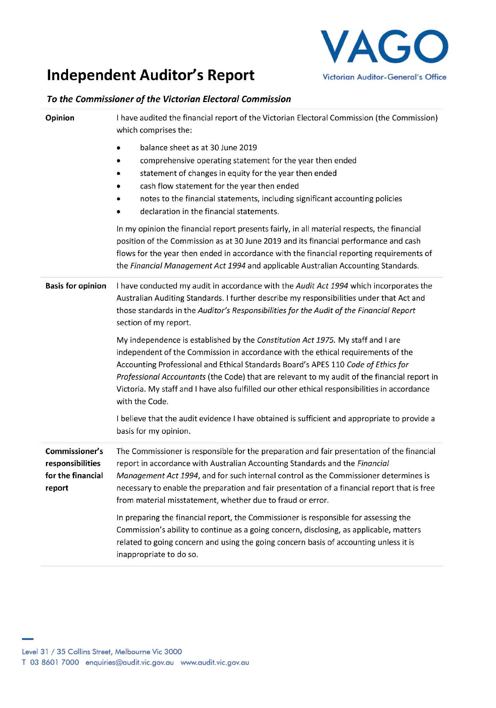

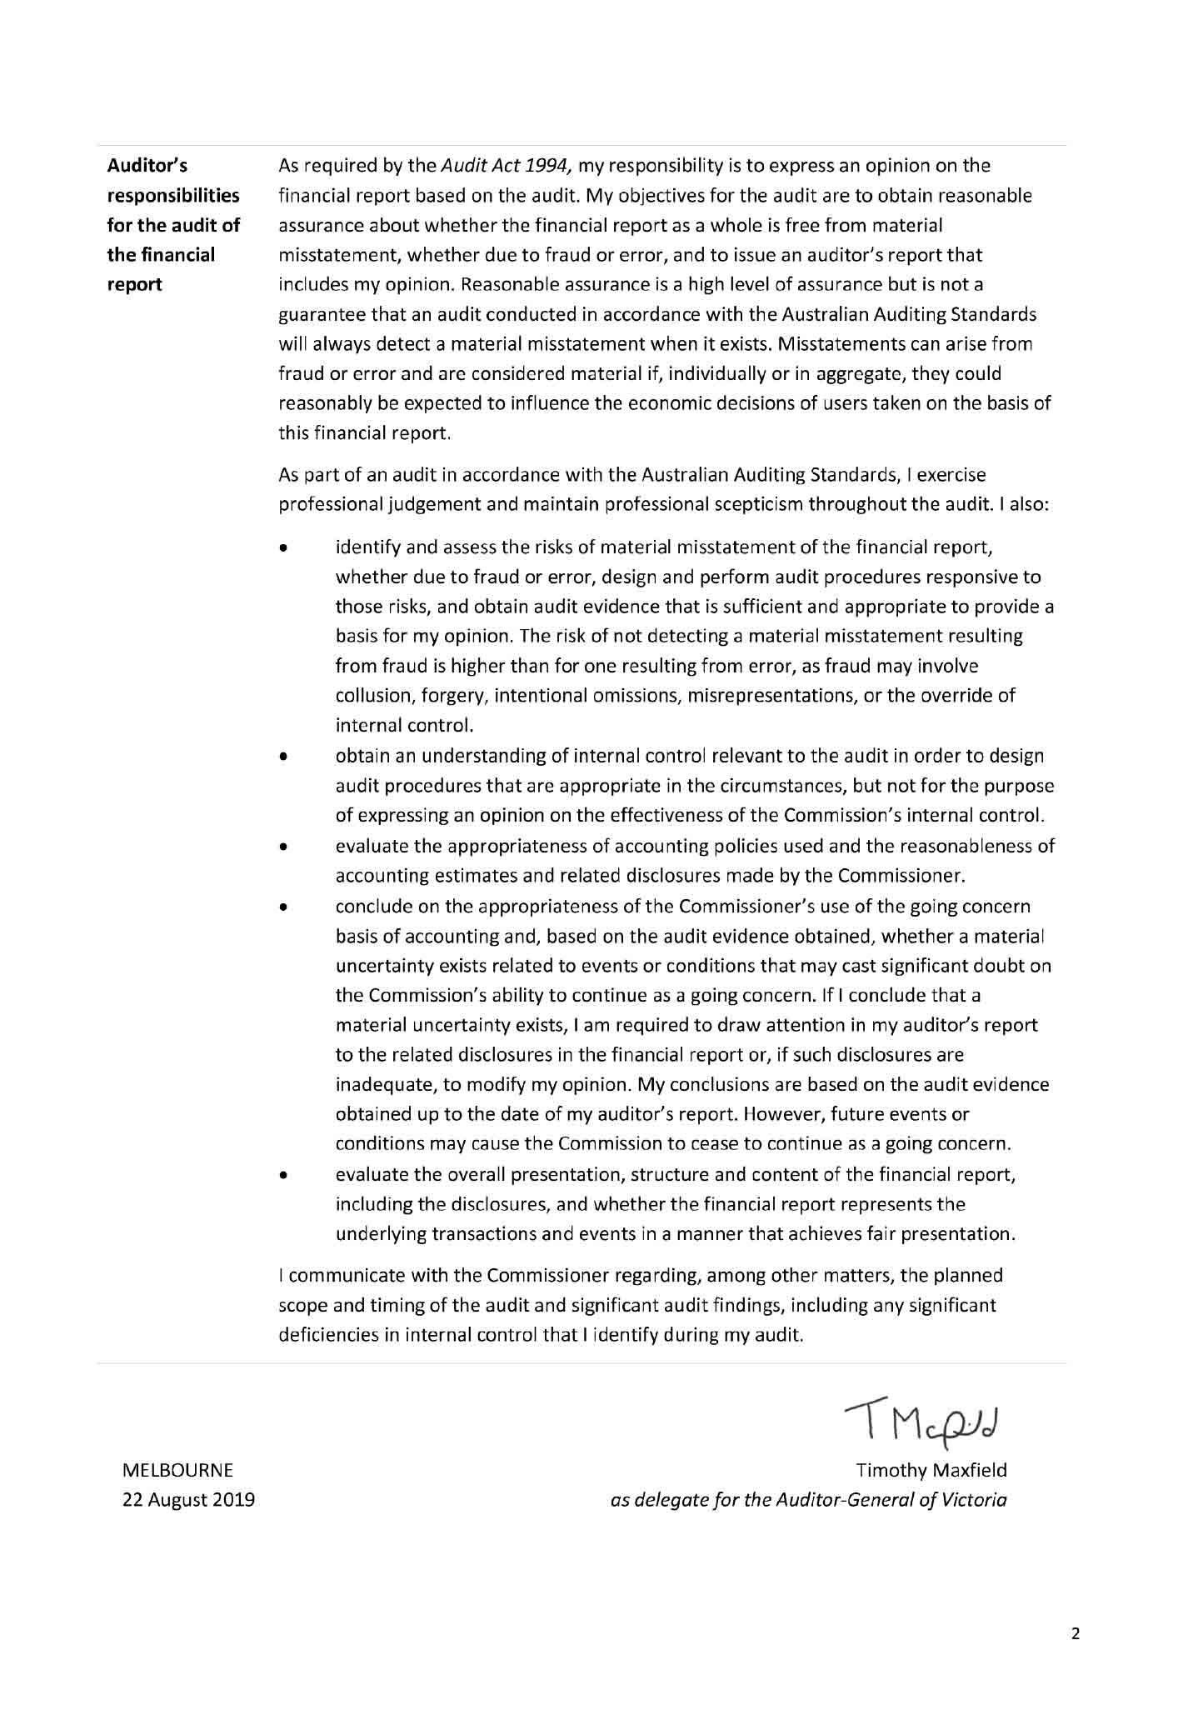

Appendices

Appendix A: Disclosure Index

Appendix B: Governing Legislation and Regulations

Appendix C: Additional Information Available on Request

Appendix D: Reporting Procedures under the Protected Disclosure Act 2012

Appendix E: Making a Request under the Freedom of Information Act 1982

Appendix F: Attestation for compliance

Appendix G: Report of the Electoral Boundaries Commission 2018-19

Appendix A: Disclosure index
Requirement
MINISTERIAL DIRECTIONS
Report of operations - FRD Guidance
Charter and purpose
FRD 22H | Manner of establishment and the relevant Ministers
FRD 22H | Purpose, functions, powers and duties
FRD 22H | Nature and range of services provided
Management and structure
FRD 22H | Organisational structure
Financial and other information
FRD 8D | Budget portfolio outcomes
FRD 10A | Disclosure index
FRD 12B | Disclosure of major contracts
FRD 15D | Executive Officer disclosures
FRD 22H | Disclosure of government advertising expenditure
FRD 22H | Operational and budgetary objectives and performance against objectives
FRD 22H | Employment and conduct principles
FRD 22H | Occupational health and safety policy
FRD 22H | Summary of the financial results for the year
FRD 22H | Significant changes in financial position during the year
FRD 22H | Major changes or factors affecting performance
FRD 22H | Subsequent events
FRD 22H | Application and operation of Freedom of Information Act 1982
FRD 22H | Compliance with building and maintenance provisions of Building Act 1993
FRD 22H | Statement on National Competition Policy
FRD 22H | Application and operation of the Protected Disclosures Act 2012
FRD 22H | Application and operation of the Carers Recognition Act 2012
FRD 22H | Details of consultancies over $10,000
FRD 22H | Details of consultancies under $10,000
FRD 22H | Statement of availability of other information
FRD 24C | Reporting of office-based environmental impacts
FRD 25D | Local jobs first
FRD 29C | Workforce Data disclosures
Compliance attestation and declaration
SD 3.7.1 | Attestation for compliance with Ministerial Standing Direction
SD 5.2.3 | Declaration in report of operations
FINANCIAL REPORT
Financial statements
Declaration
SD 5.2.2 | Declaration in financial statements
Other requirements under Standing Directions 5.2
SD 5.2.1(a) | Compliance with Australian accounting standards and other authoritative pronouncements
SD 5.2.1(a) | Compliance with Standing Directions
SD 5.2.2(a) | Accountable officer’s declaration
SD 5.2.1(b) | Compliance with Model Financial Report
Other disclosures as required by FRDs in notes to the financial statements
FRD 9A | Departmental disclosure of Administered Assets and Liabilities by Activity
FRD 11A | Disclosure of ex-gratia expenses
FRD 13 | Disclosure of parliamentary appropriations
FRD 21C | Disclosures of responsible persons, executive officers and other personnel (contractors with significant management responsibilities) in the Financial Report
FRD 102A | Inventories
FRD 103H | Non-financial physical assets
FRD 106B | Impairment of assets
FRD 109A | Intangible assets
FRD 110A | Cash flow statements
FRD 112D | Defined benefit superannuation obligations
FRD 114C | Financial Instruments - General Government Entities and public non-financial corporations

Appendix B: Governing legislation
and regulations

Legislation
- Agricultural Industry Development Act 1990
- Building Act 1993
- Charter of Human Rights and Responsibilities Act 2006
- City of Greater Geelong Act 1993
- City of Melbourne Act 2001
- Constitution Act 1975
- Electoral Act 2002
- Electoral Boundaries Commission Act 1982
- Equal Opportunity Act 2010
- Essential Services Act 1958
- Financial Management Act 1994
- Fines Reform Act 2014
- Freedom of Information Act 1982
- Infringements Act 2006
- Juries Act 2000
- Legal Profession Act 2004
- Liquor Control Reform Act 1998
- Local Government Act 1989
- Local Jobs Act 2003
- Monetary Units Act 2004
- Privacy and Data Protection Act 2014
- Protected Disclosure Act 2012
- Public Records Act 1973
- Shop Trading Reform Act 1996
- Vital State Projects Act 1976

Regulations
- Agricultural Industry Development (Polls) Regulations 2011
- City of Melbourne (Electoral) Regulations 2012
- Electoral Regulations 2012
- Fines Reform Regulations 2017
- Infringements (General) Regulations 2006
- Infringements (Reporting and Prescribed Details and Forms) Regulations 2006
- Legal Profession (Board Election) Regulations 2006
- Liquor Control Reform Regulations 2009
- Local Government (Electoral) Regulations 2016

Appendix C: Additional information available on request
On request, the information sets below are available from the VEC.
- Details of publications produced by the VEC about itself, and where these can be obtained
- Details of changes in prices, fees, charges, rates and levies charged by the VEC
- Details of any major external reviews carried out in respect of the operation of the VEC
- Details of major research and development activities undertaken by the VEC that are not otherwise covered in this report
- Details of overseas visits undertaken, including a summary of the objectives and outcomes of each visit
- Details of assessments and measures undertaken to improve the occupational health and safety of employees not otherwise detailed in this report
- A general statement on industrial relations within the VEC and details of time lost through industrial accidents and disputes.

Appendix D: Reporting procedures under the Protected Disclosure Act 2012
Disclosures of improper conduct or detrimental action by the Victorian Electoral Commissioner or another officer of the VEC must be made to the Independent Broad-based Anti-corruption Commission (IBAC).
Independent Broad-based Anti-corruption Commission
GPO Box 24234
Melbourne VIC 3001
Phone 1300 735 135

Further information
Written guidelines outlining the system for reporting disclosures of improper conduct or detrimental action by the VEC or its employees, and the disclosure handling procedures are available from the VEC.

Appendix E: Making a request under the Freedom of Information Act 1982
As detailed in section 17 of the Freedom of Information Act 1982 (FOI Act), access to documents may be obtained through written request to the Freedom of Information Officer.
In summary, the requirements for making a request are:
- it should be in writing
- it should identify as clearly as possible which document is being requested and
  - it should be accompanied by the appropriate application fee (the fee may be waived in certain circumstances).
Requests for documents in the possession of the VEC should be lodged by email to foi@vec.vic.gov.au or by mail addressed to:
Freedom of Information Officer
Victorian Electoral Commission
Level 11, 530 Collins Street
Melbourne VIC 3000
Access charges may also apply once documents have been processed and a decision on access is made; for example, photocopying and search and retrieval charges.
The VEC may make arrangements with the applicant to provide information or documents outside of the FOI Act. This avoids the need for processing a formal FOI request.
Information that may be released outside of the FOI Act may include:
- information relating only to the applicant
- information that may have been previously released to another applicant
  - publicly available information
Further information regarding Freedom of Information can be found at the Victorian Government Freedom of Information website (ovic.vic.gov.au).

Appendix F: Attestation for compliance
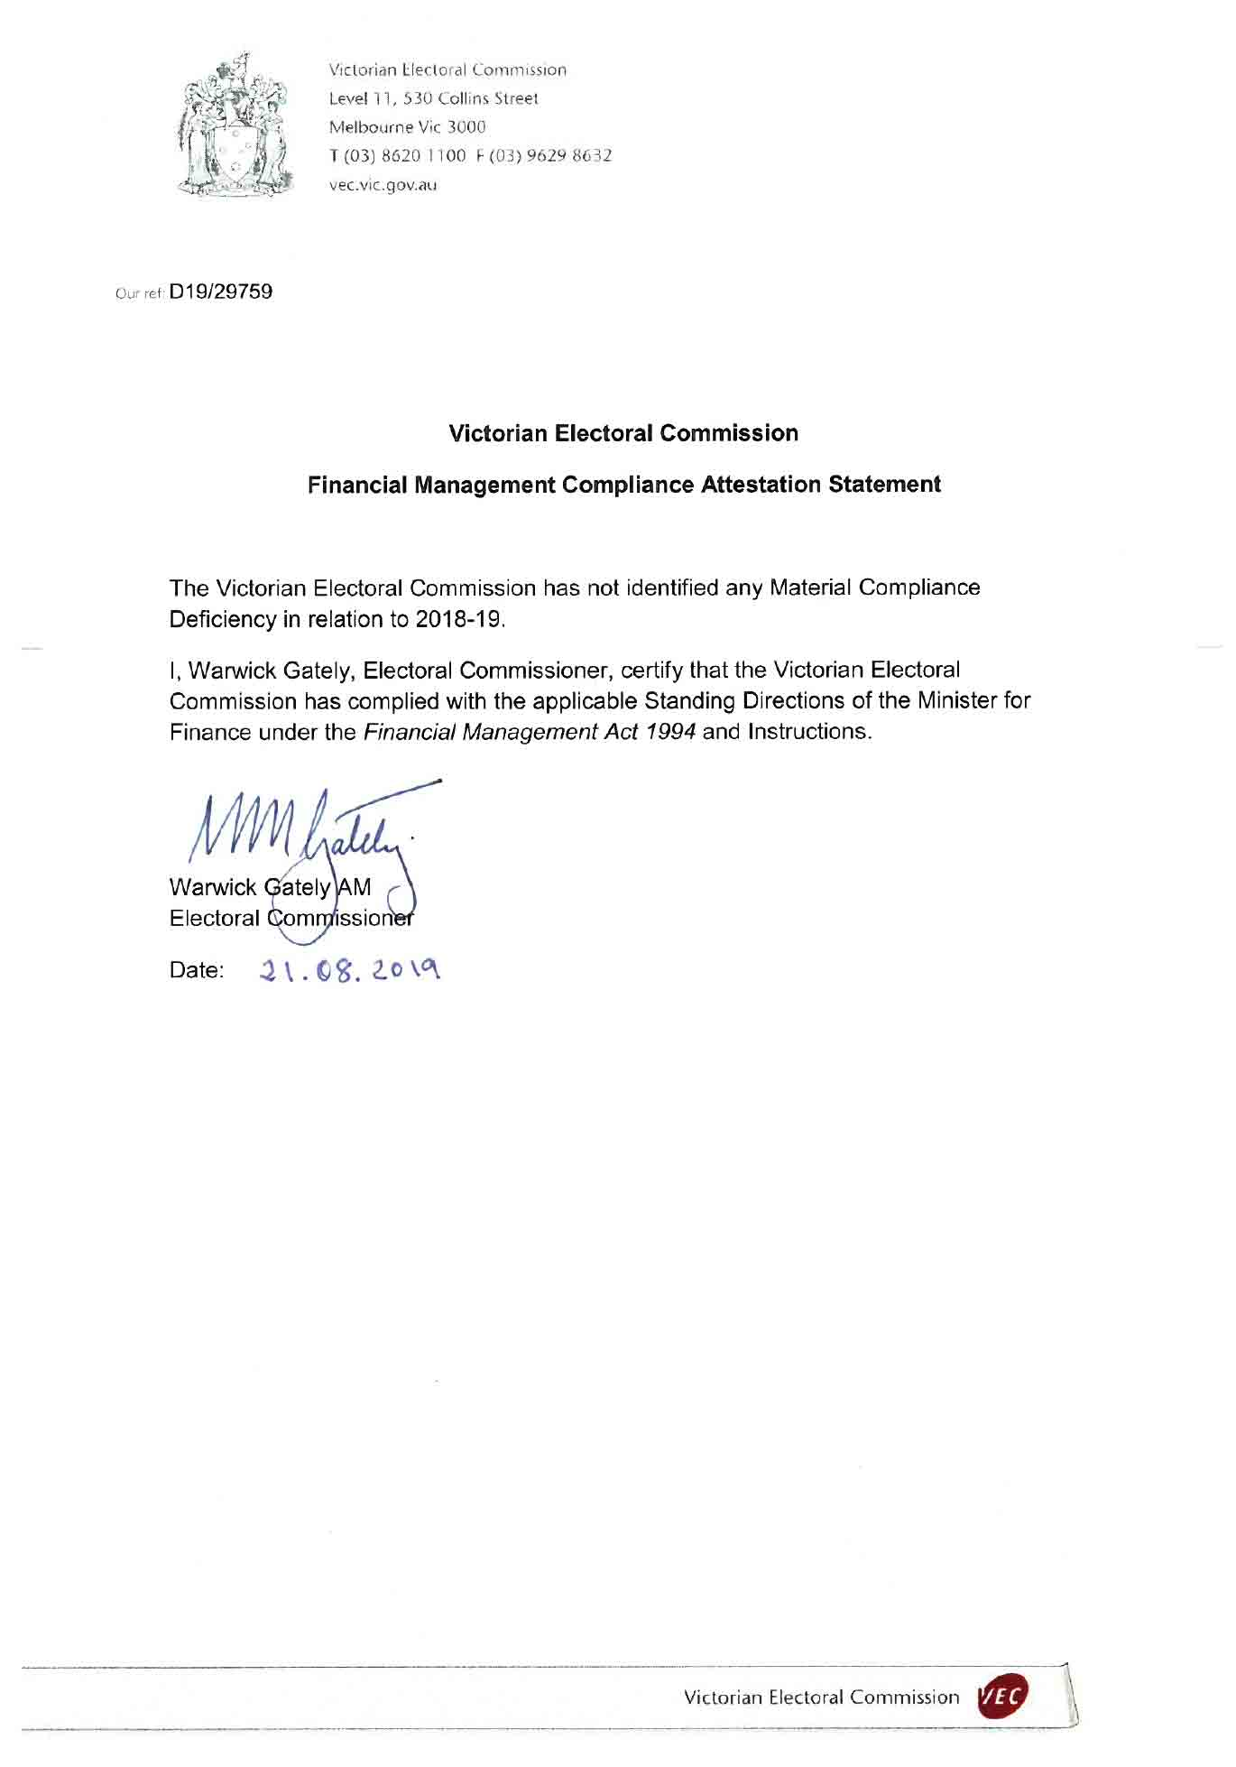

Appendix G: Report of the Electoral Boundaries Commission, 2017–18
The Electoral Boundaries Commission (EBC) is constituted under the Electoral Boundaries Commission Act 1982 (the Act). The EBC must establish and maintain electorates of approximately equal enrolment (that is, not varying by more than 10% from the average for each House of Parliament) for the conduct of parliamentary elections.
The members of the EBC during 2018–19 were:
- the Honourable Justice Peter Kidd, Chief Judge of the County Court of Victoria (Chairman)
- Mr Warwick Gately AM, Electoral Commissioner
  - Mr Craig Sandy, Surveyor-General for Victoria.
The VEC provides administrative and technical support to the EBC and Dr Paul Thornton-Smith of the VEC is the secretary.
The EBC was not required to meet during 2018-19. The next redivision of electoral boundaries will take place before the 2022 State election, in accordance with the provision that a redivision must take place after every two general elections.

GLOSSARY
Attendance election
In an attendance election voting is conducted at voting centres on election day, although voters may vote at early voting centres or by postal vote.
Ballot
A method of secret voting.
By-election
A by-election is an election in a single-member electorate to fill a casual vacancy caused by the departure of a sitting Member of Parliament or local government councillor before the term expires. A by-election may also be held in a multi-member electorate when no unsuccessful candidates remain for a countback.
Candidate
A candidate is an eligible elector who nominates for election.
Community of interest
The VEC defines a community of interest as a group of people who share a range of common concerns or aspirations. A community of interest may occur where people are linked with each other geographically
(e.g. a town or valley) or economically, such as where people work in similar industries (e.g. tourism) or where people work in mutually-dependent industries
(e.g. fruit growers, transporters and canners).
A community of interest may also appear where people share a number of special needs because of similar circumstances (such as new immigrants who may have little English, require assistance with housing or need help finding employment).
Compulsory enrolment
All Australian citizens 18 years and over are required by law to enrol.
Compulsory voting
All enrolled electors must vote at State elections. With some exceptions, enrolled voters must vote at local government elections.
Contested election
A contested election is an election where more candidates than the number of vacancies for the election have nominated by the close of nominations.
Continuous Roll Update (CRU)
The CRU process consists of a range of strategies to ensure that the electoral roll is continuously kept up-to-date by using internal and external data to direct roll review activities to targeted people and residences.
Councillor
An elected representative of a local government council.

Countback
Method of filling extraordinary vacancies in multi-member wards and unsubdivided municipalities in electorates where general election results were obtained using the proportional representation method. The votes of the vacating councillor are transferred to the previously unelected candidates to fill the vacancy.
District
One of the 88 Legislative Assembly electorates in Victoria. Each District elects one member and comprises approximately 47,000 electors.
Election
An event at which electors choose their representatives.
Election date
The legislated date of the election.
Election Manager
A person appointed by the Electoral Commissioner to conduct an election for a State electoral District or Region.
Elector
A person whose name appears on the Register of Electors and who is entitled to vote in elections.
Electoral Commissioner
The statutory officer appointed by the Governor in Council with responsibility for the proper conduct of parliamentary and statutory elections.
Electoral Matters Committee (EMC)
The EMC comprises ten Members of Parliament drawn from both Houses and is a Joint Investigatory Committee of the Parliament of Victoria. Its powers and responsibilities are determined by the Parliamentary Committees Act 2003. The EMC inquires into, considers and reports to the Parliament on any proposal, matter or thing concerned with the conduct of parliamentary elections and referendums in Victoria, the conduct of elections of councillors under the Local Government Act 1989 and the administration of, or practices associated with, the Electoral Act 2002 and any other law relating to electoral matters.
Electoral roll
A list of names of all the people who are entitled to vote in an election under relevant legislation.
Electronically-assisted voting
A method of casting a vote in State elections by electors who are blind or have low vision, or have a motor impairment.
Enrolment
The placement of a person’s name and address on the Register of Electors. A person cannot vote at an election unless they are enrolled.
Enrolment information
The information about electors that is held by the VEC.

Entitlement date
To be eligible to vote at a local government election, people must be on the State or local government voters roll 57 days before election day. This is called the ‘entitlement date’.
Geo-coding
Geo-coding is the process of assigning geographic identifiers (e.g. codes or geographic coordinates expressed as latitude-longitude) to map features and other data records, such as street addresses.
Informal vote
A ballot paper that is either left blank or is incorrectly marked. These ballot papers do not contribute to the election of a candidate.
Legislative Assembly (Lower House)
One of the two Houses in the Victorian State Parliament. There are 88 Members of the Legislative Assembly (MLAs), one from each electoral district. The party or coalition of parties that wins majority support in this House forms the Government.
Legislative Council (Upper House)
One of the two Houses in the Victorian State Parliament. There are 40 Members of the Legislative Council (MLCs), five from each region. The Legislative Council is often referred to as the ‘House of Review’.
Lost Time Injury (LTI)
An LTI is an occupational injury or illness that results in days away from work on any rostered shift subsequent to that on which the injury occurred. A fatality is also recorded as an LTI.
Marginal costs
Marginal costs include direct labour and associated on-costs, materials, equipment, mail processing, postage, advertising, printing, rent, utilities, insurance, IT equipment and software licences purchased especially for the specific activity.
Postal election
In a postal election, voting papers are posted to voters by the Returning Officer. A vote is cast by completing a ballot paper and returning it to the Returning Officer in the reply-paid envelope provided.
Preferential voting
A vote for all candidates in order of preference. If no candidate has an absolute majority of first preference votes, preferences are distributed until one candidate has an absolute majority.
Proportional representation
A system of voting designed to elect representatives in proportion to the amount of support each has in the electorate.
Redivision
The redrawing of electoral boundaries to ensure that there are, as near as possible, equal numbers of voters in each electorate within Victoria.
Region
One of the eight Legislative Council electorates. Each region comprises approximately 526,000 electors and elects five Members.

Register of Electors
The VEC’s database of all Victorian electors.
Registered Political Party (RPP)
A political party that is registered under the Electoral Act 2002. A registered party must have at least 500 members who are Victorian electors and not members of another registered political party.
Senior Election Official
A trained election official who may be appointed to act as an Election Manager for a parliamentary election. Senior Election Officials may also be appointed to act as Returning Officers or Deputy Returning Officers for a local government election.
Victorian Electoral Commission (VEC)
The VEC is the independent statutory body that conducts State elections and certain statutory elections. The VEC also conducts local government elections, and commercial and community elections. The VEC also conducts boundary reviews and electoral research, maintains the Victorian electoral enrolment register and provides education and information services.
Voter
An elector who votes in an election.
Voting centre
A place at which electors can vote in an election. There are three types of voting centres that operate in State elections: early voting centres, mobile voting centres and election day voting centres.

INDEX

#
2018 State election
A
Aboriginal and Torres Strait Islander advisory representation
About the VEC
About this report
Accountability and transparency
Additional information available on request
Additional information available on request, list
Administrative services
Advertising disclosure
Analysis of results, State election
Appendices
Arrangements with other electoral agencies
Assets, what the VEC owns
Attestation for compliance
Attestation, Public Sector Standards Commissioner
Audit and Risk Committee
Auditor-General’s report
B
Balance sheet
Bi-annual advisory group feedback survey
Building Act 1993, compliance
C
Capability framework
Case study
Cases arising from 2018 State election
Cash flow statement
Celebrating our diversity
Change management
Changes to registered political parties
Child safe standards
Claims for workcover
Code of conduct - VEC values
Communication and engagement
Communication and Engagement Branch
Communication services, State election
Comparative workforce data
Complaints
Complaints, State election
Comprehensive operating statement
Compulsory voting, State election
Consultancies and contracts
Consultancies over $10,000
Consultancies under $10,000
Contents
Corporate reporting
Counting the votes, State election
Culturally and Linguistically Diverse (CALD) Advisory Group
Customer service charter
D
Days lost as a result of workplace-related injury
Decision-making, Strategy 2023
Declaration in the financial statements
Deputy Electoral Commissioner, profile
Disability Act 2006, Compliance
Disability Action Plan (DAP)
Disclosure Index, appendices
Disclosure index, disclosures
Disclosures
Discretionary provision of enrolment information
E
Education and inclusion services, State election
Election officials by age, State election
Elections Branch
Elections, by-elections, countbacks and polls, 2018–19
Elector statistics, District
Elector statistics, Region
Electoral Access Advisory Group
Electoral Boundaries Commission (EBC)
Electoral Commissioner, profile
Electoral Council of Australia and New Zealand (ECANZ)
Electoral Enrolment Branch
Electoral Matters Committee (EMC)
Electoral Regulation Research Network (ERRN)
Electoral representation and subdivision reviews
Employment and conduct principles
EMS redevelopment steering committee
Enforcement of compulsory voting
Enforcement of compulsory voting, statistics
Enrolment
Enrolment and turnout, State election
Enrolment programs
Enrolment transactions, summary
Environmental performance
Environmental sustainability report
Equity, what the VEC is worth
Evaluation of VEC services at 2018 State election
Evaluation, State election
Executive Director, Corporate Services, profile
Executive Management Group (EMG)
Executive officer disclosure
Expenditure
Expenses, how the VECʼs funding is utilised
External advisory groups
F
Feedback on this report
Finance at a glance
Finance Branch
Financial management
Financial management compliance framework
Financial position
Financial report
Financial statements
Flexible work arrangements
Freedom of information
Freedom of information, request procedures
FTE staffing trends
Funding
Funding and disclosure
Funding and disclosure, State election
Funding fluctuations
G
Gifts, benefits and hospitality register
Glossary
Governance
Governing legislation and regulations, list
Governing legislation and tribunals
Grants and transfer payments, disclosure
H
Hazards, incidents and injuries
Hazards, incidents and injuries reported
Hepburn Shire Council, Coliban Ward by-election
History and functions, VEC
Homelessness Advisory Group
Human resource management
Human resources
I
Identifying and managing risk
Inclusion and participation
Index
Information and records management
Information Technology Branch
Inquiries and disputes, State election
Interaction with electoral bodies
Internal audit
Internal committees and groups
K
Knox City Council, Collier Ward by-election
L
Legislation
Legislative and regulatory amendments
Letter of transmittal
Liabilities, what the VEC owes
Local government by-elections and countbacks
Lodgement with the courts, compulsory voting
Looking ahead
M
Major Projects Group (MPG)
Managers community of practice
Mandatory provision of enrolment information
Media services, State election
Meeting our statutory and administrative responsibilities
N
National competition policy
New applications for registration
Notes to the financial statements
O
Occupational health and safety
Occupational Health and Safety Committee
Occupational health and safety management
Operational and budgetary objectives and performance against objectives
Operational planning and action
Organisational structure
Other elections and polls
Other electoral activity
Other interactions
Our commission
Our core business
Our highlights
Our next significant event
Our people
Our people, our year
Our stakeholders
Our strategic plan
Our year, message from the Electoral Commissioner
P
Pecuniary interest declaration
People and partners, VEC
People, Strategy 2023
Performance and development champions
Planning Group
Protected Disclosure Act 2012, reporting procedures
Protected Disclosures Act 2012
Provision of enrolment information
Purpose, VEC
Pyrenees Shire Council, Beaufort Ward by-election
R
Re-branded employee assistance services
Reconciliation Action Plan (RAP)
Recruitment (FTE ongoing)
Recruitment, departures and turnover
Register of electors
Register of political parties
Registered political parties, list
Registration of political party logos
Relationships, Strategy 2023
Report of the Electoral Boundaries Commission (EBC)
Research and development
Research into best practice inclusion for people with intellectual disability
Resource Smart Committee
Review of registered political parties
S
Service delivery excellence
Services to candidates and political parties, State election
Services to political parties
Spotlight on…
Staff engagement
Staff profile
Staffing, State election
State by-elections
Statement of changes in equity
Statistical overview, State election
Strategic planning and capacity building
Swan Hill Rural City Council, Murray-Mallee and Robinvale Ward by-elections
T
Technology, Strategy 2023
V
Values, VEC
VEC staff by gender
VEC staff profile
VEC’s performance against OHS management measures
Victorian industry participation policy
Vision, VEC
Voluntary de-registration of political parties
Voting services provided to other electoral agencies
Voting, State election
W
Warehouse
Wellbeing for elections
Workforce profile

Feedback on this report is welcome.
Please mark to the attention of:
Executive Services
Victorian Electoral Commission
Level 11, 530 Collins Street
Melbourne VIC 3000
Phone: (03) 8620 1100
Email: info@vec.vic.gov.au
Australasian Reporting Awards
2017-18 Gold
2016–17 Gold
2015–16 Gold
2014–15 Gold
2013–14 Gold
2012–13 Gold
2011–12 Gold
2010–11 Silver
2009–10 Gold
2008–09 Silver
Creative
This report was designed and produced by Cordial Creative
www.cordialcreative.com

© State of Victoria
(Victorian Electoral Commission)
October 2019
This work, the VEC 2018-19 Annual Report, is licensed under a Creative Commons Attribution 4.0 licence (http://creativecommons.org/licenses/by/4.0/). You are free to re-use the work under that licence, on the condition that you credit the State of Victoria (Victorian Electoral Commission) as author, indicate if changes were made and comply with the other licence terms. The licence does not apply to any branding, including government logos.

