Local council electoral structure review

## About the review

Under Victoria’s *Local Government Act 2020*, Port Phillip City Council must now have a single-councillor ward electoral structure.

The Minister for Local Government has appointed an electoral representation advisory panel to conduct an electoral structure review of the council. The panel will advise the Minister on the most appropriate single-councillor ward structure for Port Phillip City Council.

The panel is looking at:

* the appropriate number of councillors and wards
* the location of ward boundaries
* appropriate ward names.

Electoral structure reviews are an important part of democracy, and your input is valuable. As a local, you know your local council area better than anyone. This is your chance to let the panel know your thoughts about the single-councillor ward electoral structure that you believe would best provide representation for your community.

There are 2 opportunities for you to have your say on the electoral structure of the council:

1. in a response submission to the preliminary report
2. at an online public hearing, if you request to speak in your response submission.

About Port Phillip City Council

The Traditional Custodians of the land in Port Phillip City Council are the Bunurong and Wurundjeri peoples.

Port Phillip City Council is between 2 and 8 km south-east of Melbourne’s city centre, with a population of 101,942 in 2021 and a forecast annual growth rate of 1.1%.

Covering an area of 21 km2, the council has distinct and diverse communities in Port Melbourne, South Melbourne, the Carlisle Street area of Balaclava, and Fitzroy and Acland streets in St Kilda.

Port Phillip City Council shares its borders with 4 other councils: Melbourne and Stonnington city councils in the north, Glen Eira City Council in the east, and Bayside City Council to the south. Its western border is Port Phillip Bay.

The council area is home to the Port Phillip foreshore and beaches, Catani Gardens, Luna Park, and Albert Park, which hosts the Australian Formula 1 Grand Prix. Major roads service the area including Queens, St Kilda and Brighton roads. The area is also well-serviced by public transport.

More Port Phillip City Council residents worked in professional, scientific, and technical services than any other industry in 2021. These industries employed 16.2% of residents.

The council area’s median age in 2021 was 38, which was slightly higher than the Greater Melbourne overall median age of 37.

Over 46% of the municipality owned their own home either outright or with a mortgage in 2021, when the median weekly household income was $2,069.

## Current structure

Port Phillip City Council is divided into 3 wards with a total of 9 councillors:

* 3 wards with 3 councillors each.

## Last review

The VEC conducted an electoral representation review of Port Phillip Council in 2015. Visit the VEC website at [vec.vic.gov.au](https://www.vec.vic.gov.au/) to access a copy of the 2015 review final report.

Review process

Monday 17 and Tuesday 18 July

### Information sessions

Session 1: 12 noon, Monday 17 July

Session 2: 6 pm, Tuesday 18 July

Information sessions are for anyone wanting to find out more about the review process. Links to register for an information session will be available on the VEC website.

Wednesday 19 July

### Preliminary report

The panel will release a preliminary report including one or more options for the electoral structure on Wednesday 19 July.

**Response submissions open from this date.**

Wednesday 9 August

### Response submission close

The panel must receive all submissions by 5 pm on Wednesday 9 August.

Late submissions will not be accepted.

Tuesday 15 August

### Public hearing

The panel will hold an online public hearing if anyone requests to speak about their response submission at 2 pm Tuesday 15 August.

The hearing will not be held if there are no requests to speak.

Wednesday 13 September

### Final report

The panel will submit a final report to the Minister for Local Government including its advice on the electoral structure on Wednesday 13 September.

The Minister will then consider the panel’s advice before recommending a change to the electoral structure. Any change to the electoral structure of the council following on from the review will apply at the next local council elections.

## Untitled-1How to make a submission

On the VEC website at [vec.vic.gov.au](http://vec.vic.gov.au/)

By email to

[PortPhillip.ERAPSubmissions  
@vec.vic.gov.au](mailto:PortPhillip.ERAPSubmissions@vec.vic.gov.au)

LetterBy post to

Electoral Representation Advisory Panel  
c/o Victorian Electoral Commission  
Level 11, 530 Collins Street  
Melbourne VIC 3000

Submissions must include your:

* full name
* contact phone number or email address
* residential or postal address.

All submissions will be published on the VEC website. Your name and locality (suburb or town) will be published, but your full address and contact details will be removed. See the submission guide and VEC website at [vec.vic.gov.au/privacy](https://www.vec.vic.gov.au/privacy) for privacy information.

## Submission guide

Download the submission guide from the VEC website at [vec.vic.gov.au](http://vec.vic.gov.au/) for more information on the review process and making a submission.

## One vote, one value

The ‘one vote, one value’ democratic principle is enshrined in the *Local Government Act 2020*. This means that every person’s vote counts equally.

When a local council area is subdivided into wards, the number of voters each councillor represents in each ward must be plus-or-minus 10% of the of the average number of voters per councillor for all the wards.

The map below includes the current number of voters in each ward and the ward’s current deviation from the average. The panel will consider likely population and voter changes to ensure the structure remains equitable.

If you make a submission online, you can use a mapping tool to build your preferred electoral structure. The tool uses current voter numbers to tell you the deviations of the wards you make. This will help you propose a structure that meets the requirements of the Act.

Current electoral structure

Map of the electoral structure of Port Phillip City Council showing the area is divided into 3 wards. As at March 2023 there are 9 councillors and a total of 97,755 voters. 


|  |  |  |  |
| --- | --- | --- | --- |
| Ward | Councillors | Voters | Deviation |
| Canal Ward | 3 | 31,684 | -2.77% |
| Gateway Ward | 3 | 32,842 | +0.79% |
| Lake Ward | 3 | 33,229 | +1.98% |

## Statistics

Area (km2): 21

Voters

### Voters per square km

4,655

### Average voters per councillor

10,861

Population

### Current population

101,942

### Forecast population growth

1.1% p.a.

Further census statistics available at [abs.gov.au](http://www.abs.gov.au)

Voter numbers by locality (map)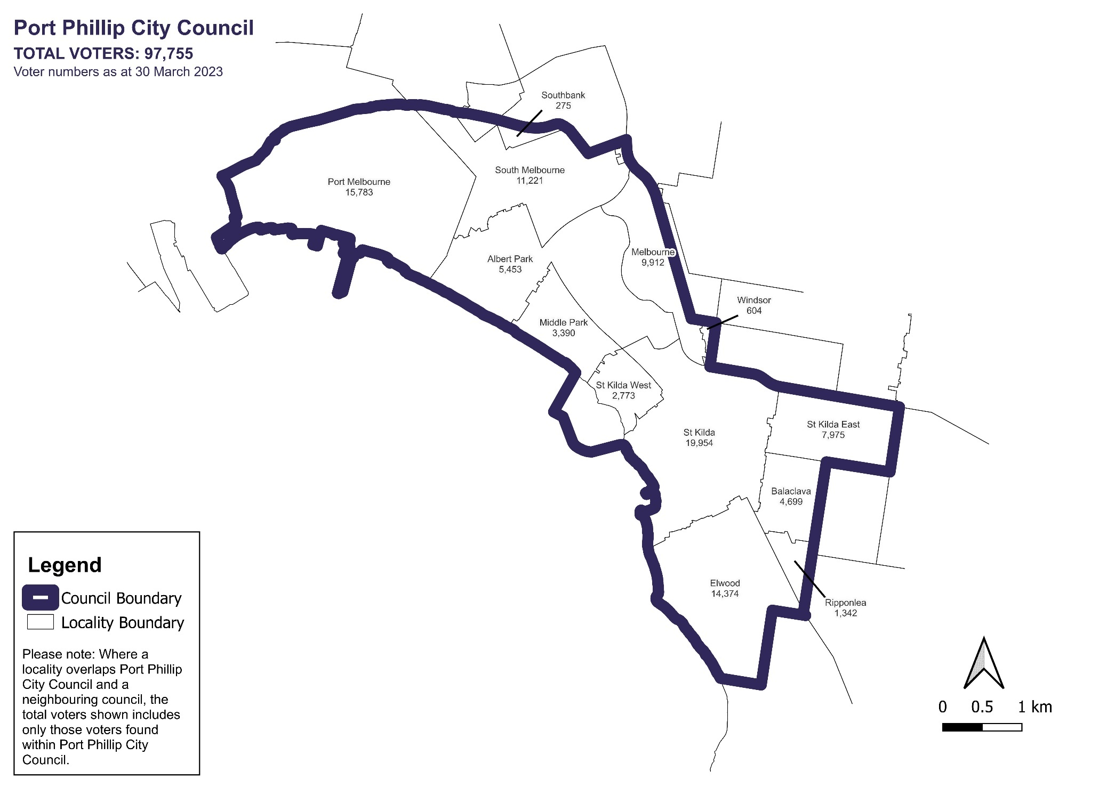

Voter numbers by locality (table)

## Port Phillip City Council voter numbers at 30 March 2023

|  |  |
| --- | --- |
| Locality | Voters |
| Albert Park | 5,453 |
| Balaclava | 4,699 |
| Elwood | 14,374 |
| Melbourne | 9,912 |
| Middle Park | 3,390 |
| Port Melbourne | 15,783 |
| Ripponlea | 1,342 |
| South Melbourne | 11,221 |
| Southbank | 275 |
| St Kilda | 19,954 |
| St Kilda East | 7,975 |
| St Kilda West | 2,773 |
| Windsor | 604 |