ELECTORAL REPRESENTATION REVIEW
Melbourne City Council
Final Report
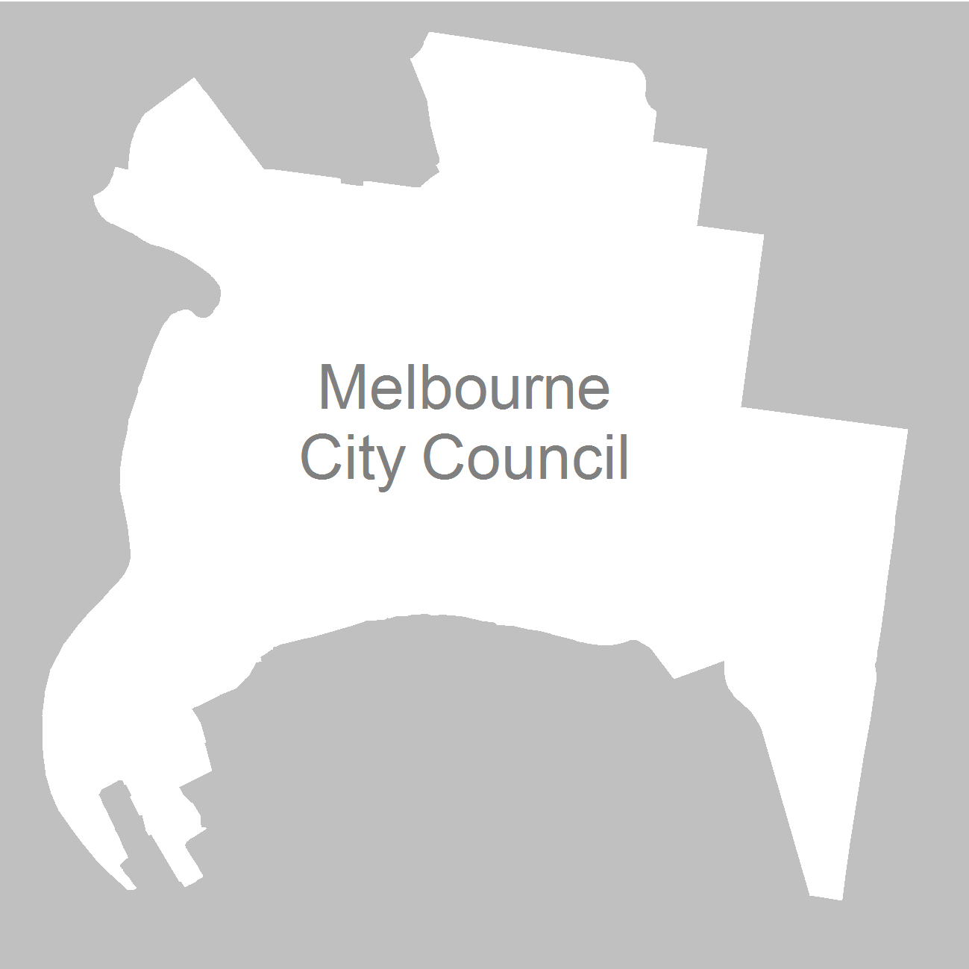

21 March 2012

Contents
Recommendation 4
Background 5
Legislative basis 5
Profile of Melbourne City Council 6
Electoral structure 6
The VEC and electoral representation reviews 6
The electoral representation review process 7
VEC research 8
Public involvement 8
Advertising 9
Media releases 9
Public information session 9
Information brochure and poster 9
Helpline 9
VEC website 10
Guide for Submissions 10
Preliminary report 11
Preliminary submissions 11
Preliminary options 12
Options 20
Public response 23
Response submissions 23
Analysis of submissions 23
Public hearing 24
Findings and Recommendation 27
Number of councillors 27
Electoral structure 28
Recommendation 38
Appendix 1: List of submitters 39
Appendix 2: Map 41

Recommendation
The Victorian Electoral Commission (VEC) recommends that Melbourne City Council consist of nine councillors (plus the Lord Mayor and Deputy Lord Mayor), to be elected from an unsubdivided municipality.

Background

Legislative basis
Unlike every other council in Victoria, the Melbourne City Council’s electoral structure is set by legislation. Under the City of Melbourne Act 2001, the Melbourne City Council consists of nine councillors. The Lord Mayor and Deputy Lord Mayor are elected directly by the voters as a team, and the other seven councillors are elected in a separate election. The city is unsubdivided, which means that all voters vote for all the candidates in an election. There has been no provision for review of this structure, so Melbourne City Council has been unreviewed while all other councils in the State have undergone electoral representation reviews.
On 30 June 2011, Melbourne City Council resolved to have an electoral representation review under the terms offered by the Minister for Local Government. On 4 July 2011, the Hon Jeanette Powell, MP, Minister for Local Government, wrote to the Electoral Commissioner requesting that he conduct a review of the Melbourne City Council’s electoral structure using the same framework for conduct of electoral representation reviews that applies to other councils. On 19 July 2011, the Electoral Commissioner replied to the Minister, undertaking to conduct the review.
The Local Government Amendment (Electoral Matters) Act 2011 (which came into operation on 1 January 2012) made the City of Melbourne subject to regular electoral representation reviews. As for other councils, reviews will take place after every third general election. The City of Melbourne Amendment Act 2011 (which came into operation on 1 February 2012) allowed for the recommendations of the representation review to be implemented by order in council.
In a context of pressure for changes to many aspects of the City of Melbourne’s electoral system, it is important to clarify the scope of the electoral representation review. The purpose of a representation review is to recommend the number of councillors and the electoral structure that provides ‘fair and equitable representation for the persons who are entitled to vote at a general election of the Council’. The VEC considered:
- the number of councillors;
- whether the City of Melbourne should be unsubdivided or subdivided;
- if it should be subdivided, the number of councillors for each ward, and the placement of ward boundaries.
The VEC could not consider the following matters:
- the position of the Lord Mayor and Deputy Lord Mayor. These will continue to be directly elected as a leadership team;
- the provisions relating to the enrolment of representatives of corporations. There will continue to be two representatives for each corporation, and the Council will continue to deem corporation representatives to be on the roll if a corporation fails to appoint its own representatives;
- whether elections should be by post or attendance. This is a matter for Council to decide; and
- the external boundaries of the City of Melbourne.

Profile of Melbourne City Council
The City of Melbourne was formed in 1995 by the amalgamation of most of the former City of Melbourne and parts of the former Cities of Essendon, Port Melbourne and South Melbourne. The City includes Melbourne’s Central Activities District (CAD) and parts or all of the suburbs of Carlton, Carlton North, Docklands, East Melbourne, Fishermans Bend, Flemington, Jolimont, Kensington, North Melbourne, Parkville, Port Melbourne, South Wharf, South Yarra, Southbank and West Melbourne.
At the 2006 census, the City recorded a population of 71,380 people. Over the next ten years, the population is projected to grow by 42.49 per cent. Growth will be concentrated in the inner city (projected to grow by 80.28 per cent) and Southbank/Docklands (with a projected growth of 74.17 per cent) while the remainder of the municipality is expected to grow by 20.74 per cent by 2021.

Electoral structure
Melbourne City Council’s previous electoral structure comprised nine councillors, with four ward councillors each representing a single-councillor ward, and five district councillors each representing the municipal district as a whole. The current unsubdivided structure with direct election of the Lord Mayor and Deputy was instituted by the City of Melbourne Act 2001.

The VEC and electoral representation reviews
The VEC has conducted Electoral Representation Reviews since 2004 on appointment by local councils. The Act was changed in 2010 to define the VEC as the only agency authorised to undertake the reviews.
The VEC drew on its experience in mapping and boundary modelling and also engaged consultants with experience in local government to provide advice on specific local representation issues during the review.

The VEC proceeds on the basis of three main principles:

The electoral representation review process
The VEC proceeded on the basis of three main principles:
- Ensuring the number of voters represented by each councillor is within 10 per cent of the average number of voters per councillor for that municipality.
Populations are continually changing. Over time these changes can lead to some wards having larger or smaller numbers of voters. As part of the review, the VEC corrected any imbalances and also took into account likely population changes to ensure these boundaries provide equitable representation until the next review.
- Taking a consistent, State-wide approach to the total number of councillors.
The VEC was guided by its comparisons of municipalities of a similar size and category to the council under review. The VEC also considered any special circumstances that may warrant the municipality to have more or fewer councillors than similar municipalities. The City of Melbourne is distinguished by many individual features, but also has commonalities with other municipalities.
- Ensuring communities of interest are as fairly represented as possible.
Each municipality contains a number of communities of interest and, where practicable, the electoral structure should be designed to take these into account. This allows elected councillors to be more effective representatives of the people in their particular municipality or ward.
The recommendation is based on:
- internal research specifically relating to the municipality under review;
- VEC experience from its work with other municipalities and in similar reviews for State elections;
- VEC expertise in mapping, demography and local government;
- careful consideration of all public input in the form of written and verbal submissions received during the review; and,
- advice received from consultants with wide experience in local government.
Public submissions were an important part of the process, but were not the only consideration during the review. The VEC seeks to combine the information gathered through public submissions with its own research and analysis of other factors, such as the need to give representation to communities of interest. The recommendation is not based on a ‘straw poll’ of the number of submissions supporting a particular option.

VEC research
Particularly in the City of Melbourne, the timing and scale of developments, and the rate at which residents move into new developments, are uncertain. It was critical that the VEC gathered information from the best sources available. The VEC obtained projected population numbers for those aged 18 years and over from ID Consulting, an expert demography consulting firm. The firm has been engaged by the City of Melbourne since 2002 to supply population forecasts to inform future planning decisions. ID Consulting adopts a conservative approach to development forecasts, and has stated that it expects Docklands to grow more slowly than other authorities have predicted. For the VEC, ID Consulting sourced and analysed data from the Melbourne City Council, the Australian Bureau of Statistics, the Department of Planning and Community Development, and other relevant government and non-government bodies.
The VEC analysed enrolment statistics to arrive at an enrolment/participation rate (electors as a percentage of the population) for all small areas within the City of Melbourne. This rate was then applied to the projected population numbers provided by ID Consulting, to produce enrolment forecasts for each small area for 2016. The VEC worked on the assumption that the number of non-resident property owners and corporation representatives will grow in the same proportion as the general population.
Some areas that currently have no residents are predicted to have a large number by 2016. For these areas, the VEC applied an enrolment/participation rate based on neighbouring areas that have recently undergone a similar development pattern.

Public involvement
The VEC values the local knowledge and perspectives presented by the public in written submissions. The public were given two opportunities to provide submissions during the review. Their input was considered by the panel in forming the options in the preliminary report and they were also invited to respond to these options. In addition, a public hearing was held to enable people to speak in support of their submissions and supplement it with information.
To ensure transparency in the process, all written submissions were published on the VEC website and all verbal submissions were heard in a public environment.
To raise awareness of the review and encourage the public to engage with the process, a full public information campaign was undertaken.

Advertising
In accordance with sections 219F(4) and 219F(7) of the Act, the VEC ensured public notices were placed in metropolitan and local newspapers.
Notification of the review appeared in The Age, the Herald Sun, the Melbourne Yarra Leader and the Moonee Valley Leader on 24 October 2011, the Melbourne Times Weekly on 26 October and the City Weekly on 27 October. The notice detailed the process for the review and called for public submissions. A general notice covering several reviews was printed in The Age and the Herald Sun on
22 October 2011.
Notification of the release of the preliminary report appeared in The Age, the Herald Sun, the Melbourne Yarra Leader and the Moonee Valley Leader on
23 January 2012, the Melbourne Times Weekly on 25 January and the City Weekly on 26 January. The notice detailed the options contained in the preliminary report, including a map of each option, instructions on how to access a copy of the preliminary report and how to make a submission in response to the report.

Media releases
The VEC distributed two media releases for this review to supplement the advertising. The first release provided information on the review and overall process. A second release detailed the options in the preliminary report and how to make a submission in response to the report.

Public information session
The VEC held three public information sessions for people interested in the review process in the Council Meeting Room, Level 2, Town Hall Administration Building, 120 Swanston Street, Melbourne at the following times:
- 5.00 pm on Monday, 7 November 2011;
- 12.30 pm on Wednesday, 9 November; and;
- 7.00 pm on Thursday, 10 November.

Information brochure and poster
An information brochure was provided to the Council to be distributed to residents through the Council’s network, such as in libraries and service centres. A poster was provided to the Council to be displayed in public spaces.

Helpline
A dedicated helpline was established to assist with public enquiries concerning the review process.

VEC website
The VEC website delivered up-to-date information to provide transparency during the preliminary and response stages of the review process. All submissions were posted on the website and an online submission tool was created to facilitate the submission process. The preliminary report was available for electronic download on the website.

Guide for Submissions
A guide for submissions was developed and distributed to those interested in making submissions. Copies of the guide for submissions were available on the VEC website, in hard copy on request, and were provided to the Council.

Preliminary report
On 23 January 2012, the VEC released a preliminary report outlining its proposed options for Melbourne City Council.

Preliminary submissions
By the close of preliminary submissions at 5.00pm on Thursday, 24 November 2011, the VEC received 21 submissions.
A majority of submissions supported an increase in the number of councillors to 11, to cater for the rapid growth of the City and the resulting increase in councillor workloads.
Four submissions supported the current unsubdivided structure. The Lord Mayor, Cr Robert Doyle, and Ms Elisabeth Haldane considered that this structure promoted a municipality-wide approach by councillors, which was desirable for a capital city council. The Lord Mayor also argued that a move to wards would not reflect the business structure of the municipality, nor the fact that almost 77 per cent of the rate base comes from the business community. The Proportional Representation Society supported the current structure on the ground that this best expresses the principles of proportional representation. The Melbourne City Greens were not averse in principle to a ‘3 x 3’ structure, but thought that the wards under such a structure would not match communities of interest.
Residents’ groups and their associates, constituting a clear majority of submissions, advocated a return to a ward structure. In their view, councillors under the current structure are unapproachable and unaccountable, focussed on the ‘brand’ of the City of Melbourne and on strategy rather than on representation, and tending to obliterate the differences between the various precincts of Melbourne. They stated that most councillors (and Council staff) were not even residents of the municipality. These submitters believed that residents and small businesses needed local representatives, who would be aware of their concerns and issues and would convey them to Council. These submitters considered that the unsubdivided structure precluded candidates lacking wealth, organisational support or a high profile from being elected, while with wards local people would have a chance.
Several ward structures were proposed. Cr Jackie Watts suggested that Docklands/Southbank, Carlton/Parkville and North Melbourne/West Melbourne/Kensington should have two councillors each, with single councillors for St Kilda Road/South Yarra/East Melbourne and for the corporate and residential sectors of the CADSome submitters put forward ideas that were outside the scope of the review. The Carlton Alliance wanted Carlton North and Princes Hill to be included in the City of Melbourne; the East Melbourne Group proposed a mixture of ward and at-large councillors; and the Melbourne City Greens expressed their opposition to universal postal voting, two votes for businesses and deeming provisions.
A list of submitters, by name, is available in Appendix One. Copies of the submissions can be viewed on the VEC website vec.vic.gov.au.

Preliminary options
The City of Melbourne Act 2001 provides that the Council consists of a Lord Mayor, a Deputy Lord Mayor and 7 Councillors, and that ‘The Lord Mayor and Deputy Lord Mayor are Councillors of the Council’. The representation review does not include a review of the positions of the Lord Mayor and Deputy Lord Mayor. However, in setting the total number of councillors considered to be appropriate for Melbourne City Council, the VEC is including the Lord Mayor and Deputy Lord Mayor as part of that total.
The VEC considers that similar types of municipality of a similar size should have the same number of councillors, unless special circumstances justify a variation. Melbourne is one of the largest nine-councillor municipalities, and has the fifth highest voter to councillor ratio of the metropolitan group of municipalities.
At the 2001 election, there were 63,760 voters on the roll. Since then the City of Melbourne has absorbed Docklands and parts of North Melbourne and Kensington, and the population has grown rapidly. Now there are 104,929 voters – a 65 per cent increase in ten years. Dramatic growth is expected to continue, particularly in the Central Activities District (CAD), Docklands and Southbank. The number of voters is projected to increase to some 145,000 by 2020.
A number of submissions supported an increase in the number of councillors based on population growth and increased workload.
Cr Jackie Watts argued that:
Essentially an increase in the number of Councillors is warranted because of the increased municipal ‘growth’ – increased resident population; increased budget; increased breadth of operations increased levels and diversity of business and as a consequence of being the State Capital – greatly expanded events calendar... Councillors are part-time, and to stay abreast of the issues in order to serve the municipality properly and comprehensively, more work hours are needed. The number of work hours available from each part-time Councillor is limited. The growth will continue and the City is in surplus. Therefore it can afford more Councillors and this is the solution to better oversight.
The Lord Mayor observed that ‘Given the predicted increase in the voting population of the City of Melbourne over the next decade, an increase to a total of 9 from 7 councillors may be appropriate and in keeping with the VEC’s preference for an odd number of councillors’.
The particular demands of being a capital city councillor mean that councillors have to deal with issues that do not exist in other municipalities. Unlike other Victorian councils, Melbourne City Council has a Statewide, a national and even an international dimension. Besides the events mentioned by Cr Watts, councillors would have to make decisions on economic strategy, major developments and infrastructure.
In view of the growth of the City and the extra demands on councillors as a result of being a capital city municipality, the VEC considered it appropriate to recommend an increase to 11 councillors (including the Lord Mayor and Deputy Lord Mayor) its preferred option for the review. This would reduce the number of voters per councillor to 9,539, which is comparable to many metropolitan councils. Because there have been indications that the Council is able to function effectively with the current number of councillors, the VEC also included two nine-councillor options.
In the debate on the City of Melbourne Bill 2001, the Minister for Local Government stated that stakeholders consulted by the Government ‘Overwhelmingly ... stressed the importance of encouraging quality candidates, able to effectively represent their constituency with a whole-of-city focus.’ The Government believed that ‘the best way to satisfy the expectations of the voters of the City of Melbourne was to provide for a whole-of-city electorate that is elected by proportional representation.’ It was believed that this structure would facilitate representation of the various interests within the City who would be focussed on the good of the City as a whole.
Supporters of the current structure in the current representation review argue that the unsubdivided structure encourages a municipality-wide focus that represents the interests of the electors and the City in general, and that is essential given Melbourne’s particular circumstances. In contrast, advocates for a ward structure stress that residents and small businesses need local, accountable representation, which is not possible under the current structure.
These opposing views are based on different principles, or models, of how representation should work. The VEC’s report on the 2004–2008 representation reviews noted three relevant models, basing its discussion on academic literature and VEC’s own experience:
Corporate representation
Under this model, the representative body is seen as authorised to act for the electorate as a whole, and to deliberate and make decisions on behalf of the voters. Decision making efficiency is seen as vital, and this attitude can lead to support for smaller numbers of councillors. Supporters of this model will tend to favour an unsubdivided structure.
Interest representation
Under this model, councillors are seen as the representatives of their constituents, and their task is to pursue the particular interests of their area. Supporters of this model favour wards, particularly single-councillor wards.
Mirror representation
Mirror representation seeks to create a representative body whose composition reflects the make-up of the constituents, with groups represented on the council in proportion to their numbers in the community. Supporters of this model tend to favour proportional representation, which facilitates representation of not only majorities but also minorities.
Each of these models of representation is valid in its own terms, but they lead to differing electoral structures. The VEC has taken each of these models of representation into account while developing options that suit the particular characteristics of the City of Melbourne.
The outstanding feature of the Melbourne City Council is that it is a capital city council. Across Australia, there is a wide variety of structures for capital city councils, but what they have in common is that they are regarded as special, often with their own legislation or with unusual electoral structures. The closest equivalent to Melbourne is the City of Sydney, which like Melbourne is the centre of a major metropolitan area and is a business centre for the whole of Australia. The City of Sydney covers the CAD and a belt of inner suburbs; the municipality is unsubdivided, and voters elect nine councillors and vote in a separate election for the Lord Mayor. This does not necessarily means that the City of Sydney has the best or most effective electoral structure, but it is significant that two capital city councils in similar circumstances, facing similar issues, have nearly identical electoral structures.

The City of Melbourne Act 2001 provides that
The Council has the following objectives-
- to ensure a proper balance within its community between economic, social, environmental and cultural considerations within the context of the City of Melbourne’s unique capital city responsibilities;
- to develop and implement strategic directions and policies for the City of Melbourne in collaboration with the Government of the State to ensure alignment with that Government’s strategic directions and policies for the City of Melbourne as the capital city of the State of Victoria;
- to co-ordinate with the State and Commonwealth Governments in the planning and delivery of services in the City of Melbourne in which those governments have an interest;
- to work in conjunction with the Government of the State on projects which that Government or the Council determines are significant to Melbourne.
By its very nature, reflected in the City of Melbourne Act 2001, the Melbourne City Council has a unique status and role, and this in itself means that the focus of elected councillors will differ markedly from that of other councils. Melbourne is the centre of business, government, administration, transport, the arts and entertainment for the entire State. The workforce for the CAD alone is some 250,000, or more than ten times the CAD’s population. Melbourne is a national centre for finance and investment, second only to Sydney. A key part of the Council’s role is to develop and implement strategies to further the interests of Melbourne and indirectly of the whole State. The risk of a reversion to a ward structure is that councillors may become preoccupied with local issues that they lose sight of capital city strategies, causing the Council to lose momentum. Melbourne is a council in which the corporate model of representation is particularly important. The current structure facilitates this model. The VEC regards the unique nature of the City of Melbourne as the main reason for making the current structure the preferred option for the Preliminary Report.
As well, an unsubdivided structure removes the necessity for subdivision reviews, which are highly likely in a subdivided municipality with rapid and uneven growth.
In the Council’s ‘Protocol supporting decision-making structures & city representation roles’, a Councillor’s role is to:
- provide civic leadership and contribute effectively to the interests and advancement of the Capital City and its community;
- contribute to the strategic vision for the City as a Capital City; and
- participate in deliberations of Council and its Committees.
Representation of constituents’ concerns does not appear in this document. The Council encourages residents to contact Council officers. The Council’s website states that:
We run public consultations on any major strategy or plan which affects the public spaces of the city or the wellbeing of residents, businesses or visitors.
We advertise a period of consultation in newspapers, local community publications and on our website. We will tell you how you can get a copy of the document, how you can respond to it and about any public meeting held to discuss it.
For the residents’ groups, this model of representation is unsatisfactory. Many submitters complained that they find councillors unapproachable and unwilling to deal with their concerns. In the absence of ward councillors, the residents’ groups claimed that they have to act as de facto ward councillors. Mr Kevin Chamberlin of the North and West Melbourne Association wrote that the Council used to employ local area liaison officers, but that these have been withdrawn. He argued that the Council’s Community Engagement Framework did not really engage with the community, and that there was increasing alienation of residents and small businesspeople from the Council, giving examples of four decisions where he believed the Council ignored ratepayers’ views.
Several submitters felt that the Council tends to regard the various precincts within the City as a homogeneous blur at the edge of the CAD, and is trying to obliterate the differences between them. For these submitters, each precinct has its own unique character and issues, and should have its local representative.
The Docklands Community Association:
believe it is important to be represented by Councillor[s] who live in the area of a ward, because of having:-
- a close knowledge of the issues of the ward area
- an obligation and an interest to represent those issues at Council
- an obligation to follow up and keep the ward community informed
- Docklands in particular requires ward representation because of being a newly developing area, including unique waterways, with special planning and infrastructure needs.
This is a strong statement of the interest model of representation. This is a legitimate model of representation, though councillors always need to be primarily concerned with the welfare of the municipality as a whole. The suburb profiles on the Council website reveal marked differences between the suburbs, from young, student oriented, socially diverse Carlton to affluent high-rise dwelling Southbank and older, stable, homogeneous South Yarra. Considering the concerns about lack of local representation and the clear variations between the precincts within the City of Melbourne, the VEC put forward several subdivided options in the Preliminary Report.
Residents’ submissions tended to favour single-councillor wards, assuming one local councillor for each precinct. However, it is impossible to create wards along these lines. The suburbs vary enormously in numbers of voters, ranging from less than 4,000 in Parkville to more than 34,000 in Melbourne itself. Furthermore, the municipality’s population is growing very rapidly, with growth concentrated in the CAD, Docklands and Southbank. Any ward boundaries have to allow for projected growth, to maximise their longevity and reduce the chances of a subdivision review before the next full representation review. The VEC projected voter numbers to 2016, to cover the next two elections, although the next representation review will not be due until after the 2020 council election. It was felt that projected voter numbers beyond 2016 were too likely to be unreliable.
Multi-councillor wards are less vulnerable to population shifts than single-councillor wards. Multi-councillor wards will necessarily group several suburbs. In drawing ward boundaries, the VEC takes communities of interest into account, and so needs to know the linkages and commonalities between suburbs. The Council divides the municipality into four Districts:
- District Central, comprising the CAD, East Melbourne and Jolimont;
- District North, including Carlton, Parkville, North and West Melbourne and Kensington;
- District South, covering the areas south of the Yarra, including St Kilda Road, South Yarra, Southbank, Fishermans Bend and Port Melbourne; and
- District West, comprising Docklands and the industrial part of West Melbourne.
It is useful to examine the characteristics of the various suburbs. The CAD is an area in itself – the commercial heart of the metropolitan area, with mushrooming high-rise apartments. The CAD has the highest proportions of both young people and older people in the municipality, and the most common household type is a person living alone. On the edge of the CAD are Docklands and Southbank, where rapidly increasing high-rise apartments are inhabited largely by affluent young couples without children. To the east and south-east of the CAD are East Melbourne, South Yarra and St Kilda Road, which share a stable, ethnically homogeneous population of older high-income earners. To the north and north-west of the CAD is a belt of old inner suburbs, growing relatively slowly and comprising a mixture of apartments and semi-detached housing. This area is largely gentrified, though it is still socially diverse and includes pockets of social disadvantage in the public housing towers in Carlton, North Melbourne and Kensington. Carlton and Parkville include large student populations and are focussed on the University of Melbourne. Downstream from the CAD are the industrial and transport areas of Fishermans Bend, Port Melbourne and the industrial part of West Melbourne. Although this area has no resident population, hundreds of non-resident voters are enrolled for addresses here.
The VEC modelled several ward structures proposed by submitters. Cr Watts grouped suburbs to suggest four two-councillor wards and one single-councillor ward, as shown below.
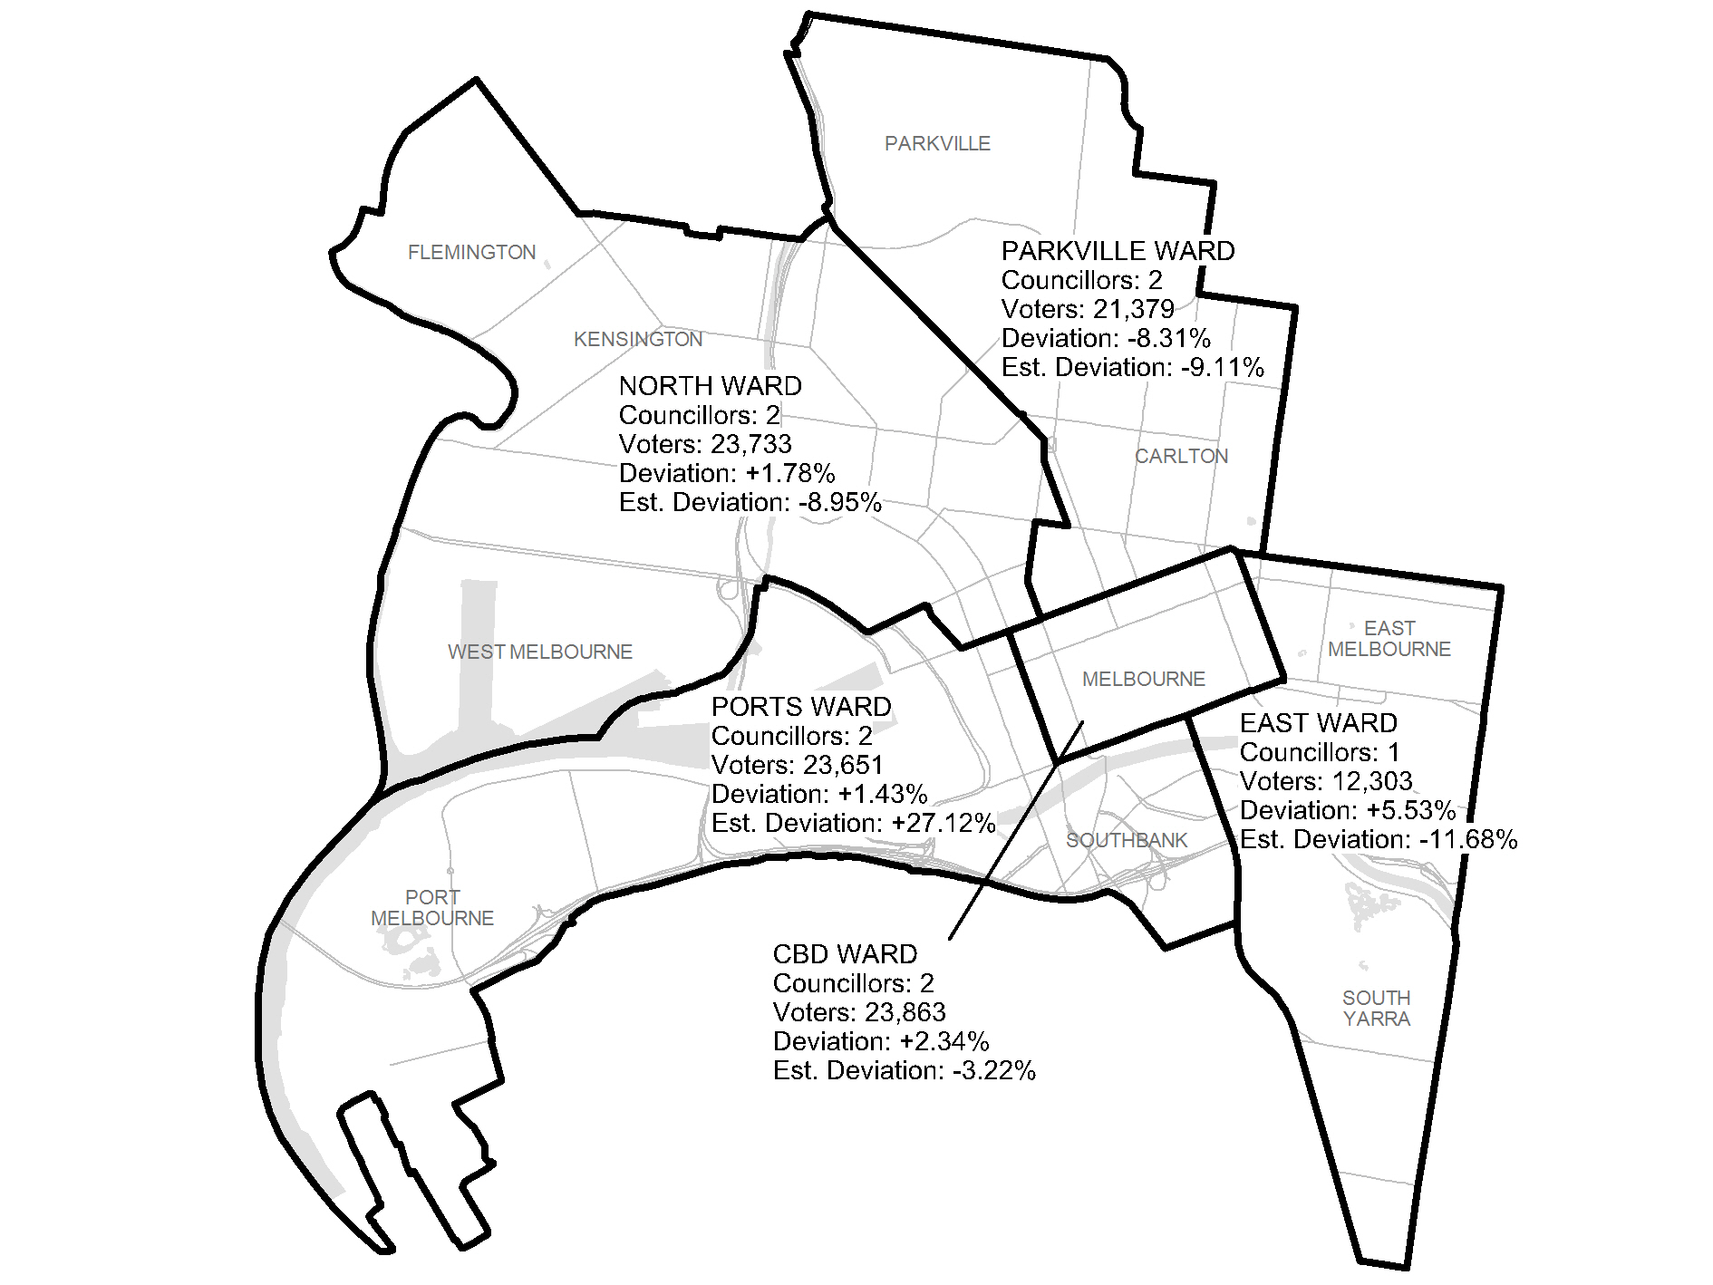
Diagram 1: Cr Watts model
Cr Watts’ model fitted communities of interest well. However, the concentration of growth areas in the Ports Ward means that enrolment for this ward would be more than 27 per cent above the average by 2016, while East Ward would be more than 10 per cent below the average and two other wards would be approaching the 10 per cent threshold. Consequently the VEC was unable to include this model as an option.
A number of submissions wanted mostly single-councillor wards. Diagram 2 shows the VEC’s best endeavour to model such a structure, with a three-councillor ward covering the CAD and Southbank.
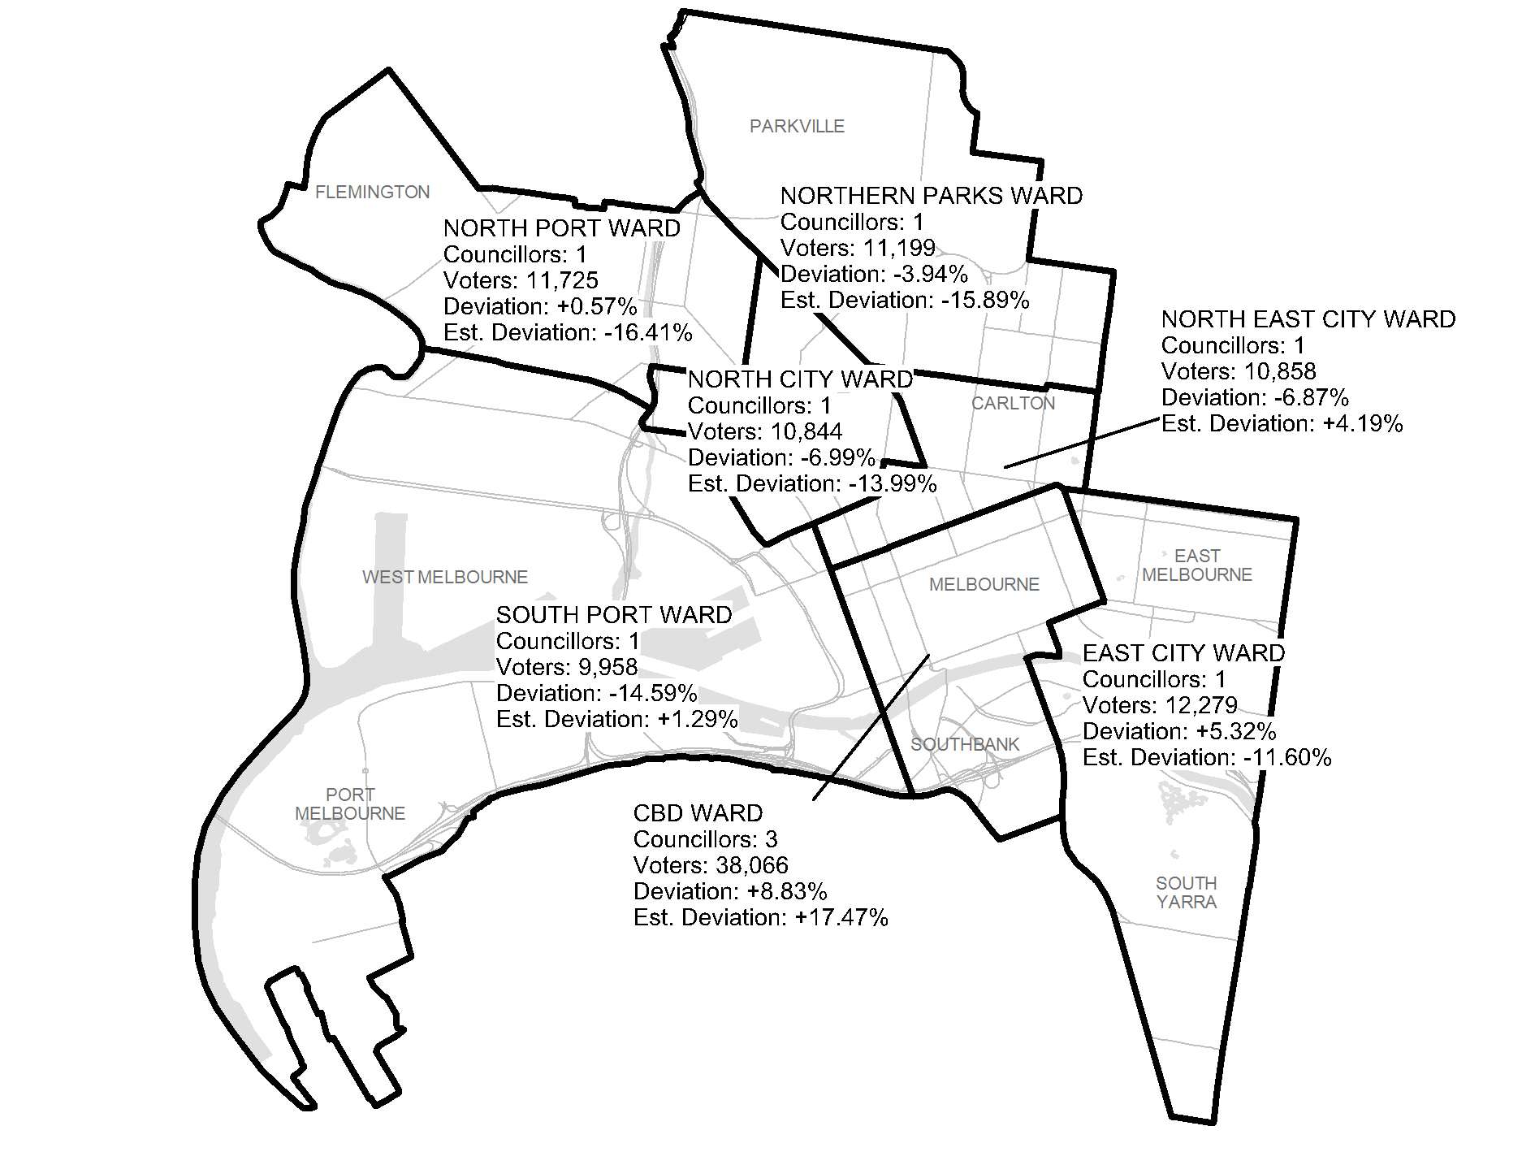
Diagram 2: Single-councillor wards, 9 councillors
It was impossible to keep wards neatly within suburbs, as proposed by the Parkville Association. The ward boundaries cut across communities of interest, especially north and north-west of the CAD. The number of voters in the South Port Ward is 14.59 per cent below the average, and five of the seven wards would be outside the 10 per cent tolerance by 2016.

Options
The VEC put forward the following six options for public comment.
Option A: Unsubdivided, 9 councillors (plus Lord Mayor and Deputy Lord Mayor)
This was the VEC’s preferred option. It takes into account the importance of the Melbourne City Council’s capital city functions, which are best suited to an unsubdivided structure, and is also able to absorb Melbourne’s uneven growth patterns. The VEC prefers an increase to nine councillors in view of the rapid growth of the City and the consequent increase in councillor workloads.

Option B: Unsubdivided, 7 councillors (plus Lord Mayor and Deputy Lord Mayor)
This alternative option was for the current unsubdivided structure with seven councillors, because there have been indications that the Council is able to function effectively with the current number of councillors.
Option C: One 3-councillor ward, three 2-councillor wards (plus Lord Mayor and Deputy Lord Mayor)
Perceived advantages of multi-councillor wards are that they allow local representation, while giving voters a choice of councillors, facilitating the representation of diversity, and encouraging a broader focus than single-councillor wards. It should be noted that ‘A Way Forward’, a December 2000 report by the Melbourne City Council Facilitation Panel that was a precursor to the City of Melbourne Act 2001, recommended the creation of multi-councillor wards with councillors elected by proportional representation.
Option C created a three-councillor ward covering the CAD, surrounded by three two-councillor wards. Voter numbers are well within tolerance both at present and in the future. The ward boundaries are clear, and mostly coincide with communities of interest, though North Melbourne and West Melbourne are split, and Kensington (in the north of the Ports Ward) might be seen as having few links with Port Melbourne and Docklands, in the south of the ward.
The ward names in option C and the three following options were suggestions, and the VEC welcomed feedback on the names.
Option D: Three 3-councillor wards (plus Lord Mayor and Deputy Lord Mayor)
An advantage of Option D is that all the wards are equal, which means that there can be no grievance that one ward had better representation than another. Again, the voter numbers are within the 10 per cent tolerance, and the ward boundaries are clear. The Bearbrass Ward (an early name for colonial Melbourne) covers the CAD and the residential part of West Melbourne. The University Ward groups the other suburbs to the north and north-west of the CAD. The Yarra River unites the Waterways Ward, though East Melbourne seems cut off from the rest of the ward.

Option E: Three 3-councillor wards splitting CAD (plus Lord Mayor and Deputy Lord Mayor)
Option E is another ‘3 x 3’ configuration. Each ward contains a segment of the CAD. The argument for this model is that each councillor would represent a microcosm of the municipality as a whole, taking responsibility for CAD matters as well as a slice of the inner suburbs. On the other hand, it could be seen as undesirable to split the very distinct community of the CAD.
Option F: Two 3-councillor wards, one single-councillor ward (plus Lord Mayor and Deputy Lord Mayor)
Option F is a subdivided seven-councillor model. This option generally conforms well with communities of interest, with the Waterways Ward including nearly all of the CAD, Docklands, Southbank and the downstream industrial areas, Zoo Ward combining the suburbs to the north and north-west of the CAD, and Botanic Ward covering the suburbs to the east and south-east.

Public response

Response submissions
The period for submissions in response to the Preliminary Report closed at 5.00pm on Thursday, 23 February 2012. Twenty-eight response submissions were received. Table 1 classifies the submissions according to support for the options in the Preliminary Report.
Table 1: Preferences expressed in response submissions for each option
A | B | C | D | E | F | Watts | N/A
6 | 2 | 6 | 1 | — | 1 | 8 | 4

Analysis of submissions
Several submissions ranked the options in preferential order. Two submissions proposed changes to the City of Melbourne’s external boundaries, which is outside the scope of the review.
As at the first stage of the review, a substantial majority of submissions (18) favoured division of the municipality into wards. A stronger majority (22) submissions) supported an increase in the number of councillors.
Supporters of the current unsubdivided structure fell into two main groups: business associations believed that this structure best suited the Council’s capital city position and was conducive to effective decision making, while organisations such as the Melbourne City Greens and the Proportional Representation Society thought that the current structure was the most proportional and so the fairest.
Supporters of a return to wards argued that the current structure was discredited and undemocratic because it resulted in councillors failing to represent residents and small businesses. In their view, a ward-based structure would be truly representative and would give local candidates a chance of election.
Proponents of wards opted for a variety of models. The most popular was a structure proposed by Cr Jackie Watts, which the VEC did not include in the Preliminary Report because the VEC’s projections indicated that enrolments in two wards would fall outside the allowable 10 per cent tolerance. Submitters argued that minor boundary adjustments would solve this problem, and suggested several areas where the ward boundaries might be moved. As well, submitters questioned the VEC’s projections and methodology. Of the options in the Preliminary Report, Option C (one three-councillor ward and three two-councillor wards) was the most popular.
A list of submitters, by name, is available in Appendix 1. Copies of the submissions can be viewed on the VEC website at vec.vic.gov.au.

Public hearing
A public hearing was held at 5.00 pm on Wednesday, 29 February 2012 at the Council Meeting Room, Level 2, Town Hall Administration Building, 120 Swanston Street, Melbourne . Everyone who made a submission in response to the report was invited to speak to their submissions and 11 individuals accepted. Members of the public were invited to attend and some 20 people, including the speakers, were present. The public hearing offered an opportunity for people to expand on their submission, and for the VEC panel to ask questions to learn more about the issues.
In the interests of a more informed debate, the VEC provided a document explaining its method of estimating projected numbers of voters, and showing the results of variations of Cr Watts’ model. Some speakers did not accept the accuracy of the models presented or the VEC’s methodology.
Cr Watts was concerned that the VEC might squander an opportunity of reform. She criticised the inclusion of a preferred option in the Preliminary Report as an improper process, and felt that the VEC had devalued the views of real constituents. In her view, the system was not working as it was intended or should. She argued that a ward structure would not disadvantage business and would not result in a parochial council, because ward-based councillors would be capable of dealing with both local and capital city issues. Cr Watts thought the VEC should give further serious attention to the model she proposed, and considered that any ward structure was better than none.
Mr David Nolte, a former councillor, stated that the Council was making poor decisions because councillors were not speaking to voters, and that voters did not have access to democratic representation. He considered Option C the best option, and did not think that the Dryburgh Street boundary through North Melbourne was a serious difficulty.
Mr Ian Bird, a committee member of the Carlton Residents Association, claimed that the representation review was a sham consultation, and that the VEC had put up four straw man ward options. He believed that under the current structure the councillors had little obligation to the community, and that the City operated in the interests of the 60 per cent of non-residents and business.
Ms Angela Munro pointed out that the representation review was dealing with only a small part of the electoral system, and criticised the undemocratic nature of that system, which favoured business and discriminated against women through such means as deeming provisions for corporations. She argued that the current system excluded a broad range of candidates and did not in practice attract high quality candidates, and that councillors were elected by virtue of being part of Lord Mayoral tickets. She believed that wards would enable democratic representation, and favoured Option F because it did not have a CAD ward, which would represent business.
Ms Greta Bird, for the Carlton Residents Association, stated there was real public interest in the review, even if people were unwilling to write submissions. She felt that the VEC had disregarded the views of real constituents, and that the primary objective of the review should be to represent communities. She stated that to run for Council, a candidate needed organisational backing or a lot of money. In answer to a question from the panel, Ms Bird stated that the Carlton Residents Association had less than 500 members, but that it informed the general community and was a source of contact for residents.
Ms Jan Lacey wanted a system that made councillors accountable to their local community. She criticised the lack of evidence provided by the VEC, and wanted to view the VEC’s data.
The Electoral Commissioner undertook to make data available. The VEC’s website included voter numbers by locality throughout the review, and the VEC would have provided small area voter data if requested.
Mr Bernd Bartl argued that the introduction of wards would make councillors more accountable to their constituents, and that councillors would carry out their capital city role regardless of the electoral structure. He favoured option C as the best compromise.
Mr Lachlan Rhodes, secretary of the Kensington Association (which has 300-500 members), stated that his Association had an effective relationship with the Council, and that a ward structure would make no difference to this. Of the ward-based options, he did not like Option C, which would link Kensington with Docklands, and preferred Options D and E. He stated that the Kensington Association considered both local issues and those affecting the whole of the municipality.
Mr Kevin Chamberlin, chairman of the North and West Melbourne Association and a former councillor and Lord Mayor, refuted the view that ward-based councillors would be incapable of dealing with the big issues, pointing to his own record and the alleged deficiencies of the current councillors. He criticised the Preliminary Report as giving credibility to the Lord Mayor’s argument that Melbourne should be unsubdivided because 77 per cent of the rate base comes from the business community. He stated that only three of the current councillors live in the municipality. In answer to a question whether Melbourne is so large and diverse that its community is city-wide, he replied that geographical divisions are important. Mr Chamberlin thought that under a subdivided structure, the Council agenda would be more democratic. He was not concerned about ward boundaries that split suburbs, believing that in fact such suburbs would get better representation.
Mr Patrick McCormick, a former resident of Boston, condemned the non-resident franchise, particularly for businesses, as an outrage on democracy, and said that that Melbourne was the least democratic city of the global cities he knew. He argued that the VEC should recommend a ward structure to mitigate the harm done by the undemocratic system. He thought that the VEC should provide datasets on its website so that anybody could work on possible models. He suggested that the VEC not make a recommendation, on the ground that there had not been enough time to do the subject justice.
Mr Anthony van der Craats, a long-term member of the Proportional Representation Society of Australia, considered that the current system is democratic, because groups are represented in proportion to their support, and a maximum of only 10 per cent of voters can be disenfranchised. Because council decisions are made as a whole, he argued that the Council should be elected as a whole. He believed that communities of interest extend beyond individual suburbs, and that the concerns of citizens of Melbourne as a whole are best represented under the current structure. In answer to a question about campaign costs, Mr van der Craats said a budget of about $20,000, to cover one mail-out, should be sufficient, though good candidates with good networks might be elected without spending as much.
Following the public hearing, the VEC placed a map showing current and projected elector estimate for small areas on its website. This information is the basis for the VEC’s work on possible ward boundaries, and is the same type of information as the VEC makes publicly available during State electoral boundary redivisions.

Findings and Recommendation

Number of councillors
The Preliminary Report’s preferred option recommended an increase in the number of councillors from seven to nine (plus the Lord Mayor and Deputy Lord Mayor). The Report also included two seven-councillor options.
The second stage of the review added little to the arguments on this matter.
VECCI (Victorian Employers’ Chamber of Commerce and Industry) did not support an increase in the number of councillors, but gave no reasons for this position. The Australian Industry Group was “of the view that the Council remains well served with the number of Councillors within the municipality. The current policy, with seven Councillors, provides adequate representation for all sectors and enables appropriate decision-making and recognition of the needs of the municipality in general”.
In contrast, two submitters thought that an increase to nine councillors (plus the Lord Mayor and Deputy) was insufficient. Ms Janet Graham argued that:
As a capital city council, regardless of comparative numbers of constituents, the City of Melbourne’s responsibilities are far more onerous, and wider reaching, than those of suburban councils. I therefore believe it should have the maximum number of councillors permitted by law, which is 12. This is on the basis of current workload, not on projected future increases, which will undoubtedly occur as the population grows.
Ms Graham dismissed the risk of tied votes as a reason against an even number of councillors, stating that in practice it is rare that all councillors are in attendance at a meeting, so the likelihood of a tied vote is no greater with 12 councillors than with any other number. She believed that more councillors would reduce the pattern of the council being divided into rigidly opposed factions, and would lead to greater diversity of representation.
Of course, an even number of councillors will not necessarily produce tied votes, nor will an odd number of councillors guarantee against ties (if not all councillors vote). Nevertheless, an even number of councillors increases the risk of tied votes, and these ties would be more likely to occur at critical divisions when all councillors are present.
The VEC considers that an increase to nine councillors (plus the Lord Mayor and Deputy) is appropriate in light of the recent and projected growth in the City of Melbourne’s population and the special responsibilities of the City’s councillors. This increase will make councillors’ workload more manageable and increase scope for diversity in representation without making the Council an unwieldy size for decision-making.

Electoral structure
The more contentious matter is which electoral structure best suits the City of Melbourne. There are valid arguments on both sides, and each of the nine-councillor options (A, C, D, and E) has the capacity to provide fair and equitable representation for the voters.
At the public hearing, Mr Chamberlin contended that the unsubdivided electoral structure, the direct election of the Lord Mayor and Deputy, the two votes and deeming provisions for corporations, and elections by post all form part of a whole, and all need to be changed to create a more democratic electoral system. The scope of the electoral representation review is legally confined to the number of councillors and the electoral structure. However, the other matters Mr Chamberlin mentioned do affect the review.
What advocates of a ward-based structure want is local representation, with councillors being representatives of their local community and accountable to that community. One of the VEC’s main principles is to ensure that communities of interest are as fairly represented as possible. This principle is constrained by the legislative requirement that the number of voters represented by each councillor must not vary by more than 10 per cent from the average for all councillors, and by the desirability of maintaining voter numbers for wards within the 10 per cent tolerance to prevent early subdivision reviews. The VEC prepared a range of ward-based models within these constraints aiming to reflect communities of interest.
The VEC was unable to accept the structure proposed by Cr Watts because enrolments for two of the five wards would fall outside the 10 per cent threshold. Several submissions argued that minor adjustments to ward boundaries would solve this problem, and suggested areas where boundaries might be moved. Cr Watts suggested two possible adjustments:
- Move the boundary between CBD Ward and Ports Ward from King Street to Spencer Street; or
- Transfer part of Southbank from Ports Ward to East Ward.
Both suggestions were intuitively attractive, and the VEC modelled them, with the following results:
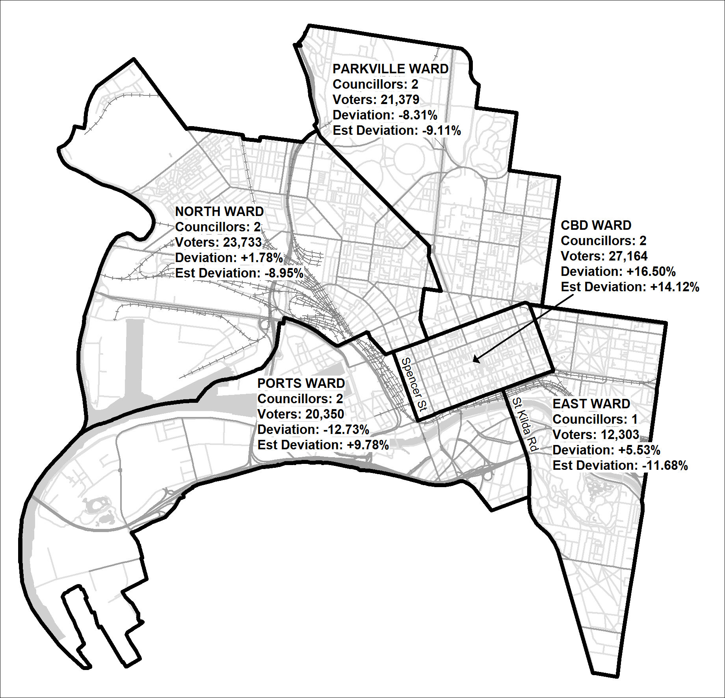
Diagram 3: Watts model: Spencer Street variation
This variation fits communities of interest better than the original model, since it includes the whole of the core CAD within the CBD Ward. However, by doing so it increases enrolment for that ward to 16.5 per cent above the average, while reducing enrolment for Ports Ward to 12.73 per cent below the average. The variation does not comply with legal requirements, and cannot be considered.
Diagram 4 shows the Southbank variation, under which East Ward would incorporate as much of Southbank as possible without exceeding the 10 per cent limit. Although enrolments for all wards would comply with the law at present, enrolment for Ports Ward is projected to balloon to 23.77 per cent above the average by 2016. As well, the boundary between East and Ports Ward would split Southbank in an arbitrary way, running largely along minor streets. Consequently, this variation also could not be accepted.

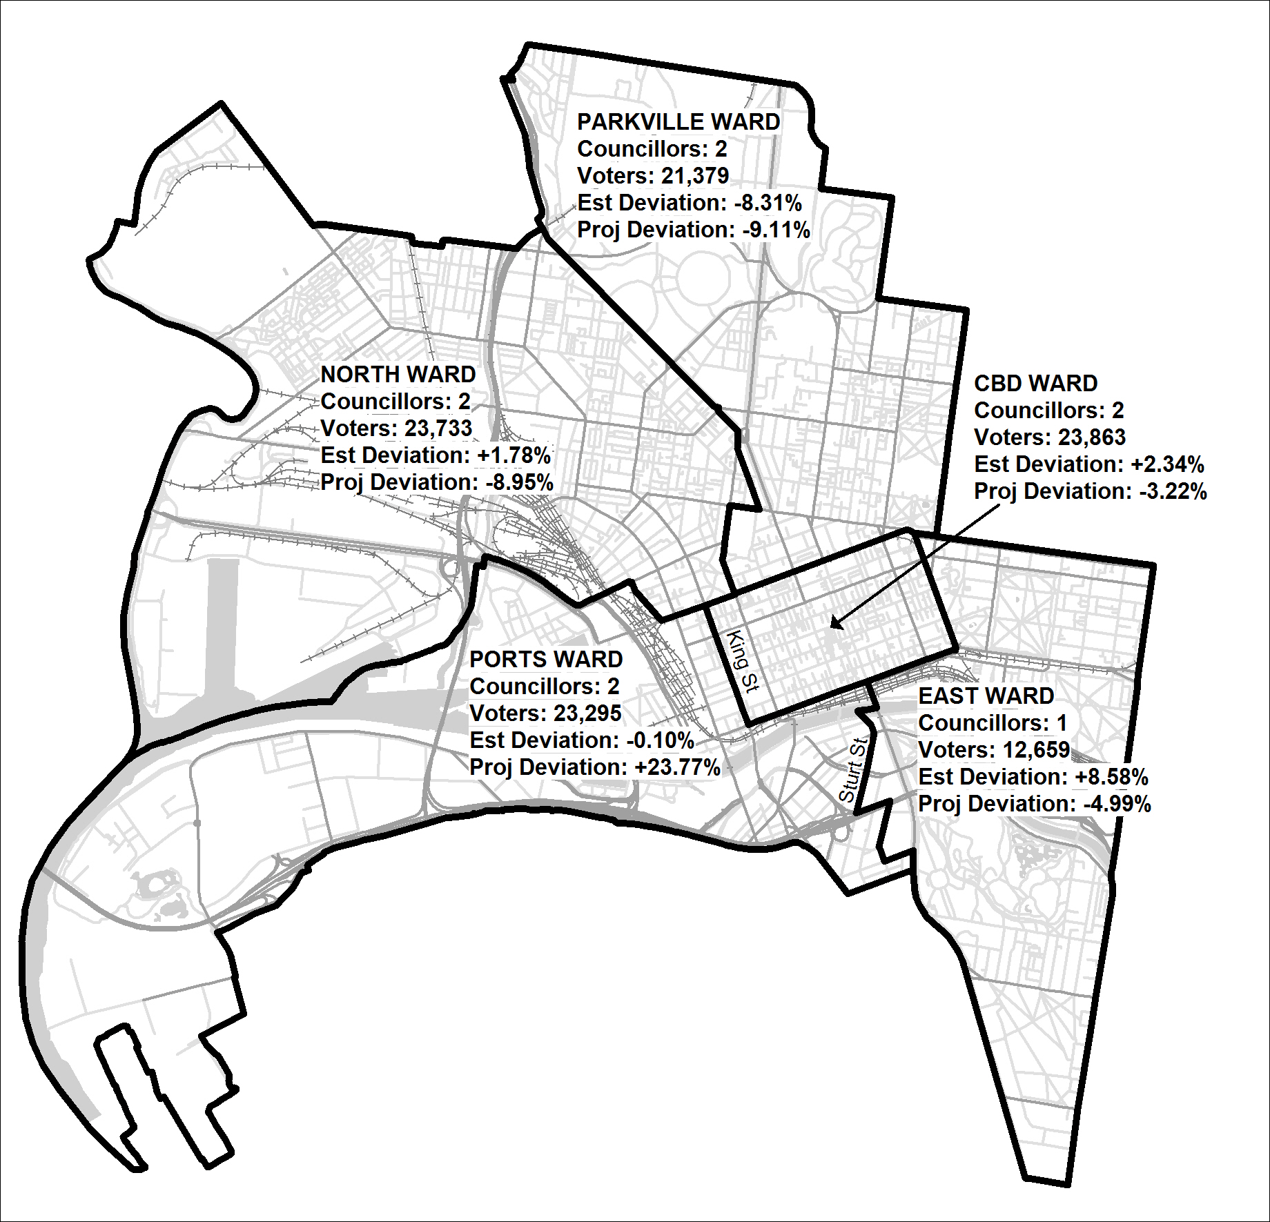
Diagram 4: Watts model: Southbank variation
At the public hearing, Cr Watts suggested transferring a councillor from the CBD Ward to the East, creating a one-councillor CBD Ward and a two-councillor East Ward. Such a change would split the CAD, and would be incompatible with a ward structure purportedly based on local communities of interest.
Turning to the VEC’s models, Option C creates the smallest possible wards that comply with legal requirements. Yet the inclusion of Kensington with Docklands is a defect, as is the splitting of North and West Melbourne.
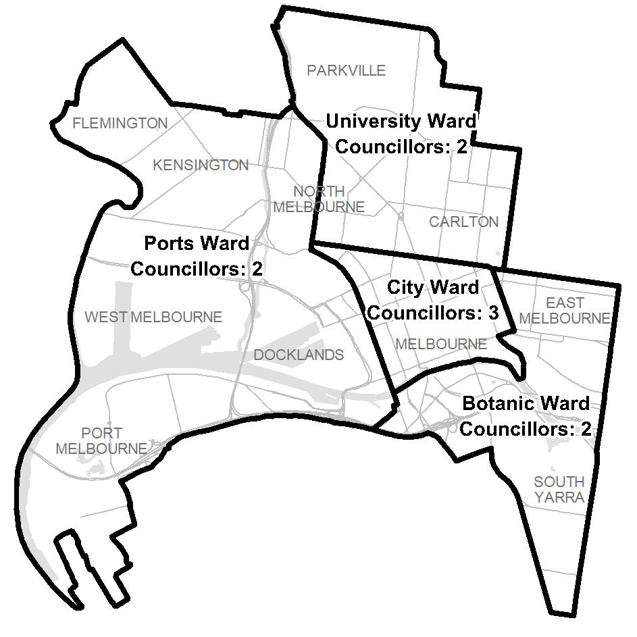
Diagram 5: Option C

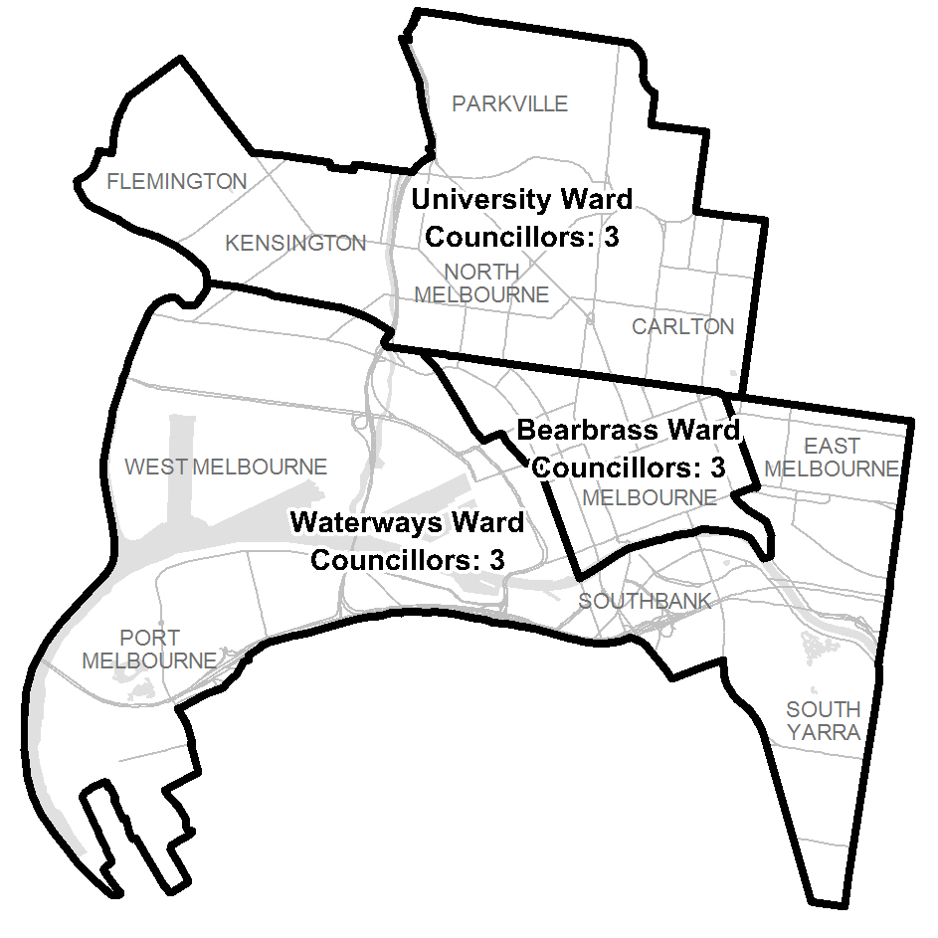
Diagram 6: Option D
Under Option D, there is parity between the three wards, with each ward electing the same number of councillors and approximately the same quota required for election. Two of the wards appear to fit broad communities of interest. However, the Waterways Ward groups disparate suburbs running the breadth of the municipality, and East Melbourne is almost cut off from the rest of the ward.
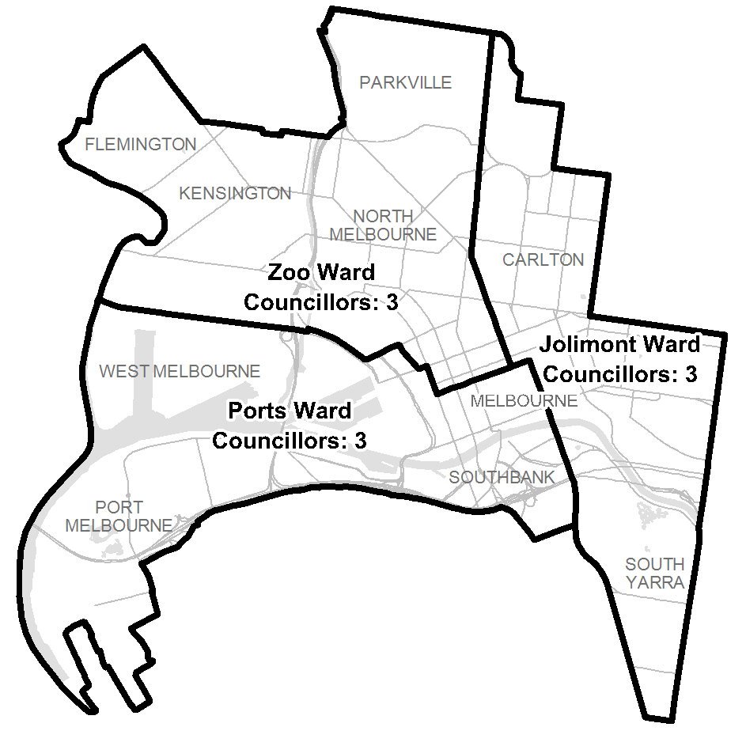
Diagram 7: Option E
Option E is a “pie slice” model, with each ward including a portion of the CAD and the wards radiating out into the surrounding suburbs. This structure would give every councillor responsibility for both the CAD and a group of suburbs. The ward boundaries generally follow suburban boundaries, but the splitting of the CAD infringes a clear community of interest.
Thus, each of the subdivided options put forward by the VEC is flawed. They are workable models, complying with legal requirements and with generally clear ward boundaries, but they are not ideal vehicles for the representation of local communities of interest.
For some submitters, any ward structure would be better than no wards at all. The critical issue is whether wards are better in principle than the current unsubdivided structure.
The purpose of an electoral representation review is “to recommend ... the electoral structure that provides fair and equitable representation for the persons who are entitled to vote at a general election of the Council”. For the City of Melbourne, the non-resident property owners and corporation representatives who comprise 60 per cent of the electorate are legally enrolled, and are just as entitled to fair and equitable representation as the residents. This has nothing to do with arguments about the proportion of rates paid by business, which is irrelevant to representation reviews.
There were no submissions from individual non-residents during the review. Submissions from business organisations, including the local Yarra River Business Association, were concerned with the welfare of the City of Melbourne as a whole rather than with local issues, and favoured an unsubdivided structure.
Residents naturally care about their local environment, and look to the Council to act on it. Yet residents are also citizens of the City of Melbourne, and are involved in City-wide issues, such as the open space and urban forest strategies, the student housing policy and car parking rates. Many communities of interest, including ethnic groups, sporting associations, environmental organisations, students and parents, transcend suburban boundaries. The complex links binding the various parts of the City suggest that the most appropriate electoral structure for Melbourne is an at-large electorate.
The residents’ groups are perfectly correct in arguing that under a subdivided-structure councillors could handle both local ward matters and city-wide issues. After all, this is what councillors in most Victorian municipalities have to do. Nevertheless, the very nature of an unsubdivided structure encourages a municipality-wide outlook. And such an outlook is particularly important for the City of Melbourne, with its capital city responsibilities.
The VEC would not consider recommending an unsubdivided structure for any other municipality of Melbourne’s size, because the likely size of the ballot paper would probably lead to an unacceptably high informal vote. However, the Senate-style ballot paper for councillor elections for the City of Melbourne removes this impediment, as voters can simply vote above the line for their preferred party or group no matter how many candidates there are.
Population growth in the City of Melbourne is so rapid and uneven that it is difficult to draw boundaries that will last. The VEC believes that the ward boundaries in its options will comply with the numbers requirements of the Act up to 2016. A subdivision review, which would be a costly and somewhat disruptive exercise, would probably be required before the 2020 Council election. With an at-large structure there would be no subdivision reviews.
For these reasons – the need to represent all the voters, the common issues and links for all residents, Melbourne’s capital city responsibilities, and the desirability of avoiding subdivision reviews, the VEC considers that the current unsubdivided structure is the most appropriate one for the City of Melbourne.
Supporters of a ward-based structure raised several arguments that need to be addressed.
There is widespread support for the reintroduction of wards
As stated above, the VEC does not base its recommendations on a straw poll of the number of submissions supporting a particular option. Still, submissions are an indication of the strength of public feeling. At both stages of the review a majority of submissions supported a change to a ward-based structure. What was remarkable, though, was how few submissions there were – 21 at the first stage and 28 response submissions. The Melbourne representation review has had a fairly high profile, and was instituted partly in response to a public campaign for a review. The release of the Preliminary Report was covered in the Herald Sun and the local newspapers, with little reaction. Yet the quantity of submissions was less than in a number of suburban and regional representation reviews. The push for change was much weaker than might have been expected. Most submissions supporting wards have come from the residents’ associations and people closely associated with them. Not all residents’ groups support a ward structure; the Kensington Association favours the continuation of the unsubdivided model.
Under the current system, only candidates who have strong financial and/or organisational backing have a real chance of being elected.
Residents’ groups argue that under an unsubdivided structure ( and with elections by post) it is difficult to contact the large numbers of non-resident voters and residents who live in secure apartment complexes. Mail-outs are the only way effective way to reach these voters, and these are very costly when there are more than 100,000 voters on the roll. Independent candidates and candidates with a local profile do not have the resources to reach these voters. The structure of the elections means that only groups that run a Lord Mayoral team have a real chance of having councillors elected.
Table 2 compares the votes for each group for the Leadership Team (Lord Mayor and Deputy) and for Councillors at the 2008 Council election. Votes for each group were very similar across the two elections, though Mr Robert Doyle’s Activate Melbourne group did less well in the election for councillors than in the Leadership Team election. It seems clear that it is beneficial for groups to stand for both elections. The election for councillors encourages candidates to form teams to take advantage of a place above the line on the ballot paper. The

Table 2: 2008 Melbourne City Council election results
Group | Leadership Team |  | Councillors
Group | Vote (%) | No. elected | Vote (%) | No. elected
Activate Melbourne | 26.1 | 2 | 20 | 1
C Melbourne Grow – Catherine Ng | 10.9 | - | 10.6 | 1
Shifting the Burden | 1.4 | - | - | -
Passion for Melbourne | 4.7 | - | 5.4 | -
The Greens | 15.1 | - | 18.4 | 1
Melbourne Supercity. World | 1.2 | - | - | -
Residents Equity – Affordable Resident Rates | 1.2 | - | - | -
Team Melbourne | 10.4 | - | 11.6 | 1
Fowles a Fresh Vision | 8.6 | - | 10.3 | 1
McMullin-Wilson For Melbourne’s Future | 12.5 | - | 12.7 | 1
Morgan Clarke – Our City – Your Council | 7.8 | - | 9.4 | 1
Forde and McEwen – Independent Locals | - | - | 1.5 | -
Source: VEC website
results were closely proportional to the first-preference votes for the group, with seven of the nine groups winning a place on the Council. Every group that obtained more than 9 per cent of the votes had a candidate elected.
In a subdivided Council, it is likely that groups associated with the Lord Mayoral teams would run in each of the wards. This fact, plus the higher quota required for election (25 per cent in a four-councillor ward) could give rise to reduced diversity of representation. In each ward there would be a high proportion of non-residents whom the candidates would need to contact, as the following table showing the number of State electors and total voters for each suburb shows.

Table 3: State electors and total voters in the City of Melbourne
Suburb | State electors | Total voters | Percentage of State electors
Carlton | 5,158 | 12,606 | 40.9
Carlton North | 4 | 8 | 50.0
Docklands | 1,571 | 7,106 | 22.1
East Melbourne | 3,274 | 6,103 | 53.6
Flemington | 40 | 182 | 22.0
Kensington | 6,264 | 8,778 | 71.4
Melbourne | 6,268 | 34,566 | 18.1
North Melbourne | 6,247 | 10,625 | 58.8
Parkville | 2,657 | 3,918 | 67.8
Port Melbourne | 3 | 730 | 0.4
Southbank | 4,668 | 11,763 | 39.7
South Wharf | 5 | 100 | 5.0
South Yarra | 2,882 | 4,296 | 67.1
West Melbourne | 1,809 | 4,148 | 43.6
Source: VEC website
In regard to the costs of campaigning, there is no cost attached to forming a group and preparing a statement, which is provided to every voter. Information on campaign expenditure by groups is not available. Returns of donations to candidates are available, with the following results: )
Table 4: Donations to Groups, 2008 Melbourne City Council Election
Group | Amount Donated ($) | Number Elected
Activate Melbourne | 81,500.00 | 3
C Melbourne Grow – Catherine Ng | 52,050.00 | 1
Shifting the Burden | 0 | 0
Passion for Melbourne | 11,800.00 | 0
The Greens | 25,050.00 | 1
Melbourne Supercity. World | 355.00 | 0
Residents Equity – Affordable Resident Rates | 1,195.00 | 0
Team Melbourne | 79,045.85 | 1
Fowles A Fresh Vision | 67,669.00 | 1
McMullin-Wilson For Melbourne’s Future | 24,500.00 | 1
Morgan Clarke – Our City – Your Council | 57,561.93 | 1
Forde and McEwen – Independent Locals | 0 | 0
Source: Melbourne City Council register of election donations
Groups that received more than $24,000 in donations had successful candidates. This squares with the statement by Mr van der Craats (a candidate in 2004) at the public hearing that the cost of a group campaign was about $20,000. Mr van der Craats also stated that strong local candidates with good networks could be elected even if they spent less than $20,000.
In short, to be elected local candidates would need to form a group and run for both the Leadership Team and Councillor elections. They would need to act together, and raise money for their campaign. However, these are not impossible obstacles, particularly considering that if the number of councillors is increased to nine, the quota for election will be reduced from 12.5 per cent to 10 per cent.
The current structure means that councillors are unapproachable
Submissions clearly express residents’ frustration at the unapproachability of the councillors. To submitters, it appears that councillors are purely concerned with major strategies, and are unwilling to listen to local concerns. The Council’s protocols do not mention local representation as part of a councillor’s role, and conduct consultations through council officers rather than councillors. The question is: Is this approach an inherent consequence of the unsubdivided structure?
The unsubdivided structure promotes a city-wide focus that tends to reduce attention to local issues. Even so, at the public hearing Cr Watts stated that councillors who live in the north and west of the municipality are currently approached by their constituents and deal with their concerns. It appears that current Council approach to representation is partly a matter of governance processes that can be changed independently of changes to the electoral structure.
Submitters have mounted strong and reasonable arguments for a change to a ward-based structure, and such a structure would have the capacity to provide fair and equitable representation. Assessment of the arguments and evidence has been a matter for judgement. The VEC concedes that reasonable people can come to different but reasonable conclusions. However, the VEC considers that on balance, the current unsubdivided structure is the most suitable one for the City of Melbourne at this time. Should there be a broader review of the City of Melbourne’s electoral system, including the municipality’s external boundaries, the direct election of the Lord Mayor and Deputy and the two votes and deeming provisions for corporations, a further representation review may be required.

Recommendation
The Victorian Electoral Commission (VEC) recommends that Melbourne City Council consists of nine councillors (plus the Lord Mayor and Deputy Lord Mayor), to be elected from an unsubdivided municipality.

S. H. Tully
Electoral Commissioner
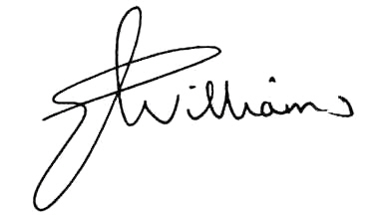
Liz Williams
Deputy Electoral Commissioner

Appendix 1: List of submitters
Preliminary submissions were received from:
Name
Bird, Ian
Birner, Henry
Carlton Alliance
Carlton Residents Association Inc.
Coalition of Resident and Business Associations – Melbourne
Docklands Community Association
Doyle, Robert
East Melbourne Group Inc.
Haldane, Elisabeth
Jackson, John
Lacey, Jan
Macnamara, Colin
Macnamara, Helen
Melbourne City Greens
North and West Melbourne Association Inc.
Parkville Association Inc.
Pohl, Nerrida
Proportional Representation Association of Australia (Victoria-Tasmania) Inc.
Residents 3000
Southbank Residents Group Inc.
Watts, Jackie

Response submissions were received from:
Name
Australian Industry Group
Bartl, Bernd*
Basile, Eila, Vincent and Reino
Bird, Ian*
Carlton Alliance
CoRBA - Melbourne
Graham, Janet
Hamilton, Olive
Hollis, David
Kennedy, Michael
Kensington Association*
Kolovrat, Maria
Lacey, Jan*
McCormick, Patrick*
Melbourne City Greens
Munro, Angela*
Nolte, David*
North and West Melbourne Association Inc.*
Proportional Representation Society of Australia (Victoria-Tasmania) Inc.
Residents Association of Parkville Gardens
Southbank Residents Group Inc.
Talbott, Julia
The Carlton Residents Association Inc.*
The East Melbourne Group Inc.
van der Craats, Anthony*
VECCI
Watts, Jackie*
Yarra River Business Association Inc.
* indicates those submitters who spoke in support of their submission at the public hearing.

Appendix 2: Map

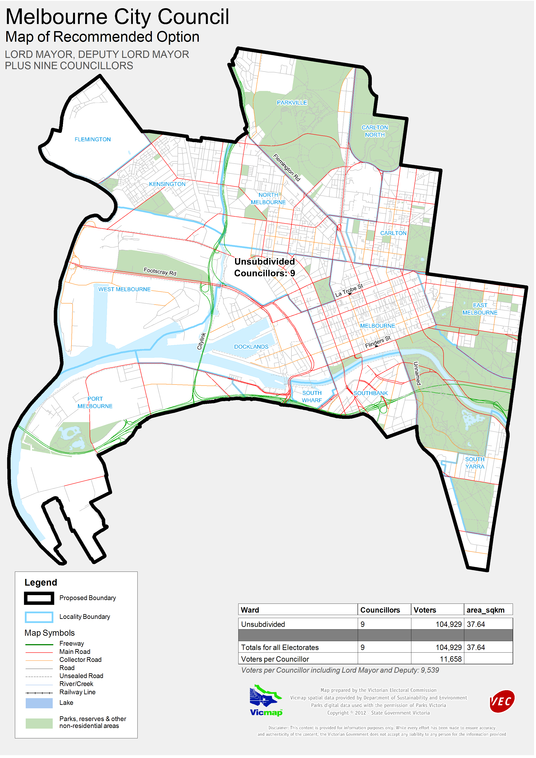

Victorian Electoral Commission
Level 11, 530 Collins Street
Melbourne, Vic 3000

131 VEC (131 832)
melbourne.review@vec.vic.gov.au
vec.vic.gov.au

Section 219D of the Local Government Act 1989.
See Docklands News, “our shrinking population”, 31 January 2012.
Section 6.
Parliamentary Debates (Hansard), Legislative Assembly, 22 March 2001, p. 436 (Hon. B Cameron, MP).
Parliamentary Debates (Hansard), Legislative Council, 3 May 2001, pp, 585-6 (Hon. G.W. Jennings, MLC).
Victorian Electoral Commission: Report of local government electoral activity 2008-09, Part III, Report of local government electoral representation reviews conducted by the VEC between 2004 and 2008, pp 4-5.
Section 7(1).
Derived from Melbourne Small Area Economic and Demographic Profile, downloaded from City of Melbourne website 16 January 2012, http://www.melbourne.vic.gov.au/AboutMelbourne/PrecinctsandSuburbs/suburbprofiles/Documents/Economic_and_Demographic_Profile_Melbourne_2008.pdf
http://www.melbourne.vic.gov.au/AboutCouncil/CouncilProfile/Documents/PROTOCOL_SUPPORTING_DECISION_MAKING.pdf, downloaded 17 January 2012.
. http://www.melbourne.vic.gov.au/AboutCouncil/financegovernance/Pages/Howweconsultwithyou.aspx, downloaded 17 January 2012.
See http://www.melbourne.vic.gov.au/AboutMelbourne/PrecinctsandSuburbs/suburbprofiles/Pages/Economicanddemographicprofiles.aspx
This range leaves out almost uninhabited fragments of suburbs, such as Carlton North (8 voters) and Flemington (182 voters).
See http://www.melbourne.vic.gov.au/AboutCouncil/grantssponsorship/Documents/DistrictPrecinctMap.PDF
? See http://www.melbourne.vic.gov.au/AboutMelbourne/PrecinctsandSuburbs/suburbprofiles/Pages/Economicanddemographicprofiles.aspx
Pp 10-11.
See Carlton Residents Association Inc. Newsflash, Spring 2011, p. 6.

