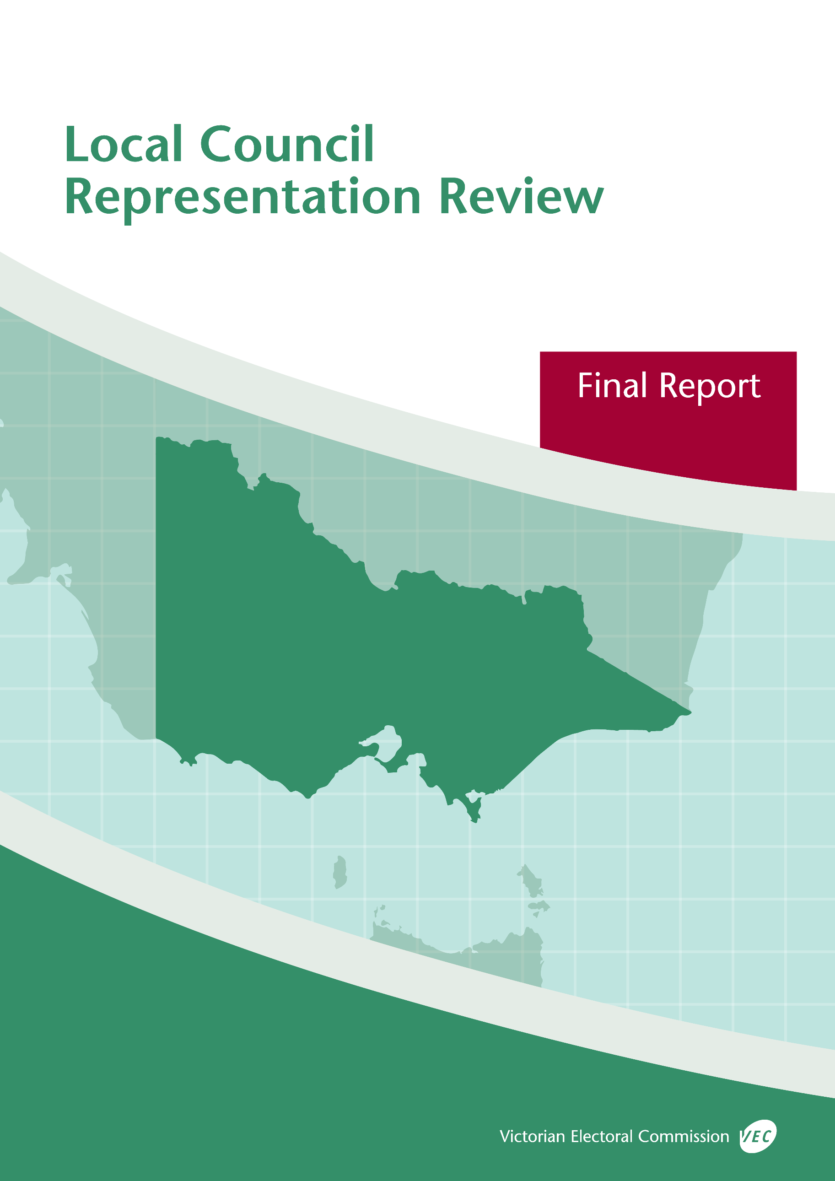



**Borough of Queenscliffe**

**May 2019**

© State of Victoria (Victorian Electoral Commission)   
Wednesday 29 May 2019

Version 1  
  
cid:image001.png@01D4D431.F774F3F0

This work, Local Council Representation Review Final Report – Borough of Queenscliffe, is licensed under a Creative Commons Attribution 4.0 licence [<http://creativecommons.org/licenses/by/4.0/>]. You are free to share this work under that licence, on the condition that you do not change any content and you credit the State of Victoria (Victorian Electoral Commission) as author and comply with the other licence terms. The licence does not apply to any branding, including Government logos.

Contents

Recommendation 1

Executive summary 2

Background 4

Legislative basis 4

Public engagement 4

The VEC’s principles 5

Developing recommendations 6

Borough of Queenscliffe representation review 8

Profile of the Borough of Queenscliffe 8

Current electoral structure 8

Preliminary submissions 9

Preliminary report 10

Public response 13

Response submissions 13

Public hearing 14

Findings and recommendation 17

The VEC’s findings 17

The VEC’s recommendation 19

Appendix 1: Public involvement 20

Appendix 2: Map 22

Appendix 3: Public information program 24

Recommendation

The Victorian Electoral Commission recommends that the Borough of Queenscliffe continue to consist of five councillors elected from an unsubdivided electoral structure.

This recommendation is submitted to the Minister for Local Government as required by the *Local Government Act 1989*.

Please see Appendix 2 for a map of this recommended structure.

Executive summary

The *Local Government Act 1989* (the Act) requires the Victorian Electoral Commission (VEC) to conduct an electoral representation review of each municipality in Victoria before every third council general election.

The purpose of an electoral representation review is to recommend an electoral structure that provides fair and equitable representation for people who are entitled to vote at a general election of the council. The matters considered by a review are:

* the number of councillors
* the electoral structure of the council (whether the council should be unsubdivided or divided into wards and, if subdivided, the ward boundaries and the number of councillors per ward).

The VEC conducts all reviews based on three main principles:

1. taking a consistent, State-wide approach to the total number of councillors
2. if subdivided, ensuring the number of voters represented by each councillor is within   
   plus-or-minus 10% of the average number of voters per councillor for that local   
   council
3. ensuring communities of interest are as fairly represented as possible.

Current electoral structure

The Borough of Queenscliffe currently comprises five councillors elected from an unsubdivided electoral structure. Prior to the last representation review in 2008, the Borough of Queenscliffe was comprised of seven councillors elected from an unsubdivided electoral structure.

Visit the VEC website at vec.vic.gov.au to access a copy of the 2008 review final report.

Preliminary submissions

Preliminary submissions opened at the commencement of the current review on Wednesday   
6 February 2019. The VEC received 22 submissions for the representation review of the Borough of Queenscliffe by the deadline at 5.00 pm on Wednesday 6 March 2019.

Preliminary report

A preliminary report was released on Wednesday 3 April 2019 with the following options for consideration:

* Option A (preferred option)  
  **The Borough of Queenscliffe consist of five councillors elected from an unsubdivided electoral structure.**
* Option B (alternative option)  
  **The Borough of Queenscliffe consist of six councillors elected from an unsubdivided electoral structure.**

Response submissions

The VEC received 13 submissions responding to the preliminary report by the deadline at 5.00 pm on Wednesday 1 May 2019.

Public hearing

The VEC conducted a public hearing for those wishing to speak about their response submission at 6.00 pm on Wednesday 8 May 2019. Eight people spoke at the hearing.

Recommendation

**The Victorian Electoral Commission recommends that the Borough of Queenscliffe continue to consist of five councillors elected from an unsubdivided electoral structure.**

This electoral structure was designated as Option A in the preliminary report. Please see Appendix 2 for a map of this recommended structure.

Background

Legislative basis

The Act requires the VEC to conduct a representation review of each local council in Victoria before every third general council election, or earlier if gazetted by the Minister for Local Government.

The Act states that the purpose of a representation review is to recommend the number of councillors and the electoral structure that provides ‘fair and equitable representation for people who are entitled to vote at a general election of the Council.’[1]

The Act requires the VEC to consider:

* the number of councillors in a local council
* whether a local council should be unsubdivided or subdivided.

If a local council is subdivided, the VEC must ensure that the number of voters represented by each councillor is within plus-or-minus 10% of the average number of voters per councillor for that local council.[2] On this basis, the review must consider the:

* number of wards
* ward boundaries
* number of councillors that should be elected for each ward.

Public engagement

### Public information program

The VEC conducted a public information program to inform the community of the representation review, including:

* public notices printed in local and state-wide papers
* a public information session to outline the review process and respond to questions from the community
* media releases announcing the commencement of the review and the release of the preliminary report
* a submission guide to explain the review process and provide background information on the scope of the review
* an information email campaign targeted at known community groups and communities of interest in the local council area
* sponsored social media advertising geo-targeted to users within the local council   
  area
* ongoing information updates and publication of submissions on the VEC website.

More information on the VEC’s public information program for the representation review of the Borough of Queenscliffe can be found at Appendix 3.

### Public consultation

Public input was accepted by the VEC via:

* preliminary submissions at the start of the review
* response submissions to the preliminary report
* a public hearing that provided an opportunity for people who had made a response submission to expand on their submission.

Public submissions are an important part of the review process but are not the only consideration. The VEC ensures its recommendations comply with the Act and are formed through careful consideration of public submissions, independent research, and analysis of all relevant factors.

The VEC’s principles

Three main principles underlie all the VEC’s work on representation reviews:

1. **Taking a consistent, State-wide approach to the total number of councillors.**

The VEC is guided by its comparisons of local councils of a similar size and category to the council under review. The VEC also considers any special circumstances that may warrant the local council having more or fewer councillors than similar local councils.

1. **If subdivided, ensuring the number of voters represented by each councillor is within plus-or-minus 10% of the average number of voters per councillor for that local council.**

This is the principle of ‘one vote, one value’, which is enshrined in the Act. This means that every person’s vote counts equally.

1. **Ensuring communities of interest are as fairly represented as possible.**

Each local council contains a number of communities of interest. Where practicable, the electoral structure should be designed to ensure they are fairly represented, and that geographic communities of interest are not split by ward boundaries. This allows elected councillors to be more effective representatives of the people and interests in their particular local council or ward.

Developing recommendations

The VEC bases its recommendations for particular electoral structures on the following information:

* internal research specifically relating to the local council under review, including data from the Australian Bureau of Statistics and .id[3]; voter statistics from the Victorian electoral roll; and other State and local government data sets
* the VEC’s experience conducting previous electoral representation reviews of local councils and similar reviews for State elections
* the VEC’s expertise in mapping, demography and local government
* careful consideration of all input from the public in written submissions received during the review and via oral submissions at the public hearing
* advice from consultants with extensive experience in local government.

### Deciding on the number of councillors

The Act allows for a local council to have between five and 12 councillors but does not specify how to decide the appropriate number.[4] In considering the number of councillors for a local council, the VEC is guided by the Victorian Parliament’s intention for fairness and equity in the local representation of voters under the Act.

The starting point in deciding the appropriate number of councillors for a local council is comparing the local council under review to other local councils of a similar size and type (Principle 1). Generally, local councils that have a larger number of voters will have a higher number of councillors. Often large populations are more likely to be diverse, both in the nature and number of their communities of interest and the issues of representation.

However, the VEC also considers the particular circumstances of each local council which could justify fewer or more councillors, such as:

* the nature and complexity of services provided by the Council
* geographic size and topography
* population growth or decline
* the social diversity of the local council.

### Deciding the electoral structure

The Act allows for a local council ward structure to be unsubdivided—with all councillors elected ‘at-large’ by all voters—or subdivided into a number of wards.

If the local council is to be subdivided into wards, there are three options available:

1. single-councillor wards
2. multi-councillor wards
3. a combination of single-councillor and multi-councillor wards.

A subdivided electoral structure must have internal ward boundaries that provide for a fair and equitable division of the local council.

The Act allows for wards with different numbers of councillors, as long as the number of voters represented by each councillor is within plus-or-minus 10% of the average number of voters per councillor for that local council (Principle 2). For example, a local council may have one   
three-councillor ward with 15,000 voters and two single-councillor wards each with 5,000 voters. In this case, the average number of voters per councillor would be 5,000.

Over time, population changes can lead to some wards in subdivided local councils having larger or smaller numbers of voters. As part of the review, the VEC corrects any imbalances and considers likely population changes to ensure ward boundaries provide equitable representation for as long as possible.

In considering which electoral structure is most appropriate, the VEC considers the following matters:

* the VEC’s recommendation at the previous representation review and the reasons for that recommendation
* the longevity of the structure, with the aim of keeping voter numbers per councillor within the 10% tolerance for as long as possible (Principle 2)
* communities of interest, consisting of people who share a range of common concerns, such as geographic, economic or cultural associations (Principle 3)
* the number of candidates in previous elections, as large numbers of candidates can lead to an increase in the number of informal (invalid) votes
* geographic factors, such as size and topography
* clear ward boundaries.

Borough of Queenscliffe representation review

Profile of the Borough of Queenscliffe

The Borough of Queenscliffe is located on the eastern tip of the Bellarine Peninsula and forms the western side of the entrance to Port Phillip Bay. Created in 1863, it is the oldest and smallest in area and population of any other Victorian local council. The Borough’s boundaries are coastal, except for its western border, which it shares with the City of Greater Geelong.

The Wadawurrung people are the traditional owners of the land represented by the Wathaurung Aboriginal Corporation.

The Borough’s population is distributed between the two localities of Queenscliff and Point Lonsdale, with the latter having a slightly higher number of residents and voters. Currently at 2,853, the population is expected to increase at a rate of 0.2% annually for the period 2011‑2031. There are limited opportunities for growth due to the size of the Borough, significant environmental, historical and heritage areas, assets that cannot be developed, and a strong desire to maintain the current character of the towns. Nonetheless, major residential developments are occurring just across the Borough’s western border, which will likely put some pressure on its services and facilities.

A large proportion of the population (40%) are aged 65 years and over and the population as a whole is considered healthy, affluent, well-educated and fairly homogenous in relation to country of birth, ancestry and language. There is a strong sense of community, particularly around civic engagement, the environment and local heritage. The Borough does not face significant social issues, such as high levels of socio-economic disadvantage, as might be the case in other urban or rural councils. It does, however, face some unique pressures in relation to its ageing population, environment and tourism, and these will likely become more pronounced in the future.

The Borough is special in many respects, making comparisons with other Victorian councils difficult. It has a much higher number of voters (about 4,400) than residents (about 2,853), a very low voter-to-councillor ratio, important environmental assets and Crown land and, as a major holiday destination, reportedly swells to over 17,000 people during the peak holiday period.

Current electoral structure

The Borough of Queenscliffe currently comprises five councillors elected from an unsubdivided electoral structure. Prior to the last representation review in 2008, the Borough of Queenscliffe was composed of seven councillors elected from an unsubdivided electoral structure.

Visit the VEC website at vec.vic.gov.au to access a copy of the 2008 review final report.

Preliminary submissions

At the close of submissions on Wednesday 6 March 2019, the VEC had received 22 submissions for the representation review of the Borough of Queenscliffe. The submissions were made available on the VEC website.

A list of people who made a preliminary submission can be found in Appendix 1.

### Number of councillors

The majority of submissions argued for an increase to the number of councillors. Most submissions suggested seven councillors, with one advocating six or nine and another not specifying the number. The main reasons provided for increasing the number of councillors were the special circumstances of the Borough, such as the pressure on services during the peak holiday season, the management of environmental, historical and cultural heritage and residential developments taking place over the border in the City of Greater Geelong. Many also proposed an increase to address the need for greater diversity on the Council, deadlocked votes, conflicts of interest, control of the Council by a few, inequitable councillor workloads and lack of forward planning.

In the five submissions advocating retaining a five-councillor structure, reference was made to the special circumstances of the Borough, but most concluded that because of factors such as the Borough’s small size, the homogeneity of its population and the absence of challenges that face larger councils, five councillors were considered appropriate.

Two submissions suggested that the Borough should be amalgamated with the City of Greater Geelong, which is a matter outside the scope of this review.

### Electoral structure

There was a clear preference among submissions for reattaining the unsubdivided electoral structure.

Most submitters presented similar arguments, such as the small area of the Borough, the risk of dividing communities and a greater choice of candidates at elections in support of an unsubdivided electoral structure. The Proportional Representation Society of Australia (Victoria‑Tasmania) Inc. argued that an unsubdivided structure was the only way in which proportional representation, which they argued gave voters a greater voice, could be applied fairly to a five- or seven-councillor electoral structure.

Only three submissions made the case for a subdivided electoral structure. One proposed a five- councillor structure consisting of two wards, a Point Lonsdale and a Queenscliff ward, but did not specify the number of councillors in each ward. The submitter proposed this structure mainly on account of the differences between the two towns, which was felt to require local representation. Another proposed two wards also based on the main towns, and while preferring seven councillors, suggested that the same model would work with five or six councillors; the submitter argued that the special circumstances faced by the Borough plus the presence of over 60 local community groups would be better represented by a subdivided structure. (Each of the two-ward options proposed slightly different ward boundaries). Another submission proposed six or nine councillors elected from three wards, each reflecting particular populations and topography, to suggest that this model would improve representation of local and environmental interests.

Preliminary report

A preliminary report was released on Wednesday 3 April 2019. The VEC considered public submissions and research findings when formulating the options presented in the preliminary report.

The preliminary report outlined the special circumstances faced by the Borough and provided a detailed response to the matters raised in submissions.

### Number of councillors

When considering the appropriate number of councillors for the Borough of Queenscliffe, the VEC assessed population data and other factors which could warrant an increase or decrease in the number of councillors, such as projected population growth or special circumstances relating to distinct communities of interest.

The Borough of Queenscliffe is the smallest local council in Victoria by area and population size and has one of the lowest voter-to-councillor ratios, though its special circumstances make comparisons with other councils difficult. The preliminary report outlined the greater number of voters than residents, the Borough’s fluctuating population which peaks during the summer months, the very small but highly significant geography, particularly in relation to the environmental, historical and cultural heritage that it covers, and its limited capacity for growth. The report noted that while these considerations placed significant pressure on the Borough, they did not justify increasing the number of councillors to seven or above.

While there was a push among submitters for increasing the number of councillors to seven, the VEC recommended that the most appropriate number of councillors for fair and equitable representation was five. However, in response to submissions and its own research, including on the special circumstances faced by the Borough, arguments concerning increased councillor workloads and the need for more diverse councillors and interests represented, the VEC proposed an alternative option of six councillors. The VEC communicated that this number comes with its own challenges, such as a further decrease to the voter-councillor ratio, the increased prospect of tied votes during the Council’s decision-making and the potential for councillors being elected unopposed due to the limited number of candidates at elections.[5]

The VEC therefore put forward five councillors as its preferred number and did so for the following reasons: the limited possibilities for growth in the Borough; an already low voter‑to‑councillor ratio; no evidence of major social issues, excepting a high proportion of the population aged over 65 years and other pressures relating to the environment and tourism; and the affluent, well-educated and socially engaged nature of the community. The VEC did not find the unique pressures faced by the Borough, including its attraction as a key holiday and retirement destination, its management of important land, environment, historical and cultural heritage, and the residential developments taking place across the border in the City of Greater Geelong compelling reasons to warrant an increase to seven councillors. The VEC also considered that improving the diversity of councillors and interests represented was achievable with five or six councillors.

### Electoral structure

Support for a subdivided electoral structure was minimal, and the VEC’s own research and modelling of different options suggested that subdividing the electorate would not provide fair and equitable representation. The size of the Borough, the shared interests between the two towns of Point Lonsdale and Queenscliff and the challenges involved in subdividing the Borough evenly were key considerations of the VEC in proposing an unsubdivided electoral structure.

Unsubdivided electoral structures assist to promote a whole-of-council approach to local council decision-making and this was viewed as important given the special circumstances that affect the Borough as a whole. The main communities of interest identified, such as different age cohorts, long-term residents and community groups active around issues related to the Borough’s heritage, appropriate development and the environment, are not confined to one geographical location but span the entire Borough and would likewise benefit from a whole-of-council approach. There was a risk that any subdivided option would divide communities of interest, and in particular, the shared interests and connections that exist between Point Lonsdale and Queenscliff.

The VEC also noted a relatively even distribution of candidates and elected councillors between Point Lonsdale and Queenscliff, and found no reason why this would not continue to be the case.

The number of candidates in previous elections suggested that uncontested or failed elections would be more likely in a subdivided electoral structure, and that voters and the Borough would benefit from having a greater choice of candidates at elections, as is the case in unsubdivided electoral structures.

### Options

After careful consideration, the VEC put forward the following options:

* Option A (preferred option)  
  **The Borough of Queenscliffe consist of five councillors elected from an unsubdivided electoral structure.**
* Option B (alternative option)  
  **The Borough of Queenscliffe consist of six councillors elected from an unsubdivided electoral structure.**

Public response

Response submissions

The VEC accepted submissions responding to the preliminary report from Wednesday 3 April 2019 until 5.00 pm on Wednesday 1 May 2019. The VEC received 13 response submissions.   
A list of people who made a response submission can be found in Appendix 1. Table 1 indicates the level of support for each option.

|  |  |  |
| --- | --- | --- |
| Table 1: Preferences expressed in response submissions | | |
| **Option A** | **Option B** | **Option not specified** |
| 2 | 10 | 1 |

Although most response submissions expressed a preference for Option B, many did so reluctantly and argued instead for increasing the number of councillors to seven. Some response submissions referred to the significant level of community support provided for seven councillors in the preliminary submission stage, suggesting that this better reflected community sentiment and should have been taken into greater consideration by the VEC when deciding its preliminary options.

The main arguments presented for increasing the number of councillors was to increase the diversity of councillors and the views and interests represented, and to enable the Borough to better address and manage the unique pressures it faced.

There was a view expressed in response submissions that current councillors did not adequately represent the diversity of the Borough’s interests and that there was a lack of discussion and community engagement around important local issues. An additional councillor (or two) would, some submitters argued, provide a greater chance of improving the range of skills and abilities of councillors to enable better decision-making and to more accurately reflect the skills and abilities of the community.

Many argued that the unique circumstances faced by the Borough, including the management of the Borough’s environmental and heritage assets, the influx of holiday-makers during peak holiday periods, the residential development occurring across the western border in the City of Greater of Geelong and the high proportion of the population aged over 65 years of age, required more councillors. These submitters felt that these special circumstances impacted the Borough’s facilities and services and thus increased the workload of councillors. Many also argued that the unique pressures placed on the Borough and its elected representatives were not being sufficiently managed under the current structure of five councillors.

Other response submissions suggested that applying the VEC’s state-wide approach to councillor numbers failed to appropriately account for the special nature of the Borough. Similarly, a few argued that factoring in a low voter-to-councillor ratio was also not necessarily appropriate given the special nature of the Borough and suggested that a low voter-to-councillor ratio should not alone determine the number of councillors recommended.

Many submissions preferred an odd number of councillors to avoid the potential for tied votes in the Council’s decision-making or the Mayor potentially having a casting vote, with one submission suggesting that an odd number of councillors would more likely make higher quality decisions than an even number.

Two submissions suggested that Option A provided the best electoral structure for the Borough. One of these argued that increasing the number of councillors would do little to address the governance, administrative, leadership and cultural issues within the Borough of Queenscliffe and advocated five as the least cost option. The other submission argued that five councillors was the most appropriate number in an unsubdivided structure and when compared to six was fairer and more equitable because it was consistent with the democratic principle that a majority view should be represented by a majority of councillors.

Public hearing

The VEC conducted a public hearing for those wishing to speak about their response submission at 6.00 pm on Wednesday 8 May 2019 in the Queenscliff Town Hall, 50 Learmonth Street, Queenscliff. A list of people who spoke at the hearing can be found in Appendix 1.

Eight speakers attended the public hearing and addressed the panel. All of the speakers at the public hearing supported Option B although increasing the number of councillors to seven was the preferred view.

Many of the speakers wanted to know whether the two options in the VEC’s preliminary report were the only options being considered and if the VEC would consider recommending an electoral structure of seven councillors. The VEC responded at the time that there would need to be compelling arguments to move away from those that were included in the preliminary report. This was because the VEC had already looked carefully at the number of councillors and had prepared the two options of five and six councillors, respectively, on the basis that these would most appropriately meet the requirements for fair and equitable representation.

Throughout the presentations, speakers generally reiterated the same arguments that were presented in preliminary and response submissions, although further detail was provided on particular issues. The public hearing also provided the VEC with the opportunity to enquire further into the factors motivating the suggested increase to seven councillors, particularly why most submitters and speakers considered the Borough to be special and how this, in turn, related to fair and equitable representation.

The majority of speakers addressed the unique characteristics of the Borough, which most of them felt was reflected in the many and diverse communities of interest present throughout the Council area. Most felt as well that there were significant tensions between the main communities of interest, including those centred around tourism, the environment, the management of heritage assets and development. These tensions, it was suggested, had created some division in the community. A solution they argued was more councillors to increase the diversity of views in the local council’s decision-making, which would ensure that all communities of interest were fairly represented.

Many advocated additional councillors to provide representation to communities of interests that were considered to be under-represented. One speaker in particular argued that the current councillors were elected from the same voting base and therefore did not provide representation to all communities of interest. Another suggested that all of the current councillors are generally from the same demographic and some speakers proposed that the Borough community would benefit from having more councillors from a younger age-group and a more equitable gender mix amongst its elected councillors. It was also pointed out by a speaker that two or three councillors lived outside of the Borough and that this posed problems for effectively knowing and representing the community. One speaker was concerned that under current arrangements the local council focuses too much of its attention on the town of Queenscliff.

Most speakers believed that, while not guaranteeing that candidates more sympathetic to their views would stand for election, an increase in the number of councillors to six or seven would nevertheless increase the chance of this happening. Some also suggested that increasing the number of councillors would create renewed interest within the community to serve as a councillor and potentially encourage a more diverse selection of candidates to put themselves forward at election time.

One speaker disputed the profile of the local council area that was presented in the preliminary report and suggested that the ageing population of the Borough in particular was a major driver of social distress. Ageing, the speaker suggested, would have a major impact on the community, especially in relation to aged care, related support services and housing turnover, and would require greater levels of community engagement and a more representative local council. It was argued that these factors necessitated an increase in the number of councillors.

A number of speakers commented on the increased workloads of councillors. These speakers argued that councillor workloads had increased due to the changing nature of local government, the role of the Borough in managing environmental, cultural and historical assets and because of various social pressures, including the growth of tourism, ageing and climate change. For many, increasing the number of councillors would enable the Borough to respond more effectively to these pressures and better manage the workload involved in Council’s responsibilities and the various committees, both internal and external, that councillors were required to be involved in. It would also reduce what many felt was a consequent over-reliance on council officers and the use of consultancy services.

Some of the speakers commented that the Borough community expected a lot from their elected representatives, such as engaging with the many community groups active in the area, contributing to and encouraging public debate about important issues and being accessible in and around the local community. Many of these speakers felt that these expectations reflected the unique nature of the Borough, such as its geographical size, close-knit community, a relatively well-educated demographic and high levels of community engagement around local issues. One speaker in particular felt that given the characteristics of the Borough’s population, there was a tendency for the community to be critical of local council decisions and processes.

Many felt that the Council itself was not functioning in the best interests of the community, and that increasing the number of councillors to the preferred seven would change current dynamics and potentially improve debate, decision-making and transparency. Speakers identified failed projects initiated by the Borough and commented that improving community consultation and decision-making would have prevented the failures from occurring. The belief that the Council was currently dominated by a small clique of councillors was prevalent amongst the speakers and many felt that this prevented open debate and fair representation for communities. Others felt the Council’s discussions and debates on key local issues were limited, adding that councillors tended to make decisions prior to public meetings, which limited debate and reduced accountability. Two speakers, both previous councillors in the Borough, reflected on the previous structure of seven councillors (and in one case nine councillors) asserting that it promoted public consultation and debate, and that a return to this number of councillors would improve the current situation.

Findings and recommendation

The VEC’s findings

The VEC considered a range of factors, including the current and projected population, number of voters, communities of interest and the special characteristics of the Borough, in making its final recommendation.

Throughout the review, the VEC acknowledged that the Borough of Queenscliffe is unlike any other local council in Victoria. The Borough has existed for over 150 years and is the only local council to have remained intact following amalgamations in the 1990s. The Borough is also the smallest in geography and population size, has a significantly high number of non-resident voters and faces pressures that do not apply to most other councils. It is these unique factors that are potential sources of many of the issues raised throughout the review process.

In making its final recommendations, the VEC considered the two main arguments presented for increasing the number of councillors: the increased demands on the Borough and thus on councillors and their workloads; and the need for more diverse candidates and elected councillors, specifically to address what submitters felt was the under-representation of some communities of interest, the lack of Council debate on important local issues and the assertion that a few councillors control debate and decision-making.

Matters raised throughout the review process included the management of important environmental, historical and cultural assets and their impact on councillor workloads, the pressure on the Borough’s services during peak holiday periods, and the residential development occurring across the border in the City of Greater Geelong. It was argued that these demands, along with needing to effectively represent and engage with communities of interest, have increased councillor workloads and that more councillors are required to fulfil the Borough’s responsibilities. The VEC determined that many of these pressures related more to council operations and would be improved by strengthening the Council’s consultation, governance and decision-making processes rather than an increase in the number of councillors. It is affirmed that an increase in the number of councillors will do little to improve the Council’s administration, planning and resource management.

As such, the VEC determines that the special nature of the Borough does not warrant an increase to the current number of councillors. Moreover, the VEC was not convinced with the argument that additional councillors would enable Queenscliffe to more effectively manage its various responsibilities relating to the management of environmental and historical assets, tourism and development. While these responsibilities do require a level of community consultation, they also rely heavily on governance and administrative structures and processes, which would not necessarily be improved with additional councillors.

The VEC also found that the Borough does not face the same challenges as other local councils: there is minimal development occurring or planned for the area; the population is relatively small, with no major growth expected; and the Borough has no country areas or extensive road systems to manage and maintain. These factors counter-balance suggestions that councillor workloads are such that an increase to their number is required.

While there may be dissatisfaction with the diversity of the candidates and the skills and abilities of its councillors, an increase to the number of councillors is not the appropriate solution to these matters. Many of these issues relate to election outcomes and the ability of voters to elect candidates that adequately represent the Borough’s interests, including those interests of the large number of non-permanent residents, which comprise approximately 40% of the total voting population. The VEC determines that the active Borough community with its large number of community groups can nominate and elect councillors that represent their interests with five councillors, particularly given the already low voter-to-councillor ratio. Increasing the number of councillors would also lower the voter-to-councillor ratio to very low levels.

The notion that the Borough is dominated by a few councillors is an important issue for voters, though this too would not necessarily change under an electoral structure comprising six or seven councillors. The expressed need to enhance public debate in council meetings, improve the performance of the Council and councillors, hold the local council administration to account and improve community consultation are best served through the election of candidates that can effectively represent multiple communities of interest. This is contingent on election results and the democratic process, which provides for communities that are dissatisfied with their elected representatives the opportunity to enact change.

The VEC acknowledges that there is a degree of community dissatisfaction with council services, or lack thereof as suggested in submissions, and a perceived over-reliance on consultancy and contracted services. These are, however, operational issues, that are unlikely to be improved by an additional one or two councillors. It is therefore doubtful that increasing the number of councillors will enable the planning and engagement required to address the service pressures of an ageing population or those resulting from the influx of tourists and the residents of new housing developments located in the adjoining Council.

Finally, the community appears to place expectations on their elected councillors consistent with the close-knit, familiar Queenscliffe community, but which potentially sits in tension with their governance responsibilities. The VEC agrees that it is reasonable to expect councillors to engage with the community on important local issues and the interests of all voters, but notes that this takes place within the context of competing communities of interest and the varied expectations placed on part-time councillors.

### Summary

In conclusion, the VEC did not find compelling grounds to increase the number of councillors from the current five to six or seven. While it is acknowledged that the Borough faces some unique challenges, these will not be addressed by additional councillors. Finally, many of the concerns raised throughout the review process, such as council debate and the diversity of councillors, relate to issues of governance, operation and administration, or to election results and the ability to elect councillors that can effectively represent the many interests of the Borough rather than the number of councillors.

The VEC’s recommendation

**The Victorian Electoral Commission recommends that the Borough of Queenscliffe continue to consist of five councillors elected from an unsubdivided electoral structure.**

This recommendation is submitted to the Minister for Local Government as required by the *Local Government Act 1989*. The model was designated as Option A in the VEC’s preliminary report for this review. Please see Appendix 2 for a map of this recommended structure.

# Appendix 1: Public involvement

Preliminary submissions

Preliminary submissions were received from:

Bell, Carmen

Bell, Prof. Richard

Bond, Catherine

Burgess, John

Connoley, David

Grant, Doug

Jackson, Dr Kate

Jepson, Michelle

Kenwood, David

Keys, Jacqueline

Keys, Prudence Mignion

Lindros, Joan

Manning, Rodger

Negri, June

Point Lonsdale Civic Association Inc.

Proportional Representation Society of Australia (Victoria-Tasmania) Inc.

Queenscliffe Environment Forum

Queenscliffe Community Association Inc.

Radcliffe, Neil

Slorach, Alison

Wasterval, Eve

Werner, Guy

Response submissions

Response submissions were received from:

Bell, Carmen

Bell, Prof. Richard

Burgess, John

Cameron, Rhonda

Jackson, Dr Kate

Jepson, Michelle

Kenwood, David

Negri, June

Lindros, Joan

Proportional Representation Society of Australia (Victoria-Tasmania) Inc.

Queenscliffe Community Association Inc.

Queenscliffe Environment Forum

Zierk, Ian

Public hearing

The following individuals spoke at the public hearing:

Bell, Carmen

Bell, Prof. Richard

Burgess, John

Kenwood, David

Lindros, Joan

Negri, June

Queenscliffe Environment Forum (David Kenwood)

Queenscliffe Community Association Inc. (President David Connoley)

# Appendix 2: Map

The map is provided on the next page.

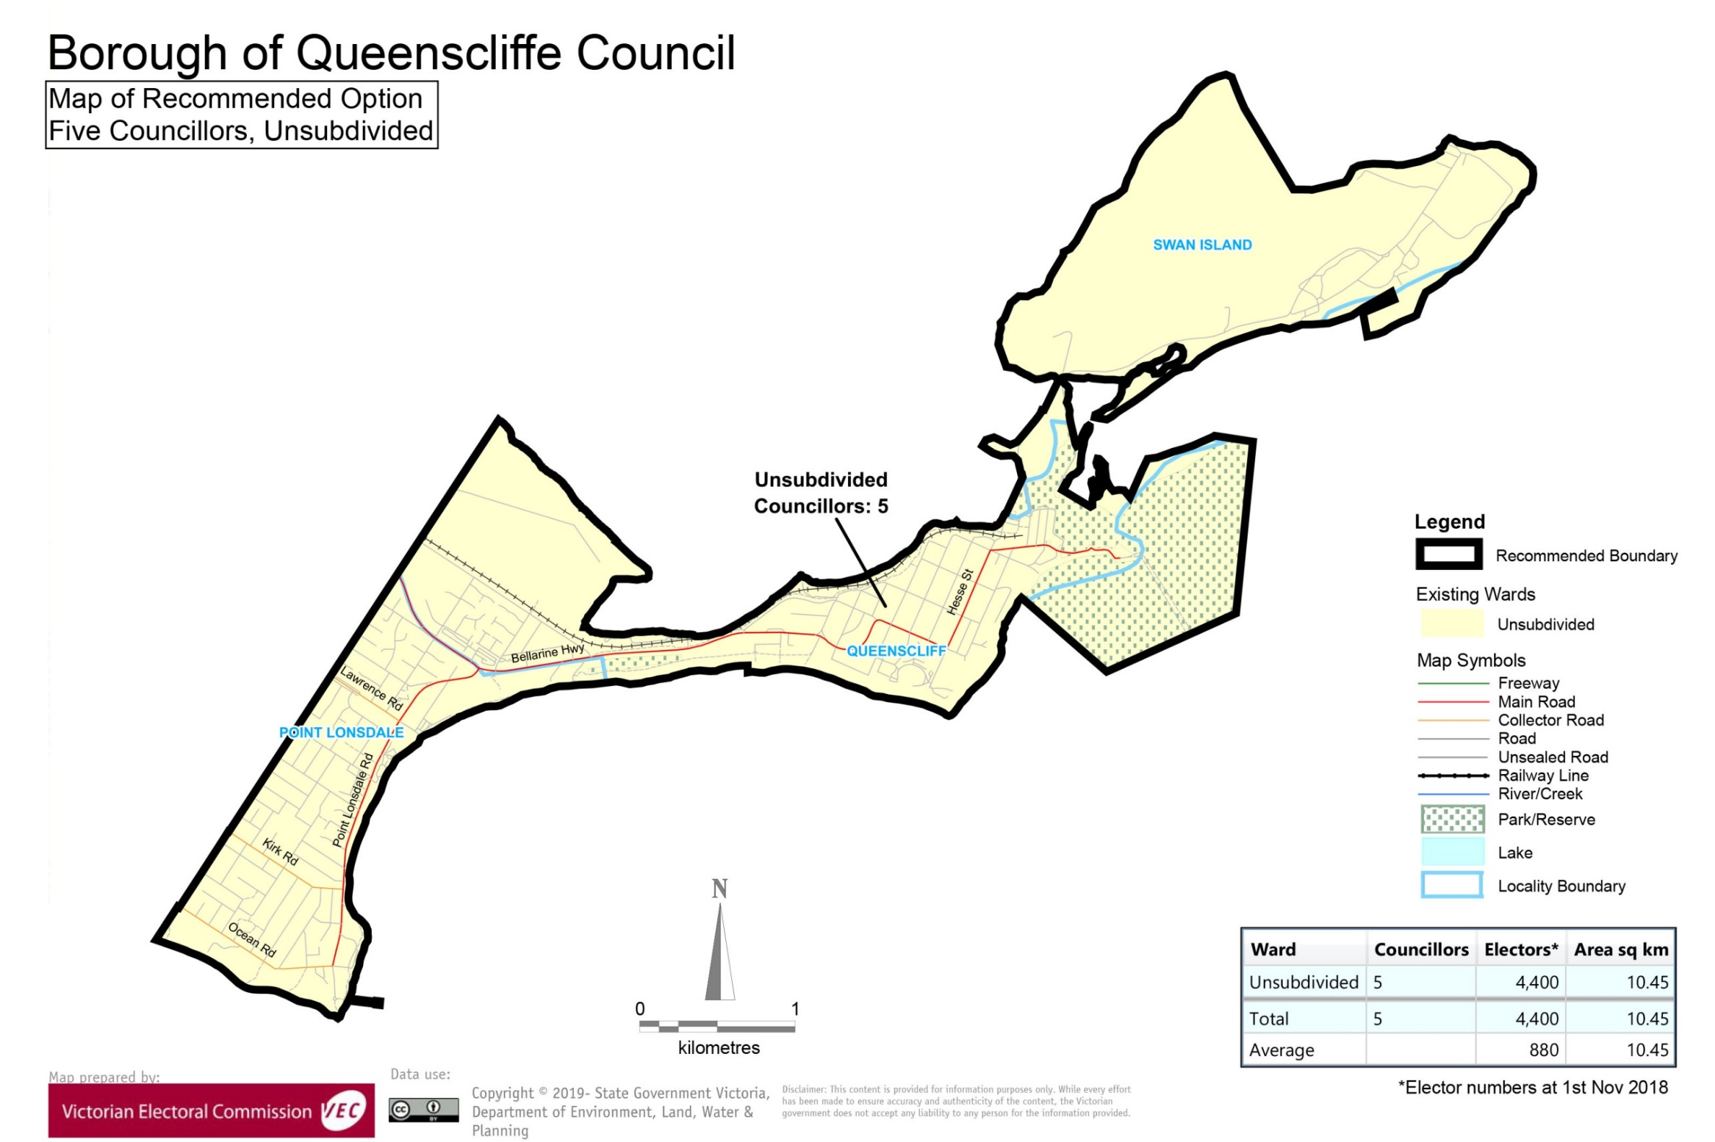

# Appendix 3: Public information program

Advertising

In accordance with the Act, public notices of the review and the release of the preliminary report were placed in the following newspapers:

|  |  |  |
| --- | --- | --- |
| **Newspaper** | **Notice of review** | **Notice of preliminary report** |
| *Herald Sun* | Thursday 17 January 2019 | Wednesday 20 March 2019 |
| *Geelong Advertiser* | Wednesday 30 January 2019 | Wednesday 3 April 2019 |
| *Bellarine Times* | Wednesday 30 January 2019 | Wednesday 3 April 2019 |

Media releases

A media release was prepared and distributed to local media to promote the commencement of the review on Wednesday 6 February 2019. A further release was distributed with the publication of the preliminary report on Wednesday 3 April 2019. A final media advisory was circulated on the publication date of this final report.

Public information session

A public information session for people interested in the review process was held on:

* Wednesday 6 February 2019 in the Queenscliff Borough Town Hall, 50 Learmonth Street, Queenscliff.

Submission guide

A submission guide was developed and made available on the VEC website, or in hardcopy on request, throughout the review timeline. The submission guide provided information about the review, the review timeline and how to make submissions to the review.

Online submission tool

An online submission tool was developed and made available during the submission periods of the review. The tool allowed people to make a submission from the VEC website. During the preliminary submission stage, users also had the opportunity to map out their preferred subdivisions through the online submission tool using Boundary Builder. Boundary Builder included real elector numbers so that users could see if their preferred structures and numbers of councillors met the plus-or-minus 10% rule.

VEC website

The VEC website delivered up-to-date information to provide transparency and facilitate public participation during the review process. All public submissions were published on the website.

Email and social media engagement

The VEC delivered an information email campaign targeted at known community groups and communities of interest in the local council area. This included a reminder email at each milestone of the representation review process.

The VEC also published sponsored social media advertising that was geo-targeted to users within the local council area. This included advertising at both the preliminary submission and response submission stages. The total reach of these posts was 966 users during the preliminary submission stage and 528 during the response submission stage.

Council communication resources

The VEC provided the Council with a communication pack that included information on the review in various formats. While the council is encouraged to distribute this information and raise awareness about the review, the VEC is an independent reviewer and all communications resources include reference and links to the VEC website and core materials.

This page has been left intentionally blank

This page has been left intentionally blank



1. Section 219D of the *Local Government Act* *1989.*
2. ibid.
3. .id is a consulting company specialising in population and demographic analysis and prediction information products in most jurisdictions in Australia and New Zealand.
4. Section 5B(1) of the *Local Government Act 1989.*
5. Although there were eleven candidates at the 2016 election, in 2012 there were only seven candidates. Under the previous seven-councillor electoral structure in the 2008 elections there were nine candidates and in 2004 all seven candidates were elected unopposed.