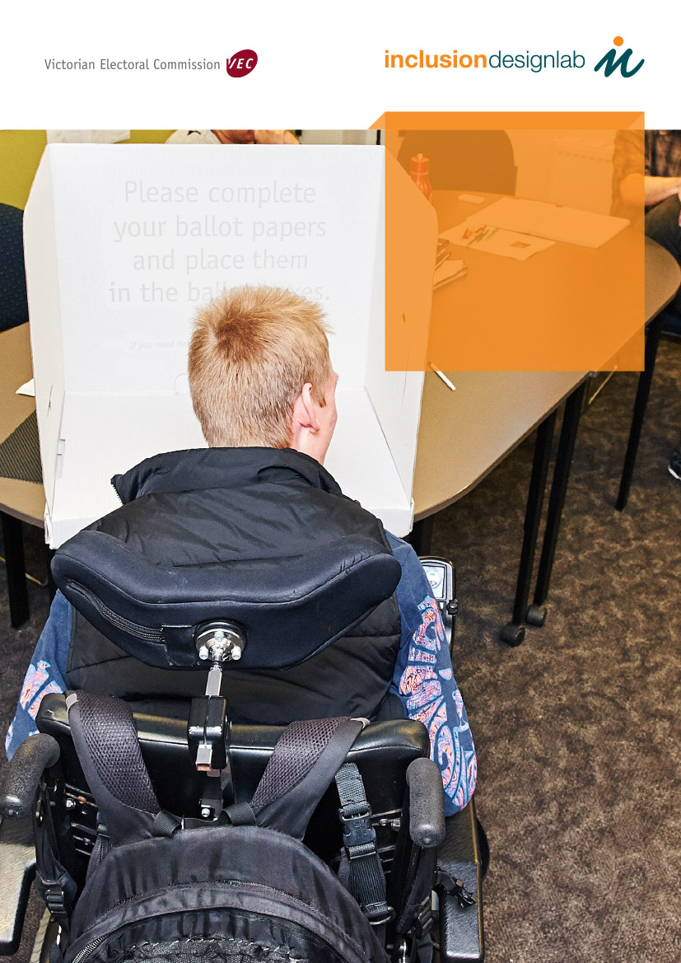

electoral inclusion

rights, barriers and global campaign strategies for voters with intellectual disability

Victorian Electoral Commission logo

This report was developed in partnership with the Victorian Electoral Commission. Inclusion Melbourne’s visits to sites of best

practice in Canada, Sweden and the UK were made possible due to the support of an Ethel Temby Scholarship, a Victorian

Department of Health and Human Services program.

Produced by:

Supported by the:

Inclusion Designlab acknowledges the following local and global partners who generously contributed to this report:

• Kjell Stjernholm, Studieförbundet Vuxenskolan, Sweden

• Dr Ann Simmeborn Fleischer, University of Gothenburg, Sweden

• Inclusion BC, British Columbia, Canada

• Professor Tim Stainton, Centre for Inclusion and Citizenship, University of British Columbia, Canada

• Dr Marcus Redley, Cambridge Intellectual and Developmental Disabilities Research Group, University of Cambridge, UK

• The Every Vote Counts and Easy News Campaigns, United Response, UK

• Human Rights Law Centre, Melbourne

• Disability Research Initiative and Disability Human Rights Clinic, Melbourne Law School, University of Melbourne.

Inclusion Designlab acknowledges JurisDoctor students Bree O’Dwyer, James Gould, Ranjini Nair, and Yusur Al-Azzawi for their delivery of political citizenship training to students of Inclusion Training. Their legal brief, Legal Capacity for Persons with Intellectual Disabilities in Australian Electoral Law (2015), is quoted in this report. The 2015 Final Project Collection is available at the University of Melbourne website.

• Sophia Tipping and Professor Christine Bigby, Living with Disability Research Centre, Latrobe University, Melbourne

• Dr Patsie Frawley, Deakin University, Geelong

• Asher Hirsch, Policy Officer, Refugee Council of Australia, Melbourne

• Dr Jane Tracy, Director, Centre for Development Disability Health Victoria, Melbourne.

Inclusion Designlab thanks Jane and her son Nick for sharing their story of electoral participation with Inclusion Designlab.

• Sue Lang and Danijela Spoljaric, Victorian Electoral Commission, Melbourne

Suggested citation:

Despott, N (2017). Electoral Inclusion: Rights, Barriers and Global Campaign Strategies for Voters with Intellectual Disability.

Inclusion Melbourne: Melbourne. February 2017.

contents

3

about this report

citizenship

6

self-advocacy and

advisory groups

rights and political citizenship

global barriers

voting and australian law

8

9

12

practice

15

person centred active

support

circles of support circles of support: relationship map

choice and supported decision making

risk mitigation and risk avoidance

16

17

18

19

pathway

the pathway to voting

citizenship

21

perspectives

24

25

27

inspiration from sweden

voting toolkits

accessible political information

citizenship in the NDIS

NDIS domains, goal making

& outcomes

NDIS pricing & costing

disability insurance scheme

30

32

36

37

barriers

selected literature

1

F

recommendations 34 recommendations

E

voting and the national 28 voting and political

D

global 22 global voting campaigns

C

pathway to political 20 a political citizenship

B

disability support 14 discretion and practice

A

overview of political 5 defining citizenship



Inclusion Melbourne is a community support organisation

that provides services to people with an intellectual disability, helping them to create more enjoyable and rewarding lives and participate fully in the community. Inclusion Melbourne was established in 1950 and remains the only registered disability support provider to have transformed its services during the life of the previous Victorian State Disability Plan (2002-2012), resulting in the sale of our premises and the delivery of all of our supports within the community, alongside community members.

Our vision at Inclusion Melbourne is for people with

intellectual disability to live in an inclusive community, where everyone has the same opportunities to participate in community life and to take their place in society as respected citizens.

We believe our role as a disability support provider is to

encourage and enable people with disability to achieve

and maintain a valued quality of life. We accomplish this by supporting people to create highly personalised and flexible lifestyles based on their needs and desires. To accomplish this we encourage people to participate in activities and develop relationships with people within their

local community.

Inclusion Designlab is Inclusion Melbourne’s engine room for

research, innovation, communications and policy.

Our vision is to bring together people with a disability, community organisations, and the world’s leading disability researchers to develop cutting-edge models of practice, choice and citizenship that shatter glass ceilings and promote a more inclusive Australia.

We do this by developing, trialling, and implementing new

systems of support and communicating our insights through a range of publications and media. We are also significant contributors to public policy and government inquiries.

The products and services created by Inclusion Designlab

contribute to the continuous development of the disability sector through evidence based practice, accessible materials, and vital training for families and collegiate organisations.

2





Part A presents an overview of the rights and Barriers



about this report

Few voters with intellectual disability have a fail-safe supported pathway that will guide them through the enrolment, preference determination, transport and voting processes, and then ensure that the pathway will be repeated at successive elections. This lack of support translates into low voter turnout. However, access to voting is about a lot more than logistics. It is also about ensuring that practice in the disability support sector focuses on building the agency of people with intellectual disability in all domains of life – from home life to self-advocacy in other domains of life.

Policy, practice and voting awareness campaigns must allow people to make political decisions and to be involved in the political

conversations millions of Australians have every day. As many as half a million Australians with intellectual, developmental and cognitive disability experience significant barriers to electoral participation simply because of the societal assumption that people with a disability are inherently disqualified from political activities due to limitations in capacity.

This report has been prepared to introduce the leaders of electoral commissions and similar organisations to the advancements

in practice that have flowed from research into the political citizenship of people with intellectual and cognitive disability. It also examines the various components of a selection of electoral inclusion campaigns in sites of best practice, namely the UK, Canada and Sweden.

legal considerations underpinning political

citizenship and electoral inclusion. It outlines the key barriers experienced by voters with intellectual disability.

Part B presents the key elements of best practice in disability support that are most relevant to

strengthening the political citizenship of people with intellectual disability.

pathway against which the United Nations

Convention on the Rights of Persons with Disabilities (UNCRPD) and the practices noted above can be mapped.

Part D presents an overview of high quality

electoral inclusion campaigns from around the world that have successfully overcome some of the key barriers.

UK

British Columbia (Canada)

Part E highlights the ways in which National Disability

Insurance Scheme (NDIS) participants may be able to include political citizenship in their support plan.

NDIS

Part F collates the barriers outlined in part A and lists Inclusion Designlab’s recommendations of initiatives that

may advance electoral inclusion in Victoria and Australia.

3

F

E

D

Sweden

C

Part C articulates a proposed political citizenship

B

These dark grey boxes summarise the barriers to electoral inclusion experienced by people with intellectual disability. They are located throughout the first part of this report and collated in Part F.

A



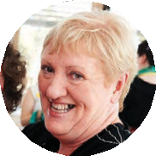

Inclusion Melbourne’s original engagement with

voting was in the context of our mission. We support people with intellectual disability to experience social inclusion and belonging in their local communities, with meaningful employment in regular workplaces, education and training. Our model incorporates engaging natural supports, such as families and volunteers, and supporting people to experience and attain meaningful social roles.

Parenting

Voting

Sexuality

Sex

•

•

•

Personal care

Residential support Participation in community-based activities

Supported employment

This approach to inclusive support means that sex,

politics and religion are domains of life to which they have full access if desired. However, people with intellectual disability have traditionally been shielded from genuine self-driven engagement with these domains. Ironically, we find that the structure of the sector, organisational support practices and the attitudes of support staff (who would otherwise be considered to be progressive) usually drive this shielding effect.

Religion

Politics

•

Careers

Retirement

Even some of the mundane

practicalities of voting

- such as organising a five-minute drive to a polling

station no more than once a year - often prove to be logistical impossibilities for many support services

Serena

Serena’s work as an Inclusion Melbourne support coordinator working in a personalised community-based model of support

provision sees her interact with broad domains of social inclusion. Assisting people to enrol and prepare for elections sits alongside preparing for going to the dentist, arranging support for a Taylor Swift concert and engaging in one’s faith community.

In other words, it is part of practice. However, until recently, political citizenship was placed firmly outside the bounds of disability

support practice.

4

U

R

overview of political citizenship

defining citizenship

Though the definition of citizenship is continually evolving in literature, a robust definition of citizenship must go beyond social and community inclusion. Political citizenship and advocacy are integral to the definition of citizenship afforded to the general population. It is reasonable and indeed vital that these aspects of citizenship are also afforded to people with intellectual disability.

Self

advocacy

Social and

community inclusion

Political

citizenship

Citizenship

5

Barrier: Definition of citizenship

Definitions of citizenship for people with intellectual disability in literature, policy, and research often fail to identify political citizenship, voting and (support for) self advocacy as core components. Furthermore, conversations about the citizenship of people with intellectual disability occur in the context of a support sector that, until recently, reinforced dependency.

A

self-advocacy and advisory groups

Literature concerning political citizenship is in formation

globally. There is a growing body of work, including that produced by Victorian researchers, that addresses the experiences of people with intellectual disability in self- advocacy roles or on disability advisory committees across the private, public and community spheres. Participatory action research and investigative and evaluative research have revealed that advisory committees – groups formed to provide information to organisations about the needs and experiences of people with disability – can sit anywhere on the spectrum

of poor participation to tokenism to genuine, empowered participation. (cf. ladder of participation, Arnstein 1969)

Though not directly related to voting, self-advocacy through

advisory groups represents a tangible example of the efforts taken by organisations, governments and businesses to ascertain the needs, views and experiences of people

with intellectual disability. However, while advisory groups represent a big step forward in acknowledging the political citizenship of people with intellectual disability, they usually offer limited control to the people who attend them and

do not guarantee that people with disability will be able to adjust or broaden the committees’ terms of reference.

Some of the trends, barriers, and considerations relating

to the agency, legitimacy and eligibility of voters are also experienced by people with disability who seek to have their voices heard in advisory groups.

Committees that incorporate adequate focus on (a)

individualised support for participation, (b) financial supports, (c) coordination and communication, (d) leadership development, and (e) value and outcomes, do better.

Standard meeting conventions can prove difficult to navigate. Frawley and Bigby (2011) tell us that “the milieu, structures, and processes of advisory bodies must all be adjusted to accommodate people with intellectual disability if they are to participate meaningfully.”

For those people seen as at risk of social exclusion, policies have focused

on employment, parenting and other performative competencies. In the case of people with a diagnosed learning disability, however, these competencies have to be achieved in the context of life-long dependency and vulnerability.

Redley and Weinberg (2007: 767)

6

Barrier: Limitations on political citizenship

People with intellectual disability are often invited to present their views, opinions and feedback in carefully curated self-advocacy and advisory initiatives, however these (1) often involve conventions and guidelines that are in themselves exclusionary, and (2) are usually intended to gather feedback about disability related matters only.

As people with intellectual disability experience greater access to inclusive education, employment and social opportunities in the community, people with intellectual disability need to be consulted on matters other than just disability and disability policy.

A



rights and political citizenship

There are more than four million Australians with a disability

whose lives are largely dependent on government services. Approximately 500,000 of these are considered to have intellectual, developmental or cognitive disability. According to political philosopher Linda Barclay (2013), “those individuals whose interests are affected by the polity’s decisions should have the right to be included in the decision-making of that polity, a principle defended by some of the most influential democratic theorists.”

3, 4, 5, 8, 9, 12, 21 and 30. When viewed in the Australian

context, the realisation of article 29 should be seen as the culmination of the outworking of these supporting articles. The inclusive voting campaigns and techniques described

later in this report demonstrate the UN CRPD through several means:

Article 5

Equality and anti-discrimination policies embraced by electoral commissions, disability support organisations and advocacy groups, particularly in relation to political citizenship.

Article 8

Raising awareness of the right to vote through targeted communications campaigns in media and advertising, with voting and political citizenship included in the practice frameworks of disability support organisations.

Article 9

Accessible polling arrangements, with all polling attendants, volunteers and staff fully trained in the communication practices and rights of voters with intellectual disability and communication barriers.

Article 12

Equality before the law and the separation of legal and mental capacity.

Article 21

Accessible information about politics, candidates and elections available from a range of sources, produced by diverse organisations and readily available via media.

This perspective allows one to see a link and common

limitation between self-advocacy advisory committees and voting. While people with intellectual disability have progressively been invited to offer feedback about the way policy affects the disability sector, inclusion and accessibility, people with disability are rarely offered the opportunity to contribute broader feedback. Can a person with intellectual disability be a political party member? Can they comment on more than just disability policy but also industrial relations as part of their union? What do they think about education policy, climate change, foreign media ownership, asylum seekers

and refugees?

The United Nations Convention on the Rights of Persons

with Disabilities (UN CRPD, 2008) has immense relevance to research concerning political citizenship. Article 29 of

the Convention instructs States Parties to support the full and robust development of all social and logistical systems required to allow people with disability to become politically active and to vote. However, article 29 should not be viewed in isolation. The foundations for political citizenship are in fact laid in several of the preceding articles, particularly articles

Article 29 as culmination,

application and expression of

Articles 3, 4, 5, 8, 9, 12, 21, 24 & 30.

8

29

Participation in political and public life

30

Participation in cultural life

24

Education

21

Freedom of expression, access to information

12

Equal recognition before the law

9

Accessibility

8

Awareness raising

5

Equality and non-discrimination

4

States Parties’ obligation to ensure rights

3

General Principles

A

global barriers

Research in the UK by Dr Marcus Redley (Cambridge Intellectual and Developmental Disabilities Research Group) demonstrates

just how slippery some interpretations of the right to vote can be. Prior to the 2005 UK General Election, many people with a disability received voting instructions in Easy English in the mail. Redley notes that several direct support workers in a particular residential service, claiming to speak on behalf of their clients, complained to their support organisation that the rights of the people they supported were being violated through being forced to do something that was, essentially, beyond them. The support workers’ impulses were sincere but misguided.

According to Agran and Hughes (2010), this contorted approach to human rights has undergone legislative justification in 44

American states in which provisions that prevent access to voting for people with an intellectual disability exist. Agran and Hughes found that this legislation is enabled by a prevalent culture of ambivalence about voting rights among disability support workers.

The 2015 Shriver Report found that 22% of Americans believe people with intellectual disability should not be allowed to vote in

elections.

From Despott, Hirsch, Leighton (2013), Sound minds, double standards and the right to vote, ABC: Ramp Up.

is informed by rights and risk

ideally governed by a person centred practice

In the absence of one or both of these, support

include risk avoidance and a focus on resource

9

Barrier: The use of discretion by disability support professionals in place of evidence based practice that

The work of disability support professionals is framework and supported by practice coaching. professionals will often default to practices that management. In such cases, voting and political

citizenship may not be encouraged, or worse, discouraged.

Barrier: Culture of voting in households

Senior members of households, including parents and house supervisors, have an enormous influence on the registration and voting behaviour of people with intellectual disability. Research from the UK shows that when people with intellectual disability live in houses where support staff, senior family members, house supervisors or other housemates regularly vote, they are more likely to vote themselves.

A

The Ruderman White Paper on Voting Accessibility for People

with Disabilities (2016) illustrates the disenfranchisement of American voters with disability. 20% of Americans have a disability (including physical, developmental and intellectual disability). Of these, 4.8% to 19% encounter difficulty voting. Voter turnout is 5.7 percentage points lower than the general population. In 2008, 73% of polling stations demonstrated

an impediment to accessibility. The White Paper presents

findings from qualitative (phenomenological) investigation

into the experiences of voters with disability and identifies five

major barriers to electoral inclusion.

Keeley and Redley (2008) found that previous analyses of

voters with disability in the UK had not distinguished between voters with physical and intellectual disability. The Valuing People in survey in 2001 found that 31% of adults with intellectual disability had voted in the most recent election, compared with 72-73% of the general population.

Keeley and Redley (2008) also found that people with

intellectual disability living in supported accommodation were often enrolled to vote at a higher rate than the general population, however actual turnout at elections was lower than that of the general population. A major factor that supported voting was “the presence or absence of other voters in the household”. In fact, “those living with at least

one other voter were 3.6 times more likely to have voted than those living with no other voters”

(Keeley and Redley 2008: 179).

• Insufficient training of polling station staff

and volunteers

• Access barriers to polls (including publicly available transport)

• Access barriers to elections material and registration material prior to elections

• Stigma (including against developmental and psychiatric disabilities)

• Limitations on resources available to election officials

10

Barrier: Awareness of communication practices

Positive stories of voting engagement from people with disability abound, however a common theme is the supportive actions of polling station attendants. Though a range of practices and techniques exist that can support people with intellectual disability and communicative impairment, polling station attendants may not understand that these practices exist. More importantly, they may not be equipped

to make decisions or assessments about the legitimacy of the actions and interactions between voters with disability and their support staff, carers or advocates on the day.

Barrier: Accessible election information and access to polling stations

People with intellectual disability are entitled to attend polling stations alongside members of the general population. They need not be restricted to postal votes. There is generally a lack of accessible voting information for people with intellectual disability who choose to attend polling stations

in person.

A

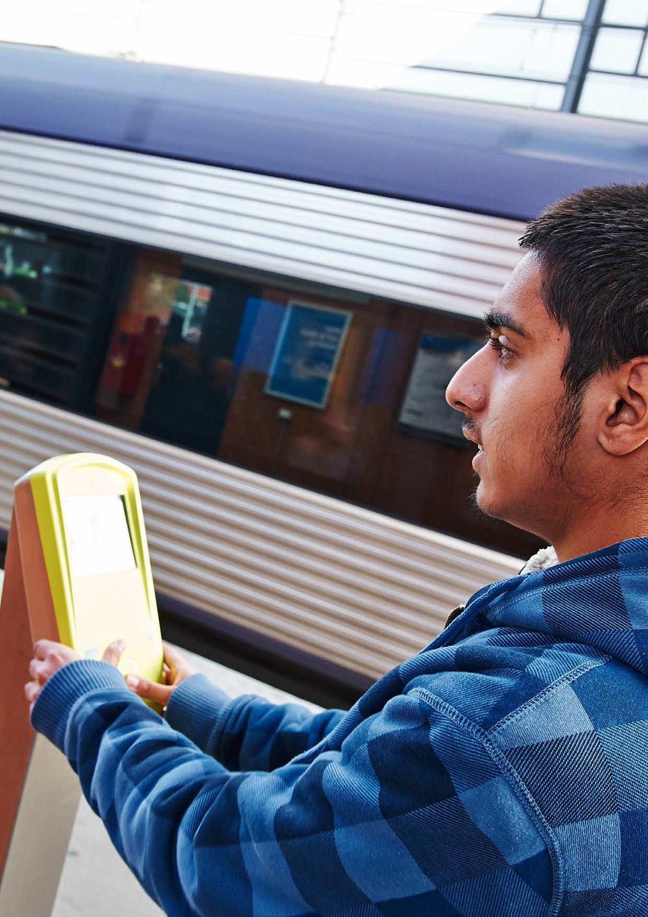

11



voting and australian

In Australia, the right of people with intellectual disability to full democratic participation is underscored by legislation, such as the Disability Act 2006, including the right of people with a disability to “realise their individual capacity for ... social ... and intellectual development”. However, this contrasts with electoral law.

law

This process may lead to some individuals with intellectual disability or cognitive impairment being removed from the roll even if supports are available that might assist them to exercise their right to vote.

Current Australian law allows for a judgment of mental health

or ability to dictate an individual’s right to legal personhood. Where the law does not recognise an individual as a legal

‘person’, autonomous participation in society becomes extremely restricted.

In 2013, 6 939 Australian citizens were removed from the

Electoral Roll due to section 93(8)(a), though not all of these were people with intellectual disability.

Section 93(8)(a) of the Australian Commonwealth Electoral

Act 1918 creates an opportunity for the law to exclude people in a discriminatory way. Current wording of section

93(8)(a) allows discretion to possibly preclude individuals characterised as having intellectual disabilities from voting.

(Reprinted with permission from O’Dwyer, B., Gould, J., Nair,

R., and Al-Azzawi, Y. (2015). Legal Capacity for Persons with Intellectual Disabilities in Australian Electoral Law, Disability Research Initiative and Disability Human Rights Clinic, Melbourne Law School, University of Melbourne.

The ‘unsound mind’ provision is emulated in section 48(2)

(d) of the Victorian Constitution, enacting the provision in

Victorian State elections.

Both the Australian and Victorian Electoral Commissions

(AEC and VEC respectively) facilitate the ‘unsound mind’ exemption through a two-page form; ‘Removal of Elector’s Name from Roll’. The form has two requirements:

1. That a registered medical practitioner certify the elec-

tor’s unsoundness of mind (s118(4) of the Electoral Act)

and;

2. That another currently enrolled voter (the objector) com- pletes and submits the form, objecting to the person’s enrolment based on the section 93(8)(a) provision.

mental and legal capacity in the united kingdom

In the UK, voting rights have been protected through the enactment of legislation in 2005 and 2006 to separate mental and legal capacity, meaning that a person’s legal capacity can not be viewed in light of their mental capacity. This has led to supported decision making – working with people to make their own decisions – being recognised as preferable to substitute decision making or a default position of not being enrolled.

• Separation of mental capacity

and legal capacity

• Supported decision making over substitute decision making

mental capacity act

(uk) 2005

S29: Voting rights.

electoral administration

act (uk) 2006

S73: Abolition of common law incapacity: mental state.

1. Nothing in this Act permits a decision

on voting at an election for any public office, or at a referendum, to be made on behalf of a person.

1. Any rule of the common law which

provides that a person is subject to a legal incapacity to vote by reason of his mental state is abolished.

12

Barrier: Australian legal barriers to voting

Clauses in Australian electoral law that conflate legal and mental capacity leave Australian voters with intellectual disability vulnerable to having their right to vote challenged or even negated.

A

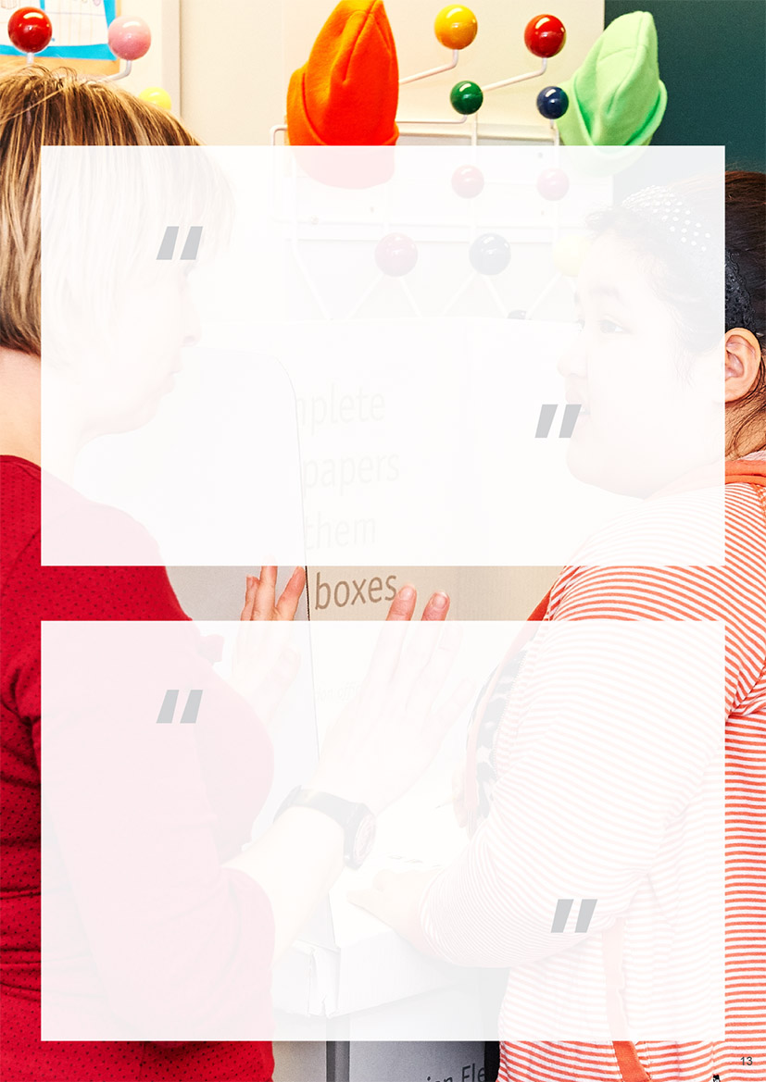

Cognitive ability does not negate

a person’s capacity to have a well- defined value system in the same way that a powerful intellect does not ensure a person will have superior ethical or moral opinions.

Despott and Hirsch (2013)

To deny an adult the right to vote

because of a perceived deficiency

in their ability to assess the qualities of individual candidates would

be discriminatory [as] no such requirement is placed upon members of the general population.

Redley (2008)

13

disability support

practice

discretion and practice

the role of discretion

What has become clear is that, despite some very problematic laws that do need to change, one of the primary hurdles facing people with intellectual disability is the discretion of the various actors and agents they encounter when attempting to exercise their political citizenship. Whether it be the example of support staff seeking to protect people from the perceived dangers

of voting, or polling volunteers taking it upon themselves to summarily assess the capability of voters with disability, social change is required to raise awareness and expectations.

As an alternative to the use of discretion and independent

judgment in determining whether or not people with disability can or should vote, an array of evidence-based techniques and practices that support political citizenship exist – and have existed for some time. These practices provide people with disability, their families, support staff and advocates with many of the tools required to support their political citizenship and electoral inclusion, despite the problematic clauses in electoral law. Discretion still plays a role, however it needs to be used in accordance with these practices. These include: Person Centred Active Support; Positive Behaviour Support, Circles of Support, Assistive Communication Technologies, Supported Decision Making and Risk Management. The following pages outline a selection of these practices and highlight the role they play in political citizenship and electoral inclusion.

• Political and electoral awareness

of legal architecture

key support practices and techniques

Person Centred

Active Support

*Assistive technologies for communication

*Positive

Behaviour Support

*Training for staff and volunteers

Supported decision making

*Training for carers

Risk processes

Circles of Support

* These items are not covered in the following pages

14

Listed below are some of the factors that drive the discretionary actions of key players in the realisation of political citizenship for people with intellectual disability.

Disability support Human rights law Electoral staff

practitioners • Assessment of decision making • Use of discretion at polling stations

• Assessment of risk abilities • Knowledge of disability practice

• Assessment of decision • Knowledge of disability research and making abilities practice

• Resource constraints • Problematisation and rationalisation

as part of regular interaction

Barrier: Undue emphasis on legislative reform

Though Australian and Victorian electoral laws do contain outdated and problematic clauses

that create barriers to electoral inclusion, viewing legislative reform as the solution to low voter participation of people with intellectual disability

is equally problematic. Current laws do not specifically disqualify people with intellectual disability from voting. Rather, they open voters with disability to undue scrutiny and allow them to be too easily removed from the electoral roll.

What has become apparent in countries that have removed such clauses from their electoral laws is that legislative change was merely the beginning of the journey. Electoral inclusion improves as steps are taken to transform practice, educate

the community, and actively promote a culture of political citizenship in the lives of people with intellectual disability. There are no legal barriers preventing these positive changes from occurring in Victoria now.

B

person centred active support

Person Centred Active Support is one of the most important evidence based practice models available to disability support organisations at the current time. It is a model that places the person at the centre of organisational planning, organisational processes, staff training, scheduling, and interpersonal relationships. “Every moment has potential” is a central theme of Active Support, ensuring that people with intellectual disability are supported to experience genuine engagement and capacity building in all activities – from household activities, to social recreation, in employment and education, and in accessing the community.

The principles of Active Support allow a person with intellectual disability – whether mild or profound – to grow their skills and build stronger relationships.

support

level

The level of support increases from simply asking someone to guiding someone (eg. hand on hand) to do something.

Graduated support – or graded assistance – is one small element of Person Centred Active Support. It is employed when

supporting people to develop and use micro skills, for example, in verbally prompting a person to make dinner or guiding the person with hand-on-hand support while preparing dinner. However, it also applies to using transport, shopping, education, and political citizenship. Broadly, Active Support is a person centred practice model that stands apart from other forms of practice, such as those models that instead place staff, carers or resources at the centre of practice. Support organisations that employ Person Centred Active Support will be more likely to view the people they support as citizens of their local community.

practice coaching and culture

Person Centred Active Support is best embedded in an organisation through strong practice leadership. This requires management and senior staff of disability support

organisations to actively promote good practice and a person centred culture through coaching, communication and regular review. It is through this systematic approach to good practice that political citizenship can become a central value of organisations that support people with intellectual disability. The hallmarks of successful practice coaching and positive organisational culture are below:

• Work practices that centre on the person

• Work practices that focus on supporting the choices of the person

• Open and discursive culture between staff with a focus on how to provide the best support

• Practices that prioritise community inclusion as led by the choices of the supported person

• Staff become leaders to the outside world so that people in the community can learn

about inclusion and person-centred support

• All staff understand the everyday, lifestyle and lifelong choices of the person being supported and seek to help the person achieve and action these.

• Power holders reflect the values of the organisation

• People supported by the organisation are included as equal citizens within their supported environments. This might look like staff eating meals alongside the people being supported and talking together as peers. The only focus on disability and impairment is for the purpose of providing better support.

15

ASK

INSTRUCT

PROMPT

SHOW

GUIDE

B

who can start a circle of support?

Anyone can support a person with a disability to start a Circle of Support. The people best equipped to support this process are parents, family members, friends, or people that have a meaningful and constant relationship with the person. These people are known as Primary Supporters. Paid facilitators can also be used to assist with the establishment of a Circle.

For more information about circles of support, visit the [Inclusion Designlab website](tp://www.inclusiondesignlab.org.au/circles).

circles of support

Developed in the 1980s and 1990s in the UK, the US and Canada, the Circles of Support model has recently been used in

Sweden as an innovative practice for building self-awareness of political agency, increased political awareness and election readiness in people with intellectual disability. Circles of Support create opportunities for people to learn about political citizenship from diverse sources and voices in a safe environment.

what is a circle of support?

A Circle of Support aims to formalise informal networks to provide valuable and authentic support to a person with

a disability.

who is in a circle of support?

The group is formed by people who care for, respect and have a common wish to support the individual to achieve short and long term goals.

Communities and organisations around the world have had

enormous success in improving the lives of marginalised and isolated people with a disability through the use of various models of Circles of Support.

when do you start one?

Circles of Support can exist at any time in a person’s life to support them long term, through both trouble-free and

crisis situations.

Circles of Support are beneficial because they support

the person with a disability over the long term, act as a mechanism that promotes communal responsibility, and support families, carers and advocates.

Circles of Support generally take time to plan, establish and

grow. It is never too late to start a Circle of Support. During childhood, adolescence, middle age or later in life.

what is a

circle of support?

A Circle of Support is a group of people that come together, on a regular basis, to assist a person with a disability to develop, support and action their goals

and aspirations.

what is a circle

of support not?

• A temporary arrangement that serves one purpose for specific individuals.

• Intended to be a tool for one-off

formal planning and service delivery.

• Contingent upon, or solely dedicated

to, the management of funds.

16

B

circles of support: relationship map

The Circles of Support Relationship Map is a tool that can be used by people with a disability and their advocates, carers or support staff to identify and categorise the people in that persons life who are best equipped to support the person to create a Circle of Support or support the person in long term planning. The people in each of the following circles of relationship will have unique perspectives about the person.

circle of intimacy

People closest to you. Your life would be significantly

impacted if they were not there.

E.g. Parents, siblings, primary carer.

circle of friendship

People you see on a regular basis. You are friends, spend time together, and enjoy each other’s company. E.g. Friends and relatives.

circle of participation

People within a group that you see as part of regular activities. It is in this Circle that relationships can be strengthened through a Circle of Support

circle of exchange

People that you see daily or on a regular basis where money is exchanged in the process.

E.g. Hairdresser, shop keeper.

17

who is in my circle? List the names of the people that you might ask to help you with your planning.

NAME

RELATIONSHIP

NAME

RELATIONSHIP

NAME

RELATIONSHIP

NAME

RELATIONSHIP

NAME

RELATIONSHIP

B



choice and supported decision making

Inclusion Melbourne, RMIT and a partnership of advocacy organisations produced the It’s My Choice toolkit in 2013 to create a framework for understanding choice and decision making. Principles of Choice 5 and 6 are particularly relevant to people with intellectual disability who need to build stronger political awareness. Person Centred Active Support and Circles of Support both embody these principles.

Increasing

knowledge and experience

My knowledge

and experience past and present

Expanding options

and

Providing information to assist reasoned judgement between options

My informed

choices

My expanded

range of informed choices

Principle 6 asks:

“What is reasonable and unreasonable?”

I could choose to become a professional ballerina

but I don’t have the feet or the body or the stamina required. Then again, there are adult ballet classes that I could join.

It’s a reasonable limitation to say that I won’t ever be a prima

ballerina, but if you told me that I couldn’t go to an adult ballet class because I might hurt myself or get lost driving there each week, then that would be unreasonable.

18

PRINCIPLE 6

My personal experiences may be limited by money, experience or what is possible.

Nobody is completely free to choose and pursue any choice they wish. What is important is whether the limitations I experience are reasonable or not.

PRINCIPLE 5

My choices are likely to be greater and more ‘expansive’ where I have more knowledge and experience to inform my choices. Building knowledge and experience is important to making choices informed by past experience.

B



risk mitigation and risk avoidance

Taking risks is an essential part of growth. Without acceptable risk people lose hope and learn helplessness. Dignity of risk means exploring new opportunities and extending a person’s choice. The links between risk, resilience and a good life are

well documented. Dignity of risk is a concept that provides a vital sense of balance to the notion of duty of care, particularly in the disability sector.

An area of practice that has become central to a rights based approach to supporting people with an intellectual disability is

risk assessment. Effective risk assessment in disability support involves distinguishing risk perception from actual risk, then devising strategies to mitigate the actual risk and effectively engage risk perception. Risk perception usually centres on fears and assumptions associated with hazards and the capacity constraints of people with intellectual disability. However, the actual risk associated with not exercising one’s political citizenship is equally – and often more – alarming. People who do not participate in elections, self-advocacy and political citizenship are more likely to experience disenfranchisement, neglect, isolation and a lack of opportunities to provide valuable feedback about their experiences.

Three of the perceived risks most commonly associated with voting and political citizenship are below. While none of them are

true, they are nonetheless compelling if left unchallenged.

“People with intellectual disability cannot understand government, governance, politics or voting.”

“It is exploitative to encourage

a person with disability to pursue civic or political engagement.”

“If the support network around an

Australian voter with intellectual disability breaks down in five year’s time, that person will be at risk of years of fines for failing to vote.”

The following three-step risk assessment and mitigation process is an example of the steps that can be taken to address

perceived risks such as those above. It can be used when training people with intellectual disability, support staff, electoral staff and volunteers, and families.

Would this cause greater exclusion, disenfranchisement, or isolation?

Note two questions that might be asked

of a person with intellectual disability who is considering voting. They demonstrate two possible approaches to speaking

to someone about voting. One question takes a risk-based human rights approach, whereby the person’s rights are prioritised. Risks are mitigated rather than avoided. The second question sticks closely to the wording of the electoral act.

ASK: What are the barriers that prevent you from

understanding, preparing for, enrolling in and make decisions throughout the voting process? How can we mitigate these?

DON’T ASK: Do you have a sound mind? Do you

understand the nature and significance of voting?

19

Mitigation

What strategies might be put in place to overcome the perceived risk?

Actual risk

If the perceived risk were to prevent the person from voting, what would the consequences be?

Reasonable /

unreasonable

Is the perceived risk, concern or limitation reasonable? Is it in line with the person’s rights? Is it true?

B

pathway to political citizenship

a political citizenship pathway

The following pathway reflects the various stages of political citizenship along which people with intellectual disability may progress on the journey to sustainable electoral participation. The functional model outlined below is a suggested pathway for people engaging in a variety of political citizenship activities. It emphasises the need for the development of self-awareness of agency as the first step on the journey to political citizenship. Developing a sense of agency is a long-term process that is different for each person. For some people, it involves progressively learning about their right to choice, such as being able to speak up when a they are given insufficient options. For others, it is about learning to voice their preferences when working with support staff. For people who are unhappy with the status quo, it may be about declaring that “I need things in my life - or my community - to change”. The rest of the steps follow after this vital first step.

In the pathway below, step two involves learning about the specific context in which the person is located. It may involve learning

about organisational processes, hierarchies of decision making, and political parties. Steps three and four involve preparing for a specific episode of participation in political citizenship. An example noted earlier in this report is the growth of disability advisory and self-advocacy groups. For people with intellectual disability to participate in such groups, attention must be given to supporting first contact with the group as well as adapting the methods and conventions of the group to ensure the person can fully participate. Step five involves the moment of participation. In the case of disability advisory groups, the moment of participation is the first (and subsequent) group meeting.

1

2

3

4

5

1

2

3

4

5

20

Moment of participation

Readiness for a political episode: preparation

Readiness for a political episode: access

Awareness of political context

Self awareness of political citizenship and agency

C

the pathway to voting

The pathway on the previous page has been applied to the context of voting below. Note that each step of the journey to voting engages various articles of the UN Convention. Each step also requires the employment of different disability support practices and electoral inclusion strategies. These will be expounded upon in the following pages.

1

2

3

4

5

1

2

3

4

5

21

Voting by ballot.

UN CRPD Articles 3, 4, 5, 8, 9, 12, 30, 29

Determination of voting preferences.

UN CRPD Articles 3, 4, 9, 21, 24

Enrolment to vote.

UN CRPD Articles 3, 4, 5, 9, 12, 30, 29

Awareness of local politics and political issues.

UN CRPD Articles 3, 4, 5, 8, 9, 21, 30, 24

Self awareness of political citizenship and agency

UN CRPD Articles 3, 8, 21, 30, 24

C

Disability Matters Vote 2016 logoCanadian flagCanadian flagAustralian flagEnglish flagEnglish flagAmerican flag

global perspectives

global voting campaigns

The following chart illustrates the extent to which some

of the world’s leading electoral inclusion campaigns have engaged the pathway to voting expressed in the previous pages. The first column highlights the role played by electoral commissions, statutory bodies that are permitted to provide information about basic political citizenship and non-partisan information relating to enrolment and elections. Electoral Commissions are not permitted to present information that is politically partial. Electoral inclusion campaigns are therefore generally run by non-profit organisations, disability advocacy bodies or support organisations.

Some campaigns focus heavily on preparing people with disability for their experience on election day, particularly at polling stations. Others focus on providing people with disability with accessible information about politics over the long term.

A.

Electoral Commission

education campaigns

1.

Self awareness of political citizenship and agency

1

Websites

B. [Studieforbundet Vuxenskolan (Swe)](https://www.sv.se/om-sv/mitt-val/)

C. [Every Vote Counts (UK)](http://www.everyvotecounts.org.uk)

D. [Easy News (UK)](http://www.unitedresponse.org.uk/easy-news)

E. [Get the vote out (Inclusion BC)(Can)](https://inclusionbc.org/)

F. [Advocacy for Inclusion (ACT)](http://www.advocacyforinclusion.org)

[Disability Matters Manitoba (Can)](http://www.disabilitymatters2016.ca)

[Disability Justice (Minnesota)](http://www.disabilityjustice.org/right-to-vote/)

2.

Awareness of local politics and political issues

3.

Enrolment to vote

3

4.

Determine voting preferences

KEY:

Significant engagement

Cursory engagement

5.

Voting by ballot

5

22

D

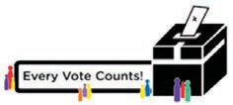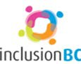Advocacy for inclusion logo



B.

C.

E.

see page 24

see page 27

1

1

see page 25

2

2

3

3

3

4

4

4

5

5

5

23

D.

see page 27

2

4

D

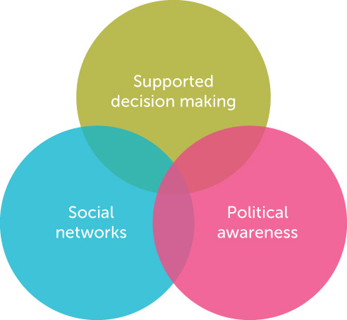

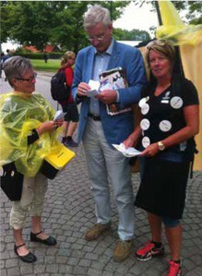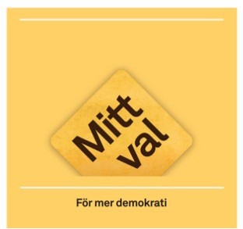

inspiration from sweden

In Sweden, the conclusion of Swedish researchers Anette

Kjellberg and Helena Hemmingsson (2013) is that people with a disability, like all members of the community, need a strong social network to empower them to actively participate in citizenship. Their work shows that having a social network creates opportunities to meet people and discuss social questions, which in turn leads to the development of the citizens’ political knowledge. Kjellberg and Hemmingsson’s (2013) work demonstrated that small groups – similar to Circles of Support – were an ideal context for helping people grow in their exposure to diverse political opinions in a safe environment.

neighbourhood houses and pre-accredited training programs,

though led by volunteers.

An example of Swedish disability voting advocacy comes

from the Mitt Val campaign’s activism at Almedalen, a week- long political festival held on the island of Gotland every year. Politicians and regular citizens connect with each other on the streets of the town and at a wide range of forums and events. People with a disability from the SV campaign wore portable voting booths on their backs and approached politicians

asking them to vote using a system of numbered cards. Each card contained a paragraph in highly complex language

that outlined a set of policies. Participants selected their preferences based on their understanding of the policies. The take home: complex language can exclude people with intellectual disability. The message - “Please use simple language when communicating your policies” – was clearly heard and received by politicians at Almedalen that year.

The voting campaign enacted by Studieforbundet

Vuxenskolan in Sweden very much reflects the work of Kjellberg and Hemmingsson (2013). The Mitt Val campaign saw small study groups of people with intellectual disability led by volunteer trainers within the studieforbundet model

– a hybrid vocational and community learning model that sits roughly between the Victorian equivalents of TAFE,

Election readiness kits

Several advocacy groups and disability peak bodies around the world have developed toolkits – usually in the form of paper booklets – to support people with intellectual disability to prepare for elections. They range in length and quality, but often involve aspects of: Easy or simplified English, an overview of the enrolment process, images of candidates, and contact details of advocates and support organisations that can assist voters with intellectual disability. The opposite page features examples from Canberra (Advocacy for Inclusion) and Canada (Get the Vote Out, Inclusion BC). These materials are available online.

24

D

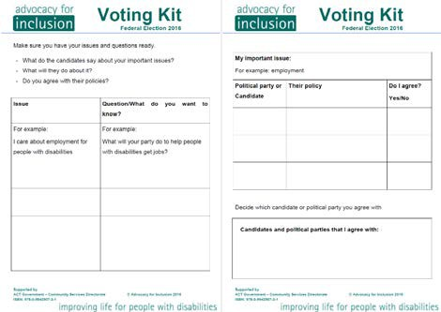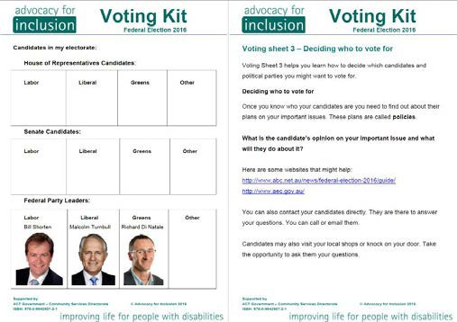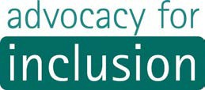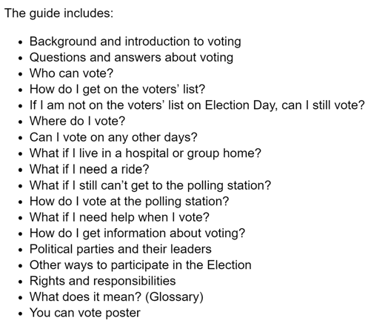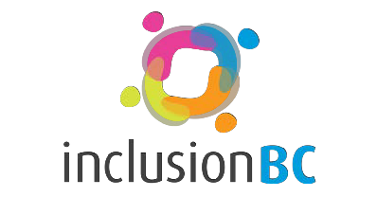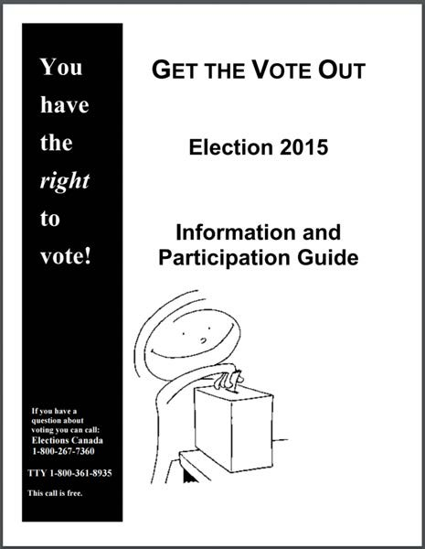

voting

toolkits

25

D

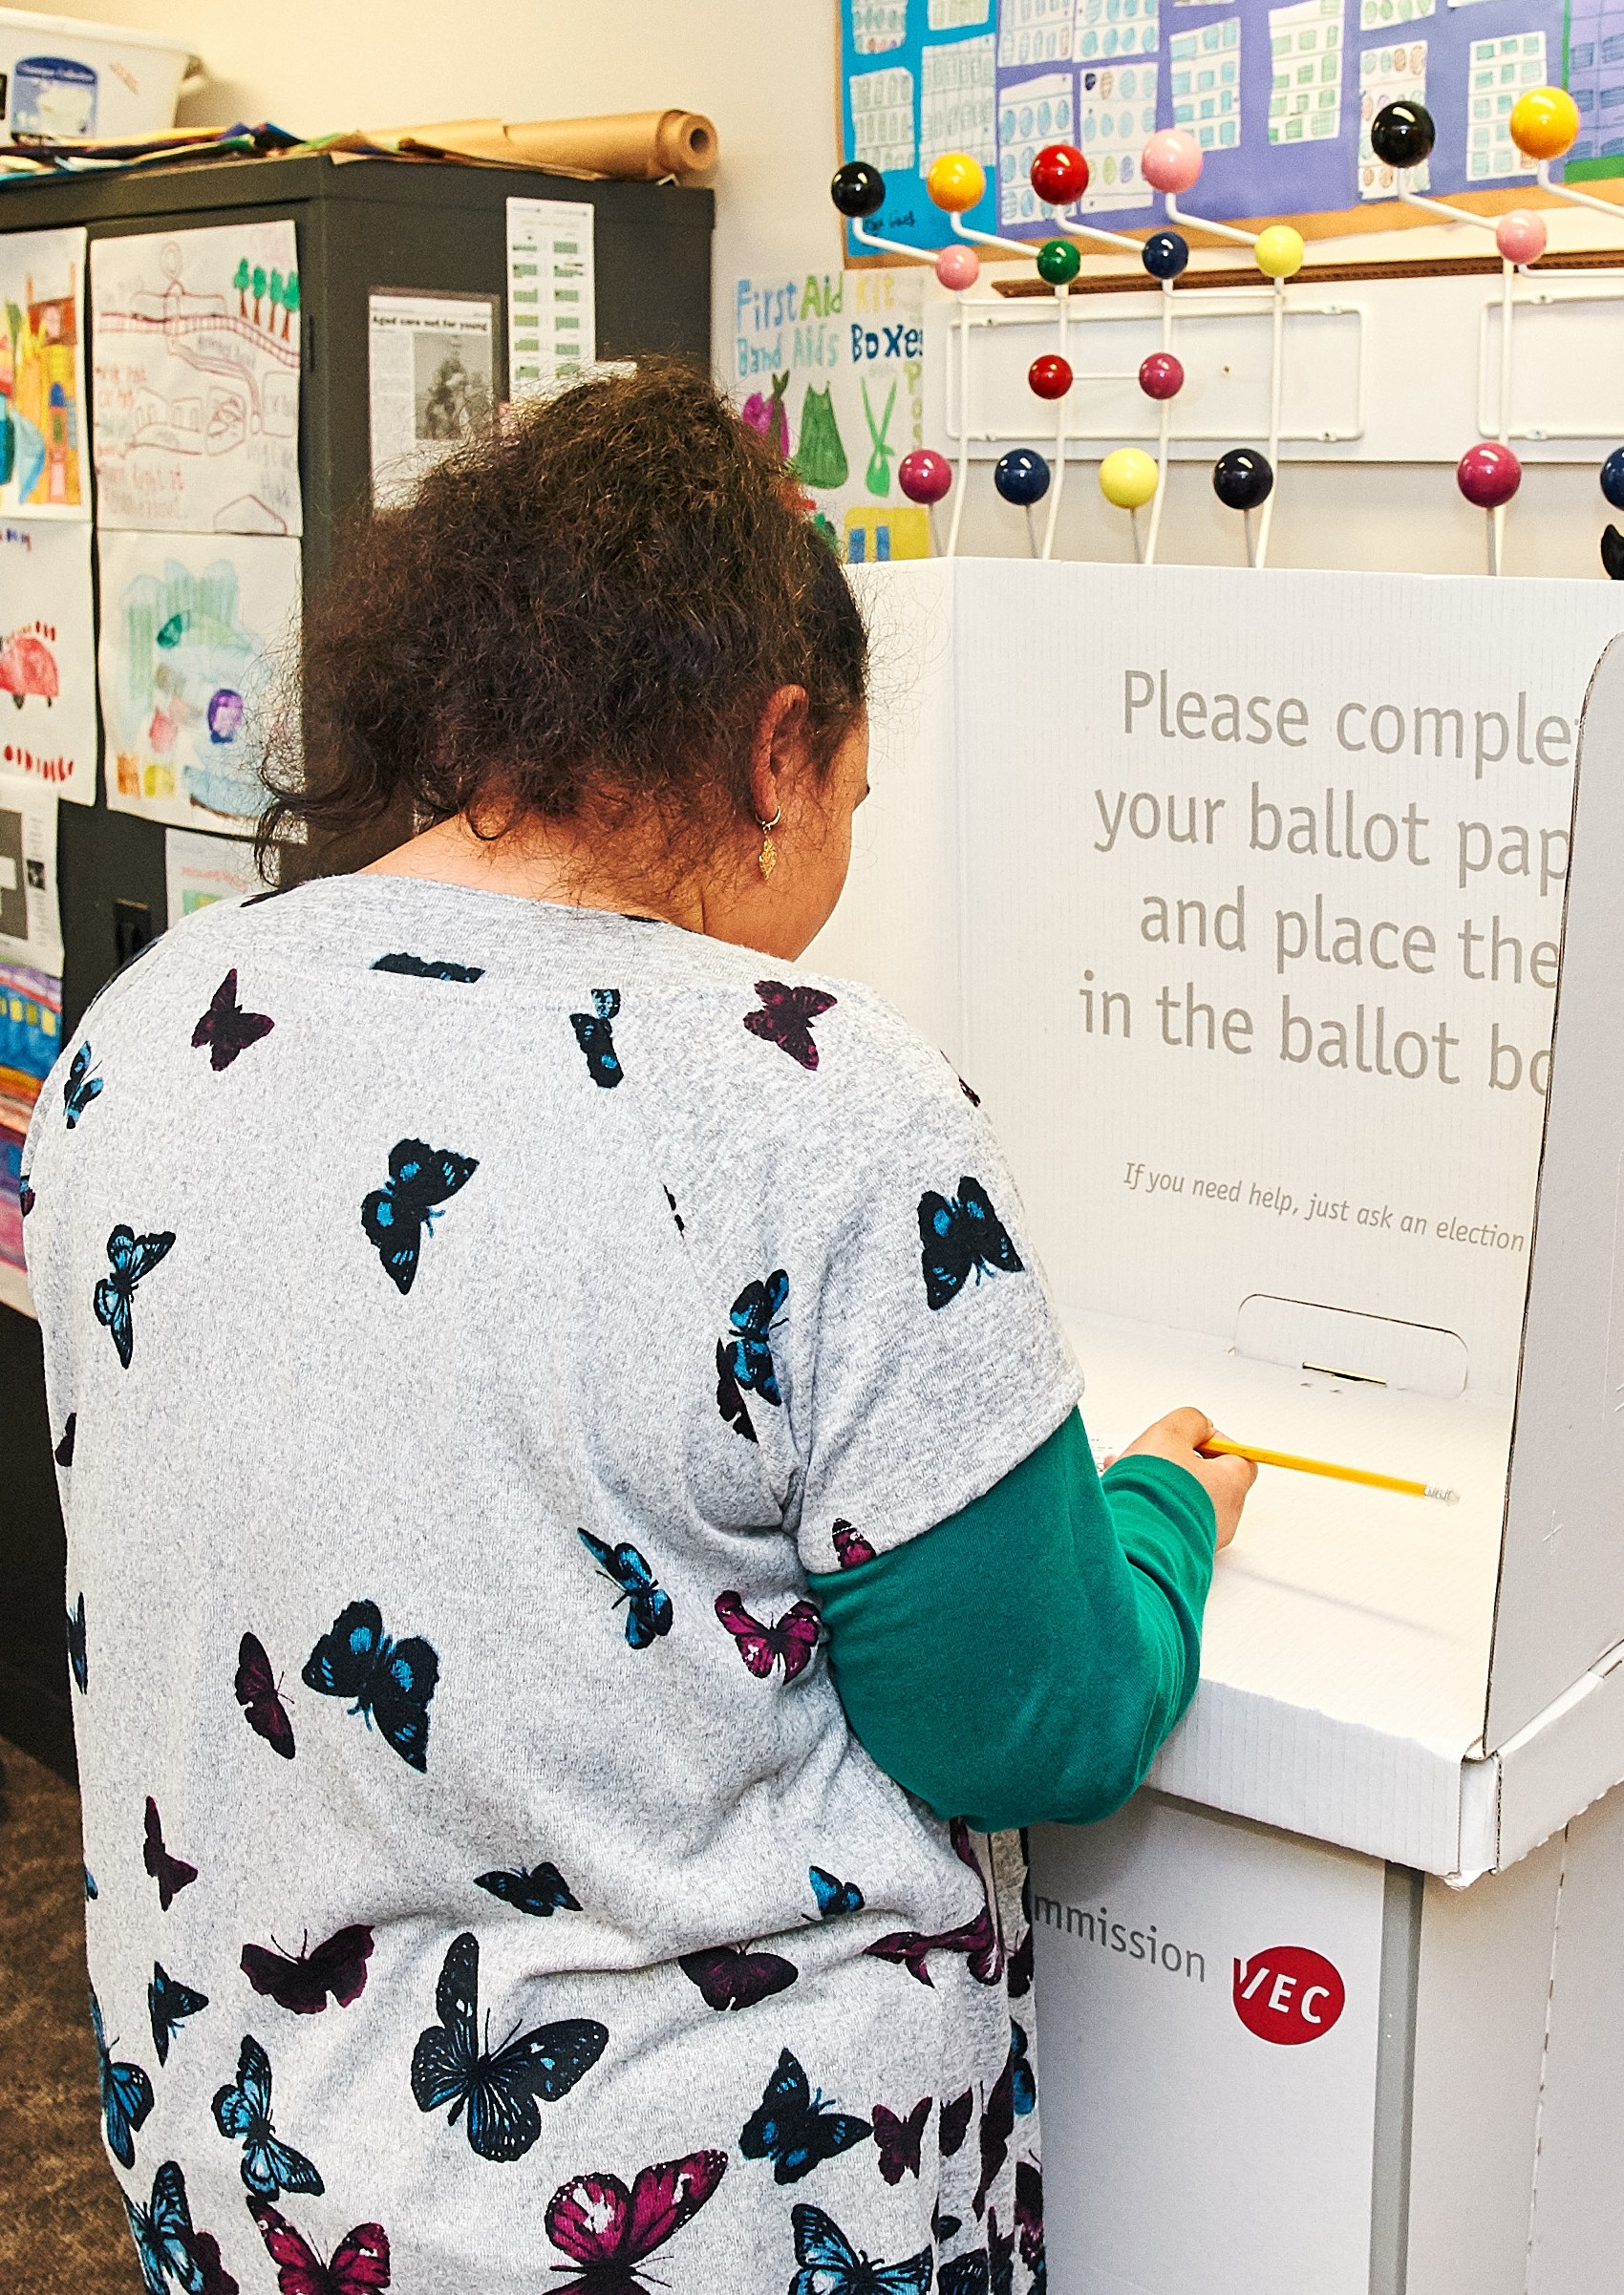

26

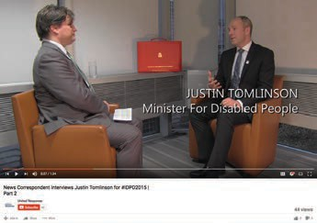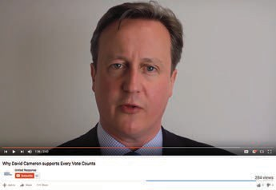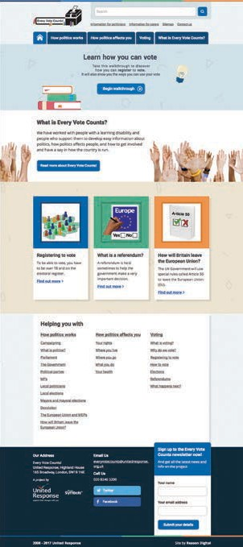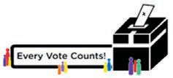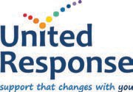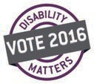

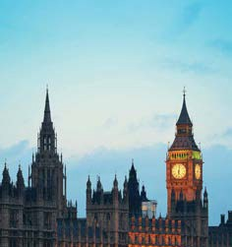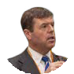

accessible political information

Organisations in the United Kingdom and Canada

have produced several high quality campaigns focused on improving the political awareness of people with intellectual disability.

Every Vote Counts is a highly successful multi-pronged

campaign run by the communications team of United Response (UK) that sees election readiness materials produced – using a similar format to Easy News – and distributed widely.

Easy News in the United Kingdom was developed

by United Response and includes several innovative components. Teams of journalists with disability across England have been mentored by professional journalists

to work collaboratively to select wide-ranging news stories and convert the content into Easy English. Easy News is published monthly and circulated to thousands of people with intellectual disability across the UK.

A journalist with intellectual disability was trained by a former

BBC journalist and producer to interview political candidates in accessible interviews. These interviews were then posted to the United Response YouTube channel.

The Every Vote Counts website can be found at [www.](https://inclusionbc.org/)

[everyvotecounts.org.uk](https://inclusionbc.org/) and contains Easy English information about rights, voting, and UK political issues. It also contains content about electoral inclusion and support practice for politicians and disability support professionals.

Easy News is available online and in high quality hard copy.

Easy News publishes special editions before elections with a focus on communicating the key policies

and characteristics of each major candidate.

Disability Matters Manitoba is a Canadian

campaign that saw provincial political candidates submit their Easy English election materials in video format to the Disability Matters campaign website.

27

**Easy News Meets**

**the Politicians**

February 2015

**Britain votes to leave the EU**

August 2016 / Issue 22

D

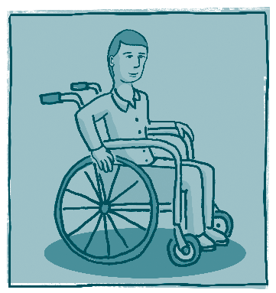

voting and the NDIS

political citizenship in the NDIS

The following National Disability Insurance Scheme(NDIS) Readiness materials have been adapted from Inclusion Melbourne’s

NDIS Readiness for Families Fact Sheets and incorporate freely available content from the National Disability Insurance Agency.

funding and the NDIS

The National Disability Insurance Scheme (NDIS) provides individual funding to people with a permanent or significant

disability based on their needs and goals.

why is it important?

In the NDIS, a person with disability will receive funding to purchase the support they need.

These supports help participants to:

funding guidelines

The NDIA makes decisions based on the National Disability Insurance Scheme Act 2013 (NDIS Act) and the rules made under the NDIS Act. The operational guidelines also provide practical guidance for decision makers.

• Follow goals and aspirations.

• Increase independence.

• Increase social and economic participation.

• Actively take part in the community.

You can read more about the operational guidelines on

the [website](https://myplace.ndis.gov.au/ndisstorefront/about-us/operational-guidelines.html).

what is reasonable and

necessary

In order to be considered reasonable and necessary, a support must:

what is funded?

The NDIS funds reasonable and necessary supports to help a person reach their goals in education, employment, social participation, independence, living arrangements, and health and wellbeing.

• Be related to the participant’s disability.

• Be value for money.

• Be likely to work and be good for the participant.

• Take into account informal supports from families, carers, and community.

•

Not include day-to-day living costs unrelated to the

person’s disability support needs, for example rent or bills.

examples of reasonable and necessary

28

Andrew’s goal is to access the community however needs a different mobility aid. It is necessary for Andrew to get a new wheelchair. Andrew found one he liked, however he wants the one that has particular features.

It is reasonable for the NDIS to fund a new wheelchair, however it was determined that the additional features are not necessary to achieve Andrew’s goal of accessing the community.

Therefore, the NDIS will fund the wheelchair and Andrew paid additional money for additional features that he wants.

Kate has a goal to be more independent and wants to go on a holiday with her friends (not with her family).

It is not reasonable for the NDIS to pay for Kate’s holiday, accommodation, food and other expenses. However because of her disability it is necessary that a support worker goes on the holiday to support her.

Therefore it is reasonable to use funding for a Disability Support Worker to support Kate on her holiday so she can achieve her goal of being more independent of her family.

E

29

voting and political citizenship

People with disability who receive costed support plans – and funding to action their plans – can have support for voting included in their plans. Voting is a clear function of the broad goal of being a more active citizen. See the following pages for more information about goal-setting in the NDIS.

The NDIS can fund:

• Support to engage in advocacy and self-advocacy roles

• Support to prepare for voting (as capacity building)

• Support to attend training or support groups to assist people with intellectual disability to develop their political citizenship

• Support to vote at elections, including support to attend polling stations with support professionals

• Support for transport on election day. It must be noted, however, that funding for taxis will generally not be included in people’s plans unless there is good reason for this. Transport in the NDIS will instead focus on utilising support professionals’ vehicles and public transport.

For more information about the specific items, supports and activities that will be funded by the NDIS, participants and their

families or advocates are encouraged to contact their current support organisation or local advocacy organisation.

Roughly 3-4 million NDIS participants will not be eligible for funded supports. This will include a contingent of people with intellectual disability who have low support needs. Support for voting will be provided through the Information, Linkages and Capacity Building (ILC) component of the NDIS.

supports that can’t be funded

A support will not be funded if it:

• Is not related to the participant’s disability.

• Is the same as other supports delivered under different funding through the NDIS.

• Relates to day-to-day living costs that are not related to a participant’s support needs.

• Is likely to cause harm to the participant or pose a risk to others.

supports that can be funded The types of supports that the NDIS may fund for participants include:

• Daily personal activities.

• Transport to community, social, work and daily life activities.

• Workplace help so a participant can get or keep a job.

• Therapeutic supports including behaviour support.

• Help with household tasks to allow the participant to maintain their home.

• Help by trained people in aids or

equipment assessment, set up and training.

• Home modifications.

• Mobility equipment.

• Vehicle modifications.

E

NDIS domains, goal making

& outcomes

The National Disability Insurance Scheme (NDIS) creates plans based on goals and measurable outcomes.

A key aim of the National Disability Insurance Scheme (NDIS) is to assist people with disability to live “an ordinary life”. The Scheme also involves families and carers, respecting their role whilst supporting them to achieve their goals by providing certainty of support for people with disability.

These aims are embedded in the Scheme’s legislation.

why is goal making important?

• Goals consider the person beyond an activity or an interest and take into account the whole of life issues that impact a person.

• It establishes what a person wants their life to look like, and what they do not want to it look like

• Goals contribute to measurable outcomes.

what are the NDIS domains?

The NDIS develops whole life plans using 10 domains. A domain is an area of life that applies to a particular group of skills or needs.

1.

Learning and applying knowledge

(e.g. understanding and remembering information, learning new things, practicing and using new skills and ideas),

General tasks and demands

(e.g. doing daily tasks, managing daily routine, handling problems, making decisions),

Communication

(e.g. being understood and understanding other people),

Mobility

(e.g. getting in or out of bed or a chair and moving around in your home and community),

Self-care and special health care needs

(e.g. showering/bathing, dressing, eating, toileting),

Domestic life activities

(e.g. preparing meals, cleaning, housekeeping and home maintenance),

Interpersonal interactions and relationships

(e.g. making and keeping friends and relationships, coping with feelings and emotions),

Community, social and civic life

(e.g. community activities, recreation and leisure),

Education and training

NOW

2.

3.

4.

Under the traditional disability support system, funding was

provided to pay for activities and support needs that may or

may not have reflect a person’s goals or individual plan.

5.

6.

NDIS

7.

8.

In the NDIS a person’s goals and individual plan are

fundamental to receiving funding to support a person’s needs. Without a plan a person will not receive any funding.

9.

10. Employment.

30

Voting and electoral inclusion belong

in domain 8 above. Peripheral supports such as political awareness, transport on election day and participation in political activities may cross into other domains.

E



goals and outcomes

The National Disability Insurance Agency is responsible for measuring and reporting on the Scheme’s success. This is done through people outlining their personal outcomes as result of their goals.

Outcomes are necessary for future funding under the NDIS and people will need to prove through outcomes that the funding they

are receiving is being spent in a way that support, benefit and improve the life of a person with a disability.

measurable

Outcomes are essential to the NDIS.

An example of a goal planning tool for domain 8 is below.

my social participation (civic & community) related goals are to:

WHAT IS STOPPING ME

WILL HELP ME ACHIEVE

OBJECTIVE?

(include informal

that you listed in goal

mainstream supports, or

31

WHAT I WANT TO ACHIEVE DURING THIS PLAN?

(my plan objectives)

HOW I WILL ACHIEVE THIS OBJECTIVE?

Strategies, inputs and

outputs

SUPPORTS I HAVE THAT

THIS OBJECTIVE FROM ACHIEVE THIS support, already existing Barriers or priorities disability services) development

2. INPUT & OUTPUT

THE INPUT: Time, support, money, resources

THE OUTPUT: Activities, therapy, volunteering, medical appointments.

3. OUTCOME

The ultimate measurable result or the meaning it has to the person.

1. GOAL

A goal is a person’s objective for the duration of the plan. Goals are always achievable and

E

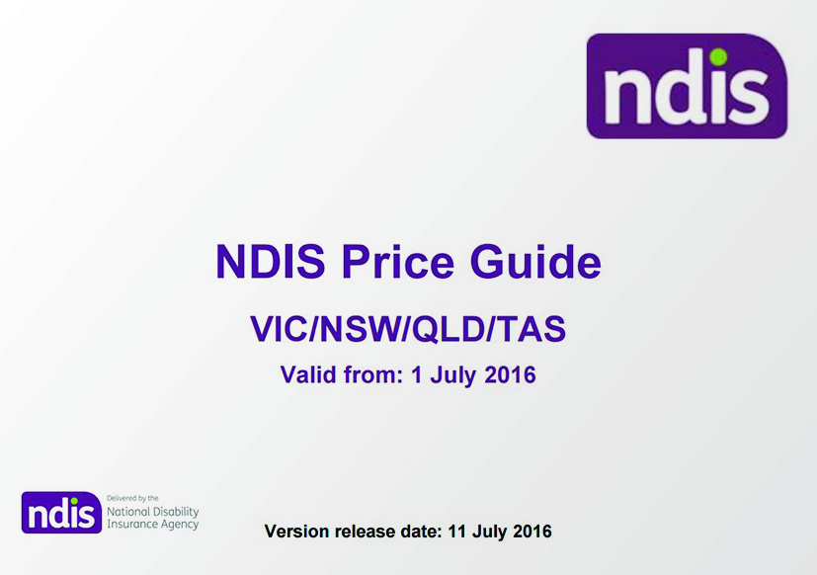

NDIS pricing & costing

The National Disability Insurance Scheme (NDIS) produces a yearly (financial) price guide that outlines the pricing and

payments for providers and participants of the NDIS.

The price guide is established in conjunction with the National Disability Insurance Scheme Act 2013.

why is this important?

It is important to understand the Pricing Guide so that participants:

how does the

pricing guide work?

NDIS Supports fall into 3 support purposes. Within each purpose there are a series of categories that break down the various types of supports and prices.

• Know what they are eligible to receive and how to use

their funding in the best way possible.

• Can efficiently organise their supports and prepare for

their planning meeting

• Understand how they can use their funds within their

plan and manage them flexibly.

• Know the restrictions, costs and maximum amount service providers can charge.

the price guide

The Pricing Guide is released

before the start of each financial year and is applicable for the duration of that year e.g.:

1 July 2016- 30 June 2017.

Some states in Australia have different Pricing Guides. This

is related to each state’s bi-lateral agreement. Victoria is included in the same Pricing Guide as New South Wales, Queensland and Tasmania.

The Pricing Guide will change so participants and supporters

need to make sure they keep up-to-date with the latest version.

terms and definitions

purpose, that is Core, Capacity and Capital.

their plan. To do this, participants create one service booking that allocates that money for all support they want

32

CORE

A support that enables a person to complete tasks of daily living. This usually includes direct support for personal care, consumables and transport. Core supports include:

• Assistance with daily living • Consumables

• Transport • Assistance with social and community participation

CAPACITY BUILDING

A support that enables the person to increase their skills and independence. Capacity Building supports include:

• Coordination of supports • Finding and keeping a job • Improved learning

• Improved living arrangements • Improved relationships • Improved life choices

• Increased social and community • Improved health and wellbeing • Improved daily living

SUPPORT CATEGORY

There are 15 Support categories in total that reflect the NDIA Quality frame work and life domains.

Each category sits within a Support purpose. You cannot have a Support category in more than one Support

SERVICE BOOKINGS

A service booking is a process where participants allocate a set amount of money to an organisation to use for

the service to provide.

CAPITAL

Consumable items for example communication devices or mobility aids.

CAPACITY

Lifelong learning and skill building supports

CORE

Personal care and day to day living

E

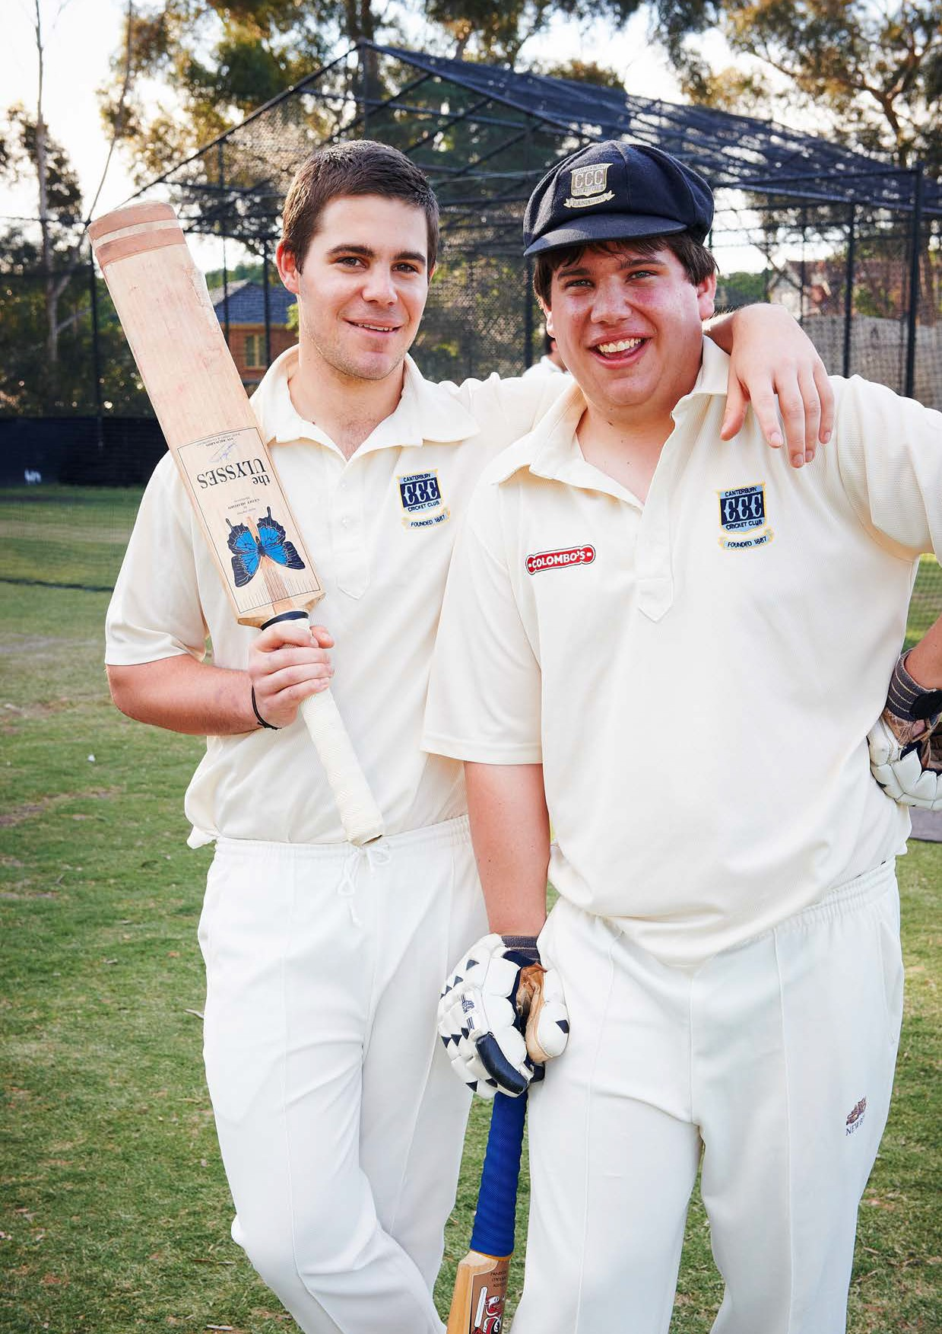

33

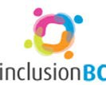Advocacy for inclusion logo

recommendations

1.

Self awareness of political citizenship and agency

2.

Awareness of local politics and political issues

3.

Enrolment to vote

4.

Determine voting preferences

5.

Voting by ballot

The following recommendations have been formulated using the above pathway as a conceptual foundation.

1. disability practice and policy

Regardless of the format or content of a campaign, well informed electoral inclusion campaigns acknowledge that the journey to political citizenship for people with intellectual disability begins with awareness of choice and rights, including the right to experience a broader range of options. The principles of supported decision making and the assumption of capacity in matters relating to legal and mental capacity, including long-term support to develop political preferences, are embedded in the Disability Act 2006, the National Disability Insurance Scheme Act 2013, and the UN Convention on the Rights of Persons with Disabilities. Electoral Commissions are advised to affirm the role of supported decision making, self-agency and Person Centred Active Support in their disability policy. Recommendations in this area include:

i.

ii.

Ensuring the rights and practices outlined in this report are embedded in all Electoral Commission Disability Action Plans.

Creating voting training programs for people with disability that embed the rights-based political citizenship pathway articulated in this report.

Ensuring voting guides and marketing collateral produced by Electoral Commissions embed the concepts of assumed capacity, the separation of mental and legal capacity, and support decision making.

Partner with leading disability support organisations to develop electoral inclusion training for direct support professionals and other people who work in the disability sector.

Develop resources that can be utilised by citizens with intellectual disability and their supporters when engaging with

support organisations. Resources must list available support practices that are available for support organisations to employ when supporting voters with intellectual disability, including how to support people through the first two steps of the political citizenship pathway above.

iii.

iv.

v.

2. electoral inclusion campaigns

Though Electoral Commissions are restricted from producing partial political information, electoral bodies worldwide have often been permitted to endorse and support electoral inclusion campaigns run by third parties.

When the various campaigns described in this report are mapped against the proposed voting pathway, it becomes clear that a

broad, UN CRPD-based campaign for the Victorian context can be created by combining aspects of each global campaign with the Victorian Electoral Commission’s leading strategies, including the Voters Voice app. To date, no campaigns globally have robustly incorporated materials to support all steps of the proposed political citizenship pathway (see pages 22-23).

34

F

An electoral inclusion strategy featuring various elements of the successful campaigns noted in this report may include:

i.

Promoting the development of political citizenship study groups, either through including political citizenship content in

foundation level vocational education and training courses, or through developing study circles such as those observed in

Swedish electoral inclusion campaigns.

ii.

Easy News publications that are created by people with intellectual disability and include wide ranging content from varies

spheres of civic life.

Easy read policy guides developed by political candidates with the support of electoral inclusion campaign officers.

Videos from political parties in Easy English developed by and for people with intellectual disability and with the support of disability support organisations and political parties.

Education for political parties about the rights and needs of voters with intellectual disability who will receive their political campaign materials.

iii.

iv.

v.

vi. Training journalists with intellectual disability who can participate in the development of the above campaign strategies.

vii. Creating a variety of Easy English voter and ballot guides that emphasise options for support.

viii. Training for polling staff and volunteers that highlights evidence-based support practices, the rights of voters with intellectual disability, and suggestions for engaging people with complex support needs on election day.

ix. A broad community awareness campaign that educates all citizens about the rights of people with intellectual disability and the role that all people can play – as friends, family, supporters and even neighbours – in building the capacity of voters with intellectual disability.

The resources required for a successful Victorian rollout of these campaign methods currently exist in the disability and disability advocacy sectors in Victoria.

3. inclusion at the ballot box

Successful campaigns also acknowledge that the experience at polling stations does not need to be restricted by the rules of the past. People with disability who have been supported by robust political education projects, circles of support or political citizenship education initiatives may be able to make use of their supportive advocates at the ballot box. Assistive Communication Technologies and inclusive voting apps (such as Voters Voice) may see people with disability supported to present pre-completed documentation at polling stations. Recommendations for Electoral Commissions include:

i.

Permitting pre-completed ballot papers and online submission for people with disability. Inclusion Designlab recognises that

this may require new forms of quality assurance to be developed to preserve integrity.

ii.

Formal recognition of decision-making supports at polling stations. This may include adopting and developing clear

standards based on current evidence-based practices within the disability support sector.

Creating training for electoral staff and volunteers on inclusion, access and citizenship. This may be accompanied by physical symbols such as badges or signage that will identify polling station staff who have been trained in this way.

Developing an inclusive public pre-polling campaign that ensures the necessary time for thought and reflection for voters with intellectual disability. This would be relevant both for voters with intellectual disability who may wish to lodge a postal vote as well as those who choose to attend a polling station in person.

iii.

iv.

4. research

Though various supported decision making research initiatives are underway across Australia, additional funding and support is required for research that:

i. Analyses and evaluates the suitability of global electoral inclusion campaigns for the Victorian context.

ii. Uses Participatory Action Research (PAR) techniques to trial and formulate models of group education that allow people with

intellectual disability to grow their knowledge of their political context.

5. national disability insurance scheme (NDIS)

The Information, Linkages and Capacity Building (ILC) program of the National Disability Insurance Scheme is intended to provide information and resources to the broader population of NDIS participants who are not eligible for funded support packages. There is potential for partner organisations to form an electoral inclusion agency within the ILC program that can support the large numbers of people with intellectual disability with low support needs.

35

F

barriers

Barrier: Definition of citizenship

Definitions of citizenship for people with intellectual disability in literature, policy, and research often fail to identify political citizenship, voting and (support for) self advocacy as core components. Furthermore, conversations about the citizenship of people with intellectual disability occur in the context of a support sector that, until recently, reinforced dependency.

Barrier: Limitations on political citizenship

People with intellectual disability are often invited to present their views, opinions and feedback in carefully curated self-advocacy and advisory initiatives, however these (1) often involve conventions and guidelines that are in themselves exclusionary, and

(2) are usually intended to gather feedback about disability related matters only. As people with intellectual disability experience greater access to inclusive education, employment and social opportunities in the community, people with intellectual disability need to be consulted on matters other than just disability and disability policy.

Barrier: The use of discretion by disability support professionals in place of evidence based practice

that is informed by rights and risk

The work of disability support professionals is ideally governed by a person centred practice framework and supported by practice coaching. In the absence of one or both of these, support professionals will often default to practices that include risk avoidance and a focus on resource management. In such cases, voting and political citizenship may not be encouraged, or worse, discouraged.

Barrier: Accessible election information and access to polling stations

People with intellectual disability are entitled to attend polling stations alongside members of the general population. They need

not be restricted to postal votes. There is generally a lack of accessible voting information for people with intellectual disability who choose to attend polling stations in person.

Barrier: Awareness of communication practices

Positive stories of voting engagement with people with disability abound, however a common theme is the supportive actions of polling station attendants. Though a range of practices and techniques exist that can support people with intellectual disability and communicative impairment, polling station attendants may not understand that these practices exist. More importantly, they may not be equipped to make decisions or assessments about the legitimacy of the actions and interactions between voters with disability and their support staff, carers or advocates on the day.

Barrier: Australian legal barriers to voting

Clauses in Australian electoral law that conflate legal and mental capacity leave Australian voters with intellectual disability

vulnerable to having their right to vote challenged or even negated.

Barrier: Undue emphasis on legislative reform

Though Australian and Victorian electoral laws do contain outdated and problematic clauses that create barriers to electoral inclusion, viewing legislative reform as the solution to low voter participation of people with intellectual disability is equally problematic. Current laws do not specifically disqualify people with intellectual disability from voting. Rather, they open voters with disability to undue scrutiny and allow them to be too easily removed from the electoral roll. What has become apparent in countries that have removed such clauses from their electoral laws is that legislative change was merely the beginning of the journey. Electoral inclusion improves as steps are taken to transform practice, educate the community, and actively promote a culture of political citizenship in the lives of people with intellectual disability. There are no legal barriers preventing these positive changes from occurring in Victoria now.

36

F

selected literature

self-advocacy and participation

Arnstein, S.R. (1969). A Ladder of Citizen Participation, JAIP

35(4): 216-224.

Caldwell, J., et al. (2009). Participation of individuals with developmental disabilities and families on advisory boards and committees, Journal of Disability Policy Studies 20(2): 101-

109. Cornwall, A. (2008). Unpacking ‘Participation’: models, meanings and practices. Community Development Journal,

14(3): 269-283.

Frawley, P. and Bigby, C. (2011). Inclusion in political and public life: The experiences of people with intellectual disability on government disability advisory bodies in Australia, Journal of Intellectual & Developmental Disability 36(1): 27-38.

Human Rights Law Centre (2014). Disenfranchising persons of “unsound mind”: Discrimination in Australia’s electoral

law (Submission no. 139). Retrieved from http://www.hrlc. org.au/wp-content/uploads/2014/01/HRLC_Submission_ Disenfranchising_persons_of_unsound_mind_Jan2014.pdf

Riddington, C. (2012). Ten years of partnership, Tizard Learning

Disability Review 17(1): 14-21.

Tsuda, E. and Smith, J.G. (2004). Defining and organizing

self-advocate centered groups: implications of survey research on self-advocacy groups in Japan, Disability & Society 19(6):

627-646.

Barclay, l. (2013). Cognitive impairment and the right to vote:

a strategic approach, Journal of Applied Philosophy, 30 (2):

146–159.

Keeley, H., Redley, M., and Clare I.C.H. (2008). Participation in the 2005 general election by adults with intellectual disabilities, Journal of Intellectual Disability Research,

53:175-81.

Kjellberg, A. (2002). Being a Citizen, Disability and Society, 17 (2): 187-203.

Kjellberg, A. and Hemmingsson, H. (2013). Citizenship and Voting: Experiences of Persons With Intellectual Disabilities in Sweden, Journal of Policy and Practice in Intellectual Disabilities, 10: 326–333.

Lord, J.E., Ashley Stein, M., and Fiala-Butora, J. (2014). Facilitating an equal right to vote for persons with disabilities, Journal of Human Rights Practice, 6 (1): 115–139.

Ornstein, N. and Kopić, K. (2016). The Ruderman white paper on voting accessibility for people with disabilities, Ruderman Family Foundation.

Redley, M. (2008). Citizens with learning disabilities and the right to vote, Disability and Society, 23 (4).

Redley, M. and Weinberg, D. (2007). Learning disability and the limits of liberal citizenship: interactional impediments to political empowerment, Sociology of Health & Illness, 29 (5): 767–786.

Redley, M., Maina, E., Keeling, A. and Pattni, P. (2012). The voting rights of adults with intellectual disabilities: reflections on the arguments, and situation in Kenya and England and Wales, Journal of Intellectual Disability Research, 56 (11): 1026–1035.

Ryan, T., Henderson, A., and Bonython, W. (2016). Voting with an “unsound mind”? A comparative study of the voting rights

of persons with mental disabilities, UNSW Law Journal, 39(3):

1038-1071.

Savery. J. (2014). Voting rights and intellectual disability in Australia: An illegal and unjustified denial of rights, Sydney Law Review, 37: 287-300.

human rights and legal capacity

Arstein-Kerslake, A. (2016). An empowering dependency: Exploring support for the exercise of legal capacity, Scandinavian Journal of Disability Research, 18(1): 77-92.

Australian Law Reform Commission (2014). Equality, capacity and disability in Commonwealth Laws, (Report no. 124). Retrieved from<https://www.alrc.gov.au>

Public Interest Advocacy Centre (2014). Equality before the law for people with disability, (Submission no. 41).

voting articles by inclusion melbourne

Despott, N. and Hirsch, A. (2013). Disability and voting rights, Right Now.

Despott, N., Hirsch, A. and Leighton, D. (2013). Sound minds, double standards and the right to vote, ABC: Ramp Up.

Voting and voting rights

Agran, M. and Hughes, C. (2013). “You can’t vote—you’re mentally incompetent”: Denying democracy to people with severe disabilities, Research and Practice for Persons with Severe Disabilities, 38(1): 58-62.

Agran, M., MacLean, W., and Kitchen Andren, K.A. (2015). I never thought about it: Teaching people with intellectual disability to vote, Education and Training in Autism and Developmental Disabilities, 50(4): 388-396.

Agran, M., MacLean, W.E., and Kitchen Andren, K.A. (2016). ‘‘My voice counts, too’’: Voting participation among individuals with intellectual disability, Journal of Intellectual & Developmental Disability, 54 (4): 285–294.

37

F





67 Sutherland Road Armadale VIC 3143

T. 03 9509 4266 E. [projects@inclusiondesignlab.org.au](mailto:projects@inclusiondesignlab.org.au)

W. inclusiondesignlab.org.au

Inclusion Melbourne Inc.

InclusionMelb