Easy English

Out of Home Action Plan
2021 - 2023

Cover image: One Tree, Many Leaves, Ashlee Harris.
Ashlee talks about her art
The tree shows that we are all connected yet we are all our own person.
The V.E.C. respects the Aboriginal people
of Victoria.
This information is from the Victorian Electoral Commission.
We write V.E.C. when we talk about us.
This plan is for and about
people who do not have a safe place to live
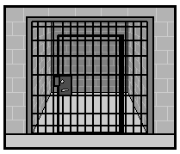
and people in prison.
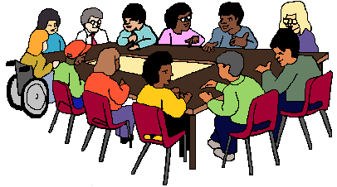
People helped us with this plan
they are called the Out of Home Advisory Group.
From the Electoral Commissioner
Warwick Gately, AM
He is the boss of the V.E.C.
He is called the Electoral Commissioner.
He says that this is our plan to be better at our work with people who do not have a safe place to live and people in prison.
We have worked with these people before
but
we can do more.

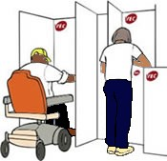
About the V.E.C.
The V.E.C. runs
- the Victorian State elections
- the local council elections.
The V.E.C. includes everyone. The V.E.C.
- is independent
- is fair
- tells us all what they do.
The V.E.C.
- respects everyone in the community
- uses new ideas to make things better.
The V.E.C. is not part of the government.

The plan
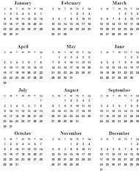
This plan is for 2021 to 2023.

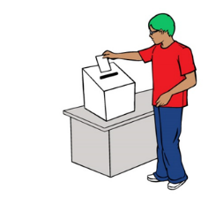
This plan is about
- Access.
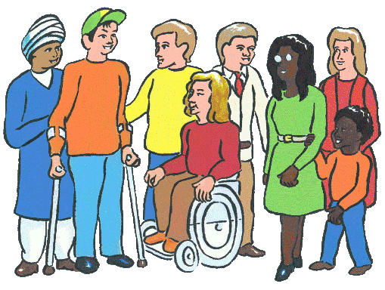
- Working together in the community.
- The people who work for us.
- Change. Be the best we can.

How we help people who do not have a home

1. Access
- We will look at our forms and make them easy for people to read and write on.
- We will keep sharing the special phone number for people who do not have a home to call when they want help to enrol or vote.
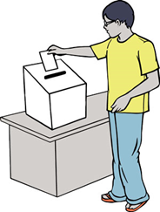
- We will plan new ways to share facts about enrolling and voting when a person does not have a home.
- If it is safe we will go to places people access services and they can vote there.

2. Working together in the community
- We will find more people in the community to help us support people who do not have a home.
- We will go to public events to talk about the work we do.
- We will make sure all the members of the Out of Home Advisory Group are a mix of different people and ready to help.

3. The people who work for us
- We will train and hire 2 new staff who know what it is like to not have a home or be in prison.

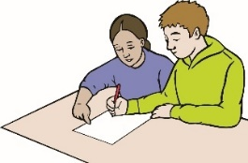
4. Be the best we can be
- Our staff will volunteer to help people who do not have a home.
- We will make sure the words we use to talk about people who do not have a home are up to date.
- We will write a guide for our staff to use when they want to share news about people who do not have a home.

How we help people in prison

1. Access
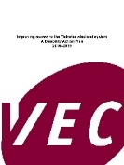
- We will look back at what we did
and think of new ways to include more people in prison.
- We will look at all the information about people in prison
and use it to make better choices.
- We will write a guide called Victorian Prison Guide - Elections and Voting and share it with all the prisons in Victoria.

2. Working together in the community
- We will ask 6 people who know about prison to meet twice a year to help us.
- We will make sure that our prison projects are up to date.
and will think of new ideas to contact people in prison.

3. Be the best we can be
- We will ask someone who knows what it is like to be in prison to help us with our work.

Report
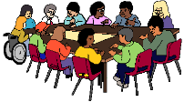
We will tell the Out of Home Advisory Group what we have done.
We write a report about this plan
each year.
This report will be part of the V.E.C. big report each year. It is called the V.E.C. Annual Report.

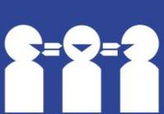
More information
Interpreter 9209 0112
Phone 03 8620 1100
Email info@vec.vic.gov.au
V.E.C.
Level 11
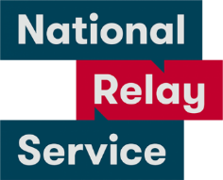
530 Collins Street. Melbourne 3000
National Relay Service 1800 555 600

How do I get this information in another language?
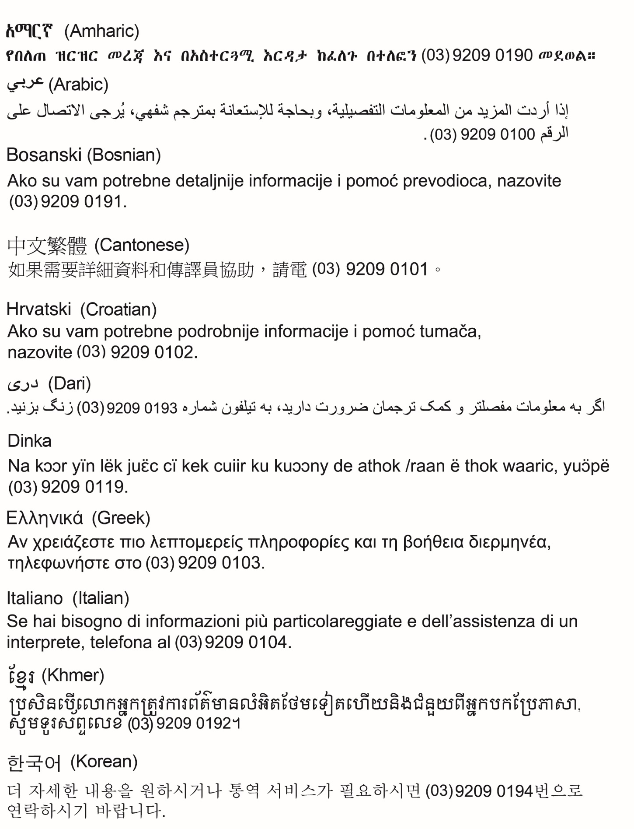
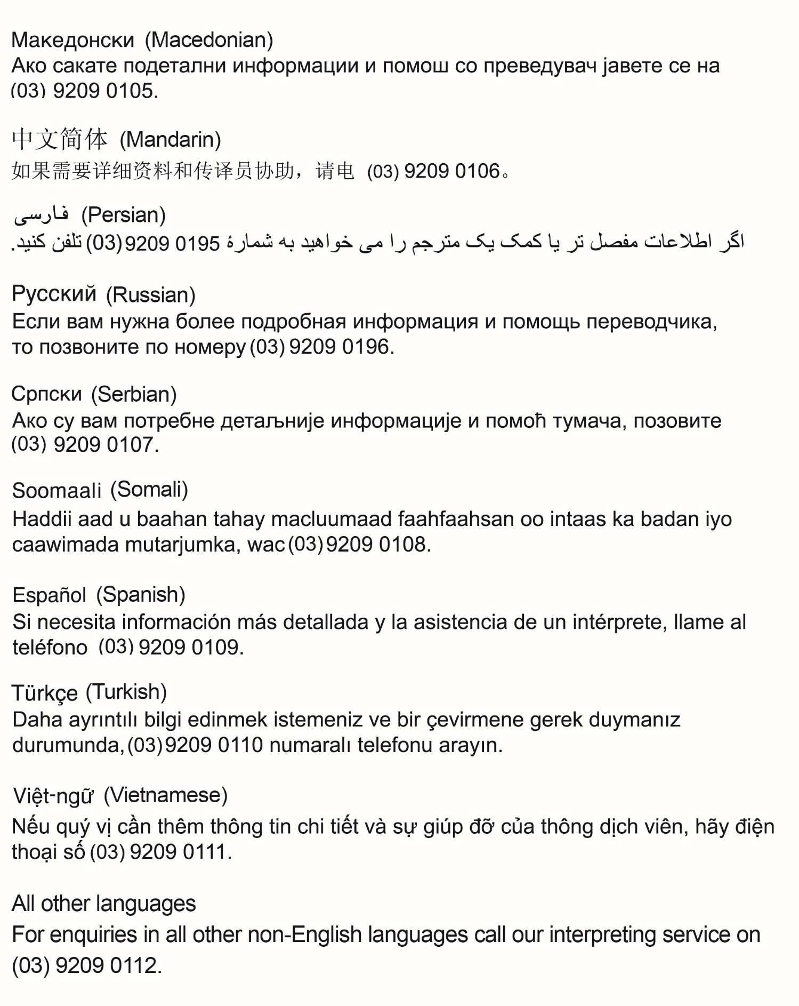

Images
We used images from
- Inspired Services
- Picto-selector
- Pinterest
- The Noun Project
- Tobii-Dynavox
and
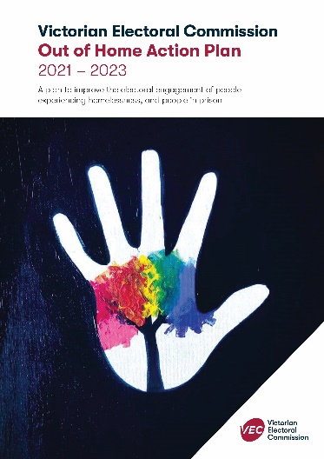
- V.E.C. images.
This plan is based on the Out of Home Action Plan
2021 – 2023

© State of Victoria (Victorian Electoral Commission) 2022.
This work, Out of Home Action Plan, is licensed under a Creative Commons Attribution 4.0 licence (http://creativecommons.org/licenses/ by/4.0/). You are free to re-use the work under that licence, on the condition that you credit the State of Victoria (Victorian Electoral Commission) as author, indicate if changes were made and comply with the other licence terms. The licence does not apply to any branding, including government logos.
Level 11, 530 Collins Street
Melbourne Victoria 3000
T 131 832
info@vec.vic.gov.au
vec.vic.gov.au

