Easy English
Multicultural Inclusion Plan
2020 - 2023

Cover image: Anuradha Patel drew the art on our cover. She named the artwork Eternal Spiral

The V.E.C. respects the Aboriginal people
of Victoria.

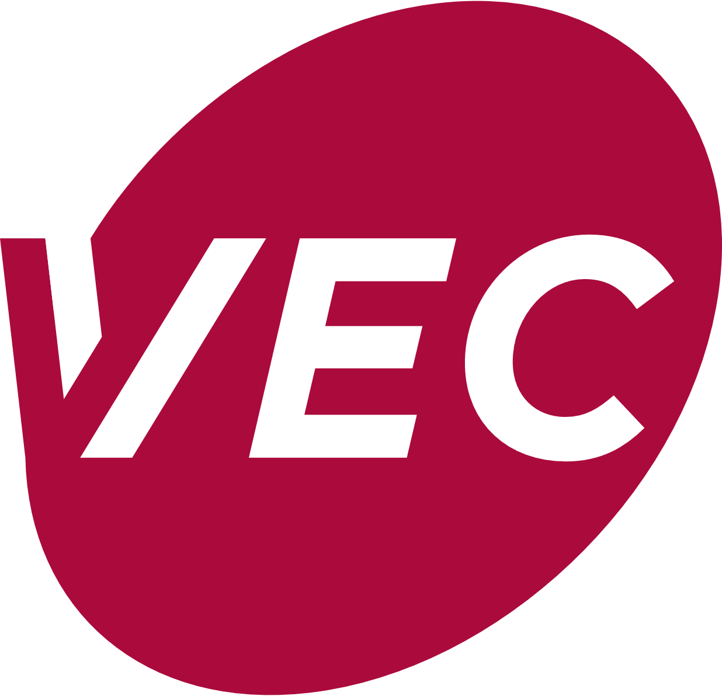
This information is from the
Victorian Electoral Commission.
We write V.E.C. when we talk about us.
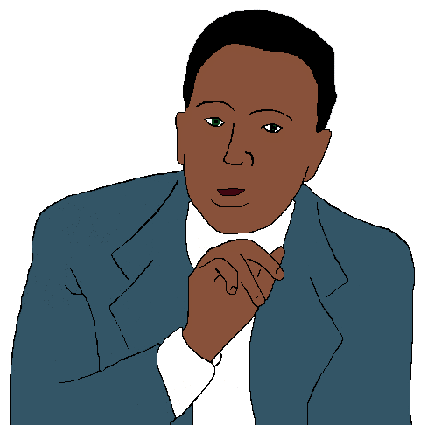
This plan is about people from many
different cultures. They may speak
different languages.
We will write CALD when we talk about them.

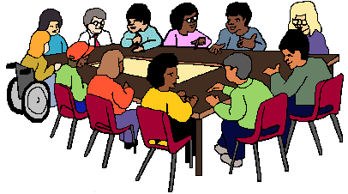
We have a group to help us do our work.
They are called the CALD Advisory Group.
We will write CALD Group when we talk about this group.

From the Electoral Commissioner

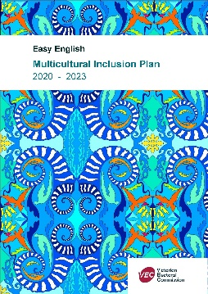
This is our plan to be better at our work
with CALD people.
This is Plan 1 from the V.E.C.

We have worked with CALD people before.

But

We can do more.

We talked to lots of different CALD people.

This plan helps us

• work more with CALD people
and
• work out what we can do better
- in their community
- at the V.E.C.

Warwick Gately. AM
He is the boss of the V.E.C.
He is called the Electoral Commissioner.

About the V.E.C.

The V.E.C. runs
- the Victorian State elections
- the local council elections.

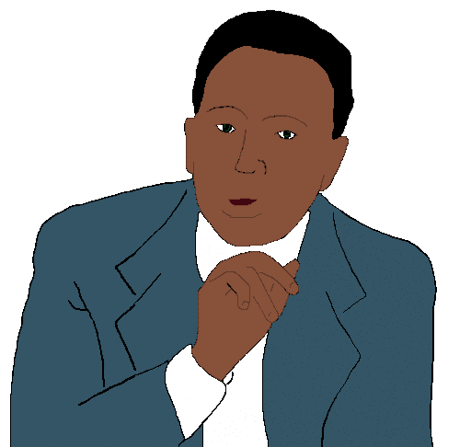
What we say about people who use a
different language.
The V.E.C. includes every one. The V.E.C.
- is independent
- is fair
- tells us all what they do.
The V.E.C.
- respects every one in the community
- uses new ideas to make things better.

The V.E.C. is not part of the government.

Things we have done
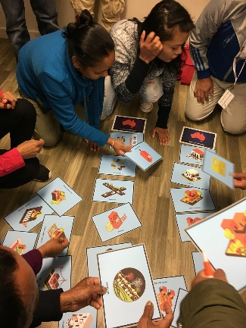
The V.E.C. has done lots of work with
CALD people. Like

- The Democracy Ambassador Program

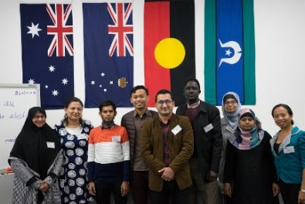
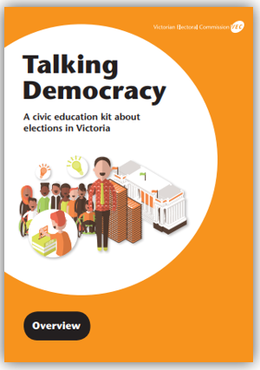
- Active Citizen workshop

• Talking Democracy

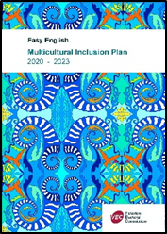
About this plan

We talked about this plan with
- our CALD Group
- staff from other places
- V.E.C. staff
- other people who work with us.

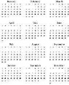

We will do a big review of this plan in 2023.
This is in 3 years.

We want more people to know how to vote.
Like

- young people
- people from many cultures.
They may speak a different language

- Aboriginal and Torres Strait Islander peoples
.

We want these people to also know how to vote.
Like

• people who do not have a home
• people in prisons.

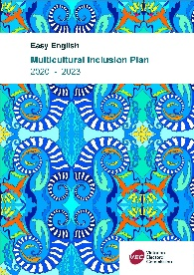

The plan
This plan is for 2020 to 2023.

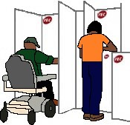
This plan is about
- Access

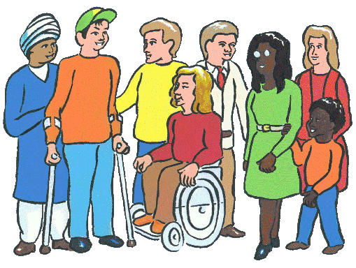
- The people who work for us.

- Working together in the community

- Staff skills. Be the best we can.

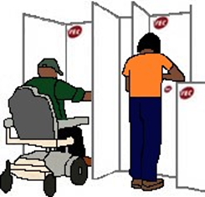
1. Access
It helps CALD people learn how to vote

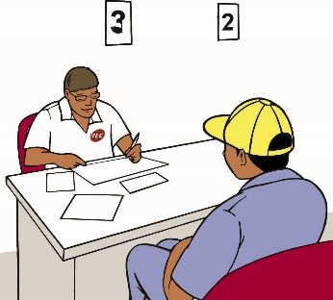

- At elections the V.E.C. has staff who know how to work with you.

- We have CALD staff to
- teach you about how to vote in Victoria

- tell you about our website. It has our forms in other languages. Like Chinese
- tell you more about how to enrol.
- The V.E.C. asks you when you need
An interpreter. We have interpreters at
- public meetings
- places we teach you how to vote.

- We translate information. It is
- at big meetings
and
- for elections.

2. The people who work for us

- We will have more CALD people at the V.E.C.

- We write a plan. It is about how to have more CALD people work at the V.E.C.

- We have a special job for a CALD person.
It is each year.

3. Working together in
the community

- The V.E.C. works with the CALD group.

- There are lots of different people in Victoria.
It changes all the time. We will ask who else needs to be in the CALD Group.

- We will listen to different people. Like
- the CALD Group
- other people who may not speak English.

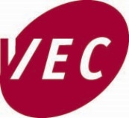
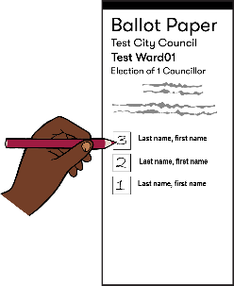

It helps us plan what different communities need to know how to vote.

- We will look to work with some teachers.
It will help them know more about how to vote
in Victoria. It helps them teach CALD people.

- We will look to work with a place where
young people go.
It helps them teach young people more about how to vote.

- We will do more with CALD communities.

- We will work with CALD leaders about
how to vote.

- Every thing from V.E.C. has pictures of the different people in Victoria.

4. Staff skills.
Be the best we can be

- We will look back at this plan every year.
We change things when they do not work.

- Teach V.E.C. staff about people from
different communities.

- Do studies.
We find out from CALD people
- what helps to vote
- what does not help to vote.

Reports

We will tell the CALD Group what we have done.

We write a report
- about this plan
- each year.

This report will be part of the V.E.C. big report
each year. It is called the V.E.C. Annual Report.

More information

Interpreter 9209 0112.

Phone 03 8620 1100

Email info@vec.vic.gov.au

V.E.C.
Level 11.
530 Collins Street. Melbourne 3000.

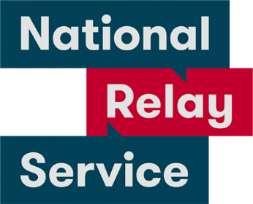
National Relay Service 1800 555 600.

Images
We used images from
- Inspired Services
- Picto-selector
- Pinterest
- The Noun Project
- Tobii-Dynavox
and
- VEC images.
Cover image. Patel Anuradha. Eternal Spiral. 2020. Digital Print.

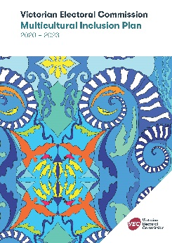
This plan is based on V.E.C. Multicultural Inclusion Plan 2020 - 2023.

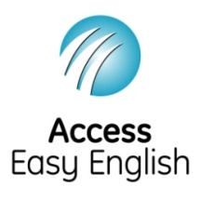
Access Easy English wrote the Easy English.
September 2020.

© State of Victoria (Victorian Electoral Commission) 2020.
This work, Multicultural Inclusion Plan, is licensed under a Creative Commons Attribution 4.0 licence (http://creativecommons.org/licenses/ by/4.0/). You are free to re-use the work under that licence, on the condition that you credit the State of Victoria (Victorian Electoral Commission) as author, indicate if changes were made and comply with the other licence terms. The licence does not apply to any branding, including government logos.

Level 11, 530 Collins Street
Melbourne Victoria 3000
T 131 832
info@vec.vic.gov.au
vec.vic.gov.au

