Victorian Electoral Commission
Annual Report 2016-2017
Department of Health
Your Council. Your Vote

about the vec

OUR VISION
All Victorians actively participating in their democracy.

OUR PURPOSE
To deliver high quality, accessible electoral services with innovation, integrity and independence.

OUR VALUES
- Independence: acting with impartiality and integrity
- Accountability: transparent reporting and effective stewardship of resources
- Innovation: shaping our future through creativity and leadership
- Respect: consideration of self, others and the environment
  - Collaboration: working as a team with partners and communities

OUR PEOPLE AND PARTNERS
The Victorian Electoral Commission (VEC) has a core staff of dedicated and highly skilled people whose specialised knowledge ensures the success of its operations. At times of peak activity, the VEC draws on the experience and expertise of a number of associated personnel, such as election officials and contractors, to complement the work of its core staff. Valued partnerships with suppliers also contribute greatly to the VEC’s achievements.
To ensure inclusion and participation, the VEC works closely with a range of advisory and community groups. These groups primarily consist of representatives of under-represented communities, including:
- Aboriginal and Torres Strait Islander communities
- Young people
- People experiencing homelessness
- People living with disabilities
  - Culturally and linguistically diverse communities
The VEC thanks all advisory and community group members and their organisations for their contributions to its work during 2016–17.
The VEC pays respect to Victoria’s traditional owners and their elders past and present who have been custodians of this country for many thousands of years. Their living culture and their role in the life of Victoria is acknowledged by the VEC.

OUR HISTORY AND FUNCTIONS
Elections for the Victorian Parliament began when Victoria achieved independence from New South Wales in 1851. In 1910, Victoria’s first Chief Electoral Inspector was appointed to head the new State Electoral Office.
The State Electoral Office existed as part of a public service department for 70 years. However, it became increasingly clear that it was inappropriate for the conduct of elections to be subject to ministerial direction. On 1 January 1989, legislation established the independent statutory office of Electoral Commissioner who was to report to Parliament instead of a Minister. In 1995, the State Electoral Office was renamed the Victorian Electoral Commission.
The VEC’s functions and operations are governed by six main pieces of legislation:
- Electoral Act 2002 - establishes the VEC as an independent statutory authority, sets out the functions and powers of the VEC and prescribes processes for State elections
- Constitution Act 1975 - sets out who is entitled to enrol as an elector, who is entitled to be elected to Parliament, and the size and term of Parliament
- Financial Management Act 1994 - governs the way the VEC manages finances and financial reporting
- Electoral Boundaries Commission Act 1982 - governs the determination of State electoral boundaries. Under this legislation, the Victorian Electoral Commissioner is nominated as a member of the Electoral Boundaries Commission
- •Local Government Act 1989 - provides for the conduct of Local Government elections and electoral representation reviews
- Infringements Act 2006 - provides for stages 2 and 3 of compulsory voting enforcement
- Subject to these Acts, the VEC:
- maintains the electoral enrolment register
- conducts State elections, Local Government elections, statutory elections and commercial and community elections
  - •conducts electoral boundary reviews
The VEC also has a mandated role to conduct electoral research, provide communication and education services and to inform and engage Victorians in the democratic process.
A list of legislation and regulations governing the VEC is included in Appendix B.

VICTORIAN ELECTORAL COMMISSION
Level 11, 530 Collins Street
Melbourne Vic 3000
Telephone: (03) 8620 1100
Fax: (03) 9629 8632
Website: vec.vic.gov.au
Email: info@vec.vic.gov.au
Office hours:
8.30 am – 5.00 pm Monday – Friday

Letter of transmittal
The Hon. Gavin Jennings MLC
Special Minister of State
1 Treasury Place
Melbourne Vic 3002
Dear Minister
In accordance with the requirements of the Financial Management Act 1994, I am pleased to submit the Annual Report of the Victorian Electoral Commission for the year ending 30 June 2017 for presentation to Parliament. Also included is the Report of the Electoral Boundaries Commission for the year ending 30 June 2017.
Yours sincerely
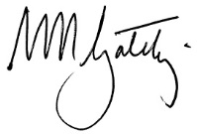
Warwick Gately AM
Electoral Commissioner

Contents

about the vec 3
About this report 8
Our highlights 10
Our year 11
Finance at a Glance 15
our STRATEGIC plan 18
our STRATEGIC INITIATIVES 19
Our commission 26
GOVERNANCE 27
organisational structure 28
the electoral commissioner 29
THE VEC executive management group 31
internal committees and groups 38
External Advisory Groups 41
governing legislation and tribunals 43
accountability and transparency 45
disclosures 49
Our core business 54
electoral activity 55
enforcement of compulsory voting 64
warehouse 66
research and development 67
Our stakeholders 69
register of electors 70
inclusion and participation 73
services to political parties 80
interaction with electoral bodies 82
our people 84
human resource management 85
Staff profile 89
staff services and employment conditions 91
occupational health and safety 92
FINANCIAL STATEMENTS 96
FINANCIAL REPORT 97
COMPREHENSIVE OPERATING STATEMENT 100
BALANCE SHEET 101
STATEMENT OF CHANGES IN EQUITY 103
CASH FLOW STATEMENT 104
NOTES TO THE FINANCIAL STATEMENTS 105
ACCOUNTABLE OFFICER’S AND CHIEF FINANCE AND
ACCOUNTING OFFICER’S DECLARATION 146
Auditor–General’s report 147
Appendices 149
GLOSSARY 170
INDEX 174

About this report
This report provides a summary of programs and initiatives implemented to meet the key objectives set out in the Strategic Plan 2013–14 to 2017–18
The report outlines efforts to deliver the Strategic Plan; progress against Strategic Initiatives; a narrative of work and presentation of key results achieved by the VEC in 2016–17; and the outlook for 2017–18.
This report has been published in accordance with Financial Reporting Direction (FRD) 30C. As part of the VEC’s environmental sustainability activity, only the required number was printed, and environmentally friendly paper and printing processes were used.
Page 11

Our year
In this section, the Electoral Commissioner, Warwick Gately AM, provides a summary of key activities and achievements for 2016–17 and the outlook for 2017–18. The coming year includes planning and preparation for the 2018 State election, development of a new five year Strategic Plan and finalising the Information Technology Branch restructure.
Chief Financial Officer, Binh Le, provides an overview of the VEC’s financial performance.
A summary of achievement against the VEC’s Strategic Initiatives is included in this section. There was continued and focused work on Strategic Initiatives relating to service delivery, business systems and information management as outlined in the VEC’s Strategic Plan.
Page 29

Our Commission
Good corporate governance and transparent reporting help ensure continued public confidence in the VEC and its processes.
This section provides detail of the VEC’s regulatory environment and governance and organisational structures, key persons and staff profiles, disclosure requirements and the corporate systems that enable the VEC to deliver its core business and operate effectively and efficiently on a day-to-day basis.
Accountability to the Victorian public and Parliament is critical, and the VEC’s good corporate citizenship is evidenced by its performance in areas such as diversity, inclusion, accessibility, sustainability, information management and reporting.
Information relating to internal and external advisory groups is also detailed in this section. These advisory groups play an important role with the VEC.
Page 57

Our core business
The VEC’s core business includes the conduct of elections, maintenance of the register of electors and ensuring fair and equitable representation for voters at State and Local Government levels.
Having earlier completed electoral representation reviews and sub-division reviews of councils, the VEC successfully delivered elections for 78 councils in October 2016. This significant and complex activity was achieved through careful planning and strong client and stakeholder liaison.
Preparations for the next major cyclical event - the 2018 State election - have commenced. This, and project work in support of priority strategic initiatives during 2017–18, will continue to underpin the realisation of the VEC’s vision of all Victorians actively participating in their democracy.
Page 72

Our stakeholders
Along with the provision of high quality electoral services to voters, the VEC’s key strategic intents include the continued accuracy, integrity and security of the enrolment register, and strong and effective partnerships with stakeholders.
In the context of the 2016 Local Government elections, this section includes details of the VEC’s efforts to enrol, inform and engage electors as voters and candidates, provide accessible voting services and ensure electors know how to cast a formal vote.
Information about key stakeholder groups such as voters with particular requirements, political parties and the media is detailed in this section. How the VEC interacts with other electoral bodies is also discussed.
Page 87

Our people
The VEC aims to provide staff with the environment and opportunity to learn and thrive on a personal and professional level.
Occupational health and safety remains a priority at the VEC. This section provides the OHS performance metrics and details the ‘lead’ activities undertaken in 2016–17, including actions taken in response to an OHS internal audit.
Page 99

Audited financial statements
The VEC is pleased to provide ‘value for money’ electoral services to the Victorian public. Once again, the VEC’s sound financial management is evidenced by an unqualified report from the Auditor-General. This section provides the VEC’s audited financial statements for 2016–17.

Appendices 134

Glossary 158

Index 161

Our highlights
Page 49
Implementation of the VEC’s Risk Management Framework
Page 50
VEC Annual Report 2015–16 achieved Gold at the 2017 Australasian Reporting Awards
Page 58
All elections, by-elections and polls conducted on schedule, within budget and in accordance with legislation, rules and guidelines
Page 58
Conduct of the 2016 Local Government elections across 78 councils, culminating in a comprehensive report to Parliament
Page 79
Successful pilot of Voters Voice, an award winning iPad app for people with complex communication needs during the 2016 Local Government elections
Page 82
Successful launch of the VEC’s Reconciliation Action Plan
Page 90
Domestic Violence awareness training provided for selected Family Violence Contact Officers and all managers
Page 92
Positive results from the VEC’s People Matters Survey with 71% participation

Our year
This year quadrennial Local Government elections were held across Victoria. This complex multifaceted program of activity dominated the VEC’s work. The hallmark of this program was the strong early planning, close liaison with client councils, candidates, voters and service providers and the evident efficiency around the many interdependent activities.
Warwick Gately AM
Electoral Commissioner

SIGNIFICANT EVENT MANAGEMENT
This year quadrennial Local Government elections were held across Victoria. This complex multifaceted program of activity dominated the VEC’s work and is the theme of this report. Many of its elements are discussed under our core business, our stakeholders and our people.
The numbers associated with the Local Government elections are themselves impressive; 78 councils as clients, 2,135 candidates contesting 636 councillor vacancies in 222 separate elections and over 3.7 million ballot packs for postal elections. Yet for the VEC the hallmark of this program was the strong early planning, the close liaison with client councils, candidates, electors and service providers and the evident efficiency around the many interdependent activities. The internal Planning Group gave life to a comprehensive and agreed client Election Service Plan, removing ambiguity over the VEC's work at each stage of the Local Government election timeline and setting performance targets by which the success of the program could be measured. As one performance measure, all election results were declared within the advertised target date.
A comprehensive report to Parliament was provided in May 2017 and I am particularly pleased with the performance of the VEC given the complexity of the activity, the volumes of material involved and the challenges introduced by last minute changes to governing rules.
A total of 17 other election activities were conducted during the year and included Local Government by-elections, countbacks and commercial elections.

CONTINUOUS IMPROVEMENT
The continuous improvement cycle associated with the 2014 State election neared its end. The release of the Electoral Matters Committee (EMC) report and recommendations on that election was followed with a Government response in November 2016. Legislative reform will follow next and changed or new administration and operational elements will be incorporated into the 2018 State election, which the Planning Group is already considering.
Operations and activities aside, internal arrangements for the management and control of the VEC received attention. The emphasis on risk management continued with the finalisation and implementation of the Risk Management Framework in March 2017 and reviews of the Strategic Risk and Operational Risk registers also occurring.

FINANCIAL MANAGEMENT
The year’s appropriation from Government also provided for the conduct of state-wide Local Government elections. While VEC marginal costs for these elections were ultimately recovered from client councils, this occurred well after the purchasing of services. Improvements continued to internal financial reporting, forecasting and expenditure controls including an important and positive audit of the VEC’s alignment with the Financial Management Compliance Framework. Internal audits were also concluded covering business continuity planning, compulsory voting and the VEC’s management of elector data provided by VicRoads and the Registry of Births, Deaths and Marriages. These audits were positive.
The Audit and Risk Committee met on four occasions. David Fahey attended his final meeting as a member in August 2016 and was succeeded by Carol Pagnon. Robert Yeo attended his final meeting as Chairman of the Committee in December 2016 with Michael Ulbrick taking up this third Committee place in March 2017. Both retiring members are thanked for their important contribution. David Nairn was appointed Committee Chairman in December 2016.

OUR PEOPLE
The contribution, focus and deliverables of the Human Resources (HR) function in the VEC continued with significant progress in the areas of staff performance and development, professional learning and occupational health and safety. A rapidly evolving HR intranet site was instrumental in communicating important policy information to staff covering such matters as health, work and well-being initiatives, conflict of interest and bullying and harassment in the workplace. A full review of position descriptions was completed, reflecting changing individual duties and corporate responsibilities. The education of managers continued with a particular focus on leadership and the important contribution this cohort can make to the management of the VEC.

ENGAGEMENT CONTINUING
The launch of the VEC’s first “Innovate” Reconciliation Action Plan (RAP) in February 2017 was a significant achievement as acknowledged by Reconciliation Australia. Brought together by a dedicated and passionate team, this plan identifies the VEC’s approach to reconciliation through engagement, inclusion and change. It remains now to act on this plan.
Additionally, involvement in the Richmond Emerging Aboriginal Leaders (REAL) program with the Korin Gamadji Institute continued as a great partnering success. For the young persons involved, this unique activity provides a transformational model of leadership and cultural affirmation, and in many cases firming career and participation aspirations. The VEC has supported the REAL Program since 2011 and an external evaluation of the program this year confirmed its merits and identified other ways to reinforce engagement with these young leaders.
Our various advisory groups met individually in early 2017 to discuss the effectiveness of the 2016 Local Government election activities and initiatives. Responses were positive and the benefit derived from engaging these groups as important partners was again evident.
The Electoral Council of Australia and New Zealand (ECANZ) met formally on two occasions to consider electoral legislation, electoral roll matters and collaboration in operations and technology. Under this auspice there is increasing interest in electronic voting and how this can be advanced as a national capability. These matters were considered in May 2017, with ECANZ resolving to advance the idea of a single national electronic voting solution.
The Electoral Regulation Research Network (ERRN) continued to prove successful as a collaborative medium bringing together political scientists, election administrators and commentators to discuss contemporary election matters. This year, 14 seminars were held around Australia, covering matters such as political finance and changing methods of voting. Also, many working papers were published along with two newsletters.

SUCCESS IN PLANNING
The Strategic Plan was further advanced. An important component was to complete a Products and Services Strategy, making clear the VEC’s priorities for the near term. This fitted with continuing work on the Information Management Framework and the Commission’s Risk Management Framework now growing in maturity. Attention was given to workforce and succession planning, which in conjunction with a review of the VEC’s operating model, identified expanded leadership opportunities for later implementation. The VEC’s commitment to diversity and inclusion was evident with work commencing on an action plan.

TECHNOLOGY DEMANDS ORGANISATIONAL CHANGE
The increasing reliance on information and communications technology to support complex election operations required a review of our structural effectiveness and responsiveness. As a first step, system development requirements for the next State election were identified along with the resourcing overhead. Associated with this was a close look at the structure of the IT Branch, given its fragmented adjustments over many years, and the identification of changing staff numbers, skill sets and governance requirements to meet all future IT development and support challenges. Importantly, this will also allow for the completion of the Election Management System (EMS) redevelopment.
The Electoral Matters Committee’s (EMC) 2016 Inquiry into Electronic Voting concluded with the publication of the report in May 2017. The report provides the opportunity for the State to move cautiously into electronic voting – subject to Parliament’s support and oversight – and system development will now receive priority. This is a significant project and not without risk.

LOOKING AHEAD
Over the next 12 months, increasing attention will be given to planning and preparation for the 2018 State election; additional staff will be recruited for project work, suppliers will be contracted and material sourced. Key community and political stakeholders will be engaged as the 24 November 2018 election day nears.
A new strategic plan will be established to set the organisational direction for the next five years, taking into account organisational goals and the prevailing environment. Associated with that will be closing the few remaining strategic initiatives from the old plan.
Work to implement the new structure of the IT Branch will continue. Staff are being recruited to redesigned and new positions, and system and application development advanced to meet established priorities, operational needs and resourcing availability. The introduction of a new intranet will also receive priority.

OUR MOST VALUABLE RESOURCE
It is an often over-used cliché that 'our people are our most valuable resource' but having successfully completed the 2016 Local Government elections, the saying holds true. VEC ongoing and contract staff managed this complex program with alacrity and diligence. Their oversight of projects and suppliers and a large dispersed casual workforce proved instrumental in the successful outcome, and this was undertaken with enthusiasm and good humour. My thanks to all for their hard work and dedication.
Changes to the Executive Management Group (EMG) must be acknowledged. Thanks go to Simon Mahony and Melanie Davidson for their contributions to financial and enrolment management, respectively, and I welcome Binh Le and Keegan Bartlett to these roles and look forward to their contribution to the management and life of the VEC. The other members of the EMG are also thanked for their leadership contribution and their support, opinion and advice throughout the year.
Warwick Gately AM
Electoral Commissioner

Finance at a Glance
The VEC’s financial position continues to fluctuate with increases in special appropriation, expenditure and equity. The call on large scale electoral services alternates biennially, influencing the VEC’s funding pattern. The VEC conducted the 2016 Local Government elections in October, and managed 17 additional events including four Local Government countbacks and 13 fee‑for-service elections and polls. The VEC successfully delivered all electoral activities on schedule and within budget.

FINANCIAL PERFORMANCE
With 2016–17 being an electoral year, special appropriations and expenditure transactions increased considerably compared to the previous year. A summary of performance is outlined below showing the movement in special appropriation, expenses, balance sheet items and net cash flow.

FIGURE 1: FIVE YEAR FINANCIAL SUMMARY 2012–13 TO 2016–17
 | 2012-2013  ($,000) | 2013-2014  ($,000) | 2014-2015  ($,000) | 2015-2016  ($,000) | 2016-2017  ($,000)
Electoral activity | Local Government  Elections |  | State Election |  | Local Government  Elections
Special appropriation | 40,245 | 23,062 | 62,623 | 25,260 | 52,336
Total expenses from transactions | 41,663 | 24,987 | 65,735 | 24,946 | 51,453
Net result from transactions | (1,418) | (1,925) | (3,112) | 314 | 883
Net result for the period | (1,411) | (1,936) | (3,142) | 253 | 917
Net cash flow from/(used in) operating activities | 4 | (1) | - | 18 | (4)
Total assets | 10,471 | 11,520 | 9,953 | 11,730 | 12,746
Total liabilities | 3,020 | 3,675 | 4,924 | 5,457 | 5,056
Net assets | 7,451 | 7,845 | 5,029 | 6,273 | 7,690

FIGURE 2: SPECIAL APPROPRIATION ($,000) 2012–13 TO 2016–17
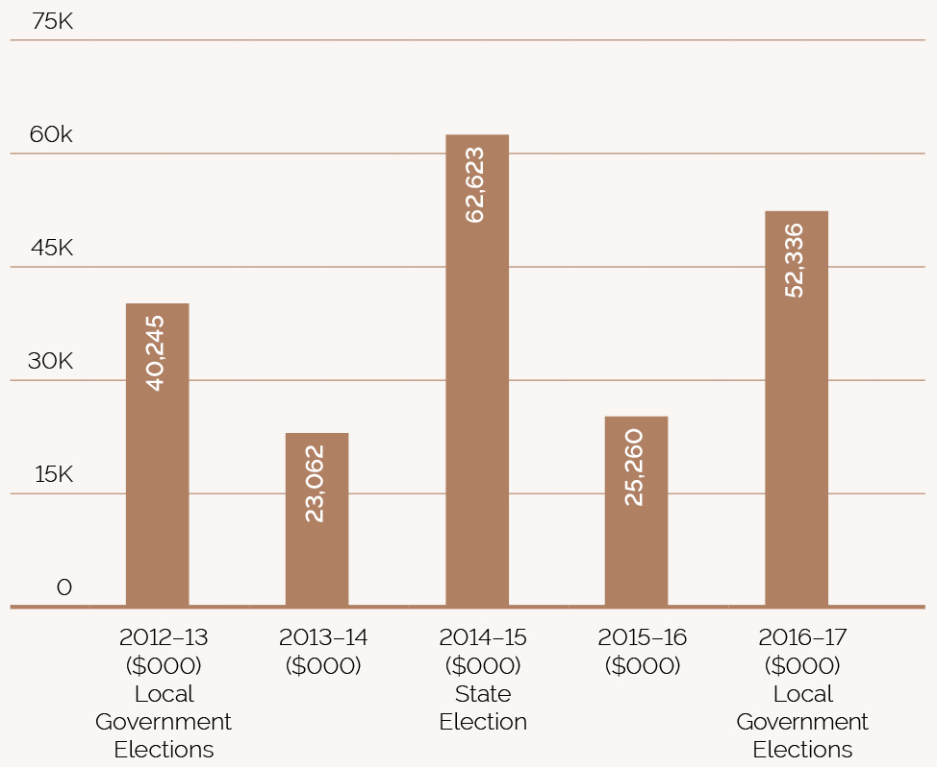

FUNDING
The VEC received $52.3 million in funding for 2016–17. Funding fluctuates significantly over the biennial electoral cycle. Every two years, the VEC undertakes either a State election or Local Government elections across Victoria. The VEC is funded solely from Government Special Appropriations and this amount represents the reimbursement to the VEC for all its cash payments.

EXPENDITURE
The VEC incurred $51.5 million in operational expenses from transactions for the reported financial period. The increased expenditure is directly associated with the Local Government elections. This reflects the State government’s funding model that reimburses the Commission for all of its cash payments during the financial year. Further, the VEC does not hold a cash reserve in its bank accounts, as it is reimbursed on a daily basis for all outgoings incurred.

OPERATIONAL AND BUDGETARY OBJECTIVES AND PERFORMANCE AGAINST OBJECTIVES
The VEC has a number of performance measures that relate specifically to Budget Paper Number 3 Service Delivery (BP3), in accordance with the Department of Treasury and Finance, Financial Reporting Directions (FRD). The following table (Figure 3) provides details of the output report provided by the VEC to the Government, including performance measures and targets for agreed outputs, and the actual performance results for the VEC over the full year ending 30 June 2017.

FINANCIAL POSITION
The VEC’s financial position remains strong and stable with total assets of $12.7 million, liabilities at $5.1 million and net equity of $7.7 million. The VEC’s assets largely comprise of the Election Management System (EMS) and election inventory. The EMS software system has been custom-built to enable the VEC to conduct elections and is recorded as an intangible asset.
The VEC’s liabilities largely comprise of employee entitlements and year-end expenditure accruals. The equity of the VEC is split into contributed capital, asset reserve and accumulated loss. The contributed capital represents the amount of funding contributed by the Government of Victoria for the purchase and development of VEC non-current assets. The accumulated loss represents the accumulated result from continuing its operations.
FIGURE 3: PERFORMANCE AGAINST BUDGETARY OBJECTIVES
 | unit | 2016–17  bp3 target | 2016–17  actual | %  Variance
State elections, Local Government and statutory elections,  by-elections, polls and electoral representation reviews | number | 99 | 96 | -3%¹
Legal challenges to VEC conduct upheld | number | 0 | 0 | 0%
Changes to elector details or additions to the  Victorian Enrolment Register processed within set timeframes | percent | 95 | 99 | 4%²
1 The 2016–17 election events number is lower than the 2016–17 target due to the number of actual extraordinary vacancies in the Legislative Assembly and on local councils tracking lower than projected for the 2016–17 reporting year.
2 The 2016–17 full year actual is higher than the target due to a stronger focus on the highest value enrolment programs relating to the 2016 Local Government elections.

our STRATEGIC plan
The VEC Strategic Plan 2013–14 to 2017–18 provides the basis for operations. Strategic Initiatives, organisational planning and staff development are linked to three key strategic intents and associated enablers or conditions that need to be in place in order for the VEC to achieve its strategic intent.
Areas of focus were identified to guide the development and prioritisation of Strategic Initiatives, enabling the VEC to successfully pursue its vision of all Victorians actively participating in their democracy. A total of 27 Strategic Initiatives were developed and prioritised for action over the five-year term of the Plan.
A review of the current Plan was conducted in May 2016 to ensure that initiatives and priorities remain relevant to the current environment. Minor adjustments were made and the revised Plan applied for 2016–17.
FIGURE 4: VEC PLANNING DOCUMENTATION HIERARCHY
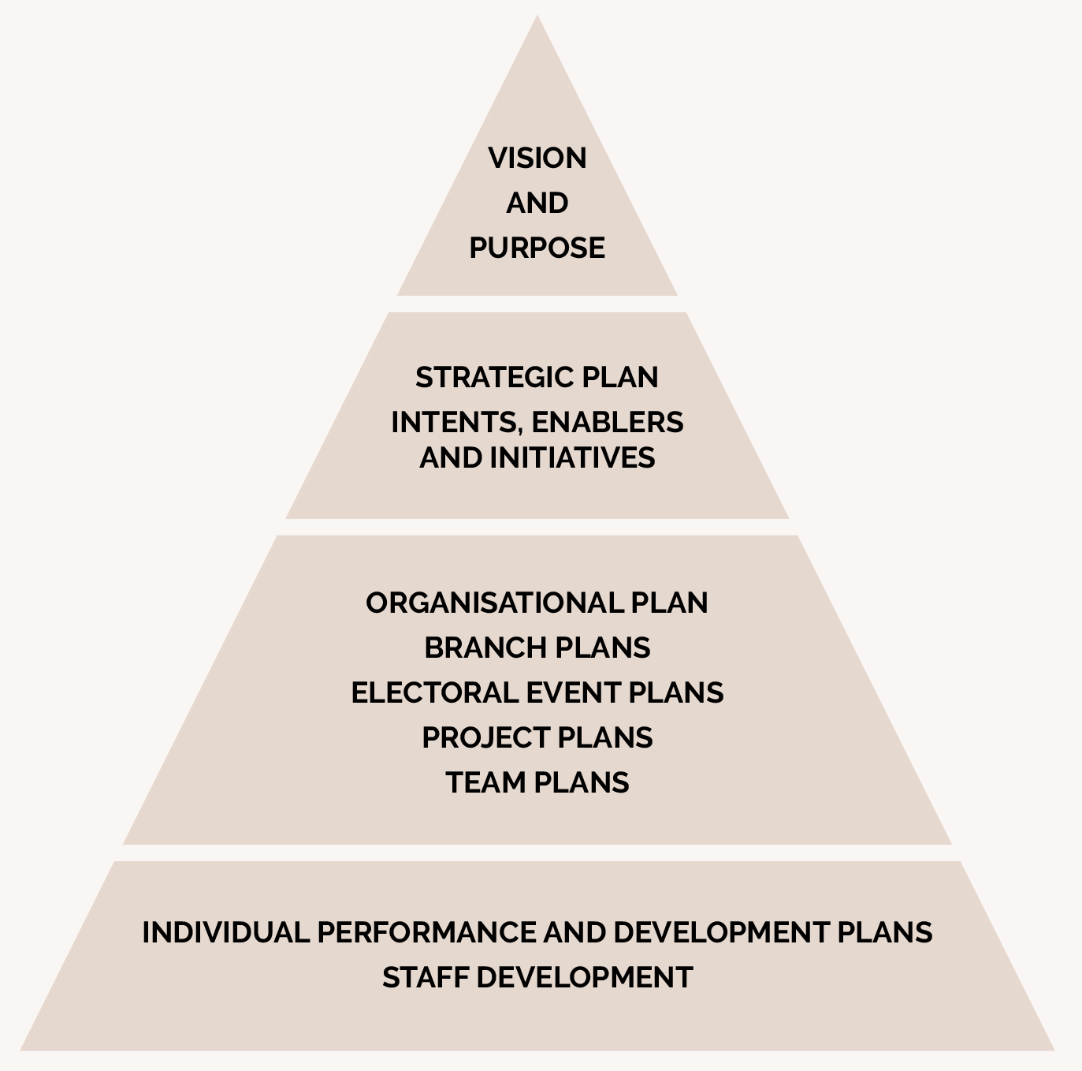

our STRATEGIC INITIATIVES

FIGURE 5: SNAPSHOT OF THE VEC STRATEGIC PLAN WITH NUMBER OF INITIATIVES SUCCESSFULLY COMPLETED, 2013–14 TO 2017–18
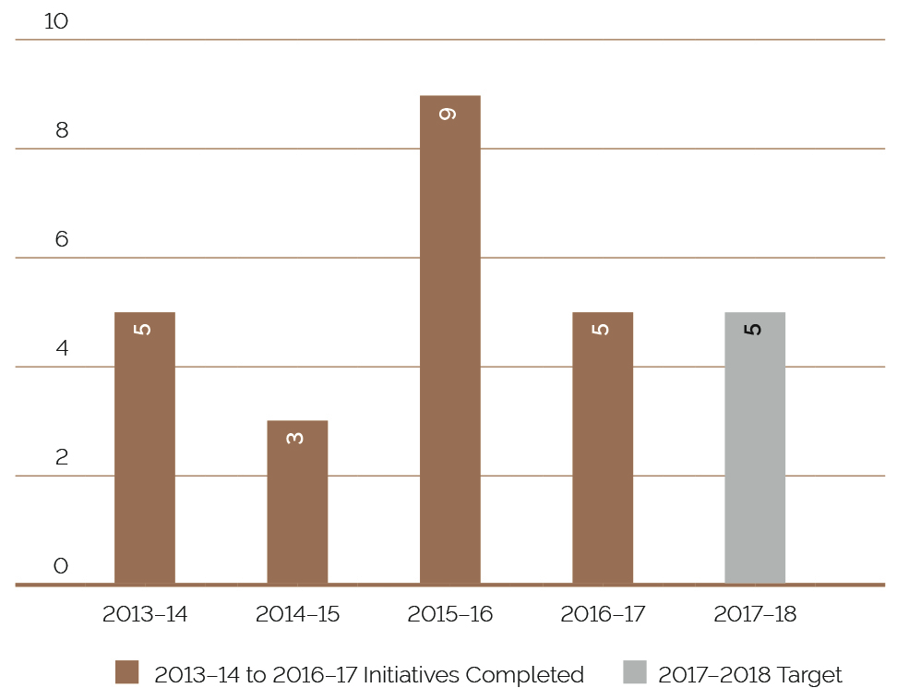

FIRST STRATEGIC INTENT
The VEC will provide high quality and innovative opportunities for all Victorians to participate in the democratic process.
Strategic initiative |  | Enabler | Comprehensive Electoral Event Programs
 | Status | Strategic initiative | Success indicators
01 |  | Maintain an effective set of electoral event plans | - Electoral events delivered within legislative and organisational requirements  - VEC project management framework applied consistently in managing electoral events  Event plans are ready for immediate implementation as required
02 |  | Maintain and enhance support structures for electoral representation activities | - Electoral Boundaries Commission has the necessary information to make decisions  Local Government Minister has the necessary information and recommendations to make decisions
03 |  | Review and improve enrolment programs | - Enrolment program targets achieved
04 |  | Review and improve enrolment system | - Enrolment transactions captured effectively  - Enrolment systems are elector-centric  - Successful security audit
05 |  | Identify enrolment and voting barriers and emerging trends | - Research conducted and utilised to inform service design and delivery
06 |  | Design and implement responsive electoral education and awareness programs | - Increased community awareness of electoral matters  - Electoral engagement program targets are met  - Enrolment, turnout and informality rates inform success

Legend for status of strategic intents
 Completed successfully and moved to business as usual
 Focus for next reporting period

strategic initiative |  | Enabler | contemporary innovative services delivered effectively
 | Status | Strategic initiative | Success indicators
07 |  | Identify and engage key partners | - Partnerships contribute to the achievement of VEC objectives
08 |  | Establish robust and resilient partnering arrangements
09 |  | Identify, encourage and facilitate service and product improvements | - VEC services represent best practice  - VEC services respond to community requirements and expectations
10 |  | Identify and engage relevant stakeholders | - •VEC stakeholder engagement objectives are met

SECOND STRATEGIC INTENT
The VEC will have transparent and accountable governance and business support systems that reinforce and sustain organisational capacity.

strategic initiative |  | Enabler | EFFECTIVE MANAGEMENT OF RESOURCES
 | Status | Strategic initiative | Success indicators
11 |  | Map, document and regularly review key organisational business processes | - VEC systems and processes are efficient and effective  - Consistent business methodologies are applied  - VEC internal and external reporting framework meets legislative and organisational requirements  - Project management and corporate reporting processes are consistent across VEC  - Corporate knowledge is accessible  - Corporate data is maintained and accessed in accordance with legislative requirements
12 |  | Review business systems to ensure they support business processes
13 |  | Develop and implement a VEC Project Management Framework
14 |  | Develop and implement a VEC Corporate Reporting Framework
15 |  | Develop and implement an Information Management System

strategic initiative |  | Enabler | QUALITY BUSINESS SYSTEMS
 | Status | Strategic initiative | Success indicators
16 |  | Further develop the VEC’s Risk Management Framework | - Risk management is integrated into all business operations and managed in accordance with government requirements
17 |  | Develop and implement effective workforce and succession planning | - Staff levels are appropriate and flexible to needs  - Critical business roles are identified with succession plans in place
18 |  | Review and implement an effective business planning and budgeting process | - Activities are conducted on schedule and within budget  - Resource management targets are achieved
19 |  | Minimise the VEC’s environmental footprint | - Environmental management targets are achieved

THIRD STRATEGIC INTENT
The VEC will have a culture that fosters professional growth and development, ensures a safe, inclusive and engaging work environment and leads to high quality staff performance.
strategic initiative |  | Enabler | ROBUST PERFORMANCE MANAGEMENT AND  PROFESSIONAL DEVELOPMENT
 | Status | Strategic initiative | Success indicators
20 |  | Enhance staff performance and development | - Performance is recognised and acknowledged  - Succession is informed by performance and development  - All performance expectations are understood, agreed and monitored on a regular basis  - Staff skills are appropriate to organisational needs  - Performance and development is aligned with corporate planning  - Core competency training delivered to staff where there is an identified need  - Staff satisfaction targets are met
21 |  | Effectively engage staff in the Performance and Development Program
22 |  | Develop and implement targeted organisation-wide learning and development

strategic initiative |  | Enabler | A SAFE AND INCLUSIVE WORKING ENVIRONMENT
 | Status | Strategic initiative | Success indicators
23 |  | Build and foster an effective health & safety and wellbeing framework | - Compliance with OH&S and Equal Opportunity requirements  - Staff satisfaction targets are met
24 |  | Develop and implement a workplace diversity and inclusion strategy | - Diversity is recognised, encouraged and respected
25 |  | Create ways to share knowledge and experiences | - Key learnings from external programs are shared within the organisation  - New ways of sharing and storing information are identified and implemented  - Skill and knowledge capabilities are enhanced
26 |  | Identify opportunities for individuals to work across and within branches and across organisations to increase skills and knowledge
27 |  | Review current operating model and respond accordingly | - VEC operating model is fit for purpose

PROGRESS report ON INITIATIVES 2016–17 AND FOCUS 2017–18
STrATEGIC INITIATIVE | initiatives completed in 2016–17
 | Strategic initiative | Achievements for 2016-2017
5 | Identify enrolment and voting barriers and emerging trends | - This initiative has delivered:  - a direct enrolment research report and  - the identification of further research directions for non‑voters.
15 | Develop and implement an Information Management System | - This initiative has delivered:  - a dedicated role with oversight of information management and  - an approved Information Management Framework.
16 | Further develop the VEC’s Risk Management Framework | - This initiative has delivered:  - the establishment and implementation of a new Risk Management Framework and  - workshops to facilitate the integration of the framework into business as usual activities, including monitoring and reporting.
17 | Develop and implement an effective workforce and succession planning process | - This initiative has delivered:  - a Succession Risk Management Framework and tools for key personnel to manage succession.
27 | Review current operating model and respond accordingly | - This initiative has delivered:  - a formal review and report including a recommendation on a changed Executive structure that will lay the foundations for business transformation.

STRATEGIC INITIATIVE | focus for 2017–18
 | Strategic initiative | Achievements for 2016-2017
9 | Identify, encourage and facilitate service and product improvements | - This initiative has delivered:  - Voters Voice; an award winning iPad app for voters with complex communication difficulties to facilitate communication with election staff and ensure the provision of election information in a range of formats  - a facility for the efficient and secure exchange of data between the VEC, councils and candidates  - enhanced services for candidates to prepare and lodge documentation required for their candidacy with the VEC online and  - recommendations for legislated change for consideration by Parliament.  - Outlook for 2017–18  - Further development of product and service improvements for the 2018 State election  - Redevelopment of the VEC’s online submission and public modelling tool to contribute to electoral boundary review activities  - Continued development and implementation of the Products and Services strategy for the next four electoral events
12 | Review business systems to ensure they support business processes | - This initiative has delivered:  - enhancements to the VEC’s election management system which successfully supported the 2016 Local Government elections and  - improvements to the register of VEC business systems.  - Outlook for 2017–18  - Further development of the VEC’s business system road map
24 | Develop and implement a workplace diversity and inclusion strategy | - This initiative has delivered:  - research and analysis of current diversity and inclusion programs and practices.  - Outlook for 2017–18  - Development, implementation and socialisation of the VEC Diversity and Inclusion strategy
25  26 | Create ways to share and store information  Identify opportunities for individuals to work across and within branches and across organisations to increase skills and knowledge | - These initiatives have delivered:  - the establishment of several communities of practice (CoP) groups  - online forums and chat boards  - “Bright Spark” initiative – providing short, engaging informal sessions delivered by subject matter experts across the VEC around four key themes; celebrate, inspire, learn and care and  - Local Government election secondments.  - Outlook for 2017–18  - Expansion of the VEC online forums, making them available to broader practice groups

Our commission
ACHIEVEMENTS 2016–17
- Unqualified report from the Victorian Auditor‑General evidences effective management of financial resources
- All reports provided to relevant bodies on schedule and within budget
- Annual Report 2015–16 achieves Gold at the 2017 Australasian Reporting Awards
- A further five of the VEC’s 27 strategic initiatives completed for the current strategic plan
- Internal committees operating effectively to give structure and discipline to management decisions
Audit and Risk Committee renewal complete
OUTLOOK 2017–18
Planning and preparations for the 2018 State election
Delivery of Election Management System requirements for the 2018 State election
Development of the next five year strategic plan 2018‑19 to 2023-24
Completion of the Information Technology Branch restructure
Implementation of changes to the Executive structure following operating model review
In 2017–18, the VEC will improve electronic information management through the review of information held in systems that have limited controls

GOVERNANCE
The VEC is the administrative agency through which the Electoral Commissioner’s legislative obligations are exercised. The VEC is committed to ensuring that its policies and practices reflect good governance, as well as complying with all relevant legislation. Adherence to the VEC’s governance framework demonstrates accountability to stakeholders and ensures the vitality and impartiality of the electoral system, now and into the future. Staffing and work practices are determined by the Public Administration Act 2004 and guided by the Victorian Public Sector Commission.
The VEC is an independent agency operating under the auspices of the Department of Premier and Cabinet, within the portfolio of the Special Minister of State. The VEC is not subject to the direction or control of the Minister in respect to the performance of its responsibilities and functions, or the exercise of its powers.
The Secretary of the Department of Premier and Cabinet, Chris Eccles AO, is responsible for providing support to the Minister and Cabinet on matters relating to the VEC and is thanked for his assistance in conveying relevant information to Government. Figure 6 shows the governance and consultation structure of the VEC.
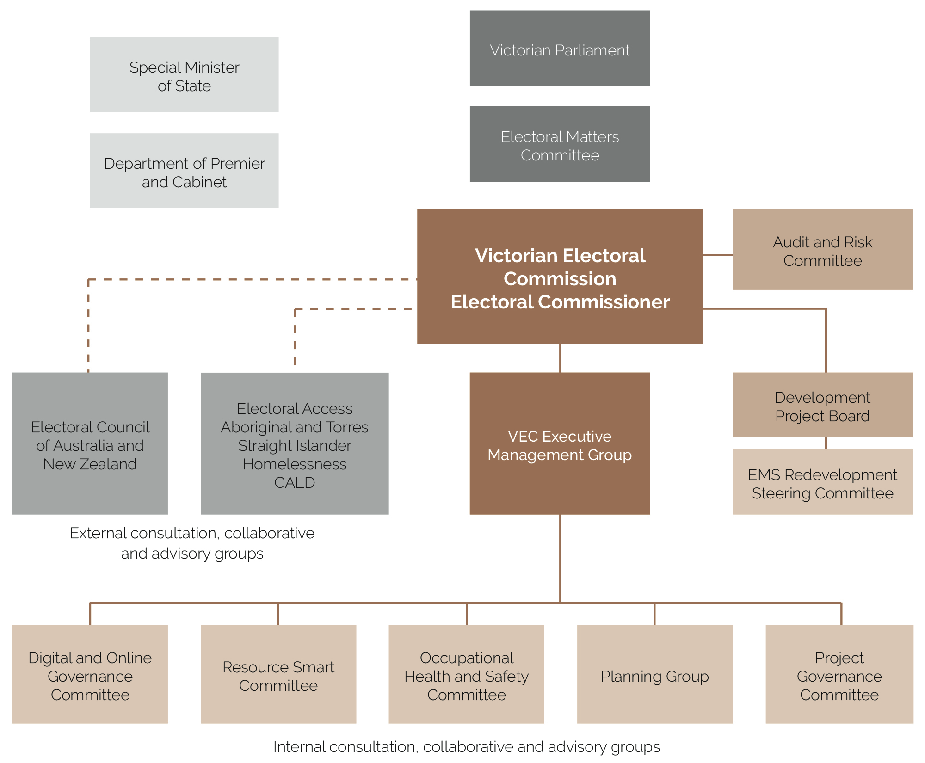
FIGURE 6: GOVERNANCE AND CONSULTATION STRUCTURE OF THE VEC

organisational structure
The VEC’s organisational structure reflects the main activity areas of the Commission (see Figure 7).
The VEC Executive Management Group works closely with the Electoral Commissioner and Deputy Electoral Commissioner to develop and implement strategic and operational plans.
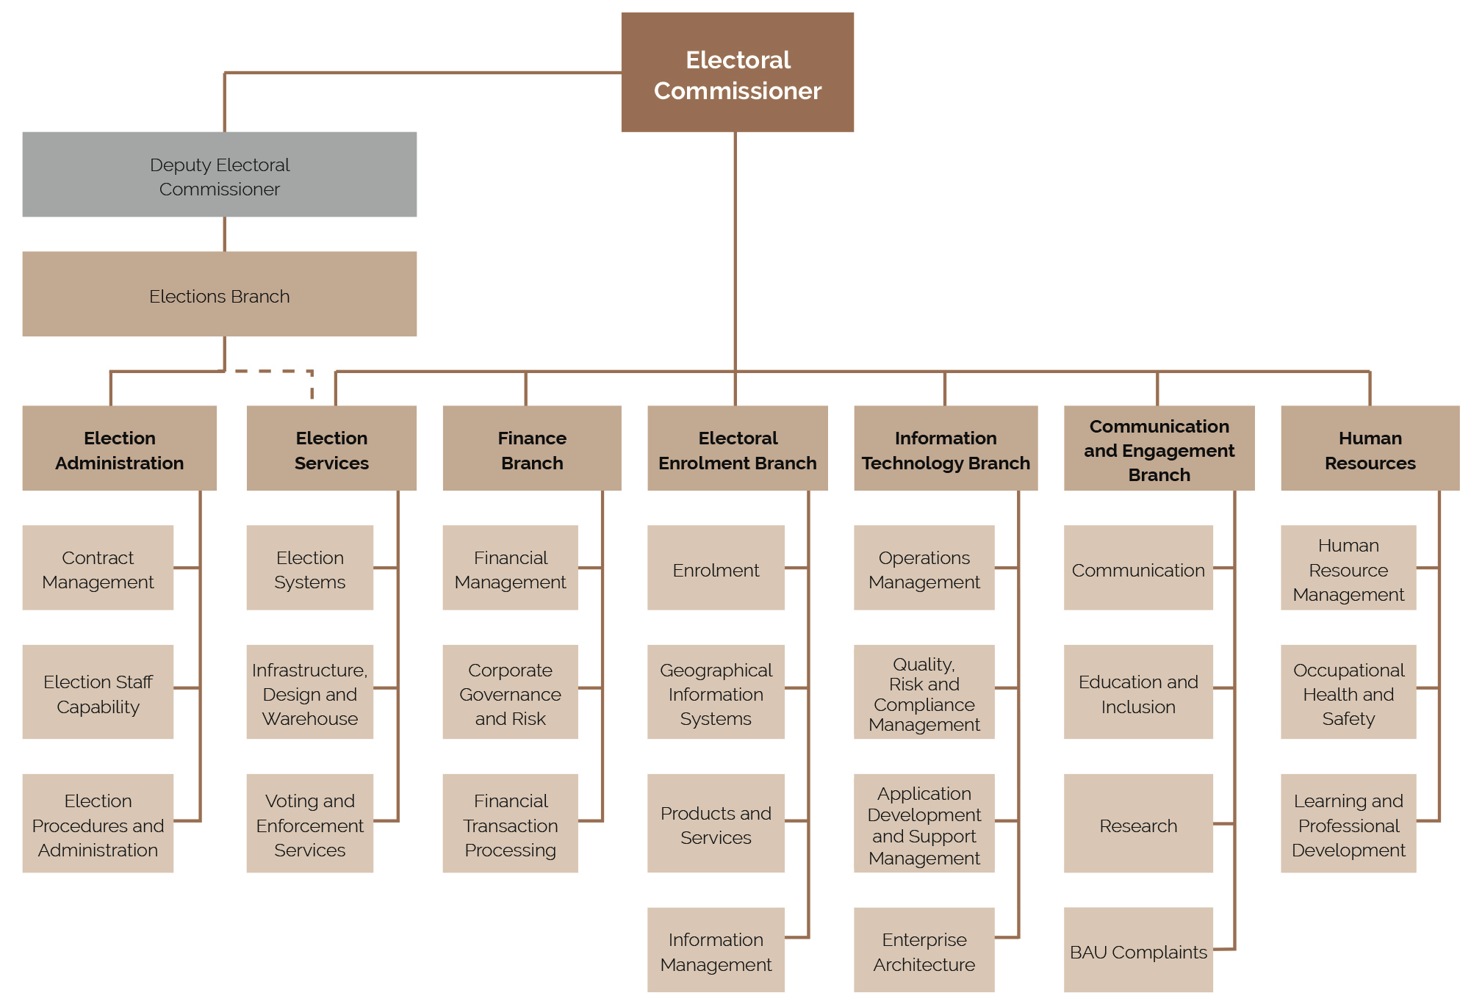
FIGURE 7: VEC ORGANISATIONAL STRUCTURE plans.

the electoral commissioner

WARWICK GATELY AM
ELECTORAL COMMISSIONER
The Electoral Commissioner is appointed by the Governor in Council for a period of 10 years, and is responsible for the administration of the enrolment process and the conduct of parliamentary elections and referendums in Victoria. Mr Warwick Gately AM was appointed as the Electoral Commissioner for Victoria on 29 April 2013.
Following an early career with the Royal Australian Navy, Warwick joined the Western Australian Electoral Commission as the Deputy Electoral Commissioner in 2003. He was appointed as the Electoral Commissioner for Western Australia in August 2006, and reappointed in 2009 for a further five-year term.
During this time, he was responsible for the conduct of the 2005, 2008 and 2013 State general elections and State‑wide referendums on retail trading hours and daylight savings. He oversaw State electoral boundary redivisions, and conducted Local Government elections every two years. Continuing his long-standing career in public service, now as Victorian Electoral Commissioner, Warwick is committed to the provision of effective electoral services to the Victorian community.
The Electoral Commissioner, assisted by the Deputy Electoral Commissioner, is the Chief Executive Officer of the Victorian Electoral Commission and remains responsible for all elements of the Commission's performance and compliance.

LIZ WILLIAMS
DEPUTY ELECTORAL COMMISSIONER
As Deputy Electoral Commissioner, Liz works closely with the Electoral Commissioner in the management and administration of the VEC. Liz also oversees the Elections Branch, which is divided into two areas: Election Administration, managed by Liz, and Election Services, managed by Glenda Frazer (see page 35).
Liz has significant electoral experience gained in various roles since moving to the VEC in 1992 from a career in education. Liz was appointed Deputy Electoral Commissioner in 2005, and was reappointed for a further term in 2015. Liz was Acting Electoral Commissioner between May 2012 and April 2013.
Liz believes fostering a working environment that promotes learning and collaboration that drives innovation and excellence in election administration; and that efficient and inclusive electoral processes are integral to full democratic participation.

THE VEC executive management group

EXECUTIVE MANAGEMENT GROUP
The Executive Management Group (EMG) comprises the Electoral Commissioner, Deputy Electoral Commissioner and the six Directors leading the main functional areas of the VEC. Working cooperatively, the EMG sets the Commission’s direction and delivers the operational, financial, workforce and other plans that underpin the efficient and effective delivery of election services to all Victorians. This is assisted through the professional mastery and experience contributed by each member. At regular intervals, the EMG considers the risks and issues facing the Commission and their management, including succession planning and knowledge transfer, along with staff and system performance and productivity matters and general compliance and reporting obligations. Staff well-being and development remains a high priority for the EMG.

ELECTIONS BRANCH
Elections Branch consists of two main areas – Election Administration and Election Services.

ELECTION ADMINISTRATION
Managed by the Deputy Electoral Commissioner, Liz Williams (see page 33), the Election Administration area manages critical partnerships and election service agreements with Victoria’s local councils, and contracts with statutory and fee-for-service clients. The team is responsible for the development and maintenance of election procedures and undertakes large-scale recruitment, training and support programs to ensure ongoing election staff capability for the VEC’s temporary workforce of around 25,000 election appointees.

GLENDA FRAZER
DIRECTOR
Glenda Frazer commenced with the VEC in 1988 as an election manager, moving to a full-time position in 1995. Glenda has extensive knowledge of the conduct of elections with significant experience in the application of information technology to elections.
Glenda is responsible for major contracts and large scale operations for the VEC, the VEC’s remote warehouse at Tullamarine and is the State election program manager. She believes thorough planning and preparation enables voters to experience trouble-free elections. Glenda and her team are focused on the efficient and effective delivery of election services. Glenda is also the Prosecution Officer for State and Local Government elections and liquor licensing polls.

ELECTION SERVICES
Working closely with the Deputy Electoral Commissioner and the Elections Administration area, the Election Services area aims to provide accessible and well-equipped voting centres and election offices, and to ensure that voting materials are accurate, easily understood and available on time.
The Election Services area has responsibility for the preparation and distribution of voting material via Australia Post and the VEC mail-house; the operation of the central processing centre for postal voting at State elections and by-elections; computerised counts; compulsory voting enforcement; the review and identification of voting centres; and the provision of voting services for interstate and overseas elections. The team is also responsible for establishing temporary remote election offices; management of the VEC warehouse; purchasing and supply of all resources for VEC head office and election offices; and the printing and design of products used for elections. In addition, the Election Services team provides application support and support materials for the VEC’s Election Management System (EMS).

BINH LE

CHIEF FINANCIAL OFFICER
Binh joined the VEC in November 2016 and brings a wealth of experience in finance, governance and corporate management. As a key member of the Executive Management Group, he provides strategic leadership and advice on financial and corporate matters.
For the past 12 years, Binh has held a number of senior financial positions, namely as the Group Business Manager in the Agriculture, Energy and Resources portfolio in the Victorian Government; Senior Finance Manager for the National Transport Commission; and Financial Controller for the online travel agent Webjet.

FINANCE BRANCH
The Finance Branch ensures the VEC has an effective financial management environment, including:
- financial management governance, compliance and risk
- financial management structures, systems, policies and procedures
- financial management planning, budgeting and reporting and
  - financial transactions processing.

KEEGAN BARTLETT
DIRECTOR
Keegan joined the VEC as a policy officer in 2010. Keegan became the Director of the Electoral Enrolment Branch in January 2017, after nearly six years managing the VEC’s Local Government and fee-for-service election programs, including the 2012 and 2016 Local Government elections.
Before moving to Australia in 2010, Keegan worked for central and Local Government in New Zealand where his roles focused on building and implementing initiatives that promoted inclusive and accountable decision-making through good governance, democratic participation and effective stakeholder management. In addition to his role as Director, Keegan is also the Electoral Registrar, with responsibility for the preparation, maintenance and review of the Register of Electors and State and local council electoral rolls.

ELECTORAL ENROLMENT BRANCH
The Electoral Enrolment Branch is responsible for maintaining an up-to-date and accurate Register of Electors. The Electoral Enrolment Branch services include:
- implementation of electoral enrolment programs
- conduct of electoral representation reviews for councils and support for electoral boundary work by the Electoral Boundaries Commission
- production of electoral rolls, other roll products and mapping data
- provision of information management and privacy advice throughout the organisation and
  - provision of advice on electoral enrolment matters.
As the VEC has moved towards a direct enrolment approach for managing enrolment, the focus is on the continued integrity of the Register of Electors, while offering more customer-focused means of updating electoral enrolment details. The Branch is also involved in managing electoral representation reviews and supporting the work of the Electoral Boundaries Commission. The Electoral Enrolment Branch employs a variety of administrative, technological and geo-spatial experts whose knowledge and skills help ensure that Victorian voters have fair and equitable representation.

SIMON HANCOCK
DIRECTOR
Simon commenced at the VEC in 2000 and has managed the Information Technology Branch since 2003. Prior to working at the VEC, Simon worked for a number of IT companies providing project management and technical consultancy over a range of industry settings. Simon considers that the provision of excellent IT services is vital for the success of VEC operations.

INFORMATION TECHNOLOGY BRANCH
Providing information technology (IT) expertise and support across the VEC, both at head office and throughout the State, the Information Technology Branch:
- manages and provides the VEC with a stable and reliable technology environment
- plans, sets up and supports the technology used during the conduct of all elections
- maintains and enhances the VEC’s enterprise software and
  - maintains and administers the VEC’s corporate databases.
The Information Technology team provides hardware and software support for everyday VEC activities and provides extremely high volume support during election periods.

SUE LANG
DIRECTOR
Sue joined the VEC in 2006 after spending much of her career in senior communication roles within the metropolitan water industry, Local Government, statutory authorities and State Government. She has particular experience in major public awareness and stakeholder engagement programs and with her team aims to effectively communicate electoral information and education, across all media platforms, to the many diverse groups throughout Victoria.

COMMUNICATION AND ENGAGEMENT BRANCH
The Communication and Engagement Branch comprises three distinct teams and provides a number of communication and education services, including the:
- provision of internal communication services for the VEC
- development and implementation of major public awareness campaigns for electoral events across traditional and digital channels
- development of stakeholder engagement programs relating to electoral participation and inclusion
- provision of electoral education and outreach services
- provision of advice on electoral legislation, electoral structures and strategic matters and
  - provision of research services and information.

BERNADETTE LAMARO
DIRECTOR
Bernadette joined the VEC in 2013 having worked in private industry for 13 years, predominately for global consulting organisations, as a human resources professional.
Bernadette has worked in several core human resource disciplines throughout her career across the following areas: learning and professional development; workforce and talent management; recruitment; performance management and remuneration, with roles incorporating transition management; program and project management; learning facilitation; consulting; people management and program leadership.

HUMAN RESOURCES
The Human Resources team is focused on the ongoing review of current work place practices and policies, assessing and evaluating the impact of existing programs and identifying opportunities for improvement with a focus on integrated solutions for improving organisational climate and employee engagement.

internal committees and groups
A number of consultation committees and groups assist the Electoral Commissioner and the Executive Management Group with the development and implementation of strategies and policies providing expertise and promoting staff consultation.

EMS REDEVELOPMENT STEERING COMMITTEE
Internal oversight and governance for the VEC’s Election Management System (EMS) redevelopment program and EMS enhancement projects are provided by the EMS Redevelopment Steering Committee. The Committee meets monthly to ensure correct project controls are being applied to EMS redevelopment and enhancement projects– along with providing oversight of schedule, budget and risk. Committee members include the Directors of Election Services and Information Technology, the Chief Financial Officer, the lead Program Architect and the IT Program Manager. The Committee is chaired by the Deputy Electoral Commissioner.
During 2016–17, the Steering Committee was focused on ensuring the successful delivery of EMS functionality required for the 2016 Local Government elections, including:
- the development of software to support the preparation of ballot pack products
- enhancements to the VEC’s online facility for candidates
- enhancements to enable more transparent reporting of integrity measures and
  - further work on enterprise architecture and security.
A further and significant project was the more detailed scoping of remaining EMS2 functionality to complete the EMS2 redevelopment program. This work has allowed greater visibility of the remaining effort required for this program enabling more effective resource planning for other development priorities.
In 2017–18, the EMS Redevelopment Steering Committee will focus on EMS functionality to support the Greater Geelong City Council elections in October 2017, the 2018 State election and other VEC functions.

PROJECT GOVERNANCE COMMITTEE
In April 2016, the VEC introduced a Project Governance Committee (PGC) to provide governance oversight to all VEC projects.
The PGC meets quarterly and functions as a decision‑making committee responsible for the assessment and ongoing oversight of VEC projects. The PGC assesses and prioritises all projects to ensure alignment with the VEC’s core responsibilities and strategic direction.

PLANNING GROUP
The Planning Group (PG) is the VEC’s major cross- organisational work group that tracks and monitors the preparation and implementation of electoral events. PG is comprised of a changing complement of key managers from across the organisation and is responsible for fostering intra-agency co-operation and reporting on event preparation and projects. During 2016–17, PG was chaired by the Local Government and Fee-for-Service Program Manager.
This year, PG has focused on final preparation, implementation and evaluation of the VEC’s role in delivering services for the October 2016 Local Government elections. All targets set in the VEC’s Service Plan for the 2016 Local Government elections were met.
In the latter part of the year, the PG commenced planning for the 2018 State election. The focus for PG in 2017–18 will be preparation of the VEC’s 2018 State Election Service Plan and the initiation of projects for that event.

DIGITAL AND ONLINE GOVERNANCE COMMITTEE
The role of VEC’s Digital and Online Governance Committee (DOGC) is to govern the organisation’s online activity. It convenes discussion and collaboration on design and development undertaken within the VEC’s internal and external online environments, including websites, web applications and third party services.
The Committee met on six occasions during the year; however the primary focus was the initiation of a digital and online strategy for the VEC (as each Victorian Government agency is required to have a structured approach to the governance of its online presence).
The cornerstone of this strategy is a framework to be used over the coming years to develop and deliver products and services that are safe, empowering and convenient. It will be a starting point for everything that will happen in the digital and online space over the next two to three years and considers everything from being ready for online voting, to a new website, and how these marry with existing VEC products and services.

OCCUPATIONAL HEALTH AND SAFETY COMMITTEE
The Occupational Health and Safety Committee (OHSC) is a forum that facilitates cooperation and communication between the VEC’s Executive Management Group (EMG) and employees. Issues considered by the OHSC include those that are likely to affect the health, safety and welfare of VEC workplaces in accordance with the requirements of the Occupational Health and Safety Act 2004.
During 2016–17, the OHSC focused on the effective implementation of the revised VEC OHS Management System (OHSMS), as well as exploring areas for improving the OHS and wellbeing culture at the VEC. The OHSC has continued to monitor VEC compliance of OHS reporting, inspections, safety action plans, and the OHS and Emergency Management Risk Register, all of which have progressed over the year without issue.
In May 2017, an OHS performance survey was conducted to evaluate the safety culture of the VEC. The results showed an improvement across the performance scores since the previous survey in 2015, and indicated a good level of awareness of OHS practices. Employees were asked to identify the top OHS areas for further focus and these included: employee health and fitness; ergonomics; mental health; managing fatigue; and managing grievances or interpersonal conflict. The key areas nominated will form a significant part of the 2017–18 OHSC agenda and will aim to improve employee understanding and experience for each of these matters.
The OHSC will continue to explore ways to grow OHS management and culture, particularly in preparation for the State election in 2018 with peak periods of work and increased staffing

RESOURCE SMART COMMITTEE
The Resource Smart Committee (RSC) oversees the implementation of the VEC’s Environmental Management Plan, with the aim of raising awareness of environmentally sound work practices and reducing any negative environmental impact of the organisation. The VEC has continued its organisational, management and staff commitment to environmental sustainability by including environmental sustainability objectives in its Strategic Plan 2013–14 to 2017–18.
During 2016–17, the RSC undertook an 18 month forward planning activity that will be incorporated into the Environmental Management Plan. Also RSC members delivered a calendar of events to take place at the VEC that continues to keep sustainable thinking in staff minds.
The RSC has established a highly successful system for collecting and recycling soft-plastic bags. In collaboration with the VEC’s building management, the RSC and the infrastructure team at the VEC has implemented E-waste collection points around the organisation. Arrangements are in place for the regular disposal and/or recycling of such waste.
Work continues to provide staff with a sustainability dashboard giving statistics on paper use, logistic impact, water, power and other consumables with graphs and trends. Staff will be encouraged to review this and suggest new ways the RSC can improve the VEC’s sustainability. Work is currently underway to review and update the RSC intranet site.
The outlook for 2017–18 includes:
delivery of the sustainability dashboard
encouraging staff involvement in sustainability focused activities external to the VEC, including participation in Plant a Tree Day and Less Meat – Less Heat and
planting workshops encouraging staff to re-use glass jars and donated plant cuttings to create terrariums for their workspaces.
A report from the RSC is included as Appendix M.
The Resource Smart Committee

External Advisory Groups
The VEC is fortunate to have a number of advisory groups who provide advice and insights into community issues, which may impact electors’ ability to participate in elections.

ANNUAL ADVISORY GROUP SURVEYS
The VEC surveys members of all of its advisory groups annually to ensure that members’ views of the effectiveness of their involvement and any suggestions for improvement are taken into account. The results of the each survey can be found below.
All advisory group members were invited to an end of year thank you event at Parliament House in December 2016, and a facilitated planning session regarding the development of the VEC’s 2018 State election outreach program in June 2017.

ELECTORAL ACCESS ADVISORY GROUP
The Electoral Access Advisory Group (EAAG) met formally twice this year, but were also invited to consultation sessions on the development of the VEC’s Digital Strategy.
During the year, the EAAG provided feedback from member’s perspectives about the conduct of the 2016 Local Government elections to inform future events.
Members also had reports on:
- the delivery of the Carers Program
- the Voters Voice app
- the commissioning of research into barriers to enrolling and voting for people with intellectual disability
- the results of the member survey
- the new VEC Digital Strategy and
  - progress against the Disability Action Plan.
Feedback on a proposed booklet, Understanding Disability, was also invited.
In a June 2017 survey on the effectiveness and efficiency of the Group, 100% of the 10 respondents reported that they were satisfied or very satisfied with the overall effectiveness of the EAAG.

HOMELESSNESS ADVISORY GROUP
The VEC’s Homelessness Advisory Group consists of regional and metropolitan homelessness sector workers, community members and peer educators.
The group met twice during the year and focused on:
- a debrief regarding the VEC’s electoral outreach and assisted voting services for the 2016 Local Government elections
- developing an information campaign regarding non-voter fines for people experiencing homelessness and
  - developing an action plan for the VEC’s Homeless not Voteless program.
In a June 2017 survey on the effectiveness and efficiency of the Group, only two respondents participated but both were satisfied with the overall effectiveness of the Homelessness Advisory Group.

ABORIGINAL AND TORRES STRAIT ISLANDER ADVISORY GROUP
Due to staffing changes, the VEC’s Aboriginal and Torres Strait Islander Advisory Group did not meet during this financial year. However, a consultation meeting was held with the Wurundjeri Council with regards to invigorating this group.
In a June 2017 survey on the effectiveness and efficiency of the Group, only one respondent participated and they were satisfied with the overall effectiveness of the Advisory Group.

CULTURALLY AND LINGUISTICALLY DIVERSE ADVISORY GROUP
Members of the Culturally and Linguistically Diverse (CALD) Advisory Group met twice this year. Meetings focused on:
- debriefing on outreach sessions from the 2016 Local Government elections and
  - the creation of an English as an Additional Language teacher professional development resource.
In a June 2017 survey on the effectiveness and efficiency of the Group, 3 of 4 respondents reported that they were satisfied or very satisfied with the overall effectiveness of the CALD Advisory Group.

governing legislation and tribunals
The three pieces of legislation that set out the VEC’s primary responsibilities are the Constitution Act 1975, the Electoral Act 2002 and the Local Government Act 1989.
In accordance with this legislation, the VEC conducts State and Local Government elections and by-elections, and certain statutory and fee-for-service elections. The VEC also provides advice to the Special Minister of State and Parliament on electoral issues. Other legislation and regulations imposing certain duties on the Electoral Commissioner are listed in Appendix B.

LEGISLATIVE AND REGULATORY AMENDMENTS
On 26 July 2016, the Governor in Council made the Local Government (Electoral) Regulations 2016 (the Regulations) that took effect on 7 August 2016. The Regulations replaced the Local Government (Electoral) Regulations 2005, which were due to expire on 8 August 2016. On 2 August 2016, the City of Melbourne (Electoral) Amendment Regulations 2016 were released to ensure corresponding changes for Melbourne City Council elections.
Included in the new Regulations were provisions that directly related to the conduct of the 2016 Local Government elections to enhance the integrity of the electoral system.
In August 2016, approximately one month after the Regulations were made, the Legislative Council disallowed one instrument in the Regulations, effectively removing the provision for candidates to lodge indications of preferences at postal elections.

MUNICIPAL ELECTORAL TRIBUNAL
Section 45 of the Local Government Act 1989 (LG Act) provides for a candidate, a group of ten voters, or the Returning Officer at a Local Government election who dispute the validity of the election, to apply for an inquiry into the election by a Municipal Electoral Tribunal (MET). Applications must be lodged within 14 days of the declaration of the result of the election in dispute.
Following the 2016 Local Government elections, there were seven applications to the MET including one brought by the VEC.
Other applications involved requests for a recount, alleged misleading election material, candidate eligibility and alleged irregularities in advice about enrolment entitlement. Of these, one application was withdrawn and three were dismissed.

VICTORIAN CIVIL AND ADMINISTRATIVE TRIBUNAL
Section 48(2) of the Local Government Act 1989 allows a person whose interests are affected by a MET decision to apply to the Victorian Civil and Administrative Tribunal (VCAT) for a review of that decision.
Regarding the Melbourne City Council Election of Councillors, the VEC applied to the Victorian Civil and Administrative Tribunal (VCAT) for a review of the MET’s decision on this and two other matters. VCAT overturned the MET’s decision for the Melbourne City Council election and, at the time of this report, the remaining two matters were still before VCAT for consideration.
Section 60 of the Electoral Act 2002 allows any person, whose interests are affected by a reviewable decision of the VEC in relation to the registration of political parties, to apply to VCAT for review of that decision.
In 2014, John Mulholland applied to VCAT for review of the VEC’s decisions not to recognise him as the registered officer of the Democratic Labour Party (DLP) and to agree to a slight change of the party’s name. VCAT’s consideration of these matters was repeatedly adjourned during 2015–16 pending the outcome of Mr Mulholland’s concurrent legal proceedings against other members of the DLP. In March 2016, Mr Mulholland applied to VCAT for review of the VEC’s decision to agree to a change in the DLP’s registered officer. This application remains in adjournment to be heard with the other two matters at a later date.

accountability and transparency
The VEC has legislative and organisational processes in place to ensure transparency and accountability to the Victorian public. These processes include internal and external auditing; regular reporting to stakeholders including Parliament, Government and the public; and tabling of audited financial statements as part of this report.

FINANCIAL MANAGEMENT COMPLIANCE FRAMEWORK
The Financial Management Compliance Framework provides the Minister for Finance an assurance that Victorian Government entities have implemented the appropriate systems to ensure compliance with the Framework. The Framework provides for effective, efficient and responsible financial management of public resources.
The directions cover:
- financial code of conduct, financial governance including the establishment of an Audit and Risk Committee; financial risk management; delegations; and internal and external audits
- financial management structure, systems, policies and procedures – which includes roles and responsibilities of the financial management team; policies and procedures; managing outsourced services; information technology management, operations, development and change; education and training and
  - financial management reporting – which includes internal and external reporting; reporting requirements for Financial Statements and Report of Operations in accordance with Part 7 of the Financial Management Act 1994; performance management and evaluation, financial management compliance obligations; tax compliance; purchasing cards and thefts and losses compliance.
The Financial Management Framework is audited by the internal auditor on a two-yearly basis, self-audited the year in between, and is reviewed by the Audit and Risk Committee. The VEC is fully compliant, following part adoption of the Standing Directions - Minister of Finance requirements. The VEC will ensure full adoption by the set target date of 30 June 2018.

AUDIT AND RISK COMMITTEE
The Committee consists of the following members:
- David Nairn, appointed Chairman December 2016 (independent member)
- Carol Pagnon from December 2016 (independent member)
- Michael Ulbrick from January 2017 (independent member)
- Robert Yeo, Chairman to December 2016 (independent member) and
  - David Fahey to August 2016 (independent member).
The main responsibilities of the Committee are to monitor and oversee the:
- financial performance and the financial reporting process, including the annual financial statements
- scope of work, performance and independence of internal audit
- engagement and dismissal by management of the internal audit contractor
- scope of work, independence and performance of the external auditor
- operation and implementation of the risk management framework
- matters of accountability and internal control affecting the operations of the VEC
- effectiveness of management information systems and other systems of internal control and
  - VEC’s process for monitoring compliance with laws and regulations and its own code of conduct and code of financial practice.

IDENTIFYING AND MANAGING RISK
The State Government’s Risk Management Framework provides for a minimum risk management standard across public sector entities. As the Accountable Officer, the Electoral Commissioner is responsible for the development and implementation of the Framework and processes, to ensure that risks are managed in a consistent manner across the organisation.
Risk management is embedded into the VEC's operations, including ongoing workshops and assessments to identify and monitor organisational risks, evaluating risk controls in place and developing new controls where required. The Audit and Risk Committee play an oversight role to the Framework.
Risks are profiled and rated according to their potential hazard across operational and non-operational activities. Risk ratings are presented to the Audit and Risk Committee in accordance with its charter. In an independent capacity, the Committee determines whether adequate controls are in place, and whether a periodic review of those controls is required.
At an operational level, the VEC has comprehensive risk management plans for all electoral events. These are developed, discussed and analysed at branch level during the planning phase and cover election management, infrastructure, communication, recruitment and information technology. Risk management is addressed at senior management level and in staff meetings.
Legal and compliance issues associated with occupational health and safety are managed through the VEC’s OHS Committee, which meets every quarter.

DEVELOPMENT PROJECT BOARD
The Development Project Board (DPB) oversees and provides advice to the VEC’s EMS Redevelopment Steering Committee in relation to the VEC’s EMS redevelopment program of works. The Board ensures that correct program controls are being applied and reports progress to external government stakeholders and the VEC’s Audit and Risk Committee through the Electoral Commissioner. The DPB is chaired by the Electoral Commissioner with one member from the Department of Justice and Regulation’s Knowledge, Information and Technology Services and the other an independent member.
The following people constituted the DPB during 2016–17:
- Warwick Gately AM, Electoral Commissioner – Chair
- Michael Cornelius, Chief Information Officer, Knowledge, Information and Technology, Department of Justice and Regulation and
  - David Fahey, Independent member.
In addition, the following provide ex-officio support to the DPB:
- Liz Williams, Deputy Electoral Commissioner – Chair of EMS Redevelopment Steering Committee and
  - Simon Hancock, VEC IT Director – Secretary.
The DPB met twice during 2016–17 and continued to note the Steering Committee decisions and narrative around the project change. Mid-year there was a gap between meetings as the VEC carefully examined the scope of the remaining work associated with the EMS redevelopment and the required resources to advance the work. The structure of the IT Branch was also reviewed and modified in response.
The DPB, within the governance structure of the EMS redevelopment program, has been effective in its oversight of this complex information technology project. At this point, while the project will now extend to 2020 and beyond its original anticipated completion date, the development is expected to deliver all system functionality within budget.

CORPORATE PLANNING
The VEC Strategic Plan 2013–14 to 2017–18 provides the basis for the Commission's operations. A new version will be developed in the next year. Currently, Strategic Initiatives, organisational planning and staff development are linked to three key strategic intents and associated enablers (defined as conditions that need to be in place in order for the VEC to achieve its strategic intent). Areas for focus have been identified to guide the development and prioritisation of Strategic Initiatives. See page 19 for an overview of achievements against Strategic Initiatives to date.
Developed under the authority of the Electoral Commissioner, the Plan shapes the day-to-day work of the VEC. Operational plans at branch and project levels support the strategic intents and are essential in pursuit of the VEC’s vision of all Victorians actively participating in their democracy.
The planning structure, strategic content and associated workforce planning framework, performance planning and capability development help ensure that the VEC continues to deliver its responsibilities in a fair, transparent, effective and accountable manner. The Strategic Initiatives are prioritised and, in 2016–17, planning and implementation was carried out in accordance with the schedule.

CORPORATE REPORTING
The VEC has a comprehensive program of stakeholder reporting that supports its goals of accountability and transparency. Internal reporting is aligned with lines of authority and cross-organisational channels to meet organisational needs.
External reporting is based on legislative and governance obligations, transparency objectives and commitments to stakeholders. The standard of reporting is high. For example, last year’s Annual Report fully complied with Department of Treasury and Finance model report requirements and also achieved a gold award at the 2017 Australasian Reporting Awards.
During 2016–17, the VEC tabled two reports before Parliament: Victorian Electoral Commission Annual Report 2015–16 and Victorian Electoral Commission Report on the 2016 Victorian Local Government Elections.
Additionally, a report was provided to the Minister for Local Government on the VEC’s Electoral Representation and Subdivision Reviews conducted during the 2015 and 2016 calendar years.
Other reporting obligations include:
- the provision of a quarterly report to the Department of Premier and Cabinet in relation to budgetary objectives
- monthly financial reporting and cash flow forecasting to the Department of Treasury and Finance
- twice yearly reporting to the Attorney-General on infringements activity
- whole of government multicultural affairs reporting
- advertising campaign reporting and
  - reporting for the Electoral Boundaries Commission (EBC) for whom the VEC provides secretarial services. The VEC also prepares an annual report for the EBC. This report can be found at Appendix N of this Report.
All reports were delivered on schedule and within budget where applicable. Annual reports and other reports and publications are available on the Victorian Electoral Commission website (vec.vic.gov.au) and from the VEC.

INTERNAL AUDIT
The VEC's internal audit function is delivered by external firm HLB Mann Judd. The internal audit program and function is to provide an independent, objective assurance to improve the VEC's operations. The rolling three year internal audit strategy and program is designed to be comprehensive and to enable effective and regular review of all operational, financial and related activities.
Part of the annual program includes annual attestations and certification reviews such as Risk and Fraud Certification and the VEC's compliance with Memorandum of Understandings (MOUs) entered into with other agencies. The VEC's internal audit program is designed in consultation with the Audit and Risk Committee and the VEC's Executive Management Group.

CUSTOMER SERVICE CHARTER
As an annual activity, the VEC’s Customer Service Charter was reviewed to ensure that it complied with best practice and was relevant to VEC operations. The Charter is available on the VEC’s website.

COMPLAINTS
The VEC handles complaints in two main areas:
- complaints alleging a breach of the Electoral Act 2002 (the Act) and
  - complaints about a process, performance or service related to an interaction with the VEC.
The VEC also receives complaints alleging a breach of the Local Government Act 1989 (LG Act) which, given the conduct of elections for 78 councils in October 2016, made up the bulk of complaint activity during the year. In dealing with complaints associated with the Local Government elections, the VEC established a dedicated team that handled all complaints received in writing through a centralised email address. Given that the VEC does not have authority to follow up allegations of a breach of the LG Act, these complaints are forwarded to and handled by the Local Government Investigations and Compliance Inspectorate (LGICI) in accordance with an established protocol. Further details on complaints received during the Local Government elections are included in Our Core Business (see page 58).
The VEC received 28 other written complaints during 2016–17. Of these complaints, two related to the 2014 State election, four related to information privacy, three related to legislation, 14 related to VEC administration or processes and five were 'other' complaints.
All complaints were dealt with in accordance with VEC procedures and were resolved by providing an explanation, follow-up and responsive action where required. The VEC aims to respond to complaints within five working days for straight forward complaints.

disclosures

ADDITIONAL INFORMATION AVAILABLE ON REQUEST
Information relating to the 2016–17 reporting period is made available to Ministers, Members of Parliament and the public on request (subject to the Freedom of Information Act 1982) and is listed in Appendix C.

ADVERTISING DISCLOSURE
Financial Reporting Direction 22D issued by the Australian Accounting Standards Board requires Victorian Government agencies to disclose advertising expenditure on campaigns with a media spend of $150,000 or greater. No reportable advertising expenditure occurred during 2016–17.

ATTESTATION TO PUBLIC SECTOR STANDARDS COMMISSIONER
The Electoral Commissioner completed an annual attestation of hospitality and gifts as required.

BUILDING ACT 1993
The VEC does not own or control any Government buildings and consequently is exempt from notifying compliance with the building and maintenance provisions of the Building Act 1993.
FIGURE 8: CONSULTANCIES VALUED AT $10,000 OR GREATER
Consultant | Purpose of Consultancy | Total  approved  Project Fee  (ex Gst) | EXPENDITURE  2016/17  (ex gst) | Fixture  EXPENDITURE  (ex gst)
PP&E Valuations Pty Ltd | Asset Revaluation Services | $30,000 | $12,557 | $17,443
Huddle Australia Pty Ltd | Digital & Online Strategy | $86,890 | $86,890 | nil
Precedent | Interactive Map Testing | $23,185 | $23,185 | nil
Kloud Solutions Pty Ltd | Federation and Disaster Recovery Design | $38,288 | $38,288 | nil
GC Risk Support Services | Risk Management Strategy | $21,450 | $18,500 | $2,950
Emma Savage Consulting | Retention of Documents Strategy | $17,400 | $17,400 | nil
Peppermint Consultants Pty Ltd | Change and HR Consulting Services | $51,750 | $51,750 | nil

CONSULTANCIES AND CONTRACTS

MAJOR CONTRACTS
In accordance with the requirements of Financial Reporting Directive 12A, the VEC discloses all contracts greater than $10 million in value which it entered into during the year ended 30 June 2017.
No contracts greater than $10 million in value were entered into by the VEC during 2016–17.

CONSULTANCY EXPENDITURE

DETAILS OF CONSULTANCIES UNDER $10,000
In 2016–17, there were three consultancies engaged during the year, where the total fees payable to the individual consultants was less than $10,000. The total expenditure incurred during 2016–17 in relation to these consultancies was $12,487 (excluding GST).

DETAILS OF CONSULTANCIES (VALUED $10,000 OR GREATER)
In 2016–17, there were seven consultancies where the total fees payable to the consultants were $10,000 or greater. The total expenditure incurred during 2016–17 in relation to these consultancies is $248,569 (excluding GST). See Figure 8.

DISABILITY ACT 2006
The Disability Act 2006 requires that all public sector bodies prepare a disability action plan and that departments report on the implementation of their disability action plan in their annual report.
The VEC’s Electoral Access Advisory Group (EAAG) were provided with a report on the VEC’s performance against every action item due for attention in 2016–17.
Out of 24 action items for completion during 2016–17, 15 were completed, six were carried over into the next year and three were unable to be completed - one due to lack of resourcing and the other two due to the fact that no State by-elections had been held.

DISCLOSURE INDEX
The Annual Report of the VEC is prepared in accordance with all relevant Victorian legislation and pronouncements. A disclosure index has been prepared to facilitate identification of the VEC’s compliance with statutory disclosure requirements. The disclosure index is included as Appendix A.

EMPLOYMENT AND CONDUCT PRINCIPLES
The VEC maintains and implements a suite of policies and guidelines with respect to upholding public sector conduct, managing and valuing diversity, employment, managing underperformance, reviewing personal grievances, and selecting on merit.

ENVIRONMENTAL PERFORMANCE
The VEC has continued its commitment to reducing the negative impact of its operations on the environment, with ongoing communication and information programs to encourage continued positive behavioural changes.
The VEC Environmental Sustainability Report for 2016–17 is included as Appendix M.

EXECUTIVE OFFICER DISCLOSURES
The Electoral Commissioner and Deputy Electoral Commissioner are appointed by the Governor in Council as statutory office holders. These appointments do not fall within the definition of Executive Officer under the Public Administration Act 2004.

FREEDOM OF INFORMATION
The Freedom of Information Act 1982 (FOI Act) gives the community the right to access information in the possession of the VEC. The VEC released non-personal information to two applicants in 2016–17. The VEC provided information to three applicants outside the freedom of information process. For information about how to lodge an application under the FOI Act, see the VEC website or Appendix E.

GRANTS AND TRANSFER PAYMENTS (OTHER THAN CONTRIBUTIONS BY OWNERS)
Included in the ‘Total expenses from transactions’ are payments of grants and assistance to certain companies and organisations. During 2016–17, the VEC provided grants totalling $186,954 to five organisations (see Figure 9 on page 56).

GIFTS, BENEFITS AND HOSPITALITY REGISTER
The Victorian Public Sector Commission issued updated standards for Victorian public sector employees on the giving and receiving of gifts, benefits and hospitality, effective 12 December 2016. To reflect these changes, the VEC now publishes its Gifts, Benefits and Hospitality Register on a quarterly basis and these reports are available on the VEC website at www.vec.vic.gov.au/legal.

OCCUPATIONAL HEALTH AND SAFETY MANAGEMENT
The goal of the VEC’s Occupational Health and Safety (OHS) strategy is to ensure all staff remain safe and healthy at work. An OHS management system is in place and branches within the VEC have implemented OHS local action plans aimed at enhancing safety performance and ensuring safe systems of work. In 2016–17, there were no lost days arising from injuries. For more on human resource management at the VEC, including performance against OHS management measures, see the Our People section of this report (see page 87).

INFORMATION AND RECORDS MANAGEMENT
The VEC has responsibility for managing information in accordance with standards issued by the Public Records Office of Victoria and the Commissioner for Privacy and Data Protection. The types of information managed by, and specific to, the VEC are detailed in the Retention and Disposal Authority for Records of the Victorian Electoral Function (PROS 06/05 V3). The VEC has invested in the development of staff to ensure they are sufficiently knowledgeable and competent to manage information in their control.
Public consultation on a new version (Version 4) of the Retention and Disposal Authority for Records of the Victorian Electoral Function (PROS 06/05) closed on 2 June 2017. Version 4 acknowledges significant changes in Victorian electoral functions, including legislative change, changes to the VEC’s statutory responsibilities and changes to the interface between the Australian Electoral Commission and the VEC.
The VEC’s adoption of HPRM has resulted in better management of electronic information. In 2017–18, the VEC will improve electronic information management through the review of information held in systems that have limited controls.

INFORMATION PRIVACY
The VEC collects and handles personal information in relation to both the Victorian public and VEC staff in order to fulfil its functions under the Electoral Act 2002. The VEC’s policies regarding the management of personal information comply with the Privacy and Data Protection Act 2014 and are set out in its Privacy Policy, available on the VEC website.
During 2016–17, the VEC’s Privacy Officer collaborated with the Office of the Commissioner for Privacy and Data Protection. Updates were given to affected and interested VEC officers, as appropriate.
One complaint was received by the VEC in relation to an alleged breach of information privacy during 2016–17. The complainant alerted the VEC to historical Local Government voters’ rolls that had been provided to candidates as required under the Local Government Act 1989 and were subsequently captured and re-published by an external organisation through its website. The VEC immediately contacted the organisation and advised the Office of the Commissioner for Privacy and Data Protection, as well as the Local Government Investigations and Compliance Inspectorate. The offending organisation took prompt action to remove the voters’ rolls and is continuing to liaise with the VEC about its notification requirements to impacted electors.
Each year the VEC also responds to queries relating to the release of information to certain people and organisations, as authorised by legislation. These queries are not treated as privacy complaints.

LEGISLATION
The VEC is subject to, and complies with, a range of legislation as listed in Appendix B, and detailed in this report as applicable.

NATIONAL COMPETITION POLICY
Competitive neutrality requires government businesses to ensure where services compete, or potentially compete with the private sector, any advantage arising solely from their government ownership be removed if they are not in the public interest. Government businesses are required to cost and price these services as if they were privately owned and thus be fully cost reflective. Competitive neutrality policy provides government businesses with a tool to enhance decisions on resource allocation. This policy does not override other policy objectives of government and focuses on efficiency in the provision of service. The VEC continues to comply with the requirements of the National Competition Policy.

PECUNIARY INTEREST DECLARATIONS
The Electoral Commissioner completed a declaration of pecuniary interests as required.

PROTECTED DISCLOSURE ACT 2012
The VEC is committed to the aims and objectives of the Protected Disclosure Act 2012 (PDA). Improper conduct by its employees, officers or members is not tolerated, nor is reprisal against those who come forward to disclose such conduct.
The VEC recognises the value of transparency and accountability in its administrative and management practices, and supports the making of disclosures that reveal corrupt conduct, conduct involving a substantial mismanagement of public resources, or conduct involving a substantial risk to public health and safety or the environment. For details about reporting procedures under the PDA see Appendix D.

VICTORIAN INDUSTRY PARTICIPATION POLICY
The Victorian Industry Participation Policy Act 2003 requires public bodies and departments to report on the implementation of the Victorian Industry Participation Policy (VIPP). Departments and public bodies are required to apply VIPP in all tenders over $3 million in metropolitan Melbourne and $1 million in regional Victoria. No contracts to which the VIPP applies were commenced or completed by the VEC during 2016–17.
FIGURE 9: GRANTS TO EXTERNAL BODIES, 2016–17
organisation | purpose of grant | amount  (ex gst)
Richmond Football Club | Support of Richmond Emerging Aboriginal Leaders camps (at Korin Gamadji Institute) for Indigenous youth to build their leadership skills through active citizenship and position them as role models within their community. | $117,604
Victorian School Representative Council | Sponsorship for one year (01/01/2016-31/12/2016) to enable delivery of teacher professional development sessions to support Passport to Democracy Program. | $5,000
Electoral Regulation Research Network (ERRN) | Ongoing support of ERRN to foster exchange and discussion of research relating to electoral regulation. | $30,000
Youth Parliament | Sponsored four youth teams to participate in 2017 Youth Parliament. | $19,773
Latrobe University – Living with Disability Research Centre | Sponsorship of PhD research into barriers to enrolling and voting for people with intellectual impairment. Multi-year project. Paid 50% deposit in this financial year.  *Contributions towards this project received from five other electoral commissions. | *$30,000

Our core business
ACHIEVEMENTS 2016–17
Conduct of 78 elections in October 2016 and compulsory voting services for 76 council elections meeting service plan performance targets
Preparation and tabling in Parliament of a comprehensive report on the conduct of the 2016 Local Government elections
Conduct of a further 17 elections, by-elections, countbacks and polls on schedule, within budget and in accordance with legislation, regulations, rules and guidelines
Successful deployment of election management system enhancements for electoral events
Completion of research into direct enrolment activities and attitudes
Delivery of the VEC’s digital strategy 2017-19
Annual review of electoral event planning framework
Research partnership with Latrobe University’s Living with Disability Research Centre established to look at inclusion and participation strategies for voters with an intellectual disability
OUTLOOK 2017–18
Planning and conduct of elections for the Greater Geelong City Council in October 2017
Consultation and finalisation of the VEC’s 2018 Victorian State Election Service Plan
Planning and preparations for the 2018 State election
Delivery of election management system requirements for the 2017 Greater Geelong City Council and 2018 State elections
Research project to establish the attitudes and motivation of non-voters
Finalisation of compulsory voting enforcement for councils including lodgement of outstanding infringements with the Infringements Court

electoral activity
The VEC conducted general elections for 78 of Victoria’s 79 local councils during 2016–17. In addition, 17 additional events were conducted including four Local Government countbacks and 13 fee-for-service elections and polls. All events were successfully conducted on schedule and within budget, with none overturned.

PREPARING FOR THE 2018 STATE ELECTION
On 24 November 2018, the VEC will conduct the State election, in which over 4.1 million eligible Victorians will cast their vote to elect the 59th Victorian Parliament. Representatives will be elected to 88 Legislative Assembly districts and eight Legislative Council regions.
An event of this size requires considerable planning and extensive preparation and co-ordination. Planning commenced in April 2017 with development of the election program, details of which will be made available in the 2018 State Election Service Plan due to be released at the end of the 2017 calendar year.
The VEC’s intention is that every eligible Victorian will vote at an election that is fully compliant with State law, transparent, fair and accurate, and delivered to the highest standards.
Key performance indicators (KPIs) closely aligned to the VEC’s Strategic Plan will be developed to assess the performance of the Commission, and to identify where future performance improvement initiatives are required. The KPIs will look at areas that will include but are not limited to:
- program and project delivery – on schedule and on budget
- enrolment – ensuring that as many Victorians as possible are enrolled to vote
- participation and inclusion
- voter experience and
  - candidate and registered political party support and compliance.
Recruitment for senior election positions, resource purchasing, campaign preparation and infrastructure identification will all commence in the latter half of the 2017 calendar year. Further information on the 2018 State election preparations will be included in the 2017–18 Annual Report.

STATE BY-ELECTIONS
A State by-election occurs if a Member of Parliament resigns or can no longer hold office. The VEC maintains the capability and capacity to conduct State by-elections as required, within minimum prescribed timeframes.
No State by-elections were required during 2016–17.

2016 LOCAL GOVERNMENT ELECTIONS
The Local Government Act 1989 (the LG Act) is the principal legislation governing the conduct of Local Government elections in Victoria. Amendments to the LG Act in 2015 prescribed the VEC as the statutory provider of election services to Victoria’s local councils.
In July 2016, the Victorian Government also made the new Local Government (Electoral) Regulations 2016 (the Regulations) to come into effect for the 2016 Local Government elections. Among other changes, the Regulations provided an extended period for postal votes to be received and accepted by the Returning Officer during the week after election day. This changed the VEC’s timeline for counting and the availability of results. The Regulations also introduced a set of prescribed questions that candidates were invited to answer through the candidate questionnaire.
In August 2016, the Legislative Council disallowed Regulation 38 of the Regulations. This removed the opportunity for candidates at elections held by postal voting to lodge an indication of preferences for inclusion in the ballot pack mailed to voters.
In response to its new statutory function and to ensure effective communication about the operations of the new legislative provisions, the VEC focused on further developing its partnerships with the Local Government sector, including individual electoral service agreements with each local council. In addition, the VEC engaged with key stakeholders including Local Government Victoria, the Local Government Investigations and Compliance Inspectorate (LGICI), and peak body organisations.
In October 2016, the VEC conducted general elections for 78 of Victoria’s 79 councils. There was no election for Greater Geelong City Council, which has a panel of administrators in place until its next general election scheduled for October 2017.
Seventy-two councils chose to conduct their elections entirely by postal voting; the remaining six councils used the attendance method of voting. A record 2,135 candidates nominated for 636 vacancies, resulting in 222 contested elections and 38 uncontested elections (where the number of candidates was equal to the number of vacancies). In Mansfield Shire Council all wards were uncontested and in Towong Shire Council, which is unsubdivided, the election was entirely uncontested. No voting was required for these two councils.
The VEC was responsible for the preparation of the voters rolls for 77 of the 78 council elections (Melbourne City Council prepare their own roll). All voters rolls were prepared within the legislative timelines and without compromising roll quality. All rolls were certified by the Registrar on 15 September 2016, triggering the opening of nominations.
The VEC established 78 election offices for the elections, and a total of 122 voting centres and 13 early voting centres for the six attendance elections held on Saturday, 22 October. Across the State, 49 computer counting venues were also established. The VEC prepared and dispatched over 3.7 million ballot packs for postal elections and 551,329 EasyVote letters for attendance elections.
Ballot papers in 153 multi-councillor wards and unsubdivided councils were counted using proportional representation. These counts were supported by use of the VEC’s computer count application, where preferences from ballot papers are captured by data entry operators prior to calculation of the results. Ballot papers were counted using the preferential method in 68 single-councillor wards and for the Melbourne City Council leadership team election. The results for 74 councils were declared on or by Wednesday 2 November, with all elections declared by Friday 4 November.
The VEC responded to 515 complaints throughout the election period. Of these, 6% were referred to relevant local councils as they related to local law matters and 23% were referred to the LGICI as they alleged possible breaches of the LG Act. The VEC’s average response time to each complaint was three working days.
The LG Act establishes a Municipal Electoral Tribunal (MET), which sits in the Magistrates’ Court of Victoria, to consider applications for an inquiry to dispute a local council election. Following the 2016 elections there were seven applications to the MET. One application was made by the Electoral Commissioner, seeking to resolve the impact of an ineligible candidate on the Melbourne City Council election of councillors. Other applications involved: three requests for a recount; alleged misleading election material; candidate eligibility; and alleged irregularities in the advice provided about the opportunity to apply to be enrolled. One matter was withdrawn and three were dismissed. For the remaining three matters, the VEC applied to the Victorian Civil and Administrative Tribunal (VCAT) for a review of the MET’s decision. VCAT overturned the MET’s decision for one of these matters and, at the time of this report, the remaining two matters were still before VCAT.
The VEC has responsibility for the enforcement of compulsory voting. Across 76 local councils, a total of 598,913 Apparent Failure to Vote Notices (AFTVN) were sent. Subsequently, 430,262 Infringement Notices were issued to those who did not respond to the AFTVN or did not provide a sufficient excuse. The enforcement program for these elections will extend into 2017–18. Further detail on enforcement is provided on page 67.
The VEC conducted an extensive evaluation and debriefing program following these elections and recommendations for future consideration have been documented. The VEC achieved all of the performance targets established in its 2016 Local Government Election Service Plan for these elections.
In accordance with the LG Act, a report on each local council’s election was delivered to the respective council in January 2017 (within three months of the election date). A consolidated report on the conduct of the 2016 Local Government elections was provided to the Minister for Local Government and tabled in Parliament on 31 May 2017.
FIGURE 10: 2016 LOCAL GOVERNMENT ELECTIONS SNAPSHOT (COMPARED TO 2012)
 | 2012 | 2016
People enrolled as voters at the entitlement date | 4,098,007 | 4,427,849
Positions vacant | 631 | 636
Candidates nominated | 2,004 | 2,135
How-to-vote cards registered | 506 | 438
Participation rate - all elections | 70.89% | 72.15%
Participation rate - postal elections | 72.32% | 73.75%
Participation rate - attendance elections | 63.62% | 61.49%
Informal voting rate - all elections | 5.39% | 6.29%
Informal voting rate - postal elections | 4.58% | 6.02%
Informal voting rate - attendance elections | 10.09% | 8.44%
Applications lodged with the Municipal Election Tribunal | 5 | 7

STAFFING FOR THE 2016 LOCAL GOVERNMENT ELECTIONS

Election Staff - Local Government Elections 2016
The VEC has approximately 300 senior election officials (SEO) on standby, who have been recruited and trained specifically for engagement as Election Managers during State and Local Government elections. From this pool of SEOs, individuals were selected for appointment to the management positions of Returning Officer (RO) or Deputy Returning Officer (DRO) for the 2016 Local Government elections. ROs are impartial and independent election staff members who are responsible for the management of their appointed election. ROs delegate responsibilities to DROs or other authorised persons to support the functions of the election office.
The Electoral Commissioner appointed 78 ROs to manage the election of the 78 participating councils. There were 89 appointed DROs with some councils being allocated up to three deputies. DROs were allocated on the basis of council enrolment numbers with additional DROs allocated to larger, more complex elections. Extensive training comprising of face-to-face seminars and home study requirements prepared each RO in the lead up to the election.
Appointed ROs and DROs across Victoria were kept up‑to‑date with late changes to the Regulations via a series of webinars and briefings from the VEC’s management team. These webinars provided ROs and DROs with the opportunity to listen to legislative updates and ask questions.
Comprehensive manuals were provided to election management teams, which included operational and procedural information.
In regard to attendance elections, ROs were provided with the resources required to present localised training for Voting Centre Managers, Assistant Voting Centre Managers and Election Liaison Officers.

Support for Returning Officers
Election Support Officers (ESOs) provided support to each election office. These support officers were located in the VEC office in Melbourne, with two field support officers available to visit and advise ROs as required. ESOs provide guidance on procedural and other complex issues.
A central helpdesk provided technical support to election offices in relation to the VEC’s computer systems, such as the Election Management and Personnel systems.

Recruitment of election officials and casuals
Each RO is responsible for recruiting administrative staff within the guidelines provided. The VEC maintains a database of approximately 30,000 people available for casual roles. ROs are encouraged and trained to source staff representative of their local community areas. Key areas of focus include employing staff with relevant language skills, as well as providing opportunities for people of Aboriginal and Torres Strait Islander background or those identifying as having a disability.

Training and support of election officials and casuals
Staff employed to work in voting centres at attendance elections were provided with online training prior to election day. Additionally, all election staff were provided with a manual outlining procedures for their role. Face-to-face training was conducted by ROs for specific roles such as Voting Centre Managers and Counting Team Leaders.
A dedicated Personnel Helpline was available to assist casual staff with:
- accessing and navigating the VEC’s election staff self-service portal
- updating contact, banking, tax or superannuation details
- accessing pay advices and ATO payment summaries
- accepting an offer to work at an election
- completing online registration and
  - resolving pay related queries.

STAFF FEEDBACK
All staff who worked at the 2016 Local Government elections were invited to participate in a survey regarding their experience. Responses were received from over 40% of those who worked. See below for the overall results from this survey:
ELECTION CASUALS AND OFFICIALS - STAFF SURVEY RESULTS
GENDER:
32% male
68% Female

DISABILITY:
3% had a disability

LANGUAGE:
18% spoke a language other than English

RECOMMENDATION:
93% would recommend the VEC to friends and family as a great place to work

ELECTION STAFF AGE GROUP
21% aged 34 and under
32% aged 35-54
47% aged 55+

EXPERIENCE
75% of staff had previously worked for the VEC

FUTURE INTEREST
99% of survey respondents were interested in future election work

OUTSIDE OF THEIR EMPLOYMENT WITH THE VEC ELECTION STAFF WERE:
9% not currently employed (looking for work)
4% students
31% casual or part time employees
19% full time employees
26% retired
0.5% of respondents were of Aboriginal or Torres Strait Islander descent

Training
Election casuals and officials were asked to rate the effectiveness of various training methods. A comparison to the 2014 survey results associated with the State election show that four out of five training methods gained a rating improvement:
FIGURE 11: TRAINING EFFECTIVENESS RATING
Training Method | 2014 rating | 2016 rating | Rating change
Supervisor support | 4.17 | 4.32 | + 0.15
Manual | 4.20 | 4.18 | - 0.02
Online training | 3.80 | 4.16 | + 0.36
On-the-job instruction | 4.12 | 4.15 | + 0.03
Face to face training | 3.96 | 4.10 | + 0.14
Overall average | 4.05 | 4.18 | + 0.13
(1=extremely dissatisfied, 5=extremely satisfied)

Based on the training received, election casuals were asked to rate how confident or comfortable they felt when undertaking the various tasks required of them in their role:
FIGURE 12: STAFF CONFIDENCE RATING
Election casual confidence undertaking their role
Early Voting Centre Officer | 4.78
Office Assistant | 4.70
Counting Officer | 4.70
Counting Team Leader | 4.64
Early Voting Centre Manager | 4.59
Data Entry Operator | 4.52
Overall rating | 4.66
(1=low, 5=high)

Personnel Helpline
A total of 19% of respondents contacted the Personnel Helpline once, while 6% (105) contacted the Personnel Helpline on more than one occasion. Those who did contact the Personnel Helpline were asked to rank their satisfaction with the interaction on a number of factors.

FIGURE 13: PERSONNEL HELPLINE RATING
Staff satisfaction with Personnel Helpline
How pleasant the staff member was | 4.50
Call/email response times | 4.38
The staff member's level of knowledge | 4.36
Ability to resolve an issue | 4.36
Overall average satisfaction | 4.40
(1=extremely dissatisfied, 5=extremely satisfied)

LOCAL GOVERNMENT ELECTION COSTS
The VEC operates a marginal cost recovery program to invoice for reasonable expenses from the conduct of Local Government elections. Significant cost increases were anticipated in a number of areas for the 2016 Local Government elections and specific details were provided to each local council well in advance of the elections.
VEC officers engaged directly with each local council and prepared an electoral service agreement specific to each election. The electoral service agreements formally established the electoral arrangements required under the LG Act for councils’ 2016-2020 term.
Following the 2016 elections, agreed cost variations were applied for each election’s cost schedule to cater for changes to anticipated enrolment, candidates and voter turnout. A total of $26m (including GST) was invoiced to local councils in February 2017 to cover preparation of the voters’ roll and conduct of the elections.
Revenue from infringements and prosecutions for failing to vote at the 2016 Local Government elections is collected by the VEC and wholly remitted to each respective council.
Information on the election costs was included with the VEC’s Report on the Conduct of the 2016 Local Government Elections, published in May 2017.

PREPARING FOR THE 2017 GREATER GEELONG CITY COUNCIL GENERAL ELECTION
Early in 2016, the Victorian Government dismissed Greater Geelong City Council, installed administrators, and commenced a community consultation program with the Greater Geelong community to discuss the future governance of the City of Greater Geelong. As part of these changes, the Parliament postponed Greater Geelong City Council’s general election by 12 months.
In January 2017, Local Government Victoria engaged the VEC to prepare one or more electoral models for Greater Geelong City Council using the recommendations from the Government’s community consultation. The VEC prepared and reported on two possible models that aligned with the recommendations by the Geelong Citizens’ Jury and complied with the underlying electoral representation requirements of the LG Act. In April 2017, the Minister for Local Government requested the VEC undertake public consultation on the two models and the VEC reported the results of the consultation in early June 2017 with the release of a consultation report.
The Government considered the consultation report and subsequently made orders giving effect to the VEC’s recommended electoral structure from its formal electoral representation review of Greater Geelong City Council completed in April 2016. Simultaneously, the VEC progressed planning for the Greater Geelong City Council general elections, scheduled to be held by post in October 2017. The delivery of these elections will be reported as part of the 2017–18 reporting year.

LOCAL GOVERNMENT BY-ELECTIONS AND COUNTBACKS
An extraordinary vacancy arises in a council when a councillor resigns, dies or can no longer hold office as a councillor. The LG Act provides for a countback to be conducted in the first instance when an extraordinary vacancy arises in a multi‑councillor ward or unsubdivided council. A by-election is necessary when an extraordinary vacancy arises in a single-councillor ward or where the vacancy cannot be filled by a countback because of a failed countback or because there are no eligible candidates for the election. Extraordinary vacancies are not required to be filled if they occur within six months of a general election, so councils were able to carry vacancies from 22 April 2016. The VEC was made aware of two such extraordinary vacancies that occurred during the 2016–17 reporting year, prior to the conduct of the 2016 Local Government elections, that were carried by their respective councils.
During 2016–17, the VEC conducted four countbacks to fill extraordinary vacancies on local councils. No by-elections were required. A report on each countback was prepared and provided to the relevant council within the legislated three month period.
In 2016–17, all countbacks were held within the respective local council area using the VEC’s web-based computer countback application. The average cost of a countback held in 2016–17 was $2,348 (including GST). The cost of a countback includes public notices, configuration of the countback application, and staff time.
A further countback is where a countback has already occurred and the successful candidate at the countback has failed to declare that they are eligible to be elected within the 48 hour period prescribed in the LG Act, and there is at least one remaining eligible candidate to be elected. There were no further countbacks during 2016–17.
All countbacks were conducted in compliance with legislative requirements and within budget. The VEC achieved its aim of providing ‘value for money’ Local Government election services.
Details of all countbacks and elections conducted during 2016–17 can be found in Appendix F.

OTHER ELECTIONS AND POLLS
Under Victorian legislation, the VEC is required to conduct certain elections and polls. Depending on the legislation, these elections and polls may be partly or wholly funded by the VEC. The VEC also conducts fee-for-service and non-statutory elections that meet certain criteria, including the number of electors, the existence of formal election rules, and election timing.
During 2016–17, the VEC conducted 13 fee-for-service elections and polls. All were conducted in accordance with their relevant rules or legislation and were delivered on time and within budget.

ELECTORAL REPRESENTATION AND SUBDIVISION REVIEWS
One of the VEC’s functions under the LG Act is to conduct electoral representation and subdivision reviews. All local councils in Victoria are subject to regular electoral representation reviews prior to every third general election, approximately every 12 years, or earlier at the request of the Minister for Local Government.
A regular electoral representation review helps maintain fair and equitable representation for the voters within each council by considering the electoral structure of the council and its number of councillors.
No electoral representation reviews or subdivision reviews were scheduled to be conducted during 2016–17. Planning for the next program of reviews will commence during 2017–18.
FIGURE 14: ELECTORAL ACTIVITY, 2012–13 TO 2016–17
TYPE OF ACTIVITY | 2012–13 | 2013–14 | 2014–15 | 2015–16 | 2016–17
State elections (88 districts 8 regions) | 0 | 0 | 1 | 0 | 0
State by-elections | 2 | 0 | 1 | 2 | 0
Local Government (council) elections | 78 | 0 | 0 | 0 | 78
Local Government (council) by-elections | 1 | 7 | 5 | 4 | 0
Local Government countbacks | 7 | 10 | 11 | 9 | 4
Liquor licencing polls | 5 | 7 | 6 | 0 | 1
Commercial elections, by-elections and polls | 10 | 9 | 4 | 7 | 12
Representation reviews | 0 | 0 | 12 | 12 | 0
Subdivision reviews | 0 | 0 | 0 | 6 | 0
Total | 103 | 33 | 40 | 40 | 95

enforcement of compulsory voting
After the conduct of elections, by-elections and polls in which voting is compulsory, the VEC implements compulsory voting enforcement. In order to conduct compulsory voting follow-up, the Electoral Commissioner appoints a VEC staff member as the prosecution officer.
The electoral provisions of the Local Government Amendment (Improved Governance) Act 2015 came into operation on 1 March 2016. The Act provides the VEC with statutory responsibility to conduct elections and polls under the Local Government Act 1989, and expands the provisions relating to non-voter follow-up for local council elections to include prosecution of non-voters in the Infringements Court.
The first stage of the non-voter follow-up process is conducted under Part 9, Division 2 of the Electoral Act 2002 or section 40 of the Local Government Act 1989. Subsequent follow-up of electors who do not respond to, or who provide an invalid response is conducted under the Infringements Act 2006.
Three stages of enforcement (or non-voter follow-up) are managed by the VEC.
- Dispatch of Apparent Failure to Vote Notices to those electors who appear not to have voted in an election. Apparent non-voters have 28 days from the date of the notice to provide a valid excuse for failing to vote.
- Follow-up (by Infringement Notice) of electors who did not respond, or who provided an invalid response to the Apparent Failure to Vote Notice. A penalty amount is applied (currently set at $78). Non-voters have 42 days to respond to the Infringement Notice by making the penalty payment or seeking a review of the infringement. Consideration is also given to written correspondence detailing reasons for failing to vote.
- A Penalty Reminder Notice is sent to those who do not pay the infringement penalty. An amount for prescribed costs is added to the original penalty amount (currently set at $22.60). Non-voters have 42 days to respond to the Penalty Reminder Notice by making the penalty payment or seeking a review of the infringement.
The VEC commenced its Local Government elections enforcement program in early January 2017 for all 76 contested council elections. It prepared and sent out Apparent Failure to Vote Notices to all voters who appeared not to have voted and were not excused or automatically exempt. The notices were dispatched progressively from 19 January to 8 February 2017. A total of 598,913 apparent failure-to-vote notices were mailed during this period.
Between 14 March and 6 April, the VEC prepared and dispatched Infringement Notices. A total of 430,262 Infringement Notices were mailed during this period, 350,035 of which were due to a lack of response to the Apparent Failure to Vote Notice, and 80,227 were due to the response provided being deemed not sufficient. A penalty of $78 applied to this notice.
During the infringement period, non-voters have a number of options under the Infringements Act 2006 including:
- pay the penalty in full
- seek a payment plan or
  - seek a review of the infringement - the legislation sets out the criteria on which a review can be requested and the process for conducting the review.
Penalties collected during the infringement period are reconciled and forwarded to councils. A total of $9,737,711.77 was refunded to councils on 5 June 2017. Further payments to councils will occur as the program progresses.
Between 16 May and 9 June, the VEC prepared and dispatched 292,473 Penalty Reminder Notices. It is envisaged that the penalty reminder stage will conclude in late July 2017.

LODGEMENT WITH THE COURTS
During the infringement and penalty reminder stages of enforcement non-voters can opt to have their matter heard directly in the Magistrates’ Court. The VEC is in the process of commencing proceedings against approximately 240 non-voters from the infringement stage that opted to go to court. Further Magistrates’ Court proceedings will be initiated at the conclusion of the penalty reminder stage.
Additionally at the completion of the penalty reminder stage the VEC will lodge final court files containing all outstanding infringements for each council with the Infringements Court.
FIGURE 15: COMPULSORY VOTING ENFORCEMENT, 2016 LOCAL GOVERNMENT ELECTIONS
Total voters enrolled | 4,427,849
Total voted | 3,084,924
Electors who did not vote | 1,342,925*
Apparent Failure to vote notices sent | 598,913
Infringement notices sent | 430,262
Penalty Reminder notices sent | 292,473
*This figure includes voters that are automatically exempt from the compulsory voting provisions of the Local Government Act 1989

In 2016–17, the VEC concluded non-voter follow-up for one Local Government by-election and provided the council with a final non-voter list and an Infringements Court file. Penalties collected on behalf of the council were transferred to council at the conclusion of stage three of the enforcement.
Enforcement of compulsory voting commenced for one liquor licensing poll, which is due to be finalised early in the 2017–18 financial year. Penalties collected for State elections and by-elections and liquor licensing polls are transferred to consolidated revenue. Appendix G provides details of all apparent non-voter follow-up and compulsory voting enforcement conducted during 2016–17.

warehouse
Warehousing and distribution facilities play a key role in supporting the core business of the VEC and ensure a high level of operational readiness is maintained. As the VEC prepares to enter another election cycle, the focus of warehouse operations is on preparation and planning.
Activities undertaken by staff at the VEC warehouse this year focused on the 2016 Local Government elections and included:
- picking and assembly of approximately 1,800 pallets of equipment and materials for multiple deliveries to 78 election offices throughout Victoria
- dispatch of 600 pallets of paper stock and envelopes to printing and mail house facilities
- storage and dispatch for over 300 Australia Post cages to ensure all postal votes met their deadline for mail out throughout Victoria
- preparation of election cardboard consignments and coordination of delivery and collection for approximately 250 voting centres throughout Melbourne
- picking and assembly of approximately 500 pallets of material destined for extraction centres and computer count venues in the days following the close of voting
- sorting of returned election office equipment, stationery, forms and envelopes
- facilitating the secure storage of election records and
  - annual stock take of approximately 750 products.
The outlook for 2017–18 is largely focused on the maintenance of equipment and preparation and planning for the 2018 State election. Activities will include:
- servicing and maintenance of equipment
- inspection and maintenance of over 2,500 electrical items, including electrical safety checks and the ‘test and tag’ of cables
- ordering, receipt and storage of resources with long production lead times such as ballot paper stock, envelopes and cardboard products (approximately 2,000 pallets)
- picking and assembly of office kits, equipment and materials for 88 election offices and up to 8 region recheck centres and
  - preparation of voting centre stationery kits for over 1,700 election day voting centres.

research and development
Research and development activity to support core business is conducted on an ongoing basis across the VEC. A research policy and plan guides the conduct of research relating to service delivery and participation in the electoral process across a range of stakeholder groups.
Research and development is carried out to ensure administrative and technological systems and services are innovative and meet the needs of internal and external stakeholders.

ELECTORAL REGULATION RESEARCH NETWORK
The VEC joined with the New South Wales Electoral Commission and the University of Melbourne in March 2012 to establish the Electoral Regulation Research Network (ERRN). The purpose of the Network is to foster exchange and discussion among academics, electoral commissions and other interested groups on research relating to electoral regulation.
ERRN hosted a total of five seminars in Victoria and others interstate, covering topics including ministerial advisers, deliberative democracy, and the Australian and Indonesian voting systems. An ERRN workshop in Melbourne on 17 May 2017 covered the challenge of money politics in the Asia-Pacific region, with speakers discussing the ramifications of this field across five countries. There were two editions of the ERRN newsletter.
ERRN is sponsoring two research projects that harness the complementary skills of academics and electoral commission staff – one on the desirability and feasibility of expanding convenience voting in Australia, and the other on implications of changes to voting in Australia. An article in the Australian Journal of Public Administration, “Democratic Representation and the Property Franchise in Australian Local Government”, has disseminated findings of a previous research project on enhancing Local Government democracy and the City of Melbourne.

DIGITAL AND ONLINE RESEARCH AND STRATEGY DEVELOPMENT
This piece of research was in response to the Victorian Government’s ICT strategy requiring agencies to take a ‘digital by default’ position in terms of online service delivery. The VEC engaged a consultant that specialises in the design of value systems to research voter preferences about online service delivery and create an evidence base to inform the development of new digital and online projects. The result of the research is a three year digital strategy, which includes an ideal citizen journey map, a holistic design tool and digital roadmap with objectives based on three guiding principles: safety, empowerment and convenience.

DIRECT ENROLMENT RESEARCH
The VEC interrogated its own databases to learn about the nature of directly enrolled electors (both those new to the roll and those whose enrolment address has been updated) and their voting participation in the 2014 State election. Feedback was also received from electors themselves. Key findings of the research are:
- directly enrolled new electors are overwhelmingly young (with a younger age profile than new electors in general), are disproportionately male, and tend to be concentrated in the outer suburbs
- electors whose address has been updated have similar characteristics to electors in general
- directly enrolled new electors had a very low voter turnout (61.73%) in the 2014 State election. There was a solid voter turnout by electors aged 18 and 19, but less than 50% of new electors aged 20 and over voted
- voter turnout by electors whose address had been updated was slightly lower than the State average and
  - respondents to a VEC survey strongly supported direct enrolment, and regarded voting as important.

RESEARCH INTO BEST PRACTICE INCLUSION FOR PEOPLE WITH INTELLECTUAL DISABILITY
The VEC sponsored the production of a research report on the findings of a best practice study tour to identify the factors that prevent, assist and grow the potential of people with cognitive disabilities to exercise their human and legal right to participate in democracy as active citizens. This research was conducted by Inclusion Melbourne.
Following on from the Inclusion Melbourne research was a submission from Latrobe University’s Living with Disability Research Centre to fund a collaborative two stage action research project. The aim of the project is twofold; to identify the factors that facilitate or obstruct voting of people with intellectual disability, and; to trial and evaluate strategies to support voting tailored to the Australian cultural and political context. This research project has commenced with the aim of trialing an initiative emanating from the research for the 2018 State election. This initiative will be evaluated and a final report will be provided to the VEC in early 2019. Interest from other Australian electoral commissions has resulted in contributions to the cost of this research with a view to sharing this Australian-first research across the industry.

Our stakeholders
ACHIEVEMENTS 2016–17
Strong partnerships with the VEC’s stakeholders for the 2016 Local Government elections
Submissions to the Electoral Matters Committee on its Inquiry into Electronic Voting
Stakeholder Engagement Framework and procedures developed and documented
Diversity and Inclusion Policy developed
Development of a Prisoner Education Program with project partner, the Department of Justice and Regulation
Inclusion and participation plan and performance indicators developed for 2018 State election
Report on the Local Government Electoral Representation Review Program delivered
Voters Voice app wins Best App at the 2017 Australian Design Awards and Silver at the 2017 Tech Design Awards
OUTLOOK 2017–18
Submission to the Electoral Matters Committee Inquiry into Civics and Electoral Participation in Victorian State Parliamentary Elections
Implementation of digital strategy for online engagement
Implementation of the Prisoner Education Program
Further development of the Voters Voice app for voters with complex communication needs to support inclusion and participation
Automation of the management of political party processes
Identification of a trial initiative for 2018 State election with research partner Latrobe University’s Living with Disability Research Centre for voters with intellectual disability
Implementation of a digital communication capability for voters
Implementation of a new Service Level Agreement with the Australian Electoral Commission to govern both agencies’ contribution to the standing Joint Roll Arrangement

register of electors
When it comes to enrolment data, key objectives for the VEC are to maintain the accuracy and security of the Register of Electors, increase the proportion of eligible electors enrolled year-on-year and maintain this measure at a level higher than the national average. The VEC undertakes a range of activities to keep the Register of Electors current and complete, and to ensure electors vote and do so correctly.

ENROLMENT Programs
To maintain the accuracy of the Register of Electors on an ongoing basis, the VEC has a range of strategic programs to help Victorians enrol or update their enrolment. The VEC undertakes regular direct enrolment of electors, using change of address data sourced primarily from VicRoads. Direct enrolment remains the most effective way of maintaining an accurate Register of Electors.
More broadly, the VEC continues to work with the Australian Electoral Commission (AEC) under the Joint Roll Arrangement to maintain a joint enrolment process. The AEC remains a significant source for maintaining the Register of Electors. During 2016–17, the AEC and VEC worked closely to develop a service level agreement to govern its joint enrolment operations going forward. The new service level agreement will be implemented during 2017–18.
Electors can also enrol or update their enrolment online. Enrolment forms are available year round from the VEC website and other locations throughout the community.
FIGURE 16: Proportion of voter ELIGIBLE POPULATION ENROLLED AT 30 JUNE 2013-2017
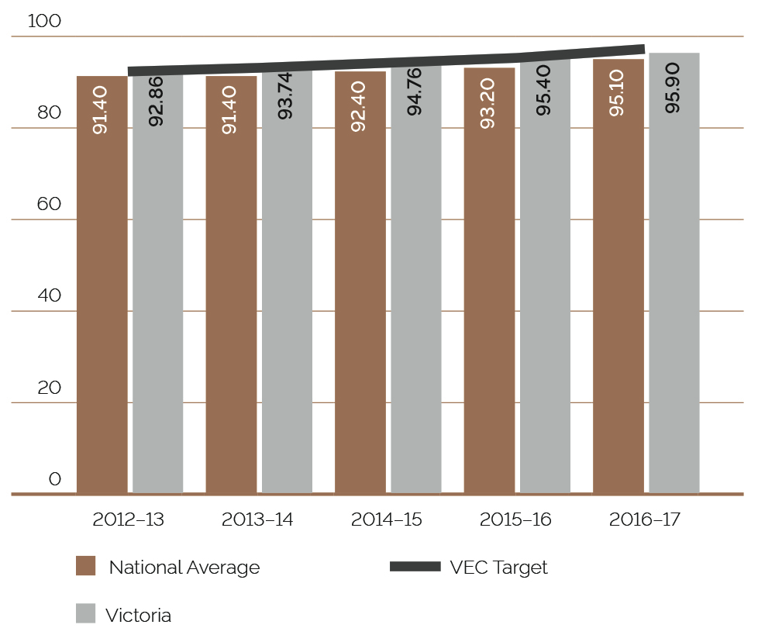

ENROLMENT
The number of Victorians enrolled to vote increased by 31,313 to 3,973,243 (0.79%) in 2016–17. Using available data, it is estimated that 95.9% of eligible electors are enrolled. This is an increase of 0.5% from 2015–16 and slightly more than the national figure of 95.1%. The VEC sets a target for enrolment to be at least 1% higher than the national average, however as a result of the 2016 Federal election, and associated national enrolment campaigns, the VEC enrolment rate was 0.8% higher (see Figure 16).
FIGURE 17: PROPORTION OF ENROLMENT UPDATES SOURCED FROM VEC PROGRAMS, 2012–13 TO 2016–17
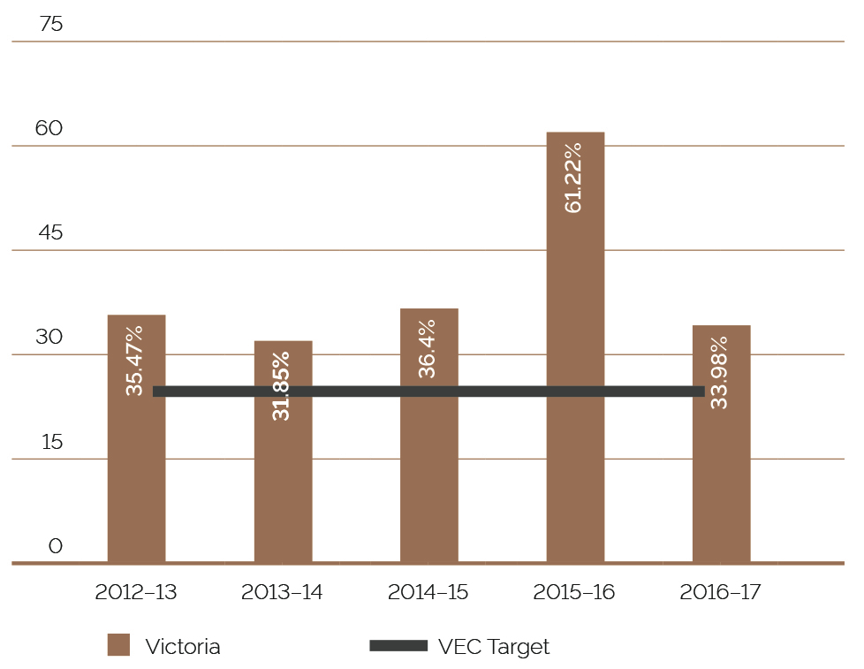

PROVISION OF ENROLMENT INFORMATION
The Register of Electors contains personal enrolment information, including name, address, date of birth and sex. Protecting the privacy of electors’ personal enrolment information is of fundamental importance to the VEC, and information is only disclosed according to legislation.

MANDATORY PROVISION OF ENROLMENT INFORMATION
The Electoral Act 2002 stipulates several requirements with regard to electoral information to be made available.
- The list of Victorian electors (names and addresses only), excluding silent electors, must be made available for public inspection at the offices of the VEC and updated every six months. Information can only be searched by name.
- The latest print of any electoral roll produced for an election (which contains name and address details only) must be made available for public inspection, free of charge, at locations and during times determined by the VEC.
- Enrolment information, excluding silent electors, must be provided a number of times each year (and at the time of an election) to registered political parties, Members of Parliament and election candidates for permitted purposes. Enrolment information is also provided under other legislation.
Under section 19 of the Juries Act 2000, to enable people to be called for jury duty, jury rolls are prepared as requested by the Juries Commission for any of Victoria’s 14 jury districts (silent electors are included in this process). A total of 47 jury rolls were provided under this legislation during 2016–17. Under section 21 of the Local Government Act 1989, enrolment information is provided to councils for elections.

DISCRETIONARY PROVISION OF ENROLMENT INFORMATION
Under section 34 of the Electoral Act 2002, the VEC has the discretion to release enrolment information to individuals or organisations under certain circumstances. Strict conditions regulate the provision of information and penalties apply for non-compliance or misuse of enrolment information.
During 2016–17, two organisations made applications through section 34 of the Electoral Act 2002 to access electoral information. The two applications were being processed at the end of the reporting period.
During 2016–17, the VEC entered into an information sharing agreement with one organisation that had made a section 34 application during 2015–16.
The VEC conducted a comprehensive review of its process for section 34 applications during 2016–17, including consultation with the Commissioner for Privacy and Data Protection. The review improved upfront advice and support to potential applicants, streamlined the processing of applications and formalised the VEC’s registration, audit and monitoring tools for information released under section 34. Improvements in processing times for applications are already being experienced as a result of this activity.
A standing agreement has been in place with Victoria Police since 2005, which allows immediate, secure access to the Register of Electors. Enrolment information was provided to six organisations under agreements subject to section 34 (see Figure 18).
FIGURE 18: INFORMATION PROVIDED TO ORGANISATIONS UNDER SECTION 34, 2016–17
Organisation | Look ups requested | unsuccessful searches | information provided
Anglicare | 9 | 1 | 8
Family Information Networks and Discovery (FIND) | 116 | 40 | 76
Victorian Assisted Reproductive Treatment Authority (VARTA) | 49 | 17 | 32
State Revenue Office | (List of electors provided monthly)
BreastScreen | (List of electors within relevant cohort provided quarterly)
Victoria Police | N/A | N/A | 2,710

inclusion and participation
The VEC provides a range of programs to ensure the participation and inclusion of all electors in Victoria’s democracy. There is, necessarily, a particular focus on communities typically under-represented within the electoral system, such as Aboriginal and Torres Strait Islanders, young people, people experiencing homelessness, people from culturally and linguistically diverse communities, people living with a disability and prisoners.

COMMUNICATION AND AWARENESS CAMPAIGN – 2016 LOCAL GOVERNMENT ELECTIONS

STATE-WIDE ADVERTISING
At a high level, all eligible voters needed to know that Local Government elections were happening. Typically, young people, Indigenous communities, people experiencing homelessness, those whose first language is not English, and people living with a disability generally need the most attention.
A limited budget ($400,000 including GST) was available for a state-wide Local Government elections campaign (excluding TV advertising) and provided for only a short burst of awareness primarily focused on the digital/online component, complemented by culturally and linguistically diverse communities (CALD) print and radio.
The VEC fully committed to a 15% regional spend requirement and doubled the 5% CALD placement requirement. Almost all digital material was developed in-house or in consultation with an agency.
Using paid promotion on Facebook, the VEC targeted voters by geographic area, CALD background and topics of interest. This paid advertising was supported by a defined timeline of social media posts on Facebook and Twitter designed to cover each of the key messages of the communication campaign, and to seed conversation about the democratic process.
For the first time, the VEC produced and used a series of animated videos focused on enrolment, postal and attendance elections to increase awareness, understanding and prompt requests for further information. A short 15 second version for enrolment was produced with all remaining videos running for one minute in duration.

STATUTORY ADVERTISING
The state-wide advertising activity was complemented by a statutory campaign for each of the 78 councils having elections. The VEC provided each council with a comprehensive communication campaign developed to meet legislative requirements and increase voter awareness and participation in the elections.
The content of the advertisements was guided by legislation, which resulted in the VEC adopting an information-based rather than a motivational approach to press advertising. The large amount of content required posed a challenge to effective communication so, to increase reader attention and recall, each press advertisement was themed. Press advertisements for the Melbourne City Council general elections were themed ‘Your Melbourne. Your Vote.’ For all other elections, the VEC used the theme ‘Your Council. Your Vote.’
More than 1,110 statutory advertisements (including reminder advertising) were placed across the Local Government elections program.

WEBSITE
The VEC website featured comprehensive information about Local Government elections generally, as well as specific information for each local council’s election. Content was updated at each phase of the election cycle.
Users were able to search for their Local Government area based on their address and, for attendance elections, use an interactive map to find voting centres. The same search feature could also be used to find election results for the user’s enrolled area.
During the period of the communication campaign (5 August to 4 November 2016) the VEC’s website had 5,038,457 page views with 3,696,383 unique page views and 666,351 unique users. A total of 43.54% of users used a desktop or laptop computer to access the website, 42.87% used a mobile and 13.59% used a tablet. This is a dramatic shift from four years ago where nearly three quarters of all users accessed the site from a desktop.
Key voting information could also be converted to Easy English on the webpages.

MEDIA RELATIONS
The strategic approach driving the media relations program was coordinated information sharing, focusing on the provision of authorised, accurate, traceable, consistent and timely information to effectively inform stakeholders and manage potential issues. Media engagement was focused on ensuring an accurate representation of the electoral process, with a focus on responsiveness when dealing with the media.
The VEC organised a media briefing at the outset of the communication campaign, with an in-person session on 1 August 2016 and a follow-up webinar for satellite media and council communication staff two days later.
The VEC distributed a total of 531 releases during the election period. There was a total of 107 online articles that were directly generated from VEC releases (translated and radio releases not included). The vast majority of these pickups related to council-specific releases in regional and suburban outlets.

DIGITAL COMMUNICATION SERVICE
After several pilots, the most recent during the 2016 Local Government elections and subsequent voter research, the VEC has commenced planning for an ongoing digital communication service for voters. It is envisaged that voters will be able to receive important alerts and reminders, such as trying to remember how and when to vote in Victorian State and Local Government elections. When launched, this new online service will be delivered via a personal text message/email.

ELECTRONIC/INTERNET VOTING
The publication of the Electoral Matters Committee (EMC) report into Electronic Voting in May 2017 noted the Committee’s in principle support for a system of remote voting at State elections for access by a limited category of electors. While the Government has yet to respond to the recommendations, the VEC will take preliminary steps toward making such a system available for the November 2018 State election.

CULTURALLY AND LINGUISTICALLY DIVERSE COMMUNITIES
The focus this year was on the 2016 Local Government elections, where the VEC’s six CALD community educators (who together speak 16 languages) delivered 74 electoral information sessions – in community languages and in English – to a total of 1,672 participants.
The sessions were primarily delivered across metropolitan Melbourne, as well as the VEC facilitating sessions in Shepparton and Bendigo.
Session content focused on increasing knowledge around how to vote correctly and making their vote count. At the conclusion of most sessions, participants were asked to complete a ‘mock’ ballot paper, which informally assessed the participants’ understanding of the information presented. The percentage of correct completion of ballot papers averaged 99% over all sessions.
Further to these sessions, the VEC consulted with CALD community members and service providers for the establishment of the following resources:
1,400 community information kits were distributed to local councils and community-based organisations and made available via the VEC’s website
information about voting in attendance elections and postal elections, which was translated into 20 languages, was included on the VEC’s website and distributed to community learning centres and the VEC’s CALD community networks and
targeted communication reminding voters from Arabic and Chinese communities about voting in the 2016 Local Government elections (placed in community language newspapers).

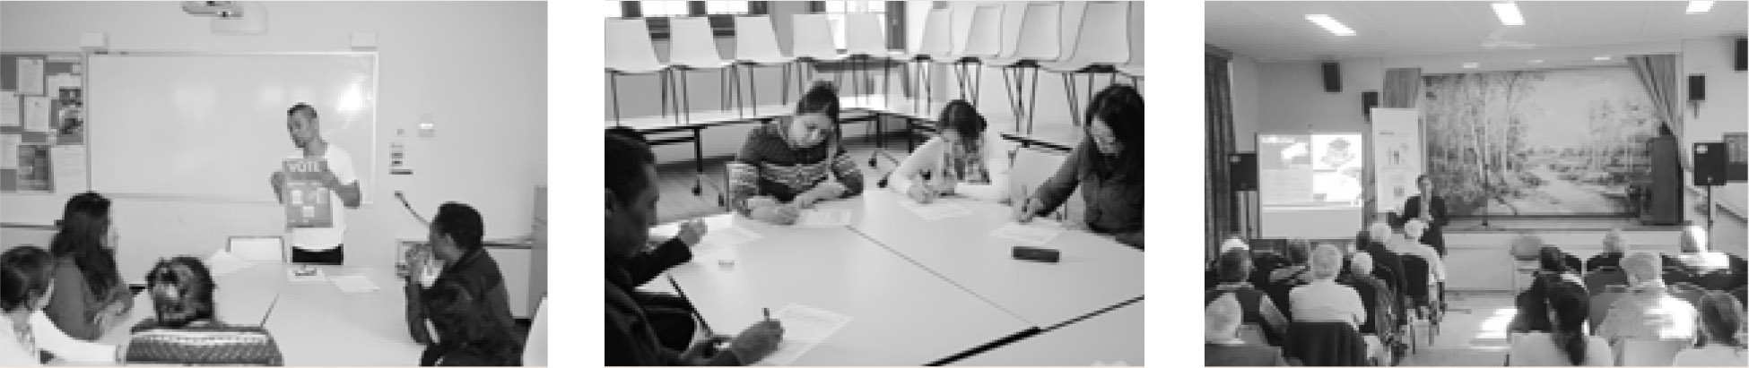
Left and middle: Focus group with students at Yarraville Community Centre
Right: Electoral information session with senior group from Indian community

ABORIGINAL AND TORRES STRAIT ISLANDER COMMUNITIES
In the months leading up to the 2016 Local Government elections, the VEC’s Aboriginal Communities Officer delivered five electoral information sessions to 82 participants in regional Victoria. The VEC also participated in two community events – one in Bendigo and one in Dandenong. Over 5,000 community members were in attendance at these events.
A culturally specific Aboriginal and Torres Strait Islander community information kit was distributed to 70 community-based organisations throughout the State. The kit consisted of a poster, resource order form, and an Easy English Guide and encouraged the community to enrol and vote at the 2016 Local Government elections.

PEOPLE EXPERIENCING HOMELESSNESS
The VEC partnered with the Council to Homeless Persons Peer Education Support Program (PESP), members of whom assisted the VEC in its electoral outreach work in the lead up to the 2016 elections.
In the four months prior to the Local Government elections:
- 12 enrolment sessions were conducted across metropolitan service providers and homeless agencies
- 43 people were enrolled or updated their details
- 53 people requested ballot pack redirections to their service agency and
  - 13 assisted voting sessions were conducted, during which 32 people were supported.
During the compulsory voting enforcement phase, the VEC delivered targeted communications to the homelessness sector regarding what to do if service users, who are experiencing homelessness, received a voting infringement.
As for previous general elections, individuals who are enrolled through the VEC’s engagement programs, including individuals experiencing homelessness, were automatically excused from voting.

PEOPLE LIVING WITH A DISABILITY
In preparation for the 2016 Local Government elections, the VEC actively promoted its education program to disability service providers and specialist schools, with a view to educating people with a disability of their voting rights. Some 25 sessions were conducted for people in a range of disability groups. The sessions focused on the support available to assist people with disabilities to vote and their understanding of how to vote correctly.

VOTERS VOICE APP
The VEC piloted an iPad tablet app – believed to be the first of its kind in the world - for people with complex communication needs for the 2016 Local Government elections. The project involved partnering with disability support service Scope in an effort to have a co-design approach for this important initiative.
The Voters Voice app has been designed to assist voters who:
- have complex communication difficulties (primary audience)
- speak Auslan (secondary audience) or
  - have English language or literacy issues (secondary audience).
The app contains a communication board with text-to-speech functionality for use in the voting centre. Also included is information on enrolling and voting in Easy English and plain English, and short videos on how to use the app and voting for the first time. An Auslan instructional video on voting in Victorian elections can also be streamed from the app. The app was available for download in the iTunes store from early August 2016 and exceeded its expected downloads by 300% (target was 500 and result was 1,615). Voters Voice won ‘Best App’ at the 2017 Australian Good Design Awards and a Silver Award at the 2017 Tech Design Awards.
The VEC is now building on the foundation app to expand it to Android and other digital devices in anticipation of a wider rollout for the 2018 State election.

CARERS PROGRAM
The VEC initiated a partnership with Carers Victoria to address the gap in carers’ understanding of voting entitlements for people with disabilities. The VEC facilitated sessions that were delivered to community members in metropolitan Melbourne and regional Victoria. Information at these sessions was based around the voting entitlements, the electoral system in Victoria and how to vote correctly.
A total of 32 face-to-face sessions were delivered to 444 carers over a period of four months.
The VEC website also published an eLearning module containing the same information for those carers who were unable to attend the workshop (attracted 648 page views and 357 unique page views).

SERVICES FOR VOTERS WHO ARE BLIND OR HAVE LOW VISION
The VEC worked with Vision Australia and Blind Citizens Australia to provide key election information at the enrolment and voting phases of the 2016 Local Government elections. The information provided to the 4,479 people on the membership lists was provided in DAISY/CD/audio, braille, large print and e-text formats. All braille products were produced by Vision Australia, which ensured that the instructions were written in a style appropriate for the formats.
To assist blind and low vision voters read election material, the VEC worked with Vision Australia in the use of a closed-circuit television monitor (CCTV) to magnify printed material at each of the attendance offices during the Local Government elections.

ACCESSIBLE VOTING CENTRES FOR LOCAL GOVERNMENT ATTENDANCE ELECTIONS
The VEC uses an audit tool to ensure that voting centres are accurately assessed for accessibility. Returning Officers of attendance elections were provided with instruction and support in the use of the audit tool. This tool ensures a clear understanding of the considerations necessary when choosing venues suitable for use as a voting centre and accurately records accessibility measures.
All voting centres were assessed for accessibility prior to the voting period and accessibility details for each venue were published on the VEC’s website and included in the Easy Vote letters mailed out to voters

AUSLAN VIDEO
The VEC produced an updated Auslan video for the Local Government elections in 2016. Signed by an Auslan interpreter and with optional subtitles, the video contained information explaining voting and enrolling entitlements, nomination procedures and voting procedures.

PRISONER EDUCATION PROGRAM
Working with program partner Corrections Victoria, the VEC undertook an extensive consultation process to design an electoral education program for people in prison – the first of its kind in Australia. The program uses a peer education model to deliver electoral information to prisoners who are eligible to vote. With the program design completed at the end of 2016, this initiative will roll out fully over the coming year.

YOUNG PEOPLE
The VEC continues to seek and encourage young Victorians’ democratic involvement through the Passport to Democracy (PTD) program. The active citizenship education program provides students with a positive experience when making their voices heard on issues, and links the experience to democracy, voting and elections.
Teachers from 165 schools have downloaded the program’s teaching and learning resources this financial year. The Education Team has delivered 12 mock-election sessions in schools. Teachers continued to highly value mock-elections and to highlight them during feedback, for example: “the students also really enjoyed the election at the conclusion of the course” and “the practical component provided students with a strong understanding of preferential voting”.
A number of vocational teachers requested in-school professional development sessions following the release of the program’s applied learning resources, known as PTD: Partner Up. Nine professional development sessions have been conducted during the year, building teachers’ capacity to deliver engaging electoral and civic education.
The program also provided a launching point for the VEC to engage with young people outside school settings.
The Office for Youth invited the VEC to run a workshop at their inaugural Victorian Youth Summit at the Melbourne Cricket Ground (MCG) in March, after seeing the program’s active citizenship resources. Over 80 young participants had “engaging”, “fun”, “informative” and “helpful” experiences improving their knowledge of how to be heard through democratic actions. Feedback included: “This workshop is inspirational. It tells youth that just because you’re young, it doesn’t mean no one can hear you” and “I really liked how this was relevant to me and gave me skills to take back to my community”.
In addition, PTD schools were encouraged to apply for the 2017 Victorian Youth Parliament. Students from four schools were awarded VEC scholarships and attended the July Parliament. These students participated in sophisticated governance activities in the Parliamentary Chambers, and proposed bills aimed at improving their communities.

VEC Reconciliation Action Plan
In January 2017, the VEC launched its first Reconciliation Action Plan (RAP). This plan was developed by the VEC’s Aboriginal Communities Officer in consultation with community groups and with VEC staff input. The aim of the RAP is to build confidence and trust in the VEC’s determination to address reconciliation and electoral participation barriers experienced by community.
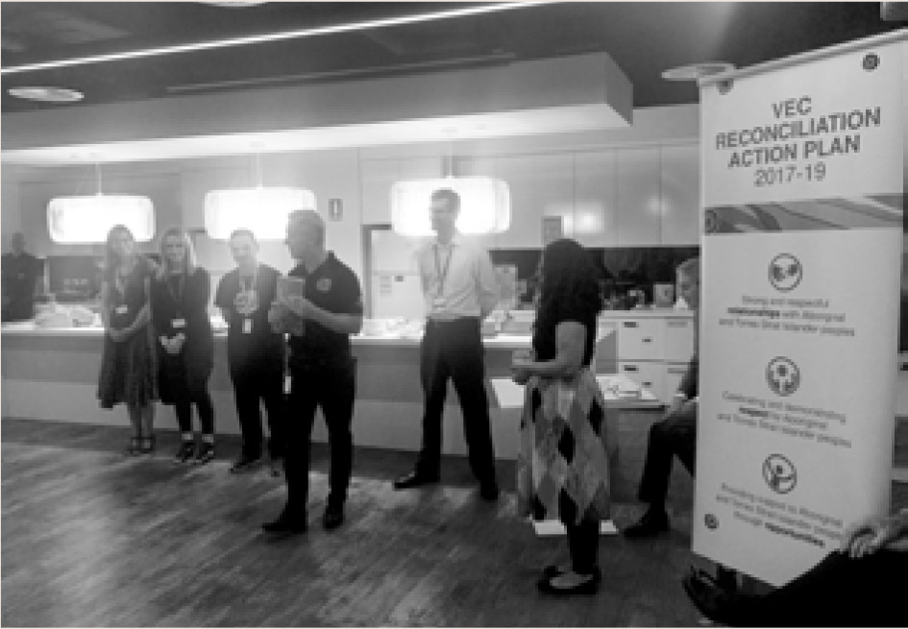
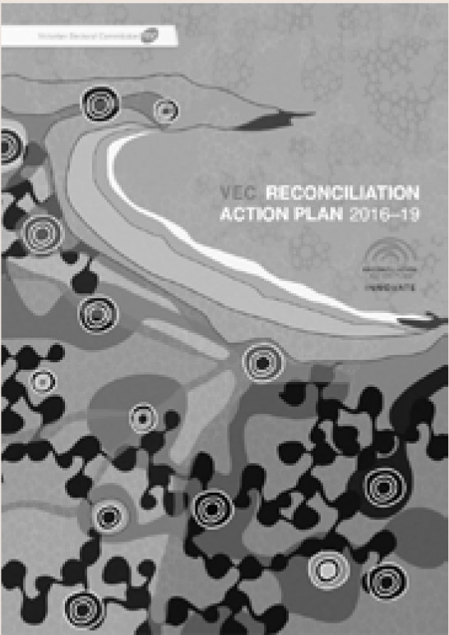
Key actions in the RAP include the development of culturally competent civic education programs, cultural learning and development opportunities for staff and building strong relationships with Aboriginal communities. Ensuring Aboriginal and Torres Strait Islanders are represented in the VEC’s core and casual workforce is also a key priority. A copy of the RAP is available from the VEC's website at vec.vic.gov.au/about.

Left: RAP Cover
Middle: Aunty Di and the VEC’s Curtis Greenwell
Right: The launch of the VEC’s RAP

services to political parties

REGISTER OF POLITICAL PARTIES
The Electoral Act 2002 (the Act) requires the VEC to establish and maintain a register of political parties. In order to qualify for registration, a political party must have a written constitution and at least 500 members who are Victorian electors, party members in accordance with the party’s rules, and not members of another registered political party or of a party applying for registration.
It is not compulsory for political parties to be registered to contest an election, but registration gives a party a number of important entitlements. These include:
- the right to have the party’s name on ballot papers
- access to enrolment and voter information on a periodic basis and
  - public funding for parties that attain a specified level of first preference votes.
A list of registered political parties at 30 June 2017 is included as Appendix I.

RE-REGISTRATION OF REGISTERED POLITICAL PARTIES
Section 58A of the Act requires registered political parties to apply to the VEC for re-registration just over two years before the next scheduled State election. The re-registration process is similar to that for an initial application for registration. Each party has to provide a statutory declaration that it has at least 500 eligible members, a copy of its constitution, the names and addresses of at least 500 members, and the application fee ($697 in 2016–17). The VEC tests whether a party has sufficient eligible members by writing to those on the list provided by the party, asking them to return a signed form about their membership in a reply-paid envelope. The VEC allows parties that have not reached the target of 500 ‘Yes’ responses to provide one supplementary list of new members for a second mail-out by the VEC.
The VEC wrote to the 17 registered political parties on 5 August 2016, reminding them of the re-registration requirements. Sixteen parties applied for re-registration by the deadline of 24 October 2016, while People Power Victoria - No Smart Meters opted to wait for six months, as allowed by the Act. On 11 November 2016, the VEC wrote to a total of 15,018 people on the lists provided by the parties. Response rates for the parties varied considerably. Eight parties provided a supplementary list, with a total of 3,011 names. In four cases the VEC provided a list of respondents, or non-respondents, to a party, though the VEC did not disclose the nature of individual responses. Parties were re-registered over a period of some six months.
Date | Party re-registered
2 December 2016 | National Party of Australia – Victoria  The Australian Greens – Victoria
7 December 2016 | Animal Justice Party  Australian Christians  Australian Labor Party – Victorian Branch
12 December 2016 | Liberal Party of Australia – Victorian Division
14 December 2016 | Voluntary Euthanasia Party (Victoria)
20 February 2017 | Shooters, Fishers and Farmers Party Victoria  Vote 1 Local Jobs
27 February 2017 | Democratic Labour Party (DLP)
22 March 2017 | Australian Sex Party – Victoria
5 April 2017 | Socialist Alliance (Victoria)
27 April 2017 | Australian Country Party
20 June 2017 | Liberal Democratic Party

Three parties were not re-registered. The VEC de-registered the Australian Cyclists Party (on 29 March 2017) and the Rise Up Australia Party (on 16 May 2017) because these parties had failed to show that they had at least 500 eligible members. People Power Victoria – No Smart Meters was de-registered (on 26 May 2017) because it had ceased to exist.

NEW APPLICATIONS FOR REGISTRATION
In June 2017, the VEC received applications for registration from the Australian Conservatives (Vic) and from the Help End Marijuana Prohibition (HEMP) Party. These applications were continuing at the end of the 2016–17 financial year.

CHANGES TO REGISTERED POLITICAL PARTIES
On 14 July 2016, the Shooters and Fishers Party was successful in their application to change their name to the Shooters, Fishers and Farmers Party.

interaction with electoral bodies
The VEC works with various national and international electoral bodies with the aim of supporting increased innovation and electoral harmonisation across Australia and globally. The exchange of ideas, collaborative research and discussion on key matters of interest with other electoral bodies (including through established forums), is an important basis for continued innovation. These interactions also support the VEC’s capacity to recommend and advise on relevant legislative change in Victoria.

ELECTORAL COUNCIL OF AUSTRALIA AND NEW ZEALAND
The Electoral Council of Australia and New Zealand (ECANZ) is a consultative forum with membership comprising Commonwealth and New Zealand and State and Territory Electoral Commissioners. This forum recognises the strong association and commonality existing between these organisations. ECANZ met on two occasions in 2016–17, with New South Wales succeeding Victoria as Council Chair in November 2016.
ECANZ considers best practice and innovation in activities such as the maintenance of electoral rolls, the operation of new electoral legislation and the management of elections. During the year the ECANZ consulted on a range of issues including enrolment strategies, material management, participation by marginalised groups, electronic roll marking and technology generally. In November 2016, a very successful workshop was held exploring best practice in election issues management and in May 2017 Commissioners considered arrangements for establishing a national capability in internet voting. Effecting such an arrangement will be a focus for 2017–18.

ELECTORAL BOUNDARIES COMMISSION
The VEC is required by legislation to provide administrative and technical services to the Electoral Boundaries Commission (EBC). The Report of the Electoral Boundaries Commission 2016–17 is included in this Report (Appendix N).
The EBC met in November 2016 being two years since the 2014 State election, and again in June 2017 as required by legislation, and confirmed elector numbers did not require action to redraw electoral district and region boundaries.

OTHER INTERACTIONS
The Electoral Commissioner met with Dr Nasim Zaidi, Chief Election Commissioner of India, during the 2016 Australian Federal election in Canberra and then later at a talk on Indian election processes, rules and governance at the Australia India Institute, Melbourne.
In May 2017, the Electoral Commissioner attended the British Columbia Provincial General Election, observing voting procedures and electoral practices over a three day period. Of particular interest were efforts to modernise voting centre arrangements, election official e-learning practices and elector communication strategies.
During the year, the Electoral Commissioner met with the Consul-General of Chile, Gabriel Jara, to discuss possible material assistance in support of Chilean Presidential elections to be held toward the end of 2017. For the first time, this election would allow Chilean citizens living abroad to vote.

ELECTORAL MATTERS COMMITTEE
The VEC has an interest in the work of the Electoral Matters Committee (EMC), a joint investigatory committee of the Parliament of Victoria. The EMC comprises seven Members of Parliament drawn from both Houses. Its powers and responsibilities are determined by the Parliamentary Committees Act 2003.
The EMC’s Inquiry into the Conduct of the 2014 Victorian State Election ended with the tabling of their report in May 2016. The Government responded to this report in November 2016 and consequent changes to legislation are being considered. The EMC’s Inquiry into Electronic Voting announced in October 2015 attracted wide interest. The VEC submitted to this Inquiry in July 2016 and appeared publically before the Committee in August. The Committee’s report was tabled in Parliament in May 2017 with one of several recommendations being in principle support for the provision of a system of remote voting at Victorian state elections. A new Inquiry by the Committee into Civics and Electoral Participation has recently been announced.

ARRANGEMENTS WITH OTHER ELECTORAL AGENCIES
In a reciprocal arrangement, the VEC provides election services such as voting services and information provision for other electoral agencies (See Figure 19).
The VEC routinely provides staff to other Australian electoral agencies for short periods to assist at their electoral events and to gain experience in different election operations. Four staff assisted with the Western Australian State general election in March 2017 in the areas of communication, declaration vote processing and Legislative Council vote counting.
FIGURE 19: VOTING SERVICES PROVIDED FOR OTHER ELECTORAL AGENCIES, 2016–17
date | Jurisdiction | Election | Total Votes
27 August 2016 | Northern Territory | Legislative Assembly general election | 41
15 October 2016 | Australian Capital Territory | Legislative Assembly election | 159
12 October 2016 | New South Wales | State District by-elections, Canterbury, Orange and Wollongong** | 0
3 December 2016 | New Zealand | Mt Roskill District by-election | 1
25 February 2017 | New Zealand | Mt Albert District by-election | 2
8 April 2017 | New South Wales | State District by-elections, Gosford, Manly and North Shore** | 0
11 March 2017 | Western Australia | State general election | 701
6 May 2017 | Tasmania | Legislative Council elections | 3
** The VEC was not required to provide voting services for the New South Wales by-elections; instead the VEC provided access to a computer to allow voters to register for an internet vote.

our people
ACHIEVEMENTS 2016–17
Establishment of the learning and development strategy and framework
Facilitation of improved work outcomes through an intranet‑based performance support platform offering just-in-time learning opportunities
Design, development and implementation of a revised New Employee and New Manager Onboarding Program with supporting e-learning modules and intranet‑based performance support platform
Design, development and delivery of e-learning modules to support improved Performance and Development program participation by all staff
100% participation in the annual Performance and Development program
Establishment and roll-out of a domestic violence policy, procedure and training
Launch of Spotlight On - an initiative that puts the spotlight on workplace practices, programs and ways of working
Introduction of the Bright Sparks program – short, engaging, informal sessions delivered by subject experts across the VEC and VPS
Establishment of 'Communities of Practice' to support improved organisational outcomes
Organisation-wide position description review
OUTLOOK 2017–18
Implementation of a leadership and management development program
Building and nurturing a succession bench for all critical roles
Developing an action plan in response to OHS survey results
Delivering the Reconciliation Action Plan
Developing and implementing a Diversity and Inclusion Strategy
Continuous focus on building a positive and progressive culture

human resource management
In 2016-17, the VEC established key workforce programs that invest in the capability of its people.

STAFF ENGAGEMENT
The VEC participated in the 2016 Victorian Public Sector Commission (VPSC) People Matter Survey with 71% of staff responding. The survey seeks input on a broad range of areas including:
- application of the Victorian Public Sector (VPS) values,
- employment principles, e.g. fair and reasonable treatment and supporting measures including policies
- provision of feedback and
  - job satisfaction and engagement.
The VEC had very strong results with 25 of the 27 measures registering above the VEC comparator group and the VPS average.
The VEC’s top ten results centred around its public interface, scoring highly on impartiality, integrity and responsiveness, as well as the VEC’s commitment to diversity – specifically age, cultural and disability. The survey identified the need to continue to focus on change management, along with a need to provide clarity on strategy and direction. Staff also indicated via the survey that the VEC needed to have better support mechanisms for lodging grievances. In response to the survey results, three action planning groups were established to act on opportunities to improve in these identified areas. There was also a group established to look at ways of celebrating what the VEC is doing well.

learning AND DEVELOPMENT
In October 2016, a dedicated learning, development and organisational capability function was defined within the Human Resource (HR) portfolio and the role of Learning, Development and Organisational Capability Program Manager introduced into the HR organisational structure. The role’s primary objective is steering the organisation-wide approach to building a skilled and committed workforce to meet our strategic objectives and commitments.
A major initiative was the establishment of a strategic learning, development and capability framework, which sets out the approach the VEC will take to develop and support staff to deliver on business strategy, and the way in which the VEC will design, develop, monitor and measure development efforts. This includes leveraging technology enabled solutions to establish intranet‑based performance support platforms that offer just in time learning, encourage improved communication and collaboration, and effectively deliver e-learning content. The intent is to move away from training-event centric approaches, to one that takes a broader capability development perspective. A set of policies, processes and tools were also created to support the program along with a revised set of learning and capability development metrics that measure the impact of the development interventions, and will form the basis for ongoing program investment, design, evaluation and reporting.

SUCCESSion risk management framework
In 2016-17, the VEC developed a Succession Risk Management Framework to enable the identification and ongoing management of succession risk.
The Framework enables the identification of business critical roles against specific criteria and promotes the development of role profiles by defining skills, capability and experience required to successfully deliver on the role. Potential candidates are then assessed against the profile and identified gaps are addressed through an individual development plan. The program recognises high potential staff and, if managed successfully, will address business continuity issues that can arise with unplanned attrition.
Concurrent to the establishment of a refreshed Learning and Development (L&D) Strategy, the VEC continued to invest in core skill development and nurturing of the VEC values by way of:
- supporting the introduction of a new Domestic Violence policy with training for selected Family Violence Contact Officers and all managers
- a revised New Employee Onboarding program which deploys a number of revised compliance e-learning modules
- a values based development initiative, Spotlight On, which shines the spotlight on a particular value highlighting the VEC’s work practices, ensuring the workplace is healthy, safe and engaging, and observing compliance requirements
- an employee development initiative, Bright Sparks, which provides accelerated, on the job development opportunities across four distinctive lenses and
  - inclusion of staff generated behavioural commitment statements in addition to KPI setting as part of the annual Performance and development program.
HR also coordinated an organisation-wide Position Description (PD) review, which involved all managers reviewing their team charter and accountabilities to ensure the currency of all PDs. Staff were consulted on any proposed changes and actively participated in the process. The PD review is a biennial project with the next review scheduled to occur in 2019.

EMPLOYMENT DIVERSITY and INCLUSION
The diversity of the workforce is embedded in the VEC’s values, specifically the value of Respect – Consideration of self, others and the environment and Collaboration – Working as a team with partners and communities. In 2016–17, the VEC demonstrated this commitment through the establishment of a Reconciliation Action Plan (RAP). Working in collaboration with Reconciliation Australia, the VEC developed and implemented a RAP including the development of an employee RAP Committee to monitor progress. One of the key aims is to engage employees in cultural learning and development opportunities, to increase understanding and appreciation of Aboriginal and Torres Strait Islander cultures, histories and achievements. All RAP Committee members attended cultural awareness training at the Koorie Heritage Trust. Cultural awareness training will be provided to all staff in 2017–18.
Also in 2016, the VEC rolled out an all staff Diversity and Inclusion Survey via an independent agency to gauge how Diversity and Inclusion (D&I) was represented in the workplace. The results indicated that the VEC’s commitment to D&I was evident to staff, as follows:
- 86% of staff agreed that colleagues supported diversity
- 83% of staff agreed that supervisors supported diversity
- 88% of staff believed that there was a positive culture in relation to employees from varied cultural backgrounds.
- 87% of staff who identified themselves as having a disability believed there is a positive culture in relation to disability
  - 71% of staff who identified themselves as LGBTI believed there is a positive culture in relation to LGBTI
In 2017–18, the VEC will formalise this commitment by developing and implementing a Diversity and Inclusion Strategy.

RECRUITMENT AND TURNOVER
In the 2016–17 year, the VEC recruited 13 ongoing positions.
Figure 20 shows the staff full time equivalent (FTE) roles recruited and departures from 2012–13 to 2016–17. Recruitment requirements vary according to electoral activity and staff movements.

ELECTION STAFFING
The VEC has approximately 300 Senior Election Officials (SEOs) on standby who have been recruited and trained for engagement in senior election management positions during State and Local Government elections. From this pool of SEOs, individuals were selected for appointment to management roles for the Local Government elections.
The VEC maintains an ongoing database of individuals interested in working during elections. There are approximately 30,500 registered in this database and people may register at any time. This database forms part of the VEC’s payroll and recruitment system, which is used to manage large volumes of casual appointments for each electoral event. The VEC is committed to continuously developing and improving the electronic payroll and recruitment system so that it meets the needs of election.
The VEC also maintains an ongoing Personnel Helpline to support casual election staff in the registration and appointment process.
FIGURE 20: RECRUITMENT, DEPARTURES AND TURNOVER, 2012–13 TO 2016–17
 | headcount (ongoing) | fte | commencements fte | departures fte | staff turnover  (% departures/fte)
2016–17 | 82 | 77.1 | 13 | 11 | 14.3%
2015–16 | 67 | 64.4 | 13 | 10 | 15.5%
2014–15 | 62 | 59.8 | 4 | 5 | 8.36%
2013–14 | 65 | 62.5 | 10.5 | 4.6 | 7.36%
2012–13 | 62 | 58.4 | 13 | 3.8 | 6.51%

FIGURE 21: RECRUITMENT (FTE ONGOING), 2012–13 TO 2016–17
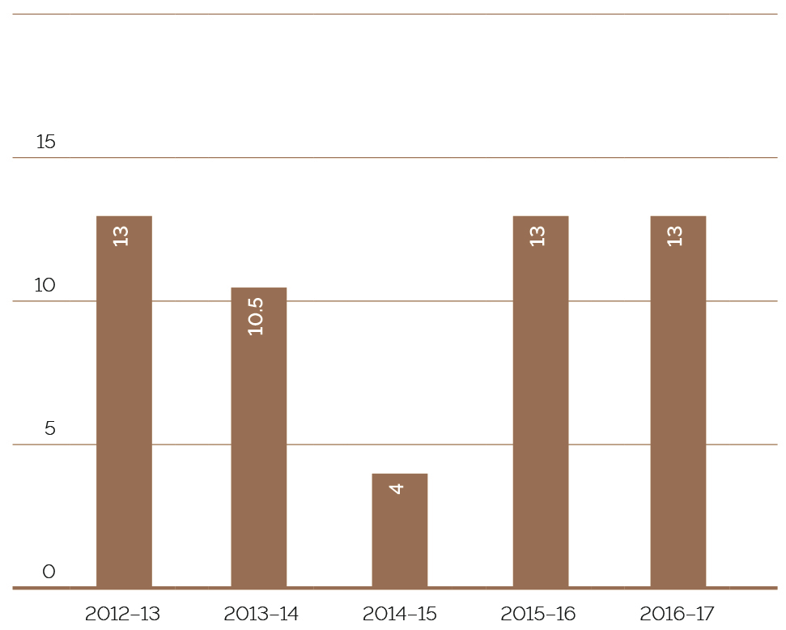

FIGURE 22: VEC STAFF BY GENDER, 2012–13 TO 2016–17
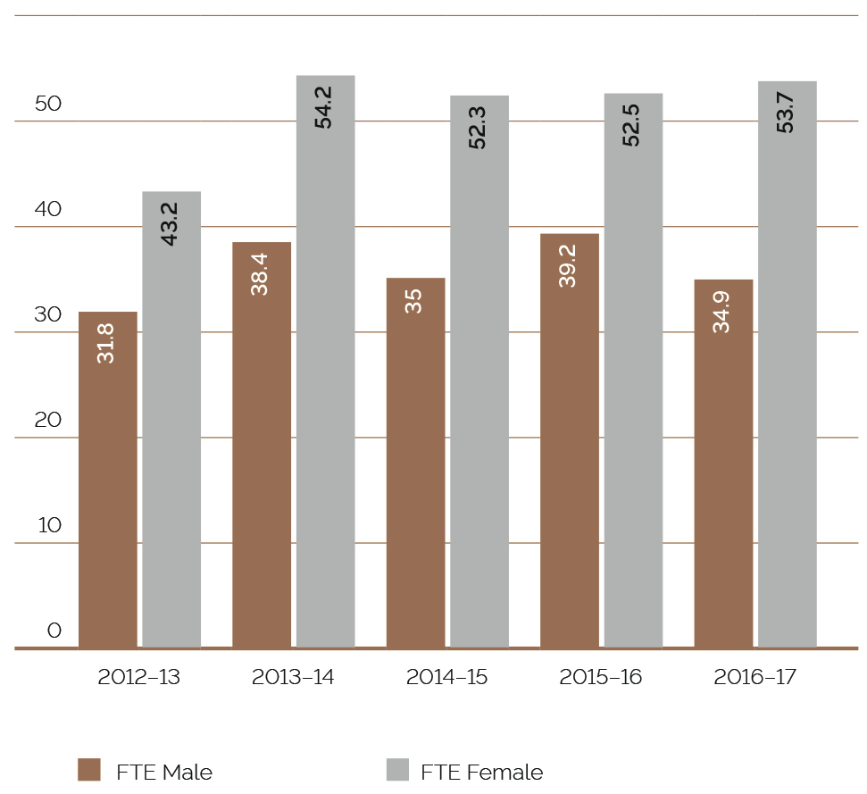

Staff profile

COMPARATIVE WORKFORCE DATA
FIGURE 23: VEC STAFF PROFILE, LAST PAY PERIOD JUNE 2017 (NOT INCLUDING STATUTORY APPOINTEES)
 | 2017 |  |  |  |  | 2016
 | ongoing |  | fixed term & casual | total |  | ongoing |  | fixed term & casual | total
 | head- count | fte | head- count | fte | fte | head- count | fte | head- count | fte | fte
Gender
Male | 33 | 32.3 | 3 | 2.6 | 34.9 | 29 | 28.2 | 13 | 11.3 | 39.5
Female | 49 | 44.9 | 12 | 8.8 | 53.7 | 38 | 36.2 | 23 | 16.3 | 52.5
Total | 82 | 77.2 | 15 | 11.4 | 88.6 | 67 | 64.4 | 36 | 27.6 | 92.0
Age
Under 25 | 2 | 2 | 0 | 0 | 2 | 0 | 0.0 | 2 | 1.4 | 1.4
25-34 | 12 | 10.9 | 2 | 1.6 | 12.5 | 12 | 12.0 | 9 | 7.7 | 19.7
35-44 | 18 | 16.6 | 8 | 5.8 | 22.4 | 15 | 14.4 | 12 | 8.7 | 23.1
45-54 | 33 | 31.3 | 2 | 1.8 | 33.1 | 21 | 20.6 | 5 | 4.0 | 24.6
55-64 | 14 | 13.4 | 2 | 1.2 | 14.6 | 16 | 14.4 | 6 | 4.6 | 19.0
Over 64 | 3 | 3 | 1 | 1 | 4 | 3 | 3.0 | 2 | 1.2 | 4.2
Total | 82 | 77.2 | 15 | 11.4 | 88.6 | 67 | 64.4 | 36 | 27.6 | 92.0
Classification
STS | 3 | 3 | 0 | 0 | 3 | 3 | 3 | 0 | 0 | 0
VPS Grade1 | 0 | 0 | 0 | 0 | 0 | 0 | 0 | 2 | 0.5 | 0.5
VPS Grade2 | 16 | 14.6 | 3 | 2.1 | 16.7 | 13 | 12.4 | 13 | 11.1 | 23.5
VPS Grade3 | 21 | 19.6 | 4 | 2.1 | 21.7 | 15 | 14.8 | 13 | 8.5 | 23.3
VPS Grade4 | 13 | 11.9 | 6 | 5.4 | 17.3 | 10 | 10 | 7 | 6.5 | 16.5
VPS Grade5 | 24 | 23.2 | 2 | 1.8 | 25 | 21 | 19.3 | 1 | 1.0 | 20.3
VPS Grade6 | 5 | 4.8 | 0 | 0 | 4.8 | 5 | 4.9 | 0 | 0 | 4.9
Total | 82 | 77.2 | 15 | 11.4 | 88.6 | 67 | 64.6 | 36 | 27.6 | 92.0
Excluded are those on leave without pay, or absent on secondment, external contractors and temporary staff employed by employment agencies, election appointees to statutory offices as defined in the Public Administration Act 2004, and election casual staff employed under the Electoral Act 2002.
FIGURE 24: FULL TIME EQUIVALENT (FTE) STAFFING TRENDS AS AT 30 JUNE, 2012 TO 2017
 | ongoing employees |  |  |  | fixed term |  | casual |  | totals
 | number (head  count) | full time (head  count) | part-time (head  COunt) | fte | number (head  count) | fte | Number (head  count) | fte | number (head  count) | fte
2017 | 82 | 69 | 13 | 77.2 | 13 | 11.2 | 2 | 0.2 | 97 | 88.6
2016 | 67 | 59 | 8 | 64.4 | 25 | 22.8 | 12 | 5.7 | 112 | 92
2015 | 62 | 54 | 8 | 59.8 | 23 | 21.2 | 16 | 6.3 | 101 | 87.3
2014 | 65 | 56 | 9 | 62.5 | 20 | 18.8 | 14 | 11.3 | 99 | 92.6
2013 | 62 | 52 | 10 | 58.4 | 16 | 16.0 | 6 | 2.6 | 84 | 75
2012 | 60 | 49 | 11 | 56.7 | 16 | 16.0 | 9 | 5.2 | 85 | 77.9

staff services and employment conditions

CODE OF CONDUCT – VEC VALUES
All new employees are provided with a copy of the VPS Code of Conduct. The VPS values, as outlined in the Code of Conduct, are embedded in the Employee Performance and Development program and employees are required to provide evidence of their behavioural contribution through the performance cycle. In 2016–17, the VEC values statements were reviewed and redesigned to ensure clarity around expectations. The new statements clearly define the expected role modelling and unacceptable behaviours in a workplace context. The statements were circulated and feature in all break-out areas and offices.
VEC employees have also established a common set of below-the-line behaviours (inappropriate behaviours), which when witnessed or identified, are called out and appropriate action is taken.

RAISING ISSUES
The VEC is committed to ensuring that principles of merit and equity are applied and work-related complaints and issues are resolved quickly, confidentially and without prejudice. The suite of policies and procedures that support staff in raising issues and supporting managers in addressing misconduct were reviewed and revised in 2016–17. The review was coordinated via the People Matter Survey Management Action planning group, who committed to ensuring a safe workplace where employees are supported in raising concerns and managers are provided with the tools and resources to address inappropriate behaviour.

FLEXIBLE WORK ARRANGEMENTS
In 2016–17, the VEC committed to supporting individual flexibility and business performance needs by encouraging employees and managers to talk about flexibility in the workplace, including when work is undertaken, working location and how staff go about their work. The VEC demonstrated a commitment in this area by providing flexible working options to a number of staff, including flexible start and finish times, compressed work fortnights, banking and taking of flex-time and the provision of ‘make-up time’. There were also a number of staff who worked from home on an ad-hoc basis and a number of employees who on request reduced their working hours. The VEC further demonstrated its commitment to flexibility using technology based solutions to enable an employee recovering from serious illness to work remotely using video conference and desktop sharing solutions.

occupational health and safety
During 2016–17, the VEC finalised the formal review of the Occupational Health and Safety Management System (OHSMS).
The VEC Executive Management Group is committed to maintaining and monitoring the OHSMS, integrating it with daily business activities and making Occupational Health and Safety (OHS) information readily available to staff.
This year, the OHS Committee focussed on identifying areas for improvement and reviewed the OHSMS, including roles and responsibilities. A number of the VEC’s Safe Work Procedures (SWPs) have been reviewed and the VEC introduced Safety in Practice guidance notes. The Safety in Practice guidance notes are designed to assist staff and managers to minimise risks in key risk areas identified as present in VEC workplaces; these risk areas include fatigue, mental health, manual handling and office workstation and ergonomics.
In April 2017, the VEC relaunched the OHS site and associated pages on the VEC’s intranet, VECentral. The site was designed as the central repository for all information and documentation related to health, safety and wellbeing; to assist employees and managers in understanding their OHS role and responsibilities; and to promote the tools and resources available to employees and managers to meet their OHS obligations. The site includes a dedicated page for staff consultation and communication, and a dedicated mental health and wellbeing page, which promotes Employee Assistance Program (EAP) services and upcoming staff wellbeing events.
The VEC is committed to continuous improvement and the continual review of the effectiveness of the OHS management system, to ensure the system supports overall improvement in OHS performance. In supporting this commitment, managers complete a quarterly OHS and fire safety inspection across all designated work group areas, ensuring the VEC is continually monitoring and improving the safety of its workplace.
Formal OHS reporting has continued and a quarterly report is shared with managers, the OHS Committee and the VEC’s Audit and Risk Committee, ensuring health and safety remains front of mind. The report provides OHS and Wellbeing information, including an overview of reported incidents and hazards, OHS training undertaken during the quarter and the VEC’s performance against OHS targets.
During 2016–17, recommendations from an OHS Audit conducted in 2015–16 were actioned and closed. As a result, the VEC has improved the safety induction for contractors and visitors to VEC’s Head Office location. OHS online training for election casuals was developed in preparation for the next major electoral event. Training completion rates will be recorded and monitored with the wider suite of online election training deliverables. OHS incident reporting and emergency procedures were updated, with instructions and responsibilities incorporated in all election manuals for the 2016 Local Government elections.
In May 2017, the OHS Committee circulated an OHS staff feedback survey to all managers and employees. The survey took a pulse check of the VEC’s ‘safety culture’ and provided an opportunity to seek staff opinion on the VEC's current OHS performance and identify topics of most importantance to employees. The Committee is collating the results and the most highly rated OHS topics will be internally audited by the OHS Committee throughout 2017–18, ensuring that current procedures are effective and implemented correctly. Based on the findings, the OHS Committee will make recommendations for improvements to the Executive Management Group, ensuring the VEC continues to review and improve the effectiveness of the VEC’s OHS Management system and its OHS performance.

STAFF WELLBEING SERVICES
During 2016–17, the VEC continued to deliver a wellbeing program that incorporated a number of activities, and provided health and wellbeing information to employees about common health issues and recommended preventative actions. The wellbeing program is driven by the VEC’s three year Wellbeing Strategy which was developed in 2016–17.
The range of activities offered during 2016–17 included:
- a health information session facilitated by an external speaker from Optum, the VEC’s Employee Assistance Program (EAP) provider. The session provided tips to staff on how to manage conflicting priorities more effectively and provided information about the confidential, short-term counselling and wellbeing support services available to all VEC employees and their immediate family members
- International Women’s Day – a speed-networking event with three very successful women from both public and private sector organisations sharing their career journey with VEC staff, and a competition for four VEC employees to attend IPAA’s International Women’s Day Gala Dinner and
  - the flu vaccination program, with 58 employees taking advantage of the service.
FIGURE 25: THE VEC’S PERFORMANCE AGAINST OHS MANAGEMENT MEASURES, 2012–13 TO 2016–17
measure | kpi | 2012-2013 | 2013-2014 | 2014-2015 | 2015-2016 | 2016-2017
Incidents | Staff FTE  No. of incidents  Rate per 100 FTE | 72.4  17  23.48 | 81.3  9  11.07 | 81  6  7.41 | 86.2  13  15.08 | 88.6  5  5.6
Claims | No. of standard claims  Rate per 100 FTE  No. of lost time claims  Rate per 100 FTE  No. of claims exceeding 13 weeks  Rate per 100 FTE | 1  1.38  0  0.00  0  0.00 | 2  2.46  2  2.46  0  0.00 | 0  0.00  0  0.00  0  0.00 | 0  0.00  0  0.00  0  0.00 | 1  1.1  0  0.00  1  1.1
Fatalities | Fatality claims | 0 | 0 | 0 | 0 | 0
Claim costs | Average cost per standard claim | N/A | 2,274 | 8,576 | 0 | 8,210.40
Return to work | Percentage of claims with RTW plan <30 days | 0 | 0 | 0 | 0 | 0
Management | Evidence of OHS policy statement, OHS commitment objectives, regular reporting to senior management of OHS, and OHS plans (signed by CEO or equivalent)  Evidence of OHS criteria in purchasing guidelines (including goods, services and personnel) | Completed  Completed | Completed  Completed | Completed  Completed | Completed  Completed | Completed  Completed
Consultation | Evidence of agreed structure of designated and workgroups (DWGs), health and safety participation representatives (HSRs), and issue resolution procedures (IRPs)  Compliance with agreed structure on DWGs, HSRs, and IRPs | Completed  Completed | Completed  Completed | Completed  Completed | Completed  Completed | Completed  Completed
Risk management | Percentage of internal audits/inspections conducted as planned  Percentage of issues identified and actioned arising from:  - internal audits  - HSR provisional improvement notices (PINs)  - WorkSafe notices | 71%  100%  N/A  N/A | 100%  100%  N/A  N/A | 100%  100%  N/A  N/A | 100%  100%  N/A  N/A | 100%  100%  N/A  N/A

Training | Percentage of managers and staff that have received OHS training: •  - induction  - management training  contractors, temps and visitors  Percentage of HSRs trained:  - •acceptance of role  - refresher training  - reporting of incidents and injuries | 100%  Scheduled  N/A  100%  100%  100% | 100%  *0%  N/A  100%  100%  100% | 100%  100%  100%  100%  100%  100% | 100%  0%  100%  100%  0%  100% | 100%  100%  N/A  100%  100%  100%
*Figure corrected
FIGURE 26: CLAIMS FOR WORKCOVER OR WORKERS COMPENSATION, 2013–14 TO 2016–17
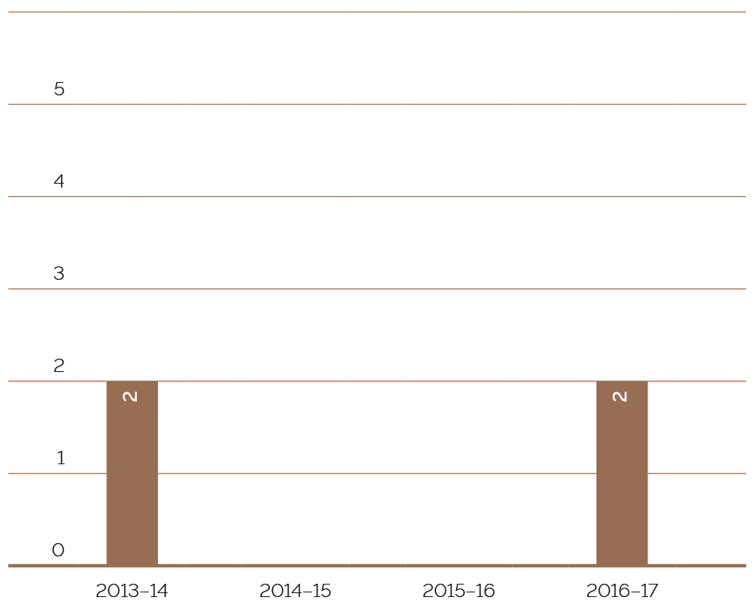

HAZARDS, INCIDENTS AND INJURIES
During 2016–17, the VEC received 22¹ incident notifications and no hazard notifications (see Figure 28). There were also two claims for compensation one primary and one minor.
All OHS incidents reported during the year have been investigated by health and safety representatives and management. Corrective action has been implemented and monitored. The VEC has seen an increase in the number of OHS incidents reported, which is a result of the increased activity during the Local Government elections. The VEC also requested staff report all incidents (even if there was no resulting injury) so that preventative action could be taken. All corrective action is monitored and reviewed on the VEC’s Safety Action Plan on a regular basis to ensure their effectiveness.
¹ five from VPS staff, four from members of the public and 13 from election staff

FIGURE 27: DAYS LOST AS A RESULT OF WORKPLACE-RELATED INJURY, 2013–14 TO 2016-17
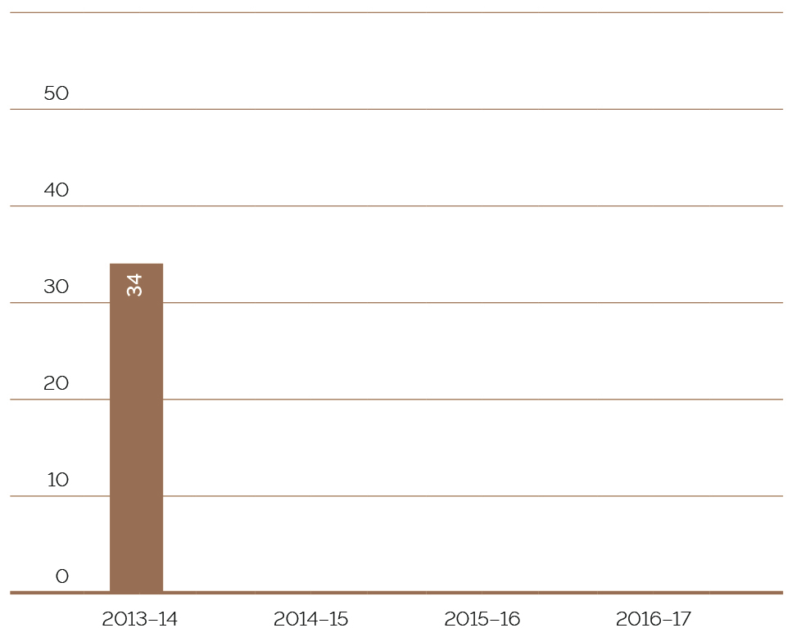
FIGURE 28: HAZARD, INCIDENTS AND INJURIES REPORTED, 2013–14 TO 2016–17
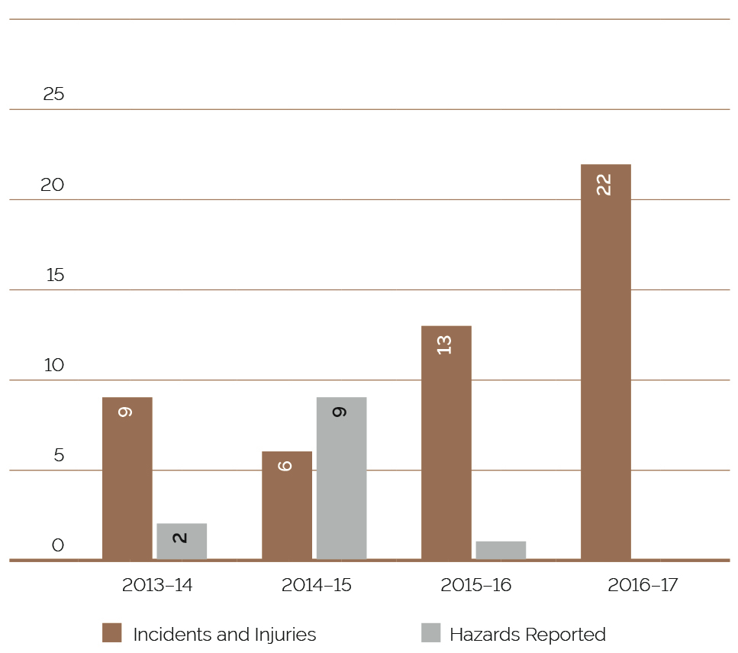

FINANCIAL STATEMENTS
Inside this section
Page 100
Financial report
Page 103
Comprehensive operating sheet
Page 104
Balance Sheet
Page 106
Statement of changes in equity
Page 107
Cash flow
Page 108
Notes to the financial statements
Page 149
Accountable officer’s and chief finance and accounting officer’s declaration
Page 150
Auditor-General’s report

FINANCIAL REPORT
The financial review is prepared to provide stakeholders with an understanding of VEC’s financial performance and position over the 2016–17 reporting period.
This financial year was significant in that the VEC conducted Local Government elections for 78 of Victoria’s 79 councils. In addition, the VEC managed 17 additional events including four Local Government countbacks and 13 fee-for-service elections and polls. The VEC successfully delivered all electoral activities on schedule and within budget.

FUNDING fluctuations
The VEC’s only source of funding is Special Appropriation from the State government. The VEC’s funding fluctuates year‑on‑year depending on the electoral activity being delivered (see Figure 29). Both the State election and Local Government elections will occur biennially, significantly increasing the VEC’s funding for the particular year. With the Local Government elections occurring in October 2016, the VEC’s funding increased to $52.3 million (2015–16: $25.2 million).

EQUITY – What The VEC Is Worth
The VEC’s equity is measured as the net of VEC’s assets less VEC’s liabilities. The VEC’s total equity position at 30 June 2017 is $7.7 million, comprising of contributed capital and carrying accumulated deficit.

ADMINISTRATIVE SERVICES
In conducting the 2016 Local Government elections, the VEC also undertook administrative services on behalf of the State government and local councils. This came in the form of issuing compulsory voting notices, infringement letters and the collection and distribution of council election related funds. As at 30 June 2017, the VEC collected and distributed $26.3 million to councils. Funding from administrative services does not form part of the VEC’s Special Appropriation funding.
FIGURE 29: SPECIAL APPROPRIATION 2012–13 TO 2016–17 ($’000)
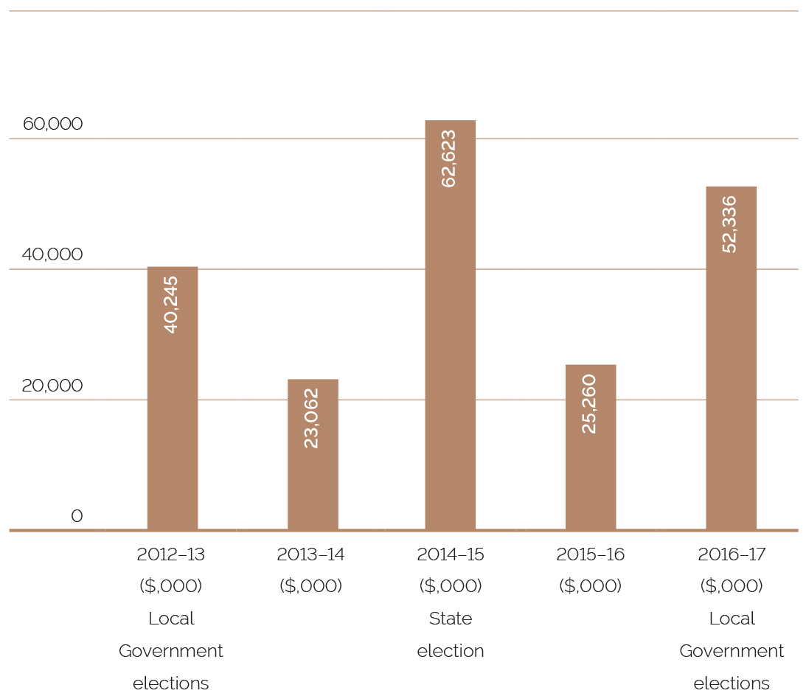

EXPENSES – How the vec’s Funding Is Utilised
The increased funding was provided for Local Government election costs, which came in the form of employee wages, and costs associated with supplies and services. The VEC’s casual workforce expanded to 8,000 members and major costs were incurred with key electoral suppliers such as Australia Post, Toll and Telstra providing significant support in mail services, logistics and telecommunication infrastructure.
VEC Operational Expenditure ($’000)
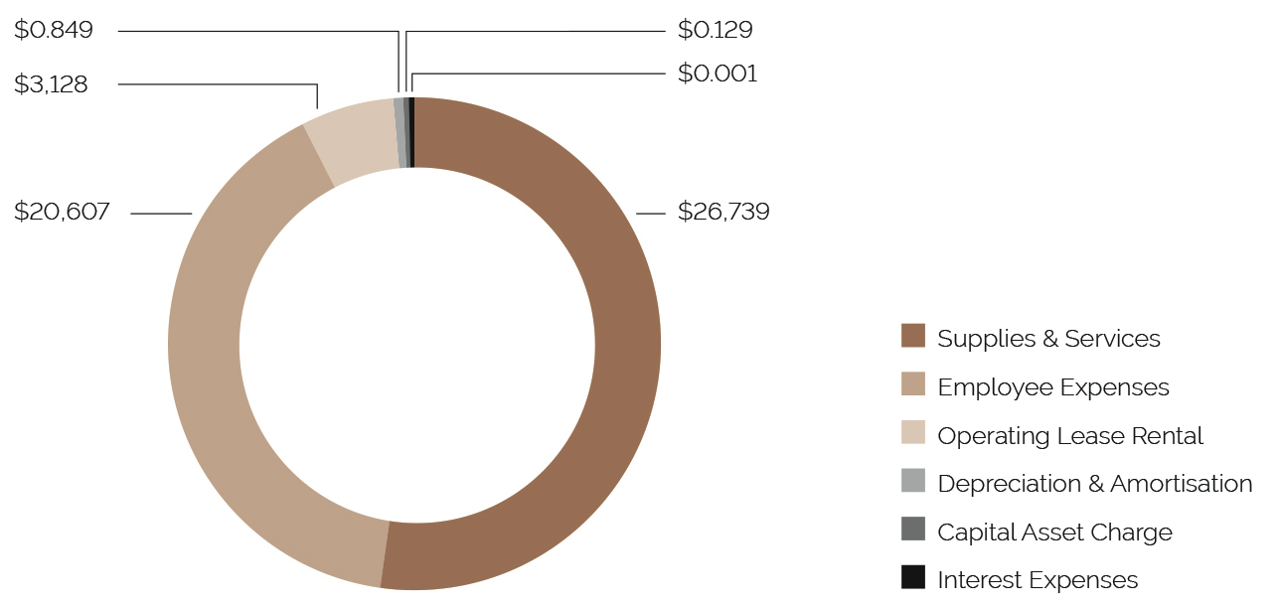

ASSETS – What the vec Owns
Assets owned by the VEC are largely within election inventory and plant and equipment across its two locations. The largest asset owned and developed by the VEC is the Election Management System, which underpins the VEC’s ability to manage and host election activities. The system undergoes ongoing development and enhancement to meet election needs and legislative changes and to improve the efficiency and delivery of elections.
VEC assets
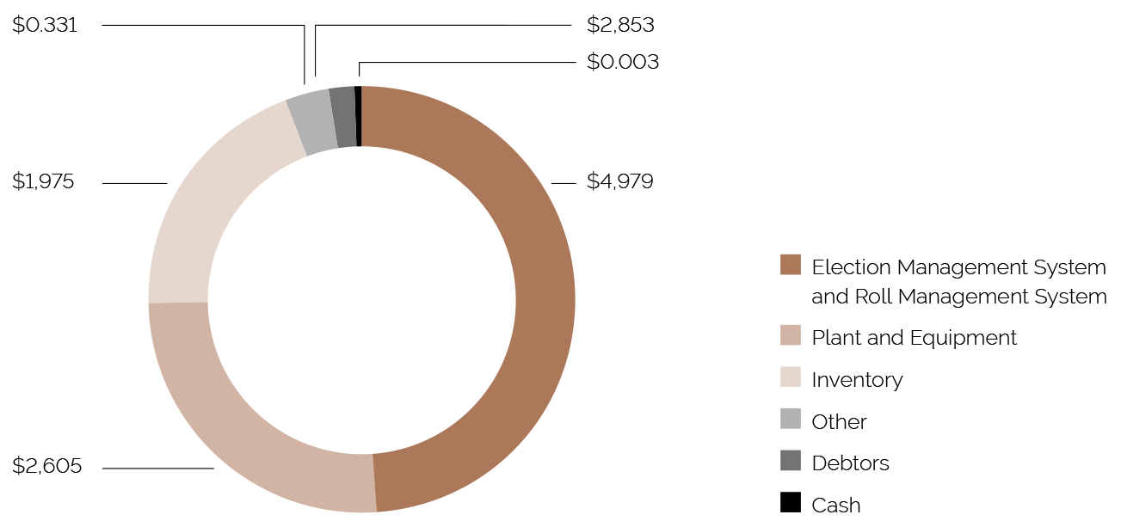

LIABILITIES – What the vec Owes
The VEC’s liabilities are largely represented by employee provisions (annual leave and long service leave owing to staff) and supplier commitments. Money owed to suppliers and creditors was timing related at 30 June 2017, based on terms of trade between the VEC and respective suppliers. These balances were subsequently cleared the following month.
VEC liabilities
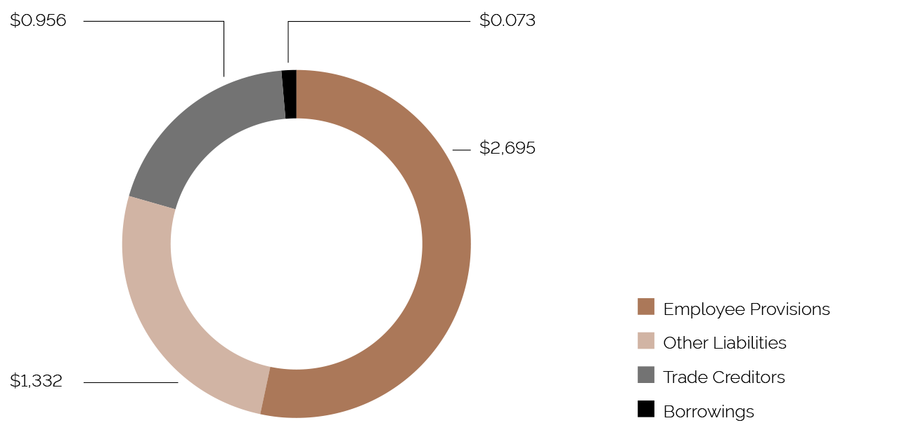

COMPREHENSIVE OPERATING STATEMENT

FOR THE FINANCIAL YEAR ENDED 30 JUNE 2017
 | Notes | 2017  $’000 | 2016  $’000
Continuing operations
Income from transactions
Special appropriations | 4, 22 | 52,336 | 25,260
Total income from transactions |  | 52,336 | 25,260
Expenses from transactions
Employee expenses | 5(a) | 20,607 | 10,948
Supplies and services | 5(d) | 26,739 | 11,009
Depreciation and amortisation | 5(b) | 849 | 1,017
Interest expense | 5(c) | 1 | 3
Capital asset charge |  | 129 | 129
Operating lease rental expense |  | 3,128 | 1,840
Total expenses from transactions |  | 51,453 | 24,946
Net result from transactions (net operating balance) |  | 883 | 314
Other economic flows included in net result
Other gains / (losses) from other economic flows | 6 | 34 | (61)
Total other economic flows included in net result |  | 34 | (61)
Net result | 21(b) | 917 | 253
Comprehensive result |  | 917 | 253
The comprehensive operating statement should be read in conjunction with the notes to the financial statements.

BALANCE SHEET

AS AT 30 JUNE 2017
 | Notes | 2017  $’000 | 2016  $’000
Assets
Financial assets
Cash and deposits | 21(a) | 3 | 2
Receivables | 7 | 2,853 | 416
Total financial assets |  | 2,856 | 418
Non-financial assets
Inventories | 8 | 1,975 | 2,615
Property, plant and equipment | 9 | 2,605 | 2,625
Intangible assets | 10 | 4,979 | 5,322
Other non-financial assets | 11 | 331 | 750
Total non-financial assets |  | 9,890 | 11,312
Total assets |  | 12,746 | 11,730
Liabilities
Payables | 12 | 956 | 1,079
Borrowings | 13, 17 | 73 | 94
Provisions | 14 | 2,695 | 2,716
Other liabilities | 15 | 1,332 | 1,568
Total liabilities |  | 5,056 | 5,457
Net assets |  | 7,690 | 6,273
Equity
Accumulated (deficit) / surplus |  | (24,878) | (25,795)
Contributed capital |  | 32,568 | 32,068
Net worth |  | 7,690 | 6,273
Commitments for expenditure | 17, 18
Contingent assets and contingent liabilities | 19
The balance sheet should be read in conjunction with the notes to the financial statements.

STATEMENT OF CHANGES IN EQUITY

FOR THE FINANCIAL YEAR ENDED 30 JUNE 2017
 | Notes | ACCUMULATED  SURPLUS  $’000 | CONTRIBUTED  CAPITAL  $’000 | TOTAL  $’000
Balance at 1 July 2015 |  | (26,048) | 31,077 | 5,029
Net result for the year |  | 253 | - | 253
Other comprehensive income for the year |  | - | - | -
Capital appropriations |  | - | 991 | 991
Balance at 30 June 2016 |  | (25,795) | 32,068 | 6,273
Net result for the year | 21(b) | 917 | - | 917
Other comprehensive income for the year |  | - | - | -
Capital appropriations | 22 | - | 500 | 500
Balance at 30 June 2017 |  | (24,878) | 32,568 | 7,690
The statement of changes in equity should be read in conjunction with the notes to the financial statements.

CASH FLOW STATEMENT

FOR THE FINANCIAL YEAR ENDED 30 JUNE 2017
 | Notes | 2017  $’000 | 2016  $’000
Cash flows from operating activities
Receipts
Receipts from Government |  | 52,573 | 26,625
Total receipts |  | 52,573 | 26,625
Payments
Payments to suppliers and employees |  | (52,198) | (25,106)
Goods and Services Tax paid to the ATO | (i) | (249) | (1,369)
Capital asset charge payments |  | (129) | (129)
Interest and other costs of finance paid |  | (1) | (3)
Total payments |  | (52,577) | (26,607)
Net cash flows from / (used in) operating activities | 21(b) | (4) | 18
Cash flows from investing activities
Purchases of non-financial assets | 22 | (500) | (991)
Sales of non-financial assets |  | 5 | (18)
Net cash flows (used in) / from investing activities |  | (495) | (1,009)
Cash flows from financing activities
Owner contributions by State government |  | 500 | 991
Net cash flows from / (used in) financing activities |  | 500 | 991
Net increase / (decrease) in cash and cash equivalents |  | 1 | -
Cash and cash equivalents at the beginning of the financial year |  | 2 | 2
Cash and cash equivalents at the end of the financial year | 21(a) | 3 | 2
The above cash flow statement should be read in conjunction with the notes to the financial statements.
Notes: (i) Goods and Services Tax paid to the ATO is presented on a net basis

NOTES TO THE FINANCIAL STATEMENTS

FOR THE FINANCIAL YEAR ENDED 30 JUNE 2017
Note 1. | Summary of significant accounting policies
Note 2. | Departmental (controlled) outputs
Note 3. | Administered (non-controlled) items
Note 4. | Income from transactions
Note 5. | Expenses from transactions
Note 6. | Other economic flows included in net result
Note 7. | Receivables
Note 8. | Inventories
Note 9. | Property, plant and equipment
Note 10. | Intangible assets
Note 11. | Other non-financial assets
Note 12. | Payables
Note 13. | Borrowings
Note 14. | Provisions
Note 15. | Other liabilities
Note 16. | Superannuation
Note 17. | Leases
Note 18. | Commitments for expenditure
Note 19. | Contingent assets and contingent liabilities
Note 20. | Financial instruments
Note 21. | Cash flow information
Note 22. | Summary of compliance with annual special appropriations
Note 23. | Ex-gratia payments
Note 24. | Economic dependency
Note 25. | Responsible persons
Note 26. | Related party transactions
Note 27. | Remuneration of executives
Note 28. | Remuneration of auditors
Note 29. | Subsequent events
Note 30. | Glossary of terms and style conventions

NOTE 1. SUMMARY OF SIGNIFICANT ACCOUNTING POLICIES
The annual financial statements represent the audited general purpose financial statements for the Victorian Electoral Commission for the period ending 30 June 2017.
The purpose of the report is to provide users with information about the Commission’s stewardship of resources entrusted to it.

(A) STATEMENT OF COMPLIANCE
These general purpose financial statements have been prepared in accordance with the Financial Management Act 1994 and applicable Australian Accounting Standards (AAS), which include Interpretations, issued by the Australian Accounting Standards Board (AASB). In particular, they are presented in a manner consistent with the requirements of the AASB1049 Whole of Government and General Government Sector Financial reporting.
Where appropriate, those AAS paragraphs applicable to not-for-profit entities have been applied.
Accounting policies are selected in a manner that ensures the resulting financial information satisfies the concepts of relevance and reliability, thereby ensuring that the substance of the underlying transactions or other events is reported.
To gain a better understanding of the terminology used in this report, a glossary of terms and style conventions can be found in Note 29.
The annual financial statements were authorised for issue by the Electoral Commissioner of the Victorian Electoral Commission on 13 September 2017.

(B) BASIS OF ACCOUNTING PREPARATION AND MEASUREMENT
The accrual basis of accounting has been applied in the preparation of these financial statements whereby assets, liabilities, equity, income and expenses are recognised in the reporting period to which they relate, regardless of when cash is received or paid. The only exception is for special appropriation revenue, which is recognised on a cash basis when the amount appropriated for a specific purpose is received by the Commission.
Judgements, estimates and assumptions are required to be made about the carrying values of assets and liabilities that are not readily apparent from other sources. The estimates and associated assumptions are based on professional judgements derived from historical experience and various other factors that are believed to be reasonable under the circumstances. Actual results may differ from these estimates.
Revisions to accounting estimates are recognised in the period in which the estimate is revised, and also in future periods that are affected by the revision. Judgements and assumptions made by management in the application of AASs that have significant effects on the financial statements and estimates relate to:
- the fair value of plant and equipment and other non-financial physical assets (refer to note 1(M)) and
  - assumptions for employee benefit provisions based on likely tenure of existing staff, patterns of leave claims, future salary movements and future discount rates (refer to note 1(N)).
These financial statements are presented in Australian dollars, and prepared in accordance with the historical cost convention.
Consistent with ASSB 13 Fair Value Measurement, the Commission determines the policies and procedures for both recurring fair value measurements such as property, plant and equipment and financial instruments, in accordance with the requirements of AASB 13 and the relevant Financial Reporting Directions.
All assets and liabilities for which fair value is measured or disclosed in the financial statements are categorised within the fair value hierarchy, described as follows, based on the lowest level input that is significant to the fair value measurement as a whole:
- Level 1 – Quoted (unadjusted) market prices in active markets for identical assets or liabilities
- Level 2 – Valuation techniques for which the lowest level input that is significant to the fair value measurement is directly or indirectly observable and
  - Level 3 – Valuation techniques for which the lowest level input that is significant to the fair value measurement is unobservable.
For the purpose of fair value disclosures, the Commission has determined classes of assets and liabilities on the basis of the nature, characteristics and risks of the asset or liability and the level of the fair value hierarchy as explained above.

(C) REPORTING ENTITY
The financial statements cover the Victorian Electoral Commission as an individual reporting entity.
The Commission is an independent body of the State of Victoria, established pursuant to an order made by the Premier under the Electoral Act 2002.
Its principal address is:
Victorian Electoral Commission
Level 11, 530 Collins Street
Melbourne VIC 3000
The Commission is an administrative agency acting on behalf of the Crown.
The financial statements include all the controlled activities of the Victorian Electoral Commission.
A description of the nature of the Commission’s operations and its principal activities is included in the report of operations, which does not form part of these financial statements.

OBJECTIVES AND FUNDING
The Commission’s overall objective is to provide election services to State and Local Government, as well as conducting various fee-for-service elections.
The Commission is funded by accrual-based parliamentary appropriations for the provision of outputs. It provides on a fee‑for‑service basis election services for Local Government and commercial elections. The fees charges for these services are determined by prevailing market forces.

OUTPUTS OF THE COMMISSION
Information about the Commission’s output activities, and the expenses, income, assets and liabilities, which are reliably attributable to those output activities, is set out in the output activities schedule (Note 2). Information about expenses, income, assets and liabilities administered by the Commission are given in the schedule of administered expenses and income and the schedule of administered assets and liabilities (see Note 3).

(D) BASIS OF CONSOLIDATION
There were no bodies consolidated into the Commission’s reporting entity during the reporting period.

ADMINISTERED ITEMS
Certain resources are administered by the Commission on behalf of the State. While the Commission is accountable for the transactions involving administered items, it does not have the discretion to deploy the resources for its own benefit or the achievement of its objectives. Accordingly, transactions and balances related to administered items are not recognised as Commission income, expenses, assets or liabilities within the body of the financial statements.
Administered income includes, fees and fines. Administered assets include government income earned but yet to be collected. Administered liabilities include government expenses incurred but yet to be paid.
Except as otherwise disclosed, administered resources are accounted for on an accrual basis using the same accounting policies adopted for recognition of the Commission items in the financial statements. Both controlled and administered items on behalf of the State government of the Commission are consolidated into the financial statements of the State.
Disclosures related to administered items on behalf of the State government can be found in Note 3.

ADMINISTERED ITEMS – PARTIES EXTERNAL TO THE STATE GOVERNMENT
The Commission has responsibility for transactions and balances relating to trust funds on behalf of third parties external to the State government. Income, expenses, assets and liabilities managed on behalf of third parties are not recognised in these financial statements as they are managed on a fiduciary and custodial basis, and therefore are not controlled by the Commission or the State government.
Disclosures related to administered items on behalf of the State government can be found in Note 3.

(E) SCOPE AND PRESENTATION OF FINANCIAL STATEMENTS

COMPREHENSIVE OPERATING STATEMENT
The comprehensive operating statement comprises three components, being ‘net result from transactions’ (or termed as ‘net operating balance’), ‘other economic flows included in net result’, as well as ‘other economic flows – other comprehensive income’. The sum of the former two, together with the net result from discontinued operations, represents the net result.
The net result is equivalent to profit or loss derived in accordance with AASs.
This classification is consistent with the whole Government reporting format and is allowed under AASB 101 Presentation of Financial Statements.

BALANCE SHEET
Assets and liabilities are presented in liquidity order with assets aggregated into financial assets and non-financial assets.
Current and non-current assets and liabilities (non-current being those assets or liabilities expected to be recovered or settled more than 12 months after the reporting period) are disclosed in the notes, where relevant.

CASH FLOW STATEMENT
Cash flows are classified according to whether or not they arise from operating, investing, or financing activities. This classification is consistent with requirements under AASB 107 Statement of Cash Flows.

STATEMENT OF CHANGES IN EQUITY
The statement of changes in equity presents reconciliation of non-owner and owner changes in equity from opening balance at the beginning of the reporting period to the closing balance at the end of the reporting period. It also shows separately changes due to amounts recognised in the ‘Comprehensive result’ and amounts recognised in ‘Other economic flows – other movements in equity’ related to ‘Transactions with owner in its capacity as owner’.

ROUNDING
Amounts in the financial statements have been rounded to the nearest thousand dollars, unless otherwise stated. Figures in the financial statements may not equate due to rounding. Please refer to the end of Note 30 for a style convention explaining that minor discrepancies in totals of tables are due to rounding.
(F) CHANGES IN ACCOUNTING POLICIES
Subsequent to the 2016–17 reporting period, there have been no new or revised Standards adopted in the current period that resulted in a change in accounting policy.

(G) INCOME FROM TRANSACTIONS
Income is recognised to the extent that it is probable that the economic benefits will flow to the entity and the income can be reliably measured at fair value.

SPECIAL APPROPRIATIONS
Appropriation income becomes controlled and is recognised by the Commission when it is appropriated from the Consolidated Fund by the Victorian Parliament via the Department of Premier and Cabinet (DPC), and applied to the purposes defined under the Electoral Act 2002. The appropriation revenue is recognised on a cash basis when the operating bank account is funded by the State government.
All amounts of income over which the Commission does not have control are disclosed as administered income in the schedule of administered income and expenses (see Note 3).

(H) EXPENSES FROM TRANSACTIONS
Expenses are recognised as they are incurred and reported in the financial year to which they relate.

EMPLOYEE EXPENSES
Refer to the section in Note 1(N) regarding employee benefits.
These expenses include all costs related to employment (other than superannuation which is accounted for separately) including wages and salaries, fringe benefits tax, leave entitlements, redundancy payments and WorkCover premiums.

SUPERANNUATION
The amount recognised in the comprehensive operating statement in relation to employer contributions for members of both defined benefit and defined contribution superannuation plans that are paid or payable during the reporting period.
The Department of Treasury and Finance (DTF) in their Annual Financial Statements, discloses on behalf of the State as the sponsoring employer, the net defined benefit cost related to the members of these plans as an administered liability. For more detail on the DTF's Annual Financial Statements in relation to these plans, please refer to the DTF's website.

DEPRECIATION AND AMORTISATION
All property, plant and equipment and other non-financial physical assets (excluding items under operating leases) that have finite useful lives are depreciated. Depreciation is generally calculated on a straight-line basis, at rates that allocate the asset’s value, less any estimated residual value, over its estimated useful life. Refer to Note 1(M) for the depreciation and amortisation policy for leasehold improvements.
The estimated useful lives, residual values and depreciation method are reviewed at the end of each annual reporting period, and adjustments made where appropriate.
The following are typical estimated useful lives for the different asset classes for current and prior years.
ASSET CLASS | USEFUL LIFE
Lease hold improvements | 10-12 years
Leased motor vehicles | 3-5 years
Plant & equipment | 2-10 years
Furniture & fittings | 5-14 years
Computer equipment | 2-3 years
Intangible produced assets - software development | 18 years (2016 – 12 years)

The assets residual values and useful lives are reviewed and adjusted if appropriate, at each balance sheet date. From 1 July 2016, the useful lives of the intangible produced assets - software development was adjusted. The adjustment has reduced the 30 June 2017 amortisation expenses by $231,366.20.
Intangible produced assets with finite useful lives are amortised as an expense from transactions on a systematic (typically straight-line) basis over the asset’s useful life. Depreciation begins when the asset is available for use, that is, when it is in the location and condition necessary for it to be capable of operating in the manner intended by management.
All intangible assets with indefinite useful lives are not depreciated or amortised, but are tested for impairment by comparing its recoverable amount with its carrying amount:
    - annually and
    - whenever there is an indication that the intangible asset may be impaired (refer to Note 1 (I)).

CAPITAL ASSET CHARGE
The capital asset charge is calculated on the budgeted carrying amount of applicable non-financial physical assets.

Other operating expenses
Other operating expenses generally represent the day‑to‑day running costs incurred in normal operations.

SUPPLIES AND SERVICES
Supplies and services costs are recognised as an expense in the reporting period in which they are incurred. The carrying amounts of any inventories held for distribution are expensed when distributed.

BAD AND DOUBTFUL DEBTS
Refer to Note 1 (L) Impairment of financial assets.

(I) OTHER ECONOMIC FLOWS INCLUDED IN THE NET RESULT
Other economic flows measure the change in volume or value of assets or liabilities that do not result from transactions.

Disposal of non-financial assets
Any gain or loss on the disposal of non-financial assets is recognised at the date of disposal and is determined after deducting from the proceeds the carrying value of the asset at that time.

Impairment of non-financial assets
Intangible assets with indefinite useful lives (and intangible assets not yet available for use) are tested annually for impairment (as described below) and whenever there is an indication that the asset may be impaired.
All other assets are assessed annually for indications of impairment, except for inventories (refer Note 1(L)).
If there is an indication of impairment, the assets concerned are tested as to whether their carrying value exceeds their recoverable amount. Where an asset’s carrying value exceeds its recoverable amount, the difference is written off as an other economic flow, except to the extent that the write-down can be debited to an asset revaluation surplus amount applicable to that class of asset.
If there is an indication that there has been a change in the estimate of an asset’s recoverable amount since the last impairment loss was recognised, the carrying amount shall be increased to its recoverable amount. This reversal of the impairment loss occurs only to the extent that the asset’s carrying amount does not exceed the carrying amount that would have been determined, net of depreciation or amortisation, if no impairment loss had been recognised in prior years.
It is deemed that, in the event of the loss or destruction of an asset, the future economic benefits arising from the use of the asset will be replaced unless a specific decision to the contrary has been made. The recoverable amount for most assets is measured at the higher of depreciated replacement cost and fair value less costs to sell. Recoverable amount for assets held primarily to generate net cash inflows is measured at the higher of the present value of future cash flows expected to be obtained from the asset and fair value less costs to sell.
Refer to Note 1 (M) in relation to the recognition and measurement of non-financial assets.

OTHER GAINS/(LOSSES) FROM OTHER ECONOMIC FLOWS
Other gains/(losses) from other economic flows include the gains or losses from the reevaluation of the present value of the long service leave liability due to the charges in the bond interest rates.

(J) ADMINISTERED INCOME

Taxes, fines and regulatory fees
The Commission does not gain control over assets arising from taxes, fines and regulatory fees, consequently no income is recognised in the Commission’s financial statements.
The Commission collects these amounts on behalf of the State. Accordingly, the amounts are disclosed as income in the schedule of Administered Items (see Note 3).

(K) FINANCIAL INSTRUMENTS
Financial instruments arise out of contractual agreements that give rise to a financial asset of one entity and a financial liability or equity instrument of another entity. Due to the nature of the Commission’s activities, certain financial assets and financial liabilities arise under statute rather than a contract. Such financial assets and financial liabilities do not meet the definition of financial instruments in AASB 132 Financial Instruments: Presentation. For example, statutory receivables arising from taxes, fines and penalties do not meet the definition of financial instruments as they do not arise under contract. However, guarantees issued by the Treasurer on behalf of the Commission are financial instruments because, although authorised under statute, the terms and conditions for each financial guarantee may vary and are subject to an agreement.
Where relevant, for note disclosure purposes, a distinction is made between those financial assets and financial liabilities that meet the definition of financial instruments in accordance with AASB 132 and those that do not.
The following refers to financial instruments unless otherwise stated.

CATEGORIES OF NON-DERIVATIVE FINANCIAL INSTRUMENTS

Loans and receivables
Loans and receivables are financial instrument assets with fixed and determinable payments that are not quoted on an active market. These assets are initially recognised at fair value plus any directly attributable transaction costs. Subsequent to initial measurement, receivables are measured at amortised cost using the effective interest method, less any impairment. Receivables category includes trade receivables and other receivables, but not statutory receivables.
Financial liabilities at amortised cost
Financial instrument liabilities are initially recognised on the date they are originated. They are initially measured at fair value plus any directly attributable transaction costs. Subsequent to initial recognition, these financial instruments are measured at amortised cost with any difference between the initial recognised amount and the redemption value being recognised in profit and loss over the period of the interest-bearing liability, using the effective interest rate method (refer to Note 20).
Financial instrument liabilities measured at amortised cost include all of the Commissions, contract payables, deposits held and advances received, and interest-bearing arrangements other than those designated at fair value through profit or loss.

(L) FINANCIAL ASSETS

CASH AND DEPOSITS
Cash and deposits recognised on the balance sheet comprise cash on hand and cash at bank.

RECEIVABLES
Receivables consist of:
- contractual receivables, which include mainly debtors in relation to goods and services and
  - statutory receivables, which include predominantly amounts owing from the State government and GST input tax credits recoverable.
Contractual receivables are classified as financial instruments and categorised as receivables (refer to Note 20.1 for recognition and measurement). Statutory receivables are recognised and measured similarly to contractual receivables (except for impairment), but are not classified as financial instruments because they do not arise from a contract.
Receivables are subject to impairment testing as described below. A provision for doubtful receivables is recognised when there is objective evidence that the debts may not be collected, and bad debts are written off when identified.
For the measurement principle of receivables, refer to Note 1 (K).

IMPAIRMENT OF FINANCIAL ASSETS
At the end of each reporting period, the Commission assesses whether there is objective evidence that a financial asset or group of financial assets is impaired. All financial instrument assets, except those measured at fair value through profit or loss, are subject to annual review for impairment.
Receivables are assessed for bad and doubtful debts on a regular basis. Those bad debts considered as written off by mutual consent are classified as a transaction expense. Bad debts not written off by mutual consent and the allowance for doubtful receivables are classified as other economic flows in the net result.
The amount of the allowance is the difference between the financial asset’s carrying amount and the present value of estimated future cash flows, discounted at the effective interest rate.
In assessing impairment of statutory (non-contractual) financial assets, which are not financial instruments, professional judgement is applied in assessing materiality using estimates, averages and other computational methods in accordance with AASB 136 Impairment of assets.

(M) NON-FINANCIAL ASSETS

INVENTORIES
Inventories include goods and other property for distribution at zero or nominal cost, or for consumption in the ordinary course of business operations.
Inventories held for distribution are measured at cost, adjusted for any loss of service potential.
Bases used in assessing loss of service potential for inventories held for distribution include current replacement cost and technical or functional obsolescence. Technical obsolescence occurs when an item still functions for some or all of the tasks it was originally acquired to do, but no longer matches existing technologies. Functional obsolescence occurs when an item no longer functions the way it did when it was first acquired.

PROPERTY, PLANT AND EQUIPMENT
All non-financial physical assets are measured initially at cost and subsequently revalued at fair value less accumulated depreciation and impairment.
The initial cost for non-financial physical assets under a finance lease (refer to Note 1 (O)) is measured at amounts equal to the fair value of the leased asset or, if lower, the present value of the minimum lease payments, each determined at the inception of the lease.
The fair value of plant, equipment and vehicles, is normally determined by reference to the asset’s depreciated replacement cost. For plant, equipment and vehicles, existing depreciated historical cost is generally a reasonable proxy for depreciated replacement cost because of the short life of the asset concerned.
For the accounting policy on impairment of non-financial physical assets, refer to impairment of non-financial assets under Note 1 (I) Impairment of non-financial assets.

LEASEHOLD IMPROVEMENTS
The cost of leasehold improvements is capitalised as an asset and amortised over the shorter of the remaining term of the lease or the estimated useful life of the improvements.

REVALUATIONS OF NON-CURRENT PHYSICAL ASSETS
Non-financial physical assets are measured at fair value on a cyclical basis, in accordance with Financial Reporting Directions (FRDs) issued by the Minister for Finance.

INTANGIBLE ASSETS
Purchased intangible assets are initially recognised at cost. Subsequently, intangible assets with finite useful lives are carried at cost less accumulated depreciation / amortisation and accumulated impairment losses. Costs incurred subsequent to initial acquisition are capitalised when it is expected that additional future economic benefits will flow to the Commission.
When the recognition criteria in AASB 138 Intangible Assets are met, internally generated intangible assets are recognised and measured at cost less accumulated depreciation / amortisation and impairment.
Refer to Note 1 (H) Depreciation and amortisation of non‑produced intangible assets and Note 1 (I) Impairment of non-financial assets.
An internally-generated intangible asset arising from development (or from the development phase of an internal project) is recognised if, and only if, all of the following are demonstrated:
    - the technical feasibility of completing the intangible asset so that it will be available for use or sale
    - an intention to complete the intangible asset and use or sell it
    - the ability to use or sell the intangible asset;
    - the intangible asset will generate probable future economic benefits
    - the availability of adequate technical, financial and other resources to complete the development and to use or sell the intangible asset and
    - the ability to measure reliably the expenditure attributable to the intangible asset during its development.
Costs associated with the development of computer software relating to the Election Management and Roll Management systems are capitalised and amortised on a straight line basis over a 12 year period (three State election periods) being the period in which the related benefits are expected to be realised.

OTHER NON-FINANCIAL ASSETS

Prepayments
Other non-financial assets include prepayments, which represent payments in advance of receipt of goods or services or that part of expenditure made in one accounting period covering a term extending beyond that period.

(N) LIABILITIES

PAYABLES
Payables consist of:
- contractual payables, such as accounts payable. Accounts payable represent liabilities for goods and services provided to the Commission prior to the end of the financial year that are unpaid, and arise when the Commission becomes obliged to make future payments in respect of the purchase of those goods and services and
  - statutory payables such as goods and services tax and fringe benefits tax payable.
Contractual payables are classified as financial instruments and categorised as financial liabilities at amortised cost (refer to Note 1 (K). Statutory payables are recognised and measured similarly to contractual payables, but are not classified as financial instruments and not included in the category of financial liabilities at amortised cost, because they do not arise from a contract.

BORROWINGS
All interest bearing liabilities are initially recognised at fair value of the consideration received, less directly attributable transaction costs (refer also to Note 1(O) Leases). The measurement basis subsequent to initial recognition depends on whether the Commission has categorised its interest-bearing liabilities as either financial liabilities designated at fair value through profit or loss, or financial liabilities at amortised cost. Any difference between the initial recognised amount and the redemption value is recognised in net result over the period of the borrowing using the effective interest method.

PROVISIONS
Provisions are recognised when the Commission has a present obligation, the future sacrifice of economic benefits is probable, and the amount of the provision can be measured reliably.
The amount recognised as a provision is the best estimate of the consideration required to settle the present obligation at reporting date, taking into account the risks and uncertainties surrounding the obligation. Where a provision is measured using the cash flows estimated to settle the present obligation, its carrying amount is the present value of those cash flows, using a discount rate that reflects the time value of money and risks specific to the provision.
A provision has been established for make good of the leased premises to cover those make good costs expected to be incurred at the expiry of the leases.

EMPLOYEE BENEFITS
Provision is made for benefits accruing to employees in respect of wages and salaries, annual leave and long service leave for services rendered to the reporting date.

(i) Wages, salaries and annual leave
Liabilities for wages and salaries, including non-monetary benefits annual leave, are all recognised in the provision for employee benefits, classified as ‘current liabilities’, as the Commission does not have an unconditional right to defer settlement of these liabilities.
Depending on the expectation of the timing of settlement, liabilities for wages, salaries and annual leave are measured at:
- undiscounted value – if the Commission expects to wholly settle within 12 months or
  - present value – if the Commission does not expect to wholly settle within 12 months.

(ii) Long service leave
Liability for Long Service Leave (LSL) is recognised in the provision for employee benefits.
Unconditional LSL is disclosed in the notes to the financial statements as a current liability, even where the Commission does not expect to settle the liability within 12 months because it will not have the unconditional right to defer the settlement of the entitlement should an employee take leave within 12 months:
The components of this current LSL are measured at:
- undiscounted value – if the Commission expects to wholly settle within 12 months or
  - present value – if the Commission does not expect to wholly settle within 12 months.
Conditional LSL is disclosed as a non-current liability. There is an unconditional right to defer the settlement of the entitlement until the employee has completed the requisite years of service. This non-current LSL liability is measured at present value.
Any gain or loss following revaluation of the present value of non-current LSL liability is recognised as a transaction, except to the extent that a gain or loss arises due to changes in bond interest rates for which it is then recognised as an other economic flows included in the net result (refer to Note 1(I)).

(iii) Termination benefits
Termination benefits are payable when employment is terminated before the normal retirement date, or when an employee decides to accept an offer of benefits in exchange for the termination of employment. The Commission recognises termination benefits when it is demonstrably committed to either terminating the employment of current employees according to a detailed formal plan without possibility of withdrawal, or providing termination benefits as a result of an offer made to encourage voluntary redundancy. Benefits falling due more than 12 months after the end of the reporting period are discounted to present value.

EMPLOYEE BENEFITS ON-COSTS
Provisions for on-costs such as payroll tax, workers compensation and superannuation are recognised separately from the provision for employee benefits.

(O) LEASES
A lease is a right to use an asset for an agreed period of time in exchange for payment.
Leases are classified at their inception as either operating or finance leases based on the economic substance of the agreement so as to reflect the risks and rewards incidental to ownership. Leases of property, plant and equipment are classified as finance infrastructure leases whenever the terms of the lease transfer substantially all the risks and rewards of ownership from the lessor to the lessee. All other leases are classified as operating leases.

FINANCE LEASES

Commission as lessee
At the commencement of the lease term, finance leases are initially recognised as assets and liabilities at amounts equal to the fair value of the lease property or, if lower, the present value of the minimum lease payment, each determined at the inception of the lease. The lease asset is accounted for as a non-financial physical asset. If there is certainty that the Commission will obtain the ownership of the lease asset by the end of the lease term, the asset shall be depreciated over the useful life of the asset. If there is no reasonable certainty that the lessee will obtain ownership by the end of the lease term, the asset shall be fully depreciated over the shorter of the lease term and its useful life.
Minimum finance lease payments are apportioned between reduction of the outstanding lease liability and periodic finance expense, which is calculated using the interest rate implicit in the lease and charged directly to the comprehensive operating statement. Contingent rentals associated with finance leases are recognised as an expense in the period in which they are incurred.

OPERATING LEASES

Commission as lessee
Operating lease payments, including any contingent rentals, are recognised as an expense in the comprehensive operating statement on a straight-line basis over the lease term, except where another systematic basis is more representative of the time pattern of the benefits derived from the use of the leased asset. The leased asset is not recognised in the balance sheet.
All incentives for the agreement of a new or renewed operating lease are recognised as an integral part of the net consideration agreed for the use of the leased asset, irrespective of the incentive’s nature or form or the timing of payments.
In the event that lease incentives are received to enter into operating leases, the aggregate cost of incentives are recognised as a reduction of rental expense over the lease term on a straight-line basis, unless another systematic basis is more representative of the time pattern in which economic benefits from the leased asset are consumed.

(P) EQUITY

CONTRIBUTIONS BY OWNERS
Additions to net assets which have been designated as contributions by owners are recognised as contributed capital. Other transfers that are in the nature of contributions or distributions have also been designated as contributions by owners.

(Q) COMMITMENTS
Commitments for future expenditure include operating and capital commitments arising from contracts. These commitments are disclosed by way of a note (refer to Note 18) at their nominal value and inclusive of the goods and services tax (GST) payable. In addition, where it is considered appropriate and provides additional relevant information to users, the net present values of significant individual projects are stated. These future expenditures cease to be disclosed as commitments once the related liabilities are recognised in the balance sheet.

(R) CONTINGENT ASSETS AND CONTINGENT LIABILITIES
Contingent assets and contingent liabilities are not recognised in the balance sheet, but are disclosed by way of a note (refer to Note 19) and, if quantifiable, are measured at nominal value. Contingent assets and liabilities are presented inclusive of GST receivable or payable respectively.

(S) ACCOUNTING FOR THE GOODS AND SERVICES TAX (GST)
Income, expenses and assets are recognised net of the amount of associated GST, except where GST incurred is not recoverable from the taxation authority. In this case, the GST payable is recognised as part of the cost of acquisition of the asset or as part of the expense.
Receivables and payables are stated inclusive of the amount of GST receivable or payable. The net amount of GST recoverable from, or payable to, the taxation authority is included with other receivables or payables in the balance sheet
Cash flows are presented on a gross basis. The GST components of cash flows arising from investing or financing activities which are recoverable from, or payable to the taxation authority, are presented as operating cash flows.
Commitments and contingent assets and liabilities are also stated inclusive of GST.

(T) EVENTS AFTER REPORTING DATE
Assets, liabilities, income or expenses arise from past transactions or other past events. Where the transactions result from an agreement between the Commission and other parties, the transactions are only recognised when the agreement is irrevocable at, or before the end, of the reporting period. Adjustments are made to amounts recognised in the financial statements for events that occur after the reporting period and before the date the financial statements are authorised for issue, where those events provide information about conditions which existed in the reporting period. Note disclosure is made about events between the end of the reporting period and the date the financial statements are authorised for issue where the events relate to condition that arose after the end of the reporting period and may have a material impact on the results of subsequent years.

(U) AASBs ISSUED THAT ARE NOT YET EFFECTIVE
Certain new AASBs have been published that are not mandatory for the 30 June 2017 reporting period. DTF assesses the impact of these new standards and advises the Commission of their applicability and early adoption where applicable.
As at 30 June 2017, the following AASBs have been issued by the AASB but not yet effective. They become effective for the first financial statements for reporting periods commencing after the stated operative dates as follows:
Standard / Interpretation | Summary | Applicable for annual reporting periods beginning on | impact on VEC financial statements
AASB 16 Leases | The key changes introduced by AASB 16 include the recognition of most operating leases (which are currently not recognised) on balance sheet. | 1 Jan 2019 | The assessment has indicated that as most operating leases will come on balance sheet, recognition of the right-of-use assets and lease liabilities will cause net debt to increase.  Rather than expensing the lease payments, depreciation of right-of-use assets and interest on lease liabilities will be recognised in the income statement with marginal impact on the operating surplus.
AASB 2016-4 Amendments to Australian Accounting Standards - Recoverable Amount of Non-Cash-Generating Specialised Assets of Not-for-Profit Entities | The standard amends AASB 136 Impairment of Assets to remove references to using depreciated replacement cost (DRC) as a measure of value in use for not-for-profit entities. | 1 Jan 2017 | The assessment has indicated that there is minimal impact. Given the specialised nature and restrictions of public sector assets, the existing use is presumed to be the highest and best use (HBU), hence current replacement cost under AASB 13 Fair Value Measurement is the same as the depreciated replacement cost concept under AASB 136.
AASB 1058 Income of Not‑for-Profit Entities | This standard replaces AASB 1004 Contributions and establishes revenue principles for transactions where the consideration to acquire an asset is significantly less than fair value to enable a not-for-profit entity to further its objectives. | 1 Jan 2019 | The assessment has indicated that revenue from capital grants that are provided under an enforceable agreement that have sufficiently specific obligations, will now be deferred and recognised as performance obligations are satisfied. As a result, the timing recognition of revenue will change.

NOTE 2. DEPARTMENTAL (CONTROLLED) OUTPUTS
A description of departmental outputs performed during the year ended 30 June 2017, and the objectives of these outputs, are summarised below.

ELECTION SERVICES

Description of output
Maintaining the enrolment register, conducting State elections, Local Government elections, statutory elections, commercial and community elections, and boundary reviews.
Provision of electoral research and communication, and education and inclusion services.

Objectives
Inform Victorians and engage them in actively participating in the democratic process.
Refer to “Comprehensive operating statement” and “Balance sheet” for the controlled income and expenses for the year ended 30 June 2017.

NOTE 3. ADMINISTERED (NON-CONTROLLED) ITEMS
In addition to the specific Commission operations which are included in the financial statements (comprehensive operating statement, balance sheet, statement of changes in equity and cash flow statement), the Commission administers or manages other activities and resources on behalf of the State and Local Government.
The transactions relating to these activities are reported as administered items (refer to Note 1 (D) and (J)).
 | STATE |  | Local Government |  | total
 | 2017  $’000 | 2016  $’000 | 2017  $’000 | 2016  $’000 | 2017  $’000 | 2016  $’000
Administered income from transactions |  |  |  | 1
Income from conducting Local Government Elections | 26,273 | 1,133 | - | - | 26,273 | 1,133
Fines | 630 | 2,700 | 11,796 | - | 12,426 | 2,700
Candidates deposits | - | 3 | - | - | - | 3
Electoral entitlements | - | 111 | - | - | - | 111
Total administered income from transactions | 26,903 | 3,947 | 11,796 | - | 38,699 | 3,947
Administered expenses from transactions
Payments to Conduct Local Government Elections | 25,945 | 3,927 | - | - | 25,945 | 3,927
Payments to Councils | - | - | 9,767 | - | 9,767 | -
Total administered expenses from transactions | 25,945 | 3,927 | 9,767 | - | 35,712 | 3,927
Total administered net result from transactions (net operating balance) | 958 | 20 | 2,029 | - | 2,987 | 20
Administered financial assets
Cash | - | 127 | 2,029 | - | 2,029 | 127
Receivables | 1,165 | 80 | - | - | 1,165 | 80
Total administered financial assets | 1,165 | 207 | 2,029 | - | 3,194 | 207
Total administered net assets | 1,165 | 207 | 2,029 | - | 3,194 | 207

NOTE 4. INCOME FROM TRANSACTIONS
 | 2017  $’000 | 2016  $’000
(a) Revenue from government
Special appropriations | 52,336 | 25,260
Total revenue from government | 52,336 | 25,260

NOTE 5. EXPENSES FROM TRANSACTIONS
 | notes | 2017  $’000 | 2016  $’000
(a) Employee expenses
Post-employment benefits:
Defined benefit and contribution superannuation expense | 16 | 1,514 | 871
Salaries and wages, annual leave and long service leave |  | 19,093 | 10,077
Total employee expenses |  | 20,607 | 10,948
(b) Depreciation and amortisation
Plant, equipment and vehicles |  | 466 | 567
Intangible produced assets |  | 383 | 450
Total depreciation and amortisation |  | 849 | 1,017
(c) Interest on finance leases |  | 1 | 3
Total interest expense |  | 1 | 3
(d) Supplies and services
Purchase of supplies and consumables |  | 5,352 | 1,357
Purchase of services |  | 20,644 | 9,102
Maintenance |  | 654 | 496
Other |  | 89 | 54
Total supplies and services |  | 26,739 | 11,009

NOTE 6. OTHER ECONOMIC FLOWS INCLUDED IN NET RESULT
 | 2017  $’000 | 2016  $’000
Other gain/(loss) from other economic flows
Net gain/(loss) arising from revaluation of long service liability (i) | 34 | (61)
Total net gain/(loss) from other economic flows | 34 | (61)
Total Other economic flows included in net result | 34 | (61)
Notes: (i) Revaluation gain/(loss) due to changes in bond rates.

NOTE 7. RECEIVABLES
 | 2017  $’000 | 2016  $’000
Current receivables
Statutory
GST input tax credit recoverable | 176 | 302
Contractual
Other receivables | 2,677 | 114
Total current receivables | 2,853 | 416

NOTE 8: Inventories
 | 2017  $’000 | 2016  $’000
Current inventories
Supplies and consumables
At cost | 1,975 | 2,615
Total inventories | 1,975 | 2,615

NOTE 9. PROPERTY, PLANT AND EQUIPMENT
TABLE 9.1: CLASSIFICATION BY ‘PURPOSE GROUP’ – CARRYING AMOUNTS (i)
PUBLIC ADMINiSTRATION
 | 2017  $’000 | 2016  $’000
Nature-based classification
Plant, equipment, fixture and fittings and vehicles at fair value | 698 | 366
Leasehold improvements | 1,907 | 2,259
Net carrying amount of PPE | 2,605 | 2,625
Notes: (i) Plant and equipment are classified primarily by the ‘purpose’ for which the assets are used, according to one of six purpose groups based upon government purpose classifications. All assets within a purpose group are further subcategorised according to the asset’s ‘nature’, with each subcategory being classified as a separate class of asset for financial reporting purposes.

TABLE 9.2: GROSS CARRYING AMOUNTS AND ACCUMULATED DEPRECIATION
 | GROSS Carrying amount |  | ACCUMULATED  DEPRECIATION |  | NET CARRYING amount
 | 2017 $’000 | 2016 $’000 | 2017 $’000 | 2016 $’000 | 2017 $’000 | 2016 $’000
Plant, equipment, fixtures and fittings and vehicles at fair value | 3,171 | 2,763 | (2,473) | (2,397) | 698 | 366
Leasehold improvements | 4,071 | 4,069 | (2,164) | (1,810) | 1,907 | 2,259
Net carrying amount of PPE | 7,242 | 6,832 | (4,637) | (4,207) | 2,605 | 2,625

TABLE 9.3: CLASSIFICATION BY ‘PUBLIC ADMINISTRATION’ PURPOSE GROUP MOVEMENTS IN CARRYING AMOUNTS (i)
 | PLANT, EQUIPMENT, FIXTURES AND FITTINGS AND VEHICLES AT FAIR VALUE |  | LEASEHOLD IMPROVEMENTS |  | total
 | 2017 $’000 | 2016 $’000 | 2017 $’000 | 2016 $’000 | 2017 $’000 | 2016 $’000
Opening balance | 366 | 498 | 2,259 | 2,613 | 2,625 | 3,111
Additions | 458 | 106 | 2 | - | 460 | 106
Disposals | (14) | (25) | - | - | (14) | (25)
Depreciation | (112) | (213) | (354) | (354) | (466) | (567)
Closing balance | 698 | 366 | 1,907 | 2,259 | 2,605 | 2,625
Note: (i) Fair value assessments have been performed for all classes of assets within this purpose group and the decision was made that movements were not material (less than or equal to 10 percent) for a full revaluation.
TABLE 9.4: AGGREGATE DEPRECIATION AND AMORTISATION RECOGNISED AS AN EXPENSE DURING THE YEAR (i)
 | 2017  $’000 | 2016  $’000
Leasehold improvements | 354 | 354
Plant, equipment, fixtures and fittings and vehicles at fair value | 112 | 213
Closing balance | 466 | 567
Note: (i)The useful lives of assets as stated in Note 1 are used in the calculation of depreciation and amortisation.

TABLE 9.5: FAIR VALUE MEASUREMENT HIERARCHY FOR ASSETS AS AT 30 JUNE 2017
($'000) CARRYING AMOUNT |  |  | FAIR VALUE MEASUREMENT AT THE END OF REPORTING PERIOD
 |  |  |  | LEVEl 1(i) | LEVEL2(i) | LEVEL3(i) | LEVEL1(i) | LEVEL2(i)
 | 2017 | 2016 |  | 2017 | 2017 | 2017 | 2016 | 2016
Plant, equipment and vehicles at fair value
Plant and equipment | 626 | 273 |  |  |  | 626
Vehicles (ii) | 72 | 93 |  |  |  | 72
Total of plant, equipment and vehicles at fair value | 698 | 366 |  |  |  | 698
Notes: (i) Classified in accordance with the fair value hierarchy, see Note 1 (B). (ii) Vehicles are categorised to level 3 assets as the depreciated replacement cost issued in estimating the fair value, see Table 9.7.

PLANT AND EQUIPMENT
Plant and equipment is held at fair value. When plant and equipment is specialised in use, such that it is rarely sold other than as part of a going concern, fair value is determined using the depreciated replacement cost method.
There were no changes in valuation techniques throughout the period to 30 June 2017.
For all assets measured at fair value, the current use is considered the highest and best use.

VEHICLES
Vehicles are valued using the depreciated replacement cost method. The Commission acquires new vehicles and, at times, disposes of them before the end of their economic life. The process of acquisition, use and disposal in the market is managed by experienced fleet managers in the State government, who set relevant depreciation rates during use to reflect the utilisation of each vehicle.

TABLE 9.6: RECONCILIATION OF LEVEL 3 FAIR VALUE
2017 | plant and equipment | vehicles
Opening balance | 272 | 94
Purchases (sales) | 436 | 8
Transfers in (out) of Level 3 | - | -
Gains or losses recognised in net result
Depreciations | (82) | (30)
Impairment loss | - | -
Subtotal | 626 | 72
Gains or losses recognised in other economic flows – other comprehensive income
Revaluation | - | -
Subtotal | - | -
Closing balance | 626 | 72
Unrealised gains/(losses) on non-financial assets | - | -

2016 | plant and equipment | vehicles
Opening balance | 396 | 103
Purchases (sales) | 30 | 50
Transfers in (out) of Level 3 | - | -
Gains or losses recognised in net result | - | -
Depreciations | (154) | (59)
Impairment loss | - | -
Subtotal | 272 | 94
Gains or losses recognised in other economic flows – other comprehensive income
Revaluation | - | -
Subtotal | - | -
Closing balance | 272 | 94
Unrealised gains/(losses) on non-financial assets | - | -

TABLE 9.7: DESCRIPTION OF SIGNIFICANT UNOBSERVABLE INPUTS TO LEVEL3 VALUATIONS
 | Valuation Technique | SIGNIFICANT UNOBSERVABLE INPUTS | range | SENSITIVITY OF FAIR VALUE MEASUREMENT TO CHANGES IN SIGNIFICANT UNOBSERVABLE INPUTS
Vehicles | Depreciated replacement cost | Useful life of vehicles | 3-5 years | A significant increase or decrease in the estimated useful life of the asset would result in a significantly higher or lower valuation.
Plant and equipment | Depreciated replacement cost | Useful life of plant and equipment | 2-14 years | A significant increase or decrease in the estimated useful life of the asset would result in a significantly higher or lower valuation.

NOTE 10: INTANGIBLE ASSETS
 | 2017  $’000 | 2016  $’000
Gross carrying amount
Opening balance | 19,888 | 18,996
Addition from internal development | 40 | 992
Closing balance | 19,928 | 19,888
Accumulated depreciation, amortisation and impairment
Opening balance | (14,566) | (14,116)
Amortisation expense (i) | (383) | (450)
Impairment losses charged to net result | - | -
Closing balance | (14,949) | (14,566)
Net book value at the end of the financial year | 4,979 | 5,322
Note: (i) The consumption of intangible produced assets is included in ‘depreciation and amortisation’ line item.

SIGNIFICANT INTANGIBLE ASSETS
The Commission has capitalised software development expenditure for the development of its election management and electoral rolls systems. The carrying amount of the capitalised software development expenditure of $4.8 million (2016: $5.3 million) includes existing developed software and software under development. The existing election management software was fully amortised in 2011 and the electoral roll software development fully amortised in 2015.

NOTE 11. OTHER NON-FINANCIAL ASSETS
 | 2017 $’000 | 2016 $’000
Current other non-financial assets
Prepayments | 331 | 750
Total current other non-financial assets | 331 | 750

NOTE 12. PAYABLES
 | 2017 $’000 | 2016 $’000
Current payables
Contractual
Supplies and services (i) | 929 | 1,061
Other payables | 27 | 18
Total current payables | 956 | 1,079
Note: (i) The average credit period is 30 days. No interest is charged on payables.

(A) MATURITY ANALYSIS OF CONTRACTUAL PAYABLES
Please refer to table 20.2 in Note 20 for the maturity analysis of contractual payables.

(B) NATURE AND EXTENT OF RISK ARISING FROM CONTRACTUAL PAYABLES
Please refer to Note 20 for the nature and extent of risks arising from contractual payables.

NOTE 13. BORROWINGS
 | 2017 $’000 | 2016 $’000
Current borrowings
Lease liabilities (i) (Note 17) | 58 | 40
Total current borrowings | 58 | 40
Non-current borrowings
Lease liabilities (i) (Note 17) | 15 | 54
Total non-current borrowings | 15 | 54
Total borrowings | 73 | 94
Note: (i) Secured by the assets leased. Finance leases are effectively secured as the rights to the leased assets revert to the lessor in the event of default.

(A) MATURITY ANALYSIS OF BORROWINGS
Please refer to table 20.2 in Note 20 for the maturity analysis of borrowings.

(B) NATURE AND EXTENT OF RISK ARISING FROM BORROWINGS
Please refer to Note 20 for the nature and extent of risks arising from borrowings.

(C) DEFAULTS AND BREACHES
During the current and prior year, there were no defaults and breaches of any of the loans.

NOTE 14. PROVISIONS
 | 2017  $’000 | 2016  $’000
Current provisions
(i) Employee benefits (Note 14 (a))
Annual leave
(ii) Unconditional and expected to be settled within 12 months | 610 | 604
(iii) Unconditional and expected to be settled after 12 months | 25 | 64
Long service leave
(iv) Unconditional and expected to be settled within 12 months | 114 | 94
(v) Unconditional and expected to be settled after 12 months | 779 | 772
 | 1,528 | 1,534
Provisions for on-costs (Note 14 (a) and Note 14 (b))
(vi) Unconditional and expected to be settled within 12 months | 112 | 108
(vii) Unconditional and expected to be settled after 12 months | 124 | 129
 | 236 | 237
Total current provisions | 1,764 | 1,771
Non-current provisions
(i) Employee benefits (Note 14 (a) and Note 14 (b)) | 229 | 241
On-costs (Note 14 (a)) | 35 | 37
Make-good provision (iii) | 667 | 667
Total non-current provisions | 931 | 945
Total provisions | 2,695 | 2,716
(a) Employee benefits and related on-costs (i)
Current employee benefits
Annual leave entitlements | 635 | 667
Long service leave entitlements | 893 | 866
Non-current employee benefits
Long service leave entitlements | 229 | 241
Total employee benefits | 1,757 | 1,774
Current on-costs | 236 | 237
Non-current on-costs | 35 | 37
Total on-costs | 271 | 274
Total employee benefits and related on-costs | 2,028 | 2,048
Note: (i) Employee benefits consist of annual leave and long service leave accrued by employees. On-costs such as payroll tax and workers’ compensation insurance are not employee benefits and are reflected as a separate provision.
(ii) Amounts are measured at present values.
(iii) In accordance with the lease agreement over the head office and warehouse facilities, the VEC must remove any leasehold improvements from the leased premises and restore the premises to its original condition at the end of the lease term.

EMPLOYEE BENEFITS
 | 2017  $’000 | 2016  $’000
(b) Movement in provisions
Opening balance | 1,774 | 1,733
Additional provisions recognised | 667 | 1,425
Additions due to transfer in | - | -
Reductions arising from payments/other sacrifices of future economic benefits | (684) | (1,384)
Reductions due to transfer out | - | -
Closing balance | 1,757 | 1,774
Current | 1,528 | 1,533
Non-current | 229 | 241
Total employee benefits | 1,757 | 1,774

NOTE 15. OTHER LIABILITIES
 | 2017  $’000 | 2016  $’000
Current other liabilities
Lease incentive | 293 | 293
Total current other liabilities | 293 | 293
Non-current other liabilities
Lease incentive | 1,039 | 1,275
Total non-current other liabilities | 1,039 | 1,275
Total other liabilities | 1,332 | 1,568

NOTE 16. SUPERANNUATION
Employees of the VEC are entitled to receive superannuation benefits and the Commission contributes to both defined benefit and defined contribution plans. The defined benefit plan(s) provide benefits based on years of service and final average salary.
The Commission does not recognise any defined benefit liability in respect of the plan(s) because the entity has no legal or constructive obligation to pay future benefits relating to its employees; its only obligation is to pay superannuation contributions as they fall due. The Department of Treasury and Finance discloses the State’s defined benefit liabilities in its disclosure for administered items.
However, superannuation contributions paid or payable for the reporting period are included as part of employee benefits in the comprehensive operating statement of the Commission.
The name, details and amounts expensed in relation to the major employee superannuation funds and contributions made by the Commission are as follows:
 | PAID CONTRIBUTION for the year |  | Contribution outstanding
 | 2017  $’000 | 2016  $’000 | 2017  $’000 | 2016  $’000
Defined benefit plans:
(i) State Superannuation Fund – revised and new | 52 | 49 | - | -
Defined contribution plans:
Vicsuper | 696 | 434 | - | -
Other | 766 | 388 | - | -
Total | 1,514 | 871 | - | -
Notes: (i) The basis for determining the level of contributions is determined by the various actuaries of the defined benefit superannuation plans.

NOTE 17. LEASES

(A) DISCLOSURES FOR LESSEES - FINANCE LEASE

LEASING ARRANGEMENTS
Finance leases relate to motor vehicles leased through the Department of Treasury and Finance. The Commission has options to purchase the vehicles for a nominal amount at the conclusion of the lease agreements.
 | MINIMUM FUTURE LEASE PAYMENTS(i) |  | PRESENT VALUE OF MINIMUM FUTURE LEASE PAYMENTS(ii)
 | 2017  $’000 | 2016  $’000 | 2017  $’000 | 2016  $’000
Other finance lease liabilities payable
Not longer than one year | 59 | 44 | 58 | 40
Longer than one year and not longer than five years | 16 | 54 | 15 | 54
Longer than five years | - | - | - | -
Minimum future lease payments | 75 | 98 | 73 | 94
Less future finance charges | 2 | 4 | - | -
Present value of minimum lease payments | 73 | 94 | 73 | 94
Included in the financial statements as:
Current borrowings lease liabilities (Note 13) |  |  | 58 | 40
Non-current borrowings lease liabilities (Note 13) |  |  | 15 | 54
 |  |  | 73 | 94
Note: (i) Minimum future lease payments include the aggregate of all lease payments and any guaranteed residual.

(B) DISCLOSURE FOR LESSEES - OPERATING LEASES
Refer to Note 18 (b)

NOTE 18. COMMITMENTS FOR EXPENDITURE
The following commitments have not been recognised as liabilities in the financial statements:

(A) COMMITMENTS (i)
 | 2017  $’000 | 2016  $’000
Operating and lease commitments
Rental leases | 19,840 | 22,617
Total operating and lease commitments | 19,840 | 22,617
Other commitments
Outsourcing | 1,518 | 2,200
Total other commitments | 1,518 | 2,200
Total commitments | 21,358 | 24,817
Notes: (i) The figures present are inclusive of GST.

(B) COMMITMENTS PAYABLE
nominal value | 2017  $’000 | 2016  $’000
Operating and lease commitments (i)
Less than one year | 3,269 | 3,098
Longer than one year and not longer than five years | 14,399 | 13,646
Five years or more | 2,172 | 5,873
Total operating and lease commitments | 19,840 | 22,617
Other commitments (ii)
Less than one year | 1,518 | 2,200
Total other commitments | 1,518 | 2,200
Total commitments (inclusive of GST) | 21,358 | 24,817
Less GST recoverable from the Australian Taxation Office | (1,804) | (2,056)
Total commitments (exclusive of GST) | 19,554 | 22,761
Notes: (i) Operating leases relate to office and warehouse facilities with lease terms between one to 12 years. All operating lease contracts contain market review clauses in the event that the Commission exercises its option to renew. The Commission does not have an option to purchase the leased asset at the expiry of the lease period.
(ii) Commitments under outsourcing contracts are for joint electoral roll procedure at the end of the reporting period.

NOTE 19. CONTINGENT ASSETS AND CONTINGENT LIABILITIES
There are no contingent assets or liabilities as at 30 June 2017 (2016 - Nil)

NOTE 20. FINANCIAL INSTRUMENTS

(A) FINANCIAL RISK MANAGEMENT OBJECTIVES AND POLICIES
The Commission’s principal financial instruments comprise of:
- cash assets
- receivables (excluding statutory receivables)
- payables (excluding statutory payables) and
  - finance lease payables.
Details of the significant accounting policies and methods adopted, including the criteria for recognition, the basis of measurement, and the basis on which income and expenses are recognised, with respect to each class of financial asset, financial liability and equity instrument above are disclosed in Note 1 to the financial statements.
The main purpose in holding financial instruments is to prudentially manage the Commission’s financial risks within the Government policy parameters.
The Commission’s main financial risks include credit risk, liquidity risk and interest rate risk. The Commission manages these financial risks in accordance with its Financial Risk Management Policy.
The Commission uses different methods to measure and manage the different risks to which it is exposed. Primary responsibility for the identification and management of financial risks rests with the Electoral Commissioner in consultation with the Audit and Risk Committee.
The carrying amounts of the Commission’s contractual financial assets and financial liabilities by category are in Table 20.1 below.
TABLE 20.1 CATEGORISATION OF FINANCIAL INSTRUMENTS
 |  | note | 2017  $’000 | 2016  $’000
Financial assets | Category
Cash and deposits | Cash and bank balances | 21 | 3 | 2
Other receivables | Loans and receivables | 7 | 2,677 | 114
Total contractual financial assets |  |  | 2,680 | 116
Financial liabilities
Trade and other payables | Amortised cost | 12 | 956 | 1,079
Lease liabilities | Amortised cost | 17 | 73 | 94
Total contractual financial liabilities |  |  | 1,029 | 1,173

(A) FINANCIAL RISKS

(i) LIQUIDITY RISK
Liquidity risk is the risk that the Commission would be unable to meet its financial obligations as and when they fall due. The Commission operates under the Government fair payments policy of settling financial obligations within 30 days and in the event of a dispute, making payments within 30 days from the date of resolution.
The Commission’s maximum exposure to liquidity risk is the carrying amounts of financial liabilities as disclosed in the face of the balance sheet. The Commission’s exposure to liquidity risk is deemed insignificant based on prior periods’ data and current assessment of risk.
The following table discloses the contractual maturity analysis for the Commission’s contractual financial liabilities:
TABLE 20.2 MATURITY ANALYSIS OF CONTRACTUAL FINANCIAL LIABILITIES (i)
 |  |  | ($'000) MATURITY DATES
 | carrying amount | normal amount | less than 1 month | 1-3 months | 3 months - 1 year | 1-5 years | 5 + yearS
2017
(ii) Payables
Trade and other payables | 956 | 956 | 914 | 42 | - | - | -
Lease liabilities | 73 | 75 | - | 19 | 36 | 20 | -
Total | 1,029 | 1,031 | 914 | 61 | 36 | 20 | -
2016
(ii) Payables
Trade and other payables | 1,079 | 1,079 | 1,079 | - | - | - | -
Lease liabilities | 94 | 98 | 16 | - | - | 83 | -
Total | 1,173 | 1,178 | 1,095 | - | - | 83 | -
Note: (i) Maturity analysis is presented using the contractual non-discounted cash flows.
(ii) The carrying amounts disclosed exclude statutory amounts (e.g. GST payables).

(ii) CREDIT RISK
Credit risk arises from the contractual financial assets of the Commission, which comprise cash and deposits, non-statutory receivables and available for sale contractual financial assets. The Commission’s exposure to credit risk arises from the potential default of a counter party on their contractual obligations resulting in financial loss to the Commission. Credit risk is measured at fair value and is monitored on a regular basis.
In addition, the Commission does not engage in hedging for its contractual financial assets and mainly obtains contractual financial assets that are on fixed interest, except for cash assets, which are mainly cash at bank. As with the policy for debtors, the Commission’s policy is to only deal with banks with high credit ratings.
Provision of impairment for contractual financial assets is recognised when there is objective evidence that the Commission will not be able to collect a receivable. Objective evidence includes financial difficulties of the debtor, default payments, debts which are more than 60 days overdue, and changes in debtor credit ratings.
The carrying amount of contractual financial assets recorded in the financial statements, net of any allowances for losses, represents the Commission’s maximum exposure to credit risk without taking into account the value of any collateral obtained. The Commission is not exposed to any material credit risk at balance date.

(iii) MARKET RISK
The Commission’s exposures to market risk are primarily through foreign currency risk and interest rate risk. Objectives, policies and processes used to manage each of these risks are disclosed below.

Foreign currency risk
The Commission is exposed to foreign currency risk mainly through its payables relating to purchases of supplies and consumables from overseas. This is because of a limited amount of transactions denominated in foreign currencies and a relatively short timeframe between commitment and settlement.
Based on past and current assessment of economic outlook, it is deemed unnecessary for the Commission to enter into any hedging arrangements to manage the risk.
The Commission is not exposed to any material foreign currency risk.

Interest rate risk
Fair value interest rate risk is the risk that the fair value of a financial instrument will fluctuate because of changes in market interest rates. The Commission does not hold any interest bearing financial instruments that are measured at fair value, therefore has no exposure to fair value interest rate risk.
Cash flow interest rate risk is the risk that the future cash flows of a financial instrument will fluctuate because of changes in market interest rates.
The Commission has minimal exposure to cash flow interest rate risks through its cash and bank overdrafts that are at a floating rate.
The Commission manages this risk by mainly undertaking fixed rate or non-interest bearing financial instruments with relatively even maturity profiles, with only insignificant amounts of financial instruments at floating rate. The Commission’s exposure to interest rate risk is limited to finance leases.
The carrying amounts of financial assets and financial liabilities that are exposed to interest rates are set out in Table 20.3. As all interest rates are fixed at balance date, the Commission is not exposed to any material interest rate risk.

TABLE 20.3 INTEREST RATE EXPOSURE OF FINANCIAL INSTRUMENTS
($'000)
 |  |  | interest rate exposure
 | weighted average interest rate % | Carrying amount | fixed interest rate | variable interest rate | non-interest bearing
2017
Financial assets
Cash and deposits | - | 3 | - | - | 3
(i) Receivables
Other receivables | - | 2,677 | - | - | 2,677
Total financial assets |  | 2,680 | - | - | 2,680
Financial liabilities
(i) Payables
Trade and other payables |  | 956 | - | - | 956
Borrowings
Lease liabilities | 4.25 | 73 | 73 | - | -
Total financial liabilities |  | 1,029 | 73 | - | 956
2016
Financial assets
Cash and deposits | - | 2 | - | - | 2
(i) Receivables
Other receivables | - | 114 | - | - | 114
Total financial assets |  | 116 | - | - | 116
Financial liabilities
(i) Payables
Trade and other payables | - | 1,079 | - | - | 1,079
Borrowings
Lease liabilities | 5.09 | 94 | 94 | - | -
Total financial liabilities |  | 1,173 | 94 | - | 1,079
Note: (i) The carrying amounts disclosed here exclude statutory amounts (e.g. amounts owing from State government, GST input tax credit recoverable, and GST payables).

(C) FAIR VALUE
The Commission considers that the carrying amount of financial instrument assets and liabilities recorded in the financial statements to be a fair approximation of their fair values, because of the short-term nature of the financial instruments and the expectation that they will be paid in full.
The following table shows that the fair values of most of the contractual financial assets and liabilities are the same as their carrying amounts:
TABLE 20.4: COMPARISON BETWEEN CARRYING AMOUNT AND FAIR VALUE
($'000)
 | CARRYING AMOUNT | fair value | carying amount | fair value
 | 2017 | 2017 | 2016 | 2016
Contractual financial assets
Cash and deposits | 3 | 3 | 2 | 2
(i) Receivables
Other receivables | 22 | 22 | 114 | 114
Total contractual financial assets | 25 | 25 | 116 | 116
Contractual financial liabilities
(i) Payables
Trade and other payables | 27 | 27 | 1,079 | 1,079
Borrowings
Lease liabilities | 73 | 73 | 94 | 94
Total contractual financial liabilities | 100 | 100 | 1,173 | 1,173
Note: (i) The carrying amounts disclosed here exclude statutory amounts (e.g. amounts owing from State government, GST input tax credit recoverable, and GST payables).

NOTE 21. CASH FLOW INFORMATION

(A) RECONCILIATION OF CASH AND CASH EQUIVALENTS
 | 2017  $’000 | 2016  $’000
Total cash and deposits disclosed in the balance sheet | 3 | 2
Balance as per cash flow statement | 3 | 2

(B) RECONCILIATION OF NET RESULT FOR THE PERIOD
 | 2017  $’000 | 2016  $’000
Net result for the period | 917 | 253
Non-cash movements:
(Gain)/loss on sale or disposal of non-current assets | (12) | (4)
Depreciation and amortisation of non-current assets | 849 | 1,017
Other non-cash movements | - | -
Movements in assets and liabilities
(Increase)/decrease in receivables | (2,437) | (121)
(Increase)/decrease in inventories | 640 | (1,177)
(Increase)/decrease in other non-financial assets | 419 | (493)
Increase/(decrease) in payables | (123) | 384
Increase/(decrease) in provisions | (21) | 715
Increase/(decrease) in other liabilities | (236) | 111
Net cash flows from /(used in) operating activities | (4) | 18

NOTE 22. SUMMARY OF COMPLIANCE WITH ANNUAL SPECIAL APPROPRIATIONS
The following table discloses the details of the annual Parliamentary appropriations received by the Commission via the Department of Premier and Cabinet. In accordance with accrual output-based management procedures ‘provisions of outputs’ and ‘additions to net assets’ are disclosed as ‘controlled’ activities of the Commission. Administered transactions are those that are undertaken on behalf of the State over which the Commission has no control or discretion.
Revenue from Government
 | 2017  $’000 | 2016  $’000
Controlled
Provision for outputs | 52,336 | 25,260
Additions to net assets | 500 | 991
Administered
Payments made on behalf of the State (Note 3) | - | 111
Total | 52,836 | 26,362

Note 23. Ex-gratia payments
The Commission made no ex-gratia payments during the reporting period. (2016 - Nil)

NOTE 24. ECONOMIC DEPENDENCY
The Victorian Electoral Commission is dependent upon the State of Victoria, via the Department of Premier and Cabinet, for the funding of its operations. At the date of this report management has no reason to believe that this financial support will not continue.

NOTE 25. RESPONSIBLE PERSONS
In accordance with the Ministerial Directions issued by the Minister for Finance under the Financial Management Act 1994, the following disclosures are made regarding responsible persons for the reporting period.
Section 7 of the Electoral Act 2002 states that the ‘Commission consists of one member being the person who is appointed as the Electoral Commissioner’. Section 10 of the Electoral Act 2002 also states that the ‘Commission is not subject to the direction or control of the Minister in respect of the performance of its responsibilities and functions and the exercise of its powers’, therefore the accountable officers of the Commission are as listed below.
Section 16(2) - Functions, powers and duties of the Electoral Act 2002 states that 'if the Electoral Commissioner is absent or unavailable to discharge the duties of his or her office or the office of Electoral Commissisoner is temporarily vacant, has the duty to act in the office of Electoral Commissoner in which case the Deputy Commissioner has all the functions, powers and duties specified in subsection (1) being the functions, powers and duties of the Electoral Commissioner as delegated by the Commission.

NAMES
Responsible Minister
The Hon. Gavin Jennings MLC
Special Minister of State
1 July 2016 to 30 June 2017
Accountable Officer
Electoral Commissioner
Mr Warwick Gately AM
1 July 2016 to 30 June 2017
Deputy Electoral Commissioner
Ms Elizabeth Williams
1 July 2016 to 30 June 2017

REMUNERATION OF RESPONSIBLE PERSONS
Remuneration received or receivable by the accountable officer in connection with the management of the Commission during the reporting period was in the range.
The Responsible Persons, excluding ministers, received remuneration for the financial year ended 30 June 2017. The number of Responsible Persons whose total remuneration in connection with the affairs of the VEC as shown in the following bands, were:
Income band | Total remuneration 30-Jun-17 No. | Total remuneration  30-Jun-16 No.
$200,000 - $299,999 | 1 | 1
$300,000 - $399,999 | 1 | 1
Total number of responsible persons | 2 | 2
 | ($000) | ($000)
Total remuneration received, or due and receivable by Responsible Persons from VEC Services for the financial period: | 569 | 547

Note 26. Related party transactions

Significant transactions with government-related entities
The Commission received funding and made payments to the Consolidated Fund of $52.3 million (2016: $25.3 million) and $28.5 million (2016: $3.9 million) respectively.
Key Management Personnel (KMP) of the Commission include:
Mr Warwick Gately AM
Electoral Commissioner
Ms Elizabeth Williams
Deputy Electoral Commissioner
The compensation below excludes the salaries and benefits the Portfolio Minister receives. The Minister's remuneration and allowances is set by the Parliamentary Salaries and Superannuation Act 1968 and is reported within the Department of Parliamentary Services' Financial Report.
Compensation of KMPs | 2017  $'000
Short-term benefits | 487
Post-employment benefits | 68
Other long-term benefits | 14
Termination benefits | N/A
Share-based payments | N/A
Total compensation (i) | 569
(i) Note that KMPs are also reported in the disclosure of executive officers (Note 28).

Transactions and balances with key management personnel and other related parties
The Commission has prepared the related party disclosures for the year based on reasonable enquiries made by management in relation to the portfolio ministers and their related parties and the information available to the organisation, with the transition to a full implementation of AASB 124 and any applicable financial reporting directions.

Note 27. Remuneration of executives
There were no other Executive Officers with key managerial responsibilities in the 2016–17 financial year. (2016 - Nil)

NOTE 28. REMUNERATION OF AUDITORS
Victorian Auditor General’s Office | 2017 $’000 | 2016 $’000
Audit of the financial statements | 25 | 22
 | 25 | 22

NOTE 29. SUBSEQUENT EVENTS
The Victorian Electoral Commission has no material or significant events occurring after the reporting date.

NOTE 30. GLOSSARY OF TERMS AND STYLE CONVENTIONS

AMORTISATION
Amortisation is the expense which results from the consumption, extraction or use over time of a non-produced physical or intangible asset. This expense is classified as another economic flow.

BORROWINGS
Borrowings refer to finance leases.

COMPREHENSIVE RESULT
The net result of all items of income and expense recognised for the period. It is the aggregate of operating result and other comprehensive income.

CAPITAL ASSET CHARGE
The capital asset charge represents the opportunity cost of capital invested in the non-financial physical assets used in the provision of outputs.

COMMITMENTS
Commitments include those operating, capital and other outsourcing commitments arising from non-cancellable contractual or statutory sources.

DEPRECIATION
Depreciation is an expense that arises from the consumption through wear or time of a produced physical or intangible asset. This expense is classified as a ‘transaction’ and so reduces the ‘net result from transaction’.

EMPLOYEE BENEFITS EXPENSES
Employee benefits expenses include all costs related to employment including wages and salaries, fringe benefits tax, leave entitlements, redundancy payments, defined benefit superannuation plans and defined contribution superannuation plans.

EX-GRATIA PAYMENTS
Ex‑gratia expenses mean the voluntary payment of money or other non‑monetary benefit (e.g. a write off) that is not made either to acquire goods, services or other benefits for the entity or to meet a legal liability, or to settle or resolve a possible legal liability or claim against the entity.

FINANCIAL ASSET
A financial asset is any asset that is:
    - cash
    - an equity instrument of another entity
    - a contractual or statutory right:
- to receive cash or another financial asset from another entity or
- to exchange financial assets or financial liabilities with another entity under conditions that are potentially favourable to the entity or
    - a contract that will or may be settled in the entity’s own equity instruments and is:
- a non-derivative for which the entity is or may be obliged to receive a variable number of the entity’s own equity instruments or
- a derivative that will or may be settled other than by the exchange of a fixed amount of cash or another financial asset for a fixed number of the entity’s own equity instruments.

FINANCIAL INSTRUMENT
A financial instrument is any contract that gives rise to a financial asset of one entity and a financial liability or equity instrument of another entity. Financial assets or liabilities that are non-contractual (such as statutory receivables or payables that arise as a result of statutory requirements imposed by governments) are not financial instruments.

FINANCIAL LIABILITY
A financial liability is any liability that is:
    - contractual obligation:
- to deliver cash or another financial asset to another entity or
to exchange financial assets or financial liabilities with another entity under conditions that are potentially unfavourable to the entity or
    - a contract that will or may be settled in the entity’s own equity instruments and is:
- a non-derivative for which the entity is or may be obliged to deliver a variable number of the entity’s own equity instruments or
a derivative that will or may be settled other than by the exchange of a fixed amount of cash or another financial asset for a fixed number of the entity’s own equity instruments. For this purpose the entity’s own equity instruments do not include instruments that are themselves contracts for the future receipt or delivery of the entity’s own equity instruments.

FINANCIAL STATEMENTS
A complete set of financial statements comprises:
    - a balance sheet as at the end of the period
    - a comprehensive operating statement for the period
    - a statement of changes in equity for the period
    - a cash flow statement for the period
    - notes, comprising a summary of significant accounting policies and other explanatory information
    - comparative information in respect of the preceding period as specified in paragraphs 38 of AASB 101 Presentation of Financial Statements and
    - a statement of financial position as at the beginning of the preceding period when an entity applies an accounting policy retrospectively or makes a retrospective restatement of items in its financial statements, or when it reclassifies items in its financial statements in accordance with paragraphs 41 of AASB 101.

GENERAL GOVERNMENT SECTOR
The general government sector comprises all government departments, offices and other bodies engaged in providing services free of charge, or at prices significantly below their cost of production. General government services include those which are mainly non-market in nature, those that are largely for collective consumption by the community and those that involve the transfer or redistribution of income. These services are financed mainly through taxes, or other compulsory levies and user charges.

INTANGIBLE PRODUCED ASSETS
Refer to produced asset in this glossary.

INTEREST EXPENSE
Costs incurred in connection with the borrowing of funds include the interest component of finance lease repayments.

NET RESULT
Net result is a measure of financial performance of the operations for the period. It is the net result of items of income, gains and expenses (including losses) recognised for the period, excluding those that are classified as ‘other economic flows - other comprehensive income’.

NET WORTH
Assets less liabilities, which is an economic measure of wealth.

OTHER ECONOMIC FLOWS INCLUDED IN NET RESULT
Other economic flows included in net result are changes in the volume or value of an asset or liability that do not result from transactions. It includes gains and losses from disposals, revaluations and impairments of non-financial physical and intangible assets and fair value changes of financial instruments.

OTHER ECONOMIC FLOWS - OTHER COMPREHENSIVE INCOME
Other economic flows - other comprehensive income comprises items (including reclassification adjustments) that are not recognised in net result as required or permitted by other Australian Accounting Standards.

PAYABLES
Includes short and long-term trade debt and accounts payable, grants, taxes and interest payable.

PRODUCED ASSETS
Produced assets include plant and equipment, inventories and certain intangible assets. Intangible produced assets may include computer software.

RECEIVABLES
Includes amounts owing from government through appropriation receivable, short and long term trade credit and accounts receivable.

SALES OF GOODS AND SERVICES
Refers to income from the direct provision of goods and services and includes fees and charges for services rendered, sales of goods and services, fees from regulatory services and work done as an agent for private enterprises. It also includes rental income under operating leases and on produced assets such as buildings and entertainment, but excludes rent income from the use of non-produced assets such as land. User charges includes sale of goods and services income.

STYLE CONVENTIONS
Figures in the tables and in the text have been rounded. Discrepancies in tables between totals and sums of components reflect rounding. Percentage variations in all tables are based on the underlying unrounded amounts.
The notation used in the tables is as follows:
- zero or rounded to zero
(XXX.x) negative numbers
200x year
200x-0x year period
The financial statements and notes are presented based on the illustration for a government department in the 2015–16 Model Report for Victorian Government departments. The presentation of other disclosures is generally consistent with the other disclosures made in earlier publications of the Commission’s annual reports.

SUPPLIES AND SERVICES
Supplies and services generally represent cost of goods sold and the day-to-day running costs, including maintenance costs, incurred in the normal operations of the Commission.

TRANSACTIONS
Transactions are those economic flows that are considered to arise as a result of policy decisions, usually an interaction between two entities by mutual agreement. They also include flows within an entity, such as depreciation where the owner is simultaneously acting as the owner of the depreciating asset and as the consumer of the service provided by the asset. Taxation is regarded as mutually agreed interactions between the government and taxpayers. Transactions can be in kind (e.g. assets provided/given free of charge or for nominal consideration) or where the final consideration is cash. In simple terms, transactions arise from the policy decisions of the government.

ACCOUNTABLE OFFICER’S AND
CHIEF FINANCE AND ACCOUNTING
OFFICER’S DECLARATION
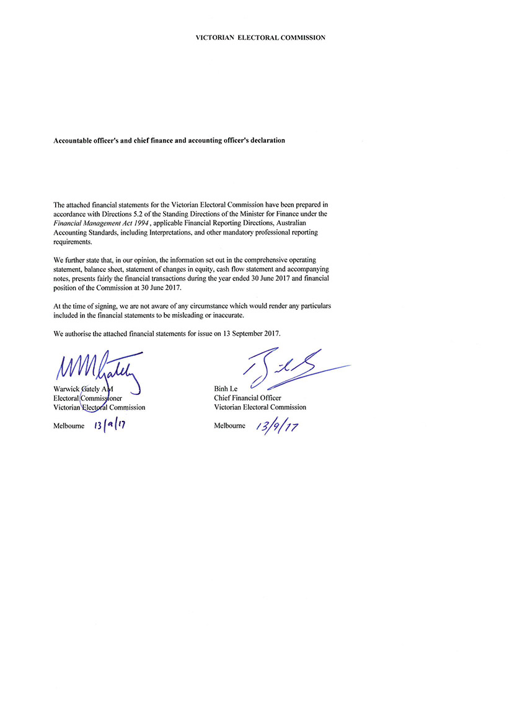

Auditor–General’s report

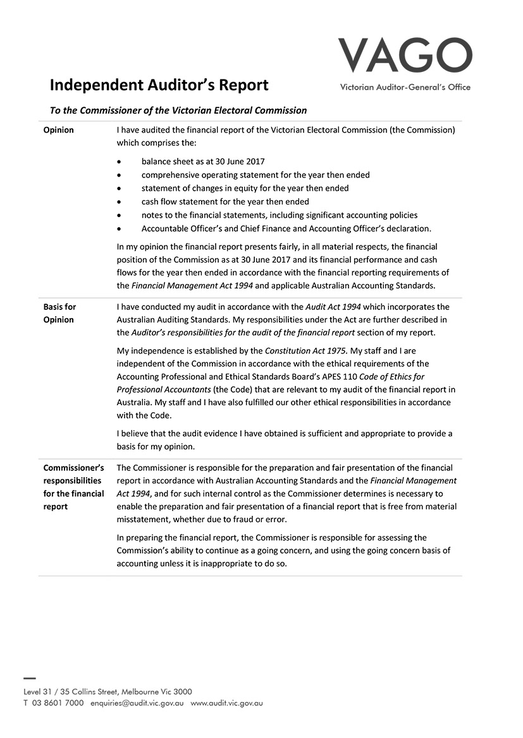

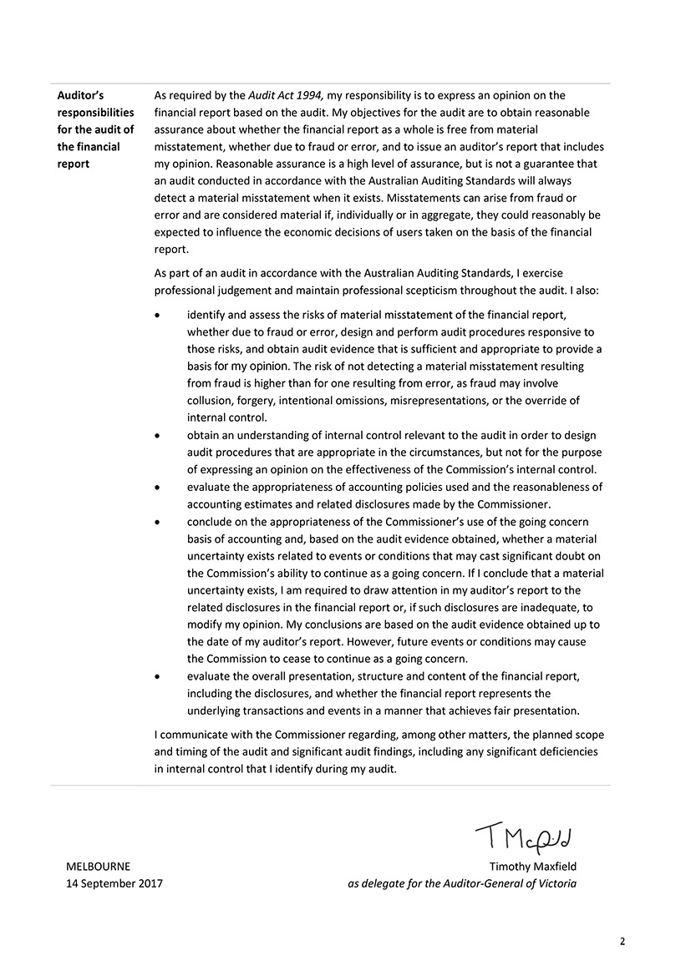

Appendices
Inside this section
Page 154

Appendix A: Disclosure Index
Page 157

Appendix B: Governing Legislation and Regulations
Page 158

Appendix C: Additional Information Available on Request
Page 158

Appendix D: Reporting Procedures under the Protected Disclosures Act 2012
Page 158

Appendix E: Making a Request under the Freedom of Information Act 1982
Page 160

Appendix F: Elections, By-elections, Countbacks and Polls, 2016–17
Page 161

Appendix G: Enforcement of Compulsory Voting, 2016–17
Page 162

Appendix H: Attestation for Compliance
Page 163

Appendix I: Registered Political Parties, 30 June 2017
Page 164

Appendix J: Elector Statistics by Region, 30 June 2017
Page 164

Appendix K: Elector Statistics by District, 30 June 2017
Page 168

Appendix L: Enrolment Transactions, 2012–13 to 2016–17
Page 169

Appendix M: Environmental Sustainability Report
Page 172

Appendix N: Report of the Electoral Boundaries Commission 2016–17

Appendix a: Disclosure index
Requirement
MINISTERIAL DIRECTIONS
Report of operations - FRD Guidance
Charter and purpose
FRD 22G | Manner of establishment and the relevant Ministers
FRD 22G | Purpose, functions, powers and duties
FRD 22G | Nature and range of services provided
Management and structure
FRD 22G | Organisational structure
Financial and other information
FRD 8D | Budget portfolio outcomes
FRD 10A | Disclosure index
FRD 12B | Disclosure of major contracts
FRD 15C | Executive Officer disclosures
FRD 22G | Comparative Workforce data
FRD 22G | Advertising disclosure
FRD 22G | Operational and budgetary objectives and performance against objectives
FRD 22G | Employment and conduct principles
FRD 22G | Occupational health and safety policy
FRD 22G | Summary of the financial results for the year
FRD 22G | Significant changes in financial position during the year
FRD 22G | Major changes or factors affecting performance
FRD 22G | Subsequent events
FRD 22G | Application and operation of Freedom of Information Act 1982
FRD 22G | Compliance with building and maintenance provisions of Building Act 1993
FRD 22G | Statement on National Competition Policy
FRD 22G | Application and operation of the Protected Disclosures Act 2012
FRD 22G | Application and operation of the Carers Recognition Act 2012
FRD 22G | Details of consultancies over $10,000
FRD 22G | Details of consultancies under $10,000
FRD 22G | Statement of availability of other information
FRD 24C | Reporting of office-based environmental impacts
FRD 25B | Victorian Industry Participation Policy disclosures
FRD 29A | Workforce Data disclosures
SD 3.4.11 | Managing gifts, benefits and hospitality
SD 4.5.5 | Risk management compliance attestation
SD 4.5.5.1 | Ministerial Standing Direction 4.5.5.1 insurance compliance attestation
SD 4.2(g) | Specific information requirements
SD 4.2(j) | Sign-off requirements
FINANCIAL REPORT
Financial statements required under Part 7 of the FMA
SD 4.2(a) | Statement of changes in equity
SD 4.2(b) | Operating statement
SD 4.2(b) | Balance sheet
SD 4.2(b) | Cash flow statement
Other requirements under Standing Directions 4.2
SD 4.2(c) | Compliance with Australian accounting standards and other authoritative pronouncements
SD 4.2(c) | Compliance with Ministerial Directions
SD 4.2(d) | Rounding of amounts
SD 4.2(c) | Accountable officer’s declaration
SD 4.2(f) | Compliance with Model Financial Report
Other disclosures as required by FRDs in notes to the financial statements
FRD 9A | Departmental disclosure of administered assets and liabilities by activity
FRD 11A | Disclosure of ex-gratia expenses
FRD 13 | Disclosure of parliamentary appropriations
FRD 21B | Disclosures of responsible persons, executive officers and other personnel (contractors with significant management responsibilities) in the Financial Report
FRD 102 | Inventories
FRD 103F | Non-financial physical assets
FRD 104 | Foreign currency
FRD 106A | Impairment of assets
FRD 109A | Intangible assets
FRD 110A | Cash flow statements
FRD 112D | Defined benefit superannuation obligations
FRD 114B | Financial Instruments - General Government Entities and public non-financial corporations

APPENDIX B: GOVERNING LEGISLATION AND REGULATIONS

LEGISLATION
- Agricultural Industry Development Act 1990
- Building Act 1993
- Charter of Human Rights and Responsibilities Act 2006
- City of Greater Geelong Act 1993
- City of Melbourne Act 2001
- Constitution Act 1975
- Electoral Act 2002
- Electoral Boundaries Commission Act 1982
- Equal Opportunity Act 2010
- Essential Services Act 1958
- Financial Management Act 1994
- Freedom of Information Act 1982
- Infringements Act 2006
- Juries Act 2000
- Legal Profession Act 2004
- Liquor Control Reform Act 1998
- Local Government Act 1989
- Monetary Units Act 2004
- Privacy and Data Protection Act 2014
- Protected Disclosure Act 2012
- Public Records Act 1973
- Shop Trading Reform Act 1996
  - Vital State Projects Act 1976

REGULATIONS
- Agricultural Industry Development (Polls) Regulations 2011
- City of Melbourne (Electoral) Regulations 2012
- Electoral Regulations 2012
- Infringements (General) Regulations 2006
- Infringements (Reporting and Prescribed Details and Forms) Regulations 2006
- Legal Profession (Board Election) Regulations 2006
- Liquor Control Reform Regulations 2009
  - Local Government (Electoral) Regulations 2016

APPENDIX C: ADDITIONAL INFORMATION AVAILABLE ON REQUEST
- Details of publications produced by the VEC about itself, and where these can be obtained
- Details of changes in prices, fees, charges, rates and levies charged by the VEC
- Details of any major external reviews carried out in respect of the operation of the VEC
- Details of major research and development activities undertaken by the VEC that are not otherwise covered in this report
- Details of overseas visits undertaken, including a summary of the objectives and outcomes of each visit
- Details of assessments and measures undertaken to improve the occupational health and safety of employees not otherwise detailed in this report
  - A general statement on industrial relations within the VEC and details of time lost through industrial accidents and disputes

APPENDIX D: REPORTING PROCEDURES UNDER THE PROTECTED DISCLOSURE ACT 2012
Disclosures of improper conduct or detrimental action by the Victorian Electoral Commissioner or another officer of the VEC must be made to the Independent Broad-based Anti-corruption Commission (IBAC).
Independent Broad-based Anti-corruption Commission
GPO Box 24234
Melbourne VIC 3001
Phone 1300 735 135

FURTHER INFORMATION
Written guidelines outlining the system for reporting disclosures of improper conduct or detrimental action by the VEC or its employees and the disclosure handling procedures are available from the VEC.

APPENDIX E: MAKING A REQUEST UNDER THE FREEDOM OF INFORMATION ACT 1982
Access to documents may be obtained through written request to the Freedom of Information (FOI) Officer, as detailed in s17 of the Freedom of Information Act 1982.
In summary, the requirements for making a request are:
- it should be in writing
- it should identify as clearly as possible which document is being requested and
  - it should be accompanied by the appropriate application fee (the fee may be waived in certain circumstances).
Requests for documents in the possession of the VEC should be lodged by email to foi@vec.vic.gov.au or by mail addressed to:
Freedom of Information Officer
Victorian Electoral Commission
Level 11, 530 Collins Street
Melbourne VIC 3000
Access charges may also apply once documents have been processed and a decision on access is made; for example, photocopying and search and retrieval charges.
Further information regarding Freedom of Information can be found at the Victorian Government Freedom of Information website (foi.vic.gov.au).

APPENDIX F: ELECTIONS, BY-ELECTIONS, COUNTBACKS AND POLLS, 2016–17
Election | Type | Election Date | Voting Method | Location | Voters
MAV Management Board, Rural North East Region By-election | Fee-for-service election | 04/08/2016 | Postal | VEC | 11
Murray Valley Wine Grape Industry Development Poll | Fee-for-service election | 23/09/2016 | Postal | VEC | 382
Central Highlands Water Enterprise Agreement | Fee-for-service election | 30/08/2016 | Postal | VEC | 191
Victorian Local Government General Elections 2016 | Municipal elections | 22/10/2016 | Attendance and postal | Victoria | 4.4M
Borough of Queenscliffe | Municipal countback | 21/11/2016 | N/A | Queenscliffe | N/A
AMES Australia Administrative Staff Agreement | Fee-for-service election | 15/12/2016 | Postal | VEC | 872
East Gippsland Shire Council | Municipal countback | 14/02/2017 | N/A | Bairnsdale | N/A
Victorian Canine Association Management Committee | Fee-for-service election | 01/03/2017 | Postal | VEC | 8,309
Casey City Council | Municipal countback | 03/04/2017 | N/A | Narre Warren | N/A
Whitehorse City Council | Municipal countback | 09/05/2017 | N/A | Nunawading | N/A
Public Transport Victoria Enterprise Agreement Ballot 2016 | Fee-for-service election | 06/07/2016 | Postal | VEC | 573
Framlingham Aboriginal Trust Committee of Management | Fee-for-service election | 25/7/16 | Attendance | Warrnambool | 21
Murray Valley Wine Grape Growers Industrial Development Order 2016 | Fee-for-service election | 23/9/16 | Postal | VEC | 381
Goldburn Valley Waste Resource Recovery Board Election | Fee-for-service election | 16/12/16 | Attendance | Shepparton | 6
Grampians Central West Water and Resource Recovery Board Election | Fee-for-service election | 10/2/17 | Attendance | Stawell | 12
Municipal Association Victoria Board Elections | Fee-for-service election | 3/3/17 | Postal | VEC | 76
Murphy's Wine Bar Liquor Licensing Poll | Fee-for-service election | 21/3/17 | Postal | VEC | 1,421

APPENDIX G: ENFORCEMENT OF COMPULSORY VOTING, 2016–17
Election | Notice Type* | Mailout Date | Records | Penalties COllected to 30 June 2017 | Infringement Court lodgement | no. of records
Camberwell LLP | 1 | 20-Apr-17 | 419 | N/A
Murphy’s Wine Bar | 2 | 31-May-17 | 157 | $2,106.00 | due to be lodged
21-Mar-17 | 3 |  |  | $0.00 | 30-Nov-17
2016 Local Government elections | 1 | 19-Jan-17 to 8-Feb-17 | 598,913 | N/A
76 Councils | 2 | 14-Mar-17 to 6-Apr-17 | 430,262 | $11,169,576.81 | due to be lodged
22-Oct-16 | 3 | 16-May-17 to 9-Jun-17 | 292,473 | $460,619.46 | 14-Sep-17 to 6-Oct-17
Campaspe | 1 | 24-Mar-16 | 419 | N/A
Western Ward by-election | 2 | 6-May-16 | 284 | $6,840.00
20-Feb-16 | 3 | 30-June-16 | 170 | $4,826.50 | 31-Aug-16 | 107
*1 - Apparent Failure to Vote
2 - Infringement
3 - Penalty Reminder

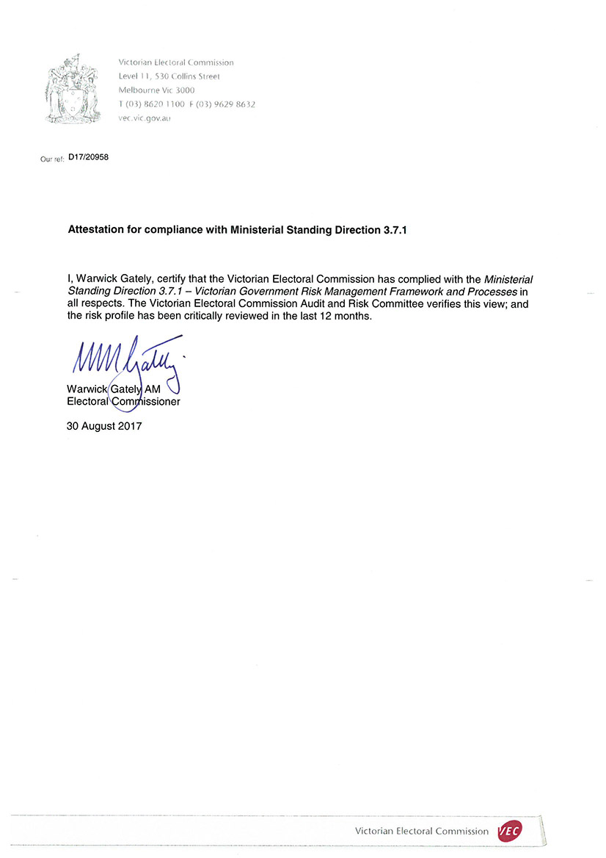
APPENDIX H: ATTESTATION FOR COMPLIANCE

APPENDIX I: REGISTERED POLITICAL PARTIES, 30 JUNE 2017
Political Party | Registered Officer | Address
Animal Justice Party | Ms Magda Wozny  Secretary | PO Box 6193  Vermont South Vic. 3133
Australian Christians | Mr Spero Katos  Secretary | 6 Sycamore Street  Caulfield South Vic. 3162
Australian Country Party | Mr Darren Cooper  Secretary | PO Box 108  Golden Square Vic. 3555
Australian Labor Party - Victorian Branch | Mr Samuel Rae  State Secretary | 438 Docklands Drive  Docklands Vic. 3008
Australian Sex Party - Victoria | Ms Ange Hopkins  Registered Officer | PO Box 113  Carlton Vic. 3053
Democratic Labour Party (DLP) | Mr Stephen Campbell  State Secretary | GPO Box 1402  Melbourne Vic. 3001
Liberal Democratic Party | Mr Tim Wilms  Treasurer | 21 Sandstone Island Circle  Bittern Vic. 3918
Liberal Party of Australia - Victorian Division | Mr Simon Frost  State Director | 104 Exhibition Street  Melbourne Vic. 3000
National Party of Australia – Victoria | Ms Sally Branson  State Director | Suite 908, Level 9,  343 Little Collins Street  Melbourne Vic. 3000
Shooters, Fishers and Farmers Party Victoria | Ms Nicole Bourman  Secretary | PO Box 92  Moorabbin Vic. 3189
Socialist Alliance (Victoria) | Ms Susanne Bolton  Registered Officer | PO Box 12427  A’Beckett Street Vic. 8006
The Australian Greens – Victoria | Mr Gurmeet Sekhon  Registered Officer | GPO Box 4589  Melbourne Vic. 3001
Voluntary Euthanasia Party (Victoria) | Ms Bertha Franklin  Secretary | PO Box 2106  Oak Park Vic. 3046
Vote 1 Local Jobs | Mr James Purcell  Leader | PO Box 46  Port Fairy Vic. 3284

APPENDIX J: ELECTOR STATISTICS BY REGION, 30 JUNE 2017
Below are the elector statistics by region for 2016–17.
Total number of electorates: 8
Total number of electors: 3,973,243
Average number of electors: 496,655
REGION | ELECTOR count | variance to average (%)
Eastern Metropolitan | 465,776 | -6.22
Eastern Victoria | 505,655 | 1.81
Northern Metropolitan | 509,549 | 2.60
Northern Victoria | 500,755 | 0.83
South-Eastern Metropolitan | 492,097 | -0.92
Southern Metropolitan | 477,635 | -3.83
Western Metropolitan | 521,945 | 5.09
Western Victoria | 499,831 | 0.64

APPENDIX K: ELECTOR STATISTICS BY DISTRICT, 30 JUNE 2017
Below are the elector statistics by district for 2016–17.
Total number of electorates: 88
Total number of electors: 3,973,243
Average number of electors: 45,150
area name | elector count | variance to average (%)
Albert Park | 46,305 | 2.56
Altona | 52,194 | 15.60
Bass | 50,872 | 12.67
Bayswater | 43,152 | -4.43
Bellarine | 46,293 | 2.53
Benambra | 46,228 | 2.39
Bendigo East | 46,296 | 2.54
Bendigo West | 43,600 | -3.43
Bentleigh | 41,580 | -7.91
Box Hill | 43,450 | -3.77
Brighton | 44,197 | -2.11
Broadmeadows | 42,247 | -6.43
Brunswick | 50,042 | 10.83
Bulleen | 43,503 | -3.65
Bundoora | 40,093 | -11.20
Buninyong | 43,042 | -4.67
Burwood | 42,261 | -6.40
Carrum | 46,632 | 3.28
Caulfield | 43,599 | -3.44
Clarinda | 44,052 | -2.43
Cranbourne | 55,820 | 23.63
Croydon | 42,197 | -6.54
Dandenong | 41,556 | -7.96
Eildon | 43,288 | -4.12
Eltham | 44,417 | -1.62
Essendon | 46,332 | 2.62
Euroa | 47,322 | 4.81
Evelyn | 41,734 | -7.57
Ferntree Gully | 40,518 | -10.26
Footscray | 48,925 | 8.36
Forest Hill | 40,144 | -11.09
Frankston | 42,807 | -5.19
Geelong | 45,911 | 1.69
Gembrook | 47,154 | 4.44
Gippsland East | 44,483 | -1.48
Gippsland South | 40,969 | -9.26
Hastings | 49,378 | 9.36
Hawthorn | 43,528 | -3.59
Ivanhoe | 45,379 | 0.51
Kew | 43,619 | -3.39
Keysborough | 44,156 | -2.20
Kororoit | 49,021 | 8.57
Lara | 44,793 | -0.79
Lowan | 42,606 | -5.63
Macedon | 43,520 | -3.61
Malvern | 41,188 | -8.78
Melbourne | 47,441 | 5.07
Melton | 49,469 | 9.57
Mildura | 42,866 | -5.06
Mill Park | 45,294 | 0.32
Monbulk | 42,451 | -5.98
Mordialloc | 44,809 | -0.76
Mornington | 45,533 | 0.85
Morwell | 46,318 | 2.59
Mount Waverley | 39,052 | -13.51
Mulgrave | 40,555 | -10.18
Murray Plains | 45,722 | 1.27
Narracan | 49,234 | 9.05
Narre Warren North | 44,089 | -2.35
Narre Warren South | 48,384 | 7.16
Nepean | 47,529 | 5.27
Niddrie | 43,812 | -2.96
Northcote | 46,692 | 3.42
Oakleigh | 40,383 | -10.56
Ovens Valley | 41,981 | -7.02
Pascoe Vale | 48,208 | 6.77
Polwarth | 44,335 | -1.81
Prahran | 47,483 | 5.17
Preston | 43,467 | -3.73
Richmond | 51,239 | 13.49
Ringwood | 40,908 | -9.40
Ripon | 46,203 | 2.33
Rowville | 39,237 | -13.10
Sandringham | 43,492 | -3.67
Shepparton | 46,945 | 3.98
South Barwon | 49,809 | 10.32
South-West Coast | 45,829 | 1.50
St Albans | 46,189 | 2.30
Sunbury | 43,483 | -3.69
Sydenham | 48,733 | 7.94
Tarneit | 50,473 | 11.79
Thomastown | 42,989 | -4.79
Warrandyte | 43,056 | -4.64
Wendouree | 41,541 | -7.99
Werribee | 43,946 | -2.67
Williamstown | 48,837 | 8.17
Yan Yean | 52,987 | 17.36
Yuroke | 51,837 | 14.81

APPENDIX L: ENROLMENT TRANSACTIONS, 2012–13 TO 2016–17
VEC ENROLMENT TRANSACTIONS¹ | 2012–13 | 2013–14 | 2014–15 | 2015-2016 | 2016–17
State direct enrolment activity | 112,499 | 246,362 | 257,972 | 191,849 | 131,030
VEC online enrolment | - | - | 41,262 | 11,138 | 19,614
VEC enrolment forms received | 79,915 | 40,892 | 90,781 | 31,339 | 19,936
Total enrolment transactions through VEC’s enrolment programs | 192,414 | 287,254 | 390,015 | 234,326 | 170,580

ENROLMENT APPLICATION TRANSACTIONS PROVIDED BY THE AEC AND IMPORTED  INTO VICTORIAN REGISTER OF ELECTORS | 2012–13 | 2013–14 | 2014–15 | 2015-2016 | 2016–17
Additions
New to roll | 115,729 | 130,931 | 102,224 | 129,296 | 82,861
Reinstatements | 79,416 | 67,246 | 51,311 | 41,927 | 36,254
Subtotal | 195,145 | 198,177 | 153,535 | 171,223 | 119,115
Changes
Change of address | 409,062 | 558,763 | 478,409 | 518,439 | 484,617
Total AEC Import Transactions | 604,207 | 756,940 | 631,944 | 689,662 | 603,732
Total VEC Sourced Transactions | 192,414 | 287,254 | 390,015 | 234,326 | 170,580
Total collected through AEC’s enrolment programs | 411,793 | 469,686 | 241,929 | 455,336 | 433,152
VEC sourced enrolments as a percentage of the total | 31.85% | 37.95% | 61.72% | 33.98% | 28.55%

OTHER ENROLMENT-RELATED TRANSACTIONS² | 2012–13 | 2013–14 | 2014–15 | 2015-2016 | 2016–17
Special category applications | 3,429 | 1,297 | 4,026 | 2,135 | 3,625
Non-application changes | 106,348 | 13,469 | 57,836 | 6,269 | 1,345
Subtotal | 109,777 | 14,766 | 61,862 | 8,404 | 4,970
TOTAL VEC enrolment transactions | 302,191 | 302,020 | 451,877 | 242,730 | 175,550
¹ The VEC undertakes direct enrolment using a number of data sources, including VicRoads and the AEC. This allows the VEC to both update details and enrol electors for the first time without requiring a form to be completed. Where the VEC is unable to verify a person’s eligibility to enrol, a paper form is sent to them. Electors may enrol for the first time, or update their enrolment details using the VEC Online Enrolment Service. However, when an elector prefers to use a paper form, they are able to do so and can access forms from a number of sources including Australia Post Offices, the VEC website and council offices. In addition, the VEC provides forms to all students as they turn 17, using data received from the Victorian Curriculum and Assessment Authority so that they may provisionally enrol.
² Special category applications received by the VEC include: applications to become General Postal Voters (GPV), Silent Electors, Itinerant or Eligible Overseas Electors. Some of these transactions are processed by the VEC and some are passed to the AEC for completion under the Commonwealth Electoral Act. Non-application changes include administrative changes made to ensure the integrity and accuracy of the electoral register and the processing of return to sender mail.

APPENDIX M:
ENVIRONMENTAL SUSTAINABILITY REPORT
Now in its ninth year, the VEC's Resource Smart Committee (RSC) continued in its role of exploring and overseeing environmental efficiency gains, reducing resource consumption, and making improvements in waste management.
During the year, RSC members delivered a calendar of events to take place at the VEC that continues to keep sustainable thinking in staff minds.
The RSC continued to use the special branded “GreenFlash” email to promote ideas across the organisation, though part-way through the year new branding with a more modern look and feel was introduced.
Throughout the year, the RSC also continued to present short humorous presentations at staff meetings and are regular presenters at each meeting.
February 2017 was branded the ‘Shoe-a-day’ month where staff were asked to wear (as far as possible) a different pair of shoes each day with the goal being that any shoes in good condition but no longer wanted by staff could be donated to a good cause. Clothing and accessories were also welcome during this time. In early March, 30 pairs of shoes were among the items donated to Wear for Success, an organisation that helps people getting back into the workplace.
In June 2017, the RSC hosted a Market Day event, where staff were invited to bring their unwanted household goods, books, clothes, etc, and others had the opportunity to purchase these items for a gold coin donation. The funds raised from this event went to Melbourne City Mission, who supports some of Victoria’s most vulnerable individuals, families and communities. The Market Day was a resounding success and the total raised from this event was $500. Leftover items that were not sold on the day were donated to the Salvation Army.
The RSC continued with the highly successful system for collecting soft-plastic bags via custom bins in all head office staff kitchens, capturing them before land fill and returning them to the recycling chain.
The VEC continues to make environmentally sustainable changes across all operations. A full review of resources dispatched during September 2016 was reviewed in the lead up to the Local Government elections; this resulted in a massive reduction in the amount of paper products used during this time. Work is currently underway to replace around 100 multi-function devices used during electoral events as they come to their end-of-life. They are being replaced with more efficient, environmentally friendly devices.
Market Day event at the VEC.

During the next 12 months the Resource Smart team will be promoting:
- Plant a Tree Day – an opportunity for VEC staff members to take part in tree planting across Victoria.
- Run 2 Mend Minds – a major fundraising event for the Monash Alfred Psychiatry Research Centre (MAPrc)
- Less Meat – Less Heat – that aims to reduce the consumption of meat most damaging to the climate.
  - Terrarium Workshop – encouraging staff to re-use glass jars and bring cuttings of their plants to create terrariums for their workspaces.
As an organisation with a focus on openness to innovative ideas, the VEC continues to seek ways to achieve environmental sustainability and drive efficiency.

The results of initiatives reported in the previous annual report are as follows:
initiative | Outcome
A review of resource requirements for the October 2016 Local Government elections has identified an almost 50% reduction in the number of reams of paper that will be purchased, distributed and used during the elections. | Achieved.
The work of the VEC’s RSC, its goals and its achievements as well as the VEC policies toward the environment will be made part of the new employee induction process. New employees will be provided with a kit containing information regarding the VEC’s sustainability activities and a Resource Smart branded keep cup. | In-progress. To be included in new ‘on-boarding’ package for new starters. Approximately 100 casual staff currently working at VEC were provided with a keep cup.
A clothing drive where staff members can recycle office wear in good condition to be donated to groups working with people returning to the workforce who may not be financially able to purchase office wear. | Successfully achieved – hence the follow up ‘Shoe-a-day’ month.
Work continues to provide staff with a sustainability dashboard giving paper use, logistic impact, water, power and other consumables with graphs and trends. Staff will be encouraged to review this and suggest new ways RSC can improve VEC’s sustainability. | In-progress. While the VEC is undergoing a review of the current intranet system, the RSC is working on updating an interim portal through which staff can access information and updates on RSC activities.

APPENDIX N:
REPORT OF THE ELECTORAL BOUNDARIES COMMISSION, 2016–17
The Electoral Boundaries Commission (EBC) is constituted under the Electoral Boundaries Commission Act 1982 (the Act). The EBC must establish and maintain electorates of approximately equal enrolment (that is, not varying by more than 10% from the average for each House of Parliament) for the conduct of parliamentary elections.
The members of the EBC during 2016–17 were:
- the Honourable Justice Peter Kidd, Chief Judge of the County Court of Victoria (Chairman)
- Mr Warwick Gately AM, Electoral Commissioner and
  - Mr John Tulloch, Surveyor-General (Mr Tulloch retired in May 2017, and Mr David Boyle, the Acting Surveyor‑General, filled his place.)
The VEC provides administrative and technical support to the EBC and Dr Paul Thornton-Smith of the VEC is the secretary.
Section 8 of the Act requires the EBC to meet no more than two years after the State election of 29 November 2014. The EBC’s meeting on 10 November 2016 complied with this requirement, and was also an opportunity to consider whether a redivision of electoral boundaries would be required before the 2018 State election. Section 5 of the Act provides that a redivision must be held if, during the relevant period of 18-24 months before the next State election, enrolments for a sufficient number of electorates have diverged by more than 10% from the State average for at least two months.
As at 10 November 2016, prior to the start of the relevant period, only 10 districts (Legislative Assembly electorates) were more than 10% outside the average – well short of the legislated trigger point of 27 districts.
When the EBC met again on 5 June 2017, just after the end of the relevant period, 13 districts had been more than 10% outside the average for more than two months, and one of these districts was more than 20% outside the average. These numbers did not meet the conditions for a redivision.
Consequently, the EBC determined that there would be no redivision before the 2018 State election. The next redivision will take place before the 2022 State election, in accordance with the provision that a redivision must take place after every two general elections. The EBC disseminated this information to members of Parliament, the registered political parties and the media.

GLOSSARY

Attendance election
In an attendance election most voting is conducted at voting centres on election day, although voters may vote at early voting centres or by postal vote.

Ballot
A method of secret voting.

By-election
A by-election is an election in a single-member electorate to fill a casual vacancy caused by the departure of a sitting Member of Parliament or Local Government councillor before the term expires. A by-election may also be held in a multi-member electorate when no unsuccessful candidates remain for a countback.

Candidate
A candidate is an eligible elector who nominates for election.

Community of interest
The VEC defines a community of interest as a group of people who share a range of common concerns or aspirations. A community of interest may occur where people are linked with each other geographically (e.g. a town or valley) or economically, such as where people work in similar industries (e.g. tourism) or where people work in mutually-dependent industries (e.g. fruit growers, transporters and canners).
A community of interest may also appear where people share a number of special needs because of similar circumstances (such as new immigrants who may have little English, require assistance with housing or need help finding employment).

Compulsory enrolment
All Australian citizens 18 years and over are required by law to enrol.

Compulsory voting
All enrolled electors must vote at State elections. With some exceptions, enrolled voters must vote at Local Government elections.

Contested election
A contested election is an election where more candidates than the number of vacancies for the election have nominated by the close of nominations.

Continuous Roll Update (CRU)
The CRU process consists of a range of strategies to ensure that the electoral roll is continuously kept up-to-date by using internal and external data to direct roll review activities to targeted people and residences.

Councillor
An elected representative on a Local Government council.

Countback
Method of filling extraordinary vacancies in multi-member wards and unsubdivided municipalities in electorates where general election results were obtained using the proportional representation method. The votes of the vacating councillor are transferred to the previously unelected candidates to fill the vacancy.

District
One of the 88 Legislative Assembly electorates in Victoria. Each District elects one member and comprises approximately 45,000 electors.

Election
An event at which electors choose their representatives.

Election date
The legislated date of the election.

Election Manager
A person appointed by the Electoral Commissioner to conduct an election for an electoral district or region.

Elector
A person whose name appears on the register of electors and who is entitled to vote in elections.

Electoral Commissioner
The statutory officer appointed by the Governor-in-Council with responsibility for the proper conduct of parliamentary and statutory elections.

Electoral Matters Committee (EMC)
The EMC comprises seven Members of Parliament drawn from both Houses and is a Joint Investigatory Committee of the Parliament of Victoria. Its powers and responsibilities are determined by the Parliamentary Committees Act 2003. The EMC inquiries into, considers and reports to the Parliament on any proposal, matter or thing concerned with the conduct of parliamentary elections and referendums in Victoria, the conduct of elections of councillors under the Local Government Act 1989 and the administration of, or practices associated with, the Electoral Act 2002 and any other law relating to electoral matters.

Electoral roll
A list of names of all the people who are entitled to vote in an election under relevant legislation.

Electronically Assisted Voting
A method of casting a vote under legislation by electors who are blind or have low vision, are not literate in English, have a motor impairment or are located interstate or overseas.

Enrolment
The placement of a person’s name and address on the Register of Electors. A person cannot vote at an election unless they are enrolled.

Enrolment information
The information about electors that is held by the VEC.

Entitlement date
To be eligible to vote at a Local Government election, people must be on the State or Local Government voters roll 57 days before election day. This is called the ‘entitlement date’.

Geo-coding
Geo-coding is the process of assigning geographic identifiers (e.g. codes or geographic coordinates expressed as latitude-longitude) to map features and other data records, such as street addresses.

Informal vote
A ballot paper that is either left blank or is incorrectly marked. These ballot papers do not contribute to the election of a candidate.

Legislative Assembly (Lower House)
One of the two Houses in the Victorian State Parliament. There are 88 Members of the Legislative Assembly (MLAs), one from each electoral district. The party or coalition of parties that wins majority support in this House forms the Government.

Legislative Council (Upper House)
One of the two Houses in the Victorian State Parliament. There are 40 Members of the Legislative Council (MLCs), five from each region. The Legislative Council is often referred to as the ‘House of review’.

Lost Time Injury (LTI)
An LTI is an occupational injury or illness that results in days away from work on any rostered shift subsequent to that on which the injury occurred. A fatality is also recorded as an LTI.

Marginal costs
Marginal costs include direct labour and associated on-costs, materials, equipment, mail processing, postage, advertising, printing, rent, utilities, insurance, IT equipment and software licences purchased especially for the specific activity.

Postal election
In an all-postal election, voting papers are posted to voters by the Returning Officer. A vote is cast by completing a ballot paper and returning it to the Returning Officer in the reply-paid envelope provided.

Preferential voting
A vote for all candidates in order of preference. If no candidate has an absolute majority of first preference votes, preferences are distributed until one candidate has an absolute majority.

Proportional representation
A system of voting designed to elect representatives in proportion to the amount of support each has in the electorate.

Redivision
The redrawing of electoral boundaries to ensure that there are, as near as possible, equal numbers of voters in each electorate within Victoria.

Region
One of the eight Legislative Council electorates. Each region comprises approximately 496,000 electors and elects five Members.

Register of Electors
The VEC’s database of all Victorian electors.

Registered Political Party (RPP)
A political party that is registered under the Electoral Act 2002. A registered party must have at least 500 members who are Victorian electors and not members of another registered political party.

Resource Smart Committee (RSC)
Comprising a representative from each branch of the VEC and a member of the VEC Management Group, the ResourceSmart Committee oversees the implementation of the VEC’s Environmental Management Plan.

Senior Election Official
A trained election official who may be appointed to act as an Election Manager for a parliamentary election. Senior Election Officials may also be appointed to act as Returning Officers or Deputy Returning Officers for a Local Government election.

Victorian Electoral Commission (VEC)
The VEC is the independent statutory body that conducts State elections and certain statutory elections. The VEC conducts Local Government elections, and commercial and community elections. The VEC also conducts boundary reviews and electoral research, maintains the Victorian electoral enrolment register and provides education and inclusion services.

Voter
An elector who votes in an election.

Voting centre
A place at which electors can vote in an election. There are three types of voting centres that operate in State elections: early voting centres, mobile voting centres and election day voting centres.

INDEX

#
2016 Local Government elections
A
Aboriginal and Torres Strait Islander Advisory Group
Aboriginal and Torres Strait Islander Communities
About the VEC
About This Report
Accountability and Transparency
Accountable officer's and chief finance and accounting officer's declaration
Additional information available on request
Additional information available on request, list
Administrative services
Advertising disclosure
Annual advisory group surveys
Appendices
Arragements with other electoral agencies
Assets, what the VEC owns
Attestation for compliance
Attestation, Public Sector Standards Commissioner
Audit and Risk Committee
Auditor-General’s report
B
Balance Sheet
Building Act 1993, compliance
By-elections and countbacks, Local Government
C
Cash Flow Statement
Changes to registrations
Code of Conduct - VEC values
Communication and awareness campaign - 2016 Local Government elections
Communication and engagement branch
Comparative workforce data
Complaints
Comprehensive Operating Statement
Consultancies over $10,000
Consultancies under $10,000
Contents
Consultancies and contracts
Continuous improvement
Core business, VEC
Corporate planning
Corporate reporting
Culturally and linguistically diverse (CALD) communities
Culturally and Linguistically Diverse Advisory Group (CALD)
Customer service charter
D
Deputy Electoral Commissioner profile
Development Project Board
Digital and Online Governance Committee
Digital and online research and strategy cevelopment
Digital communication service
Direct enrolment research
Disability Act 2006, Compliance
Disclosure index, disclosures
Disclosure Index, appendices
Disclosures
Discretionary provision of enrolment information
E
Election administration
Election services
Election staffing
Elections Branch
Elections, by-elections, countbacks and polls, 2015–16
Elector statistics, District
Elector statistics, Region
Electoral Access Advisory Group
Electoral activity
Electoral Boundaries Commission (EBC)
Electoral Commissioner, profile
Electoral Council of Australia and New Zealand (ECANZ)
Electoral Enrolment Branch
Electoral Matters Committee (EMC)
Electoral Regulation Research network ( ERRN)
Electoral representation and subdivision reviews
Electronic/Internet voting
Employment and conduct principles
Employment diversity and inclusion
EMS redevelopment steering committee
Enforcement of compulsory voting
Enforcement of compulsory voting, appendices
Engagement continuing
Enrolment
Enrolment programs
Enrolment transactions, summary
Environmental performance
Environmental sustainability report
Equity, what the VEC is worth
Executive Management Group
Executive officer disclosure
Expenditure
Expenses, how the VEC's funding is utilised
External Advisory Groups
F
Finance at a glance
Finance branch
Financial management
Financial management compliance framework
Financial performance
Financial position
Financial report
Financial statements
First strategic intent
Flexible work arrangements
Freedom of Information
Freedom of Information, request procedures
Funding
Funding flucuations
G
Gifts, Benefits and Hospitality Register
Glossary
Governance
Governing legislation and regulations, list
Governing Legislation and Tribunals
Grants and Transfer Payments, disclosure
H
Hazards, incidents and injuries
History and Functions, VEC
Homelessness Advisory Group
Human resource management
Human resource management, disclosures
Human resources
I
Identifying and managing risk
Inclusion and Participation
Index
Index of Notes to the financial statements
Information and records management
Information privacy
Information Technology Branch
Interaction with electoral bodies
Internal audit
Internal committees and groups
L
Legislation
Legislative and regulatory amendments
Letter of transmittal
Liabilities, what the VEC owes
Local Government by-elections and countbacks
Local Government election costs
Lodgement with the courts, compulsory voting
Looking ahead
M
Mandatory provision of enrolment information
Municipal Electoral Tribunal (MET)
N
National Competition Policy
New applications for registration
O
Occupational health and safety
Occupational Health and Safety Committee
Organisational structure
Other elections and polls
Other interactions
Our Commission
Our Core Business
Our Highlights
Our most valuable resource
Our People
Our people, our year
Our Stakeholders
Our Year, message from the Electoral Commissioner
P
Pecuniary interest declaration
People and partners, VEC
People experiencing homelessness
People living with a disability
Planning Group, The
Preparing for the 2017 Greater Geelong City Council general election
Preparing for the 2018 State election
Prisoner education program
Progress report on initiatives 2016–17 and focus 2017–18
Project Governance Committee
Protected Disclosure Act 2012, reporting procedures
Protected Disclosures Act 2012
Provision of enrolment information
Purpose, VEC
R
Raising issues
Re-registration of registered political parties
Reconciliation action plan, VEC
Recruitment and turnover
Register of electors
Register of political parties
Registered political parties, list
Report of the Electoral Boundaries Commission
Research and Development
Research into best practice inclusion for people with intellectual disability
Resource Smart Committee
S
Second strategic intent
Services to Political Parties
Significant event management
Staff engagement
Staff feedback
Staff Profile
Staff well-being services
Staffing for the 2016 Local Government election
State by-elections
Statement of Changes in Equity
Strategic Initiatives
Strategic Plan
Success in planning
T
Technology demands organisational change
Third strategic intent
V
Values, VEC
Victorian Civil and Administrative Tribunal (VCAT)
Victorian Industry participation policy
Vision, VEC
Voter's Voice
W
Warehouse
Y
Young people

Feedback on this report is welcome.
Please mark to the attention of:
Executive Services
Victorian Electoral Commission
Level 11, 530 Collins Street
Melbourne VIC 3000
Phone: (03) 8620 1100
Email: info@vec.vic.gov.au

Australasian Reporting Awards
2015–16 Gold
2014–15 Gold
2013–14 Gold
2012–13 Gold
2011–12 Gold
2010–11 Silver
2009–10 Gold
2008–09 Silver

Creative
This report was designed and produced by Cordial Creative www.cordialcreative.com

© State of Victoria
(Victorian Electoral Commission)
October 2017
This work, the VEC 2016–17 Annual Report, is licensed under a Creative Commons Attribution 4.0 licence (http://creativecommons.org/licenses/by/4.0/). You are free to re-use the work under that licence, on the condition that you credit the State of Victoria (Victorian Electoral Commission) as author, indicate if changes were made and comply with the other licence terms. The licence does not apply to any branding, including government logos.

Figure does not include casual staff
Figure does not include casual staff or members of the public
Figure includes casual election staff

