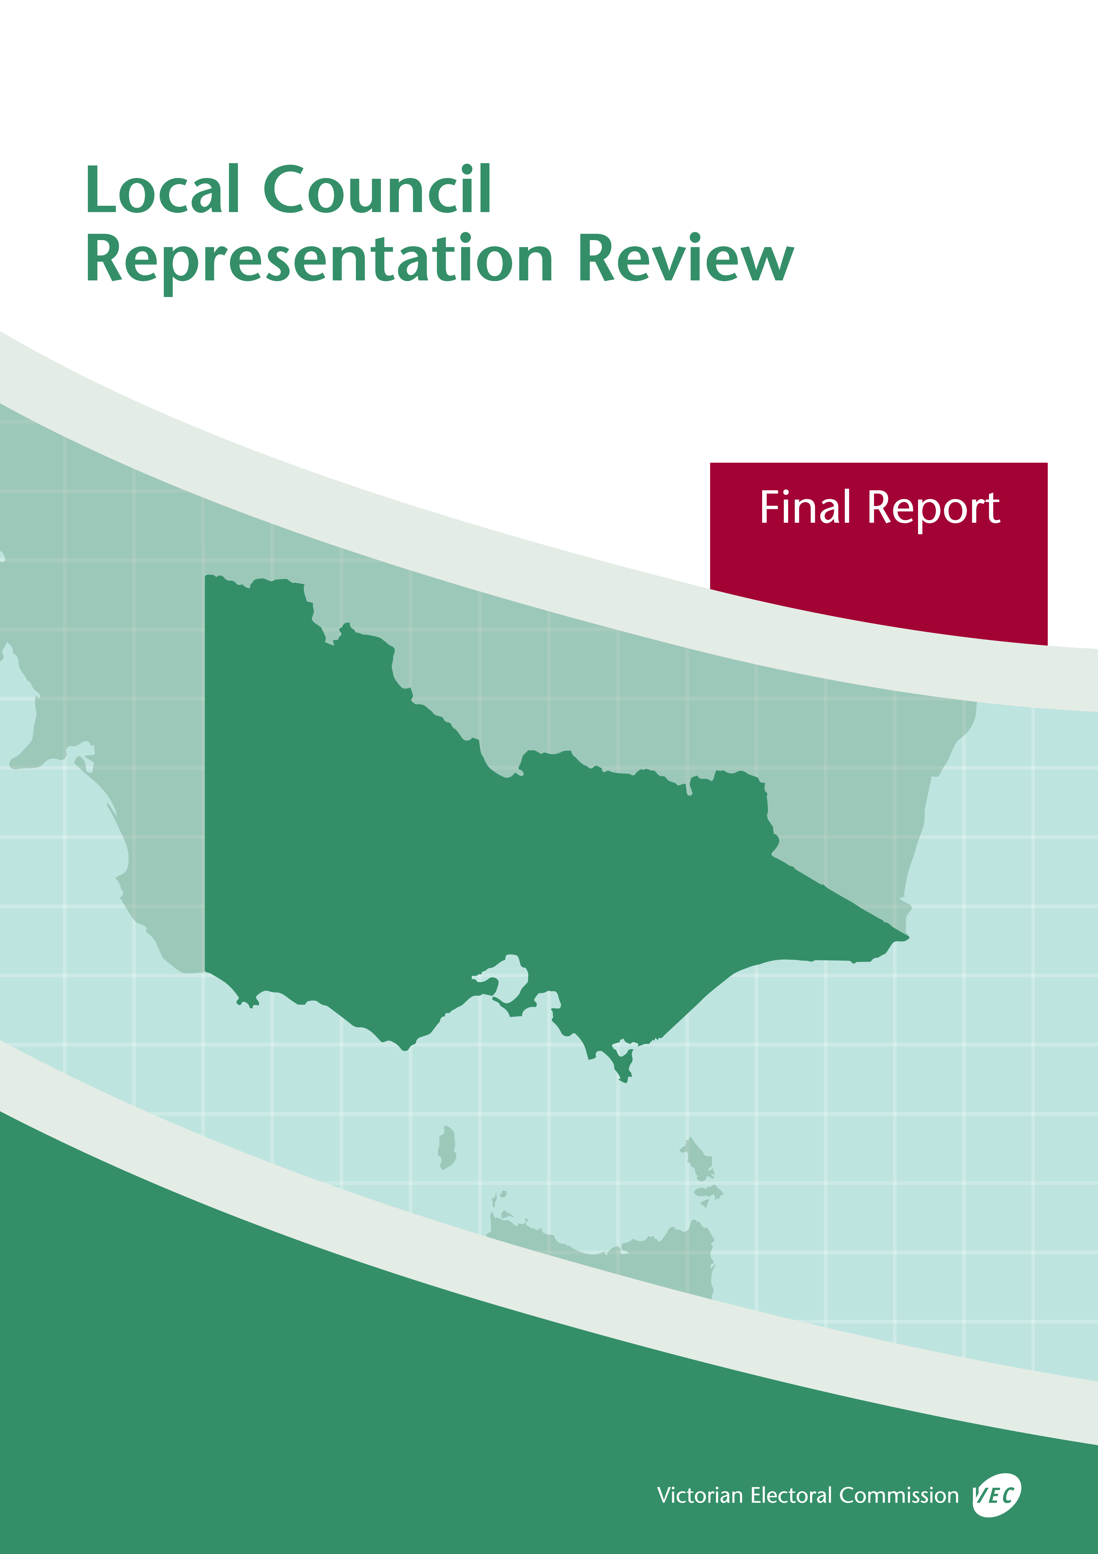

**October 2019**

**Manningham   
City Council**

© State of Victoria (Victorian Electoral Commission)   
Wednesday 16 October 2019

Version 1



This work, Local Council Representation Review Final Report – Manningham City Council, is licensed under a Creative Commons Attribution 4.0 licence [<http://creativecommons.org/licenses/by/4.0/>]. You are free to share this work under that licence, on the condition that you do not change any content and you credit the State of Victoria (Victorian Electoral Commission) as author and comply with the other licence terms. The licence does not apply to any branding, including Government logos.

Contents

Recommendation 1

Executive summary 2

Legislative basis 4

Public engagement 4

The VEC’s principles 5

Developing recommendations 6

Manningham City Council representation review 8

Profile of Manningham City Council 8

Current electoral structure 9

Preliminary submissions 10

Preliminary report 11

Public response 15

Response submissions 15

Public hearing 16

Findings and recommendation 18

The VEC’s findings 18

The VEC’s recommendation 19

Appendix 1: Public involvement 20

Appendix 2: Map 21

Appendix 3: Public information program 23

Recommendation

The Victorian Electoral Commission recommends that Manningham City Council consist of nine councillors elected from three three-councillor wards, with adjustments to the current ward boundaries.

This recommendation is submitted to the Minister for Local Government as required by the *Local Government Act 1989*.

Please see Appendix 2 for a detailed map of this recommended structure.

Executive summary

The *Local Government Act 1989* (the Act) requires the Victorian Electoral Commission (VEC) to conduct an electoral representation review of each municipality in Victoria before every third council general election.

The purpose of an electoral representation review is to recommend an electoral structure that provides ‘fair and equitable representation for the persons who are entitled to vote at a general election of the Council.’[1] The matters considered by a review are:

* the number of councillors
* the electoral structure of the council (whether the council should be unsubdivided or divided into wards and, if subdivided, the details of the ward boundaries and the number of councillors per ward).

The VEC conducts all reviews based on three main principles:

1. taking a consistent, State-wide approach to the total number of councillors
2. if subdivided, ensuring the number of voters represented by each councillor is within   
   plus-or-minus 10% of the average number of voters per councillor for that local   
   council
3. ensuring communities of interest are as fairly represented as possible.

Current electoral structure

Manningham City Council currently comprises nine councillors elected from three three-councillor wards. More information on Manningham City Council and the current electoral structure is available in the council fact sheet on the VEC website at [vec.vic.gov.au](http://vec.vic.gov.au).

Prior to the last representation review in 2007, Manningham City Council was comprised of eight councillors elected from four two-councillor wards. Visit the VEC website at [vec.vic.gov.au](http://www.vec.vic.gov.au/) to access a copy of the 2007 review final report.

Preliminary submissions

Preliminary submissions opened at the commencement of the current review on Wednesday   
26 June 2019. The VEC received six submissions for the representation review of Manningham City Council by the deadline at 5.00 pm on Wednesday 24 July 2019.

Preliminary report

A preliminary report was released on Wednesday 21 August 2019 with the following options for consideration:

* Option A (preferred option)  
  **Manningham City Council consist of nine councillors elected from three three-councillor wards, with adjustments to the current ward boundaries.**
* Option B (alternative option)  
  **Manningham City Council consist of nine councillors elected from three three-councillor wards, with adjustments to the current ward boundaries different to Option A.**

Response submissions

The VEC received five submissions responding to the preliminary report by the deadline at   
5.00 pm on Wednesday 18 September 2019.

Public hearing

The VEC conducted a public hearing for those wishing to speak about their response submission at 7.00 pm on Monday 23 September 2019. One person spoke at the hearing.

Recommendation

**The Victorian Electoral Commission recommends that Manningham City Council consist of nine councillors elected from three three-councillor wards, with adjustments to the current ward boundaries.**

This electoral structure was designated as Option A in the preliminary report. Please see Appendix 2 for a detailed map of this recommended structure.

Background

Legislative basis

The Act requires the VEC to conduct a representation review of each local council in Victoria before every third general council election, or earlier if gazetted by the Minister for Local Government.

The Act states that the purpose of a representation review is to recommend the number of councillors and the electoral structure that provides ‘fair and equitable representation for the persons who are entitled to vote at a general election of the Council.’[2]

The Act requires the VEC to consider:

* the number of councillors in a local council
* whether a local council should be unsubdivided or subdivided.

If a local council is subdivided, the VEC must ensure that the number of voters represented by each councillor is within plus-or-minus 10% of the average number of voters per councillor for that local council.[3] On this basis, the review must consider the:

* number of wards
* ward boundaries
* number of councillors that should be elected for each ward.

Public engagement

### Public information program

The VEC conducted a public information program to inform the community of the representation review, including:

* public notices printed in local and State-wide papers
* a public information session to outline the review process and respond to questions from the community
* a media release announcing the commencement of the review and the release of the preliminary report
* a submission guide to explain the review process and provide background information on the scope of the review
* an information email campaign targeted at known community groups and communities of interest in the local council area
* sponsored social media advertising geo-targeted to users within the local council   
  area
* ongoing information updates and publication of submissions on the VEC website.

More information on the VEC’s public information program for the representation review of Manningham City Council can be found at Appendix 3.

### Public consultation

Public input was accepted by the VEC via:

* preliminary submissions at the start of the review
* response submissions to the preliminary report
* a public hearing that provided an opportunity for people who had made a response submission to expand on their submission.

Public submissions are an important part of the review process but are not the only consideration. The VEC ensures its recommendations comply with the Act and are formed through careful consideration of public submissions, independent research, and analysis of all relevant factors.

The VEC’s principles

Three main principles underlie all the VEC’s work on representation reviews:

1. **Taking a consistent, State-wide approach to the total number of councillors.**

The VEC is guided by its comparisons of local councils of a similar size and category to the council under review. The VEC also considers any special circumstances that may warrant the local council having more or fewer councillors than similar local councils.

1. **If subdivided, ensuring the number of voters represented by each councillor is within plus-or-minus 10% of the average number of voters per councillor for that local council.**

This is the principle of ‘one vote, one value’, which is enshrined in the Act. This means that every person’s vote counts equally.

1. **Ensuring communities of interest are as fairly represented as possible.**

Each local council contains a number of communities of interest. Where practicable, the electoral structure should be designed to ensure they are fairly represented, and that geographic communities of interest are not split by ward boundaries. This allows elected councillors to be more effective representatives of the people and interests in their particular local council or ward.

Developing recommendations

The VEC bases its recommendations for particular electoral structures on the following information:

* internal research specifically relating to the local council under review, including data from the Australian Bureau of Statistics and .id[4]; voter statistics from the Victorian electoral roll; and other State and local government data sets
* small area forecasts provided by .id for relevant local council areas
* the VEC’s experience conducting previous electoral representation reviews of local councils and similar reviews for State elections
* the VEC’s expertise in mapping, demography and local government
* careful consideration of all input from the public in written submissions received during the review and via oral submissions at the public hearing
* advice from consultants with extensive experience in local government.

### Deciding on the number of councillors

The Act allows for a local council to have between five and 12 councillors but does not specify how to decide the appropriate number.[5] In considering the number of councillors for a local council, the VEC is guided by the Victorian Parliament’s intention for fairness and equity in the local representation of voters under the Act.

The starting point in deciding the appropriate number of councillors for a local council is comparing the local council under review to other local councils of a similar size and type (Principle 1). Generally, local councils that have a larger number of voters will have a higher number of councillors. Often large populations are more likely to be diverse, both in the nature and number of their communities of interest and the issues of representation.

However, the VEC also considers the particular circumstances of each local council which could justify fewer or more councillors, such as:

* the nature and complexity of services provided by the Council
* geographic size and topography
* population growth or decline
* the social diversity of the local council.

### Deciding the electoral structure

The Act allows for a local council ward structure to be unsubdivided—with all councillors elected ‘at-large’ by all voters—or subdivided into a number of wards.

If the local council is to be subdivided into wards, there are three options available:

1. single-councillor wards
2. multi-councillor wards
3. a combination of single-councillor and multi-councillor wards.

A subdivided electoral structure must be developed with internal ward boundaries that provide for a fair and equitable division of the local council.

The Act allows for wards with different numbers of councillors, as long as the number of voters represented by each councillor is within plus-or-minus 10% of the average number of voters per councillor for that local council (Principle 2). For example, a local council may have one   
three-councillor ward with 15,000 voters and two single-councillor wards each with 5,000 voters. In this case, the average number of voters per councillor would be 5,000.

Over time, population changes can lead to some wards in subdivided local councils having larger or smaller numbers of voters. As part of the review, the VEC corrects any imbalances and considers likely population changes to ensure ward boundaries provide equitable representation for as long as possible.

In considering which electoral structure is most appropriate, the VEC considers the following matters:

* the VEC’s recommendation at the previous representation review and the reasons for that recommendation
* the longevity of the structure, with the aim of keeping voter numbers per councillor within the 10% tolerance for as long as possible (Principle 2)
* communities of interest, consisting of people who share a range of common concerns, such as geographic, economic or cultural associations (Principle 3)
* the number of candidates in previous elections, as outcomes from previous elections indicate that large numbers of candidates can lead to an increase in the number of informal (invalid) votes
* geographic factors, such as size and topography
* clear ward boundaries.

Manningham City Council representation review

Profile of Manningham City Council

Manningham City Council is located in metropolitan Melbourne, approximately 12 kilometres east of the Melbourne CBD. The Yarra River forms the northern boundary of the local council, while Koonung Creek forms most of the southern boundary. The local council area covers the suburbs of Bulleen, Doncaster, Doncaster East, Donvale, Templestowe, Templestowe Lower, Warrandyte and Warrandyte South, as well as parts of Nunawading, Park Orchards, Ringwood North, and Wonga Park. The City of Manningham includes urban areas as well as areas of Green Wedge. The area west of Mullum Mullum Creek is largely urban residential, while to the east is a mix of Green Wedge and semi-rural residential.

The major commercial centre is located at Doncaster Hill. Additional smaller commercial centres include The Pines Shopping Centre, Bulleen Plaza and Templestowe Village Shopping Centre. Main industries in the local council include retail, property, business, health services and community services.[6] Land uses in the non-urban areas to the east include conservation and small-scale agriculture (viticulture and grazing).[7]

Train and tram services do not operate in the City of Manningham. Instead, public transport is provided by a large bus network, and residents within the local council area are heavily reliant on private transport.

At the 2016 Census, Manningham City Council had a population of 116,255.[8] As of February 2019 there were an estimated 89,624 registered voters for Manningham City Council, with a ratio of 9,958 voters per councillor. The population is expected to increase at a rate of 1.0% per annum between 2021-2026 and 0.9% per annum between 2026-2031, reaching approximately 142,720 residents by 2031. This rate of growth is below average compared to the expected growth for Metropolitan local councils overall (1.9% per annum for 2021-2026, 1.7% per annum for 2026-2031).[9] The highest rates of population growth within the local council are expected for Doncaster, particularly in the vicinity of Doncaster Hill.[10]

Compared to Greater Melbourne, median personal weekly income is lower for the City of Manningham ($629 versus $673) while median household weekly income is higher ($1,642 versus $1,582). The unemployment rate for residents of the City of Manningham (6.1%) is lower than the rates for both Greater Melbourne (6.8%) and Victoria (6.6%).[11] The population has relatively low socio-economic disadvantage and the City of Manningham is one of the least disadvantaged local council areas in Victoria. Within the local council area, the Doncaster Hill area is experiencing slightly higher than average levels of disadvantage, while Park Orchards, Wonga Park and Warrandyte are experiencing the least disadvantage.[12]

The City of Manningham has a relatively older population, with a higher median age (43 years) compared to that of Greater Melbourne (36 years). There is also a higher proportion of the population aged over 45 years compared to Greater Melbourne.[13] The City’s population is expected to age further in the future.[14]

The population within the City of Manningham has more cultural and linguistic diversity compared to Greater Melbourne as a whole. The proportion of residents that were born in Australia (55.7%) is lower than average for Greater Melbourne (59.8%), indicating a higher than average proportion of immigrants residing in the local council area. Of those born overseas, the largest groups are from China (9.3%), Malaysia (3.3%), Italy (2.7%), Hong Kong (2.6%) and Greece (2.4%). The most common ancestries in Manningham are Chinese 18.1%, English 16.8%, Australian 14.7%, Italian 8.3% and Greek 6.6%. The proportion of households where a non-English language is spoken (47.3%) is also higher than that for Greater Melbourne (34.9%).[15] Areas of greatest diversity in the local council area are located mainly to the west of Mullum Mullum Creek.

The City of Manningham has a lower proportion of Aboriginal and Torres Strait Islander peoples in the population (0.2%) compared to Greater Melbourne (0.5%). The Wurundjeri people are the original inhabitants of the land now known as Manningham City Council.[16]

Current electoral structure

Manningham City Council currently comprises nine councillors elected from three three-councillor wards. More information on Manningham City Council and the current electoral structure is available in the council fact sheet on the VEC website at [vec.vic.gov.au](http://vec.vic.gov.au).

Prior to the last representation review in 2007, Manningham City Council was comprised of eight councillors elected from four two-councillor wards. Visit the VEC website at [vec.vic.gov.au](http://www.vec.vic.gov.au/) to access a copy of the 2007 review final report.

Preliminary submissions

At the close of submissions on Wednesday 24 July 2019, the VEC had received six preliminary submissions for the representation review of Manningham City Council. A list of people who made a preliminary submission can be found in Appendix 1.

Submissions were received from a range of stakeholders including individuals, community organisations, a current councillor and Manningham City Council. The submissions were made available on the VEC website.

### Number of councillors

Four preliminary submissions supported maintaining the number of councillors for Manningham City Council at nine. Submitters supporting the current number of councillors generally thought that nine councillors is appropriate for the local council and that an increased number of councillors is not required. One submitter proposed increasing the number of councillors to 11 to account for recent population growth in the west of the local council area. One preliminary submission did not indicate a preference regarding the number of councillors.

### Electoral structure

All preliminary submissions supported a subdivided electoral structure. One submission also indicated some support for an unsubdivided electoral structure.

Four submissions supported the current electoral structure, including the distribution of councillors across wards. Supporters of the existing electoral structure argued that the current structure has provided good representation for the local community and suits the diverse population and land uses within the local council area. It was also argued that the electoral structure provides fair and equitable representation, is logical, has easily identifiable ward boundaries, is more stable than single-councillor wards, and enables proportional representation to function well.

Manningham City Council’s submission acknowledged that a minor boundary adjustment may be needed to balance voter numbers across wards. An additional submitter proposed a minor ward boundary adjustment to balance voter numbers across the Heide and Mullum Mullum Wards by using Andersons Creek Road as an alternative boundary to Blackburn Road.

One submitter supported the existing three-ward electoral structure, but with an increase to 11 councillors. This submitter supported the current ward boundaries, but also suggested that ward boundaries could replicate those that existed prior to amalgamation and the creation of Manningham City Council in the 1990s.

Two submitters expressed opposition to the introduction of an unsubdivided electoral structure. One submitter argued that the large number of candidates experienced at recent elections in Manningham City Council indicates that ballot papers would be impractically large, while the other submitter expressed concern that an unsubdivided electoral structure may result in all councillors residing in the same part of the local council area.

Four preliminary submissions expressed opposition to the introduction of single-councillor wards, arguing that single-councillor wards were less favourable than multi-councillor wards. These submitters argued that single-councillor wards were less stable and more sensitive to population changes, limit choice of candidates for voters, could encourage parochialism, left wards unrepresented when councillors were absent, and offered poor representation if the ward councillor was ineffective. It was also argued that single-councillor wards may make it easier for organised groups to gain a majority of seats on the Council.

Overall, most preliminary submissions supported the continuation of a three-ward electoral structure for Manningham City Council, and all submitters supported multi-councillor wards.

Preliminary report

A preliminary report was released on Wednesday 21 August 2019. The VEC considered public submissions and research findings when formulating the options presented in the preliminary report.

### Number of councillors

When considering the appropriate number of councillors for a local council, the VEC reviews population data and assesses other factors which may warrant an increase or decrease in the number of councillors, such as projected population growth or special circumstances relating to distinct communities of interest.

When compared with other Victorian metropolitan local councils of similar size and number of voters, Manningham City Council sits towards the bottom of the nine-councillor local council grouping. Although the local council is experiencing some population growth, this is not significant enough to warrant consideration of increasing the number of councillors until at least the next scheduled electoral representation review. Also, although the population is culturally and linguistically diverse, there have been no indications that this diversity has impacted councillor workloads to a degree that warrants an increase in the number of councillors. The City of Manningham also has one of the lowest levels of disadvantage of all local councils in Victoria. There was also minimal support for an increased number of councillors in preliminary submissions. For these reasons, the VEC considered that nine councillors continued to be appropriate for Manningham City Council, and all options put forward by the VEC consisted of nine councillors.

### Electoral structure

The VEC observed that since the introduction of the current electoral structure at the 2008 general election, there has been a wider choice of candidates in all wards and no uncontested elections. This compares to the previous electoral structure, which experienced smaller fields of candidates and one uncontested ward at the Council’s 2000 general election. In addition, all preliminary submissions indicated a level of support for the three-ward structure and current ward boundaries, arguing that the electoral structure works well, provides representation for the diverse groups and regions of the local council area, is stable, and provides clear and easily identifiable ward boundaries.

One potential concern regarding the current electoral structure is the moderate to high numbers of candidates nominating within each ward at elections under the current electoral structure. While a high number of candidates may indicate a greater level of interest in standing for election, the VEC has generally observed informal voting rates increase as more candidates are listed on the ballot paper.[17] Longer ballot papers can be confusing for voters and more difficult for voters to fill out correctly, leading to higher levels of informal voting through voter error. Informal voting levels for Manningham City Council elections are not currently high enough to raise concern, however this issue may warrant further consideration at the next scheduled representation review prior to the 2032 general election.

Overall, the arguments in support of the current electoral structure that the VEC outlined in its 2007 review report still apply for Manningham City Council. However, the VEC also explored alternative electoral structures to assess whether a change to the current electoral structure could further improve representation within the local council.

The VEC recognises that there are differences between the eastern and western regions of the local council area, and that Mullum Mullum Creek provides a reasonably clear division between these two regions. The region to the west of Mullum Mullum Creek is urban, largely residential and experiencing population growth. The region to the east is less densely populated, more affluent, somewhat semi-rural, includes areas of Green Wedge, and includes some areas experiencing population decline. The VEC considered whether using Mullum Mullum Creek as a ward boundary could improve representation for these two geographic regions. However, this resulted in the eastern region forming one large single-councillor ward, while the area to the west would be allocated eight councillors (comprising either two four-councillor wards or four two-councillor wards). The VEC considered such a significant change was not warranted given that the existing electoral structure provides good representation and there was minimal call for change in preliminary submissions.

The VEC modelled the suggestion by one submitter to adjust the Mullum Mullum Ward boundary to Andersons Creek Road. However, this caused voter-to-councillor ratios for both Heide and Mullum Mullum Wards to fall outside the legislated plus-or-minus 10% range.

There was no support for single-councillor wards in preliminary submissions, and opposition to single-councillor wards was expressed in four submissions. Single-councillor wards would constitute a significant change from the current multi-councillor ward structure of Manningham City Council, which appears to be functioning well and was favoured by nearly all submitters. Therefore, the VEC did not consider a structure consisting of single-councillor wards to be an appropriate option for Manningham City Council.

The VEC also did not consider an unsubdivided electoral structure to be an appropriate option for Manningham City Council. At the three most recent general elections for Manningham City Council, there were high numbers of nominations across the three wards. At the 2016 general election there were a total of 32 candidates, in 2012 there were 35 candidates, and in 2008 there were 40 candidates. While this number of candidates is manageable for voters when spread across multiple wards, an unsubdivided electoral structure would likely result in increased levels of informal voting at elections due to the length of the ballot paper. Also, there was minimal support for an unsubdivided electoral structure in preliminary submissions, and opposition to an unsubdivided electoral structure was specifically expressed in two submissions. Again, moving to an unsubdivided electoral structure would constitute a significant change from the current   
multi-councillor ward structure of Manningham City Council, which appears to be functioning well and was favoured by most submitters.

After modelling alternative electoral structures, the VEC considers the current electoral structure to be the strongest option for fair and equitable representation in Manningham City Council.

The VEC found a minor boundary adjustment is needed to correct one issue concerning the current electoral structure. Although voter-to-councillor ratios for all wards are currently within the legislated plus-or-minus 10% requirement, projections indicate that Koonung Ward is likely to exceed +10% tolerance before the next scheduled representation review. This is likely due to substantial development and population growth in Doncaster and Doncaster East. As a result, it is necessary to make a ward boundary adjustment to balance voter-to-councillor ratios into the future. Both Option A and Option B consist of the current electoral structure, with each option offering a different ward boundary adjustment. Both options enable the current system of representation to continue with minimal disruption to the voters of Manningham City Council.

In Option A, the western end of the ward boundary between Heide and Koonung Wards would shift from Thompsons Road to Ayr Street and Outhwaite Avenue. All other internal ward boundaries remain unchanged. The VEC considered this change would be an improvement on the current electoral structure as the entire suburb of Bulleen would be contained within Heide Ward, whereas the current ward boundary splits Bulleen across Heide and Koonung Wards. This adjustment would result in a slight reduction in the geographic area of Koonung Ward. Option A balances voter-to-councillor ratios well across all wards and enables Koonung Ward to absorb the projected growth expected for that area of the local council.

In Option B, the southern end of the boundary between Koonung and Mullum Mullum Wards would shift from Doncaster Road and Tunstall Road to Blackburn Road. All other ward boundaries remain unchanged. Option B would improve the current electoral structure by including Tunstall Square Shopping Centre entirely within Mullum Mullum Ward. Like Option A, the ward boundary adjustment would reduce the geographic area of Koonung Ward and balance current and projected voter-to-councillor ratios across all wards. Moving the boundary to Blackburn Road would also simplify the ward boundary, making it easier to identify. One drawback of Option B is that the suburb of Bulleen would remain split across Heide and Koonung Wards. Option B also brings more of Doncaster East into Mullum Mullum Ward, whereas this suburb has closer links to Doncaster and greater commonality with other Koonung Ward suburbs. Overall, under Option B, more of the urban area of the local council would be included in Mullum Mullum Ward, which would further change the mostly semi-rural nature of this ward.

### Options

After careful consideration, the VEC put forward the following options:

* Option A (preferred option)  
  **Manningham City Council consist of nine councillors elected from three three-councillor wards, with adjustments to the current ward boundaries.**
* Option B (alternative option)  
  **Manningham City Council consist of nine councillors elected from three three-councillor wards, with adjustments to the current ward boundaries different to Option A.**

Public response

Response submissions

The VEC accepted submissions responding to the preliminary report from Wednesday 21 August 2019 until 5.00 pm on Wednesday 18 September 2019. The VEC received five response submissions. A list of people who made a response submission can be found in Appendix 1. Table 1 indicates the level of support for each option.

|  |  |
| --- | --- |
| Preferences expressed in response submissions | |
| **Option A** | **Option B** | |
| 5* | 1* | |

*One submitter indicated support for both options

All response submissions supported Option A. Of these, one submission also supported   
Option B. The main argument put forward in favour of Option A was that this model enabled the existing electoral structure to be retained, with a minor boundary adjustment to balance voter-to-councillor ratios across wards.

Manningham City Council argued that the existing electoral structure works well, suits the diverse landscape and land uses within the local council area, and that the Council had been successfully governed under a multi-councillor ward structure for many years. Supporters of Option A also argued the current ward boundaries were effective, and the changes proposed by Option A would provide ward boundaries that were clearly identifiable.

Submitters argued that, by incorporating all of the suburb of Bulleen into Heide Ward, Option A was the fairest and most practical option for balancing voter-to-councillor ratios across wards and accounting for future growth within the local council. Manningham City Council also argued that Option A provided a more even distribution of voters across all wards than Option B.

Councillor Dot Haynes argued that Option B was less favourable because Tunstall Square Shopping Centre would be wholly incorporated into Mullum Mullum Ward, while Bulleen would remain split across wards. Cr Haynes indicated that residents from both Koonung and Mullum Mullum Wards shop at Tunstall Square Shopping Centre, and that the shopping centre benefits from being split across the two wards as this increases its representation. Cr Haynes stated that the combined representation from both Koonung and Mullum Mullum Ward councillors had led to positive outcomes for shoppers and traders in the past.

Adam Newman argued that Option B was less favourable as it would bring more of Doncaster East into Mullum Mullum Ward, whereas Doncaster East has stronger links with Doncaster in Koonung Ward than with Warrandyte or Wonga Park in Mullum Mullum Ward.

The Proportional Representation Society of Australia (Victoria-Tasmania) Inc. indicated support for both Option A and Option B, as both options provided electoral structures consisting of three three-councillor wards, which the submitter considered favourable for proportional representation to function effectively.

Public hearing

The VEC conducted a public hearing for those wishing to speak about their response submission at 7.00 pm on Monday 23 September 2019 in the Council Chambers, Manningham Civic Centre, 699 Doncaster Road, Doncaster. One person, Carrie Bruce, Senior Governance Advisor at Manningham City Council, spoke in support of Option A on behalf of the Council’s submission. Ms Bruce covered similar topics to those outlined in the response submission from Manningham City Council.

Ms Bruce stated that Manningham City Council supported the preliminary report findings that nine councillors was appropriate, agreeing that the diversity within the local council had not impacted councillor workloads to a degree that would require an increased number of councillors. Ms Bruce stated the current electoral structure had served the community well, and the Council had been governed successfully under this electoral structure since its introduction in 2008.

Ms Bruce stated that Manningham City Council ranged from high-density activity centres to   
low-density semi-rural acreage, with higher than average levels of cultural and linguistic diversity. Ms Bruce argued that the diverse nature of the local council area was well represented under a   
multi-councillor ward structure, which provided fair and equitable representation for voters and the various communities of interest in the local council. Ms Bruce stated that the multi-councillor structure provided many benefits, including:

* wider choice of candidates for voters at elections
* greater opportunity for significant minorities to gain representation on the Council
* stable ward boundaries which had tolerated population growth since the 2007 representation review
* no uncontested elections
* ability for councillors to more effectively share workloads
* clear and readily identifiable ward boundaries, which respect the various communities of interest as well as the urban and semi-rural landscapes of the local council area.

Ms Bruce also stated that, based on personal observation, multi-councillor ward structures generally provided more stability for local councils that contained a mixture of high- and low-growth areas. Ms Bruce noted that the majority of submissions had also supported the retention of a multi-councillor ward structure.

Outlining the Council’s specific reasons for supporting Option A over Option B, Ms Bruce stated that the Option A boundary adjustment was an improvement on the current electoral structure as it brought all of Bulleen into Heide Ward. Also, that Ayr Road and Outhwaite Avenue provided a clear and readily identifiable ward boundary for voters. Ms Bruce noted that voter-to-councillor ratios would be more evenly balanced across all wards under Option A, and that this option would account for projected growth in Koonung Ward while ensuring minimal disruption for voters. Ms Bruce noted that potential downsides of Option B were Bulleen remaining split across wards, and Tunstall Square Shopping Centre being brought entirely within Mullum Mullum Ward. Ms Bruce stated that Option B did not necessarily consider the community of interest related to this shopping centre, which was highly utilised by shoppers from both Koonung and Mullum Mullum Wards.

Findings and recommendation

The VEC’s findings

Throughout this review, there has been consensus regarding the appropriate number of councillors for Manningham City Council. The VEC recommends retaining the existing number of nine councillors on the basis that this number is consistent with other Melbourne metropolitan councils of similar size and number of voters, and no increase or decrease is warranted considering population trends or special circumstances relating to distinct communities of interest.

There was also unanimous support for retaining a multi-councillor ward arrangement for Manningham City Council. The VEC’s analysis, along with submissions from the community and the Council, indicate that the current electoral structure is functioning well and suits the diverse landscape and demography of the local council. The VEC also heard from submitters that the current ward boundaries are clear and easily identifiable, provide representation for the different regions of the local council area, and have been stable over time. As such, the VEC has not altered its preliminary report findings that the current electoral structure continues to be the strongest option for fair and equitable representation in Manningham City Council.

The main focus of response submissions was the minor ward boundary adjustment needed to correct the impacts of uneven population growth across the local council area. Although current voter-to-councillor ratios for all wards are within the legislated plus-or-minus 10% requirement, projections indicate that substantial development in Doncaster and Doncaster East will likely result in Koonung Ward exceeding the +10% tolerance before the next scheduled representation review. As a result, it is necessary to make a ward boundary adjustment to balance voter-to-councillor ratios into the future. The VEC’s preliminary report put forward two options for public comment (Option A and Option B) each consisting of the current electoral structure with a different ward boundary adjustment. The VEC considered that both options would enable the current system of representation to continue with the least disruption to the voters of Manningham City Council.

Feedback received via response submissions and at the public hearing indicated clear support for Option A. The VEC heard that Option A improved the current electoral structure by including the entire suburb of Bulleen within Heide Ward. Submitters indicated that the proposed boundary along Ayr Road and Outhwaite Avenue was logical and easily identifiable. The VEC also heard that, although Option B offered strong ward boundaries and representation for communities of interest, this option had the drawback of reduced representation for the Tunstall Square Shopping Centre community of interest, as well as the continued division of Bulleen.

After consideration of the feedback received in response to the preliminary report, the VEC considers Option A to be the best option for ensuring fair and equitable representation for all voters across Manningham City Council.

The VEC’s recommendation

**The Victorian Electoral Commission recommends that Manningham City Council consist of nine councillors elected from three three-councillor wards, with adjustments to the current ward boundaries.**

This recommendation is submitted to the Minister for Local Government as required by the *Local Government Act 1989*. The model was designated as Option A in the VEC’s preliminary report for this review.

Please see Appendix 2 for a detailed map of this recommended structure.

# Appendix 1: Public involvement

Preliminary submissions

Preliminary submissions were made by:

Doncaster Bowling Club

Grivokostopoulos, Jim

Haynes, Dot (Councillor)

Kloot, Geoff

Manningham City Council

Proportional Representation Society of Australia (Victoria-Tasmania) Inc.

Response submissions

Response submissions were made by:

Anand, Preet

Haynes, Dot (Councillor)

Manningham City Council

Newman, Adam

Proportional Representation Society of Australia (Victoria-Tasmania) Inc.

Public hearing

The following individuals spoke at the public hearing:

Bruce, Carrie (Senior Governance Advisor) for Manningham City Council

# Appendix 2: Map

The map is provided on the next page.

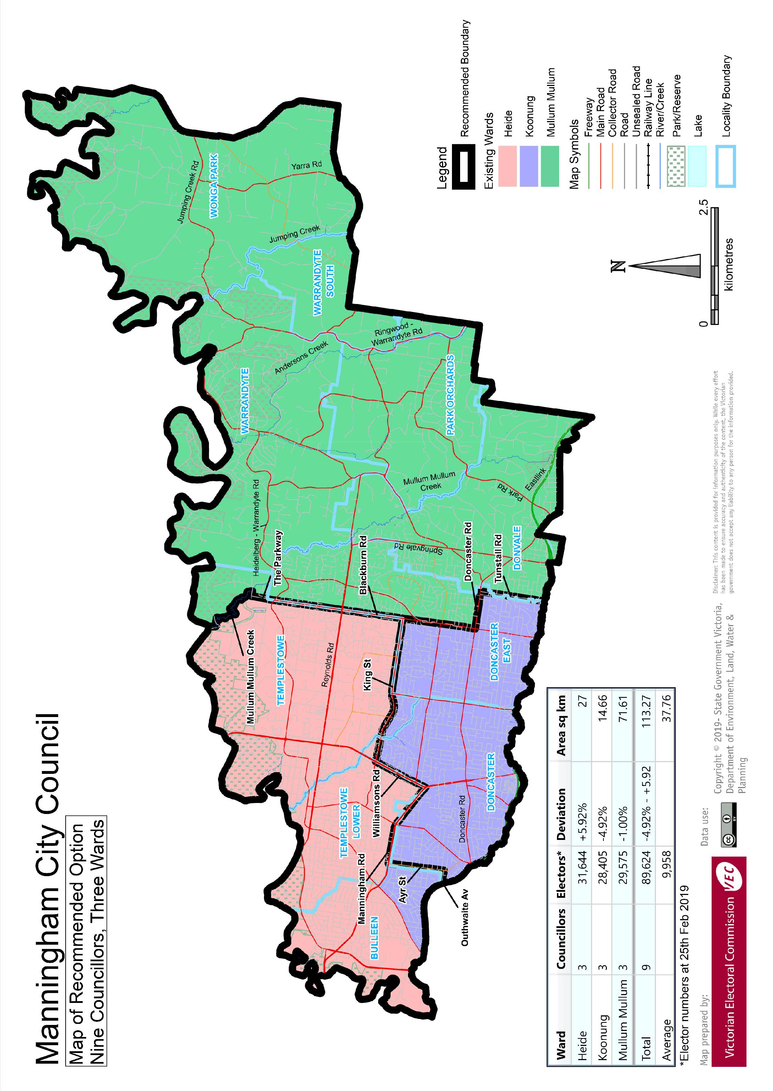

# Appendix 3: Public information program

Advertising

In accordance with the Act, public notices of the review and the release of the preliminary report were placed in the following newspapers:

|  |  |  |
| --- | --- | --- |
| **Newspaper** | **Notice of review** | **Notice of preliminary report** |
| *Herald Sun* | Thursday 6 June | Wednesday 7 August |
| *Manningham Leader* | Wednesday 12 June | Wednesday 21 August |

Media releases

A media release was prepared and distributed to local media to promote the commencement of the review. A further release was distributed with the publication of the preliminary report. A final media advisory was circulated on the publication date of this final report.

Public information session

A public information session for people interested in the review process was held on Monday   
24 June 2019 in the Council Chambers, Manningham Civic Centre, 699 Doncaster Road, Doncaster.

Submissions guide

A submission guide was developed and made available on the VEC website, or in hardcopy on request, throughout the review timeline. The submission guide provided information about the review, the review timeline and how to make submissions to the review.

Online submission tool

An online submission tool was developed and made available during the submission periods of the review. The tool allowed people to make a submission from the VEC website. During the preliminary submission stage, users also had the opportunity to map out their preferred subdivisions through the online submission tool using Boundary Builder. Boundary Builder included real elector numbers so that users could see if their preferred structures and numbers of councillors met the plus-or-minus 10% rule.

VEC website

The VEC website delivered up-to-date information to provide transparency and facilitate public participation during the review process. All public submissions were published on the website.

Email and social media engagement

The VEC delivered an information email campaign targeted at known community groups and communities of interest in the local council area. This included a reminder email at each milestone of the representation review process.

The VEC also published sponsored social media advertising that was geo-targeted to users within the local council area. This included advertising at both the preliminary submission and response submission stages. The total reach of these posts was 7,946 during the preliminary submission stage and 8,240 during the response submission stage.

Council communication resources

The VEC provided the Council with a communication pack that included information on the review in various formats. While the council is encouraged to distribute this information and raise awareness about the review, the VEC is an independent reviewer and all communications resources include reference and links to the VEC website and core materials.

This page has been left intentionally blank

This page has been left intentionally blank

This page has been left intentionally blank

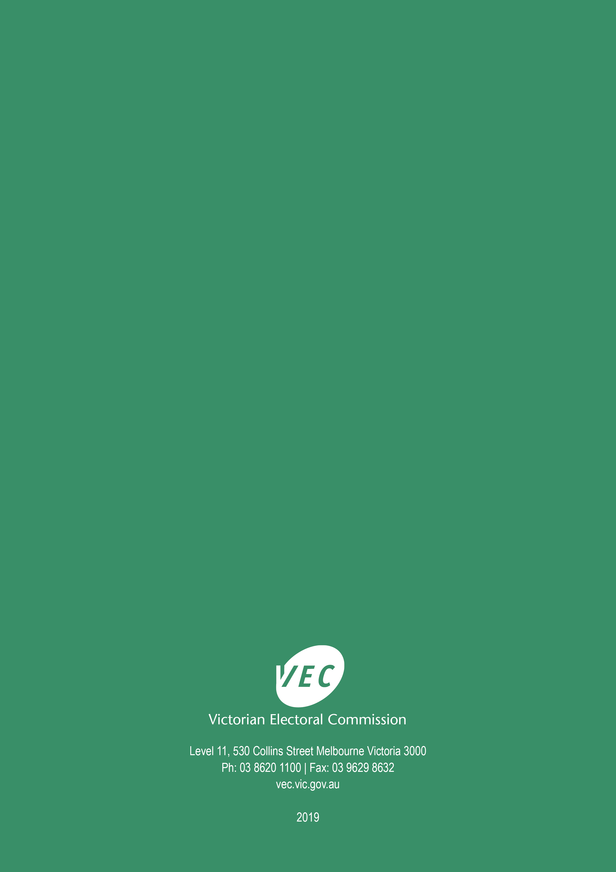

1. Section 219D of the *Local Government Act* *1989.*
2. Section 219D of the *Local Government Act* *1989.*
3. Ibid.
4. .id is a consulting company specialising in population and demographic analysis and prediction information products in most jurisdictions in Australia and New Zealand.
5. Section 5B(1) of the *Local Government Act 1989.*
6. Know Your Council, ‘Manningham City’, <http://knowyourcouncil.vic.gov.au/councils/manningham>, accessed 30 September 2019.
7. .id, ‘Manningham City Council: About the area’, <https://economy.id.com.au/manningham/about>, accessed 30 September 2019.
8. Australian Bureau of Statistics, ‘2016 Census QuickStats - Manningham (C)’, <https://quickstats.censusdata.abs.gov.au/census_services/getproduct/census/2016/quickstat/LGA24210?opendocument>, accessed 30 September 2019.
9. Department of Environment, Land, Water and Planning, ‘Victoria in Future 2019’, <https://www.planning.vic.gov.au/land-use-and-population-research/victoria-in-future>, accessed 30 September 2019.
10. id, ‘City of Manningham: Population and age structure map’, <https://forecast.id.com.au/manningham/population-age-structure-map>, accessed 30 September 2019.
11. Australian Bureau of Statistics, ‘2016 Census QuickStats - Manningham (C)’, loc. cit.. See also: ‘2016 Census QuickStats – Greater Melbourne’.
12. id, ‘City of Manningham: SEIFA by profile area’, <https://profile.id.com.au/manningham/seifa-disadvantage-small-area>, accessed 30 September 2019.
13. Australian Bureau of Statistics, ‘2016 Census QuickStats – Manningham (C)’, loc. cit.. See also: ‘2016 Census QuickStats – Greater Melbourne’.
14. Department of Land, Water and Planning, ‘Victoria in Future 2016: Manningham (C)’, loc. cit.
15. Australian Bureau of Statistics, ‘2016 Census QuickStats - Manningham (C)’, loc. cit.
16. Aboriginal Victoria, ‘Acknowledgement of Traditional Owners’, <https://www.aboriginalvictoria.vic.gov.au/acknowledgement-traditional-owners>, accessed 10 October 2019.
17. *2016 Local Government Elections Report*, 2017, Figure 9, pp. 26, <https://www.vec.vic.gov.au/files/Report%20on%20the%20conduct%20of%20the%202016%20Local%20Government%20Elections.pdf>