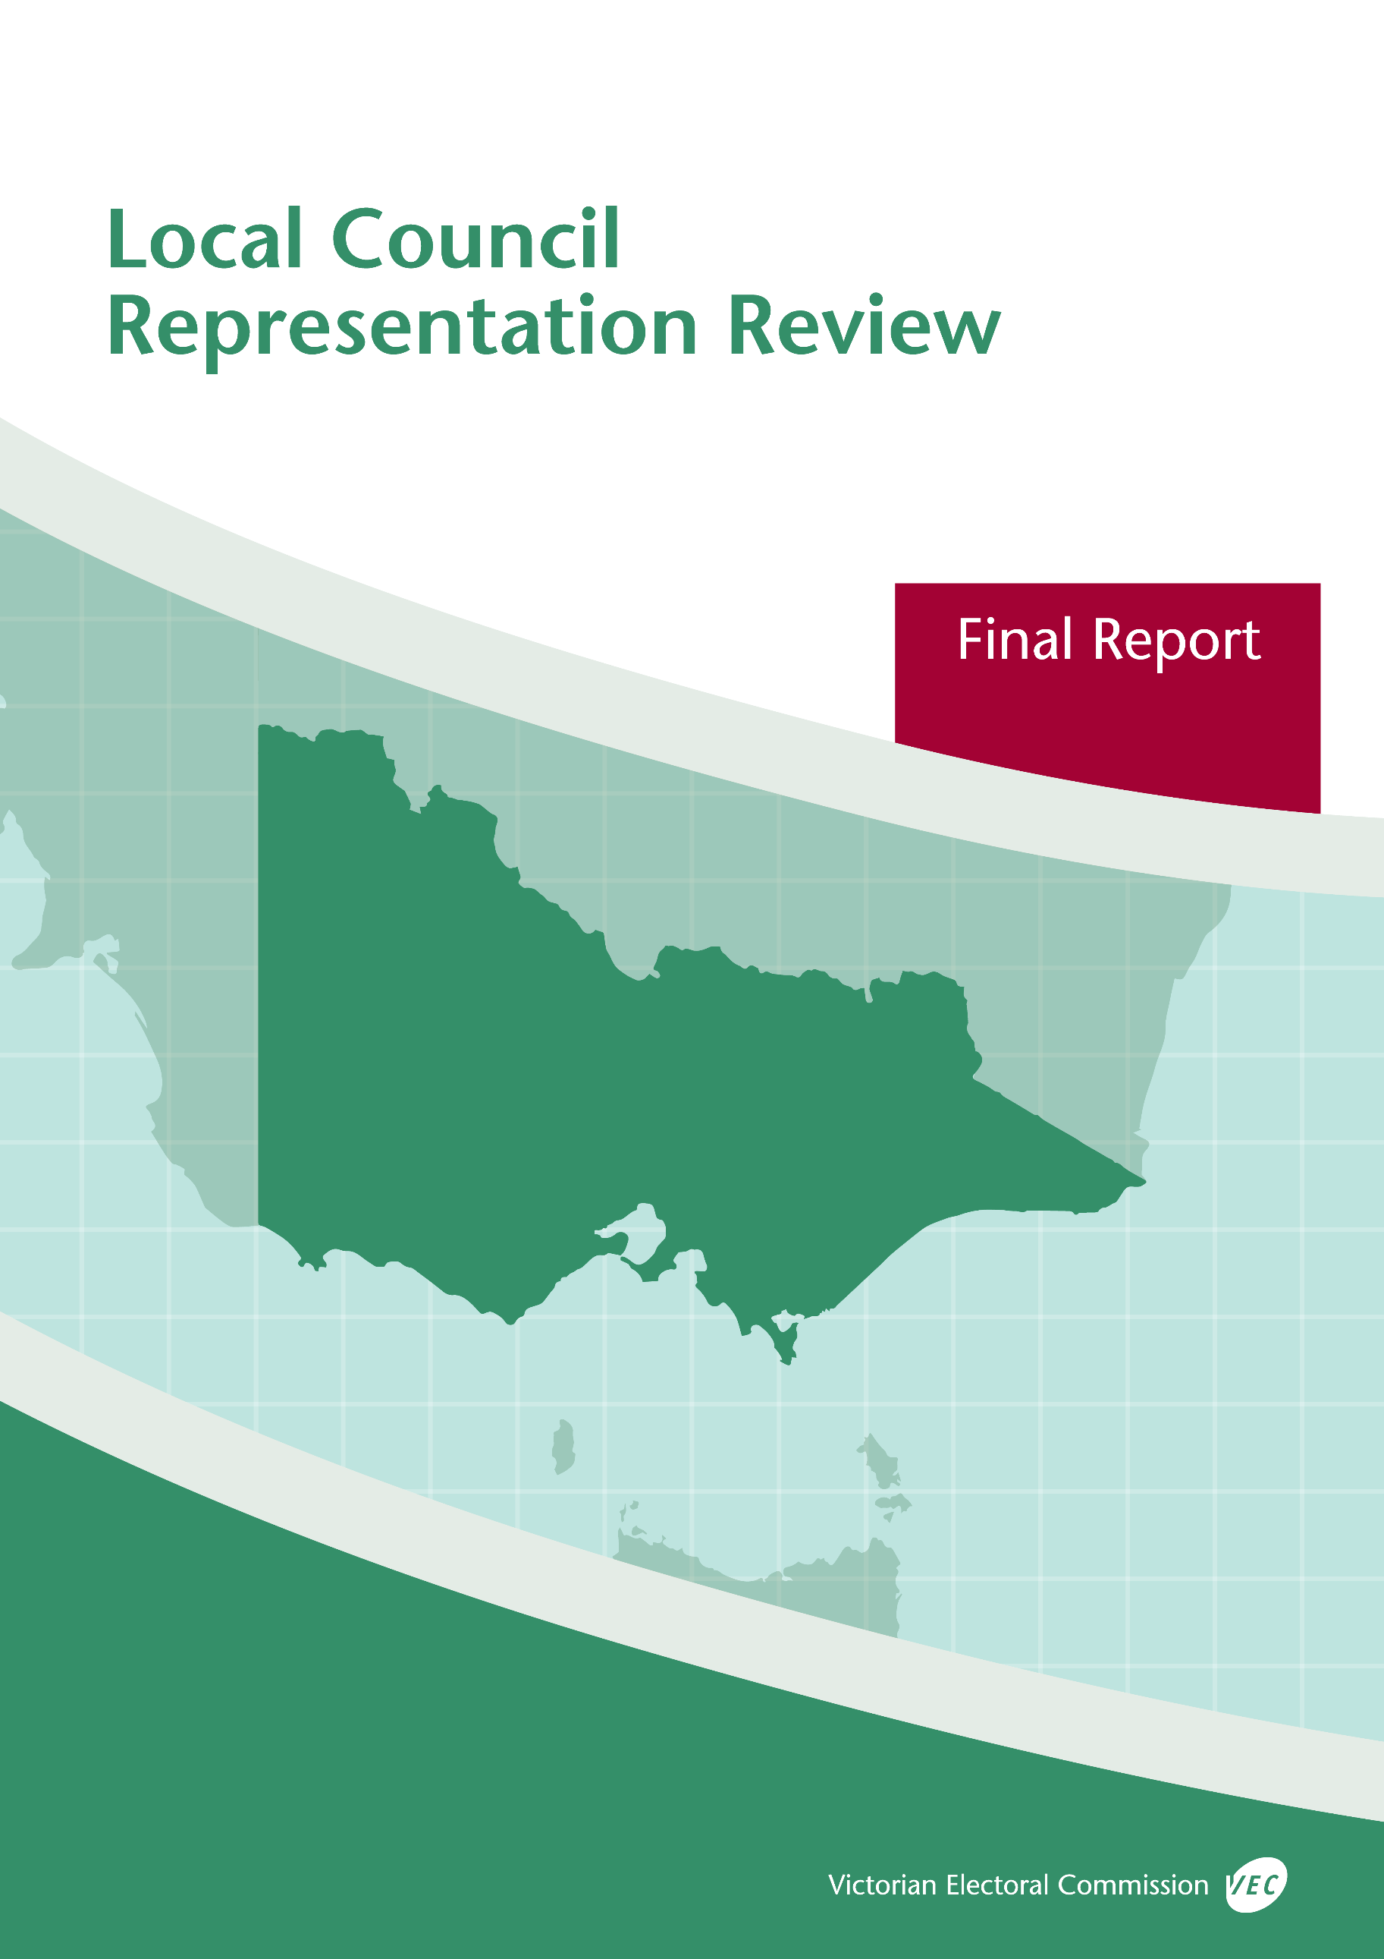



**Glenelg Shire Council**

**May 2019**

© State of Victoria (Victorian Electoral Commission)   
Wednesday 15 May 2019

Version 1  
  
cid:image001.png@01D4D431.F774F3F0

This work, Local Council Representation Review Final Report – Glenelg Shire Council, is licensed under a Creative Commons Attribution 4.0 licence [<http://creativecommons.org/licenses/by/4.0/>]. You are free to share this work under that licence, on the condition that you do not change any content and you credit the State of Victoria (Victorian Electoral Commission) as author and comply with the other licence terms. The licence does not apply to any branding, including Government logos.

Contents

Recommendation 1

Executive summary 2

Background 4

Legislative basis 4

Public engagement 4

The VEC’s principles 5

Developing recommendations 6

Glenelg Shire Council representation review 8

Profile of Glenelg Shire Council 8

Current electoral structure 9

Preliminary submissions 9

Preliminary report 11

Public response 14

Response submissions 14

Public hearing 16

Findings and recommendation 19

The VEC’s findings 19

The VEC’s recommendation 23

Appendix 1: Public involvement 24

Appendix 2: Map 26

Appendix 3: Public information program 28

Recommendation

The Victorian Electoral Commission recommends that Glenelg Shire Council continue to consist of seven councillors elected from an unsubdivided electoral structure.

This recommendation is submitted to the Minister for Local Government as required by the *Local Government Act 1989*.

Please see Appendix 2 for a map of this recommended structure.

Executive summary

The *Local Government Act 1989* (the Act) requires the Victorian Electoral Commission (VEC) to conduct an electoral representation review of each municipality in Victoria before every third council general election.

The purpose of an electoral representation review is to recommend an electoral structure that provides fair and equitable representation for people who are entitled to vote at a general election of the council. The matters considered by a review are:

* the number of councillors
* the electoral structure of the council (whether the council should be unsubdivided or divided into wards and, if subdivided, the ward boundaries and the number of councillors per ward).

The VEC conducts all reviews based on three main principles:

1. taking a consistent, State-wide approach to the total number of councillors
2. if subdivided, ensuring the number of voters represented by each councillor is within   
   plus-or-minus 10% of the average number of voters per councillor for that local   
   council
3. ensuring communities of interest are as fairly represented as possible.

Current electoral structure

Glenelg Shire Council currently comprises seven councillors elected from an unsubdivided electoral structure. Prior to the last representation review in 2007, Glenelg Shire Council comprised nine councillors elected from nine single-councillor wards.

Visit the VEC website at [vec.vic.gov.au](http://www.vec.vic.gov.au/) to access a copy of the 2007 review final report.

Preliminary submissions

Preliminary submissions opened at the commencement of the current review on Wednesday 23 January 2019. The VEC received 16 submissions for the representation review of Glenelg Shire Council by the deadline at 5.00 pm on Wednesday 20 February 2019.

Preliminary report

A preliminary report was released on Wednesday 20 March 2019 with the following options for consideration:

* Option A (preferred option)  
  **Glenelg Shire Council consist of seven councillors elected from an unsubdivided electoral structure.**
* Option B (alternative option)  
  **Glenelg Shire Council consist of seven councillors elected from two wards (one five-councillor ward and one two-councillor ward).**
* Option C (alternative option)  
  **Glenelg Shire Council consist of seven councillors elected from three wards (one four-councillor ward, one two-councillor ward and one single-councillor ward).**

Response submissions

The VEC received 13 submissions responding to the preliminary report by the deadline at   
5.00 pm on Wednesday 17 April 2019.

Public hearing

The VEC conducted a public hearing for those wishing to speak about their response submission at 7.00 pm on Wednesday 24 April 2019. Two people spoke at the hearing.

Recommendation

**The Victorian Electoral Commission recommends that Glenelg Shire Council continue to consist of seven councillors elected from an unsubdivided electoral structure.**

This electoral structure was designated as Option A in the preliminary report. Please see Appendix 2 for a map of this recommended structure.

Background

Legislative basis

The Act requires the VEC to conduct a representation review of each local council in Victoria before every third general council election, or earlier if gazetted by the Minister for Local Government.

The Act states that the purpose of a representation review is to recommend the number of councillors and the electoral structure that provides ‘fair and equitable representation for the persons who are entitled to vote at a general election of the Council.’[1]

The Act requires the VEC to consider:

* the number of councillors in a local council
* whether a local council should be unsubdivided or subdivided.

If a local council is subdivided, the VEC must ensure that the number of voters represented by each councillor is within plus-or-minus 10% of the average number of voters per councillor for that local council.[2] On this basis, the review must consider the:

* number of wards
* ward boundaries
* number of councillors that should be elected for each ward.

Public engagement

### Public information program

The VEC conducted a public information program to inform the community of the representation review, including:

* public notices printed in local and state-wide papers
* public information sessions to outline the review process and respond to questions from the community
* media releases announcing the commencement of the review and the release of the preliminary report
* a submission guide to explain the review process and provide background information on the scope of the review
* an information email campaign targeted at known community groups and communities of interest in the local council area
* sponsored social media advertising geo-targeted to users within the local council   
  area
* ongoing information updates and publication of submissions on the VEC website.

More information on the VEC’s public information program for the representation review of Glenelg Shire Council can be found at Appendix 3.

### Public consultation

Public input was accepted by the VEC via:

* preliminary submissions at the start of the review
* response submissions to the preliminary report
* a public hearing that provided an opportunity for people who had made a response submission to expand on their submission.

Public submissions are an important part of the review process but are not the only consideration. The VEC ensures its recommendations comply with the Act and are formed through careful consideration of public submissions, independent research, and analysis of all relevant factors.

The VEC’s principles

Three main principles underlie all the VEC’s work on representation reviews:

1. **Taking a consistent, State-wide approach to the total number of councillors.**

The VEC is guided by its comparisons of local councils of a similar size and category to the council under review. The VEC also considers any special circumstances that may warrant the local council having more or fewer councillors than similar local councils.

1. **If subdivided, ensuring the number of voters represented by each councillor is within plus-or-minus 10% of the average number of voters per councillor for that local council.**

This is the principle of ‘one vote, one value’, which is enshrined in the Act. This means that every person’s vote counts equally.

1. **Ensuring communities of interest are as fairly represented as possible.**

Each local council contains a number of communities of interest. Where practicable, the electoral structure should be designed to ensure they are fairly represented, and that geographic communities of interest are not split by ward boundaries. This allows elected councillors to be more effective representatives of the people and interests in their particular local council or ward.

Developing recommendations

The VEC bases its recommendations for particular electoral structures on the following information:

* internal research specifically relating to the local council under review, including data from the Australian Bureau of Statistics and .id[3]; voter statistics from the Victorian electoral roll; and other State and local government data sets
* the VEC’s experience conducting previous electoral representation reviews of local councils and similar reviews for State elections
* the VEC’s expertise in mapping, demography and local government
* careful consideration of all input from the public in written submissions received during the review and via oral submissions at the public hearing
* advice from consultants with extensive experience in local government.

### Deciding on the number of councillors

The Act allows for a local council to have between five and 12 councillors but does not specify how to decide the appropriate number.[4] In considering the number of councillors for a local council, the VEC is guided by the Victorian Parliament’s intention for fairness and equity in the local representation of voters under the Act.

The starting point in deciding the appropriate number of councillors for a local council is comparing the local council under review to other local councils of a similar size and type (Principle 1). Generally, local councils that have a larger number of voters will have a higher number of councillors. Often large populations are more likely to be diverse, both in the nature and number of their communities of interest and the issues of representation.

However, the VEC also considers the particular circumstances of each local council which could justify fewer or more councillors, such as:

* the nature and complexity of services provided by the Council
* geographic size and topography
* population growth or decline
* the social diversity of the local council.

### Deciding the electoral structure

The Act allows for a local council ward structure to be unsubdivided—with all councillors elected ‘at-large’ by all voters—or subdivided into a number of wards.

If the local council is to be subdivided into wards, there are three options available:

1. single-councillor wards
2. multi-councillor wards
3. a combination of single-councillor and multi-councillor wards.

A subdivided electoral structure must have internal ward boundaries that provide for a fair and equitable division of the local council.

The Act allows for wards with different numbers of councillors, as long as the number of voters represented by each councillor is within plus-or-minus 10% of the average number of voters per councillor for that local council (Principle 2). For example, a local council may have one   
three-councillor ward with 15,000 voters and two single-councillor wards each with 5,000 voters. In this case, the average number of voters per councillor would be 5,000.

Over time, population changes can lead to some wards in subdivided local councils having larger or smaller numbers of voters. As part of the review, the VEC corrects any imbalances and considers likely population changes to ensure ward boundaries provide equitable representation for as long as possible.

In considering which electoral structure is most appropriate, the VEC considers the following matters:

* the VEC’s recommendation at the previous representation review and the reasons for that recommendation
* the longevity of the structure, with the aim of keeping voter numbers per councillor within the 10% tolerance for as long as possible (Principle 2)
* communities of interest, consisting of people who share a range of common concerns, such as geographic, economic or cultural associations (Principle 3)
* the number of candidates in previous elections, as large numbers of candidates can lead to an increase in the number of informal (invalid) votes
* geographic factors, such as size and topography
* clear ward boundaries.

Glenelg Shire Council representation review

Profile of Glenelg Shire Council

Glenelg Shire Council is located in far south-west Victoria on the South Australian border. The Shire covers an area of 6,212 square kilometres, with an estimated total population of 19,557.[5]

Portland is the major town, with an estimated 9,712 residents. Portland and its neighbouring localities are home to more than half of the Shire’s population. Casterton (population 1,668) and Heywood (population 1,726) are the largest towns after Portland. The remaining population is dispersed across rural localities and smaller rural towns including Dartmoor, Nelson, Digby and Merino. The west of the Shire is very sparsely populated.

Glenelg Shire includes both coastal and rural landscapes. Portland, the deep-water Port of Portland, and townships such as Nelson are located along the coast. The Glenelg River is the major waterway, and the Lower Glenelg and Cobboboonee National Parks separate inland areas from the south-west coastal region. Inland, timber plantations and smaller State parks and reserves separate the north-east agricultural area around Casterton from the central agricultural region near Dartmoor.

Industries within Glenelg Shire include fishing, forestry, agriculture, manufacturing, sea transport, tourism and services, and renewable energy. Portland Aluminium is one of four aluminium smelters operating in Australia[6] and along with its associated industries is the largest employer in the Shire. Renewable energy is a growing industry in the Shire, with four coastal wind farms currently operating in the Portland area[7]. The Port of Portland also provides a vital trade link for south-eastern Australia.[8]

The median age in the Shire is 47 years, which is higher than both the regional average (43 years) and State average (37 years). Glenelg Shire has a slightly higher percentage of persons at post retirement age (22.2%) compared to the regional average (20.4%).[9]

Couples without children are the most common family unit, making up 46.6% of families. This is higher than the regional average of 42.9%. The proportion of couples with children (36.6%) is slightly lower than the regional average (39.6%).[10]

The unemployment rate for Glenelg Shire is the same as the regional Victorian average of 6%, and lower than the State average of 6.6%.[11] Glenelg’s rural communities have a lower unemployment rate (3.2%) compared to the Shire as a whole.[12] The median weekly income for households in Glenelg Shire is $1,043, which is lower than the State average of $1,419.[13]

At the 2016 census the three most common ancestries within the Glenelg Shire were Australian, English and Scottish. The majority of Glenelg Shire residents were born in Australia. Of the 7.6% of residents born overseas, most were from the United Kingdom and New Zealand. The Shire is home to a higher proportion of Aboriginal and Torres Strait Islander peoples (2.4%) compared to the regional Victorian average of 1.6%.[14] The original inhabitants of Glenelg Shire were the Gunditjmara, Bunganditj and Jarwadjali peoples.[15]

Glenelg Shire has an estimated 17,570 voters, with a ratio of about 2,510 voters per councillor. Population forecasts indicate that Glenelg Shire’s total population is fairly stable, with little significant population change expected between now and 2031.The majority of growth is expected in the Portland area, with smaller growth around Casterton and Heywood, and a declining population in rural areas.[16]

Current electoral structure

Glenelg Shire Council currently comprises seven councillors elected from an unsubdivided electoral structure. Prior to the last representation review in 2007, Glenelg Shire Council comprised nine councillors elected from nine single-councillor wards.

Visit the VEC website at [vec.vic.gov.au](http://www.vec.vic.gov.au/) to access a copy of the 2007 review final report.

Preliminary submissions

The VEC received 16 preliminary submissions by the deadline at 5.00 pm on Wednesday 20 February 2019. Submissions were received from a range of stakeholders, including community organisations and individuals.

The submissions were made available on the VEC website.

### Number of councillors

Ten submissions identified seven as the appropriate number of councillors for Glenelg Shire Council. Of these submissions, one also supported reducing the number to five if there was strong justification and community support.

Six submissions did not indicate a preference for a specific number of councillors. However, of these submissions there were two that suggested increasing the number of councillors, while one suggested a reduction to less than seven councillors.

### Electoral structure

The majority of submissions expressed a desire to introduce a subdivided electoral structure, and a wide range of proposals for ward-based representation were put forward.

Two submissions supported a four-ward structure, with a four-councillor ward for Portland and three single-councillor wards covering the northern Casterton area, the eastern Heywood area, and the western region. A third submission also supported a four-ward model with a similar positioning of wards but an additional number of councillors.

Two submissions supported a three-ward structure, with a three-councillor ward for Portland and surrounds, a two-councillor ward for the Heywood/rural area, and a two-councillor ward for the Casterton/rural area.

Additional submissions proposed various ward arrangements, including a two-ward structure (one ward for the Portland area, one ward for the remaining areas), a five-ward structure (wards for Portland and eastern, western, northern and southern regions), a seven-ward structure, as well as structures with four-to-five wards and eight or more wards. One additional submission indicated a preference for wards without describing a specific structure.

Those in support of a subdivided electoral structure argued that areas outside Portland feel disadvantaged and unrepresented under the current electoral structure. Six out of seven current councillors reside in Portland, which has given rise to a perception that the current council and electoral structure favours Portland and the surrounding coastal areas, and that it is more difficult for rural candidates to be elected. Multiple submissions also argued that rural communities should have representatives who are known to them, and who live in and understand the issues in those local communities.

Five submissions expressed a preference for retaining the current arrangement of seven councillors elected from an unsubdivided local council. Those in support of the current electoral structure argued that the current model is an improvement on and is fairer than the previous subdivided electoral structure and does not disadvantage any part of the local council. It was also argued that the current unsubdivided electoral structure has unified the local council and promotes a more harmonious ‘whole-of-shire’ approach to representation, community identity and community engagement.

A list of people who made a preliminary submission can be found in Appendix 1.

Preliminary report

A preliminary report was released on Wednesday 20 March 2019. The VEC considered public submissions and research findings when formulating the options presented in the preliminary report.

### Number of councillors

When considering the appropriate number of councillors for a local council, the VEC reviews population data and assesses other factors which may warrant an increase or decrease in the number of councillors, such as projected population growth or special circumstances relating to distinct communities of interest.

Although Glenelg Shire Council covers a large geographic area, the number of voters in the Shire is not high and Glenelg Shire Council sits in the mid-range when compared to other country Victorian local councils with seven councillors. Population growth across the local council is uneven, but the population overall is fairly static with little change projected to occur over the mid- to long-term. The Shire is home to a high proportion of Aboriginal and Torres Strait Islander peoples compared to other country Victorian local councils, however the population is largely socially and linguistically similar. Overall, the VEC’s analysis and information provided in preliminary submissions did not identify any special circumstances that would justify an increased number of councillors at Glenelg Shire Council. The VEC therefore recommended no change be made to the current number of seven councillors.

### Electoral structure

In its preliminary report, the VEC found that the uneven growth and distribution of the population in Glenelg Shire Council, as well as widespread communities of interest, are a challenge for developing ward boundaries. The VEC found that an unsubdivided electoral structure is a suitable model for the Shire because it can effectively address the issues associated with ward boundaries. Unsubdivided electoral structures can foster a ‘whole-of-shire’ approach to representation and community identity, and enable voters to raise concerns and vote on matters they care about regardless of their location within the local council. Unsubdivided electoral structures also allow all voters to choose from the widest selection of candidates, reduce the risk of uncontested elections occurring in sparsely populated rural areas, and do not limit the number of councillors that can be elected from any area of a local council. Uneven population growth across a local council area is not an issue under an unsubdivided structure. The VEC put forward an unsubdivided model, reflecting the existing structure of the local council, as its preferred option.

The VEC also acknowledged the support for a subdivided structure in preliminary submissions. The VEC noted that at the 2016 general election for Glenelg Shire Council there was a larger field of candidates and higher levels of informal voting than had been observed at previous elections, as well as fewer candidates from rural areas outside of the Portland region. Therefore, the VEC also considered subdivided electoral structures when preparing the preliminary report.

Two preliminary submissions suggested a four-ward model that was based on the first alternative option from the VEC’s last representation review of Glenelg Shire Council in 2007. This model consisted of a four-councillor ward for Portland and three single-councillor wards for the remaining northern, western and eastern areas of the local council. The VEC considered this option, but ultimately determined it would be unsuitable as there was a risk of uncontested elections for single-councillor wards and projections indicated that this model may not remain viable through to the next scheduled representation review. In addition, the distribution of the population made it difficult to encapsulate communities of interest within ward boundaries.

The VEC also considered a three-ward model based on comments made in preliminary submissions, which aimed to provide representation for the northern, central and coastal areas of the Shire. This model comprised a five-councillor ward for Portland and the coastal area of the Shire, and two single-councillor wards for the central and northern rural areas. This model was also determined to be unsuitable as there was a risk of uncontested elections for single-councillor wards and projections indicated that this model may not remain viable through to the next scheduled representation review.

To reflect the call for subdivision expressed in preliminary submissions, with separate representation for the Portland area and for rural communities, the VEC put forward two subdivided electoral structures. Option B consisted of a five-councillor ward encompassing the coastal areas of the Shire (including Portland) and a two-councillor ward encompassing the inland areas. Option C consisted of a four-councillor ward for the Portland area, a two-councillor ward for the central region, and a single-councillor ward for the northern region around Casterton. It was considered that both options enabled representation for the major geographic regions of the local council, accommodated uneven population growth, and could help reduce informal voting. Option B had the additional benefit of reducing the risk of uncontested elections associated with single-councillor wards.

### Options

After careful consideration, the VEC put forward the following options:

* Option A (preferred option)  
  **Glenelg Shire Council consist of seven councillors elected from an unsubdivided electoral structure.**
* Option B (alternative option)  
  **Glenelg Shire Council consist of seven councillors elected from two wards (one five-councillor ward and one two-councillor ward).**
* Option C (alternative option)  
  **Glenelg Shire Council consist of seven councillors elected from** **three wards (one four-councillor ward, one two-councillor ward and one single-councillor ward).**

Public response

Response submissions

The VEC accepted submissions responding to the preliminary report from Wednesday 20 March 2019 until 5.00 pm on Wednesday 17 April 2019. The VEC received 13 response submissions.   
A list of people who made a response submission can be found in Appendix 1.

Table 1 indicates the level of support for each option.

|  |  |  |  |
| --- | --- | --- | --- |
| Table 1: Preferences expressed in response submissions | | | |
| **Option A** | **Option B** | **Option C** | **Other** |
| 6 | 1 | 5* | 1 |

*One of the submissions in favour of Option C also stated that Option B would be acceptable.

### Number of councillors

Based on its preliminary findings, the VEC put forward three options with seven councillors. The majority of response submissions did not comment on the appropriate number of councillors for the Shire. The three submitters that did comment all supported keeping the councillor number at seven.

### Electoral structure

As indicated in Table 1, support in response submissions was divided between retaining the current unsubdivided electoral structure (Option A) and changing to a subdivided electoral structure (either Option B or Option C). Submitters on both sides supported their views with similar arguments to those in preliminary submissions. One submission did not clearly indicate a preferred electoral structure. The key themes of the response submissions are outlined below.

#### Support for Option A

Six submissions supported Option A, expressing a preference for retaining the current arrangement of seven councillors elected from an unsubdivided local council. Of those in support of Option A, four submissions were from individuals and two were from organisations.[17] Arguments in support of Option A echoed the benefits of this model that were outlined in the preliminary report.

Submissions argued that the current electoral structure is an improvement on the previous subdivided electoral structure, being fairer, more democratic and without disadvantage to any part of the local council. It was argued that the introduction of the current unsubdivided electoral structure has unified the local council and promotes a more harmonious ‘whole-of-shire’ approach to representation, decision-making and the strategic direction of the council, and which mitigates favouritism toward any area of the Shire.

The general benefits of unsubdivided electoral structures were also put forward as arguments in support of Option A, including:

* every voter has the widest possible choice of candidates at an election
* voters have freedom to select a candidate that they best identify with, which may or may not mean voting for a local candidate
* having the widest possible field of candidates may result in councillors with a wide range of viewpoints, knowledge and experience
* voters feel free to approach and discuss issues with their councillor of choice
* no confusion about ward boundaries, and no need for periodic readjustment of ward boundaries which may add further confusion
* encourages councillors to have a greater knowledge of and act for the Shire as a whole
* it is the most fair and equitable electoral structure, as all votes have equal value and a high percentage of voters will be represented by a person they voted for.

Glenelg Shire Council supported Option A, agreeing with the benefits that were outlined in the preliminary report. The council submission indicated a belief that the current structure was working well and provides fair representation to the whole council area. The council felt that current councillors have demonstrated the ability to work cooperatively with a whole-of-shire approach, while still being able to address specific issues in local communities. The council also indicated that the unsubdivided structure enabled councillor workloads and responsibilities to be more equitably shared.

Those in support of Option A also argued against a move to a subdivided structure. Glenelg Shire Council argued that wards can enforce divisions within the council, as councillors may feel obliged to put the interests of their ward over the interests of the Shire as a whole. Submitters also highlighted the risk of uncontested elections with wards. It was also pointed out that wards will not necessarily result in local councillors for rural areas, as there is no guarantee that a councillor would actually reside in the ward they were elected to represent. Additional arguments against Options B and C were that they limit choice of candidates for voters, force voters to vote as a geographic community of interest, contain ‘stalemate’ wards (with even numbers of councillors) or single-councillor wards, and carry a greater risk of uncontested elections.

#### Support for Options B and C

Many preliminary submissions raised concerns that rural towns and localities outside of the Portland region were not being sufficiently represented under the current electoral structure. Response submissions supporting Options B and C put forward similar arguments, indicating that the desire to move to a subdivided structure is largely driven by dissatisfaction with rural representation under the current electoral structure, and concerns about the potential for decreased rural representation in the future.

Several submissions mentioned that six out of seven current councillors reside in or near Portland, contributing to a perception that the current council and unsubdivided electoral structure favours Portland and the surrounding areas. Submitters felt that Portland-based councillors had an urban focus which was not representative of rural interests. It was argued that rural communities should have representatives that live locally, as locals have a better understanding of local issues and would be better advocates for their communities. It was also argued that local representatives would be more likely to be known to rural voters and be more accessible for voters who wish to discuss issues.

Submitters also argued that rural people are deterred from standing as candidates because of a belief that there is little chance of success when competing with candidates from Portland. Submitters argued that it was more difficult for rural candidates to be elected than for Portland candidates, as there are fewer voters in rural areas to support local candidates, campaigning across the dispersed rural population is a harder task, and there are fewer opportunities for preference swapping, whereas a subdivided structure was likely to encourage more rural candidates to stand as they would feel they had a greater chance of being elected.

The arguments put forward in support of Option B and Option C indicate that support for these options was chiefly based on a belief that these structures would deliver local representatives for rural communities outside of the Portland region.

A list of people who made a response submission can be found in Appendix 1.

Public hearing

The VEC conducted a public hearing for those wishing to speak about their response submission at 7.00 pm on Wednesday 24 April 2019 at the Portland Municipal Offices, 71 Cliff Street, Portland. Two speakers attended the public hearing. A list of people who spoke at the hearing can be found in Appendix 1.

One person spoke in support of Option A and the other spoke in support of Option C.

### Support for Option A: Retaining the current unsubdivided electoral structure

A resident of Glenelg Shire (Margaret Punton) argued in favour of retaining the current structure of seven councillors in an unsubdivided local council.

Ms Punton indicated that her support for the current unsubdivided structure was based on the reasons outlined in her preliminary submission.[18] Ms Punton argued that the current unsubdivided structure was the most democratic option, as councillors are elected by voters from across the whole local council, whereas any alternative option negates the principles of majority democracy and equal rights for all voters. Ms Punton argued that the change from the previous subdivided electoral structure to the current unsubdivided structure has not caused detriment to any area of the local council, that the Shire as a whole received economic benefits from the Port of Portland and the Portland-based aluminium smelter, and that the declining population in the north (leading to reduced trade for local businesses) may contribute to the perception that these areas are disadvantaged.

During question time the speaker was asked about her thoughts on declining numbers of candidates from rural areas. Ms Punton expressed a belief that rural candidates must stand if they wish to have any chance of becoming a councillor. Ms Punton also thought it possible that there was a lack of understanding about how the preference system worked, and that under the unsubdivided electoral structure rural candidates could benefit if multiple rural candidates stood and supported each other through a sharing of preferences. Ms Punton indicated that if there are few candidates from rural areas as has been seen at recent elections, it is harder for these candidates to benefit from preferences.

### Support for Option C: Changing to a subdivided electoral structure with one four-councillor ward, one two-councillor ward and one single-councillor ward

A resident of Glenelg Shire Council (Wendye Maddox) argued in favour of changing to a subdivided electoral structure consisting of one four-councillor ward for Portland, one two-councillor ward for the central part of the local council, and one single-councillor ward for the northern area around Casterton.

Ms Maddox concurred with the benefits of Option C outlined in the preliminary report but had reservations about the potential downsides described. The speaker argued that voters in the single-councillor northern ward would not feel underrepresented under Option C, as it would address a community concern that this area will not be able to elect another local councillor when the current Casterton-based councillor eventually retires.

Ms Maddox put forward similar arguments in support of Option C to those seen in response submissions. Ms Maddox argued that rural communities needed representatives that live locally, as local residents better understand the day-to-day issues and needs of their community, would be better advocates for that local community, and as members of the community they represent, their opinion would be more likely to be taken seriously by external groups. Ms Maddox argued that the Portland-based majority on Council disadvantages rural areas, who do not know Portland councillors and have fewer opportunities to discuss issues in person. Ms Maddox also raised concerns about the possibility that in the future all councillors could be Portland residents. Ms Maddox argued that councillors should reflect the makeup of the whole Shire, with representatives drawn from different areas.

Ms Maddox also believed that a sense of alienation, disillusionment and apathy in rural areas, along with a perception that it is impossible for rural candidates to be elected without wards, has contributed to a reduced interest for rural people to stand as candidates.

During question time, the speaker indicated that a subdivided structure would encourage more rural people to stand as candidates, because there would be less competition (from Portland candidates) and people would have more of a sense of ownership over their ward.

The speaker was also asked about her thoughts on whether the boundary around Portland adequately incorporates surrounding areas with a close association with Portland. Ms Maddox indicated that residents that were close to Portland but outside the Portland ward boundary would still have good access to and knowledge of Portland-based councillors under Option C.

When asked whether there were shared interests between Portland and rural areas, Ms Maddox argued this was not the case and that Casterton had a closer association with Hamilton or Mt Gambier in South Australia than with Portland. However, she considered that the customer service centres in Heywood and Casterton possibly contribute a greater feeling of association with Portland, and that customer service centres could be extended to other towns in the Shire.

Findings and recommendation

The VEC’s findings

### Number of councillors

Determining the number of councillors for Glenelg Shire Council was not a substantially disputed element of this review. The VEC recommends retaining the existing number of seven councillors on the basis that this number is consistent with other country Victorian councils of similar size and number of voters, and no increase or decrease is warranted considering population trends or special circumstances relating to distinct communities of interest.

### Electoral structure

In contrast to the question of the number of councillors, determining the electoral structure for Glenelg Shire Council was a more complex matter to resolve. A variety of subdivided electoral structures were put forward in preliminary submissions, many of which were not viable due to difficulties in balancing voter-to-councillor ratios across wards, caused by the uneven distribution and growth of the population across the local council area.

The VEC put forward three electoral structures in its preliminary report which were all considered to facilitate fair and equitable representation. Option A, an unsubdivided structure, reflected the current electoral structure in the local council, while Options B and C responded to the support expressed in preliminary submissions for a local ward model reflecting geographic and social communities of interest of Glenelg Shire.

An equal number of response submissions supported unsubdivided and subdivided structures.

It was clear from both preliminary and response submissions that those desiring a change to the electoral structure did so due to a feeling of dissatisfaction with rural representation under the current electoral structure, and concern about the potential for decreased rural representation in the future. Submissions indicated there is a perception that the Portland region is favoured by council decisions, while rural areas are disadvantaged because their needs are disregarded or misunderstood. The major factor contributing to this perception seems to be that six of the current Glenelg Shire councillors are residents of Portland, while only one councillor is from a rural area (Casterton).

Interestingly, two submitters that supported a move to a subdivided structure (including one speaker at the public hearing) made a point of saying that it was not necessarily the case that rural areas of the Shire are disadvantaged in certain ways, but that this perception of disadvantage did exist in the broader community or there was concern that disadvantage may arise in the future.

The arguments put forward in support of Option B and Option C indicated that the support for these options was based on a belief that those options were more likely to deliver more local representatives for rural areas. However, supporters of Options B and C did not clearly articulate how the specific features of those options would significantly improve representation for voters across the Shire.

The VEC acknowledges the desire expressed in submissions and at the public hearing that more councillors be drawn from areas across the entire local council. However, the VEC also recognises that both Option B and Option C do not necessarily resolve this concern.

In Option B, Portland is included in a five-councillor Coastal Ward with many smaller rural localities and townships, with no guarantee that the smaller communities in this Coastal Ward would gain a local councillor. The large two-councillor Northern Ward incorporates the remaining inland areas. The number of councillors that can be elected for the Northern Ward is capped at two[19], whereas at the 2008 general election four councillors were elected from this area. Under the current unsubdivided structure there remains a possibility that future elections may return an increased number of councillors from this region, whereas Option B would remove that possibility. Additional drawbacks of Option B include concerns about the workload required for two councillors representing the large Northern Ward (more than ¾ of the local council area) and a risk that this two-ward structure may entrench a divide between coastal and inland areas.

A major drawback of Option C, identified in the preliminary report, was the boundary around Portland. This boundary sits close to the town and excludes surrounding communities closely connected with Portland. Those outer-Portland communities are instead included in the large Central Ward that covers more than half the local council area. It is noted that at the 2016 general election many candidates stood from these outer-Portland areas, and may also stand at future elections. Therefore, not only does Option C split the Portland region community of interest, Option C also cannot guarantee that the Central Ward councillors will be elected from small communities far from Portland, leaving those rural communities in the same position as they are currently. Conversely, if both councillors for the Central Ward were from rural areas, this could leave residents living close to Portland feeling unrepresented. Another drawback of   
Option C is the single-councillor North Ward. Three councillors were elected from this area at the 2008 general election, and two councillors at the 2012 election. Under the current unsubdivided structure there remains a possibility that future elections may return an increased number of councillors from this region, but Option C would remove that possibility. In addition, this large single-councillor North Ward would be a challenge for a single councillor to represent compared to other wards in this option. Single-councillor wards also increase the risk of uncontested elections.

Although the VEC acknowledges the desire for wards and more rural councillors expressed in submissions and at the public hearing, neither Option B or Option C sufficiently addresses this wish, while at the same time both these options have drawbacks that weaken fair and equitable representation for the Shire as a whole. The VEC also acknowledges the arguments put forward in support of retaining the current unsubdivided electoral structure expressed in submissions and at the public hearing.

The VEC considers there to be two valid concerns with the current unsubdivided electoral structure: an increased level of informal voting seen at the 2016 general election, and an apparent decline in the number of candidates standing from rural areas of the Shire. Although the VEC acknowledges these two issues exist under the current unsubdivided electoral structure, it is not guaranteed that either Option B or Option C would satisfactorily resolve those issues.

The VEC has observed a decline in the number of candidates from rural parts of the Shire over the past three general elections (in 2008, 2012, 2016). Submissions to the current review argued that rural people are deterred from standing as candidates because of a belief that there is little chance of being elected when running against candidates from Portland. However, the VEC considers that the current electoral structure does not prevent the election of councillors from rural areas of Glenelg Shire Council. At the 2008 general election, a field of seven candidates from rural areas and 10 candidates from the Portland region resulted in the election of a majority of councillors (four out of seven) coming from rural areas. The population distribution of the Shire has not altered significantly since that time, and the VEC considers that there are sufficient rural voters to support local rural candidates, if they wish to do so. The current unsubdivided electoral structure offers the possibility that the majority of councillors may again be drawn from rural areas, whereas both Option B and Option C entrench a structure with a minority of rural councillors.

The VEC also observed an increased level of informal voting at the 2016 election, with 8.16% of votes unable to be admitted to the count. While it is not clear what caused this increase in informal votes in 2016, the VEC has generally observed informal voting rates tend to increase as more candidates are listed on the ballot paper.[20] This is related to one of the drawbacks of an unsubdivided electoral structure, which can encourage larger fields of candidates at elections and lengthier ballot papers. Longer ballot papers can be confusing for voters and more difficult for voters to fill out correctly, leading to higher levels of informal voting through voter error. Although this is certainly a potential drawback of the unsubdivided model, the VEC considers that the possibility of high informal votes occurring at an election is outweighed by the benefits an unsubdivided electoral structure provides to Glenelg Shire Council.

In summary, the VEC put forward two subdivided options, Option B and Option C, for consideration in this review, and found these two models to have particular drawbacks that outweigh their positive attributes. Due to the uneven distribution of the population and the uneven population growth expected to occur across the local council area, any subdivided structure for Glenelg Shire Council will inevitably result in the majority of councillors being assigned to the Portland area, the number of non-Portland councillors capped at two or three, and issues with ward boundaries splitting communities of interest.

Overall, the VEC has found that the general arguments in support of an unsubdivided electoral structure outlined in the 2007 representation review still apply for Glenelg Shire Council, with no significant changes having taken place in the local council since 2007 that would alter the findings of the last review. The VEC therefore considers that Option A continues to be the best option for balancing the various issues at play within Glenelg Shire Council to provide fair and equitable representation for all voters across the Shire.

The VEC’s recommendation

**The Victorian Electoral Commission recommends that Glenelg Shire Council continue to consist of seven councillors elected from an unsubdivided electoral structure.**

This recommendation is submitted to the Minister for Local Government as required by the *Local Government Act 1989*. The model was designated as Option A in the VEC’s preliminary report for this review. Please see Appendix 2 for a map of this recommended structure.

# Appendix 1: Public involvement

Preliminary submissions

Sixteen preliminary submissions were received in total.

Preliminary submissions were received from:

Benbow, Ian

Casterton Business & Development Association

Douglass, Stephen

Douglass, Stephen (second submission)

Ferguson, Lawrance and Anne

Huculak, Christopher

Kelly, Rose

Maddox, Wendye

Mendez Lujano, Elvia

Mullan, Allan Richard and Trena Joy

Murrel, Brian

Newman Debens, Meredith

Norris, Noel

Proportional Representation Society of Australia (Victoria-Tasmania) Inc.

Punton, John and Margaret

Race, Rosemary

Response submissions

Thirteen response submissions were received in total.

Response submissions were received from:

Bourke, Pamela

Brown, Colleen

Curtis, Chris

Davis, Murray

Glenelg Shire Council

Hunter, Karen

McLennan, Robyn and Donald

Maddox, Wendye

Naoum, Fethon

Newman Debens, Meredith

Northcott, John

Proportional Representation Society of Australia (Victoria-Tasmania) Inc.

Spiers, Darren

Public hearing

The following individuals spoke at the public hearing:

Maddox, Wendye

Punton, Margaret

# Appendix 2: Map

The map is provided on the next page.

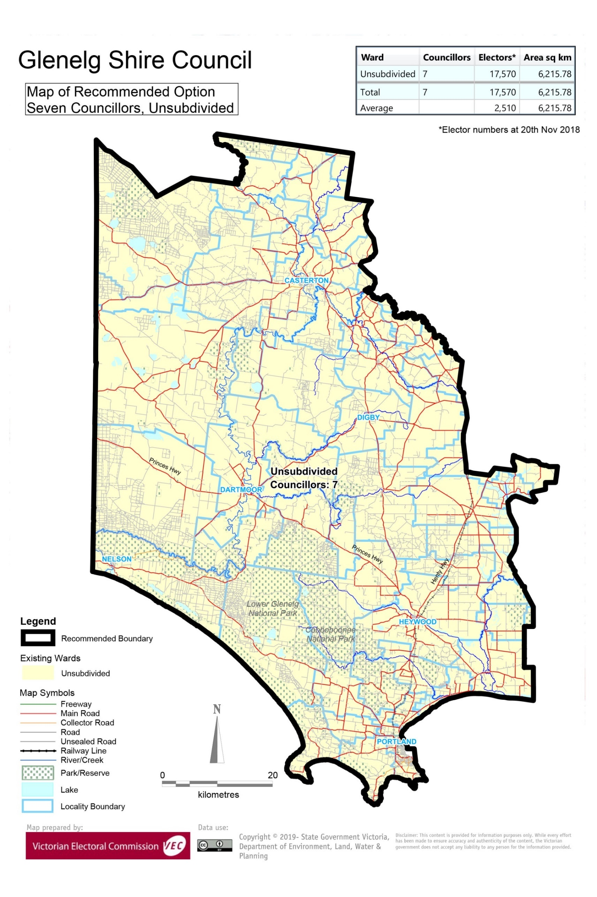

# Appendix 3: Public information program

Advertising

In accordance with the Act, public notices of the review and the release of the preliminary report were placed in the following newspapers:

|  |  |  |
| --- | --- | --- |
| **Newspaper** | **Notice of review** | **Notice of preliminary report** |
| *Herald Sun* | Thursday 17 January | Wednesday 20 March |
| *Casterton News* | Wednesday 16 January | Wednesday 20 March |
| *Hamilton Spectator* | Thursday 17 January | Tuesday 19 March |
| *Mount Gambier Border Watch* | Thursday 17 January | Thursday 21 March |
| *Portland Observer* | Wednesday 16 January | Wednesday 20 March |

Media releases

A media release was prepared and distributed to local media to promote the commencement of the review on Wednesday 23 January 2019. A further release was distributed with the publication of the preliminary report on Wednesday 20 March 2019. A final media advisory was circulated on the publication date of this final report.

Public information sessions

Public information sessions for people interested in the review process were held on:

* Thursday 24 January 2019 at Portland Municipal Offices, 71 Cliff Street, Portland
* Wednesday 23 January 2019 at 77 Edgar Street, Heywood
* Wednesday 23 January 2019 at Casterton Customer Service Centre, 67 Henty Street, Casterton.

Submission guide

A submission guide was developed and made available on the VEC website, or in hardcopy on request, throughout the review timeline. The submission guide provided information about the review, the review timeline and how to make submissions to the review.

Online submission tool

An online submission tool was developed and made available during the submission periods of the review. The tool allowed people to make a submission from the VEC website. During the preliminary submission stage, users also had the opportunity to map out their preferred subdivisions through the online submission tool using Boundary Builder. Boundary Builder included real elector numbers so that users could see if their preferred structures and numbers of councillors met the plus-or-minus 10% rule.

VEC website

The VEC website delivered up-to-date information to provide transparency and facilitate public participation during the review process. All public submissions were published on the website.

Email and social media engagement

The VEC delivered an information email campaign targeted at known community groups and communities of interest in the local council area. This included a reminder email at each milestone of the representation review process.

The VEC also published sponsored social media advertising that was geo-targeted to users within the local council area. This included advertising at both the preliminary submission and response submission stages. The total approximate reach of these posts was 9,140 users.

Council communication resources

The VEC provided the Council with a communication pack that included information on the review in various formats. While the Council is encouraged to distribute this information and raise awareness about the review, the VEC is an independent reviewer and all communications resources include reference and links to the VEC website and core materials.

This page has been left intentionally blank

This page has been left intentionally blank

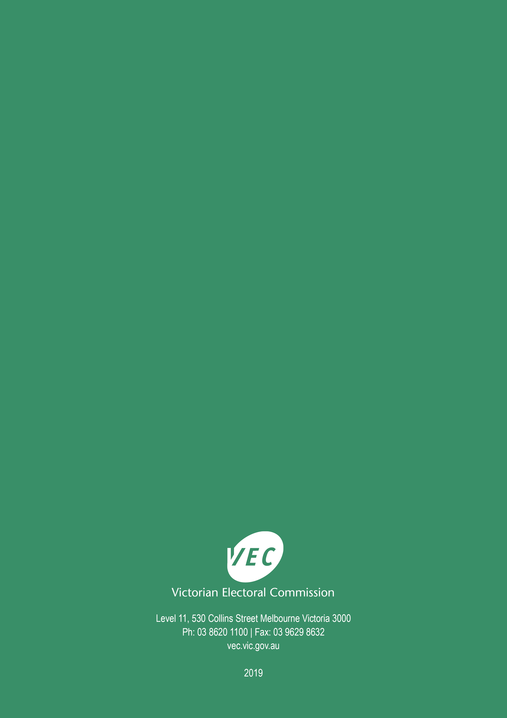

1. Section 219D of the *Local Government Act* *1989.*
2. ibid*.*
3. .id is a consulting company specialising in population and demographic analysis and prediction information products in most jurisdictions in Australia and New Zealand.
4. Section 5B(1) of the *Local Government Act 1989.*
5. Australian Bureau of Statistics, ‘2016 Census Quickstats – Glenelg (S)’, [https://quickstats.censusdata.abs.gov.au](https://quickstats.censusdata.abs.gov.au/census_services/getproduct/census/2016/quickstat/LGA22410?opendocument), accessed 29 April 2019.
6. Australian Aluminium Council Ltd, ‘Australian Aluminium’, <https://aluminium.org.au/australian-industry>, accessed 29 April 2019.
7. Department of Environment, Land, Water and Planning, ‘Wind energy’, <https://www.energy.vic.gov.au/renewable-energy/wind-energy>, accessed 29 April 2019.
8. Port of Portland Pty Ltd, ‘Port of Portland’, available from <http://www.portofportland.com.au/publications.html>, accessed 30 April 2019.
9. Australian Bureau of Statistics, ‘2016 Census Quickstats – Glenelg (S)’, loc. cit. *See also:* Australian Bureau of Statistics, ‘2016 Census Quickstats – Rest of Vic.’, accessed 29 April 2019.
10. ibid.
11. Australian Bureau of Statistics, ‘2016 Census Quickstats – Glenelg (S)’, loc. cit.
12. .id, ‘Glenelg Rural: employment status’, <https://profile.id.com.au/glenelg/employment-status?WebID=110>, accessed 29 April 2019.
13. Australian Bureau of Statistics, ‘2016 Census Quickstats – Glenelg (S)’, loc. cit.
14. .id, ‘Glenelg Shire: highlights’, <https://profile.id.com.au/glenelg/highlights-2016>, accessed 29 April 2019.
15. .id, ‘Glenelg Shire’, https://profile.id.com.au/glenelg/about, accessed 29 April 2019.
16. .id, ‘Glenelg Shire: population and age structure’, <https://forecast.id.com.au/glenelg>, accessed 29 April 2019. *See also:* Department of Environment, Land, Water and Planning, ‘Victoria in Future 2016: Glenelg’, <https://www.planning.vic.gov.au/__data/assets/pdf_file/0028/96490/Glenelg_VIF_2016_One_Page_Profile_Output.pdf>, accessed 29 April 2019.
17. One individual submission was from a submitter located outside Glenelg Shire Council. The two organisations who made response submissions were Glenelg Shire Council and the Proportional Representation Society of Australia (Victoria-Tasmania) Inc.
18. This speaker did not submit a response submission and was not scheduled to speak at the hearing. The VEC noted that the speaker did submit a preliminary submission which indicated a wish to speak at the public hearing. Although this is outside of normal procedure, the VEC opted to hear Ms Punton and consider the views put forward.
19. The VEC notes that a person enrolled for a local council general election may stand as a candidate in any ward for that council, regardless of which ward they are enrolled in.
20. Victorian Electoral Commission, *2016 Local Government Elections Report*, 2017, Figure 9, pp. 26, <https://www.vec.vic.gov.au/files/Report%20on%20the%20conduct%20of%20the%202016%20Local%20Government%20Elections.pdf>